

NATIONAL INVASIVE ANT BIOSECURITY PLAN 2018–2028

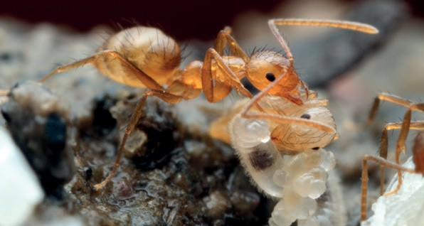

*Nylanderia* species. © Alex Wild

Environment and Invasives Committee

© Commonwealth of Australia 2019



*National Invasive Ant Biosecurity Plan* is licenced by the Commonwealth of Australia for use under a Creative Commons Attribution

4.0 International licence with the exception of content supplied by third parties. This licence agreement that allows you to copy, distribute, transmit and adapt this publication provided that you attribute the work. For licence conditions see: [creativecommons.org/licenses/by/4.0](http://creativecommons.org/licenses/by/4.0).

This publication should be cited as:

Environment and Invasives Committee (2019) *National Invasive Ant Biosecurity Plan* Australian Government, Canberra. Available at: [www.environment.gov.au/biodiversity/threatened/publications/tap/invasive-ants](http://www.environment.gov.au/biodiversity/threatened/publications/tap/invasive-ants)

Also available at: [www.agriculture.gov.au/pests-diseases-weeds/plant/tramp-ants](http://www.agriculture.gov.au/pests-diseases-weeds/plant/tramp-ants)

**Disclaimer**

While reasonable efforts have been made to ensure that the contents of this publication are factually correct, the Environment and Invasives Committee and Commonwealth do not accept responsibility for the accuracy or completeness of the contents, and shall not be liable for any loss or damage that may be occasioned directly or indirectly through the use of, or reliance on, the contents of this publication.

The Environment and Invasives Committee would like to thank all who contributed to the development of this Biosecurity Plan. Front cover: *Nylanderia* sp. worker with developing brood © Alex Wild.

# Contents

Contents 3

Acknowledgments 4

Executive Summary 1

1 Introduction 2

2 National Invasive Ant Biosecurity Plan 3

2.1 Scope of the plan 3

2.2 Structure of the plan 3

2.3 Supporting documents 3

2.4 High priority invasive ants for Australia 4

3 National context 11

3.1 Legislation 11

3.2 National arrangements 14

3.3 Regional and local arrangements 14

3.4 The biosecurity continuum 14

4 Action Areas 18

Action Area 1: PREVENTION 18

Action Area 2: DETECTION 21

Action Area 3: RESPONSE 25

Action Area 4: CONTAINMENT 29

Action Area 5: ASSET-BASED PROTECTION/ONGOING MANAGEMENT 31

Action Area 6: CROSS-CUTTING ISSUES 33

5 Implementation 39

6 Monitoring, evaluation and review 39

7 References 39

8 Acronyms and abbreviations 39

9 Definitions/Glossary 40

National Invasive Ant Biosecurity Plan—Implementation Summary 42

# Acknowledgments

This biosecurity plan builds on the *Threat Abatement Plan to reduce the impacts of invasive tramp ants on biodiversity in Australia and its territories* and a report prepared by Mr Bill Magee, Dr Sabine T. Perrone, Dr Jo Luck and

Ms Naomi Thomson for the Department of Agriculture and Water Resources. The plan incorporates feedback and technical input from the former Tramp Ant Consultative Committee, the National Red Imported Fire Ant Eradication Program, participants at a national workshop in 2016, and relevant committees and working groups. This input has assisted the identification of the core biosecurity activities for invasive ants, specific surveillance research, development and extension issues, and validated the specific actions proposed for this plan. The contribution of these people and organisations is acknowledged.

Our particular thanks go to Sarah Corcoran (formerly Biosecurity Queensland), Sharon Janssen and Dr Ross Wylie (Biosecurity Queensland), Bill Crowe and James Walker (Department of Agriculture and Water Resources),

Dr Ben Hoffmann (CSIRO), and Dr David Oi (United States Department of Agriculture, Florida).

The commentary and actions within the plan related to the environment benefited from the assistance of

Dr Lori Lach, Centre for Tropical Environmental and Sustainability Science and Centre for Tropical Biodiversity and Climate Change at James Cook University and Dr Ben Hoffmann (CSIRO).

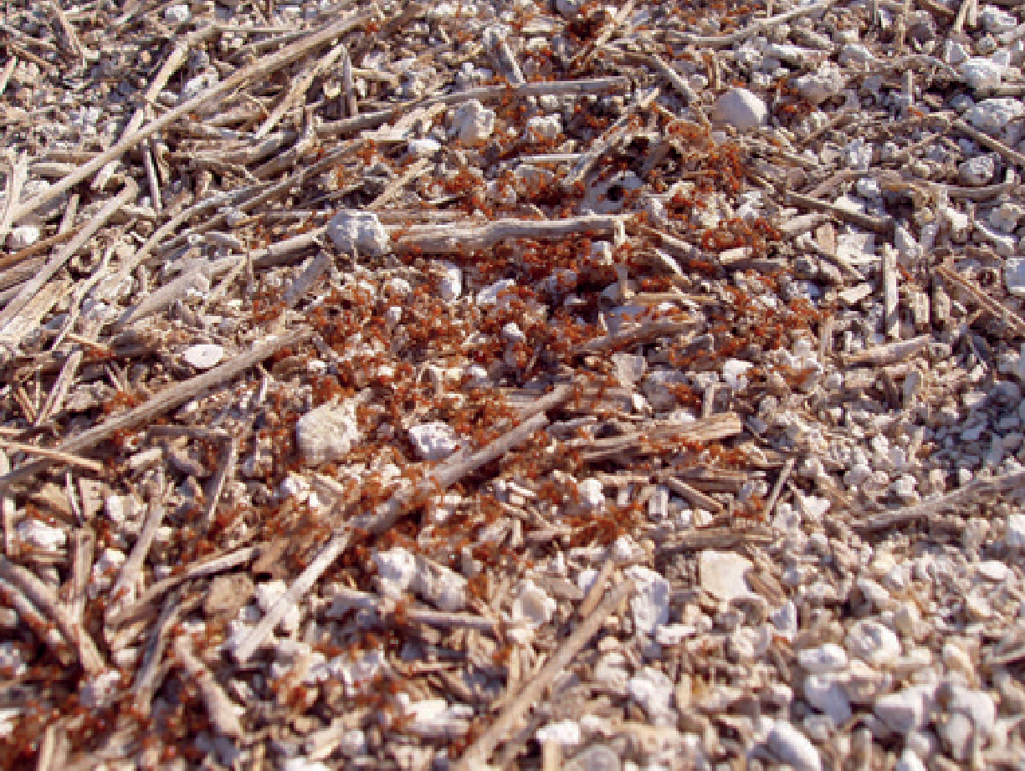

Tropical fire ants (*Solenopsis geminata*). © Monash University

# Executive Summary

A number of invasive ant species are amongst the most serious global invasive pests. Australia’s environmental, economic, and social wellbeing is threatened by these ants, some of which have already been introduced and have become established in Australia. The environmental impacts of invasive ants can be complex; ranging from predation and competition through to modifying habitat. Economically, invasive ants impact primary production through seed consumption or animal attack, and biting or stinging farm workers; and impact electrical infrastructure in buildings. Communities are also affected by invasive ants by making outdoor areas un-usable and invading houses.

Exotic invasive ants, as a group, have been identified nationally as the seventh most important National Priority Plant Pest. In recognition of this serious threat, the National Biosecurity Committee requested the development of this national plan.

This biosecurity plan provides a nationally agreed approach to enhance Australia’s capacity to manage the ongoing threat of invasive ants establishing in Australia and the impacts caused by those species already established.

This plan covers the biosecurity spectrum, specifically broken into the stages of prevention, detection, response, containment and asset-based protection/ongoing management.

This plan describes the actions required to best address the biosecurity threats posed by invasive ants offshore, at the border and onshore. It includes the elements of a national approach to prevent, prepare for and respond to invasive ants, including surveillance, and how this could be achieved.

An Implementation Plan compliments this national action plan. Other supporting documents provide basic information about the priority invasive ant species or groups identified as a known or potential biosecurity risk to Australia. This plan is complemented by a range of other activities that are in progress, including national eradication programs and other programs for established invasive ants.

This plan has been endorsed by the National Biosecurity Committee, and the Environment and Invasives Committee will formally oversee the associated implementation of the plan on behalf of the National Biosecurity Committee.

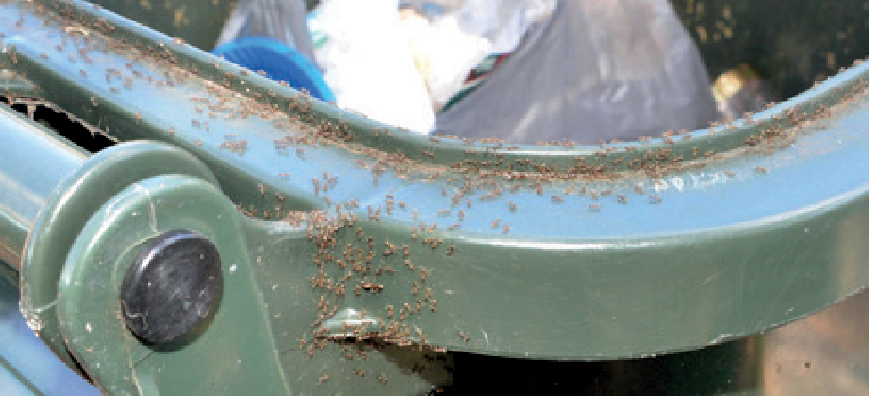

Argentine Ant *(Linepithema humile)* on a rubbish bin © Marc Widmer

# 1 Introduction

Invasive ants are a diverse group of ant species originating from many regions that can be introduced through a variety of pathways. Invasive ants can reach our shores either as hitchhikers on a range of conveyances

(e.g. agricultural machinery and mining or military equipment), or on specific goods or groups of goods (e.g. scrap metal, soil, hay, straw, plant material). Invasive ants have previously been referred to by Australian governments as tramp ants. Invasive ants generally have a reliance on human-mediated dispersal and close association with humans generally.

These ants share some behavioural and ecological attributes that influence their probability of entry, establishment and spread as well as their potential ecological dominance and impact (Box 1).

**Box 1. The world’s most invasive ant species all share the following characteristics**

1. They are omnivorous.
2. They have adopted an opportunistic nesting behaviour.
3. They are found living in human-disturbed environments but may disperse into the natural environment from these areas.
4. Their nests may have a large number of reproductive queens (polygyny) and extend over large areas.
5. They show exacerbated aggressiveness towards other ant species but a reduced intra-specific aggressiveness at the population level.
6. Their aggressive dominance affects other native species directly and indirectly, potentially causing ecosystem disruption.

Invasive ants have the potential to negatively impact the Australian environment, agriculture industries, infrastructure, and human health and amenity. While the impacts of invasive ants on biodiversity in Australia have not been fully quantified, invasive ants have the ability to significantly affect Australia’s native biodiversity directly through predation upon, or competition with, native animals, or indirectly by modifying habitat structure and altering ecosystem processes. Invasive ants can directly impact agriculture by feeding on sown crop seeds and attacking new-born animals, and indirectly through damage to infrastructure such as irrigation pipes, farming of scale insects for their honeydew and stinging or biting field workers. Invasive ants can damage electrical infrastructure in buildings and sting or bite people when they are in their back yards or urban parks. Other industries and sectors of the economy have potential to be impacted by invasive ants directly, such as tourists avoiding areas because of being bitten/stung, or indirectly, such as host-material movement restrictions.

Two species have been listed key threatening process under the *Environment Protection and Biodiversity*

*Conservation Act 1999*: *Solenopsis invicta* (red imported fire ant) and *Anoplolepis gracilipes* (yellow crazy ant). The listing of the yellow crazy ant is for Christmas Island where the formation of supercolonies of the ant impacts severely on

the iconic red land crabs and other native species. A Threat Abatement Plan was developed in 2006, identifying red imported fire ant, yellow crazy ant and four other national priority species. The additional species were recognised as being either an emerging or established threat in Australia and included *Wasmannia auropunctata* (little fire ant/electric ant), *Solenopsis geminata* (tropical fire ant), *Pheidole megacephala* (African big-headed ant) and *Linepithema humile* (Argentine ant). This biosecurity plan captures the necessary actions required to abate the threat from invasive ants to biodiversity in Australia and as such it replaces the threat abatement plan.

Significant funds and resources have been invested in national eradication programs, many of which have spanned numerous financial years. Additionally, there are many activities underway across a range of organisations to prevent and prepare for invasive ants.

# 2 National Invasive Ant Biosecurity Plan

## This photo shows a large number of Argentine ants, or Linepithema humile ants, in a trail up the trunk of a eucalyptus tree. This photo is copyrighted to Marc Widmer.2.1 Scope of the plan

This plan describes the elements of a national approach across the entire biosecurity continuum—prevention, detection, response, containment and asset-based protection/ongoing management—and sets out specific actions and priorities to improve the management of risk associated with invasive ants.

## 2.2 Structure of the plan

This plan is structured into six action areas across the five key biosecurity continuum areas of prevention, detection, response, containment and management; and one area of cross-cutting actions. The cross-cutting area contains actions that fit into two or more of the five key biosecurity continuum areas and are equally important to consider to reduce invasive ant risks and threats. The cross-cutting actions are divided into the themes of retaining core skills;

A trail of Argentine Ants *(Linepithema humile)* on a tree

© Marc Widmer

governance; research, development and extension; and communication and engagement.

Through the document are specific actions that link to the *Biosecurity Act 2015* or the *Environment Protection and Biodiversity Conservation Act 1999*. Other actions may relate to Australian state and territory legislation or may be important for other reasons. Users of this biosecurity plan are expected to identify actions for which they have responsibility.

Many of the actions identified in this plan are applicable to several or all five of the major action areas – prevention, detection, response, containment and management. Recognising this limitation, the action areas have been listed under the theme of most relevance. All priorities will need to be assessed in relation to current work programs and budgets.

## 2.3 Supporting documents

There are a number of supporting documents to the National Invasive Ant Biosecurity Plan. An Implementation Plan has been developed for the National Invasive Ant Biosecurity Plan.

Supporting documents include brief information about priority invasive ant species including a physical description; their food, habitat and climate requirements; information on their nesting habits and some of what is known about their impacts on biodiversity and people. There is also general information about invasive ant monitoring methods, control methods and ways to prevent further spread. This information is to help stakeholders, particularly those managing established invasive ants, to understand their options and should not be used as the technical information required for a response plan.

Other supporting documents will be made publically available as they are developed and may include outputs of actions.

## 2.4 High priority invasive ants for Australia

High-priority invasive ants require action because of their potential or actual impacts on the Australian environment, agriculture industries, infrastructure, and human health and amenity. High-priority invasive ants have been identified based on experience and expertise from Australia and overseas (Table 1 and Table 2), and these may change as new information becomes available. These include high risk species not yet present but known to cause issues overseas (exotic), and species already present in Australia (either under eradication or established). When undertaking some of the actions in this plan, the additional categorisation of the invasive ant list into biological groups based on similarities in their biology, ecology and behaviour may be useful.

Table 1 groups invasive ants into three groups, as follow:

1. species that are not yet present in Australia (exotic)
2. species that are subject to active eradication programs (under eradication)
3. species established in Australia (established).

Note that the species in the table have *not* been ranked by their order of importance.

There are other exotic ants established in Australia that are not known to be invasive or causing problems. Many of these ants are listed in the Atlas of Living Australia (www.ala.org.au).

#### Table 1: High priority invasive ants

**Scientific names1**

**Common names**

**Notes about the species and risk**

**Exotic to Australia**

*Brachyponera chinensis* Asian needle ant

*Camponotus pennsylvanicus*

High risk exotic species that should be considered for eradication if detected.

Invasive in the United States where it stings people and has negative impacts on native invertebrates.

High risk exotic species that should be considered for eradication if detected.

Camponotus are an extremely large genus (>1000 species)

and other species of *Camponotus* as

identified by a pest risk assessment

Some species in the genus are known as Carpenter ants

with a variety of habitats. There are many exotic Componotus species in this group.

The main risk from this genus is the carpenter ants that damage buildings and other timber in service by hollowing out wood (e.g. structural beams).

High risk exotic species that should be considered for

*Lasius neglectus* Invasive garden ant

*Myrmica rubra* European fire ant

eradication if detected. Invasive in Europe where it is a nuisance pest in buildings, displacing local ant species and tending honey dew producing insects (e.g. aphids).

Very high risk exotic species that should be considered for eradication if detected.

Invasive in parts of Europe and North America where it is a nuisance pest due to its painful sting.

1. Pest risk assessments may be conducted on additional species, which may result in this table being amended.

**Scientific names1 Common names Notes about the species and risk**

*Nylanderia fulva* Tawny crazy ant or Rasberry ant

*Solenopsis richteri* Black imported fire ant

*Tapinoma sessile* Odorous house ant

Very high risk exotic species that should be considered for eradication if detected.

Invasive in the USA where it is a nuisance pest in and around infrastructure due to its ability to attain extremely high abundance levels

Very high risk exotic species that should be considered for eradication should it be detected. *Solenopsis richteri* would likely have a similar impact to *S. invicta*, where *S. invicta* is absent.

High risk exotic species that should be considered for eradication if detected.

In its native habitat, this species only causes problems in urban and disturbed areas.

High risk species such as *Technomyrmex Pallipes* and

*Technomyrmex* species (excluding *T. difficilis* and *T. vitensis)*

*Tetramorium*

Species often misidentified as

*Technomyrmex difficilis*

*T. albipes* currently exotic to Australia that should be considered for eradication if detected.

This grouping excludes *T. difficilis* (difficult white-footed ant) and *T. vitensis* (white footed ant) as established species.

High risk exotic species in this species-group that should be considered for eradication if detected. Specific species within the *Tetramorium caespitum* complex have a

highly complex taxonomy, beyond what is necessary for

*caespitum complex* Pavement ants

identifying the ant as a high priority invasive ant. These species can be polygynous and form supercolonies with the potential to spread quickly and become a nuisance and environmental pest.

**Under national eradication in Australia**

*Lepisiota frauenfeldi*

(also *L. incisa*;

*L. canescens*)

Browsing ant

Under eradication in Darwin and in Western Australia; freedom declared at Perth airport in August 2016, and at Belmont WA in November 2017. Other *Lepisiota* species are known to have traits typical of invasive ants, including low aggression between populations.).

Under eradication. Very high risk; eradication should continue to be pursued unless the SEQ infestation is determined as not technically feasible or cost beneficial to eradicate. This species impacts human and animal

*Solenopsis invicta* Red imported fire ant (RIFA)

health, agriculture and horticulture, the environment (through their impact on native species) and results in a general decrease in quality of life for those living with

fire ants in their backyards, public parks and gardens. This species is our most significant threat and includes multiple government portfolios

Under eradication. High risk and eradication should

*Wasmannia auropunctata*

Electric ant or little fire ant

continue to be pursued until the Cairns infestation is found to be not technically feasible or cost beneficial to eradicate. This species should remain a priority.

#### 

**Scientific names1**

**Common names**

**Notes about the species and risk**

**Established (either in discrete locations or widespread)**

*Anoplolepis gracilipes* Yellow crazy ant

*Linepithema humile* Argentine ant

*Pheidole megacephala* Coastal brown ant or African

big-headed ant

*Solenopsis geminata* Tropical fire ant

Under management and/or eradication in some areas.

High risk with control efforts on some populations in place: Australian external territory, Christmas Island; Wet Tropic World Heritage Area in north Qld; North-east Arnhem Land, Townsville, Qld, and Lismore NSW).

In isolated areas where there are biosecurity arrangements in place (e.g. island environments) eradication should be attempted as the environmental impacts are significant.

The Wet Tropics Management Authority is conducting a long-term eradication program focused on protecting values of the Wet Tropics of Queensland World

Heritage Area.

Under management and/or eradication in some areas.

High risk but widely established in numerous parts of mainland Australia with no current control efforts in place.

On Australian external territory Norfolk Island and has been subject to an eradication effort since 2008 by the Norfolk Island Regional Council.

High risk but widely established in numerous parts of Australia with no current control efforts in place. This species is very common in garden and home environments.

In isolated areas where there are biosecurity arrangements in place (e.g. island environments) eradication should be attempted as the environmental impacts are significant.

Eradicated from Lord Howe Island.

Under management and/or eradication in some areas. High risk but widely established in and around Darwin with no current control efforts in place on the mainland. Established on Groote Eylandt in the Northern Territory.

They are present on the Australian external territories of Ashmore Reef and Christmas Island.

Subject to an eradication program on Melville Island since 2003, reduced to a single population over the community of Milikapiti.

In isolated areas where there are biosecurity arrangements in place (e.g. island environments) eradication should be attempted as the environmental impacts are significant.

#### Table 2: Images of high priority invasive ants

| **Scientific names** | | |
| --- | --- | --- |
| **Exotic to Australia** | | |
| *Brachyponera chinensis* | Asian needle ant | © Queensland Museum. Image by Geoff Thomson and created using support from the Commonwealth Department of Agriculture and Water Resources. |
| *Camponotus pennsylvanicus* and other species of *Camponotus* as identified by a pest risk assessment | Some species in the genus are known as Carpenter ants | © Queensland Museum. Image by Geoff Thomson and created using support from the Commonwealth Department of Agriculture and Water Resources. |
| *Lasius neglectus* | Invasive garden ant | Credit Will Ericson, CASENT0903220 from [www.antweb.org](http://www.antweb.org/) |
| *Myrmica rubra* | European fire ant | Credit California Academy of Sciences, CASENT0010684 from [www.antweb.org](http://www.antweb.org/) |
| *Nylanderia fulva* | Tawny crazy ant or Rasberry ant | © Queensland Museum. Image by Geoff Thomson and created using support from the Commonwealth Department of Agriculture and Water Resources. |
| *Solenopsis richteri* | Black imported fire ant | © Queensland Museum. Image by Geoff Thomson and created using support from the Commonwealth Department of Agriculture and Water Resources. |
| *Tapinoma sessile* | Odorous house ant | Credit California Academy of Sciences, CASENT0005329 from [www.antweb.org](http://www.antweb.org/) |
| *Technomyrmex* species (excluding *T. difficilis* and *T. vitensis*) | Species often misidentified as Technomyrmex difficilis | © Queensland Museum. Image by Geoff Thomson and created using support from the Commonwealth Department of Agriculture and Water Resources. |
| *Tetramorium caespitum* complex | Pavement ants | Credit Flavia Esteves and Kate Marynova, CASENT0919632/CAENT0917058 from  [www.antweb.org](http://www.antweb.org/) |
| **Under national eradication in Australia** | | |
| *Lepisiota frauenfeldi* (also *L. incisa; L canescens*) | Browsing ant | © Queensland Museum. Image by Geoff Thomson and created using support from the Commonwealth Department of Agriculture and Water Resources. |
| *Solenopsis invicta* | Red imported fire ant (RIFA) | © Queensland Museum. Image by Geoff Thomson and created using support from the Commonwealth Department of Agriculture and Water Resources. |
| *Wasmannia auropunctata* | Electric ant or little fire ant | © Queensland Museum. Image by Geoff Thomson and created using support from the Commonwealth Department of Agriculture and Water Resources. |
| **Established (either in discrete locations or widespread)** | | |
| Anoplolepis gracilipes | Yellow crazy ant | © Queensland Museum. Image by Geoff Thomson and created using support from the Commonwealth Department of Agriculture and Water Resources. |
| Linepithema humile | Argentine ant | © Queensland Museum. Image by Geoff Thomson and created using support from the Commonwealth Department of Agriculture and Water Resources. |
| Pehidole megacephala | Coastal brown ant or African big-headed ant  Major worker | © Queensland Museum. Image by Geoff Thomson and created using support from the Commonwealth Department of Agriculture and Water Resources. |
| Pehidole megacephala | Coastal brown ant or African big-headed ant  Minor worker | © Queensland Museum. Image by Geoff Thomson and created using support from the Commonwealth Department of Agriculture and Water Resources. |
| Solenopsis geminata | Tropical fire ant | © Queensland Museum. Image by Geoff Thomson and created using support from the Commonwealth Department of Agriculture and Water Resources. |

# 3 National context

Australia’s biosecurity system operates under Commonwealth, state and territory legislation administered and managed by the respective government agricultural and environmental agencies. These agencies also contribute to the national response arrangements and committees.

## 3.1 Legislation

Legislation relevant to the management of invasive ants, current as at April 2018 is listed in Table 3. In addition to the listed legislation, there is also regulation associated with chemicals used to control invasive ants by Commonwealth, state and territory governments.

#### Table 3 Commonwealth, state and territory legislation relevant to the management of risks associated with invasive ants

|  |  |  |
| --- | --- | --- |
| **Jurisdiction** | **Administering authority** | **Primary legislation** |
| Commonwealth | Department of Agriculture and Water Resources | *Biosecurity Act 2015* |
|  | Department of the Environment and Energy | *Environment Protection and Biodiversity Conservation Act 1999* |
| ACT | Environment Planning and Sustainable Development Directorate | *Pest Plants and Animals Act 2005* |
| NSW | Department of Primary Industries | *NSW Biosecurity Act 2015* |
|  |  | *Biological Control Act 1985* |
|  | Office of the Environment and Heritage | *Biodiversity Conservation Act 2016* |
| NT | Department of Primary Industries and Resources | *Plant Health Act 2008* |
| QLD | Department of Agriculture and Fisheries | *Biosecurity Act 2014* |
|  | Department of Environment and Science | *Environmental Protection Act 1994* |
| SA | Primary Industries and Regions | *Plant Health Act 2009* |
| TAS | Department of Primary Industries, Parks, Water | *Plant Quarantine Act 1997* |
|  | and Environment | *Nature Conservation Act 2002* |
| VIC | Department of Economic Development, Jobs, Transport and Resources | *Plant Biosecurity Act 2010* |
|  | Department of Health and Human Services | *Public Health and Wellbeing Act 2008* |
| WA | Department of Primary Industries and Regional Development | *Biosecurity and Agricultural Management Act 2007* |
|  | Department of Water and Environmental Regulation | [*Environmental Protection Act 1986*](http://www.slp.wa.gov.au/legislation/statutes.nsf/main_mrtitle_304_homepage.html) |
|  | Department of Biodiversity, Conservation | *Biodiversity Conservation Act 2016* |

and Attractions

*Conservation and Land Management Act 1984*

**National Invasive Ant Biosecurity Plan 2018–2028**

| PAGE 12 |

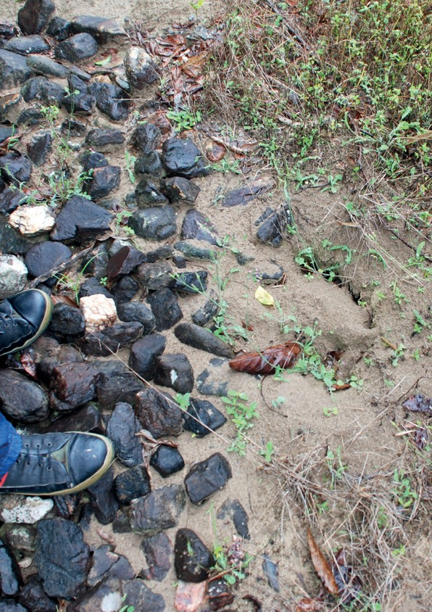

Yellow crazy ant *(Anoplolepis gracilipes)* nest near Cairns © Marc Widmer

*Biosecurity Act 2015 (Cth)*

The Biosecurity Act established requirements and regulatory powers that affect how the department manages the biosecurity risks associated with goods, people and conveyances entering Australia. These powers allow for the biosecurity risks posed by some invasive pests, including invasive ants, to be more effectively managed, and complement arrangements with states, territories and industry to support the management of incursions. The definition of ‘biosecurity risk’ considers the risk posed to the environment, as well as human, animal and plant health and the economy.

While the focus of the Biosecurity Act is on the Australian border, many of the supporting activities around the border are focused on reducing the biosecurity risk or responding to where unwanted pests and diseases have hitchhiked to Australia on goods, people or conveyances. The actions in this biosecurity plan related to prevention, detection and response all fall under the management of biosecurity risks under the Biosecurity Act.

*Environment Protection and Biodiversity Conservation Act 1999 (Cth)*

The *Environment Protection and Biodiversity Conservation Act* (EPBC Act) provides for the identification and listing of key threatening processes. A threatening process is defined as a key threatening process if it threatens or may threaten the survival, abundance or evolutionary development of a native species or ecological community and impacts listed threatened species or ecological communities to cause listing under the Act, or adversely affects multiple threatened species or ecological communities. There are two key threatening processes associated with invasive ants. In 2003, the *reduction in the biodiversity of Australian native fauna and flora due to the red imported fire ant, Solenopsis invicta (fire ant)* was listed under the EPBC Act, and in 2005, the *loss of biodiversity and ecosystem integrity following invasion by the yellow crazy ant (Anoplolepis gracilipes) on Christmas Island, Indian Ocean* was listed.

When listing a key threatening process under the EPBC Act, the Minister must decide if a Threat Abatement Plan is a feasible, effective and efficient means to abate the theat. A Threat Abatement Plan was in place between 2006 and 2016 to reduce the impacts of invasive ants on biodiversity in Australia and its territories, and this biosecurity plan now fulfils the need for a Threat Abatement Plan that provides a feasible, effective and efficient means to abate the threat.

*Commonwealth land managers*

In addition to roles specified under the Biosecurity Act and the EPBC Act, the Australian Government is also responsible for land management in some ports, national parks through Parks Australia, Department of Defence lands and Offshore Territories under Commonwealth management.

## 3.2 National arrangements

Well established relationships and national arrangements are in place between the Australian, state and territory governments and, where relevant, industry and other stakeholders to coordinate and implement national action on biosecurity issues.

For nationally significant exotic pests that primarily impact on the environment, social amenity or infrastructure, governments have agreed to share the costs of eradicating incursions where it is technically feasible and cost beneficial to do so. These arrangements are underpinned by the Intergovernmental Agreement on Biosecurity2 (IGAB) and, specifically, the National Environmental Biosecurity Response Agreement3 (NEBRA).

Eradication programs have been funded under the NEBRA for browsing ant. The SE Queensland eradication program for the red imported fire ant (National Red Imported Fire Ant Eradication Program) and the electric ant program (National Electric Ant Eradication Program) pre-date the establishment of the NEBRA. The management of these two eradication programs are overseen by an inter-government consultative committee and cost-shared by governments in a similar manner to the NEBRA agreement. Three successful eradications of the red imported fire ant (Yarwun, 2013; Port Botany, 2014; and Brisbane Airport, 2015) were funded under NEBRA.

## 3.3 Regional and local arrangements

Established ants, or localised eradication programs, are considered to be the responsibility of the state or territory government where they are located. These governments may choose to place biosecurity responsibilities on land managers, such as a requirement to control the ants. The Australian Government may assist with the management of established ants or localised eradication programs where these are affecting or have the potential to affect matters of national interest.

## 3.4 The biosecurity continuum

The generalised biosecurity invasion curve (Figure 1) outlines the changing role of governments and stakeholders as actions to respond to a pest or disease change from prevention, eradication, containment to asset-based protection (ongoing management). ‘Entry’ or detection of a new pest incursion into Australia sits between prevention and eradication. The ‘return on investment’ of public funds generally reduces when progressing along the invasion curve, but is still beneficial at the asset based protection end of the curve for species that are of national interest.

For example, governments have a greater responsibility in the earlier stages of prevention and eradication, whereas those best placed to protect assets (public or private) from established pests and diseases are generally the owners of those assets. The environmental, primary production and social costs of inaction are high, especially at the prevention and eradication end of the curve. While it is possible to determine the economic cost in terms of adverse effects on primary production; at present there are few agreed models to measure the ecological cost to the environment of exotic pests and diseases in economic terms.

1. Intergovernmental Agreement on Biosecurity can be found at [www.agriculture.gov.au/biosecurity/partnerships/nbc/intergovernmen tal-agreement-on-biosecurity](http://www.agriculture.gov.au/biosecurity/partnerships/nbc/intergovernmental-agreement-on-biosecurity).
2. National Environmental Biosecurity Response Agreement can be found at [www.agriculture.gov.au/biosecurity/emergency/nebra](http://www.agriculture.gov.au/biosecurity/emergency/nebra).

| PAGE 14 |

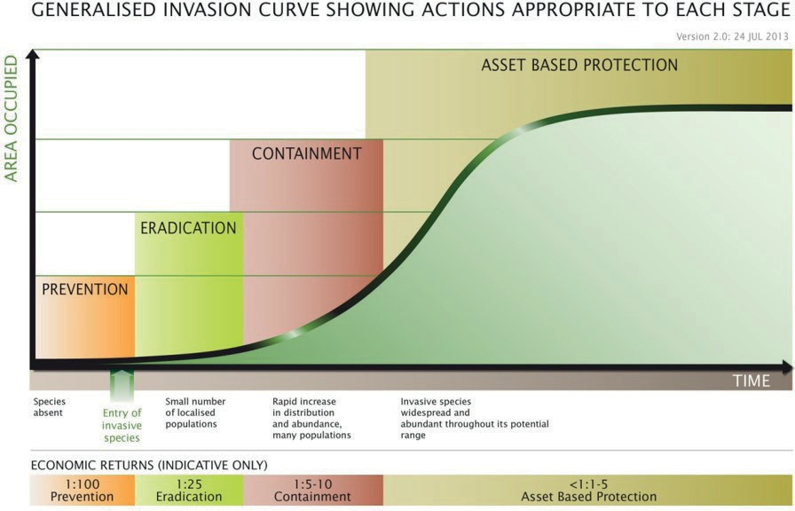

#### Figure 1. Biosecurity invasion curve (Agriculture Victoria, 2009)

The actions identified in this plan mapped against the generalised invasion curve are presented visually in Figure 2.

#### Figure 2 (over page): Actions identified in the National Invasive Ant Biosecurity Plan mapped against the biosecurity continuum as shown on the generalised invasion curve



**National Invasive Ant Biosecurity Plan 2018–2028**

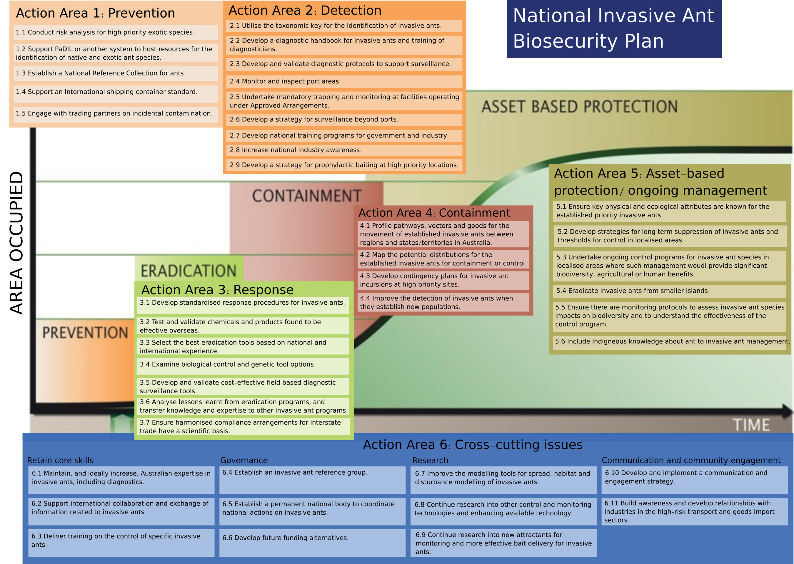

See the associated A3 version of Figure 2 if necessary

# 4 Action Areas

This biosecurity plan covers the biosecurity spectrum, specifically divided into the areas of prevention, detection, response, containment, asset-based protection/ongoing management and cross-cutting actions. The actions described below address the biosecurity threats posed by invasive ants offshore, at the border and onshore. It includes the elements of a national approach to prevent, prepare for and respond to invasive ants, including surveillance, and how this could be achieved. Elements of containment and ongoing management are included, as are actions that cut across two or more areas of the biosecurity spectrum.

## Action Area 1: PREVENTION

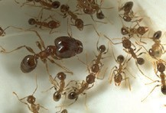African big-headed ants *(Pheidole megacephala)* © Marc Widmer

Prevention is aimed at minimising the likelihood of entry of a new pest into Australia. The actions identified in this key area aim to achieve a better understanding of the biology of the high priority species that are not yet present in Australia or are under eradication, their potential pathways to Australia, how to minimise the risk of the exotic invasive ants utilising the pathways, and resources needed to quickly identify ants.

See Table 3 for a summary of the actions under Prevention.

Action 1.1: Conduct risk assessments for high priority exotic species

A risk analysis of each species/biological group is important to predict the emerging threats and to identify the most effective risk management available to deploy offshore, at the border and onshore.

The risk assessments will be conducted in line with the International Plant Protection Convention (IPPC) standards and will incorporate:

* identification of import pathways
* analysis of interception data as part of risk assessment
* comprehensive review of species biology and ecology to inform incursion risk
* assessment of currently available diagnostic information.

Ongoing review of import pathways to identify those of highest risk will strengthen intervention for invasive ants on known and emerging pathways. There are multiple import pathways that have a known association with ant interceptions:

* sea cargo—break bulk (including timber, machinery and military equipment) and shipping containers (including scrap metal)
* air cargo
  + passenger ships with live plants on deck
  + yachts
  + nursery stock imports
  + air passenger baggage
  + mail
  + refrigerated containers.

An analysis of the Department of Agriculture and Water Resources’ interception data for invasive ants will inform origin and pathways of entry as well as provide early warning of increasing risk of other invasive ant species.

As a sub-component of this action, a specialist entomologist could be funded and dedicated to the task of full identification (at the species level where possible) of intercepted ants for a period of twelve months.

As part of the risk assessment, species that meet the definition of a quarantine pest under the IPPC will be identified and risk mitigation measures will be established for application at the national border.

Identification and comprehensive review of the biology and ecology of each species may be needed to provide the necessary information to identify potential entry and establishment pathways, to assess the risk posed to Australia (potential impacts on the environment, agriculture, infrastructure, and human health and amenity) and to determine their potential for eradication. Procedures to mitigate the risk can then be further developed and implemented.

This action is important for the invasive ants that are not in Australia to prevent their arrival, and also crosses over to the invasive ant species under eradication to assist with eradication or prevention of further spread, and for established species to assist with their containment, control and localised eradications (e.g. from islands).

Action 1.2: Support PaDIL or another system to host resources for the identification of native and exotic ant species

Support of PaDIL or another system with a taxonomic key will be very valuable for ant identification into the future.

The Pest and Disease Image Library (PaDIL; [www.padil.gov.au](http://www.padil.gov.au/)) has been developed as a publically accessible visual collection of high-resolution images of pests and diseases, and is used by front-line biosecurity staff in the Department of Agriculture and Water Resources. The capture and storage of high-resolution images of key morphological characteristics of invasive ants into a freely accessible gallery would be very valuable for ant identification. The addition of the taxonomic key specifically for invasive ants is a logical and much needed tool to assist in the rapid and accurate identification of ants.

Action 1.3: Establish a National Reference Collection for ants

A national reference collection, comprising relevant existing collections, of key species of concern and native species will greatly assist rapid identification.

There is a need for the development of a reference of the key invasive ant species of concern, as well as native species, to assist in the identification of invasive ants. This collection would effectively be a virtual collection, referencing existing collections around the country. The collection would be available for use by diagnosticians at all major ports of entry and by other diagnosticians supporting onshore surveillance. International specialists may be able to assist in the compilation of such reference collections. The images of collected specimens could also be used to populate the PaDIL Library.

Action 1.4: Support an international shipping container standard

Development of an international standard for phytosanitary measures for shipping containers will reduce hitchhiker and contamination risks associated with shipping containers.

The Commission of Phytosanitary Measures (CPM) of the International Plant Protection Convention (IPPC) has indicated a desire to create more commodity class and conveyance-specific phytosanitary standards to supplement the existing suite of phytosanitary standards. Such standards have international benefits, particularly where there are generic phytosanitary risks and also widely accepted international phytosanitary measures. The development of a standard for shipping containers has been on the agenda for the IPPC standards committee which progresses the development of ISPMs in recent years. However, following the CPM meeting #11 in April 2017 this was put on hold pending assessment of the available tools such as the Code of Practice for Packing of Cargo Transport Units ([CTU Code)](http://www.unece.org/trans/wp24/guidelinespackingctus/intro.html) and the [CPM Recommendation on Sea Containers](https://www.ippc.int/en/core-activities/governance/cpm/cpm-recommendations-1/cpm-recommendations/sea-containers/) which encourage National Plant Protection

Organizations to support the implementation of the relevant parts of the revised Code of Practice. The impact of the CTU Code would then be assessed over the next five years.

In view of the strong association between international movement of shipping containers and the presence of invasive ants, along with other hitchhiker pests, Australia needs to be actively involved at the IPPC in the consideration of the risk posed by sea containers.

Action 1.5: Engage with trading partners on incidental contamination

Dialogue with trading partners on contamination of conveyances or other non-commodity related risk pathways will assist Australia to address the risk of emerging invasive ants.

Australia has regular engagement with trading partners on biosecurity issues. The agenda for these meetings is often dominated by trade and market access commodity issues owing to the impact of phytosanitary measures on trade in commodities. Other issues such as incidental contamination of conveyances or other non-commodity related risk pathways are rarely included on the bilateral meeting agenda. However, there are a number of pest-specific issues that could be included in the bilateral dialogue, not limited just to the formal meetings, but as a regular exchange of information about emerging pest concerns. Given the prominence of invasive ants as a pest grouping of biosecurity concern to Australia, bilateral dialogue covering pests of this nature would assist Australia in its preparedness for emerging high-risk ants in the trading environment.

#### Table 3: Summary table of Action Area 1: PREVENTION

**Action Area 1: PREVENTION Priority Timeframe****4**

Action 1.1 Conduct risk assessments for high priority exotic species High Short term

Action 1.2 Support PaDIL or another system to host resources for the identification of native and exotic ant species

Medium Medium term

Action 1.3 Establish a National Reference Collection for ants Medium Medium term Action 1.4 Support an international shipping container standard High Very long term Action 1.5 Engage with trading partners on incidental contamination High Short term, ongoing

1. Timeframe: SHORT up to 3 year; MEDIUM 4 to 8 years; LONG up to 10 years.

## Action Area 2: DETECTION

Detection is focused on ensuring that the right tools and strategies are in place to find exotic invasive ants when they enter Australia, regardless of the means of transportation. The actions identified include appropriate strategies for surveillance and identification capacity.

See Table 4 for a summary of the actions under Detection.

Action 2.1: Utilise the taxonomic key for the identification of invasive ants

A tailored up-to-date taxonomic key to differentiate between exotic and native ants has been developed. Assisting the adoption and utilisation of this key will greatly improve Australia’s capacity for early detection of invasive ants.

There is now a tailored taxonomic key available in Australia specifically for the identification of invasive ants. Taxonomic keys are a critical tool and should be used in conjunction with the PaDIL high resolution image library resource. Used in combination, they will greatly improve Australia’s capacity for early detection of invasive ants. This is particularly relevant for problematic genera (species complexes) with known intricate challenges in identification. It will be useful to expand this key to other species that pose a threat to Australia and Australian species outside of their native range.

General knowledge on the biology, ecology, behaviour and taxonomy of native species is also poor, which can be problematic when trying to identify invasive ants. Key characteristics need to be identified and listed to distinguish native and established ants from exotic ant species.

Action 2.2: Develop a diagnostic handbook for invasive ants and training of diagnosticians

A standardised and nationally agreed diagnostics handbook for ants that focuses specifically on invasive ants will assist Australian diagnosticians to make rapid and accurate identifications of invasive ants.

Consistent with the approach for fruit flies in Australia, is the value of developing a diagnostics handbook (the fruit fly diagnostics handbook is accessible on the Plant Health Australia [website](http://www.planthealthaustralia.com.au/national-programs/fruit-fly/handbook-for-the-identification-of-fruit-fly/)) for assisting in the identification of invasive ants. Australian diagnosticians would benefit from a standardised and nationally agreed diagnostics handbook for ants focusing specifically on exotic ant species. The handbook could be complemented by further specialist training programs for diagnosticians focusing on identification of invasive ants. A register of diagnosticians trained for the identification of invasive ants should be maintained for ready access to appropriate experts.

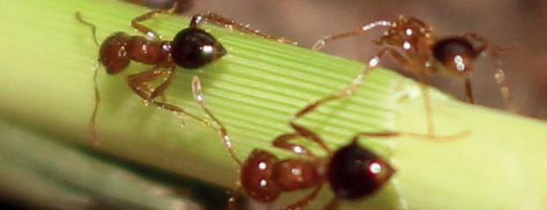

Red imported fire ants (*Solenopsis invicta*) on a plant stem. © The State of Queensland (Department of Agriculture and Fisheries)

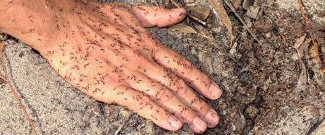

Browsing ant *(Leipisiota frauenfeldi)* on a person’s hand. © Marc Widmer

Action 2.3: Develop and validate diagnostic protocols to support surveillance

Reliable and affordable tools to detect and identify ants will assist in surveillance activities aimed at detecting new incursions of invasive ants.

There is a need for reliable and affordable diagnostic tools to be adopted from overseas initiatives and/or developed and validated to assist with detecting and identifying invasive ants during surveillance activities in Australia. What is currently lacking is a range of tools that are able to detect and identify ant species in a variety of situations and environments. Current diagnostic and detection tools, such as the red imported fire ant lateral flow device are needed for more species. An assessment of available diagnostic tools is needed before efforts are invested into developing new tools and techniques.

A longer term aim is to extend the diagnostic protocols to the identification of individual incursions of the same species of ant, as can currently be done for red imported fire ant. This is necessary to determine if spread relates to a current incursion, or a new incursion, and to be able to identify the country where the population originated from to allow re-assessment of pathway risk.

Action 2.4: Monitor and inspect port areas

Regular surveys around seaports and international airports will improve the likelihood of detecting an incursion of an invasive ant as well as increasing our knowledge of all ant species necessary to improve detection of invasive ants.

Regular surveys around seaports and international airports would enhance early detection of any invasive ant incursions. Improved familiarity and awareness of exotic and native ants by front line biosecurity staff is a powerful tool for ensuring a rapid response when an invasive ant is detected. The presence of front line biosecurity staff in the port areas also serves the secondary purpose of educating and promoting awareness of invasive ants to the larger pool of wharf operators and workers who share an important role in the early detection of invasive ants.

The National Border Surveillance program within the Department of Agriculture and Water Resources is ideally placed to implement this action.

The surveillance methods that could be tested for inclusion in regular monitoring include sentinel sites, odour detection dogs and other standard ant collection techniques. Sentinel sites may be monitored by local governments and/or industry.

Action 2.5: Undertake mandatory trapping and monitoring at facilities operating under Approved Arrangements

Effective surveillance programs that include trapping at first points of entry and Approved Arrangements may assist with early detection of invasive ants and will reduce the likelihood of establishment or spread should an invasive ant arrive.

The *Biosecurity Act 2015* contains provisions for importers to operate under Approved Arrangements. These arrangements specify structural requirements for premises, treatment facilities where appropriate and a range of other conditions necessary for the management of biosecurity risk. The conditions for Approved Arrangements receiving imported goods, identified in the risk pathway as posing a risk of invasive ant entry, could include mandatory surveillance.

An additional consideration could be specific biosecurity training where appropriate on invasive ants to a level consistent with operational officers for at least one employee at high risk sites. This approach would be consistent with officers in the existing ‘authorised officer’ program who conduct business related to export programs on behalf of the Department of Agriculture and Water Resources.

A national ant surveillance strategy could include ant luring and other collection techniques at Approved Arrangements and similar related sites handling sea containers and break bulk cargo, air cargo facilities, first point of entry yacht marinas, passenger ships with significant live plant material and mail handling facilities.

Action 2.6: Develop a strategy for surveillance beyond ports

A strategy for surveillance in strategic areas beyond ports will also support early detection of invasive ants and significantly increase opportunities to eradicate.

There is currently no strategy for surveillance beyond ports. As there are many species of ants in Australia, most people tend to ignore them unless they are extremely abundant in the area or causing a problem. Early stage establishment of an invasive ant may not be immediately noticed.

This new action to develop a strategy for surveillance is needed to integrate state, territory and Commonwealth surveillance, and to also consider industry involvement; for example, the mining industry. The surveillance strategy should also include educating land managers and the community in areas considered as being at risk (either as a high risk receiving site for border incursions or for values such as threatened species or ecological communities).

Action 2.7: Develop national training programs for government and industry

An effective training package for front line biosecurity officers and industry personnel, both at the border and onshore, will strengthen biosecurity awareness.

The frequency of onshore detections and incursions has highlighted the need for increased awareness of invasive ants by front line biosecurity inspectors and industry personnel, both at the border and onshore, in all states and territories. Ideally, a training package would address:

* + general ant biology, behaviour, identification and detection
  + treatment methods with an emphasis on invasive ants, and
  + requirements for high priority invasive ants where there are specific treatments or environmental differences.

The training requirements for biosecurity inspectors and industry personnel may be slightly different depending on available identification people or resources. This action overlaps with the onshore management of established invasive ants for groups seeking to undertake control programs. These groups need to receive specific training related to the invasive ant they are targeting.

#### This photo shows a person baiting browsing ants or Lepisiota frauenfeldi in a yard with sand, grass and weeds. The baiting is being done by a hand spreader that is a plastic container held by the person and the bait is flicked by a spreader at the bottom of the container. This photo is copyrighted to Marc Widmer. This photo shows a close-up image of Technomyrmex jocosus ants with their brood. There are approximately 50 black ants with even greater numbers of white brood of about the same size.

Baiting by hand for browsing ant (*Leipisiota frauenfeldi*)

© Marc Widmer

Action 2.8: Increase national industry awareness

*Technomyrmex jocosus* on food © Pia Scanlon, DPIRD

#### Increased awareness of the threat of invasive ants by industry workers at ports and mining operations will support notification of suspicious ants leading to early detection at mining sites and rural areas.

Experience with some detections of red imported fire ant on imported goods has demonstrated the importance of general industry awareness of invasive ants, including not only port areas and wharf operators, but also end-users such as the mining industry. Red imported fire ant has been detected on mining equipment onshore and in some cases in-transit to remote mining sites. There are other examples of break bulk and containerised cargo moving directly to rural areas. Increased awareness of the threat of invasive ants amongst workers associated with these related industries would increase the probability of early detection for this pathway.

Action 2.9: Develop a strategy for prophylactic baiting at high priority locations

An effective prophylactic baiting program at high priority locations will assist the removal of invasive ants before they can establish.

An important element of the National Border Surveillance is to ensure invasive ants around port areas or Approved Arrangements receiving imported goods or conveyances that are associated with the movement of invasive ants, do not have a chance to establish. Prophylactic baiting may be considered for other hot spots along the supply chain.

#### Table 4: Summary table of Action Area 2: DETECTION

**Action Area 2: DETECTION Priority Timeframe**

Action 2.1 Utilise the taxonomic key for the identification of invasive ants High Short term

Action 2.2 Develop a diagnostic handbook for invasive ants and training of diagnosticians

High Short term

Action 2.3 Develop and validate diagnostic protocols to support surveillance High Long term

Action 2.4 Monitor and inspect port areas High Short term, ongoing

Action 2.5 Undertake mandatory trapping and monitoring at facilities operating under Approved Arrangements

High Short term, ongoing

Action 2.6 Develop a strategy for surveillance beyond ports High Long term Action 2.7 Develop national training programs for government and industry Medium Short term Action 2.8 Increase national industry awareness Medium Short term

Action 2.9 Develop a strategy for prophylactic baiting at high priority locations

High Long term

## Action Area 3: RESPONSE

Eradicating an incursion of an exotic invasive ant may be a complicated and lengthy process depending on the extent of spread of the species, technical challenges with eradicating and how long it has been present before detection. The national biosecurity system and the NEBRA in particular outline how governments will behave in response to an incursion. However, for invasive ants there is still a need to develop standardised response procedures and improve tools to quickly and effectively remove the ants.

See Table 5 for a summary of the actions under Response.

Action 3.1: Develop standardised response procedures for invasive ants

Standardised response procedures will support rapid response to an incursion and a consistent approach through the eradication program.

Standardised response procedures can be used to provide a streamlined approach to responding to a new incursion of invasive ants, which can be then tailored to suit the specific circumstances of the incursion. These procedures could potentially be based on a generic approach, using pest groups and/or biological traits. Procedures should address the following concepts and techniques, amongst others:

* + surveillance for detection, delimitation and, later, proof of freedom
  + definitive diagnostics to confirm the species and diagnostics with the capability to process large numbers of samples
  + tracing to assist in delimiting the spread of the species and to identify probable pathways of introduction
  + movement and quarantine controls to limit spread
  + potential treatment options that can be tailored for the specific species
  + community engagement.

Any response procedures need to be consistent with the principles outlined in NEBRA. The procedures should also be consistent with the Food and Agriculture Organisation of the United Nationals/ International Plant Protection Convention Guidelines for pest eradication programs.

Action 3.2 Test and validate chemicals and products found to be effective overseas

Testing and validating chemicals or products will ensure there are no unacceptable off-target impacts or interactions with native species, and will also ensure that these formulations are effective against the invasive ants under eradication and under Australian conditions in which the ants may establish.

Chemical control products available for invasive ants in Australia are limited. Direct nest injection or baiting with insecticides, and baiting with regulated growth hormones are the current chemical control methods, with some area-limited aerial baiting under special permits. Further research is needed into alternative chemical controls or products, including the use of hydrogel formulations.

The United States has been testing and using a range of chemical formulations for the baiting and control of invasive ants. This expertise and experience should be drawn on to ensure that appropriate formulations are tested through field research trials, not only to account for unacceptable off-target impacts and interactions with native species, but also to ascertain that these formulations are effective under Australian conditions. Timely registrations of formulations with the Australian Pesticides and Veterinary Medicines Authority (APVMA) are needed to expedite approvals for field use.

Additionally, identifying elements of control successes for invasive ants, both nationally and internationally, that could be incorporated into best practice guidelines for invasive ant eradications in Australia.

A number of these tools are also likely to be of use for asset-based protection programs. Approved chemicals or products should continue to be monitored to ensure they remain effective on the invasive ants.

Action 3.3: Select the best eradication tools based on national and international experience

Eradication tools used will be the most effective, both for the invasive ant under eradication and for Australian conditions.

Through red imported fire ant and other eradication programs in Australia and invasive ant experiences overseas, a range of tools are available. These include aerial baiting (under special permits only ), all-terrain vehicle baiting, ground baiting, direct injection of nests, surveillance by ground teams, luring, odour detection dogs, remote sensing and electronic sensing. Some of these tools might be more effective for certain invasive ants and not others and they should also be reviewed and adapted to Australian conditions where the ants may establish.

The South East Queensland red imported fire ant program and the Far North Queensland electric ant program have provided strong underlying evidence of the effectiveness and value of detector dogs. Detector dogs are able to locate nests and, in some cases, have been shown to detect individual ants with a high level of reliability. The dogs are able to be trained to different types of invasive ant, so may be able to be trained independently and shared between various eradication programs. The value of detector dogs needs to be carefully weighed against the benefits of electronic noses as these become more advanced.

A number of these tools are also likely to be of use for asset-based protection programs.

Action 3.4: Examine biological control and genetic tool options

Managers may benefit from a broader suite of management tools, including biological and genetic, to control invasive ants during eradication programs and may provide a back-up plan if eradication programs fail or are not feasible.

Control tools available for invasive ants are limited. Further research is needed into alternative chemical controls, biological controls and genetic tools.

The concept of biological control should be researched even though there is not a historically established strong case to support the efficacy of biological control agents for invasive ants. A range of biological control options are being investigated overseas and their effectiveness should be monitored. Australia has a well-established process for the assessment of biological controls agents, which legitimately takes a considerable period of time and, therefore, the use of biological control agents is very much a long-term strategy. Investment in biological control for the established priority species (e.g. Argentine ants, African big headed ants) may also be appropriate.

Gene editing technology is developing and may be an option for the control of invasive ants. Invasive ants should continue to be included in conversations about how this technology could be applied and the ethical considerations that need to be resolved in order to make a decision about use of the technology.

A number of these tools are also likely to be of use for asset-based protection programs.

Action 3.5: Develop and validate cost-effective field based diagnostic surveillance tools

Cost effective field-based diagnostic surveillance tools will allow delimitation to be done as quickly as possible.

Ants can be difficult to tell apart, even for experts. Additional tools are needed to assist with surveillance and management for both rapid in-field determination of species and for researchers to use on particularly difficult species. A number of invasive ant specialists have highlighted the urgent need for cost effective field-based diagnostic surveillance tools to identify specific invasive ant species.

The development of lateral-flow immune-assay tests or automatic photo identification systems may be options. A lateral-flow immune-assay test uses a simple device to detect the presence (or absence) of a target chemical in a sample without the need for specialized and costly equipment. A lateral flow device has been developed in the United States for the identification of red imported fire ant, black fire ant and the hybrid of these two species, but no other tools have been developed for any of the other priority invasive ants.

Personnel involved in delimitation surveys, post-eradication

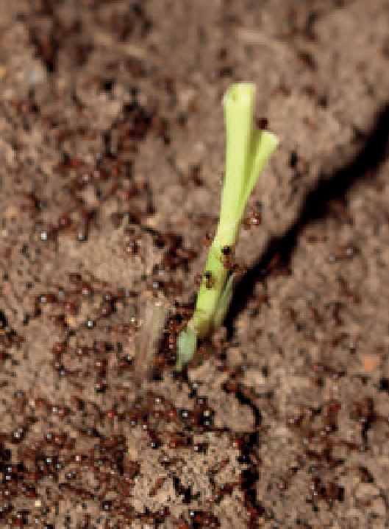

Red imported fire ants *(Solenopsis invicta)* on soil and a plant stem. © The State of Queensland (Department of Agriculture and Fisheries)

surveillance programs or targeted surveys in specific locations would benefit from a range of tools to identify specific invasive ants, or confirm identification of ant samples. It is also important to have such diagnostic tools, so the delimitation can be done as quickly and accurately as possible.

This action of developing additional field tools, such as the lateral-flow immune-assay tests, is also applicable to containment and ongoing management. For the established invasive ant species improved diagnostic tools will assist land managers to identify when they have an invasive ant problem or for post-control surveillance.

Action 3.6: Analyse the lessons learnt from eradication programs, and transfer knowledge and expertise to other invasive ant programs

Analysis of initiatives, programs and tools developed for the South East Queensland red import fire ant eradication program, Far North Queensland electric ant eradication program and other programs will identify any knowledge transferable to the detection, surveillance and eradication of other invasive ants.

The top invasive ants will most likely share only a few red imported fire ant attributes. However, numerous initiatives, programs and tools developed over the last 15 years as part of the red imported fire ant eradication efforts might be fully or at least partially transferable to the detection, surveillance and eradication of invasive ant biological groups or individual species. The red imported fire ant independent review noted that red imported fire ant research spill-overs combined with a strong core group of professionals, who have the skills and expertise to manage red imported fire ant incursions, have increased the probability of eradicating other invasive ant species throughout Australia. Analysis of the many red imported fire ant initiatives, programs and previous program reviews, their successes and failures, should be carried out by an expert in red imported fire ant eradication to identify the specific components that can be transferred to other invasive ants (e.g. surveillance activities, community engagement programs, modelling, etc.). Likewise, the program to eradicate electric ants also should be analysed for the specific components that can be transferred to other invasive ants. There is a need for a literature repository where lessons about failure to delimit, eradicate or contain invasive ants can be accessed by other programs.

There may also be elements of these two eradication programs that can inform containment and control programs so it is important that the knowledge is freely available to groups wishing to control established invasive ants as well.

In addition, a further issue affecting the ability to eradicate invasive ants relates to the timeliness and flexibility of budgets. For all invasive ant eradication programs, contingencies for unexpected detections and flexibility should be built into budgets. A challenge for funding multi-year invasive ant eradication programs is often the ability for the programs to maintain skilled staff when the funding fluctuates.

Action 3.7: Ensure harmonised compliance arrangements for interstate trade have a scientific basis

A nationally harmonised system for specifying interstate trade conditions will provide certainty for industry and prevent the spread of invasive ants.

When eradication programs are in progress for invasive ants, a recognised area of risk for the spread of invasive ants is the unintentional movement of infested conveyances or goods. Currently there is no nationally harmonised system for specifying movement conditions for hosts of pests (including invasive ants) for interstate trade and it can be confusing for businesses that move goods or conveyances within and out of a state or territory, as there can be different risk mitigation processes in place for each type of movement. Any system should be based on science and mitigate the risk of spread, and acknowledge different legislative approaches taken by states/territories. The Subcommittee on Domestic Quarantine and Market Access is the appropriate forum to address this issue.

#### Table 5: Summary table of Action Area 3: RESPONSE

**Action Area 3: RESPONSE PRIORITY TIMEFRAME**

Action 3.1 Develop standardised response procedures for invasive ants High Medium term

Action 3.2 Test and validate chemicals and products found to be effective overseas

Action 3.3 Select the best eradication tools based on national and international experience

Medium Medium term Medium Short term, ongoing

Action 3.4 Examine biological control and genetic tool options Medium Long term

Action 3.5 Develop and validate cost-effective field based diagnostic surveillance tools

Action 3.6 Analyse the lessons learnt from eradication programs, and transfer knowledge and expertise to other invasive ant programs

Action 3.7 Ensure harmonised compliance arrangements for interstate trade have a scientific basis

Medium Medium to long term

High Short term

High Short term

## Action Area 4: CONTAINMENT

Some invasive ants that are considered to be established in Australia are limited to discrete locations. This provides an opportunity to implement management practices that contain the ant to that location. Management may also include the attempt to eradicate it from a particular site.

See Table 6 for a summary of the actions under Containment.

Action 4.1: Profile pathways, vectors and goods for the movement of established invasive ants between regions and states/territories in Australia

The profiling of pathways, vectors and goods will allow jurisdictions to minimise the risk of long-distance invasive ant spread.

While the natural spread of most established invasive ants is relatively slow (less than a kilometre per year), they are capable of long-distance movement via human mediated transport. While invasive ants are easy to opportunistically move, each invasive ant species is prone to be moved by particular human-mediated pathways. Understanding these and where such pathways may spread ants to high risk areas (e.g. into a high biodiversity national park) will enable the identification of how the risk can be minimised. Once pathways are identified, encourage incentives or regulation (self or imposed) to minimise the risk.

Action 4.2: Map the potential distributions for established invasive ants for containment or control

Regional or local maps of the established invasive ants will allow managers to understand potential impacts when considering containment, localised eradication or control programs.

In order to contain, or even undertake localised eradication of, invasive ants it is important that the ecological parameters of the species are known which may allow accurate prediction of where the species may have spread to in the area. This is particularly important in order to identify threatened species and ecological communities that may be affected within these distributions. Mapping of the potential distributions of the priority established invasive ants needs to be done on an appropriate scale, possibly incorporating ecological communities or habitat mapping. Knowing the potential spatial distribution of invasive ants will allow land managers to understand potential movement pathways for re-infestation (both natural and human-assisted), where to look for these species and to understand what native species may be affected.

Action 4.3: Develop contingency plans for invasive ant infestations at high priority sites

Contingency plans to remove new infestations of established invasive ants will protect high priority sites.

Management of the spread of an invasive ant is most effective if undertaken as soon as possible. A single nest or small area is much easier to control—with a much higher likelihood of success—than a widespread infestation. Where a specific invasive ant species or group of species with similar characteristics are found to be a high risk, contingency plans can be developed so control action can be quickly undertaken.

Action 4.4: Improve the detection of invasive ants when they establish new populations

The development of surveillance protocols will allow land managers to integrate invasive ant prevention.

There are many species of ant in Australia and most people tend to ignore ants unless they are extremely abundant or are causing a problem. New tools as well as surveillance protocols that can be built into land management practices need to be developed and provided to land managers in areas identified as high risk.

#### Table 6: Summary table of Action Area 4: CONTAINMENT

**Action Area 4: CONTAINMENT PRIORITY TIMEFRAME**

Action 4.1

Profile pathways, vectors and goods for the movement of established invasive ants between regions and states/territories in Australia

High Short term

Action 4.2 Map the potential distributions for the established invasive ants for containment or control

Action 4.3 Develop contingency plans for invasive ant incursions at high priority sites

Action 4.4 Improve the detection of invasive ants when they establish new populations

Very high Short term

Medium Short to Medium term

Medium Medium term

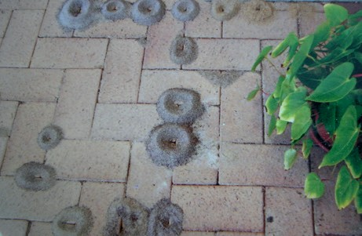

Nests of the African big-headed ant *(Pheidole megacephala)* © Marc Widmer

## Action Area 5: ASSET-BASED PROTECTION/ONGOING MANAGEMENT

Established invasive ants have a significant impact on biodiversity, agriculture, infrastructure, human health and public amenity. An analysis of the costs of managing established pests provides a cost:benefit ratio of

1:1-5 (Agriculture Victoria, 2009) so, while it is still worthwhile controlling pests, the current approach is to manage invasive ants only where they are impacting on high value assets. The impact of invasive ants on environmental, agricultural and social values have been outlined in the introduction and further information is available in supporting documentation. A number of actions are identified to improve the management of invasive ants.

See Table 7 for a summary of the actions under Asset-based Protection/Ongoing Management.

Action 5.1: Ensure key physical and ecological attributes are known for the established priority invasive ants

Understanding the physiological and ecological attributes related to Australian conditions will assist with ongoing management of invasive ants.

To help understand the potential threat from established invasive ants, knowing the key physical or ecological attributes of the ants will assist to identify threatened species and ecological communities; threatened biodiversity more broadly, as well as primary production, human health and public amenity. This information should be published to make it available as widely as possible. Note that this action overlaps with action area 4 – Containment.

Action 5.2: Develop strategies for long term suppression of invasive ants and thresholds for control in localised areas

Threshold criteria for when to undertake suppression of invasive ants need to be developed for the priority established invasive ants.

It is an uncommon situation to eradicate an invasive ant from a localised area, although success rates are improving. Where localised eradication fails, the invasive ant abundance is reduced for a period of time after the control action and management of the invasive ant needs to move to control. There will be points of abundance of the invasive ant where the impacts are high enough that control action should commence (and stopped as the invasive ant has been suppressed). This may be site specific, but there may also be general criteria to determine when to undertake control for each of the priority established invasive ants. This would be useful information for land managers.

Action 5.3: Undertake ongoing control programs for invasive ant species in localised areas where such management would provide significant biodiversity, agricultural or human benefits

Control programs should be established or continued in high priority areas to control established invasive ants.

There is a need to undertake local control programs for invasive ant species in Australia where they are not able to be eradicated, but where there is benefit to the environment, agriculture or people in ongoing management. This work should be conducted collaboratively so that the programs remain effective and are supported by multiple people or organisations to ensure longevity.

Action 5.4: Eradicate invasive ants from smaller islands

Eradicating invasive ants from islands can have huge biodiversity benefits.

Localised eradications may be effective on smaller islands where the entire island, or infested part of the island, can effectively be treated. This action seeks to achieve the rich biodiversity benefits that island eradications can lead to. An example is the benefits that would ensue to seabirds and their chicks, hatchling turtles, crabs and other invertebrates from the eradication of tropical fire ants from Ashmore Reef. A number of these species are listed under the *Environment Protection and Biodiversity Conservation Act 1999*. Processes would need to be put in place to mitigate the risk of re-infestation.

Action 5.5: Ensure there are monitoring protocols to assess invasive ant species impacts on biodiversity and to understand the effectiveness of the control program

Monitoring of invasive ant control programs is essential to understand the benefits to threatened species, ecological communities and biodiversity more broadly.

For groups undertaking or seeking to undertake control programs for invasive ant species, it is important that monitoring is undertaken to both understand the impacts on biodiversity and to measure the effectiveness of the control program in relation to benefits to native species. Monitoring should also include ensuring there are no unintended consequences of the control to native species. Effective monitoring protocols are needed for all of the invasive ant species in different environments and at different densities. Some of these need to be in a form suitable for small scale programs as well as those with greater human or monetary resources. The development of criteria to determine when to undertake control for each of the established priority invasive ants would be useful for land managers.

Action 5.6: Include Indigenous knowledge about ants into invasive ant management

Indigenous knowledge about ants may be able to inform surveillance and contingency plans for invasive ants.

There are many species of ant in Australia and ants are intertwined with Indigenous cultures. In many areas where invasive ants may spread there is likely to be people with Indigenous knowledge about native ants. This knowledge may be able to improve the likelihood of early detection and the development of contingency plans. In addition, Indigenous knowledge of the inter-relationships and dependencies of native species that may be affected by invasive ants may also assist in their management.

#### Table 7: Summary table of Action Area 5: ASSET-BASED PROTECTION/ONGOING MANAGEMENT

**Action Area 5: ASSET-BASED PROTECTION/ONGOING MANAGEMENT PRIORITY TIMEFRAME**

Action 5.1 Ensure key physical and ecological attributes are known for the established priority invasive ants

Action 5.2 Develop strategies for long term suppression of invasive ants and thresholds for control in localised areas

Undertake ongoing control programs for invasive ant species

Very high Short term

Medium Medium term

High Short term—

Action 5.3

in localised areas where such management would provide significant biodiversity, agricultural or human benefits

ongoing

Action 5.4 Eradicate invasive ants from smaller islands High Short to

medium term

Action 5.5 Ensure there are monitoring protocols to assess invasive ant species impacts on biodiversity and to understand the effectiveness of the control program

High Short, medium

and long term

Action 5.6 Include Indigenous knowledge about ants into invasive ant management

Low-medium (location dependent)

Medium term

## Action Area 6: CROSS-CUTTING ISSUES

A range of cross-cutting issues apply to some or all of the biosecurity continuum. These actions come from four issues of retention of skills; governance; research, development and extension; and communication and engagement. It is important for managers when implementing relevant aspects of this plan to consider which of these cross-cutting issues apply to their situation.

See Table 8 for a summary of the actions under Cross-cutting issues.

*Long term retention of core skills in invasive ants*

There is a need for mapping and coordinating human and infrastructure resources to ensure successful planning and consistency of resource availability. This is in the following specific areas.

Action 6.1: Maintain, and ideally increase, Australian expertise in invasive ants, including diagnostics

Maintaining a national core invasive ant skill set, and diagnostic capacity, is essential for invasive ant management in Australia. Increasing diagnostic and taxonomy capacity, and succession planning for future myrmecologists is a priority.

There is a recognised need to preserve scientific capability, corporate knowledge and rapid response capacity. Retaining expertise and core skill sets across the different biosecurity disciplines has been an issue in many instances. The retention of capacity has a close relationship with the future governance arrangements outlined under governance. The principal skill areas relevant to invasive ants that require preservation are:

* + scientific capability
  + corporate knowledge
  + rapid response capacity
  + treatment technology and tools
  + industry liaison and collaboration, and
  + public awareness and national coordination.

There is a need for better integration of diagnostic knowledge outside government agencies. Core capability and capacity in diagnostics relies on an on-going connectivity between experts both nationally and internationally and fostering partnerships with relevant institutions outside government and industry. People able to reliably identify ants at the species level are in short supply, both nationally and internationally. There is little to no succession planning for a majority of myrmecologists, taxonomists and diagnosticians in universities, museums and government departments and very few students undertaking the necessary qualifications to replace them. Invasive ant diagnostic tools and training programs need to be developed with the view to maintain a long-term core capability in ant diagnostics and taxonomy in Australia to provide services to governments, public and other organisations.

Retention of skilled and qualified staff in eradication programs is difficult owing to lack of certainty of ongoing funding in many cases.

Action 6.2: Support international collaboration and exchange of information relating to invasive ants

Regular exchange of information at the international level will support preparedness for emerging high-risk ants both regionally and beyond.

Information gathering and sharing across agencies and between specialists, both nationally and internationally, is needed as there are so few myrmecologists specialising in invasive ants worldwide. Invasive ant programs would benefit from partnership development with Biosecurity Queensland and any other relevant agencies (national or international), as well as science based organisations.

Collaborative opportunities, amongst others, which could be explored include the following:

* Active engagement with regional collaborative websites including the Pacific Invasive Ant Toolkit or Pacific Invasive Ant Key. This may include the provision or exchange of information on invasive ants, their eradication, control and management techniques and options, updates on current eradication and control programs, and other relevant material. Specifically, the Pacific Invasive Ant Toolkit is a collection of resources to help prevent and control invasive ants in the Pacific. While targeting Pacific nations, many of the invasive ants that are causing problems in the Pacific are the same ants causing problems in Australia.
* Worldwide collaboration on invasive ants could be through the Invasive Species Specialist Group. The Invasive Species Specialist Group of the International Union for the Conservation of Nature is a global network of scientific and policy experts on invasive species. The Group manages the Global Invasive Species Database (GISD), which is an online resource of information on invasive species, their ecology, spread, management and impacts. Invasive ants are included in this database. This is another platform for sharing additional information on invasive ants, their eradication, control and management techniques and options, updates on current eradication and control programs, and other relevant material.
* Ongoing international partnerships exchanging base-line information on biology, behaviour, ecology of invasive ants and other activities across detection and diagnostics, baiting, control, management, surveillance tools and programs and community engagement strategies. Examples in Australia include partnerships with the New Zealand and United States governments and organisations in Taiwan.
* In 2016, the IPPC commenced a Pilot Project on Surveillance that is focusing on three example pests with wide-ranging potential impact on agriculture and trade. Pests considered include invasive ants and Australia was determined as the champion for invasive ants. Australia has contributed technical resources, including

a factsheet.

* A regular invasive-ant dedicated workshop, possibly in association with a conference, would provide a forum for the regular exchange of information and establishment of collaborative opportunities.
* The regular exchange of information would be assisted by an increase in the number of peer-reviewed publications available on high-risk pest programs across the world. It has been identified that this is mostly due to a lack of funding and time for scientific staff involved in responses to collect information and data to publish in peer-reviewed journals. Often, interactions and linkages with research institutions where such publications are a necessity only occur during specific parts of the programs (e.g. development of models, some evaluation of eradication successes, etc.).

Action 6.3: Deliver training on the control of specific invasive ants

Invasive ant control training programs will support maintaining a long-term core capability in effective invasive ant control programs in Australia.

Groups seeking to undertake containment or control programs for invasive ants need to receive specific training related to the invasive ant species they are targeting. The control method required of each particular invasive ant species will be different due to species and environmental differences. There is also a need for skilled people to deliver the training.

*Governance*

As national biosecurity arrangements have been developed over time, national eradication programs for invasive ants have had a variety of governance arrangements. These actions seek to establish consistency in governance for invasive ants and incursion responses in particular.

Action 6.4: Establish an invasive ant reference group

An invasive ant reference group should be established comprising Australia’s leading ant specialists, regulators and international experts who may be called upon periodically for advice and guidance on invasive ants.

From within this broader reference group, individuals with particular expertise may also be called upon to participate in specific technical working groups or advisory panels, such as the National Exotic Invasive Ant Scientific Advisory Group for the National Red Imported Fire Ant Eradication Program. Although technical advice on invasive ants being considered for an eradication response is the role of the National Biosecurity Management Consultative Committee (under NEBRA), this advice could be informed by the technical and scientific expertise residing in the invasive ant reference group.

A reference group may also be an appropriate forum to support international collaboration and exchange of experts related to the invasive ants, especially in the Pacific. This may take the form of researchers and program managers sharing knowledge, through documents, funding, sabbaticals, conferences and other means.

Informal networks of experts are also important, including the international collaborative websites such as the Pacific Invasive Ant Toolkit, Pacific Invasive Ant key, AntWeb, and Hungrypests (US).

The invasive ant reference group could provide a review of standardised response procedures and a technical review of eradication and surveillance designs on a regular basis. This review process could include consideration of:

* + ant specific interception data from border activities
  + national border surveillance data for ant activities
  + capture state and territory ant surveillance data
  + community data
  + offshore response/management experiences
  + updates to general invasive ants communication information.

Action 6.5: Establish a permanent national body to coordinate national actions on invasive ants

A permanent national body would assist to preserve the accrued knowledge, scientific skills and expertise for transfer to other programs.

A permanent national body could be achieved in a number of ways, including through the existing national committee arrangements or a new governance body could be established. Either option would greatly improve Australia’s capacity to respond to any new invasive ant threats.

The most efficient option would be utilisation of the existing Environment and Invasives Committee (overseen by the National Biosecurity Committee) to coordinate national action. This committee could also be responsible for progressing work to implement the plan and engaging with the reference group on technical matters.

Action 6.6: Develop future funding alternatives

Invasive ant management covers a broad range of risk creators and beneficiaries who could contribute to the cost of risk reduction.

As biosecurity risk increases with increasing and changing trade patterns and passenger movements, the resources required to protect Australia from biosecurity risk including invasive ants must also increase. New sources of investment will need to be identified and better use made of emerging technologies and available information on potential risks. Biosecurity is a shared responsibility between governments at all levels, business, industries, trading partners and the community. Additional funding for biosecurity could involve passenger or consignment levies

to fund cross-sectoral biosecurity research and innovation, but potentially also other specific components of the national biosecurity system. The New Zealand government has already implemented an additional border clearance levy for air and sea passengers that is directed towards recovering biosecurity and border protection costs. Invasive ants would appear to be well suited to the application of such funding reforms and initiatives.

*Research, development and extension*

The action areas of prevention, detection and response for exotic invasive ants include some recommendations that are directly relevant to research, development and extension.

Action 6.7: Improve the modelling tools for spread, habitat and disturbance modelling of invasive ants

Modelling tools are essential for an effective management program for invasive ants.

A range of modelling tools have been developed and applied both in Australia and overseas including spread modelling, habitat modelling and disturbance modelling*.* There is evidence in published literature that invasive ants can compete with native species or other established invasive ants, none of which is reflected in the current models. A core capability for modelling should be secured so that the expertise can be transferred to any new invasive ant incursion and/or spread and refined to reflect known interactions between ant species overseas.

Action 6.8: Continue research into other control and monitoring technologies and enhancing available technology

New technologies should be adapted to use with control or monitoring programs for invasive ants.

Remote sensing and bait delivery tools such as drones, electronic or biosensor detectors, are rapidly evolving and their potential uses in the control and monitoring of invasive ants should be investigated and exploited.

Action 6.9: Continue research into new attractants for monitoring and more effective bait delivery for invasive ants

Improvements to management tools may improve bait delivery in all conditions.

Dietary preferences for the priority invasive ants are broadly known, and attractants and bait types suitable for the species are also known. However, there are situations where the attractants or baits are ineffective and new tools or innovative methods of deployment are necessary.

*Communication and engagement*

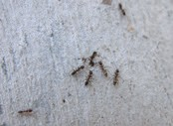

Argentine Ant *(Linepithema humile)* © Marc Widmer

Action 6.10: Develop and implement a communication and engagement strategy

There is a need for the development of a communication and engagement strategy for invasive ants.

Consideration of the best approach to follow for community engagement is guided by the extensive work already established in national eradication and other localised control programs.

Community engagement initiatives have been highly successful for red imported fire ant. For red imported fire ant, 70 per cent of new detections come from reports by the public. Fourteen years after the first ant detection, the fact that 95 per cent of people in Brisbane are aware of red imported fire ant is a testimony to the effectiveness of this program’s engagement strategies, as is the strong in-kind support generated by a large number of stakeholders (e.g. councils). In recent years, communication strategies have been essential in assisting to delimit the red imported fire ant infestation through the ‘Beyond the Edge’ campaign, which actively engaged stakeholders on the edge of the infestation. Core community engagement learnings and activities from the red imported fire ant program should be transferred to other invasive ant programs as appropriate.

An important part of engaging with the community is to provide information about how the invasive ants may affect them directly as well as the impacts on the environment nearby or in which they live. Invasive ants can impact on social and cultural values and norms, and there are possible impacts on human health, predominantly from bites or stings. Further, this needs to be linked to an effective reporting system to link members of the public with diagnosticians and return information to the public, to either inform a national eradication program or a local control program.

However, to further refine community engagement, there is an urgent need to understand the role that general and specific surveillance plays within a successful eradication campaign. Investment needs to analyse the baseline level of reporting and measure the increased activity in a response that can be attributed to engagement programs, and to interpret this increased activity in terms of positive eradication and containment outcomes.

The strategy should also include ways for increasing transparency and communication with a range of stakeholders including non-government organisations, other Commonwealth agencies, state and territory government agencies, local councils and research organisations, as well as the community.

Action 6.11: Build awareness and develop relationships with industries in the high-risk transport and goods import sectors

Strengthening relationships with high-risk sectors may reduce propagule pressure of new invasive ants at the Australian border.

There is a recognised need for the development and implementation of a national communication and engagement strategy to build awareness and strengthen the partnership with high-risk transport and commodity import sectors to prevent the entry of invasive ants. Training packages developed for front-line Department of Agriculture and Water Resources officers should also be used to train personnel in the cargo and import sector as well as the mining industry. Other risk creators in the private sectors could be trained as needed. Other government agencies such as the Department of Defence could also benefit from such training for the movement of their equipment both internationally and locally.

There is also a need to strengthen partnerships with ‘risk’ industries more broadly to encourage them to report any suspect ants (i.e. detected within Australia). Training packages developed for the National Red Imported Fire Ant Eradication Program and National Electric Ant Eradication Program industry stakeholders can inform any new packages developed.

#### Table 8: Summary table of Action Area 6: CROSS-CUTTING ISSUES

**Action Area 6: CROSS-CUTTING ISSUES**

**PRIORITY**

**TIMEFRAME**

Retaining core skills

Action 6.1 Maintain, and ideally increase, Australian expertise in invasive ants, including diagnostics

Action 6.2 Support international collaboration and exchange of information relating to invasive ants

Medium Long term, ongoing

Medium Long term, ongoing

Action 6.3 Deliver training on the control of specific invasive ants Medium Medium term,

ongoing

Governance

Action 6.4 Establish an invasive ant reference group High Short term

Action 6.5 Establish a permanent national body to coordinate national actions on invasive ants

High Short term

Action 6.6 Develop future funding alternatives Medium Medium term

Research

Action 6.7 Improve the modelling tools for spread, habitat and disturbance modelling of invasive ants

Action 6.8 Continue research into other control and monitoring technologies and enhancing available technology

Action 6.9 Continue research into new attractants for monitoring and more effective bait delivery for invasive ants

Medium Medium term

High Short term, ongoing

High Short term, ongoing

Communication and community engagement

Action 6.10 Develop and implement a communication and engagement strategy

Action 6.11 Build awareness and develop relationships with industries in the high-risk transport and goods import sectors

High Medium term

High Short term

# 5 Implementation

The success of this national biosecurity plan will depend on a high level of cooperation between all levels of government, landholders, non-government organisations, community groups, invasive ant experts and other research agencies. Success will depend on all participants in this area of the biosecurity system assessing their roles and responsibilities around invasive ants and allocating adequate resources to achieve the necessary outcomes to protect Australia’s environment, primary industries, urban infrastructure and way of life.

The Environment and Invasives Committee, a subcommittee of the inter-governmental National Biosecurity Committee, will provide formal oversight of the implementation of the plan.

# 6 Monitoring, evaluation and review

The Environment and Invasives Committee will undertake an annual review of progress on implementation of the plan and will report to the National Biosecurity Committee.

A formal review and evaluation of the plan will occur within five years of its release.

# 7 References

Agriculture Victoria (2009). Invasive Plants and Animals Framework. Available at:

[http://agriculture.vic.gov.au/ data/assets/image/0005/179051/invasion_curve_big.jpg](http://agriculture.vic.gov.au/__data/assets/image/0005/179051/invasion_curve_big.jpg). Accessed 21 Dec 2017.

# 8 Acronyms and abbreviations

IPPC International Plant Protection Convention

ISPM International Standards for Phytosanitary Measures NEBRA National Environmental Biosecurity Response Agreement PaDIL Pest and Disease Image Library

# 9 Definitions/Glossary

Ant luring Placing a container or similar in the environment with a food or scent to attract ants.

Approved Arrangement Voluntary arrangements entered into with the Department of Agriculture and

Water Resources in accordance with the *Biosecurity Act 2015* that allow operators to manage biosecurity risks and/or perform the documentary assessment of goods in accordance with departmental requirements, using their own premises, facilities, equipment and people, and without constant supervision by the department and with occasional compliance monitoring or auditing.

Biological control The control of a species by introducing a natural predator or pathogen.

Biosecurity continuum An integrated approach to prevent, detect, contain, eradicate and/or lessen

the impact of a pest or disease through complementary biosecurity activities undertaken offshore (in other countries), at the border and onshore

(within Australia).

Biosecurity risk The likelihood of a disease or pest entering Australian territory or a part of

Australian territory; or establishing itself or spreading in Australian territory or a part of Australian territory; and the potential for any of the following: the disease or pest to cause harm to human, animal or plant health; the disease or pest to cause harm to the environment; economic consequences associated with the entry, establishment or spread of the disease or pest.

Break bulk (of cargo) A system of transporting cargo as separate pieces rather than in containers. Containment Restricting an invasive ant to a defined area without the goal of eradication. Conveyance A means of transport such as an aircraft, vessel, vehicle, or train.

Delimitation Determining the extent of the species spread on the ground through surveillance. Detection Finding an invasive ant.

Diagnostician A person whose job it is to identify species.

Ecological community An assemblage of native species that inhabit a particular area in nature. Entomologist A person who studies insects.

Eradication Eliminating a pest or disease from an area. Eradication is indicated by the pest or disease no longer being detectable.

Established A pest or disease that, for the foreseeable future, is perpetuated within any area and which it is deemed not feasible (either technically or as a result of a benefit:cost analysis) to eradicate.

Exotic A species that is not native.

Goods A raw material or primary agricultural product that can be bought and sold.

Key threatening process A key threatening process threatens or may threaten the survival, abundance or

evolutionary development of a native species or ecological community and:

* + - could cause a native species or an ecological community to become eligible for listing in any category, other than conservation dependent; or
    - could cause a listed threatened species or a listed threatened ecological community to become eligible to be listed in another category representing a higher degree of endangerment; or
    - adversely affects two or more listed threatened species (other than conservation dependent species) or two or more listed threatened ecological communities.

Myrmecologist A person who studies ants.

Native A species, subspecies, or lower taxon, occurring within its natural range (past or present) and dispersal potential (i.e. within the range it occupies naturally or could occupy without direct or indirect introduction or care by humans).

Pathway The way that an invasive ant may reach the border.

Phytosanitary Relating to the health of plants, especially with respect to the requirements of

international trade.

Prevention Stopping an invasive ant from approaching the border.

Proof of freedom Where surveillance activities carried out by the parties in accordance with the

approved national biosecurity incident response plan indicate that the pest or disease has been eradicated.

Response The management actions undertaken when an invasive ant is detected. The response may be formalised through a national agreement or response plan.

Sentinel site A site of continuous surveillance.

Surveillance The systematic investigation, over time, of a population or area to collect data and information about the presence, incidence, prevalence or geographical extent of a pest or disease. Surveillance includes active and passive approaches.

Threat abatement plan A plan, under the EPBC Act, that addresses a key threatening process. Taxonomist A biologist who groups organisms into categories and can identify invasive ants.

# National Invasive Ant Biosecurity Plan—Implementation Summary

The Environment and Invasives Committee, a subcommittee of the inter-governmental National Biosecurity Committee, will provide formal oversight of the implementation of the plan. This table summarises the actions identified in the *National Invasive Ant Biosecurity Plan* relating to prevention, detection, response, containment, asset-based protection (ongoing management) and cross-cutting issues.

Timeframes (from plan): Timeframe: SHORT up to 3 years; MEDIUM 3 to 8 years; LONG 8 to 10 years, VERY LONG 10 years and beyond.

The lead, notes on how to implement, and potential cost or people resources are provided as a guide to organisations to identify where they can invest their available or future resources.

**other actions**

|  |  |  |  |  |  |  |  |
| --- | --- | --- | --- | --- | --- | --- | --- |
| **ACTION AREAS** | **Lead** | **Priority** | **Timeframe** | **Notes – how to implement** | **Potential cost/people** | **Dependencies to** | **Status** |
| 1. PREVENTION |  |  |  |  |  |  |  |
| 1.1 Conduct risk | DAWR (existing | High | Short term | Risk assessment will include consideration | Fourth quarter 2018. | Supports many other |  |

assessments for high priority exotic species

1.2 Support PaDIL or

another system to host resources for the identification of native and exotic ant species

resources)

Project commenced in 2017–18

PHC (DAWR

existing resources initially)

of biology, interception data, import pathways, modelling, risk mitigation/ management options. Risk assessments need to be conducted on individual species but the identification of functional groups will help.

Over time cross-reference to ants identified in the ABARES priority species project

and also to the Invasive Species Council invertebrates risk assessment project.

Medium Medium term DAWR to determine future with PHC.

Queensland Museum may be able to assist with linking information.

$500,000 to deliver new platform for images, limited long term costs for maintenance of images.

DAWR is nominally involved, subject to budget and resource considerations. This will not necessarily be funded separately, as it makes sense to consider this in conjunction with interlinked actions.

actions.

Relates to 1.3, 2.1, 2.2, 

and 2.3.

**Status**

**Dependencies to other actions**

**Potential cost/people**

**Notes – how to implement**

**Timeframe**

**Priority**

**Lead**

**ACTION AREAS**

considerations. This will not

as it makes sense to consider this actions.

images relates to 1.2.

container standard

Supported by 1.1.

partners on incidental contamination

resources)

supports many other actions.

2. DETECTION

* 1. Utilise the taxonomic key for the identification of invasive ants

|  |  |  |  |  |  |  |  |  |
| --- | --- | --- | --- | --- | --- | --- | --- | --- |
| 1.3 | Establish a National Reference Collection for ants | DAWR (project)  Project commenced in 2017–18 for imagery | Medium | Medium term | Further imagery and molecular data required. | DAWR is nominally involved, subject to budget and resource  necessarily be funded separately, in conjunction with interlinked | Platform to share |  |
| 1.4 | Support an international shipping | DAWR (existing resources) | High | Very long term | International policy work undertaken by DAWR | N/A | Relates to 1.5, and 6.2. |  |
| 1.5 | Engage with trading | DAWR (existing | High | Short term | International work undertaken by DAWR. | N/A | Relates to 1.4, 6.2 and |  |

* 1. Develop a diagnostic handbook for invasive ants and training of diagnosticians

TBC

(*entomologists— CSIRO, museum or university*)

DAWR (project)

Project commenced in 2017–18

to develop specialised training

High Short term The key developed by CSIRO separates

all native Australian species from exotic species established in Australia, as well as a few other exotic species not yet present in Australia, and will continue to be expanded to include other species that are known to exist outside of their native range.

Queensland Museum may be able to assist with resources on invasive ant species under eradication in Australia.

High Short term Development of specialised training.

Delivery of training and handbook.

Ongoing people time to make the keys—which will be Australian myrmecologists and those with international

knowledge. Support for ensuring the keys are utilised for effective identification.

DAWR is nominally involved, subject to budget and resource considerations. This will not necessarily be funded separately, as it makes sense to consider this in conjunction with interlinked actions.

Relates to 1.2, 1.3, 2.1 

and 2.3.

Relates to 1.2, 1.3, 2.1 

and 2.3.

**Status**

**Dependencies to other actions**

**Potential cost/people**

**Notes – how to implement**

**Timeframe**

**Priority**

**Lead**

**ACTION AREAS**

protocol for each species/genera.

subject to budget and resource necessarily be funded separately, in conjunction with interlinked

and 2.3, 2.6, and 3.1.

staff undertaking this action.

2.9.

under Approved

under area 1 and 2 will assist DAWR staff

2.9.

surveillance beyond ports

* 1. to be at least partially complete to determine the approach of the strategy.

the EIC Terrestrial Invertebrates WG drafts for adaption by each jurisdiction.

Six months, $50,000 to develop a strategy. Will then require implementing.

2.3. Relates to 2.4, 2.5, 2.9, and 3.1.

|  |  |  |  |  |  |  |  |  |
| --- | --- | --- | --- | --- | --- | --- | --- | --- |
| 2.3 | Develop and validate diagnostic protocols to support surveillance | TBC  (*Entomologists – CSIRO, museum or university*  *for technical information. Roll-out may be the above or governments*) | High | Long term | Draw on international work already developed (e.g. PIAT key). | Six month project or $50,000 to develop and validate a diagnostic  DAWR is nominally involved, considerations. This will not  as it makes sense to consider this  actions. | Relates to 1.2, 1.3, 2.1 |  |
| 2.4 | Monitor and inspect port areas | DAWR (existing resources) | High | Short term, ongoing | Ports are already monitored for invasive ants. Actions under area 1 and 2 will assist DAWR | N/A | Relates to 2.5, 2.6, and |  |
| 2.5 | Undertake mandatory trapping and monitoring at facilities operating  Arrangements | DAWR (existing resources) | High | Short term, ongoing | DAWR and Approved Arrangements staff already monitored for invasive ants. Actions  undertaking this action. | N/A | Relates to 2.4, 2.6, and |  |
| 2.6 | Develop a strategy for | Jurisdictions | High | Long term | This action will require actions 1.1, 2.2, | Could be a national strategy that | Requires 1.1, 2.2 and |  |

**Status**

**Dependencies to other actions**

**Potential cost/people**

**Notes – how to implement**

**Timeframe**

**Priority**

**Lead**

**ACTION AREAS**

* 1. Develop national

training programs for government and industry

* 1. Increase national

industry awareness

* 1. Develop a strategy for prophylactic baiting at high priority locations

TBC

(*Training package will require entomologists working in association with an educator familiar with national training program development. May need to be overseen by government.*

*Delivery by governments*)

TBC, relates to 6.10

(*Government based liaison person)*

Jurisdictions and DAWR at ports

Medium Short term Biosecurity Queensland is developing a

Cert 4 in Pest Management for Invasive Ant Species using the Australian Qualifications Framework and non-competency based skills packages aimed at government and industry personnel.

Check BQ’s work is applicable for all priority ant species and also for key industries.

Medium Short term This action is focused at key industries.

Could be a specific roll-out of action 2.7.

Delivery to First Ports and Approved Arrangements will be in association with other training provided by DAWR.

High Long term Would be done at ports or approved

arrangements in association with inspection, surveillance and other current risk assessment procedures. May be appropriate for places such as automatic container terminals where surveillance is more challenging.

Needs actions under areas 1 and 2 to provide risk assessment and protocols to implement.

One year $120,000 to develop training package.

Delivery to First Ports and Approved Arrangements will be in association with other training provided by DAWR.

Roll-out to other areas/industry part-time position over time.

$60,000 pa.

Implement national communication strategy to raise awareness of biosecurity, including invasive ants (as per 6.10).

There will be a role for the National Communication and Engagement Network.

Probably require one person part- time per industry or jurisdiction to liaise and assist with roll-out.

Need to develop strategy/plan, undertake research perhaps and then roll out as business as usual activity.

Relates to 2.8, 6.10, 

and 6.11.

Relates to 2.7, 6.10, 

and 6.11.

Relates to 2.3, 2.4, 2.5, 

2.6, and 3.1.

**ACTION AREAS**

**Lead**

**Priority**

**Timeframe**

**Notes – how to implement**

**Potential cost/people**

**Dependencies to other actions**

**Status**

3. RESPONSE

* 1. Develop standardised response procedures for invasive ants

DAWR (project) Yet to commence

High Medium term DAWR project. Will be in line with

requirements under NEBRA.

$120,000/12 months. Informed by many 

other actions.

* 1. Test and validate

chemicals and products to treat invasive

ants found to be effective overseas

TBC

(*Consultancy run by government*)

Medium Medium term Step 1: review potential candidates for

Australia.

Step 2: experimental research to test effectiveness in Australian conditions and potential non-target risks.

Step 3: seek registration.

Step 1: Review, 6 months either in-house or consultant. $80,000.

Step 2: Research stages. $0.5–

$1 million.

Step 3: Registration package writing and registration costs.

Relates to 3.3, and 3.4. 

* 1. Select the best eradication tools based on national and

international experience

Jurisdictions, input to 3.1

Medium Short term, ongoing

Review of existing tools applicability to other species or locations.

Included in 3.1. Will inform 3.1. 

* 1. Examine biological control and genetic tool options

TBC

(*Biological control review could be a consultancy*)

Medium Long term An action to link in with other groups

examining genetic technology for invasive species. Review projects to identify possible biological control agents or genetic tools.

Consideration of genetic tools needs to fit in with other conversations/ research related to other invasive species.

Regulatory steps are required once an agent (of either variety) is found.

Initial assessment $80–100,000.

Lots for any further examination of potential tools and multiple years.

Will support many 

other actions.

* 1. Develop and validate cost-effective field based diagnostic surveillance tools

TBC

(*Researchers— CSIRO, university or museum*)

Medium Medium to long term

Continue work on lateral-flow devices. Identify and commence work on others. Links with Action 2.3 (detection tools).

Research to start with then field trials prior to deployment.

Research or field trial project: variable but $250,000 for a 1–2 year project.

Relates to 2.1, 2.2 and 

2.3 and supported by many other actions.

**Status**

**Dependencies to other actions**

**Potential cost/people**

**Notes – how to implement**

**Timeframe**

**Priority**

**Lead**

**ACTION AREAS**

invasive ant programs

Invertebrates WG and using Could be undertaken as part of

arrangements for scientific basis

5.1, 6.1, 6.2, 6.7, 6.8,

with knowledge/ant programs. jurisdiction to undertake their

3 months, $40,000 for

2.6, 3.1, 3.6, 4.1, 5.1,

work, part-time including

of invasive ants when they establish new populations

needed and these need to be rolled out to land managers.

surveillance practices $250,000 for a 2 year project.

Roll-out via the communications and engagement action.

6.9, 6.10 and 6.11.

|  |  |  |  |  |  |  |  |  |
| --- | --- | --- | --- | --- | --- | --- | --- | --- |
| 3.6 | Analyse the lessons learnt from eradication programs, and transfer knowledge and expertise to other | Jurisdictions | High | Short term | There will be a substantial amount of this information already in reporting—collation and dissemination to others a key. | Coordinated by the EIC Terrestrial government people.  implementing 3.1. | Will inform 3.1. |  |
| 3.7 | Ensure harmonised | PHC (existing | High | Short term | Refer to Plant Health Committee for | Subcommittee on Domestic | Informed by 1.1. |  |
|  | compliance  interstate trade have a | resources) |  |  | implementation advice. | Quarantine and Market Access. |  |  |
| 4. CONTAINMENT | | | | | | | | |
| 4.1 | Profile pathways, vectors and goods for the movement of established invasive ants between regions  and states/territories in Australia | Jurisdictions | High | Short term | Profiles to be established from risk assessments and grouping of invasive ants by pathways. Second stage is for the risk mitigation. | First stage can be done as a discrete project with  assistance from jurisdictions  Second stage will require each necessary bit, probably in-house. | Informed by 1.1, 4.2,  6.9, and 6.11. |  |
| 4.2 | Map the potential | TBC | Very high | Short term | Mapping project. | Complexity of the project will | Informed by 1.1, 4.1, |  |
|  | distributions for the  established invasive  ants for containment or | (*Government environmental* |  |  |  | determine person time and cost. | 5.1, 6.1, 6.2 and 6.7. |  |
|  | control | *modellers*) |  |  |  | one species. |  |  |
| 4.3 | Develop contingency plans for invasive ant incursions at high priority sites | Site managers | Medium | Short to medium term | Standardised response procedures will assist (action 3.1), although they need to be site specific. | Site specific contingency plans would be developed by or for site managers. Possibly 6 months’  consultation. | Supported by 1.1, 2.3,  6.1 and 6.2. |  |
| 4.4 | Improve the detection | Researchers | Medium | Medium term | New tools, surveillance practices are | Development of tools and | Supported by 6.7, 6.8, |  |

#### 

**ACTION AREAS**

**Lead**

**Priority**

**Timeframe**

**Notes – how to implement**

**Potential cost/people**

**Dependencies to other actions**

**Status**

5. ASSET-BASED PROTECTION/ ONGOING MANAGEMENT

established priority

undertake work.

2.1, 2.2, and 2.3.

of invasive ants and

of the same species.

year project.

6.1 and 6.2.

localised areas where would provide agricultural or human

2.1, 3.6, 4.2, 5.1, 5.2,

$3.5–4.5 million. Eradication

years, with a further 2 years of monitoring.

and 6.2.

|  |  |  |  |  |  |  |  |  |
| --- | --- | --- | --- | --- | --- | --- | --- | --- |
| 5.1 | Ensure key physical and ecological attributes are known for the  invasive ants | Researchers | Very high | Short term | Project to determine what needs to be done for the established ants. Then | Review project to determine needs $80,000. | Supported by 1.2, 1.3, |  |
| 5.2 | Develop strategies for | Researchers and | Medium | Medium term | Ongoing management plans to be | Research or field trial project: | Informed by 1.2, 1.3, |  |
| long term suppression project managers developed, and shared between managers variable but $250,000 for a 1–2 2.1, 3.6, 4.2, 5.1, 5.3,  thresholds for control in Sharing of knowledge via | | | | | | | | |
|  | localised areas |  |  |  |  | collaborative groups (in kind). |  |  |
| 5.3 | Undertake ongoing control programs for invasive ant species in  such management significant biodiversity, benefits | Land managers | High | Short term, ongoing | Need to define the assets being protected. | Control programs 5+ days per year. | Informed by 1.2, 1.3,  6.1 and 6.2. |  |
| 5.4 | Eradicate invasive ants | Island managers | High | Short to | Eradication programs using baiting. | Costs will vary depending on | Informed by 1.2, 1.3, |  |
|  | from smaller islands |  |  | medium term | Site specific plans will be required for  each island. | remoteness and species. Upper  bound for a remote site about  programs are likely to take 1–2 | 2.1, 3.6, 4.2, 5.1, 6.1 |  |

**Status**

**Dependencies to other actions**

**Potential cost/people**

**Notes – how to implement**

**Timeframe**

**Priority**

**Lead**

**ACTION AREAS**

effectiveness of the

of programs. May be able to adapt other compile currently used protocols.

4.2, 5.1, 5.6, 6.1, 6.2,

knowledge about ants into invasive ant management

medium (location dependent)

during planning phase.

5.3, 5.4, 5.5 and 6.3.

6. CROSS CUTTING ISSUES

* 1. Maintain, and ideally increase, Australian expertise in invasive ants, including diagnostics

|  |  |  |  |  |  |  |  |  |
| --- | --- | --- | --- | --- | --- | --- | --- | --- |
| 5.5 | Ensure there are monitoring protocols to assess invasive  ant species impacts on biodiversity and to understand the  control program | Researchers and project managers | High | Short, medium and long term | A suite of monitoring protocols suitable for different scales, budgets and resources for local groups to measure the effectiveness  biodiversity monitoring protocols or | Compilation and development of protocols, 1 year project,  $120,000. | Informed by 1.2, 2.1,  6.8 and 6.9. |  |
| 5.6 | Include Indigenous | Project managers | Low- | Medium term | Should be built into the planning process. | May require additional time | Informs 4.3, 4.4, 5.2, |  |

Jurisdictions Medium Long term,

ongoing

Provision of scholarships to attract students to myrmecology.

Australian Government Research Training Program Stipend Scholarship is worth $27,082 pa and awarded for 3 years.

DAWR Priority Pest and Disease Planning and Response and Surveillance announcement in 2018–19 and ongoing includes building national diagnostic capability through scholarships and other mechanisms.

Once implemented 

will inform 1.1, 1.3, 2.1,

2.2, 2.3, 2.5, 3.5, 5.1,

and 6.2.

* 1. Support international collaboration and exchange of information relating to invasive ants

DAWR (existing resources)

Medium Long term, ongoing

Opportunities in plan are to feed into international sites, international

partnerships, and publications. Establish an international group, initially based on the people at the 2016 workshop + recommendations.

Coordination of the group needs to be formal and with one Lead. EIC TIWG should be involved by not coordinating (see Action 6.5).

Opportunistic. Minimal cost.

Ideally, eradication programs should provision for sharing of information (e.g. time to write papers and/or technical website materials).

Relates to all actions. 

**Status**

**Dependencies to other actions**

**Potential cost/people**

**Notes – how to implement**

**Timeframe**

**Priority**

**Lead**

**ACTION AREAS**

control programs underway in Australia YCA—CSIRO, WTMA, Parks Australia, AA CSIRO, and Browsing ant – WA, NT).

provide time for these people to undertake

1 person. be variable.

6.11.

*coordinate*)

coordinate national

all other actions.

of 2.4, 2.5, 2.6, 2.7, 2.8,

Biosecurity Committee.

and resources.

enhancing available technology

*museum)*

6.9.

|  |  |  |  |  |  |  |  |  |
| --- | --- | --- | --- | --- | --- | --- | --- | --- |
| 6.3 | Deliver training on the control of specific invasive ants | TBC  (*Coordinated by governments*) | Medium | Medium term, ongoing | Similar to action 2.7. Develop training package and deliver, except that this is a different audience (local groups).  First step is to identify skilled people within the localised eradication, containment and  for invasive ants (e.g. RIFA – Qld, EA—Qld,  – Parks Australia, ABHA—Parks Australia,  Skilled people—additional incentives to the skill transfer work? | Development of a training package for several ants, 1 year,  Delivery requirements will | Relates to 2.7, 2.8, and |  |
| 6.4 | Establish an invasive ant | TBC | High | Short term | Group of Australian ant experts. Should | Will require some (minimal) | Supports delivery of |  |
|  | reference group | (*EIC TIWG to* |  |  | work with the EIC TIWG. | secretariat support. | all other actions. |  |
| 6.5 | Establish a permanent national body to  actions on invasive ants | EIC | High | Short term | EIC TIWG to oversee. | In-kind. | Supports delivery of |  |
| 6.6 | Develop future funding  alternatives | TBC Medium  (*Consultancy led by* | | Medium term | Project to consider who are risk creators in  the spread and establishment of invasive | Consultancy $80,000. Some work is in progress | May support delivery |  |
|  |  | *government*) |  |  | ants and determine if they can contribute  to funding responses. | through the National | 2.9, 3.7, and 6.11. |  |
| 6.7 | Improve the modelling | TBC | Medium | Medium term | Probably linked to action 1.1 and 4.2. | Improvement of modelling tools, | Informed by 1.1, 4.1, |  |
|  | tools for spread, habitat  and disturbance  modelling of invasive | (*Government environmental* |  |  | Would need to scope to determine cost | 2 year project $250,000. | 4.2, and 5.1. |  |
|  | ants | *modellers*) |  |  |  |  |  |  |
| 6.8 | Research into other | TBC | High | Short term, | Research projects into new technologies | Research project: variable but | Informed by 1.1, 4.1, |  |
|  | control and monitoring  technologies and | (*Researchers—*  *CSIRO, university* | *or* | ongoing | and their applicability to invasive ants. | $250,000 for a 1–2 year project. | 4.2, 5.1, 6.1, 6.2, and |  |

**Status**

**Dependencies to other actions**

**Potential cost/people**

**Notes – how to implement**

**Timeframe**

**Priority**

**Lead**

**ACTION AREAS**

* 1. Continue research into new attractants for monitoring and more effective bait delivery for invasive ants

TBC

(*Researchers— CSIRO, university or museum)*

High Short term, ongoing

Research projects into new attractants for invasive ants.

Research project: variable but

$250,000 for a 1–2 year project.

Supports delivery of 

2.5, 2.6, 2.9, 3.1, 3.2,

3.3, 3.5, and 5.5.

* 1. Develop and implement a communication and engagement strategy

TBC

(*Governments, possibly a consultancy. Could be a project of the EIC TIWG; NCN role*0

High Medium term Scope of the communication and

engagement strategy will need to be determined.

RIFA SE Qld eradication program uses ~$1 m and 6 staff.

Scope may be most effective to be broader than ants, but include them as a key topic.

Supports delivery of 

many other actions.

* 1. Build awareness and develop relationships with industries in the high-risk transport and goods import sectors

DAWR

(existing resources)

High Short term This could be implemented in association

with or using material developed for action 2.7.

Ongoing business as usual for DAWR.

Relates to 2.7, and 2.8. 