**INTERIM CLASSIFICATION OF AQUATIC ECOSYSTEMS IN THE MURRAY-DARLING BASIN**

**Stage 2 report:** database version 1.6

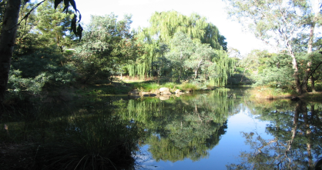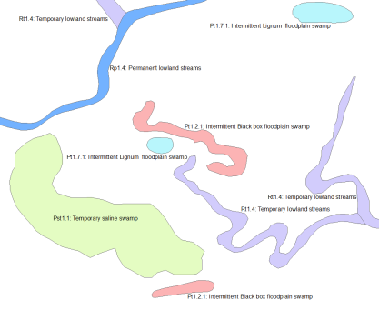

**Prepared for the Commonwealth Environmental Water Office and Murray-Darling Basin Authority**

**by Peter Cottingham & Associates**

**April 2014**

**Citation:** Brooks S., Cottingham P., Butcher R. and Hale J. (2014). Murray-Darling Basin aquatic ecosystem classification: Stage 2 report. Peter Cottingham & Associates report to the Commonwealth Environmental Water Office and Murray-Darling Basin Authority, Canberra.

**Acknowledgements:**

The Technical Advisory Group and project steering committee provided valuable feedback and suggestions for this report. The Technical Advisory Group was comprised of the following:

Nick Bond (Griffith University)

Wes Davison (Queensland Department of Environment and Heritage Protection)

Ashraf Hanna (Murray-Darling Basin Authority)

Janet Holmes (Department of Environment and Primary Industries Victoria)

Mark Kennard (Griffith University)

Dale McNeil (South Australia Department of Environment, Water and Natural Resources)

Matt Miles (South Australia Department of Environment, Water and Natural Resources)

John Patten (New South Wales Office for Environment and Heritage)

Allan Raine (New South Wales Office of Water)

Mike Ronan (Department of Environment and Heritage Protection)

Rebecca Turner (South Australian Murray-Darling Basin Natural Resources Management Board)

Maria Vandergragt (Queensland Department of Science, Information Technology, Innovation and the Arts)

Paul Wainwright (South Australia Department of Environment, Water and Natural Resources)

Paul Wilson (Department of Environment and Primary Industries Victoria)

Andrea White (Department of Sustainability and Environment Victoria)

Rebecca White (Murray-Darling Basin Authority).

The Steering Committee, focusing upon the application of the classification to environmental water management, was comprised of:

Ben Docker (Commonwealth Environmental Water Office)

Janet Holmes (Department of Environment and Primary Industries Victoria)

Geoff Lundie-Jenkins (Department of Environment and Heritage Protection)

John Patten (New South Wales Office for Environment and Heritage)

Bridie Velik-Lord (Victorian Environmental Water Holder)

Adam Vey (Murray Darling Basin Authority)

Paul Wainwright (South Australia Department of Environment, Water and Natural Resources).

Our thanks also go to the following people and organisations that greatly assisted with the supply of mapping and attribute data, and information on the CSIRO cluster project:

John Gallant (CSIRO)

Matt Miles (South Australia Department of Environment, Water and Natural Resources)

Mark Kennard (Griffith University)

Nick Bond (Griffith University)

Matt Bolton (Department of Sustainability, Environment, Water, Population and Communities, National Vegetation Information System)

Natalie Lyons (Department of Sustainability, Environment, Water, Population and Communities, National Vegetation Information System)

Deb Nias and Rhonda Sinclair (Murray Wetlands Working Group)

Namoi Catchment Management Authority

Murrumbidgee Catchment Management Authority.

Our thanks also go to the advice provided by Commonwealth Environmental Water Office staff, including Alana Wilkes, Amy O’Brien and Ben Docker, Murray-Darling Basin Authority staff, including Adam Vey, Rebecca White, Ashraf Hanna and Ian Neave, and Neil Freeman.

The funding for this project was provided jointly by the Commonwealth Environmental Water Office and the Murray-Darling Basin Authority.

**Disclaimer:**

The views and opinions expressed in this publication are those of the authors and are presented for the purpose of informing and stimulating discussion for improved management of the Murray-Darling Basin’s natural resources. They do not necessarily reflect the views and opinions of the Australian Government, the Minister for the Environment, or the Murray-Darling Basin Authority.

While reasonable efforts have been made to ensure the contents of this publication are factually correct, the Commonwealth does not accept responsibility for the accuracy or completeness of the contents, and shall not be liable for any loss or damage that may be occasioned directly or indirectly through the use of, or reliance on, the contents of this publication. Guidance on the development of the Interim Australian National Aquatic Ecosystem (ANAE) Classification Framework is an area of active policy development. Accordingly there may be differences in the type of information contained in this report, to those using future versions of the ANAE.

This information does not create a policy position to be applied in statutory decision making. Further it does not provide assessment of any particular action within the meaning of the *Environment Protection and Biodiversity Conservation Act 1999* or *Water Act 2007*, nor replace the role of the Minister or his delegate in making an informed decision on any action.

**Executive Summary**

The Commonwealth (for the purpose of this report comprising the Commonwealth Environmental Water Holder and Murray-Darling Basin Authority (the Authority), in collaboration with State jurisdictions and other stakeholders, is seeking to implement a classification framework for aquatic ecosystems within the Murray-Darling Basin (MDB). There is currently no consistent, agreed definition or spatial delineation of aquatic systems in the MDB from which to identify asset types. The Commonwealth holds over 1,700 gigalitres of registered water entitlements in the MDB that must be managed in accordance with the environmental watering plan that is as part of the Basin Plan. A classification of aquatic systems in the MDB might assist in the implementation of the Basin Plan and the management of the Commonwealth's environmental water.

The Commonwealth has engaged Peter Cottingham & Associates to undertake a two-stage project to:

1. In collaboration with the Commonwealth and state jurisdictions, confirm the feasibility of implementing a classification framework that is relevant to environmental water management, and depending on the outcomes of this stage
2. Implement the preferred classification framework across the MDB on an interim basis.

This report describes the outcomes of Stage 2 activities. The outcomes of Stage 1 are reported in Cottingham et al. (2012).

An Australian National Aquatic Ecosystem (ANAE) Classification Framework has been developed by a multi-jurisdictional Aquatic Ecosystems Task Group (AETG 2012). The ANAE framework is a ‘top down[1]’ (rules-based) approach to classification that includes provision to include both surface and subterranean aquatic ecosystems. The surface water ecosystems include freshwater, marine and estuary systems. As this project focuses on the MDB, marine systems were omitted. In addition, it was considered that there is insufficient information and knowledge available to include subterranean aquatic ecosystems. The project, therefore, includes freshwater and estuarine aquatic ecosystems types. While there are thousands of riverine (river), lacustrine (lake), palustrine (wetland) and floodplain ecosystems across the MDB, the only estuarine system in the Basin is the Coorong and Murray Mouth system where the River Murray connects to the sea.

The implementation of the ANAE framework for this project is based on the application of best available mapping and attributes data for aquatic ecosystems across the MDB. Wherever possible, the best available mapping and attribute data was included in the classification. It is important to note that the scale and coverage of available mapping and attribute data varies considerably across the MDB. This project is, therefore, considered as an “interim classification”, noting the expectation that the classification will be updated and refined as new data becomes available or if the ANAE framework is modified. Despite its ‘interim’ nature, a major benefit of the project has been to collate Basin-wide and State mapping and attribute data into a single repository.

The ANAE framework includes three levels of attribute data. Level 1 attributes include such national and regional data related to national climate, landform and hydrological patterns. Level 2 attributes are similar to Level1 but applied at sub-catchment scales. Level 3 attributes are applied to individual aquatic ecosystems (Table 1).

Table 1: List of Level 3 ANAE attributes

|  |  |
| --- | --- |
| **Riverine, palustrine, lacustrine, floodplain ecosystems** | **Estuarine ecosystems** |
| * Landform   + Confinement (riverine only)   + Soils   + Substrate   + Water source   + Water type   + Water regime   + Vegetation/fringing vegetation | * Substrate * Structural macrobiota * Light availability * Nutrient availability * Water depth * Exposure. |

The combination of attributes (and associated metrics) means that an application of the ANAE framework to the MDB can result in hundreds of classes. A typology has been developed to group these classes into a smaller, ecologically meaningful number of aquatic ecosystem types (e.g. permanent freshwater lakes, temporary woodland swamps, and permanent lowland rivers). The typology includes several, but not all, of the Level 3 attributes for each of the ecosystem classes. Given the intended application to environmental water decisions, key attributes included in the typology are water type, water regime (or water permanency), landform and vegetation. The typology is nested and can be used to describe a given aquatic ecosystem at a minimum of two levels, typically with each level having greater specificity as the number of attributes used increases. In the first instance the types were informed by the Level 3 ANAE attributes (e.g. Table 29), however some Level 2 attributes (location on a floodplain) have also been used. The typology proposes 16 lacustrine types, 48 palustrine types, 10 riverine types, 19 floodplain types and 17 estuarine types.

Table 2: Generic structure of typology

|  |  |
| --- | --- |
| ANAE class and attribute combinations | Type |
| Lacustrine | Lakes |
| Lacustrine + Level 3 water type | Lakes  Saline Lakes |
| Lacustrine + Level 3 water type + Level 3 water regime | Permanent lakes  Temporary lakes  Saline permanent lakes  Saline temporary lakes |

The total number of aquatic ecosystems for the entire MDB is presented as follows for lacustrine, palustrine, riverine, floodplain and estuarine systems. Overall, over 250,000 polygons and lines representing aquatic ecosystem features across the MDB were assigned with attribute data using the ANAE framework. Approximately 8,400 lacustrine (lake) were classified into 15 (of the 16 proposed) lacustrine types and 37,000 palustrine (wetland) features were classified into 47 (of the 48 proposed) palustrine types. Approximately 157,000 riverine (stream segments) and 33,000 floodplain units were classified into 10 riverine and 19 floodplain types respectively. Features within the Coorong and Murray Mouth were classified to only eight of the 17 estuarine types. It is recommended that both the estuarine typology and the scale at which it is applied is reviewed when the Aquatic Ecosystem Task Group completes its review of the attributes that are to be assigned to estuarine systems within the ANAE framework.

Three lacustrine types, ten palustrine types, one floodplain type and seven estuarine types were found to have a relatively low representation in the classification framework (arbitrarily defined as having 10 representatives or less) across the MDB. Further investigation into the data supporting the low representation of the types listed above, and/or ground-truthing is recommended to confirm whether or not they are rare or if rarity is an artifact of the available data.

Given the focus of environmental water management on systems (such as lake and palustrine) that occur on the floodplain, the classification of aquatic ecosystems differentiates those which do occur in floodplain ecosystems from those that don’t. Across the MDB, approximately 37 percent of lacustrine systems and 46 percent of palustrine systems

are located on floodplains. Further information on the distribution of types associated with each aquatic ecosystem (lacustrine, palustrine, riverine, and floodplain) is provided for each jurisdiction later in the report.

The ANAE framework is not the only approach to classification that exists for the MDB. There are many state-based classification schemes. Further, a ‘bottom-up’ statistical classification[2] has been developed as part of the CSIRO ‘*Murray-Darling Basin aquatic ecosystem mapping and classification project’* (hereafter the ‘Cluster Classification’ project). A link has been maintained between the Cluster Classification project and this application of the ANAE framework through Cluster Classification project representation on the Technical Advisory Group, and by undertaking two tasks. Firstly, the attributes that discriminated between the Cluster Classification classes were considered. It was found that attribute data exist along a continuum, rather than being categorical, as indicated by low overall class strength for each aquatic system classification. Secondly, a comparison of outputs highlighted differences between the classification results, which were not surprising given the ‘bottom up’ statistical classification of the Cluster Classification and the ‘top down’ rules-based classification and typology of the ANAE framework. The fundamental differences in method, combined with the use of different attribute data[3] accounts for the low levels of concordance between the outputs of the two approaches.

However, having a number of classification methods at hand can serve to strengthen decision-making in the future. For example, this application of the ANAE framework (although interim at this stage) will establish a broad understanding of ‘what type of aquatic ecosystem is it’ and ‘where is it’ that will persist over time, as the approach to attributing data and classifying aquatic ecosystems is consistent. The typology developed for this application of the ANAE framework is transparent, consistent with many classification schemes currently in use, and easily interpreted by water managers. Thus this application of the ANAE framework built on a standard terminology that can be used as a communication tool. The Cluster Classification approach can complement the ANAE approach by providing insights on statistical relationships between attributes and aquatic ecosystems that may not be evident when using the ANAE framework. In terms of implications for the current application of ANAE framework to the MDB, the Cluster Classification has reinforced the need to consider the following:

* Key differences between the method and aquatic ecosystem and attribute data used for each classification. Given the differences and low concordance between the results, the choice of classification to apply to informing a particular question will depend on factors such as preference for an output based on a rules-based or statistical method, and the need for a basis in data consistent across the MDB or where finer-scale mapping is required.
* The scale at which aquatic ecosystems are best mapped; both approaches map riverine systems at a similar scale, albeit by different methods. If fine-scale mapping of lacustrine and palustrine systems is an important consideration, then the ANAE classification is well placed as it uses the best-available mapping scales.
* The retention of playas such as ‘clay pans’ in the ANAE classification will be important, as these have been shown to be a distinct class in the Cluster Classification.

Undertaking this ‘interim’ application of the ANAE framework has highlighted a number of ways in which it can be improved in the future. The following are recommendations that will improve the mapping and attribute data:

* Further investigation and design of approaches to use the classification to determine rarity of aquatic ecosystem types is recommended, as is ground-truthing to reveal if they have been misclassified or are indeed uncommon in the Basin. Furthermore, the relative abundance would need to be considered with respect to the expected or suitable representativeness, given variation in watering requirements. Any assessment of representativeness or rarity should consider these new datasets.
* There are a number of activities currently underway that will produce information and data useful for future iterations of the ANAE framework. It is recommended that an annual review of available mapping and attribute data be undertaken, with a view to including outputs from the following:
  + Queensland groundwater interaction mapping (completed May 2012);
  + The Authority vegetation modelling project (due for completion in 2013);
  + The Authority floodplain modelling project (due for completion in 2015);
  + Future updates of National Vegetation Information System (NVIS) (ongoing)
* The way river features were mapped (pruning fine-scale river segments to match the 1:250,000 scale Geofabric 2.0 mapping) under-represents headwater systems present in the 1:100,000 scale jurisdiction mapping. A future application of the ANAE should be carried out on the original jurisdiction mapping to provide a more complete representation of the river network that includes the headwater systems.
* The AETG is currently updating the attributes to be assigned to estuaries. It is recommended that the attribution, typology and scale at which they apply are reviewed once the AETG has completed it revision.
* Landform and confinement definitions might benefit from a more systematic statistical comparison with the New South Wales River Styles data. Analysis should be undertaken before aligning the two, to consider the relative merits of each approach.

This report describes the development of Version 1.0 of the classification and typology. A number of validation exercises were undertaken by participating jurisdictions upon completion of the first version and suggestions were implemented. These validations are detailed in Section 5.6.2 and led to significant improvements in the quality of the dataset with an update to version 1.4. Results presented in section 6 have been revised accordingly to version 1.4.

**Table of Contents**

1 Introduction 1

1.1 Project background 1

2 Finalisation of attribute and metric definitions 3

2.1 Structure of ANAE 3

2.1.1 Aquatic ecosystems 3

2.1.2 ANAE framework 3

3 Application of the ANAE Framework to the Murray-Darling Basin 5

3.1 Base mapping of aquatic ecosystem features. 6

3.1.1 Geofabric v2 6

3.1.2 Finer scale jurisdiction data 8

3.1.3 “Quasi-fabric” – Representing the Geofabric Riverine systems with higher resolution data 9

3.1.4 Wetland mapping (Palustrine and Lacustrine systems) 11

3.1.5 Assigning Riverine, Palustrine and Lacustrine 14

3.1.6 Floodplains 14

3.2 ANAE attributes 17

3.2.1 General approach for applying attributes in GIS 17

3.2.2 Level 1 and Level 2 attributes 18

3.2.3 Level 3 attributes 19

3.3 Riverine, Lacustrine, Palustrine and Floodplain attributes 21

3.3.1 Landform 21

3.3.2 Confinement 24

3.3.3 Soils and substrate 26

3.3.4 Water source 31

3.3.5 Water type 32

3.3.6 Water regime (permanency) 34

3.3.7 Vegetation 36

3.4 Estuarine attributes 39

3.5 Arthur Rylah Institute vegetation mapping (Victoria) 40

4 Geodatabase Structure 47

4.1.1 Confidence ratings 48

5 Aquatic ecosystem typology 53

5.1 Example typologies 53

5.2 Terminology and caveats 60

5.3 Typology structure 61

5.4 Attributes by aquatic ecosystem class 61

5.4.1 Lacustrine 62

5.4.2 Palustrine 62

5.4.3 Riverine 71

5.4.4 Floodplain 72

5.4.5 Estuarine 75

5.5 Typology validation 80

5.6 Issues encountered 85

5.6.1 Summary of typology development issues 85

5.6.2 Summary of validation issues 85

6 Classification results 87

6.1 Murray-Darling Basin results 87

6.1.1 Lacustrine 88

6.1.2 Palustrine 89

6.1.3 Riverine 93

6.1.4 Floodplain 94

6.1.5 Estuarine 95

6.2 Results by jurisdiction 96

6.2.1 Lacustrine 96

6.2.2 Palustrine 97

6.2.3 Riverine 100

6.2.4 Floodplains 100

7 Comparison of outputs: ANAE and the CSIRO Cluster project 103

7.1 Task 1: Discriminating among Cluster Classification classes: spread sheet outputs 104

7.2 Task 2: Concordance between Cluster project classes and ANAE types 106

7.3 Implications for the ANAE Classification Project 109

8 Summary and recommendations 111

8.1 Summary 111

8.2 Recommendations 111

9 References 113

10 Appendix 1: Vegetation attribute decision rules 117

10.1 Vegetation attributes from NVIS41_MDB 117

10.2 Riverine 117

10.3 Floodplain 118

10.4 Palustrine 120

11 Appendix 2: Attribution and confidence rules 121

12 Appendix 3: Interpretation of Cluster Classification project discriminant analysis 125

12.1 Lacustrine 125

12.2 Paulstrine 129

12.3 Riverine 133

**Tables**

Table 1: List of Level 3 ANAE attributes iv

Table 2: Generic structure of typology iv

Table 3: Mapping sources for aquatic ecosystem features 7

Table 4: Definition queries to remove artificial systems from jurisdiction data layers before then assessing overlap with the Authority’s water storages database 13

Table 5: Summary of Level 1 data sourced for Stage 2. 19

Table 6: Summary of Level 2 data sourced for Stage 2. 19

Table 7: Level 3 attributes included in the ANAE Classification Framework 20

Table 8: Description of ANAE landform attribute (AETG 2012) 21

Table 9: Interpretation of mrVBF and mrRTF values. 23

Table 10: Source data used to attribute Landform 24

Table 11: Description of ANAE confinement attribute (AETG 2012) 24

Table 12: Source data used to attribute Confinement 26

Table 13: Description of ANAE soil/substrate attribute (AETG 2012) 26

Table 14: Suggested ANAE category and soil order using Australian soil classification (modified from Australian Soils Classification, Isbell 2002). 29

Table 15: Source data used to attribute Confinement 31

Table 16: Description of ANAE water source attribute (AETG 2012) 31

Table 17: Source data used to attribute Water Source 32

Table 18: Description of ANAE water type attribute (AETG 2012) 32

Table 19: Source data used to attribute Water Type 34

Table 20: Description of ANAE water regime attribute (AETG 2012) 34

Table 21: Source data used to attribute Water Type 35

Table 22: Description of ANAE vegetation attribute (AETG 2012) 36

Table 23: Source data used to attribute Vegetation 39

Table 24: Two example confidence rule sets. Individual feature attribute assignments are scored with the confidence number (bold) 49

Table 25: Ramsar classification of inland wetlands (Ramsar 2009) 54

Table 26: Ramsar classification of marine/coastal wetlands (Ramsar 2009) 54

Table 27: South Australian aquatic ecosystem typology (adapted from Jones and Miles 2009). 55

Table 28: Queensland aquatic ecosystem typology (EPA 2005) 57

Table 29: Generic structure of typology 61

Table 30: Lacustrine types using Level 3 attributes and a location descriptor (floodplain). 63

Table 31: Palustrine types using Level 3 attributes. 65

Table 32: Riverine types using Level 3 attributes. 71

Table 33: Floodplain types using Level 3 attributes. 73

Table 34: Coastal system types (from Ryan et al. 2003 cited Hale et al. 2012). 76

Table 35: Estuarine types using Level 2 and 3 attributes. 77

Table 36: Areas nominated for a trial application of the typology in each jurisdiction 80

Table 37: Number of each lacustrine type present across the MDB (see Table 30 for further details of each type) 89

Table 38: Number of each palustrine type present across the MDB (see Table 31 for further details of each type) 91

Table 39: Number of each riverine type present across the MDB (see Table 32 for further details of each type) 93

Table 40: Number of each floodplain type present across the MDB (see Table 33 for further details of each type) 94

Table 41: Number of each estuarine type present across the MDB (see Table 35 for further details of each type) 95

Table 42: Number of each lacustrine type present across the MDB and each jurisdiction. 97

Table 43: Number of each palustrine type present across the MDB and each jurisdiction. 98

Table 44: Number of each riverine type present across the MDB and each jurisdiction. 100

Table 45: Number of each floodplain type present across the MDB and each jurisdiction (see Table 33 for further details of each type). 101

Table 46: Mapping and attributes used in the Cluster Classification 103

Table 47: Example of separation of Lacustrine class 11 from other lacustrine classes based on number of standard deviations above/below the global mean 105

Table 48: Example of separation of Lacustrine class 15 from other lacustrine classes based on number of standard deviations above/below the global mean 106

**Figures**

Figure 1: Structure and levels of the Interim Australian National Aquatic Ecosystem Classification Framework (from AETG 2012). 4

Figure 2: Summary of steps associated with the classification of aquatic ecosystems across the MDB. 5

Figure 3: Comparison of Victorian stream mapping at 1:100,000 (red lines) compared to Geofabric topographic mapping at 1:250,000 (blue) with Victorian riparian forest vegetation mapping overlain (green squares). 9

Figure 4: Jurisdiction stream lines before trimming (left) and after trimming to within 250m of Geofabric streams (right). 10

Figure 5: Combined quasi-fabric stream line layer for South Australia. 11

Figure 6: MDB-FIM2 modelled 1 in 10 year ARI floodplain (Chen et al. 2012) 15

Figure 7: New South Wales floodplain atlas maximum floodplain extent mapping (New South Wales general floodplain atlas, New South Wales Public Works Department 1983. Supplied by SEWPaC, 2013). 16

Figure 8: The Authority’s Wetlands GIS of the Murray-Darling Basin Series 2.0 floodplain extent from (1983-1993) floods. Also known as the “Kingsford” mapping after Kingsford et al. (2004) 17

Figure 9: Flatness Index (from Stein 2006). 23

Figure 10: Source data scales for 2011 NVIS mapping (http://www.environment.gov.au/erin/nvis/mvg/index.html). 38

Figure 11: Multi spectral map of simple vegetation classes surrounding Kerang Lakes in Victoria. Red = Mallee, Blue=Trees, Green = Grassland (70 metre pixels). 41

Figure 12: Kerang lakes area of Victoria. Arthur Rylah Institute tree raster layer 70 metre pixels shaded white-black (0-100% tree) compared with the ANAE ‘Tree’ category from combining NVIS 4.1 vegetation types. 43

Figure 13: Barmah-Millewa area of New South Wales and Victoria. Arthur Rylah Institute tree raster layer 70 metre pixels shaded white-black (0-100% tree) compared with the ANAE ‘Tree’ category from combining NVIS 4.1 vegetation types. 44

Figure 14: Kerang lakes area of Victoria. Arthur Rylah Institute “shrub” raster layer 70 metre pixels shaded white-black (0-100% tree) compared to ANAE “shrub” category from combining NVIS 4.1 vegetation types. 45

Figure 15: Coefficient of variation (mean/standard deviation) for Arthur Rylah Institute “Tree” category at Kerang lakes, Victoria (top) and across the entire Victorian map sample (bottom). 46

Figure 16 ANAE Classification database structure. 48

Figure 17: Confidence “heat map” for the ANAE attribute Water Type applied to wetlands (high confidence=green, medium confidence = yellow, low confidence = red, types that have been manually assigned = purple). 50

Figure 18 Example of vegetation attribute confidence halos around individual wetlands (the green permanent floodplain tall emergent marsh is the Great Cumbung Swamp in New South Wales at the terminus of the Lachlan River) 51

Figure 19 Total combined rank confidence for all ANAE attributes assigned to wetlands in the MDB during this classification (high confidence=green, medium confidence = yellow, low confidence = red, types that have been manually assigned = purple) 52

Figure 20: Classification of coastal systems into seven classes (Ryan et al. 2003). 75

Figure 21: Example typology output for the Chowilla floodplain, South Australia 81

Figure 22: Example typology output for the Kerang Lakes, Victoria 82

Figure 23: Example typology output for the upper Namoi River, New South Wales 83

Figure 24: Example typology output for Nebine Creek, Queensland 84

Figure 25: Proportion of lacustrine types at the Basin scale (see Table 37 for list of types). 88

Figure 26: Proportion of palustrine swamp types at the Basin scale (see Table 38 below for list of types). 90

Figure 27: Proportion of palustrine marsh types at the Basin scale (see Table 38 below for list of types). 90

Figure 28: Proportion of riverine types at the Basin scale (see Table 39 below for list of types). 93

Figure 29: Proportion of floodplain types at the Basin scale (see Table 40 below for list of types). 94

Figure 30: Overall classification strength for each of the four aquatic systems classifications as a function of the number of classes used in the classification. 104

Figure 31: Visual comparison of riverine classes/types assigned by the (a) Cluster project and (b) ANAE classification (M. Kennard, Griffith University, pers. comm., 2013). 107

Figure 32: Concordance of Cluster project PAM classes and ANAE classification type. Note: the larger the number of ANAE types in each PAM class, the lower the concordance (M. Kennard, Griffith University, pers. comm., 2013). 108

Figure 33: Relative measures of concordance applied to riverine, palustrine and lacustrine classes/types using the statistical measures of the Adjusted Rand Index and Cramer’s V (M. Kennard, Griffith University, pers. comm., 2013). 108

Figure 34: Concordance of riverine, palustrine and lacustrine features using (a) the Adjusted Rand Index and (b) Cramer’s V (M. Kennard, Griffith University, pers. comm.). 109

# Introduction

## Project background

The Commonwealth holds over 1,700 gigalitres of registered water entitlements in the Murray-Darling Basin (MDB). This environmental water holding must be managed in accordance with the environmental watering plan that is part of the Basin Plan. The environmental watering plan will provide a framework for a whole-of-Basin approach to environmental water management. The ANAE interim classification might assist with the implementation of the Basin Plan and, for example, the environmental watering plan. The classification of aquatic systems in the MDB will also support such things as the consideration of the comprehensiveness, adequacy and representativeness (CAR) of the Commonwealth’s environmental watering program within the Basin. The classification of aquatic systems within the Basin will facilitate comparability, consistency and transparency when assessing and prioritising watering options.

As there is no current agreed definition or spatial delineation of aquatic systems across the Basin from which to consistently and transparently identify asset types, inform decisions on environmental watering options, or for activities such as long-term planning, monitoring and evaluation, the Commonwealth, in collaboration with State jurisdictions and other stakeholders, seeks to apply a suitable classification framework, such as the interim Australian National Aquatic Ecosystem (ANAE) Classification Framework. The Commonwealth engaged Peter Cottingham & Associates to undertake a two-stage project to:

1. Confirm the feasibility of implementing a classification framework that is relevant to the management of Commonwealth environmental water to aquatic ecosystem assets across the Basin; and depending on the outcomes of this stage
2. Implement the preferred classification framework.

The outcomes of the first stage of the project were described in Cottingham et al. (2012). This report describes the outcomes of Stage 2 activities, which included:

* Final data collection and confirmation of metrics and thresholds
* Presentations and workshops with a Technical Advisory Group, Project Steering Committee, Commonwealth Environmental Water Scientific Advisory Panel and jurisdiction staff; to clarify and refine how the classification would be developed, including:
* Identifying critical linkages to maintain throughout process (e.g. important data sets and mapping layers);
* Clarifying and documenting procedures for assigning attributes;
* Clarifying and documenting procedures for assigning confidence/data quality indices;
* Identifying potential redundancy in ANAE Level 1 and 2 attributes.
* Initial attribution of aquatic ecosystems:
* Initial attribution using state-wide layers (including ANAE Level 1 and 2 attributes); and
* Detailed attribution (including ANAE Level 3 attributes) in a test catchment (Murrumbidgee) where finer-scale mapping permitted a more detailed approach.
* Roll-out of the classification and development of a draft typology, including:
* Adjustments to metrics, thresholds and methods as required based on Technical Advisory Group and Steering Committee meeting outcomes;
* Applying the classification to the remainder of the MDB aquatic ecosystems;
* Development of a draft typology for aquatic ecosystems in the MDB, based on the assigned attributes and wetland ecology.
* Finalisation of the classification, including:
* Final amendments to the classification based on Technical Advisory Group and Steering Committee feedback;
* Validation of the typology by jurisdiction staff based on trial application of the typology to select regions as nominated by jurisdictions.
* Development of final Geographic Information System (GIS) products and reporting:
* GIS spatial layers, attribute tables and meta data; and
* The current report describes the approach used to implement the classification framework in the MDB.
* Contribution to a strategy for updating and maintaining the classification beyond the life of the current project.

Wherever possible, the best available mapping and attribute data was included in the classification. It is important to note that the scale and coverage of available mapping and attribute data varies considerably across the MDB. This project is, therefore, considered as an “interim classification”, noting the expectation that the classification will be updated and refined as new data becomes available.

In addition to applying the ANAE framework to the MDB, the project also maintained close links with the CSIRO Cluster Classification ‘*Murray-Darling Basin aquatic ecosystem mapping and classification project’* that developed a ‘bottom-up’ statistical classification of features across the MDB (Ward et al. 2012). The Cluster Classification project took a ‘bottom up’, statistical approach to classifying aquatic ecosystems across the MDB, in contrast to the ‘top down’, rules-based classification of the ANAE framework. Links were maintained between this project and the CSIRO Cluster Classification project in order to compare and contrast the outputs from each project.

The activities listed above are reported in the following chapters:

* Chapter 2 provides an overview of the general structure and attributes included in the ANAE as applied to the MDB;
* Chapter 3 identifies the source of the mapping and attribute data that has been compiled into a GIS database;
* Chapter 4 outlines the structure of the GIS and the classification process;
* Chapter 5 describes the development of the typology applied to the classification;
* Chapters 6 describes the results from applying the typology for the MDB and for each jurisdiction updated to version 1.4 (February 2014).
* Chapter 7 presents a comparison of the outputs from the ANAE classification with the outputs of the CSIRO Cluster Classification project;
* A summary and recommendations and opportunities for the next iteration of the ANAE are included in Chapter 8.

# Finalisation of attribute and metric definitions

## Structure of ANAE

### Aquatic ecosystems

The ANAE framework includes provision to include both surface and subterranean aquatic ecosystems. The surface water ecosystems include freshwater, marine and estuary systems. As this project focuses on the MDB, marine systems were omitted. In addition, it was considered that there is insufficient information and knowledge available to include subterranean aquatic ecosystems. The project, therefore, includes freshwater and estuary aquatic ecosystem types (see AETG 2012 for full descriptions):

* Riverine systems:
* The river channel and associated streamside vegetation (analogous to riparian vegetation)
* Lacustrine systems:
* Greater than eight hectares, emergent vegetation coverage less than 30 percent
* Less than eight hectares are also included if active wave-formed or bedrock shoreline features makes up all or part of the boundary, or their depth is greater than two metres
* Palustrine systems:
* Any size with greater than 30 percent emergent vegetation.
* Aquatic ecosystems less than eight hectares, can lack emergent vegetation, if no wave-formed or bedrock shoreline and depth is less than two metres
* Floodplain systems:
* Areas inundated from river channels with an average recurrence interval (ARI) of ten years or less
* Estuarine:
* Limit of tidal influence in the lower reaches of creeks and rivers draining into an estuary, where ocean-derived salinity is less than 0.5 parts per thousand or the Highest Astronomical Tide (HAT) mark.

While there are many thousands of riverine, lacustrine, palustrine and floodplain ecosystems across the MDB, the only estuary system is the Coorong and Murray Mouth system where the River Murray connects to the sea.

### ANAE framework

The ANAE has three attribute levels (). Levels 1 and 2 rely on high level regionalisations to characterise aquatic systems at the national, regional and landscape scales. Level 3 identifies the classes of aquatic systems, largely based on that of Cowardin et al. (1979), and a pool of attributes used to classify habitats (AETG 2012). Commonwealth agencies and state jurisdictions are likely to use the ANAE framework as an input to such activities as:

* Environmental watering planning and decisions;
* Aquatic ecosystem rehabilitation and management priority setting;
* Ecological risk assessment;
* Predictive modeling; and
* Aquatic ecosystem monitoring and evaluation.



Figure 1: Structure and levels of the Interim Australian National Aquatic Ecosystem Classification Framework (from AETG 2012).

# Application of the ANAE Framework to the Murray-Darling Basin

Applying the ANAE framework to classify the aquatic ecosystems in the MDB required the following steps:

* Identification of the aquatic ecosystems that are to be classified and assigning them to a system class (estuarine, lacustrine, palustrine, riverine, floodplain). The attributes of the ANAE framework differ according to ecosystem class so identifying which system class an ecosystem belongs in is a necessary first step.
* Assignment of the relevant Level 1, 2 and 3 attributes to each aquatic ecosystem in order to classify the aquatic ecosystems.
* Development and application of a typology that categorises the aquatic ecosystems into distinct groups such that systems within a type share common attributes, but in combinations that differ from other types.
* Validation of classes to confirm utility and accuracy.

The classification steps of collating mapping and attribute data, assigning data to aquatic ecosystems and development and application of a typology are summarised in Figure 2, with further detail provided in the following sections. The process applied was not as simple and linear as presented, but rather some iteration was required. For example, in developing the typology changes were made to the definition of vegetation attributes requiring a revisit to the attribution process.

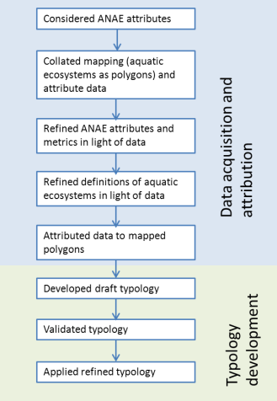

Figure 2: Summary of steps associated with the classification of aquatic ecosystems across the MDB.

## Base mapping of aquatic ecosystem features.

Aquatic ecosystem mapping was obtained from a variety of sources including publically available data, data supplied by the jurisdictions (basin states), and fine scale mapping sourced from individual organisations ().

### Geofabric v2

Consistent mapping at the 1:250,000 scale is available Australia-wide in the Australian Hydrological Geospatial Fabric (Geofabric) v2 made available by the Bureau of Meteorology Water Information website (BoM 2012a). The Geofabric is a specialised GIS that maps Australian rivers, water bodies and aquifers and identifies how these features are connected hydrologically, and how water flows through the landscape. For wetlands, the Geofabric includes cartographic mapping (from 1:250,000 topographic maps) of waterbodies (lakes and reservoirs) and hydro-areas (pondages, shorelines, channels and a feature denoted as “flats” that includes swamps and clay pans). Rivers are represented two ways in the Geofabric. First, cartographic mapping of river channels as derived from the 1:250,000 topographic maps (BoM 2012b), and secondly a modelled river network derived from the 9 second Australian landscape digital elevation model (DEM). This network layer has been derived by modelling water drainage patterns over the DEM, with a degree of manual processing and addition of artificial connectors that are required to ensure the modelled stream network drains from the headwaters to the appropriate terminus in the sea, or inland drainage basin (BoM 2012c).

For the purposes of this project, the cartographic representation of the rivers was used to inform the classification as this represents known rivers and streams that have been mapped in the MDB. Each river is mapped as a centreline, and rivers are divided into segments between confluence points with tributaries and distributaries that are allocated a unique HydroID number.

The DEM derived Geofabric river network mapping is also useful from a catchment perspective. Drainage patterns across the DEM have been used to define the individual catchments and sub-catchments of each network stream in a nested hierarchy encoded using a modified Pfafstetter numbering system (BoM 2012d). The highest level of the hierarchy relevant to the ANAE classification is the MDB itself of which there is just one catchment defined by the MDB area. At the lowest level (finest granularity) the catchment boundaries subdivide the basin into more than 170,000 first order catchments. Each catchment has a unique identifier, and every river segment within each first order catchment is given a unique “SegmentNo” identifier. Knowing the river segment number opens up two possibilities for our treatment of river mapping:

1. Direct alignment of our ANAE river classification with the classification of rivers conducted by the CSIRO Cluster Classification that used the Geofabric Network Streams.
2. The ability to link river segments to the National Environmental Stream Attributes (currently v1.1.5) developed by Janet Stein of the Fenner School of Environment and Society, Australia National University (Stein 2012).

The National Environmental Stream Attributes data set comprises a set of lookup tables supplying more than 100 attributes describing the natural and anthropogenic characteristics of the stream and catchment environment for each river segment number. The characteristics are derived from relatively coarse scale climatic, topographic, landuse, hydrology, vegetation and disturbance data. Many of these attributes were used in the CSIRO Cluster Classification. They are not used in the ANAE classification as most are attributes of the catchment, not the aquatic ecosystems themselves. However, the alignment of the ANAE topographic river mapping with the catchments by assigning SegmentNo identifiers adds value to the GIS feature layers for future research initiatives that seek to apply the catchment attributes.

Table 3: Mapping sources for aquatic ecosystem features

|  |  |  |  |  |  |
| --- | --- | --- | --- | --- | --- |
|  | **Features (also informing attributes)** |  |  |  |  |
| **SrcDataID** | **SrcDataName** | **Use** | **SrcJurisdiction** | **SrcAgency** | **SrcDate** |
| 1 | Geofabric v2.0 Cartography AHGFMappedStream | Watercourses Feature, WaterRegime, WaterType | Australia | BoM | 2012 |
| 2 | Geofabric v2.0 Cartography AHGFHydroArea | Wetlands Feature | Australia | BoM | 2012 |
| 3 | Geofabric v2.0 Cartography AHGFWaterbody | Wetlands Feature, WaterRegime | Australia | BoM | 2012 |
| 4 | SA Topo Watercourses | Watercourses Feature, WaterRegime | South Australia | DEWNR | 2011 |
| 5 | SA Topo Statewide Wetlands | Wetlands Feature, WaterRegime | South Australia | DEWNR | 2011 |
| 6 | Vic ISC HydroLine | Watercourses Feature, WaterRegime | Victoria | DEPI | 2011 |
| 7 | Vic Wetlands 2013 | Wetlands Feature, WaterRegime, WaterType | Victoria | DEPI | 2013 |
| 8 | QLD Wetland Mapping – HydroLine | Watercourses Feature, WaterRegime | Queensland | DEHP | 2013 |
| 9 | QLD Wetland Mapping – Regional Ecosystems | Wetlands Feature, WaterRegime, WaterType | Queensland | DEHP | 2013 |
| 10 | NSW Topography HydroLine | Watercourses Feature, WaterRegime | New South Wales | LPI | 2013 |
| 11 | NSW Topography HydroArea | Wetlands Feature, WaterRegime | New South Wales | LPI | 2013 |
| 12 | River Murray Wetlands | Wetlands Feature, WaterRegime, WaterType, WaterSource | New South Wales | Murray Darling Wetlands Working Group | 2003 |
| 14 | Namoi Wetland Assessment Mapping | Wetlands Feature, WaterRegime, WaterType, WaterSource, Soils, Vegetation | New South Wales | Namoi CMA | 2009 |
| 15 | Murrumbidgee Wetlands Resource Book (WRB) spatial data | Wetlands Feature, WaterRegime, WaterType, WaterSource | New South Wales | Murrumbidgee CMA | 2011 |
| 17 | Lowbidgee RERP | Floodplain Feature | New South Wales | OEH | 2008 |
| 18 | Gwydir RERP | Floodplain Feature | New South Wales | OEH | 2008 |
| 19 | Macquarie Marshes RERP | Floodplain Feature | New South Wales | OEH | 2008 |
| 20 | Wetlands GIS of the Murray-Darling Basin Series 2.0 | Floodplain Feature, Wetlands Feature | MDB | The Authority | 2004 |

River networks are continuous features from the headwaters to the outlet. The Geofabric segment was chosen (in consultation with the Technical Advisory Group) as the minimum resolution for which stream networks would be classified.

This application of the ANAE framework to the MDB used the highest resolution data possible that best reflects the aquatic ecosystems of the Basin. At 1:250,000 scale, the Geofabric mapping is coarse relative to the width of many riparian zones, especially in agricultural landscapes where riparian zones may be reduced to a single band of trees. The Geofabric also only represents the larger lakes and wetlands (typically to features more than several km in width). Finer scale data (Table 3) was sourced from the relevant jurisdictions (discussed below).

### Finer scale jurisdiction data

Each jurisdiction supplied wetland and watercourse (rivers) mapping with jurisdiction-wide coverage for aquatic ecosystems at a range of spatial scales, namely:

* New South Wales: Watercourses 1:100,000, Wetlands 1:100,000;
* Queensland: Watercourses 1:100,000; Wetlands 1:100,000;
* South Australia: Watercourses 1:50,000; Wetlands <1:50,000;
* Victoria: Watercourses 1:25,000, 1:100,000; Wetlands <1:50,000.

An immediate outcome from using the highest resolution data available is to maximize the number of aquatic ecosystems included in the classification. The jurisdiction layers contain many more aquatic features than the Geofabric. For example, at 1:250,000 the Geofabric includes only 1944 lakes and swamps in the portion of Victoria that lies within the MDB. In contrast, the Victorian state wetland layer at 1:50,000 contains 9,770 wetlands in this same area. Similarly for South Australia, the Geofabric contains 883 wetlands in the South Australian portion of the MDB compared to 8,041 wetlands in the South Australian wetlands layer (1:50,000) in this same area.

A classification of aquatic ecosystems limited to 1:250,000 scales (e.g. Geofabric, Wetlands GIS of the MDB Series 2 “Kingsford Layer”) could therefore result in only 10-25 percent of known aquatic ecosystems being classified.

In addition to finer scale mapping capturing a more complete representation of the number of aquatic ecosystems in the MDB, it also provides much greater spatial accuracy for the alignment of aquatic ecosystem features with spatially mapped attributes (Cottingham et al. 2012). Patterns of vegetation in particular vary at much finer spatial scales than the 250 metre minimum resolution attained with 1:250,000 mapping. shows a small area of Victoria where the Geofabric topographic streams (blue) are a poor fit to the on-ground river channels. The Victorian 1:100,000 stream mapping (red) better represent the channels, and are more closely associated with the riparian vegetation.

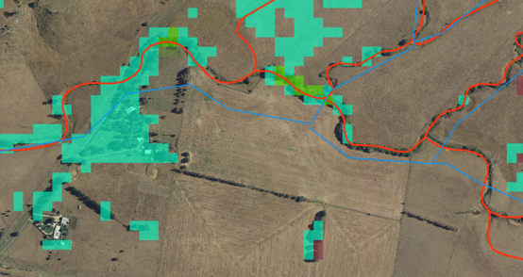

Figure 3: Comparison of Victorian stream mapping at 1:100,000 (red lines) compared to Geofabric topographic mapping at 1:250,000 (blue) with Victorian riparian forest vegetation mapping overlain (green squares).

### “Quasi-fabric” – Representing the Geofabric Riverine systems with higher resolution data

A challenge was to meet the seemingly conflicting objectives of:

1. Align the river network to the 1:250,000 Geofabric to assign Geofabric SegmentNo identifiers to river segments for comparison with the CSIRO Cluster Classification. Segment numbers also permit the National Environmental Stream Attributes data set to be used in conjunction with the ANAE classification mapping layers.
2. Use the highest resolution data possible to best represent the MDB aquatic ecosystems along with accurate alignment with other ANAE attribute data layers such as soils and vegetation.

A composite stream mapping data layer was constructed in GIS using the following workflow:

1. In accordance with the decision of the Technical Advisory Group, artificial stream segments present in the Victoria and New South Wales mapping (e.g. irrigation channels) were removed using definition queries (New South Wales: “HYDROTYPE” <=1; Victoria: not “FTYPE_CODE” LIKE ‘%drain’ and not “FTYPE_CODE” LIKE ‘%channel’). South Australia and Queensland mapping did not have identifiers to isolate artificial channels, which means that such features could be included in their databases.
2. The Geofabric stream lines were buffered by 250 metres.
3. The jurisdiction streamlines were intersected with the buffers to trim the higher resolution jurisdiction streams to only those streamlines located within 250 metres of the Geofabric stream lines (). The 250 metre buffer size was chosen to represent the upper end of the location error (distance between parallel red and blue streams in and ) meaning most Geofabric streams could be represented by the jurisdictional mapping.
4. The trimmed jurisdiction stream lines were intersected with the Geofabric catchment boundaries to break the stream lines into individual segments and assign the Geofabric SegmentNo.
5. Due to mapping anomalies, some streamline segments were missing from the jurisdiction layers, or were only partially represented. Catchments with missing or underrepresented stream segments were identified by comparing the length of each Geofabric stream segment with the equivalent (same SegmentNo) trimmed jurisdiction stream segment length. In cases where less than 50 percent of the Geofabric segment length was mapped by the higher resolution jurisdiction layer, the small jurisdiction fragment was discarded and the Geofabric mapping was substituted in to represent that segment. In New South Wales, Victoria, and Queensland, only 1-2% of stream segments were substituted from the Geofabric. For these states the fine scale jurisdiction mapping provided a more accurate representation of the Geofabric river network as depicted in Figure 3. For South Australia the error was much higher as the state topographic streams layer was incomplete. For South Australia the fine scale jurisdiction mapping was used where possible, but approximately 30% of the state’s rivers had to be in-filled using Geofabric segments (Figure 5).

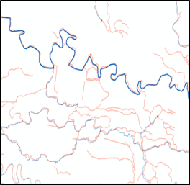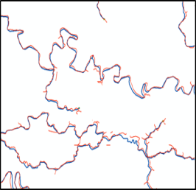

Figure 4: Jurisdiction stream lines before trimming (left) and after trimming to within 250m of Geofabric streams (right).

*Note: Red lines are from Victorian 1:100,000 Index of Stream Condition stream network. Blue is Geofabric mapped streams at 1:250,000.*

The resulting “quasi-fabric” river layer is a close representation of the 1:250,000 Geofabric cartographic stream network, but using 1:50,000-1:100,000 jurisdiction mapping, with rivers divided longitudinally into segments identified by the equivalent Geofabric catchment mapping SegmentNo identifier. In total, 157,542 river segments were mapped across the MDB.

This approach was chosen to allow us to accurately attribute river segments with associated vegetation, landform and soils mapping, while providing for a direct comparison of the ANAE river classification with the CSIRO Cluster Classification for riverine systems that was applied to the Geofabric Network streams. An additional benefit is the ability to link the “quasi-fabric” layer to the National Environmental Stream Attributes data set. A disadvantage is that we have eliminated (by pruning) many headwater streams that were mapped at scales finer than 1:250,000 by the jurisdictions. The resulting ANAE classification of streams therefore under-represents these headwater systems. A future application of the ANAE could be extended to carry the original jurisdiction mapping to provide a more complete representation of the river network that includes the headwater systems. It would still be possible to align the rivers to national catchment boundaries and a subset of the National Environmental Stream Attributes data set may still be applicable (e.g. those attributes that are catchment based and don’t rely on the channel mapping *per se*).

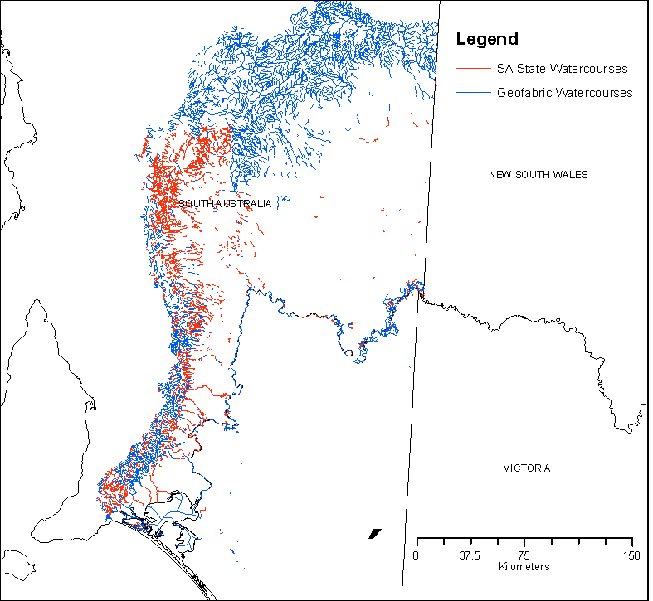

Figure 5: Combined quasi-fabric stream line layer for South Australia.

*Note: The fine scale 1:50,000 state topography watercourses layer (red) has incomplete coverage. For this classification the fine scale state 1:50,000 state topography watercourses layer (red) was used wherever it could represent greater than 50% of the length of the coarser scale 1:250,000 Geofabric river segments (blue).*

### Wetland mapping (Palustrine and Lacustrine systems)

Wetland and floodplain feature mapping was provided in 13 separate source data layers (see ). The mapping approaches used varied and include mapping of distinct water features (e.g. lakes, ponds, channels), and mapping of broader areas based on dominant vegetation (e.g. floodplain forests types). After reviewing the layers with the Technical Advisory Group it was resolved that due to these different approaches to mapping, and different scales it would not be possible in this project to dissolve all the mapping into a single master map layer (“one layer to rule them all”). The approach taken was to:

1. Create a master layer that includes the four jurisdictional wetland layers, supplemented by the Geofabric waterbodies and “flats” and the Authority’s Wetlands GIS of the Murray-Darling Basin Series 2.0.
2. Three additional sources in NSW with accurate mapping at a fine scale (1:25,0000-1:50,000) were then added to the master layer. These fine-scale regional mapping projects contained many additional wetland features and only a small proportion of wetlands that were already represented in the master layer from jurisdiction data sources. Where features overlapped by more than 25%, preference was given to use the mapping from the finer scale mapping projects. These additional regional layers are:
   1. The Namoi Wetlands Assessment mapping
   2. The Murrumbidgee Wetlands Resource Book (WRB) spatial data (Murray 2008)
   3. Murray-Darling Wetlands Working Group River Murray Wetlands
3. The River Environmental Restoration Program (RERP) mapping for the Lowbidgee, Gwydir and Macquarie Marshes contained boundaries for large blocks of floodplain defined by the ability to manage environmental water rather than specific wetland polygons. These three source layers were merged into a single layer and mapped as floodplain (section 3.1.6).

The floodplain system type in the Authority’s Wetlands GIS of the Murray-Darling Basin Series 2.0 was exported as a separate GIS layer to be classified as floodplain (section 3.1.6).

A first step to creating the combined master wetlands layer was to identify and remove artificial systems where possible. This involved removing the many farm dams, irrigation channels and water storages that were included in the jurisdiction mapping. For example the New South Wales whole state “Hyroareas” layer included more than 426,000 artificial features that are mostly farm dams compared to 38,600 naturally occurring features across the state (identified by the HYDROTYPE attribute).

The workflow to build the wetlands layer was:

1. From each jurisdiction layer select only those wetlands that intersected (centroid within) that jurisdictions portion of the MDB.
2. Eliminate artificial systems where possible using definition queries based on data set attributes ().
3. Inter sect resulting layers with the Authority Water Storage database (which includes small farm dams (point data), large farm dams, unnamed reservoirs, and large named reservoirs (all polygon layers)). The following logic was applied.
   1. Polygons with an area < 1 hectare that intersected a storage in any of the Authority’s Water Storage layers were removed (likely small farm dams)
   2. Polygons >= 1 hectare were removed if an Water Storage overlapped the polygon area by more than 25 percent (likely large farm dams and water storages).
4. The four state layers were combined in GIS (a UNION of layers).
5. The MDB Geofabric waterbodies and flats were then compared to the merged state layers by intersecting the layers and comparing the intersecting polygon areas.
   1. Geofabric wetlands that were not present at all in the state layers (intersection area = zero) were added to the combined layer.
   2. Where Geofabric wetlands touched jurisdiction mapping or overlapped slightly (intersection area <25 percent) only the “new” portion of the wetland represented by the Geofabric polygon was added.
   3. If the intersection of polygons was >= 25 percent we considered the wetland to be represented already in the jurisdiction mapping and nothing was added (i.e. in most cases the finer resolution mapping of the jurisdiction layers was considered to be the “default” representation of any given wetland and only those Geofabric polygons with major differences (75-100 percent) were added.
6. A similar process to above was applied to see if the Authority’s Wetlands GIS *Murray-Darling Basin Series 2.0* contained additional wetland features that had not been captured. After removing polygons identified as floodplain (discussed in more detail below) no additional palustrine or lacustrine features were identified that were not already captured in the combined jurisdiction and Geofabric data set.
7. Some manual processing was required along the New South Wales-Queensland border and New South Wales-Victoria border where fragments of the Macintyre River and Murray River respectively were merged together from each abutting jurisdiction data set.

From this initial process, a total of 68,196 wetland polygons were identified that included lacustrine, palustrine and riverine aquatic ecosystems. Comments from Queensland representatives indicate this figure includes 19,385 polygons that are currently mapped as “potential wetlands” that have not been adequately surveyed and have not been allocated a wetland ID. Many of these features are described as “floodplain tree swamps”, but visual inspection shows them to be patches of remnant vegetation between paddocks in agricultural landscapes that are unlikely to be wetlands. There are also many riparian vegetation communities mapped within this group that are not strictly aquatic ecosystems, but rather are adjacent to rivers and wetland features. There is a degree of inconsistency in the data whereby some riparian polygons are identified as riverine wetlands, with adjacent polygons with the same vegetation characteristics upstream or downstream being unclassified. For the purposes of this classification, the pragmatic decision was to remove these 19,385 polygons until such time as revisions and updates to the state mapping resolves their status as aquatic ecosystems.

The addition of the finer scale mapping for the Namoi Wetlands, Murrumbidgee Wetlands Resource Book mapping and Murray-Darling Wetlands Working Group River Murray Wetlands was done manually by:

Overlaying the fine scale mapping over the current “master layer’;

Where wetland polygons overlapped existing features (i.e. the same wetland) the duplicated polygon was deleted from the master layer;

The fine scale mapping was then combined into the master layer using the GIS UNION function.

This process resulted in a total of 62,452 wetland polygons being identified that were then classified as individual wetlands. Some individual wetlands are comprised of multiple mapping polygons (e.g. a wetland may have a central lacustrine polygon with a fringing palustrine polygon). These can be identified in Queensland and Victoria using the relevant jurisdictions wetland ID number. In these states multiple polygons from the same wetland are given the same ID code. For Queensland, 5,922 wetland ID numbers are represented by 12,778 individual polygons (on average approximately 2 polygons per wetland). In Victoria there are fewer aggregated polygons, with 7,917 wetland ID numbers represented by 8,599 polygons (on average approximately 1.1 polygons per wetland). New South Wales and South Australia treat each polygon as a unique entity. For this interim classification in the MDB each polygon is considered an entity and classified independently.

In this classification, unique polygon identifiers needed to be added to the Victorian and Queensland source data to permit individual polygons to be classified and traced through the different GIS processes that were used. We recommend jurisdictions need to develop consistent unique identifiers at three levels for:

Individual polygons;

Wetlands, where polygons are representing different habitat types within a larger wetland;

Wetland complexes.

Table 4: Definition queries to remove artificial systems from jurisdiction data layers before then assessing overlap with the Authority’s water storages database

|  |  |
| --- | --- |
| State | Definition Query |
| New South Wales | “HYDROTYPE” <=1 |
| Queensland | not (“WTRREGIME” = ‘-‘ or “HAB_L” = ‘Artificial/ highly modified wetlands (dams, ring tanks, irrigation channel’) |
| South Australia | n/a |
| Victoria | “Origin” =’Naturally occurring’ |
| Geofabric | “SrcFCName” <> ‘Reservoirs’ |

### Assigning Riverine, Palustrine and Lacustrine

***Assigning features to aquatic ecosystems***

South Australian, Queensland, Victorian and the Geofabric data sets all included attribute data to indicate which polygons were considered lacustrine or palustrine, although not every polygon is assigned to a class. For New South Wales, none of the polygons are allocated to an ecosystem class. The rules that were applied to classify each aquatic ecosystem feature in the GIS were:

1. All river line mapping (quasi-fabric) is riverine.
2. For polygons we assign the system type allocated by source data sets where one is provided. If the same wetland polygon is represented in more than one source data set with a different assignment the jurisdictional layer takes precedent.
3. Any unclassified features greater than 8 hectares in size and where the dominant vegetation from NVIS is attributed as “water” are lacustrine.
4. Where no other information is available but the polygon has a name that includes the word “lake” we define it as lacustrine.
5. A heuristic process was developed for New South Wales to identify “long skinny” polygons that overly major rivers as riverine (discussed below).
6. In the absence of any other information, a polygon is assigned to palustrine.

The New South Wales feature mapping is not specifically “wetland” mapping, rather it is mapping of “hydro-areas”. These are waterbodies that are large enough or wide enough to be represented in the GIS as polygons, in contrast to smaller creeks and rivers that are mapped as lines. The polygon hydro-area mapping therefore includes long sections of the major lowland rivers (e.g. the Murray, Murrumbidgee, Darling, Lachlan, Edward-Wakool systems among others) where the rivers are wide. It was necessary to develop a protocol to identify these distinctly riverine ecosystems. The approach used for the New South Wales mapping was:

1. Convert the quasi-fabric rivers layer from lines to 50 metres wide polygons by buffering the stream lines by 25 metres;
2. Intersect this new rivers polygon layer with the wetlands polygon layer;
3. Examine the proportion of the wetland polygon area that was intersected by the 50 metre wide river polygons defining polygons with > 30% overlap as riverine.

This correctly identified the polygon features that represented riverine segments of the major lowland rivers. Visual inspection of remaining “long skinny” polygons in the New South Wales mapping shows that some do not intersect any river mapping at all (Geofabric or finer scale state mapping). These are presumed to be paleo-channels and for the purposes of this classification were classified as palustrine by default, as indicated above.

***Assigning confidence***

A measure of “confidence” is recorded against every feature to reflect the certainty of data. Where the system type is assumed (based on the rules identified above) the confidence is automatically given the lowest value of 1. The approach used to assign confidence is discussed further in section 4.1.1.

### Floodplains

The ANAE framework identifies the 1 in 10 year average return interval (ARI) floodplain as being an appropriate definition in which to classify floodplain ecosystems. The framework uses floodplains in two ways. The first is at Level 2 of the ANAE framework, identifying the context of aquatic ecosystems in the landscape. For example palustrine and lacustrine wetlands can occur *on* the floodplain, where overbank flows may be an important determinant of the hydrological regime, or *off* the floodplain in other areas of the catchment where groundwater and surface runoff may be greater contributors to the ecosystem hydrology. Secondly, floodplains are identified at Level 3 of the ANAE hierarchy as an aquatic ecosystem type in their own right (Figure 1).

No mapping exists for the 1 in 10 year ARI floodplain in the MDB. As a research initiative, CSIRO have developed a basin wide floodplain inundation model (MDBFIM and its successor MDBFIM2) that uses flood extent captured by satellite imagery over time (Overton et al. 2010, Chen et al. 2012). While this model does produce a 1 in 10 year ARI output it is based on only a few actual flood events that did not reach many areas of the basin. The model output is fragmented spatially with many isolated areas identified, with many areas not adjacent to rivers (). As the modelling is largely experimental, has not been ground-truthed, and differs from other regional mapping based on surveys of flood events, in consultation with the Technical Advisory Group it was decided not to use the modelled outputs in the classification.

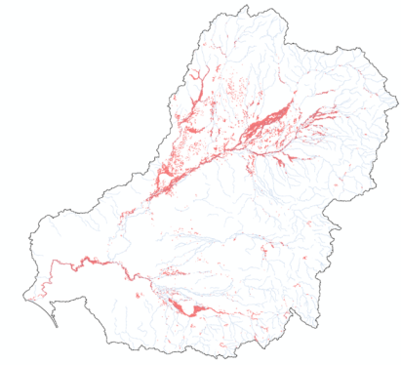

Figure 6: MDB-FIM2 modelled 1 in 10 year ARI floodplain (Chen et al. 2012)

Other existing floodplain mapping in the MDB is limited to maximum extent floodplain mapping (extreme flood events) with only partial coverage. The New South Wales floodplain atlas includes relatively old mapping (1983) of the Namoi, Lachlan, Edward-Wakool Rivers and New South Wales portion of the Murray River (). Victoria has a modelled 1 in 100 year floodplain map developed for property planning in that state but Victorian Technical Advisory Group representative felt this over-estimated the extent of floodplain and was not reliable or well suited for application of the ANAE. Due to incomplete coverage and that mapping did not agree with other efforts (e.g. as evidenced by comparing to , described below) these mapping layers were not used.

The only consistent, basin-wide floodplain map is the maximum extent floodplain included in the MDBA Wetlands GIS of the Murray-Darling Basin Series 2.0 () based on the work of Kingsford et al. (2004). This mapping is derived from Landsat imagery of the maximum extent of floods within the MDB over a ten-year period (1983-1993). While this does not fit the recommended requirement of 1 in 10 year ARI, the advice of the Technical Advisory Group was to use this mapping to represent the floodplain for this initial implementation of the ANAE. This initial effort serves as proof of concept informing the development of techniques for attributing the floodplains with other information (e.g. land form and vegetation at ANAE Level 3), and using the floodplain attributes of palustrine and lacustrine systems (ANAE Level 2) in the development of the aquatic ecosystems typology. Wetlands that intersected the Kingsford et al. (2004) floodplain layer were designated as “on the floodplain” and assigned low confidence. The QLD wetland mapping specifically identified a subset of wetlands as being on floodplains, allowing more confident attribution of the floodplain attribute for these features. Similarly, for South Australia the SAAE River Murray floodplain layer allowed the floodplain wetlands within the River Murray corridor to be attributed with greater confidence.

The resulting floodplain classification is provided as an example in the database output and should not be relied up without careful validation over the breadth of any area of interest.

The Authority informed the Technical Advisory Group that floodplain modelling for delineation at different ARI in the MDB is an area of current activity, and reliable models to map floodplains for the southern connected basin are expected by the end of 2014. Within a 2-3 year horizon, the Authority expects to have models developed for the entire MDB that will allow the 1 in 10 year ARI floodplain to be estimated. At that time the interim ANAE classification may be revised (refer Section 8). This process will reduce the number of floodplain systems that are identified in the classification (due to the narrower extent of the more frequent return interval), and will raise questions about what to do with adjacent floodplain areas higher up the catchment (e.g. black box woodlands that may not be identified as being on the floodplains).

The RERP floodplain mapping for the Lowbidgee, Macquarie Marshes and Gwydir are included in the GIS database as a separate layer of floodplain mapping. The individual polygons in this mapping represent water delivery management units (watering “buckets”) rather than individual floodplain areas.

In version 1.4 a floodplain layer for South Australia has been included to assist with the separation of flood-outs and land subject to inundation from the classified wetlands layer. These SA floodplains have not been classified.

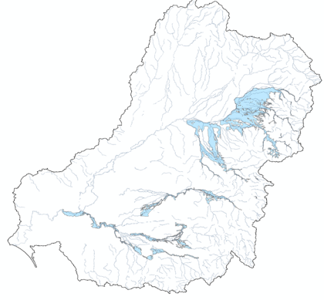

Figure 7: New South Wales floodplain atlas maximum floodplain extent mapping (New South Wales general floodplain atlas, New South Wales Public Works Department 1983. Supplied by SEWPaC, 2013).

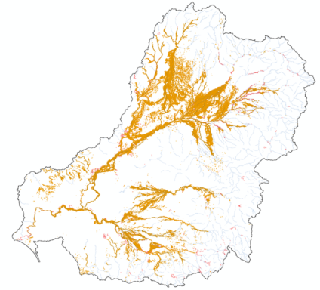

Figure 8: The Authority’s Wetlands GIS of the Murray-Darling Basin Series 2.0 floodplain extent from (1983-1993) floods. Also known as the “Kingsford” mapping after Kingsford et al. (2004)

## ANAE attributes

### General approach for applying attributes in GIS

Three different basin-wide aquatic ecosystem GIS layers were developed for this project (previous section):

1. The quasi-fabric river network, which maps jurisdictional rivers to an equivalent of the Geofabric cartographic stream network divided into segments using the national catchment boundaries; riverine systems represented by lines (see Section 3.1.3).
2. The wetlands layer; which includes palustrine and lacustrine systems. As noted in Section 3.1.4, some more localised fine scale wetland mapping is also included as separate layers.
3. The Authority’s “Kingsford” floodplain layer (polygons)

Three critical decisions were made by the Technical Advisory Group that influenced the attribution and classification process:

* Features would not be split into smaller features. If multiple values of an attribute (e.g. different vegetation types) overlap a given feature line or polygon then the assignment is made as the value that occupies the MAJORITY of the feature area.
* Every mapped wetland polygon is attributed and classified to type as if it were an individual aquatic ecosystem. Some wetland complexes consist of multiple adjacent or intersecting polygons. For this classification, each part of the complex would be classified to type separately and no attempt has been made to combine types to give a single description for the complex. This same logic also applies to the river network where each river segment is attributed and classified without considering adjoining river segments or other segments in the same catchment.
* Features would not be buffered. The attribute is applied by direct intersection of the attribute mapping with the feature mapping. For the rivers this means attributes are intersected with the river centre lines. At the scale of the mapping (1:50,000-1:100,000) it is assumed this represents the river and fringing vegetation. For palustrine, lacustrine and floodplain systems that are represented by polygons, the attribute is calculated from the entire area of the feature. Fringe areas are only included if they are mapped as part of the feature. For example in Victoria, some wetlands are mapped as wetland complexes with concentric polygons having a lacustrine inner water body and surrounding palustrine wetland fringe. As indicated above these wetland complexes would be considered as two independent wetland types in this classification.

The assignment of ANAE attributes to these aquatic ecosystem features in GIS was accomplished as follows:

1. For attribute data that is represented spatially as maps (e.g. ANAE level 1 and 2 attributes, soils, landform and vegetation mapping) the assignment of attributes was achieved in GIS using ArcMAP 10.1 by calculating the majority area overlap between the feature and the attribute mapping. More specific methods are included in the discussion for each attribute below.
2. For attribute data that is not mapped on its own but exists as attributes in the source feature mapping (e.g. water regime, salinity) the assignment was made by copying the data from the source mapping layer. In cases where an aquatic ecosystem is represented in multiple source data maps (e.g. in jurisdictional mapping and in the Geofabric) it was possible to align the layers using spatial joins in GIS. This allowed the attribute data to be looked up from one mapping layer that applied to the equivalent feature in another mapping layer.

The processing requirements for the large basin-wide feature and attribute layers often exceeded the capabilities of the GIS desktop software (ArcMAP 10.1) used in this project causing software crashes and incomplete processing runs. A “winning formula” for processing the data was established as follows:

* The MDB was divided into the 27 major river basins defined by the former Australian Water Resources Council (AWRC). Feature layers were attributed with an AWRC basin identifier and processing scripts were written to cycle through each of the catchments one at a time calculating the attribute values. When finished, the 27 output tables representing each AWRC basin were merged back into a single output.
* Basin-wide raster layers (landform, vegetation) were split into 2048x2048 pixel tiles that were stored in a single raster catalogue and then referenced as a raster mosaic. The mosaic data structure enables all the tiles to be used in GIS applying the same tools as for the original single raster layer. The repackaging allows the software to use the data in a more structured piece-wise manner, accessing only those tiles that overlapped the features being analysed.

### Level 1 and Level 2 attributes

The data layers for all Level 1 and 2 ANAE attributes are available as GIS data layers from the Bureau of Meteorology and Geosciences Australia (Table 5 and Table 6). All are broad scale national data sets mapped as polygons. Each aquatic ecosystem feature was attributed with the unique identifier of the region it was located in within each attribute map. The resulting attribute tables were collected and compiled into GIS should they be required. However, the classification and, in particular, the typology (see Chapter 6) have not drawn on these attributes.

Table 5: Summary of Level 1 data sourced for Stage 2.

|  |  |
| --- | --- |
| Attribute | Data |
| ANAE L1: Regional hydrology | BoM Geofabric v2.0 L1 drainage divisions |
| ANAE L1: Regional hydrology | Groundwater provinces (AWR 2005) |
| ANAE L1: Regional hydrology | Principal Hydrogeological Divisions of Australia (National Geoscience Dataset) |
| ANAE L1: Regional hydrology | Hydrogeology of the Great Artesian Basin – Boundaries of the Hydrogeological Units |
| ANAE L1: Regional climate | Bureau of Meteorology (BoM) Köppen climate classification |
| ANAE L1: Regional landform | Physiographic Provinces of Australia (Divisions) |
| ANAE L1: Regional landform | Interim Biogeographic Regionalisation for Australia (IBRA) |
| ANAE L1: Regional landform | Integrated Marine and Coastal Regionalisation of Australia (IMCRA) v4.0 – Meso-scale Bioregions* |

*Not used in this project as it is outside the project area.

Table 6: Summary of Level 2 data sourced for Stage 2.

|  |  |
| --- | --- |
| Attribute | Data |
| ANAE L2: Landscape water influence | BoM Geofabric v2.0 groundwater cartography |
| ANAE L2: Landscape landform | Physiographic Provinces of Australia (subregions) |
| ANAE L2: Landscape landform | Interim Biogeographic Regionalisation for Australia (IBRA) (subregions) |
| ANAE L2: Landscape landform | Integrated Marine and Coastal Regionalisation of Australia (IMCRA) subregions v4.0* |
| ANAE L2: Landscape topography | BoM Geofabric v2.0 catchment boundaries |
| ANAE L2: Landscape: climate | Bureau of Meteorology (BoM) Köppen climate classification subcategories |

*Not used in this project as it is outside the project area.

### Level 3 attributes

The attributes to be considered when applying the ANAE framework are listed in Table 7. While all of the attributes listed in Table 7 were considered relevant to the current project, it was recognised in Stage 1 that some refinement to attribute definitions and metrics was required before attribute data were assigned to the respective aquatic ecosystems (Cottingham et al. 2012). These refinements are considered in the following sections.

Table 7: Level 3 attributes included in the ANAE Classification Framework

| **Riverine, Lacustrine, Palustrine and Floodplain ANAE attributes** | **Estuarine ANAE attributes** |
| --- | --- |
| **Landform**   * High energy   + Upland   + Slope * Low energy   + Upland (plateau)   + Lowland | **Substrate**   * Unbroken rock * Broken rock/Boulder/Cobble * Pebble/Gravel * Sand * Silt |
| **Confinement (riverine only)**   * Unconfined (floodplain) * Semi-confined (discontinuous floodplain) * Confined (non-floodplain) | **Structural macrobiota (SMB)**   * Mangroves * Saltmarsh * Seagrass * Macroalgae * Coral * Filter feeders |
| **Soil**   * Porous   + Peat (organic)   + Mineral (soil)   + Sand (non-soil) * Non-porous   + Rock (non-soil)   **Substrate**   * Clay * Sedimentary (chemical/organic) * Sedimentary (detrital) * Unconsolidated * Volcanic | **Light availability**   * >15% * 5-15% * <5%   **OR**   * Photic zone * Low light zone * Aphotic zone |
| **Water source**  Dominant water source (>70%)   * Surface water * Groundwater * Both surface and ground (where there is temporal dominance by one of the other) * Localised rainfall | **Nutrient availability**   * High * Medium * Low   **OR**   * Oligotrophic * Mesotrophic * Eutrophic |
| **Water type**   1. Salinity  * Fresh (<3000 mg/L) * Brackish* (3000-5000 mg/L) * Saline (>5000 mg/L)   OR   1. pH**  * Acidic (<6) * Neutral (6-8) * Alkaline (>8)   *Brackish may not be important for all systems. If so, change saline metric to 3000 mg/L.  **pH may change with the changing hydrograph; if so, the ‘normal’ pH should be used. | **Water depth**   * Supratidal * Intertidal * Subtidal   + Shallow   + Deep * Abyssal |
| **Water regime**  Presence of water*:   * Permanently inundated * Seasonally inundated * Aseasonally inundated * Water Logged***   OR**   * Commonly wet (>70% of time) * Periodic inundation * Water Logged***   * This attribute may include sub-metrics to support environmental flow assessment where data is available. Potential sub-metrics for detailed flow regime include flow to achieve inundation/commence to flow, duration, 10 year representation of flow etc. available from records or modelling.  ** Where data is limited. Based on remote sensing plus expert knowledge.  *** Included to accommodate seasonally waterlogged areas in temperate Australia and Alpine bogs etc. that are generally not inundated. | **Exposure**   * Sheltered * Exposed |
| **Vegetation/fringing vegetation**  Dominant vegetation   * Forested * Shrub * Sedge/grassland/forb * No emergent vegetation |  |

## Riverine, Lacustrine, Palustrine and Floodplain attributes

### Landform

The ANAE provides the following guidance on the landform attribute for riverine, lacustrine and palustrine systems (Table 8).

Table 8: Description of ANAE landform attribute (AETG 2012)

| **Attribute** | **Metrics and thresholds** | **References** |
| --- | --- | --- |
| Whilst this attribute is dealt with at the landscape and regional levels, there is also scope to use it at the system level, particularly to address reach scale issues. It is more commonly used as a riverine attribute, but may have application to describe lacustrine and palustrine systems as well.  Local landform often has a major role in influencing the environment and subsequent habitat conditions, biota etc. at a location. For example, high energy, upland and slope areas result in higher water velocity which in turn influences the types of biota that inhabit the area. Metrics have been chosen that differentiate between the major influence landform has on aquatic ecosystems at the local level. | * High Energy   + Upland   + Slope* * Low Energy   + Upland (Plateau)   + Lowland   * This zone is a transitional zone between the high energy eroding upland zone and the low energy depositional lowland zone. It is often referred to as the ‘transport’ zone. | Potential sources include Nanson and Croke (1992), however could use Valley Bottom Flatness Index (VBFI) or Digital Elevation Model (DEM) to determine valley position, i.e. is energy based (slope versus flat). |

There are a few existing systems that have definitions and categories that may help with applying the landform attribute. For example, the New South Wales wetland typology (Claus et al. 2010) and the Queensland wetlands program (DERM 2011) do not include an equivalent attribute or metric. The Victorian wetlands classification (DSE 2011) has a landscape context metric that uses elevation derived from a DEM that is based on altitude. This includes four categories:

* Alpine/subalpine - > 1200 metres;
* Upland - > 500-1200 metres;
* Lowland - < 500 metres;
* Floodplain (derived separately).

The four categories listed above could easily be applied to the whole basin from the 9 sec DEM but are not really equivalent to the metrics and thresholds in the ANAE as they are only based on elevation rather than energy.

The South Australian classification (Butcher et al. 2011) has a landscape position attribute that includes three levels: upland, midland and lowland. While it was stated that this was based on simple topographic regionalisation, there is no more information on how the thresholds were set and being in a flat landscape the attribute was deemed to be of low relevance. The South Australian River Murray Classification (Jones and Miles 2009) used a DEM to assign a landscape setting of flat, dune hills, subterranean or ‘other’. No information is provided on thresholds or how the classes where applied.

The Lake Eyre Basin High Conservation Value Aquatic Ecosystem project (Hale 2010) derived a landform attribute based on the 9-sec DEM using a roughness index (Jenness 2007) averaged over a 10 km window, with a 1 km smoothing factor. The attribute was classified into three groups based on natural breaks:

* Class 1 – Low lands;
* Class 2 – Intermediate (semi rough) includes tall sand dunes, low isolated hills, undulating terrain and a small buffer around class 3 of about 500 – 1000 metres;
* Class 3 – uplands (rough).

Technically, the classes listed above could be applied across the MDB relatively easily. However, Hale (2010) noted that the application of this system resulted in a number of anomalies that required manual resolution. In addition, this method does not differentiate upland areas that are plateaus, as per the ANAE metrics.

Stein (2006) developed a landform (flatness) index using the accepted Valley Bottom Flatness Index (mrVBF) and Ridge Top Flatness Index (mrRTF) (Gallant and Dowling 2003) computed from the national 9-sec DEM. This provided the following four classes:

* Hillslope (Erosional) = mrVBF < 2.5 and mrRTF < 2.5;
* Valley bottom = (mrVBF – mrRTF ) > 2;
* Ridge top flat = (mrRTF – mrVBF ) > 2;
* Indeterminate = abs(mrRTF –mrVBF) ≤ 2.

This index has already been applied across Australia (Figure 9), and provides categories for three of the four metrics of the ANAE, such that Hillslope = High Energy Upland; Valley bottom = Low Energy Lowland; and Ridge Top Flat = Low Energy Upland. The indeterminate category is based on those that were not clearly distinguished between valley bottom and Ridge top flat and is considered transitional. This scheme does not provide a category for the transitional zone (Upland Slope) as described in the ANAE.

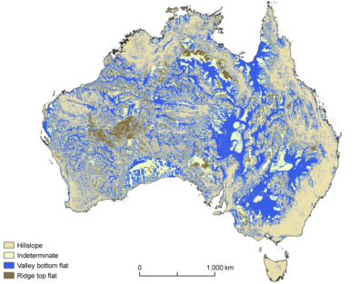

Figure 9: Flatness Index (from Stein 2006).

***Approach adopted***

In consultation with the Technical Advisory Group and Steering Committee, the Stein (2006) application of the Valley Bottom Flatness Index and Ridge Top Flatness Index of Gallant and Dowling (2003) was adopted, as it provides the best option for uniform application across the MDB. The metrics incorporate measures of both slope and spatial scale. Stein’s work was conducted using mrVBF and mrRTF calculated from the 9 sec DEM (250 metre pixel size). Finer scale versions (3 sec DEM scale or 70 metre pixels) for mrVBF and mrRTF were obtained from CSIRO via John Gallant. Both layers are available on the CSIRO data access portal ([https://data.csiro.au/dap/home accessed June 2013](https://data.csiro.au/dap/home%20accessed%20June%202013)). After some initial exploratory application of Steins thresholds (above) it was determined that a slightly different approach may be needed as visual inspection of the mapping showed some areas were not being classified as expected based on known topography. After conversation with John Gallant (CSIRO) this was attributed to differences in the scales of the 3 sec versus 9 sec mapping. The value of mrVBF is a combination of spatial scale and slope and the 3 sec DEM mapping included finer spatial scales (30 metre) at low mrVBF values (Table 9). As a result we increased our threshold for Valley Floor (Lowland) from 2 to >3 where the valley bottom is at least 90 metres wide. Note this is still smaller than the minimum scale of the 9sec DEM (250 metre).

Table 9: Interpretation of mrVBF and mrRTF values.

|  |  |  |  |
| --- | --- | --- | --- |
| Value | Threshold slope (%) | Resolution  (approximate) | Interpretation |
| **0** |  | 30 metres | Erosional |
| **1** | 16 | 30 metres | Small hillside deposit |
| **2** | 8 | 30 metres | Narrow valley floor |
| **3** | 4 | 90 metres |  |
| **4** | 2 | 270 metres | Valley floor |
| **5** | 1 | 800 metres | Extensive valley floor |
| **6** | 0.5 | 2.4 kilometres |  |
| **7** | 0.25 | 7.2 kilometres | Depositional basin |
| **8** | 0.125 | 22 kilometres |  |
| **9** | 0.0625 | 66 kilometres | Extensive depositional basin |

The final definitions for landform, in terms of the Stein index are:

Lowland: mrVBF > 3;

Low Energy Upland: mrVBF <2.5 AND mrRTF >2.5;

High Energy Upland: mrVBF < 2.5 AND mrRTF <= 2.5;

Transitional: mrVBF >=2.5 AND mrVBF<=3.

The use of 2.5 and 3 as thresholds is based on the logic of expert opinion only applied to the scales represented in Table 9 with Lowland representing areas with a valley floor exceeding 90m wide. The resulting mapping was then examined and agreed upon by the Technical Advisory Group. Initial comparison with New South Wales River Styles mapping by New South Wales Office of Water for the Tenterfield Creek catchment in the north-eastern corner of New South Wales indicates the ANAE transitional category may be including a high number of streams the New South Wales River Styles program identified as ‘upland’. This may indicate our thresholds need to be increased further (e.g. lowland >4, transitional 3.5 to 4). A visual inspection of other areas in New South Wales did not support changing thresholds at this time, but a more rigorous calibration and validation process has not yet been carried out. The New South Wales River Styles data set based on site observations is likely to be a valuable contributor to this process.

***GIS application***

The landform attribute was developed using the 3 sec mrVBF and mrRTF from CSIRO (Table 10).

Table 10: Source data used to attribute Landform

|  |  |  |  |
| --- | --- | --- | --- |
| Data Name | Jurisdiction | Agency | Currency |
| 3 sec Multi-Resolution Valley Bottom Floor mrVBF | Australia | CSIRO | 2012 |
| 3 sec Multi-Resolution Ridge Top Flatness mrRTF | Australia | CSIRO | 2013 |

As mrVBF and mrRTF are represented by a continuous scale (0 to 9), each feature was attributed with the MEAN of all mrVBF/mrRTF pixel values that it intersected rather than just selecting the majority. The mrVBF and mrRTF values were attributed separately and the formula above used to assign the landform attribute.

### Confinement

The ANAE provides the following guidance on the confinement attribute (Table 11). Note that this attribute only applies to riverine ecosystems.

Table 11: Description of ANAE confinement attribute (AETG 2012)

| **Attribute** | **Metrics and thresholds** | **References** |
| --- | --- | --- |
| Confinement defines the channel character of riverine systems i.e. how easily channel dimensions adjust to flow events. For example a confined channel is usually associated with bedrock, partly confined channel is a mix of bedrock and unconsolidated sediments, and unconfined is purely unconsolidated. Unconfined channels are usually associated with floodplains. These metrics are based on River Styles.  Confinement influences the type of environment and biota occurring at a location. | * Unconfined (Floodplain) * Semi-confined (Discontinuous floodplain) * Confined (non-floodplain) | Geofabric, DEM  River Styles |

As this attribute only applies to rivers, there is little or no guidance in the Queensland (DERM 2011) or New South Wales (Claus et al. 2010) wetland classifications, both of which only cover lacustrine and palustrine systems. There is no equivalent metric in the South Australian classification (Jones and Miles 2009).

River Styles (Brierley et al. 2002) has three categories based on valley confinement:

* Confined valley setting (> 90% of the channel abuts valley margin);
* Partly confined valley setting (10-90% of the channel abuts valley margin);
* Unconfined valley setting (< 10% of the channel abuts valley margin).

While the categories listed above are broadly equivalent to the three ANAE metrics, their method of derivation relies partially on manual interpretation of aerial photos and also by field ground-truthing. To date it has been applied across New South Wales and parts of Queensland, and only to a subset of rivers. The manual and field components of this system make it unlikely to be suited for application across the Basin, based on available data. However, as it represents the best available data for New South Wales, it was used for the rivers to which it applies

Victoria has applied two categories to their Index of Stream Condition stream reaches: confined and unconfined (DSE 2005). These were derived using the slope tile raster and were delineated based on a slope of four degrees. This categorisation may be able to be applied across the Basin (dependent on the topographic resolution at the Basin scale) but only captures two of the three ANAE categories.

Stein (2006) derived confinement (termed valley confinement) by using proportion of the stream and immediately neighbouring cells that are not valley bottoms (as a percentage). Stein defined the spatial area of Valley bottom using the Flatness Index as described above (Valley bottom = (mrVBF – mrRTF ) > 2). The attribute was applied as an absolute, but classes were mapped in 5 bands. Stein (2006) recognised that confinement must be described relative to the width of the channel, but found that neither valley nor channel width can be estimated reliably with the available continental scale data. Discussions with Janet Stein (Australian National University, personal communication November 2012) indicated that the categories were arbitrarily defined for mapping, but a continuous variable is available within the data set. The level of uncertainty in the derivation of this attribute from the 9 sec DEM (250 metre minimum resolution) was highlighted, although it was also stated that the finer detail 1 sec DEM would not be in a suitable form until the end of 2013 at the earliest.

An initial test application confirmed Stein’s confinement index from the 9 sec DEM that is included in the National Environmental Stream Attributes data set was insensitive with most rivers being defined as 100 percent confined or 100 percent unconfined (confinement index = 1 or 0 with few intermediates), thereby vastly over-estimating the number of confined rivers compared to the New South Wales River Styles data set.

Spencer et al. (2008) developed a valley confinement index for Northern Rivers based on a different set of algorithms to account for the low relief topography of Northern Australia (<http://www.anzgg.org/ANZGG%2013%202008%20Abstracts.pdf>). This has not been widely applied and its applicability to the Basin remains unknown.

***Approach adopted***

In consultation with the Technical Advisory Group and project Steering Committee, the approach of Stein (2006) was adopted using the proportion of the aquatic feature that abuts the valley bottom. While the approach is the same, the resulting resolution is finer. The resulting lowland landform definition equates to valley bottoms. Using the 3 sec mrVBF gives an on-ground resolution of 70 metres compared with Stein’s 250 metres from the 9 sec DEM. The resulting definition of valley bottom therefore identifies all area with a gradient < 4% and width > 90 metres (see Table 9). This approach enabled the confinement to be defined in a consistent manner for the entire MDB. The confinement index (the proportion of the aquatic feature that abuts the valley bottom) was then converted into three categories to align with the New South Wales River Styles confinement categories (confined, semi-confined and unconfined). This alignment allowed the use of River Styles data that is based on observational data from site visits to calibrate the confinement index calculated from the DEM derived mrVBF data.

Calibrating against the river styles confinement mapping the following thresholds were used:

Confined: 0-10 percent of stream segment is valley bottom (mrVBF >3);

Partially Confined: >10-50 percent of stream segment is valley floor (mrVBF >3);

Unconfined: >50-100 percent of stream segment is valley floor (mrVBF >3).

***GIS application***

The confinement attribute was developed using the same 3 sec mrVBF data layer from CSIRO (Table 12) that was used to develop landform attributes. All areas in the MDB with mrVBF >3 were selected and converted to a single MDB valley bottom polygon layer. The confinement index for each river segment was therefore the percentage of each river segment that intersected the valley bottom. The New South Wales River Styles confinement data were then used to calibrate thresholds as indicated above.

Table 12: Source data used to attribute Confinement

|  |  |  |  |
| --- | --- | --- | --- |
| Data Name | Jurisdiction | Agency | Currency |
| 3 sec Multi-Resolution Valley Bottom Floor mrVBF | Australia | CSIRO | 2012 |
| New South Wales River Styles | New South Wales | NoW | 2012 |

A valley floor layer raster mask was created for the basin from the 3 sec mrVBF CSIRO raster using the threshold to define valley floor as mrVBF > 3 (the lowland definition used by the landform attribute). The resulting valley floor layer contained a value of 1 for all pixels with mrVBF >3, and 0 for all other pixels. This raster was converted to a valley bottom polygon that was intersected with the rivers feature layer (quasi-fabric). The proportion of each river segment that aligned with the valley bottom was calculated as the ratio of valley floor length to total segment length. Rivers were mapped using this valley floor ratio classified into three categories. The category thresholds were then adjusted until the spatial representation of confinement approximated the New South Wales River Styles confinement categories resulting in the 10% valley floor threshold separating confined and partially confined, and the 50% valley floor threshold separating partially and unconfined river segments.

### Soils and substrate

The ANAE provides the following guidance on the soil/substrate attribute for riverine, lacustrine and palustrine systems (Table 13). It is assumed that ‘soils’ apply predominantly to lacustrine, palustrine and floodplain systems, while ‘substrate’ applies to riverine systems.

Table 13: Description of ANAE soil/substrate attribute (AETG 2012)

| **Attribute** | **Metrics and thresholds** | **References** |
| --- | --- | --- |
| This attribute is somewhat complex, depending upon the systems being attributed.  Soils are potentially powerful indicators of aquatic ecosystem dynamics because of the specific morphological features that develop in wet environments impacting directly on other system characteristics (e.g. water quality, fauna and vegetation) and can be a reflection of the physical processes occurring within the system (e.g. water inflow and water chemistry). Broad categories for soil include peat (organic), mineral (soil) and rock (non-soil).  The substrate layer refers to material lying below the soil layer that shows no pedological development. Its source may be from the parent material of the aquatic habitat or from other processes (e.g. aeolian deposition). This attribute is often used as a secondary layer that may be useful in classifying various aquatic systems but is not always available or essential. The substrate layer can play a role in determining vegetation communities, water quality and connectivity with groundwater.  Where there is more infrequent wetting on, for example, floodplains, the porosity of the soil/substrate layer may be of importance. | **Soils**   * Porous   + Peat (organic)   + Mineral (soil)   + Sand (non-soil) * Non-porous   + Rock (non-soil)   **Substrate**   * Clay * Sedimentary (chemical/organic) * Sedimentary (detrital) * Unconsolidated * Volcanic | National Committee on Soil and Terrain (2009) ‘Australian Soil and Land Survey Field Handbook’ 3rd Edition. (summarises more than 70 categories of the more recognizable substrate types e.g. igneous, dolerite, limestone).  Refer to ASRIS for access to soils data. In some cases access to soil information at the catchment level is important for providing additional contextual information. Such spatial information is generally available. |

Soil and substrate data exists at the landscape scale (1:250,000 to 1:100,000) but rarely at the aquatic ecosystem scale. Each jurisdiction has soil mapping that could be used for this purpose, with varying categories. However, none match those of the ANAE exactly.

There are a number of soil classifications available in Australia including the Handbook of Australian Soils by Stace et al. (1968), the Factual Key by Northcote (1971) and the most recent Australian Soils Classification (Raymond 2002). The Australian Soils Classification is the adopted national standard and as such forms the basis for the soil attribute. It focuses on soil rather than geographic attributes, with the classes being mutually exclusive (<http://www.clw.csiro.au/aclep/asc_re_on_line/soilhome.htm>). Soil classification is complex, with hundreds of soil types being described. For the application of the interim ANAE the Australian Soils Classification will form the basis of the attribution for soils.

***Approach adopted***

In consultation with the Technical Advisory Group and project Steering Committee, it was agreed that the Atlas of Australian Soils from the Australian Soils Classification (<http://www.clw.csiro.au/aclep/asc_re_on_line/soilhome.htm>) would be used as the base map for soils. Finer resolution data may be available at the jurisdictional or regional level and could be incorporated as is appropriate.

The suggested soils categories and the corresponding soils orders from Australian Soil Classification are presented in Table 14. The classification of soils is complex and grouping the range of soil types into the four categories suggested in the interim ANAE may be too limiting. As a result, two approaches were considered and option 2 (below) adopted:

1. Use Soil order as the categories in the classification (column 1 in Table 14). This would result in 13 soil categories. This approach would match some of the jurisdiction data (i.e. Queensland) and would conform to the national approach to soil classification. The relevance of this soil order classification to aquatic ecosystems, however, has not been established and for this reason this approach was not adopted.
2. Combine soil orders into the ANAE soil categories. The ANAE soil categories have been identified as being relevant to aquatic ecosystems, however the soil orders alone do not neatly collapse down into the ANAE categories. A number of soil orders contain soil types that fall into two ANAE categories (e.g. rudosols and tenesols include mineral soils and sands; calcarosols include sands and calcareous soils; (columns 2 to 4 in Table 14). The adopted approach uses a combination of soil order, and soil texture as identified by Factual Key code to map the Australian Soils Classification to the ANAE.

Table 14: Suggested ANAE category and soil order using Australian soil classification (modified from Australian Soils Classification, Isbell 2002).

| **ANAE category** | **Order** | **Great soil group** | **Factual Key code (not all listed)** | **Comment** |
| --- | --- | --- | --- | --- |
| Peat (organic) soils | Organosol | Neutral to alkaline, and acid peats | Organic (O) soils |  |
| Podosols | Podzols, humus podzols, peaty podsols. | Many Uc2, some Uc3, Uc4 soils | Can be described on the organic content as per the Australian soils classification or on texture. |
| Mineral soils | Vertosols | Cracking clays. Black earths, grey, brown and red clays | Ug5 soils | Clay soils with shrink-swell properties that exhibit strong cracking when dry and at depth have slickensides and/or lenticular structural aggregates. Although many soils exhibit gilgai microrelief, this feature is not used in their definition. Australia has the greatest area and diversity of cracking clay soils of any country in the world. |
| Sodosols | Solodized solonetz and solodic soils, some soloths and red-brown earths, desert loams | Many duplex (D) soils | Has a clear or abrupt textual B horizon and is sodic. Includes red, brown, back, yellow duplex soils with clayey subsoils |
| Chromosols | Non-calcic brown soils, some red-brown earths and a range of podzolic soils | Many forms of duplex (D) soils | Has a clear or abrupt textual B horizon and is not strongly acidic. Includes red, brown, back, yellow duplex soils with clayey subsoils. |
| Ferrosols | Krasnozems, euchrozems, chocolate soils | Gn3, Gn4, Uf5, Uf6 soils | Soils with B2 horizons which are high in free iron oxide, and which lack strong texture contrast between A and B horizons. These soils are almost entirely formed on either basic or ultrabasic igneous rocks, their metamorphic equivalents, or alluvium derived therefrom. |
| Dermosols | Prairie soils, chocolate soils, some red and yellow podzolic soils | Wide range of Gn3 soils, some Um4 | Soils with structured B2 horizons and lacking strong texture contrast between A and B horizons. |
| Kandasols | Red, yellow and grey earths, calcareous red earths | Gn2, Um5, Uf6 soils | Massive earths, some loams and non-cracking clay. |
| Rudosols | See below under Sands | Um1 | Several loam soils of medium texture are found in the Rudosols |
| Tenesols | See below under Sands | Many Um classes including Um1-7 | Range of loamy soils (classed as having 10-20% clay) |
| Seasonally or permanently wet soils | Hydrosols | Humic gleys, gleyed podzolic soils, solonchaks and some alluvial soils | Wide range of classes, Dg and some Uf6 soils probably most common | Key characteristic is that they are saturated in the major part* of the solum for at least 2-3 months in most years (includes tidal waters). |
| Calcareous soils | Calcarosols | Solonised brown soils, grey-brown and red calcareous soils. | Gc1, Gc2, Um1, Um5 soils | Soils in this order are usually calcareous throughout the profile, often highly so. They constitute one of the most widespread and important groups of soils in southern Australia. Um1 soils are loams and could also be considered under mineral soils. |
| Acidic soils | Kurosols | Many podzolic soils and soloths | Many strongly acid duplex soils | Soils with strong texture contrast between A horizons and strongly acidic B horizon. Many of these soils have some unusual subsoil chemical features (high magnesium, sodium and aluminium). |
| Sand | Rudosols | Lithosols, alluvial soils, calcareous and siliceous sands, some solonchaks | Uc1, Uf1, soils | Some of these soils are medium texture loams and are therefore considered mineral soils. |
| Calcarosols | As above | Uc1 | Based on metadata received some Uc soils have coarse texture and are classed as sand. |
| Tenesols | Lithosols, siliceous and earthly sands, alpine humus soils and some alluvial soils | Many Uc classes including Uc2 Uc4 Uc5 Uc6 | This order is designed to embrace soils with generally only weak pedologic organisation apart from the A horizons. It encompasses a rather diverse range of soils, which are nevertheless widespread in many parts of Australia. Um soils are medium textured loamy soils and are considered under Mineral soils. |
| Rock |  | Specified as bare rock | Rock | Quaternary basalt: no soil except pockets of organic debris in rock crevices |

*The ‘major part’ means the requirement must be met over more than half the specified thickness. Analyses or estimates should be used from horizons or sub-horizons that subdivide the profile, or if the sub-horizons are not recognised, then from subsamples of the relevant horizons.

***GIS application***

Soils mapping for all of Australia was obtained from the Digital Atlas of Australian Soils ().

Table 15: Source data used to attribute Confinement

|  |  |  |  |
| --- | --- | --- | --- |
| Data Name | Jurisdiction | Agency | Currency |
| Digital Atlas Of Australian Soils (ABARE 1991) | Australia | Geosciences Australia | 2000 |

Attribution of individual features with soils was a straightforward intersect between the atlas and feature layers using soil order. A lookup table (Table 14) was used to assign ANAE soil classes according to the soil order. Factual key codes (see Table 14) were used to resolve different soil types that occur in the same order (e.g. both tenesols and rudosols include sands as well as mineral soils).

### Water source

The ANAE framework provides the following guidance for the water source attribute for riverine, lacustrine and palustrine systems (Table 16).

Table 16: Description of ANAE water source attribute (AETG 2012)

| **Attribute** | **Metrics and thresholds** | **References** |
| --- | --- | --- |
| Water source (along with type and regime) has a significant impact on the specific environmental conditions found at a location and therefore influences habitat and biota (along with other facets). As such water source, type and regime contribute strongly to typology. | Dominant water source (>70%):   * Surface water * Groundwater * Both surface and ground (where there is temporal dominance by one or the other) * Localised rainfall | Localised rainfall relates to non-riverine floodplains areas |

There is little in the way of jurisdictional data that directly relates to the application of this attribute.

Various jurisdictions have been mapping likely groundwater dependent ecosystems (GDE) across the landscape. It is possible that these mapping products could be used to supplement water source information included in wetland layers provided by the jurisdictions. The potential for groundwater-surface water interaction was mapped in south-eastern Australia and used to inform the South East Wetland strategy (SKM 2009). A National Water Commission initiative created a comprehensive national inventory of GDEs in the Australian Groundwater Atlas (SKM 2012). The GDE Atlas identifies ecosystems with a potential for groundwater exchange but does not differentiate between groundwater source areas or recharge areas adequately enough to identify dominant water source. GDE’s are often mapped in drought years using unexpectedly high transpiration rates to identify vegetation tapping into groundwater reserves. Concern was raised within the Technical Advisory Group that this logic does not translate to dominant water sources in other years, especially as many GDE are identified on river floodplains where overbank flows from the river channels are the likely dominant water source for palustrine and lacustrine wetlands on the floodplain.

***Approach adopted***

In consultation with the Technical Advisory Group and project Steering Committee, it was agreed that water source will be as defined in existing jurisdiction data sets. Where there is no data related to a feature, water source will be assigned as ‘surface water’ but with a low confidence rating. The Australian Groundwater Atlas (SKM 2012) can be used to identify aquatic features listed as having ‘high potential for groundwater interaction’ but it needs to be clearly articulated that this not a surrogate for ‘Groundwater source’.

***GIS application***

The Namoi wetlands mapping is the only aquatic ecosystem data source that specifically includes groundwater sources describing the wetland hydrology (Table 17).

The GDE atlas layer for “Ecosystems dependent on the surface expression of groundwater” was intersected with aquatic ecosystem feature sets to align GDE attributes with the features. The GDE atlas includes an identifier for likelihood of groundwater exchange (high, medium and low).

By default all springs were attributed as having a groundwater source.

Table 17: Source data used to attribute Water Source

|  |  |  |  |
| --- | --- | --- | --- |
| Data Name | Jurisdiction | Agency | Currency |
| Namoi Wetland Assessment Mapping | New South Wales | Namoi CMA | 2009 |
| GDE Atlas | Australia | Bureau of Meteorology | 2012 |

### Water type

The ANAE framework makes provision for the use of salinity or pH data for the assigning water type. Salinity was used as the basis for water type in this project because of the lack of pH data available for aquatic ecosystems across the MDB. The ANAE framework provides the following categories for salinity for riverine, lacustrine and palustrine systems (Table 18):

* Fresh <3,000 mg/L;
* Brackish 3,000-5,000 mg/L;
* Saline >5,000 mg/L.

The AETG (2012) acknowledges that the categories listed above may not be appropriate for some parts of the Australian landscape and that they should be critically evaluated before use, and substituted with more appropriate local levels if necessary.

Table 18: Description of ANAE water type attribute (AETG 2012)

| **Attribute** | **Metrics and thresholds** | **References** |
| --- | --- | --- |
| As described above, water type has a major impact on both habitat conditions and biota found at a location. It also impacts on many other facets.  Within the ANAE, ‘water type’ relates to chemistry and is influenced by the surrounding landscape (geological setting, water balance, quality, type of soils, vegetation and land use) which in turn dictates habitat of the aquatic environment. Water type information can be used to determine the ‘normal’ water chemistry of a waterbody.  Metrics and thresholds have been chosen that provide a suitable basis for differentiating and characterising different systems.  Whilst these salinity thresholds have been proposed, it is acknowledged that they may not be appropriate for some parts of the Australian landscape. They should be critically evaluated before using, and substituted with more appropriate local levels if necessary. The AETG should be notified of the changes made and their justification, to ensure that future versions of the ANAE reflect the scientific advances in this area. | 1. Salinity:  * Fresh (<3000 mg/L) * Brackish* (3000-5000 mg/L) * Saline (>5000 mg/L)     OR   1. pH**  * Acidic (<6) * Neutral (6-8) * Alkaline (>8)   *Brackish may not be important for all systems. If so, change saline metric to 3000 mg/L.  **pH may change with the changing hydrograph; if so, the ‘normal’ pH should be used. | Vegetation mapping layers are one source of remote sensing information that may be used to derive this attribute, as well as other documented ground-based information  Radke (2003; pers. Comm.) proposes that more appropriate salinity thresholds are: fresh <1,000 mg/L; brackish 1,000-3,000mg/L; saline 3,000-10,000 mg/L; hypersaline >10,000 mg/L.  The calcium carbonate branchpoint occurs at ~1,000-1,200mg/L in Australian waters (Lac/Pal/Riverine). This is when calcium carbonate starts to precipitate, and causes a very major change in the ionic composition of water. New aquatic genera emerge at this time (see also Buckney and Tyler, 1976).  Significant ion pair formation occurs at ~10,000 mg/L, causing another major change in the ionic structure of the water and ecological transition (e.g. emergence of halobionts). |

Jurisdictions currently use a variety of salinity thresholds*, as follows:

* Queensland categories:
* Fresh < 500 mg/L;
* Brackish 500 to 30,000 mg/L;
* Saline > 30,000 mg/L;
* South Australia categories:
* Fresh < 1,000 mg/L;
* Brackish 1,000 to 10,000 mg/L;
* Saline > 10,000 mg/L;
* Victorian categories (proposed):
* Fresh < 3000 mg/L;
* Saline 3000 – 50,000 mg/L;
* Hypersaline >50,000 mg/L.

*the New South Wales wetlands mapping does not include a salinity attribute, and so the assigned thresholds are those of the ANAE framework.

Inland surface waters are variable in terms of their salinity and setting thresholds needs to take this into consideration. Under natural flow conditions, many of Australia’s inland aquatic ecosystems would undergo a period of low flow/high salinity due to evaporation in dryer months. With the advent of river regulation much of the riverine aquatic ecosystems in the MDB would no longer be prone to these periods of low flow/high salinity events (Nielsen et al. 2003). However, increased secondary salinisation is delivering more salt to surface waters. In-stream surface water salinity levels respond in cyclical events related to rainfall due to raised saline groundwater and mobilisation of salt through dryland salinity entering waterways post high rainfall periods. This process is most notable in the high salinity risk catchments (e.g. Wickes et al. 2012).

A widely adopted threshold for classifying saline aquatic ecosystems is 3,000 mg/L; however it should be noted that biological effects can occur at salinities of 1500 mg/L or less, depending on the life history stage and species (Nielsen et al. 2003). It was found that there was insufficient data available to identify and apply a brackish category; aquatic ecosystems have, therefore, been attributed as either freshwater or saline. In jurisdictions where data does not match the proposed thresholds for the salinity metric, additional data sources such as vegetation and possibly soils will be reviewed to check the assigned category. For example, in South Australia the fresh threshold is <1000mg/L and brackish systems are defined as 1,000 mg/L to 10,000 mg/L. All brackish wetlands will need to be reviewed and reassigned as either fresh or saline. Confidence ratings will be applied based on the level of supporting evidence.

***Approach adopted***

Following consultation with the Technical Advisory Group and project Steering Committee, the following thresholds for salinity have been adopted when applying the water type attribute:

* Fresh = <3,000 mg/L;
* Saline = >3,000 mg/L.

Attribution rules include:

1. Brackish wetlands from South Australia and Queensland are to be identified as fresh unless other data, such as vegetation, supports attribution as saline. Confidence ratings are to be applied according to strength of evidence/data sources used to assign as saline.
2. Saline and hyper-saline systems from Victoria are all to be attributed as saline.
3. Aquatic ecosystems lacking salinity data are assumed to be fresh unless other data, such as vegetation, supports attribution as saline.

No pH data exists in the jurisdiction data sets therefore water type is described by salinity only.

***GIS application***

Salinity was included in South Australian, Victorian, and Queensland jurisdictional data sets (). No salinity information is present in the New South Wales wetlands mapping layer, or in the Geofabric. Queensland, Victorian and South Australian data sources were joined to the aquatic ecosystem feature layers using the respective Source ID data fields in respective databases. Salinity attributes were copied into the ANAE attribute tables with the following mappings:

* Victoria: Fresh => Fresh; all other categories => Saline;
* South Australia: Fresh => Fresh; Brackish, saline => Saline;
* Queensland: Fresh=> Fresh; Saline, Hyposaline => Saline;
* New South Wales: No data. All systems assumed Fresh.

All systems in the jurisdiction layers where salinity information was ‘null’ or ‘unknown’ were attributed as fresh with low confidence.

Table 19: Source data used to attribute Water Type

|  |  |  |  |
| --- | --- | --- | --- |
| Data Name | Jurisdiction | Agency | Currency |
| Queensland Wetland Mapping – Regional Ecosystems | Queensland | DEHP | 2013 |
| Victoria Wetlands 2013 | Victoria | DEPI | 2013 |
| River Murray South Australia Aquatic Ecosystem Mapping (SAAE) | South Australia | DEWNR | 2012 |

### Water regime (permanency)

The ANAE provides the following guidance for the water regime attribute for riverine, lacustrine and palustrine systems (Table 20).

Table 20: Description of ANAE water regime attribute (AETG 2012)

| **Attribute** | **Metrics and thresholds** | **References** |
| --- | --- | --- |
| Water regime conditions have a major influence in determining the nature and persistence of aquatic ecosystems. For example, permanent systems are often highly important in providing refugia for plants and animals during dry/drought conditions, while the unique nature of ephemeral systems, especially those in arid areas, leads to interesting endemic and highly adapted flora and fauna.  As such, water regime is a key attribute used to characterise and differentiate between different habitats and ecosystems.  A range of metrics and thresholds have been identified which differentiate the range of influence water regime has on aquatic ecosystems. | Presence of water:   * Permanently inundated * Seasonally inundated * Aseasonally inundated * Water Logged   OR   * Commonly wet (>70% of time) * Periodic inundation * Water Logged | Information for this category is often derived from remote imagery to identify extent over a range of wet and dry periods. |

With the exception of South Australia and Queensland, jurisdictions do not currently have water regime assigned to aquatic ecosystems at the level of detail required to meet the four ANAE categories (permanently inundated; seasonally inundated; aseasonally inundated; water logged).

***Approach adopted***

Water regime will be attributed as ‘commonly wet’, ‘periodic inundation’ or ‘water logged’, based on information contained in jurisdiction data sets. Note: for convenience ‘commonly wet’ was termed ‘permanent’ and ‘periodic inundation’ termed ‘temporary’ as part of the naming convention adopted in the typology (see Chapter 6). A sub-category was added for waterholes within the typology for riverine ecosystems. Data will be sourced from jurisdiction data sources. In the absence of data, aquatic ecosystems will be assigned to have ‘periodic inundation’.

***GIS application***

All jurisdiction layers included a measure of water permanency (). Attribute tables were joined to the aquatic ecosystem feature layers using the SourceID data field. Each layer included at least one descriptor that could be ascribed to ‘Commonly wet’. All other values which included: temporary, seasonal, episodic, mainly dry, ephemeral, intermittently or rarely were mapped to ‘Periodically inundated’. Where two sources indicated a different regime (e.g. the state layer listed the wetland as permanent but the Geofabric listed the same feature as temporary) the state attribute was used, but the confidence rating was lowered.

All systems without hydrological regime data were assumed to be periodically inundated. This gave rise to some errors that were instantly recognisable. For example the South Australian wetlands mapping did not include water source for Lake Alexandrina. The default of “periodically inundated” saw the lake classified as a temporary system. Initial feedback from South Australia indicates that other lakes are also thought to be incorrectly classified. This highlights that the classification is only as accurate as the source data and will need to be upgraded as jurisdictions recognise classification limitations and update their source layers.

Table 21: Source data used to attribute Water Type

| **DataName** | **Jurisdiction** | **Agency** | **Date** |
| --- | --- | --- | --- |
| Geofabric v2.0 Cartography AHGFMappedStream | Australia | BoM | 2012 |
| Geofabric v2.0 Cartography AHGFHydroArea | Australia | BoM | 2012 |
| Geofabric v2.0 Cartography AHGFWaterbody | Australia | BoM | 2012 |
| SA Topo Watercourses – HydroLine | SA | DEWNR | 2011 |
| SA Topo Watercourses - Statewide Wetlands | SA | DEWNR | 2011 |
| Vic ISC HydroLine | Vic | DEPI | 2011 |
| Vic Wetlands 2013 | Vic | DEPI | 2013 |
| QLD Wetland Mapping – HydroLine | QLD | DEHP | 2013 |
| QLD Wetland Mapping – Regional Ecosystems | QLD | DEHP | 2013 |
| NSW HydroLine | NSW | LPI | 2013 |
| NSW HydroArea | NSW | LPI | 2013 |
| River Murray SA Aquatic Ecosystem Mapping (SAAE) | SA | DEWNR | 2012 |

### Vegetation

The ANAE provides the following guidance on the vegetation attribute for riverine, lacustrine and palustrine systems (Table 22).

Table 22: Description of ANAE vegetation attribute (AETG 2012)

| **Attribute** | **Metrics and thresholds** | **References** |
| --- | --- | --- |
| Dominant vegetation and non-dominant vegetation conditions contribute significantly to the habitat and biodiversity found in any location. As such vegetation has a large influence on typology and differentiating different types of aquatic ecosystems and is especially important in palustrine systems.  Although this attribute is about dominant vegetation there may be situations where non-dominant vegetation is also important.  There is often a difference between grass and sedge in relation to inundation frequency – especially in the rangeland/arid zone areas. In such cases it may be appropriate to split this at a lower level. Care needs to be taken however to ensure that the process is distinguishing between wetland types. | * Forested * Shrub * Sedge/grass/forb * No emergent vegetation | National Committee on Soil and Terrain (2009) ‘Australian Soil and Land Survey Field Handbook’ 3rd Edition (summarises more than 70 categories of the more recognisable substrate types e.g. igneous, dolerite, limestone).  Refer to ASRIS for access to soils data. In some cases access to soil information at the catchment level is important for providing additional contextual information. Such spatial information is generally available. |

In addition, the Commonwealth has requested that dominant vegetation species be considered as additional, more detailed metrics to complement the broader metrics listed in Table 22, applicable to palustrine and floodplain features (lacustrine features, by their definition are not dominated by vegetation).

Each of the jurisdictions has data useful for applying the vegetation attribute, whether for the structural classes in Table 22 or for dominant species.

The New South Wales wetlands typology (Claus et al. 2010) has four categories that are applied to palustrine wetlands: forest/woodland, shrubland, grassland/sedgeland/herbs, and *Sphagnum*-dominated. While these could be easily translated to the ANAE structural classes, they have not been applied or mapped. The New South Wales Vegetation Classification and Assessment Database Project has classified and mapped 585 vegetation classes across parts of New South Wales. The classes include aquatic ecosystem vegetation that could be used to apply the ANAE structural classes and dominant species to both palustrine and floodplain systems. However it would require some translation and a series of look up tables and it only covers a fraction of the basin. The Office of Environment and Heritage indicated that there are numerous small vegetation datasets for New South Wales that may also be useful. Many of these have been undertaken by New South Wales Catchment Management Authorities and map aquatic dependent vegetation.

Queensland has dominant structural vegetation assigned to the same classes as the ANAE (Forested, Shrub, Sedge/grass/forb, No emergent vegetation), which was derived from regional ecosystem mapping (1:100,000 scale for the MDB within Queensland). This has been applied to lacustrine and palustrine systems and so is easily adopted for this project. Dominant species was derived from the regional ecosystem layer and ‘look-up’ tables.

South Australia has four categories of structural vegetation in its aquatic ecosystem classification (trees, shrubs, sedge and samphire) that could be easily translated to the ANAE structural classes. They have been applied in the South Australia MDB for all wetlands on the floodplain above Wellington and for parts of the Lower Lakes. The information does not, however, cover wetlands that are not on the floodplain of the main stem of the River Murray or riverine systems. Dominant species data was also be derived from the South Australia vegetation mapping, which covers the entire MDB in South Australia and includes species lists derived from ground surveys.

The 1994 Victoria wetlands layer contains sub-categories that could be translated into the structural ANAE classes and may also be used to derive dominant woody vegetation species:

* Herb,
* Sedge,
* Cane grass,
* Rush,
* Reed,
* Shrub,
* Lignum,
* Red Gum,
* Black Box,
* Sea Rush,
* Melaleuca.

For riverine and floodplain systems, the Ecological Vegetation Classes (EVC) layer could be used to derive dominant structure and species. A look up table that cross-references EVCs to structural classes would need to be derived. The Department of Environment and Primary Industries Victoria is currently developing such an approach.

The most recent version of the National Vegetation Information System (NVIS, ESCAVI 2003) was released at the end of 2012 during this current project development (NVIS version 4.1, November 2012, <http://www.environment.gov.au/erin/nvis/>). NVIS information has been compiled from Commonwealth, jurisdictional and other data sets to enable Australia-wide analyses of the major vegetation groups (MVGs) and subgroups (MVSs). The MVGs and MVSs can be used to assign the structural vegetation classes included in the ANAE framework as well as dominant vegetation species. Data are available in present (extant) and estimated Pre-1750 (pre-European) vegetation themes.

NVIS currently integrates the current South Australia, Victoria and New South Wales state mapping layers into a consistent format. This integration is carried out by jurisdiction personnel familiar with their own state data and involves translating the existing state mapping into the NVIS format. The NVIS format seeks to preserve much of the source information. The format requires each polygon to be represented by at least one NVIS Description code (NVISDSC) that defines the dominant vegetation type. In mixed assemblages additional codes (up to six in total) can be assigned to the same polygon. Other attributes include structural information (overstorey, understory, and ground layer), species names and an assignment to one of the MVGs and MVSs.

For New South Wales NVIS integrates 30 different data sets over a wide range of mapping scales from 1:1,000,000 down to 1:10,000 (Figure 10). After considerable effort in obtaining individual vegetation mapping from Office for Environment and Heritage, New South Wales Office of Water, and Catchment Management Authorities the data were compared to that in NVIS. Very recent sources (mapped in the last 2 years) had not yet been incorporated into NVIS but the older sources (>5 year) were already captured within NVIS and aligned to the consistent format.

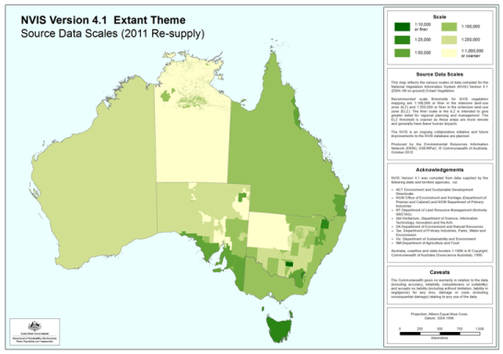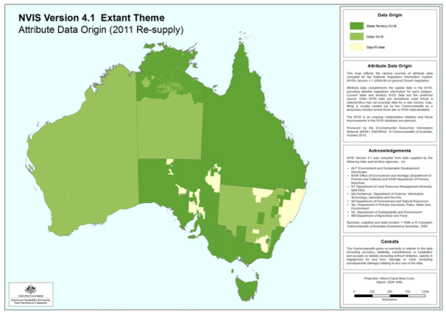

Figure 10: Source data scales for 2011 NVIS mapping (<http://www.environment.gov.au/erin/nvis/mvg/index.html>).

***Approach adopted***

In consultation with the Technical Advisory Group and project Steering Committee, it was agreed that NVIS 4.1 would be the primary source of vegetation attribution, as it has Basin-wide coverage, generally represented the most recent vegetation mapping for South Australia, Queensland and Victoria and much of New South Wales and therefore was consistent with our goal of using the best-available jurisdiction data. Having the data in a consistent format with all sources already integrated spatially would be a significant advantage to the project.

***GIS application***

(NVIS v 4.1 was the only data source used to map the dominant vegetation to aquatic ecosystems ()

NVIS 4.1 data were obtained from a number of shape files and geodatabases that together provided complete coverage of the MDB, mapped as polygons. For the current project the dominant vegetation type in each mapped polygon (identified by the NVISDSC1 code) was used. The vast majority of mapped polygons only have NVISDSC1 codes (additional codes are only added by jurisdictions to indicate mixed assemblages if required). This enabled a significant reduction in the data processing by transforming the multiple polygon data sets into a single basin-wide raster mosaic where the value of the raster pixels is the NVISDSC1 number. A lookup table supplied by the Department of Sustainability, Environment, Water, Population and Communities NVIS team was then used to map the 14,200 individual NVISDSC1 codes to ANAE vegetation types (Appendix 1). Conversion of the polygon mapping to raster needed to be carried out at a very fine scale to ensure small aquatic ecosystems were not eliminated from the dataset in the conversion to raster. A 25 metre grid was chosen. The workflow for this process was:

1. All NVIS polygon data layers were converted to raster with a 25m pixel size where each pixel value is the NVISDSC1 vegetation type identifier.
2. The various raster layers were then joined together as a mosaic to create a single consistent data layer for the basin. Some of the individual data sets in the mosaic were still very large (e.g. all of Queensland) causing the GIS to crash when processing.
3. The single mosaic layer was exported into approximately 400 tiles (2048 x 2048 pixels)
4. A new mosaic layer was created from the tiles.
5. Processing scripts for each aquatic ecosystem layer (rivers, wetlands, floodplain) then cycled through the 27 AWRC basins that comprise the MDB attributing each feature using the GIS zonal statistics tool to identify the vegetation NVISDSC1 ID code that overlapped the majority of each feature (the dominant vegetation type).
6. A lookup table was then used to assign the dominant vegetation code to a coarse structural category (trees, shrubs, grass) and a finer category that includes aquatic dependent vegetation assemblages (see Appendix 1 for details).

Table 23: Source data used to attribute Vegetation

|  |  |  |  |
| --- | --- | --- | --- |
| Data Name | Jurisdiction | Agency | Currency |
| National Vegetation Information System (NVIS) v 4.1 | Australia | SEWPaC | 2013 |
| Rivers Environmental Restoration Program 2008 (Gwydir, Macquarie Marshes, Lowbidgee) | New South Wales | OEH | 2008 |

## Estuarine attributes

The only estuarine features associated with the MDB is the Coorong and Murray Mouth features below the barrages that separate the lower lakes (e.g. Lakes Alexandrina and Albert, fringing lakes) from marine influence.

Data for the ANAE estuarine attributes listed in Table 7 are not readily available for the Coorong and Murray Mouth. Expert advice from South Australian jurisdictional representatives was therefore used with supporting data from the 2003 Coorong and Lower Lakes Ramsar habitat mapping (Seaman 2003).

## Arthur Rylah Institute vegetation mapping (Victoria)

As discussed above, NVIS 4.1 is currently the best consolidated vegetation mapping for the Basin. The data is mostly derived from on-ground mapping and the consistent NVIS data structures provide a level of quality assurance where only data that meets the minimum requirements can be integrated into the system. NVIS also has a number of limitations:

* It can take a number of years for new mapping to be integrated.
* Data resolution and accuracy is not consistent (although it is a positive that the system is robust enough to incorporate data of differing resolution).
* Coverage of data is not consistent, with some more remote areas of the MDB being poorly mapped.
* Classification of vegetation data to consistent classes is difficult because each mapping exercise describes vegetation differently and some information will inevitably be lost in translation when converting to NVIS Descriptors, MVGs and MSGs.

Researchers at the Department of Environment and Primary Industries Arthur Rylah Institute in Melbourne use a vegetation mapping procedure that employs regression models informed by vegetation quadrat data to predict the structure of vegetation assemblages in the landscape from remote sensing imagery. The combination of remote sensing and modelling is not new, but the data resources Arthur Rylah Institute have accrued over time and their proven approach are now being applied to the MDB and will represent a significant step forward in the available vegetation mapping for the basin that is directly relevant to this ANAE classification.

The modelling inputs are a data set of more than 30,000 vegetation quadrats collected over a 30 year period, and an “image stack” that includes a sequence through time of many different remote sensing images spanning many wavelengths and different combinations of wavelengths. Comparing images of the same on-ground area from a single satellite source allows anomalies such as clouds, smoke, and reflectance at different times of the day to be identified and corrected. Over longer time periods variation due to season (e.g. wet/dry phases) or even defoliation from insect pests can also be identified and corrected. The combination of many different sources of normalised (corrected) imagery for the same landscape, in combination with on-ground survey (quadrat) species data feeds into a modelling environment that can take current remote sensing imagery and model the on-ground vegetation mapping. The 2005 Victorian EVC mapping that is currently the state vegetation mapping included in NVIS 4.1 was produced by Arthur Rylah Institute using an earlier, less sophisticated, version of this modelling approach. Three advantages of the Arthur Rylah Institute approach to vegetation mapping are:

* Consistent resolution mapping at all locations.
* Simulations using ensembles of regression models to selectively excluding subsets of data and predict those same values provides a spatial error term that tells you where mapping is a good or poor fit to the data.
* Data for any point is continuous and probabilistic for each modelled entity (species or assemblage) allowing different combinations to be assembled to suit specific purposes.

Currently Arthur Rylah Institute is working with Dr Shaun Cunningham at Monash University and the Authority to map floodplain vegetation condition systematically across the MDB. The project team is using variation in the remote sensing imagery through time to detect changes in canopy health that is then mapped spatially and ground-truthed against on-ground surveys. The vegetation mapping products that are being developed for the MDB are at very fine resolution (1:25,000, 25 metre pixel size) with basin wide coverage. Within each pixel the models predict the canopy cover of trees, grass, shrubs, black box, red-gum, lignum, river coobah, water (possibly other species also). The data is continuous, and mixed assemblages can be identified (e.g. an individual 25 metre square pixel could represent 40 percent red gum, 30 percent black box and 30 percent lignum). Imagery presented below (Figure 11 to Figure 13) uses a preliminary sample of the Arthur Rylah Institute mapping approach that is at a coarser scale (70 metre) pixel data and only course groupings of trees, shrubs, Mallee and grasses. The MDB floodplain mapping project is expected to be completed by the end of 2013. The satellite imagery is still being compiled by Geosciences Australia and is expected to be delivered to the Arthur Rylah Institute by the end of July 2013.



Figure 11: Multi spectral map of simple vegetation classes surrounding Kerang Lakes in Victoria. Red = Mallee, Blue=Trees, Green = Grassland (70 metre pixels).

Figure 12 compares the mapping outputs from the Arthur Rylah Institute sample for “Tree” with the combined “Tree” category prepared from grouping appropriate NVIS data types (see Appendix 1 for details). The Arthur Rylah Institute map (shaded to indicate tree density) appears to agree in general with the NVIS mapping but more specifically has better resolution of the dense tree bands that occur along the watercourses of the Murray and Wakool Rivers. The NVIS data is less sensitive, because the definition of “Tree” is based on groupings of vegetation classes that were originally proposed to portray groupings of species; Victoria’s EVCs. Given that Victoria’s state-wide vegetation mapping included in NVIS is derived from a similar remote sensing modelling process, it is perhaps not surprising that there is good agreement in the mapping.

Figure 13 shows a similar comparison of Arthur Rylah Institute mapping to NVIS mapping for the Barmah-Milewa area of New South Wales and Victoria. In this comparison the vegetation mapping included in NVIS was obtained from very detailed vegetation surveys with mapping at fine scales (1:10,000-1:25,000). Comparing the Arthur Rylah Institute and NVIS output also shows good agreement in the distribution of trees with the red gum and black box forests of the floodplain clearly evident in both maps with similar riparian width either side of the Murray River main stem. The NVIS mapping indicates there is a higher density of trees in the lower half of the map (south of the Murray River) than to the north. The Arthur Rylah Institute mapping shows the opposite pattern (generally lighter area below the Murray River than to the north). In this case the mapping in NVIS is a composite layer with different data sources contributing to the areas north and south of the river, with finer scale mapping to the south. The observation that there are more trees in NVIS may result from differences in the mapping resolution and categories that have been combined, rather than on-ground differences. For this example a more rigorous comparison is not justified as there are known differences between the two categories of “tree” (the Arthur Rylah Institute mapping specifically excludes Mallee, where these were included as trees for the ANAE mapping in NVIS). The new Arthur Rylah Institute mapping in development for the Authority matches the ANAE categories and once this data is available more robust comparisons can be made.

For this initial comparison, the Arthur Rylah Institute approach does appear to be mapping trees with some certainty, and appears promising that it will be able to provide more accurate mapping in other areas of the MDB where the current vegetation mapping is very old (1970-1980) and low resolution (e.g. 1:1,000,000 in north western New South Wales).

Mapping against the NVIS category of “shrub” does not compare as well (). In this case the dark areas to the right of include Mallee, which is not included in the ANAE NVIS shrub category. Once the Authority mapping is available it may be necessary to revisit the NVIS vegetation groupings and ensure they are aligned to the Arthur Rylah Institute mapping so that more rigorous statistical approaches can assess the accuracy of the modelled mapping (comparing apples with apples).

The Arthur Rylah Institute mapping also provides a residual error term for each mapped pixel (the standard deviation of many regression model combinations). These can be used to get a confidence map for the data, and potentially inform the definition and delineation of categories. Using GIS the raster layers for the standard deviation in tree density can be divided by the raster layer for mean tree density providing a map of the coefficient of variation in the models at the same resolution as the original mapping () this identifies areas of the mapping where the mapping error is highest. For the examples provided in , the mapping around Kerang is generally quite low variance (entire map is pale grey) but specifically the riparian areas and Murray River and Wakool floodplain mapping show very low error (white in the figure). At the scale of the entire state of Victoria, the areas where the mapping performs worst are areas where trees are rare (New South Wales hay plains, Victorian Alps, and the grasslands of the Victorian volcanic plains). The Mallee area of Victoria also has a higher error rate because in this example data set Mallee trees are excluded from the tree category. This pattern of the models having greater accuracy in the areas that match the categories being mapped is characteristic of the regression approach being used where more data is providing stronger analytical power. An advantage of this approach is that identifying areas that map poorly can trigger the collection of more on-ground survey data (e.g. vegetation quadrat data) to improve the modelling.

The Arthur Rylah Institute pixel mapping can be combined using raster statistics in GIS (e.g. as for the calculation of coefficient of variation in ), or alternatively multiple characteristics can be mapped together as different spectral bands. Figure 11 shows the area surrounding Kerang lakes mapped using red (Mallee), green (grassland) and blue (trees) to simultaneously map different vegetation classes. The large blue expanse of trees to the right is the Wakool River floodplain. This map intentionally stretches the colour thresholds to make the relative differences clear but shows how combining classes can make patterns clear that are not as visible when viewed one-dimensionally.

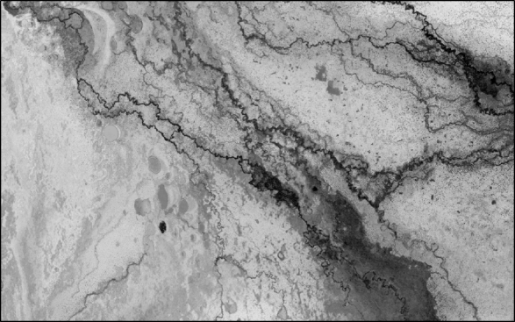

Kerang Lakes

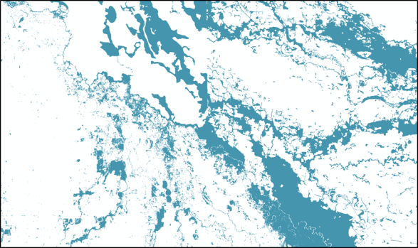

Figure 12: Kerang lakes area of Victoria. Arthur Rylah Institute tree raster layer 70 metre pixels shaded white-black (0-100% tree) compared with the ANAE ‘Tree’ category from combining NVIS 4.1 vegetation types.

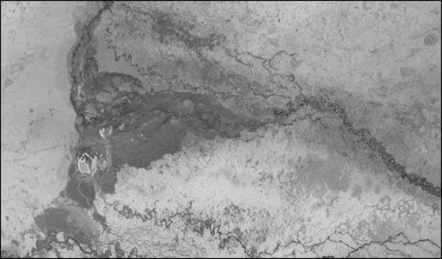

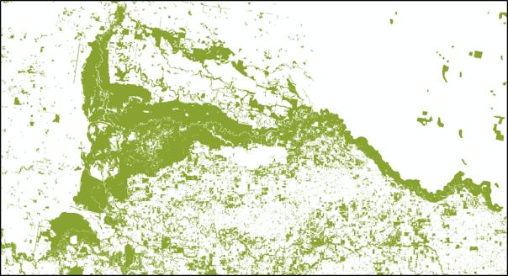

Figure 13: Barmah-Millewa area of New South Wales and Victoria. Arthur Rylah Institute tree raster layer 70 metre pixels shaded white-black (0-100% tree) compared with the ANAE ‘Tree’ category from combining NVIS 4.1 vegetation types.

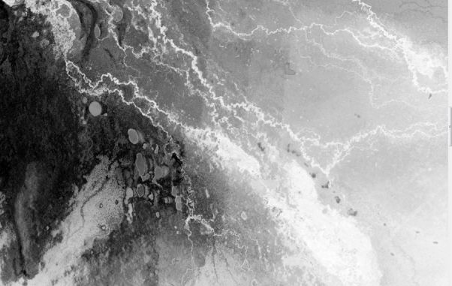

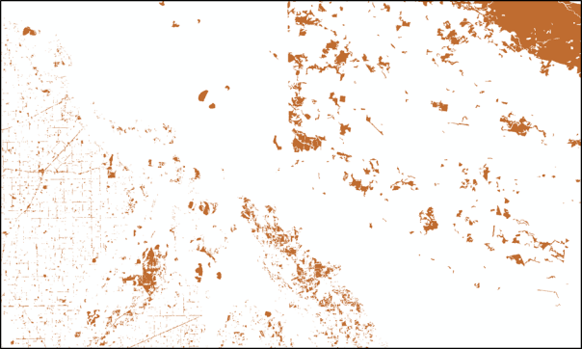

Figure 14: Kerang lakes area of Victoria. Arthur Rylah Institute “shrub” raster layer 70 metre pixels shaded white-black (0-100% tree) compared to ANAE “shrub” category from combining NVIS 4.1 vegetation types.



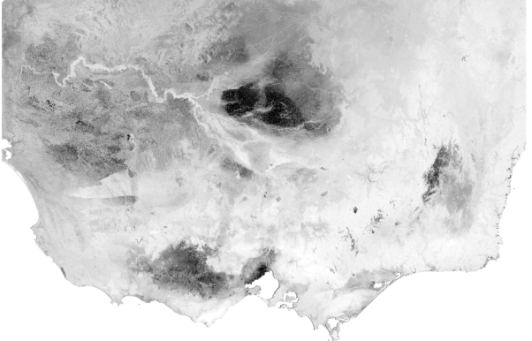

Mallee

Volcanic Plains (grasslands)

Victorian Alps

Hay plains

Figure 15: Coefficient of variation (mean/standard deviation) for Arthur Rylah Institute “Tree” category at Kerang lakes, Victoria (top) and across the entire Victorian map sample (bottom).

*Note: Dark areas indicate where the models are poor predictors of tree density. These areas correspond to areas where trees are absent or rare (the Hay plain in New South Wales, Victorian alpine region, and Victorian volcanic plains, Mallee).*

# Geodatabase Structure

The classification is housed in an ArcGIS geodatabase (Figure 16). The database consists of several Feature Layers:

* Rivers,
* Wetlands (lacustrine, palustrine, and estuarine),
* Example Floodplains (MDBA, RERP, SA)

Each feature layer is connected to a group of Attribute Tables:

* Each attribute occupies its own table;
* An attribute table may contain information from more than one data source (Src1 and Src2 depicted in Figure 16);
* Each attribute data value (Src1DataValue) includes enough information to locate the original source data record (Src1DataField, Src1ID, Src1DataID);
* Confidence in the data is tracked by ID number in the Confidence Table.

Each data source is referenced by a link to the Data Sources Table

Confidence measures are allocated both for the feature mapping and for the attribute assignments (discussed below). Confidence values are assigned using simple heuristic rule sets that are identified by a unique ID and documented in the Confidence table.

The philosophy behind the database structure is that every piece of information that is used can be traced back to the original source. All decisions that are made in assigning attributes should be given a confidence rating and be documented. The design is modular so that individual attribute tables can be updated in isolation.

The typology is applied by filtering the assigned attributes for a feature as identified in Chapter 5. This is currently performed manually.

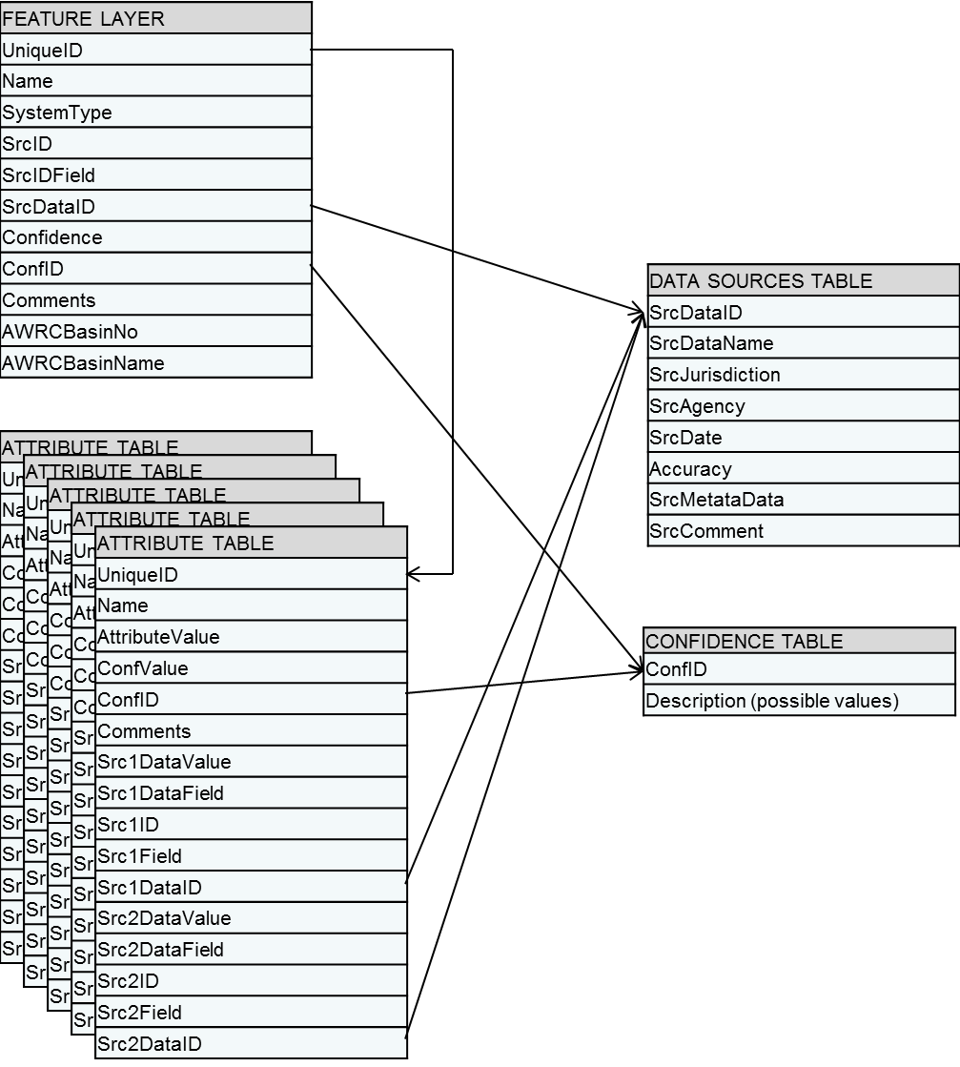

Figure 16 ANAE Classification database structure.

### Confidence ratings

The mapping and attribute data that have been applied to individual aquatic ecosystems have been assigned confidence ratings. Two broad elements where considered: (i) confidence in a dataset, (ii) confidence that the final type represents on-ground reality, with the former informing the latter. Thus the confidence in the various data sources will be a key informant of overall confidence in the classification and typology. Factors considered included such things as whether to assign a low confidence due to there being no data, compared with low confidence due to poor data.

Confidence ratings can be applied for any reason (the reason should be documented as part of a confidence rule set; ) and were often based on:

* Mapping discrepancies,
* Mapping accuracy issues,
* Data resolution,
* Data accuracy,
* Interpretation and attribution decision rules.

In addition to the above, other factors informing confidence include such things as whether the data is quantitative, or whether the spatial coverage is comprehensive. Some attributes are obtained by intersecting or overlaying features with attribute data layers (e.g. vegetation and landform). For these attributes confidence may be related to mapping alignment, scale and interpretation. Other attributes were derived from the attributes of other data sets (e.g. water source) and confidence will depend on how the data is stored in the source data set and whether multiple sources agree or disagree (for example if one data set indicates a wetland is commonly wet but another data set indicates the same wetland is periodically inundated).

In consultation with the Technical Advisory Group, it was agreed that confidence would be applied on an attribute by attribute basis. It was also agreed that a simple confidence range (low, medium, high) would be most appropriate. A scoring system (e.g. 3 = high confidence, 2 = medium confidence, 1 = low confidence) has been applied to the mapping and attribute data and is included in the table structure of the GIS. Using scores allows individual confidence scores to be combined (e.g. mapping confidence + data confidence) to arrive at a combined overall confidence. These combinations have not been made for this data set and remain an avenue for further work.

Two examples of how confidence ratings were applied are provided in Table 24 (see Appendix 2 for the full set). The first ConfID = 01 is for the assignment of system type (riverine, lacustrine, palustrine). This rule set therefore only applies to the Wetlands Feature Table. Blanket rules for assigning confidence are under the “All states” heading. Individual exceptions for the different jurisdictions are noted below that. The second rules set would be cited (ConfID set to value 02) on the WaterType attributes table. Enough information should be supplied in the description to understand why the confidence rating (bold in Table 24) was assigned.

Table 24: Two example confidence rule sets. Individual feature attribute assignments are scored with the confidence number (bold)

|  |  |
| --- | --- |
| ConfID | Description |
| 01 | Assigning system type to wetland polygons.  All states:  **Confidence = 1**: If type is unknown assumed value is Palustrine.  **Confidence = 2**: Riverine defined by intersection of polygons with Geofabric major rivers.  **Confidence = 3**: Jurisdiction mapping defines the system type for this feature.  NSW:  **Confidence = 2**: SystemType assigned to Lacustrine based on part of the Name  NSW_Wetlands.HYDRONAMETYPE = 'LAKE' OR NSW_Wetlands.HYDRONAMETYPE = 'LAKES' OR NSW_Wetlands.HYDRONAMETYPE = 'POND' OR NSW_Wetlands.HYDRONAMETYPE = 'PONDS'.  SA:  158 systems with “Dam” in the name. Confidence lowered to **2** perhaps should be deleted because artificial.  **Confidence = 4**: Murray River main channel in SA (certain). |
| 02 | Assigning water type (salinity) to wetland polygons.  All states:  **Confidence = 1**: Assume Freshwater if no data or unknown.  VIC:  **Confidence = 3**: Fresh, and all saline categories apart from “Fresh-Hyposaline” obvious mappings.  **Confidence = 2**: “Fresh-Hyposaline” mapped to saline (lower confidence).  QLD:  **Confidence = 3**: Fresh and Saline are straightforward mappings  **Confidence = 2**: Hyposaline (3,000 -30,000 ppt). - mapped to saline but low end of range overlap fresh.  SA:  **Confidence = 3**: Fresh and Saline are straightforward mappings  **Confidence = 2**: Brackish mapped to Saline.  NSW:  **Confidence = 1**: NO DATA. |

A rigorous analysis of confidence ratings was beyond the scope of the present project, however one approach that was trialled was to produce confidence “halos” for wetland features by colouring the outline of mapped wetlands based on the confidence rating (e.g. high confidence=green, medium confidence = yellow, low confidence = red) (see Figure 17 to Figure 19). In this manner a “heat map” of confidence can be produced for an individual attribute (e.g. Water Type, Figure 17) or confidence ratings can be combined arithmetically to produce an overall summary map (Figure 19). Figure 17 shows the entire basin “heat map” for confidence in the single attribute of Water Type (freshwater or saline) as applied to the basin. The resulting pattern is a result of Victoria and Queensland having a salinity field embedded in the jurisdiction wetland mapping (green=high confidence). South Australia does not include salinity in the state-wide wetlands mapping, but does in the River Murray SAAE mapping along the Murray River only and in the South East Wetland Inventory Database (SAWID) used in the estuarine and coastal areas. For New South Wales and the majority of South Australia there was no salinity data available so the attribute defaults to “Freshwater” with low confidence (red).

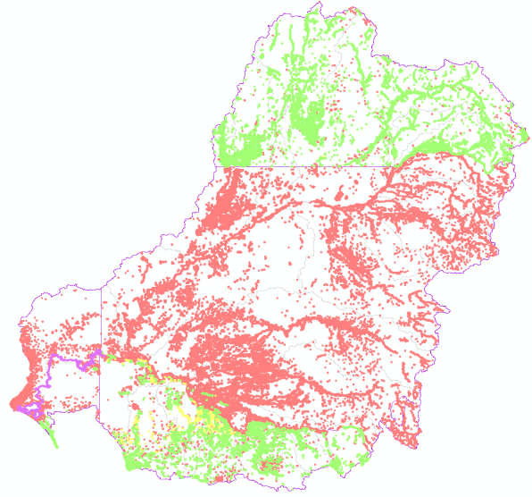

Figure 17: Confidence “heat map” for the ANAE attribute Water Type applied to wetlands (high confidence=green, medium confidence = yellow, low confidence = red, types that have been manually assigned = purple).

At the basin level, the “heat map” approach is useful for displaying broad jurisdictional or regional differences in attribute confidence that can typically be traced to differences in data sources as demonstrated above. At the scale of individual wetland features the confidence halos can also be useful. Figure 18 shows the Great Cumbung Swamp in New South Wales (in green) which has a green vegetation attribute confidence halo indicating high confidence in assigning the vegetation attribute “Tall emergent aquatic”. In this case the NVIS source data for the vegetation mapping included a lot of information about the dominant vegetation for this well-known reed-bed swamp. In contrast, the three smaller temporary tall emergent floodplain marshes to the south-west of the swamp (pale blue in Figure 18) have the same vegetation type of “Tall emergent aquatic”, but low confidence indicated by the red halo. For these wetlands the NVIS source data listed the dominant vegetation characteristics as “unknown”, but included enough information in the NVIS vegetation group and source data description fields for the vegetation type to be assigned, albeit with lower confidence.

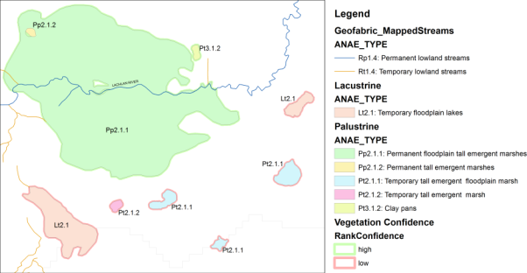

Figure 18 Example of vegetation attribute confidence halos around individual wetlands (the green permanent floodplain tall emergent marsh is the Great Cumbung Swamp in New South Wales at the terminus of the Lachlan River)

Confidence ratings can also be combined. Figure 19 shows the result for wetlands in the classification by unweighted addition of all individual attribute confidence scores for system type, landform, water source, water type water regime and vegetation rescaled to low, medium and high. The resulting map shows how the detailed jurisdiction mapping of Queensland, Victoria and parts of South Australia contribute to higher overall confidence in the classification.

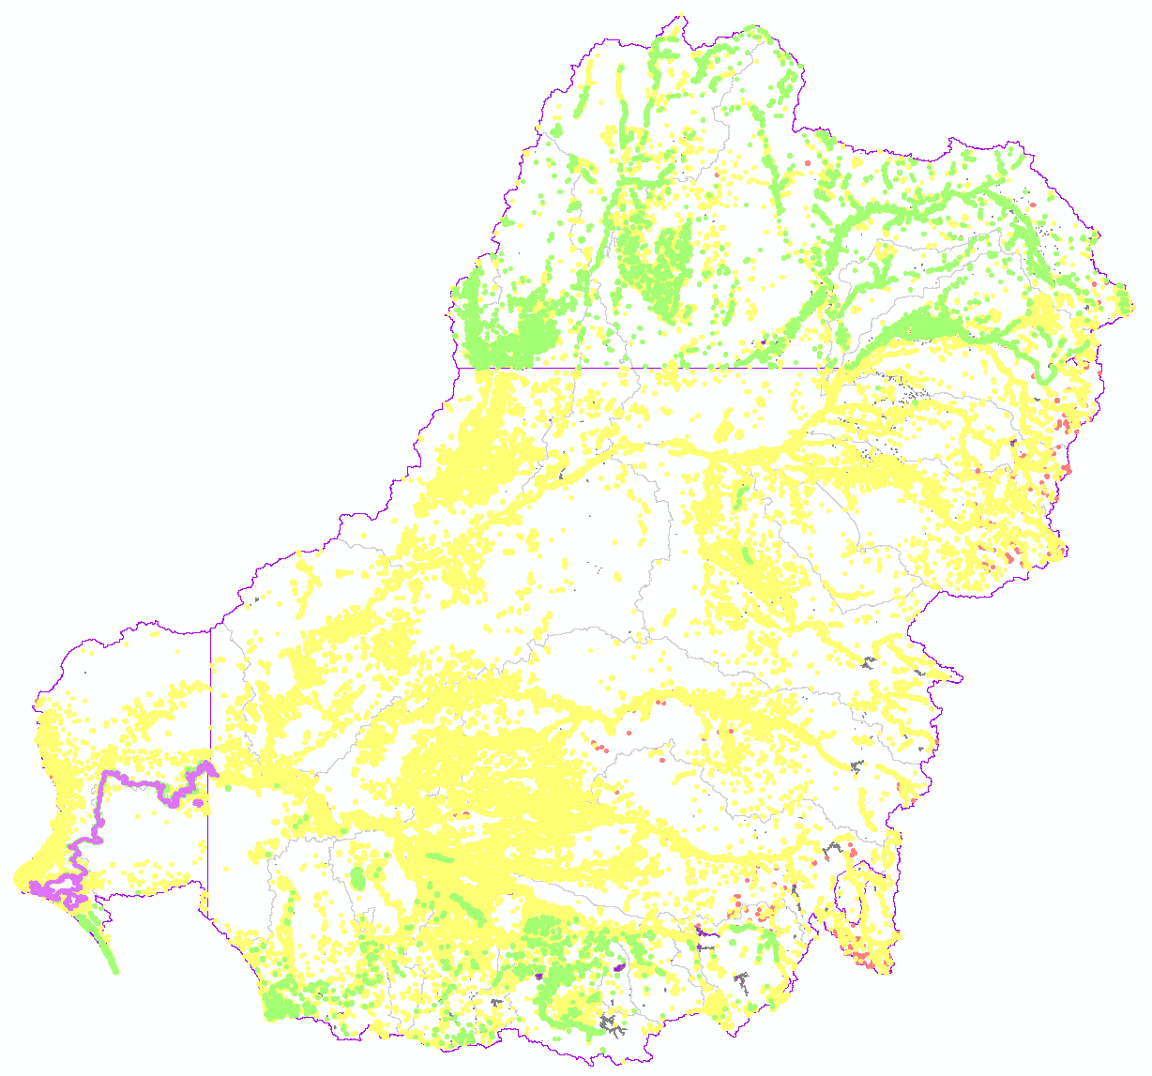

Figure 19 Total combined rank confidence for all ANAE attributes assigned to wetlands in the MDB during this classification (high confidence=green, medium confidence = yellow, low confidence = red, types that have been manually assigned = purple)

*Note: Multiple confidence scores were added without any specific weighting and then re-scaled to the range 1-3 representing high, medium and low combined confidence. ANAE types along the Murray River in South Australia were assigned manually during validation (section 5.5).*

# Aquatic ecosystem typology

AETG (2012) distinguishes between classification and typology as follows:

* **Classification** is the process of cataloguing items, in this case aquatic ecosystems, into logical groups based on attributes that have been identified as being relevant to, for example, ecological functioning; and
* **Typology** is an extension to classification whereby those classified aquatic ecosystems are assembled into groups for a specific purpose i.e. a naming convention.

At present the ANAE framework does not include any guidance on producing a typology associated with the application of the classification. Obtaining guidance from other classifications has proved difficult as the typology has generally been included as part of the classification process with little information on how types were developed (e.g. Jones and Miles 2009). The typology applied for this project includes several, but not all, of the Level 3 attributes for each of the ecosystem classes. Given the likely application to environmental water decisions, key attributes included in the typology are water type, water regime, landform and vegetation. These are often key elements of other classification/typologies also (e.g. Jones and Miles 2009).

The development of the typology builds on work already undertaken in this area, notably by Queensland and South Australia. The basic elements for the typology are that it has to be ecologically meaningful, comparable with other typologies, particularly the Ramsar and jurisdictional typologies where they exist (see section 7.1), and should reflect the key drivers of wetland ecology. Clear definitions and description of each ecosystem type are considered an essential component of the typology, as this is often lacking in existing classifications. Thus this typology includes definitions of commonly used terms such as swamp, marsh, lake and so on (see section 7.2).

## Example typologies

The following is a very brief description of several existing typologies; it is not intended as a comprehensive review/critique but serves to illustrate the types of features that might be expected in a typology.

The Ramsar wetland classification doesn’t have ecosystem classes (Riverine, Lacustrine, Palustrine, Estuarine, and Marine) as in the ANAE framework, but rather has three broad categories with a total of 42 types assigned: inland wetland (20 types) (Table 25), marine/coastal wetlands (12 types) (Table 26), and human made wetlands (10 types). The names used typically include water regime (permanent, seasonal/intermittent), water type (fresh, saline, brackish or alkaline) and a mixture of dominant vegetation and location (Ramsar 2009).

Table 25: Ramsar classification of inland wetlands (Ramsar 2009)

|  |  |  |  |  |
| --- | --- | --- | --- | --- |
| **Water type** | **Classification** | | | **Code** |
| Fresh water | Flowing water | Permanent | Rivers, streams, creeks | M |
| Deltas | L |
| Springs, oases | Y |
| Seasonal/intermittent | Rivers, streams, creeks | N |
| Lakes and pools | Permanent | > 8 ha | O |
| < 8 ha | Tp |
| Seasonal/intermittent | > 8 ha | P |
|  | < 8 ha | Ts |
| Marshes on inorganic soils | Permanent | Herb-dominated | Tp |
| Permanent/ Seasonal/intermittent | Shrub-dominated | W |
| Tree-dominated | Xf |
| Seasonal/intermittent | Herb-dominated | Ts |
| Marshes on peat soils | Permanent | Non-forested | U |
| Forested | Xp |
| Marshes on inorganic or peat soils | High altitude (alpine) | | Va |
| Tundra | | Vt |
| Saline, brackish or alkaline water | Lakes | Permanent | | Q |
| Seasonal/intermittent | | R |
| Marshes & pools | Permanent | | Sp |
| Seasonal/intermittent | | Ss |
| Fresh, saline, brackish or alkaline water | Geothermal | | | Zg |
| Subterranean | | | Zk(b) |

Table 26: Ramsar classification of marine/coastal wetlands (Ramsar 2009)

|  |  |  |  |
| --- | --- | --- | --- |
| **Water type** | **Classification** | | **Code** |
| Saline water | Permanent | < 6 m deep | A |
| Underwater vegetation | B |
| Coral reefs | C |
| Shores | Rocky | D |
| Sand, shingle or pebble | E |
| Saline or brackish water | Intertidal | Flats (mud, sand or salt) | G |
| Marshes | H |
| Forested | I |
| Lagoons | | J |
| Estuarine waters | | F |
| Saline, brackish or fresh water | Subterranean | | Zk(a) |
| Fresh water | Lagoons | | K |

South Australia has developed a typology associated with South Australian aquatic ecosystems at two scales: (i) a regional scale which has been applied to the River Murray wetlands (Jones and Miles 2009) and (ii) a state scale typology. A total of 12 types were identified in the regional typology, while 28 types were identified for the state typology (Table 27). Higher resolution of the hydrology attribute is used in the regional typology to split 5 state level types into 9 regional types. The types use common names (e.g. dunal lake, temporary wetlands, freshwater meadows, grass sedge wetlands etc.) and it is not always evident by the name as to why it is a different type to others in the typology. The South Australian system doesn’t indicate anything about water regime (in most cases), climate or location. The exception is the typology for Riverine systems, which includes water regime in the name and includes a type for waterholes.

Table 27: South Australian aquatic ecosystem typology (adapted from Jones and Miles 2009).

|  |  |  |
| --- | --- | --- |
| **Aquatic Ecosystem Class** | **Aquatic ecosystem** | **Code** |
| **Wetland type (inland and not instream)** | | |
| Lacustrine | Inland lakes | IL |
| Dune lakes | DL |
| Salt lakes | SL |
| Terminal lakes | TL |
| Permanent lake | PL |
| Palustrine | Permanent swamp | PS |
| Artesian springs | AS |
| Inland swamps | IS |
| Rockholes | RH |
| Claypans | CP |
| Inland interdunal wetlands | IIW |
| Soaks & springs | SkSp |
| Grass sedge wetland | GSW |
| Saline Swamp | SSw |
| Temporary wetlands | TW |
| Freshwater meadows | FM |
| Peat swamp | PS |
| Floodplain | Floodplain | FP |
| Karst (not in ANAE surface water classification) | Sub Karst systems | Kst |
| **Watercourse type (instream)** | | |
| Riverine | Permanent reach | PWC |
| Seasonal reach | SWC |
| Seasonal waterhole | SWH |
| Ephemeral reach | EWC |
| Ephemeral waterhole | EWH |
| **Estuary type** | | |
| Estuarine | Wave dominated system | WDE |
| Tide dominated system | TDE |
| Tide flat and creeks | TFC |
| Embayment/Lagoon | EBL |

Queensland also has an advanced typology having developed a state-wide Wetland Habitat Typology for Lacustrine and Palustrine wetlands using the following set of attributes (DERM 2012):

* Wetland system;
* Climate;
* Water type;
* Water regime;
* Geomorphology/topography;
* Floodplain, non-floodplain (depressional), non-floodplain (springs);
* Soils;
* Dominant vegetation;
* For treed wetlands – two community types:
  + Melaleuca and Eucalypt swamps
  + Palm swamps.

The typology groups wetlands into two main ‘sub-categories’ based on climate and location:

* **Coastal and sub-coastal** – includes tropical, subtropical, and temperate zones;
* Inland – includes **Arid and semi-arid** zones

All type names begin with the climate subcategory, but can also include some reference to vegetation or landscape geomorphology/topography. Water regime is not captured in the name of any types. The typology was developed through expert consultation and an iterative process of ‘reality checking’ against the state wetland mapping, providing broad types relevant at the state level but which also allowed for identification and grouping of key ecological and physical processes within wetlands of each broad climatic zone (DERM 2012).

Table 28: Queensland aquatic ecosystem typology (EPA 2005)

|  | **Wetland system** | **Climatic zone** | **Wetland substrate** | **Water type** | **Water regime** | **Landscape geomorphology/ topography** | **Vegetation** | **Wetland name** |
| --- | --- | --- | --- | --- | --- | --- | --- | --- |
| **Estuarine** | | | | | | | | |
| A1 | Estuarine | All | All | All | All | All | Trees (Mangroves) | Mangrove Wetlands |
| A2 | Estuarine | All | All | All | All | All | Grass, Sedge, Herbs (Saltmarsh) | Saltmarsh Wetlands |
| **Coastal and subcoastal** | | | | | | | | |
| 1 | Palustrine | Coastal and subcoastal | All | Saline | All | All | All | Coastal and subcoastal saline swamps of all substrates, water regimes, topographic types and vegetation communities |
| 2a | Palustrine | Coastal and subcoastal | All | Fresh | All | Non-floodplain (depressional) | Trees (Melaleuca and Eucalypt) | Coastal and subcoastal non-floodplain tree swamps (Melaleuca and Eucalypt)  of all substrates and water regimes |
| 2b | Palustrine | Coastal and subcoastal | All | Fresh | All | Non-floodplain (depressional) | Wet Heath | Coastal and subcoastal non-floodplain wet heath swamps of all substrates and water regimes |
| 2c | Palustrine | Coastal and subcoastal | All | Fresh | All | Non-floodplain (depressional) | Grasses, Sedges, Herbs | Coastal and subcoastal non-floodplain grass, sedge and herb swamps of all substrates and water regimes |
| 3 | Palustrine | Coastal and subcoastal | All | All | All | Non-floodplain (spring) | All | Coastal and subcoastal spring swamps of all substrates, water types, water regimes and vegetation communities. |
| 4a | Palustrine | Coastal and subcoastal | All | Fresh | All | Floodplain | Trees (Melaleuca and Eucalypt) | Coastal and subcoastal floodplain tree swamps – melaleuca and eucalypt of all substrates and water regimes |
| 4b | Palustrine | Coastal and subcoastal | All | Fresh | All | Floodplain | Wet Heath | Coastal and subcoastal floodplain wet heath swamps of all substrates and water regimes |
| 4c | Palustrine | Coastal and subcoastal | All | Fresh | All | Floodplain | Grasses, Sedges, Herbs | Coastal and subcoastal floodplain, grass, sedge herb  swamps of all substrates and water regimes |
| 5 | Palustrine | Coastal and subcoastal | All | Fresh | All | All | Trees (Palm) | Coastal and subcoastal tree swamps – palm of all substrates, topographic types and water regimes |
| 6 | Lacustrine | Coastal and subcoastal | All | All | All | Floodplain | NA | Coastal and subcoastal Floodplain Lakes of all substrates, water types and water regimes. |
| 7 | Lacustrine | Coastal and subcoastal | Rock | All | All | Non-floodplain | NA | Coastal and subcoastal non-floodplain rock lakes of all water types and water regimes |
| 8a | Lacustrine | Coastal and subcoastal | Sand | Fresh | All | Non-floodplain (window) | NA | Coastal and subcoastal non-floodplain sand lakes (window) of all water types and water regimes |
| 8b | Lacustrine | Coastal and subcoastal | Sand | Fresh | All | Non-floodplain (Perched) | NA | Coastal and subcoastal non-floodplain sand lakes (perched) of all water types and water regimes |
| 9 | Lacustrine | Coastal and subcoastal | Mineral soils | All | All | Non-floodplain | NA | Coastal and subcoastal non-floodplain soil lakes of all water types and water regimes |
| **Arid and semi-arid** | | | | | | | | |
| 10 | Palustrine | Arid and semi-arid | All | Saline | All | All | All | Arid and semi-arid saline swamps of all substrates, water regimes, topographic types and vegetation communities |
| 11a | Palustrine | Arid and semi-arid | All | Fresh | All | Floodplain | Trees | Arid and semi-arid fresh tree swamps of all substrates, and water regimes and topographic types |
| 11b | Palustrine | Arid and semi-arid | All | Fresh | All | Floodplain | Lignum | Arid and semi-arid lignum swamps of all substrates, and water regimes and topographic types |
| 11c | Palustrine | Arid and semi-arid | All | Fresh | All | Floodplain | Grasses, Sedges, Herbs | Arid and semi-arid grass, sedge, herb swamps of all substrates, water regimes and topographic types |
| 12a | Palustrine | Arid and semi-arid | All | Fresh | All | Non-floodplain | Trees | Arid and semi-arid fresh non-floodplain tree swamps of all substrates and water regimes |
| 12b | Palustrine | Arid and semi-arid | All | Fresh | All | Non-floodplain | Lignum | Arid and semi-arid fresh non-floodplain lignum swamps of all substrates and water regimes |
| 12c | Palustrine | Arid and semi-arid | All | Fresh | All | Non-floodplain | Grasses, Sedges, Herbs | Arid and semi-arid fresh non-floodplain grass, sedge, herb swamps of all substrates and water regimes |
| 13 | Palustrine | Arid and semi-arid | All | All | All | Non-floodplain (spring) | All | Arid and semi-arid, non-floodplain swamps – springs of all substrates, water regimes and vegetation communities |
| 14 | Lacustrine | Arid and semi-arid | All | Saline | All | All | NA | Arid and semi-arid, saline lakes of all substrates, topographic types and water regimes |
| 15 | Lacustrine | Arid and semi-arid | All | Fresh | All | Floodplain | NA | Arid and semi-arid, floodplain lakes of all, substrates and water regimes |
| 16a | Lacustrine | Arid and semi-arid | All | Fresh | All | Non-floodplain | NA | Arid and semi-arid, non-floodplain Lakes of all substrates and water regimes |
| 16b | Lacustrine | Arid and semi-arid | All | Fresh | All | Non-floodplain (clay pans) | NA | Arid/ semi-arid, non-floodplain (clay pans) lakes of all substrates and water regimes |
| 17 | Lacustrine | Arid and semi-arid | All | All | Permanent | All | NA | Arid and semi-arid, Permanent Lakes permanently inundated lakes of all substrates, water types, topographic types and vegetation communities |

## Terminology and caveats

The following terminology explains some of the descriptors used in the typology developed for this project, and some of the assumptions made in order to simplify the naming convention:

**Energy** (high, low) – pertains to the relative energy of riverine flows resulting from the slope or steepness of the terrain.

**Fen and bogs** – peatlands (bogs and fen) are created under a range of hydrological and physical conditions. Fens are formed where mineral rich groundwater flows sustain vegetation such as grasses, sedges, reeds, shrubs and trees (Batzer and Sharitz 2006). The alkaline nature of fens and the fact that their primary water source is groundwater, with some surface and rainfall inputs, distinguishes them from bogs, which are dominated by surface water inputs. Bogs are further characterised as supporting Sphagnum moss.

**Freshwater** – unless specified, aquatic ecosystems are assumed to be freshwater (salinity <3000 mg/L).

**Intermittent** – used to describe the water regime of periodically inundated types in which inundation is known to be less frequent than annual or seasonal inundation, but more frequent than episodic and ephemeral inundation[4]. Flooding may persist from months to years (Boulton and Brock 1999). Only used in the type name when the inundation requirements of the dominant vegetation associated with the system are able to inform the frequency of inundation, or when waterholes have been identified as being present in a stream.

**Intertidal** – shore area between the high tide mark and the low tide mark.

**Lake** – an inland body of water, predominantly still or lentic in nature. Cowardin et al. (1979) defines them as being situated in a topographic depression or a dammed river channel, and having less than 30 percent emergent vegetation. Size may vary but most will exceed eight hectares; those with similar habitats but less than eight hectares can also be included, however, if active wave-formed or bedrock shoreline features makes up all or part of the boundary, or their depth is greater than 2 metres. Ocean-derived salinity is always less than 0.5 parts per thousand, thus separating them from lagoons.

**Lowland** – area of land within a catchment or subcatchment based on definitions in section 3.1.1. For example, lowland areas with a mrVBF score of 3 have a slope of less than four percent at a spatial resolution of 90 metres (Table 9). Note: the definition applied for this project does not include altitude.

**Marsh** – a wetland dominated by non-woody emergent vegetation such as sedges, reeds and rushes. Marshes can be shallow or deep with a combination of emergent and submergent vegetation types. They may also have areas of open water in deeper systems, up to 70 percent of wetland area. Marshes are typically between 0.5 to 2 metres depth, but depth can be highly variable.

**Meadow** – a wetland dominated by grasses (excluding Phragmites which is typically found in deeper marsh environments) and forbs. Meadows typically have shallow depths in the order of 10 to 50 centimetres. They are rarely permanent, often being filled on a seasonal basis.

**Permanent** – used to describe the water regime of commonly wet systems (wet >70 percent of the time). This assumes that for commonly wet lakes, for example, that they have water all year round except during extreme droughts, when they can dry out. Permanent is used as a commonly accepted term (e.g. Ramsar and Queensland typologies).

**Saline** – ecosystems with a salinity >3000 mg/L.

**Streams** – ‘streams’ is taken to include rivers, streams and creeks for the purposes of simplifying the naming convention. Rivers are large natural in-channel bodies of moving water (lotic) which have the capacity to structure the surrounding landscape (i.e. alluvial processes). This includes large anabranching systems (e.g. Edward-Wakool Rivers are major anabranches of the River Murray). Streams and creeks, both of which are typically smaller in-channel bodies of moving water, can be either a tributary or distributary of a river.

**Supratidal** – shore area immediately marginal to and above the high-tide level.

**Subtidal** – shore are below the low tide mark.

**Swamp** – a wetland dominated by woody vegetation, either shrubs and or trees.

**Temporary** – used to describe the water regime of periodically inundated types when the frequency of inundation is not known, but is less than commonly wet (wet <70 percent of the time).

**Upland** – area of land within a catchment or subcatchment based on definitions in section 3.1.1. For example, upland areas with a mrVBF score of 2 have a slope of greater than eight percent at a spatial resolution of 30 metres (Table 9). Note: the definition applied for this project does not include altitude.

**Valley bottom flatness** – identifies relatively flat and low areas in the landscape at a range of scales (Gallant and Dowling 2003).

## Typology structure

The typology is nested and can be used to describe a given aquatic ecosystem at a minimum of two levels, typically with each level having greater specificity as the number of attributes used increases. In the first instance the types were informed by the Level 3 ANAE attributes (e.g. Table 29), however some Level 2 attributes (location on a floodplain) have also been used. Additional information can be incorporated as needed, such as geographic location (e.g. coastal, alpine) and significant geomorphic features, which are not captured in the ANAE attributes but necessary to reflect distinctive, and in some cases, rare aquatic ecosystem types. The typology has been presented as a series of look up tables.

Table 29: Generic structure of typology

|  |  |
| --- | --- |
| ANAE class and attribute combinations | Type |
| Lacustrine | Lakes |
| Lacustrine + Level 3 water type | Lakes  Saline Lakes |
| Lacustrine + Level 3 water type + Level 3 water regime | Permanent lakes  Temporary lakes  Saline permanent lakes  Saline temporary lakes |

## Attributes by aquatic ecosystem class

A draft typology was presented to the Technical Advisory Group, Steering Committee and Environmental Water Scientific Advisory Panel at meetings in May 2013. The typology was then refined based on the comments and suggestions at those meetings. In particular, separation of floodplain and non-floodplain aquatic ecosystems was to be included. The Technical Advisory Group advised that a key locational descriptor was needed, specifically to show if lakes and wetlands were found on floodplains or in non-floodplain environments and so provide information helpful in terms of identifying aquatic ecosystems in environments to which riverine water could be delivered. It was also agreed that the floodplain typology would be based on dominant vegetation and that forest and woodland structural associations would be separated into types.

Water regime, water type and vegetation attributes are the main attributes used throughout the typology. The decision rules for the vegetation attribute categories are listed in Appendix 1. It should be noted that only vegetation structure (not dominant vegetation) has been used to help distinguish types for lacustrine and riverine classes. ‘Non-vegetated’ is a valid category for riverine systems as it can represent areas of settlement, or cleared areas (see Appendix 1 for more detail). As lacustrine systems are defined on the basis of having less than 30 percent emergent vegetation, only water is considered as a valid attribute category for the dominant vegetation attribute in the typology for lakes. For example, it would not be appropriate to describe a type on vegetation that only occurred over, say, 5 percent of the site.

### Lacustrine

The typology proposed for lacustrine systems (Table 30) is based on the following Level 3 ANAE attributes:

* Water type;
* Water regime (water permanency);
* Dominant vegetation (water only);
* Finer vegetation (aquatic bed).

The typology for lacustrine systems also captures if the system is located on a floodplain. A number of types can be aggregated (for example permanent lakes with or without submerged macrophytes can be aggregated up to being called just permanent lakes) and this is explained in the descriptions for each combination of attributes in Table 30. As stated above, systems are considered freshwater unless stated otherwise in the naming convention. Also lakes are assumed to have no submergent vegetation unless stated in the name convention.

### Palustrine

The typology proposed for palustrine systems (Table 31) is based on the following Level 3 ANAE attributes:

* Water type;
* Water regime;
* Dominant vegetation (structure);
* Finer scale vegetation (dominant species).

The typology for palustrine systems also captures if the system is located on a floodplain. The typology for palustrine systems includes a greater number of types as the potential range of vegetation associations/attributes is greater, as these reflect the greater range or variability in water regime encountered in this ecosystem class. Springs were assigned to individual features as designated in jurisdictional data sets and were assumed to be commonly wet.

Decision rules for assigning the various vegetation categories for the finer scale vegetation attribute is provided in Appendix 1. For the palustrine typology the following has been applied:

* Where the data for finer scale vegetation attributes (i.e. NVIS data) is either not specified, is specified as unknown, or the data is inconsistent, then this is assigned as **Not specified** in the typology. This assumes that there will be no permanently inundated swamps with associated vegetation other than paperbark. This is based on the general understanding of water requirements for the key water dependent species specified in the typology.

Table 30: Lacustrine types using Level 3 attributes and a location descriptor (floodplain).

*Note: Dominant vegetation and fringing vegetation do not provide any greater separation of types. Codes: Lp = permanent freshwater lacustrine/lakes, Lt = temporary freshwater lacustrine/lakes, Lsp = permanent saline lacustrine/lakes, Lst = temporary saline lacustrine/lakes*

| **Water type** | **Water regime** | **Dominant vegetation** | **Finer scale vegetation** | **Located on floodplain** | **Type** | | | **Description** |
| --- | --- | --- | --- | --- | --- | --- | --- | --- |
| Fresh | Commonly wet | Water | No vegetation | No | Lakes | Lp1: Permanent lakes | Lp1.1: Permanent lakes | Includes volcanic lakes, dune lakes, crater lakes, alpine lakes and other inland lakes. Typically greater than 2 metres deep with substantial areas of open water – may have fringing vegetation in littoral zone, but are defined as having less than 30 percent emergent vegetation and no to limited submergent vegetation. Often greater than 8 ha in size, but smaller systems are also included if they are greater than 2m deep and support wave action. |
| Aquatic bed | Lp1.2: Permanent lakes with aquatic beds | As for Lp1.1 but have substantial areas of submergent macrophytes (e.g. Hattah Lakes). This type of lake is likely to be shallow in areas which support macrophytes. |
| No vegetation | Yes | Lp2: Permanent floodplain lakes | Lp2.1: Permanent floodplain lakes | As for Lp1.1, but lakes located on floodplains. |
| Aquatic bed | Lp2.2: Permanent floodplain lakes with aquatic beds | As for Lp1.2, but lakes located on floodplains. |
| Periodic inundation | Water | No vegetation | No | Lt1: Temporary lakes | Lt1.1: Temporary lakes | As for Lp1.1 but tend to be shallower and periodically dries (temporary). |
| Aquatic bed | Lt1.2: Temporary lakes with aquatic beds | As for Lp1.2; but lakes are temporary. |
| No vegetation | Yes | Lt2: Temporary floodplain lakes | Lt2.1: Temporary floodplain lakes | As for Lt1.1, with main distinction being location on floodplain with dominant water source assumed to be from parent stream. |
| Aquatic bed | Lt2.2: Temporary floodplain lakes with aquatic beds | As for Lt1.2, with main distinction being location on floodplain with dominant water source assumed to be from parent stream. |
| Saline | Commonly wet | Water | No vegetation | No | Saline lakes | Lsp1: Permanent saline lakes | Lsp1.1: Permanent saline lakes | As for Lp1.1, but saline. |
| Aquatic bed | Lsp1.1: Permanent saline lakes with aquatic beds | As for Lp1.2, but saline. Examples of typical aquatic vegetation include systems with *Ruppia*. |
| No vegetation | Yes | Lsp2: Permanent saline floodplain lakes | Lsp2.1: Permanent saline floodplain lakes | As for Lp2.1 but saline. |
| Aquatic bed | Lsp2.2: Permanent saline floodplain lakes with aquatic beds | As for Lp2.2 but saline. |
| Periodic inundation | Water | No vegetation | No | Lst1: Temporary saline lakes | Lst1.1: Temporary saline lakes | As for Lt1.1, but saline |
| Aquatic bed | Lst1.2: Temporary saline lakes with aquatic beds | As for Lt1.2, but saline. |
| No vegetation | Yes | Lst2: Temporary saline floodplain lakes | Lst2.1: Temporary saline floodplain lakes | As for Lt2.1, but saline. |
| Aquatic bed | Lst2.2: Temporary saline floodplain lakes with aquatic beds | As for Lt2.2, but saline. |

Table 31: Palustrine types using Level 3 attributes.

*Codes Pp = permanent wetland types, Pt = temporary wetland types, Psp = permanent saline wetland types, Pst = temporary saline wetland types, Pu = unknown*

| **Water type** | **Water regime** | **Dominant vegetation** | **Finer scale vegetation** | **Located on floodplain** | **Type** | | | | | | **Description** |
| --- | --- | --- | --- | --- | --- | --- | --- | --- | --- | --- | --- |
| Fresh | Commonly wet | Tree | Paperbark | Yes | Pp1: Permanent swamp forest | Pp1.1: Permanent paperbark swamps | | | Pp1.1.1: Permanent floodplain paperbark swamps | | Permanent wetlands on floodplains; vegetation is emergent and dominated by paperbark. |
| No | Pp1.1.2: Permanent paperbark swamps | | As for Pp1.1.1, but not on floodplains. |
| Sedge | Tall emergent aquatic | Yes | Pp2: Permanent marsh | Pp2.1: Permanent tall emergent marshes | | | Pp2.1.1: Permanent floodplain tall emergent marshes | | Permanent wetlands on floodplains; vegetation is dominated by emergent aquatic species, including *Typha*, *Phragmities*, *Eleocharis*, some *Juncus* species, Includes species ≥1m in height. |
| No | Pp2.1.2: Permanent tall emergent marshes | | As for Pp2.1.1, but not on floodplains. |
| Sedge | Aquatic sedge/grass/forb | Yes | Pp2.2: Permanent sedge/grass/forb marshes | | | Pp2.2.1: Permanent floodplain sedge/grass/forb marshes | | Permanent wetlands on floodplains; vegetation is emergent, but can also include submergent species as well. Height of emergent species is typically ≤1m – can include species from *Carex*, *Cyperus*, *Myriophyllum*, *Triglochin*, *Eleocharis, Sporobolus, Amphibromus, Pseudoraphis spinescens* etc. Includes obligate aquatics as well as amphibious species in littoral zones. |
| No | Pp2.2.2: Permanent sedge/grass/forb marshes | | As for Pp2.2.1, but not on floodplains. |
| Grass/forb | Freshwater grasses | Yes | Pp2.3: Permanent grass marshes | | | Pp2.3.1: Permanent floodplain grass marshes | | Permanent wetlands on floodplains; vegetation is emergent grass species. |
| No | Pp2.3.2: Permanent grass marshes | | As for Pp2.3.1, but not on floodplains. |
| Grass/forb | Freshwater forb | Yes | Pp2.4: Permanent forb marshes | | | Pp2.4.1: Permanent floodplain forb marshes | | Permanent wetlands on floodplains; vegetation is emergent forb species. |
| No | Pp2.4.2: Permanent forb marshes | | As for Pp2.4.1, but not on floodplains. |
| Sedge/Grass/  forb | Bogs and fen | No | Pp3: Peat bogs and fen marshes | | | | | | Permanent wetlands with emergent sedge, grass or forb. Fen marshes are separated from bog by the presence of Sphagnum and groundwater being the dominant water source. |
| All remaining | Not specified | Yes | Pp4.1: Permanent floodplain wetland | | | | | | Permanent wetlands on floodplains with unspecified vegetation. |
| No | Pp4.2: Permanent wetland | | | | | | As per Pp4.1 but not on floodplains. |
| Not specified | All | Pps5: Permanent springs | | | | | | Permanent freshwater wetlands in groundwater discharge areas. |
| Periodic inundation | Tree | River red gum | Yes | Pt1:Temporary swamps | | | Pt1.1:Intermittent River red gum swamp | | Pt1.1.1: Intermittent River red gum floodplain swamp | Intermittent River red gum wetland on floodplains; can include both woodland and forest forms. |
| No | Pt1.1.2: Intermittent River red gum swamp | As for Pt1.1.1, but not on floodplains. |
| Tree | Black box | Yes | Pt1.2:Intermittent Black box swamp | | Pt1.2.1: Intermittent Black box floodplain swamp | Intermittent Black box wetlands on floodplains; have predominantly woodland structure. Occurs on infrequently flooded outwash areas, as a narrow fringe around intermittent lakes, as a woodland across the floor of some deflation basins and as a string of trees following a palaeo-channel (Roberts and Marston 2011). |
| No | Pt1.2.2: Intermittent Black box swamp | As for Pt1.2.1, but not on floodplains. |
| Tree | Coolibah | Yes | Pt1.3:Intermittent Coolibah swamp | | Pt1.3.1: Intermittent Coolibah floodplain swamp | Intermittent Coolibah wetlands on floodplains; mainly restricted to the north-west of the Basin. Often the dominant tree in infrequently inundated floodplains of northern rivers such as the Darling and Gwydir; forming extensive woodlands. This type may also occur as a riparian fringe beside river channels and around waterholes (Roberts and Marston 2011). |
| No | Pt1.3.2: Intermittent Coolibah swamp | As for Pt1.3.1, but not on floodplains. |
| Tree | River Cooba | Yes | Pt1.4:Intermittent River Cooba swamp | | Pt1.4.1: Intermittent River Cooba floodplain swamp | Intermittent River Cooba wetlands on floodplains. River Cooba is also known as Belalie and Eumong (Roberts and Marston 2011). Common in the northern Basin. |
| No | Pt1.4.2: Intermittent River Cooba swamp | As for Pt1.4.1, but not on floodplains. |
| Tree | Paperbark | Yes | Pt1.5:Temporary paperbark swamp | | Pt1.5.1: Temporary paperbark floodplain swamp | As for Pp1.1.1 but temporary. |
| No | Pt1.5.2: Temporary paperbark swamp | As for Pp1.2.1 but temporary. |
| Tree | Other aquatic trees | Yes | Pt1.6:Temporary swamp | | Pt1.6.1: Temporary woodland floodplain swamp | Temporary wetlands on floodplain with a range of aquatic trees such as *Casuarina*, *Allocasuarina*, *Eucalyptus* *ovata*. |
| No | Pt1.6.2: Temporary woodland swamp | As for Pt1.6.1, but not on floodplains. |
| Shrub | Lignum | Yes | Pt1.7:Intermittent Lignum swamps | | Pt1.7.1: Intermittent Lignum floodplain swamps | Temporary Lignum swamps on floodplains. |
| No | Pt1.7.2: Intermittent Lignum swamps | As for Pt1.7.1, but not on floodplains. |
| Sedge | Tall emergent aquatics | Yes | Pt2: Temporary marshes | | | Pt2.1: Temporary tall emergent marshes | | Pt2.1.1: Temporary tall emergent floodplain marsh | Temporary floodplain wetlands dominated by *Phragmites*, *Juncus* *Typha*, *Eleocharis*, *Baumea,* etc. |
| No | Pt2.1.2: Temporary tall emergent marsh | As for Pt2.1.1, but not on floodplains. |
| Sedge/grass/ forb | Aquatic sedge/grass/forb | Yes | Pt2.2: Temporary sedge/grass/forb marsh | | Pt2.2.1: Temporary sedge/grass/forb floodplain marsh | Temporary sedge/grass/forb marshes on floodplains. Marshes tend to be deeper than meadows, ranging anywhere from 20-30 centimetres in depth to up to two metres in depth. Can be vegetated across the whole system or include areas of open water (deeper areas). Includes systems with *Eragrostis*, *Eleocharis*, *Carex*, *Cyperus*, *Paspalum*, etc |
| No | Pt2.2.2: Temporary sedge/grass/forb marsh | As for Pt2.2.1, but not on floodplains. |
| Grass/forb | Freshwater grasses, Freshwater forbs | Yes | Pt2.3: Freshwater meadow | | Pt2.3.1: Floodplain freshwater meadow | Temporary meadows on floodplains, which tend to be shallow typically ranging between 20 to 40 centimetres in depth. Meadows are typically vegetated across whole system, may have scattered trees, shrubs, and or sedges, but are dominated by grasses and forbs. |
| No | Pt2.3.2: Freshwater meadow | As for Pt2.3.1, but not on floodplains. |
| No vegetation/ Water | n/a | Yes | Pt3: Freshwater playas | | | Pt3.1:Clay pans | | Pt3.1.1: Floodplain clay pan | Floodplain clay pans typically less than eight hectares and less than two metres deep. Lack wave action characteristic of lacustrine systems |
| No | Pt3.1.2: Clay pan | As for Pt3.1.1, but not on floodplains. |
| All remaining | Not specified | Yes | Pt4.1: Temporary floodplain wetland | | | | | | Temporary wetlands on the floodplain with unspecified vegetation. |
| No | Pt4.2: Temporary wetland | | | | | | As for Pt4.1, but not on floodplains. |
| Saline | Commonly wet | Tree | Paperbark | All | Psp1: Saline swamps | | Psp1.1: Saline paperbark swamp | | | | Permanent saline paperbark swamps, including *Melaleuca* *halmaturorum.* |
| Shrub/sedge/ grass/forb | Saltmarsh | All | Psp2: Salt marsh | | Psp2.1: Permanent salt marsh | | | | Permanent inland saltmarsh. |
| Grass | Seagrass | All | Psp3: Seagrass marsh | | Psp3.1: Permanent seagrass marsh | | | | Permanent saline marshes dominated by seagrass. |
| All remaining | Not specified | All | Psp4: Permanent saline wetland | | | | | | Permanent saline wetlands with unspecified vegetation. |
| Periodic inundation | Tree | All trees | All | Pst1: Saline swamp | | Pst1.1: Temporary saline swamp | | | | Temporary saline wetlands with tree species. |
| Shrub/sedge/ grass/forb | Saltmarsh | All | Pst2: Salt marsh | | Pst2.2: Temporary salt marsh | | | | Temporary inland saltmarsh wetlands. |
| No vegetation/ water | n/a | All | Pst3: Saline playas | | Pst3.2: Salt pans and salt flats | | | | Temporary saltpans and playas typically less than eight hectares and less than two metres deep. Lack wave action characteristic of lacustrine systems. |
| All remaining | Not specified | All | Pst4: Temporary saline wetlands | | | | | | Temporary saline wetlands with unspecified vegetation. |
| Unknown | Unknown | Unknown | Unknown | All | Pu1: Unspecified wetland | | | | | | There is insufficient information to assign a type. |

### Riverine

The typology proposed for palustrine systems (Table 32) is based on the following Level 3 ANAE attributes:

* Water source,
* Water regime, and
* Landform.

The riverine confinement attribute was also considered for the typology but was found to be highly correlated with the landform attribute and so provided no additional ecological information.

Waterholes are assumed to have been identified in temporary or periodically inundated streams. However, approaches such as designating permanent palustrine features that intersect steams as ‘waterholes’ resulted in a vast (unrealistic) number of features being so assigned. The designation of a feature as a ‘waterhole’ therefore relies on designations from jurisdiction databases.

Including substrate as an attribute in the typology for riverine systems would be informative; however, there is insufficient information available for the MDB to include it at this stage. It may be considered in future iterations of the ANAE framework as it would add useful information on the characteristics of a riverine system (e.g. help define sandy bottom, cobble, boulder or bedrock streams).

Table 32: Riverine types using Level 3 attributes.

*Codes: Rp = riverine – permanent streams, Rt = riverine – temporary streams, Rw = riverine – waterholes, Ru = unspecified streams.*

| **Water source** | **Water regime** | **Landform** | **Type** | | **Description** |
| --- | --- | --- | --- | --- | --- |
| Surface | Commonly wet | High energy upland | Rp1: Permanent streams | Rp1.1: Permanent high energy upland streams | Fast flowing streams with steep gradient (>6%), and dominated by riffles and runs. Often with coarse substrate. Base flow typically maintained except in extreme droughts. |
| Transitional | Rp1.2: Permanent transitional zone streams | Intermediate slope (4-6%) with long runs and riffle zones; pools are infrequent. |
| Low energy upland | Rp1.3: Permanent low energy upland streams | Low gradient (<4%), slow flowing systems, often with a narrow channel on relatively flat land. May lack extensive riffle areas. |
| Lowland | Rp1.4: Permanent lowland streams | Low gradient (<4%),systems that can include both narrow and relatively shallow flowing systems with pool, riffle, run sequences, and large deeper lowland systems with slow flow and no riffle areas. Base flow is maintained in dry periods, except in extreme drought. |
| Periodic inundation | High energy upland | Rt1: Temporary streams | Rt1.1: Temporary high energy upland streams | As for Rp1.1, but may be systems which rise and fall rapidly, wetting and drying for varying lengths of times. |
| Transitional | Rt1.2: Temporary transitional zone streams | As for Rp1.2, but are only periodically wet. |
| Low energy upland | Rt1.3: Temporary low energy upland streams | As for Rp1.3, but are only periodically wet. |
| Lowland | Rt1.4: Temporary lowland streams | As for Rp1.4, but are only periodically wet. |
| All | Commonly wet | All | Rw1: Waterholes | | Commonly wet remnant pools that are located on periodically wet riverine segments. |
| Unknown | Unknown | Ru1: Unspecified river | | There is insufficient information to assign a type. |

### Floodplain

The typology proposed for floodplain systems (Table 33) is based on the following Level 3 ANAE attributes:

* Water type,
* Water regime,
* Dominant vegetation (structure),
* Finer scale vegetation (dominant species), and
* Landform.

All floodplains are considered fresh and are periodically inundated. Most if not all are intermittent, although some may have either an ephemeral or episodic water regime. Dominant vegetation type is the key to determining a general description of water regime. All floodplain types are assumed to be lowland, unless stated otherwise. Landform was assigned as upland or lowland in the typology, based on the categories identified in section 3.1.1 (‘lowland’ = lowland + transitional categories; ‘upland’ = high energy upland and low energy upland categories).

Table 33: Floodplain types using Level 3 attributes.

*Codes: F = floodplain*

| **Water type** | **Water regime** | **Dominant vegetation** | **Finer scale vegetation** | **Landform** | **Type** | | **Description** |
| --- | --- | --- | --- | --- | --- | --- | --- |
| Fresh | Periodic inundation | Tree | River red gum forest | Upland | F1: Floodplain forest and woodlands | F1.1: Upland river red gum forest floodplain | River red gum forest floodplain located in upland areas. Forests are restricted to frequently flooded sites. Can occur as large (e.g. Barmah Forest) or small patches and strips depending on local topography (Roberts and Marston 2011). |
| Lowland | F1.2: River red gum forest floodplain | As for F1.1, but in lowland areas. |
| River red gum woodland | Upland | F1.3: Upland river red gum woodland floodplain | River red gum woodland floodplain in upland areas. May have a number of different vegetation understory associations present, including shrubland (lignum) and/or grasslands. Woodland associations are typically inundated less frequently. Cover large areas of the Basin including associated with temporary streams in the west of the Basin (Roberts and Marston 2011). |
| Lowland | F1.4: River red gum woodland floodplain | As for F1.3, but in lowland areas |
| Black box forest | Upland | F1.5: Upland black box forest floodplain | Black box forest floodplain in upland areas. |
| Lowland | F1.6: Black box forest floodplain | As for F1.5, but in lowland areas |
| Black box woodland | Upland | F1.7: Upland black box woodland floodplain | Black box woodland floodplain in upland areas. |
| Lowland | F1.8: Black box woodland floodplain | As for F1.7, but in lowland areas. |
| Coolibah | Upland | F1.9: Upland Coolibah woodland and forest floodplain | Coolibah woodland and forest floodplain in upland areas. |
| Lowland | F1.10: Coolibah woodland and forest floodplain | As for F1.9, but in lowland areas. |
| River Cooba | Lowland | F1.11: River cooba woodland floodplain | River cooba woodland floodplain. River cooba (or Eumong) is largely a lowland species typically occurring between 50 to 325 m above sea level, but can be found up to 625m ASL. |
| Other aquatic tree | F1.12: Woodland floodplain | Woodland floodplain with unspecified dominant tree species. |
| Shrub | Lignum | Upland | F2: Floodplain shrubland | F2.1: Upland lignum shrubland floodplain | Lignum shrubland floodplain in upland areas. |
| Lowland | F2.2: Lignum shrubland floodplain | As for F2.1, but in lowland areas. |
| Other shrub | Upland | F2.3: Upland shrubland floodplain | Shrubland floodplain in upland areas |
| Lowland | F2.4: Shrubland floodplain | As for F2.3, but in lowland areas. |
| Sedge/grass/forb | Aquatic Sedge/grass/forb | Upland | F3: Floodplain sedge/grassland | F3.1: Upland sedge/forb/grassland floodplain | Sedge/forb/grassland floodplain in upland areas. |
| Lowland | F3.2: Sedge/forb/grassland floodplain | As for F3.1, but in lowland areas. |
| All other | Not specified | All | F4: Unspecified floodplain | F4: Unspecified vegetation | Floodplain areas with unspecified vegetation. Such areas require further investigation to confirm the associated vegetation and have the feature re-assigned to a more meaningful type. |

### Estuarine

Estuarine systems (deep water habitats, tidal wetlands, lagoons, coastal salt marshes, mangroves etc.) are the component parts of estuaries i.e. those areas that are semi-enclosed by land with a permanently or intermittently open connection with the ocean, and where ocean water can be diluted by freshwater runoff from the land (AETG 2012). Three main estuarine classifications have been developed for Australia: Bucher and Saenger 1989; Digby et al. 1999; and Ryan et al. 2003 (cited in Hale et al. 2012).

In the absence of confirmed attributes, a number of the existing ANAE attributes combined with the type names used in the classification of Ryan et al. (2003) were used to produce a preliminary typology for estuaries (Table 35). The approach of Ryan et al. (2003) (Table 34) was adopted as it builds on the other approaches identified above and is the most recent and widely-used system. It is based on the relative influence of wave, tide, and river power (Figure 20) and is included in the ANAE as the water influence Level 2 attribute.

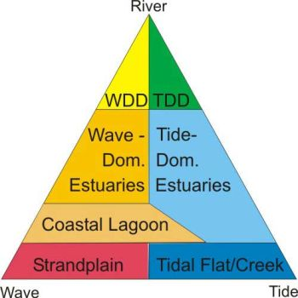

Figure 20: Classification of coastal systems into seven classes (Ryan et al. 2003).

The single estuary associated with the MDB is that of the Coorong and Murray Mouth. Typically this system is described, and to some extent managed, as three separate areas: the Murray Mouth, North Lagoon and South Lagoon of the Coorong. The hydrology of the system is highly modified and influenced by different inputs of freshwater over the barrages from the Lower Lakes, freshwater from the Upper South East of South Australia (into the South Lagoon), and tidal waters entering via the Murray Mouth. Evaporation in the South Lagoon, in particular, exceeds freshwater inputs and maintains hypersaline conditions; this portion of the Coorong operates predominantly as a reverse estuary (i.e. marine water moving in across the water surface over denser hypersaline water).

The estuary part of the typology was developed for the Coorong and Murray Mouth. Should it be considered for use elsewhere then additional work will be required to refine the typology to better reflect the range of estuarine types found around Australia.

Table 34: Coastal system types (from Ryan et al. 2003 cited Hale et al. 2012).

|  |  |  |  |  |
| --- | --- | --- | --- | --- |
| **Classification** | **Landward**  **(Nearer to the river or catchment)** | **Middle**  **(Centre or main water body)** | **Seaward**  **(Entrance or mouth adjacent to the open ocean)** | **Comments** |
| Embayment,  (EMB)  (Wave- or Tide-dominated) | Highly variable river-derived sediment and freshwater input, unrestricted wave penetration. | Deep broad basin flanked by narrow intertidal zone, and exposed bedrock and rocky reef. | Wide, unconstructed entrance, large water exchange with the sea. | Marine conditions prevail throughout system. May evolve into an estuary with time. |
| Wave-dominated  Estuary, (WDE) | River-derived sediment and freshwater input dominates.  Fluvial-bayhead delta development | Broad, low energy central basin, flanked by small areas of intertidal environments. | Entrance constricted by a barrier that attenuates tides within the estuary.  Marine sediment dominates | Sediment is mostly trapped in the central basin. Limited oceanic water exchange |
| Wave-dominated  Delta, (WDD) | Riverine sediment input. Floodplain/ alluvial plain, shifting channel. | Channel(s) act as a conduit for transport of sediment offshore, flanked by thin intertidal areas. | Constricted entrance characterised by a barrier and tidal delta deposits, export of sediment to the sea. | Represents a WDE mostly infilled by sediment. River inputs are predominantly transported offshore. |
| Coastal  Lagoon/ Strandplain,  (CL/SP) | Very little (or no) freshwater and river-sediment input. No fluvial bayhead delta | Low energy central basin dominates.  Flanked by small areas of intertidal environments. | Intermittent entrance (often closed) characterised by barrier and tidal delta deposits. Tides attenuated/excluded. | Similar to a small WDE. Frequently isolated from the sea, and slow infilling. |
| Tide-dominated  Estuary, (TDE) | Riverine sediment input. Floodplain/ alluvial plain. | Wide tidal channel network flanked by large areas of inter- and sub-tidal environments. | Wide funnel-shaped entrance containing tidal sand banks, large tidal exchange. | Shifting channels and sand banks, fine sediments trapped in inter- & sub-tidal environments. |
| Tide-dominated  Delta, (TDD) | Riverine sediment input. Floodplain/ alluvial plain, shifting channel. | Tidal channel network acts as conduit for sediments.  Smaller intertidal area. | Wide funnel-shaped entrance containing tidal sand banks that may have merged with intertidal environments. | Represents a TDE mostly infilled by sediment. River inputs are predominantly transported offshore. |
| Tidal Creek,  (TC) | Very little (or no) freshwater and river-sediment input. No fluvial bayhead delta | Wide channel network flanked by large areas of inter- & sub-tidal environments. | Wide funnel-shaped entrance that does not contain tidal sand banks, large tidal exchange. | Similar to a TDE, contains sediment derived from marine sources only |

Table 35: Estuarine types using Level 2 and 3 attributes.

| **Water influence (Level 2)** | **Water depth** | **Substrate** | **Structural macrobiota** | **Type** | | | **Description** |
| --- | --- | --- | --- | --- | --- | --- | --- |
| Wave dominated | Supratidal | Pebble/gravel | None | Ewd1: Wave dominated | Ewd1.1: Wave dominated supratidal | Ewd1.1.1: Pebble/gravel shorelines | Exposed wave dominated shorelines with coarse substrate. |
|  | Rock | None |  | Ewd1.1.2: Rocky shoreline | Exposed wave dominated rocky shorelines – can have mud and vegetated areas, typical with saltmarsh species. |
| Intertidal | Silt/sand | Seagrass | Ewd1.2: Wave dominated intertidal | Ewd1.2.1:Intertidal seagrass beds | Intertidal seagrass beds exposed at low tide. |
| All | Macroalgae | Ewd1.2.2: Intertidal seaweed beds | Intertidal seaweed beds exposed at low tide. |
| Silt | Saltmarsh | Ewd1.2.3: Intertidal saltmarsh | Intertidal saltmarsh, as distinct from inland saltmarsh, directly influenced by tidal regime. |
| Silt/sand | None | Ewd1.2.4: Intertidal mudflats and sand bars | Fine to medium sands with a relatively high organic content, and areas  of microbial mats comprised of cyanobacteria and filamentous algae  (Diittmann 2005). |
| Rock | None | Ewd1.2.5: Intertidal rocky shorelines | Intertidal rocky shorelines, including exposed rocky shorelines of islands. |
| All | Tree |  | Ewd1.2.6: Wave dominated intertidal forests | Includes *Melaleuca halmaturorum* swamp paperbark tidally influenced forest/woodland |
| Subtidal | Silt/sand | Seagrass | Ewd1.3: Wave dominated subtidal | Ewd1.3.1: Wave dominated seagrass beds | Wave dominated seagrass beds, including seagrass beds in the Coorong North Lagoon. |
| Sand | None | Ewd1.3.2: Coastal lagoon | Wave dominated lagoons that are typically shallow, often elongated bodies of water, often flanked by small areas of intertidal environments. |
| Tide dominated | Supratidal | Rock | None | Etd1: Tide dominated | Etd1.1: Tide dominated supratidal | Etd1.1.1: Tide dominated rocky shoreline | Tide dominated bare, rocky shoreline. |
| Intertidal | Silt | Saltmarsh | Etd1.2: Tide dominated intertidal | Etd1.2.1: Tide dominated saltmarsh | Tidal mudflats. |
| Silt/sand | None | Etd1.2.2: Tide dominated mudflats and sandbars | As per Ewd1.2.4, except under tidal influence (may be intermittent). |
| All | Tree |  | Etd1.2.3 Tide dominated forests | Includes *Melaleuca halmaturorum* swamp paperbark tidally influenced forest/woodland |
| Subtidal | Silt/sand | Seagrass | Etd1.3: Tide dominated subtidal | Etd1.3.1: Tide dominated seagrass beds | As per Ewd1.3.3 except tide dominated; rarely exposed except during low tides. |
| All | Macroalgae | Etd1.3.2: Tide dominated subtidal seaweed beds | Tide dominated subtidal seaweed beds; rarely exposed except during low tides. |
| Sand | None | Etd1.3.3: Tide dominated estuary | Tide dominated estuary with sandy substrate. Murray Mouth and estuary defined by Phillips and Muller (2006) as including the Murray Mouth from the Goolwa Barrage to Pelican Point, including the Goolwa, Coorong and Mundoo channels. Wide tidal channel network flanked by large areas of inter- and sub-tidal environments. |

## Typology validation

Jurisdictions were invited to nominate areas in each state whereby the project team could demonstrate the typology for validation. The nominated test regions are listed in Table 36. Example outputs for each jurisdiction are presented in Figure 21 to Figure 24.

Table 36: Areas nominated for a trial application of the typology in each jurisdiction

|  |  |
| --- | --- |
| **State** | **Locations** |
| South Australia | 1. An area of the Riverland (centred around Chowilla Ramsar site) 2. Eastern Mt Lofty Ranges (from ~Murray Bridge up into the hills) 3. Coorong, Murray Mouth and some of the shores of Lake Albert |
| Victoria | 1. Wetlands at Victorian Ramsar sites 2. Rivers: Ovens River |
| New South Wales | 1. Lower Gwydir  floodplain 2. Tenterfield Creek catchment |
| Queensland | 1. Random samples of small areas in the Queensland MDB 2. Condamine |

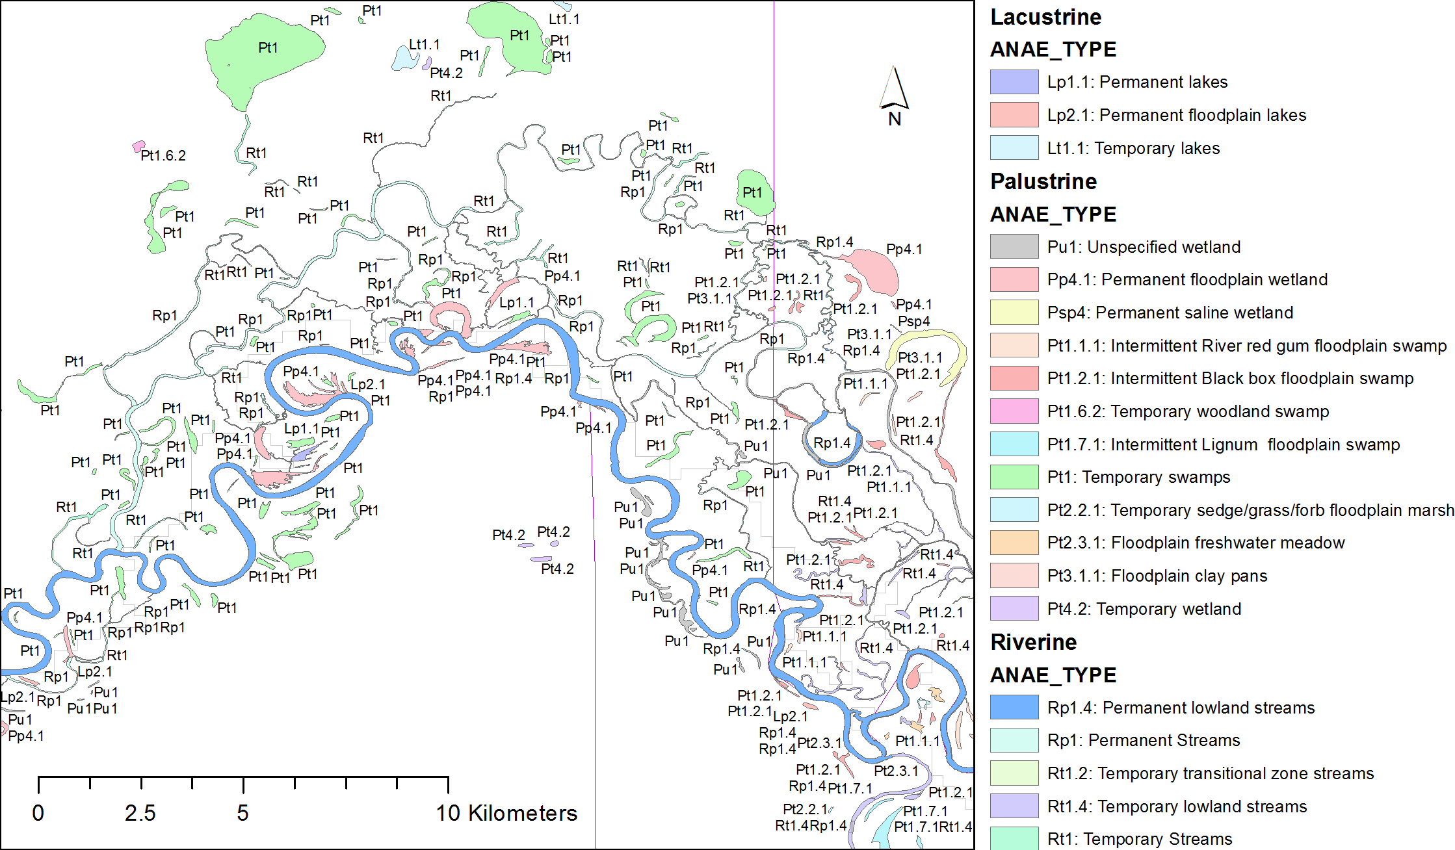

Figure 21: Example typology output for the Chowilla floodplain, South Australia

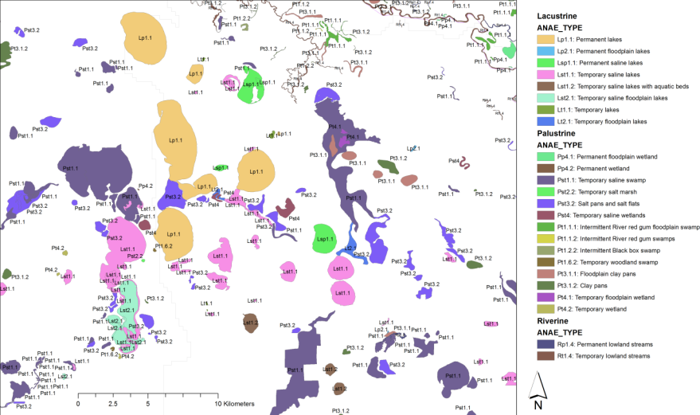

Figure 22: Example typology output for the Kerang Lakes, Victoria

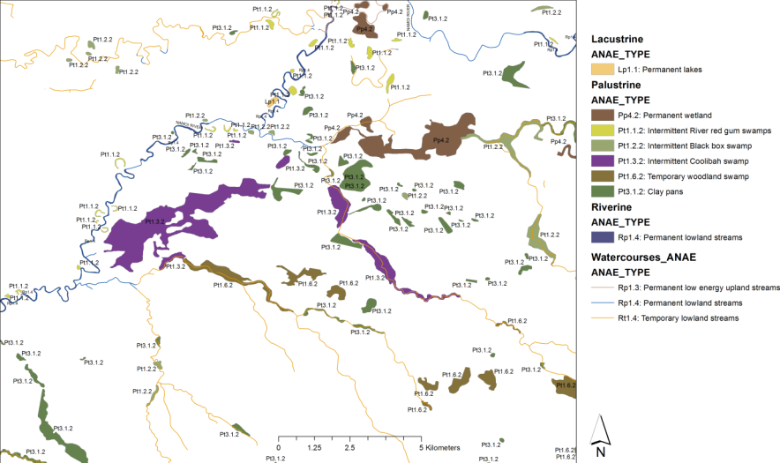

Figure 23: Example typology output for the upper Namoi River, New South Wales

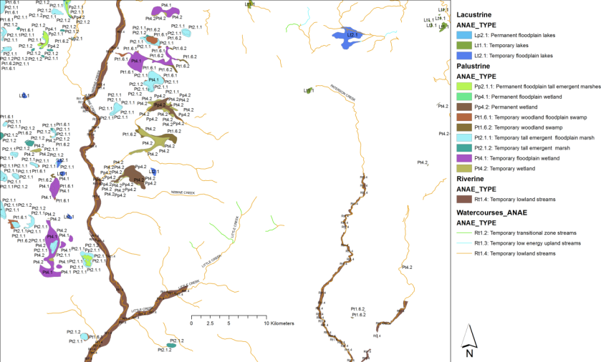

Figure 24: Example typology output for Nebine Creek, Queensland

## Issues encountered

### Summary of typology development issues

There were no significant issues encountered in developing the typology for the inland aquatic ecosystems as it was in most cases straight forward and reflects subsets of the ANAE attributes used in the classification. Challenges which did arise were more to do with attributing the data to polygons (see Chapters 3 and 4), rather than with creating the typology. There will need to be some refinement of the typology in the future when improved data allows better attribution of some of the Level 3 attributes (i.e. water regime, and possibly vegetation), but the basic structure of the typology should be relatively sustainable into future iterations. The terms used to describe Landform, as discussed in Chapter 3, may need to be modified as in most cases the data is not actually reflecting upland/lowland gradients in a catchment/basin, but rather refer to the local landscape and topography immediately surrounding the aquatic ecosystems. Once improved or alternative data becomes available for this attribute, it may be necessary to change the naming convention. At present this only affects the riverine and floodplain classes, however it may be that the terms “upland”, ‘lowland” and ‘transitional’ could be removed from the typology as at present they are potentially misleading.

The other difficulty encountered was in developing a typology for the estuarine system. As the attributes for estuaries are currently being reviewed by the AETG, the typology presented in this report for the Coorong and Murray Mouth is likely to change.

### Summary of validation issues

The following feedback from the Commonwealth and jurisdictional representatives during the typology validation greatly assisted the final selection of definitions and datasets used for attribution and typology:

* Queensland:
* Wetlands without a wetland ID number were included but were in the Queensland dataset as ‘potential for wetlands’. These were subsequently removed from the data set as recommended by Queensland representatives. This also resolved a request by the Commonwealth to remove (if possible) features that appear to be infrastructure such as straight-line irrigation channels.
* During a validation workshop run by Queensland officers, an error in the relational element of the Wetland ID was identified. The wrong QLD ‘Wetland_ID' were assigned to wetlands in a band approximately 40km wide north of the New South Wales border and a block to the East of 150 degrees longitude. Wetlands that had no ID had one under the mapping, and those that did had been removed. This error was addressed to give Version 1.1 of the classification dataset, with the removal of inadvertently added trailing spaces leading to Version 1.2.
* Further validation by Queensland staff identified that wetlands with a floodplain identifier had been interpreted as floodplains in their own right and omitted. These wetlands were restored to the wetlands feature class and classified as ANAE wetlands in Version 1.4.
* New South Wales:
  + The example provided for the Gwydir Wetlands was developed using NVIS vegetation data. As NVIS data are sparse for this area of New South Wales, many of the features were typed as ‘unspecified’. Fortunately, more detailed vegetation mapping has been undertaken as part of the New South Wales Rivers Environmental Restoration Program (RERP). The use of this data allows a far more detailed typology of existing features and highlights the importance of updating NVIS as soon as is practical in the future.
  + Comparison of outputs with River Styles mapping was considered to provide a “reasonable” match. For example the River Styles areas classified as “Gorge” in the lower Tenterfield Creek match those areas classified as “high energy upland” in ANAE. The “transitional” zone areas on the main stem of Tenterfield Creek match broadly. However, many areas mapped as “high energy upland” belong to the “Swampy Meadow Group” in River Styles and would not be “high energy”. This was noted as an obvious scale issue and reflected in the associated metadata accompanying the GIS.
  + Some of the areas marked as “permanent” were noted as questionable. For example, most of the first order streams that flow into lower Tenterfield Creek are marked as permanent – this is highly unlikely. This is reflective of Geofabric subcatchments, and an option is to omit first and second order streams. However, it was decided that such streams be left in, and the limitation be noted in associated metadata.
* South Australia:
  + The floodplain layer used in this project extends to the Coorong, meaning that ‘floodplain’ could be attributed to the estuary. The floodplain layer has been trimmed to finish above the estuary. Note that the floodplain layer was created as an example, or proof of concept, only and issues around the downstream extent will be examined when a fit for purpose floodplain layer is available for adding to the classification product
  + There are instances of misclassification, for example where features positioned on streamlines have been classified as lacustrine. This misclassification has been investigated and reflects the data in the South Australian datasets. To fully compare and validate all the typology results against that in each of the jurisdictional layers is beyond the scope of this project, but is recommended as a future activity to improve the alignment between the ANAE framework and jurisdictional datasets. This will then increase the confidence in any future global updates.
  + Following the release of Version 1.0 of this interim ANAE classification DEWNR undertook a more thorough validation as documented in Miles (2014). The validation identified a number of changes to the mapping layers and wetland classification (‘wetland’ and ‘floodplain’ layers only) to:
    - Remove inappropriate floodplain geometry
    - Update a subset of wetland geometries to mapping currently in use in SA.
    - Reassign (override) a subset of ANAE types for improved accuracy and alignment with the SAAE state classification.

DEWNR edits were incorporated into Version 1.4 and fields were added to feature layers to identify manual edits that over-ride ANAE class assignment. The process undertaken by DEWNR did not follow the same logical rules as the rest of the classification in applying the typology and in some cases the final assigned ANAE type does differs from the ANAE_TYPE_SA field (e.g. DEWNR assigned permanent lakes as Lp1 which was mapped to Lp 1.1 in the final type assignment).

DEWR also identified a number of limitations in the SA portion of the classification some of which also apply more generally to this interim ANAE classification. These are (Miles 2014):

* only final ANAE types have been amended in this data, these will not match related attributes that should have internal consistency e.g. level 3 attributes.
* clay pans – this type has been given erroneously to many farm dams in the Mt Lofty Ranges and temporary saline systems above the floodplain around Lake Alexandrina.
* Southern Flurieu swamps in the Mt Lofty Ranges need validating for appropriate water regime and type – DEWNR has some data for this.
* managed and artificial wetlands are not provided for in the typology in that they cannot be distinguished e.g evaporation basins – stockyard plains and noora are represented in floodplain layer.
* wetlands to the south east of the south lagoon of the Coorong are listed as permanent but these are temporary systems.
* confidence in confidence values needs assessing.
* That not only is accuracy of wetland type an issue, but whether the delineation of wetlands has captured the system needing to be classified. In other words geometry should be considered when validating any of this data along with wetland type. Some of the edits to ANAE_type around the Lower Lakes are relevant here e.g. the wetland delineation covers an area where in fact two ANAE types occur such as a reeded area fringing a broader meadow. This will lower confidence and reduce applicability of the polygon and its type.

# Classification results

## Murray-Darling Basin results

The total number of aquatic ecosystems for the entire MDB is presented below for lacustrine, palustrine, riverine, floodplain and estuarine systems. Overall, 250,000 polygons and line segments across the MDB were attributed using the ANAE classification. This included approximately 8,400 lacustrine features, 37,000 palustrine features, 157,000 riverine line segments, 33,000 floodplain units, and 70 estuarine features. As noted above (see section 3.1.3) this is still considered an under-representation of the total number of aquatic ecosystems that occur in the Basin.

Wetland features were assigned to 15 of the 16 lacustrine types (section 6.1.1), 47 of the 48 palustrine types (section 6.1.2), all 10 riverine types (section 6.1.3), the 19 floodplain types (section 6.1.4) and eight of the 17 estuarine types (section 6.1.5). A large proportion, approximately 30 percent, of palustrine systems was classified as having unspecified vegetation, where data was inadequate to attribute these to a more detailed type.

Lacustrine types with low representation at the Basin level (arbitrarily defined as having 10 representatives or less) included:

* Lsp1.2: Permanent saline lakes with aquatic beds (1);
* Lsp2.1: Permanent saline floodplain lakes (10)
* Lst1.2: Temporary saline lakes with aquatic beds (6);
* Lst2.2: Temporary saline floodplain lakes with aquatic beds (2).

Palustrine types with low representation included:

* Pp1.1.2: Permanent paperbark swamps (2);
* Pp2.3.2: Permanent grass marshes (10);
* Pp2.4.2: Permanent forb marshes (4);
* Pp3: Peat bogs and fen marshes (5);
* Psp1.1: Saline paperbark swamp(4);
* Psp2.1: Permanent salt marsh (2);
* Psp3.1: Permanent seagrass marshes (2).
* Pt1.4.1: Intermittent River Cooba floodplain swamp (2);
* Pt1.4.2: Intermittent River Cooba swamp (3);
* Pt1.5.1: Temporary paperbark floodplain swamp (8);

The riverine type with lowest representation was Rp1.3: Permanent low energy upland streams with 193 stream segments (0.1 percent of all stream segments), while for floodplains, F1.11: Floodplain river cooba woodland had the lowest representation with seven representatives.

Of the 17 estuarine types proposed, seven of the eight types present were found to have low representation:

* Ewd1.2.3: Intertidal saltmarsh (6);
* Ewd1.2.4: Intertidal mudflats and sand bars (9);
* Ewd1.3.2: Coastal lagoon (10);
* Etd1.1.1: Tide dominated rocky shoreline (1);
* Etd1.2.2: Tide dominated mudflats and sandbars (6);
* Etd1.2.3 Tide dominated forests (2);
* Etd1.3.3: Tide dominated estuary (3).

Types that had no representatives included:

* Lsp2.2: Permanent saline floodplain lakes with aquatic beds;
* Pp1.1.1: Permanent floodplain paperbark swamps;
* Ewd1.1.1: Pebble/gravel shorelines;
* Ewd1.1.2: Rocky shoreline;
* Ewd1.2.1:Intertidal seagrass beds;
* Ewd1.2.2: Intertidal seaweed beds;
* Ewd1.2.5: Intertidal rocky shorelines;
* Ewd1.2.6: Wave dominated intertidal forests;
* Ewd1.3.1: Wave dominated seagrass beds;
* Etd1.3.1: Tide dominated seagrass beds;
* Etd1.3.2: Tide dominated subtidal seaweed beds.

Further investigation into the data supporting these types, and/or ground-truthing may reveal some of these types to be either more common (i.e. their absence is an artifact of the data) or not represented in the Basin.

For environmental water management for lacustrine and palustrine systems, identifying those which lie on floodplains was considered an important output of the classification. For the purpose of this interim classification the Wetlands of the MDBv2 (Kingsford Mapping) was used as the reference floodplain map and approximately 37 percent of lacustrine systems and 46 percent of palustrine systems intersected the floodplains.

### Lacustrine

A total of 8,409 lacustrine features were identified and classified into 15 of the 16 proposed types (Table 37). The proportion of the different lacustrine types at the Basin scale is shown in Figure 25. Temporary freshwater lakes are the most numerous across the MDB.

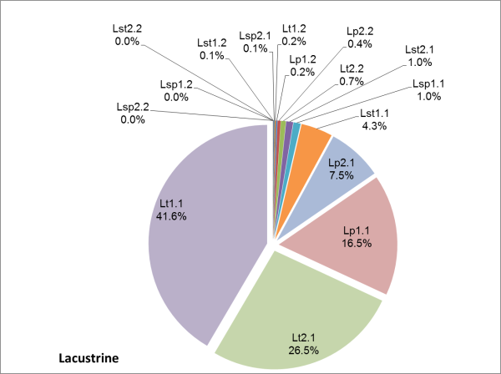

Figure 25: Proportion of lacustrine types at the Basin scale (see for list of types).

Table 37: Number of each lacustrine type present across the MDB (see Table 30 for further details of each type)

| **Type** | | | **Number of each type across the MDB** |
| --- | --- | --- | --- |
| Lakes | Lp1: Permanent lakes | Lp1.1: Permanent lakes | 1288 |
| Lp1.2: Permanent lakes with aquatic beds | 16 |
| Lp2: Permanent floodplain lakes | Lp2.1: Permanent floodplain lakes | 730 |
| Lp2.2: Permanent floodplain lakes with aquatic beds | 35 |
| Lt1: Temporary lakes | Lt1.1: Temporary lakes | 3,494 |
| Lt1.2: Temporary lakes with aquatic beds | 15 |
| Lt2: Temporary floodplain lakes | Lt2.1: Temporary floodplain lakes | 2,231 |
| Lt2.2: Temporary floodplain lakes with aquatic beds | 57 |
| Saline lakes | Lsp1: Permanent saline lakes | Lsp1.1: Permanent saline lakes | 82 |
| Lsp1.2: Permanent saline lakes with aquatic beds | 1 |
| Lsp2: Permanent saline floodplain lakes | Lsp2.1: Permanent saline floodplain lakes | 10 |
| Lsp2.2: Permanent saline floodplain lakes with aquatic beds | 0 |
| Lst1: Temporary saline lakes | Lst1.1: Temporary saline lakes | 362 |
| Lst1.2: Temporary saline lakes with aquatic beds | 6 |
| Lst2: Temporary saline floodplain lakes | Lst2.1: Temporary saline floodplain lakes | 80 |
| Lst2.2: Temporary saline floodplain lakes with aquatic beds | 2 |

### Palustrine

A total of 36,937 palustrine wetlands (34,063 freshwater, 1,313 saline, and 562 springs, and 999 manually assigned without defining WaterType) were recorded and classified into 47 of the 48 proposed types (). Palustrine aquatic ecosystems are by far the most numerous across the MDB and reflect the diversity in water regime and vegetation found within this class. Approximately 88 percent of the palustrine aquatic ecosystems classified are temporary in nature; again this is considered representative of Australian aquatic ecosystems and climatic conditions (i.e. driest continent). Just over 36 percent are swamps (woody vegetation) and 17 percent marshes (i.e. non-woody vegetation such as sedges, grasses etc.), however a significant proportion (30 percent) are unspecified in terms of the dominant and or fine scale vegetation attributes. As would be expected the majority of the swamps are and marshes are temporary wetlands (, Figure 27).

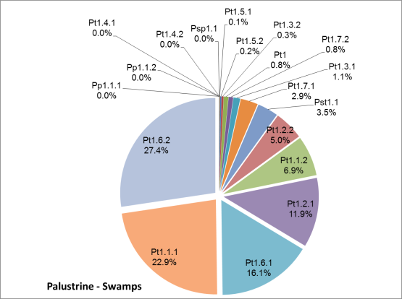

Figure 26: Proportion of palustrine swamp types at the Basin scale (see Table 38 below for list of types).

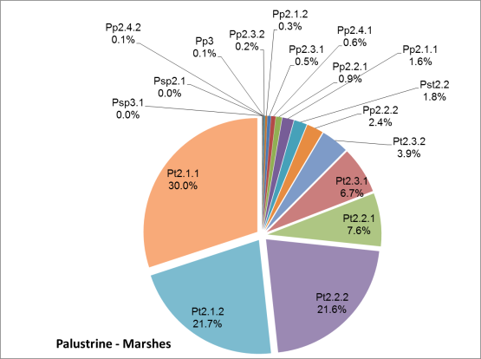

Figure 27: Proportion of palustrine marsh types at the Basin scale (see Table 38 below for list of types).

Table 38: Number of each palustrine type present across the MDB (see Table 31 for further details of each type)

| **Type** | | | | | | **Number of each type across the MDB** |
| --- | --- | --- | --- | --- | --- | --- |
| Pp1: Permanent swamp forest | Pp1.1: Permanent paperbark swamps | | | | Pp1.1.1: Permanent floodplain paperbark swamps | 0 |
| Pp1.1.2: Permanent paperbark swamps | 2 |
| Pp2: Permanent marsh | Pp2.1: Permanent tall emergent marshes | | | | Pp2.1.1: Permanent floodplain tall emergent marshes | 90 |
| Pp2.1.2: Permanent tall emergent marshes | 17 |
| Pp2.2: Permanent sedge/grass/forb marshes | | | | Pp2.2.1: Permanent floodplain sedge/grass/forb marshes | 47 |
| Pp2.2.2: Permanent sedge/grass/forb marshes | 130 |
| Pp2.3: Permanent grass marshes | | | | Pp2.3.1: Permanent floodplain grass marshes | 27 |
| Pp2.3.2: Permanent grass marshes | 10 |
| Pp2.4: Permanent forb marshes | | | | Pp2.4.1: Permanent floodplain forb marshes | 35 |
| Pp2.4.2: Permanent forb marshes | 4 |
| Pp3: Peat bogs and fen marshes | | | | | | 5 |
| Pp4.1: Permanent floodplain wetland | | | | | | 1,776 |
| Pp4.2: Permanent wetland | | | | | | 1,334 |
| Pps5: Permanent springs | | | | | | 562 |
| Pt1:Temporary swamps | | | Pt1:Temporary swamps* | | | 811 |
| Pt1.1:Intermittent River red gum swamp | Pt1.1.1: Intermittent River red gum floodplain swamp | | 2,844 |
| Pt1.1.2: Intermittent River red gum swamps | | 856 |
| Pt1.2:Intermittent Black box swamp | Pt1.2.1: Intermittent Black box floodplain swamp | | 1,475 |
| Pt1.2.2: Intermittent Black box swamp | | 621 |
| Pt1.3:Intermittent Coolibah swamp | Pt1.3.1: Intermittent Coolibah floodplain swamp | | 142 |
| Pt1.3.2: Intermittent Coolibah swamp | | 43 |
| Pt1.4:Intermittent River Cooba swamp | Pt1.4.1: Intermittent River Cooba floodplain swamp | | 2 |
| Pt1.4.2: Intermittent River Cooba swamp | | 3 |
| Pt1.5:Temporary paperbark swamp | Pt1.5.1: Temporary paperbark floodplain swamp | | 8 |
| Pt1.5.2: Temporary paperbark swamp | | 30 |
| Pt1.6:Temporary swamp | Pt1.6.1: Temporary woodland floodplain swamp | | 2,007 |
| Pt1.6.2: Temporary woodland swamp | | 3,406 |
| Pt1.7:Intermittent Lignum swamp | Pt1.7.1: Intermittent Lignum floodplain swamp | | 367 |
| Pt1.7.2: Intermittent Lignum swamps | | 97 |
| Pt2: Temporary marshes | | | Pt2.1: Temporary tall emergent marsh | Pt2.1.1: Temporary tall emergent floodplain marsh | | 1,658 |
| Pt2.1.2: Temporary tall emergent marsh | | 1,195 |
| Pt2.2: Temporary sedge/grass/forb marshes | Pt2.2.1: Temporary sedge/grass/forb floodplain marsh | | 417 |
| Pt2.2.2: Temporary sedge/grass/forb marsh | | 1,193 |
| Pt2.3: Freshwater meadows | Pt2.3.1: Floodplain freshwater meadow | | 368 |
| Pt2.3.2: Freshwater meadow | | 217 |
| Pt3: Freshwater playas | | | Pt3.1:Clay pans | Pt3.1.1: Floodplain clay pans | | 1,235 |
| Pt3.1.2: Clay pans | | 6,798 |
| Pt4.1: Temporary floodplain wetland | | | | | | 2,408 |
| Pt4.2: Temporary wetland | | | | | | 3,315 |
| Psp1: Saline swamps | | Psp1.1: Saline paperbark swamp | | | | 4 |
| Psp2: Salt marsh | | Psp2.1: Permanent salt marsh | | | | 2 |
| Psp3: Seagrass marshes | | Psp3.1: Permanent seagrass marshes** | | | | 2 |
| Psp4: Permanent saline wetland | | | | | | 96 |
| Pst1: Saline swamp | | Pst1.1: Temporary saline swamp | | | | 439 |
| Pst2: Salt marsh | | Pst2.2: Temporary salt marsh | | | | 101 |
| Pst3: Saline playas | | Pst3.2: Salt pans and salt flats | | | | 359 |
| Pst4: Temporary saline wetlands | | | | | | 359 | 359 |
| Pu1: Unspecified wetland | | | | | | 20 |

* During validation South Australia assigned swamps to the higher order parent type (Pt1:Temporary swamps) when tree species were mixed or unknown (Miles 2014). May be equivalent to Pt1.6.2: Temporary woodland swamp.

**Includes *Lepilaena,* a genus of aquatic and marine flowering plant comprising a number of species endemic to coastal and brackish or alkaline inland waters.

### Riverine

A total of 157,542 riverine line features and 1,382 waterholes were identified and classified the 10 proposed types (, Table 39). As this is one of the first applications of a classification to riverine systems across the whole of the Basin it is difficult to make statements regarding the accuracy of the numbers of each type. The relatively high proportion of temporary lowland streams (types Rt1.4) is a reflection of the mapping and attribution process. This type of aquatic ecosystems is very numerous in the landscape and the scale of mapping has captured a large number of these. It is likely that the thresholds for separating between upland, transitional and lowland may be refined in light of comments received from the jurisdictions. Further it should be noted that the data presented here are for the line river segments only, not the river segments which mapped as polygons. Unspecified river segments and river segments which mapped as polygons have not been included in Figure 28.

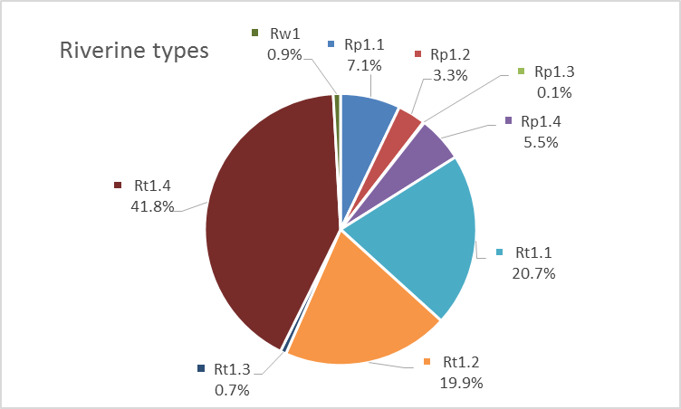

Figure 28: Proportion of riverine types at the Basin scale (see below for list of types).

Table 39: Number of each riverine type present across the MDB (see Table 32 for further details of each type)

| **Type** | | **Number of each type across the MDB** |
| --- | --- | --- |
| Rp1: Permanent streams | Rp1.1: Permanent high energy upland streams | 11,279 |
| Rp1.2: Permanent transitional zone streams | 5,282 |
| Rp1.3: Permanent low energy upland streams | 193 |
| Rp1.4: Permanent lowland streams | 8,663 |
| Rt1: Temporary streams | Rt1.1: Temporary high energy upland streams | 32,764 |
| Rt1.2: Temporary transitional zone streams | 31,456 |
| Rt1.3: Temporary low energy upland streams | 1,118 |
| Rt1.4: Temporary lowland streams | 66,787 |
| Rw1: Waterholes | | 1,382 |
| Ru1: Unspecified river | | 550 |

### Floodplain

A total of 33,320 floodplain features were identified and classified into the 19 proposed types using the MDBA Wetlands GIS of the Murray-Darling Basin Series 2.0 (Kingsford mapping) (Table 40). Forested and woodland floodplains are the dominant types at the Basin scale representing 53 percent of the floodplains classified. Shrubland dominated floodplains and sedge/grassland floodplains represented 15 percent and 13 percent of floodplains (Figure 29). Limits in the vegetation data meant that 18 percent of the floodplains mapped and classified were unspecified in terms of vegetation. The classification of the MDB floodplains presented here is intended only as an example application of the ANAE framework to floodplain systems. At this time, floodplain mapping in the Basin is fragmented and floodplain extent and inundation frequency are poorly represented. Improved mapping and inundation modelling for the Basin is expected within the next 5 years and once available may be used to improve the classification.

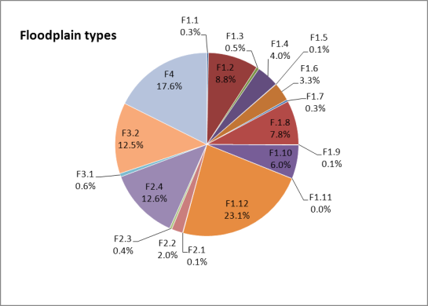

Figure 29: Proportion of floodplain types at the Basin scale (see below for list of types).

Table 40: Number of each floodplain type present across the MDB (see for further details of each type)

|  | **Type** | **Number of each type across the MDB** |
| --- | --- | --- |
| F1: Floodplain forest and woodlands | F1.1: Upland River red gum forest floodplain | 97 |
| F1.2: River red gum forest floodplain | 2,944 |
| F1.3: Upland River red gum woodland floodplain | 160 |
| F1.4: River red gum woodland floodplain | 1,318 |
| F1.5: Upland black box forest floodplain | 24 |
| F1.6: Black box forest floodplain | 1,089 |
| F1.7: Upland black box woodland floodplain | 112 |
| F.1.8: Black box woodland floodplain | 2,601 |
| F1.9: Upland Coolibah woodland and forest floodplain | 27 |
| F1.10: Coolibah woodland and forest floodplain | 1,984 |
| F1.11: River cooba woodland floodplain | 7 |
| F1.12: Woodland floodplain | 7,704 |
| F2: Floodplain shrubland | F2.1: Upland lignum shrubland floodplain | 23 |
| F2.2: Lignum shrubland floodplain | 657 |
| F2.3: Upland shrubland floodplain | 136 |
| F2.4: Shrubland floodplain | 4,203 |
| F3: Floodplain sedge/grassland | F3.1: Upland sedge/forb/grassland floodplain | 201 |
| F3.2: Sedge/forb/grassland floodplain | 4,170 |
| F4: Unspecified floodplain | F4: Unspecified floodplain | 5,876 |

### Estuarine

As there was no attribute data available, the estuarine typology was applied using expert opinion and information in Seaman (2003). This resulted in estuarine features being classified into 8 of the 17 proposed estuarine types (Table 41). More detailed consideration of the types and the scale at which they apply is recommended when the AETG finalises the attributes to be included for estuarine systems as part of the ANAE framework.

Table 41: Number of each estuarine type present across the MDB (see Table 35 for further details of each type)

| **Type** | | **Number of each type across the MDB** |
| --- | --- | --- |
| Ewd1.1: Wave dominated supratidal | Ewd1.1.1: Pebble/gravel shorelines | 0 |
| Ewd1.1.2: Rocky shoreline | 0 |
| Ewd1.2: Wave dominated intertidal | Ewd1.2.1:Intertidal seagrass beds | 0 |
| Ewd1.2.2: Intertidal seaweed beds | 0 |
| Ewd1.2.3: Intertidal saltmarsh | 6 |
| Ewd1.2.4: Intertidal mudflats and sand bars | 9 |
| Ewd1.2.5: Intertidal rocky shorelines | 0 |
| Ewd1.2.6: Wave dominated intertidal forests | 0 |
| Ewd1.3: Wave dominated subtidal | Ewd1.3.1: Wave dominated seagrass beds | 0 |
| Ewd1.3.2: Coastal lagoon | 10 |
| Etd1.1: Tide dominated supratidal | Etd1.1.1: Tide dominated rocky shoreline | 1 |
| Etd1.2: Tide dominated intertidal | Etd1.2.1: Tide dominated saltmarsh | 34 |
| Etd1.2.2: Tide dominated mudflats and sandbars | 6 |
| Etd1.2.3 Tide dominated forests | 2 |
| Etd1.3: Tide dominated subtidal | Etd1.3.1: Tide dominated seagrass beds | 0 |
| Etd1.3.2: Tide dominated subtidal seaweed beds | 0 |
| Etd1.3.3: Tide dominated estuary | 3 |

## Results by jurisdiction

### Lacustrine

Jurisdictional results for lacustrine systems indicate that Victoria has a wide range of lakes with all except one type (Permanent saline lakes with aquatic beds) represented. New South Wales has representatives from only five of the freshwater lacustrine types (Table 42). Queensland has the highest proportion of lakes in the Basin (40 percent). There was only one lacustrine feature mapped for the ACT in jurisdictional data sets.

In addition to the lake types that are rare at the Basin level (see above), the following also have low representation at the jurisdiction level (10 or less representatives):

New South Wales:

* Lst1.1: Temporary saline lakes (4);

Queensland:

* Lp1.2: Permanent lakes with aquatic beds (6);
* Lsp2.1: Permanent saline floodplain lakes (4);

South Australia:

* Lst1.1: Temporary saline lakes (2);

Victoria:

* Lp1.2: Permanent lakes with aquatic beds (10);
* Lp2.2: Permanent floodplain lakes with aquatic beds (7);
* Lt2.2: Temporary floodplain lakes with aquatic beds (9)
* Lsp1.2: Permanent saline lakes with aquatic beds (1)
* Lsp2.1: Permanent saline floodplain lakes (6);
* Lst1.2: Temporary saline lakes with aquatic beds (6);
* Lst2.2: Temporary saline floodplain lakes with aquatic beds (2);

The pattern of dominance at the jurisdictional level is similar to that seen at the Basin level with Temporary lakes (Lt1.1), Temporary floodplain lakes (Lt2.1) and Permanent lakes (Lp1.1) being the most common lake types (see ).

Table 42: Number of each lacustrine type present across the MDB and each jurisdiction.

| **Type** | **MDB** | **ACT** | **NSW** | **QLD** | **SA** | **VIC** |
| --- | --- | --- | --- | --- | --- | --- |
| Lp1.1: Permanent lakes | 1388 | 1 | 508 | 492 | 17 | 270 |
| Lp1.2: Permanent lakes with aquatic beds | 16 | 0 | 0 | 6 | 0 | 10 |
| Lp2.1: Permanent floodplain lakes | 630 | 0 | 182 | 254 | 179 | 115 |
| Lp2.2: Permanent floodplain lakes with aquatic beds | 35 | 0 | 0 | 28 | 0 | 7 |
| Lt1.1: Temporary lakes | 3494 | 0 | 956 | 1246 | 352 | 940 |
| Lt1.2: Temporary lakes with aquatic beds | 15 | 0 | 0 | 0 | 0 | 15 |
| Lt2.1: Temporary floodplain lakes | 2231 | 0 | 383 | 1602 | 111 | 135 |
| Lt2.2: Temporary floodplain lakes with aquatic beds | 57 | 0 | 0 | 48 | 0 | 9 |
| Lsp1.1: Permanent saline lakes | 82 | 0 | 0 | 19 | 50 | 13 |
| Lsp1.2: Permanent saline lakes with aquatic beds | 1 | 0 | 0 | 0 | 0 | 1 |
| Lsp2.1: Permanent saline floodplain lakes | 10 | 0 | 0 | 4 | 0 | 6 |
| Lsp2.2: Permanent saline floodplain lakes with aquatic beds | 0 | 0 | 0 | 0 | 0 | 0 |
| Lst1.1: Temporary saline lakes | 362 | 0 | 4 | 102 | 2 | 254 |
| Lst1.2: Temporary saline lakes with aquatic beds | 6 | 0 | 0 | 0 | 0 | 6 |
| Lst2.1: Temporary saline floodplain lakes | 80 | 0 | 0 | 12 | 0 | 68 |
| Lst2.2: Temporary saline floodplain lakes with aquatic beds | 2 | 0 | 0 | 0 | 0 | 2 |

### Palustrine

Only one type of palustrine wetland was recorded for the ACT (Pp4.2: Permanent wetland with unspecified vegetation, count of 8) (Table 43). Two River cooba types (Pt1.4.1 and Pt1.4.2) have representatives only in New South Wales and South Australia with very low counts (5 in NSW and 2 in SA). This species is considered widespread in central New South Wales but may be underrepresented in the vegetation data as it occurs in transitional areas between River red gum and Black box. Temporary paperbark swamps are largely only represented in South Australia with only one other temporary paperbark swamp represented in Queensland. Pp2.3.2: Permanent grass marshes were only recorded in NSW. Types with low representation, in addition to those listed as rare at the Basin level, include:

New South Wales:

* Pp2.1.1: Permanent floodplain tall emergent marshes (8);
* Pp2.1.2: Permanent tall emergent marshes (6);
* Pp2.3.1: Permanent floodplain grass marshes (9);
* Psp4: Permanent saline wetlands (2);
* Pst1.1: Temporary saline swamp (1);
* Pst3.2: Salt pans and salt flats (5);
* Pt2.1.2: Temporary tall emergent marsh (2).

Queensland:

* Pp2.1.2: Permanent tall emergent marshes (4);
* Pt1.1.2: Intermittent River red gum swamps (2);*
* Pt1.3.2: Intermittent Coolibah swamp (4);
* Pt1.5.2: Temporary paperbark swamp (1);
* Pt1.7.2: Intermittent Lignum swamps (1);
* Pst1.1: Temporary saline swamps (1);
* Pst4: Temporary saline wetlands (5);
* Pt2.3.2: Freshwater meadow (6);
* Pt3.1.2: Clay pans (3);

South Australia

* Pp2.1.2: Permanent tall emergent marshes (1);
* Pt1.7.2: Intermittent Lignum swamps (1);
* Pt1.2.1: Intermittent Black box floodplain swamp (1)

Victoria

* Pp2.1.2: Permanent tall emergent marshes (7);
* Pp2.3.1: Permanent floodplain grass marshes (7);

* Intermittent river red gum swamps in QLD were mostly designated as on floodplains.

Temporary tall emergent floodplain marshes(Pt2.1.1) are one of the dominant types found in Queensland that were infrequent in other states. Intermittent River red gum floodplain swamp (Pt1.1.1) was most common in NSW. Clay pans **(**Pt3.1.2) are common in South Australia (48 percent of specified types) which may be an over-estimate due to gaps in vegetation mapping in the northern part of the state outside of the River Murray floodplain corridor.

Table 43: Number of each palustrine type present across the MDB and each jurisdiction.

|  |  |  |  |  |  |  |
| --- | --- | --- | --- | --- | --- | --- |
| **Type** | **MDB** | **ACT** | **NSW** | **QLD** | **SA** | **Vic** |
| Pp1.1.1: Permanent floodplain paperbark swamps | 0 | 0 | 0 | 0 | 0 | 0 |
| Pp1.1.2: Permanent paperbark swamps | 2 | 0 | 2 | 0 | 0 | 0 |
| Pp2.1.1: Permanent floodplain tall emergent marshes | 90 | 0 | 8 | 19 | 1 | 62 |
| Pp2.1.2: Permanent tall emergent marshes | 17 | 0 | 6 | 4 | 0 | 7 |
| Pp2.2.1: Permanent floodplain sedge/grass/forb marshes | 47 | 0 | 31 | 0 | 0 | 16 |
| Pp2.2.2: Permanent sedge/grass/forb marshes | 130 | 0 | 96 | 0 | 0 | 34 |
| Pp2.3.1: Permanent floodplain grass marshes | 27 | 0 | 9 | 11 | 0 | 7 |
| Pp2.3.2: Permanent grass marshes | 10 | 0 | 10 | 0 | 0 | 0 |
| Pp2.4.1: Permanent floodplain forb marshes | 35 | 0 | 0 | 0 | 0 | 35 |
| Pp2.4.2: Permanent forb marshes | 4 | 0 | 0 | 0 | 0 | 4 |
| Pp3: Peat bogs and fen marshes | 5 | 0 | 5 | 0 | 0 | 0 |
| Pp4.1: Permanent floodplain wetland | 1776 | 0 | 1,135 | 282 | 136 | 223 |
| Pp4.2: Permanent wetland | 1334 | 8 | 1,109 | 41 | 20 | 156 |
| Pps5: Permanent springs | 562 | 0 | 97 | 297 | 45 | 123 |
| Psp1.1: Saline paperbark swamp | 4 | 0 | 0 | 0 | 1 | 3 |
| Psp2.1: Permanent salt marsh | 2 | 0 | 0 | 0 | 2 | 0 |
| Psp3.1: Permanent seagrass marshes | 2 | 0 | 0 | 0 | 0 | 2 |
| Psp4: Permanent saline wetlands | 96 | 0 | 2 | 0 | 68 | 26 |
| Pst1.1: Temporary saline swamp | 439 | 0 | 1 | 1 | 106 | 331 |
| Pst2.2: Temporary salt marsh | 101 | 0 | 0 | 39 | 13 | 49 |
| Pst3.2: Salt pans and salt flats | 359 | 0 | 5 | 0 | 202 | 152 |
| Pst4: Temporary saline wetlands | 359 | 0 | 0 | 5 | 133 | 221 |
| Pt1: Temporary swamp | 811 | 0 | 0 | 0 | 811 | 0 |
| Pt1.1.1: Intermittent River red gum floodplain swamp | 2844 | 0 | 1,842 | 250 | 0 | 752 |
| Pt1.1.2: Intermittent River red gum swamps | 856 | 0 | 304 | 2 | 29 | 521 |
| Pt1.2.1: Intermittent Black box floodplain swamp | 1475 | 0 | 755 | 458 | 1 | 261 |
| Pt1.2.2: Intermittent Black box swamp | 621 | 0 | 514 | 14 | 0 | 93 |
| Pt1.3.1: Intermittent Coolibah floodplain swamp | 142 | 0 | 44 | 98 | 0 | 0 |
| Pt1.3.2: Intermittent Coolibah swamp | 43 | 0 | 39 | 4 | 0 | 0 |
| Pt1.4.1: Intermittent River Cooba floodplain swamp | 2 | 0 | 2 | 0 | 0 | 0 |
| Pt1.4.2: Intermittent River Cooba swamp | 3 | 0 | 3 | 0 | 0 | 0 |
| Pt1.5.1: Temporary paperbark floodplain swamp | 8 | 0 | 0 | 0 | 8 | 0 |
| Pt1.5.2: Temporary paperbark swamp | 30 | 0 | 0 | 1 | 29 | 0 |
| Pt1.6.1: Temporary woodland floodplain swamp | 2007 | 0 | 658 | 1,100 | 16 | 233 |
| Pt1.6.2: Temporary woodland swamp | 3406 | 0 | 1,292 | 352 | 284 | 1,478 |
| Pt1.7.1: Intermittent Lignum floodplain swamp | 367 | 0 | 115 | 57 | 3 | 192 |
| Pt1.7.2: Intermittent Lignum swamps | 97 | 0 | 76 | 1 | 1 | 19 |
| Pt2.1.1: Temporary tall emergent floodplain marsh | 1658 | 0 | 17 | 1,529 | 6 | 106 |
| Pt2.1.2: Temporary tall emergent marsh | 1195 | 0 | 2 | 718 | 412 | 63 |
| Pt2.2.1: Temporary sedge/grass/forb floodplain marsh | 417 | 0 | 207 | 15 | 127 | 68 |
| Pt2.2.2: Temporary sedge/grass/forb marsh | 1193 | 0 | 639 | 14 | 119 | 421 |
| Pt2.3.1: Floodplain freshwater meadow | 368 | 0 | 48 | 72 | 2 | 246 |
| Pt2.3.2: Freshwater meadow | 217 | 0 | 74 | 6 | 0 | 137 |
| Pt3.1.1: Floodplain clay pans | 1235 | 0 | 641 | 82 | 168 | 344 |
| Pt3.1.2: Clay pans | 6798 | 0 | 1,622 | 3 | 3085 | 2,088 |
| Pt4.1: Temporary floodplain wetland | 2408 | 0 | 506 | 1,777 | 94 | 31 |
| Pt4.2: Temporary wetland | 3315 | 0 | 1,837 | 502 | 300 | 676 |
| Pu1: Unspecified wetland | 20 | 0 | 0 | 0 | 20 | 0 |

### Riverine

Data presented here represents the line data for riverine ecosystems (Table 44), with the following riverine types being dominant for each jurisdiction being:

* Australian Capital Territory:
* Rt1.1: Temporary high energy upland streams (43 percent);
* Rp1.1: Permanent high energy upland streams (38 percent);
* New South Wales:
* Rt1.4: Temporary lowland streams (34 percent);
* Rt1.1: Temporary high energy upland streams (22 percent);
* Queensland:
* Rt1.4: Temporary lowland streams (67 percent);
* Rt1.2: Temporary transitional zone streams (25 percent);
* South Australia:
* Rt1.4: Temporary lowland streams (43 percent);
* Rt1.2: Temporary transitional zone streams (28 percent);
* Victoria:
* Rt1.1: Temporary high energy upland streams (43 percent);
* Rt1.4: Temporary lowland streams (27 percent).

The two least common riverine types encountered across the Basin are the Permanent low energy upland streams (Rp1.3) and the Temporary low energy upland streams (Rt1.3). Landform strongly influences the assignment to types in the riverine class and, as stated previously, the breakdown of types may change if this attribute is refined or modified.

Table 44: Number of each riverine type present across the MDB and each jurisdiction.

|  |  |  |  |  |  |  |
| --- | --- | --- | --- | --- | --- | --- |
| **Type** | **MDB** | **ACT** | **NSW** | **QLD** | **SA** | **Vic** |
| Rp1.1: Permanent high energy upland streams | 11,279 | 194 | 10,099 | 10 | 56 | 920 |
| Rp1.2: Permanent transitional zone streams | 5,282 | 44 | 4,941 | 21 | 12 | 264 |
| Rp1.3: Permanent low energy upland streams | 193 | 0 | 146 | 1 | 15 | 31 |
| Rp1.4: Permanent lowland streams | 8,663 | 38 | 7,764 | 108 | 109 | 644 |
| Rt1.1: Temporary high energy upland streams | 32,764 | 223 | 19,982 | 2,614 | 1,340 | 8,605 |
| Rt1.2: Temporary transitional zone streams | 31,456 | 42 | 15,908 | 10,045 | 1,653 | 3,808 |
| Rt1.3: Temporary low energy upland streams | 1,118 | 0 | 548 | 241 | 110 | 219 |
| Rt1.4: Temporary lowland streams | 66,237 | 6 | 30,880 | 27,363 | 2,484 | 5,504 |
| Rw1: Waterholes | 1,382 | 1 | 832 | 436 | 54 | 59 |
| Unspecified | 550 | 3 | 270 | 100 | 65 | 112 |

*Waterholes identified specifically in the jurisdictional layers have proved to be springs (groundwater expressions). Rules to assign permanent palustrine features that coincide with temporary stream centre-lines as waterholes have generated ambiguous results.

### Floodplains

Floodplains systems are not evenly distributed across the jurisdictions with 62 percent of the mapped floodplain systems in the Basin occurring in New South Wales. South Australia has the least number of floodplains with only 7 percent, Victoria has 9 percent and Queensland 23 percent. In part this could be attributed to the type of mapping available for New South Wales but it may also reflect the actual on-ground reality, that South Australia in particular does not have much of the floodplain habitat in the Basin.

Floodplain types for the Basin and for each jurisdiction are shown in Table 45 below. Floodplain woodland (F1.12) and Floodplain unspecified (F4) are common across all jurisdictions falling out in the top three most abundant types. The other dominant floodplain types in each jurisdiction include:

* New South Wales:
* F1.2: River red gum forest floodplain (12 percent);
* F2.4: Shrubland floodplain (12 percent);
* Queensland:
* F3.2: Sedge/forb/grassland floodplain (20 percent);
* F2.4: Shrubland floodplain (17 percent);
* South Australia:
* F2.4: Shrubland floodplain (23 percent);
* F1.4: River red gum woodland floodplain (6 percent);
* Victoria:
* F1.4: River red gum woodland floodplain (17 percent);
* F1.8: Black box woodland floodplain (9 percent).

Types with low representation (arbitrarily set at 10 or less representatives) within each jurisdiction are as follows:

* New South Wales
* F1.11: Floodplain river cooba woodland (7) (note all representatives found in New South Wales);
* F2.1: Upland lignum floodplain (2);
* Queensland
* F1.1: Floodplain upland river red gum forest (2);
* F2.2: Lignum shrubland floodplain (6);
* South Australia
* F1.6: Floodplain black box forest (1);
* Victoria
* F1.1: Floodplain upland river red gum forest (7);
* F1.7: Upland black box woodland floodplain (10);
* F2.3: Upland shrub floodplain (6).

Several of the rare types are upland floodplain types, and these results may suggest that the landform attribute, in its current form, may not be suited for use in typology for floodplains. The term upland is not really an accurate representation of the actual floodplain types, and could be misleading. This aspect of the typology needs to be reviewed.

Table 45: Number of each floodplain type present across the MDB and each jurisdiction (see Table 33 for further details of each type).

*Note: No floodplain systems were mapped in ACT.*

| Type | MDB | NSW | QLD | SA | VIC |
| --- | --- | --- | --- | --- | --- |
| F1.1: Upland river red gum forest floodplain | 97 | 74 | 2 | 14 | 7 |
| F1.2: River red gum forest floodplain | 2,944 | 2,476 | 267 | 45 | 156 |
| F1.3: Upland river red gum woodland floodplain | 160 | 15 | 18 | 60 | 67 |
| F1.4: River red gum woodland floodplain | 1,318 | 628 | 77 | 136 | 477 |
| F1.5: Upland black box forest floodplain | 24 | 24 | 0 | 0 | 0 |
| F1.6: Black box forest floodplain | 1,089 | 1,077 | 0 | 1 | 11 |
| F1.7: Upland black box woodland floodplain | 112 | 72 | 0 | 30 | 10 |
| F1.8: Black box woodland floodplain | 2,601 | 2,112 | 191 | 51 | 247 |
| F1.9: Upland Coolibah woodland and forest floodplain | 27 | 14 | 13 | 0 | 0 |
| F1.10: Coolibah woodland and forest floodplain | 1,984 | 1,515 | 469 | 0 | 0 |
| F1.11: River cooba woodland floodplain | 7 | 7 | 0 | 0 | 0 |
| F1.12: Woodland floodplain | 7,704 | 4,128 | 2,432 | 692 | 452 |
| F2.1: Upland lignum shrubland floodplain | 23 | 2 | 0 | 21 | 0 |
| F2.2: Lignum shrubland floodplain | 657 | 558 | 6 | 56 | 37 |
| F2.3: Upland shrubland floodplain | 136 | 52 | 30 | 48 | 6 |
| F2.4: Shrubland floodplain | 4,203 | 2,394 | 1,269 | 507 | 33 |
| F3.1: Upland sedge/forb/grassland floodplain | 201 | 28 | 44 | 110 | 19 |
| F3.2: Sedge/forb/grassland floodplain | 4,170 | 2,309 | 1,528 | 144 | 189 |
| F4: Floodplain with unspecified vegetation | 5,876 | 3,175 | 1,268 | 301 | 1,132 |

**Estuaries**

The only estuary is the Coorong and Lower lakes in South Australia: see section 6.1.5.

# Comparison of outputs: ANAE and the CSIRO Cluster project

The Cluster Classification project aimed to develop an ecologically-relevant physical classification of river and wetland habitats across the Basin to provide an important line of evidence in selecting ‘representativeness’ in conservation modelling, set the likely spatial bounds of extrapolation of ecological information, and underpin the spatial prediction of ecological assets and surrogates of biodiversity. The Cluster Classification is a data driven, ‘bottom-up’ approach (as opposed to the ‘top down’, rules based approach of ANAE), whereby statistical methods are used to define classes according to environmental similarities. Specifying *a priori* the boundaries between classes (i.e. a ‘top-down’ approach to environmental classification) has been criticized because it assumes all possible classes are already known. A ‘bottom-up’ approach to the environmental classification results in classes that are an emergent property of the data and reflect the shared similarities of key attributes. Although there are still subjective choices on environmental attributes, weightings, classificatory strategy and numbers of groups to include in the classification process, these decisions are explicit and therefore transparent and repeatable (see Olden et al. 2012).

The approach employed for the Cluster Classification was the ‘*Clustering Large Applications (CLARA) application of the Partitioning Around Medoids (PAM) method’* (Kaufman and Rousseeuw 1990). The approach uses algorithms to cluster objects in a data set based on distance measures (e.g. Euclidian distance) of similarity/dissimilarity data. It is a non-hierarchical classification method that is suitable for large data sets and can deal with missing data (Nick Bond, Griffith University, pers. comm., 2013). The approach involves the use of data sets that have Basin-wide coverage (e.g. 1:250,000 scale mapping). Using spatially consistent scale mapping and attribute data meets the needs of the intended application of the classifications (i.e. spatial comparisons over broad scales) but is acknowledged to omit a large proportion of the aquatic (lacustrine and palustrine) ecosystems that are mapped at finer scales (e.g. 1:50,000 or 1:100,000). The range of environmental attribute information used for characterisation and classification of Riverine, lacustrine, palustrine is summarised in Table 46.

Links were maintained between the Cluster Classification project throughout Stage 2 of the ANAE project in order to share experience and explore the linkages between the two projects. Linkages were explored via two tasks:

1. Undertaking a sensitivity analysis to determine which variables were most important in discriminating among classes for the Cluster Classification and provide advice as to how these results may inform how rules are set for determining ecosystem types for the ANAE classification.
2. Comparison of the ecosystems classified by each project, and the degree of concordance between results of the two classification approaches.

Table 46: Mapping and attributes used in the Cluster Classification

| **Environmental Asset Mapping** | **Environmental Attributes** |
| --- | --- |
| Australian Hydrological Geofabric surface cartography (1:250,000)  Kingsford et al. Landsat based mapping and typology (1:250,000) | * Australian Hydrological Geofabric and National Environmental Stream Attributes Database (Geoscience Australia 2011): * Net terrestrial primary productivity * Size & shape attributes * Climate * Runoff * NVIS vegetation classes * Geology and soils * Terrain * Perenniality * Feature type (dam, canal etc.) |
| MDB Flood Inundation Model | * MDB Flood Inundation Model (inundation frequency) |

## Task 1: Discriminating among Cluster Classification classes: spread sheet outputs

The results of discriminant analysis to identify the attribute most responsible for the separation of the classes from the Cluster Classification were presented as an MS Excel spread sheet (M. Kennard, Griffith University, pers. comm., 2013). The spread sheet identified:

* The approach (Partitioning Around Medoids) and attributes used;
* The number of classes for each aquatic ecosystem type (lacustrine, palustrine, floodplain and riverine) that results in the best separation of classes; and
* The results of discriminant and cluster analysis that can be used to identify the attributes that separate each class for each ecosystem type.

In summary, the classification resulted in 14 classes for riverine aquatic systems (n=167,682 stream segments) 15 classes for Lacustrine aquatic systems (n=5,359 lake polygons), 13 classes for Palustrine aquatic systems (3,208 wetland polygons) and 20 classes for floodplains (65,118 floodplain polygons). Overall classification strength (Figure 30) was very weak, indicated that discrete classes of aquatic systems do not actually exist. Instead, aquatic systems vary along a multivariate continuum of environmental characteristics.

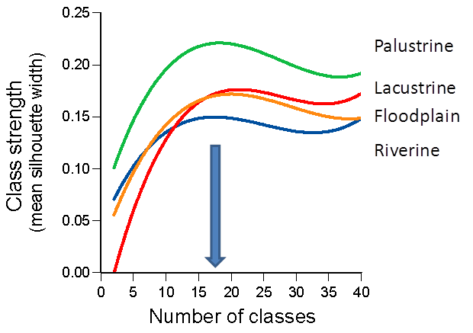

Figure 30: Overall classification strength for each of the four aquatic systems classifications as a function of the number of classes used in the classification.

*Note: The most appropriate number of classes is determined as that with the highest class strength (indicated with an arrow). Class strength ranges between zero (no class structure) to one (strong class separation) and indicates that these dataset are weakly structured.*

Results for each ecosystem type (lacustrine, palustrine, floodplain, riverine) were presented on separate sheets in the spread sheet. The results for ‘Number of GLOBAL-level standard deviations separating the class-level mean from the global mean’ on each sheet provide the basis for identifying attributes that discriminate one class from another. For example, Class 11 in the lacustrine systems is discriminated from the other classes on the basis of area and area:perimeter ratio (Table 47).

There are both positive and negative numbers in the results for each attribute versus class. This sign indicates the nature (trajectory) of the relationship of the attribute being considered compared with global means. For example, a large positive number indicates that a particular class has a larger proportion of the attribute in question compared with the global mean. Similarly, a large negative score for an attribute suggests that the class has a much lower proportion of an attribute than the global mean. Using some lacustrine results as an example:

* Lacustrine Class 11 is discriminated from the other lacustrine classes on the basis of (i) area and (ii) area:perimeter ratio (Table 47); this suggests this class is dominated by large, circular lakes.
* Lacustrine Class 15 is separated from other lacustrine classes by having a large negative score for unconsolidated rocks, a large positive score for igneous rocks, and a large positive score for mean elevation (Table 48); this suggests the lakes in this class are present high in their catchments, and are typified by consolidated igneous rock substrate (i.e. the lakes in this class lack the unconsolidated rocks of most other classes).

Table 47: Example of separation of Lacustrine class 11 from other lacustrine classes based on number of standard deviations above/below the global mean

|  |  |  |
| --- | --- | --- |
| **PAM Class** | **Area(m2)** | **Area to Perimeter ratio** |
| 1 | 0.1 | 0.4 |
| 2 | -0.1 | -0.2 |
| 3 | -0.1 | -0.2 |
| 4 | 0.0 | -0.2 |
| 5 | 0.0 | 0.4 |
| 6 | 0.0 | 0.4 |
| 7 | 0.0 | 0.1 |
| 8 | -0.1 | -0.4 |
| 9 | -0.1 | -0.3 |
| 10 | -0.1 | -0.5 |
| 11 | 8.9 | 7.8 |
| 12 | -0.1 | 0.1 |
| 13 | -0.1 | -0.1 |
| 14 | -0.1 | -0.2 |
| 15 | -0.1 | -0.4 |

Table 48: Example of separation of Lacustrine class 15 from other lacustrine classes based on number of standard deviations above/below the global mean

|  |  |  |  |
| --- | --- | --- | --- |
| **PAM Class** | **Unconsolidated rock** | **Igneous rock** | **Mean elevation** |
| 1 | -0.3 | -0.1 | -0.4 |
| 2 | 0.1 | -0.1 | 0.1 |
| 3 | 0.3 | -0.1 | -0.6 |
| 4 | -1.5 | 0.0 | -0.8 |
| 5 | 0.3 | -0.1 | -0.5 |
| 6 | 0.3 | -0.1 | -0.5 |
| 7 | -0.1 | -0.1 | 0.0 |
| 8 | 0.1 | -0.1 | 0.5 |
| 9 | 0.2 | 0.0 | 1.2 |
| 10 | -3.8 | 0.1 | 2.7 |
| 11 | -0.4 | -0.1 | -0.2 |
| 12 | 0.3 | -0.1 | 0.6 |
| 13 | 0.3 | -0.1 | -0.1 |
| 14 | 0.1 | -0.1 | -0.1 |
| 15 | -4.1 | 10.7 | 4.5 |

The various lacustrine, palustrine and riverine classes developed by the Cluster project and the basis of their separation resulting from discriminant analysis is presented in Appendix 3.

Overall, while some Cluster Classification project classes could be readily interpreted (e.g. those in Table 47 and Table 48), many were very difficult to interpret. This is not surprising, as the PAM method assigns individual features (wetlands, lakes, rivers) to classes on a statistical basis, in contrast to the ‘rules’ based (categorical) approach for assigning features used by the ANAE. A statistical approach means that individual attributes (and related metrics) can be assigned to multiple classes, and the basis for separation of classes can be quite subtle (as indicated by low class strength – see Appendix 3 and the accompanying discriminant analysis spread sheet). The low class strength indicates that there is a fundamental challenge in any classification in assigning classes to aquatic ecosystems based on attributes that tend to occur as a continuum, rather than in discrete categories.

## Task 2: Concordance between Cluster project classes and ANAE types

A number of methods were employed to compare the level of concordance between the assignment of Cluster project classes and ANAE classification types:

* Visual comparison of spatial distribution;
* Contingency charts; and
* Statistical measures of concordance (Adjusted Rand Index and Cramer’s V).

The comparison was only applied for overlapping polygons; i.e. the ANAE typology was applied only to the polygons included in the Cluster project, as this provides the ‘best-case’ scenario for comparison. The 1:250,000 scale mapping applied by the Cluster project means that a large proportion of small lacustrine and palustrine features that map at finer scales were not included in the analysis; including such features (as in the ANAE classification) would greatly reduce the level of concordance that might be present between the Cluster project and ANAE classification outputs.

Visual comparison of riverine features (Figure 31) shows that while there appears to broadly similar patterns across the MDB, the level of concordance between the two approaches was low based on contingency charts (Figure 32) and statistical measures of concordance ( and ). For example, there are multiple ANAE types that intersect with any given Cluster Classification (PAM) class.

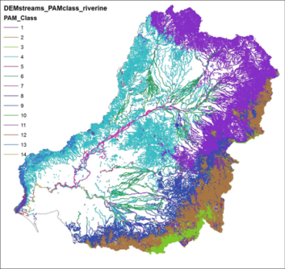

(a)

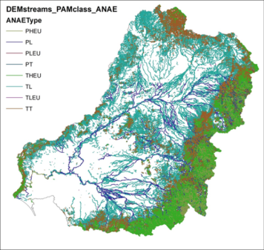

(b)

Figure 31: Visual comparison of riverine classes/types assigned by the (a) Cluster project and (b) ANAE classification (M. Kennard, Griffith University, pers. comm., 2013).

*Note: the different density in water course lines reflects the different data sets used by each classification.*

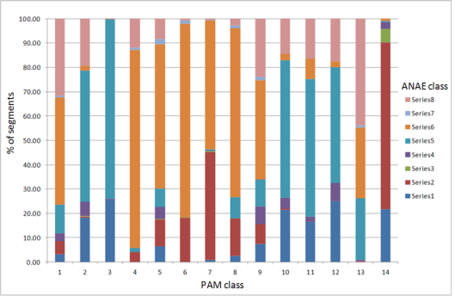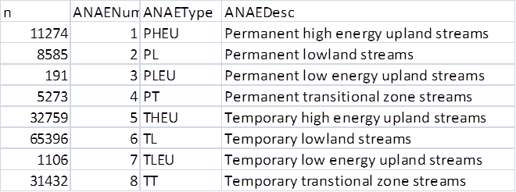

Figure 32: Concordance of Cluster project PAM classes and ANAE classification type. Note: the larger the number of ANAE types in each PAM class, the lower the concordance (M. Kennard, Griffith University, pers. comm., 2013).

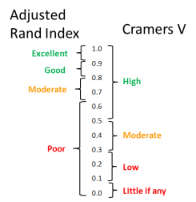

Figure 33: Relative measures of concordance applied to riverine, palustrine and lacustrine classes/types using the statistical measures of the Adjusted Rand Index and Cramer’s V (M. Kennard, Griffith University, pers. comm., 2013).

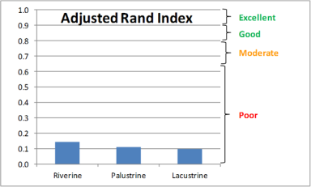

(a)

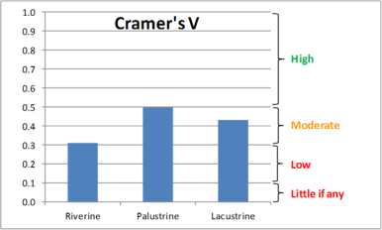

(b)

Figure 34: Concordance of riverine, palustrine and lacustrine features using (a) the Adjusted Rand Index and (b) Cramer’s V (M. Kennard, Griffith University, pers. comm.).

The level of concordance differed substantially depending on which statistical measure was used. Concordance of riverine, palustrine and lacustrine features were all moderate using Cramer’s V, but were at the low end of the poor scale using the Adjusted Rand Index.

## Implications for the ANAE Classification Project

Task 1 isolated the attributes that discriminated between the Cluster Classification classes. It showed that attribute data exist along a continuum, rather than being categorical, as indicated by low overall class strength for each aquatic system classification. As such, specific implications for the ANAE Classification Project could not be drawn.

The comparison undertaken as part of Task 2 highlighted differences between the classification results, which were not surprising given that the Cluster project employed a ‘bottom up’ statistical classification and the ANAE classification employed a ‘top down’ rules-based classification and typology. These fundamental differences in method, combined with the use of different attribute data accounts for the low levels of concordance between the two approaches.

However, having two classification methods at hand can serve decision-making in the future. For example, the ANAE classification (although interim at this stage) will establish a broad understanding of ‘what type of aquatic ecosystem is it’ and ‘where is it’ that will persist over time, as the approach to attributing data and classifying aquatic ecosystems is consistent. The classification typology is transparent, consistent with many classification schemes currently in use, and easily interpreted by water managers. The input of new or more accurate mapping and attribute data in the future will strengthen the confidence assigned to the interim classification of aquatic ecosystems over time.

The Cluster project approach can complement the ANAE classification by providing insights on statistical relationships between attributes and aquatic ecosystems that may not be evident when using the rules-based ANAE classification. Having the two classification methods available means that there is ‘multiple lines of evidence’ to assist water managers in making policy or implementation decisions.

In terms of implications for the current (interim) application of ANAE to the MDB, the Cluster project classification has reinforced the need to consider the following issues:

* Key differences between the method and aquatic ecosystem and attribute data used for each classification. Given the differences in the results, the choice of classification to apply to informing a particular question will depend on factors such as preference for an output based on a rules-based or statistical method, and the need for a basis in data consistent across the MDB or where finer-scale mapping is required.
* The scale at which aquatic ecosystems are best mapped; both approaches map riverine systems at a similar scale, albeit by different methods. If fine-scale mapping of lacustrine and palustrine systems is an important consideration, then the ANAE classification is well placed as it uses the best-available mapping scales.
* The retention of playas such as ‘clay pans’ in the ANAE classification will be important, as these have been shown to be a distinct class in the Cluster Classification.

These issues were considered as this application of the ANAE framework was refined.

# Summary and recommendations

## Summary

This is the first application of the interim ANAE framework to the MDB. It includes ‘best available’ mapping and attribute data, although it is recognised that mapping scales and accuracy, as well as attribute data coverage varies across jurisdictions and regions. This application of the ANAE framework is, therefore, considered an ‘interim’ classification with the expectation that the classification will be refined as new and more detailed mapping and attribute data becomes available over time, or following changes to the ANAE framework by the Aquatic Ecosystem Task Group. It is recommended that the use of this interim ANAE framework be conducted in close consultation with jurisdictional representatives who have a detailed knowledge of the area(s) of interest so that the potential for anomalies (e.g. low confidence data leading to inaccurate classification) can be considered. However, a major benefit of the project has been to collate Basin-wide mapping and attribute data into a single repository. This will be a valuable resource for Commonwealth and jurisdiction agencies in the future.

The typology presented is based predominantly on a subset of Level 3 attributes considered most relevant to environmental water management. However, the basis of the classification is that it will be useful for numerous applications, including ecological risk assessment, state of the environment reporting and monitoring and assessment.

Over 96,000 wetland and floodplain polygons and 157,000 river line segments were attributed using the ANAE classification and assigned to 15 of 16 proposed lacustrine types, 47 of 48 palustrine types, 10 riverine types, 19 floodplain and eight of 19 estuarine types. Three lacustrine, ten palustrine, one floodplain and seven estuarine types were considered to have low representation across the MDB with 10 or fewer aquatic ecosystems in each type. Results have been summarised to provide information on the number and type of aquatic ecosystems for each jurisdiction, as well as for the entire MDB.

The project has maintained links with the CSIRO Cluster Classification project. Comparisons have shown that there was little concordance in the ANAE classifications and the Cluster Classification that resulted from two different approaches. This is not surprising as the ‘top down’ approach of the ANAE framework is different from the ‘bottom up’ statistical approach of the Cluster Classification. Despite the differences, there is value in having two different classification approaches as it means that managers can explore classification results and gain insights to assist with decision-making in different ways. The ANAE classification has the benefit of:

* Using best available mapping data (palustrine and lacustrine features are better represented);
* Being consistent in its application, transparent, easily interpreted and communicated;
* Broadly consistent with the classification approaches being used or developed by jurisdictions.

## Recommendations

Undertaking this ‘interim’ application of the ANAE framework has highlighted a number of ways in which the classification can be improved in the future. The following are recommendations that will improve the mapping and attribute data, and so should be considered as part of any revision of the ANAE classification:

* Further investigation into the data supporting the underrepresented rare aquatic ecosystem types is recommended, as is ground-truthing to reveal if they have been misclassified or are indeed uncommon in the Basin.
* Detailed validation of the ANAE types against that from state classifications.
* There are a number of activities currently underway that will produce information and data useful for future iterations of the ANAE framework. It is recommended that an annual review of available mapping and attribute data be undertaken, with a view to including outputs from the following the following:
  + Queensland groundwater interaction mapping (completed May 2012);
  + The Authority vegetation modelling project with Arthur Rylah Institute (due for completion in 2013);
  + The Authority floodplain modelling project (due for completion in 2015);
  + Future updates of NVIS. A number of mapping errors (Datum Errors) in NVIS 4.1 are currently being fixed. The area affected is the lower Murrumbidgee (Hay plains vegetation mapping).
* The way river features were mapped (aggregating fine-scale segments to 1:250,000 scale) is likely to have under-represented headwater systems. A future application of the ANAE should be carried out on the original jurisdiction mapping to provide a more complete representation of the river network that includes the headwater systems.
* The AETG is currently updating the attributes to be assigned to estuaries. It is recommended that the attribution, typology and scale at which they apply are reviewed once the AETG has completed its revision.
* Landform and confinement definitions might benefit from a more systematic statistical comparison with the New South Wales River Styles data. Analysis should be undertaken before aligning the two, to consider the relative merits of each approach.

# References

ABARES (1991). Digital Atlas of Australian Soils–Soil landscapes map, Australian Bureau of Agricultural and Resource Economics and Sciences, Canberra available at <http://www.daff.gov.au/abares/publications>.

Aquatic Ecosystems Task Group (AETG) (2012). Aquatic Ecosystems Toolkit. Module 2 Interim Australian National Aquatic Ecosystems (ANAE) Classification Framework. Department of Sustainability, Environment, Water Population and Communities, Canberra.

Batzer D.P., Sharitz R., (2006). Ecology of freshwater and estuarine wetlands. Los

Angeles: University of California Press.

BoM (2012a) Australian Hydrological Geospatial Fabric (Geofabric) v2. Bureau of Meteorology, Australia [http://www.bom.gov.au/water/geofabric/index.shtml accessed 1st June 2012](http://www.bom.gov.au/water/geofabric/index.shtml%20accessed%201st%20June%202012).

BoM (2012b) Australian Hydrological Geospatial Fabric (Geofabric) Data Product Specification: Surface Cartography Version 2.1. Bureau of Meteorology, Australia <http://www.bom.gov.au/water/geofabric/documents/v2_1/ahgf_dps_surface_cartography_V2_1_release.pdf> accessed 1st June 2012.

BoM (2012c) Australian Hydrological Geospatial Fabric (Geofabric) Data Product Specification: Surface Network version 2.1. Bureau of Meteorology, Australia <http://www.bom.gov.au/water/geofabric/documents/v2_1/ahgf_dps_surface_network_V2_1_release.pdf> accessed 1st June 2012.

BoM (2012d) Australian Hydrological Geospatial Fabric (Geofabric) Data Product Specification: Surface Catchments. Bureau of Meteorology, Australia [http://www.bom.gov.au/water/geofabric/documents/v2_1/ahgf_dps_surface_catchments_V2_1_release.pdf accessed 1st June 2012](http://www.bom.gov.au/water/geofabric/documents/v2_1/ahgf_dps_surface_catchments_V2_1_release.pdf%20accessed%201st%20June%202012).

Boulton, A.J., and Brock, M.A. (1999). *Australian Freshwater Ecology: Process and Management*. Gleneagles Publishing, Glen Osmond, SA, Australia.

Brierley, G., Fryirs, K., Outhet, D. and Massey, C. (2002). Application of the River Styles framework as a basis for river management in New South Wales, Australia. *Applied Geography* 22: 91-122.

Bucher, D. and Saenger,P. (1989). An inventory of Australian estuaries and enclosed marine waters. The Australian Recreational and Sport Fishing Confederation.

Butcher, R., (ed), Farrington, L., Harding, C., and O’Connor, P. (2011). An integrated

trial of the Australian National Aquatic Ecosystem Classification Scheme in southeastern

South Australia. Report prepared for the Department of Sustainability,

Environment, Water, Population and Communities.

Chen Y, SM Cuddy, LE Merrin, C Huang, D Pollock, N Sims, B Wang and Q Bai, (2012). Murray-Darling Basin Floodplain Inundation Model Version 2.0 (MDB-FIM2). Technical report. CSIRO Water for a Healthy Country Flagship, Australia. <http://www.clw.csiro.au/products/mdb-fim/>

Claus S., Imgraben S., Brennan K., Carthey A., Daly B., Blakey R., Turak E. & Saintilan N. (2011). Assessing the extent and condition of wetlands in NSW: Supporting report A – Conceptual framework: monitoring, evaluation and reporting program, Technical report series, Office of Environment and Heritage, Sydney.

Cottingham P., Brooks S., Butcher R. and Hale J. (2012). Murray-Darling Basin aquatic ecosystem classification: Stage 1 report. Peter Cottingham & Associates report to the Commonwealth Environmental Water Office, Canberra.

Cowardin, L.M., Carter, V., Golet, F.C. and LaRoe, E.T. (1979). Classification of Wetlands and Deepwater Habitats of the United States. US Department of the Interior, Fish 7 Wildlife

Service, Office of Biological Services, Washington DC 20240

DERM (2012). Lacustrine and Palustrine wetland typology, <http://wetlandinfo.ehp.qld.gov.au/wetlands/what-are-wetlands/definitions-classification/classification-systems-background/typology.html>.

DERM (2011) Queensland Wetland Definition and Delineation Guideline, Part A: A guide to existing wetland definitions and the application of the Queensland Wetlands Program Definition. Department of Environment and Resource Management, Queensland Government, Brisbane.

Digby, M. J., Saenger, P., Whelan, M. B., McConchie, D., Eyre, B., Holmes, N. and Bucher, D. (1999). A Physical Classification of Australian Estuaries. National River Health Program – Project E1. Urban Sub-Program Report No.9. Occasional Paper 16/99, Land and Water Resources Research and Development Corporation.

Dittmann, S. (2005). Coorong and Lower Lakes Mud Flat Investigation December 2004 sampling campaign, interim report for Department for Environment and Heritage.

DSE (2005). Index of Stream Condition: The Second Benchmark of Victorian River

Condition. Department of Sustainability and Environment, Melbourne. <http://www.vicwaterdata.net/vicwaterdata/data_warehouse_content.aspx?option=5>

Environmental Protection Agency (2005). Wetland Mapping and Classification Methodology – Overall Framework – A Method to Provide Baseline Mapping and Classification for

Wetlands in Queensland, Version 1.2, Queensland Government, Brisbane. ISBN 0 9757 344 6 6. <http://wetlandinfo.ehp.qld.gov.au/wetlands/what-are-wetlands/definitions-classification/classification-systems-background/typology.html>)

Executive Steering Committee for Australian Vegetation Information (ESCAVI) (2003)

Australian Vegetation Attribute Manual: National Vegetation Information System,

Version 6.0. Department of the Environment and Heritage, Canberra. <http://www.environment.gov.au/erin/nvis/publications/avam/pubs/vegetation-attribute-manual-6.pdf>

Gallant, J., and Dowling, T. (2003). A multi-resolution index of valley bottom flatness for mapping depositional areas, Water Resources Research, 39 (12): 1347-1360.

Hale, J., Butcher, R. Collier, K. and Snelder, T. (2012). ANZECC/ARMCANZ Water Quality Guidelines revision: Ecoregionalisation and ecosystem types in Australian and New Zealand marine, coastal and inland water systems. Prepared for DSEWPaC.

Hale, J. (ed.) (2010). Lake Eyre Basin High Conservation Value Aquatic Ecosystem

Pilot Project. Report to the Australian Government Department of Environment, Water,

Heritage and the Arts, and the Aquatic Ecosystems Task Group.

Hale, J and Butcher, R. (2008). Summary and review of approaches to the bioregionalisation and classification of aquatic ecosystems within Australia and Internationally. Report to the Department of Environment, Water, Heritage and the Arts, Canberra.

Isbell R. (2002). The Australian soil classification, revised edition. Australian Soil and Land Survey Handbooks, Series 4, CSIRO Publishing. <http://www.clw.csiro.au/aclep/asc_re_on_line/soilhome.htm>

Jenness, J.S. (2007). Some thoughts on analyzing topographic habitat characteristics.

<http://www.jennessent.com/downloads/topographic_analysis_online.pdf>.

Jones, L. and Miles, M. (2009). River Murray Wetland Classification Project DEH) report to the Riverine Recovery Project, Department of Water, Land & Biodiversity Conservation.

Kaufman, L. and Rousseeuw, P.J. (1990). Finding Groups in Data: An Introduction to Cluster Analysis. Wiley, New York).

Kingsford, R. T., K. Brandis, R. F. Thomas, P. Crighton, E. Knowles, and E. Gale. 2004. Classifying landform at broad spatial scales: the distribution and conservation of wetlands in New South Wales, Australia. Marine and Freshwater Research 55:17-31

Miles, M. 2014. SA Manual Edits to Murray-Darling Basin ANAE dataset. Department of Environment, Water and Natural Resources (DEWNR), South Australia.

Murray, P.A., 2008. Murrumbidgee Wetlands Resource Book, Murrumbidgee Catchment Management Authority, New South Wales

Nielsen, D.L., Brock, M.A., Rees, G.N., and Baldwin, D.S. (2003). Effects of increasing salinity on freshwater ecosystems in Australia. Australian Journal of Botany, 51:655-665.

Northcote, K.H. (1971). A factual key for the recognition of Australian soils (3rd ed.). Glenside, South Australia: Rellim Technical Publications

Olden, JD, Kennard, MJ & Pusey, BJ (2012). A framework for hydrologic classification with a review of methodologies and applications in ecohydrology. *Ecohydrology* 5: 503–518

Overton IC, TM Doody, D Pollock, JP Guerschman, G Warren, W Jin, Y Chen and B Wurcker. (2010) ‘Murray-Darling Basin Floodplain Inundation Model’. Version 1Water for a Healthy Country Flagship Technical Report, CSIRO, Adelaide.

Phillips, W. and Muller, K. (2006). Ecological Character of the Coorong, Lakes Alexandrina and Albert Wetland of International Importance. South Australian Department for Environment and Heritage.

Ramsar Convention (2009). Strategic Framework for the List of Wetlands of International Importance, Third edition, as adopted by Resolution VII.11 (COP7, 1999) and amended by Resolutions VII.13 (1999), VIII.11 and VIII.33 (COP8, 2002), IX.1 Annexes A and B (COP9, 2005), and X.20 (COP10, 2008). <http://www.ramsar.org/doc/key_guide_list2009_e.doc>

Ryan, D. A., Heap, A. D., Radke, L., and Heggie, D. T. (2003). Conceptual models of Australia’s estuaries and coastal waterways: applications for coastal resource management. Geoscience Australia, Record 2003/09.

Seaman R.L. (2003). Coorong and Lower Lakes habitat mapping program, Conservation Programs, Department for Environment and Heritage, South Australia.

SKM (2012). Atlas of Groundwater Dependent Ecosystems (GDE Atlas), Phase 2, Task 5 report: identifying and mapping GDEs. Sinclair Knight Merz, Melbourne.

Stace, H.C.T.; Hubble, G.D.; Brewer, R; Northcote, K.H.; Sleeman, J.R.; Mulcahy, M.J.; and Hallsworth, E.G. (1968). A Handbook of Australian Soils. Glenside, South Australia: Rellim Technical Publications.

Stein J. L. (2006). ‘A Continental Landscape Framework for Systematic Conservation Planning for Australian Rivers and Streams.’ (PhD Thesis, Centre for Resource and Environmental Studies, Australian National University: Canberra.) Available at <http://hdl.handle.net/1885/49406>.

Stein (2012) National Environmental Stream Attributes v1.1.5 Available at <http://www.ga.gov.au/topographic-mapping/national-surface-water-information.html> June 2012.

TFMPA (1999). Understanding and applying the principles of comprehensiveness, adequacy and representativeness for the NRSMPA, Version 3.1. Report prepared by the Action Team for the ANZECC Task Force on Marine Protected Areas. Marine Group, Environment Australia, Canberra.

Ward D., Tews K., Kennard M., Peterson E. & Bond N. (2012). Murray-Darling Basin aquatic system mapping and classification – aquatic assets and environmental attribute geodatabases. Sub-project 2: flow regimes, ecological assets: key habitats and refugia CSIRO-cluster project “ecological responses to altered flow regimes”, Griffith university and CSIRO.

Wickes, R., Merrick, N., and Shaw, R. (2012). Report of the Independent Audit Group for Salinity 2010–11. MDBA, Canberra.

# Appendix 1: Vegetation attribute decision rules

## Vegetation attributes from NVIS41_MDB

Vegetation attributes were applied from data within NVIS41_MDB. The ANAE suggests vegetation be classified into three categories based on dominant vegetation stricture: trees, shrubs and grass/sedge/forb. These categories were predominantly extracted from the NVIS field “L1_Class”, which has structural classes (at a slightly finer scale). However, there were instances where the NVIS class field was blank or “unknown”, but there were data describing vegetation in other fields. In these cases, indications in other fields were used to apply the ANAE structural categories (e.g. forest or woodland vegetation descriptions, were assigned the structural class “tree”).

It was considered important to separate water and areas without vegetation from those that were unknown. For this reason three additional structural classes were extracted from NVIS: water (to indicate wetland and lake features), Non-veg (to indicate cleared and bare areas) and unknown (where vegetation may occur, but there is a gap in the mapping).

Vegetation attributes were applied differently for different aquatic ecosystem types. Riverine systems were classified at the broad structural level: trees, shrubs, grass/sedge/forb, water, non-veg and known (as described above). For Riverine systems the three vegetation classes relate to all vegetation associations and types (terrestrial and aquatic), reflecting the importance of streamside vegetation in providing carbon and shade to stream systems.

Vegetation in Floodplain and Palustrine systems was applied at a finer scale, with aquatic dependent species and associations, separated from terrestrial vegetation. The typology developed for Floodplain and Palustrine systems incorporates dominant aquatic vegetation types (see Chapter 5) and these were extracted from the NVIS data. For transparency and to enable decisions to be tracked, the decision processes in assigning this finer scale vegetation classes is provided in the tables below.

## Riverine

|  |  |
| --- | --- |
| **Class** | **Decision** |
| Tree | L1_CLASS = “Tree”, “Tree Mallee”, “Palm”  L1_CLASS = “unknown” and “woodland” or “forest” appear in MVG_NAME and / or MVS_ NAME |
| Shrub | L1_CLASS = “Shrub”, “Heath shrub”, “Mallee shrub”, “Samphire shrub”, “Tree fern” or “Grass tree”  L1_CLASS = “unknown” and “shrub”, “heath” or “scrub” appear in MVG_ NAME and / or MVS_ NAME |
| Grass/sedge/forb | L1_CLASS = “Fern”, “Forb”, “Hummock grass”, “Lower plant”, Other grass”, Rush”, “Seagrass”, “Sedge”, “Tussock grass”, “Vine” or “Aquatic”  L1_CLASS = “unknown” where “Grass”, occurred in MVG_NAME and / or L5_ASSOCIA indicated a species of grass, sedge or forb as dominant, and / or SOURCE_DES contained “treeless vegetation” |
| Water | L5_ASSOCIA = “NA”, “salt lake” or “unknown” AND L2_Structu = “water”, “lake”, “sea” or “inland aquatic” and / or SOURCE_DES = “Water” |
| Non-veg | L5_ASSOCIA = “NA”, “cleared” or “unknown” AND the terms “cleared”, “bare”, “settlement” appeared in L2_STRUCTU, SOURCE_DES and/ or MVG_NAME |
| Unknown | L1_Class, L2_STRUCTU and L5_ASSOCIA = “unknown” or NA  OR L1_CLASS = “dummy” |

## Floodplain

|  |  |
| --- | --- |
| **Class** | **Decision** |
| River red gum | Riverine class = tree AND  L5_ASSOCIA has dominant species as *Eucalyptus camaldulensis*  L5_ASSOCIA = “NA” or “unknown” AND “river red gum” appears in SOURCE_DES |
| Black box | Riverine class = tree AND  L5_ASSOCIA has dominant species as *Eucalyptus largiflorens*  L5_ASSOCIA = “NA” or “unknown” AND “black box” appears in SOURCE_DES |
| Coolibah | Riverine class = tree AND  L5_ASSOCIA has dominant species as *Eucalyptus coolabah*  L5_ASSOCIA = “NA” or “unknown” AND “Coolabah” or “Coolibah” appears in SOURCE_DES |
| River cooba | Riverine class = tree AND  L5_ASSOCIA has dominant species as *Acacia stenophylla*  L5_ASSOCIA = “NA” or “unknown” AND “river red gum” appears in SOURCE_DES |
| Paperbark | Riverine class = tree AND  L5_ASSOCIA has dominant species as *Melaleuca quinquenervia, M. ericofolia* |
| Other aquatic tree | Riverine class = tree AND  L5_ASSOCIA has dominant species as *Avicennia sp., Casuarina cunninghamii, Casuarina gluaca, Cerios tagal, Eucalyptus camphora, E. Microtheca, E. ovate, E. robusta, Pemphis acidula, Rhizophora sp.*  L5_ASSOCIA = “NA” or “unknown” AND SOURCE_DES =:  Drainage-line Aggregate/Riverine Swamp Forest Mosaic  Drainage-line Aggregate/Sedgy Riverine Forest Mosaic  Floodplain Grassy Wetland/Riverine Swamp Forest Mosaic  Floodplain Grassy Wetland/Riverine Swampy Woodland Mosaic  Floodplain Riparian Woodland/Riverine Grassy Woodland Mosaic  Floodplain Riparian Woodland/Riverine Swamp Forest Mosaic  Floodplain Riparian Woodland/Sedgy Riverine Forest Mosaic  Floodway Pond Herbland/Riverine Swamp Forest Complex - Murray Fans  Floodway Pond Herbland/Riverine Swamp Forest Mosaic  FOW Forested Wetlands Burragorang River Flat Forest  FOW Forested Wetlands Cumberland River Flat Forest  FOW Forested Wetlands Riverbank Forest  FOW Forested Wetlands South Coast River Flat Forest  Grassy Riverine Forest/Drainage-line Aggregate Mosaic  Grassy Riverine Forest/Floodway Pond Herbland Complex  Grassy Riverine Forest/Floodway Pond Herbland Mosaic  Grassy Riverine Forest/Riverine Grassy Woodland Mosaic  Grassy Riverine Forest/Riverine Swamp Forest Complex  Grassy Riverine Forest/Riverine Swamp Forest Mosaic  Grassy Riverine Forest/Sedgy Riverine Forest Mosaic  Grassy Riverine Forest/Tall Marsh Mosaic  Grassy Woodland/Riverine Grassy Woodland Mosaic  Intermittent Swampy Woodland/Riverine Grassy Woodland Complex  Low Rises Woodland/Riverine Swampy Woodland Mosaic  Mosaic of Aquatic Herbland/Floodway Pond Herbland-Riverine Swamp Forest Complex  Mosaic of Aquatic Herbland/Sedgy Riverine Forest-Riverine Swamp Forest Complex  Mosaic of Drainage-line Aggregate/Floodway Pond Herbland-Riverine Swamp Forest Complex  Mosaic of Drainage-line Aggregate/Grassy Riverine Forest-Riverine Swamp Forest Complex  Mosaic of Drainage-line Aggregate/Sedgy Riverine Forest-Riverine Swamp Forest Complex  Mosaic of Grassy Riverine Forest-Riverine Swamp Forest Complex/Riverine Swamp Forest  Mosaic of Grassy Riverine Forest/Floodway Pond Herbland-Riverine Swamp Forest Complex  Mosaic of Grassy Riverine Forest/Sedgy Riverine Forest-Riverine Swamp Forest Complex  Mosaic of Riverine Grassy Woodland/Floodway Pond Herbland-Riverine Swamp Forest Complex  Mosaic of Riverine Swamp Forest/Floodway Pond Herbland-Riverine Swamp Forest Complex  Mosaic of Riverine Swampy Woodland/Sedgy Riverine Forest-Riverine Swamp Forest Complex  Mosaic of Sedgy Riverine Forest-Riverine Swamp Forest Complex/Floodway Pond Herbland-Riverine Swamp Forest Complex  Mosaic of Sedgy Riverine Forest-Riverine Swamp Forest Complex/Tall Marsh  Mosaic of Sedgy Riverine Forest/Floodway Pond Herbland-Riverine Swamp Forest Complex  Mosaic of Sedgy Riverine Forest/Sedgy Riverine Forest-Riverine Swamp Forest Complex  Riparian Forest/Swampy Riparian Woodland/Riparian Shrubland/Riverine Escarpment Scrub Mosaic  River Oak; An extremely widespread type with River Oak as the clear dominant, occurring as a ribbon alongside creeks and rivers, usually on stony or sandy soils. It occurs throughout the eastern part of the state, extending west of the Divide down to an  Riverine Chenopod Woodland  Riverine Chenopod Woodland/Lignum Swamp Mosaic  Riverine Chenopod Woodland/Plains Grassland Mosaic  Riverine Grassy Woodland  Riverine Grassy Woodland/Plains Woodland Complex  Riverine Grassy Woodland/Plains Woodland/Gilgai Wetland Complex  Riverine Grassy Woodland/Riverine Chenopod Woodland/Wetland Mosaic  Riverine Grassy Woodland/Riverine Swampy Woodland Mosaic  Riverine Grassy Woodland/Sedgy Riverine Forest Mosaic  Riverine Grassy Woodland/Sedgy Riverine Forest/Aquatic Herbland Mosaic  Riverine Grassy Woodland/Sedgy Riverine Forest/Wetland Formation Mosaic  Riverine Swamp Forest/Riverine Swampy Woodland Mosaic  Riverine Swamp Forest/Sedgy Riverine Forest Mosaic  Riverine Swamp Forest/Spike-sedge Wetland Mosaic  Riverine Swampy Woodland  Riverine Swampy Woodland/Lignum Swamp Mosaic  Riverine Swampy Woodland/Sedgy Riverine Forest Mosaic  Sedgy Riverine Forest/Tall Marsh Mosaic |
| Tree | Riverine class = tree AND none of the above apply |
| Lignum | Riverine class = shrub AND  L5_ASSOCIA has dominant species as *Muehlenbeckia florulenta*  L5_ASSOCIA = “NA” or “unknown” AND “lignum” appears in SOURCE_DES |
| Shrub | Riverine class = tree AND lignum does not apply |
| Aquatic grass / sedge/forb | Riverine class = Grass/sedge/forb AND  L5_ASSOCIA has dominant species as any of the following:  *Apodasmia brownii*, *Amphibromus nervosa, Baloskion tetraphyllum, Baumea spp., Carex spp., Chara, spp., Cladium procerum, Cyperaceae spp., Cyperus spp., Eleocharis spp., Eragrostis spp., Gahnia spp., Gymnoschoenus sphaerocephalus, Halophila spp., Juncus spp., Hemarthria uncinata, Lepidosperma spp., Lepilaena spp., Lepironia articulata, Leptocarpus tenax, Lomandra spp., Marsilea drummondii, Monochoria spp., Myriophyllum spp, Najas spp., Persicaria spp., Phragmites australis, Posidonia spp., Potamogeton spp., Pseudoraphis spinescens, Rupia spp., Schoenoplectus spp., Schoenus brevifolius, Stellaria angustifolia, Trigolchin spp., Typha, sp., Zostera spp.*  OR SOURCE_DES contained the terms “swamp”, “wetland”, or “estuarine” |
| Grass/forb | Riverine class = tree AND none of the above apply |
| Water | Riverine class = Water |
| Non-veg | Riverine class = Non-veg |
| Unknown | Riverine class = Unknown |

## Palustrine

|  |  |
| --- | --- |
| **Class** | **Decision** |
| River red gum | Floodplain class = River red gum |
| Black box | Floodplain class = Black box |
| Coolibah | Floodplain class = Coolibah |
| River cooba | Floodplain class = River cooba |
| Paperbark | Floodplain class = Paperbark |
| Other aquatic tree | Floodplain class = Other aquatic tree |
| Mangrove | Floodplain class = Tree AND  L5_ASSOCIA has dominant species as any of the following:  *Avicennia spp., Ceriops tagal, Rhizophora spp.,*  OR SOURCE_DES contains “mangrove” |
| Tree | Floodplain class = Tree |
| Lignum | Floodplain class = Lignum |
| Shrub | Floodplain class = Shrub and “saltmarsh” and “bog and fen” (see below) does not apply |
| Saltmarsh | L5_ASSOCIA has dominant species as any of the following:  *Baumea juncea, Gahnia filum, Gahnia trifida, Halosarcia spp., Juncus kraussii, Sarcocornia spp., Sclerostegia spp., Suaeda australis, Wilsonia rotundifolia*  OR SOURCE_DES contained the terms “brackish”, “estuarine”, “saline”, “salt” or “saltmarsh” |
| Bogs and fens | Term “bog” or “fen” occurs in SOURCE_DES |
| Tall emergent aquatic | Floodplain class = Aquatic grass/sedge/forb AND  L1_CLASS = “sedge” or “rush”  OR L1_CLASS = “aquatic” AND L5_ASSOCIA has dominant species as Typha  OR L1_CLASS = “Forb”, “Other grass” or “Tussock grass” AND L5_ASSOCIA has dominant species as Phragmites |
| Seagrass | Floodplain class = Aquatic grass/sedge/forb AND  L1_Class = “Seagrass” OR  L5_ASSOCIA = has dominant species as any of the following:  *Halophilla spp., Lepilaena spp., Posidonia spp., Ruppia spp., or Zostera spp.* |
| Freshwater grasses | Floodplain class = Aquatic grass/sedge/forb AND rules for “Tall emergent aquatic” and “Seagrass” above do not apply AND  L1_CLASS = “Hummock grass”, “Other grass” or “Tussock grass”  OR L1_CLASS = “Sedge” and L5_ASSOCIA has dominant species as Eragrostis sp.  OR L1_CLASS = “Unknown” AND SOURCE_DES contains the terms “Cane Grass” or “Grassy wetland” |
| Freshwater forbs | Floodplain class = Aquatic grass/sedge/forb AND rules for “Tall emergent aquatic” and “Seagrass” and “Freshwater grasses” above do not apply AND  L1_CLASS = “Aquatic”, “Fern”, “Forb” or “Lower plant”  OR L1_CLASS = “Unknown” AND SOURCE_DES contains the term “Aquatic herbland” |
| Aquatic grass / sedge/forb | Floodplain class = Aquatic grass/sedge/forb AND none of the above rules apply |
| Grass / forb | Floodplain class = Grass / forb |
| Water | Riverine class = Water |
| Non-veg | Riverine class = Non-veg |
| Unknown | Riverine class = Unknown |

# Appendix 2: Attribution and confidence rules

|  |  |
| --- | --- |
| **ConfID** | **Description** |
| 1 | Rivers Feature Mapping  Confidence = 2. Geofabric Mapped Streams. Used only as infill where state layers not represented. Confidence =2 because courser scale of data. Not as accurate as state layers. Includes connector segments that don’t exist in real world. |
| 2 | Rivers Feature Mapping  Confidence = 3 for all Victorian data stream segments. High confidence (3). Fine scale data with complete coverage. |
| 3 | Rivers Feature Mapping  Confidence = 2. SA Selection of stream segments. Confidence down rated due to large number of incomplete, disconnected stream segments. |
| 4 | Rivers Feature Mapping  Confidence = 3. NSW Selection of stream segments. High confidence (3). Fine scale complete coverage. |
| 5 | Rivers Feature Mapping  Confidence =3 QLD Selection of stream segments. High confidence (3). Fine scale complete coverage. |
| 6 | Rivers Feature Mapping  Confidence = 3  Average of state and Geofabric confidence values per Geofabric SegmentID. |
| 7 | Landform  Confidence = 3  Lowland determination with mrVBF. High confidence - upper limit of data set is unambiguous. |
| 8 | Landform  Confidence = 3  Upland determination with mrVBF, mrRTF High confidence - lower limit of data set is unambiguous. |
| 9 | Landform  Confidence = 2  Transitional - confidence down-rated because threshold somewhat arbitrary despite calibration with River Styles. Feedback from NSW suggests results might over-represent upland areas. |
| 10 | Landform  Confidence = 2  Low energy upland - confidence down-rated because threshold is somewhat arbitrary and discussion with John Gallant CSIRO indicated mrRTF has undergone less testing. |
| 11 | Confinement (river mapping)  Confidence = 3 if confinement ratio = 0 or 1 (absolute)  Confidence = 2 for ratios in between as thresholds are arbitrary despite being informed by River Styles. |
| 12 | Water Regime to river mapping  All states:  Confidence = 1: Assume periodically inundated if no data or unknown  Confidence = 3: provided in state layer  Confidence = 2: down rate to 2 if Geofabric doesn’t agree with state layer  Confidence = 2: no data in state layer and regime derived from Geofabric only  Confidence = 4: State Layer Agrees with Geofabric (2 sources of evidence). |
| 13 | Water Source to river mapping  Confidence = 1: Assumed surface water fed in absence of any data if listed as unknown in state layers. |
| 14 | Wetland polygon mapping  General confidence in Jurisdiction wetland layers.  Confidence = 3: QLD, VIC, SA,  Confidence = 2: NSW (mapping is surface water area not wetlands)  Confidence = 2: Feature in Geofabric but not in state layers. |
| 15 | Assigning system type to wetland polygons.  All states:  Confidence = 1: If type is unknown assumed value is Palustrine.  Confidence = 2: Riverine defined by intersection of polygons with Geofabric major rivers.  Confidence = 3: Jurisdiction mapping defines the system type for this feature.  NSW:  Confidence = 2: SystemType assigned to Lacustrine based on part of the Name  NSW_Wetlands.HYDRONAMETYPE = 'LAKE' OR NSW_Wetlands.HYDRONAMETYPE = 'LAKES' OR NSW_Wetlands.HYDRONAMETYPE = 'POND' OR NSW_Wetlands.HYDRONAMETYPE = 'PONDS'.  SA:  158 systems with “Dam” in the name. Confidence lowered to 2 perhaps should be deleted because artificial.  Confidence = 4: Murray River main channel in SA (certain). |
| 16 | Assigning water type (salinity) to wetland polygons.  All states:  Confidence = 1: Assume Freshwater if no data or unknown.  VIC:  Confidence = 3: Fresh, and all saline categories apart from “Fresh-Hyposaline” obvious mappings.  Confidence = 2: “Fresh-Hyposaline” mapped to saline (lower confidence).  QLD:  Confidence = 3: Fresh and Saline are straightforward mappings  Confidence = 2: Hyposaline (3000 -30000 ppt). - mapped to saline but low end of range overlap fresh.  SA:  Confidence = 3: Fresh and Saline are straightforward mappings  Confidence = 2: Brackish mapped to Saline.  NSW:  Confidence = 1: NO DATA. |
| 17 | Water Regime to wetland polygons  Confidence = 1: Assume Periodic (no data or unknown)  SA. two data sources  Confidence = 3, "Src2DataValue" is null and ("Src1DataValue" = 'TEMPORARY' OR "Src1DataValue" = 'SEASONAL' OR "Src1DataValue" = 'RUNOFF/TEMPORARY COMBINATION' OR "Src1DataValue" = 'RUNOFF OR SEEPAGE' OR "Src1DataValue" = 'CONTROLLED IRRIGATION')  Confidence = 3, WET "Src2DataValue" = 'Permanent'.  Confidence = 3, PERIODIC "Src2DataValue" = 'Ephemeral' OR "Src2DataValue" = 'Seasonal' OR "Src2DataValue" = 'Years (> 1yr)'  Confidence = 2, data sources different: "Src2DataValue" = 'Permanent' and ("Src1DataValue" = 'SEASONAL' OR "Src1DataValue" = 'TEMPORARY')  Geofabric  Confidence = 3 = permanent, temporary. Rest are no data (1)  QLD  Confidence = 3: PI: "Src1DataValue" = 'Intermediately (40-60% of images)' OR "Src1DataValue" = 'Rarely (20% of images)'  Confidence = 3: CW: "Src1DataValue" = 'Commonly (80-100% of images)'  NSW  Confidence = 3: CW: "Src1DataValue" = '1’  Confidence = 3: PI: "Src1DataValue" = '2' OR "Src1DataValue" = '3'  VIC  Confidence = 3: CW: "Src1DataValue" = 'Permanent'  Confidence = 3: PI: "Src1DataValue" = 'Seasonal' OR "Src1DataValue" = 'Intermittent' OR "Src1DataValue" = 'Episodic'. |
| 18 | Floodplain  Confidence = 1: All low confidence. Allocated as spatial join with Kingsford floodplain. Low confidence in Kingsford layer being definitive for floodplain boundary. |
| 19 | Landform using mrVBF and mrRTF  Confidence = 3: Low Engery Lowland = VBF > 3, "mrVBFMean" > '3'  Confidence = 3: Low Energy Upland = VBF <2.5 and RTF >2.5, "mrVBFMean" <2.5 and "mrRTFMean">2.5  Confidence = 3: High Energy Upland = mrVBF < 2.5 and mrRTF <= 2.5, "mrVBFMean" <2.5 and "mrRTFMean"<=2.5  Transitional VBF  Confidence = 3: "mrVBFMean" >=2.5 and "mrVBFMean"<=3. |
| 20 | Springs Feature  Confidence = 2: Larger wetland polygons (supplied to GDE mapping by NSW) - spring identifies the whole polygon not spring outlet  Confidence = 3: Points Taken from GDE mapping |
| 21 | RERP Feature Mapping  Confidence =2. Not really mapping wetlands. Mapping is management units for environmental watering that contain wetlands and floodplain assets |
| 22 | WaterSource-Wetlands  Confidence = 1 Assume Surface  Confidence = 3 SAWID SE_ANAE water source  Confidence = 3 SPRINGS = GROUNDWATER  Confidence = 3 MWWG GROUNDWATER= underground water. |
| 23 | 2008 RERP veg mapping  Confidence = 3: certain at even the fine (Palustrine) level that the ANAE vegetation class assigned matches the vegetation description provided.  Confidence = 2: some assumptions made e.g. "River Cooba-Lignum Association" is River cooba and not lignum, based on description of how things were assigned in the metadata.  Confidence =1: Bigger assumption made mostly in the absence of clear direction in the metadata e.g. "Baradine Red Gum Association" has been assigned as "tree" because it is actually the species *Eucalyptus chloroclada* (sometimes called Baradine, but sometimes called Baradine red gum) - but Baradine also grows with *E. camaldulensis*, so maybe the association name meant a combination of the two species and should have been assigned "Red gum" under the ANAE. |
| 24 | Namoi feature mapping  Confidence = 3: fine scale mapping. System Type defined in the source data for all features. |
| 25 | MCMA Wetlands feature mapping  Confidence = 3: system type defined in the source  Confidence = 1: no type defined so assume palustrine |
| 26 | SAWID mapping  Confidence = 3: system type defined  Confidence = 2: SAWID lists feature as “EST - Estuary” but 2003 habitat mapping says “palustrine”. Define as palustrine with lower confidence (ie believe 2003 habitat mapping)  Confidence = 1: no system type defined. Assume palustrine. |
| 27 | MWWG Features  Confidence =2: system Type defined using NAME of system   * Lacustrine: upper (Name) like '%LAKE%' * Riverine: upper (Wetlands_All_NEW.Name) like '%CREEK%' or upper( Wetlands_All_NEW.Name) like '%RIVER%' or upper( Wetlands_All_NEW.Name) like '%ANABRANCH%') * Palustrine: upper( Wetlands_All_NEW.Name) like '%SWAMP%' or upper( Wetlands_All_NEW.Name) like '%LAGOON%') |
| 28 | Confidence = 2:Method to define riverine if NOT defined already in source data sets: riv_perc_overlap >0.3  Confidence =1: buffer ANAE quasi-fabric to 50m buffer. Intersect with wetland polygons. Overlap greater than 30% = riverine |
| 29 | Confidence =3: Water Source in Namoi. Specified groundwater or surface water in data set |
| 30 | NVIS vegetation assignment  Use confidence attribution from the NVIS lookup table. |
| 31 | MWWG Salinity  Confidence = 3: SALINE=”YES”  Confidence = 2: SALINE=”YES?” (note the question mark)  Confidence = 1: SALINE= blank therefore assume fresh. |
| 32 | MWWG water regime(set using intersect with NSW hydroarea)  Confidence = 2: NSW topo hydroarea pereniallity = 1 or 3.  Confidence = 1: no data. Assume periodic inundation  Confidence = 3: perenniality = “NO” (explicit definition)  Confidence = 1: NSW topo data = “mainly dry” but MWWG = permanent. MWWG preferred as mapping was from ground surveys. Lower confidence. |
| 33 | SPRINGS  Confidence = 3:permanent defined using two fields in the dataset - L3_WaterRegime_Wetlands.Src1DataValue = 'Permanent, near permanent (static)' OR L3_WaterRegime_Wetlands.Src2DataValue = 'Permanent, Near Permanent'  Confidence = 1: no data therefore default to assumption that springs are “Commonly wet”. |
| 34 | ASRIS Soils  Confidence =1: all confidence; source data very coarse. |
| 99 | Typology or system type over ridden manually Confidence = 3 (or can be set lower by user) |

# Appendix 3: Interpretation of Cluster Classification project discriminant analysis

## Lacustrine

Class strength varied but was generally low, with average dissimilarity varying from 3-34 percent (see accompanying discriminant analysis spreadsheet, M. Kennard, Griffith University, pers. comm.). This means that discrete classes of objects (e.g. classes of rivers) do not exist, but rather vary along a multivariate environmental continuum.

Results for the lacustrine classes are provided, along with the number of features/units in each class in parenthesis. The general approach was to look for the attributes with the largest magnitude (with both positive and negative trajectory) as the basis for describing each class. For example, Class 1 is separated from other classes by (amongst other attributes) high dry quarter temperature, low wet quarter temperature and temperatures that favour mesothermic plants on a seasonal basis. This suggests the lakes are in temperate areas.

**Class 1 (109):**

|  |  |  |  |
| --- | --- | --- | --- |
| STRDRYQTEM | 0.945237 | | |
| STRGROMESOSEAS | 0.757622 | | |
| STRWOODL_1 | | -0.72995 |
| STRGROMICROSEAS | | -0.75011 |
| STRCOLDQTE | | -0.75426 |
| STRANNTEMP | | -0.78216 |
| STRANNRAD | | -0.79673 |
| STRWETQTEM | | -0.88145 |

***Temperate lakes?***

**Class 2 (414):**

|  |  |
| --- | --- |
| STRANNGROMICRO | 1.894048 |
| STRGROMESOSEAS | 1.72609 |
| STRCOLDQRA | 1.648686 |
| NPPBASEANN | 1.329922 |
| STRANNGROMESO | 1.241883 |
| STRDRYQRAI | 1.166397 |
| STRDRYQTEM | 1.122973 |
| STRANNRAIN | 1.108705 |
| STRGROMEGASEAS | 1.053314 |

|  |  |
| --- | --- |
| STRHOTMTHM | -1.0997 |
| STRGROMICROSEAS | -1.35062 |
| STRANNTEMP | -1.40874 |
| STRWETQTEM | -1.42241 |
| STRCOLDQTE | -1.54827 |
| STRANNRAD | -1.6331 |

***Temperate lakes but warmer than Class 1?***

**Class 3 (959):**

|  |  |  |
| --- | --- | --- |
| STRDRYQTEM | 1.124261 | |
| STR_CLAYA | 0.818352 | |
| STRWETQRAI | | -0.71594 | |
| STR_SANDA | | -0.74041 | |
| STRWARMQRA | | -0.74791 | |
| SUBEROSIVI | | -0.78618 | |
| STRWETQTEM | | -0.92882 | |

***Lakes with clay substrate?***

**Class 4 (297):**

|  |  |  |
| --- | --- | --- |
| STRCOLDMTH | | 1.818033 |
| STRBARE_EX | | 1.39966 |
| STRCOLDQRA | | 1.159812 |
| STRANNGROMICRO | | 0.90119 |
| STRANNRAD | -0.89217 | | |
| STRGROMEGASEAS | -1.06049 | | |
| STR_UNCONS | -1.51726 | | |
| STRHOTMTHM | -1.62558 | | |

***Cold temperate lakes?***

**Class 5 (419):**

|  |  |  |  |
| --- | --- | --- | --- |
| STRSHRUBS1 | 2.323853 | | |
| STRWOODL_1 | | -0.72728 |
| STRWETQRAI | | -0.88432 |

***Lakes in a shrub dominated landscape?***

**Class 6 (704):**

|  |  |  |
| --- | --- | --- |
| STRWOODL_1 | 0.857141 | |
| CAT_SOLPAW | | -0.85088 |
| STRGROMESOSEAS | | -0.90184 |
| STRANNRAIN | | -0.92717 |
| STRWETQRAI | | -0.9909 |

***Lakes in a low rainfall woodland dominated landscape?***

**Class 7 (61):**

|  |  |
| --- | --- |
| STR_A_KSAT | 0.946958 |

***Lakes with permeable soils? Not much else to go on.***

**Class 8 (444):**

|  |  |  |
| --- | --- | --- |
| SUBEROSIVI | | 1.631829 |
| STRWARMQRA | | 1.599306 |
| STRANNGROMEGA | | 1.496914 |
| STRWETQRAI | | 1.182404 |
| STRGROMICROSEAS | | 0.976953 |
|  | |  |
| STRGROMEGASEAS | -0.69167 | | |
| STRGROMESOSEAS | -1.00022 | | |

***Hard to interpret. Favours megathermic plants and microtherms on a seasonal basis, but not mesothermic plants?***

***Megathermic and wet during the warm season suggests sub-tropical lakes?***

**Class 9 (343):**

|  |  |  |  |
| --- | --- | --- | --- |
| STRDRYQRAI | | 1.701804 | |
| STRANNGROMESO | | 1.292208 | |
| STRANNRAIN | | 1.252708 | |
| STRELEMEAN | | 1.219914 | |
| STRANNGROMEGA | | 1.216049 | |
| STRWARMQRA | | 1.162792 | |
| SUBEROSIVI | | 1.016959 | |
|  | |  | |
| STRCOLDQTE | -0.8767 | |
| STRDRYQTEM | -1.0443 | |
| STRCOLDMTH | -1.3292 | |

***High elevation lakes in sub-tropics?***

**Class 10 (107):**

|  |  |  |  |
| --- | --- | --- | --- |
| STR_SILICS | | 6.009762 | |
| STRELEMEAN | | 2.725574 | |
| STRANNRAIN | | 2.252575 | |
| STRWARMQRA | | 2.22357 | |
| STRGROMEGASEAS | | 2.183844 | |
| STRDRYQRAI | | 2.178313 | |
| STRANNGROMEGA | | 2.132716 | |
| STRWETQRAI | | 2.117779 | |
| SUBEROSIVI | | 2.065696 | |
| STRANNGROMESO | | 2.061688 | |
|  | |  | |
| STRDRYQTEM | -0.91021 | |
| STRCOLDQTE | -1.05055 | |
| STRCOLDMTH | -2.2222 | |
| STR_UNCONS | -3.83518 | |

***High elevation lakes with silicate soils in sub-tropics?***

**Class 11 (34):**

|  |  |
| --- | --- |
| area_sqm | 8.908791 |
| A2P_ratio | 7.80209 |

***Large round lakes.***

**Class 12 (468):**

|  |  |  |  |
| --- | --- | --- | --- |
| STR_A_KSAT | | 1.827901 | |
| STRGROMICROSEAS | | 1.425344 | |
| STRANNTEMP | | 1.307948 | |
| STRCOLDQTE | | 1.276928 | |
| STRANNRAD | | 1.196537 | |
| CAT_SOLPAW | | 1.150615 | |
|  | |  | |
| STRANNGROMICRO | -0.7631 | |
| STRGROMEGASEAS | -0.98164 | |

***Not sure how to interpret.***

**Class 13 (831):**

|  |  |  |  |
| --- | --- | --- | --- |
| STRANNRAD | | | 1.225094 |
| STRHOTMTHM | | | 1.168161 |
| STRANNTEMP | | | 1.159584 |
| STRGROMICROSEAS | | | 1.154062 |
| STRWOODL_1 | | 1.103372 | | |
| STR_A_KSAT | | 1.06863 | | |
| STRCOLDQTE | | 1.01088 | | |
|  | |  | | |
| STRANNGROMICRO | | -0.9119 | |
| STRANNGROMESO | | -0.91396 | |
| NPPBASEANN | | -0.91467 | |
| STRDRYQRAI | | -0.96031 | |
| STR_CLAYB | | -0.96813 | |

***Not sure how to interpret.***

**Class 14 (126):**

|  |  |  |
| --- | --- | --- |
| STRANNGROMICRO | 1.702381 | |
| STRGROMESOSEAS | 1.682201 | |
| STRCOLDQRA | 1.343439 | |
| STRDRYQTEM | 1.006533 | |
|  |  | |
| STRHOTMTHM | | -1.34373 | |
| STRGROMICROSEAS | | -1.34403 | |
| STRWETQTEM | | -1.39285 | |
| STRANNTEMP | | -1.51037 | |
| STRANNRAD | | -1.60315 | |

***From Salinity code, these lakes are saline. But limited to cold areas?***

**Class 15 (43):**

|  |  |  |
| --- | --- | --- |
| STR_IGNEOU | | 10.66073 |
| STRELEMEAN | | 4.527406 |
| STRGROMEGASEAS | | 3.313196 |
|  | |  |
| STRCOLDQTE | -2.6649 | |
| STRCOLDMTH | -3.47445 | |
| STR_UNCONS | -4.10467 | |

***High elevation volcanic lakes in subtropical areas?***

**Lacustrine Summary**

* Classes 2 and 14 are temperate lakes and presumably separated on the basis of salinity (Class 14 is saline).
* Classes 10 and 15 are lakes at high elevation and separated on the basis of substrate.
* Classes 6, 12 and 13 are similar and separated on the basis of woodland vegetation in Class 6. However, all are difficult to interpret.
* Classes 8 and 9 are sub-tropical lakes. Presume the difference is due to elevation.
* Classes 1, 3, 4, 5 and 7 are presumed to temperate lakes separated by soils and vegetation. Interpretation is difficult.

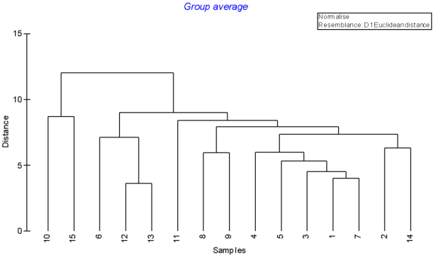

## Paulstrine

Class strength varied but was generally low to moderate, with average dissimilarity varying from 1-69 percent (but generally 1-22 percent; see accompanying discriminant analysis spreadsheet M. Kennard, Griffith University, pers. comm.).

Results for the palustrine classes are provided, along with the number of units in each class in parenthesis.

**Class 1 (646):**

|  |  |
| --- | --- |
| STRDRYQTEM | 0.776163 |
| STR_CLAYA | 0.745685 |
| STRSHRUBS1 | 0.656202 |
| STRFORES_1 | 0.616701 |

|  |  |
| --- | --- |
| SUBEROSIVI | -0.8613 |
| STRWARMQRA | -0.88238 |
| STRANNRAIN | -0.90078 |
| STRWETQRAI | -0.96428 |

Perenniality = 0.62

***Not sure how to interpret. Semi-permanent forest swamp?***

**Class 2 (689):**

|  |  |
| --- | --- |
| STRDRYQTEM | 0.933279 |
| STRGROMESOSEAS | 0.76121 |
| STRANNGROMICRO | 0.755361 |

|  |  |
| --- | --- |
| STRGROMICROSEAS | -0.74434 |
| STRHOTMTHM | -0.76128 |
| STRANNTEMP | -0.76289 |
| STRANNRAD | -0.90179 |
| STRWETQTEM | -1.03173 |

Perenniality = 0.34

***Not sure how to interpret.***

**Class 3 (9):**

|  |  |
| --- | --- |
| STRCOLDMTH | 1.928285 |
| STR_A_KSAT | 1.125606 |
| STRDRYQTEM | 0.746317 |
| STRANNGROMESO | 0.697047 |
| STRANNGROMICRO | 0.652047 |

|  |  |
| --- | --- |
| SUBEROSIVI | -1.03314 |
| STR_CLAYB | -1.05064 |
| STRWARMQRA | -1.08659 |
| STR_UNCONS | -1.36828 |
| STRHOTMTHM | -1.71923 |

Perenniality = 0.11

Salinity code = 0, saline wetlands.

***Intermittent, saline wetlands?***

**Class 4 (15):**

|  |  |
| --- | --- |
| STRBARE_EX | 13.77611 |
| STRSHRUBS1 | 2.069635 |
| STRFORES_1 | 0.79306 |
| CAT_SOLPAW | 0.764655 |

|  |  |
| --- | --- |
| STRWETQRAI | -0.72848 |
| STRANNRAIN | -0.75546 |
| STRANNGROMICRO | -0.79922 |
| STRANNGROMESO | -0.82413 |

***Not sure how to interpret***.

**Class 5 (4):**

|  |  |
| --- | --- |
| STR_CARBNA | 27.47785 |
| STRCOLDMTH | 1.2625 |
| STR_SANDA | 1.076263 |
| STRDRYQTEM | 1.06181 |

|  |  |
| --- | --- |
| STRDRYQRAI | -1.07053 |
| STRWARMQRA | -1.15847 |
| STRANNRAIN | -1.22777 |
| STRWETQRAI | -1.24793 |
| STR_CLAYB | -2.44477 |

Perenniality = 1.0

***Permanent freshwater wetland with carbonaceous sand substrate.***

**Class 6 (249):**

|  |  |  |  |
| --- | --- | --- | --- |
| STRCOLDQRA | | 2.171424 | |
| NPPBASEANN | | 1.967708 | |
| STRANNGROMICRO | | 1.896686 | |
| STRANNRAIN | | 1.866834 | |
| STRDRYQRAI | | 1.814221 | |
| STRANNGROMESO | | 1.748395 | |
| CONFINEMEN | 1.720539 | |

|  |  |
| --- | --- |
| STRANNTEMP | -1.41843 |
| STRCOLDQTE | -1.51182 |
| STRGROMICROSEAS | -1.52709 |
| STRANNRAD | -1.59613 |

Perenniality = 0.88

***Permanent temperate wetland in confined valley?***

**Class 7 (7):**

|  |  |
| --- | --- |
| STR_OLDROC | 20.35356 |
| STRCOLDQRA | 3.774461 |
| STRWETQRAI | 2.798315 |
| STR_METAMO | 2.514328 |
| STRANNGROMICRO | 2.255361 |
| STRANNRAIN | 2.088722 |

|  |  |
| --- | --- |
| STRGROMICROSEAS | -1.73852 |
| STRHOTMTHM | -2.37521 |
| STR_UNCONS | -2.4036 |

Perreniality = 1.

***Permanent, temperate wetland on metamorphic bed rock.***

**Class 8 (7):**

|  |  |
| --- | --- |
| STR_METAMO | 18.49838 |
| STRCOLDQRA | 2.007329 |
| STRANNGROMICRO | 1.789474 |
| CONFINEMEN | 1.709587 |

|  |  |
| --- | --- |
| STR_CLAYB | -1.33491 |
| STRHOTMTHM | -1.76896 |
| STR_UNCONS | -3.06911 |

Perreniality = 1.

***As for Class 7 but in confined valleys?***

**Class 9 (428):**

|  |  |
| --- | --- |
| STRDRYQRAI | 0.911517 |
| STRWETQTEM | 0.6474 |

|  |  |
| --- | --- |
| CAT_SOLPAW | -0.62871 |
| STRDRYQTEM | -1.00761 |

Perreniality = 0.83.

***Hard to interpret.***

**Class 10 (483):**

|  |  |
| --- | --- |
| STRWOODL_1 | 1.61069 |
| STRANNRAD | 1.406453 |
| STRHOTMTHM | 1.294883 |
| STR_A_KSAT | 1.213444 |
| STRANNTEMP | 1.169316 |
| STRGROMICROSEAS | 1.147032 |

|  |  |
| --- | --- |
| STRCOLDQRA | -1.00805 |
| STRDRYQRAI | -1.07784 |
| NPPBASEANN | -1.0961 |
| STRANNGROMICRO | -1.15497 |
| STRANNGROMESO | -1.19897 |

Perreniality = 0.15.

***Hard to interpret. Temperate, intermittant wetlands in woodlands?***

**Class 11 (104):**

|  |  |
| --- | --- |
| STR_IGNEOU | 5.159977 |
| STRELEMEAN | 3.291828 |
| STRGROMEGASEAS | 2.598185 |
| STRGROMESOSEAS | 1.820797 |
| STRDRYQRAI | 1.814554 |
| STRANNRAIN | 1.715815 |
| CONFINEMEN | 1.539534 |

|  |  |
| --- | --- |
| STRCOLDQTE | -2.16773 |
| STRCOLDMTH | -2.70272 |
| STR_UNCONS | -3.12934 |

Perenniality = 0.42

***High elevation subtropical volcanic wetlands***

**Class 12 (564):**

|  |  |
| --- | --- |
| STRWARMQRA | 1.536584 |
| STRANNGROMEGA | 1.503158 |
| SUBEROSIVI | 1.47 |
| STRGROMICROSEAS | 1.251689 |

|  |  |
| --- | --- |
| STRDRYQTEM | -0.72715 |
| STRANNGROMICRO | -0.78265 |
| STRGROMESOSEAS | -1.18209 |

Perenniality = 0.91

***Difficult to interpret.***

**Class 13 (3):**

|  |  |
| --- | --- |
| area_sqm | 29.91061 |
| A2P_ratio | 7.223238 |

STR_CLAYA 1.3832

|  |  |
| --- | --- |
| STRGROMEGASEAS | -0.8975 |
| STRANNGROMESO | -0.94352 |
| STRANNGROMICRO | -0.98733 |
| STR_SANDA | -1.11369 |

Perenniality = 0.0

***Large clay pans***

**Palustrine Summary:**

* Classess 6, 7, 8 and 11 are permanent or semi-permanent. Classes 7 and 8 are on metamorphic rock. Class 11 is at higher elevation on igneous rock (volcanic).
* Class 3 is saline wetlands.
* The remaining classes are hard to interpret, expect perhaps for Class 13 which might be clay pans?

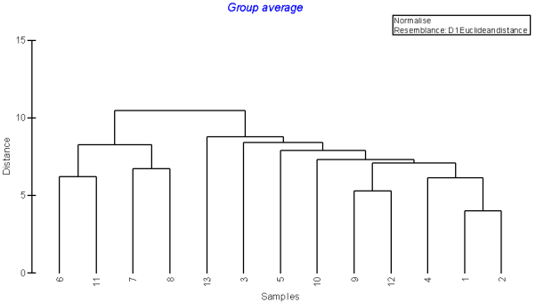

## Riverine

Class strength varied low to very high. Classes 8, 10, 12 and 14 were very distinct from all the other classes (see accompanying discriminant analysis spreadsheet, M. Kennard, Griffith University, pers. comm.).

Results for the riverine classes are provided, along with the number of units in each class in parenthesis.

**Class 1 (46,855):**

|  |  |  |
| --- | --- | --- |
| STRANNGROMEGA | 1.024054 | |
| STRWARMQRA | 0.817003 | |
| D2OUTLET | 0.764757 | |
| STRANNGROMICRO | | -0.46 | |
| STRDRYQTEM | | -0.49665 | |
| STRGROMESOSEAS | | -0.67501 | |

***Hard to interpret. Sub-tropical?***

**Class 2 (32,671):**

|  |  |  |  |  |
| --- | --- | --- | --- | --- |
| STRANNGROMICRO | | 1.233035 | | |
| STRGROMESOSEAS | | 1.130089 | | |
| STRGROMEGASEAS | | 1.0555 | | |
| STR_IGNEOU | | 1.050141 | | |
| STRDRYQRAI | | 1.021882 | | |
| STRELEMEAN | 0.9629 | | |
| STRCOLDMTH | | | -1.06611 | | |
| STRHOTMTHM | | | -1.11239 | | |
| STRANNTEMP | | | -1.14944 | | |
| STRCOLDQTE | | | -1.15361 | | |
| STRGROMICROSEAS | | | -1.15725 | | |

***Upland stream in volcanic soils.***

**Class 3 (6,144):**

|  |  |
| --- | --- |
| SUBSLOPE_1 | 3.827011 |
| CATSLOPE | 3.027067 |
| STRCOLDQRA | 3.007002 |
| RELIEFRATI | 2.938759 |
| VALLEYSLOP | 2.8306 |
| STRANNRAIN | 2.714211 |
| STRWETQRAI | 2.610935 |
| STRFORES_1 | 2.603028 |
| STRGROMEGASEAS | 2.376592 |
| STRGROMESOSEAS | 2.281526 |
| CATSNOW | 2.14 |
| STRANNTEMP | -1.92446 | |
| STRHOTMTHM | -1.93592 | |
| STRCOLDQTE | -1.96392 | |
| STRANNRAD | -2.01726 | |

***Steep alpine or sub-alpine streams***

**Class 4 (36,430):**

|  |  |  |
| --- | --- | --- |
| RUNANNCOFV | | 1.43013 |
| STRHOTMTHM | | 0.950437 |
| STRANNRAD | | 0.943571 |
| STRCOLDMTH | | 0.874653 |
| STRWOODL_1 | | 0.867294 |
| STRANNTEMP | | 0.835931 |
| STRGROMICROSEAS | | 0.807284 |
| STRANNGROMICRO | -0.9889 | | |
| STRANNRAIN | -1.03452 | | |
| STRDRYQRAI | -1.07267 | | |
| NPPBASEANN | -1.09784 | | |
| STRANNGROMESO | -1.22287 | | |

***Not sure how to interpret.***

**Class 5 (1,876):**

|  |  |
| --- | --- |
| WATERYNESS | 8.158714 |
| STR_UNCONS | 0.654002 |
| STRWARMQRA | -0.62983 | |
| STRELEMEAN | -0.66039 | |
| D2OUTLET | -0.80462 | |

***Lowland waterhole or spring fed stream.***

**Class 6 (10,335):**

|  |  |
| --- | --- |
| UPSDIST | 2.078927 |
| STR_CLAYA | 1.610971 |
| CATELEMAX | 1.588443 |
| STR_UNCONS | 1.046854 |
| STR_CLAYB | 0.900294 |
| STRHOTMTHM | 0.891878 |
| STRELEMEAN | -0.90785 | |
| STRANNGROMESO | -0.97877 | |
| STRGROMEGASEAS | -1.04282 | |
| STR_SANDA | -1.28545 | |
| CATRELIEF | -1.60488 | |
| ELONGRATIO | -1.74233 | |

***Clay bed lowland streams far from their source.***

**Class 7 (2183):**

|  |  |
| --- | --- |
| CATAREA | 7.465164 |
| UPSDIST | 5.847231 |
| RUNSUMMERM | 4.512388 |
| RUNAUTUMNM | 3.542278 |
| CATELEMAX | 2.084044 |
| RUNANNMEAN | 1.973107 |
| STRELEMEAN | -1.20624 | |
| STRANNRAIN | -1.24044 | |
| ELONGRATIO | -1.25073 | |
| STRWETQRAI | -1.26765 | |
| STRWARMQRA | -1.29353 | |
| STR_SANDA | -1.32847 | |
| STRANNGROMESO | -1.37586 | |
| CATRELIEF | -1.87834 | |

***Lowland streams near the lower Murray.***

**Class 8 (236):**

|  |  |
| --- | --- |
| STRBARE_EX | 19.41951 |
| CATSTORAGE | 1.406975 |
| STR_CLAYA | 0.880583 |
| STRSHRUBS1 | 0.86278 |
| WATERYNESS | 0.841948 |
| STR_SANDA | -0.72127 | |
| CONFINEMEN | -0.96016 | |

***Bare streams in the mid Murray area?***

**Class 9 (24,964):**

|  |  |  |
| --- | --- | --- |
| STRANNGROMICRO | 0.648331 | |
| STRDRYQTEM | 0.537531 | |
| STRANNGROMESO | 0.419781 | |
| STRGROMICROSEAS | | -0.5963 | |
| STRWETQTEM | | -0.60374 | |
| STRWOODL_1 | | -0.61565 | |
| STRANNRAD | | -0.65672 | |

***Hard to interpret. Non-descript temperate streams?***

**Class 10 (162):**

|  |  |
| --- | --- |
| STR_CARBNA | 14.48626 |
| STRANNGROMICRO | 0.949864 |
| STRDRYQTEM | 0.86867 |

|  |  |
| --- | --- |
| STRANNTEMP | -0.73915 |
| STRGROMICROSEAS | -0.75883 |
| STR_UNCONS | -0.82458 |
| STRWETQTEM | -0.85028 |

**Temperate streams in carbonaceous substrate?**

**Class 11 (3.138):**

|  |  |
| --- | --- |
| STR_METAMO | 6.010529 |
| STRANNGROMICRO | 1.008622 |
| STRGROMEGASEAS | 0.892635 |
| STRCOLDQRA | 0.83625 |
| DOWNMAXSLP | 0.824446 |
| VALLEYSLOP | 0.802461 |

|  |  |
| --- | --- |
| STRGROMICROSEAS | -0.92385 |
| STRANNTEMP | -0.92735 |
| STR_UNCONS | -1.01407 |

**Steep temperate streams on metamorphic substrate?**

**Class 12 (80):**

|  |  |
| --- | --- |
| STR_CARBNA | 39.33673 |
| STRBARE_EX | 1.513097 |
| STRANNGROMICRO | 1.092208 |
| STRDRYQRAI | 1.01219 |

|  |  |
| --- | --- |
| STRANNTEMP | -0.76787 |
| STRANNRAD | -0.77689 |
| STRCOLDQTE | -0.79077 |
| STRGROMICROSEAS | -0.80173 |
| STR_UNCONS | -1.08688 |

**As for Class 10 but with little vegetation?**

**Class 13 (2,326):**

|  |  |
| --- | --- |
| STR_OLDROC | 8.022234 |
| STR_METAMO | 1.637991 |
| STRSHRUBS1 | 1.617893 |
| RUNANNCOFV | 1.365728 |

|  |  |
| --- | --- |
| CAT_SOLPAW | -1.18279 |
| STRWETQRAI | -1.18618 |
| SUBEROSIVI | -1.28676 |
| STRWARMQRA | -1.56132 |
| D2OUTLET | -1.80718 |

**Short, high runoff, metamorphic bedrock streams in shrub landscape?**

**Class 14 (237):**

|  |  |
| --- | --- |
| RUNWINTERM | 21.13336 |
| RUNANNMEAN | 20.99318 |
| RUNSPRINGM | 20.79808 |
| RUNAUTUMNM | 18.36446 |
| RUNSUMMERM | 13.27686 |
| CATAREA | 7.886852 |
| UPSDIST | 7.203021 |
| CATELEMAX | 3.315155 |
| WATERYNESS | 3.131448 |

|  |  |
| --- | --- |
| STRELEMEAN | -1.35541 |
| SUBEROSIVI | -1.48867 |
| STRWARMQRA | -1.60004 |
| ELONGRATIO | -1.746 |
| CATRELIEF | -2.04451 |

***Lower Murray.***

**Riverine Summary**

* Class 3 is alpine or sub-alpine streams.
* Class 14 is likely to be the Lower Murray as distance from source and other attributes have their maximum values.
* Classes 4, 5, 6, 7 and 8 are lowland streams separated by factors such as distance form source and substrate.
* Classes 9, 10, 11 and 12 are temperate, presumably mid-slope streams separated on the basis of soils.
* Class 1 is sub-tropical.

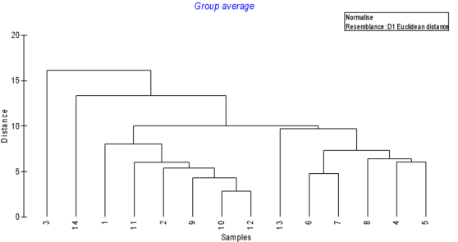

1. Top-down classifications are based on the *a priori* selection of attributes and associated metrics (e.g. salinity as an attribute; metrics based on various thresholds of salinity to define freshwater, brackish, saline). The ANAE framework has assigned attributes based on expert opinion.
2. A bottom-up classification makes no *a priori* decisions on how features are assigned to classes; features are assigned to classes statistically.
3. The Cluster Classification used mapping and attribute data at 1:250,000 scale that was applied consistently across the MDB. The data used in the classification were applied consistently, meeting statistical requirements, but the coarse scale meant many small features (e.g. wetlands) were not included in the analysis. This application of the ANAE framework used best-available mapping and attribute data; a larger number of features such as wetlands were, therefore, included but at scales ranging from 1:25,000 to 1:250,000.
4. *Ephemeral* is defined as systems which fill after unpredictable rains and run-off, lasting only days and typically do not support macroscopic aquatic biota (Boulton and Brock 1999).

   *Episodic* is defined as systems which are typically dry nine out of ten years, with rare and very irregular flooding which may last for months (Boulton and Brock 1999).