# Infection with Perkinsus olseni

Also known as perkinsosis and Perkinsus disease

From Aquatic animal diseases significant to Australia: identification field guide, 5th edition

Figure 1 Cross-section of foot of greenlip abalone (Haliotis laevigata) infected with Perkinsus olseni

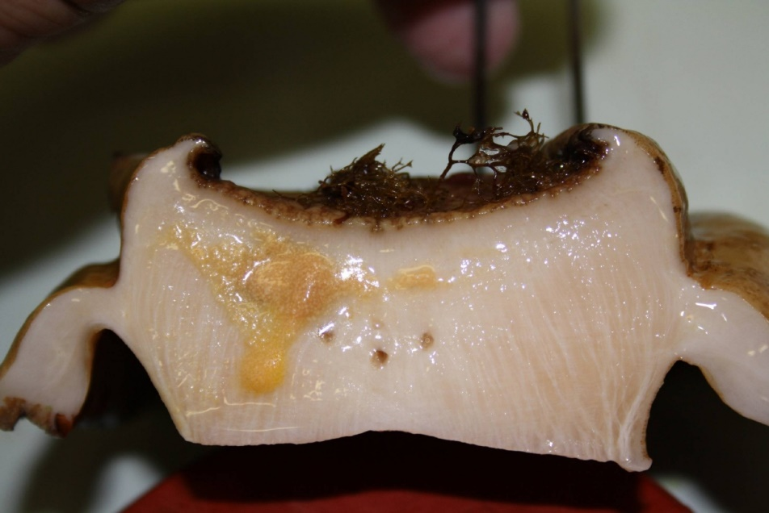

Note: Yellow and smaller brown pustular lesions within the body tissue infected with P. olseni.

Source: N Moody, CSIRO Australian Animal Health Laboratory

## Signs of disease

Important: Animals with this disease may show one or more of these signs, but the pathogen may still be present in the absence of any signs.

Disease signs at the farm, tank or pond level are:

* morbidity observed in cultured greenlip (Haliotis laevigata) and blacklip (H. rubra) abalone
* gaping in bivalve species
* increased mortality.

Gross pathological signs are:

* spherical brown abscesses up to 8mm in diameter containing a caseous creamy-brown or yellow deposit in the foot and mantle of blacklip and greenlip abalone (affecting marketability)
* thin, watery tissue with a pale digestive gland
* nodules in the mantle or gills.

Microscopic pathological signs are:

* large focal or multifocal necrotic lesions in connective tissue. These contain haemocyte aggregations around individuals or groups of crescent- or signet-ring-shaped Perkinsus cells with eccentric vacuoles.

## Disease agent

Perkinsosis is caused by infection with Perkinsus spp., alveolate protists in the family Perkinsidae. P. olseni has been placed nominally in the order Dinoflagellida, but its higher taxonomy is subject to scientific debate. Several species of the genus Perkinsus infect molluscs such as oysters, mussels, clams and abalone worldwide.

Perkinsus olseni is the main species known to cause this disease in the Asia–Pacific region and is responsible for perkinsosis in abalone, clams and pearl oysters in Australia. P. atlanticus is a junior synonym of P. olseni. Another species, P. chesapeaki, has been detected in wild mud arks (Anadara trapezia) in Moreton Bay, Queensland.

## Host range

P. olseni appears to have low host specificity and can infect a wide range of bivalve and gastropod molluscs.

Table 1 Species known to be susceptible to infection with Perkinsus olseni

| Common name | Scientific name |
| --- | --- |
| Akoya pearl oystera | Pinctada martensii |
| Asian littleneck clama | Venerupis philippinarum |
| Blacklip abalonea | Haliotis rubra |
| Blacklip pearl oystera | Pinctada margaritifera |
| Crocus clama | Tridacna crocea |
| Elongated giant clam or rugose giant clama | Tridacna maxima |
| European aurora venus clama | Venerupis aurea |
| Giant clama | Tridacna gigas |
| Greenlip abalonea | Haliotis laevigata |
| Green-lipped mussela | Perna canaliculus |
| Grooved carpet shell or venerid clama | Ruditapes decussatus |
| Japanese pearl oystera | Pinctada fucata |
| Kumamoto oyster | Crassostrea sikamea |
| Manila clama | Ruditapes (Venerupis) philippinarum |
| New Zealand ark shella | Barbatia novaezelandiae |
| New Zealand cocklea | Austrovenus stutchburyi |
| New Zealand pauaa | Haliotis iris |
| New Zealand pipia | Paphies australis |
| New Zealand scallopa | Pecten novaezelandiae |
| Pacific oystera | Crassostrea gigas |
| Pearl oystera | Pinctada sugillata |
| Pullet carpet shella | Venerupis corrugata |
| Sand cockle | Katelysia rhytiphora |
| Silverlip pearl oystera | Pinctada maxima |
| Southern mud oyster or Australian flat oystera | Ostrea angasi |
| Staircase abalonea | Haliotis scalaris |
| Suminoe oystera | Crassostrea ariakensis |
| Sydney cockle or mud arka | Anadara trapezia |
| Venerid clama | Ruditapes semidecussatus |
| Venerid commercial clama | Pitar prostrata |
| Venus clam | Protothaca jedoensis |
| Wedge shell | Macomona liliana |
| Whirling abalonea | Haliotis cyclobates |

**a** Naturally susceptible. Note: Other species have been shown to be experimentally susceptible.

## Presence in Australia

Perkinsus olseni has been reported in Queensland, New South Wales, South Australia and Western Australia; and in Australian flat oysters from Victoria. P. olseni was originally described from wild abalone in South Australia, but has since been detected in a wide variety of molluscs, including clams and pearl oysters.

Map 1 Presence of Perkinsus olseni, by jurisdiction

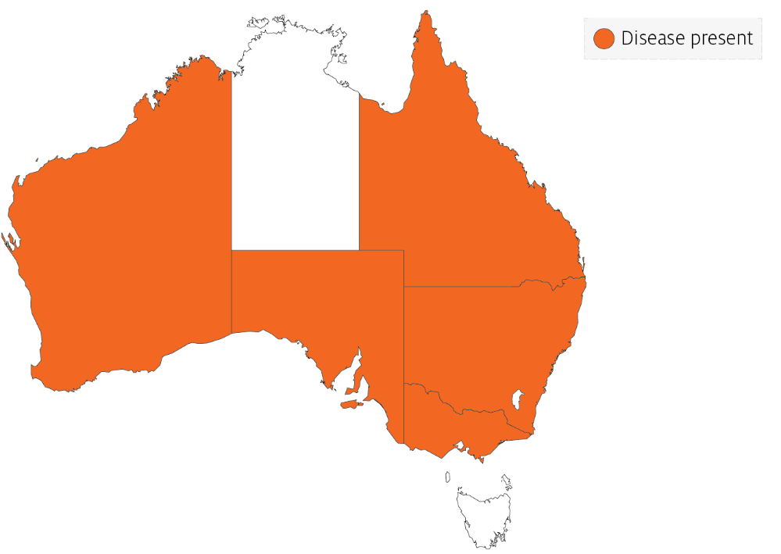

## Epidemiology

* Perkinsus olseni has been associated with mass mortality of Haliotis spp. (blacklip and greenlip abalone) in the Gulf of St Vincent, South Australia, and coastal New South Wales (mostly blacklip abalone).
* Horizontal transmission occurs directly from host to host. Some environmental conditions (temperature and salinity) can promote a lifelong carrier state. Higher water temperatures (greater than 20°C) can cause disease and mortalities in temperate species such as abalone.
* Infection intensity increases with the age of the host.
* Prezoosporangia that escape from necrotic pustules or decaying dead abalone undergo further development to zoosporangia in seawater.
* Within 9 days at 20°C and 3 days at 28°C, hundreds of motile, biflagellated zoospores (about 3µm by 5µm) exit from the zoosporangium. The zoospores are infective to abalone and other molluscs.
* P. olseni can survive in salt water for several weeks at –20°C. However, the parasite cannot survive below 15ppt salinity.

## Differential diagnosis

The list of similar diseases in the next section refers only to the diseases covered by this field guide. Gross pathological signs may also be representative of diseases not included in this guide. Do not rely on gross signs to provide a definitive diagnosis. Use them as a tool to help identify the listed diseases that most closely account for the observed signs.

## Similar diseases

Infection with Perkinsus marinus.

The clinical signs of infection with P. olseni are similar to those of infection with other species of Perkinsus. These include occasional pustules in soft tissue, pale digestive gland, poor condition, emaciation, shrinkage of mantle and retarded growth. It is therefore difficult to make a presumptive diagnosis based on gross signs alone. Any presumptive diagnosis requires further laboratory examination.

## Sample collection

Only trained personnel should collect samples. Using only gross pathological signs to differentiate between diseases is not reliable, and some aquatic animal disease agents pose a risk to humans. If you are not appropriately trained, phone your state or territory hotline number and report your observations. If you have to collect samples, the agency taking your call will advise you on the appropriate course of action. Local or district fisheries or veterinary authorities may also advise on sampling.

## Emergency disease hotline

See something you think is this disease? Report it. Even if you’re not sure.

Call the Emergency Animal Disease Watch Hotline on **1800 675 888**. They will refer you to the right state or territory agency.

## Microscope images

Figure 2 Tissue of New Zealand cockle (Austrovenus stutchburyi) infected with Perkinsus olseni

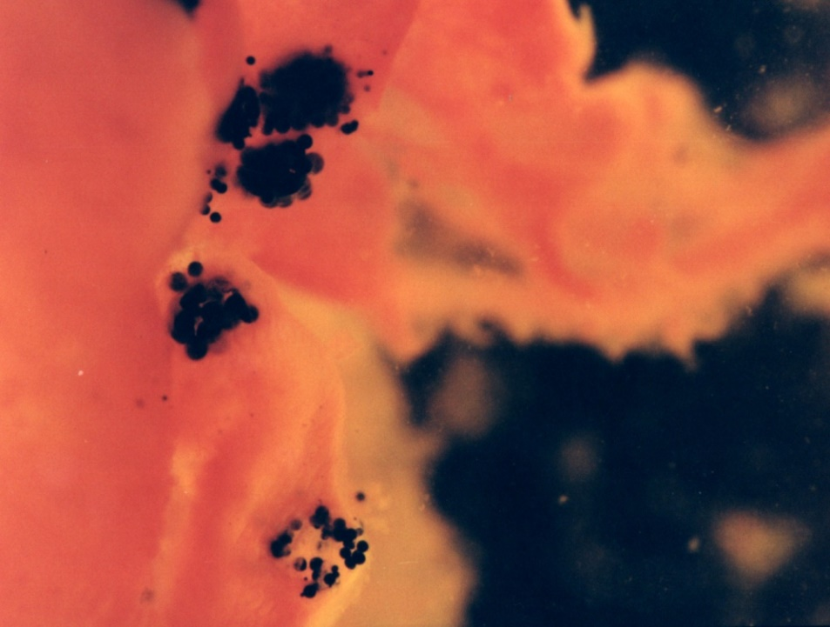

Note: Greatly enlarged individual trophozoites (also called hypnospores) of P. olseni. Sample was stained black by Lugol’s iodine after infected tissue was incubated in Ray’s fluid thioglycollate medium. Stained tissue is visible with the naked eye.

Source: B Diggles

Figure 3 Histopathology of New Zealand cockle (Austrovenus stutchburyi) infected with Perkinsus olseni

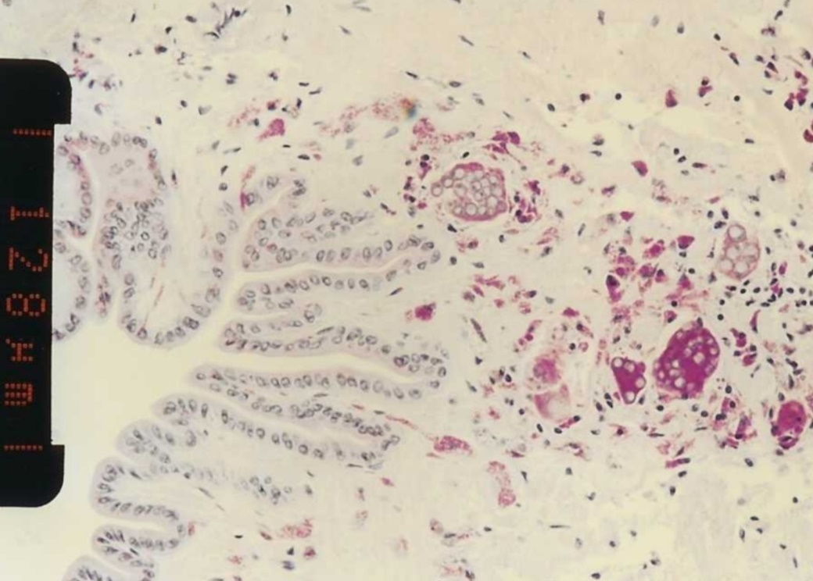

Note: Clusters of developing P. olseni trophozoites surrounded by a strongly eosinophilic periodic acid-Shiff positive amorphous matrix and a host response. Scale bar = 128µm.

Source: B Diggles

Figure 4 Histopathology of clam (Ruditapes sp.) infected with Perkinsus olseni

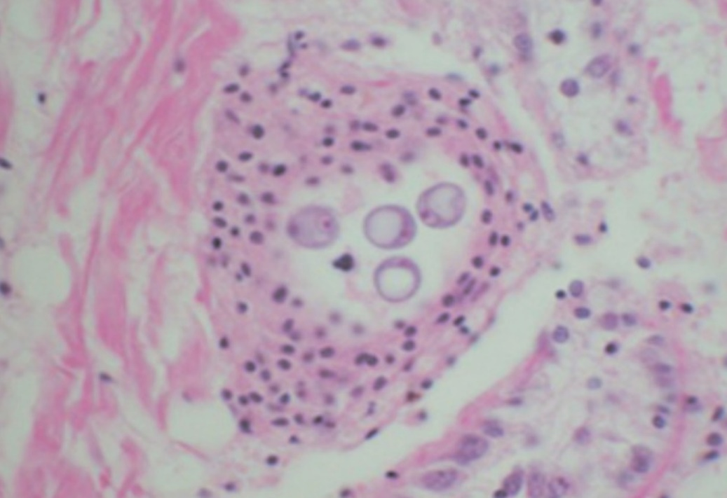

Note: A cluster of signet-ring-shaped P. olseni trophozoites surrounded by an encapsulating host response.

Source: E Burreson

Figure 5 Pedal tissue of greenlip abalone (Haliotis laevigata) infected with Perkinsus olseni

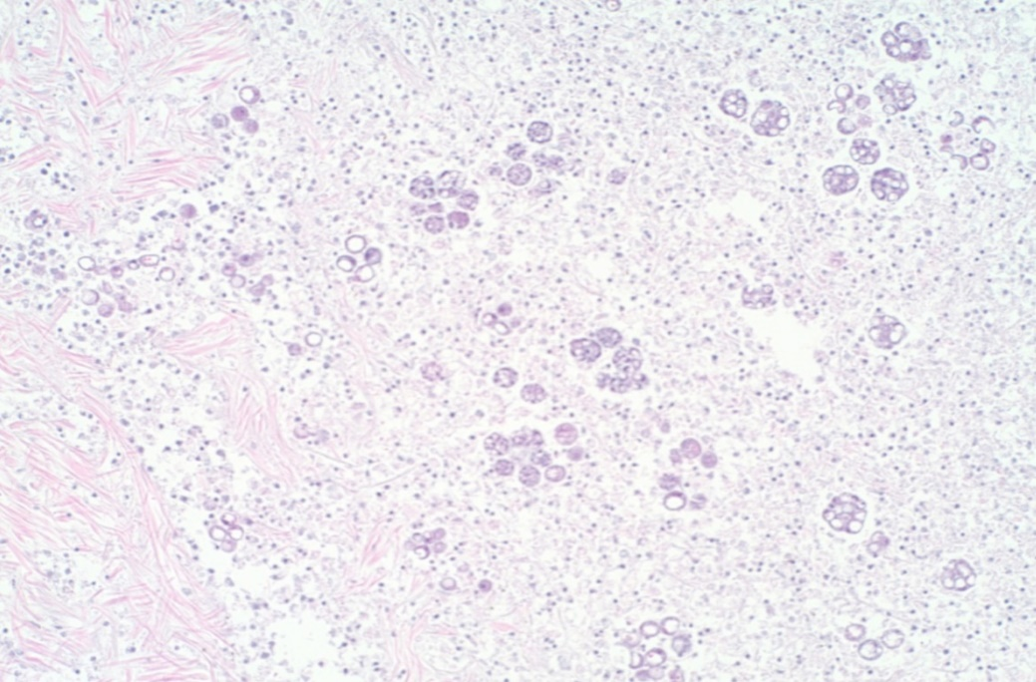

Note: The lesion contains multilocular P. olseni clusters among haemocytes and floccular debris. Haematoxylin and eosin stain. 100x magnification.

Source: S Bastianello

Figure 6 Pedal tissue of greenlip abalone (Haliotis laevigata) infected with Perkinsus olseni

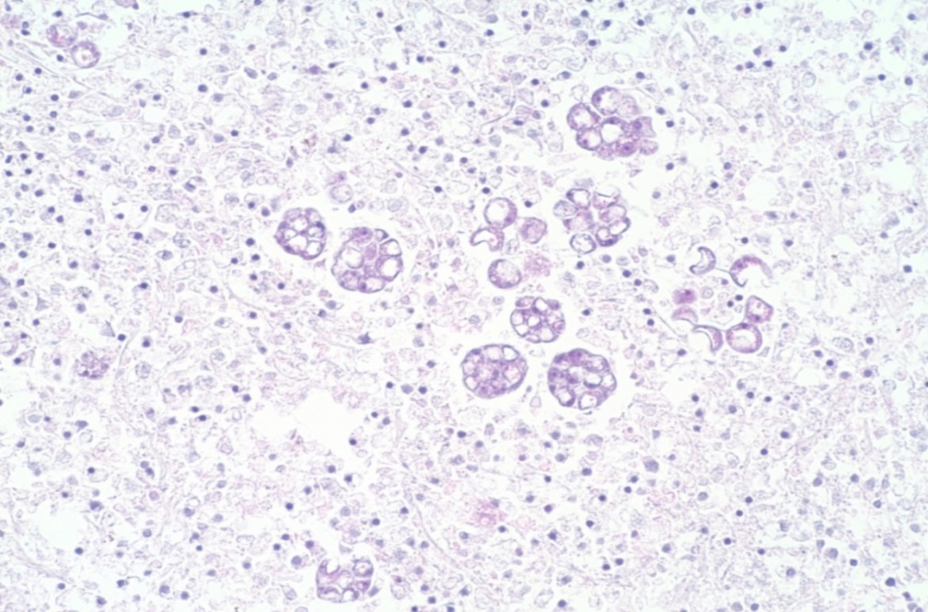

Note: Higher magnification view of Figure 5. Multilocular P. olseni clusters, and more mature signet-ring-shaped organisms among haemocytes and floccular debris. Haematoxylin and eosin stain. 200x magnification.

Source: S Bastianello

## Further reading

CABI Invasive Species Compendium [Infection with ‘Perkinsus olseni’](https://www.cabi.org/ISC/datasheet/70074)

CEFAS International Database on Aquatic Animal Diseases [Infection with ‘Perkinsus olseni’](https://www.cefas.co.uk/international-database-on-aquatic-animal-diseases/disease-data/?id=32)

World Organisation for Animal Health [Manual of diagnostic tests for aquatic animals](http://www.oie.int/en/international-standard-setting/aquatic-manual/access-online)

These hyperlinks were correct at the time of publication.

## Contact details

Emergency Animal Disease Watch Hotline 1800 675 888

Email [AAH@agriculture.gov.au](mailto:AAH@agriculture.gov.au)Website [agriculture.gov.au/pests-diseases-weeds/aquatic](http://www.agriculture.gov.au/pests-diseases-weeds/aquatic)

© Commonwealth of Australia 2020

This work is copyright. It may be reproduced in whole or in part subject to the inclusion of an acknowledgement of the source and no commercial usage or sale.