# Infection with Batrachochytrium salamandrivorans (Bsal)

Also known as Bsal chytridiomycosis and salamander chytrid disease

From Aquatic animal diseases significant to Australia: identification field guide, 5th edition

Figure 1 Adult fire salamander (Salamandra salamandra) infected by Batrachochytrium salamandrivorans

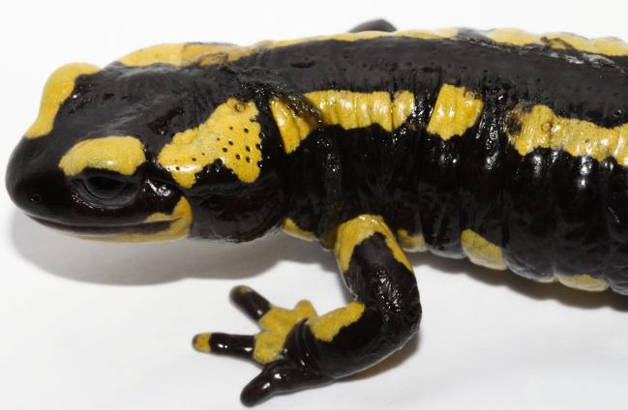

Note: Lesions consist of multifocal erosions with a black margin and dysecdysis.

Source: F Pasmans

## Signs of disease

Important: Animals with this disease may show one or more of these signs, but the pathogen may still be present in the absence of any signs.

Disease signs at the farm, tank or pond level are:

* anorexia
* apathy
* ataxia
* high levels of mortality at temperatures below 25°C.

Gross pathological signs are:

* discolouration and/or roughening of the skin, with excessive skin sloughing
* focal or multifocal skin ulcerations with significant degradation of the epidermis, impairment of vital skin functions, and subsequent death.

Microscopic pathological signs are:

* lesions consisting of focal necrotic epidermal ulcerations with high numbers of colonial thalli of B. salamandrivorans, bordered by keratinocytes containing intracellular fungal thalli.

## Disease agent

Bsal chytridiomycosis is caused by infection with the parasitic chytrid fungus, Batrachochytrium salamandrivorans (Bsal) of the class Chytridiomycota, order Rhizophydiales. B. salamandrivorans was first detected in wild salamanders in the Netherlands and Belgium in 2013/14, and was subsequently found in captive salamanders and newts in Germany, and the UK. Investigations suggest B. salamandrivorans probably originated in southeast Asia, where it has been found in Japan, Thailand, Vietnam and China.

## Host range

A range of salamanders, newts and sirens (order Caudata) appear to be highly susceptible to infection with B. salamandrivorans. Members of the families Salamandridae, Plethodontidae, Hynobiidae and Sirenidae can carry the pathogen, often without showing any clinical signs. Species endemic to Asia appear to be more resistant to disease but may be asymptomatic carriers of the fungus.

Table 1 Species known to be susceptible to Batrachochytrium salamandrivorans

| Common name | Scientific name |
| --- | --- |
| Alpine newt | Ichthyosaura alpestris |
| Blue tailed fire belly newt | Cynops cyanurus |
| Chiang Mai crocodile newt | Tylototriton uyenoi |
| Clouded salamander | Hynobius nebulosus |
| Eastern newt | Notophthalmus viridescens |
| European cave salamanders | Speleomantes spp. |
| Fire salamander | Salamandra salamandra |
| French cave salamander | Hydromantes strinatii |
| Italian newt | Lissotriton italicus |
| Japanese clawed salamander | Onychodactylus japonicas |
| Japanese fire belly newt | Cynops pyrrhogaster |
| Lesser siren | Siren intermedia |
| North African fire salamander | Salamandra algira |
| Northern crested newt | Triturus cristatus |
| Northern spectacled salamander | Salamandrina perspicillata |
| Rough skinned newt | Taricha granulosa |
| Sardinian brook salamander | Euproctus platycephalus |
| Siberian salamander | Salamandrella keyserlingii |
| Smooth newt | Lissotriton vulgaris |
| Spanish ribbed newt | Pleurodeles waltl |
| Sword tailed newt | Cynops ensicauda |
| Vietnamese crocodile newt | Tylototriton vietnamensis |
| Vietnamese salamander | Paramesotriton deloustali |
| Wenxian knobby newt | Tylototriton wenxianensis |
| Yellow spotted newt | Neurergus crocatus |
| Zeigler’s crocodile newt | Tylototriton ziegleri |

## Presence in Australia

Exotic disease—not recorded in Australia.

Map 1 Presence of Batrachochytrium salamandrivorans, by jurisdiction

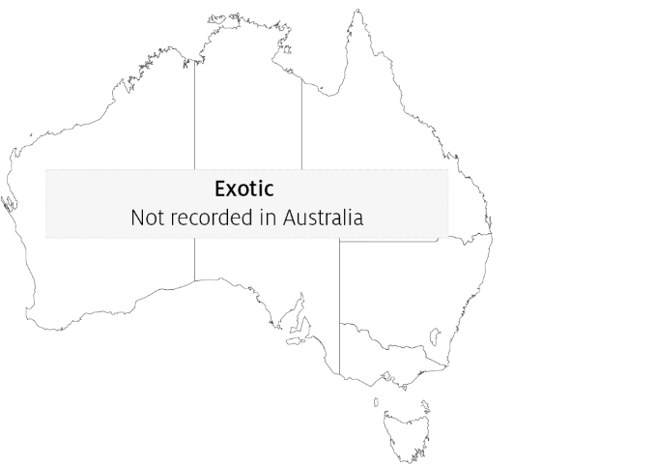

## Epidemiology

* Batrachochytrium salamandrivorans infects epidermal tissue causing multifocal ulcerations.
* Optimal temperature for growth of the fungus is 15°C and optimal salinity is 0ppt (freshwater). Desiccation is fatal for all life stages of the fungus.
* Horizontal transmission is via waterborne, motile zoospores and is likely to be by direct animal-to-animal contact. Mortality occurs 12 to 18 days after exposure to infective zoospores at 15°C, and within 22 to 27 days when susceptible animals are placed in contact with infected animals.
* Zoospores can remain viable in water for up to 3 weeks.
* Batrachochytrium salamandrivorans has been eliminated from wild salamanders by exposure to greater than 25°C for at least 10 days or a synergistic treatment with antifungals.
* Disease outbreaks in wild populations may be seasonal (during the cooler months), and can cause significant population declines that may lead to extinction.

## Differential diagnosis

The list of similar diseases in the next section refers only to the diseases covered by this field guide. Gross pathological signs may also be representative of diseases not included in this guide. Do not rely on gross signs to provide a definitive diagnosis. Use them as a tool to help identify the listed diseases that most closely account for the observed signs.

## Similar diseases

Infection with Batrachochytrium dendrobatidis.

## Sample collection

Only trained personnel should collect samples. Using only gross pathological signs to differentiate between diseases is not reliable, and some aquatic animal disease agents pose a risk to humans. If you are not appropriately trained, phone your state or territory hotline number and report your observations. If you have to collect samples, the agency taking your call will advise you on the appropriate course of action. Local or district fisheries or veterinary authorities may also advise on sampling.

## Emergency disease hotline

See something you think is this disease? Report it. Even if you’re not sure.

Call the Emergency Animal Disease Watch Hotline on **1800 675 888**. They will refer you to the right state or territory agency.

## Microscope images

Figure 2 Hematoxylin and eosin stained section of skin of fire salamander (Salamandra salamandra) infected by Batrachochytrium salamandrivorans

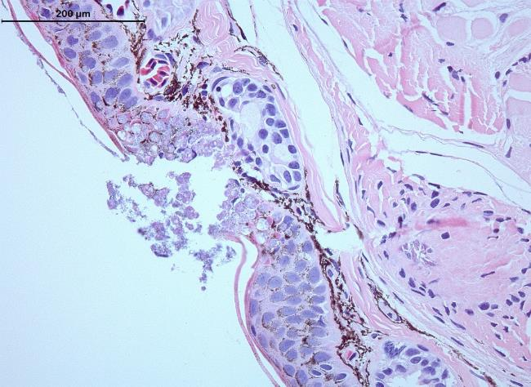

Note: Histopathological lesions consist of multifocal epidermal erosions, with numerous colonial chytrid thalli inside epidermal cells and bacterial overgrowth. Scale bar = 200µm

Source: A Martel

## Further reading

European Food Safety Authority [Scientific and technical assistance concerning the survival, establishment and spread of ‘Batrachochytrium salamandrivorans’ (Bsal) in the EU](https://www.efsa.europa.eu/en/efsajournal/pub/4739)

World Organisation for Animal Health, [‘Batrachochytrium salamandrivorans’ disease card](http://www.oie.int/en/standard-setting/specialists-commissions-working-ad-hoc-groups/aquatic-animals-commission-reports/disease-information-cards/)

These hyperlinks were correct at the time of publication.

## Contact details

Emergency Animal Disease Watch Hotline 1800 675 888

Email [AAH@agriculture.gov.au](mailto:AAH@agriculture.gov.au)Website [agriculture.gov.au/pests-diseases-weeds/aquatic](http://www.agriculture.gov.au/pests-diseases-weeds/aquatic)

© Commonwealth of Australia 2020

This work is copyright. It may be reproduced in whole or in part subject to the inclusion of an acknowledgement of the source and no commercial usage or sale.