

# 

# Industry reference guide for tarping imported goods

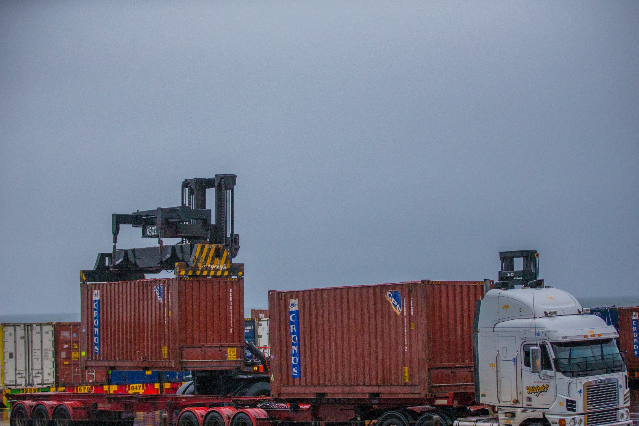

**Biosecurity Operations Division – 13 January 2025**

**Version 1.0**

© Commonwealth of Australia 2025

**Ownership of intellectual property rights**

Unless otherwise noted, copyright (and any other intellectual property rights) in this publication is owned by the Commonwealth of Australia (referred to as the Commonwealth).

**Creative Commons licence**

All material in this publication is licensed under a [Creative Commons Attribution 4.0 International Licence](https://creativecommons.org/licenses/by/4.0/legalcode) except content supplied by third parties, logos and the Commonwealth Coat of Arms.

**Cataloguing data**

This publication (and any material sourced from it) should be attributed as: DAFF 2025, *Industry reference guide for tarping imported goods*, Department of Agriculture, Fisheries and Forestry, Canberra, January. CC BY 4.0.

This guide is available at <https://www.agriculture.gov.au/biosecurity-trade/import/arrival>

Department of Agriculture, Fisheries and Forestry

GPO Box 858 Canberra ACT 2601

Telephone 1800 900 090

Web [agriculture.gov.au](https://www.agriculture.gov.au/)

**Disclaimer**

The Australian Government acting through the Department of Agriculture, Fisheries and Forestry has exercised due care and skill in preparing and compiling the information and data in this publication. Notwithstanding, the Department of Agriculture, Fisheries and Forestry, its employees and advisers disclaim all liability, including liability for negligence and for any loss, damage, injury, expense, or cost incurred by any person as a result of accessing, using or relying on any of the information or data in this publication to the maximum extent permitted by law.

**Acknowledgement of Country**

We acknowledge the Traditional Custodians of Australia and their continuing connection to land and sea, waters, environment, and community. We pay our respects to the Traditional Custodians of the lands we live and work on, their culture, and their Elders past and present.

**Version control**

Updated versions of this document will be published on the department’s website.

|  |  |  |  |
| --- | --- | --- | --- |
| **Date** | **Version** | **Amendments** | **Approved by** |
| 13/01/2025 | V1.0 | First release | Hitchhikers and NFP Cargo Policy |

**In this document**

This document contains the following topics.

Purpose of this document 4

Background 4

Types of biosecurity tarping directions 4

Tarping and movement without biosecurity officer verification 4

CAL goods may also receive different second direction: 5

Tarping with biosecurity officer verification required 5

Applying tarping materials to imported goods 5

Prior to commencement 5

Live pest detection 5

Appropriate tarping materials 6

Tarping types 6

Partial 6

Full tarping 7

Prior to transporting goods off wharf 7

Approved Arrangement responsibilities 7

On arrival of the goods 8

Detection of biosecurity concerns regarding tarping on arrival at AA 8

Release or disposal of used tarping materials 9

Further information 9

Attachment A 10

Definitions 10

Attachment B 11

Biosecurity Directions Industry verification of tarping 11

Attachment C 13

Examples of compliant tarped goods 13

Examples of non-compliant tarped goods 16

## Purpose of this document

The purpose of this document is to provide reference information to support industry in the application and verification of tarped, imported sea containers and break bulk (BB) goods including Country Action List (CAL) goods.

## Background

The departments import conditions information system (BICON) sets out advice in relation to imported goods that require a biosecurity inspection at the port of discharge prior to movement off wharf. Where the inspection is unable to be completed on wharf or biosecurity risk material is identified by the department, and the discharge wharf does not have suitable facilities to enable the risk to be managed onsite, these goods will be directed for movement to an Approved Arrangement (AA) site.

Where it is identified that external biosecurity risk material (soil, plant or other contamination) is likely to dislodge during movement to the AA, the biosecurity officer will direct that the goods must be tarped prior to movement.

The department may also direct goods for a verified tarping. This direction is used where the risk associated with the biosecurity risk material (BRM) is too great, and the goods must be exported or to manage goods identified with risk material subject to heightened seasonal measures. This requires a biosecurity officer to physically verify correct tarping has occurred.

The level of containment required will depend on the type, location and scale of identified BRM identified:

* **Full tarping:** Wherecontamination is present on multiple surfaces of the container or break bulk goods, or
* **Partial tarping:** Where contamination is only identified underneath or in a specific area of the container or break bulk goods.

## Types of biosecurity tarping directions

Post inspection of the goods on wharf and where tarping is required, the department will issue either a direction for goods to be tarped and moved without the requirement for a biosecurity officer verification or a direction to be tarped with biosecurity officer verification required.

### Tarping and movement without biosecurity officer verification

Any imported goods (sea freight container or break bulk (BB), including CAL) with an associated direction that requires tarping and permits movement is to be verified by the BIP upon receipt of the goods at the AA site.

Two directions will be issued concurrently by the department to the person in charge of the goods to manage the biosecurity risk identified:

* Direction 1 of 2 ***Movement allowed - To specified location***
* Direction 2 of 2 ***Other Treatments - Cleaning as Directed and Re-insp.***

Examples of these direction types and Additional comments can be found at Attachment B

#### CAL goods may also receive a different second direction:

* Direction 2 of 2 ***Ext. Container Insp – Movement*** - if CAL containers require deconsolidation and further inspection at an AA, or
* Direction 2 of 2 ***Re-inspection of goods*** – if CAL breakbulk goods cannot be inspected on wharf and require inspection at an AA.

### Tarping with biosecurity officer verification required

In certain situations, goods directed for tarping will need to be physically verified by a biosecurity officer. This includes tarping directions in relation to:

* + goods that have been identified by the department on inspection as having live biosecurity risk material (live insects or animals)
  + goods that do not have an associated Movement Allowed – **To** specified location direction.
  + goods being managed under seasonal measures including for brown marmorated stink bug (BMSB) risk.
  + goods directed for export.

## Applying tarping materials to imported goods

### Prior to commencement

Before starting the tarping process, the person performing the tarping must be in possession of relevant biosecurity direction issued by the department that authorises the permitted activity for the goods.

Check the Biosecurity direction to confirm:

* direction title and required activities.
* the container number, serial number/VIN or other identification matches the goods.
* the type of tarping required – partial or full. The type or location of the tarping required is identified in the direction comments.
* whether a departmental verification inspection is required.

It is important to check the details on these directions to ensure all details are correct prior to commencement. If any details do not match the direction, do not perform the tarping and contact the department on 1800 900 090.

### Live pest detection during tarping

If any live or dead animals/invertebrates/insects are detected on or have left the container or BB goods during the tarping activity (this includes both the application of and removal of the tarping), immediately:

* + cease the action of tarping or removal of tarping of the goods,
  + if safe, seek to contain any escaped live animal or pest,
  + use knockdown spray if live invertebrates or insects are sighted,
  + If snails or slugs are sighted ring with salt or other approved barrier,
  + secure the goods,
  + call the **See. Secure. Report** hotline on 1800 798 636 or contact an onsite biosecurity officer,
  + follow any directions given by the biosecurity officer to manage the risk. This may include further directions from the department.

### Appropriate tarping materials

Goods directed by the department to be tarped must be secured using strong, flexible, water-resistant or waterproof material, such as:

* + cloth tarpaulins, including canvas or polyester coated with polyurethane,
  + tarpaulins made of plastics such as polyethylene,
  + plastic wrap that adheres to surfaces, such as shrink wrapping, or
  + other department approved methods of containment. e.g. containerised goods.

To ensure that tarping is secure and remains in place to contain all biosecurity risk material during any movement, the use of additional secure methods may be used (e.g. tape binders, ropes, or other securing measures appropriate to the tarping method used).

**Note**: Any tape used to secure ends or seams must be heavy duty duct or cloth tape at least 50 mm wide. Gaffer, electrical or sticky tape is not to be used. Any additional materials used are subject to inspection along with the tarping material or must be disposed of as biosecurity waste.

All materials must prevent passage of, or leakage of, all biosecurity risk material and potential undetected pests during movement, transport and storage. It is important that industry consider the type, size and quantity of equipment required to contain biosecurity risk material prior to commencement.

Before applying the tarping material, confirm the tarp or other material to be used is free of holes or damage.

* + If there are no holes or tears, continue tarping the goods.
  + If there are holes or tears, do not apply the tarp materials.

### 

### Tarping types

Dependent on the level and location of biosecurity risk material identified on inspection, the goods will require either a partial or full tarping to manage any loss of biosecurity risk material (BRM) during transport. Examples of different tarping types for containers and goods with photographs can be found at Attachment C.

#### Partial

Partial tarping is used to partially enclose areas of goods or containers where BRM has been detected, but the contamination is such that full tarping is not required, and the risk can be secured by partially tarping specific areas of the container or goods.

* Apply the tarp(s) to the specified areas of the goods as per the direction comments
* Ensure the ends of the tarp are overlapped and securely fastened over the specified areas.
* Ensure the ends or any seams of the tarp(s) overlap and are securely fastened with suitable tape able to withstand transportation and climatic conditions.
* Ensure that there are no holes or gaps in the tarping where BRM could dislodge from the container or goods.

#### Full tarping

Full tarping (also known as envelope tarping) is used to completely enclose a container or goods to secure identified BRM.

* Apply the tarp(s) to the goods, ensuring that it is has sufficient overlap, can be securely fastened and fully encloses the goods.
* Ensure the ends or any seams of the tarp(s) overlap and are securely fastened with suitable tape able to withstand transportation and climatic conditions.
* If multiple tarpaulins have been used, ensure the lower tarpaulin completely envelopes the underside of the goods and is overlapped by the top tarpaulin/s and joins are sealed with tape.

**Note**: When conducting full tarping, please be aware of the container type and any special requirements that may be needed e.g. full reefer requiring power to the motor (and no tarping of the motor).

**Important**: Upon completion of tarping the goods, the BIP must write the container number, serial number/VIN or other identification that matches the goods clearly on the tarpaulin to ensure traceability.

## Prior to transporting goods off wharf

Prior to movement of the goods off the wharf, the transport operator must be in possession of the Biosecurity movement direction and must verify the goods to confirm the following:

* the container number or VIN, serial number or other identification number matches the direction
* the goods have been tarped in accordance with the biosecurity direction comments (example partial or full)
* the ends or any seams of the tarpaulin(s) are overlapped and securely fastened
* the tarping will adequately contain loose BRM during transport, and
* the tarping will prevent the escape of any BRM.

If tarping meets the above conditions, the goods can be moved offsite in accordance with the issued biosecurity direction. If any issues are identified the goods must not be moved.

## Approved Arrangement responsibilities

The department no longer requires a verification inspection to be performed on most tarped goods prior to movement off wharf for treatment or further inspection. To ensure ongoing monitoring of tarping activities, the receiving AA site will be required via the entry direction comments to perform a visual verification of the goods on arrival. The department may also perform random verification activities to ensure that biosecurity risk during movement is being maintained.

It should be noted that this new requirement to verify the tarping on arrival does not form part of AA class conditions and will not be included in existing AA auditing processes.

The person that verifies the tarp on behalf of the AA must be an accredited person registered under the AA.

### Important: If the approved arrangement applies the tarpaulin on wharf prior to movement, the person verifying the tarpaulin upon arrival to the AA site must not be the same. This ensures that transparency and accountability of the process is maintained.

### On arrival of the goods

Upon receival of the tarped goods at the AA, the AA must verify the following information:

* + the container number or VIN, serial number or other identification number
  + that the degree of tarping (full or partial) has been performed as directed by the department
  + if full tarping has been directed, the goods are fully enclosed,
  + if partial tarping has been directed, the identified areas on the biosecurity direction have been adequately tarped and secured,
  + that the ends or any seams of the tarpaulin(s) still overlap and are securely fastened with suitable tape other secure methods post transportation and withstood any climatic conditions, and
  + if multiple tarpaulins have been used, ensure the lower tarpaulin completely encloses the underside of the goods and is still overlapped by the top tarpaulin(s).

### Detection of biosecurity concerns regarding tarping on arrival at AA

If the tarping on the goods does not comply with:

* the direction issued by the department, or
* the tarping requirements in this guide, or
* the tarping has been compromised during transport,

The Biosecurity Industry Participant (BIP) must immediately:

* + secure any loose biosecurity risk material (including from the transport vehicle) and dispose of in a biosecurity bin,
  + take photographs of the goods or tarping concerns,
  + report the incident to the department immediately by using the online [[[Reportable biosecurity incident form](https://www.agriculture.gov.au/biosecurity/legislation/reportable-incident/form)](https://www.agriculture.gov.au/biosecurity/legislation/reportable-incident/form)](https://www.agriculture.gov.au/biosecurity/legislation/reportable-incident/form) or by calling the **See. Secure. Report.** hotline on 1800 798 636.

When reporting please ensure you provide the following information:

* + - biosecurity entry number associated with the biosecurity direction,
    - container number, VIN, serial number or other identification number,
    - details of who performed the tarping.

**Note:** Once the report is submitted to the department, the goods may be actioned by the AA as per the biosecurity direction requirements, unless live BRM is found. In this instance BIPs are to refer to the Live pest detection section.

**Note:** Photos may not be required when submitting a report, however you may be contacted by the department to provide photos, which will assist with the assessment of the tarping concerns and ensuring that adequate action can be taken to mitigate biosecurity risk.

## Release or disposal of used tarping materials

Due to risks of cross-contamination during transport, it is important that any tarpaulins and associated items such as strapping or tape are managed as part of the consignment and in accordance with relevant approved arrangement class conditions, import conditions and departmental directions.

## Further information

For further information about tarping requirements, visit the departments website: [agriculture.gov.au/ on Arrival](https://www.agriculture.gov.au/biosecurity-trade/import/arrival)

## Attachment A

### Definitions

| Term | Definition |
| --- | --- |
| Biosecurity risk | Examples of biosecurity risks include, but are not limited to:   * live insects, animals, and plants, dead insects, animals, and plants, insect and animal products (borer holes, frass, faeces, webs, hives), plant products (seeds, bamboo, timber, and bark), soil, dirt, clay and sand, mould, water, including watermarks. |
| Full tarping | Fully enclosing goods to prevent BRM dislodging during transportation, using one or more tarpaulins or other approved methods. |
| Goods | Defined in section 19 of the Biosecurity Act 2015 as including:   * an animal, a plant (whether moveable or not), a sample or specimen of a disease agent, a pest, mail, any other article, substance or thing (including, but not limited to, any kind of moveable property). * This definition also captures biosecurity waste. |
| Partial tarping | Partially enclosing goods to prevent BRM dislodging during transportation, using one or more tarpaulins or other approved methods.  Partial tarping may be used where the contamination is such that full tarping is not required, and the risk can be secured by partially tarping specified areas:   * Underside or lower parts of goods (at minimum, tarping must cover above wheel arches, machinery tracks or wheels). * Attachments on machinery (i.e., buckets, blades etc). * Machinery spare parts / attachments separate to main machine unit * Underside tarping of containers. |
| Tarpaulin (tarp) | A sheet of strong, flexible, water-resistant, or waterproof material, often:   * cloth such as canvas or polyester coated with polyurethane, or * made of plastics such as polyethylene. |
| Plastic wrap | A plastic film that adheres to surfaces and is used to contain the Biosecurity Risk Material (BRM) in situ, during transportation of the contaminated cargo to its destination for treatment. |
| CAL | A list of countries and ports identified by the department as having documented high levels contamination or high pest risks. The list is available on the department’s [Country Action List webpage.](https://www.agriculture.gov.au/biosecurity-trade/import/arrival/pests/cal#country-action-list) |
| Break Bulk | Non-containerised goods that must be loaded individually or cannot fit into a container. Typical break bulk goods includes machinery, vehicles and timber. |
| Sea Container | Unit used for storing and/or transporting sea cargo by vessel. |

## Attachment B

### Biosecurity Directions Industry verification of tarping

**Country Action List (CAL) Goods**

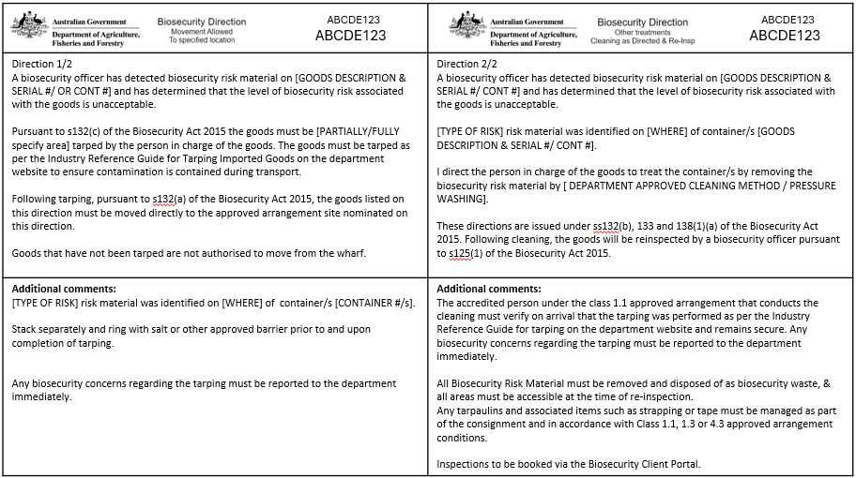

**All other Non CAL Goods**

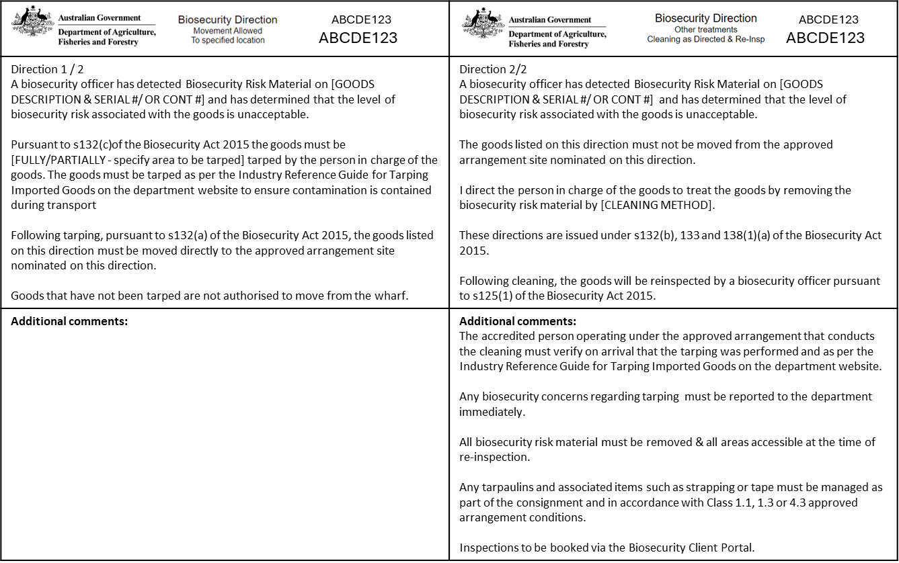

## Attachment C

### Examples of compliant tarped goods

The following tables provides inspection guidance in relation to tarpaulin application types and verification assessment outcomes.

| Tarping requirement | Image |
| --- | --- |
| Partial Tarp | A heavy lifter which has lifted the container to expose a securely applied underside tarpaulin with clear plastic wrap that encloses the ends of the tarpaulin in addition to blue plastic strip strapping which fastens both wrappings.A blue shipping container on a black plastic tarp waiting to be applied to the bottom of the shipping container. A blue shipping container wrapped in black plastic and shrink wrapped, covering only the underside of the shipping container.  A shipping container fully tarped with black plastic and shrink wrapped. Container number is written in large red text on the black plastic. Two yellow binders are strapped at each end of the shipping container to hold the tarping in place. |
| Full Tarp | A shipping container fully tarped in white plastic. Shipping container number is written in large black numbers on the white plastic wrap. A military tank on a skeletal trailer. The tank is securely wrapped, sealed on all sides and secured. |

Examples of non-compliant tarped goods

| Tarping requirement | Image | Reason |
| --- | --- | --- |
| Full Tarp | Poorly-secured tarpaulin where top tarpaulin does not sufficiently overlap lower tarpaulin.  Small pieces of electrical tape have been used to secure the two tarpaulins to each other however this has fallen off and exposed the bottom rails of the sea container where the contamination is located. | * Upper and lower tarpaulins not sufficiently sealed, * Upper tarpaulin does not sufficiently overlap lower tarpaulin, * Additional secure methods (tape /strapping) used is insufficient. |
| Partial Tarp | Two pieces of earth moving equipment on a 40 foot flat rack with sufficient coverage of tarpaulins on tracks and buckets but is not securely fastened.  The ratchet straps are not in place and are lying on the ground beside the flat rack. | * Tarping appears sufficient however strapping has not been completed. * Goods must be fully ready prior to transportation to the AA. |
| Full Tarp | A boat on a pallet that has been inadequately tarped on the underside where the pallet is located. The anchor points are not completely enclosed by the tarp. | Goods not considered to be sufficiently fully tarped, to manage the biosecurity risk as   * underside of goods are not sealed, * anchor points in tarp are oversized and unsealed.   Goods must be completely enclosed and sealed under this direction. |