**Importing Exotic fish**

**The exotic fish problem**

Fish species that do not occur naturally in Australia are known as exotic fish. Some exotic fish are popular aquarium pets, but if released they pose a serious threat to Australia’s aquatic ecosystems.

Exotic fish have the potential to establish as pests in the wild, introduce diseases, compete with native species for food, reduce water quality, and prey on native marine life. They can quickly over-populate waterways and change the ecosystem structure.

**What are the laws?**

The import of exotic fish into Australia is controlled by the Environment Protection and Biodiversity Conservation Act 1999 (EPBC Act), administered by the Department of the Environment and Energy (the Department), and the Biosecurity Act 2015 as administered by the Department of Agriculture and Water Resources (DAWR).

Exotic fish considered to be suitable for live import into Australia are listed on the live import list (see: <http://www.environment.gov.au/biodiversity/wildlife-trade/live/import-list>)

* Part 1 of the list contains species and can be brought into Australia without a permit
* Part 2 of the list contains species that require a permit
* Species not listed on the live import list are banned

Even fish that are allowed to be imported have the potential to introduce new diseases. The Department of Agriculture and Water Resources (DAWR) has a range of quarantine procedures for exotic fish. Before considering importing exotic fish, contact DAWR to determine what permits you need and what the quarantine procedures are.

Restrictions and rules for importing exotic fish must be adhered to by all – businesses, individuals, commercial traders, fish breeders, retail outlets, and aquarium enthusiasts/hobbyist keepers.

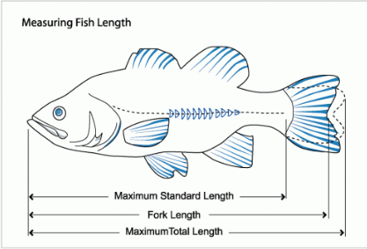**Size restrictions**

A number of fish that are listed on the live import list have minimum size restrictions. There are a number of ways to measure fish, but the live import list uses **Standard Length (SL)** to determine size. This measurement excludes the length of the caudal or tail fin. This diagram demonstrates the standard measurement that is used at the border to determine legal import of fish listed with size limits/restriction on the live import list.

Image source: FishXing, US Forest Service

**Case study - European carp**

Carp are large freshwater fish native to central Asia. They were introduced into Australia both deliberately, in an attempt to imitate the European environment, and accidentally, through the escape of ornamental or aquaculture fish. Carp are highly invasive and over the past few decades have spread across most of south-eastern Australia. They are now the most abundant large freshwater fish in some areas, including most of the Murray-Darling Basin, and have contributed to the degradation of our natural aquatic ecosystems (NSW, Department of Primary Industries)

**Case study – Asian arowana**

Asian arowana are highly sought after ornamental aquarium fish. In some cultures they are a symbol of good luck and prosperity. Asian arowana are listed as endangered, but are bred in captivity overseas to supply the pet industry. They are difficult to keep as they can grow up to 90cm long, need a lot of space, and can be aggressive towards other fish. If released into the wild, they would prey on a variety of Australian native species that are crucial to ecosystem health, including frogs, insects, and smaller fish. Because of this, Asian arowana cannot be brought into Australian under any circumstances.

**Don’t release your exotic fish!**

Do not release your exotic fish into the wild – this can cause serious harm to the Australian environment and wildlife and could result in penalties. If you have exotic fish you can no longer care for, please contact the Department or your state government for advice. You can remain anonymous.

**For more information please contact:**

Environmental Biosecurity Section  
Department of the Environment and Energy  
GPO Box 787  
Canberra ACT 2601  
**Telephone**: (02) 6274 1900  
**Email**: exotic.species@environment.gov.au

© Commonwealth of Australia, 2018

First published in 2018

Published by the Australian Government Department of the Environment and Energy

GPO Box 787, Canberra ACT 2601 Australia

Email: **exotic.species@environment.gov.au • Phone: (02) 6274 1900**