What’s New, What’s Different: Quick Reference Guide

PEMS Release – 10 August 2024
Following the outage on Saturday 10 August 2024, the Plant Export Management System (PEMS) will be updated with the following changes:
PEMS Updates - Bug fixes
Bug – Checkbox not visible for Japan market |  | Fix – Checkbox visible for all markets
The mandatory check box for Citrus Protocol market- 10% calyces lift is not visible for Japan.  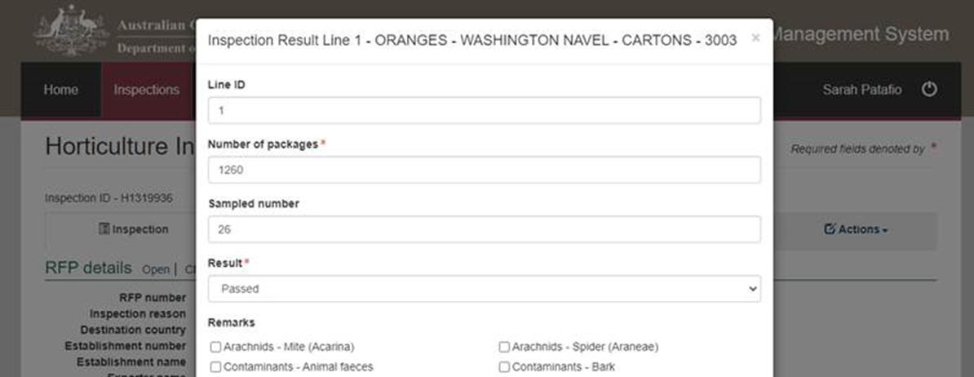 | The check box is now available for all citrus protocol markets including Japan.  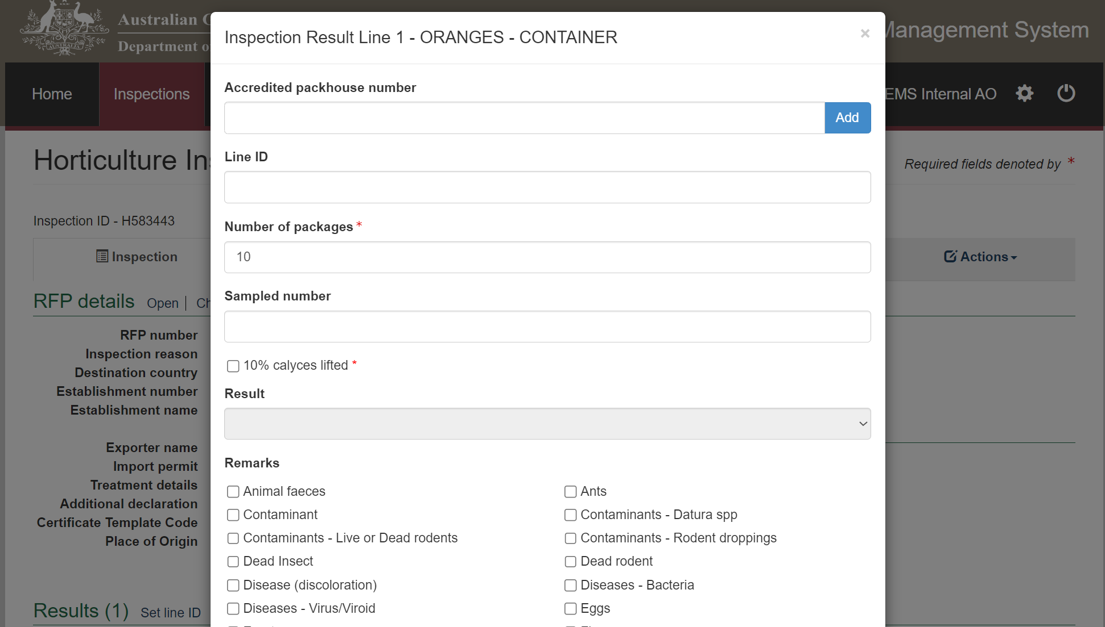

Enhancements
Current – End Use field | Enhancement – Renamed to Intended Use
The End Use field is available in both the Request for Permit screen and the Commodity Inspection screen.  Commodity inspections include Grain and Plant Product inspections, Bulk into ship hold inspections, QSR inspections and Horticulture inspections.  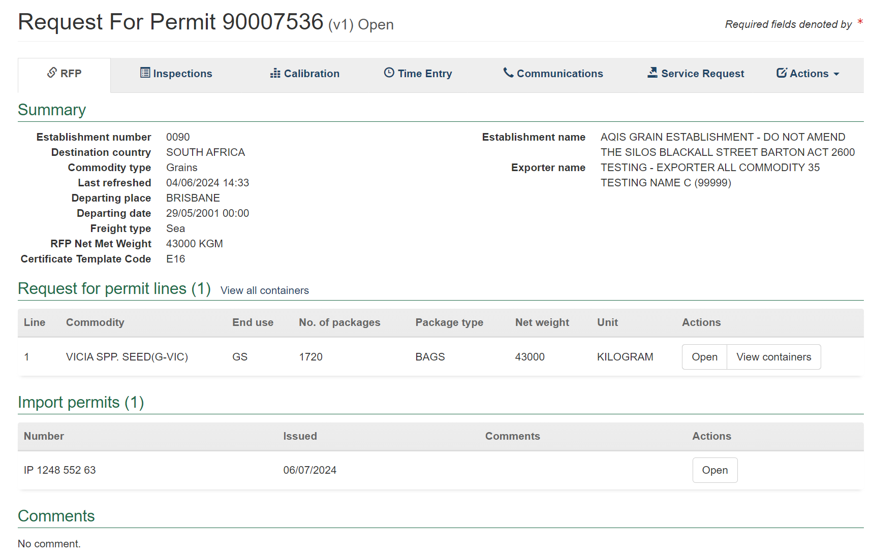  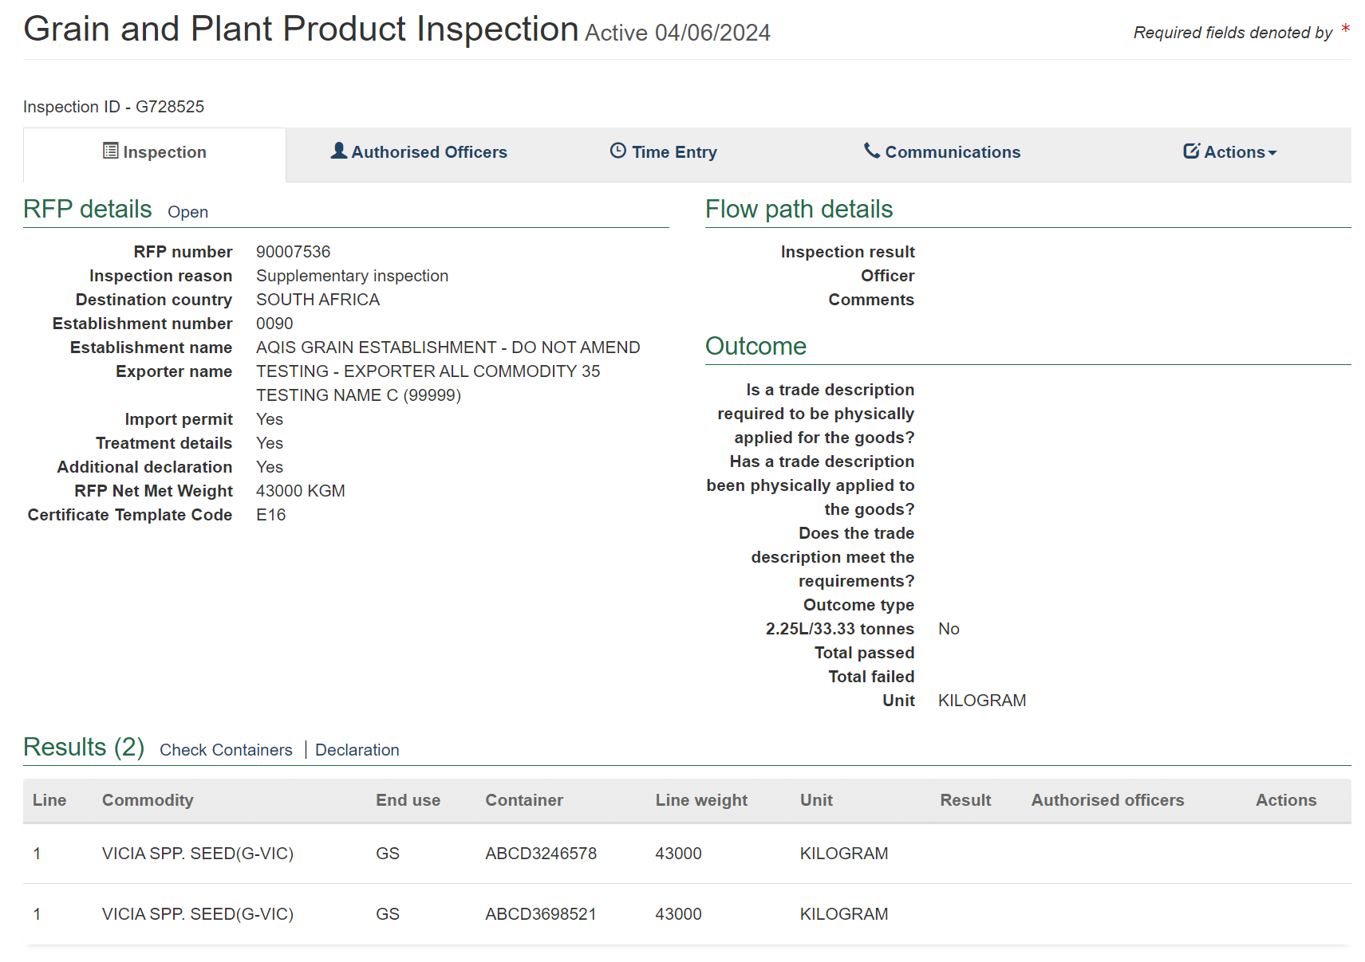 | This field has been renamed to “Intended Use” on both screens. This is to meet the international standard set by IPPC ePhyto.  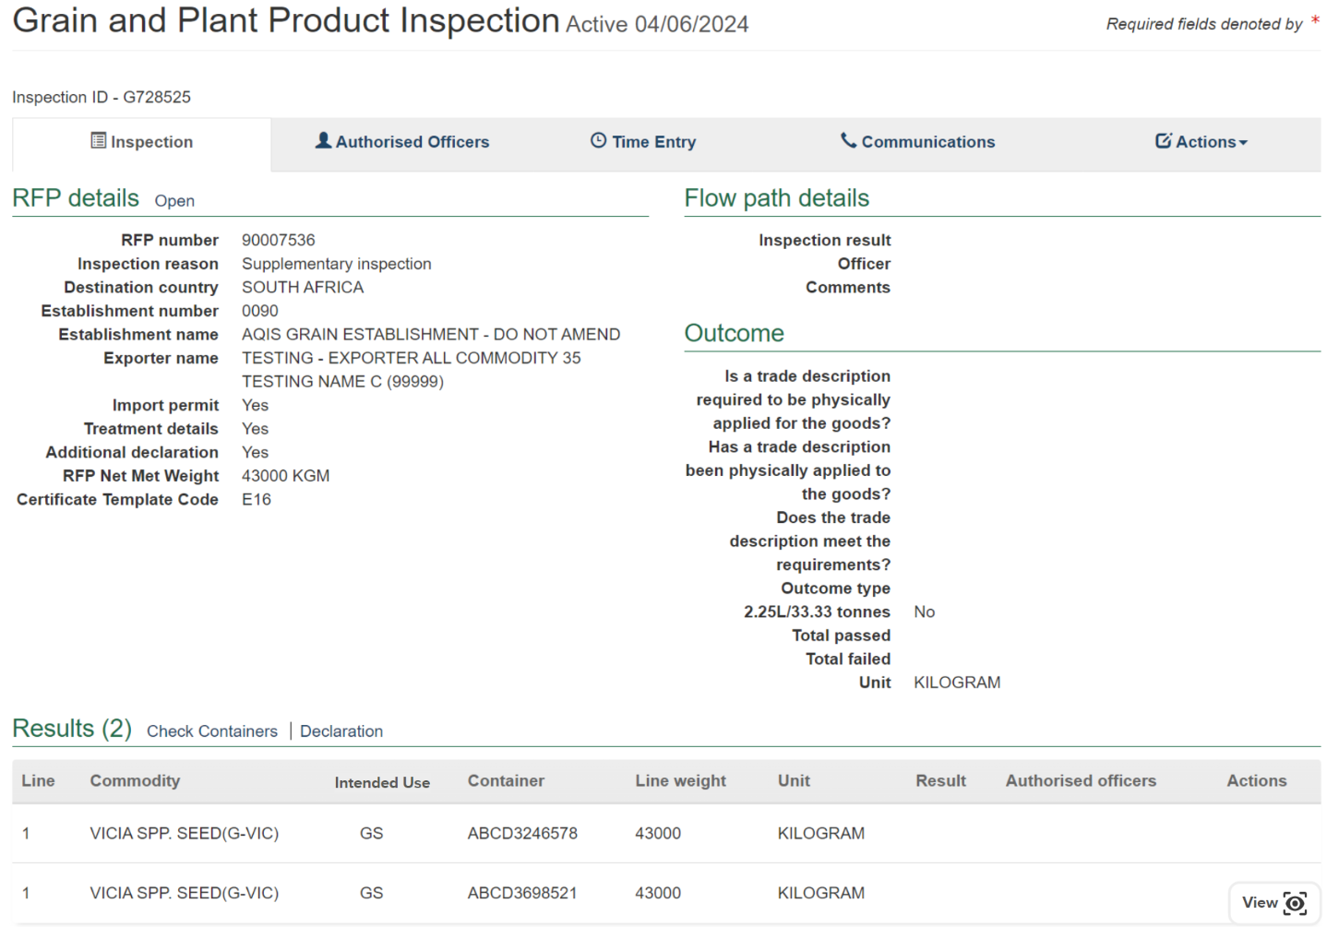  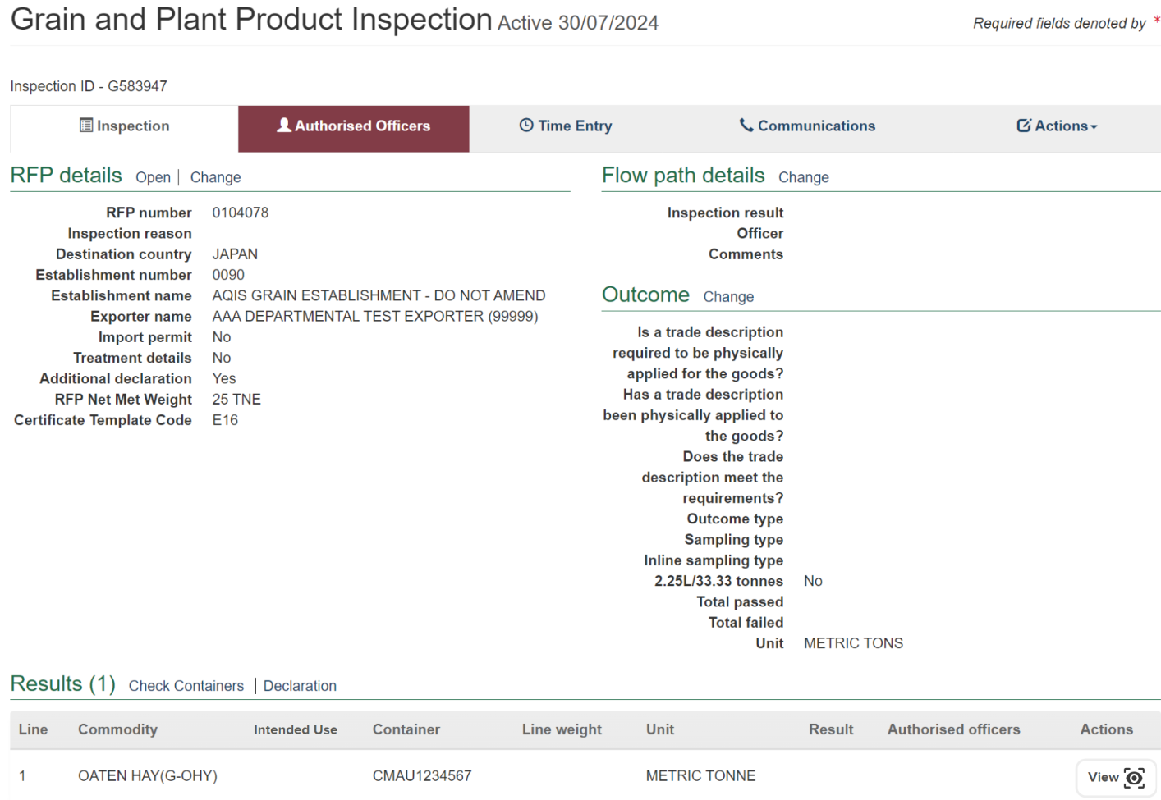
Current – Service Request tab not consolidated | Enhancement – Service Request tab consolidated
Currently when a user requests RFP authorisation or Request for issuance of ITCT calibration certificate through the PEMS Service Request tab, the service request field is only available on that version of the RFP.  If users refresh the RFP and the version is updated, the service requests raised in previous versions of the RFP are not available to view in the latest version of the RFP.  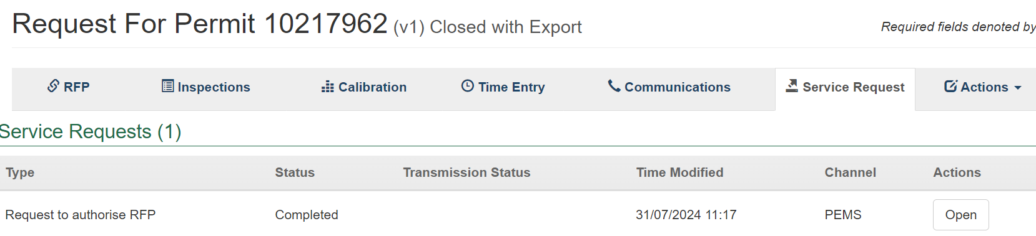  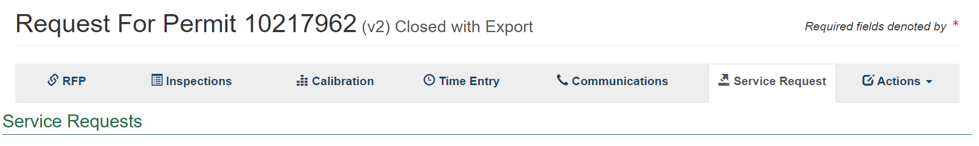 | Service Requests have been consolidated to show on the latest version of the RFP.  If a Request to Authorise RFP or Request for Issuance of ITCT calibration certificate was raised in the previous version of the RFP all of these will be visible from the latest version of the RFP.  The links to the Request to authorise RFP, Issuance of ICTC calibration certificate and Issuance of EX188 certificate will only be available on the latest version of the RFP.  Selecting the Action button on the Service Request tab, enables Withdraw, Request Info, and Resubmit to be available from the latest version of the RFP only.  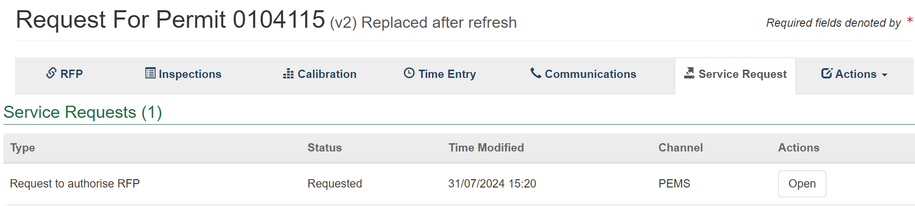  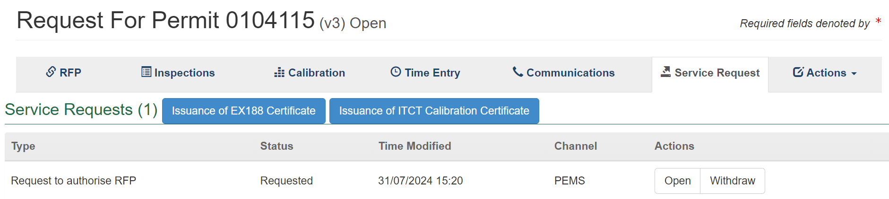
Current – Request Issuance of calibration certificate not available unless RFP raised in PEMS | Enhancement - Request for Authorise RFP in PEMS not required
Currently the Issuance of ITCT calibration certificate and Issuance of EX188 certificate is only available if the Request for authorising RFP is raised through PEMS.  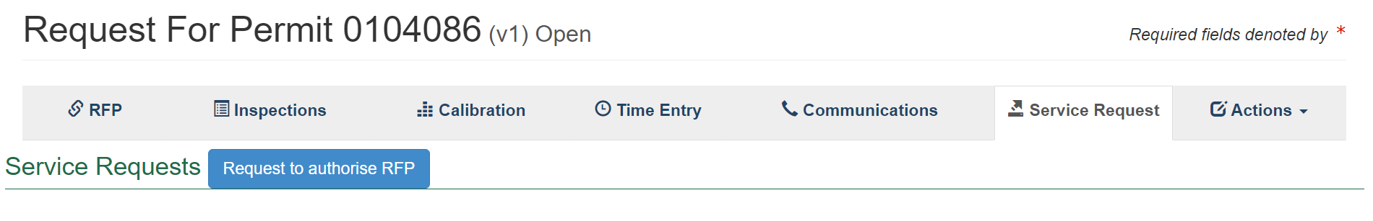  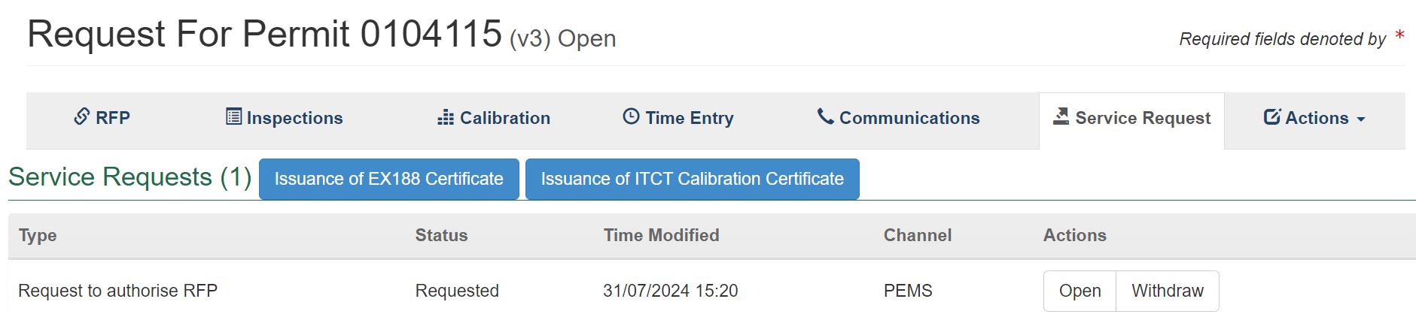 | Users can request the Issuance of ITCT calibration certificate and Issuance of EX188 certificate without needing the Request to authorise RFP to be raised through PEMS.  These buttons are now available through PEMS, even if the Request to authorise RFP was not raised in PEMS. This is only available when the RFP is set to “Closed with export”.  