|  |
| --- |
| Huanglongbing (*Candidatus* Liberibacter *asiaticus, Ca.* L*. africanus and Ca.* L*. americanus*) |

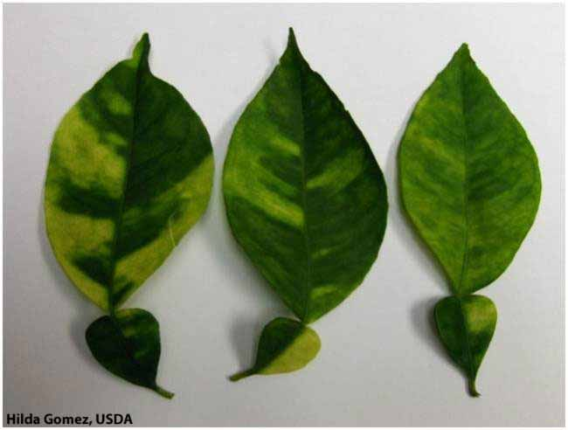

**Fig. 1** Asymmetrical, uneven chlorotic patches on leaves are a classic symptom of the blotchy mottling from huanglongbing (Hilda Gomes, USDA)*.*

**Likely mode of entry**

Importation of citrus planting material poses the greatest threat of introduction of this bacterial disease and the insect vectors that spread it. Fruit which has been brushed, washed with leaves and stems removed and has gone through a packing house process is not considered to pose a risk. Psyllid insects which can vector this disease have been intercepted on imported fresh curry leaves (*Bergera koenigii*).

**Symptoms (Figures 1–3)**

The most characteristic leaf symptom is a blotchy mottle on both side of the leaves that appear as asymmetrical, uneven chlorotic patches that cross the veins. Infected fruits display colour inversion, are small and lopsided, have discolouration on the vascular columella, a curved central core, and small brown aborted seeds. All plant parts and growth stages are affected, and it leads to tree decline and often death.

**Host range**

All species and cultivars of *Citrus* are susceptible to the three ‘*Candidatus’* Liberibacter species which cause huanglongbing. Other hosts (also in the Rutaceae family) include: Atalantia, Balsamocitrus, Calodendrum, Clausena (wampi), Fortunella (kumquat), Microcitrus, Murraya (orange-jessamine), Poncirus (trifoliate-orange), Severinia (Chinese box-orange), Swinglea, Toddalia and Triphasia (limeberry).

**Biology (Figure 4)**

Huanglongbing (HLB), also known as citrus greening is caused by phloem-limited non-culturable bacteria which occur in three forms: the Asian, African and American forms, known respectively as *Candidatus* Liberibacter *asiaticus, Ca.* L. *africanus,* and *Ca.* L. *americanus*. The Asian and African forms of HLB are vectored by both the Asian citrus psyllid, *Diaphorina citri,* and African citrus psyllid, *Trioza erytreae*. The American form is transmitted by D. citri. HLB is graft-transmitted, however seed transmission occurs only at very low levels and the disease does not seem to persist beyond early seedling stages.

**Distribution**

The Asian form is found in Asia, the Middle East, and throughout much of the Americas. The African form is found in Africa and the Middle East. The American form is found only in Brazil. These diseases and vectors are not present in Australia.

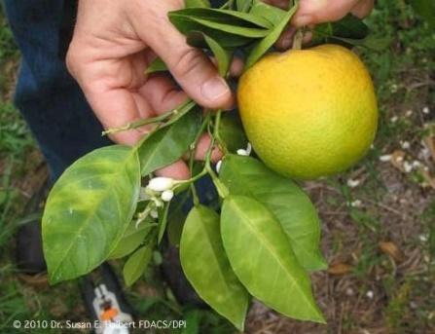

**Fig. 2** Colour inversion in affected fruits: the stem-end turns yellow or orange, while the opposite half remains green (©Dr Susan E. Holbert, FDACS DPI).

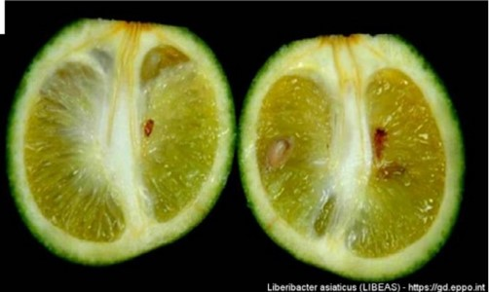

**Fig. 3** Lopsided fruit have aborted seeds, a curved central core and discolouration beneath the calyx button (©JM Bove, INRA Bordeaux FR).

**What to do if you find suspect huanglongbing or insect vectors**

**Department officers:** Contain the risk, collect plant specimens double-bagged into zip-lock plastic bags and deliver to a department plant pathologist immediately. Collect insect specimens into a vial containing 80% ethanol and deliver to a department entomologist immediately.

**Industry and the public:** **SEE. SECURE. REPORT.**

Secure the goods to limit movement and immediately report your detection to the Department of Agriculture, Fisheries and Forestry on **1800 798 636**.

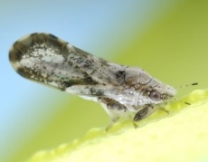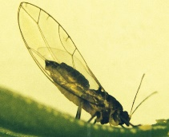

**Fig. 4** Vectors of HLB: Asian citrus psyllid (left) and African citrus psyllid (right) (Jeffrey W Lotz, Florida Dept. of Agric. and Consumer Services; SP van Vuuren, Citrus Research International, bugwood.org).