USER GUIDE

NEXDOC:
Lodge a Request for Export (REX) for fish and fish products

__________________________________________________________________________________
In this document
This document contains the following topics.
Purpose of this document 2
Start a new Request for Export (REX) 2
REX Section 1: Country details 4
REX Section 2: Product Details 4
REX Section 3: Exporter Details 17
REX Section 4: Consignee Details 18
REX Section 5: Transport Details 18
REX Section 6: Authorisation 20
REX Section 7: Endorsements 21
REX Section 8: Single Electronic Window (SEW) 22
REX Section 9: Additional Details 23
REX Section 10: Attachments 25
REX Section 11: Submit 26
Contact the NEXDOC help desk 27

Purpose of this document
The below information will guide you through lodging a Request for Export (REX) for fish.
Lodge your REX using the Next Export Documentation (NEXDOC) system.
The department will then:
- assess whether you have met all export requirements.
- issue an export certificate, if approved.

Start a new Request for Export (REX)
Step 1  Log in to the Online Services Portal. | 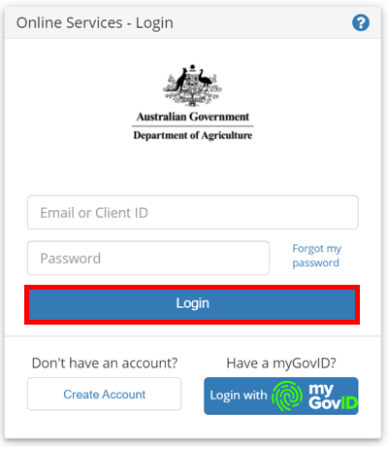
Step 2  Select Lodge a Request for Export (REX). | 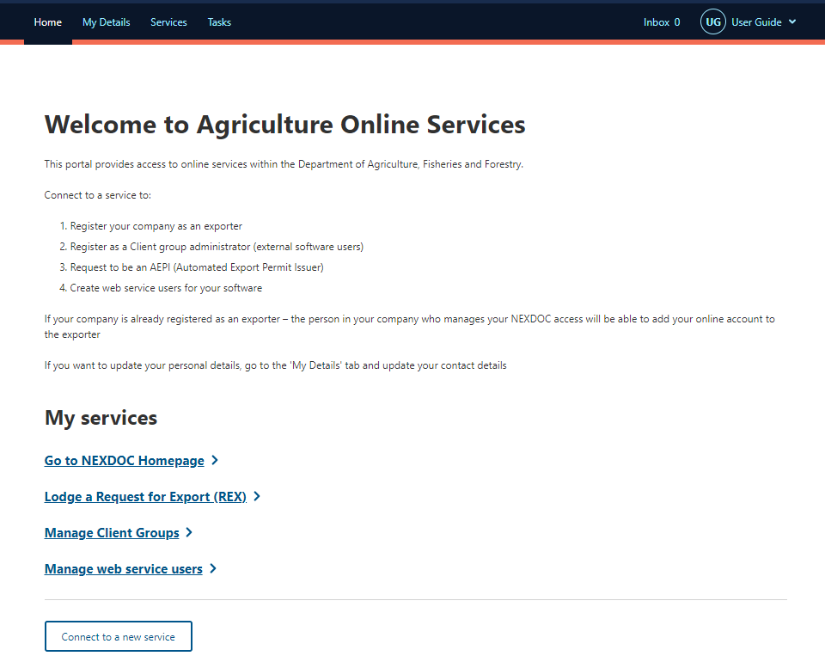
Step 3  From the dropdown menu, select the Commodity type of your export. You will need to select Fish for a fish REX.  Then select Start. | 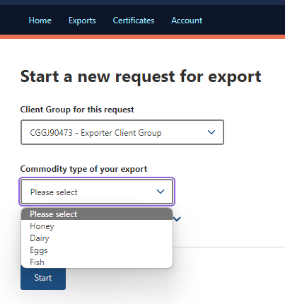  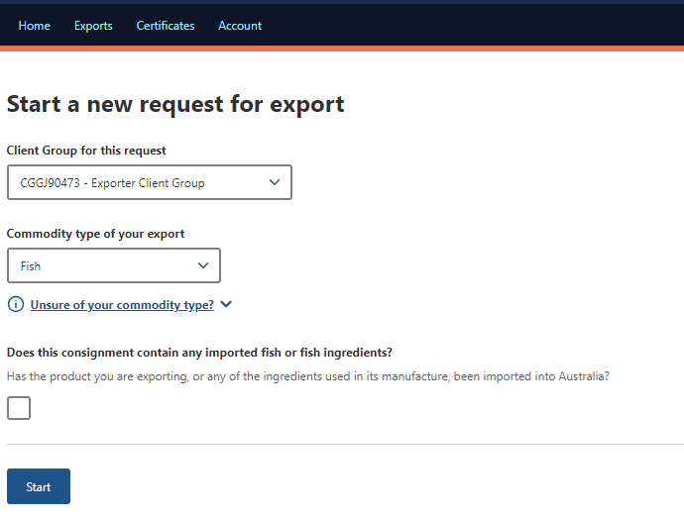

REX Section 1: Country details
Step 1  Type in the Country you wish to export to in the drop down menu.  Select Next. | 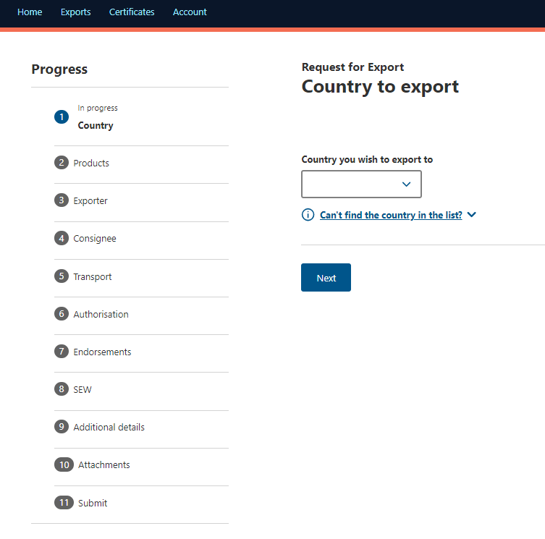

REX Section 2: Product Details

Step 1  Select the + Add a product to export button. | 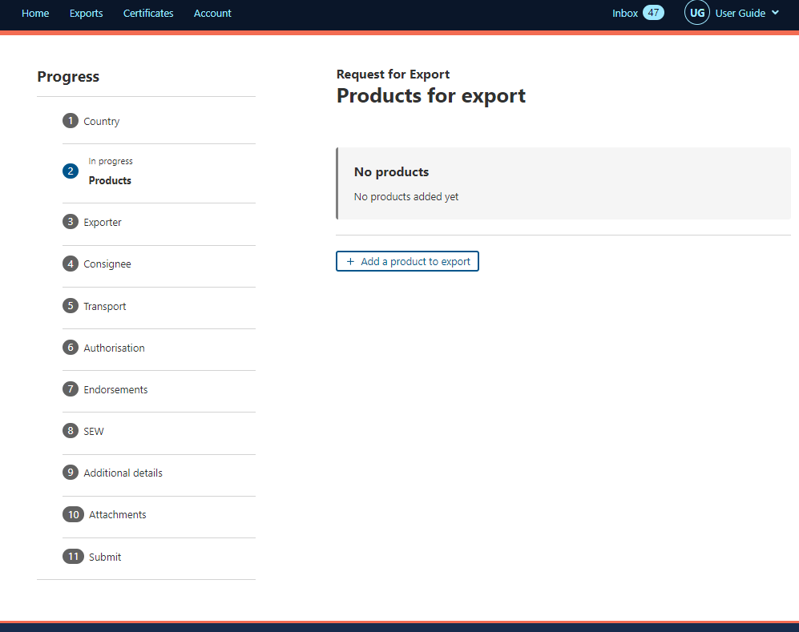
Step 2  Select the Product you wish to export or begin typing in the product in the drop down menu.  Only valid product types will be displayed.  Scroll down the list or start typing in the product for it to display. | 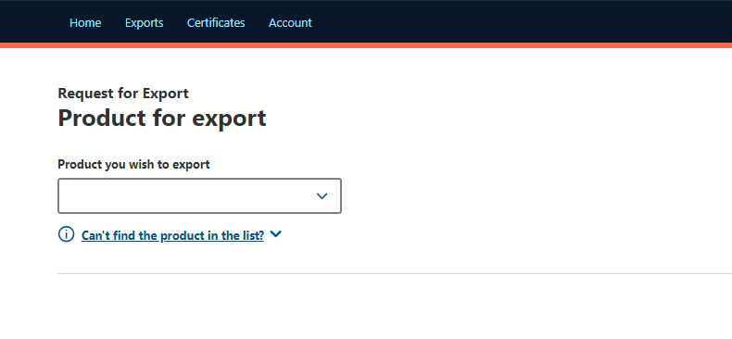  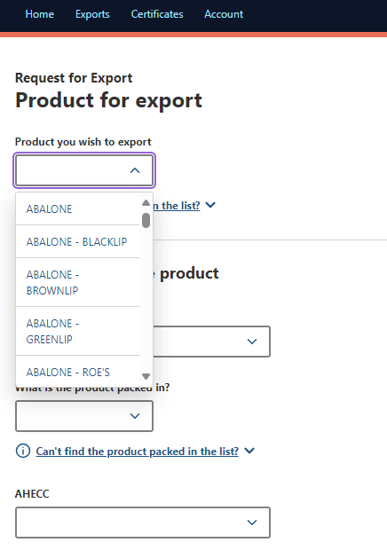
Step 3  Complete relevant fields within Add details for the product. | 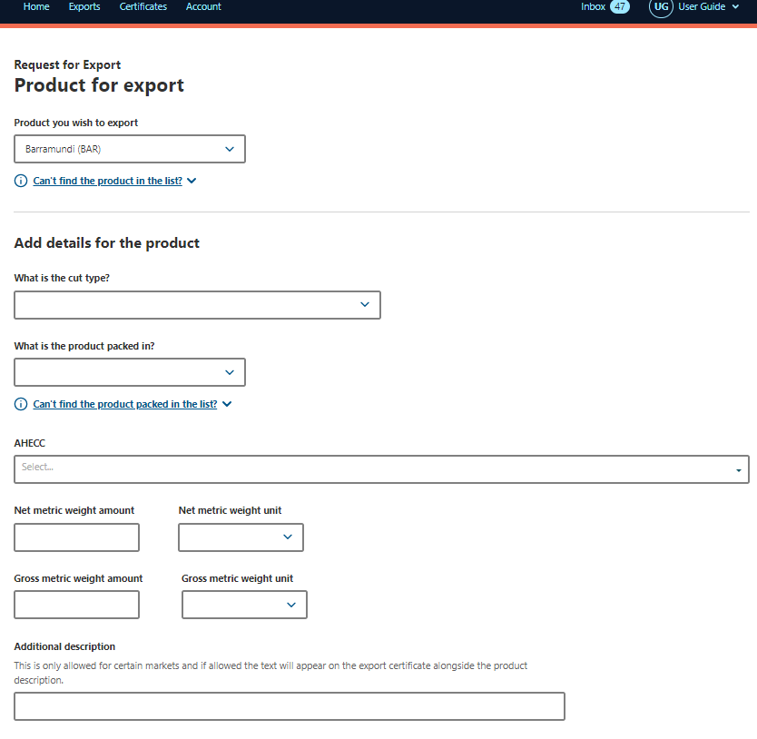
Step 4  Complete the relevant fields for Outer packaging. | 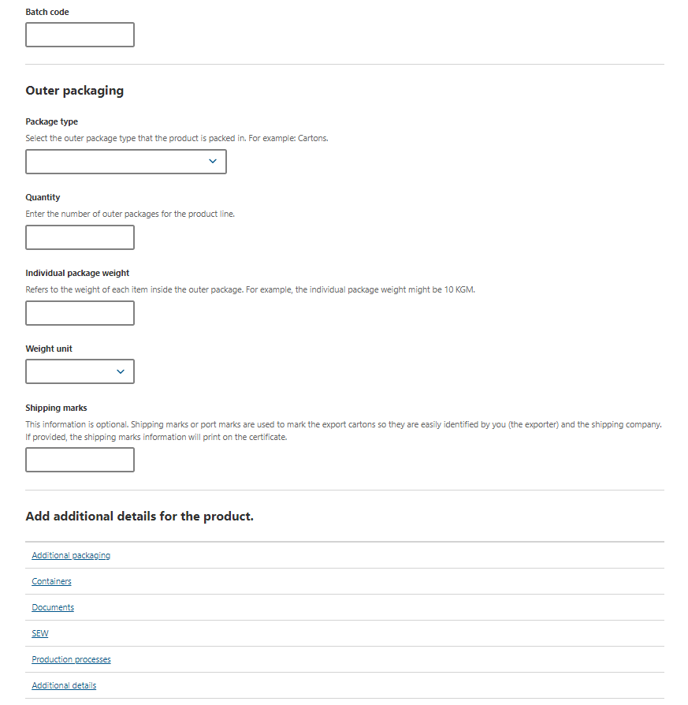
To add additional information about your product:
Step 5  Select Additional packaging tab. | 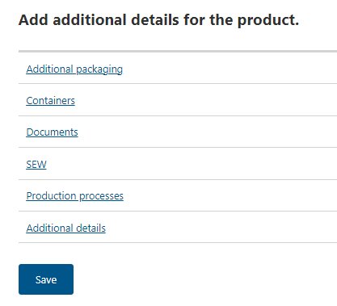
Step 6  Complete relevant fields within Packaging for the product.  Select Save. | 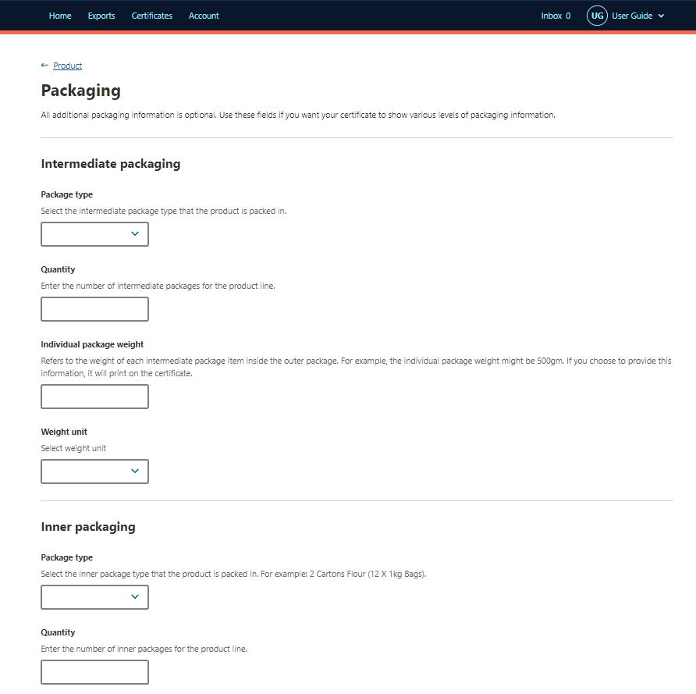  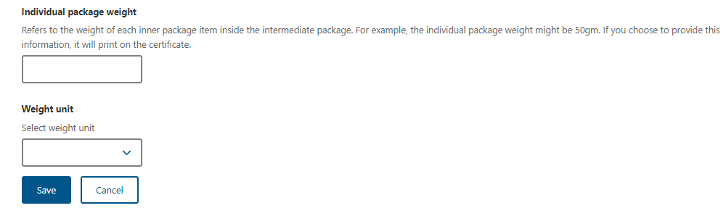
Step 7
Select Containers tab.

Step 8  Select the tick box for Air or Sea freight. | 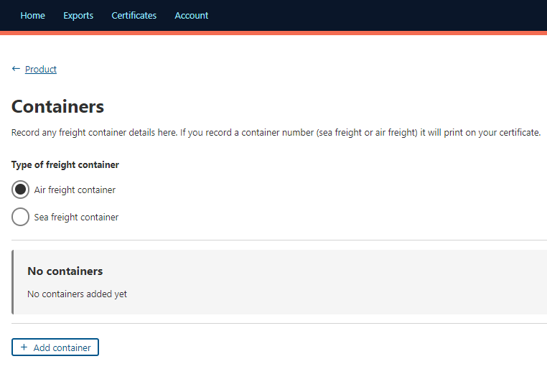
Step 9

If required, select Add container.
Step 10  Type the Container number.  Select + Add seal number. | 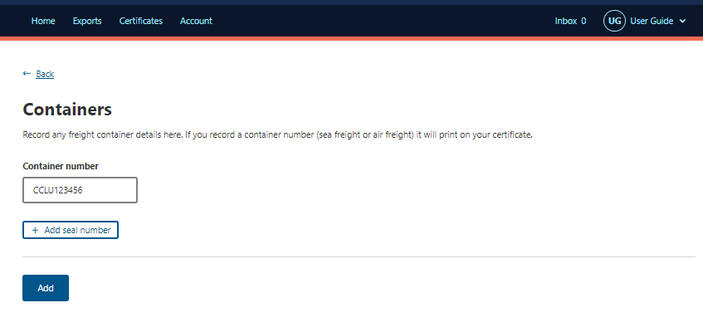
Step 11  Type the Seal number.  Select Add. | 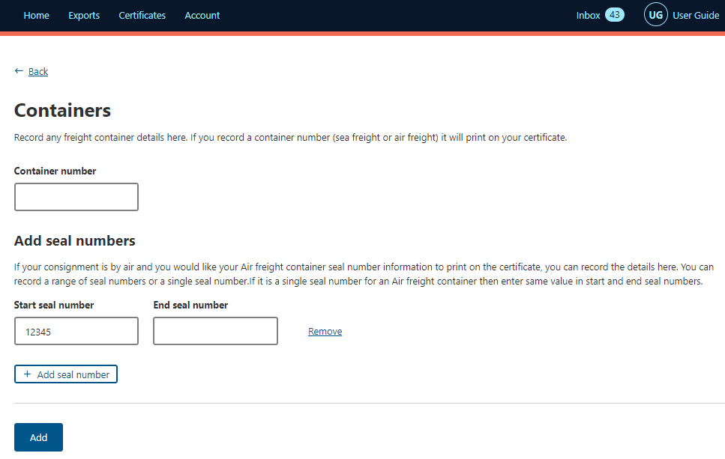
Step 12  Select Product | 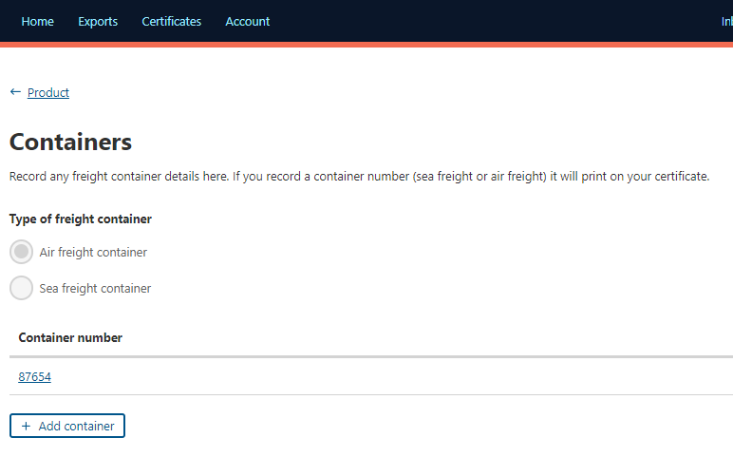
Step 13
Select Documents tab.

Step 14  Find the relevant document and select it.  Click Add to add the document to the REX.  Then Select Product | 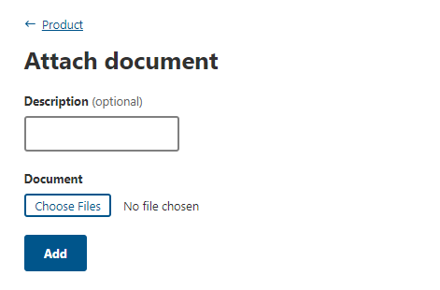
Step 15

Select Production processes tab.

Step 16  Select + Add Production process. | 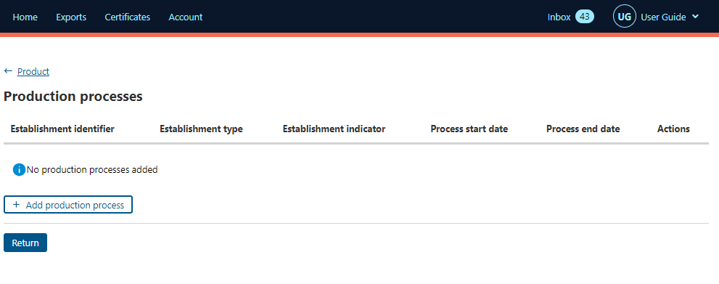
Step 17  Select an Establishment Type and click Continue | 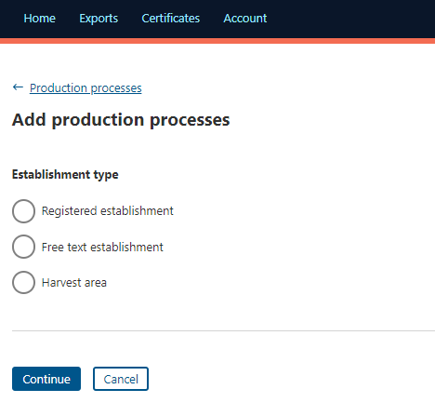
Step 18  If you select  Registered establishment –  Complete the Registered establishment details  Click Add  If you select  Free text establishment –  Complete the details  Click Add  If you select  Harvest area –  Complete the details  Click Add | 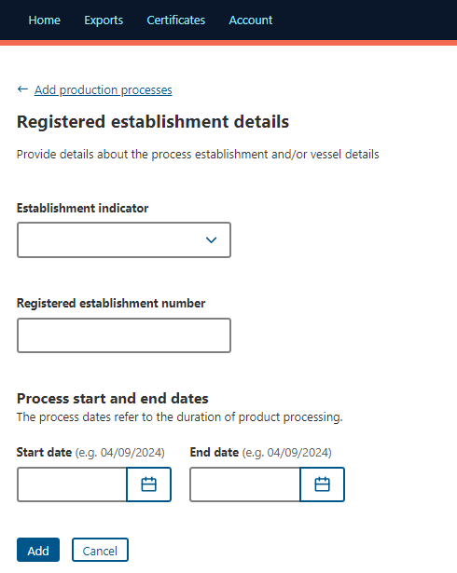  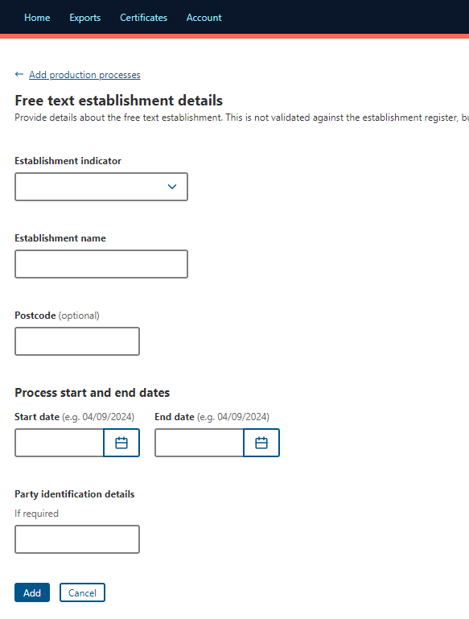  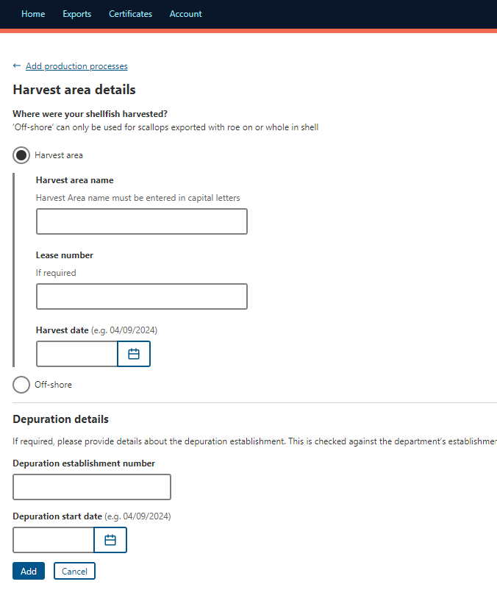
Step 19  Select Product | 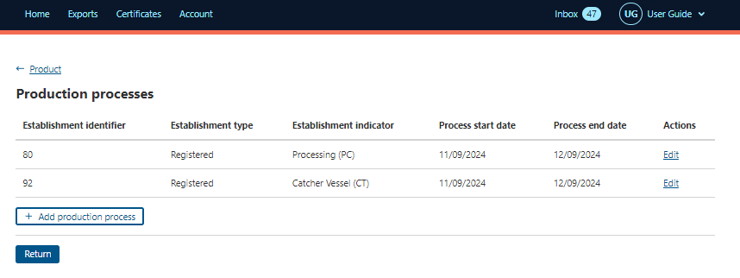
Step 20

Select the Additional Details tab.

Step 21  Complete required fields in Additional details.  Select Save.  Select Product | 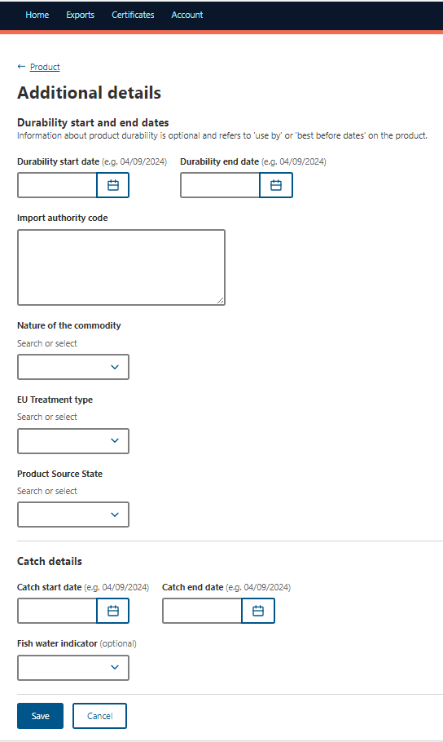  0
Step 22  Select Save. | 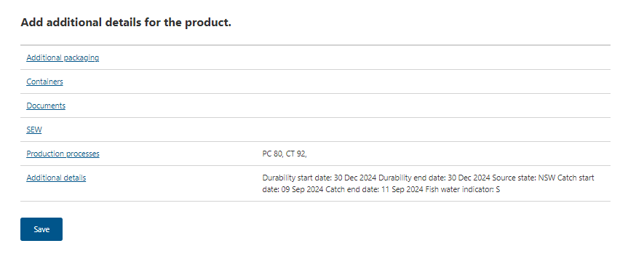
Step 23

If you have more than one product repeat steps 1 – 25.

Step 24  Your REX application has been saved and assigned a REX number.  If desired, you may add additional product lines by selecting Add a product to export or Copy a product line.  This is an optional feature. | 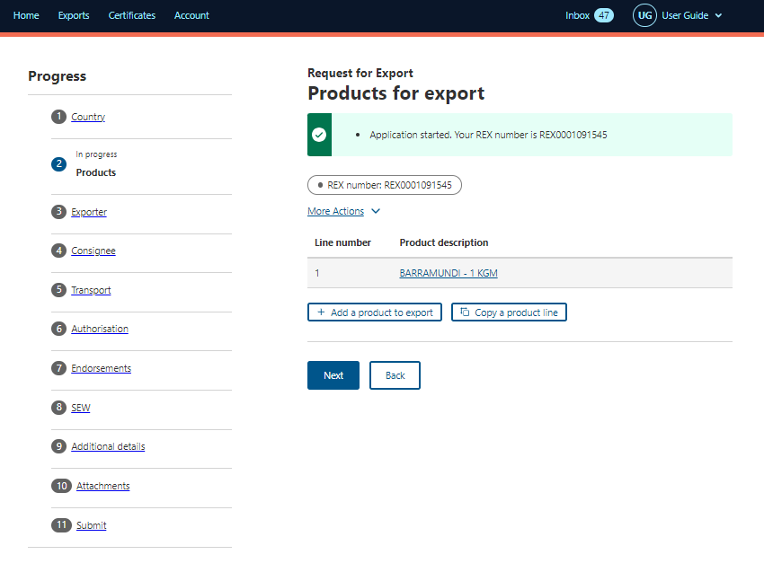
Step 25  Once all necessary products are added to the REX, select Next. | 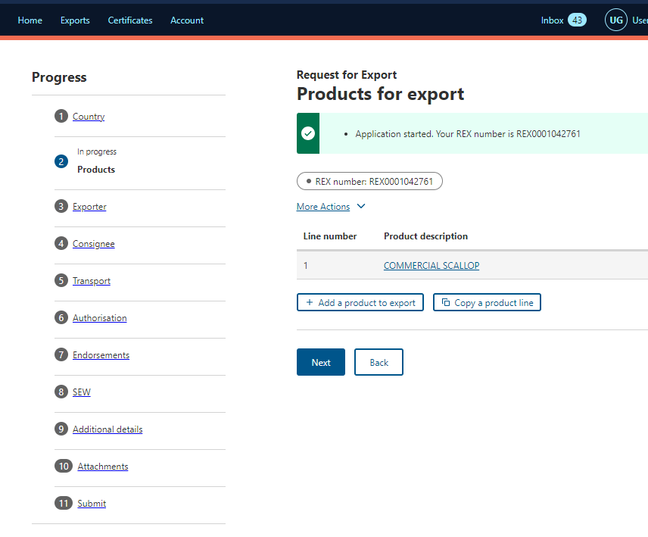

REX Section 3: Exporter Details
Step 1  Exporter details are prepopulated from your exporter registration for NEXDOC.  If you need to update these details, select Edit exporter details.  If you wish to use your other exporter details for the consignment, please select Request new exporter.  Provide your Exporter Reference.  Select Save and next. | 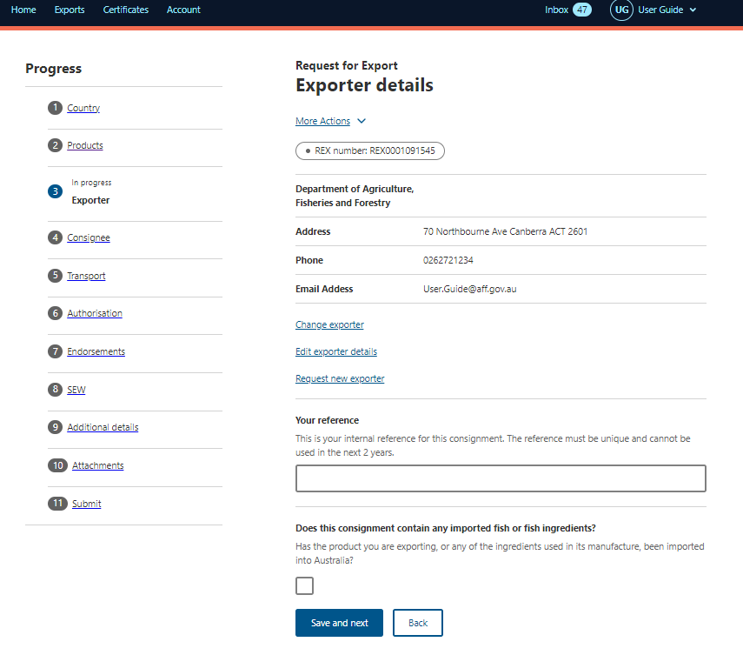

REX Section 4: Consignee Details
Step 1  Provide the consignee Name. This is a mandatory field.  Provide the consignee Phone number, if known.  Provide the consignee Address. This is a mandatory field.  Select Save and next. | 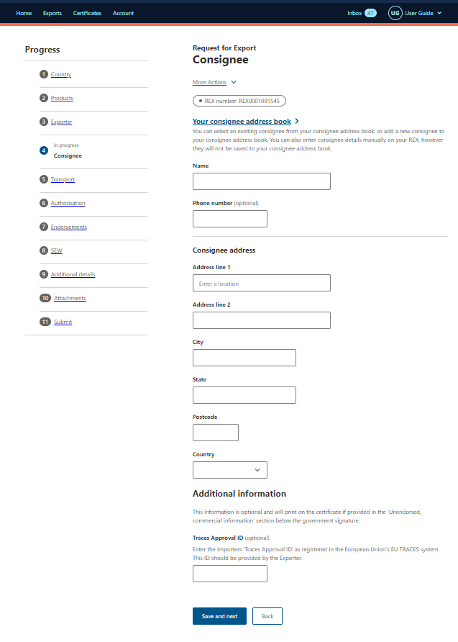

REX Section 5: Transport Details

Step 1  Enter the Departure Date. The date must be in the future and is a mandatory field.  Select the Load Port from the drop-down menu. This is a mandatory field.  Select the Discharge Port from the drop-down menu. This is an optional field.  Select the Border Inspection Port from the drop-down menu.  Provide the Destination City. This is a mandatory field.  Transit Countries is an optional field.  Provide the Transport Storage Temperature (number only) and Transport Storage Temperature Unit. This is a mandatory field. | 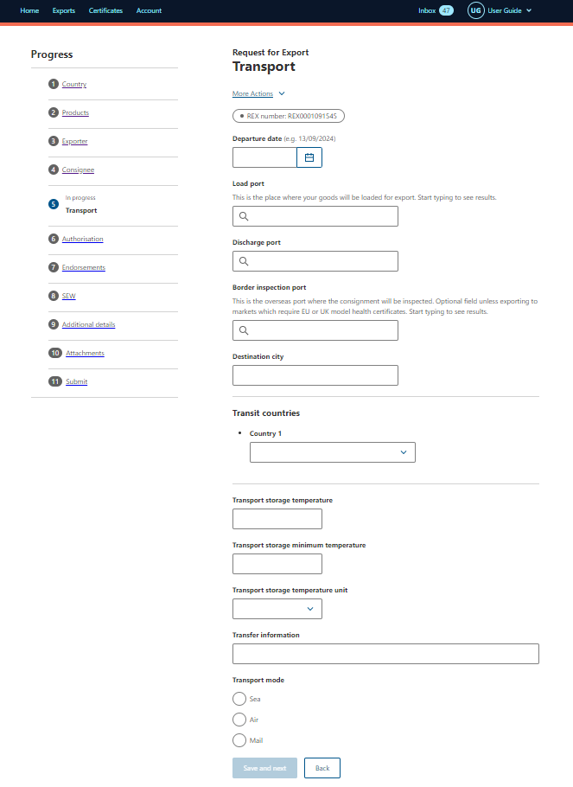
Step 2  Select the Transport Mode. It is mandatory to select either Sea or Air.  If you select Sea, you must provide the Vessel Name and Voyage Number. These are mandatory fields.  If you select Sea, you must provide the Vessel Name and Voyage Number. These are mandatory fields.  If you select Air, you must provide the Flight Number. This is a mandatory field.  If you select Mail, no additional information is required.  Select Save and next. | 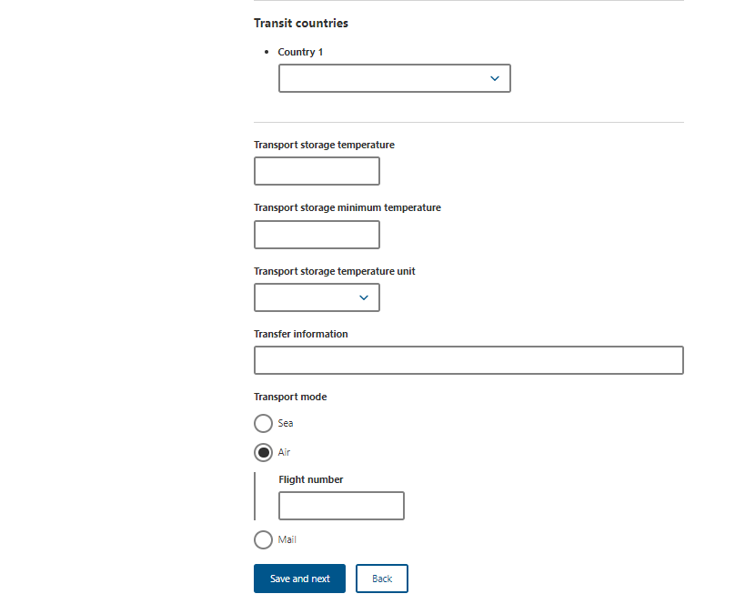

REX Section 6: Authorisation
Step 1  Type the Authorising Establishment Number.  If you have AEPI permission, you will have the ability to select if you would like to authorise this REX for export?  If you select Yes, the below fields will display. You must insert an Authorisation Date for the REX to be authorised.  This date must be before or equal to today’s date. If you do not wish to authorise the REX yet, leave it blank. You can amend your REX and input the Authorisation Date after submitting.  If you select No, the department will review your REX for authorisation.  Select Save and next. | 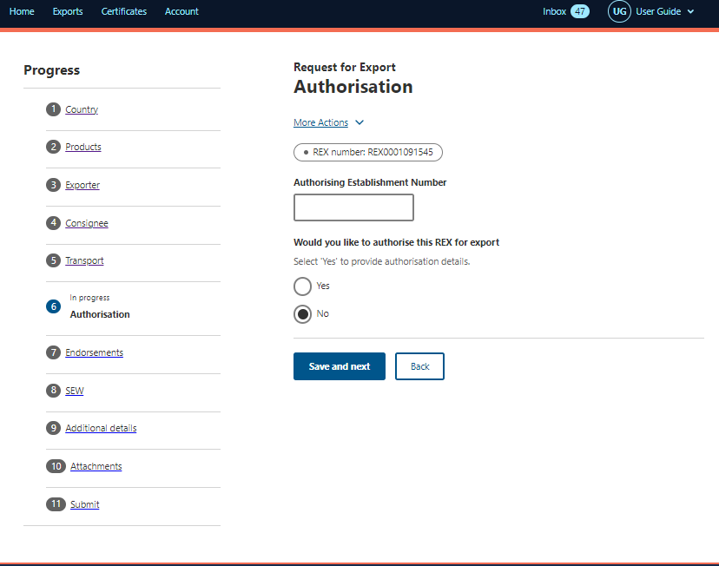

REX Section 7: Endorsements
Step 1  The system will automatically allocate you the default certificate template and endorsement if applicable.  Select Next. | 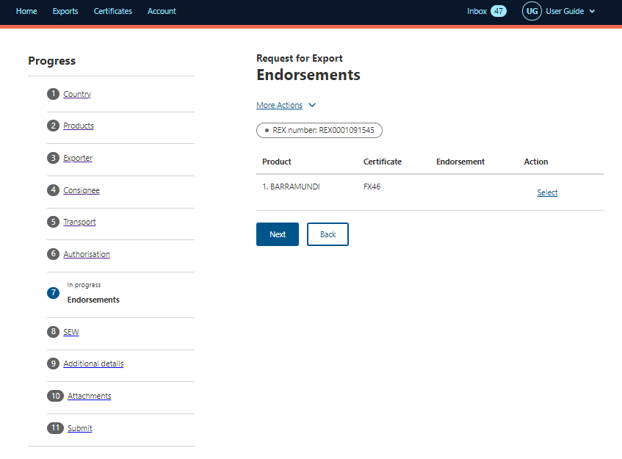
Step 2

If you would like to change the template or endorsement select the Select button.

Step 3  Use the drop-down menu to choose the appropriate Certificate Template and or Endorsement.  Select Save.  The SEW Integration tab will appear. | 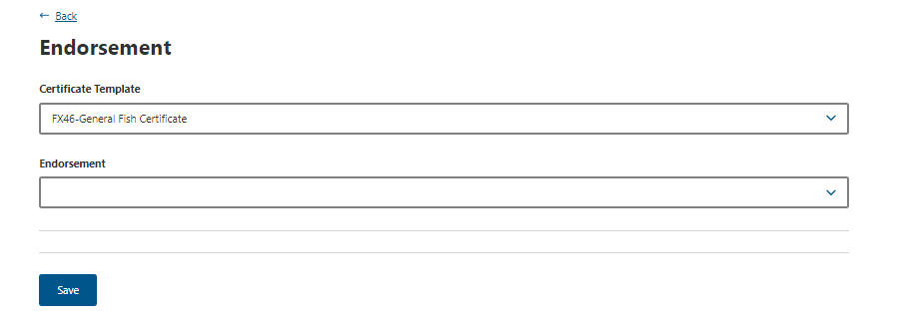

REX Section 8: Single Electronic Window (SEW)
Step 1  If you are not using Single Electronic Window (SEW), deselect the box next to Would you like to use SEW integration (ICS)?  Select Save and next.  Move to Rex Section 9: Additional details.  If you are using SEW you will need to complete the details on this screen.  Continue to Step 2. | 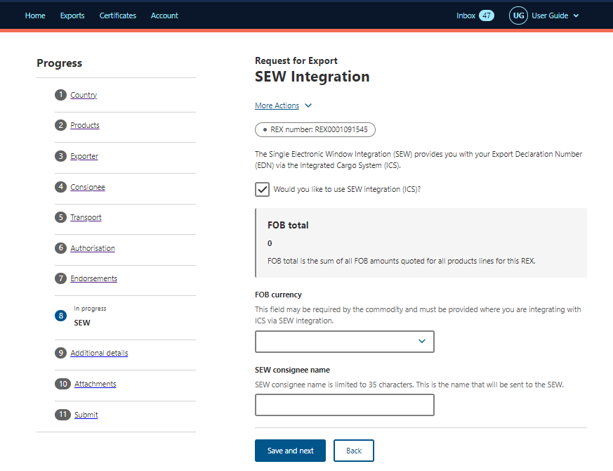
Step 2  If you are using SEW, you will need to complete the details on this screen.  Tick the box next to Would you like to use SEW integration (ICS)?  Complete the FOB currency and SEW consignee name.  Select Save and Next.  If you wish to use the SEW connection, you must have provided the relevant details in each of your product lines.  These are optional fields. | Note:  You must have requested access to SEW in your exporter registration for this to be available. Alternatively, you can update your account and request this permission.

REX Section 9: Additional Details
Step 1  Select your Certificate Print Indicator  You must select Automatic or Hold.  This selection is mandatory.  The NEXDOC Printing FAQ on the NEXDOC Help Page has further information.  You must select an available printer or regional office from the Print region to print your certificate.  You can choose to:  - Add catching zone information in the Other details section and your EDN number  - request extra certificates or add supporting documentation for this consignment  - save your import permit number and import permit date within your REX, select Add import permit.  This is an optional feature. See Step 2.  Select Save and next. | 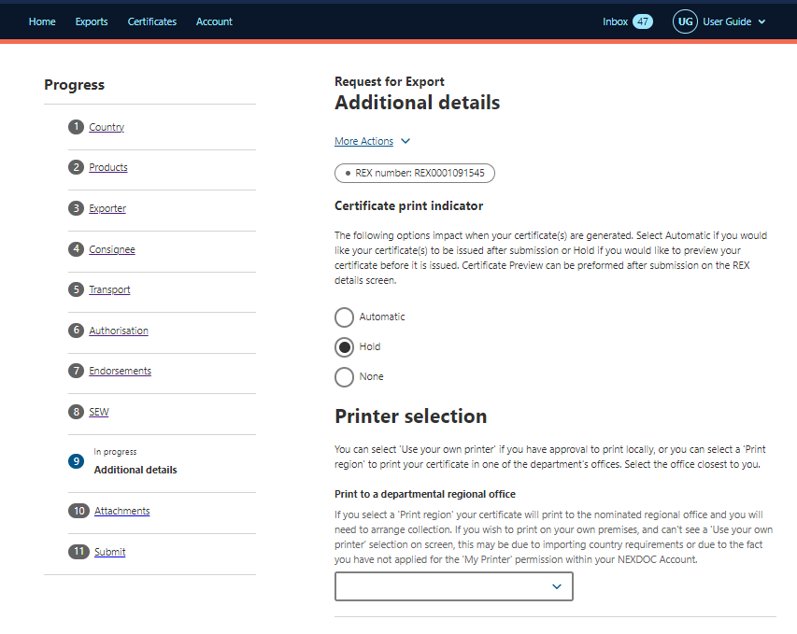  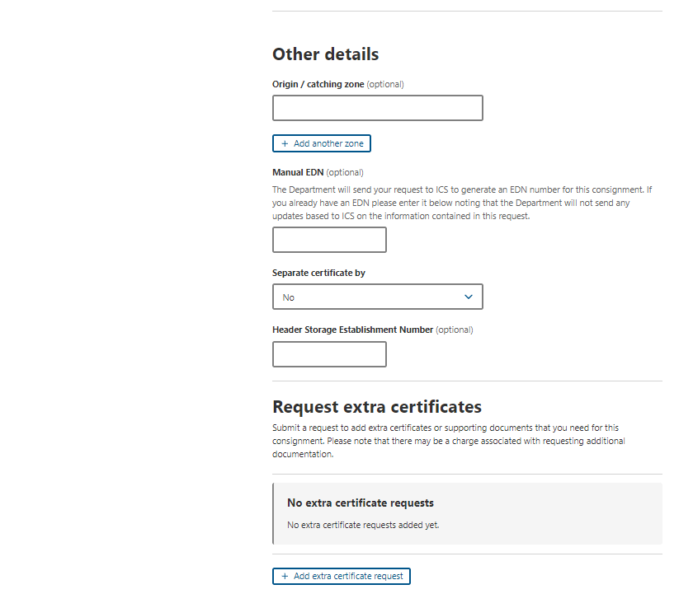  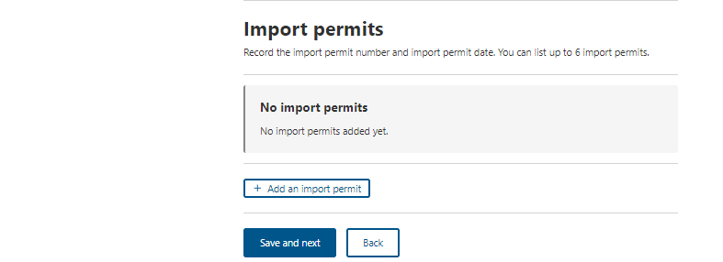
Step 2  Provide your Import permit number and Import permit date.  These are optional fields.  If provided, the import permit date must be in the past.  Select Save. | 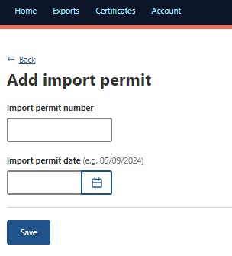

REX Section 10: Attachments
Step 1  Each REX is assessed against importing country requirements.  You must provide all relevant documentation to support your request for certification.  Please liaise with your importer and check MICOR for specific details.  If not required, select Next.  If required, select Add attachment and go to Step 2. | 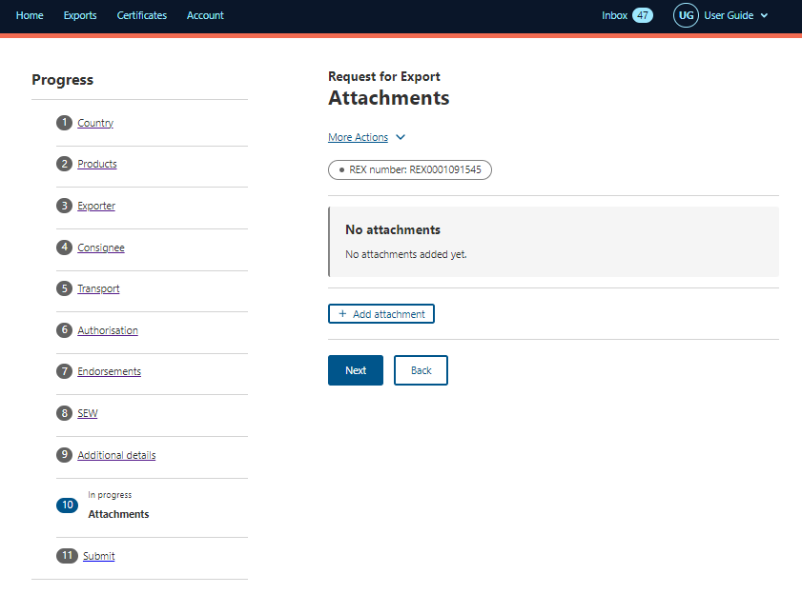
Step 2  Select the drop-down menu and indicate the Document type.  This is a mandatory field if you are attaching a document.  Provide a Comment in relation to your attachment, if applicable.  This is an optional field.  Select or drag and drop the file to attach.  Select Save. | 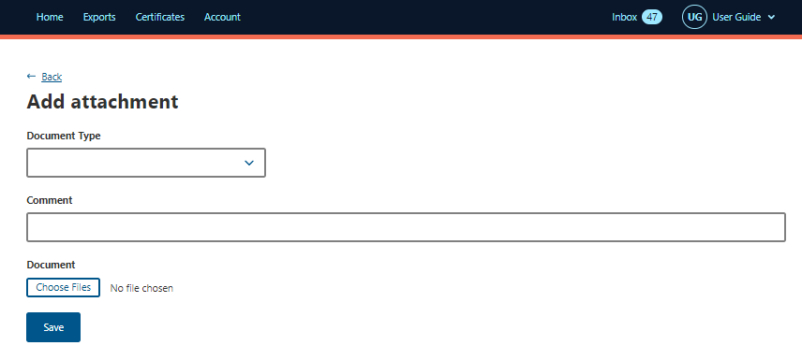

REX Section 11: Submit
Step 1  The Declaration will display. Please read this carefully.  If you wish to proceed with your lodgement, select I agree.  Step 2  After selecting I Agree, the screen will display details of the REX.  Select Lodge REX to complete the lodgement process. | 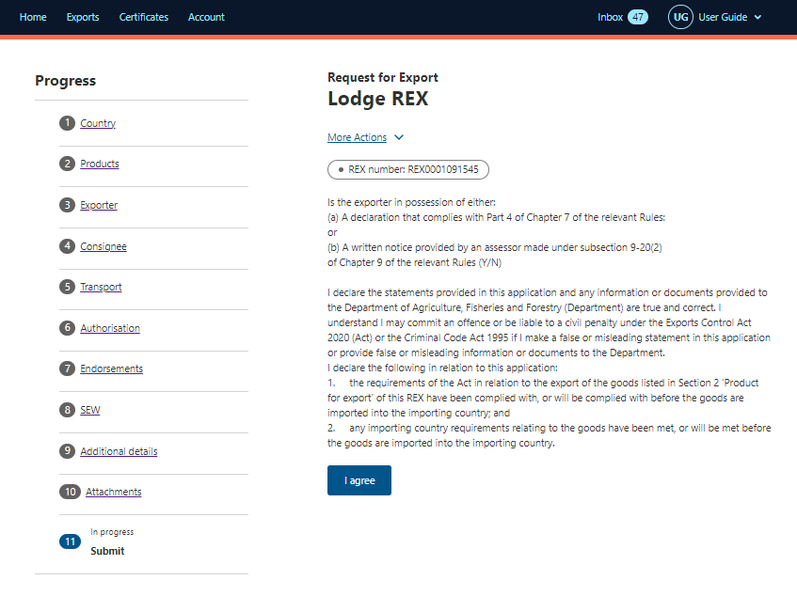  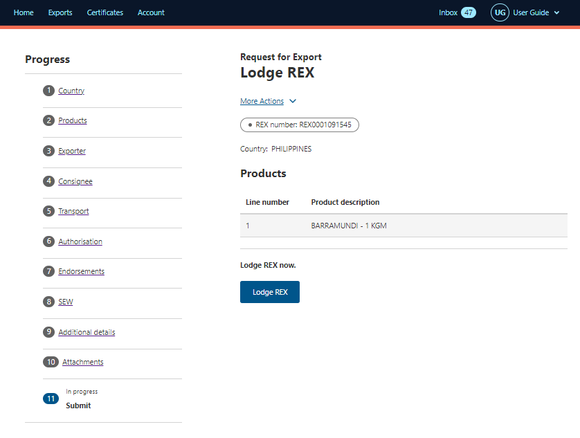
Step 3  A confirmation message will appear, alongside the Service ID associated with your application. Your REX is now awaiting assessment from a departmental officer. | 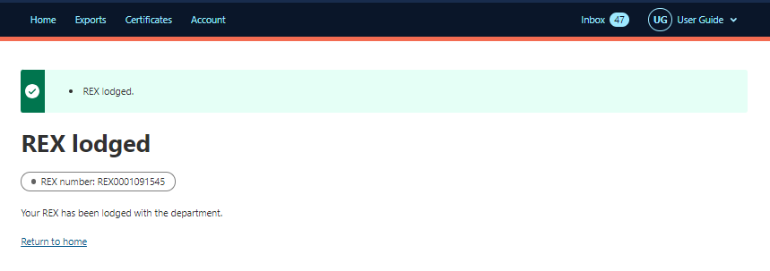

Contact the NEXDOC help desk
For more information or assistance, please contact NEXDOC@aff.gov.au

