# How to login to Learnhub

Accredited persons can access approved arrangement class 19 continued biosecurity competency activities and other resources through our Learnhub platform.

## Create a password and login to Learnhub

1. To access Learnhub, visit the following link or type it directly into the address bar of your internet browser: <https://www.learnhub.agriculture.gov.au>

Note: we recommend you bookmark this site for quick access.

1. Under the **Manual Login** field, click the **Forgot your password** button. This allows you to setup a password for the first time or create a new password.

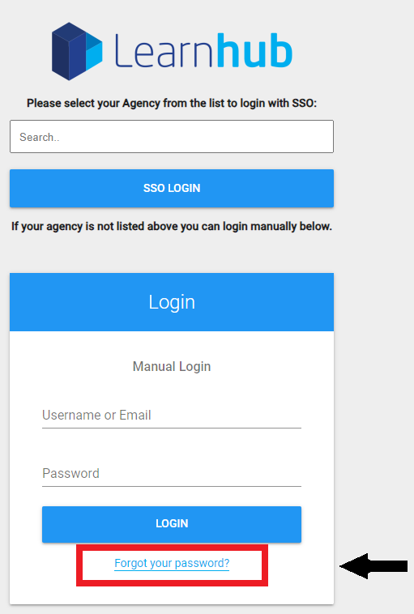

1. Type your email address into the **Enter your username** and **Confirm your username** fields.

Note: Your username/email is the unique email address that is registered with the department. If you are unsure of your registered email, please contact [AEPSupport@aff.gov.au](mailto:AEPSupport@aff.gov.au).

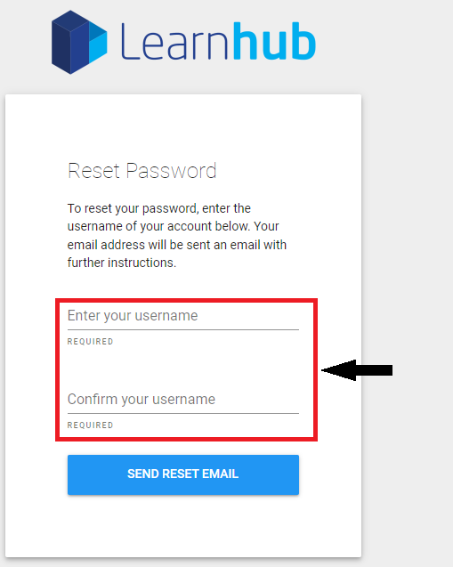

1. Click the **Send reset email** button to generate a password reset link.

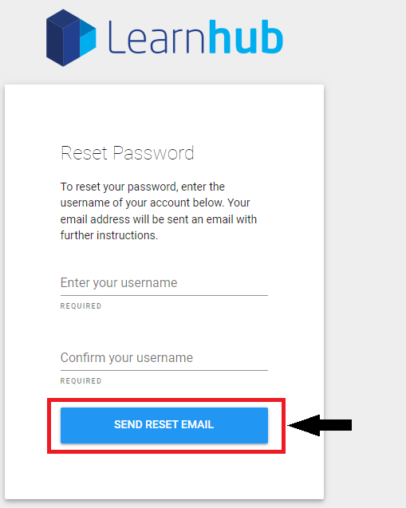

1. Head to your email inbox and follow the email instructions to setup a new password. The process will redirect you back to the Learnhub login page, where you will be prompted to create a new password.
2. You should now be able to login to Learnhub by completing the **Manual Login** fields (email and password) and selecting the **Login** button.

Note: the **SSO Login** option is not available for accredited persons.

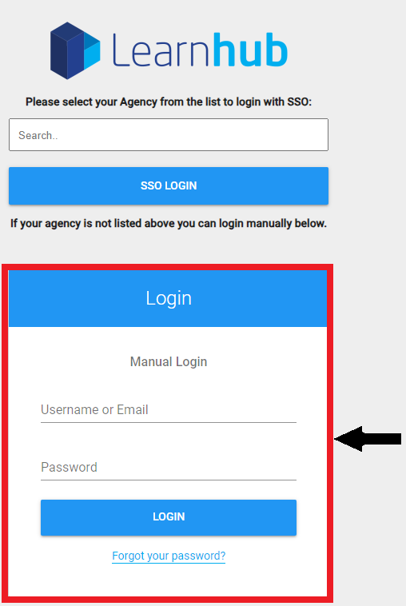

## More information

If you require further assistance, please email [AEPSupport@aff.gov.au](mailto:AEPSupport@agriculture.gov.au).

**Acknowledgement of Country**

We acknowledge the Traditional Custodians of Australia and their continuing connection to land and sea, waters, environment and community. We pay our respects to the Traditional Custodians of the lands we live and work on, their culture, and their Elders past and present.

© Commonwealth of Australia 2023

Unless otherwise noted, copyright (and any other intellectual property rights) in this publication is owned by the Commonwealth of Australia (referred to as the Commonwealth).

All material in this publication is licensed under a [Creative Commons Attribution 4.0 International Licence](https://creativecommons.org/licenses/by/4.0/legalcode) except content supplied by third parties, logos and the Commonwealth Coat of Arms.

The Australian Government acting through the Department of Agriculture, Fisheries and Forestry has exercised due care and skill in preparing and compiling the information and data in this publication. Notwithstanding, the Department of Agriculture, Fisheries and Forestry, its employees and advisers disclaim all liability, including liability for negligence and for any loss, damage, injury, expense or cost incurred by any person as a result of accessing, using or relying on any of the information or data in this publication to the maximum extent permitted by law.