USER GUIDE

NEXDOC:
Lodge a Request for Export (REX) for honey and apiculture products for human consumption to the European Union (EU)

__________________________________________________________________________________
In this document
This document contains the following topics.
Purpose of this document 2
Start a new Request for Export (REX) 2
REX Section 1: Country details 4
REX Section 2: Product Details 5
REX Section 3: Exporter Details 17
REX Section 4: Consignee Details 18
REX Section 5: Transport Details 19
REX Section 6: Templates and Endorsements 21
REX Section 7: Single Electronic Window (SEW) 21
REX Section 8: Additional Details 24
REX Section 9: Attachments 29
REX Section 10: Submit 30
Contact the NEXDOC help desk. 31

Purpose of this document
The below information will guide you through lodging a Request for Export (REX) and obtaining an eCert.
Certification for honey and apiculture products for human consumption to the EU is electronically exchanged between NEXDOC and the EU's platform, TRACES NT. This government-to-government exchange, referred to as eCert, eliminates the need for paper export certificates.

Start a new Request for Export (REX)
Step 1  Log in to the Online Services Portal. | 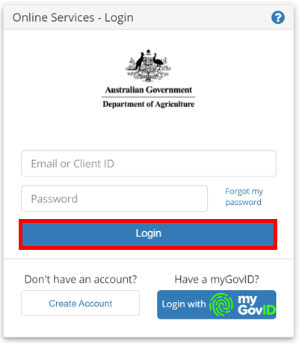
Step 2  Select Go to NEXDOC Homepage. | 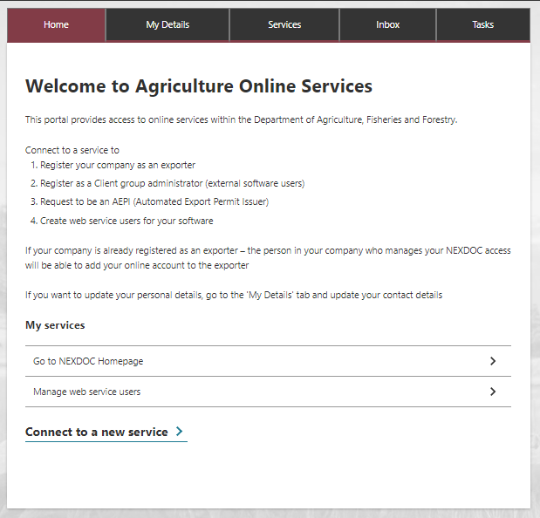
Step 3  Select Start new Request for Export. | 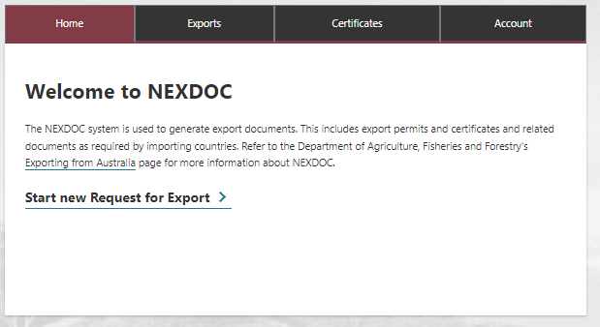
Step 4  Select the Commodity type of your export drop down menu. You will need to select Honey for a Honey REX.  This is a mandatory field.  Then select Start. | 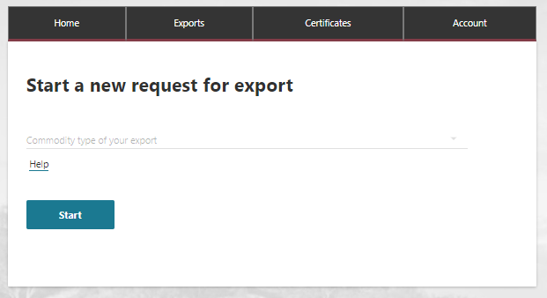

REX Section 1: Country details
Step 1  Type the Country you wish to export to drop down menu. You will need to select your final destination country, then select Next.  This is a mandatory field.  Note: You will need to select a country that is part of the EU TRACES NT group. | 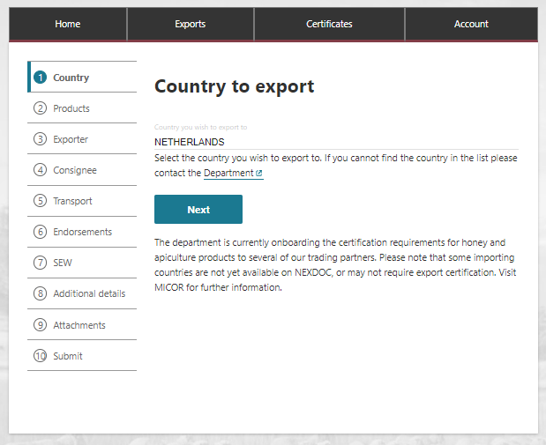

REX Section 2: Product Details
Step 1  Select the Add a product for export button. | 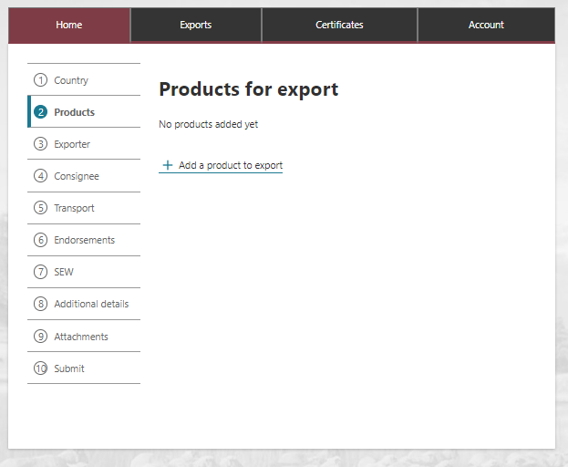
Step 2  Select Product you wish to export drop down menu.  You will need to select Honey (Edible).  This is a mandatory field. | 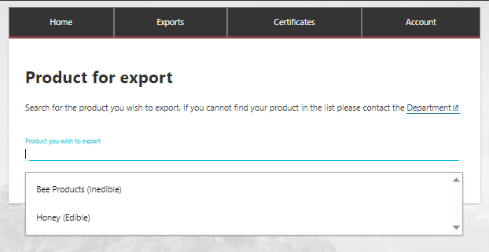
Step 3  Select a suitable option from the What is the product category? drop down menu.  This is a mandatory field. | 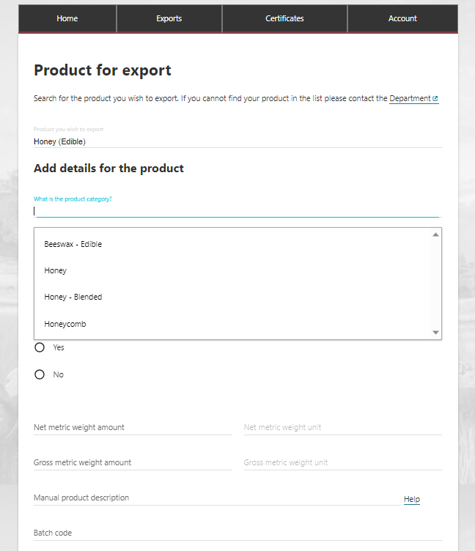
Step 4  Select a suitable option from the What is the product packed in? drop down menu.  This is a mandatory field. | 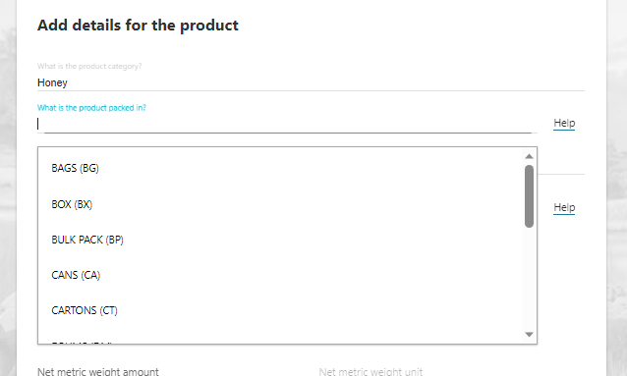
Step 5  Select a suitable option from the Preservation drop down menu  This is a mandatory field. | 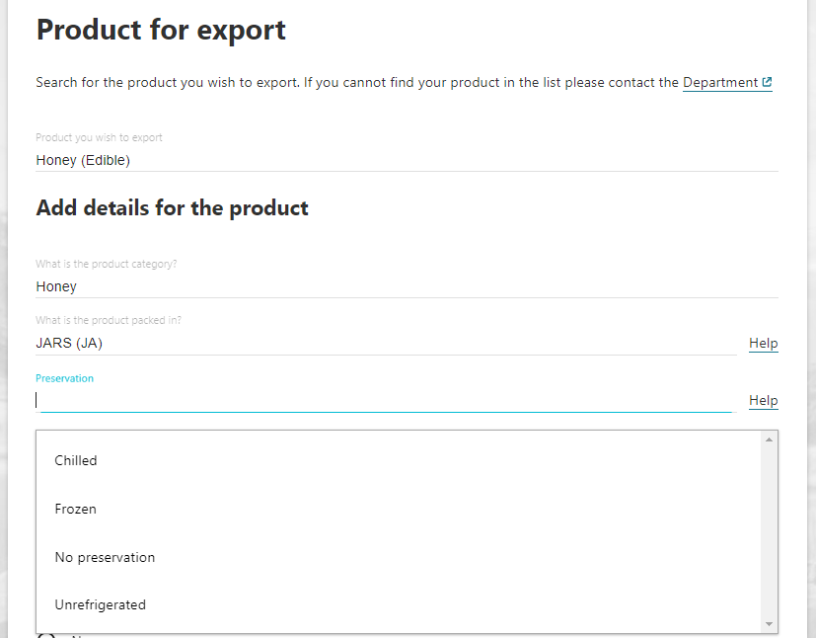
Step 6  Select the relevant AHECC code for the product.  This is only a mandatory field if you are using the Single Electronic Window (SEW) connection to obtain an Export Declaration Number (EDN) via NEXDOC. | 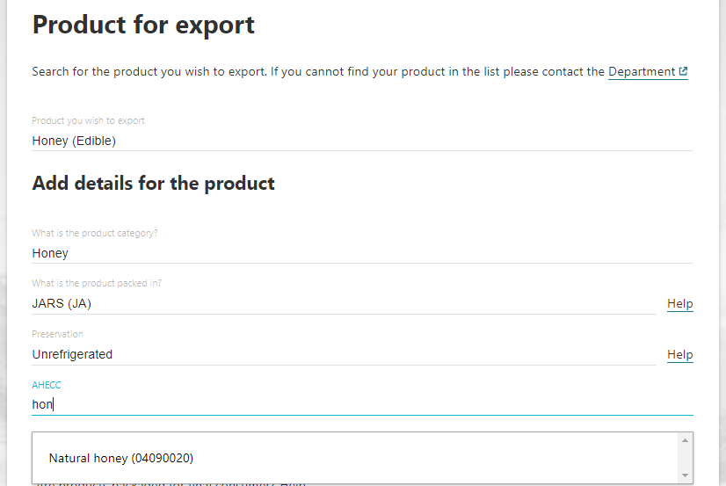
Step 7  Select the CN Code (Combined Nomenclature) for the product.  This is a mandatory field. | 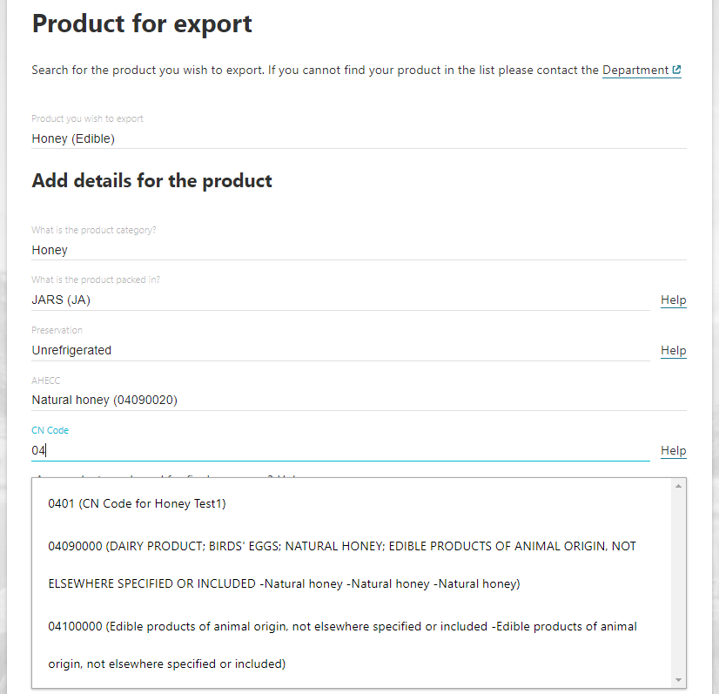
Step 8  Indicate if the product is packaged for the Final Consumer.  This is a mandatory field. | 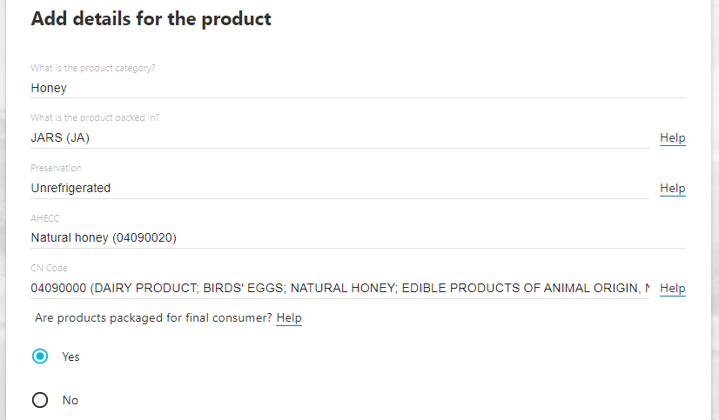
Step 9  - Provide the Net metric weight amount and the Gross metric weight amount. You will need to provide the Unit of measure for both these fields.  These fields are mandatory.  Note: You do not need to provide a manual description for EU markets. The manual product description information is not used for EU certification. | 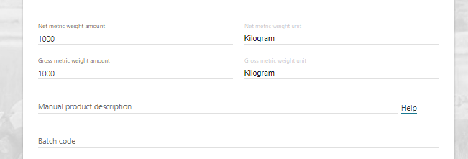
Step 10  - Provide the Batch Code.  This field is mandatory.  This field has limit of 30 characters. | 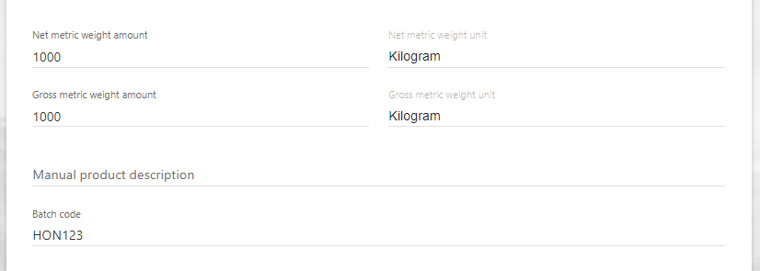
Step 11  Provide the Outer Packaging details.  The Package Type, Quantity, Individual Package Weight, and Weight Unit are mandatory fields.  Shipping marks are optional.  This field has limit of 30 characters. | 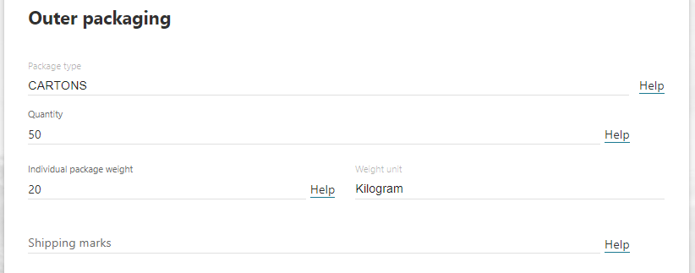
Step 12  The below information relates to Additional details for the product.  For this market, details relating to the Production processes are mandatory.  Details for Additional Details are mandatory.  Details relating to Containers are optional.  Details relating to SEW are optional. However, if you wish to use SEW and obtain your EDN, then in this tab the Net weight amount, Net weight unit and FOB amount fields become mandatory. | 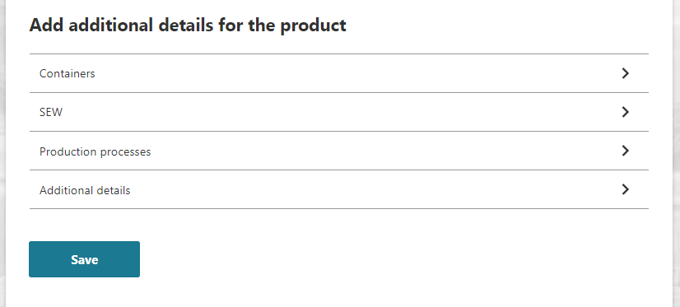
Step 13
Select Production processes
Step 14  Select Add production process. | 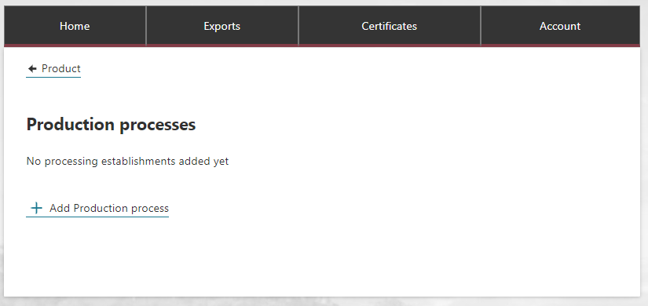
Step 15  Provide the Process start date and Process end date.  These are mandatory fields.  Select Add.  Note: The manufacturing plant must be export listed for this market at the time of both the Process Start and End Dates. | 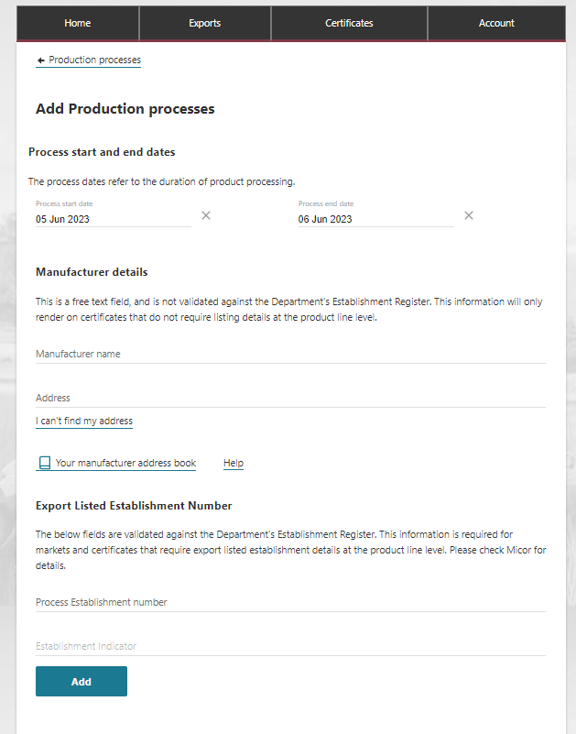
Step 16  Select Product to go back to the product screen | 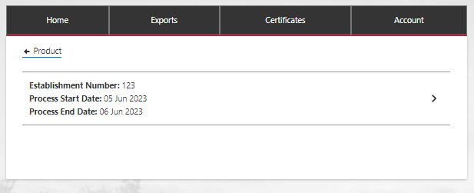
Step 17  Select the Additional Details tab. | 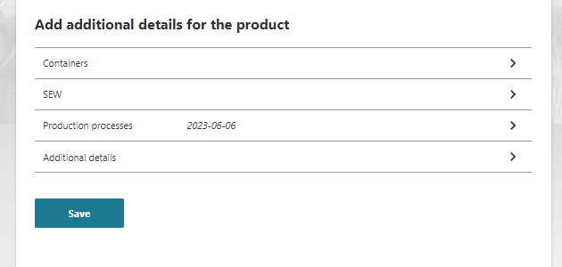
Step 18  Select the relevant EU Treatment Type.  This is a mandatory field.  The other fields on this screen are optional for this market. | 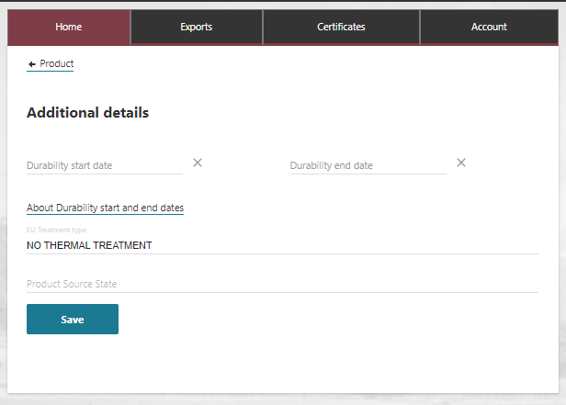
Step 19
Select Save.
You will return to the Product screen.
Step 20  If you wish to add container details, select the Containers tab.  Container details are optional for this market. | 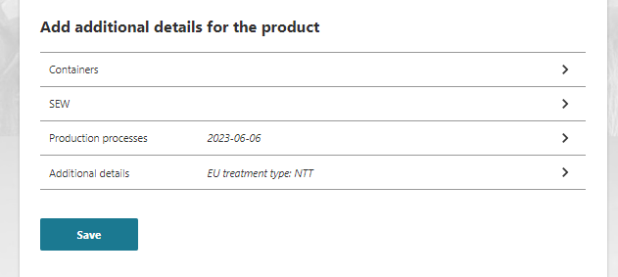
Step 21  Select the relevant type of freight container then select Add container.  Note: If provided for one product line, they must be provided against all product lines. | 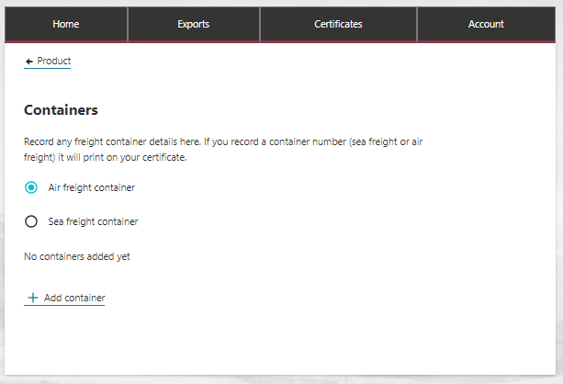
Step 22  If Air Freight  Provide the Container number for the Air Freight container.  If seal numbers are available, select Add seal number and provide the Start seal number and End seal number.  Select Add.  Note: Optional fields. | 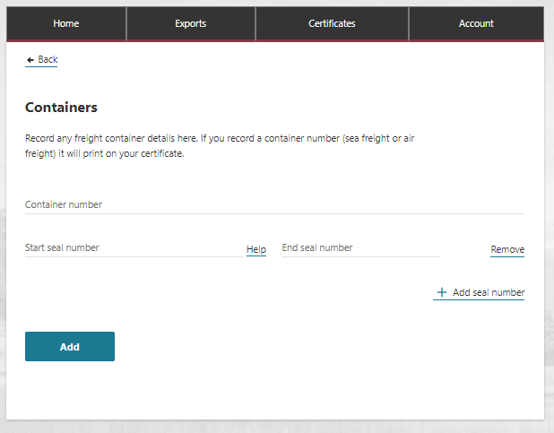
Step 23  If Sea Freight  Provide the Container number for the Sea Freight container.  Select Add seal number and provide the seal number.  Select Add.  Note: Optional fields. | 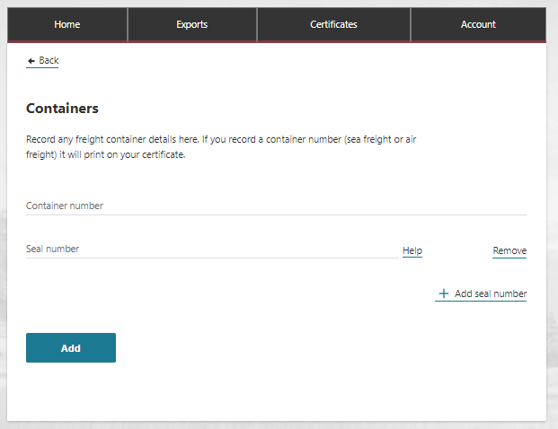
Step 24  Select Product. | 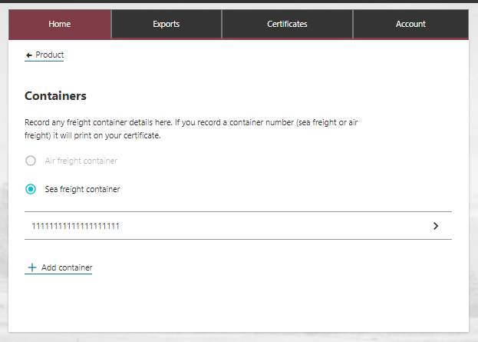
Step 25  If you wish to use SEW, select the SEW tab.  Information in this tab is optional. | 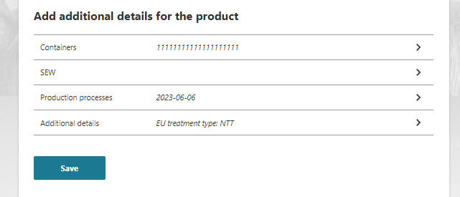
Step 26  SEW information is optional.  This information becomes mandatory if you are using the Single Electronic Window (SEW) connection to obtain an Export Declaration Number (EDN) via NEXDOC.  Select Save to return to the product page | 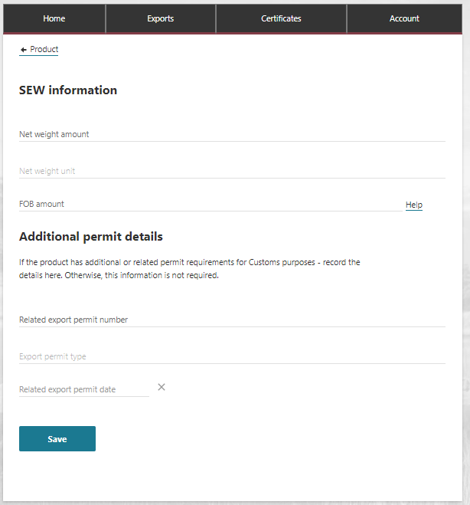
Step 27  Select the Save button on the Product for export tab. | 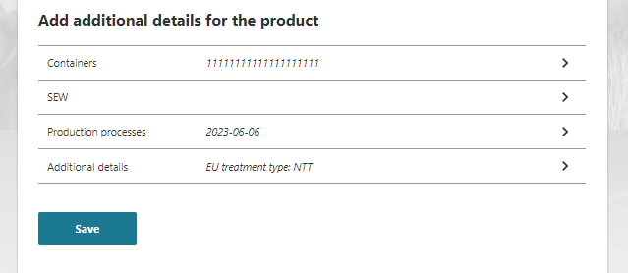
Step 28  Your REX application has been saved and assigned a REX number.  If desired, you may add additional product lines by selecting Add a product to export or Copy a product line.  This is an optional feature. | 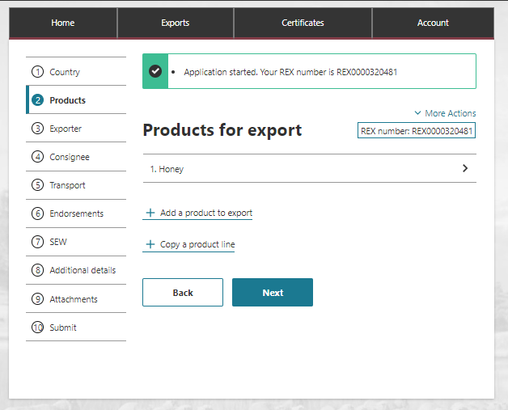
Step 29
Once all necessary products are added to the REX, select Next.

REX Section 3: Exporter Details
Step 1  Exporter details are prepopulated from your exporter registration for NEXDOC.  If you need to update these details, select Edit exporter details.  If you wish to use your other exporter details for the consignment, please select Request new exporter.  Provide your Exporter Reference.  This is a mandatory field.  Select Save and next. | 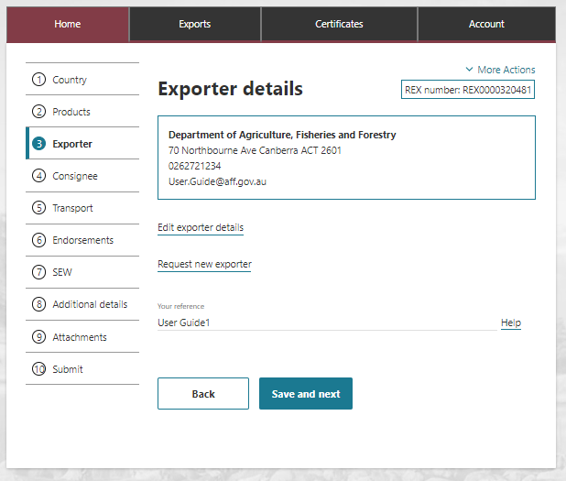

REX Section 4: Consignee Details
Step 1  Provide the consignee Name. This is a mandatory field.  Provide the consignee Phone number, if known. This is an optional field.  Provide the consignee Address. This is a mandatory field. | 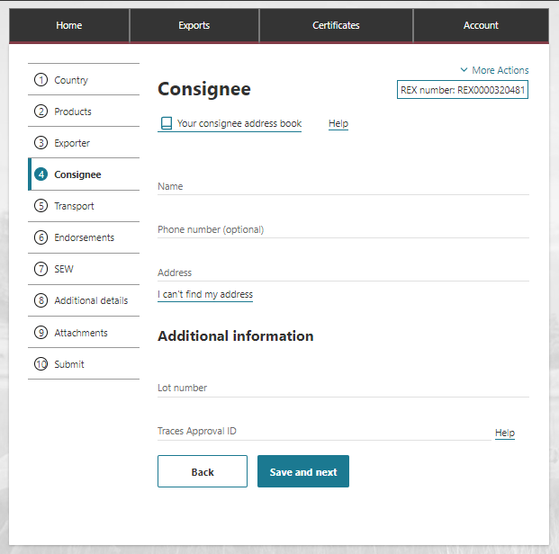
Step 2  Provide the Consignee’s TRACES Approval ID. The consignee is issued this number by the European Union and should provide it to you. It will be validated in the EU TRACES NT system. This is a mandatory field.  Select Save and next.  The Consignee’s TRACES Approval ID must be recorded in NEXDOC prior to lodging your REX, as well as in each REX application. Contact the NEXDOC Help Desk to request your Consignee TRACES Approval ID to be added to the system. | 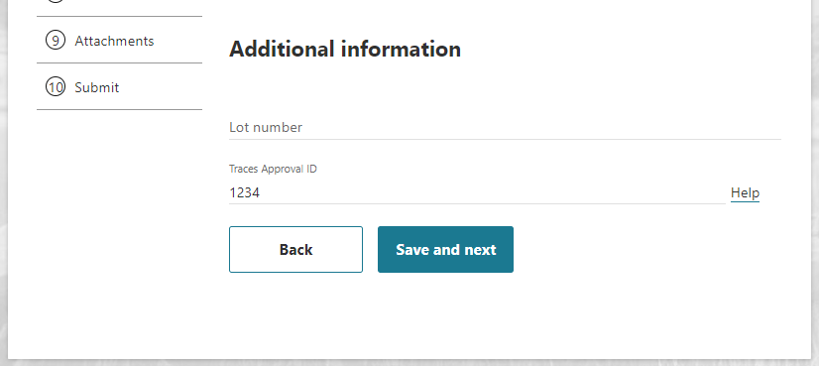

REX Section 5: Transport Details
Step 1  Enter the Departure Date. The date must be in the future and is a mandatory field.  Select the Load Port from the drop-down menu. This is a mandatory field.  Select the Discharge Port from the drop-down menu. This is an optional field.  Select the Border Inspection Port from the drop-down menu. This is a mandatory field and must be an EU port.  Provide the Destination City. This is a mandatory field.  Transit Countries is an optional field. | 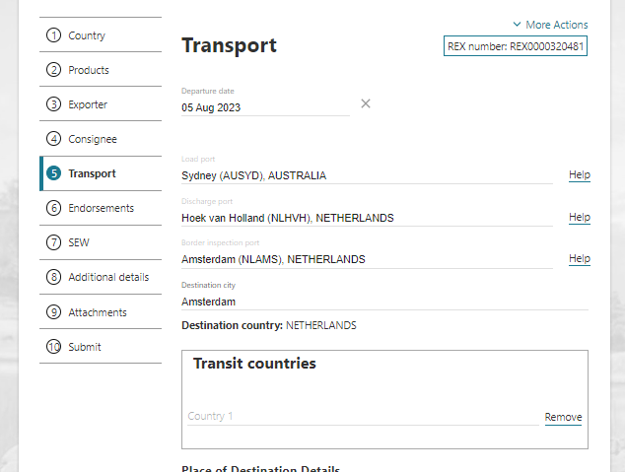
Step 2  Enter the Place of Destination details.  Provide the Approval Number for the Place of Destination.  The EU issues this number to the establishment of destination.  It will be validated in the EU TRACES NT system. This is a mandatory field.  Provide the Destination Business Name.  This should reflect the business name per the EU TRACES NT records.  This is a mandatory field.  Enter the Place of Destination Address.  This is a mandatory field. | 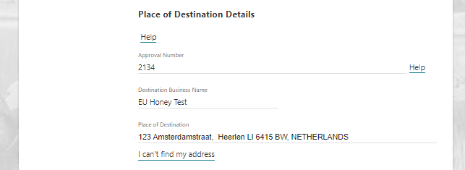
Step 3  Select the Transport Mode. It is mandatory to select either Sea or Air | 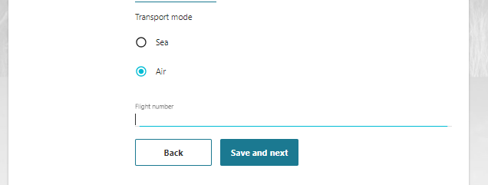
Step 4  If you select Sea, you must provide the Vessel Name and Voyage Number. These are mandatory fields. | 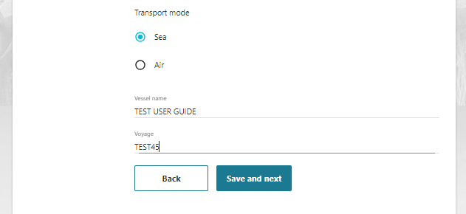
Step 4  If you select Air, you must provide the Flight Number. This is a mandatory field. | 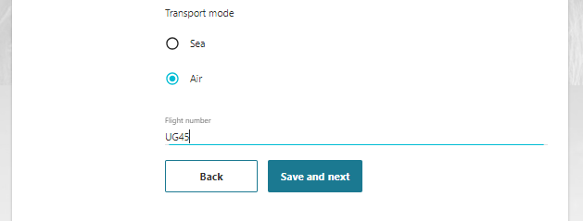
Step 5
Select Save and next.

REX Section 6: Templates and Endorsements
Step 1  No paper certificate will be issued for this market, and consequently you will be provided an ‘extract’ of the information that was sent to EU TRACES NT via NEXDOC.  The system will automatically allocate you the appropriate extract template, which you will receive when your REX reaches the status of Complete.  No action is required on this screen.  Select Next. | 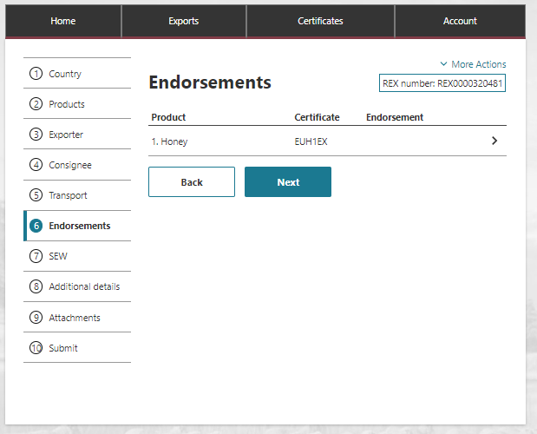

REX Section 7: Single Electronic Window (SEW)
Step 1  If you are not using SEW, then select Save and Next.  Move to Rex Section 8: Additional details.  If you are using Single Electronic Window (SEW) you will need to complete the details on this screen.  Continue to step 2. | 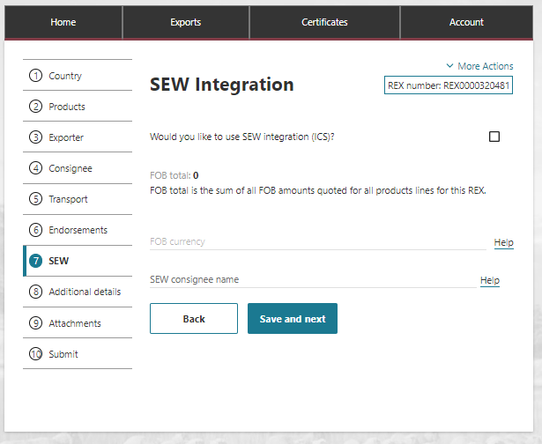
Step 2  If you are using Single Electronic Window (SEW) you will need to complete the details on this screen.  Tick the box next to Would you like to use SEW integration (ICS)?  Complete the FOB currency and SEW consignee name.  Select Save and Next.  Note:  - You must have requested access to SEW in your exporter registration for this to be available. Alternatively, you can update your account and request this permission.  - If you wish to use the SEW connection, you must have provided the relevant details in each of your product lines.  These are optional fields. | 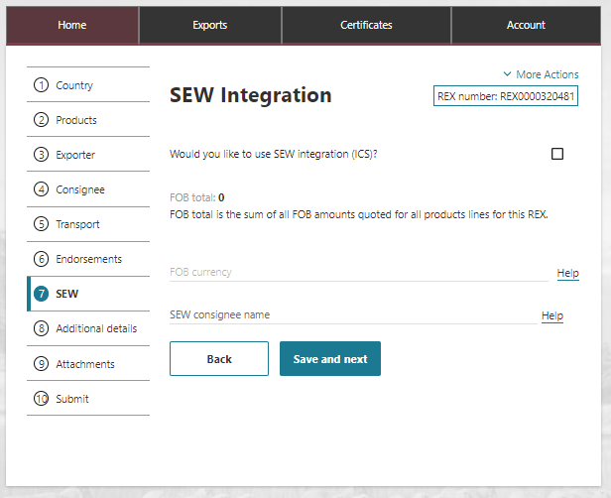

REX Section 8: Additional Details
Step 1  Select your Certificate Print Indicator  You must select Automatic or Hold.  This selection is mandatory.  Please view the NEXDOC Printing FAQ on the NEXDOC Help Page for further information regarding these options. | 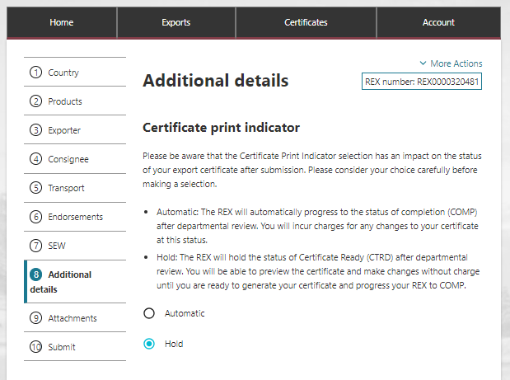
Step 2  Selecting the Use your own printer tick box will allow you to print your eCert extract remotely rather than needing to collect it from a regional department office.  If you do not have this option on screen, please request this permission via your registered NEXDOC exporter account. | 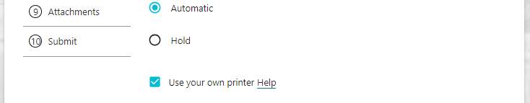
Step 3  If you do not wish to print remotely, you must select an available regional office from the Print region to print your extract.  You will need to contact the department’s Assessment Services (Exports) team to make arrangements to collect your eCert extract. | 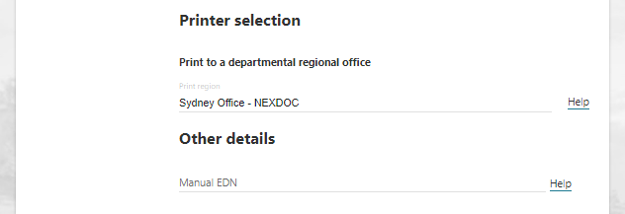
Step 4  Should you wish to save your import permit number and import permit date within your REX, select Add import permit.  This is an optional feature. | 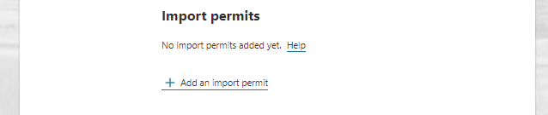
Step 5  Provide your Import permit number and Import permit date.  These are optional fields.  If provided, the import permit date must be in the past.  Select Save. | 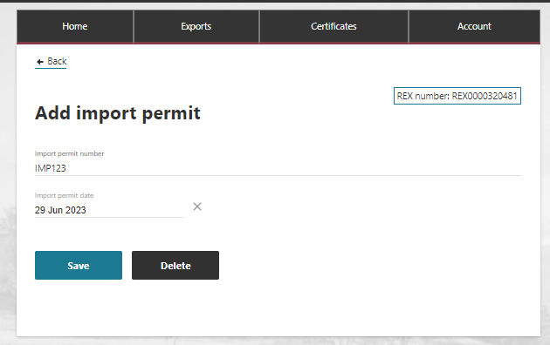
Step 6  Your import permit has saved, and you will return to the Additional details page. | 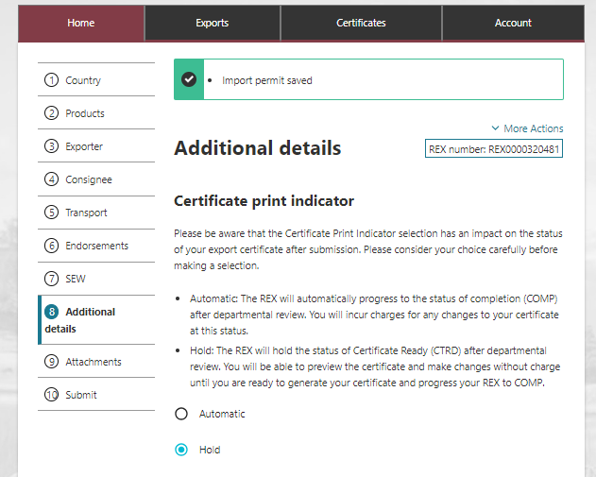
Step 7  Place of Dispatch  Enter the export establishment number for the Place of Dispatch. The establishment must be export listed for this market.  This number is issued by the department and validated against the department’s Establishment Register.  This is a mandatory field. | 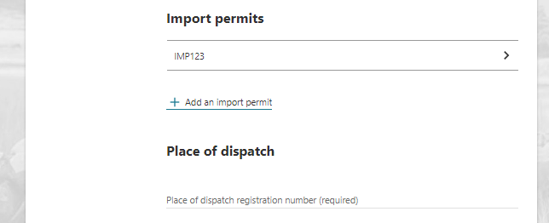
Step 8  Primary Manufacturing Plant Details  Enter the export establishment number for the Manufacturing Plant that produced the goods. The establishment must be export listed for this market.  This number is issued by the department and validated against the department’s Establishment Register.  This is a mandatory field.  If only one manufacturer was involved in manufacturing the goods, please skip  Steps 9-12 and select Save and next. | 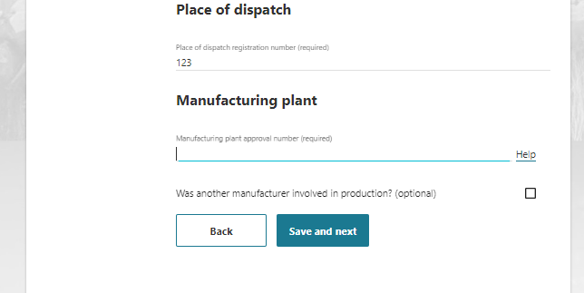
Step 9  Secondary Manufacturer Details (if applicable)  The below information is only applicable if a secondary manufacturer was involved in the production of the goods.  If there was another manufacturer involved in the production of the products, tick the Secondary Manufacturing plant tick box.  If you select the Secondary Manufacturer tick box, indicate if the other manufacturer that contributed to the production of the goods is Australian or Overseas.  This is a mandatory field if you indicated there is a secondary manufacturer. | 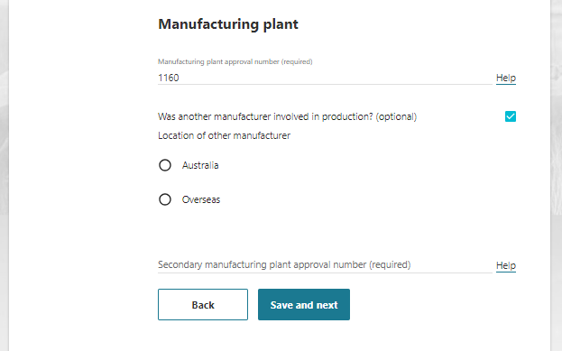
Step 10  Australian manufacturer  If you indicated that there is a second Australian manufacturer, enter the manufacturer’s export establishment number.  This number is issued by the department and validated against the department’s Establishment Register. The establishment must be export listed for this market.  This is a mandatory field. | 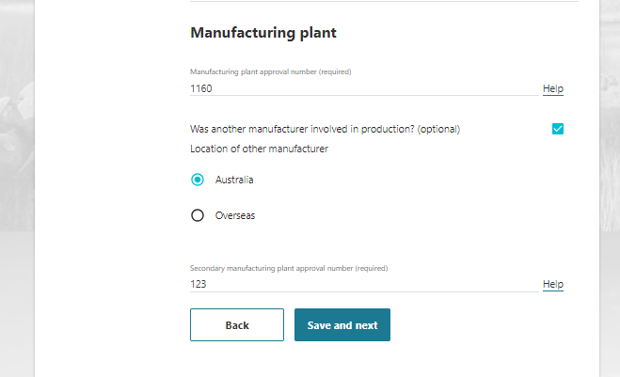
Step 11  Overseas manufacturer  If you indicated that there is an Overseas manufacturer involved:  Enter the manufacturer’s operator activity identification (that they hold in EU TRACES NT) into the Secondary Manufacturing Approval Number field.  This number is validated in the system.  This is a mandatory field.  Enter the Name of the manufacturer  This is a mandatory field.  Select the manufacturer’s Country from the drop-down list.  This is a mandatory field. | 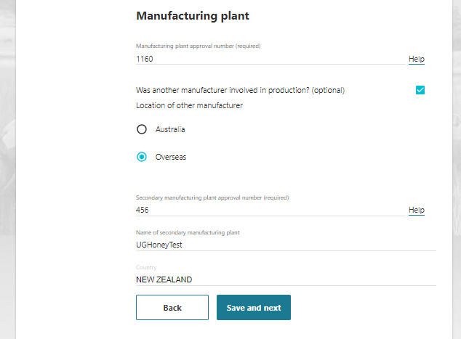
Step 12  Select Save and next. | 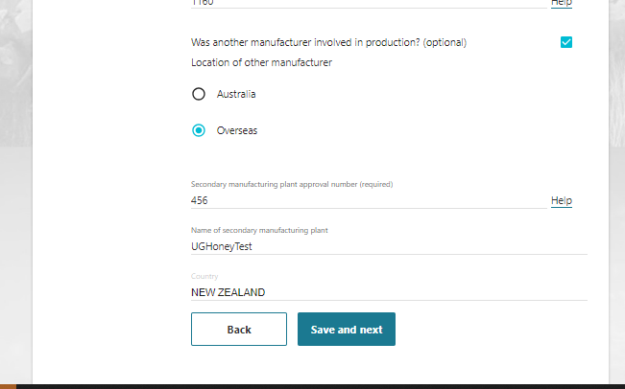

REX Section 9: Attachments
Step 1  Each REX is assessed against importing country requirements. You must provide all relevant documentation to support your request for certification. This may include, but is not limited to, an import permit and manufacturers declarations.  Please liaise with your importer and check MICOR for specific details.  If required, select Add attachment. | 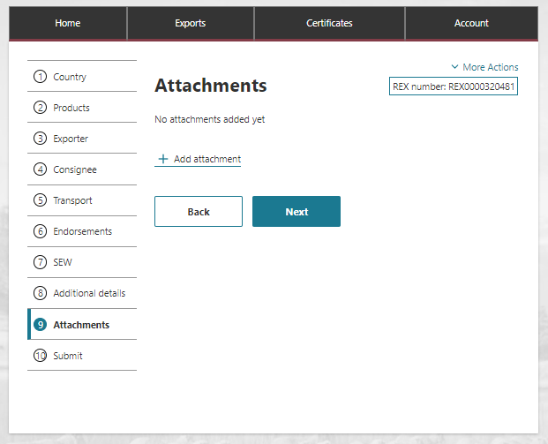
Step 2  Select the drop-down menu and indicate the Document type.  This is a mandatory field if you are attaching a document.  Provide a Comment in relation to your attachment, if applicable.  This is an optional field.  Select or drag and drop the file to attach.  Select Save. | 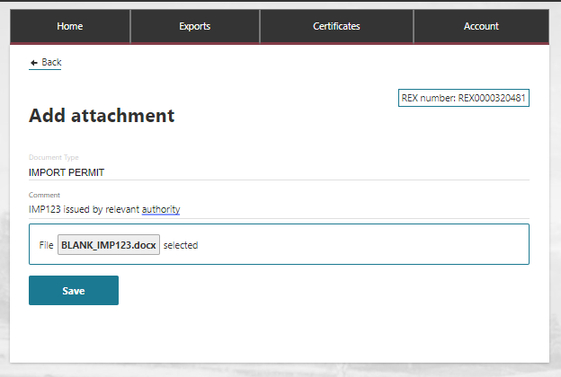
Step 3  Attach all necessary documentation to support your application. A departmental officer will review these documents when assessing your REX.  Select Next. | 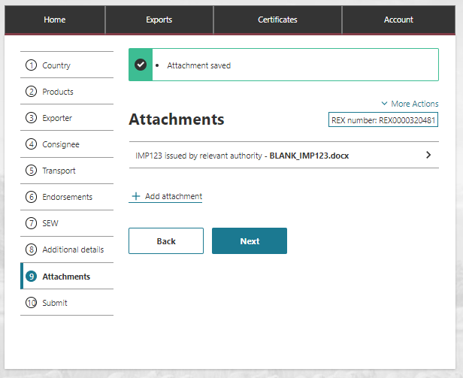

REX Section 10: Submit
Step 1  The Declaration will display. Please read this carefully.  If you wish to proceed with your lodgement, select I agree. | 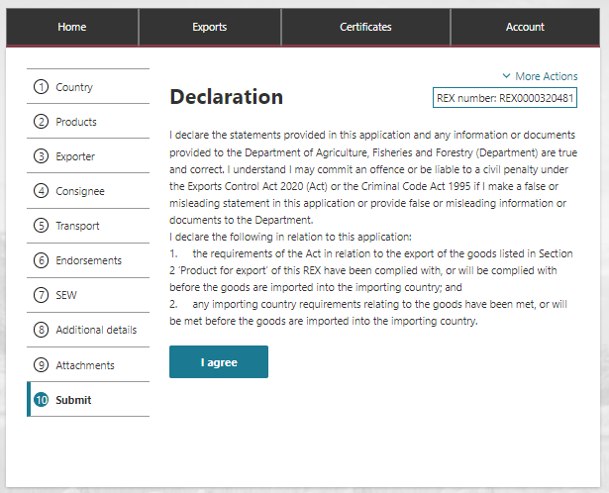
Step 2  The destination country and products will display. If there are no changes required, select Lodge REX. | 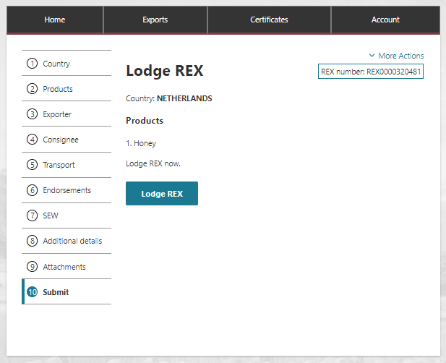
Step 3  A confirmation message will appear, alongside the Request Id associated with your application. Your REX is now awaiting assessment from a departmental officer. | 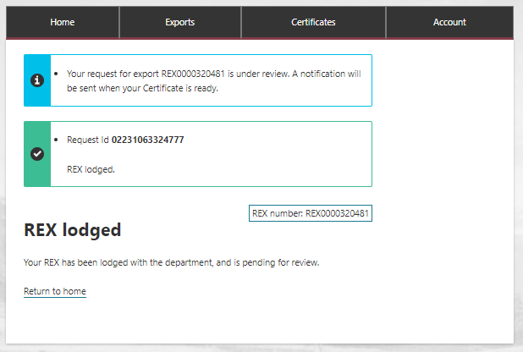

Contact the NEXDOC help desk.
For more information or assistance, please contact NEXDOC@aff.gov.au

