USER GUIDE

NEXDOC:
Adding an Exporters TRACES ID for honey

__________________________________________________________________________________
In this document
This document contains the following topics.
Purpose of this document 2
Adding an Exporters TRACES ID for honey 2
Contact the NEXDOC help desk. 9

Purpose of this document
This document will guide exporters on how to update their account to include their Exporters TRACES ID.
Note: If you do not already have a user account, please refer to Create and Manage your account user guide for instructions on how to complete this registration.
Note: For information on how exporters obtain their TRACES exporter number, please refer to EU TRACES New Technology (NT) - Frequently Asked Questions

Adding an Exporters TRACES ID for honey
Step 1  Log in to NEXDOC. | 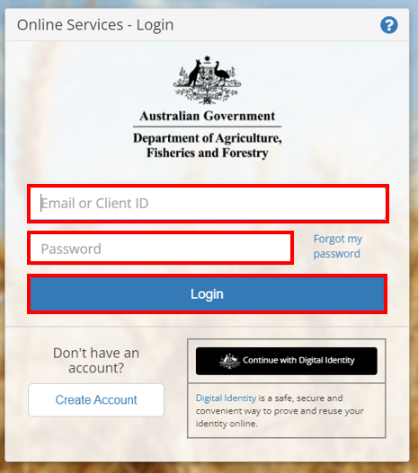
Step 2  Select Go to NEXDOC Homepage | 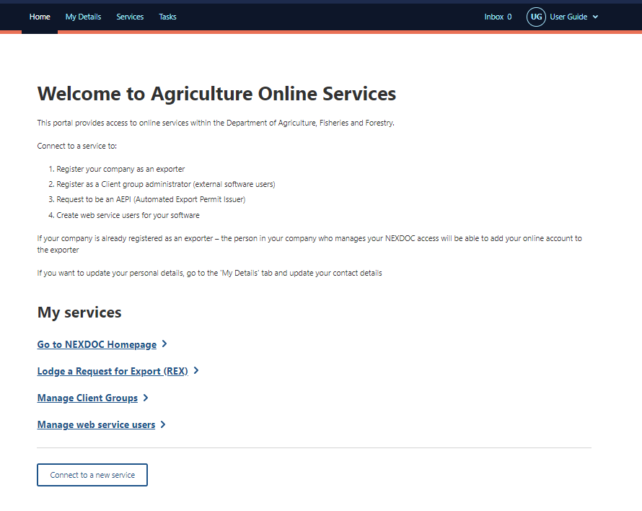
Step 3  Select Account tab. | 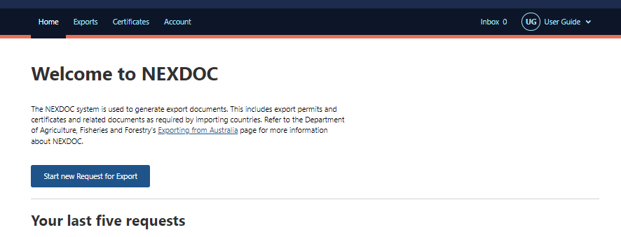
Step 4  Select NEXDOC services tab. | 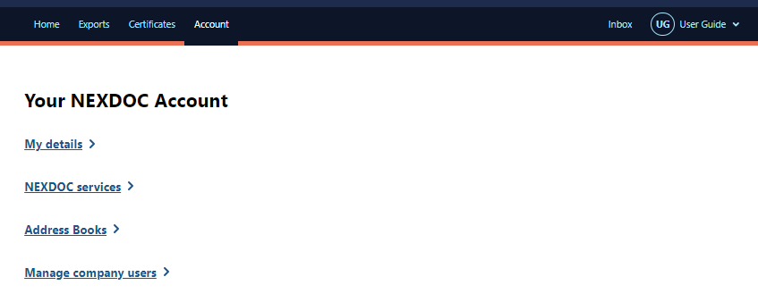
Step 5  Select Exporter Management tab. | 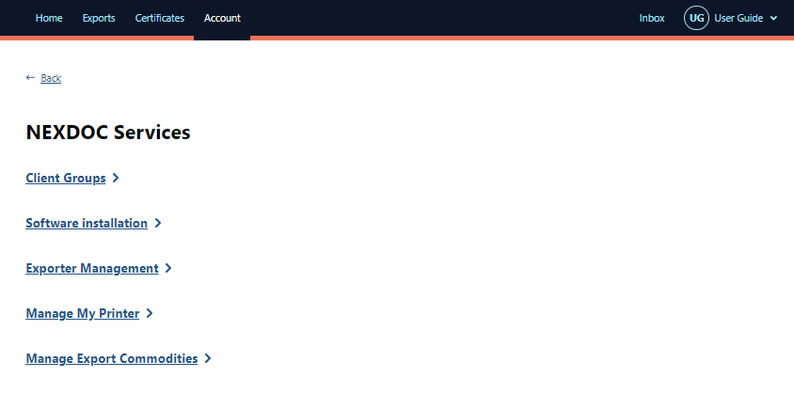
Step 6  Select the exporter profile you need to update. | 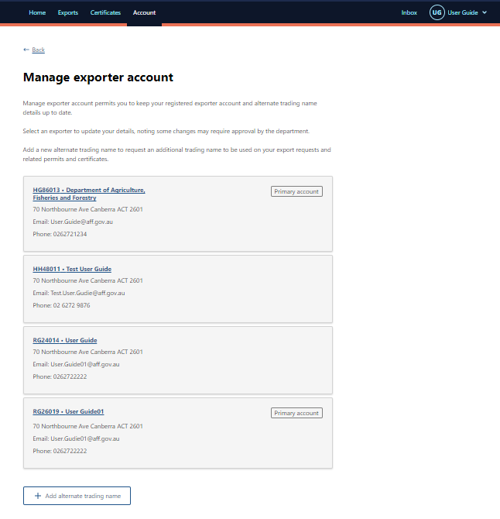
Step 7  Type your TRACES exporter number in the EU TRACES exporter number field. | 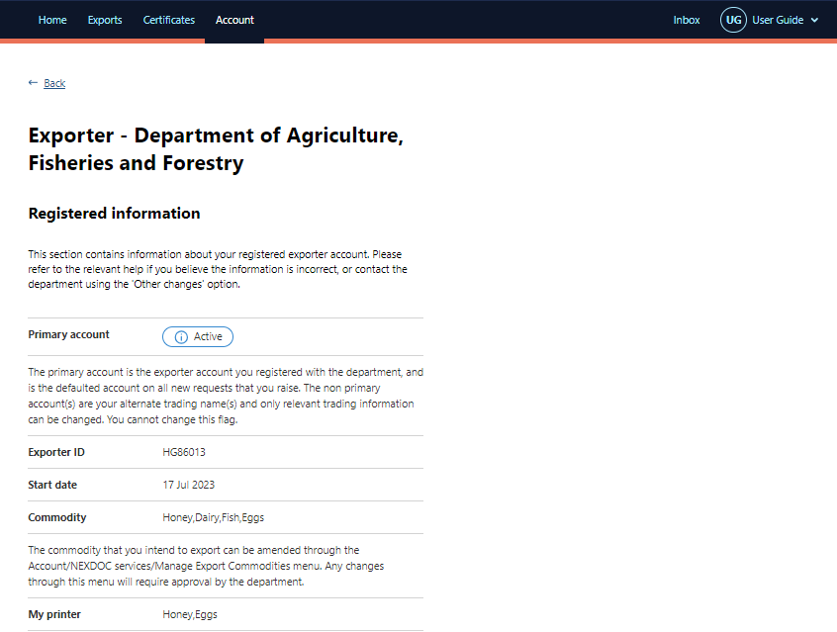  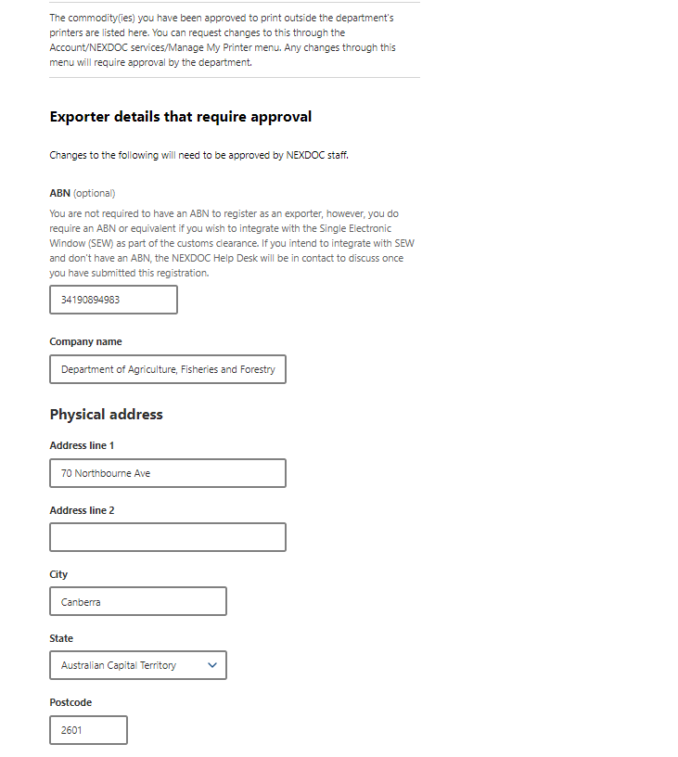  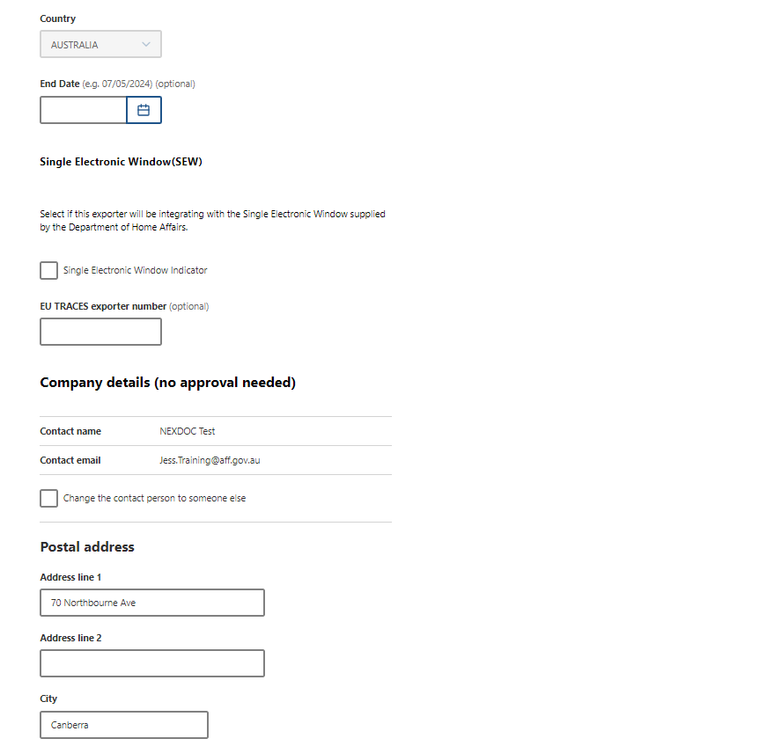  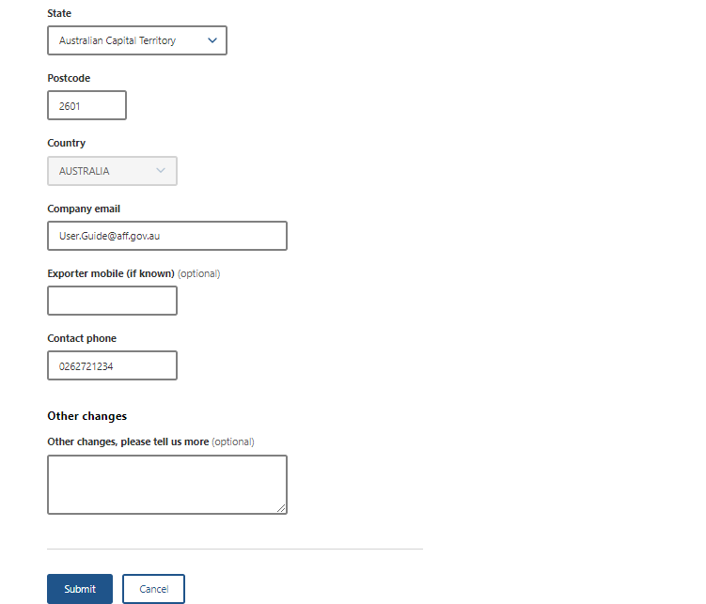

Step 8  Select Submit. | 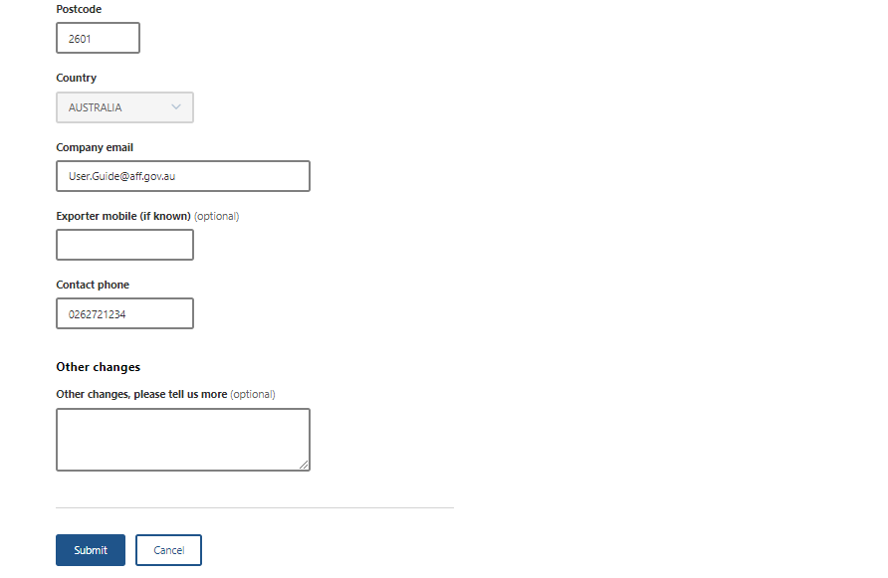
Step 9  Your TRACES exporter number update has now been lodged with the department. | 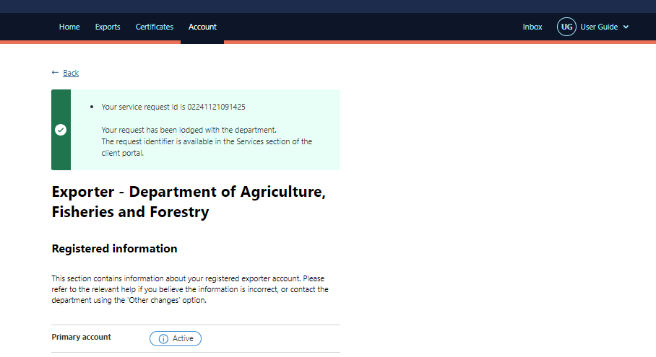
Step 10  Once your request has been actioned by the department, you will receive a notification in your NEXDOC inbox. | 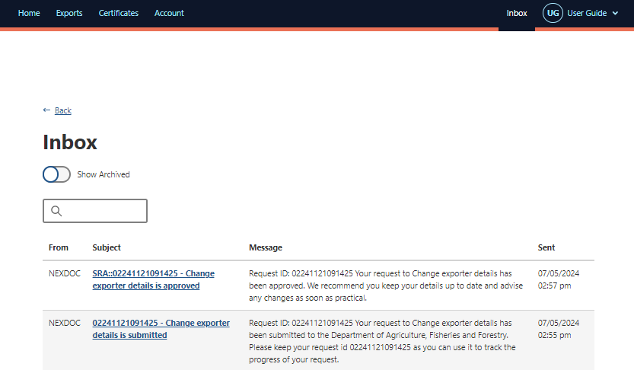
If your TRACES exporter number is rejected, the notification will provide the reason for this decision. Complete steps 3 to 8 to re-lodge.

Contact the NEXDOC help desk.
For more information or assistance, please contact NEXDOC@aff.gov.au

