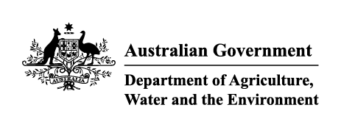

# Instrument revoking a holding order 15(6)

Section 15(6) of the *Imported Food Control Act 1992* (the Act)

The following holding order(s), having satisfied the circumstances specified for revocation, is/are revoked under section 15(6) of the Act.

| Holding order number | Date revoked |
| --- | --- |
| THO21001 | 24/09/2021 |
|  |  |

**Delegate position number Date**

| 100968 | 29/09/2021 |
| --- | --- |

Delegate of the Secretary for the purposes of section 15(6) of the Act.