# Methyl bromide fumigation guide

Performing quarantine pre-shipment (QPS) fumigations with methyl bromide

Version 2.0

© Commonwealth of Australia 2024

**Ownership of intellectual property rights**

Unless otherwise noted, copyright (and any other intellectual property rights) in this publication is owned by the Commonwealth of Australia (referred to as the Commonwealth).

**Creative Commons licence**

All material in this publication is licensed under a [Creative Commons Attribution 4.0 International Licence](https://creativecommons.org/licenses/by/4.0/legalcode) except content supplied by third parties, logos and the Commonwealth Coat of Arms.



**Cataloguing data**

This publication (and any material sourced from it) should be attributed as: DAFF 2024, *Methyl bromide fumigation guide V2.0*, Department of Agriculture, Fisheries and Forestry, Canberra, July. CC BY 4.0.

This publication is available at [Methodologies and documents for biosecurity treatments - DAFF (agriculture.gov.au)](https://www.agriculture.gov.au/biosecurity-trade/import/arrival/treatments/treatments-fumigants#methyl-bromide-fumigation_2).

Department of Agriculture, Fisheries and Forestry

GPO Box 858 Canberra ACT 2601

Telephone 1800 900 090

Web [agriculture.gov.au](https://www.agriculture.gov.au/)

**Disclaimer**

The Australian Government acting through the Department of Agriculture, Fisheries and Forestry has exercised due care and skill in preparing and compiling the information and data in this publication. Notwithstanding, the Department of Agriculture, Fisheries and Forestry, its employees and advisers disclaim all liability, including liability for negligence and for any loss, damage, injury, expense or cost incurred by any person as a result of accessing, using or relying on any of the information or data in this publication to the maximum extent permitted by law.

**Acknowledgements**

The authors would like to thank the participants for their input.

**Acknowledgement of Country**

We acknowledge the Traditional Custodians of Australia and their continuing connection to land and sea, waters, environment and community. We pay our respects to the Traditional Custodians of the lands we live and work on, their culture, and their Elders past and present.

### Purpose

This guide provides detailed information and further explanation of the various methods and techniques that can be used by fumigators to meet the requirements of the *Methyl Bromide Fumigation Methodology*.

### Scope

This document is not intended to specifically cover the performance of methyl bromide fumigation treatments under ISPM 15, however, the basic principles, requirements and recommendations described in this document and the associated guideline are still generally applicable.

Even though the basic principles and requirements would be relevant, this document is not intended to specifically cover fumigations of vessels, whether it is the vessel itself or its cargo, silos or other storage facilities, buildings or other fumigations not done in the types of enclosure described herein and not related to import or export.

### How to use this document

This document should be read in conjunction with the *Methyl Bromide Fumigation Methodology* which specifies the minimum requirements that must be met by fumigators when performing QPS methyl bromide fumigations.

This document covers the most commonly encountered fumigation situations and provides information on the methods that a fumigator may use to ensure a successful fumigation.

Contents

Purpose 3

Scope 3

How to use this document 3

1 Fumigator capability 7

1.1 Fumigation personnel 7

1.2 Fumigation equipment 8

1.3 Site suitability 9

2 Safety 11

2.1 Risk assessment 12

1.4 Personal Protective Equipment 14

3 Consignment suitability 17

3.1 Target of fumigation 17

3.2 Impermeable packaging, wrappings and surface coatings 18

3.3 Requirements for perishable commodity packaging 19

3.4 Load factors 19

3.5 Requirements for timber 20

4 Fumigation enclosures 23

4.1 All enclosures 23

4.2 Sheeted enclosures 25

4.3 Fumigation chambers 28

4.4 Vacuum Chamber 29

5 Preparing to fumigate 31

5.1 Exclusion Zone 31

5.2 Gas concentration monitoring equipment 34

5.3 Gas concentration monitoring locations 35

5.4 Gas concentration monitoring locations – perishable commodities 37

5.5 Temperature monitoring instrument locations 38

5.6 Methyl bromide supply pipes 40

5.7 Fans and heaters 41

5.8 Temperature in methyl bromide fumigations 42

6 Temperature used to calculate the dose 44

6.1 Ambient temperature fumigations 44

6.2 Controlled temperature fumigations 45

6.3 Perishable commodity fumigations 45

7 Temperature used during the exposure period 46

7.1 Ambient temperature fumigations 46

7.2 Controlled temperature fumigations 48

7.3 Perishable commodity fumigations 49

8 Performing the fumigation 50

8.1 Dose rate compensation for temperature variation 50

8.2 Calculating the dose 50

8.3 Injecting methyl bromide into the fumigation enclosure 52

8.4 Even methyl bromide distribution 57

8.5 Exposure period 58

9 Monitoring the fumigation 59

9.1 Gas concentration monitoring 59

10 Topping up methyl bromide levels 61

10.1 Topping-up during the exposure period 62

10.2 Topping-up at the end of the exposure period 62

10.3 Performing the top-up 62

11 Ventilating the fumigation enclosure 64

11.1 Threshold limit value (TLV) 64

11.2 Releasing methyl bromide from the enclosure 65

11.3 Releasing the consignment from the control of the fumigator-in-charge 67

12 Documentation 68

12.1 Record of fumigation 68

12.2 Fumigation treatment certificate 70

13 Environment and recapture 72

13.1 Methyl bromide and the Montreal Protocol 72

13.2 Recapture technology 72

13.3 The department’s requirements 72

Appendix A: Commodities that may have adverse reactions to methyl bromide 73

Appendix B: List of fumigation records 75

Glossary 77

**Tables**

Table 1 Potential risks during fumigation 12

Table 2 Determining methyl bromide concentrations with the halide detector 56

Table 3 Standard concentrations required at specific monitoring times 60

**Figures**

Figure 1 Illustration of a gas cylinder supply system for methyl bromide 14

Figure 2 Compliant timber fumigation penetration 20

Figure 3 Non-compliant timber shape examples 20

Figure 4 Coated timber surface requirements 21

Figure 5 Stacked timber requirements 22

Figure 6 Exclusion zone with one or more walls 32

Figure 7 Exclusion zone outdoors 33

Figure 8 Exclusion zone indoors 33

Figure 9 Single container enclosure monitoring locations 36

Figure 10 Double container sheeted enclosure monitoring locations 36

Figure 11 Monitoring tube in a perishable fruit package 37

Figure 12 Monitoring tube in a package of cut flowers 38

Figure 13 Flowchart for determining temperature requirements 48

Figure 14 Vaporiser design 53

Figure 15 Copper tubing with progressively increasing diameter to avoid back pressure 54

Figure 16 Equilibrium calculation 57

Figure 17 Example of a ventilation/exhaust system for a fumigation chamber 66

Figure 18 Record of Fumigation (non perishable) Section A and B 68

Figure 19 - Record of Fumigation (non perishable) Section C 68

Figure 20 - Record of Fumigation (non perishable) Section D 68

Figure 21 Record of Fumigation (non perishable) Section E 68

Figure 22 Record of Fumigation (perishable) Section A and B 69

Figure 23 Record of Fumigation (perishable) Section C 69

Figure 24 Record of Fumigation (perishable) Section D 69

Figure 25 Record of Fumigation (perishable) Section E 69

Figure 26 Fumigation certificate example 71

## Fumigator readiness

The fumigator capability section of the methodology covers three areas critical to ensuring the successful performance of a fumigation for quarantine pre-shipment (QPS) purposes. To be capable of performing a fumigation the fumigator must have:

* the skills, capability, and required licencing to fumigate
* the correct equipment
* a suitable site.

### Fumigation personnel

#### The fumigator-in-charge must ensure the requirements of methodology are complied with.

##### Who is the fumigator in charge?

The fumigator in charge is the licenced and/or accredited individual responsible for the conduct of the fumigation at the time specific fumigation activities are undertaken.

The fumigator in charge must know why the fumigation is being performed and what the specific target of the fumigation is so they can determine if the fumigant will reach the target of fumigation and effectively treat the risk.

The fumigator in charge must demonstrate an understanding of all the requirements in the methyl bromide fumigation methodology and the relevant treatment schedule and ensure these are complied with.

The fumigator in charge may not be the person performing every function but has ultimate responsibility for overseeing and ensuring all personnel comply with the methodology, import conditions and the treatment schedule.

##### What licences must a fumigator have?

Licencing requirements vary depending on where the fumigator is located. Fumigators must determine the local licencing requirements for their jurisdiction.

#### The fumigator-in-charge must comply with the correct treatment schedule.

##### What is a treatment schedule and where do you get one?

The treatment schedule is the prescribed treatment parameters (typically the dose, exposure period and temperature) that are set to ensure the fumigation achieves the intended outcome, that is, *the killing, inactivation or removal of pests, or rendering pests infertile, or devitalisation at a stated efficacy.*[1]

Specific treatment schedules for QPS treatments are usually set by the National Plant Protection Organisation (NPPO), or relevant state and/or territory department of the importing jurisdiction. The treatment parameters can include, chemical concentration levels, exposure period, treatment temperature, load factors, and any other rules as imposed by the relevant authority.

The fumigator must always know and comply with the treatment schedule specific to the goods being fumigated.

For goods imported into Australia, the treatment schedule can be found on:

* Import permits. This will be supplied by the importer or person responsible for the goods.
* Australian Biosecurity Import Conditions (BICON). The department’s biosecurity import conditions database. These are generic import conditions, and you would need to ensure they apply to your specific consignment.
* Biosecurity directions. These are issued to the importer or broker and will be specific to a consignment.

For international export fumigations from Australia refer to the importing country requirements on the Manual of Importing Country Requirements (MICOR) or with the importing country’s NPPO.

For interstate fumigations refer to the importing state regulations.

### Fumigation equipment

#### The equipment used for performing a fumigation must be fit for purpose and in good working order.

##### What does fit for purpose and good working order mean?

All equipment used for the fumigation must be suitable for the use with methyl bromide. The equipment must be functioning properly and without significant defects or impairments that hinder its intended operations or performance.

##### How can I maintain the fumigation equipment?

Electronic instruments used to measure temperature, methyl bromide concentration or to detect the presence of methyl bromide, must be calibrated and serviced in accordance with the manufacturer’s instructions at the time of use. The manufacturer’s instructions must be made available to the department on request and clearly linked to the equipment so assessment of compliance can be made.

Depending on the type and make of equipment, the manufacturer’s instructions would include (but is not limited to) services and maintenance procedures, calibration, filter changes, storage requirements, environmental conditions for use, and safety precautions.

Keeping records of any maintenance activities helps demonstrate that the equipment is maintained and calibrated in accordance with the manufacturer's instructions.

If the manufactures instructions do not specify calibration frequency, equipment used for monitoring fumigations levels and temperature monitoring devices must be calibrated every 12 months.

### Site suitability

Selecting a suitable site for fumigation is crucial to achieve an effective fumigation while ensuring the safety of personnel and the environment. The fumigation enclosure should be secured from un-authorised access as much as practicable.

The fumigation site must:

* have adequate space to establish an exclusion zone around the enclosure as per section 5.1 Exclusion Zone
* allow for safe ventilation
* be on a flat and even surface
* be well ventilated
* have power available, either via mains or a generator.

##### Fumigation chambers

Site suitability for fumigation chambers needs to be considered in the design and construction of the permanent fumigation facility. The site suitability does not need to be specifically considered for every fumigation but needs to be maintained through regular maintenance and site management processes. It is good management practice, and sometimes mandated by the relevant authorities, to keep maintenance records to demonstrate continued site suitability while the fumigation chamber is in use.

##### Temporary fumigation enclosures

Having processes in place to ensure site suitability prior to every fumigation is particularly important for fumigations performed in temporary enclosure. A site suitability assessment should be carried out prior to each fumigation.

##### Exclusion zones and safe ventilation

Always adhere to local regulations and environmental factors specific to the fumigation site when considering the size of the exclusion zone.

There must be enough space to create an exclusion zone around the enclosure to warn others that a fumigation is underway. If the enclosure is adjacent to a high traffic area, either pedestrian or vehicular, it may be appropriate to extend the exclusion zone out further if space permits. If there is a prevailing wind, it is also prudent to extend the exclusion zone out further on the downwind side. Methyl bromide dissipates rapidly, and the concentration will decrease exponentially as the distance increases from the source.

Ventilating the enclosure poses the greatest risk for un-protected personnel to be exposed to unsafe levels of methyl bromide. As part of the site suitability assessment the fumigator must determine if the enclosure can be ventilated safely before starting to fumigate. It is too late once the enclosure is under gas. As a general guide 50 metres downwind from the enclosure is safe in most circumstances. The site should be well ventilated. This is particularly important when ventilating the enclosure to promote rapid dispersal of the fumigant.

Section 11 Ventilating the fumigation enclosure provides more information on how the ventilation process can be managed safely in different situations.

##### Fumigation surface

The fumigation surface must be flat and even. For un–sheeted shipping container fumigations, uneven or sloping surfaces can cause the container to twist which may result in greater leakage around the door seals or make opening and closing the door difficult.

##### Power

Power must be available to run the fans and any other equipment that requires mains power. If mains power is not available, then a generator will be needed. Fluctuations in the current can affect some concentration measuring instruments, so the more consistent and reliable the power source, the better.

## Safety

Methyl bromide must be handled in a manner consistent with instructions on the product label, safety data sheet, and compliant with relevant licence requirements.

For safety requirements always check the local legislation and regulations for the safe performance of a fumigation for the jurisdiction where the fumigation is being performed.

Methyl bromide is a toxic gas which can be harmful to humans if not handled carefully. Fumigation personnel, as well as any other persons in the vicinity, must take appropriate precautions to avoid exposure to unsafe levels of fumigant.

The effect of methyl bromide on humans and other mammals varies according to the intensity of exposure. The concentration and length of time determine the intensity of exposure and the resulting signs and symptoms can vary greatly.

##### What are the harmful effects from exposure?

Harmful effects from exposure to a toxic gas such as methyl bromide may fall into two general categories - acute and chronic.

1. Acute effects can result from a single exposure to high levels of methyl bromide. At concentrations not immediately fatal, it produces neurological symptoms. High concentrations may bring about death through pulmonary injury and associated circulatory failure. The onset of toxic symptoms is delayed and may vary between 30 minutes to 48 hours, according to the intensity of the exposure and the reaction of the individual. The most common signs and symptoms of acute exposure include central nervous system depression, nausea, fever, dizziness, confusion, delirium, staggering, visual disturbances, abdominal pain, mania, tremors, pulmonary oedema, convulsions and coma. Contact of the skin with the liquid or strong concentrations of the gas may cause severe local blistering.
2. Chronic effects may result from an overdose on a single exposure or from repeated long-term exposure to relatively low concentrations. In some cases, the effects are cumulative and may not become apparent for some time, therefore they may not be easily associated with long-term low-level exposure to methyl bromide.

##### What are the exposure limits?

There is a body of evidence which indicates that daily exposure to concentrations of 20 ppm to 100 ppm of methyl bromide can quickly result in serious neurological symptoms. Exposure for only a few hours to concentrations of 100 ppm to 200 ppm may cause severe illness or death.

Persons should not be exposed continuously to concentrations of methyl bromide more than 5 ppm.

This concentration is the most broadly accepted threshold limit for an 8-hour daily exposure. Some countries already have or, are moving towards, a lower value. The fumigator must fully comply with the local requirements whenever they are more stringent.

### Risk assessment

Always adhere to local regulations for work health and safety regulations. Before conducting a fumigation, perform a risk assessment to determine if any hazards are present and to evaluate the potential consequences to:

* fumigation personnel
* people in the vicinity
* occupants of surrounding buildings.

Appropriate control measures must be in place to address the hazards identified. Review any identified risks as needed to respond to changing circumstances and adjust control measures accordingly.

##### Who is responsible for the safe fumigation?

The fumigator in charge is responsible for the safe conduct of the fumigation.

The fumigator in charge must:

* evaluate the fumigation site from a safety perspective
* be confident the fumigation can be carried out safely and must manage any potential risks.

##### What sort of risks are there?

There are three phases during the fumigation which present different types and degrees of risk. The list at Table 1 explains *some* main risks that need to be considered. This is not an exhaustive list, and each fumigation will encounter different risks and may need alternative controls.

Table 1 Potential risks during fumigation

| Phase | Risk | Control |
| --- | --- | --- |
| Injection phase | Methyl bromide exposure to the fumigator | Wear appropriate PPE. |
| Injection phase | Accidental leakage from the supply system | Pre-determine a safe and accessible route to follow away from the fumigation area. |
| Injection phase | Accidental leakage from the supply system | Pre-determined process in the case of an accidental leak.  For example, turn off gas, leave the area, do not return until gas levels are safe, determine gas leak cause, fix cause. |
| Injection phase | Accidental leakage from the supply system | Using good quality supply hoses and secure connections. |
| Injection phase | Accidental leakage from the supply system | Fumigators directly involved in the injection of the gas should be the only ones in the exclusion zone. |
| Injection phase | Accidental leakage from the supply system | Wear appropriate PEE during the injection phase. |
| Injection phase | Methyl bromide exposure to bystanders | Set up exclusion zone and keep un-protected personnel well away even if they are outside the risk area. |
| Injection phase | Methyl bromide exposure to bystanders | The methyl bromide supply and the vaporiser must be inside the risk area during injection. |
| Injection phase | Methyl bromide exposure to bystanders | Close the methyl bromide cylinder securely after injection is complete. |
| Injection phase | Methyl bromide exposure to bystanders | Purge the injection system prior to dismantling. This is explained further in how to purge the gas supply system. |
| Treatment phase | Methyl bromide exposure to bystanders | Check for leaks. |
| Treatment phase | Methyl bromide exposure to bystanders | Maintain exclusion zone and keep un-protected personnel well away even if they are outside the risk area. |
| Treatment phase | Methyl bromide exposure to bystanders | Un–sheeted containers should be locked to prevent unintentional opening. |
| Ventilation phase | Methyl bromide exposure to the fumigator | Wear appropriate PPE. |
| Ventilation phase | Methyl bromide exposure to bystanders | Plan for the safe ventilation of the enclosure before it is put under gas. |
| Ventilation phase | Methyl bromide exposure to bystanders | Consider the proximity of occupied buildings, other site personnel in the vicinity and the likelihood of passing traffic, either pedestrian or vehicular. |
| Ventilation phase | Methyl bromide exposure to bystanders | Further information on consideration during this phase can be found in section 9 ventilation of this document. |

##### How do I purge the gas supply system?

When the required amount of methyl bromide has been measured, close the methyl bromide cylinder securely, this is not applicable for cans as the entire contents must be fully discharged into the enclosure. The supply system will now contain pure methyl bromide which should be purged before dismantling the supply system. This can be easily completed by forcing air through the system from the methyl bromide supply to the enclosure. Some methyl bromide cylinders have an additional valve for this purpose, if it doesn’t then a simple T piece with a valve connected in-line with the supply pipe close to the cylinder outlet is effective.

Purging the methyl bromide from the supply system not only prevents the diffusion of methyl bromide out of the system which may accumulate in un-safe levels, particularly in enclosed spaces, but will ensure that the entire dose is in the enclosure. This can be a significant proportion of the dose depending on the volume of the system in relation to the enclosure (Figure 1).

Figure 1 Illustration of a gas cylinder supply system for methyl bromide

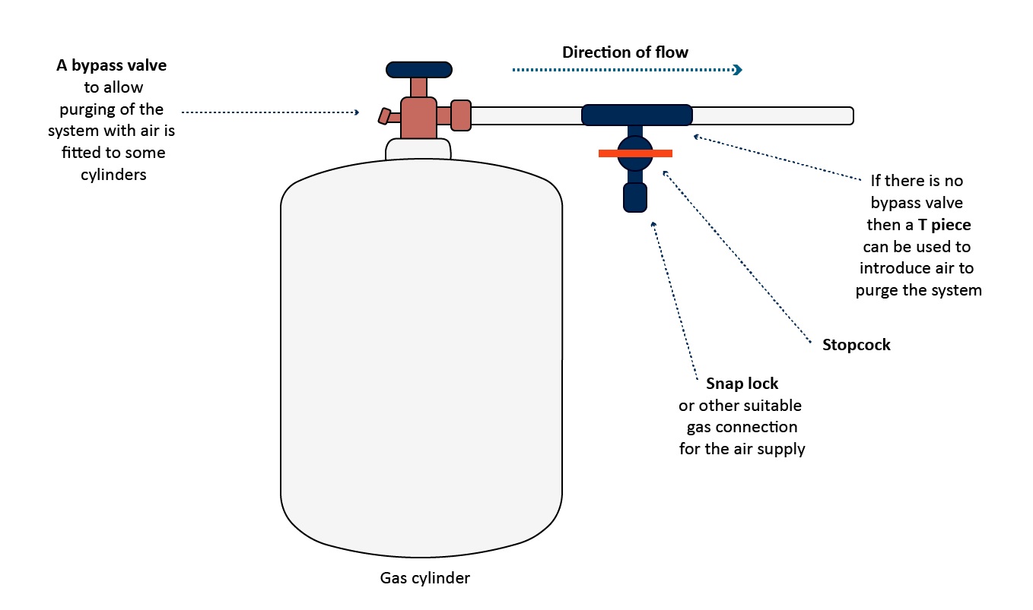

An alternative is to disconnect the supply pipe from the cylinder and force air down the pipe until all the methyl bromide has been forced into the enclosure.

##### Planning for safe ventilation

The fumigator must plan for the safe ventilation of the enclosure before it is put under gas, it is too late afterwards. The fumigator must consider the proximity of occupied buildings, other site personnel in the vicinity and the likelihood of passing traffic, either pedestrian or vehicular. Further information on consideration during this phase can be found in section 11 Ventilating the fumigation enclosure.

### Personal Protective Equipment

#### Personal protective equipment (PPE)

##### When does respiratory protection need to be worn?

Suitable respiratory protection must be worn inside the exclusion zone at all times while it is under gas. That is, from the time you are ready to inject the gas into the enclosure until the enclosure has been ventilated to below 5ppm.

The respirator is the most important piece of equipment used for the protection of persons working with fumigants. When fumigation is carried out regularly, it is advisable for each of the operators to be supplied with their own respirator so that they are responsible for its care and upkeep, for their own personal protection.

##### What type of respirators are suitable for use with methyl bromide?

The two most common types of respirators used for QPS fumigations are:

1. filter type respirators
2. self-contained breathing apparatus (SCBA).

Whichever type of respirator used, the mask must cover the entire face, including the eyes.

##### Filter-type respirators

Filter type respirators use a filter canister designed to remove contaminant gases from the air being breathed. When using filter canister respirators, the fumigator must read the manufacturer’s instruction on the safe use for the brand of filter that they use. The canister provides protection for a limited length of time which varies depending on the concentration of fumigant it is exposed to. The only practical way to determine if there has been exposure is to use a suitably sensitive electronic detector with an audible alarm set to signal if there are unsafe levels of fumigant present.

It is important to check the canister on the respirator is correct for use with the specific gas or mixture of gases that will be used for that job. Cartridge-type respirators are small devices with one or two small chemical cartridges attached to the nosepiece. These are usually designed to give protection against gases up to 0.1 percent by volume. They should not be used in any phase of fumigation work. Also, respirators designed as dust filters, or for use with insecticidal or fungicidal aerosols, provide no protection whatsoever against fumigants.

Detailed instructions for applying, adjusting, and checking respirators are supplied with each unit purchased. They should be carefully read at the time of purchase and read over again before the respirator is used. Supervisors should give new operators detailed instructions on the proper use of the respirators.

When a canister is new, the top and bottom are sealed. Manufacturers stamp an expiry date on the label to indicate when the canister must be discarded, even if the seals have not been broken.

The supply of canisters should be stored in a cool, dry, well-ventilated place away from contamination by any gases.

For methyl bromide, the correct filter canister designation is AX which is designed for Volatile Organic Compounds (VOC) with a boiling point below 65°C. Do not use A2 filters as they are specifically designed for VOCs with a boiling point above 65°C and are much less effective.

##### Self-contained Breathing Apparatus (SCBA)

SCBA respirators provide breathable air from a portable cylinder carried by the user. These types of respirators are becoming more common as they have some significant advantages over the canister type respirators. SCBA provides protection in environments with high concentrations and are effective against all toxic gasses. While the initial purchase price can be quite high compared to a filter type respirator, the ongoing operating costs are much lower than the cost of replacing spent filter canisters. Operators need to be properly trained in their use and maintenance and they must only ever be re-filled by an authorised agent. The cylinder must never be refilled using normal air compressor as the air will be contaminated and cause severe injury or death.

##### Care and maintenance

Regular maintenance should be undertaken on the respirators to ensure that they continue to provide effective protection. After each use, particularly in hot conditions, the mask should be washed in mild soapy water, otherwise the mask may become permanently tainted. The valves should be removed and checked regularly to ensure that they are clean and in good condition. Care should be taken to ensure that the valves are refitted properly so that the respirator functions correctly. Valves can be easily replaced when signs of wear start to occur. The seal around the faceplate should also be checked in case it has been damaged.

#### Fumigation personnel

We recommend two people are always present during a fumigation, especially when undertaking work within the risk area. If a fumigator becomes sick or an accident occurs and they can no longer maintain control of the fumigation, serious consequences may occur if no one is there to help.

It is difficult to communicate verbally while wearing a respirator, so it is advisable for the fumigation team to establish visual signals to indicate if there is a problem and what action should be taken. For example, one of the fumigators may notice a leak from the supply system. The first action should be to shut off the gas supply at the cylinder, then they can assess the situation and, if the leak was significant enough to warrant them to temporarily leave the area, get their colleagues attention by tapping on their shoulder and indicate that they must leave the area until it is safe to return.

#### Exclusion Zone

A critical component of a safe fumigation is the creation of an exclusion zone. More details on exclusion zones are covered in section 5.1 Exclusion Zone.

## Consignment suitability

Every consignment must be assessed for suitability for fumigation. There are several factors that will affect the suitability of the consignment for fumigation. Some materials are adversely affected by methyl bromide which can cause damage to the commodity and thereby reduce its value. There are some commodities that are not suitable for fumigation with methyl bromide or may be affected in some circumstances.

The key things the fumigator needs to determine are:

1. Can the fumigant reach the target of the fumigation?
2. Can the fumigant reach the target of the fumigation at the correct concentration?
3. Can the fumigant reach the target of the fumigation throughout the enclosure?
4. Will the fumigant be affected by the goods being fumigated?

The list in Appendix A provides a guide on some commodities where problems have been known to occur. Due to the variations in the composition of materials and other factors like temperature, humidity, length of exposure and concentration levels it is not easy to evaluate the suitability of a particular commodity. If there is some doubt as to the suitability of any material, it may be necessary to conduct tests to determine if the outcome will be satisfactory.

The fumigator and the owner should also consider the potential for adverse effects on other materials in the consignment that are not the target of the fumigation but will also be exposed to the fumigant.

##### What is meant by free airspace?

There must be sufficient free airspace in the enclosure for the fumigation to circulate and so the fumigant can reach the target of the fumigation and the correct concentration. This is measured by monitoring the gas distribution in the enclosure. See section 9 Monitoring the fumigation for more details.

The enclosure should be configured to ensure that there is adequate space above, below, at the sides and throughout the commodity. Putting the commodity on pallets, creating space between the sheets and the commodity, and stacking the commodity so there is space between items, will improve fumigant circulation.

If there is inadequate free airspace, the consignment may need to be unpacked and fumigated as a stack. Fumigators should encourage the person responsible for the goods to present the consignment in a way that is suitable for fumigation. If the consignment is not packed with sufficient free air space, the fumigation should not proceed.

### Target of fumigation

##### What is the target of fumigation?

The target of fumigation is the specific object or area that is intended to be treated through the fumigation process. The target of fumigation may be the commodity, packaging material, container, or conveyance or combination of these.

The fumigator must know why the fumigation is being done and what the specific target of the fumigation is so they can determine if the fumigant will come into contact with, and if required be able to penetrate into the goods.

The target of fumigation must be recorded on the record of fumigation (RoF).

##### What if the consignment is not suitable for fumigation?

If the fumigator determines that the consignment is not suitable for fumigation the fumigator has three choices:

1. Do not fumigate the consignment.
2. Take remedial actions to make the consignment suitable for fumigation.
3. Conduct an alternate approved treatment if registered to do so.

##### What sort of remedial action can be taken to make the consignment suitable?

To make the consignment suitable for fumigation the fumigator should work with the person responsible for the consignment to make changes such as unpacking the container and fumigating as a tarped stack, removing or slashing any impervious packaging, stacking the consignment so the fumigant can circulate, or conducting an appropriate alternative treatment type if registered to do so. These are not exhaustive remedial actions, but it is important for the fumigator to work with the person responsible for the goods to ensure the goods are presented in a way that will allow for a successful fumigation.

### Impermeable packaging, wrappings and surface coatings

##### What is impermeable packaging?

Impermeable packaging and wrappings are intact and solid plastic films and wrappings that prevent or impede gas exchange.

If the target of the fumigation is wrapped in materials that are impervious to the fumigant, the wrapping should be cut, slashed or removed prior to fumigation.

If the target of the fumigation has impervious surfaces that will prevent effective penetration of the fumigant, then an alternative method of treatment must be used. If practical, the commodity should be fumigated prior to any impervious surfaces being applied.

The packaging material associated with consignments must also be treated along with the product. The packaging may harbour insects that could re-infest the consignment when the product is re-packed after treatment.

#### Impermeable wrapping requirements

In addition to cutting, slashing or removing wrapping, wraps can also be perforated to allow fumigant to pass through and come into contact with the commodity. Perforated impermeable wrapping must meet the requirements outlined in the methodology and must not be layered or wrapped over itself. This is to ensure the fumigant is not impeded as it passes through the holes in the wrapping.

To be considered pervious, wrappings must have at least:

1. 4 holes of 6 mm diameter per 100 mm x 100 mm surface area, or
2. 5 holes of 5 mm diameter per 100 mm x 100 mm surface area, or
3. 6 pinholes per 10 mm x 10 mm surface area.

##### Impermeable coating or surfaces

If penetration into the target of fumigation is required, the target of fumigation must not be coated in materials that may impede penetration of methyl bromide into the target of fumigation (for example: lacquers, paints, waxes, natural oils, veneers or plastic wraps).

### Requirements for perishable commodity packaging

Perishable commodities are often packaged in multiple layers of packaging. For the consignment to be considered suitable for fumigation, the fumigant must be able to reach inside all layers of packaging.

If fresh produce is packaged in cartons, they must have holes that allow methyl bromide to distribute into the cartons and reach the target of fumigation. Often for phytosanitary security or biosecurity reasons the holes in perishable commodity boxes are covered in mesh to prevent contamination or the escape of pests. The mesh is considered permeable if it meets the permeability requirements in section 3.2 .

Impermeable packaging, wrappings and surface coatings.

If the cartons do not have holes, then prior to fumigation all cartons must:

* be opened or have lids removed, or
* have holes created in the cartons that allow distribution of methyl bromide into the cartons and reach the target of fumigation.

Cartons must be arranged in a way that does not block holes or impede methyl bromide distribution.

If any packaging is removed and requires fumigation with the goods, the fumigator must ensure it is prepared in such a manner that the fumigant can reach all surfaces of the packaging to effectively treat the risk.

### Load factors

Load factors are important when treating some perishable items as the exposure periods can be very short and rapid distribution of gas throughout the enclosure and into the commodity is critical to achieve an effective treatment. Another reason to specify a load factor is to avoid an excessive concentration of methyl bromide which can damage the commodity in some instances. For example, if a load factor of 50% is specified, then the quantity of the commodity and any associated packaging can occupy a maximum of half the volume of the available space inside the enclosure. This can also result in an effective doubling of the initial concentration of methyl bromide as half the air in the enclosure is displaced by the commodity.

### Requirements for timber

##### Penetration into the commodity

In many cases, the fumigant must be able to penetrate the commodity to effectively treat pests (for example, wood borers) that can exist inside the commodity itself. The fumigator should inspect the consignment to verify it can be treated effectively prior to fumigation. If the consignment cannot be adequately inspected, the fumigator may need to rely on information from the manufacturer/exporter of the goods to ascertain whether there is anything that may prevent the fumigant from adequately penetrating the commodity.

The effective penetration of methyl bromide into wood is 100 mm under normal fumigation conditions and exposure periods. The methodology states in clause 3.5.2 “If the target of the fumigation is uncoated timber, all internal points within the timber must be no greater than 100 mm from a surface of the timber.” This means the timber can have one physical dimension 200 mm thick in one direction, but be any length if the timber is consistent in thickness the entire length as shown in Figure 2 Compliant timber fumigation penetration.

Figure 2 Compliant timber fumigation penetration

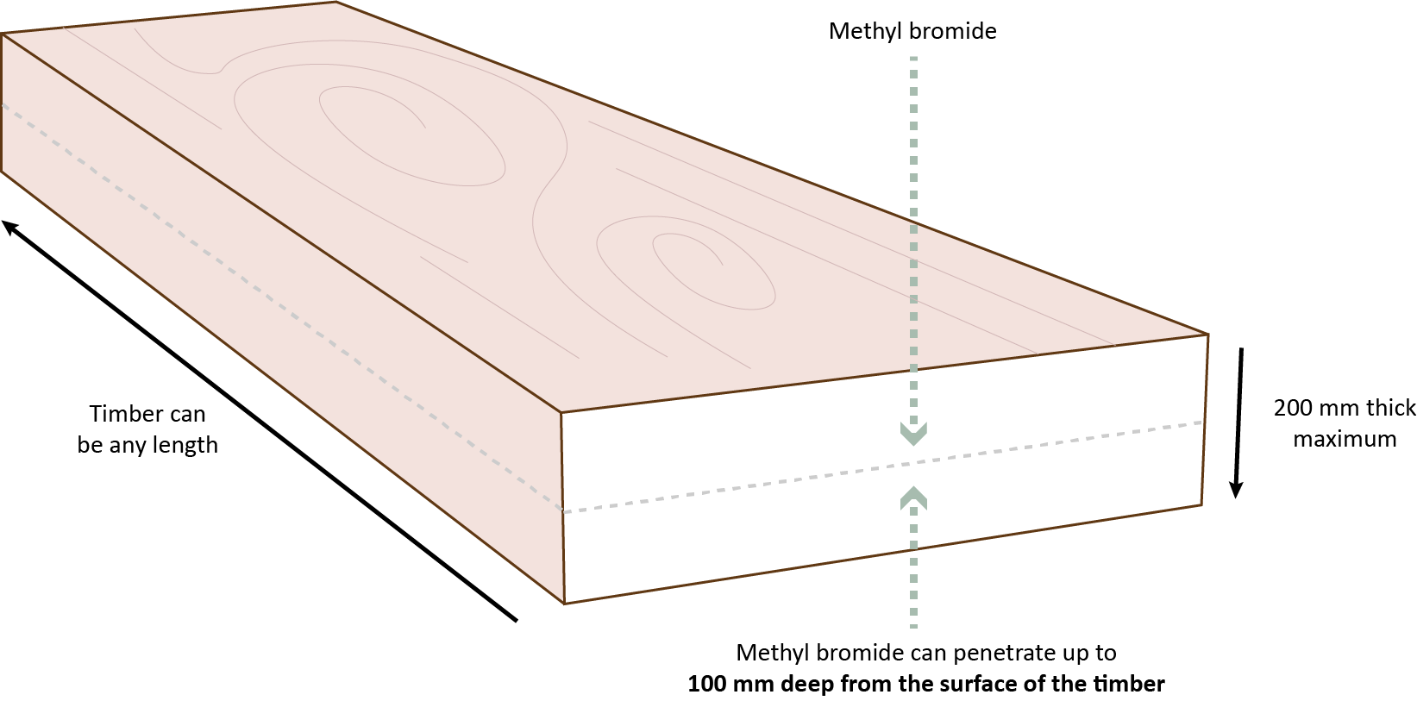 .

Figure 3 Non-compliant timber shape examples shows non-compliant timber. Methyl bromide will not reach some parts of the timber because the centre of the timber is further than 100mm from any surface.

Figure 3 Non-compliant timber shape examples

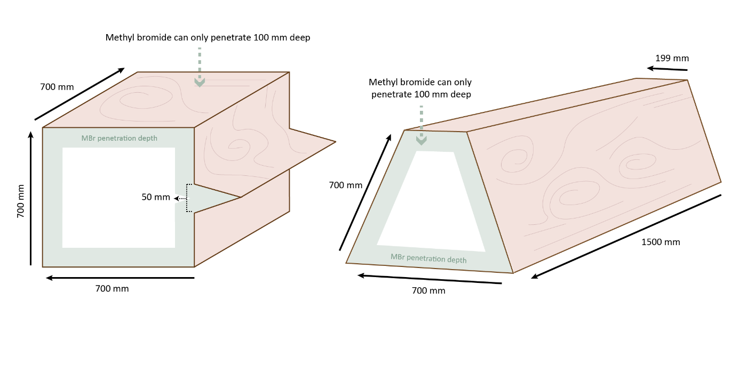If, however, the commodity is partially coated with an impermeable surface the maximum thickness from the uncoated surface will be 100mm as shown in Figure 4 Coated timber surface requirements.

Figure 4 Coated timber surface requirements

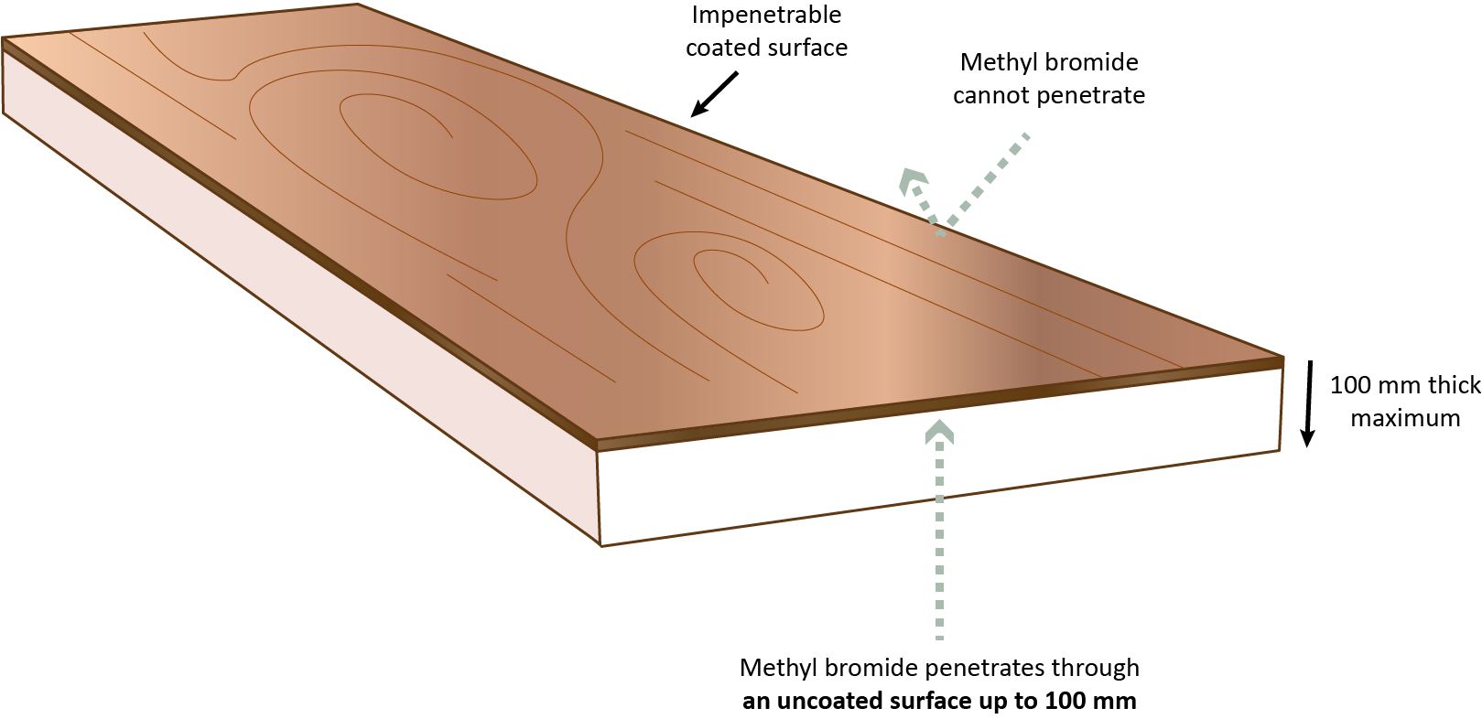

##### Stacked timber

Individual timber products must be separated by a minimum of 5 mm every 200 mm to create space for fumigant penetration along the entire length of the timber. This separation can be horizontal or vertical as shown in Figure 5 Stacked timber requirements.

Figure 5 Stacked timber requirements

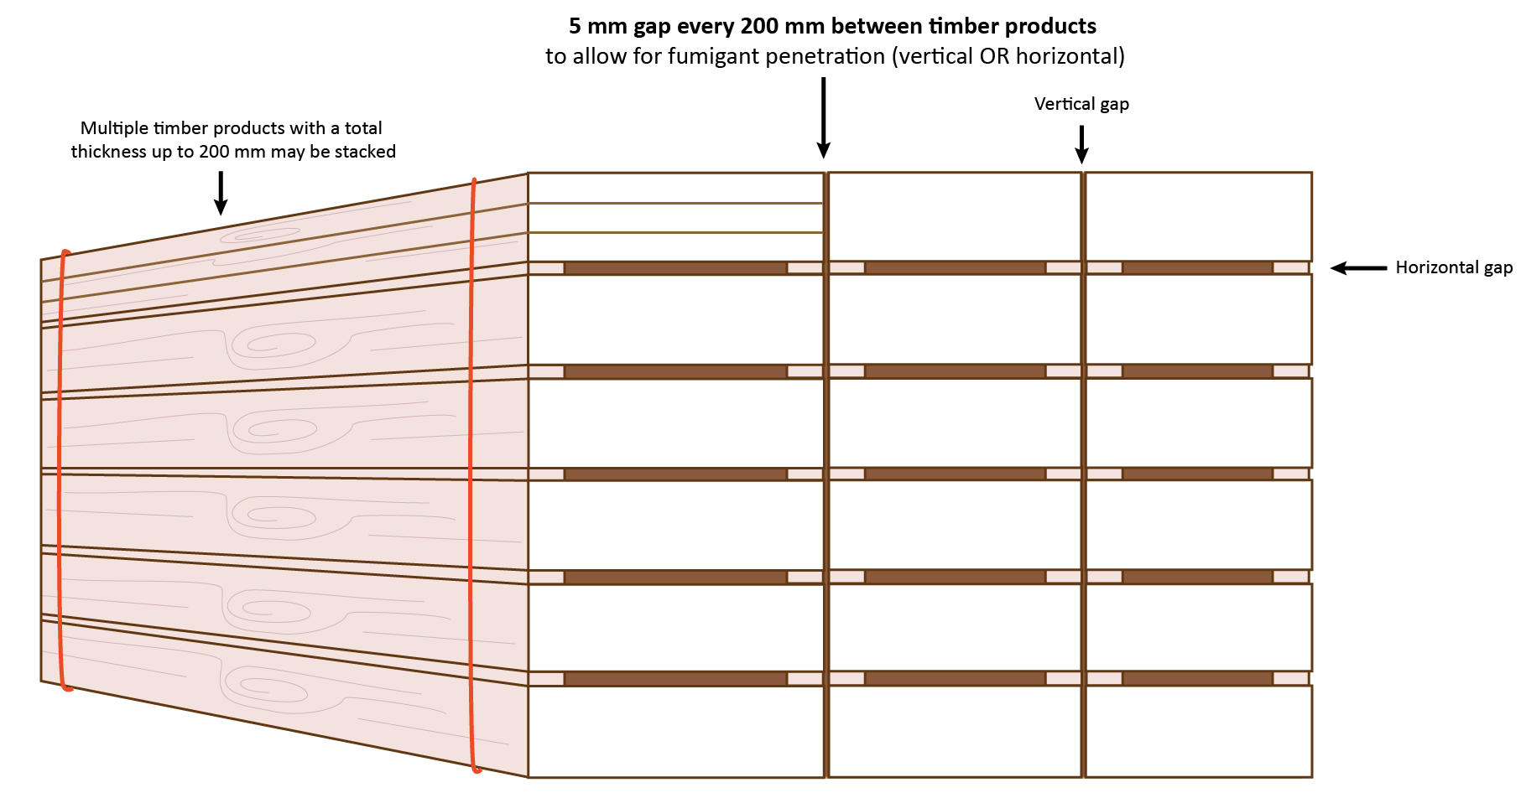

## Fumigation enclosures

Performing a successful fumigation relies on containment of the fumigant within the fumigation enclosure. Various types of fumigation enclosures are used based on the target of the fumigation and the specific requirements of the treatment.

Some common enclosures used for methyl bromide fumigations include:

* un-sheeted sea containers
* sheeted enclosure
* pressure tested fumigation chamber
* vacuum chamber
* ship holds
* grain silos.

All fumigation enclosures must comply with the “All enclosure” requirements in the Methyl bromide fumigation methodology, other enclosures have specific conditions. Suggestions on how to meet these requirements are detailed below.

### All enclosures

All fumigation enclosures must be:

* sufficiently gas-tight to retain the methyl bromide for the duration of the exposure period; and
* prepared to safely inject and ventilate methyl bromide
* sealed to minimise methyl bromide escape
* prepared to ensure even methyl bromide distribution throughout the enclosure
* monitored for temperature if applicable.

##### What does sufficiently gas-tight mean?

All enclosures will leak, to some degree, particularly temporary ones such as sheeted enclosures and shipping containers. The fumigator must take all reasonable steps to minimise fumigant loss from the enclosure during the exposure period to:

* Ensure the treatment is effective.
* Prevent unsafe levels of fumigant accumulating in the immediate vicinity.
* Reduce methyl bromide usage by minimising the need to use additional fumigant.

#### Un-sheeted sea containers

If an un-sheeted sea container is used as a fumigation enclosure the ‘All enclosure’ conditions apply.

Any sea container used as a fumigation enclosure without a sheet, is to be set up and managed as a separate fumigation, even if each container is part of the same consignment. For this reason, in some circumstances, it may be more efficient to fumigate multiple containers under a single fumigation sheet.

##### Container inspection

Not all sea containers are fit to be fumigation enclosures so before preparing the container for fumigation, the fumigator must:

* Check that there is enough space to position and operate the fan inside with the doors closed.
* Inspect the container for any visible holes or damage that would make it unsuitable.
* Check the door seals are intact and in good condition.
* Seal the air vents from the outside using impervious tape that will remain in place throughout the exposure period.

##### Container preparation

Once the fumigator is satisfied the container is suitable, they can install sampling tubes and fans (and/or heaters) in accordance with the requirements. Arrange the tubes and leads so they all exit the container where the doors meet at the base of the container. There is more space between the doors at this point making them easier to close and less likely to compress or kink the sampling tubes. Tape or other suitable method of sealing can then be used to reduce leakage further.

Injection of fumigant into the container should be done by inserting the supply hose through the door seals at the top of the container where the doors meet. Remove the supply hose after fumigant injection. A rigid tube may need to be fitted to the end of the supply hose to make it easier to insert through the door seals.

A potential risk that could cause a problem is excessive leakage through the container floor. These leaks may go undetected and, even if they are, it is not practical to fix them if the container is on the ground. If there are significant leaks through the floor, the rate of gas loss will be exacerbated by any wind passing under the container. This can be minimised by creating a barrier around the enclosure to reduce the airflow. One of the simplest methods to create this barrier is to use sand snakes to cover any fork-lift holes or gaps. This is not intended to stop any leaks only to slow down the effects of the wind.

The container should be set up on a flat even surface to prevent the risk of the container twisting and resulting in potential gaps at the doors that could increase the risk of gas-leakage. Sometimes, despite careful preparation and set-up, a container may still leak too much gas to be able to maintain the required concentration throughout the exposure period. If the fumigator is concerned about this, careful monitoring at the start of the fumigation is advisable to give an indication of the rate of gas loss and determine whether it is acceptable. If the monitoring shows a trend that may lead to fumigation failure, a possible solution may be to enclose the fumigation, as is, under a gas-proof sheet provided the fumigation surface is acceptable.

Another option when fumigating inside an un-sheeted container is to fit a false door to create the gas tight seal. This is normally conducted if the extraction of the gas needs to be carefully controlled or for recapture. The supply pipe, sampling tubes and power leads must pass through the false door and there must be a re-sealable opening to allow fresh air into the container to replace the extracted gases. The door needs to be leak checked and any leaks detected sealed using tape.

The tape used for any sealing should be impervious to methyl bromide and able to withstand wet weather if there is a possibility of rain.

### Sheeted enclosures

##### What is a sheeted enclosure?

A sheeted enclosure is an enclosure created under a gas-proof sheet that is covering and/or enclosing the commodities that are going to be fumigated. A type of sheeted enclosure known as a ‘sheeted stack’ is any sheeted enclosure over free standing goods.

Sheeted enclosures are temporary fumigation enclosures created using a sheet or sheets to cover the consignment. The sheet or sheets ensure the fumigant is retained in the enclosure and freely circulate around the target of fumigation. The space enclosed by the gas–proof sheets is, irrespective of the size of the enclosure, a single fumigation for concentration monitoring and documentation purposes.

##### Maintaining gas-tightness

The success of the fumigation depends on maintaining the required gas concentrations for the entire exposure period. Some simple and easily performed preparations can greatly assist in improving gas retention on sheeted enclosures. Folding and securing sheets at the corners so they lay flat against the floor improves the effectiveness of the seal. Putting a rope around the enclosure between a third from the bottom and halfway will also help to reduce sheet movement in windy conditions which may result in the sheet working loose and releasing fumigant.

##### Reasons for gas loss from a sheeted enclosure

There are three main causes of gas loss from sheeted enclosures:

* the fumigation surface is not impervious
* the fumigation sheet is not made of a suitably impervious material, or it is in poor condition
* leakage from between the sheet and the fumigation surface.

##### Preventing gas loss from a sheeted enclosure

The fumigation sheet must be held flat against the fumigation surface to prevent excessive leakage. This is easily achieved using sand snakes. Sand snakes are flexible tubes filled with sand around 100 mm in diameter and from 0.5 metres to 1.5 metres long. Sand snakes should only be filled to 65% to 75% with clean dry sand so they remain flexible enough to bend around corners and lie flat on the ground. A minimum of two rows of sand snakes should be used around the entire enclosure. They should be laid end to end with the second row offset to overlap the joins of the first row in a brick-work pattern.

Water snakes can also be used. A single continuous water snake should be laid flush against the stack and filled 75% to 85% full. Care should be taken to ensure a complete seal where the ends of the snake meet. The water snake should not start or end on a corner. If water is used to create snakes similar to sand snakes they should be laid in the same way as sand snakes.

Loose sand or soil can also be used to seal the sheet to the floor. Sufficient sand or soil must be used to create a continuous seal around the entire enclosure.

Fumigation sheets should extend at least 500 mm from the base of the stack to allow sand snakes or water snakes to be added to improve the seal between the sheet and the fumigation surface if a leak is detected. The additional snakes should be placed alongside the existing rows rather than on top.

The sheet at the corners of the stack should be folded so the sheet will lay flat against the fumigation surface making it easier to get a good seal. Once folded the corners should be secured with clamps or tape to prevent the wind from pulling the sheet apart.

Strong winds can cause the fumigation sheet to billow resulting in excessive loss of methyl bromide with the potential to cause the fumigation to fail. In circumstances where high winds are unavoidable (for example, an open site at a port) ropes should be used around the enclosure to hold the sheet in place.

##### Fumigation sheets

Fumigation sheets must be impervious to methyl bromide. They must be able to retain sufficient fumigant concentrations for the entire exposure period without the need to add additional fumigant. The ability of the sheets to retain fumigant will deteriorate with use and they should be carefully monitored to ensure their condition is good enough to meet the gas retention requirements.

The sheets must be inspected for any damage before each use. Any tears or holes can be temporarily repaired using impervious tape capable of adhering to the sheet material. Permanent repairs should be made to sheets at the first opportunity by heat welding or gluing patches over the damaged area. Patches should not be sewn on as the needle holes will still allow gas to escape.

A variety of different materials are suitable for use as fumigations sheets. They range from thin plastic sheets that last for only a few uses, to heavier, more durable sheets that will last for many years if handled with care. Most of the materials used in the manufacture of fumigation sheets are not completely gas-tight because such materials are all permeable to fumigants to some degree. The rate at which diffusion through the sheet takes place depends upon the type of material, its thickness, and the ambient temperature. Diffusion through the sheet will reduce the concentration of fumigant to which insects are exposed. If a sheet is highly permeable to methyl bromide, there may be uneven distribution of fumigant within the enclosure to such an extent that in some locations the concentration is insufficient to kill any present insects. As the ratio of sheet area to enclosure volume is greater in small enclosures compared to larger enclosures, loss of gas by diffusion would be expected to be proportionally greater in smaller enclosures.

Woven tarpaulins that are either not coated or are only thinly coated allow too much gas loss and are unsuitable for use as fumigation sheets.

When purchasing fumigation sheets, consider the following:

* permeability
* durability of the material
* flexibility
* weight
* size
* ease with which any holes, tears or abrasions can be permanently and effectively repaired
* if a sheet has joins that they are connected in a way that is gas tight.

Many fumigators prefer to use lightweight sheets regardless of other properties, because such sheets require less labour and are easier to handle. However, caution should be taken when handling these types of sheets. Removal of debris such as stones from the fumigation floor, carrying rather than dragging the sheet and padding any sharp corners can protect the sheet and they can last for many years.

The sheets should be large enough to completely cover the enclosure being fumigated with a minimum 500mm of sheet extended out from the base of the enclosure on all sides. As a guide the following size sheets would be sufficient for shipping containers:

* 20 ft = 12.5 m wide x 16 m long
* 40 ft = 12.5 m wide x 22 m long.

Sheets can be joined to create a larger enclosure if necessary, but care should be taken to ensure that the joins are gas tight.

Sheets can be joined by tightly rolling a 400 mm to 500 mm overlapped join that can be secured using tight welding style clips or other suitable means. Often, a better join can be created by wrapping the sheets around something rigid like lengths of wood. Roll the sheets at least three to four full turns around the wooden battens and hold together with tight welding style clips or other suitable method.

Any clamps or clips with sharp edges should either not be used or the sharp edges should be covered in some way to prevent damage to the sheet.

Joins should be positioned so they are supported by a solid surface. For example, a container roof.

##### Sand snakes

Sheeted enclosures require some method of creating a gas tight seal between the sheet and the fumigation surface and sand snakes are the most common method used for achieving this. They are preferred because they are:

* heavy enough to hold down the sheet flat to the fumigation surface to create a good seal
* light enough to be easily handled
* flexible so they can be bent around corners
* soft, so they do not damage fumigation sheets
* easy to make
* reusable, if made from durable material
* versatile, they can also be used to pad sharp corners, hold down supply pipe and sampling tubes.

The snakes should be partially filled with clean dry sand to no more than 65% to 75%. To check how full a sand snake is, hold it up lengthwise and shake the sand down. For example, a correctly filled snake 1 metre long should have sand up to between 65 cm to 75 cm.

If the filling does not move freely then it is likely that the filling is not clean sand. This can affect the ability of the snake to lay flat against the fumigation surface reducing its effectiveness to create a gas tight seal. A correctly filled sand snake can be turned around a right-angle corner with an even distribution of sand along the full length of the sand-snake.

##### Water snakes

Water snakes are much less common than sand snakes. While they can be very effective in creating a gas tight seal, they have several disadvantages over sand snakes such as:

* water for filling is required on-site
* they are very heavy and can be difficult to move or adjust once filled
* easily punctured
* can make the ventilation procedure more difficult.

Water snakes must be filled to the point where they are still flexible enough to bend at right angles around the corners of the enclosure, lay flat against the fumigation surface and be heavy enough to give a good seal. Care should be taken around the corners of the fumigation sheet to ensure they are flattened, otherwise water will flow to the lowest points reducing the weight and hence their effectiveness. This can also be a problem on uneven surfaces.

**Empty Containers**

Empty containers are often treated prior to packing to manage hitchhiker pests such as Khapra beetle. They are usually treated under fumigation sheets, so the treatment should be performed in the same way as any other sheeted enclosure/container.

### Fumigation chambers

Most chambers are either converted shipping containers or a structure designed and built specifically for fumigation. The door seals on converted shipping containers need to be inspected regularly for wear.

#### Pressure testing

##### Procedure for performing a pressure test

Check the monitoring tubes, supply pipes and exhaust system valves are closed.

The pressure inside the closed chamber must be raised to 250 Pa. This can be done using high-pressure compressed air supplied from a portable compressor or gas cylinders attached to the supply pipe orby reversing the flow of the extraction fans.

Attach a suitable pressure measuring instrument to one of the sampling tubes.

1. When the pressure inside the chamber reaches 250 Pa, turn off the compressed air supply.
2. Allow the pressure to decay to 200 Pa.
3. Start measuring the time (in seconds) when it reaches 200 Pa.
4. Stop measuring the time (in seconds) when it reaches 100 Pa.
5. Record the pressure decay time.

##### Instruments for measuring the pressure decay time

The pressure inside the chamber can be measured using a variety of instruments. These include:

* a simple U tube manometer or an inclined manometer, using a manually operated stopwatch
* any sensitive pressure gauge, using a manually operated stopwatch
* a purpose made instrument, the CONTESTOR, which combines a pressure sensor with a timer that cuts in when the required pressures have been achieved.

### Vacuum Chamber

A vacuum chamber is a specialised enclosure designed to create a controlled environment for fumigations. A vacuum chamber operates by removing air and lowering the pressure within the chamber before the fumigant is introduced.

It is necessary to have a specially constructed chamber, usually made of steel, that can withstand external pressure up to one atmosphere.

Vacuum chambers are often used for treating delicate or sensitive items that may be damaged by exposure to high-pressure fumigation methods. This method is common in the fumigation of certain electronic components, artworks, museum artifacts, or other valuable materials where precision and gentle treatment are crucial.

There are two types of fumigations methods that can be used for vacuum chambers. These are:

* sustained vacuum fumigation
* atmospheric pressure restored fumigation.

##### Why does the exposure period performed in a vacuum chamber start straight after injection has finished?

Methyl bromide distributes rapidly when injected into a vacuum chamber. The rapid distribution can be attributed to the low-pressure environment. In the low-pressure environment of a vacuum chamber, the reduced atmospheric pressure lowers the boiling point, causing the methyl bromide to vaporise rapidly. This increased volatility facilitates swift and uniform dispersion of methyl bromide throughout the chamber. The absence of competing atmospheric pressure also the gas molecules to readily escape from their liquid state, filling the vacuum chamber quickly.

##### Why don’t you have to monitor methyl bromide levels in vacuum chambers?

Fumigant monitoring is not required in vacuum chambers because the inherent characteristics of a vacuum chamber mean the gas is unlikely to escape. It is also difficult to take samples, sample extraction requires specialised equipment and processes.

To ensure the fumigation is effective the fumigator must monitor the temperature and pressure of the chamber during the treatment.

The reasons for not requiring monitoring include:

* The vacuum chamber operates as a hermetically sealed system, limiting gas escape for the chamber.
* Equipment constraints: Traditional gas monitoring equipment encounters limitations within the vacuum chamber due to extreme pressure differentials and the confined space, impeding accurate readings.
* Sampling challenges: Extracting a representative gas sample from the vacuum chamber poses technical challenges. The pressure differentials hinder the collection of a sample without specialised processes and equipment. Then analysing the sample without corrupting the sample with air outside the chamber is an additional challenge.

Vacuum fumigation cannot be used with certain tender plants, fruits and vegetables which are unable to withstand reduced pressure.

## Preparing to fumigate

Prior to fumigation, to complete a safe and effective fumigation you must:

* establish an exclusion zone
* prepare the enclosure with supply pipes and monitoring equipment
* assess the consignment suitability
* calculate the amount of fumigant to inject
* create a suitably gas tight enclosure.

### Exclusion Zone

##### Does the Methyl Bromide Fumigation Methodology take precedence over local legislation?

Local jurisdictions may have safety legislation and regulations that govern the safe performance of a fumigation. The following information is for generic guidance only, the fumigator-in-charge must comply with the laws relevant to where the fumigation is being performed.

An exclusion zone must be established around the fumigation enclosure and equipment used for methyl bromide injection. For all fumigations, excluding pressure tested fumigation chambers and vacuum chambers, the exclusion zone must be in force from immediately prior to methyl bromide injection and until the enclosure has been successfully ventilated.

##### How should an exclusion zone be demarcated?

The exclusion zone must have a physical barrier at all points where the enclosure is accessible. The exclusion zone must be:

* demarcated by a physical barrier, such as rope or tape hung on stands or bollards
* held off the ground so that someone must deliberately step over the barrier to enter the exclusion zone
* clearly marked with warning signs visible from all angles of approach.

##### Are lines painted on the ground acceptable?

Lines painted on the ground are ineffective and are not acceptable.

##### Can solid walls be considered a barrier?

When fumigating outdoors, a solid wall can be used for one or more of the sides if it is at least 2 metres high. When fumigating indoors, a wall can be used as part of the barrier if it extends from floor to ceiling.

For example, Figure 6 Exclusion zone with one or more walls.

It is not recommended to use shipping containers as part of the barrier, unless you are certain that they will not be moved before the fumigation is finished.

##### Warning signs

Large and easily seen warning signs must be placed on all sides of approach to the enclosure. For an enclosure that can be approached from all sides a minimum of four signs would be needed. They could either be placed on each of the corners of the risk area or on each side if they are visible from all angles of approach.

The exclusion zone barrier should have warning signs that:

* are visible from all angles of approach
* display symbols indicating danger and/or toxic gas is in use
* are in a language spoken by staff at the fumigation site
* additional information such as the contact details of the fumigator or company name.

It is not advisable to use signs made from paper, cardboard or other material that could deteriorate through exposure to the elements.

#### Size of the exclusion zone

The required exclusion zone size varies depending on where the fumigation is being conducted.

In some circumstances, it may be appropriate to increase the risk area of the fumigation from the minimum required in the methodology.

The size of the exclusion zone must not be less than:

* 3 metres from the enclosure, if the enclosure is located outdoors, as per Figure 7 Exclusion zone outdoors, or
* 6 metres from the enclosure, if the enclosure is located inside a building or structure, as per Figure 8 Exclusion zone indoors.

A 6 metre exclusion zone is required inside a building because there is less air movement. Therefore, there is an increased chance for unsafe levels of gas to accumulate if there is a significant leak from the enclosure.

Figure 6 Exclusion zone with one or more walls

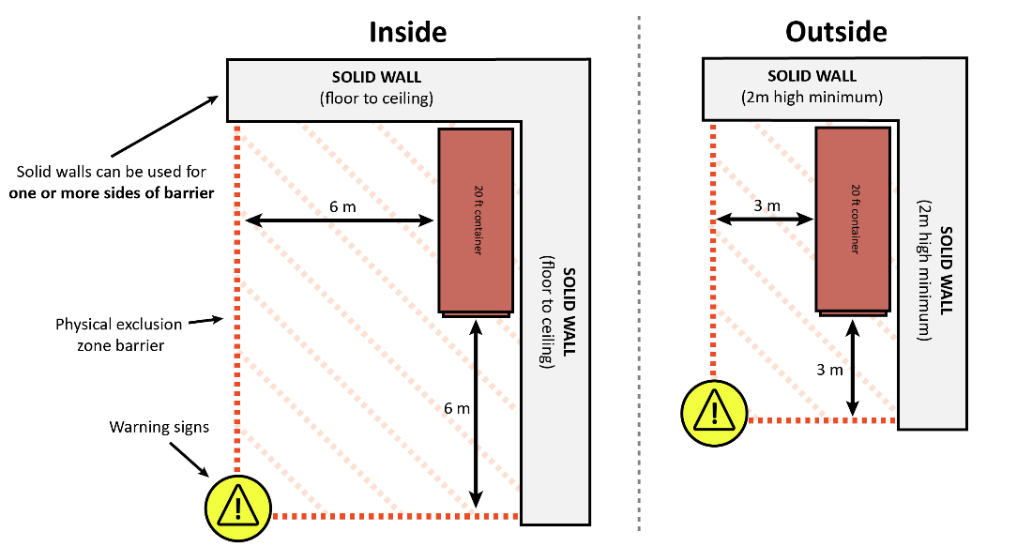

Figure 7 Exclusion zone outdoors

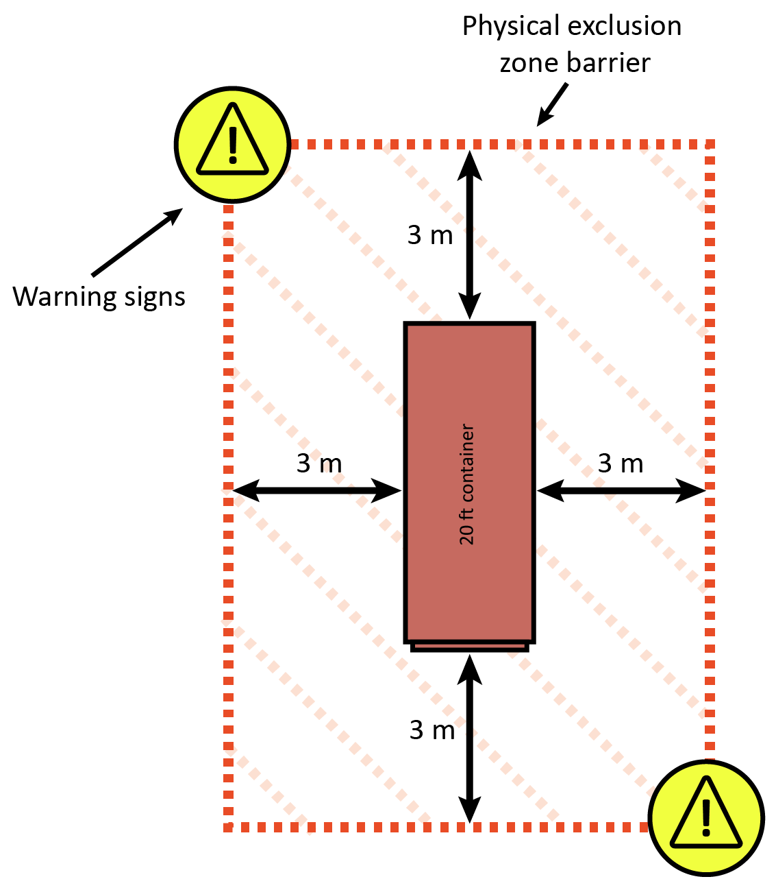

Figure 8 Exclusion zone indoors

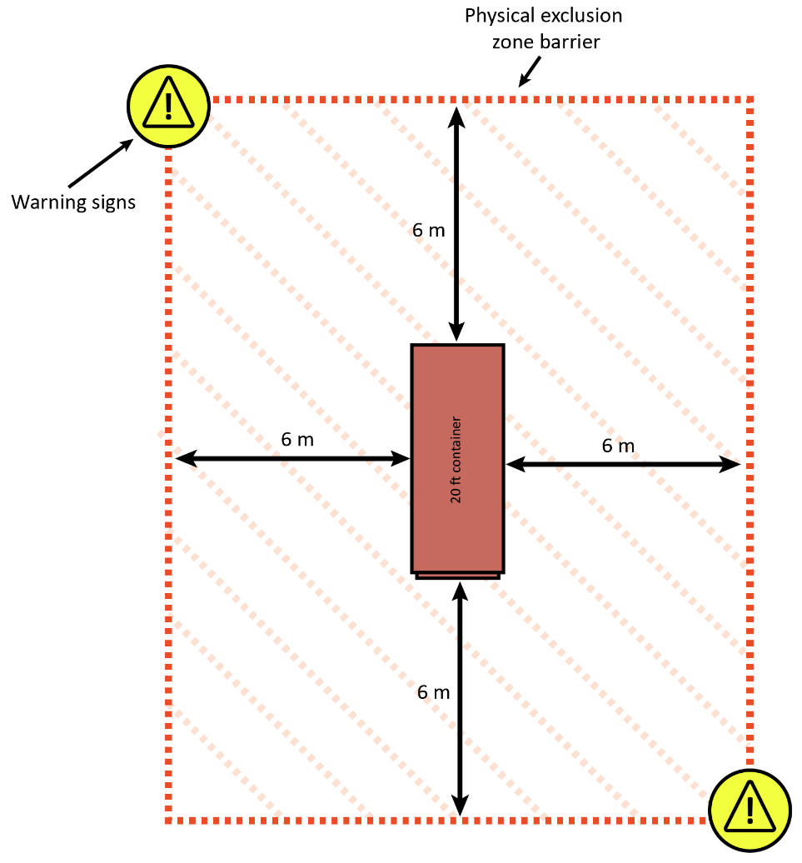

### Gas concentration monitoring equipment

All gas concentration monitoring equipment must be able to detect methyl bromide concentrations within the treatment dose range for the goods treated and be in good working order. It must be operated, calibrated, and serviced according to the manufacturer’s instructions.

##### What needs to be considered when choosing monitoring equipment?

There are several suitable monitoring instruments that can be used. When choosing the right monitoring equipment, careful consideration should be given to the reliability and ease of use. Carefully research the brand and model for your individual circumstances. When deciding on a fumigation monitoring instrument you should consider the following:

* accuracy
* detection range
* durability
* reliability
* sensitivity to other factors such as carbon dioxide and moisture
* cycle time between readings
* ease of use
* portability if required
* calibration and maintenance requirements
* after sales service
* purchase price and ongoing costs for maintenance and repair
* the detection range should be between 2 g to 200 g/m³ (1 g/m³ = 250 ppm).

Some examples of companies that make electronic fumigation monitoring equipment include, but are not limited to: Spectros, Fumiscope, PPM Messtechnik, Uniphos, and Riken.

#### Use and maintenance of gas measuring equipment

Gas concentration measuring instruments must be used and maintained in accordance with the manufacturer's instruction manual and be fitted with any filters as specified by the manufacturer to suit the circumstances of the fumigation.

It is not uncommon to see experienced fumigators using their equipment incorrectly, so it is important for all fumigators to read and understand the user’s manual for their instrument even if they are trained by a colleague.

Some perishable commodities (for example, garlic, onions, or mangoes) release high amounts of carbon dioxide and this affects gas measurements in some instruments. It is particularly important to maintain the carbon dioxide and moisture filters fitted to instruments.

Maintenance and calibration records must be kept for all monitors.

#### Concentration Sampling Tubes

Concentration sampling tubes must be placed at different points within the enclosure to measure fumigation levels for even distribution and concentration levels at or above any specified minimum amount.

The tubes should be labelled according to their location within the enclosure. The labels should be placed at the end of the sampling tubes outside the exclusion zone to allow easy identification when taking concentration readings. Check your local safety regulations to see if they allow sampling tube to extend outside the exclusion zone.

The internal diameter of the sampling tubes should be suitable for the inlet of the concentration measuring instrument used. The connection must be gas-tight with no fresh air being drawn in contaminating the sample. The usual range of internal diameter is from 2 mm to 6 mm.

The sampling tubes should be long enough to extend outside the risk area to allow readings to be taken without the need to wear PPE.

The tubes should not be able to be compressed easily or susceptible to kinking which may restrict air flow and adversely affect the accuracy of the readings.

### Gas concentration monitoring locations

##### Additional concentration monitoring locations

It is critical that you understand the treatment schedule for the fumigation you are conducting, the methyl bromide fumigation methodology set the minimum requirements for a fumigation, additional concentration monitoring locations may be mandated by different jurisdictions’ import conditions.

Enclosures less than 30 m3 in volume must have at least one gas concentration monitoring location. The monitoring location must be on the top, centre of the goods.

Enclosures larger in volume than 30 m3 must have at least three gas concentration monitoring locations. The monitoring locations must be:

* on top of the goods within 2 metres of the end of the enclosure; and
* no more than 250 mm above the floor of the enclosure and within 2 metres of the opposite end from the top gas monitoring location; and
* in the middle centre of the enclosure among the goods and at least 2 metres from the other gas concentration monitoring locations.

Figure 9 Single container enclosure monitoring locations

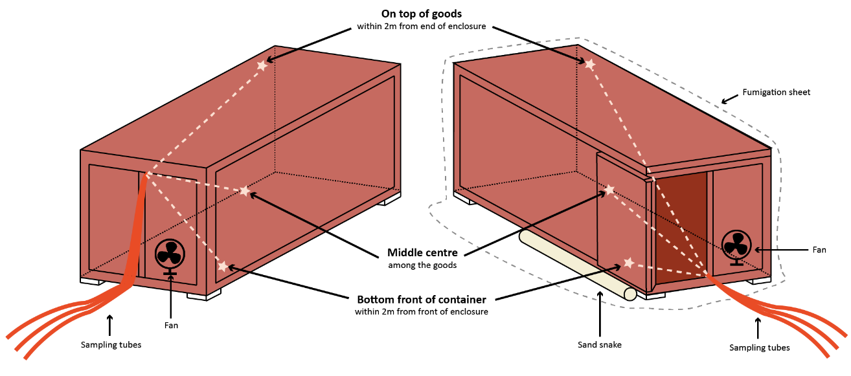

If a sheeted enclosure contains multiple sea containers, each sea container must have at least three gas concentration monitoring locations.

Figure 10 Double container sheeted enclosure monitoring locations

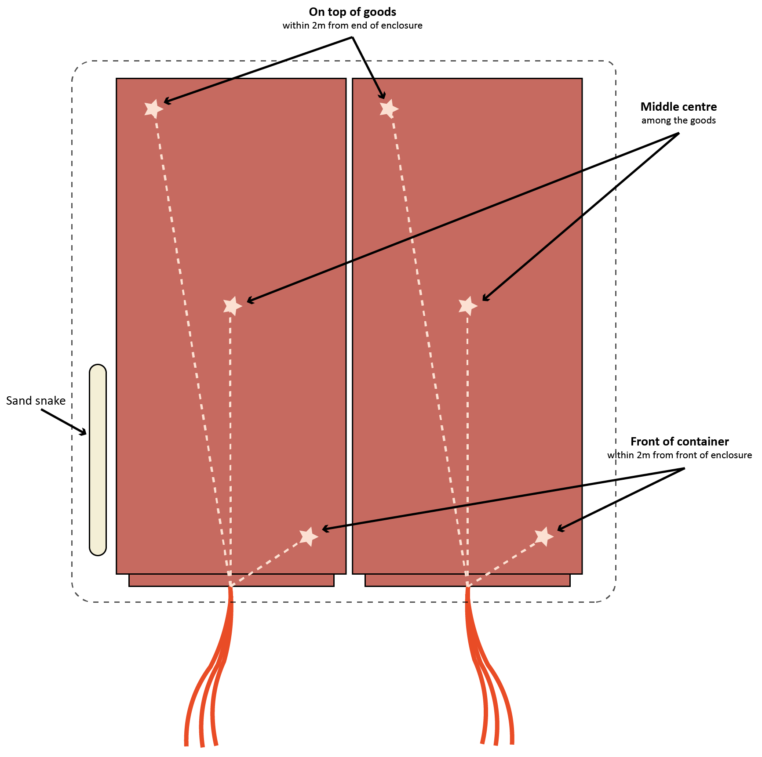

The reason for positioning the sampling tubes as required is to demonstrate that the fumigant is evenly distributed throughout the enclosure.

Positioning the tubes in a loaded container can present a problem especially for the two tubes away from the door. Fixing the tubes to rigid poles long enough to extend into the container can solve this problem. Bamboo poles or plastic electrical conduit are commonly used for this purpose.

### Gas concentration monitoring locations – perishable commodities

##### Additional concentration monitoring locations

As with non-perishable commodities, additional concentration monitoring locations may be mandated by different jurisdiction’s import conditions. Refer back to the treatment schedule for the fumigation you are conducting.

Often perishable commodities are packaged in multiple layers of packaging. These layers of packaging may create a barrier to fumigant distribution. To demonstrate the fumigant has penetrated in sufficient concentrations to achieve an effective treatment, the monitoring locations must be placed next to the commodity which is the target of the fumigation. If not being removed prior to fumigation, each of these layers of packaging must meet the packaging suitability requirements.

The number of monitoring tubes required is dependent on the size of the enclosure and the different types of packaging and commodity being fumigated. If there are different types of packaging in the consignment, there must be one gas concentration monitoring location inside each of the different packaging types.

Figure 11 Monitoring tube in a perishable fruit package

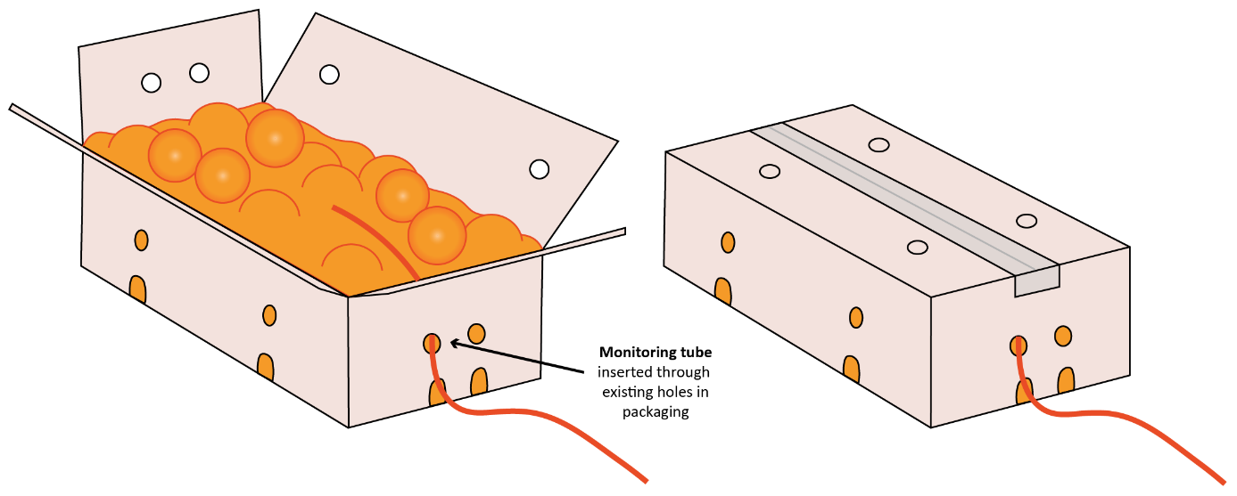

If there is one type of commodity and packaging, and the total enclosure volume is less than 5 m3, the gas concentration must be monitored in at least one location.

If the enclosure is greater than 5m3, the gas concentration must be monitored in at least three locations.

The placement and installation of gas concentration monitoring equipment within cartons or packaging must not change the gas penetration properties of the carton or package. The box being sampled should replicate the penetration properties of the other boxes within the consignment. For example, if a hole is made in a box to insert the sampling tube the hole should be taped up around the sampling tube. If additional holes are made in the box being sampled gas may penetrate more quickly into that box giving a false indication that gas has distributed throughout the consignment.

Figure 12 Monitoring tube in a package of cut flowers

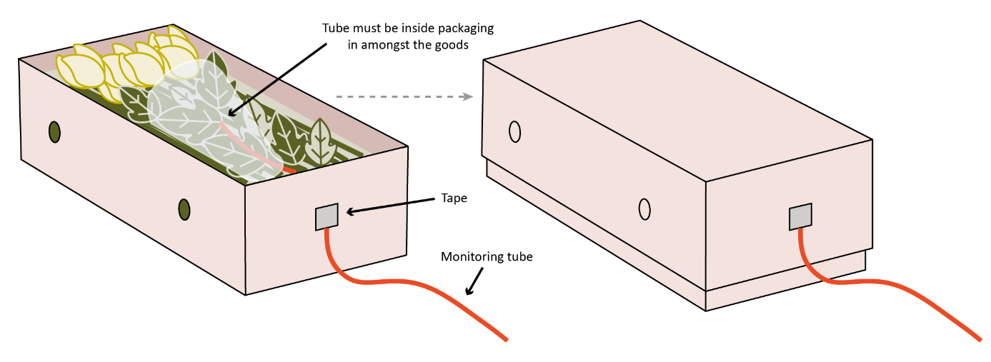

### Temperature monitoring instrument locations

The temperature monitoring requirements apply in this section apply to perishable commodity fumigations and controlled temperature fumigations. They can also be used as guide if you chose to monitor the enclosure temperature during ambient temperature fumigations.

Temperature is a critical component of a methyl bromide treatment. You must know the temperature of the enclosure during the treatment.

#### Headspace temperature

The temperature of the enclosure must be monitored with a digital thermometer in at least one location within the enclosure. The temperature of the headspace within the enclosure is monitored to ensure the enclosure meets the temperature requirements of the treatment schedule.

This is especially important if heating is used to get the enclosure up to temperature. If the temperature in the enclosure drops below the required temperature, the fumigation has failed.

#### Temperature probes for fruit and vegetables

Some perishables and other commodities require the temperature of the commodity to be taken prior to treatment, and monitoring during treatment. This is because the target of the fumigation is often an internal feeding pest, for example fruit fly larvae, meaning the temperature of the commodity is critical to ensuring an effective treatment. Perishable commodities are also stored at low temperatures and have short duration treatments. If the fruit is fumigated at the low storage temperature the insects may not start respirating if the fruit does not reach temperature.

If the treatment requires measurement of the internal or pulp temperature of the commodity, then suitable temperature probes must be used. Fumigations that require a specific temperature of temperature range must be performed in a facility capable of heating the commodity to the desired temperature and maintaining it for the duration of the fumigation exposure period.

The temperature must be measured by placing the tip of the temperature probe into the centre of a piece of fruit or vegetable located in the middle of a carton. At least three temperature readings must be taken from the fruit/vegetable in three different cartons/pallets and from different varieties within the consignment.

#### Calibration of temperature sensors

Temperature sensors must be maintained to an accuracy of at least plus or minus (+/-) 1°C. A suitably qualified technician, manufacturer, or distributor should calibrate the temperature sensors at least once a year.

The complete measuring system (sensor probe, cable, and data logger) must be checked and calibrated, not only the sensor. The date and result of the calibration of each thermometer must be recorded.

If temperature sensors are calibrated in-house, it is expected that there are processes in place to ensure the calibration is conducted in-line with the following principles.

* **Reference standard:** A reliable and traceable reference standard with a known and stable temperature is used. This could be a certified thermometer or a calibration bath with a known temperature value.
* **Temperature range**: The temperature probes are calibrated across its entire operating range. If the probe is used in a specific temperature range, focus on that range to ensure accuracy where it matters most.
* **Stability of calibration Equipment:** The calibration equipment (e.g., calibration bath or dry block) is stable and maintains a consistent temperature throughout the calibration process.
* **Equilibration time:** Sufficient time is allowed for the temperature probe to reach thermal equilibrium with the calibration standard. This ensures that the probe is measuring the true temperature of the standard.
* **Accuracy and precision:** High accuracy and precision during the calibration process is achieved. The probe is calibrated at multiple points within its range to assess its linearity and overall performance.
* **Calibration intervals:** A regular calibration schedule is established. The frequency of calibration may depend on factors such as the probes usage, the environment it operates in, and any manufacturer recommendations.
* **Documentation:** Detailed records of the calibration process, including the date, the standard used, the reference temperature, and any adjustments made to the probe are maintained. This documentation is crucial for quality control and audit purposes.
* **Adjustment:** If the calibration reveals significant deviations from the expected values, adjust the temperature probe according to the manufacturer's guidelines. Some probes may have user-adjustable offsets or calibration features.
* **Environmental conditions:** Perform calibrations in a controlled environment, considering factors like ambient temperature and humidity. These factors can impact the accuracy of temperature measurements.
* **Training and competence**: Personnel conducting self-calibrations are adequately trained and competent in the calibration procedures. This includes understanding the equipment, following proper techniques, and interpreting results.
* **Verification:** The calibration results are periodically verified using secondary standards or by sending the probe to a certified calibration laboratory for independent verification.

### Methyl bromide supply pipes

Methyl bromide supply pipes are used to introduce the gas into the enclosure.

The method used to inject methyl bromide into the enclosure will vary depending on the type of enclosure used.

##### What sort of supply pipes should be used?

Aluminium tubing should not be used for any part of the system used for the application of methyl bromide as it can react violently on contact with liquid methyl bromide.

If the fumigation is conducted in an un-sheeted sea container, then the gas can be injected using a rigid tube fitted to the end of the supply pipe and pushed through the door seals, usually at the top where the doors meet. Once injection is complete, the tube is withdrawn and the door seal can be checked for leaks. If additional fumigant needs to be added to the enclosure, reinsert the supply tube through the seal.

If a sheeted enclosure is used, the pipes should be disconnected from the vaporiser after injection is complete, sealed to prevent leakage and left in position for the duration of the exposure period in case additional fumigant is required. The supply pipes should be positioned so the fumigant is directed into the free airspace to aid circulation and secured in place to prevent it from moving around due to the force of the gas exiting the pipe. The outlet should be positioned away from the sampling tubes. If the supply pipes are not purged of methyl bromide after injection is complete, they will contain pure methyl bromide which will slowly diffuse out of the pipe and may create a localised pocket of higher concentration near the outlet and any nearby sampling tube. Placement one to two metres away from the sampling tubes should be sufficient.

##### Can multiple supply pipes be used?

Using more than one supply pipe in larger enclosures will help to achieve even fumigant distribution faster. Fumigations of multiple containers in a single sheeted enclosure must have at least one supply pipe placed in each container.

If more than one supply pipe is used, the fumigant can be released into the enclosure through the pipes simultaneously if the pipes are balanced. A balanced system is created when the supply pipes are of equal internal diameter and equal length so an equal amount of fumigant will flow through each pipe. Using multiple supply pipes that are balanced can significantly shorten the time taken to achieve equilibrium. If the multi-pipe supply system is not balanced, then an equal proportion of fumigant should be released through each pipe in turn until the entire dose has been applied.

### Fans and heaters

#### Fans

Methyl bromide is more than three times heavier than air, it diffuses outward and downward readily, but requires agitation to ensure upward movement and equal gas distribution. Air circulation also enhances penetration of methyl bromide into the commodity.

Fans are used to circulate the methyl bromide during injection and until equilibrium is reached. There are alternative methods of distributing the gas such as utilising compressed air. If utilising an alternative to fans the effectiveness of that system must be demonstrated. The fumigator-in-charge may need to have the alternative method of distributing gas approved for effectiveness before use.

Once the gas is evenly distributed, it will be maintained for the duration of the treatment unless an outside even such as excessive leakage occurs.

##### How many fans are required?

Enclosures should have at least one fan for each 100 m3 of volume or part thereof. This forces the fumigant to mix thoroughly with the air and circulate throughout the entire enclosure until even gas distribution is achieved. You must ensure the fan has sufficient capacity to distribute the gas quickly. If even gas distribution is slow, you may want to consider a more powerful fan.

Multiple sea containers fumigated in a single enclosure should have at least one fan placed in each container. The fans should be positioned so that an air flow will be created to rapidly disperse the fumigant evenly throughout the enclosure.

##### How big do the fans need to be?

The capacity and/or number of fans used should be proportionate to the volume of the enclosure. The total combined air flow capacity of the fans in each enclosure should be sufficient to move the equivalent of the enclosure volume of air every one to two minutes.

A fan with a capacity of at least 30 cubic metres (m3) per minute would be reasonable for an enclosure around 30 m3 in volume (equivalent to a 20 ft shipping container).

For larger enclosures it is advisable to use a higher capacity fan and, for large stacks over 100 m³, multiple fans would further assist in achieving equilibrium.

If it is taking a long time to reach equilibrium, the fumigator may want to consider using higher capacity fans.

##### Plugging in the fan

It is very important to check that the fans are working when they are installed. After testing the fan make sure that the power switch on the fan itself is left on and turn it off by unplugging the lead from the power source on the outside of the enclosure. Once the enclosure is sealed and under gas the fans can’t be operated if the power switch inside the enclosure is off.

#### Heaters

If heaters are used, they must be positioned in such a way to raise and maintain the air temperature throughout the entire enclosure above the treatment temperature used for the dose calculation.

### Temperature in methyl bromide fumigations

Temperature is a critical component of a methyl bromide fumigation. The temperature of the environment influences the sensitivity of target pests to methyl bromide by increasing or decreasing respiration rates of organisms.

Temperature is the most important environmental factor influencing the action of fumigants as the toxicity of a fumigant depends on the respiration rate of the target organism. Generally, the lower the temperature, the lower the respiration rate of the organism making it less susceptible to the mode of action of the fumigant. To compensate for this effect, fumigation at lower temperatures requires a higher concentration of fumigant than fumigation at higher temperatures.

Research shows methyl bromide fumigations become ineffective against target pests when the temperature is 10°C or less. Ambient temperature fumigation is not permitted if the temperature is expected to fall below 10°C at any stage during the exposure period. The temperature of the enclosure will need to be raised and maintained as per the controlled temperature fumigation requirements in the methodology.

In methyl bromide fumigations, there are two main steps relating to temperature. The first, calculating the dose to determine how much fumigant to inject into the enclosure. The second, understating the temperature during the exposure period to determine if the temperature component of the treatment schedule has been met. To articulate this, temperature is split into two distinct sections in the Methyl Bromide Fumigation Methodology.

1. Section 6: Temperature used to calculate the dose.
2. Section 7: Temperature used during the exposure period.

Each of these sections contain conditions specific to the type of fumigation performed, including:

* ambient temperature fumigations
* controlled temperature fumigations
* perishable commodity fumigations.

##### What is an ambient temperature fumigation?

An ambient temperature fumigation is any fumigation subject to environmental ambient temperatures or conducted outdoors, and if there is no artificial heat source used to raise the temperature of the enclosure.

##### What is a controlled temperature fumigation?

A controlled temperature fumigation is any fumigation when an artificial heat source is used to heat and maintain the temperature of an enclosure during a fumigation.

If the temperature within a fumigation enclosure has been controlled, either through mechanical heating or placement within a larger climate-controlled environment, the ambient air temperature should be monitored throughout the duration of the fumigation and recorded. This is to ensure the temperature does not fall below the allowable minimum temperature at any point during the fumigation.

##### What is a perishable commodity fumigation?

A perishable commodity fumigation is a fumigation performed on commodities such as, cut flowers, fresh fruit, fresh vegetables, fresh leaves, fresh herbs, fresh fungi, and nursery stock that will deteriorate rapidly if not stored or transported under suitable conditions.

## Temperature used to calculate the dose

In some fumigations the dose rate can be adjusted to allow for lower temperatures. The expected minimum ambient temperature must be used to determine any adjustments to the dosage rate for fumigations performed outside or in facilities without adequate temperature control.

If dose compensation for temperature variation is not allowed the dose rate specified in the treatment schedule must be used to calculate the dose, this said, there are still temperature factors that need to be determined prior to starting a fumigation.

### Ambient temperature fumigations

Unless specified otherwise, the minimum expected ambient air temperature within the enclosure during the exposure period should be used to determine any adjustments to the dosage rate.

A weather forecast for the location closest to the fumigation site must be obtained from a verifiable weather source to determine the forecast temperature during the fumigation exposure period.

The lowest forecast minimum temperature for the exposure period must be used to calculate the dose. It must be sourced no earlier than the previous day of the start of the exposure period and a record of the source of the information must be retained with the fumigation documentation. It must be recorded on the record of fumigation.

##### Ambient temperature fumigations below 10°C

If the ambient temperature is forecast to be 10°C or lower the fumigation cannot be performed as an ambient temperature fumigation. The temperature of the enclosure will need to be raised and maintained meaning the controlled temperature fumigation requirements will apply.

##### What is a verifiable weather source?

A verifiable weather source is a trusted and reliable provider of weather information that adheres to recognised standards and can be confirmed for accuracy. Examples of verifiable weather source include but are not limited to the following:

* The Bureau of Meteorology (BOM)
* AccuWeather
* Weather.com
* MetService New Zealand
* National Weather Service (NWS)
* China Meteorological Administration (CMA)
* Weather.gov
* BBC Weather
* The Japan Meteorological Agency (JMA)
* MeteoGroup
* Canadian Meteorological Centre (CMC)
* Weather Underground
* WeatherSpark

### Controlled temperature fumigations

Sometime the temperature of the enclosure must be artificially managed to meet the temperature requirements of the treatment schedule. In these cases a controlled temperature fumigation is performed.

##### What temperature do I use when calculating the dose for a controlled temperature fumigation?

The temperature used to calculate the dose is usually the temperature contained in the treatment schedule. The fumigator can predict that the temperature will be raised to and maintained at a certain temperature for the purposes of dose calculations.

### Perishable commodity fumigations

If the treatment requires measurement of the internal or pulp temperature of the commodity then suitable temperatures probes must be used. Fumigations that require a specific temperature or temperature range must be performed in a facility capable of heating the commodity to the desired temperature and maintaining it for the duration of the fumigation exposure period.

##### What temperature do I use when calculating the dose for a perishable commodity fumigation?

The temperature used to calculate the dose is usually the temperature contained in the treatment schedule. The fumigator can predict that the temperature will be raised to and maintained at a certain temperature for the purposes of dose calculations.

##### Why does the temperature of the product need to be measured prior to fumigation?

Perishable commodities are often stored at low temperatures and have short duration treatments. If the fruit is fumigated at the low storage temperature the insects may not start respirating if the fruit dose not reach temperature.

Prior to applying the dose:

* the fumigator must measure the core temperature of the goods; and
* the core temperature of the goods must be at or above the temperature specified in the treatment schedule.

## Temperature used during the exposure period

The fumigator must know what the temperature of the fumigation enclosure was during the exposure period to ensure the fumigation was successful. This can be done in different ways depending on the type of enclosure used.

### Ambient temperature fumigations

The minimum ambient temperature must be maintained during the exposure period. The minimum temperature allowable is specified in the treatment schedule.

##### What are the temperature monitoring requirements for ambient temperature fumigations?

The temperature of the enclosure during an ambient temperature fumigation can be obtained from:

* a verifiable weather source
* temperature monitoring equipment inside the enclosure, that complies with section 1.2 Fumigation equipment of the Methyl Bromide Fumigation Methodology
* weather station/equipment, that complies with the fumigation equipment section of the Methyl Bromide Fumigation Methodology.

The fumigator must not rely on the predicted temperature but review the actual temperature reached during the exposure period. This information does not need to be recorded on the Record of Fumigation (ROF) but a fumigator may choose to. This information must be available on request. If a verifiable weather source is used to determine the ambient temperature the fumigator should understand how to retrieve that information if needed.

##### How does the temperature obtained during the exposure period affect the treatment outcome?

The Methyl Bromide Fumigation Methodology states if dose compensation for temperature variation is allowed:

* the minimum temperature must be equal to or above the temperature used for dosing, or
* if dose calculations for temperature variation is permitted and the minimum temperature is above 10°C, all concentration readings must be equal to or above the standard concentration requirements for the minimum temperature obtained.

When the fumigator is determining if the treatment has passed or failed they need to determine what the temperature was during the exposure period.

If the required time has passed and all other parameters for a successful fumigation have been met the fumigator needs to determine if the temperature and methyl bromide concentration levels have also been met. If dose compensation for temperature variation is allowed, the fumigator can determine if a fumigation has been successful by considering both the actual temperature and all concentration readings during the exposure period.

Here are some examples of how to determine if the temperature requirements have been met.

Example 1: Dose compensation for temperature variation is not allowed - Pass

* The forecast minimum temperature is 30°C and the dose rate is 48g/m3 for 24 hours at 21°C.
* All the recorded fumigation concentrations are above ‘the standard’ for a 48g/m3 treatment.
* At the end of the fumigation the minimum temperature recorded by the verifiable weather source temperature is 28°C. The fumigation is effective because the temperature is above the temperature specified in the treatment schedule.

Example 2: Dose compensation for temperature variation is not allowed – Fail

* The forecast minimum temperature is 22°C and the dose rate is 48g/m3 for 24 hours at 21°C.
* All the recorded fumigation concentrations are above ‘the standard’ for a 48g/m3 treatment.
* At the end of the fumigation the minimum temperature recorded by the verifiable weather source is 19°C. The fumigation not effective because it has fallen below the temperature specified in the treatment schedule.

Example 3: Dose compensation for temperature variation is allowed – Pass

* The forecast minimum temperature is 19°C and the fumigator increases the dose rate from 48g/m3 to 56g/m3 to compensate for the lower temperature.
* At the end of the fumigation the actual recorded temperature is 17°C.
* All the recorded fumigation concentrations are above ‘the standard’ for a 56 g/m3 treatment. The fumigation effective because the actual recorded temperature is within the 5°C temperature band allowable for the 56g/m3 dose rate.

Example 4: Dose compensation for temperature variation is allowed – Pass

* The forecast minimum temperature is 17°C and the fumigator increases the dose rate from 48 g/m3 to 56 g/m3 to compensate for the lower temperature.
* At the end of the fumigation the actual recorded temperature is 15°C.
* All the recorded fumigation concentrations, including start point and fumigation phase, are above ‘the standard’ required for a 64g/m3 treatment.
* The fumigation is effective because the amount of fumigant detected in the enclosure is at a level that is acceptable for a 64g/m3 dose rate fumigation. Which is the dose rate required for a treatment that was forecast to fall to 15°C.

The process is explained in Figure 13.

Figure 13 Flowchart for determining temperature requirements

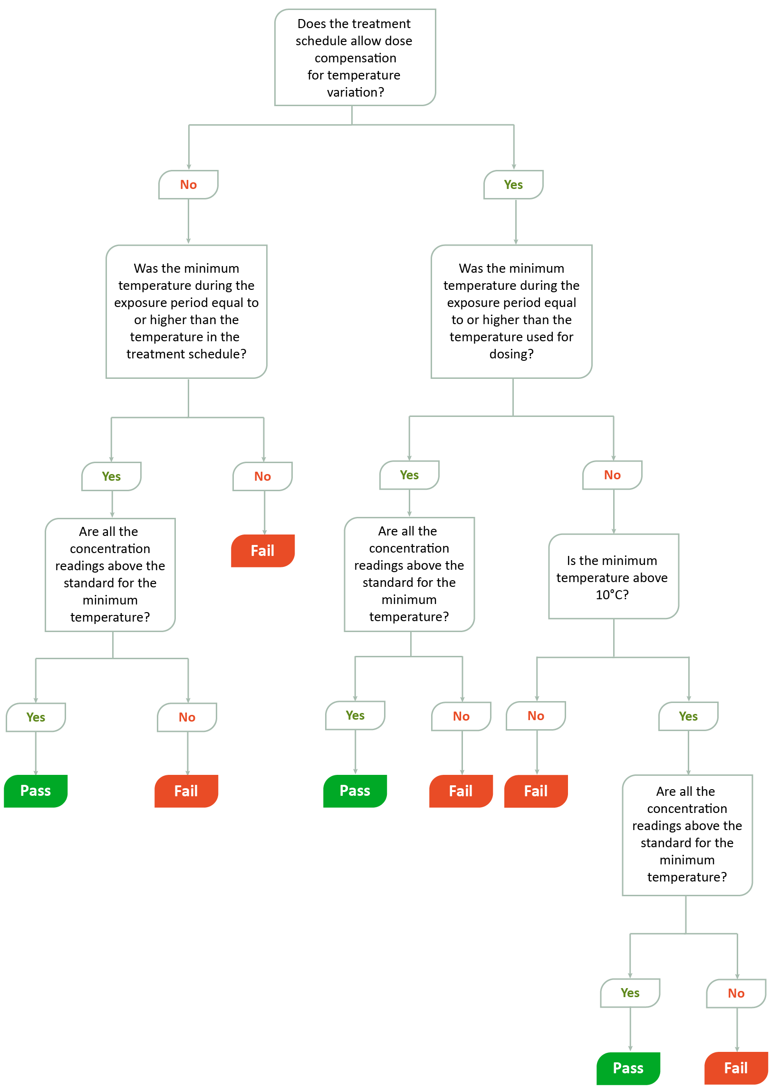

### Controlled temperature fumigations

If the ambient temperature is expected to fall below 10°C, heaters can be used to increase the temperature and maintain it at a satisfactory level for the duration of the exposure period. There will be a gradient within the enclosure where the temperature will progressively decrease the greater the distance from the heat source. Using fan heaters can improve the heat distribution in the enclosure but they may also contribute to an increased loss of methyl bromide from the enclosure, for this reason, the enclosure needs to be as gas-tight as practical.

The enclosure and the commodity must have sufficient time to reach the desired temperature prior to starting the fumigation.

##### What are the temperature monitoring requirements for controlled temperature fumigations?

For controlled temperature fumigations, the temperature within the enclosure must be monitored with a minimum of one temperature instrument.

The temperature within the enclosure must be monitored and recorded at least once every 60 minutes for the entirety of the exposure period. These records must be retained with the fumigation documentation.

The temperature recorded within the enclosure during the exposure period must be equal to or above the temperature used for dosing.

The minimum temperature recorded with the enclosure during the exposure period must be recorded on the record of fumigation.

### Perishable commodity fumigations

##### What are the temperature monitoring requirements for perishable commodity fumigations?

The temperature of the enclosure must be monitored and recorded at least once every 60 minutes for the entirety of the exposure period. These records must be retained with the fumigation documentation.

The temperatures recorded during the exposure period, including enclosure temperature and all core/pulp temperatures, must be equal to or above the temperature used for dosing.

The minimum temperature of the goods achieved for the exposure period must be recorded on the record of fumigation.

## Performing the fumigation

To achieve an effective fumigation the target of the fumigation must be exposed to a sufficient concentration of fumigant for a sufficient length of time to achieve a lethal dose. The dosage rate, temperature and any minimum retention rate as set in the treatment schedule, to effectively treat all life stages of the target pest.

Fumigations must be conducted in enclosures that are sufficiently gas-tight to maintain concentration levels above the minimum requirement over the duration of the exposure period. Typically, there will be a reduction of fumigant concentration in the enclosure over time due to penetration into or sorption by the commodity and leakage from the enclosure. To ensure that the target pest is subjected to a lethal concentration of fumigant over the entire exposure period, a minimum final retention rate may be required. The minimum retention rate is a percentage of the dosage rate concentration which must be met or exceeded at the end of the fumigation exposure period.

##### What’s the difference between the dose rate and the dose?

The **dose rate** specifies the concentration of fumigant that must be initially applied to the enclosure and the required exposure period.

The **dose** is the amount of fumigant introduced into the enclose to reach the required does rate.

### Dose rate compensation for temperature variation

If the treatment schedule allows dose rate compensation for temperature variation, and the treatment schedule does not specify dose compensation requirements the following calculation must be used: for each 5°C, or part thereof, the temperature is expected to fall below 21°C add 8 g/m³ to the prescribed dose rate.

The adjustment schedule for temperatures below 21°C is:

* 21°C and above no adjustment allowed
* 16°C to 20°C – add 8 g/m3 to the prescribed dose rate
* 11°C to 15°C – add 16 g/m3 to the prescribed dose rate
* 10°C – add 24 g/m3 to the prescribed dose rate.

### Calculating the dose

##### How is the actual amount of methyl bromide needed calculated?

The weight of methyl bromide needed to achieve the prescribed concentration must be calculated by multiplying the dose rate by the volume of the enclosure. The formula is:

Dose (g) = Enclosure Volume (m3) x Dose Rate (g/m3)

The dose can be measured using:

* volume
* weight
* cans, 1 can of fumigate equals 1 pound (454 g) and 1 ½ pound (680 g).

If cans are used the fumigator must round the dose up to the next full can, calculate using a combination of 1 and 1 ½ pound cans (454 g and 680 g respectively) to get the optimal combination. Partial use of a can is not permitted so the dose in this case must comprise one or more full cans.

Due to the inaccuracy inherent with measuring the dose by weight or volume the actual amount of methyl bromide injected into the enclosure will vary slightly to what was intended.

It is not always possible to measure methyl bromide precisely, no matter what method you use. For this reason the calculated dose should be rounded up to the nearest reliably measurable increment for the equipment being used. Rounding is always completed once all other calculations have been completed.

The actual amount used, as far as can be practically determined, must be recorded on the Record of Fumigation.

##### Calculating enclosure volume

The volume of the enclosure must be calculated from the measured dimensions.

If the fumigation is performed as a sheeted enclosure, the external dimensions of the enclosure must be measured. The dimensions of sheeted enclosure should be measured prior to each fumigation because significant variations in volume can occur depending on the set-up of the enclosure.

If the fumigation is performed in a fixed-size enclosure, the internal dimensions of the enclosure must be used to calculate the enclosure volume. The volume of any gas circulation equipment external to the chamber must be included in the calculation of the enclosure volume.

No reduction in the volume and therefore, the dose, is allowed to account for any displacement of air in the enclosure by the commodity.

##### How is the dose calculated when Chloropicrin in the methyl bromide mix?

Some fumigants can be supplied mixed with other gases, so the fumigant is diluted to less than 100%. For example, methyl bromide is commonly supplied with a mixture of 2% chloropicrin. Methyl bromide is colourless and odourless at concentrations normally encountered during fumigation so the chloropicrin is added as a warning agent.

If the methyl bromide is mixed with another gas, compensation must be made to the dose amount, so the full amount of methyl bromide required is injected into the enclosure. For methyl bromide supplied with 2% chloropicrin the formula is:

Dose (g) = (Enclosure Volume m3) x Dose Rate (g/m3)) ÷ 0.98

Chloropicrin will have an adverse effect on cut flower commodities and some other perishable commodities. In this scenario, 100% methyl bromide dose is needed. 100% methyl bromide is mandated in some jurisdictions, so please refer back to the local legislation in your jurisdiction.

#### CT Product

The amount of fumigant required to achieve the lethal dose is referred to as the dosage rate and is expressed as a function of concentration and time, commonly referred to as the CT product. It is an expression of the minimum total cumulative exposure to the fumigant needed to effectively treat the biosecurity risk associated with the consignment.

The starting dose is set to achieve the required CT product, taking into account gas loss during the exposure period from leakage and sorption. For example, timber is typically fumigated with methyl bromide at a dosage rate of 48 g/m3 for 24 hours giving a CT product of 48 x 24 which is 1152 g/h/m3, assuming no gas loss. In reality, the actual CT product, taking into account gas loss, is around 500 g/h/m3 based on a retention rate of 30% after 24 hours.

### Injecting methyl bromide into the fumigation enclosure

##### Why is methyl bromide vaporised?

The main reason the methyl bromide must be completely vaporised is to prevent liquid methyl bromide from being released into the enclosure. If liquid methyl bromide comes into contact with the commodity it can cause cold ‘burns’ as it continues to try and draw the heat from the environment it needs to evaporate. Not only can this cause damage to the commodity, but it is also potentially dangerous as liquid methyl bromide reacts explosively on contact with aluminium, magnesium and zinc (whereas gaseous methyl bromide does not do this).

It is poor fumigation practice to not fully vaporise the methyl bromide and the fumigator may be held responsible if the product is adversely affected as a result.

In addition, vaporising the methyl bromide has the added benefit of energising the methyl bromide molecules improving the speed of dispersion throughout the enclosure and encouraging more rapid penetration into the product if it is porous.

#### Vaporiser design

There are two related factors that affect the vaporisation of methyl bromide, the first is temperature and the second is pressure. The higher the temperature i.e. the more heat available, the greater the tendency there is for the liquid to become a gas. Conversely, the higher the pressure the greater the tendency there is to stay as, or turn back into, a liquid. Both these factors need to be taken into account to ensure that the methyl bromide is fully vaporised before it reaches the enclosure.

Methyl bromide is supplied as a liquid under pressure in cylinders or cans. The methyl bromide changes from a liquid to a gas as is released. This process requires energy in the form of heat which it draws from the immediate surroundings. When it vaporises the methyl bromide increases 275 times in volume and this expansion increases the pressure in the supply hose. If this pressure gets too great and there is not enough heat available, the methyl bromide will turn back into a liquid. As more methyl bromide passes through the supply system there is progressively less and less heat available so the liquid methyl bromide will travel further towards the outlet without vaporising until it exits into the enclosure.

The vaporiser is a heat exchanger that uses a metal coil immersed in a container of hot water to provide the energy needed to ensure that the methyl bromide is fully vaporised and remains in a gaseous state. There is a direct relationship between the amount of methyl bromide passing through the system and the energy available to turn it into a gas. If there is insufficient heat available, the pressure build-up in the supply system can turn the methyl bromide back into a liquid.

Following is a simple design for a versatile and portable vaporiser suitable for most fumigation situations that would be covered by the Methyl Bromide Fumigation Methodology.

Figure 14 Vaporiser design

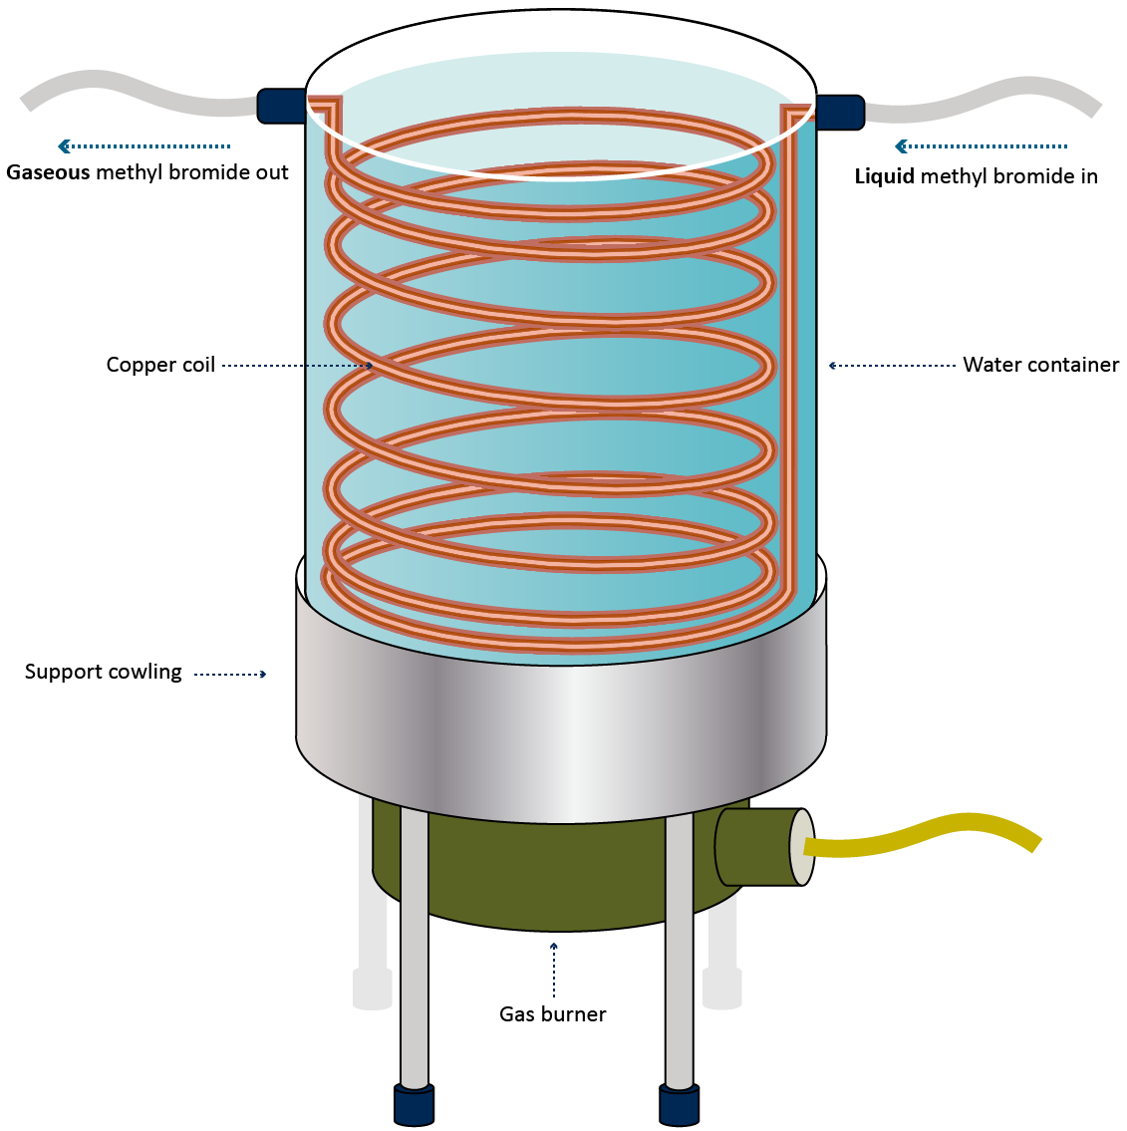

##### The heat transfer coil

The coil should be made from copper tubing because it is a good conductor of heat. The coil can be made from one continuous length that should be at least 12 metres long and with an internal diameter (ID) no greater than 12 mm. Internal diameters larger than 12 mm proportionally decreases the ratio of surface area to volume (assuming equivalent flow rates) making the vaporisation process less efficient as the internal diameter increases. This, in combination with allowing the methyl bromide to pass more quickly through the system, increases the chances of liquid methyl bromide exiting the supply pipe unless the flow rate is carefully monitored and controlled.

Another design option for the coil is to construct it from three five metre lengths of copper tubing of progressively increasing from 6 mm ID to 9 mm ID and finally 12 mm ID (**Error! Reference source not found.**). This smaller ID at the start of the coil restricts the flow rate of methyl bromide from the supply cylinder and the subsequent increasing size improves the flow of the gas in the direction of the by avoiding excessive back-pressure which can re-liquefy the Methyl bromide.

Figure 15 Copper tubing with progressively increasing diameter to avoid back pressure

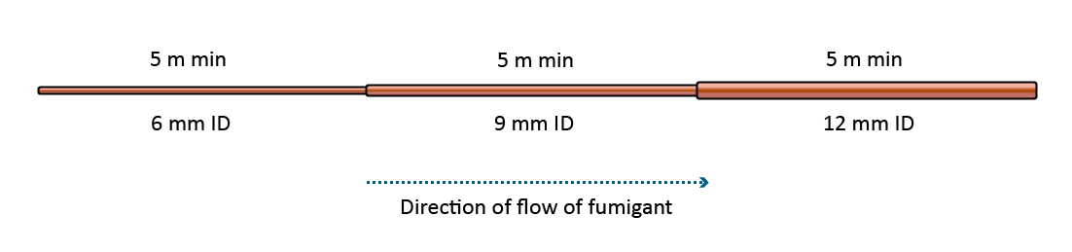

The lengths of tubing must be carefully joined in a manner that is completely gas-tight. The joins should be checked regularly as they can be susceptible to leaks, particularly if the vaporiser is moved around frequently.

Whichever coil design is used, suitable connectors should be used to join the coil to inlet and outlet of the vaporiser.

##### The water container

The water capacity of the vaporiser should be proportional to the length of the heat transfer coil. A water volume between 20 litres to 25 litres would be adequate for the coil specifications described above.

The container should be constructed of a material suitable for the heating method used. Stainless steel is a good option.

It is advisable for the vaporiser to have handles so that it can be moved if needed while it is full of water.

A lid that can be easily removed once the water is hot to make it easier to monitor the water temperature during injection. Alternatively, a thermometer or steam whistle could be used.

##### Heating the water

The heating method used should be able to heat the water to boiling in around 20 minutes to 30 minutes, this is about the time it would normally take an experienced fumigation team to prepare the enclosure for fumigation.

The method of heating must also be able to maintain the water temperature above 65°C while the fumigant is being injected. The vaporisation process will draw heat from the water as the Methyl bromide passes through the coil so the heat source must continue operating during injection to replace the lost heat.

It is strongly recommended that good capacity gas burners are used. A cowling should be included to support the container above the gas burner and to protect the burner from the wind. Electrical heating elements are acceptable, but they are generally less effective than gas slowing down the rate at which the gas can be injected (.

Figure 3).

##### Fittings and connections

The choice of fittings for both inlet and outlet will depend on the individual and the equipment used. However, it is strongly recommended that good quality gas rated fittings are used. Threaded fittings on all gas piping is recommended, rather than relying on hose clamps to hold piping in place on bare copper tubing. It is never a good idea to use tape to join any part of the supply system.

##### Using the vaporiser

Prior to use, the vaporiser should be inspected for damage and that the connections and fittings are in good order.

Set up the vaporiser inside the exclusion zone and start heating the water so that it will be ready to use as soon as the enclosure has been prepared. Do not connect the vaporiser to the cylinder until just before you are ready to inject the gas.

Check the vaporiser for leaks by releasing a small amount of methyl bromide from the cylinder and test all the connections along the supply system with a suitable leak detector. Fix any leaks before starting to inject the dose into the enclosure. Be careful to open the supply valve slowly to avoid rapid pressurisation of the system which could result in weak or poor connections coming apart releasing methyl bromide into the area. Suitable respiratory protection must be worn while releasing the methyl bromide.

While the required minimum water temperature is 65°C it is recommend that the water be kept on the boil prior to and during the injection process as this allows the operator to easily check that the temperature is above the mandatory requirement. If the water is not boiling or the operator cannot see if it is, then a simple method to test that the temperature is acceptable is to hold the outlet hose about a metre from the vaporiser with bare hands. If it is almost too hot to hold firmly then the water temperature should be sufficient.

The operator must regulate the flow of the methyl bromide so that the temperature of the water is maintained and there is not excessive build-up of pressure in the system. Some vaporisers are fitted with thermometers or pressure gauges to assist with managing the rate of release. If the water temperature drops too low, slow or stop the methyl bromide until the temperature has time to recover and recommence releasing the methyl bromide at a slower rate.

#### Checking for leaks

Excessive leakage from the enclosure may cause the fumigant concentrations to fall below acceptable levels resulting in an ineffective fumigation.

Carefully check the enclosure for leaks. For sheeted enclosures check where the sheet meets the fumigation surface around the entire enclosure. Particular attention should be paid to the corners, where the monitoring tubes and leads exit the enclosure, any cracks or expansion joints in the floor and any temporary repairs made to the sheet.

Check around the door seals of un-sheeted containers used as enclosures.

The leak detection equipment must be sufficiently sensitive to detect fumigant concentrations low enough to find a leak that warrants attention. As a general guide the leak detector should be capable of detecting concentrations down to 30 ppm.

The leak detection equipment must be fit for purpose and properly maintained in accordance with the manufacturer’s instructions.

#### Halide leak detection lamp

A halide lamp works on the principle that a flame in contact with a clean piece of copper will burn with a green to blue flame if vapour of an organic halide is present in the surrounding air. The copper ring must be kept clean and replaced regularly to ensure proper functioning. These instruments can be used to detect methyl bromide in the air for the purpose of detecting serious leaks which can then be rectified to prevent excessive loss of fumigant and thereby reduce the likelihood of fumigation failure (.

Table 1). At increasing concentrations of the halide gas, the colour changes from green to greenish-blue or blue.

Table 2 Determining methyl bromide concentrations with the halide detector

|  |  |
| --- | --- |
| **Concentrations in air – parts per million** | **Reaction of flame** |
| 10 | Very faint green tinge at edge of flame |
| 20 | Light green edge to flame |
| 30 | Light green flame |
| 100 | Moderate green |
| 200 | Intense green, blue at edge |
| 500 | Blue green |
| 1000 | Intense blue |

Note: Owing to variations in response of individual lamps, readings below 30 ppm are unreliable.

Halide detection lamps cannot be relied upon for accurate quantitative measurements. They are useful for indicating the presence of immediately dangerous concentrations, for preliminary checking the effectiveness of aeration and for finding leaks during treatment. They are not suitable for checking threshold limits for continuous daily exposure to methyl bromide; a more accurate method must be used for final determination of gas clearance after ventilation.

Changes in the colour of the flame can be difficult to identify, particularly in direct sunlight or brightly lit areas. Colour blind people cannot use halide lamps.

#### Electronic gas detection

There is a range of electronic methyl bromide gas detection equipment available that are more sensitive and easier to use then a halide lamp. There are two types of electronic leak detectors, ones that only detect the presence of methyl bromide and those that give an actual value for the concentration detected. Leak detectors that provide quantitative reading of the concentration are also suitable for checking TLV if they can detect concentrations below 5 ppm.

Leak detectors used for refrigerant gases are not suitable for use with methyl bromide and are not acceptable.

### Even methyl bromide distribution

The methyl bromide must be evenly distributed throughout the enclosure. This is verified by equilibrium. Equilibrium is achieved when the highest concentration reading is within 15% of the lowest concentration reading.

The calculation for equilibrium is pictured below (Figure 16):

Figure 16 Equilibrium calculation

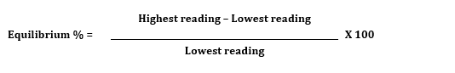

If the result of this calculation is more than 15%, equilibrium has not been achieved and additional time is needed to allow the methyl bromide to further distribute throughout the enclosure.

Note that once equilibrium has been achieved it is not required at any other time.

#### Circulating the fumigant

The methyl bromide must be evenly distributed throughout the enclosure to ensure that fumigant concentrations are sufficient to administer a lethal dose to the target pests.

Methyl bromide is considerably heavier than air (3.27 times) and could be described as a ‘lazy’ gas. If it is allowed to disperse naturally, there will likely be areas of high concentration near the outlet and lower concentrations further away. Smaller spaces between and air pockets within the goods are particularly susceptible to lower concentrations as the natural movement of air is less effective in dispersing methyl bromide into these areas.

Mechanical agitation of the air is required to force rapid dispersal of the fumigant throughout the enclosure and into the spaces between and within the commodity. It is most common to use an electric fan for this purpose. There are alternative methods of distributing the gas such as utilising compressed air. If utilising an alternative to fans the effectiveness of that system must be demonstrated. The fumigator in-charge may need to have the alternative method of distributing gas approved for effectiveness before use.

There is no specified minimum capacity as the suitability of a particular fan will depend on the size of the enclosure, how the consignment is configured and the amount of free airspace. However, the fan will have a direct effect on how quickly equilibrium is reached and therefore when start-time is achieved. For more details on fans see Section 5.7 Fans and heaters.

##### When do the fans need to be turned on?

Fans should be turned on 10 minutes to 15 minutes before releasing any fumigant into the enclosure and continue to run until equilibrium is reached. The time it takes to achieve equilibrium will vary depending on factors such as, how tightly packed the commodity is, the size of the enclosure, the capacity of the fans and the number of supply pipes used to introduce the fumigant. It is a matter of experience to judge how long to run the fans before taking the first readings.

The fans must be running during the injection phase and for as long as necessary to achieve equilibrium. The fans should be turned off prior to taking the concentration readings to allow the air in the enclosure to settle. This helps to get more accurate and stable readings.

It is not necessary to run the fans again once equilibrium is achieved unless additional methyl bromide is added to the enclosure.

### Exposure period

##### When does the exposure period start?

It is a common mistake for fumigators to start the exposure period as soon as they get equilibrium and overlook the need for the concentration to be above the required level. Whenever any concentration readings are taken the fumigator must first check if they are at or above the required level for the time at which they were taken

The fumigation exposure period must not start until:

* all concentration readings are equal to or above the standard concentration
* equilibrium has been achieved.

##### What if additional methyl bromide is added prior to the start of the exposure period?

If additional methyl bromide is added to the enclosure before the start of the exposure period, the time of the injection of additional methyl bromide is completed becomes the new injection time for determining the required start time concentration.

##### When does the exposure period end?

The exposure period ends when:

* the exposure period prescribed in the treatment schedule has elapsed
* and all concentration readings are equal to or above the concentration in the treatment schedule.

The time recorded on the ROF for the end of the exposure period must be the time the final concentration reading is taken.

## Monitoring the fumigation

### Gas concentration monitoring

The principal objective of fumigation is to maintain an adequate concentration of fumigant within the enclosure for a sufficient length of time for all pests, including different stages of their life cycle, to receive a lethal dose. The only way to determine if the minimum concentration levels have been met is to take concentration readings at the start of the fumigation and again at the end. If both these readings are at or above the minimum level specified for the time they were taken, then the concentrations have met the minimum requirements throughout the entire exposure period.

Every concentration reading must also show the time at which it was taken. When taking readings from more than one sampling tube, the time must be recorded **after** the final concentration reading was taken and used as the time for all the readings in that set.

If the exposure period is longer than 24 hours, concentration readings must be taken from all concentration monitoring locations at least every 24 hours in addition to the start and end point readings.

All gas concentration readings must be recorded on the record of fumigation at the time they are taken. This includes readings taken prior to achieving start time or optional readings during the exposure period. Readings from additional concentration monitoring locations that are mandated by import conditions must also be recorded.

Additional readings can be taken at any time during the exposure period to check concentrations are equal to or above the levels required for an effective treatment.

#### Monitoring frequency

There may be times when it is necessary for the fumigator to take concentration readings in addition to the mandatory readings. If the fumigator is concerned that fumigant levels may fall below the required concentration, then the fumigator should carefully monitor the fumigant levels and take preventative measures if needed.

The minimum gas retention rates assume that there will be a certain amount of gas loss during the fumigation due to leakage and/or sorption. The rate of gas loss tends to be highest at the start of the fumigation and then stabilises. If there are any leaks then the enclosure will be losing gas until the leaks are found and fixed. Any sorption will happen early in the exposure period until the product becomes saturated.

Another important factor is the degree of penetration into the commodity. The goods will occupy a volume of space within the enclosure making less air space available for the fumigant. Due to this, the initial concentrations measured will be somewhat higher as the dose is calculated assuming an empty enclosure. If the goods are porous, timber for example, then the methyl bromide will progressively penetrate the goods, reducing the methyl bromide in the surrounding space. The rate and extent of penetration depends on several factors and will vary considerably depending on the nature of the goods.

To account for these factors the minimum concentration levels allow for a 50% loss of gas in the first 4 hours. If the rate of loss is greater than this, it is almost certain that the concentration levels are going to fall below the minimum levels and the fumigation will fail unless the problem is identified and addressed.

#### Minimum concentration levels

If any of the readings show that the concentration level has fallen below the standard concentration specified for the time the reading was taken then the fumigation has failed. Rather than automatically requiring the fumigation to be conducted again it is permitted, in some circumstances, to add additional methyl bromide to the enclosure to get the concentration levels back to a satisfactory level and continue the fumigation.

Below is a table outlining the standard methyl bromide concentrations required at specific monitoring times.

Table 3 Standard concentrations required at specific monitoring times

|  |  |
| --- | --- |
| **Monitoring times** | **Concentration of original fumigant required** |
| 15-30 minutes | 85% or more |
| 30 minutes – 1 hour | 75% or more |
| 1 hour | 70% or more |
| 2 hours | 60% or more |
| 4 hours | 50% or more |
| 12 hours | 35% or more |
| 24 hours | 30% or more |
| 48 hours | 25% or more |

## Topping up methyl bromide levels

If concentration monitoring indicates that fumigant levels are at risk of falling below the standard concentration, then the target of the fumigation may not be exposed to the minimum lethal dose needed to for effective treatment. Therefore, in some circumstances, the fumigator can add extra methyl bromide to increase the concentration levels to prevent the fumigation from failing.

Additional methyl bromide may be added to the enclosure at any time during the exposure period if:

* all the concentration readings are above the standard concentration
* the lowest concentration reading is below the maximum top-up concentration
* the treatment schedule allows top-ups.

Topping up is not permitted for perishable fumigations as over exposure to the fumigant can harm the product, such as reduced shelf-life, and this may not become apparent until sometime after the commodity has been treated. It is important that the fumigator takes this into account when preparing to fumigate and take appropriate measures to ensure the fumigation will be effective without the need to top-up.

Topping-up is not permitted to compensate for excessive leakage from the enclosure. The fumigator is responsible for ensuring that the enclosure is sufficiently gas-tight that the required fumigant retention is met without the need to top-up.

#### Topping-up prior to the start of the fumigation

If the concentration falls below the standard concentration before even gas distribution has been achieved there is probably excessive leakage from the enclosure. For sheeted enclosures it is most likely due to fumigation sheets not being suitable or in poor condition, a porous fumigation surface or proper care was not taken to create a good seal between the sheet and the fumigation surface. Before adding any additional methyl bromide the fumigator must find and fix the cause of the problem.

Once the problem has been identified and fixed the fumigator needs to take another set of readings to determine how much fumigant remains in the enclosure, as the fumigant would have continued to leak until the problem was fixed.

Use the lowest of these readings to calculate the amount of additional methyl bromide to add by subtracting the lowest reading from the initial dose concentration to give a value in g/m³. This is then multiplied by the enclosure volume to give you the amount of methyl bromide to be added to the enclosure.

The fumigation now effectively starts again and all the requirements for injecting the gas, even gas distribution and start time apply.

If start point can be achieved, then the fumigation can proceed but it would be sensible to take some additional readings an hour or so after the start to check that the concentration levels have been maintained.

### Topping-up during the exposure period

During the exposure period the concentration levels must not drop below the standard. If the concentration drops below the standard, it is difficult to determine how long the level has been below the standard meaning there is no assurance that the required CT will have been met.

The need to top-up during the exposure period could be a result of sorption, leakage or a combination of both. The process of sorption occurs mostly at the start of the fumigation and then tapers off as the consignment becomes saturated. Therefore, there should be no need to top-up due to sorption once the fumigation start time has been achieved. If the need to top-up is because of leakage then this will continue unless the leak is found and fixed.

If the enclosure has been carefully leak checked and there is a need to top-up more than once during the exposure period, then it would indicate that the fumigation sheet is not suitable and is unable to retain the methyl bromide for the required time. If the sheets are not made of a suitable material the gas will pass through the sheet. The cumulative effect over a large surface area can be significant and lead to excessive gas loss even if it can’t be directly detected. If this is the case, the fumigation sheet needs to be replaced before re-starting the fumigation with one that is suitable.

If a top-up is performed during the original exposure period, no extension of the exposure period is required.

Multiple top-ups are permitted during the exposure period.

### Topping-up at the end of the exposure period

If a top-up is necessary at the end of the exposure period, the exposure period must be extended by 4 hours. If this is a regular occurrence it is indicative of poor gas retention. The fumigator should identify and address the problem before conducting any further fumigations.

If the lowest concentration reading at the end of the exposure period is below the standard concentration but not below the minimum concentration to allow top-up, additional methyl bromide may be added to the enclosure.

After the minimum four-hour extension time, readings must be taken from all sampling lines and the concentration must be equal to or above the standard concentration required for the original exposure period, if not, the fumigation has failed.

Only one top-up at the end of the exposure period is permitted.

Topping-up the concentration at the end of the exposure period is not permitted if:

* the lowest concentration reading is below the minimum concentration to allow top-up, or
* the treatment schedule prohibits topping-up.

### Performing the top-up

The weight of methyl bromide for top-up must be calculated by subtracting the lowest concentration reading from the maximum to allow top-up concentration, and multiplied by the volume of the enclosure, as below:

Top-up amount (g) = Enclosure volume (m3) x (Maximum to allow top-up – Lowest concentration reading)

When the additional methyl bromide has circulated, a concentration reading must be taken from the monitoring location that had the lowest reading to verify that the methyl bromide is back above the standard concentration.

Top-up details (amount, time and concentration readings) must be recorded on the record of fumigation.

If top-ups are performed equilibrium is not required.

## Ventilating the fumigation enclosure

At the end of the exposure period the enclosure must be safely vented to remove the fumigant from the consignment by exposure to fresh air until the concentration of fumigant is below the required threshold limit value (TLV).

Sufficient free airspace and the use of fans will help to ventilate the enclosure more quickly. The time taken to ventilate depends on a number of factors such as the size of the enclosure, how tightly packed the commodity is, whether there is sorptive materials in the enclosure and the degree of penetration into the goods.

The methyl bromide in the air around the commodity will dissipate rapidly once the enclosure has been opened. If, however, the methyl bromide has penetrated the commodity, for example timber or cardboard boxes, then it will take considerably longer for the gas to diffuse out of the goods. This process could take 24 hours or more depending on the nature and configuration of the commodity. The fumigator needs to plan for this prior to starting the fumigation.

### Threshold limit value (TLV)

The TLV is the maximum concentration of fumigant that the average person can be safely exposed to day after day over a working lifetime without adverse health effects. The TLV is an estimate based on the known toxicity in humans or animals of a given chemical substance. The limits specified are subject to change as new information emerges that may modify the risk assessment for a particular substance. Therefore, it is strongly advised that any exposure to fumigants be minimised as much as possible unless proper respiratory protection is worn.

The TLV-TWA for fumigants are expressed as parts per million (ppm) or part parts per billion (ppb).

Three types of TLVs for chemical substances are defined:

1. **Threshold limit value - Time weighted average (TLV-TWA):** average exposure on the basis of an 8 hour/day, 40 hour/week work schedule. For methyl bromide the TLV-TWA is widely accepted as 5 ppm.
2. **Threshold limit value - Short-term exposure limit (TLV-STEL):** spot exposure for a duration of 15 minutes, that cannot be repeated more than 4 times per day with at least 60 minutes between exposure periods. For methyl bromide the TLV-STEL is widely accepted as 15 ppm.
3. **Threshold limit value - Ceiling limit (TLV-C):** absolute exposure limit that should not be exceeded at any time. There is currently no TLV-C defined for methyl bromide.

The TLV is different for each fumigant and may also vary from country to country. The TLV for methyl bromide is 5 ppm.

The equipment used to test for TLV must be sensitive enough to accurately and reliably detect concentrations in ppm below the TLV.

If stain tubes are used to detect methyl bromide, they must be used:

* in accordance with the manufacturer’s instructions
* in conjunction with the sampling pump specified by the manufacturer
* before the expiry date.

The equipment used for measuring TLV must be able to measure the actual concentration, not just the presence of methyl bromide, to at least 1 ppm.

### Releasing methyl bromide from the enclosure

At the end of the exposure period, the methyl bromide must be fully ventilated from the enclosure in a controlled and safe manner.

Releasing the fumigant from the enclosure is the only time a fumigator knowingly exposes themselves and possibly others to methyl bromide. The fumigator needs to actively manage the risk to themselves and anyone in the vicinity. The fumigator should control the rate of release by progressively opening the enclosure so the fumigant is not released as a large plume which can travel further and in higher concentrations than it would otherwise do.

A risk assessment must be performed to manage the ventilation process and ensure it is safe by considering:

* prevailing wind direction
* location and proximity of unprotected personnel
* extension of the exclusion zone around the enclosure if required to prevent unprotected personnel in the vicinity from being exposed to methyl bromide levels above the TLV.

Electronic leak detection equipment should be used (if available) to verify that the buffer zone around the enclosure is sufficient, when it can be decreased, and by how much as the ventilation proceeds.

If there are local regulations that set a maximum concentration that can be released from the enclosure, the fumigator must dilute the exhaust stream to restrict the concentration under the level specified. This is normally achieved by drawing the air from the enclosure through a duct attached to a tall chimney, so the gas is released high above ground level. The exhaust stream is diluted by valves along the duct that controls the amount of fresh air drawn in from the surrounding area (Figure 14).

Figure 17 Example of a ventilation/exhaust system for a fumigation chamber

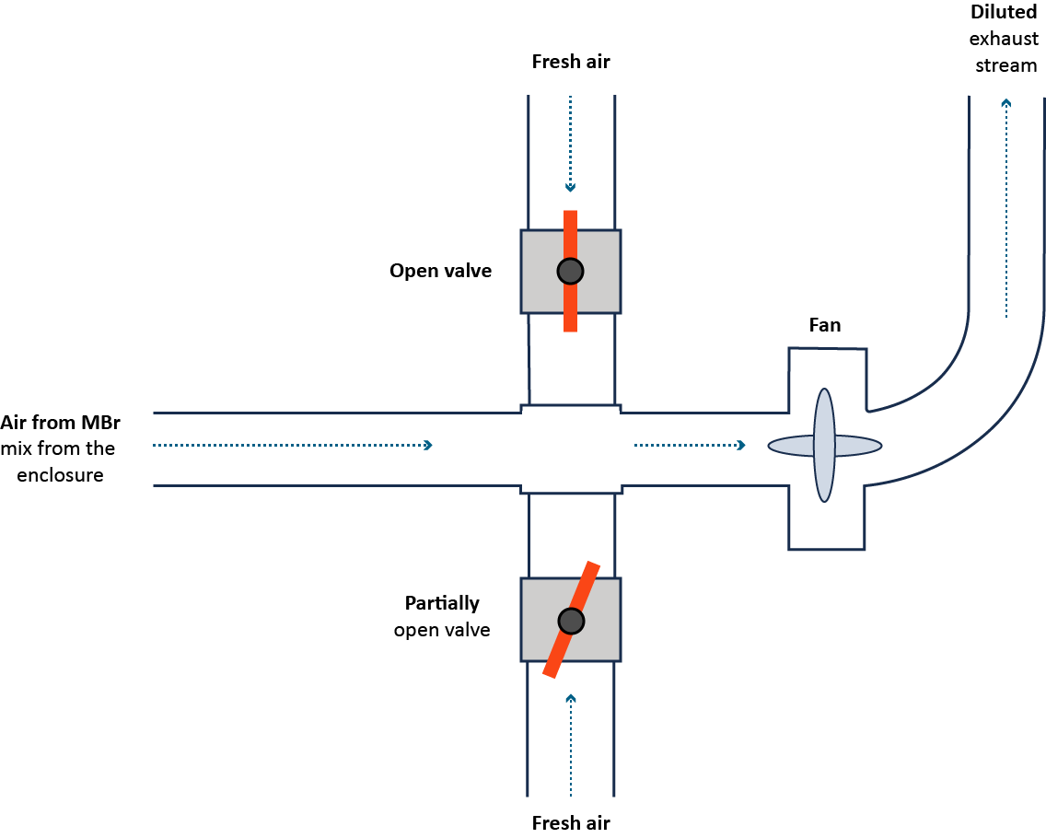

##### Procedure for ventilating a sheeted enclosure

Remove all the sand snakes except a few down both sides of the enclosure. At one end, lift the sheet on both corners to no more than waist height and secure, use the belly rope if there is one. Do this first on the downwind direction so the wind doesn’t get under the sheet and lift it off before you are ready. Repeat this procedure at the upwind end, then pull the sheets out at the sides. The few sand snakes that were left down the sides will hold the sheets in place creating a wind tunnel effect. Wait for 5 minutes to 10 minutes until most of the fumigant has dissipated then remove the sheet entirely.

##### Procedure for ventilating an un-sheeted shipping container

Remove the tape from the vents then open the right-hand door slightly and leave ajar. In windy conditions a rope or chain can be used to prevent it from blowing open and a block of wood or similar can be inserted to prevent the door from closing. After 10 or so minutes both doors can be opened fully and the container left until ventilation is complete.

The sea container must not be moved until the methyl bromide concentration inside the enclosure is at or below the TLV.

##### Checking the TLV-TWA

Ventilation of the enclosure and aeration of the commodity must continue until concentration levels in the enclosure are at or below the TLV-TWA. Attach the TLV measuring instrument to the monitoring tubes positioned in the centre or back of enclosures to check if TLV has been reached at all points.

The concentration levels in the free airspace will fall relatively quickly compared to the rate of methyl bromide diffusion back out of the commodity. It is particularly important that the consignment is fully aerated if it is fumigated in a shipping container. Once the container is closed, concentrations levels can increase again to unsafe levels as the methyl bromide continues to diffuse out of the commodity. This has the potential for unprotected personnel to be exposed to unsafe levels of fumigant when the container is opened at its destination.

If the consignment is a perishable commodity fumigation, packed in cartons and/or bags that have been opened during fumigation, the cartons and/or bags can only be closed once the methyl bromide concentration inside the cartons and/or bags is under the TLV.

The TLV readings and the time they were taken must be recorded on the record of fumigation.

### Releasing the consignment from the control of the fumigator-in-charge

Following a fumigation, the consignment can only be released from the control of the fumigator-in-charge once the following requirements have been met:

* the fumigation complies with the requirements of this methodology and the methyl bromide concentration has been verified at or below the TLV, or
* the fumigation has failed, and it is subsequently unsuitable for further fumigation with methyl bromide and the methyl bromide concentration has been verified at or below the TLV.

## Documentation

### Record of fumigation

Figure 18 Record of Fumigation (non perishable) Section A and B

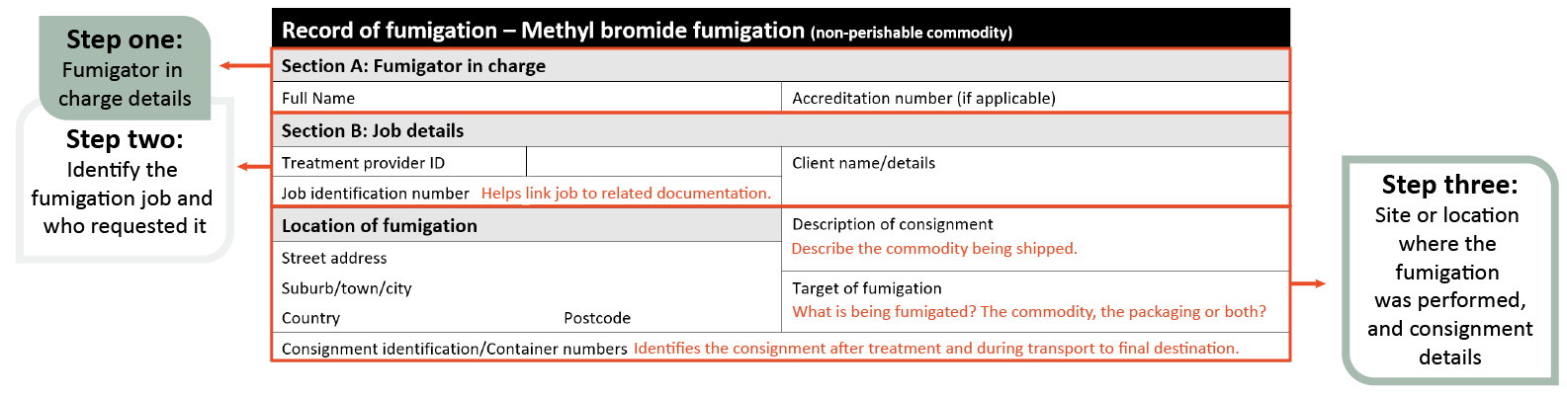

Figure 19 Record of Fumigation (non perishable) Section C

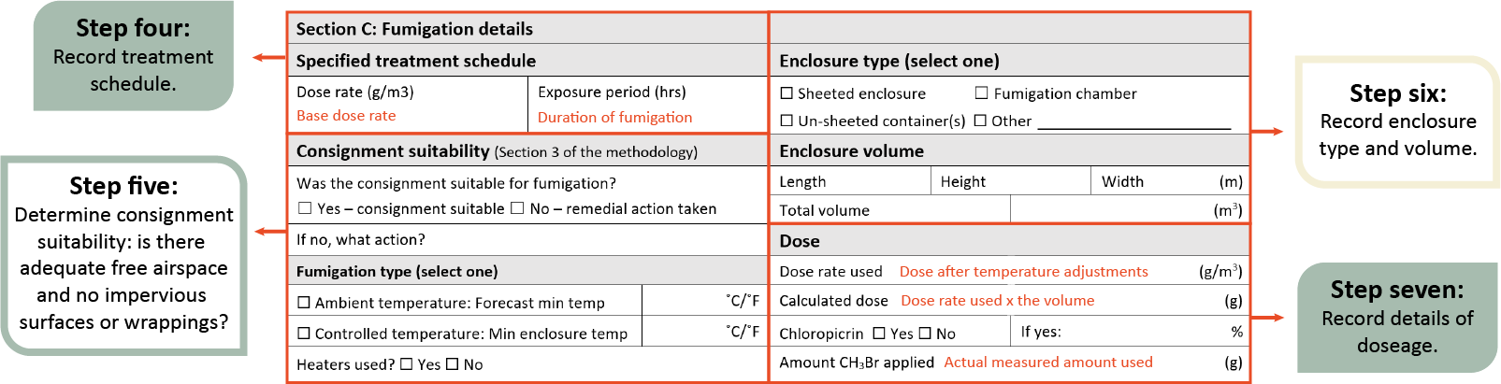

Figure 20 Record of Fumigation (non perishable) Section D

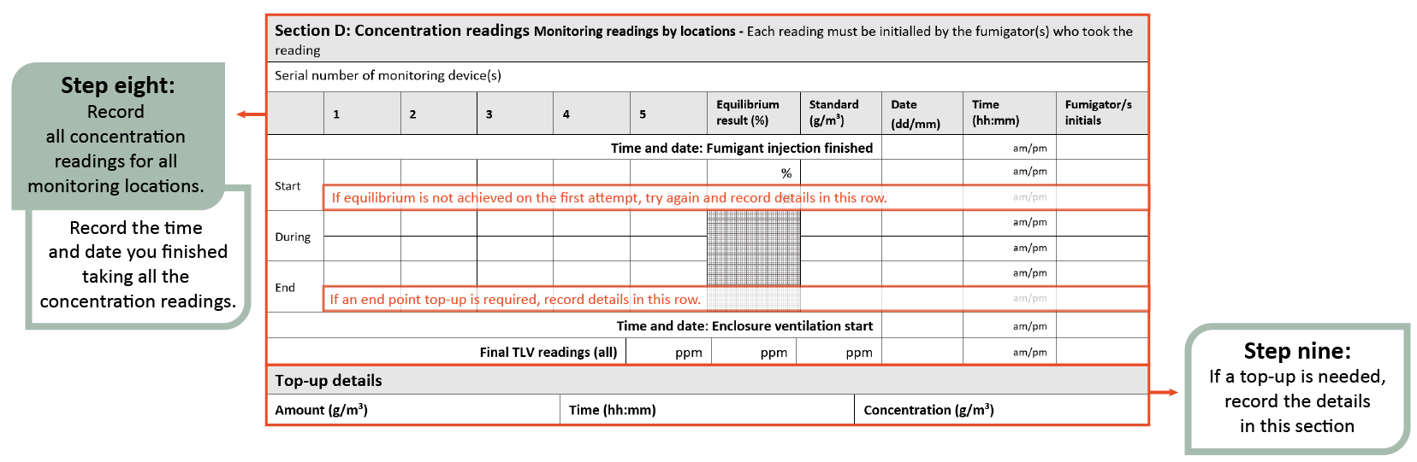

Figure 21 Record of Fumigation (non perishable) Section E

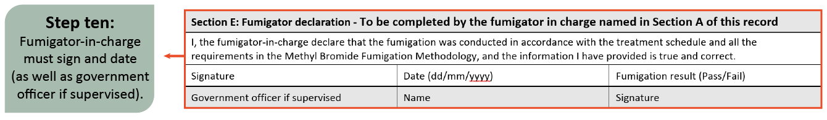

Figure 22 Record of Fumigation (perishable) Section A and B

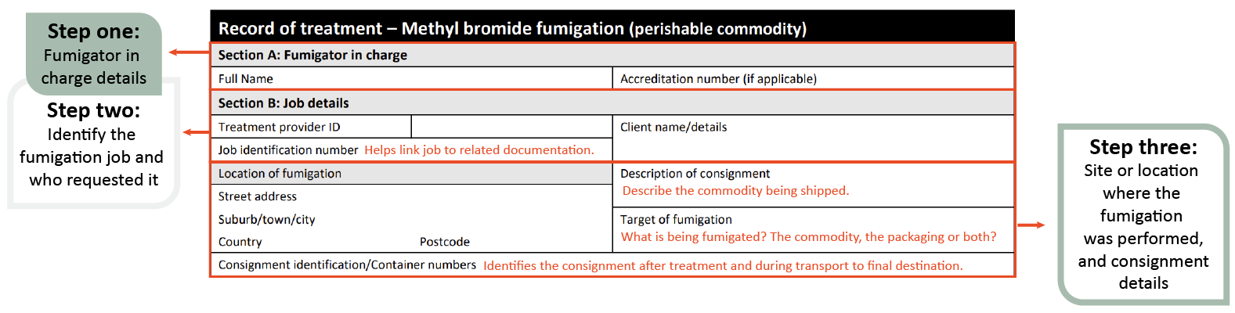

Figure 23 Record of Fumigation (perishable) Section C

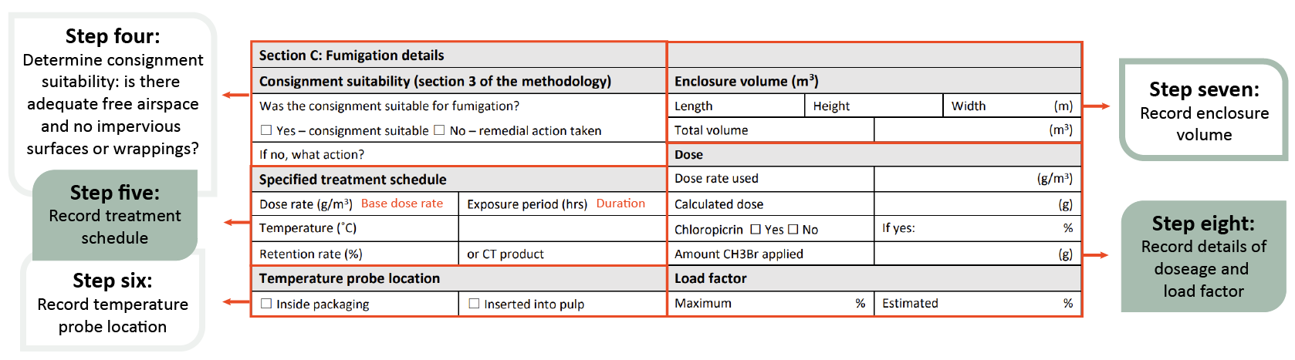

Figure 24 Record of Fumigation (perishable) Section D

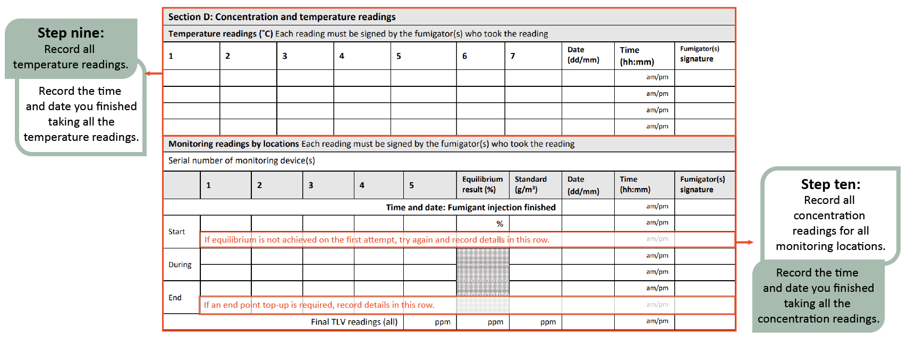

Figure 25 Record of Fumigation (perishable) Section E

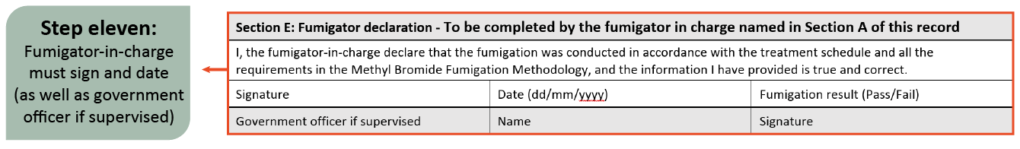

### Fumigation treatment certificate

The fumigation certificate is an official export document issued by the fumigator to declare that the fumigation has been performed in accordance with the requirements of the Methyl Bromide Fumigation Methodology. The fumigation certificate must accompany the consignment.

A fumigation treatment certificate is issued once the fumigator-in-charge determines the fumigation has complied with requirements of the Methyl Bromide Fumigation Methodology.

Details of the consignment and information relating to the fumigation must be included on the fumigation certificate for it to be accepted by the department. This information should be on a single page and in a format consistent with the fumigation treatment certificate template in the methodology.

Fumigation certificates from ICCBA and AFAS countries will only be accepted if they are issued by a treatment provider listed on the relevant [List of Treatment Providers](https://www.agriculture.gov.au/biosecurity-trade/import/before/prepare/treatment-outside-australia/pre-border-biosecurity-treatment-providers).

#### Treatment certificate minimum requirements

The certificate must contain all content specified in the methyl bromide fumigation methodology. Templates are provided for ease of use and to demonstrate the minimum requirements, but these templates are not mandated. If the fumigator had a different template that contains all the required information this is acceptable.

#### Declaration

The AFAS accredited fumigator (or accredited officer if the certificate is endorsed by the relevant regulatory authority) responsible for ensuring that the treatment is effective and performed according to the requirements of the Methyl Bromide Fumigation Methodology must sign and date the certificate and print their name and accreditation number. They may also wish to stamp the certificate with their company stamp.

False declarations may result in accreditation being revoked.

Figure 26 Fumigation certificate example

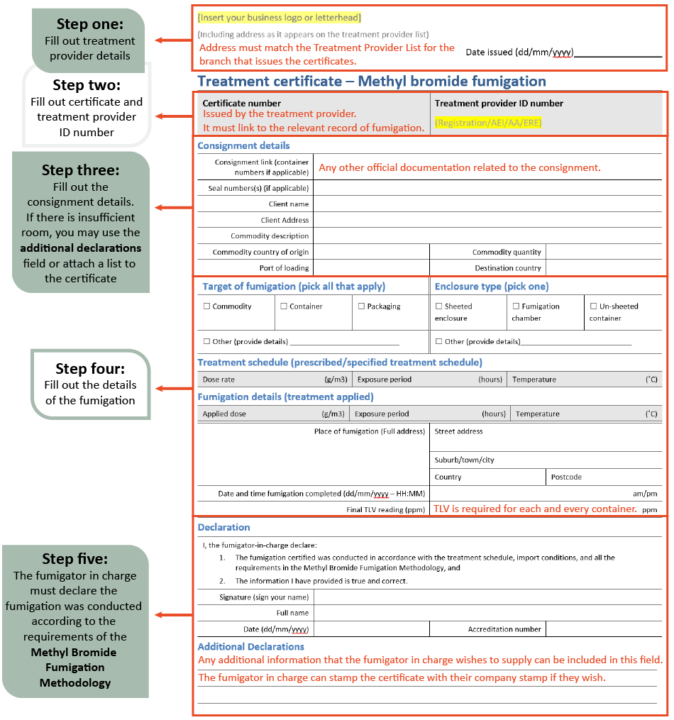

## Environment and recapture

Methyl Bromide is a widely used but strictly regulated fumigant, as it is known to be an ozone-depleting substance. It is approved for use as a biosecurity fumigant for quarantine and pre-shipment uses, but efforts are being undertaken to find alternatives to methyl bromide and to encourage the use of recapture technologies to minimise the amount of methyl bromide that is released into the atmosphere.

### Methyl bromide and the Montreal Protocol

The Montreal Protocol is an international agreement made in 1987 that aims to restore the ozone layer by regulating the production and consumption of ozone depleting substances.

The agreement sets out a timetable for the phase out of all major ozone depleting substances, including methyl bromide.

For more information on the Montreal Protocol, visit the Department of Climate Change, Energy, the Environment and Water’s [web page](https://www.dcceew.gov.au/environment/protection/ozone/publications/montreal-protocol-factsheet).

### Recapture technology

The goal of recapture technology is to reduce methyl bromide emissions.

There are two categories of methyl bromide capture systems:

1. carbon based systems
2. capture and destroy systems.

Carbon based systems use activated carbon filter beds to trap and hold methyl bromide via adsorption.

Capture systems use scrubbing solutions to agitate the methyl bromide, causing complete breakdown of the gas.

Destroy systems trap the methyl bromide on a carbon filter bed and treat the carbon with extremely high temperatures so the methyl bromide begins to decompose.

### The department’s requirements

The Methyl Bromide Fumigation Methodology sets out the requirements for the safe and effective use of methyl bromide as a biosecurity fumigant, with the aim of providing robust requirements that will increase fumigator capability, and thereby reduce the need for re-treatment. By working to increase the capability of treatment providers, the department aims to mitigate the risks of methyl bromide use and meet Australia’s obligations in phasing out methyl bromide.

Please refer to your local jurisdiction for methyl bromide recapture requirements.

## Appendix A: Commodities that may have adverse reactions to methyl bromide

**Note:** Appendix A is intended for informational purposes only. While it provides a list of commodities that may have adverse reactions to methyl bromide, it is not exhaustive. Users should conduct their own tests and consult with experts to ensure the suitability of methyl bromide for their specific commodities and circumstances. The department is not liable for any damage or loss resulting from the use or misuse of this information.

Methyl bromide may cause unwelcome and irreparable odours, taints, and changes in texture to the commodities listed below. The absorbative capacity depends on the commodity, with methyl bromide highly soluble in fats in particular.

Methyl bromide can react to sulphur and sulphur compounds present in commodities.

|  |  |  |
| --- | --- | --- |
|  | Commodity | Notes |
| 1 | Foodstuffs:   * Butter, lards and fats * Iodised salt stabilised with sodium hyposulphite * Full fat soybean flour, whole wheat flour, other high protein flours and baking powders * Nuts with high oil content * Certain baking sodas, cattle licks, salt blocks, or other foodstuffs containing reactive sulphur compounds * Bone meal. | Never exceed the treatment schedule dosage or exposure periods for food or foodstuff commodities. For more information, check food safety laws and legislations in your jurisdiction. |
| 2 | Leather Goods | Particularly kid or other leather goods tanned with sulphur processes. |
| 3 | Woollens | Caution should be used in the fumigation of Angora woollens.  Some adverse effects have been noted on woollen socks, sweaters, shawls and yarn. |
| 4 | Viscose rayon | Rayons processed or manufactured with the use of carbon bisulfide. |
| 5 | Photographic chemicals | Excluding camera film or X-ray film. |
| 6 | Paper:   * Silver polishing papers * Certain writing and other papers cured by sulphide processes * Photographic prints “Carbonless” carbon paper * Blueprint papers. |  |
| 7 | Rubber Goods:   * Sponge rubber * Foam rubber, such as rug padding, pillows, cushions, mattresses, and some car seals * Rubber stamps and other similar forms of reclaimed rubber |  |
| 8 | Vinyl |  |
| 9 | Furs |  |
| 10 | Feathers | Especially in feather pillows. |
| 11 | Charcoal, cinder blocks and activated carbon |  |
| 12 | Horsehair articles |  |
| 13 | Oil artworks |  |
| 14 | Sulphur-based paint |  |
| 15 | Cellophane |  |
| 16 | Polystyrene packaging and containers | Polystyrene can absorb large quantities of methyl bromide, which may take a long time to desorb. |
| 17 | Perishable plant products including fruit and vegetables | Both fresh and dry vegetables are generally tolerant to treatment with methyl bromide.  Some varieties of fruit may be susceptible to injury resulting in external markings on the skin or internal injury appearing as browning of the flesh.  It is recommended to use 100% methyl bromide when fumigating perishable products as chloropicrin will cause damage.  Note: 100% methyl bromide use is mandated in some countries. Please refer to your local jurisdiction.  Also check food safety laws and legislations in your jurisdiction. |
| 18 | Live plants, bulbs, seeds | Methyl bromide is one of the few fumigants that may be used safely on a wide range of living plants without causing harmful effects. However, there are a number of genera known to be adversely affected by methyl bromide and some species should only be fumigated when fully dormant. Actively growing plants are more susceptible to harm than dormant plants. |

## Appendix B: List of fumigation records

Table B1 List of fumigation records specifically mentioned in the methyl bromide fumigation methodology.

|  |  |  |
| --- | --- | --- |
| Section | Record Type | Comments |
| 4.4 | Pressure Test | A record of the pressure test must be completed for every pressure test and kept for a minimum of two years |
| 6.1 | Ambient temperature records – Forecast minimum temperature | Temperature used to calculate the dose needs to be recoded on the ROF.  The source of the information must be retained with the fumigation documentation. |
| 7.1 | Ambient temperature records – Actual minimum temperature | The source of the information must be retained with the fumigation documentation. |
| 7.2, 7.3 | Enclosure temperature records | For controlled temperature and perishable commodity fumigations.  These records must be retained with the fumigation documentation. |
| 12.1 | Record of Fumigation – Non- perishable | All fumigations require a ROF to be completed at the time the fumigation is occurring. |
| 12.1 | Record of fumigation – Perishable | All fumigations require a ROF to be completed at the time the fumigation is occurring.  The perishable ROF also contains temperature recordings. |
| 12.2 | Fumigation certificate | The treatment provider must keep a copy of all fumigation treatment certificates and all fumigation documentation for a minimum of two years. |

Table B2 List of other fumigation records

|  |  |
| --- | --- |
| Record Type | Comments |
| Risk assessment | A document that identifies and evaluates potential risks, and hazards specific to fumigations performed by a particular company. It may also include controls to mitigate any identified risks. |
| Equipment list | Comprehensive inventory listing all the items, tools, devices, machinery, or other tangible assets that are considered essential for performing a fumigation. The list may include information such as the names or descriptions of each item, quantity, specifications, model numbers. |
| Calibration record | Official document that provides a detailed account of the adjustments or corrections made to a measuring instrument or device. It includes information such as the initial and final readings, the standard references used for calibration, the date of calibration, and the personnel responsible for performing the calibration. Calibration records are crucial for ensuring the accuracy and reliability of instruments used in various fields such as science, engineering, manufacturing, and quality control. They serve as a documented history of calibration activities, helping maintain the precision of measurement tools and compliance with quality standards. |
| Calibration certificate | Official document that provides detailed information about the calibration process performed on a measuring instrument or device. It serves as proof that the instrument has been tested, adjusted, and verified to meet specified standards or specifications.  The calibration certificate typically includes details such as the instrument's identification, the calibration procedure used, the standards or references employed, the before-and-after readings, the date of calibration, and the signature or accreditation of the individual or laboratory conducting the calibration. |
| Chemical use register | A record that details the information related to the usage of chemicals.  It serves as a comprehensive log or database, providing essential information about the chemicals employed, their quantities, locations, and associated safety considerations.  This is mandated in some jurisdictions. |
| Maintenance register | Structured record or log that systematically documents information related to the maintenance activities carried out on equipment, machinery, facilities, or other assets within an organization. It serves as a central repository for recording and tracking maintenance tasks, schedules, and relevant details. |
| Training register | Record of any staff training conducted. |

## Glossary

| **Term** | **Definition** |
| --- | --- |
| Ambient temperature | The air temperature of the surrounding area where the fumigation will be performed. |
| Ambient temperature fumigation | When the enclosure being fumigated is subject to environmental ambient temperatures or outdoors. |
| Carton | Box, often cardboard or polystyrene, in which perishable commodities are packed for transport and sale. |
| Chloropicrin | A strong-smelling chemical commonly added to the odourless methyl bromide to indicate the presence of gas. |
| Commodity | The item or goods that are being exported or imported. |
| Concentration | The amount of methyl bromide present at a certain point in the fumigation enclosure, usually expressed as grams per cubic metre (g/m³). |
| Concentration sampling tube | A small diameter tube used to draw a sample of gas/air mixture from within a fumigation enclosure to measure the methyl bromide concentration. |
| Consignment | Refers collectively to the commodity, any packing materials used and the mode of transport such as sea container. |
| Controlled temperature fumigation | When an artificial heat source is used to heat and maintain the temperature of an enclosure during a fumigation. |
| Dose | The amount of methyl bromide injected to a fumigation enclosure. |
| Dose rate | The prescribed concentration of methyl bromide to be used per unit of volume and the exposure period (temperature adjusted if applicable). |
| Enclosure | Any gas-tight space intended to contain sufficient concentrations of methyl bromide for a period of time. Common examples of fumigation enclosures used for QPS fumigations are (but not limited to) un-sheeted sea containers, semi-permanent or permanent structures, sheeted enclosures, vessel holds, silos and bunkers. |
| Equilibrium | An even distribution of methyl bromide throughout the enclosure. |
| Exclusion zone | The area around the enclosure to which access is restricted to personnel wearing personal protective equipment. |
| Exposure period | The amount of time, in one continuous block, that the consignment must be exposed to sufficient concentration levels of methyl bromide to be lethal to the targeted pests. |
| Fit for purpose | Equipment that is suitable and appropriate for its intended use. That is, capable of measuring methyl bromide or temperature specifically and in the concentration or temperature ranges necessary to meet the requirements of this methodology. |
| Fumigant | A chemical, which at a particular temperature and pressure can exist in a gaseous state in sufficient concentration and for sufficient time to be lethal to insects and other pests. |
| Fumigation chamber | A gas-tight fumigation enclosure with an inbuilt extraction system. All requirements for fumigation chambers specified in section 4.3 Fumigation chambers |
| Fumigation documentation | Documents and records associated with particular fumigations that is not a record of fumigation. May be hardcopy or softcopy. |
| Fumigation sheets | A sheet (or tarpaulin) used to create a sheeted enclosure that is made of material impermeable to methyl bromide. |
| Fumigator | An individual responsible for conducting fumigation activities under the supervision of the fumigator-in-charge. |
| Fumigator-in-charge | The licenced and/or accredited individual that is responsible for the conduct of the fumigation at the time specific fumigation activities are undertaken. |
| Gas concentration monitoring location | The specified location where gas must be drawn from for the purpose of determining the gas concentration at that location. This is location where concentration sampling tubes or gas concentration sampling equipment is placed. |
| Goods | Goods includes an animal, a plant, a sample or specimen, a pest, mail or any other article, substance or thing (including, but not limited to, any kind of moveable property). |
| Good working order | State of an item, system or equipment is deemed to be functioning properly, without significant defects or impairments that hinder its intended operations or performance. |
| Impermeable package and wrappings | Intact and solid plastic films and wrappings that prevent or impede gas exchange. |
| Load factor | Specifies the maximum volume of space that the commodity can occupy in the enclosure to achieve rapid fumigation circulation. Normally expressed as a percentage (for example, maximum load factor of 50%) |
| Manufacturer’s instructions | Specific details on equipment produced by the equipment manufacturer. May include instruction manuals, operating instructions, conditions of use or calibration information. |
| Maximum top-up concentration | The concentration used to calculate the amount of methyl bromide to be added to the enclosure when topping-up. |
| Minimum top-up concentration | The absolute minimum concentration below which levels methyl bromide concentration must not be below to allow top-up at the end of the exposure period. |
| Pascal (Pa) | The standard international unit for pressure. Standard atmospheric pressure is 101.325 kPa. |
| Perishable commodities | Commodities such as, cut flowers, fresh fruit, fresh vegetables, fresh leaves, fresh herbs, fresh fungi and nursery stock that will deteriorate rapidly if not stored or transported under suitable conditions. |
| Pest | Any animal, plant or other organism that may pose a threat to the community or the natural environment. |
| Quarantine pest | A pest of potential economic and/or environmental importance to an area where it is not yet present or is present but not widely distributed and is being officially controlled. |
| Quarantine and Pre-shipment (QPS) | 1) ‘Quarantine applications’, with respect to methyl bromide, are treatments to prevent the introduction, establishment and/or spread of quarantine pests (including diseases), or to ensure their official control, where:  a) Official control is that performed by, or authorised by, a national plant, animal or environmental protection or health authority.  b) Quarantine pests are pests of potential importance to the areas endangered thereby and not yet present there, or present but not widely distributed and being officially controlled.  2) ‘Pre-shipment applications’ are those non–quarantine applications applied within 21 days prior to export to meet the official requirements of the importing country or existing official requirements of the exporting country.  This definition is based on the Montreal Protocol on Substances that Deplete the Ozone Layer. Non-QPS uses of methyl bromide is prohibited under the Montreal Protocol unless a specific exemption is approved by Parties to the Montreal Protocol. |
| Record of fumigation | An official document or electronic record that records the information of section 12 to demonstrate the fumigation complied with requirements. |
| Relevant authority | The government department, ministry or agency responsible for animal and plant biosecurity in the importing or exporting jurisdiction. |
| Risk Assessment | An assessment performed and recorded according to any instructions on the product label, safety data sheet or jurisdictional licence requirements. In the absence of this, a visual inspection to meet the requirements of this methodology that the fumigator-in-charge can verbally describe. |
| Sheeted enclosure | An enclosure created under a gas-proof sheet that is covering/enclosing the commodities to be fumigated. |
| Sheeted stack | Any sheeted enclosure over free standing goods. |
| Sea container | Standardised transportation units that can be moved from one mode of transport to another without needing to unload the contents. |
| Standard concentration | The methyl bromide concentration below which the fumigation will not be effective unless additional fumigation is added to the enclosure to compensate. |
| Target of fumigation | The specific object or area that is intended to be treated through the fumigation process. The target of fumigation may be the commodity, packaging material, container, or conveyance or combination of these. |
| Threshold limit value (TLV) | TLV is the maximum concentration of methyl bromide that a person can be repeatedly exposed to in the workplace without harmful effects. This figure is based on an 8-hour day, 40-hour working week. |
| Treatment | Application of a set of specified requirements intended to kill pests and diseases that may be associated with a consignment. |
| Timber | Processed wood harvested from trees, often processed into beams and planks. |
| Timber products | Any product made from timber or wood. |
| Treatment provider | An entity or company that is responsible for the effective conduct of a QPS treatment. |
| Treatment schedule | Specific treatment rates, exposure period and rules as imposed by the relevant authority – usually the importing jurisdiction. |
| Treatment temperature | The temperature at which the applied dose rate was calculated. |
| Vacuum chamber | A rigid enclosure from which air and other gases are removed by a vacuum pump. This results in a low-pressure environment within the chamber. |
| Verifiable weather source | Reliable source of weather data that can be independently confirmed and validated at audit. |

1. Glossary of phytosanitary terms (as adopted by CPM-17, 2023)