|  |
| --- |
| Glassy-winged sharpshooter (*Homalodisca vitripennis*) |

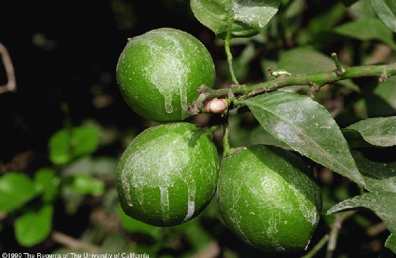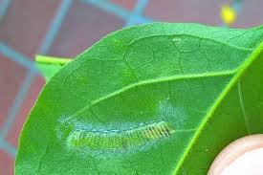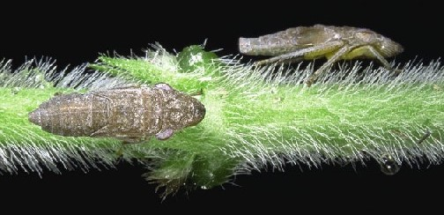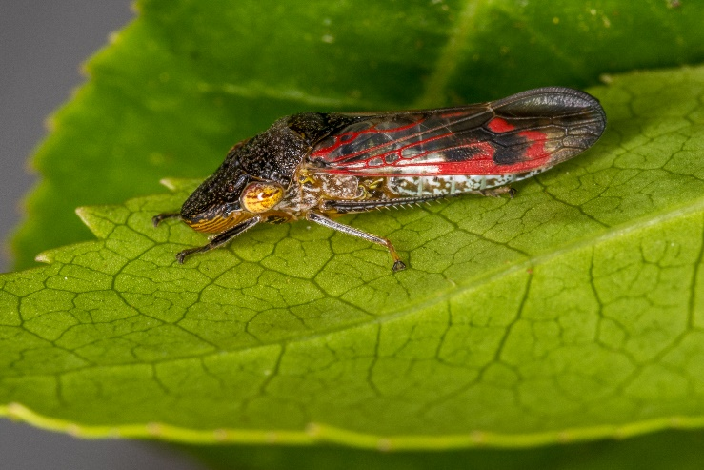

**Fig. 1** Adult glassy-winged sharpshooter, *Homalodisca vitripennis* (Shutterstock).

**Fig. 2** Glassy-winged sharpshooter nymphs (©The Regents of the University of California).

**Likely mode of entry**

The glassy-winged sharpshooter can spread long distances through international trade, especially as egg masses on live plants, planting material and nursery stock. Adults and nymphs could also be imported on plants or in shipping vessels, containers, packing material and in many types of cargo such as vehicles, machinery, and furniture.

**Signs of infestation (Figures 1–4)**

Egg masses laid into the underside of leaves appear as a greenish water blister coated with a white, chalky substance. Adults and older nymphs feed on the woody stems of host plants. Their feeding results in the production of large amounts of liquid, which dries leaving a whitewashed appearance on leaves and fruit. Look for adults around bright lights.

**Host range**

Glassy-winged sharpshooters feed on hundreds of plant species from over 65 families, including commercial crops like avocado, citrus, stone fruit, grapes and macadamia, woody ornamentals such as crepe myrtle and oak, and natural vegetation like eucalypt*s*.

**Biology (Figures 1–3)**

***Eggs*:** small, laid in batches of usually about 10, arranged side-by-side, inserted just under the leaf tissue on the underside of host leaves. ***Nymphs*:** five stages, 2–8 mm long, grey and wingless; initially feeding at veins on the underside of leaves, moving to woody stems and branches as they mature. ***Adults***: about 13 mm long; a generally brown to black body, with small yellow/white spots on the head and thorax, and the abdomen appearing white underneath. Wings are transparent with reddish veins.

Adults congregate at night under bright lights and are attracted to yellow. They are an important vector for damaging plant diseases caused by the bacterium *Xylella fastidiosa*.

**Distribution**

Native to south-eastern USA and northern Mexico. Introduced to California, Hawaii, French Polynesia, the Cook Islands, and parts of South America. Not present in Australia.

**Fig. 4** Whitewashed appearance of citrus fruit from glassy-winged sharpshooter excrement (©The Regents of the University of California).

**Fig. 3** Egg mass of the glassy-winged sharpshooter inserted into the underside of a leaf (©Napa County Agricultural Commissioner’s Office).

**What to do if you find suspect glassy-winged sharpshooter**

**Department officers:** Contain the risk, collect specimens into a vial containing 80% ethanol and deliver to a department entomologist immediately.

**Industry and the public:** **SEE. SECURE. REPORT.**

Secure the goods to limit movement and immediately report your detection to the Department of Agriculture, Fisheries and Forestry on **1800 798 636**.