STATE PARTY REPORT
ON THE STATE OF CONSERVATION OF THE GREAT BARRIER REEF
WORLD HERITAGE AREA (AUSTRALIA)
PROPERTY ID N154

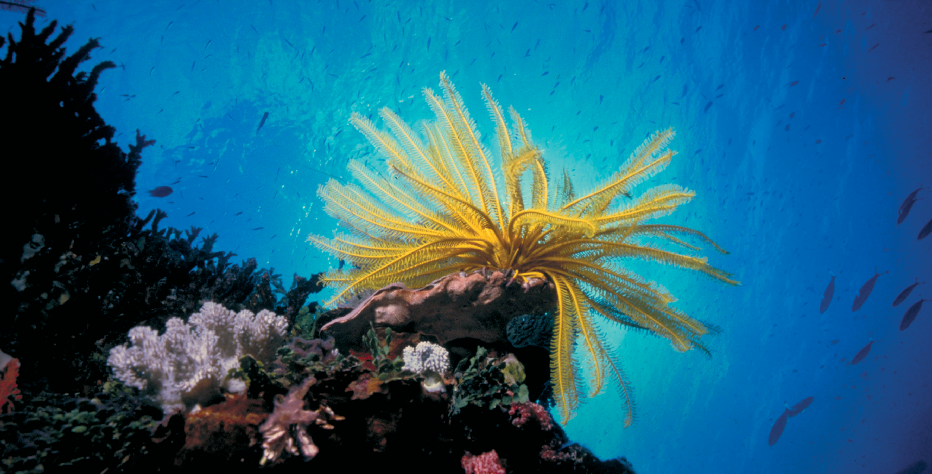
IN RESPONSE TO
THE WORLD HERITAGE COMMITTEE DECISION 41COM 7B.24

FOR SUBMISSION BY 1 DECEMBER 2019

© Commonwealth of Australia, 2019.

State Party Report on the state of conservation of the Great Barrier Reef World Heritage Area (Australia) is licensed by the Commonwealth of Australia for use under a Creative Commons by Attribution 3.0 Australia licence with the exception of the Coat of Arms of the Commonwealth of Australia, the logo of the agency responsible for publishing the report, content supplied by third parties, and any images depicting people.
For licence conditions see: http://creativecommons.org/licenses/by/3.0/au/
This report should be attributed as State Party Report on the state of conservation of the Great Barrier Reef World Heritage Area (Australia), Commonwealth of Australia, 2019.
Images used throughout provided courtesy of the Great Barrier Reef Marine Park Authority.

Table of Contents

1. | Executive summary (English) | 3
2. | Executive summary (French) | 5
3. | Introduction and context | 7
3.1 | The Great Barrier Reef World Heritage Area | 8
3.2 | Management of the Great Barrier Reef World Heritage Area | 8
3.2.1 | Governance arrangements | 9
3.2.2 | Traditional Owner engagement | 9
3.3 | Investing for impact | 9
4. | Response to the decision of the World Heritage Committee | 12
4.1 | Demonstrating the effective and sustained protection of the property’s
 | Outstanding Universal Value | 12
4.1.1 | Pillar 1: The World Heritage criteria | 13
4.1.2 | Pillar 2: Meeting the condition of integrity (wholeness and intactness) | 13
4.1.3 | Pillar 3: Adequate systems of protection and management | 14
4.2 | Acceleration of efforts to meet targets of the Reef 2050 Long-Term Sustainability Plan | 17
4.2.1 | Action on Climate Change | 17
4.2.2 | Reef Blueprint for Resilience | 18
4.2.3 | Reef 2050 Plan reviews | 21
4.2.4 | Joint Field Management Program | 23
4.2.5 | Water quality | 24
4.2.6 | Crown-of-thorns starfish control program | 28
4.2.7 | Collaboration and key partnerships | 28
4.3 | Effective performance in meeting the targets established under the Reef 2050 Plan | 31
4.3.1 | Progress implementing the Reef 2050 Plan | 31
4.3.2 | Assessment of progress against current targets | 39
4.3.2a | Ecosystem health | 39
4.3.2b | Biodiversity | 37
4.3.2c | Cultural heritage | 39
4.3.2d | Water quality | 40
4.3.2e | Community benefit | 42
4.3.2f | Economic benefit | 48
4.3.2g | Governanace and performance | 48

1

4.3.3 Development of targets for the revised Reef 2050 Plan 49
- Other conservation issues identified by the State Party which may
have an impact on the property’s outstanding universal value 50
  - Great Barrier Reef Outlook Report 2019 – risk assessment 50
  - Great Barrier Reef Outlook Report 2019 – long-term outlook 50
- Potential major restorations, alterations and/or new constructions intended within the property, the buffer zones and/or corridors or other areas, where such developments may affect the outstanding universal value of the
property, including authenticity and integrity 51
  - Quarterly reporting 51
- Appendices 52
Appendix A: Map of the Great Barrier Reef World Heritage Area 53
Appendix B: Reef funding 2014-15 to 2023-24 54
Appendix C: World Heritage Committee Decisions 60
Appendix D: Summary of heritage attributes from the 2019 Outlook Report
and Complementary assessments- linking the Outlook Report
and the Great Barrier Reef’s outstanding universal value 64
Appendix E: Integrity test – Great Barrier Reef World Heritage Area (from the 2019 Outlook Report) 68

2 / State Party Report on the state of conservation of the Great Barrier Reef World Heritage Area (Australia) 2019

Executive summary

The Great Barrier Reef World Heritage Area is beautiful, vast and diverse. It is the world’s largest coral reef ecosystem and a living natural wonder of the world. The Great Barrier Reef was inscribed on the World Heritage List in 1981. Australia is strongly committed to the responsible stewardship of the Great Barrier Reef World Heritage Area and continues to act and invest to protect its Outstanding Universal Value (OUV) and strengthen its resilience. Total investment to benefit the Reef over the decade ending in 2023-24 will exceed $2.7 billion.
Mass coral bleaching events in 2016 and 2017, six tropical cyclones, flooding, and a coral-eating crown-of-thorns starfish outbreak have impacted the OUV of the property since the last State Party Report in 2015. The Great Barrier Reef Marine Park Authority’s Great Barrier Reef Outlook Report 2019 (2019 Outlook Report) found that the long-term outlook for the Reef’s ecosystem has deteriorated from poor to very poor. It states that climate change (especially sea temperature rise) remains the most serious and pervasive threat to the Great Barrier Reef – a threat in common with all coral reefs globally. The other key threats identified in the 2019 Outlook Report are land-based run off, coastal development and some aspects of direct human use such as illegal fishing.
Concerted global action to limit global warming is needed to turn around the deteriorating outlook for the Great Barrier Reef – and all other coral reefs. This is the context in which Australia manages the Great Barrier Reef. We are actively managing the pressures over which we have direct control through investment and regulation based on the best available science. In the face of these pressures we are scaling up investment in reef restoration and adaptation science.
Australia is taking strong action as part of global efforts to address the global threat of climate change under the United Nations Framework Convention on Climate Change and the Paris Agreement. The Paris Agreement aims to keep global temperature rise well below 2°C – and to pursue efforts to limit the temperature increase to 1.5°C. Australia’s commitment under the Paris Agreement is to reduce emissions by 26 to 28 per cent below 2005 levels by 2030.
In 2015, the Australian and Queensland governments put in place the Reef 2050 Long-Term Sustainability Plan (Reef 2050 Plan). This Plan was welcomed by the World Heritage Committee at its meeting in Bonn (decision 39 COM 7B.7), as was our early progress in implementing the Plan (41 COM 7B.24). Since then we have matured, diversified and accelerated our response to Reef health challenges. A mid-term review of the Reef 2050 Plan was brought forward to 2017 in light of the mass coral bleaching that occurred in 2016 and 2017 and additional funding provided, demonstrating our ongoing commitment to responsive and adaptive management of the Reef. The Reef 2050 Plan Insights Report (an independent report commissioned to inform the 2019 Outlook Report) found the Reef 2050 Plan provides a “very sound framework for improving the management of the Reef’s values through improved governance, planning and resourcing”.
To accelerate efforts to address water quality, the Australian and Queensland governments are implementing a $600 million Reef 2050 Water Quality Improvement Plan for 2017-2022 (Reef 2050 WQIP). The Reef 2050 WQIP uses an adaptive management approach, informed by the best available science. The approach to improving water quality includes working with landholders to reduce pollution run off into waterways, land
restoration to prevent erosion, and strengthening regulation of vegetation management, water quality and dredge disposal. Water quality management for the Reef is expected to improve following the approval of new legislation by the Queensland Government on 19 September 2019 which strengthens Queensland’s regulatory framework for reducing nutrient and sediment releases from agricultural activities and new industrial development. Amongst

3

other measures, these Reef Protection Regulations regulate agricultural activities to avoid excessive fertiliser application, and to actively manage erosion risks in all Reef catchments.
Australia is also committed to transparent monitoring and reporting through publication of the Great Barrier Reef Outlook Report (required every five years under the Great Barrier Reef Marine Park Act 1975), Scientific Consensus Statement for water quality (updated every five years), annual Reef Water Quality Report Cards and the establishment of the Reef 2050 Integrated Monitoring and Reporting Program.
While there has been significant progress in addressing the threats and pressures facing the Reef, Australia does not underestimate the scale of the challenges that lie ahead. The Australian and Queensland governments will continue to comprehensively address these threats and pressures in order to sustain the OUV of the Great Barrier Reef World Heritage Area.

4 / State Party Report on the state of conservation of the Great Barrier Reef World Heritage Area (Australia) 2019

Résumé analytique (français)

La Grande Barrière est une zone de patrimoine mondial vaste, diverse et d’une grande beauté. Il s’agit du plus grand écosystème de récifs coralliens du monde et de l’une des merveilles naturelles vivantes de notre planète. La Grande Barrière a été inscrite sur la Liste du patrimoine mondial en 1981. L’Australie s’engage fortement en faveur d’une gestion responsable de la zone de patrimoine mondial de la Grande Barrière et continue d’agir et
d’investir pour protéger sa valeur universelle exceptionnelle (VUE) et renforcer sa résilience. Le montant total des investissements au profit de la Grande Barrière dépasseront les 2,7 milliards de dollars sur la décennie terminant en 2023-24.Depuis le dernier Rapport de l’Etat partie sur l’état de conservation en 2015, la VUE de ce site a
été mise à l’épreuve par plusieurs événements de grande ampleur de blanchiment des coraux en 2016 et 2017, par les inondations causées par six cyclones tropicaux, ainsi que par une invasion d’étoiles de mer « couronne d’épines » se nourrissant de corail. Le Rapport de 2019 sur les perspectives de la Grande Barrière (Great Barrier Reef Outlook Report 2019, ou Rapport de perspectives 2019) de l’Autorité du parc marin de la Grande Barrière a révélé une détérioration des perspectives à long terme de l’écosystème du récif, passant de « mauvaises » à « très mauvaises ». Ce rapport identifie le changement climatique (notamment l’augmentation de la température des mers) comme la menace la plus sérieuse et la plus généralisée affectant la Grande Barrière, une menace affectant par ailleurs tous les récifs coralliens du monde. Les autres menaces principales identifiées dans le Rapport de perspectives de 2019 sont les ruissellements terriens, le développement côtier et certains aspects d’exploitation humaine directe, comme la pêche illégale.
Une action concertée à l’échelle mondiale pour limiter le réchauffement planétaire est nécessaire pour inverser les sombres perspectives pour la Grande Barrière et tous les autres récifs coralliens. Voici le contexte dans lequel l’Australie gère la Grande Barrière. Nous gérons activement les pressions sur lesquelles nous avons un contrôle direct par le biais d’investissements et de réglementations reposant sur les meilleures données scientifiques disponibles. Face à ces pressions, nous intensifions nos investissements pour une restauration du récif corallien et dans le domaine de la science de l’adaptation.
L’Australie prend des mesures fortes dans le cadre des efforts internationaux pour faire face à la menace mondiale du changement climatique selon la Convention-cadre des Nations Unies sur les changements climatiques et l’Accord de Paris. Ce dernier a pour objectif de maintenir le réchauffement planétaire bien en dessous de 2 °C – tout en essayant de le limiter à 1,5 °C. Dans le cadre de cet accord, l’Australie s’est engagée à réduire ses émissions d’ici 2030 de 26 à 28 % par rapport aux niveaux de 2005.
En 2015, les gouvernements de l’Australie et de l’État du Queensland ont mis en place le Plan de durabilité à long terme Reef 2050 (Reef 2050 Long-Term Sustainability Plan, ou Reef 2050 Plan). Le Comité du patrimoine mondial a favorablement accueilli ce plan lors de sa réunion à Bonn (décision 39 COM 7B.7), de même que
nos premières avancées pour sa mise en application (41 COM 7B.24). Depuis, notre réponse aux défis affectant le récif corallien a gagné en réflexion, en diversité et en rapidité. L’examen à mi-parcours du plan Reef 2050 a été avancé à 2017 en réponse au phénomène de blanchiment des coraux de grande ampleur de 2016 et 2017, et des subventions supplémentaires ont été accordées, démontrant ainsi notre engagement continu envers une
gestion réactive et adaptative du récif. Selon le Rapport d’observation du plan Reef 2050 (Reef 2050 Plan Insights Report, un rapport indépendant visant à renseigner le Rapport de perspectives 2019), le plan Reef 2050 est jugé comme une « structure très solide pour améliorer la gestion des valeurs du récif en améliorant la gouvernance, la planification et les ressources ».
Pour accélérer les efforts visant à améliorer la qualité de l’eau, les gouvernements de l’Australie et de l’État du Queensland mettent actuellement en application un Plan Reef 2050 d’amélioration de la qualité de l’eau pour

5

2017-2022 (Reef 2050 Water Quality Improvement Plan for 2017-2022, ou WQIP Reef 2050) de 600 millions de dollars. Le plan WQIP Reef 2050 fait appel à une gestion adaptative fondée sur les meilleures données scientifiques disponibles. L’approche visant à améliorer la qualité de l’eau repose notamment sur une collaboration avec les exploitants agricoles pour réduire les ruissellements d’eaux polluées vers les cours d’eau, sur une restauration des terres pour lutter contre leur érosion, et sur un renforcement des réglementations sur la gestion de la végétation, de la qualité de l’eau et des activités de dragage. La gestion de la qualité de l’eau du récif devrait s’améliorer à la suite de l’approbation d’une nouvelle législation par le gouvernement de l’État du Queensland
du 19 septembre 2019 qui renforce le cadre réglementaire de cet État pour réduire les rejets de nutriments et de sédiments des activités agricoles et de nouveaux développements industriels. Ces règlements pour la protection du récif, accompagnés d’autres mesures, contrôlent les activités agricoles pour éviter l’utilisation excessive d’engrais et activement gérer les risques d’érosion dans tous les bassins du récif.
L’Australie s’engage également envers une surveillance et un suivi transparents grâce à la publication du Rapport sur les perspectives de la Grande Barrière (exigé tous les cinq ans selon la Loi de 1975 sur le parc marin de la Grande Barrière (Great Barrier Reef Marine Park Act 1975)) et la Déclaration de consensus scientifique pour la qualité de l’eau (mise à jour tous les cinq ans), les Fiches de résultat annuelles sur la qualité de l’eau dans le récif, ainsi que par la mise en place du Programme intégré de surveillance et de suivi Reef 2050.
Bien qu'il y ait eu des progrès significatifs dans la lutte contre les menaces et les pressions qui pèsent sur le récif, l’Australie ne sous-estime pas l’ampleur des défis à relever. Les gouvernements de l’Australie et du
Queensland continueront de faire face à l’ensemble de ces défis et pressions afin de préserver la Valeur universelle exceptionnelle de la zone de patrimoine mondial de la Grande Barrière.

6 / State Party Report on the state of conservation of the Great Barrier Reef World Heritage Area (Australia) 2019

Introduction and context
This State Party Report demonstrates the continued commitment of Australia to manage and protect the Outstanding Universal Value (OUV) of the Great Barrier Reef World Heritage Area (the Reef). It focuses on progress made since the most recent State Party Report was considered in 2015 and builds on the Reef 2050 Plan Update on Progress, which reported on early implementation of the Reef 2050 Long-Term Sustainability Plan (Reef 2050 Plan) and was received positively by the World Heritage Committee (the Committee) at its meeting in Krakow, Poland, in July 2017.
Australia has a strong history of working closely with the Committee to protect the Reef World Heritage Area. Continuous engagement with the Committee and its technical advisers over the past decade has yielded significant improvement in the management of the Reef, backed by legislation and increased investment and founded on scientific evidence. This will continue.
As the custodian of this World Heritage icon, Australia understands and willingly accepts its responsibility to protect and sustain the Reef. Australia has accelerated efforts for the effective and sustained protection of the Reef’s OUV and is diligently addressing all decisions of the Committee through implementation of the Reef 2050 Plan.
We understand that the Reef is an icon under pressure with a deteriorating long-term outlook. We know that concerted action is needed on multiple fronts to address the key threats it faces – and we are acting. Climate change, poor water quality caused primarily by land-based run off, coastal development and some aspects of direct human use such as illegal fishing are the primary threats. Among them, climate change is the most significant and can only be addressed by effective global action under the Paris Agreement. Australia has committed to reduce greenhouse gas emissions by 26-28 per cent below 2005 levels by 2030. We are joined with other signatories
to the Paris Agreement in striving to keep global average surface temperature increases to well below 2°C above pre-industrial levels and to pursue efforts to limit the temperature increase to 1.5°C. The target of limiting the temperature increase to 1.5°C is widely cited as a critical threshold for the Reef.
The Reef is greatly valued by people across Australia and around the world. The Reef is an important economic asset, providing jobs for the people who live in its catchment and supporting diverse and sustainable
communities. The Reef is estimated to generate 64,000 jobs and annual income of $6.4 billion1 to the Australian economy, most of this from tourism.
Aboriginal and Torres Strait Islander peoples are the Traditional Owners of the Reef area and have a continuing connection to their land and sea country. The Reef is of great significance to its Traditional Owners and is fundamental to their cultural, economic and social wellbeing.

1 All references to dollar values within this report are for Australian dollars

7

The Great Barrier Reef World Heritage Area
The Reef is an iconic World Heritage property that contains about 10 per cent of the world's coral reefs, making it the world’s largest coral reef ecosystem. It is one of the best known and most complex natural systems on earth, containing a unique range of ecological communities, habitats and species. The World Heritage Area covers 34,870,000 hectares, or more than 348,000 km2, which is approximately the same area as Japan, Germany or Malaysia (see map in Appendix A).
As a whole, the property is a diverse patchwork of habitats supporting thousands of species. It is home to abundant animal life including bony fishes, sharks and rays, marine mammals, marine reptiles, seabirds and a wide variety of invertebrates. When describing the property, it is important to understand it is more than just coral reefs, which comprise only about seven per cent of the World Heritage Area. The property contains a diverse array of spectacular non-reef habitats. These range from shallow estuarine areas with seagrass beds, mangroves
and sponge gardens, to deep oceanic areas more than 250 km offshore. The lagoon floor habitat that surrounds and connects reefs and islands covers approximately 61 per cent of the property’s footprint. Beaches, cays and vegetated islands provide habitat and nesting areas for many species.
All properties inscribed on the World Heritage List have OUV. The United Nations Educational, Scientific and Cultural Organization (UNESCO) explains OUV as having three pillars. To have OUV a property must:
- meet one or more of the 10 world heritage criteria (Pillar 1). The Reef is inscribed under four natural world heritage criteria:
  - natural beauty and natural phenomena (criterion vii),
  - major stages of the Earth’s evolutionary history (criterion viii),
  - ecological and biological processes (criterion ix), and
  - habitats for conservation of biodiversity (criterion x).
- meet the condition of integrity (wholeness and intactness) (Pillar 2).
- have an adequate system of protection and management to safeguard its future (Pillar 3).

Management of the Great Barrier Reef World Heritage Area
Protection and management of the Reef is achieved through multiple partnerships between government agencies, industry, community and non-government organisations, scientists, and Traditional Owners. The Commonwealth Great Barrier Reef Marine Park Act 1975, which established the Great Barrier Reef Marine Park Authority
(the Marine Park Authority), is the primary national legislation dedicated to the long-term protection of the environment, biodiversity and heritage values of the Great Barrier Reef Region. The Commonwealth marine protected area is complemented by the Queensland Great Barrier Reef Coast Marine Park in adjacent Queensland waters and Queensland island national parks, and the Commonwealth Coral Sea Marine Park, which extends from the outer boundary of the Great Barrier Reef Marine Park eastwards to the edge of Australia’s Exclusive Economic Zone. Many of the islands within the property are national parks and there are also extensive areas of national park and other protected land along the adjacent coast.
The Australian and Queensland governments work in partnership through the Great Barrier Reef Intergovernmental Agreement 2015 to protect and manage the Region. This agreement provides a transparent framework for cooperative management of the environment, biodiversity and heritage values of the World Heritage Area by the Marine Park Authority and the Queensland Parks and Wildlife Service.

8 / State Party Report on the state of conservation of the Great Barrier Reef World Heritage Area (Australia) 2019

In response to concerns raised by the World Heritage Committee in 2011, the Australian and Queensland governments took decisive action to improve the management and protection of the Reef. This included a strategic assessment between 2012 and 2014 of the World Heritage Area and adjacent coastal zone to evaluate and improve the effectiveness of the management of existing and emerging risks to the Reef. The assessment resulted in development of the Reef 2050 Plan, which was strongly affirmed by the Committee in 2015 (39 COM 7B.7). In 2017, the Committee welcomed progress with the initial implementation of the Reef 2050 Plan and the establishment of the associated Investment Framework (41 COM 7B.24).

Governance arrangements
The Reef 2050 Plan sets out what Australians, as custodians of the Reef for the international community, want the future of the Great Barrier Reef World Heritage Area to be and how this will be achieved. The Reef 2050 Plan is overseen by the Great Barrier Reef Ministerial Forum and is supported by strong governance arrangements that draw on the expertise of a number of advisory bodies.
The Reef 2050 Independent Expert Panel (IEP) chaired by former Chief Scientist of Australia, Emeritus Professor Ian Chubb AC2 FAA FTSE3, provides expert scientific advice related to the Reef. Panel members have expertise in climate change, water quality, agriculture, reef ecology, fisheries and economics.
The Reef 2050 Advisory Committee (RAC), chaired by The Hon Penelope Wensley AC, former Governor of Queensland and former Australian Ambassador for the Environment, provides strategic advice on the implementation of Reef 2050 Plan actions, stakeholder priorities, and any emerging cross-sectoral issues that need to be addressed. Membership includes Traditional Owners, a range of industry sectors (agriculture,
tourism, fishing and ports) as well as local government, natural resource management, community, science and environmental non-government organisations.

Traditional Owner engagement
Aboriginal and Torres Strait Islander people are the Traditional Owners of the Great Barrier Reef region. Evidence of their sea country connection goes back over 60,000 years. Improving involvement of Indigenous Traditional Owners in the protection and management of the Reef is a priority for the Australian and Queensland governments. Traditional Owner involvement in implementing the Reef 2050 Plan has been boosted. Twenty-three Reef 2050 Plan actions specifically relate to Traditional Owners. In 2017, the Australian Government engaged a consortium of Indigenous and research organisations to work with Great Barrier Reef Traditional Owners to better understand and support their aspirations and commitments under the Reef
2050 Plan.
The final report of the consortium was published in June 2019, and includes advice from Traditional Owners about their aspirations for involvement in the management and protection of the Reef. It offers a strategic blueprint to support the fulfilment of Traditional Owners’ custodial responsibilities and obligations. The report’s findings and recommendations are helping inform the comprehensive review of the Reef 2050 Plan currently underway and to be completed in 2020. Further detail on Traditional Owner engagement is reported in section 4.3.2c.

- Officer of the Order of Australia. The Order of Australia recognises Australians who have demonstrated outstanding service or exceptional achievement.
- Fellow of the Australian Academy of Science and Fellow of the Academy of Technological Services and Engineering.

9

Investing for impact
The Australian and Queensland governments have made significant progress in implementing the Reef 2050 Plan. In December 2016, the Reef 2050 Plan Investment Framework was released to help guide Reef investment decisions. The framework established the baseline for investments, identified investment priorities for securing the future health of the Reef, and set out a strategy for boosting investment and diversifying its sources. Since it was released, the Australian and Queensland governments have made a range of additional funding commitments, which are outlined in the Reef 2050 Plan (as updated in 2018).
The Australian and Queensland governments, along with their many partners, are making substantial investments to achieve the successful implementation of the Reef 2050 Plan. When the Reef 2050 Plan was considered by
the World Heritage Committee in 2015, the Reef 2050 Plan Investment Baseline projected that the Australian and Queensland governments would invest around $2 billion over the decade from 2014-15 to 2023-24 on its implementation. Investments have increased substantially since that time and the investment over this period is now more than $2.7 billion (Table 1).
The investment includes funding for marine park management, improving water quality, controlling coral-eating crown-of-thorns starfish, reducing marine debris, research and innovative science, increasing engagement with Traditional Owners, monitoring and reporting, and the restoration and repair of coastal ecosystems. This investment continues to grow and has increased since the 2017 decision of the Committee which encouraged the acceleration of efforts to meet the targets of the Reef 2050 Plan. Further detail about Reef investments is included at Appendix B.
The Reef is a highly complex socio-ecological system. Effecting enduring positive outcomes demands not only an understanding of the Reefs’ physical processes and ecological systems, but also the importance of people in creating change. Engaging with a range of communities and utilising modern behavioural science to achieve practice change is essential to improving the long-term outlook of the Reef. Australia is driving change by empowering communities to have a positive influence on the Reef, whether it be through agricultural practice change on farms or a reduction of plastic use within households. Ensuring these changes are sustainable over the long-term will continue to be an important area of investment under the Reef 2050 Plan.

Table 1: Reef funding 2014-15 to 2023-24

Australian and Queensland Government Reef funding (2014-15 to 2023-24)
Source | All figures in AUD $m
Australian Government Reef Programs | 875.199
Reef Science | 388.606
Great Barrier Reef Marine Park Authority | 400.941
Australian Maritime Safety Authority | 270.901
Queensland Government Reef Programs | 498.759
Queensland Sustainable Fisheries Programs | 41.852
Maritime Safety Queensland | 280.000
Total | 2756.258
A full breakdown of Reef funding from 2014-15 to 2023-24 is provided at Appendix B.

10 / State Party Report on the state of conservation of the Great Barrier Reef World Heritage Area (Australia) 2019

Australian Government Investment
The Australian Government is investing more than $1.9 billion in the Reef over 10 years. Over $875 million has been allocated to deliver Reef programs consistent with the Reef 2050 Plan. On-ground Reef protection
through the Reef Trust has grown from an initial multi-year investment of $40 million commencing in 2015 to a commitment of $704 million until 2022-23.
The Reef 2050 Plan is underpinned by the best available science. The Australian Government invests in the science underpinning the health and resilience of the Reef through the Australian Institute of Marine Science (AIMS). AIMS invests more than $313 million in Reef activities, including reef monitoring through programs such as the AIMS Long Term Monitoring Program; field work and experimentation in AIMS’s world-class research aquarium facility and research and development to protect and restore the Reef from the cumulative effects of environmental stresses. The Australian Government also invests in the scientific evidence base through the National Environmental Science Program (NESP). Reef water quality research is a key focus for research under NESP, with total investment of more than $31 million.
Australia continues to focus on reducing the impacts of shipping with $270 million invested through the Australian Maritime Safety Authority for the protection of the marine environment, preventing and combating ship-sourced pollution, and providing infrastructure for safe navigation in Australian waters.

Queensland Government Investment
The Queensland Government is investing $820 million over 10 years to deliver a broad range of programs that benefit the Reef. Through Queensland’s Reef Water Quality Program, a record five year investment of
$261 million from 2017, the Queensland government is investing in a range of actions to reduce land-based run off. Maritime Safety Queensland is investing $280 million over 10 years to improve maritime safety in Queensland waters including the Reef, to minimise vessel-sourced waste and respond to marine pollution incidents. Queensland is investing more than $41 million to improve the sustainability of commercial and recreational fisheries.

Local Government and the Private and Philanthropic Sectors
In addition to the $2.7 billion being invested by the Australian and Queensland governments, the Reef continues to benefit from additional investment from local governments and the private and philanthropic sectors. Local government authorities invest more than $200 million a year in urban stormwater treatment, waterways and coastal foreshore rehabilitation, vegetation and pest management and coastal hazard adaptation strategies amongst many other actions. The private and philanthropic sectors continue to invest in Reef outcomes through awareness raising, community education, on-ground works, monitoring, planning and research.

11

Response to the decision of the World Heritage Committee
This Report responds to the World Heritage Committee decision 41 COM 7B.24 (Appendix C) in three parts:
- how Australia is protecting the OUV of the Reef though an analysis of outcomes from the 2019 Outlook Report against the three pillars of OUV.
- how the management of the Reef has been enhanced in an effort to meet the targets of the Reef 2050 Plan; and
- how effective Australia’s performance has been in meeting targets established under the Reef 2050 Plan through an analysis of progress against a representative selection of these targets.

Demonstrating the effective and sustained protection of the property’s Outstanding Universal Value

41 COM 7B.24 Paragraph 6: Reiterates its request to the State Party to submit to the World Heritage Centre, by 1 December 2019, an overall report on the state of conservation of the property demonstrating the effective and sustained protection of the property’s Outstanding Universal Value and effective performance in meeting the targets established under the Reef 2050 LTSP, linked to the findings of the 2014 and 2019 Great Barrier Reef Outlook Reports, for examination by the World Heritage Committee at its 44th session in 2020.

State Party’s Response
Every five years, the Great Barrier Reef Marine Park Authority publishes a Great Barrier Reef Outlook Report that examines the Reef’s health, pressures, and likely future. The report is required under the Great Barrier Reef Marine Park Act 1975 and provides a regular, reliable and transparent assessment of the condition of natural and heritage values, as well as an independent assessment of management effectiveness.
The Great Barrier Reef Outlook Report 2019 (2019 Outlook Report) found that key pressures on the Reef remain largely the same as the previous 2014 assessment. Climate change (especially sea temperature rise and temperature extremes) remains the most serious and pervasive threat to the Reef – a threat in common with all coral reefs globally. This is consistent with the recently released IPCC Special Report on the Ocean and Cryosphere in a Changing Environment which stated “Almost all warm-water coral reefs are projected to suffer significant losses of area and local extinctions, even if global warming is limited to 1.5°C.”4 The other key threats were associated with land-based run-off, coastal development and some aspects of direct human use such as illegal fishing. It concluded that the long-term outlook for the Reef’s ecosystem has deteriorated from poor to very poor and indicated that accelerated action to mitigate climate change and improve water quality is essential to turn around this outlook.
Concerted global action to limit global warming is needed to turn around the deteriorating outlook for the Great Barrier Reef – and all other coral reefs. This is the context in which Australia manages the Reef and is the context in which this State Party Report has been prepared. We are actively managing the pressures over which we have direct control through investment and regulation based on the best available science.
The 2019 Outlook Report included nine assessments covering biodiversity, ecosystem health, heritage values, commercial and non-commercial use, factors influencing the Reef’s values, existing protection and management, resilience, risks and a long-term outlook for both the ecosystem and heritage values. To do this, the report assessed

4 IPCC Special Report on the Ocean and Cryosphere in a Changing Environment, 25 September 2019. Pg 34.

12 / State Party Report on the state of conservation of the Great Barrier Reef World Heritage Area (Australia) 2019

87 components of which 38 were then mapped to the OUV of the property, enabling an assessment of current state and future trends.
The 2019 Outlook Report concluded that the OUV of the Reef remains whole and intact and maintains many of the elements that make up its OUV, however, components that underpin all four natural criteria have deteriorated since the Reef’s inscription on the World Heritage List. The size of the property is becoming a less effective buffer to broadscale and cumulative threats, primarily due to climate change.
An overall summary of the World Heritage attributes from the 2019 Outlook Report and an assessment of the linkages between the Outlook Report and the Reef’s OUV are provided at Appendix D.

Pillar 1: The World Heritage criteria
The Reef is inscribed on the World Heritage List under four natural world heritage criteria. The 2019 Outlook Report (chapter 4) provides assessments under each of these criteria, summarised below.
- Natural beauty and natural phenomena (criterion vii) – the natural beauty and natural phenomena of the Reef endure. However, it is clear that coral mortality (resulting from sea temperature extremes in
combination with predation from crown-of-thorns starfish) and impacts from severe cyclones has affected aspects of the Reef’s natural beauty and natural phenomena.
- Major stages of the Earth’s evolutionary history (criterion viii) – the Reef continues to provide outstanding examples of the earth’s evolutional history and geomorphological diversity, though Reef disturbances will have some long-lasting effects.
- Ecological and biological processes (criterion ix) – ecosystem processes continue to operate, with ecological and biological processes, such as primary production, microbial process and herbivory, remaining in very good to good condition. However, climate change is having a detrimental impact on some critical
regulating processes such as sea temperature, reef building and recruitment (the addition of new young to the population) which means the ability of the system to ‘bounce back’ is weakening.
- Habitats for conservation of biodiversity (criterion x) – the Reef continues to be one of the richest and most complex natural ecosystems on earth, and one of the most significant for biodiversity conservation. Large habitats, such as the lagoon floor, are considered to be in good condition, whereas coral reef habitat has deteriorated and is considered to be in very poor condition. Threats from a changing climate and other human impacts have led to habitat loss and degradation in a number of areas, which is having a detrimental impact on habitats for conservation of biodiversity.
Additional detail on the condition of a wide range of the elements that make up the Reef ecosystem is provided in the assessment of progress against Reef 2050 Plan targets in section 4.3.

13

Pillar 2: Meeting the condition of integrity (wholeness and intactness)
Since the last State Party Report was submitted in 2015, the Reef – like many coral reefs globally – has been impacted by unprecedented temperature-driven mass coral bleaching events in 2016 and 2017. Additionally six tropical cyclones have made landfall. While these events were large scale and significant, particularly in terms
of coral loss, integrity is intact, but borderline in two of the six integrity criteria (see Appendix E for the 2019 Outlook Report Integrity Test). While the Reef exists in a dynamic state, the spatial extent of the World Heritage Area has remained generally unchanged since the time of inscription and the property remains whole and intact (2019 Outlook Report, page 90).
The 2019 Outlook Report notes that the property’s size, at least for some of its habitats, is becoming a less effective buffer against ongoing and increasing reef wide disturbances. The widespread loss of coral habitat, warming seas and intensifying external pressures such as ocean acidification, altered weather patterns, and modification of coastal habitats are affecting the property’s intactness.

Pillar 3: Adequate systems of protection and management
Australia established the Great Barrier Reef Marine Park Act and the Great Barrier Reef Marine Park Authority in 1975. Over the succeeding 40 years, the Marine Park Authority has developed world-class expertise in tropical marine ecosystem management. Under Queensland’s Marine Parks Act 2004, protection extends into coastal and inland tidal waters. Many of the islands within the property are national parks and there are also extensive areas of national park and other protected land along the adjacent coast. The Great Barrier Reef Marine Park and the Great Barrier Reef Coastal Marine Park together comprise about 99 per cent of the World Heritage Area. The Great Barrier Reef Marine Park is protected as a matter of national environmental significance under the national Environment Protection and Biodiversity Conservation Act 1999.
In assessing the effectiveness of current protection and management of the Reef, the 2019 Outlook Report drew on two independent assessment reports: the Reef 2050 Insights Report and the Independent assessment of
management effectiveness for the Great Barrier Reef Outlook Report 2019. The Reef 2050 Plan Insights Report, which drew from the main independent assessment, used a management effectiveness evaluation approach (based
on the framework developed by the IUCN World Commission on Protected Areas). The report considered whether the Reef 2050 Plan was appropriate and effective in achieving its vision, based on its goals, objectives and targets, and looked at evidence of improvements achieved to date. The independent management effectiveness assessment considered the activities of all Australian and Queensland government agencies and other partners that contribute to protection and management of the Region. This framework has been consistently applied across all Outlook reports.
Management actions inside and outside the Region were examined to the extent they are relevant to, and influence protection and management of, the Region’s ecosystem and heritage values. In relation to the global issue of climate change, the assessment primarily considered measures undertaken by managing agencies specifically to protect and manage the Region. Given the unprecedented back-to-back coral bleaching events and other climate change driven pressures, this assessment also broadly considered state, national and global climate change initiatives that are relevant to the values of the Region.
The Reef 2050 Plan Insights Report concluded that the Reef 2050 Plan has provided a “very sound framework for improving the effective management of the Reef’s values through improved governance, planning and resourcing” (page 5). The independent management effectiveness assessment found improvements in management were
most notable for ports, heritage values and fishing activities and that many of the improvements in management effectiveness are the result of the Reef 2050 Plan, which has improved consistency of priority-setting between

14 / State Party Report on the state of conservation of the Great Barrier Reef World Heritage Area (Australia) 2019

the Australian and Queensland governments and enabled better coordination of a range of actions, targets and objectives to address the key threats to the Region.
It also noted that the Reef 2050 Water Quality Improvement Plan consolidates water quality planning, and reduces duplication by providing a single framework for addressing water quality issues. However, it concluded that achieving outcomes on the ground continues to be difficult for complex and spatially broad topics, such as
land-based run off. The 2019 Outlook Report observed that there are significant time lags between actions on the ground and observable improvements in water quality.
The 2019 Outlook Report includes a chapter on Existing Protection and Management (Chapter 7) which summarises the findings from the independent management effectiveness assessments referred to above. Table 2 below is taken from the 2019 Outlook Report (page 222) and summarises these findings. It demonstrates that across almost all management topics (those addressed directly by the Reef 2050 Plan and existing well established management frameworks), the effectiveness of existing measures is rated as good or very good, and stable or improving. Nonetheless, the extensive investment, management action, and policy and regulatory changes delivered under the Reef 2050 Plan are yet to translate into measurable improvement in outcomes against some management topics that are more complex and where outcomes take long periods to achieve. The independent management effectiveness review observed that “achieving outcomes on the ground continues to be difficult for complex and spatially broad topics such as climate change, land based run-off and biodiversity” (2019 Outlook Report, page 221).

Improvements to Reef governance
In March 2017, the Australian Government commissioned an independent review into the governance of the Marine Park Authority, specifically the role and composition of the Marine Park Authority Board and the Authority’s executive management arrangements. The Government accepted all 24 recommendations of the independent report released on 5 October 2017, and the Authority is well advanced in their implementation.
Recognising the significant challenges facing the Reef, part of the response created a separate Chairperson and Chief Executive Officer for the Authority. The board was also expanded to include one more additional part-time member and a broader range of skills and expertise.
Further information is available at: https://www.environment.gov.au/marine/gbr/authority-governance-review.

15

Table 2: Overall assessment of the effectiveness of existing measures to protect and manage the Region’s values (2019 Outlook Report)
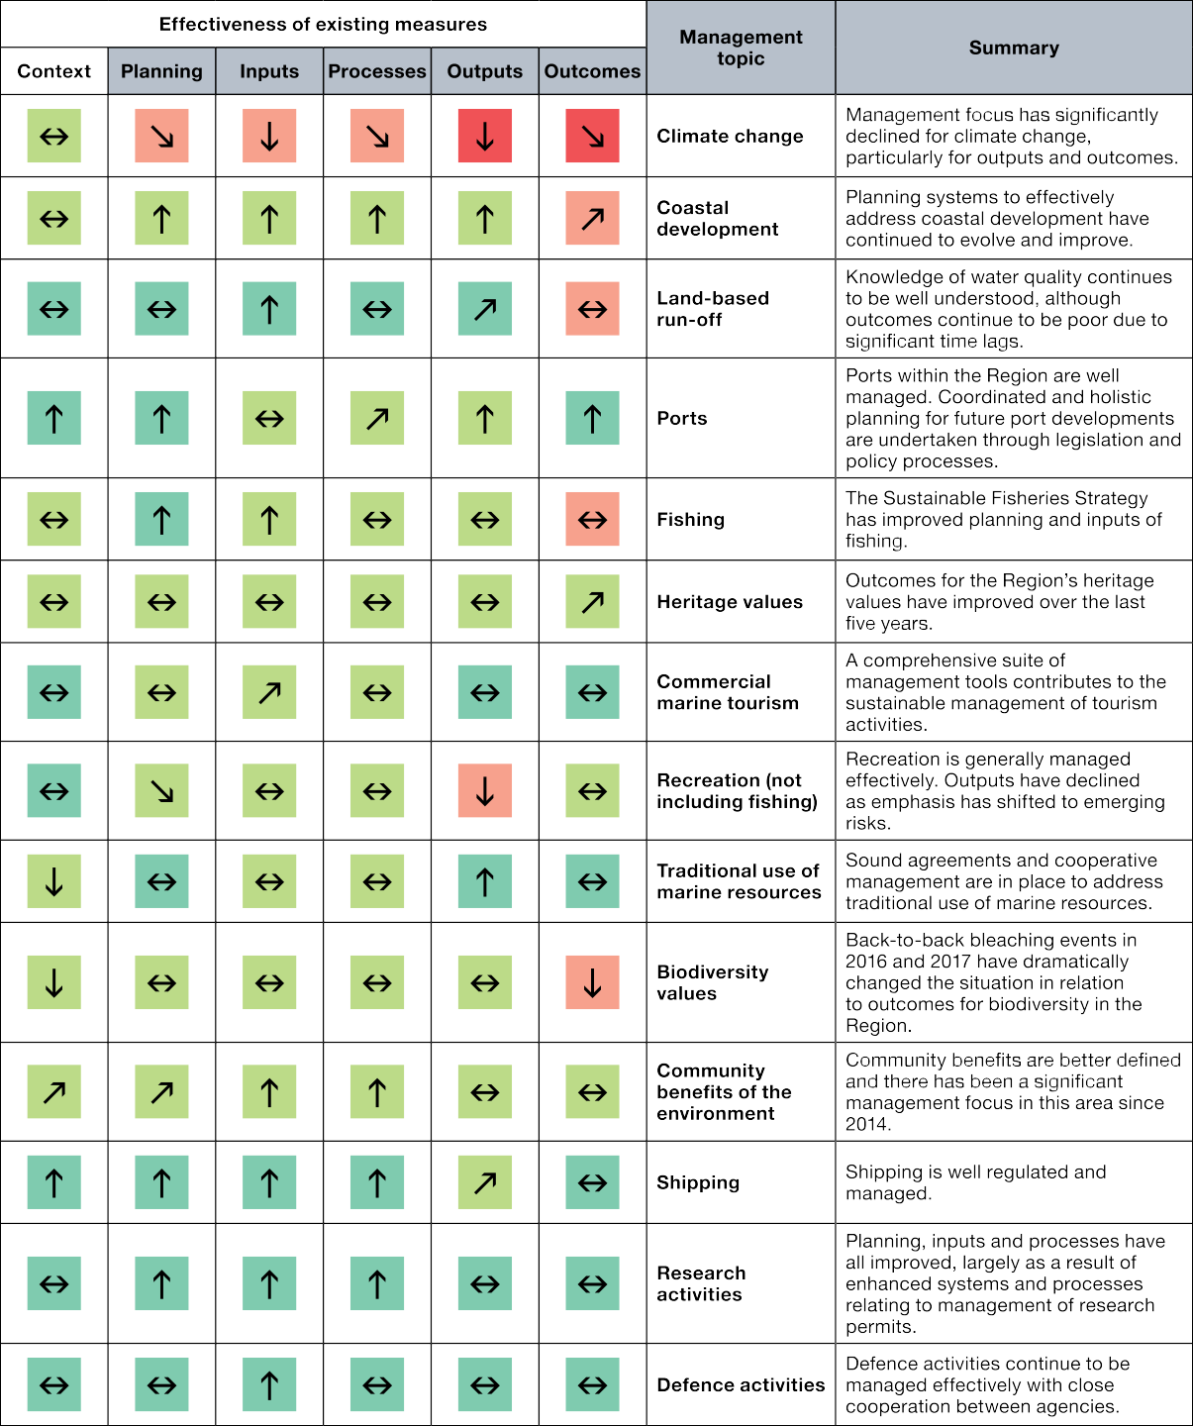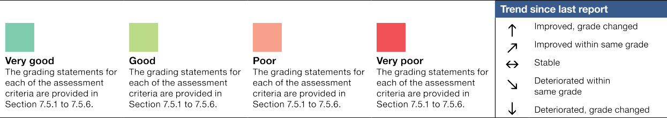

16 / State Party Report on the state of conservation of the Great Barrier Reef World Heritage Area (Australia) 2019

Acceleration of efforts to meet targets of the Reef 2050 Long-Term Sustainability Plan

41 COM 7B.24 Paragraph 4: Strongly encourages the State Party to accelerate efforts to ensure meeting the intermediate and long-term targets of the plan, which are essential to the overall resilience of the property, in particular regarding water quality.

State Party’s response
Our strategy for improving the long-term outlook for the Reef is founded on three key action areas: first, Australia’s contribution to global emissions reductions (under the Paris Agreement and outside the scope of the Reef 2050 Plan); second, direct action to reduce pressures like poor water quality and direct human use; and third, supporting adaptation to a changing climate. The focus of the Reef 2050 Plan is on improving the Reef’s health and resilience to climate change by reducing local and regional pressures. A more resilient Reef will recover faster in the absence of further disturbances. This focus on resilience management is consistent with the recent World Heritage Committee decision (43 COM 7) that all State Parties put in place adaptation strategies that strengthen the resilience of properties and ensure the conservation of their OUV. Australia is leading the way in reef adaptation science, as outlined in the Reef Restoration and Adaptation Program case study in section 4.3.2.
Australia is accelerating efforts to strengthen the health and resilience of the Reef. The mid-term review of the Reef 2050 Plan was brought forward in response to the mass coral bleaching events of 2016 and 2017. The Plan was updated and investment has been increased with priorities carefully planned. Australia is addressing key threats to the Reef by taking action on climate change, improving water quality and coastal habitats, tackling outbreaks of crown-of-thorns starfish, addressing pollution and protecting threatened and migratory species.
Our investments are informed by the best available science and knowledge, with water quality interventions maturing to the point where we can prioritise our interventions by type and catchment to ensure that we get the greatest benefit possible from our funding. The Reef 2050 Water Quality Improvement Plan 2017-2022 – the fourth iteration of this plan – builds on more than 15 years of effort by governments at all levels working in
partnership with landholders, natural resource managers and conservation groups to address all land-based sources of water pollution. Results from this program show steady progress is being made.

Action on climate change
Australia is taking strong action to address the global threat of climate change under the United Nations Framework Convention on Climate Change and the Paris Agreement.
Australia has a track record of meeting its international commitments and is on track to exceed its 2020 target to reduce greenhouse gas emissions by five per cent below 2000 levels by 2020. Australia’s Paris target to reduce emissions by 26 to 28 per cent below 2005 levels by 2030 is a significant contribution to global climate action. The headline target represents a halving of emissions per person in Australia, or a two-thirds reduction in emissions per unit of GDP.
To meet the goals of the Paris Agreement Australia, like all other Parties to the Agreement, will put forward new commitments every five years. As part of the recommendations in the Australian Government’s 2017 Review of Climate Change Policies (2017 Review), the Government agreed to introduce a process of ‘review and refine’ cycles of its climate change policies to ensure integrated consideration of domestic policy and international targets.

17

Australia is also developing a long-term whole-of-economy emissions reduction strategy, as recommended in the 2017 Review, which is expected to be delivered by the end of 2020.
The Australian Government has a comprehensive set of policies to reduce greenhouse gas emissions, increase energy efficiency and fast track the development and uptake of clean energy. This is backed by strong investments, such as our $3.5 billion Climate Solutions Package to help deliver on Australia’s 2030 Paris climate commitments, including a $2 billion Climate Solutions Fund to build on the success of the Emissions Reduction Fund. These measures will contribute more than 200 million tonnes of abatement toward our emissions reduction targets while giving farmers, small businesses and Indigenous communities the chance to improve the environment and benefit from new revenue opportunities.
The Australian Government is funding clean energy projects in the Reef catchment area through the Clean Energy Finance Corporation’s (CEFC) $1 billion Reef Funding Program, launched in June 2016. To 30 June 2019, the CEFC has committed more than $370 million towards over 400 projects under the Reef Funding Program with a total project value of more than $1.22 billion. Under the Reef Funding Program, finance is directed to eligible projects in the Reef catchment area, across renewable energy, energy efficiency and low emissions technologies. The CEFC’s primary role and statutory objective is to facilitate financial flows into the clean energy technology sector. As such, CEFC’s investments within the Reef catchment area can benefit the Reef in that they address its greatest threat, that of climate change. They also contribute to the region’s economic development by providing a local source of clean renewable energy supply and efficient local use of energy; and
they demonstrate to the Reef communities that action on climate change makes good business sense; all outcomes that support the Government’s Reef 2050 Plan. Also in line with the Reef 2050 Plan, the CEFC seeks projects that deliver water quality outcomes.
The Queensland Government similarly recognises the threat that climate change is posing to the Reef and is committed to playing its part in the global effort to address climate change impacts, having committed to
achieving a net reduction of its greenhouse gas emissions of 30 per cent by 2030. In addition to its comprehensive climate mitigation and adaptation strategies, the Queensland Government has introduced a $500 million Land Restoration Fund to facilitate Queensland-based land sector carbon offset projects which also generate co-benefits such as improved vegetation management to reduce sediment entering the Reef.
The Queensland Government is also investing $8.9 million for improved infrastructure on Reef islands along with $1.7 million to help Great Barrier Reef islands develop business cases for renewable energy use to cut their carbon emissions.

Reef Blueprint for Resilience
In 2017, prompted by the significant loss of coral cover during the 2016 and 2017 mass coral bleaching events, the Marine Park Authority brought together over 70 regional, national and international delegates representing Traditional Owners, marine park rangers, managers, scientists, industry representatives, and government and non-government organisations for a dedicated summit to address the situation.
The Marine Park Authority’s Reef Blueprint for Resilience was the primary output of the 2017 Reef Summit.
The Blueprint signals the actions that will be taken to strengthen the Reef’s resilience, its capacity to recover after disturbances and return to a healthy state, and the challenges it faces now and in the future.
The Blueprint is designed around 10 key initiatives focused on delivering maximum benefits for Reef resilience. In considering the initiatives, summit participants looked at what scale solutions needed to be applied, how quickly they could be implemented and how soon they would deliver benefits for the Reef.
The Blueprint informed the 2018 update of the Reef 2050 Plan and has contributed to securing additional funding to develop and implement innovative and timely strategies. It has also helped galvanise collaboration and resilience-building efforts across the Reef community.

18 / State Party Report on the state of conservation of the Great Barrier Reef World Heritage Area (Australia) 2019

From Blueprint to Action examines the first year of progress by the Authority towards achieving the Blueprint initiatives, describing the critical work undertaken to help sustain the Reef as a functioning ecosystem while the key threats of climate change and water quality are tackled in the longer term.

Building Resilience – helping the Reef help itself

In recent years it has become clear that conventional management methods will no longer be enough to protect coral reefs under any projected climate change scenario. A new set of on-reef management options is needed if we are to give coral reefs the best chance to survive and persist in a warmer future, and to build resilience while the causes of climate change are being addressed.
Since the mass coral bleaching events of 2016 and 2017, the Australian Government has put the nation’s best minds to work on building the Reef’s resilience to future pressures, not only through existing actions such as improving water quality and controlling crown-of-thorns starfish outbreaks, but also by actively investigating options for helping the Reef to recover and adapt to changing pressures.
With initial funding of $6 million, the Reef Restoration and Adaptation Program has embarked on finding new, creative and targeted measures for large-scale protection of the Reef’s ecology, social and economic values. The program has three phases – scoping and feasibility, research and development and implementation (production and deployment).
The scoping phase drew on world leading expertise from the Australian Institute of Marine Science, the Commonwealth Scientific and Industrial Research Organisation (CSIRO), James Cook University, the University of Queensland, Queensland University of Technology, the Marine Park Authority, and the Great Barrier Reef Foundation, as well as many other leading research universities and institutes.
During this 18-month scoping and feasibility process, which concluded in mid-2019, experts conducted a preliminary evaluation of the widest possible range of new intervention techniques that could, alone and in combination, complement existing management approaches to help protect the Reef’s ecological functions

19

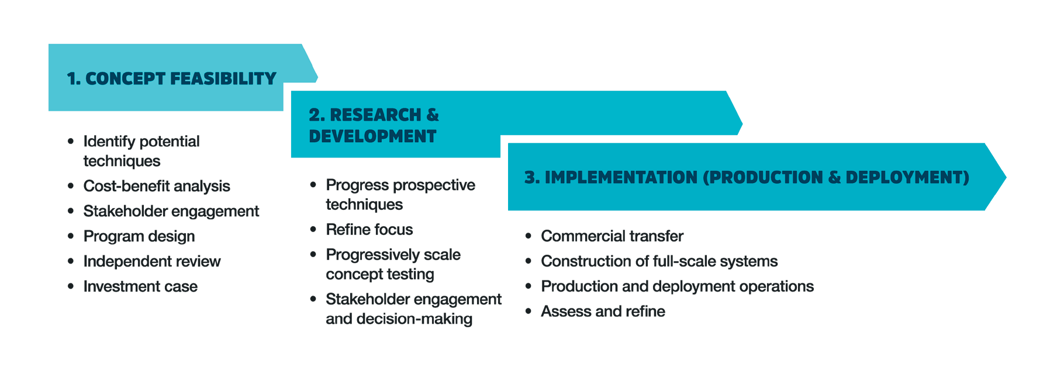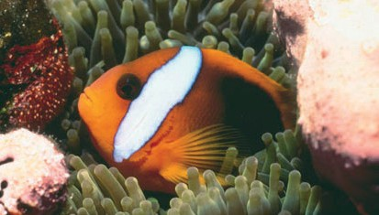and economic and social values. The program aims to provide decision-makers with scientifically-proven, ecologically-effective, socially-acceptable, technically-feasible and economically-viable options to successfully intervene at scale on the Reef. It is strengthening our understanding of how coral reefs are likely to be affected by global temperature increases and the interventions required to ensure they can continue
to function.
The program is considering how the Reef could repair and recover after disturbances like coral bleaching and cyclones through modifying reef surfaces to promote growth, or producing and distributing coral larvae on a large scale. Experts are examining prevention measures such as reducing corals’ exposure to extreme temperatures by increasing shade or cooling water, or building up coral populations through selective breeding.
The scoping phase modelled the potential benefits, costs and risks of ecological and physical interventions, looking at all the relevant factors and drivers, from regulatory and institutional factors to social factors and planning for long-term research and development.
Results of the scoping phase are now informing how best to fund smart, cost effective and scalable reef solutions through the $100 million available for reef resilience and adaptation science under the Reef Trust Partnership with the Great Barrier Reef Foundation.

20 / State Party Report on the state of conservation of the Great Barrier Reef World Heritage Area (Australia) 2019

Reef 2050 Plan reviews

Bringing forward the Reef 2050 Plan mid-term review
The Reef 2050 Plan was scheduled for a mid-term review in 2018. In light of the mass coral bleaching events in 2016 and 2017, the Great Barrier Reef Ministerial Forum, consisting of relevant Australian and Queensland
government ministers, brought forward the mid-term review in 2017. This was to ensure that the Plan effectively considered and addressed current pressures impacting the health and resilience of the Reef to identify any further action that needed to be taken. The updated Reef 2050 Plan was published in July 2018. The revised 2018 Plan clearly recognised climate change impacts on the Reef and the importance of coordinated global action to reduce carbon emissions.
As part of the 2018 review process, all the actions from the original Plan were reviewed and either confirmed as finalised, updated, re-categorised or incorporated into new actions. These actions underpin the targets in the revised Reef 2050 Plan. A comprehensive list of how all the actions in the original Plan have been treated is available on the Department of the Environment and Energy website at:
http://www.environment.gov.au/system/files/resources/35e55187-b76e-4aaf-a2fa-376a65c89810/files/reef-2050-l ong-term-sustainability-plan-action-tracker-2018.pdf
The Reef 2050 Plan includes new actions for immediate attention. For example, the revised Reef 2050 Plan includes an action to “undertake further research to gain a deeper understanding of climate change trajectories for the Reef and communities that depend on it”. The outcomes from this work are currently being used to help to identify the effect that regional and local management efforts have under different climate scenarios, which will help inform Reef management planning.

Full review of the Reef 2050 Plan in 2020
The Reef 2050 Plan identifies that there will be a full review of the plan every five years to ensure it remains current, consistent with scientific advice, and relevant in addressing pressures on the Reef. The next comprehensive review is due for completion in 2020. It is being informed by the outcomes of the mid-term review and the 2019 Outlook Report, and is engaging the advisory committees established under the plan. It will take into account new information about the condition of the Reef, the results of implemented actions and the effectiveness of management interventions.
The outcome of the 2020 review will be a revised Reef 2050 Plan that reflects the current state and future management needs of the Reef. This best-practice adaptive management approach to planning will again be informed by the best available science and knowledge.

21

Case study: The Reef Trust Partnership
During the International Year of the Reef in 2018, following back-to-back coral bleaching events in 2016 and 2017, the Australian Government announced investment of $443 million in a Reef Trust Partnership with the Great Barrier Reef Foundation.
It is the Government’s largest ever single investment in reef protection, aiming to spark new and innovative responses from private investors and philanthropists.
The Great Barrier Reef Foundation is the leading charity for the Reef. The Partnership is boosting the engagement of Australian and international businesses, science, communities, individuals and Traditional Owners in a united effort to keep the Reef healthy.
The Partnership’s comprehensive and innovative approach will be complemented by an investment portfolio substantial enough to effect real change. It aims to:
      - improve water quality by further improving farming practices, including more efficient fertiliser use, and increasing the uptake of new technology and land management practices ($201 million)
      - enable reef restoration and adaptation, by harnessing the best available science and knowledge to fund innovative projects that support Reef resilience ($100 million)
      - expand efforts in the fight against the coral-eating crown-of-thorns starfish, including investigating new ways to detect and tackle primary outbreaks ($57.8 million)
      - create opportunities for greater engagement of Traditional Owners in the Great Barrier Reef World Heritage Area (up to $42 million, which equates to 10 per cent of the value of the grant agreement. This includes $12 million under the original grant, plus earmarked funds from across all other components)
      - improve engagement by local communities in the protection of the Reef ($10 million)
      - improve Reef health monitoring and reporting that tracks progress and informs better management ($40 million).
The Foundation has set a target of leveraging a further $300 million to $400 million in investment over five years from domestic and international partner organisations and philanthropic donors to complement the Australian Government’s investment. To date, more than $21 million has been indicated as in-kind contribution for the Foundation’s 2018-19 committed on-ground projects.
With strong governance arrangements in place, funding is rolling out with an annual work plan for
2019-20 that commits $58 million to projects ranging from large-scale water quality projects across priority Reef catchments to targeted regional community activities.
Early investment projects worth $25 million include more than 50 on-ground projects - 11 water quality projects with farmers to remediate gully erosion and reduce run-off of sediments, nutrients and pesticides; 18 projects with Traditional Owner groups to support land and sea country action planning and junior ranger programs; and 25 projects for community groups to take action through citizen science and projects coordinated through Local Marine Advisory Committees.

22 / State Party Report on the state of conservation of the Great Barrier Reef World Heritage Area (Australia) 2019

Case study: Queensland fisheries reforms
The Queensland Sustainable Fisheries Strategy was released in June 2017 and sets out the Queensland Government’s reform agenda for the next 10 years. It is the biggest fisheries reform in Queensland’s history and will help ensure healthy fish stocks that will support thousands of Queensland jobs. This strategy delivers the fisheries-related commitments under the Reef 2050 Plan.
The strategy is the outcome of a significant consultation exercise in 2016. A total of 11,800 submissions were received and the overwhelming message was that all stakeholders wanted reform in the way fisheries are managed.
The strategy outlines 33 actions to be delivered across 10 reform areas with specific targets to achieve by 2020 and 2027. Actions include harvest strategies for each fishery, satellite tracking on all commercial fishing boats, regionally specific fishing rules and using new technologies more effectively.
An additional $30 million over four years is being invested by the Queensland Government to support the reforms. Key investments in the Reef region include 14 new Queensland Boating and Fisheries Patrol officers (one each in Cairns, Mackay and Yeppoon; two each in Port Douglas and Airlie Beach; three
in Townsville and four in Gladstone). The Gladstone Queensland Boating and Fisheries Patrol office reopened in October 2017. The new funding also provides for additional biological monitoring in the Great Barrier Reef on species like coral reef fish species, shark and scallops, as well as a new economic and social monitoring program for fisheries, which will contribute to the Reef 2050 Integrated Monitoring and Reporting Program.
Vessel tracking has been rolled out to all net, crab and line boats, with more than 1100 boats brought online in 2019, with the remaining commercial fisheries to commence 1 January 2020. The Marine Park Authority and the Queensland Government have pooled funding, with around $3 million available to subsidise the costs for industry.
Major reforms to fisheries laws were completed in 2019, including stronger compliance powers, heavier penalties, a more responsive decision making framework and rules to recover depleted stocks and address bycatch and protected species interaction issues.
A year two progress report on implementation of the Strategy is available online at: https://www.daf.qld.gov. au/business-priorities/fisheries/sustainable/sustainable-fisheries-strategy/sustainable-fisheries-strategy-overview

Joint Field Management Program
The Marine Park Authority and the Queensland Department of Environment and Science deliver the Joint Field Management Program. The Program delivers practical on-ground actions to protect, maintain and restore the marine and island ecosystems of the Reef. Ensuring compliance with Marine Protected Area zones, particularly the no-take zones, has been shown to include a range of benefits including faster recovery of coral and fish communities following cyclones, coral bleaching, and crown of thorns starfish and coral disease outbreaks.
Following the coral bleaching events of 2016 and 2017 and severe Tropical Cyclone Debbie, which impacted the health and resilience of the Reef, the Australian and Queensland governments recognised the need for further action. A range of additional funding commitments, outlined in the revised Reef 2050 Plan, included increased funding for the Joint Field Management Program. This was one of the initiatives identified in the Reef Blueprint.

23

In 2017-18 the Australian and Queensland governments provided an additional $73.7 million over six years, with a commitment of a further $20.6 million per year ongoing for the Joint Field Management Program. This is the largest expansion of the program since its inception in 1979. It is enabling an increased focus on compliance, island and Reef restoration activities, incident response, collaboration with Aboriginal and Torres Strait Islander people to deliver field activities, and engagement with Reef and island users.

Joint Field Management Program - Prime Minister’s Gold Award
On 13 November 2019, the Marine Park Authority and the Queensland Department of Environment and Science collectively won the Prime Minister’s Gold Award for Excellence in Public Sector Management.
The award recognised ‘A Transformed Great Barrier Reef Joint Field Management Program – Meeting 21st Century Challenges’. The accolade comes following a transformative period in Reef and island
management, where the focus has been on striving for excellence and modernising the approach to tackling unprecedented threats to the Great Barrier Reef World Heritage Area. The award recognised the program’s cross-jurisdictional collaboration, integrated stakeholder engagement and planning in a complex and sensitive multi-stakeholder context.

Gold Award Winners: Damian Head, Jackie Chappell and Simon Banks from the QLD Department of Environment and Science and the Great Barrier Reef Marine Park Authority © 2019 Institute of Public Administration Australia (ACT) Limited.

Water quality
The Reef’s biodiversity, its networks of habitats and range of species are an important part of its OUV and are dependent on the quality of the water within and around them. Poor water quality, influenced by land-based run-off, is recognised as one of the most significant threats to the long-term health and resilience of the Reef,

24 / State Party Report on the state of conservation of the Great Barrier Reef World Heritage Area (Australia) 2019

which is why the majority of Australian and Queensland government investment in Reef 2050 Plan actions is focused on water quality.
This investment is guided by the Reef 2050 Water Quality Improvement Plan 2017-2022 (see below). The Australian and Queensland governments have committed more than $600 million to projects to reduce pollutants and sediment flowing into the Reef, remediate eroded gullies and streambanks, and work with landowners to improve their land management practices.
Queensland has committed $261 million to the 2017 Queensland Reef Water Quality Program. Over the five years of the program, Queensland is investing in on-ground water quality improvement projects with a strong focus on innovation and working with landholders to reduce the run-off of nutrients, sediment and pesticides into local waterways. Investments are also underway in land restoration, science and research projects and setting industry minimum standards through regulation to limit the risk of polluted run-off.
Including $201 million for delivery through the Reef Trust – Great Barrier Reef Foundation Partnership, the Australian Government has committed more than $362 million over this five year period to improving the quality of water entering the Great Barrier Reef World Heritage Area. This investment is helping support land managers change practices to reduce pollutant loads, address sediment loss from legacy issues of land development and past practices and increase the uptake of new technology. It helps governments to monitor and report on progress towards the 2025 water quality targets.

Reef 2050 Water Quality Improvement Plan 2017-2022
Better management of water quality flowing to the Reef commenced with the release of the Reef Water Quality Protection Plan in 2003, with subsequent iterations in 2009 and 2013. When the Reef 2050 Plan was released in 2015, water quality was one of seven themes for managing the Reef. The Reef 2050 Water Quality Improvement Plan 2017-2022 (Reef 2050 WQIP) is nested under the water quality theme of the Reef 2050 Plan. The desired outcome of the Reef 2050 WQIP is to ensure that ‘good water quality sustains the OUV of the Reef, builds resilience, improves ecosystem health and benefits communities’.
This revised Reef 2050 WQIP builds on water quality achievements to date, while recognising the need to accelerate adoption of improved land and catchment management. It takes an adaptive management approach, informed by best available science, with regular monitoring of actions to ensure continuous improvement.
The revised plan builds on the work many landholders are doing already to reduce pollution run-off into local waterways, making a clear, long-term and tangible difference to Reef water quality and the World Heritage Area’s overall health. The Reef 2050 WQIP:
- includes all sources of land-based water pollution (agriculture, industry, urban and public lands) while recognising that most water pollution still arises from agriculture
- incorporates human dimensions of change: our social, cultural and economic values and why we take action to improve water quality, and
- sets individual catchment targets for reducing water pollution, enabling action to be targeted to where it is most needed in all 35 catchments flowing to the Reef.
Measures to address declining water quality are underpinned by an extensive body of science brought together in the 2017 Scientific Consensus Statement: Land use impacts on Great Barrier Reef water quality and ecosystem condition. The 2017 Scientific Consensus Statement is an authoritative synthesis of Reef water quality science and draws on independent, peer reviewed research from more than 1600 reports. It was prepared by a panel of 48 scientists and government officials from a range of disciplines with expertise in Reef water quality science and management.

25

The most recent progress towards the Reef 2050 WQIP targets is detailed in the Reef Water Quality Report Card 2017 and 2018, which assessed the results of the Reef 2050 WQIP actions reported up to June 2018. Progress against targets is outlined in section 4.3 below.
The report card outlines results captured through the Paddock to Reef Integrated Monitoring, Modelling and Reporting Program, and details a range of results including levels of sediment reduction and improvements in best practice nutrient management. It shows the progress being made in improving water quality across regions and river catchments, sets out progress towards achieving the finer-scale water quality targets for the 35 major river basins that flow into the Reef and provides a clearer view of where actions have been successful.
Further information on the outcomes of the Reef 2050 WQIP and the Reef Water Quality Report Cards is available at: https://www.reefplan.qld.gov.au/tracking-progress/outcomes.
Work is also underway on an independent review of Regional Water Quality Improvement Plans to ensure that they reflect the latest available information including alignment with the Reef 2050 WQIP. This review will identify any major gaps and areas for improvement, along with opportunities to strengthen and simplify the plans so that they are a useful resource for multiple stakeholders. This work will be complete in early 2020.

Case study: Regulation to improve water quality from land-based run-off
Water quality management for the Reef is expected to improve following the approval of new legislation by the Queensland Parliament on 19 September 2019. The legislation strengthens Queensland’s regulatory
framework for reducing nutrient and sediment releases from existing and new agricultural activities and new industrial development.
These Reef Protection laws regulate agricultural activities to cut excessive fertiliser use and to actively manage erosion risks in all Reef catchments. Sugar cane, grazing, banana, grains and horticulture operations will be required to meet minimum practice standards that are designed to minimise pollution run off
while maintaining profitable and productive farms. Additionally, new cropping activities will need to meet farm design standards under a permit to allow for ecologically sustainable development. The Regulations complement the investments of the Australian and Queensland governments and the voluntary action being taken by many farmers, ensuring that the uptake of good practice is widespread, driving more rapid improvements in water quality.
The Regulations also require new industrial development, such as sewage treatment plants, mining and aquaculture to avoid, mitigate or offset any sediment and nutrient emissions to Reef waters.
Implementation of the new regulations is being supported through a $10.1 million support package for farmers and a $3.7 million expanded compliance program.
Compliance data from Queensland’s work with the existing Reef protection regulations shows that regulation is effective in encouraging growers to improve their practices. While more than half of farmers visited for the first time are found to be non-compliant with at least one requirement, compliance improves with repeat visits. The statistics are available at: https://www.qld.gov.au/environment/agriculture/ sustainable-farming/reef/reef-regulations/reef-initiatives/cane-farmers.

Vegetation management legislation to improve water quality
One of the Queensland Government’s commitments in the Reef 2050 Plan was to strengthen vegetation management legislation to protect remnant and high value regrowth native vegetation, including in riparian

26 / State Party Report on the state of conservation of the Great Barrier Reef World Heritage Area (Australia) 2019

zones. Changes to Queensland’s vegetation management laws were passed in 2018, delivering on this commitment, with the laws boosting protection for important habitats, including waterways leading to the Great Barrier Reef World Heritage Area.
The changes protect high-value regrowth vegetation in Reef catchments and prevent broadscale clearing of remnant vegetation for new agricultural development. Vegetation clearing within 50 metres of a watercourse is also regulated to provide consistent protection of riparian vegetation in all Reef catchments. Queensland has also improved monitoring and other measures to ensure compliance with the law, and reporting based on latest science.
The changes are expected to deliver reduced carbon emissions and sediment run-off, as well as provide increased protection for endangered, vulnerable and near-threatened species. This is helping to protect the habitats for conservation of biodiversity of the Reef, one of the world heritage criteria for which the Reef was inscribed on the World Heritage List.

Other Reef regulations and water quality improvement policies
In June 2015 the Australian Government established a new regulation under the Great Barrier Reef Marine Park Regulations 1983 that restricted the disposal of dredge material in the Great Barrier Reef Marine Park from capital dredging projects such as port developments. Under the regulation the Marine Park Authority must not grant a permission for conduct that includes dumping of capital dredge material (greater than 15,000 cubic metres) in the Marine Park. The ban applies to existing permits for conduct that includes uncontained disposal of capital dredge material in the Marine Park where the permits have yet to expire.
The Queensland Government is also implementing key port-related actions of the Reef 2050 Plan, including through the Sustainable Ports Development Act 2015 (Ports Act), which came into effect in November 2015. The Ports Act established a legislative framework to balance the protection of the Reef with the development of major bulk commodity ports in that region, responding to World Heritage Committee decisions by ensuring the OUV of the Reef is an intrinsic consideration in future port development, as well as prohibiting the disposal of capital dredge spoil in areas of the World Heritage Area that are not part of the Marine Park.
The Queensland Government has made a range of other improvements to regulations and policies which are providing tangible benefits to the Reef.
- Three net-free fishing zones were introduced in November 2015, providing a 1400 square kilometre boost in protection for snub fin dolphins, dugong and turtles which are all listed as either vulnerable or endangered.
- The Queensland Government’s revised Planning Act 2016 and associated legislation, which came into effect in July 2017, established ecological sustainability as a core principle. The legislative changes included
reinstatement of coastal land surrender provisions under the Coastal Protection and Management Act 1995 to ensure areas at high risk of coastal erosion are maintained development free.
- The Queensland Government developed the Wetlands in the Great Barrier Reef Catchments Management Strategy 2016–2021 to outline an integrated approach to catchment and coastal environment management that considers the multiple values of wetlands and the role they play in ecosystem health of the World Heritage Area. The strategy provides a whole-of-system framework for catchment management and the protection, maintenance and restoration of wetland systems.

27

Crown-of-thorns starfish control program
Outbreaks of crown-of-thorns starfish are one of the major sources of coral mortality across the Reef, driving coral decline on a scale comparable to cyclones and severe bleaching events. However, unlike cyclones and bleaching events, crown-of-thorns starfish outbreaks can be controlled at manageable spatial scales. More than $100 million has been allocated to this essential work.
Efforts to reduce the impact of crown-of-thorns predation on coral have become increasingly critical given the cumulative impacts to coral cover from other threats, such as climate change, coral bleaching, tropical cyclones and poor water quality. The Reef Blueprint (see section 4.2.2) identified crown-of-thorns starfish control as one of the most feasible actions to reduce coral mortality and improve resilience on the Reef.
The largest broad-scale, government-funded crown-of-thorns starfish control program began in 2012. To date the control program has been successful in holding starfish densities below thresholds to allow for coral growth on 75 per cent of the 57 priority reefs between Port Douglas and Townsville.
Based on this success, in 2017 and 2018 the Marine Park Authority received additional funding to expand the crown-of-thorns starfish control program. Control of starfish is achieved by a team of divers manually injecting starfish with either vinegar or approved chemicals. Repeat visits to high value reefs by control teams has been key to knocking down starfish numbers and protecting live corals. Total funding directed towards crown-of-thorns starfish control from 2012-13 until 2019-20 is $46.9 million. As part of the Australian Government’s Reef Trust Partnership, a further $57.8 million has been committed towards crown-of-thorns starfish control work and research from 2019-20 until 2023-24 under the Reef Trust Partnership.
The goals of the expanded program are to:
- protect coral cover at reefs that are critical sources of coral larvae to facilitate Reef recovery and resilience
- protect coral cover at reefs of high value for the tourism industry
- reduce the spread of the outbreak by culling at reefs that have greatest risk of spreading crown-of-thorns starfish larvae.
The Marine Park Authority works cooperatively with and relies on the National Environmental Science Program (NESP) Integrated Pest Management Program to provide research and advice to continually improve crown-of-thorns starfish control.

Collaboration and key partnerships
Working with a wide range of partners on Reef management, protection and restoration has enabled the Australian and Queensland governments to accelerate activities and achieve far more than would otherwise have been possible. Formal and informal partnerships, whether they be international or local, non-government, industry, community or cultural organisations, provide crucial resources, financial co-contributions, volunteer
hours and valuable on-the-ground support and knowledge. Partnerships with Traditional Owners, essential to the stewardship of the Reef, are discussed in sections 3.2.2 and 4.3.2c.
Internationally, Australia is a founding member of the International Coral Reef Initiative (ICRI- established in 1994), an informal partnership between nations and organisations that strive to preserve coral reefs and related ecosystems. From mid–2018 to mid–2020 the Marine Park Authority on behalf of Australia, partnering with Monaco and Indonesia, is the Secretariat for ICRI. Australia has made many contributions to international marine science, including a leading role coordinating ICRI’s Global Coral Reef Monitoring Network. Australia’s

28 / State Party Report on the state of conservation of the Great Barrier Reef World Heritage Area (Australia) 2019

emphasis is on sharing and collaborating with international partners to build scientific capacity and innovation in reef management in the face of increasing impacts of climate change.
Domestically, the Australian and Queensland governments work in partnership with experts, industry, community and the non-government sectors. The Reef 2050 Independent Expert Panel (IEP) and the Reef 2050 Advisory Committee (RAC) – the advisory bodies under the Reef 2050 Plan are important forums for collaboration on strategies and actions for Reef conservation, under the Reef 2050 Plan.
Partnerships provide additional resources and expertise. The 2018 Reef Trust Partnership with the Great Barrier Reef Foundation, outlined earlier, is an example of a successful partnership between government, private investors and philanthropists that is already delivering and building on the Reef 2050 Plan. Further information is available at https://www.barrierreef.org/science-with-impact/reef-partnership.

Case Study: Reef Alliance – Sugarcane farmers tackling inorganic nitrogen and pesticides
The sugar industry is rising to the challenge of changing land management practices to help improve the quality of water flowing into the Reef.
As of June 2019, 580 sugarcane farmers across more than 76,000 hectares in Reef catchments had taken action under the $45.6 million Reef Alliance Project: Growing a Great Barrier Reef. The Reef Alliance is a partnership 14 organisations – industry, regional natural resource management bodies and the conservation sector – all working since March 2016 towards the common goal of a healthy Great Barrier Reef.
The project aims to help farmers update and improve their practices beyond industry best management practice and fast track the implementation of innovative practices.
By its December 2019 end date it aims to support up to 1,196 farmers and graziers to improve their practices over more than 1.8 million hectares spanning 33 of 35 of the Great Barrier Reef catchments. The project aligns with Reef 2050 Plan and Reef 2050 targets using the Water Quality Risk Frameworks developed by the Paddock to Reef Program to prioritise activities.
The project addresses all priority water quality target pollutants by working with the main agriculture groups in the Reef catchments including sugarcane, grazing, grains, horticulture and dairy.
Sugarcane farmers in the Burnett Mary, Burdekin and Wet Tropics regions are making strides in tackling such pollutants as dissolved inorganic nitrogen and pesticides. For more about the work under way,
see: https://wtsip.org.au/uncategorized/nutrient-management-plans-over-300-sugarcane-growers-benef it-from-reef-program/.

A range of other partnerships established with local governments and communities are contributing to positive outcomes for the Reef.
- The 2018 Marine Park Authority Reef Guardians stewardship grants program provided funding to communities to undertake locally relevant Reef protection projects. This includes the Reef Guardian School Program’s annual Future Leaders Eco Challenge. Operating in partnership with local communities, the challenge includes more than 270 schools, 120,000 students and 7,400 teachers and is designed to give students new skills and knowledge to help protect the Reef.

29

- Originally established in 1999, the new term of the Marine Park Authority’s Local Marine Advisory Committees started in July 2018 with about 180 community members volunteering their advice and input on the management of the Marine Park, as well as encouraging and participating in actions to protect
the Reef.
- The Queensland Local Government Coastal Hazard Adaptation Program was launched in June 2016. This partnership, delivered by the Local Government Association of Queensland, provides funding, tools and technical support to enable coastal local governments, including Reef councils, to develop adaptation strategies to address climate change related coastal hazard risks over the long-term.
Further information on the range of partnerships that have been established to provide positive and enduring outcomes for the Reef is available at: http://www.environment.gov.au/marine/gbr/our-partners.

30 / State Party Report on the state of conservation of the Great Barrier Reef World Heritage Area (Australia) 2019

Effective performance in meeting the targets established under the Reef 2050 Plan

41 COM 7B.24 Paragraph 6: Reiterates its request to the State Party to submit to the World Heritage Centre, by 1 December 2019, an overall report on the state of conservation of the property demonstrating the effective and sustained protection of the property’s Outstanding Universal Value and effective performance in meeting the targets established under the 2050 LTSP, linked to the findings of the 2014 and 2019 Great Barrier Reef outlook reports, for examination by the World Heritage Committee at its 44th session in 2020.

State Party’s Response
    - Progress implementing the Reef 2050 Plan
The Reef was seriously affected by extreme weather events after the development of the Reef 2050 Plan in 2015 and this has impacted the ability to meet targets despite the actions of the Australian and Queensland
governments, their partners and stakeholders. The mass coral bleaching events of 2016 and 2017, together with the impacts of six tropical cyclones since 2014, significantly impacted ecosystem health and biodiversity and this is reflected in the performance measures set out below.
Similarly, poor water quality is a big, system-wide challenge. The changes in land management needed to improve water quality require substantial investment and take time to implement – this means it can be years before we see the results on the ground, and this reality is reflected in the performance reported below.
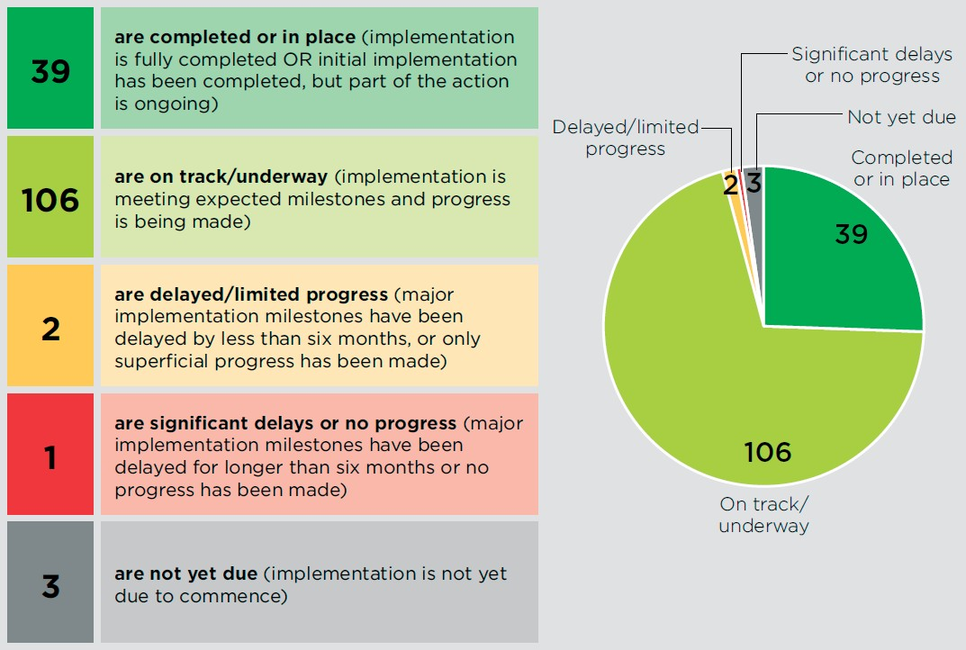
Progress on the implementation of the Reef 2050 Plan is reported annually. Annual reports, provided to the Great Barrier Reef Ministerial Forum, highlight key achievements during the year and include case studies demonstrating the range of work undertaken by Reef 2050 delivery partners. Substantial progress has been made in implementing the 151 actions under the original Reef 2050 Plan. The Reef 2050 Plan 2017 Annual Report showed that more than 25 per cent of the actions were completed or in place and over 70 per cent were on track or underway, as shown in the figure below.
31

The revised Reef 2050 Plan, released in July 2018, included a set of actions comprised of updated targets from the original Reef 2050 Plan, along with new actions developed to reflect the current state of the Reef. In total, there are 70 actions in the current Reef 2050 Plan. A summary of progress against them is provided in the figure below:
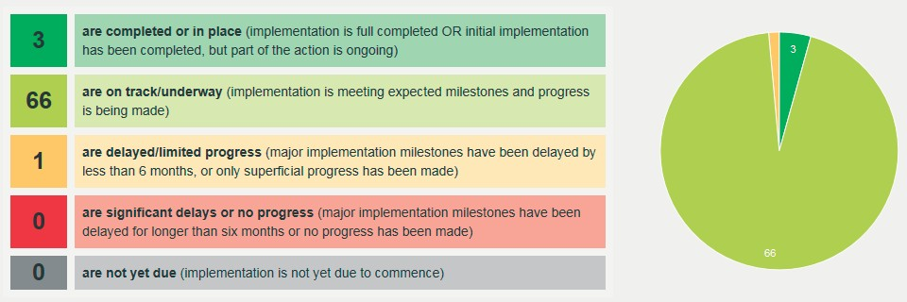
Comprehensive progress updates for all Reef 2050 Plan actions are published on the Atlas of Living Australia every six months. All Reef 2050 Action Reports are available at: https://fieldcapture.ala.org.au/home/projectExplo rer#reportView-heading.

    - Assessment of progress against current targets
To demonstrate the extent of progress against the Reef 2050 Plan, at least one target from each of the Reef 2050 Plan themes was selected for in-depth assessment. The targets were selected after consideration of whether the intent of the target was clear, what spatial and temporal scales applied to the target, and whether accurate information was available to support the assessment. These targets cover ecosystem health; biodiversity; cultural heritage; water quality; social, community and economic benefits; and governance. The primary source of information that informed this assessment is the 2019 Outlook Report.

4.3.2a Ecosystem health
Ecosystem health encompasses habitats and processes that operate to keep an ecosystem functioning and resilient.
Resilience cannot be measured directly – assessing the resilience of a system depends on how well it responds to and recovers from disturbance, and is a function of its health. Changes in habitats and species listed below can only be used as an approximate indicator of ecosystem status – the 2019 Outlook Report also includes an assessment of key ecosystem processes (refer Chapter 3 of the Outlook Report).
The ecosystem health targets within the Reef 2050 Plan focus on key ecological and biological processes important to Reef function. Two selected targets against which progress has been measured are detailed below, and relate to key habitats and coastal ecosystems.

Target: Condition and resilience indicators for coral reefs, seagrass meadows, islands, estuaries, shoals and inter-reefal shelf habitats are on a trajectory towards at least good condition at local, regional and Reef-wide scales (EHT5).
In this target ‘condition and resilience indicators’ included consideration of the abundance, diversity, and recruitment success or reproductive potential of the listed habitats (where data was available).

32 / State Party Report on the state of conservation of the Great Barrier Reef World Heritage Area (Australia) 2019

Key lines of evidence used to measure progress:
- Current condition and trend for listed habitats in 2019 Great Barrier Reef Outlook Report (Region-wide scale)
- Marine Monitoring Program (for inshore coral reefs and seagrass) (local and regional scale)
- Long-term coral monitoring program (local and regional scale)

Progress Summary
The assessment has shown a stable to deteriorating trend in the listed habitats and species for this indicator; particularly for coral reefs and corals. This is only a subset of habitats, species and ecosystem health processes assessed in the 2019 Outlook Report, which shows some habitats in good to very good condition. Events such as floods and cyclones, along with changes in physical processes such as increasing sea temperature caused by global warming, have resulted in limited progress against some ecosystem health targets under the Reef 2050 Plan.

Habitat | Condition and trend5 |  | Progress | Reason for current state | Key progress enablers
 | 2014 | 2019
Halimeda banks | Stable | No consistent trend | Target met | Improved spatial analysis has increased understanding of  the spatial coverage of Halimeda banks. Exposure to  potentially damaging cyclonic waves and thermal stress in some areas has occurred since 2014, but impacts are inferred to be limited given their isolation and depth | Isolation from populated areas  Great Barrier Reef Marine Park Zoning Plan 2003 (and complementarry State zoning) protection and enforcement  Depth and proximity to high water movement

- 2019 Outlook grading key:
Very Good | Good | Poor | VeryPoor
Further detail is available in the 2019 Outlook Report available at: www.gbrmpa.gov.au

33

Habitat | Condition and trend6 |  | Progress | Reason for current state | Key progress enablers
 | 2014 | 2019
Islands | Deteriorated | Stable | Target met – trend improved | Localised damage to some islands has  occurred from severe weather, temperature extremes and pests. Recovery from past impacts is occurring due to management intervention in  the form of pest management and restoration and monitoring of island condition is increasing | Comprehensive pest management program  Great Barrier Reef Marine Park Zoning Plan 2003 (and complementarry State zoning) protection and enforcement  Australian and Qld government funding – post cyclone clean up and repair
Lagoon floor | Stable | Deteriorated | Improvement required | Some areas of the lagoon floor have been exposed to prolonged thermal stress, impacts associated with dredging and disposal, bottom trawling, vessel anchorage, shipping and potentially damaging cyclonic waves. | Some isolation from populated areas  Great Barrier Reef Marine Park Zoning Plan 2003 (and complementarry State zoning) protection and enforcement  Expansion of Reef protection markers and  moorings to prevent anchor damage

- 2019 Outlook grading key:
Very Good | Good | Poor | VeryPoor
Further detail is available in the 2019 Outlook Report available at: www.gbrmpa.gov.au

34 / State Party Report on the state of conservation of the Great Barrier Reef World Heritage Area (Australia) 2019

Habitat | Condition and trend7 |  | Progress | Reason for current state | Key progress enablers
 | 2014 | 2019
Shoals | Stable | Deteriorated | Improvement required |  | Some isolation from populated areas
 |  |  |  |  | Great Barrier Reef Marine Park Zoning Plan 2003 (and complementarry State zoning) protection and enforcement
 |  |  |  |  | Expansion of Reef protection markers and moorings to prevent anchor damage
Seagrass meadows | Stable | Deteriorated | Significant improvement required to meet target | Degradation of inshore seagrass meadows has occurred in a number of areas and recovery has been slowed  by a number of disturbances (Cyclone Debbie near the Whitsundays, poor water quality and marine heatwaves).  The absence of seed banks and low reproductive effort  have resulted in many seagrass meadows being vulnerable  A more regional analysis of inshore seagrass meadows shows inshore seagrass remained in poor condition in all regions except the Burdekin, where it remained | Australian Government climate commitments (see section 4.2.4)  Great Barrier Reef Marine Park Zoning Plan 2003 (and complementarry State zoning) protection and enforcement  Reef 2050 Water Quality Improvement Plan – although  it takes significant period of time for improved land practices to influence the condtion  of inshore

- 2019 Outlook grading key:
Very Good | Good | Poor | VeryPoor
Further detail is available in the 2019 Outlook Report available at: www.gbrmpa.gov.au

35

Habitat | Condition and trend8 |  | Progress | Reason for current state | Key progress enablers
 | 2014 | 2019
Coral reefs | Deteriorated | Deteriorated | Significant improvement required to meet target  Australian Institute of Marine Science – regional surveys  disturbances have caused widespread damage and loss of coral reef habitat in a number of areas. Coral | Multiple severe disturbances have caused widespread damage and loss of coral reef habitat in a number of areas.  Coral recruitment has declined significantly.  More regionally, across the three sectors surveyed that make up the Reef, coral cover in the northern Reef  (north of Cooktown) has stabilised, but remains close to  the lowest levels recorded since 1985. Coral cover in the central and southern survey locations (the remaining two thirds of the Reef) followed a declining trend. | Australian Government climate commitments (see section 4.2.4)  Great Barrier Reef Marine Park Zoning Plan 2003 (and complementarry State zoning) protection and enforcement  Expansion of Reef protection markers and  moorings to prevent anchor damage  Reef 2050 Water Quality Improvement Plan – although  it takes significant period of time for improved land practices to influence the condtion of inshore ecosystems
Target: There is no net loss of the extent, and a net improvement in the condition, of natural wetlands and riparian vegetation that contribute to Reef resilience and ecosystem health (EHT 3).

Progress Summary

The current condition and trend in the 2019 Outlook Report (Region-wide scale) shows that coastal ecosystems that support the Reef remain in poor condition overall, mainly due to historical modification of coastal ecosystems for different land uses. However, the trends of most components have stabilised.
Currently the remaining extent of each coastal ecosystem is the primary indicator of condition within the 2019 Outlook Report until such time as more broadscale condition and function data are available. The Statewide

- 2019 Outlook grading key:
Very Good | Good | Poor | VeryPoor
Further detail is available in the 2019 Outlook Report available at: www.gbrmpa.gov.au

36 / State Party Report on the state of conservation of the Great Barrier Reef World Heritage Area (Australia) 2019

Landcover and Tree Study is a Queensland Government vegetation monitoring program that reports annually on the woody vegetation loss in Queensland. Since the 2014 Outlook Report, the clearing rate of regrowth woody vegetation (mainly for agriculture land use) in the Reef catchment has increased. Vegetation management laws were reinstated in mid-2018 to provide consistent protection to regrowth vegetation in all Reef catchments.
There has been limited clearing of freshwater wetlands, with about 81 per cent of the habitat remaining in the Catchment. Freshwater wetlands help the Reef by absorbing and transforming pollutants, regulating sediment, slowing freshwater flows and providing nurseries for freshwater and marine species, including barramundi and other finfish (2019 Outlook Report). Heath and shrublands remain in very good condition and two coastal ecosystems (saltmarshes and rainforests) remain in good condition.

Changes in the extent of coastal ecosystems in the Catchment before European settlement, 2009 and 2015
The 2014 Outlook Report outlined the remaining extent of terrestrial habitats (renamed to coastal ecosystems) since European settlement. The current extent and trend since 2009 of coastal ecosystems is presented (being remnant vegetation only; or more broadly, vegetation that has not previously been cleared). Source: Adapted from Neldner et al. 2017 and Kelley and Ryan 2018.that has not previously been cleared). Source: Adapted from Neldner et al. 2017 and Kelley and Ryan 2018.

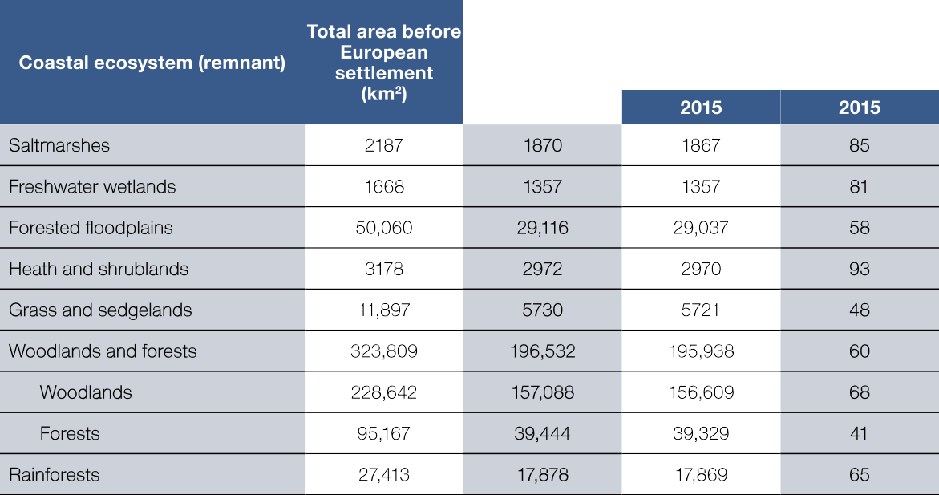

4.3.2b Biodiversity
Target: Populations of Australian humpback and snubfin dolphins, dugong, and loggerhead, green, hawksbill and flatback turtles are stable or increasing at Reef-wide and regionally relevant scales (target BT4)
Dolphins, dugongs and marine turtles are protected under national and state legislation. The Marine Park Authority and the Queensland Department of Environment and Science work with Traditional Owners, stakeholders and other Australian and Queensland government agencies to ensure Marine Park populations are able to recover from disturbances, and that their habitat is improved.
In 2017, the Australian Government released a 10-year recovery plan for marine turtles in Australia (available at http://www.environment.gov.au/system/files/resources/46eedcfc-204b-43de-99c5-4d6f6e72704f/files/recovery-p lan-marine-turtles-2017.pdf). The recovery plan summarises actions to be implemented and responsible agencies.

37

While data is limited for some species, such as dolphins, more comprehensive data for other species indicate signs of population recovery. For example, the dugong breeding rate has increased along the urban coast after a decline following effects of a severe cyclone and flooding in 2011, and the southern green turtle population continues to recover. Green turtle strandings within the Region have also declined markedly since 2011 (following impacts on seagrasses from cyclone Yasi). While whale populations are not specifically included in this target, populations of whale species within the region are stable, while humpback whale populations have recovered strongly.

Progress Summary

Species | Condition and trend9 |  | Progress | Reason for current state | Key progress enablers
 | 2014 | 2019
Dolphin | Deteriorated | Deteriorated | Improvement required | Data on the Region’s dolphins are very limited. Offshore dolphin species are considered more stable as they are less likely to be exposed to human-related threats than inshore dolphin species.  Concerns continue for the condition of Australian humpback and snubfin dolphins (both inshore  species), which may be in decline due  to human-related mortality. | Inshore – 3 net free areas established  in 2015 – reduce interactions  with species of conservation concern.  Protection of coastal habitats.  ‘Go slow’ areas in the marine park to reduce boat strike.  Inshore – Port Master Planning, Sustainable Ports Act, and permit assessments to reduce impacts on these populations where they exist.

9 2019 Outlook grading key:
Very Good | Good | Poor | VeryPoor
Further detail is available in the 2019 Outlook Report available at: www.gbrmpa.gov.au

38 / State Party Report on the state of conservation of the Great Barrier Reef World Heritage Area (Australia) 2019

Species | Condition and trend10 |  | Progress | Reason for current state | Key progress enablers
 | 2014 | 2019
Dugong | Deteriorated | Improved | While grade is poor, progress improved and is tracking to meet target – but this will take time. | The Region is home to globally significant populations of dugongs. Over the entire Region there is a high probability that the dugong  population declined between 2005 and 2016 – due to multiple impacts, particularly loss of seagrass following extreme weather.  However, along the urban coast, from Hinchinbrook south (approximately  half of the property area), the breeding rate has improved since the impacts of cyclone Yasi and  widespread flooding in 2011. The poor condition reflects both ongoing effects of past significant population declines (for example commerical harvest at least 60 years ago) and current impacts. | Inshore – 3 net free areas established in 2015 – interactions with species of conservation concern.  Reef 2050 Water Quality Improvement Plan (regarding link to improving water quality which is important to dugong foodsource – seagrass).  ‘Go slow’ areas in the marine park to reduce boat strike.  Sustainable traditional use through accredited Traditional Use of Marine  Resources Agreements.

- 2019 Outlook grading key:
Very Good | Good | Poor | VeryPoor
Further detail is available in the 2019 Outlook Report available at: www.gbrmpa.gov.au

39

Species | Condition and trend11 |  | Progress | Reason for current state | Key progress enablers
 | 2014 | 2019
Marine Turtles | No consistent trend | No consistent trend | Significant improvement required | Heightened concerns exist for the future of loggerhead, hawksbill and northern green  turtle populations. The southern green turtle population continues to recover. The trend for flatback turtles is not clear.  Increasing sea and air temperatures are a very high risk for marine turtles – warmer temperatures lead to more female and fewer male turtle hatchlings. | As above for dugongs.  Australian Government climate commitments (see section 4.2.4)  Reduced mortality of large female green turtle breeders under the Raine Island Recovery Project.

4.3.2c Cultural heritage
Target: Partnerships between Traditional Owners and all stakeholders are increased to ensure key Reef heritage values are identified, documented and monitored (target HT3).

The 2019 Outlook Report indicated that for Aboriginal and Torres Strait Islander people many cultural practices remain strong and the resilience of this value is increasing in some areas (Chapters 4 and 8). Partnerships are being maintained and new partnerships formed to protect multiple Indigenous values within the property.
Some heritage components have been documented on and around islands, but there is limited monitoring of their condition by Reef managers who do not always have a sufficient understanding of the condition of Indigenous structures, technology, tools and archaeology. While some structures and sites are located within the Region,

- 2019 Outlook grading key:
Very Good | Good | Poor | VeryPoor
Further detail is available in the 2019 Outlook Report available at: www.gbrmpa.gov.au

40 / State Party Report on the state of conservation of the Great Barrier Reef World Heritage Area (Australia) 2019

many are located on the adjacent coast and islands and are important to the Region’s heritage. Some heritage components have been documented (for example, on the Keppel Island group, Lizard Island and the Whitsunday islands). Strengthening ‘ask first’ principles and protocols for consultation with Indigenous people will improve progress against this target.
Traditional Owners also validated indicators for the Reef 2050 Integrated Monitoring and Reporting Program (RIMReP) targets and objectives under the Strong Peoples – Strong Country framework.

Progress Summary
As discussed in section 3.2.2, the Department of the Environment and Energy in 2017 commissioned a consortium of Indigenous and research organisations to engage with Reef Traditional Owners to better understand and reflect their aspirations for the Reef. The Consortium prepared a report, titled Traditional Owners of the Great Barrier Reef: The next Generation of Reef 2050 Plan Actions, which provides advice from Reef Traditional Owners about their aspirations for involvement in the management, governance and protection of the Reef. The report is an important contribution to the comprehensive review of the Reef 2050 Plan in 2020.
In 2019 the Marine Park Authority released its Aboriginal and Torres Strait Islander Heritage Strategy for the Marine Park, which contains aspirations and actions for sea country management. The strategy addresses many actions under the Reef 2050 Plan and commits to increasing co-management of the Reef. The strategy will lead to better understanding, protection and promotion of Indigenous heritage values of the Reef. Indigenous
community engagement is fostered through membership on the Marine Park Authority board and the Indigenous Reef Advisory Committee, science and management workshops for Traditional Owners, compliance training, monitoring and traditional ecological knowledge projects.
Through the partnership between the Australian Government’s Reef Trust and the Great Barrier Reef Foundation, the Foundation has committed to making the largest single investment in Traditional Owner Reef protection, amounting to $42 million over six years, equalling 10 per cent of the total partnership funding. In April 2019
an investment of $1.8 million was announced for 18 Reef protection projects designed to empower Traditional Owners to expand their Reef protection activities in three priority areas: Indigenous junior ranger programs; country-based planning; and implementation of existing land and sea country plans.
The Australian Institute of Marine Science (AIMS) is implementing an Indigenous Partnership Plan to work with Reef's Traditional Owners in areas of mutual interest, to develop genuine research and monitoring partnerships, to combine excellent science with Indigenous knowledge, insights, capability and capacity, and to generate the best possible knowledge-base to inform land and sea management based practice.
Partnerships with Traditional Owners are delivering benefits for Aboriginal and Torres Strait Islander communities and the Reef. This includes the implementation of Traditional Use of Marine Resources Agreements which cover around 25 per cent of the property’s coastline and support Traditional Owners involvement in Reef compliance management, research, education and youth-focussed activities.
Partnerships with Indigenous organisations are also delivering on-ground water quality outcomes for the Reef such as innovative denitrification bioreactor trials to remediate water quality and prevent nutrients from leaving the farm. In the Cape York region, the Yalanji Joint Venture is delivering on-ground gully remediation to reduce sediment loss, preserve cultural heritage significance and empower the local community while building local capacity to deliver major investments.
In 2017, the Queensland Government boosted funding for the Indigenous Land and Sea Ranger Program, bringing the number of funded rangers to over 100 across 23 regional and remote communities. The $12 million per annum program, administered by the Department of Environment and Science, assists Indigenous Land

41

and Sea Ranger groups to conserve Queensland’s important ecosystems and Aboriginal and Torres Strait Islander cultural heritage in locations stretching from Cape York to the Bunya Mountains.
The Queensland Government has committed to systemic improvements in the relationship between Aboriginal and Torres Strait Islander peoples and the Queensland Government. The Queensland Government has specifically recognised the rights of Indigenous Queenslanders through the Human Rights Act 2019, including that Indigenous peoples have the right:
- not to be subjected to forced assimilation or destruction of their culture (article 8)
- to maintain and strengthen their distinctive spiritual relationship with their traditionally owned or otherwise occupied and used lands, territories, waters and coastal seas (article 25)
- to conserve and protect the environment and the productive capacity of their lands, territories and waters (article 29)
- to maintain, control, protect and develop their cultural heritage, traditional knowledge and traditional cultural expressions (article 31).
In July 2019, the Queensland Government announced Tracks to Treaty – A Path to Treaty which will develop a process for state-wide agreement making. Such processes build on successful programs engaging the First Nations peoples of the Reef region, such as the Queensland Indigenous Land and Sea Ranger Program.

4.3.2d Water quality
At its 2017 meeting in Krakow, Poland, the World Heritage Committee welcomed the progress made since the inception of the Reef 2050 Plan in 2015, but noted progress towards the water quality targets was slow. Poor water quality is a large, system-wide challenge, with action needed to reduce nutrient, pesticide and sediment loads that are impacting the ecosystems of the Great Barrier Reef.

The changes in land management needed require substantial investment and take time to implement. Significant time is needed to engage individual land managers and support them in planning for and then making the changes that will improve the quality of water flowing into the Reef lagoon. This means it can be years before we see the results on the ground and for the Reef. For example, a key source of sediments is the extensive gullies in Reef catchments that have eroded over many years. Gully erosion remediation is a high cost and often technically complex undertaking. We are investing more resources and trialling new approaches to more effectively address the required landscape scale changes in the future.

The Reef Water Quality Report Card 2017 and 2018 assesses the results of Reef 2050 Water Quality Improvement Plan 2017-2022 actions reported up to June 2018. The report card results reflect the large scale of change still required to meet water quality targets. The report card shows that we are seeing some encouraging progress towards improving the quality of the water flowing to the Great Barrier Reef. Many landholders have improved their land management practices.

With many water quality improvement projects in different stages of implementation, not all water quality improvement outcomes have been captured in the report card. Over coming years, we will see more results being reported from existing and additional programs, including through the regulatory measures, Reef Trust - Great Barrier Reef Foundation Partnership, and further investments under the Australian Government Reef Trust, Queensland Reef Water Quality Program and Queensland Natural Resource Management Investment Program. Future reporting will better reflect progress towards the Reef 2050 WQIP targets, as the benefits to Reef water quality from investments are realised.

42 / State Party Report on the state of conservation of the Great Barrier Reef World Heritage Area (Australia) 2019

The Queensland Government has introduced additional regulatory measures to improve the quality of water entering the Reef from the catchment (see section 4.2.5 for additional detail). This will build on the voluntary efforts of landholders to change their farming practices and reduce run-off, setting agricultural minimum practice standards across a number of industries in Reef catchments. This will help to further improve Reef water quality when the new laws come into effect on 1 December 2019.
Modelling suggests the Reef Regulations could deliver an estimated 80 per cent of the 2025 nutrient target in the Reef 2050 Water Quality Improvement Plan 2017-2022 and just over 16 per cent of the 2025 sediment target.
Target: By 2025 (compared to a 2013 baseline): MTR WQT1
- 60 per cent reduction in anthropogenic end-of catchment dissolved inorganic nitrogen loads.
- 25 per cent reduction in anthropogenic end-of catchment fine sediment loads
- 20 per cent reduction in particulate nutrient loads
- pesticide target—to protect at least 99% of aquatic species at the end-of-catchments.

These are the targets in the Reef 2050 Water Quality Improvement Plan 2017-2022, which seeks to improve the quality of water flowing from the catchments adjacent to the Reef. The Plan was updated from high level
Reef-wide targets to evidence-based targets for each of the 35 major catchments adjacent to the Reef. This helps prioritise both the sources of and the types of pollution that pose the highest risks to the Reef, and to each catchment, and identifies the types of actions that will assist in achieving the water quality targets.
Water quality targets define the required reductions in sediment, nutrient and dissolved inorganic nitrogen loads by 2025 for the catchments discharging to the Reef. The pesticide target defines the required protection level for aquatic ecosystems.

Progress Summary
Progress across regions and river catchments against these targets is demonstrated in the interactive online
Reef Water Quality Report Card 2017 and 2018.
The report card shows that while progress is being made towards the 2025 water quality targets, the trajectory of improvement needs to be lifted. The Australian and Queensland governments are confident that investments already made or still in the pipeline will further improve results. The introduction of the enhanced Queensland Reef regulations is also expected to lift performance in future years.
Results in the report card show overall progress to date of:
- 21.2 per cent reduction in anthropogenic end-of-catchment dissolved inorganic nitrogen loads
- 14.4 per cent reduction in anthropogenic end-of-catchment fine sediment loads
- 13 per cent reduction in anthropogenic end-of-catchment particulate nutrient loads
- Pesticide target not included in this report card – scoring will occur for the next report card.
The 2017 and 2018 report card has some promising results:
- The Cape York sediment and particulate nutrient targets were met. Modelling shows the average annual loads of sediment reduced by 1.8 per cent to 9.8 per cent, almost double the 5 per cent target. Reductions were due to improved pasture management from destocking cattle and controlling feral animals on the

43

Queensland Government owned Springvale Station, and improved pasture and gully management through Australian Government Reef Trust projects.
- The Burdekin region recorded the largest improvement (up 3.2 per cent to 19.6 per cent) in best practice nutrient management for sugarcane. Improved nutrient management was delivered through the Queensland Government Burdekin Nitrogen Project and the Australian Government Reef Trust: Reef Alliance Growing a Great Barrier Reef project.
- Modelling shows the annual average load of dissolved inorganic nitrogen flowing from the Burdekin reduced by 1.2 per cent to 26.7 per cent as a result of these projects.
- The loss of natural wetlands across the Reef catchments slowed with less than 0.1 per cent loss (556 hectares) between 2013 and 2017.
- Throughout the catchments, freshwater floodplain wetlands remained in moderate condition.
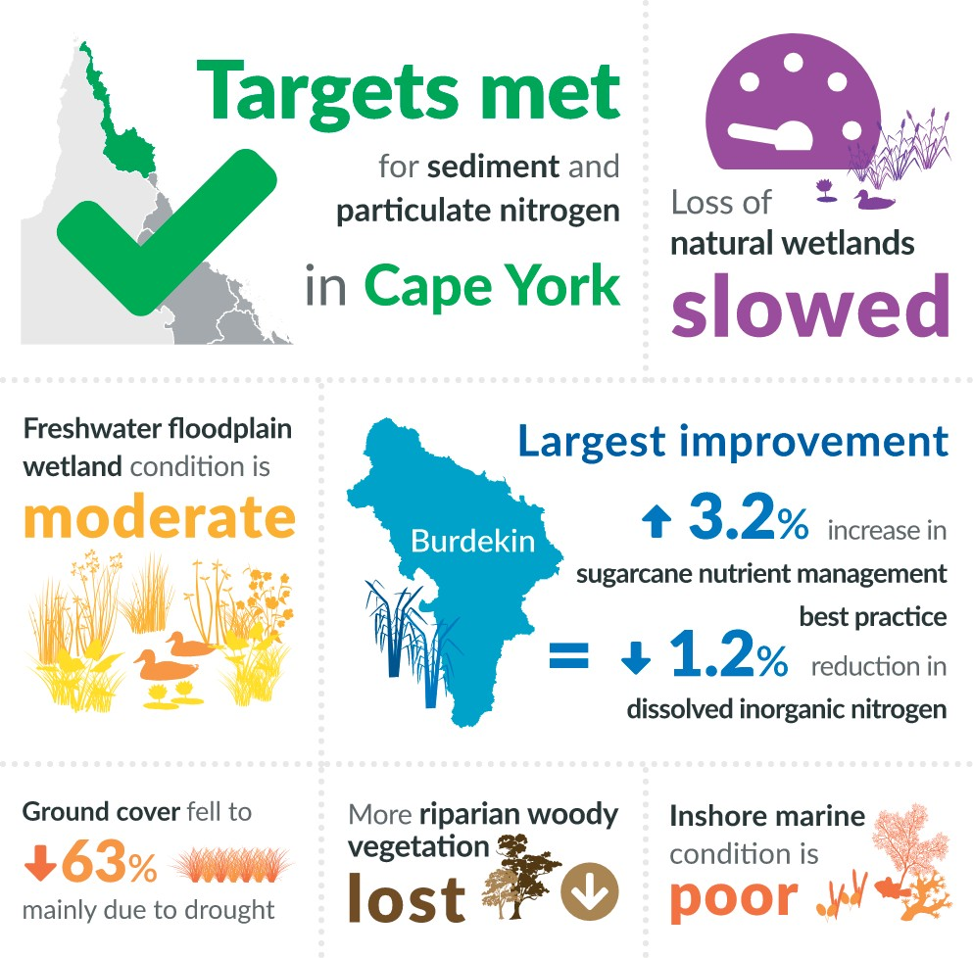

44 / State Party Report on the state of conservation of the Great Barrier Reef World Heritage Area (Australia) 2019

Continuous improvements in water quality management
Working with the Queensland Government and NCEconomics, Alluvium Consulting developed an online interface to evaluate the cost effectiveness of investment options for meeting specific regional water quality targets across the Reef, determining least cost pathways to meet these targets. By modelling reductions
in pollutant loads achieved through the various investments made under the governments water quality improvement initiatives, the tool can be used to estimate marginal and total abatement cost curves. A cost range was established enabling the total costs of achieving regional targets to be determined.
Case study: Gully and Stream Bank Erosion Control Program
This program addresses one of the key threats to the Reef, sediment run-off from gully and stream bank erosion, including in minor streams and drainage lines, large river channels, and high-energy streams in wet coastal catchments. Following a $7.5 million pilot program, the Australian Government has expanded the program providing over $29 million in grants for nine projects through the Reef Trust.
This includes a $2.9 million project, Improving Reef Water Quality through Herbert River Catchment and Gully Remediation. Targeting priority erosion hot spots and high-risk areas in the Herbert River Basin, the project will reduce the export of fine sediments from eroding stream banks and gullies into the Reef lagoon. New grazing management practices and erosion repair work is taking place on century-old Woodleigh Cattle Station, stopping thousands of tonnes of fine sediment from flowing to the Reef each year. Read more about this work at: https://terrain.org.au/wp-content/uploads/2019/09/Case-Study-Woodleigh-Cat tle-Station-Herbert-Gully-and-Grazing-Program.pdf.

4.3.2e Community benefit
Target: Community benefit values for Great Barrier Reef coastal ecosystems are being monitored and show a positive trend (target CBT4)
The community benefits of a healthy Reef (understanding, appreciation, enjoyment, personal connections, health benefits and aesthetics) are recognised in the Marine Parks, Commonwealth marine area, National heritage
place and World Heritage Area as values. Income, employment and access to reef resources are also considered community benefits, and are discussed under economic benefit below.
The property provides constantly evolving opportunities for people to engage with it. This allows people to develop a sense of identity based on living within the Region, pride in the World Heritage Area and an
appreciation of its outstanding natural beauty and biodiversity. Survey results suggest that the cultural value of the Reef has significantly increased for residents since 2013 despite the loss of corals from climate change.12

12 Marshall and Curnock (2019) Changes among coastal residents in the Great Barrier Reef Region 2013-2017: a Report from the Social and Economic Long-term Monitoring Program – prepared for the Great Barrier Reef Marine Park Authority, CSIRO, Townsville.

45

Progress Summary
Significant work has been undertaken over the past five years to understand the range of community benefits and to incorporate community benefits into policy, assessment processes and decision-making guidelines.
This includes projects under the National Environmental Science Program that are developing indicators and metrics for human dimension outcomes, objectives and targets in the Reef 2050 Plan. This reflects a high-level understanding by managers that the property provides substantial and diverse community benefits.

Case Study: National Environmental Science Program
Climate change, poor water quality from land-based run-off, impacts from coastal development and some fishing impacts such as illegal fishing are the major challenges being tackled as part of the National Environmental Science Program. With funding of $31 million, a new Tropical Water Quality hub was established in 2015 to research coastal water quality and coastal management focused on the Reef. In January 2018, 50 new research projects were announced under the program with more than a dozen projects looking at solutions to the challenges faced by the Reef. Projects being funded range from
crown-of-thorns starfish management approaches and seagrass condition assessment, through to reducing Reef governance risks and testing the effectiveness of managing gully erosion to reduce sediment sources to the Reef.
Further information on the National Environmental Science Program Tropical Water Quality hub is available at https://www.environment.gov.au/science/nesp/current-projects/tropical-water.

Economic and social use of the Region continues to provide benefit to communities and the Region is valued by residents, the nation and the world. This aspect of use continues to be in very good to good condition (refer table below from 2019 Outlook Report). For example, commercial and non-commercial use continue to contribute to the Region’s economy while the social benefits of traditional use, fishing and recreation continue to contribute to connection, health and wellbeing.
However, many factors both inside and outside the Reef are impacting upon the social, economic and heritage values of the Region (Chapter 6). The economic value of Reef-dependent uses relies on a healthy reef ecosystem. The impact on economic values from factors such as climate change, coastal development, land-based run off and other direct uses is considered to be high and likely to increase into the future. The relatively low impact on social values so far is predicted to increase if ecosystem health declines with resulting consequences for community health, wellbeing and enjoyment (pg 188, 2019 Outlook Report).

46 / State Party Report on the state of conservation of the Great Barrier Reef World Heritage Area (Australia) 2019

Value | Condition and trend13 |  | Progress | Reason for current state | Key progress enablers
 | 2014 | 2019
Economic and social benefits of use (of the Marine Parks) | Stable | Stable | Target met | The property continues to be managed as a multiple use marine park, enabling different types of use and community benefit to be derived  from the Region in a sustainable manner.  Economic and social benefits to the Region continue to be in very good or good condition overall.  Commercial and non-commercial use continue  to contribute to the Region’s  economy. The social benefits of fishing and recreation contribute significantly to health and wellbeing. The Reef is of major importance to Traditional Owners. health and wellbeing. The Reef is of major importance to Traditional Owners. | Social and Economic Long-term Monitoring program continues to inform management on community benefit.  Great Barrier Reef Marine Park Zoning Plan 2003 (and complementarry State zoning) protection and enforcement.  Expansion of Reef protection markers and moorings to prevent anchor damage.

13 2019 Outlook grading key
Very Good | Good | Poor | VeryPoor

Further detail is available in the 2019 Outlook Report available at: www.gbrmpa.gov.au

47

4.3.2f Economic benefit
Target: The relationship between Reef health and the viability of Reef-dependent industries (e.g. tourism and fishing) is understood and considered in planning and development decisions (target EBT5)
Reef-dependent industries and activities directly support approximately 64,000 jobs and brought $6.4 billion into the Australian economy in 2015-16. Direct human use of the Reef continues to be a significant contributor to regional and national economies, which demonstrates that the Reef continues to be valued by national and international communities.

Progress Summary
The economic contributions to the Australian economy from Reef-dependent activities, 2006-07 to 2015-16 is provided in the table below (2019 Outlook Report, page 111). Data such as this are essential to measuring progress against this target. However up to date, ongoing analysis of the direct and indirect economic benefit
from the Reef was identified as a knowledge gap in the 2019 Outlook Report and will need to be considered in the 2020 review of the Reef 2050 Plan.

Activity | Australian total value-added ($ million)
 | 2006-07 | 2011-12 | 2015-16 | Change since  2011-12 (%)
Tourism | $5117 | $5176 | $5700 | +10
Commercial fishing and  aquaculture | $139 | $160 | $162 | +1
Recreation use  (including fishing) | $153 | $244 | $346 | +42
Scientific research and Reef  management | - | $98 | $182 | +86
Total contribution | $5409 | $5678 | $6390 | +13

g Governance and performance
Target: A comprehensive Integrated Monitoring and Reporting Program is established and operational and the reporting informs the review and updating of this Plan (target GT5)

A key element of the Reef 2050 Plan is the establishment of the Reef 2050 Integrated Monitoring and Reporting Program. The program will provide a comprehensive and up-to-date understanding of the Reef and its adjacent catchment – the values and processes that support it and the threats that affect it. This knowledge is fundamental to informing actions required to protect and improve the Reef’s condition and to drive adaptive management.
The program’s vision is to become a knowledge system that will enable resilience-based management of the Reef and its catchment, and provide managers with a comprehensive understanding of how the Reef 2050 Plan is progressing. Its goals are to be:
- effective in enabling the early detection of trends and changes in the Reef’s environment, inform the assessment of threats and risks, and drive resilience-based management

48 / State Party Report on the state of conservation of the Great Barrier Reef World Heritage Area (Australia) 2019

- efficient in enabling management priorities and ensuring that all decisions are well informed, cost-effective and transparent.
- evolving based on the findings of the Great Barrier Reef Outlook reports, new technology and priority management and stakeholder feedback.
This ambitious program, now moving from design to implementation, is unprecedented in its scale and scope, drawing together more than 90 existing environmental, social and economic monitoring and modelling programs across the Reef and adjacent catchment.

Progress Summary
The Marine Park Authority has finalised version one of the recommended monitoring program design and developed a prototype knowledge system that is currently being tested by program partners. The next steps are to establish governance, funding and data systems to support the delivery.

Development of targets for the revised Reef 2050 Plan
Reporting against Reef 2050 targets has presented a number of reporting challenges, including:
- limited capability to provide quantitative data against targets
- high complexity within single targets, including varying spatial scales and habitat types, and
- reference to terminology not defined in legislation or policy.
To ensure that the Reef 2050 Plan remains fit for purpose, its 2020 review will include the development of a comprehensive and measurable set of targets and objectives to guide the delivery of the revised outcomes and vision. This reflects the continuous improvement approach adopted by the Australian and Queensland
governments to ensure that the property is managed adaptively in a changing environment. This, combined with the implementation of the Reef 2050 Integrated Monitoring and Reporting Program, will facilitate improved tracking and evaluation or progress and reporting against targets in future.
Progress on the implementation of the Reef 2050 Plan is reported annually. Annual reports, provided to the Great Barrier Reef Ministerial Forum, highlight key achievements during the year and include case studies demonstrating the range of work undertaken by Reef 2050 delivery partners.

49

Other conservation issues identified by the State Party which may have an impact on the property’s outstanding universal value

Great Barrier Reef Outlook Report 2019 – risk assessment
The 2019 Outlook Report includes a chapter assessing the risks to the Reef’s ecosystem and heritage values (Chapter 9). It demonstrates that, as well as the significant risk from threats associated with climate change and water quality, a range of other threats also pose risks and contribute to cumulative impacts. Recognising the need to manage cumulative impacts, the Reef 2050 Cumulative Impact Management Policy was developed alongside a complimentary Reef 2050 Net Benefit Policy. These policies were released in July 2018 and are being implemented. Continued awareness and management of all threats is critical to ongoing protection and management of the Reef.

Great Barrier Reef Outlook Report 2019 – long-term outlook
The final chapter of the report (Chapter 10) considers the risk findings as part of the overarching assessment of the Reef’s future long-term outlook and mentions some of the existing and future initiatives to support the Reef’s resilience. This includes work in the Marine Park such as enhanced compliance and effective Reef restoration
and intervention, as well as accelerated action to improve agricultural land management practices across the catchments.

50 / State Party Report on the state of conservation of the Great Barrier Reef World Heritage Area (Australia) 2019

Potential major restorations, alterations and/or new constructions intended within the property, the buffer zones and/or corridors or other areas, where such developments may affect the outstanding universal value of the property, including authenticity and integrity

Quarterly reporting
In 2011 Australia formalised a procedure for providing quarterly notification reports to the World Heritage Centre of proposed developments within or outside a property that may impact upon a property's Outstanding Universal Value. Notification reports and a full list of proposed, approved and withdrawn actions relating to the property that require consideration under the national Environment Protection and Biodiversity Conservation Act 1999 (the EPBC Act) are available at: www.environment.gov.au/heritage/about/world/notification-developm ent-proposals.
Sixteen proposals have been approved under the EPBC Act for the Great Barrier Reef World Heritage Area since the 2015 State Party Report on the state of conservation of the property was submitted on 30 January 2015.

51

Appendices

Appendix A: Map of the Great Barrier Reef World Heritage Area
Appendix B: Reef Funding 2014-15 to 2023-24
Appendix C: World Heritage Committee Decisions
Appendix D: Summary of heritage attributes from the 2019 Outlook Report and Complementary assessments- linking the Outlook Report and the Great Barrier Reef’s outstanding universal value
Appendix E: Integrity test – Great Barrier Reef World Heritage Area (from the 2019 Outlook Report)

52 / State Party Report on the state of conservation of the Great Barrier Reef World Heritage Area (Australia) 2019

Appendix A: Map of the Great Barrier Reef World Heritage Area
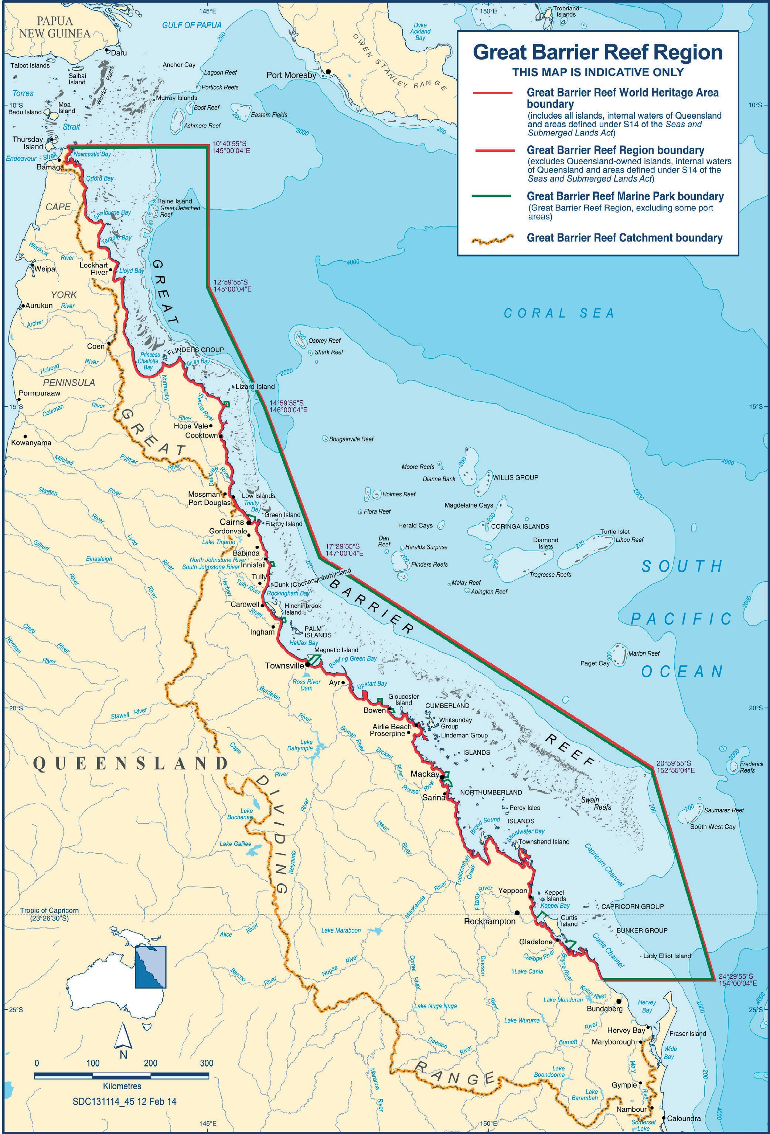
53

54 / State Party Report on the state of conservation of the Great Barrier Reef World Heritage Area (Australia) 2019

Appendix B: Reef funding 2014-15 to 2023-24

All figures in AUD $m | 2014-15 | 2015-16 | 2016-17 | 2017-18 | 2018-19 | 2019-20 | 2020-21 | 2021-22 | 2022-23 | 2023-24 | Total
Australian Government Reef Programs
Reef 2050 |  |  | 2.090 | 9.438 | 8.891 | 8.891 | 7.736 | 7.736 | 9.700 | TBD | 54.482
Reef Trust*^ | 7.702 | 15.865 | 35.554 | 486.422 | 34.161 | 42.175 | 34.650 | 25.853 | 21.670 | TBD | 704.052
Reef Program | 29.650 | 32.850 | 10.100 | 10.150 |  |  |  |  |  |  | 82.750
Other Reef Funding | 15.507 | 10.426 | 5.986 | 1.996 |  |  |  |  |  |  | 33.915
Sub-total | 52.859 | 59.141 | 53.730 | 508.006 | 43.052 | 51.066 | 42.386 | 33.589 | 31.370 | 0.000 | 875.199
Australian Government Reef Science
National Environment Science Program  (Tropical Water Quality Hub) | 2.200 | 5.630 | 5.400 | 5.400 | 5.400 | 5.400 | 2.550 | NP | NP | NP | 31.980
Australian Institute of Marine Science | 15.100 | 15.100 | 15.100 | 29.100 | 39.200 | 34.800 | 37.400 | 40.100 | 42.800 | 45.200 | 313.900
Australian Research Council  (Centre of Excellence for Coral Reef Studies) | 6.437 | 6.409 | 6.304 | 6.778 | 6.956 | 5.994 | 3.403 | 0.385 | 0.06 | TBD | 42.726
Sub-total | 23.737 | 27.139 | 26.804 | 41.278 | 51.556 | 46.194 | 43.353 | 40.485 | 42.860 | 45.200 | 388.606
Great Barrier Reef Marine Park Authority**
Joint Field Management Program  (Australian Government funding) | 8.372 | 8.372 | 9.767 | 14.859 | 11.965 | 12.740 | 16.576 | 19.428 | 18.99 | 18.99 | 140.059
Great Barrier Reef Marine Park Authority | 18.773 | 19.845 | 22.411 | 24.830 | 41.256 | 33.086 | 33.369 | 33.550 | 33.762 | TBD | 260.882
Sub-total | 27.145 | 28.217 | 32.178 | 39.689 | 53.221 | 45.826 | 49.945 | 52.978 | 52.752 | 18.990 | 400.941
Australian Maritime Safety Authority
Sub-total | 23.459 | 24.185 | 21.088 | 24.888 | 27.533 | 28.927 | 29.703 | 29.838 | 30.340 | 30.940 | 270.901
Australian Government Total | 127.200 | 138.682 | 133.800 | 613.861 | 175.362 | 172.013 | 165.387 | 156.890 | 157.322 | 95.130 | 1935.647
Queensland Government Reef Programs
Queensland Government Reef Water Quality Program* | 35.000 | 33.425 | 47.145 | 43.308 | 61.493 | 69.962 | 39.000 | 35.000 | TBD | TBD | 364.333
Joint Field Management Program  (Queensland Government funding) | 8.372 | 8.372 | 8.766 | 8.779 | 13.279 | 12.709 | 16.468 | 19.227 | 19.227 | 19.227 | 134.426
Sub-total | 43.372 | 41.797 | 55.911 | 52.087 | 74.772 | 82.671 | 55.468 | 54.227 | 19.227 | 19.227 | 498.759
Queensland Sustainable Fisheries Programs
 |  | 7.001 | 2.674 | 6.439 | 7.697 | 9.541 | 8.500 | TBD | TBD | TBD | 41.852
Maritime Safety Queensland
 | 28.000 | 28.000 | 28.000 | 28.000 | 28.000 | 28.000 | 28.000 | 28.000 | 28.000 | 28.000 | 280.000
Queensland Total | 71.372 | 76.798 | 86.585 | 86.526 | 110.469 | 120.212 | 91.968 | 82.227 | 47.227 | 47.227 | 820.611
TOTAL | 198.572 | 215.480 | 220.385 | 700.387 | 285.831 | 292.225 | 257.355 | 239.117 | 204.549 | 142.357 | 2756.258
Cumulative total | 198.572 | 414.052 | 634.437 | 1334.824 | 1620.655 | 1912.880 | 2170.235 | 2409.352 | 2613.901 | 2756.258

 | Shows years prior to the commitment of funds and after allocated funding has finished.
NP | New program in development. The National Environmental Science Program is scheduled for completion in 2021. The Australian Government has budgeted for a future environmental research program.
TBD | To be determined-funding allocations to be considered in future budgets.

Notes

Australian Government Reef Programs
Reef 2050 | TBD- 2023-24 funding will be determined as part of future Australian Government budget processes.
Reef Trust*^ | *$2.1 million provided by Queensland Government in 2016-17 for the Reef Trust Phase IV Enhanced Efficiency Fertiliser Project with expenditure to occur from 2016-17 to 2019-20 is reported under Queensland Government investment (and not in Reef Trust).  ^2017-18, funding includes $443.3 million for the Reef Trust Partnership. Funding will be expended over six-years until 30 June 2024.  TBD- 2023-24 funding will be determined as part of future Australian Government budget processes.
Reef Program | Reef Program ended in 2017-18. Future Reef funding was allocated to the Reef Trust.
Other Reef Funding | Includes a range of Reef projects undertaken between 2014-15 and 2017-18:  - Natural Heritage Trust Reef projects.  - Systems Repair and Urban Water Quality Grants (Biodiversity Fund).  - $9.375 million for e-Reefs coastal information system (Total project value is $12.5 million and commenced in 2013-14).
Australian Government Reef Science
National Environment Science Program (Tropical Water Quality Hub) | TBD- 2021-22 funding will be determined as part of future Australian Government budget processes.  The National Environmental Science Program (NESP) is a long-term environment and climate research program with funding of $145 million. The Tropical Water Quality Hub is one of the six thematic NESP research hubs, with Australian Government funding of $31.98 million.
Australian Institute of Marine Science | The Australian Institute of Marine Science invests a considerable proportion of its scientific effort in research that supports the health and resilience of the Great Barrier Reef. This covers a wide range of activities which can be summarised as: detailed reef monitoring; field work and experimentation; research and development; and partnerships and international engagement.
Australian Research Council (Centre of Excellence for Coral Reef Studies) | The Australian Research Council Centre of Excellence for Coral Reef Studies undertakes world-best integrated research for sustainable use and management of coral reefs.  Includes ARC Centre for Excellence for Coral Reef Studies and other ARC funded projects relating the Reef.  TBD- 2023-24 funding will be determined as part of future Australian Government budget processes.
Great Barrier Reef Marine Park Authority
Joint Field Management Program (Australian Government funding) | The Great Barrier Reef Marine Park Authority and the Queensland Government co-fund the Reef Joint Field Management Program. Through the 2018 Budget, the Australian Government boosted funding of the Joint Field Management Program by $42.685 million from 2018-19 until 2023-24.

55

Great Barrier Reef Marine Park Authority** | ** Funding for this item includes Departmental Appropriation and Environmental Management Charge (EMC). The EMC is a charge associated with most commercial activities, including tourism operations, non-tourist charter operations, and facilities, operating under a permit issued by the Marine Park Authority.  Funding for this item does not include Reef HQ sales or permits.  TBD- 2023-24 funding will be determined as part of future Australian Government budget processes.
Australian Maritime Safety Authority
 | The Australian Maritime Safety Authority, together with the Marine Park Authority and Maritime Safety Queensland, administer a suite of measures that regulate all ship activities within the region.

Additional Australian Government funding for the Reef is provided through:

- The Commonwealth Scientific and Industrial Research Organisation (CSIRO), including significant investments in understanding water quality and how agricultural practices affect sediment and nutrient loss, as well as
developing practical solutions for land managers to reduce these losses.
- The Bureau of Meteorology (BOM) is Australia’s national weather, marine, climate and water information agency. BOM’s operational services, including weather and ocean forecasts, climate outlooks including ocean temperature outlooks for the Reef lagoon, flood and streamflow forecasts and tropical cyclone warnings, and they provide critical support to communities and agencies in the Great Barrier Reef region. BOM is part of the eReefs+ project.

Queensland Government Reef Programs
Queensland Government Reef Water Quality Program | *$2.1 million provided by Queensland Government in 2016-17 for the Reef Trust Phase IV Enhanced Efficiency Fertiliser Project with expenditure to occur from 2016-17 to 2019-20 is reported under Queensland Government investment (and not captured in the Reef Trust).  TBD- 2023-24 funding will be determined as part of future Queensland Government budget processes.  Since 2015, the Queensland Government has invested approximately  $570 million into initiatives targeted solely at the protection of the Reef. In addition, the Queensland Government delivers a range of other programs that apply to the whole state of Queensland, with the Great Barrier Reef and its catchment making up a significant proportion of the state. The Queensland Reef Water Quality Program is invested through three Queensland Government agencies, the Department of Environment and Science, the Department of Agriculture and Fisheries and the Department of Natural Resources, Mines and Energy.
Joint Field Management Program (Queensland Government funding) | The Queensland Government and the Great Barrier Reef Marine Park Authority (GBRMPA). co-fund the Reef Joint Field Management Program.  The Queensland Government contributed over $8 million per year to the program until additional funding was announced in 2018 which will see the Queensland Government’s contribution grow to over $19 million by 2021.

56 / State Party Report on the state of conservation of the Great Barrier Reef World Heritage Area (Australia) 2019

Queensland Sustainable Fisheries Programs
TBD- 2023-24 funding will be determined as part of future Queensland Government budget processes.
The Queensland Government Department of Agriculture and Fisheries developed and commenced implementation of the Queensland Sustainable Fisheries Strategy.
Maritime Safety Queensland
Maritime Safety Queensland is responsible for improving maritime safety in Queensland waters, minimising vessel-sourced waste, responding to marine pollution incidents, and providing essential maritime services such as aids to navigation and vessel traffic services. Maritime Safety Queensland operates the Great Barrier Reef and Torres Strait vessel traffic service, which aims to improve navigational safety, reduce the risk of maritime incidents and respond quickly to incidents that do occur within those regions. The Great Barrier Reef and Torres Strait vessel traffic service is supported by a User Guide which was published in 2017.

57

Appendix C: World Heritage Committee Decisions
41 COM 7B.24 Great Barrier Reef (Australia) (N 154)
The World Heritage Committee,
- Having examined Document WHC/17/41.COM/7B.Add,
- Recalling Decision 39 COM 7B.7, adopted at its 39th session (Bonn, 2015),
- Welcomes the progress made with the inception and initial implementation of the Reef 2050 Long-Term Sustainability Plan (2050 LTSP) and the establishment of the Investment Framework, and expresses its appreciation for the significant efforts by all those involved in the implementation of the 2050 LTSP;
- Strongly encourages the State Party to accelerate efforts to ensure meeting the intermediate and long-term targets of the plan, which are essential to the overall resilience of the property, in particular regarding water quality;
- Notes with serious concern the coral bleaching and mortality that affected the property in 2016 and 2017;
- Reiterates its request to the State Party to submit to the World Heritage Centre, by 1 December 2019, an overall report on the state of conservation of the property demonstrating the effective and sustained protection of the property’s Outstanding Universal Value and effective performance in meeting the targets established under the 2050 LTSP, linked to the findings of 2014 and 2019 Great Barrier Reef Outlook Reports, for examination by the World Heritage Committee at its 44th session in 2020.
39 COM 7B.7 Great Barrier Reef (Australia) (N 154)
The World Heritage Committee,
- Having examined Document WHC-15/39.COM/7B.Add,
- Recalling Decisions 36 COM 7B.8, 37 COM 7B.10, and 38 COM 7B.63, adopted at its 36th (Saint-Petersburg, 2012), 37th (Phnom Penh, 2013) and 38th (Doha, 2014) sessions respectively,
- Notes with concern the conclusion of the 2014 Great Barrier Reef Outlook Report that the overall Outlook for the property is poor, and that climate change, poor water quality and impacts from coastal development are major threats to the property’s health and regrets that key habitats, species and ecosystem processes in the central and southern inshore areas have continued to deteriorate from the cumulative effects of these impacts;
- Welcomes the State Party’s efforts, in consultation and partnership with stakeholders, to establish the Reef 2050 Long-Term Sustainability Plan (2050 LTSP) that outlines an overarching vision for the future conservation of the property over the next 35 years and, in particular:
  - The establishment of an 80% reduction in pollution run-off in the property by 2025 and the commitment of an initial additional investment of AUS 200 million dollars to accelerate progress in water quality improvements,
  - The confirmation of protection of greenfield areas by restricting major new port development in and adjoining the property, thereby limiting capital dredging for the development of new or expansion of existing port facilities within the regulated port limits of the major ports of Gladstone, Hay Point/Mackay, Abbott Point and Townsville, excluding Fitzroy Delta, North Curtis Island and Keppel Bay from future port development and ensuring consistency with the 2003 Great Barrier Reef Zoning Plan,
  - The commitment toward a 5-yearly evaluation of the plan performance and adaptation of its actions and targets on the basis of the results of future Great Barrier Reef Outlook reports;
- Also welcomes the State Party’s decision to reconsider the approval to dispose capital dredge material inside the property from the proposed Abbot Point development and the commitment to establish a permanent ban on dumping of dredged material from all capital dredging projects within the property;
- Considers that the effective implementation of the 2050 LTSP, supported by clear oversight and accountability, research, monitoring and adequate and sustained financing, is essential to respond to the current and potential threats to the property’s Outstanding Universal Value, and requests the State Party to rigorously implement all of its commitments of the 2050 LTSP, including where necessary through their inclusion in legislation, in order to halt the current documented declines in the property, create the conditions for sustained recovery and to enhance the property’s resilience;
- Takes note of the State Party commitment to establish an investment framework in 2015 and also considers that

58 / State Party Report on the state of conservation of the Great Barrier Reef World Heritage Area (Australia) 2019

this is an essential requirement for the effective implementation of the 2050 LTSP, that should be established as a matter of priority;
- Also requests the State Party to submit to the World Heritage Centre, by 1 December 2016, an update on progress with implementation of the 2050 LTSP to confirm that the inception of the plan has been effective, and the Investment Strategy has been established, for examination by the World Heritage Centre and IUCN, and if in their assessment the anticipated progress is not being made, for consideration at the subsequent session of the World Heritage Committee in 2017;
- Further requests the State Party to submit to the World Heritage Centre, by 1 December 2019, an overall state of conservation report, including a 1-page summary, on the state of conservation of the property demonstrating effective and sustained protection of the property’s Outstanding Universal Value and effective performance in meeting the targets established under the 2050 LTSP, linked to the findings of the 2014 and anticipated 2019 Great Barrier Reef Outlook Reports, for examination by the World Heritage Committee at its 44th session in 2020.

59

Appendix D: Summary of heritage attributes from the 2019 Outlook Report and Complementary assessments- linking the Outlook Report and the Great Barrier Reef’s outstanding universal value

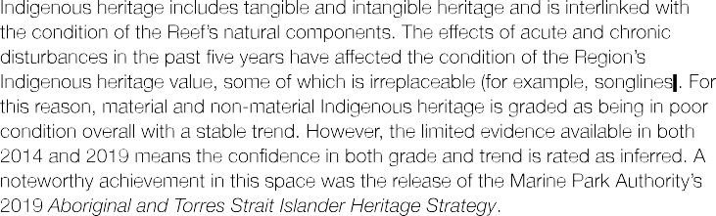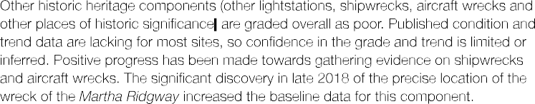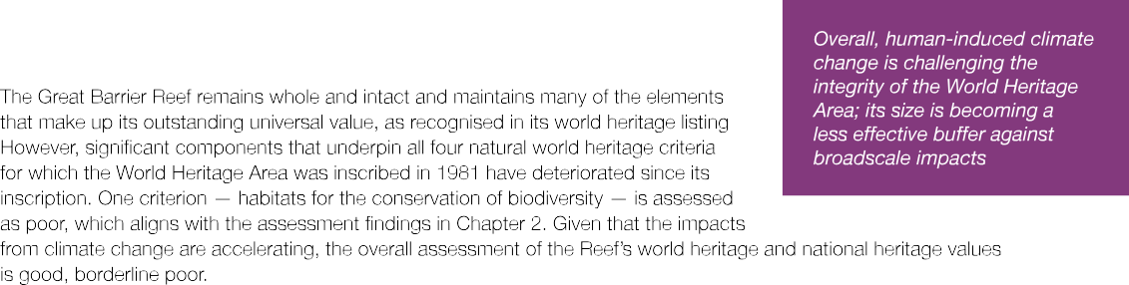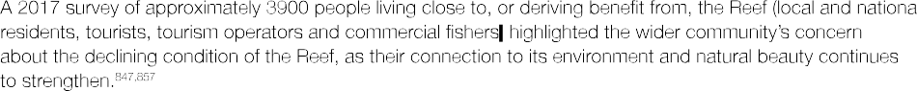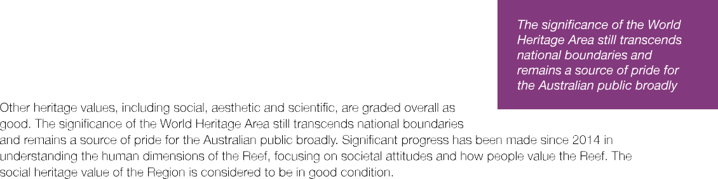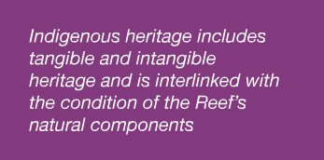

60 / State Party Report on the state of conservation of the Great Barrier Reef World Heritage Area (Australia) 2019

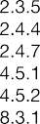
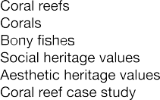
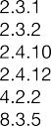

Complementary assessments - linking the Outlook Report to the great Barrier reef's outstanding universal value

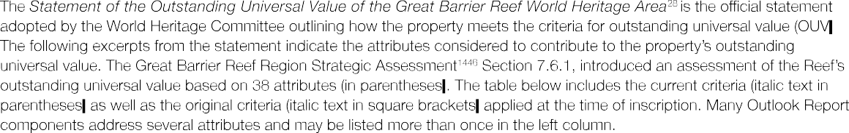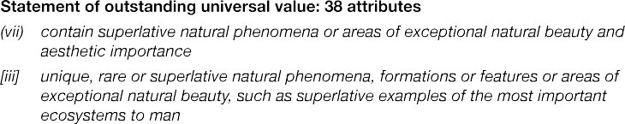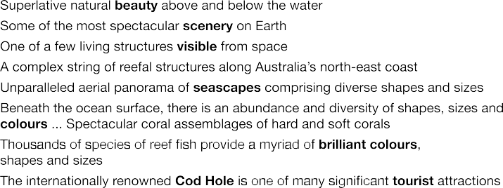

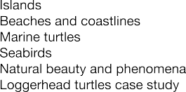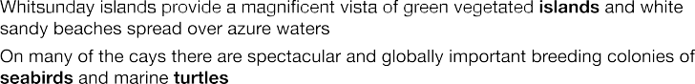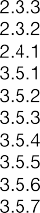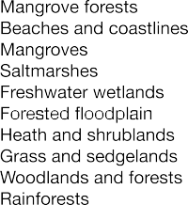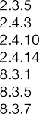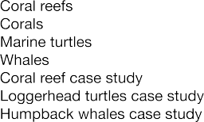

61

Major stages of the Earth's evolutionary history (viii)
(viii) be outstanding examples representing major stages of Earth's history, including the record of life, significant ongoing geological processes in the development of landforms, or significant geomorphic or physiographic features
[i] outstanding examples representing the major stages of the Earth's evolutionary history

3.4.8
4.2.3

3.2.1
3.2.2
3.2.3
3.2.4
3.2.5
3.2.6
3.2.7
3.3.2
3.3.3
3.4.8

Reef building
Major stages of the Earth's evolutionary history

Currents
Cyclones and wind Freshwater inflow Sediment exposure Sea level
Sea temperature Light
Ocean pH (acidity) Salinity
Reef building
- Globally outstanding example of an ecosystem that has evolved over millennia
- Area has been exposed and flooded by at least four glacial and interglacial cycles, and over the past 18,000 years reefs have grown on the continental shelf
- Today, the Great Barrier Reef forms the world's largest coral reef ecosystem ... Including examples of all stages of reef development
- Processes of geological and geomorphological evolution are well represented, linking continental islands, coral cays and reefs

- The varied seascapes and landscapes that occur today have been moulded by changing climates and sea levels, and the erosive power of wind and water, over long time periods

    - Continental slope
    - Water column
Ecological and biological processes (ix)
(ix) be outstanding examples representing significant ongoing ecological and biological processes in the evolution and development of terrestrial, fresh water, coastal and marine ecosystems and communities of plants and animals
{ii] outstanding examples representing significant ongoing geological processes, biological evolution and man's interaction with his natural environment

2.3.1 Islands
2.3.5 Coral reefs
2.3.8 Halimeda banks
2.4.4 Corals
3.4.8 Reef building
3.3.2 Ocean pH (acidity)
8.3.1 Coral reef case study
    - Currents
    - Cyclones and wind
3.4.10 Connectivity
3.3.1 Nutrient cycling
    - Microbial processes
    - Particle feeding
    - Primary production
    - Predation
    - Symbiosis
    - Recruitment
3.2.2 Cyclones and wind
3.2.4 Sediment exposure
3.4.4 Herbivory
    - Reef building
    - Competition

2.3.8 Halimeda banks

    - Seabirds
    - Shorebirds
2.3.1 Islands
3.4.7 Recruitment
- One-third of the Great Barrier Reef lies beyond the seaward edge of the shallower reefs (and) comprises continental slope and deep oceanic waters and abyssal plains

- Significant diversity of reef and island morphologies reflects ongoing geomorphic , oceanographic and environmental processes
(25) Biologically the unique diversity of the Great Barrier Reef reflects the maturity of an ecosystem that has evolved over millennia; evidence exists for the evolution of hard corals and other fauna

- Complex cross-shelf, longshore and vertical connectivity is influenced by dynamic
oceanic currents

- Ongoing ecological processes, such as upwellings, larval dispersal and migration

- Ongoing erosion and accretion of coral reefs, sand banks and coral cays combine with similar processes along the coast and around continental islands

- Extensive beds of Halimeda algae represent active calcification and accretion over thousands of years

(26) Vegetation on the cays and continental islands exemplifies the important role of birds ... in seed dispersal and plant colonisation

62 / State Party Report on the state of conservation of the Great Barrier Reef World Heritage Area (Australia) 2019

Habitats for conservation of biodiversity (x)
(x) contain the most important and significant natural habitats for in situ conservation of biological diversity, including those containing threatened species of outstanding universal value from the point of view of science or conservation
[iv] habitats where populations of rare or endangered species of plants and animals still survive

- Biodiversity
- Ecosystem Health
2.4.3 Benthic algae (includes macroalgae and microalgae)
    - Other invertebrates
    - Plankton and microbes
    - Bony fish
    - Sharks and rays
    - Sea snakes
    - Estuarine crocodiles
    - Seabirds
    - Shorebirds
    - Black teatfish case study
    - Coral trout case study
2.3.5 Coral reefs
2.4.3 Corals
8.3.1 Coral reef case study
2.3.3 Mangrove forests
2.4.1 Mangroves

- One of the richest and most complex natural ecosystems on Earth, and one of the most significant for biodiversity conservation
- Tens of thousands of marine and terrestrial species, many of which are of global conservation significance

- The world's most complex expanse of coral reefs ... Contain some 400 species of corals in 60 genera

- Large ecologically important inter-reefal areas. The shallower marine areas support half the world's diversity of mangroves

2.3.4
2.4.2

Seagrass meadows Seagrasses
- Large ecologically important inter-reefal areas. The shallower marine areas support ... many seagrass species

2.4.16 Dugongs
8.3.6 Urban coast dugongs case study
    - Whales
    - Dolphins
8.3.7 Humpback whales case study

2.3.1 Islands
2.4.10 Marine turtles
    - Seabirds
    - Shorebirds
8.3.5 Loggerhead turtles case study

4.3.6 Integrity
7 Existing protection and

- Waters also provide major feeding grounds for one of the world's largest populations of the threatened dugong

- At least 30 species of whales and dolphins occur here
- A significant area for humpback whale calving
- Six of the world's seven species of marine turtle occur in the Great Barrier Reef. As well as the world's largest green turtle breeding site at Raine Island , the Great Barrier Reef also includes many regionally important marine turtle rookeries
- Some 242 species of birds have been recorded in the Great Barrier Reef. Twenty­ two seabird species breed on cays and some continental islands, and some of these breeding sites are globally significant
- The continental islands support thousands of plant species, while the coral cays also have their own distinct flora and fauna

Related to assessment of integrity of the property's outstanding universal value

management
Broader than outstanding universal value

4.3 Indigenous heritage values (27)
5.9 Traditional use of marine resources
2.2 Legacies and shifted baselines
3.6 Outbreaks of disease, introduced species and pest species
4.4 Historic heritage values
- Commercial and non-commercial use
- Factors influencing the Region 's values
- Existing protection and management
8.5 Heritage resilience (Indigenous and historic heritage value)
- Risks to the Region's values
- Long-term outlook
Human interaction with the natural environment is illustrated by strong ongoing links between Indigenous people and their sea country, and includes numerous shell deposits (middens) and fish traps, plus the application of story places and marine totems

63

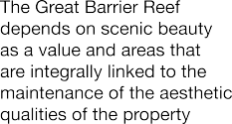
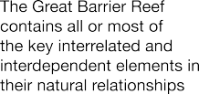
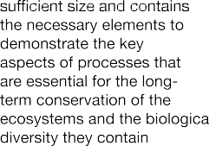Appendix E: Integrity test – Great Barrier Reef World Heritage Area (from the 2019 Outlook Report)

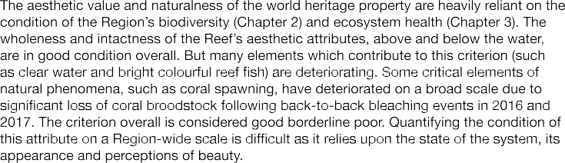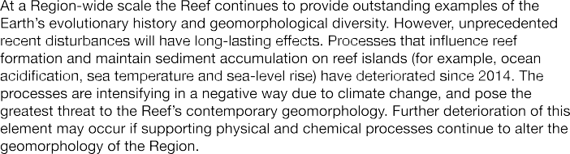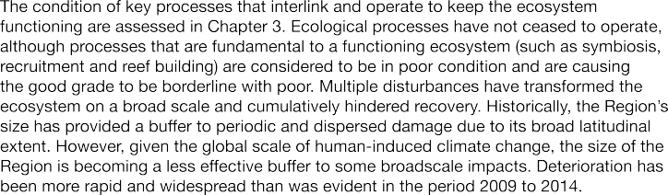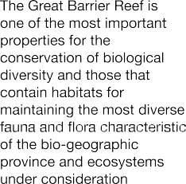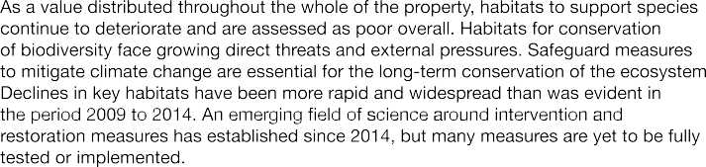

64 / State Party Report on the state of conservation of the Great Barrier Reef World Heritage Area (Australia) 2019
