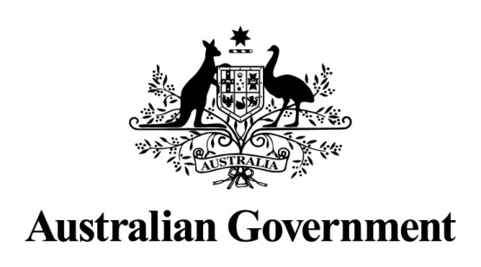

**STATE PARTY REPORT**

**ON THE STATE OF CONSERVATION**

**OF THE**

**GREATER BLUE MOUNTAINS AREA**

**(AUSTRALIA)**

**PROPERTY ID 917**

**11 April 2019**

© Copyright Commonwealth of Australia, 2019.

Creative Commons


State Party Report on the state of conservation of the Greater Blue Mountains Area (Australia) is licensed by the Commonwealth of Australia for use under a Creative Commons Attribution 4.0 International licence with the exception of the Coat of Arms of the Commonwealth of Australia, the logo of the agency responsible for publishing the report, content supplied by third parties, and any images depicting people. For licence conditions see: <https://creativecommons.org/licenses/by/4.0/>

This report should be attributed as ‘State Party Report on the state of conservation of the Greater Blue Mountains Area (Australia), Commonwealth of Australia 2019’.

Contents

EXECUTIVE SUMMARY ii

RÉSUMÉ iii

1. RESPONSE FROM THE STATE PARTY TO THE REQUEST FROM THE WORLD HERITAGE CENTRE 1

1.1 Request from the World Heritage Centre 1

1.2 The Greater Blue Mountains Area 1

1.3 Legislative protection of the Greater Blue Mountains Area 1

1.4 Quarterly reporting to the World Heritage Centre 2

1.5 Effective management and planning 3

1.6 Funding 4

1.7 Coal mining proposals close to the Greater Blue Mountains Area 4

1.8 Proposal to raise the Warragamba Dam wall (EPBC referral 2017/7940) 7

2. OTHER CURRENT CONSERVATION ISSUES IDENTIFIED BY THE STATE PARTY WHICH MAY HAVE AN IMPACT ON THE PROPERTY’S OUTSTANDING UNIVERSAL VALUE 10

2.1 Western Sydney Airport (EPBC referral 2014/7391) 10

2.2 Transit tunnel proposal 10

2.3 Significant conservation achievements and other changes since World Heritage listing 11

MAPS

Map 1 Greater Blue Mountains Area and adjacent reserves. iv

Map 2 Greater Blue Mountains Area – location of coal mining proposals 12

# EXECUTIVE SUMMARY

This report responds to a request from the World Heritage Centre on 1 March 2019 for a State Party Report on the State of Conservation of the Greater Blue Mountains Area (GBMA).

The request followed on from the provision of information to the World Heritage Centre by the Australian Government in relation to a series of development proposals outside the World Heritage Area that had the potential to, or were claimed to, affect the Outstanding Universal Value of the property. Factual information about these proposals was provided, as requested, under Paragraph 174 of the World Heritage *Operational Guidelines*.

Furthermore, each quarter the Australian Government informs the World Heritage Centre of potential developments that may affect the Outstanding Universal Value and integrity of Australia’s World Heritage properties.

The Greater Blue Mountains Area, located in the State of New South Wales (see **Map 1**), is noted for its representation of the evolutionary adaptation and diversification of the eucalypts in post-Gondwana isolation on the Australian continent. The World Heritage property, comprised of eight protected areas, consists of 1.03 million hectares of sandstone plateaux, escarpments and gorges dominated by temperate eucalypt forest. The property provides significant representation of Australia's biodiversity with ten percent of the vascular flora as well as significant numbers of rare or threatened species, including endemic and evolutionary relict species.

The Australian and New South Wales governments are fully committed to protecting the Outstanding Universal Value of the property. Australia’s national environmental law, the *Environment Protection and Biodiversity Conservation Act 1999* (EPBC Act) provides overarching national protection for the Outstanding Universal Value of the whole property. The property is managed and protected by the New South Wales Government under state legislation.

Mining is prohibited in national parks under New South Wales legislation and there is no mining within the Greater Blue Mountains Area. Some mines near the property were in existence at the time the property was nominated for inclusion in the World Heritage List and are still in operation. All the proposed mining projects referred to in this report are located outside the World Heritage property and all have been, or are being assessed, under the EPBC Act.

The New South Wales Government proposal to raise the Warragamba Dam wall by 14 metres is being assessed under the EPBC Act. The Warragamba Dam is downstream and outside of the World Heritage property and the proposal is for flood mitigation downstream of the dam. The Australian Government notified the World Heritage Centre about this proposal in September 2017 in accordance with Paragraph 172 of the World Heritage *Operational Guidelines.* A detailed Environmental Impact Statement is being prepared. Subject to all environmental and planning approvals being obtained, the New South Wales Government is not expected to consider a business case for the dam raising proposal until 2020. Construction can only begin if the environmental and planning approvals are granted, and once the New South Wales Government has made a decision on a final business case.

In December 2016 the Australian Government approved the construction of Western Sydney Airport, which will be located about eight kilometres east of the World Heritage property. The airspace and flight path design must take into account and minimise to the extent practicable the impact of aircraft overflight noise on the Greater Blue Mountains Area.

This report also highlights a number of significant conservation achievements in the Greater Blue Mountains Area since it was inscribed on the World Heritage List in 2000.

# RÉSUMÉ

Le présent rapport répond à une demande du Centre du patrimoine mondial faite le 1er mars 2019 concernant la rédaction d’un rapport d’État partie sur l’état de sauvegarde de la région des montagnes Bleues.

Cette demande a fait suite aux informations fournies par le gouvernement australien au Centre du patrimoine mondial concernant plusieurs propositions de développement en dehors du bien du patrimoine mondial, lesquelles auraient le potentiel, selon certaines sources, d’affecter la valeur universelle exceptionnelle du site. Des informations factuelles concernant ces propositions ont été mises à disposition, conformément à cette demande, en vertu du paragraphe 174 des *Orientations* du patrimoine mondial.

En outre, le gouvernement australien informe chaque trimestre le Centre du patrimoine mondial des projets de développement potentiels pouvant affecter la valeur universelle exceptionnelle et l’intégrité des sites du patrimoine mondial en Australie.

La région des montagnes Bleues, située en Nouvelle-Galles du Sud (voir **Carte 1**), a la particularité de représenter l’adaptation évolutive et la diversification des eucalyptus dans l’isolement post-Gondwana du continent australien. Le site du patrimoine mondial, composé de huit zones protégées, comporte 1,03 million d’hectares de plateaux de grès, d’escarpements et de gorges dominés par une forêt d’eucalyptus de climat tempéré. Ce site offre une représentation importante de la biodiversité australienne, avec 10 % de la flore vasculaire, ainsi qu’un nombre important d’espèces rares ou menacées, notamment des espèces endémiques et des reliques de l’évolution.

Le gouvernement australien et le gouvernement de Nouvelle-Galles du Sud s’engagent pleinement en faveur de la préservation de la valeur universelle exceptionnelle du site. Il est important de noter que la loi nationale australienne sur l’environnement, l’Environment Protection and Biodiversity Conservation Act 1999 (loi EPBC : loi de 1999 pour la protection de l’environnement et la préservation de la biodiversité) assure une protection nationale globale de la valeur universelle exceptionnelle de l’intégralité du site. La gestion et la protection du bien est assuré par le gouvernment de l’État de la Nouvelle-Galles du Sud selon la législation de cet État.

La législation de Nouvelle-Galles du Sud interdisant les activités minières au sein des parcs nationaux, il n’y a pas d’exploitations minières dans les limites de la région des montagnes Bleues. Certaines mines situées à proximité du site étaient déjà en place lorsque le site fut nominé pour être inscrit sur la Liste du patrimoine mondial, et sont toujours exploitées à l’heure actuelle. Tous les projets miniers potentiels mentionnés dans le présent rapport sont situés en dehors du site du patrimoine mondial et ont fait l’objet, ou font actuellement l’objet, d’une évaluation conformément à la loi EPBC.

La proposition du gouvernement de Nouvelle-Galles du Sud d’augmenter la hauteur du barrage de Warragamba de 14 mètres est en cours d’évaluation en vertu de la loi EPBC. Le barrage de Warragamba se situe en aval et en dehors du site du patrimoine mondial et cette proposition vise à limiter les inondations en aval du barrage. Le gouvernement australien a informé le Centre du patrimoine mondial de cette proposition en septembre 2017 conformément au paragraphe 172 des *Orientations* du patrimoine mondial*.* Une étude détaillée d’impact environnemental est en cours. Sous réserve de l’octroi de toutes les autorisations environnementales et de planification, le gouvernement de Nouvelle-Galles du Sud n’envisage pas d’évaluation du dossier commercial de cette proposition avant 2020. La construction ne pourra débuter qu’après l’octroi des autorisations environnementales et de planification, et une fois que le gouvernement de Nouvelle-Galles du Sud aura pris une décision quant au dossier commercial final.

En décembre 2016, le gouvernement australien a donné son approbation pour la construction de l’aéroport de Sydney Ouest, dont l’emplacement se trouvera à environ 8 km à l’est de la limite orientale du site du patrimoine mondial. L’espace aérien et les trajectoires de vol doivent prendre en compte et minimiser, dans la mesure du possible, l’impact sonore du trafic aérien au-dessus de la région des montagnes Bleues.

Le présent rapport souligne également plusieurs réussites importantes en matière de protection de l’environnement dans la région des montagnes Bleues depuis son inscription sur la Liste du patrimoine mondial en 2000.

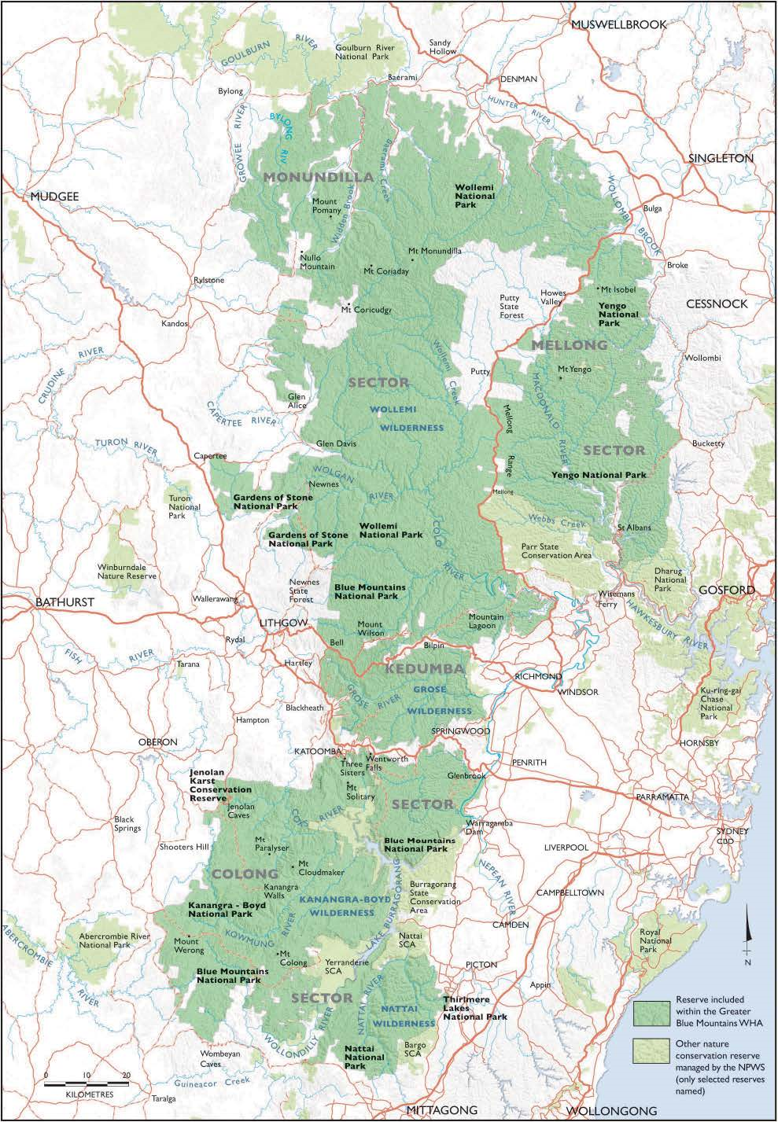

Map 1 Greater Blue Mountains Area (GBMA) and adjacent reserves

Constituent reserves in bold text. Warragamba Dam to the east of the World Heritage property.

Source: *Greater Blue Mountains World Heritage Area Strategic Plan 2009*

# 1. RESPONSE FROM THE STATE PARTY TO THE REQUEST FROM THE WORLD HERITAGE CENTRE

## 1.1 Request from the World Heritage Centre

On 1 March 2019, the World Heritage Centre wrote to the Australian Government requesting a report concerning the state of conservation of the Greater Blue Mountains Area with reference to proposals for coal mining and for raising the Warragamba Dam wall.

The potential impact of these proposals on the Outstanding Universal Value of the Greater Blue Mountains Area has been or is being assessed under Australian law. All of the proposals referred to in this report are located outside the Greater Blue Mountains Area. Australian law provides legal protection for Outstanding Universal Value by regulating actions occurring within or outside a World Heritage property that have, will have or are likely to have a significant impact on the Outstanding Universal Value of a World Heritage property.

This State Party Report has been prepared in cooperation with the New South Wales Government.

## 1.2 The Greater Blue Mountains Area

The Greater Blue Mountains Area located in the State of New South Wales is noted for its representation of the evolutionary adaptation and diversification of eucalypts in post-Gondwana isolation on the Australian continent and provides significant representation of Australia's biodiversity with ten percent of the vascular flora as well as significant numbers of rare or threatened species, including endemic and evolutionary relict species.

The Greater Blue Mountains Area (GBMA) was inscribed on the World Heritage List in 2000 on the basis of criteria (ix) and (x) and consists of 1.03 million hectares of sandstone plateaux, escarpments and gorges dominated by temperate eucalypt forest (see **Map 1**). The property, comprised of eight protected areas, is noted for its representation of the evolutionary adaptation and diversification of eucalypts in post-Gondwana isolation on the Australian continent. Ninety-seven eucalypt taxa occur within the Greater Blue Mountains Area which is also outstanding for its exceptional expression of the structural and ecological diversity of the eucalypts associated with its wide range of habitats. The site provides significant representation of Australia's biodiversity with ten percent of the vascular flora as well as significant numbers of rare or threatened species, including endemic and evolutionary relict species, such as the Wollemi pine, which have persisted in highly-restricted microsites.

## 1.3 Legislative protection of the Greater Blue Mountains Area

Australia’s national environmental law, the *Environment Protection and Biodiversity Conservation Act 1999* (EPBC Act) provides an overarching high level of protection for the Outstanding Universal Value of the Greater Blue Mountains Area.

The EPBC Act provides legal protection for Outstanding Universal Value by regulating actions occurring within or outside a property that have, will have or are likely to have a significant impact on the Outstanding Universal Value of a World Heritage property. Under the EPBC Act, World Heritage values (Outstanding Universal Value) are one of the protected Matters of National Environmental Significance and as such they trigger application of the Act. In Australia, most World Heritage properties, including the Greater Blue Mountains Area, do not have a formal buffer zone. This is because the EPBC Act provides legal protection for Outstanding Universal Value by regulating actions occurring within or outside a property that have, will have or are likely to have a significant impact on the Outstanding Universal Value of the property.

There are two key stages in the environment assessment process required by the EPBC Act.

**Stage 1** Referral – this stage determines whether or not a proposed action requires approval under the EPBC Act. Where a development proposal (proposed action) has, will have or is likely to have a significant impact on Outstanding Universal Value, it is determined to be a ‘controlled action’ and must undergo assessment and a decision whether or not to approve the action. Proposals can be determined to be:

* + - Controlled action - subject to the assessment and approval process,
    - Not a controlled action - approval is not required if the action is taken in accordance with the referral,
    - Not a controlled action ‘particular manner’- not a controlled action if undertaken in accordance with the manner specified.

**Stage 2** Assessment/decision whether to approve - Actions can be assessed using one of the following assessment methods:

• accredited assessment by a State government

• assessment on referral information (assessment done solely on the information provided in the referral form)

• assessment on preliminary documentation (referral form and any other relevant material identified by the minister as being necessary to adequately assess a proposed action)

• assessment by environmental impact statement (EIS) or public environment report (PER), and

• assessment by public inquiry

Alternatively, a proposal can be assessed by a State government on behalf of the Australian Government under a bilateral assessment agreement.

All proposals considered under the EPBC Act are subject to the referral process. EPBC referrals for projects in the vicinity of the Greater Blue Mountains Area are referenced below and can be accessed at <http://epbcnotices.environment.gov.au/referralslist/>.

Legislation in New South Wales relevant to the management of the Greater Blue Mountains Area is the *National Parks and Wildlife Act 1974*, the *Wilderness Act 1987*, the *Water NSW Act 2014*, the *Biodiversity Conservation Act 2016*, and the *Environmental Planning and Assessment Act 1979*. Other relevant New South Wales legislation, guidelines and policies in relation to the Environmental Impact Statement for the Warragamba Dam wall raising proposal are contained in the ‘Secretary’s Environmental Assessment Requirements (SEARS)’ referred to in section 1.8.5 of this report.

## 1.4 Quarterly reporting to the World Heritage Centre

The Australian Government has been regularly informing the World Heritage Centre of potential developments that may affect the Outstanding Universal Value of the Greater Blue Mountains Area, including its integrity, since 2011.

In 2011 Australia formalised a procedure for providing quarterly notification reports to the World Heritage Centre of proposed developments within or outside an Australian World Heritage property that may impact a property's Outstanding Universal Value.

Notification reports and a full list of proposed, approved and withdrawn actions relating to the Greater Blue Mountains Area that require consideration under the EPBC Act are available at: [www.environment.gov.au/heritage/about/world/notification-development-proposals](http://www.environment.gov.au/heritage/about/world/notification-development-proposals).

## 1.5 Effective management and planning

The Australian and New South Wales governments are fully committed to protecting the Outstanding Universal Value of the Greater Blue Mountains Area.

The New South Wales Government manages the eight conservation reserves that make up the [Greater Blue Mountains Area](https://www.environment.nsw.gov.au/topics/parks-reserves-and-protected-areas/types-of-protected-areas/world-heritage-listed-areas/greater-blue-mountains)[1]:

* Blue Mountains National Park
* Gardens of Stone National Park
* Jenolan Karst Conservation Reserve
* Kanangra-Boyd National Park
* Nattai National Park
* Thirlmere Lakes National Park
* Wollemi National Park
* Yengo National Park

All eight of the reserves have statutory plans of management in place, with the exception of the Thirlmere Lakes National Park for which the Plan of Management is with the New South Wales Minister for adoption.

Plans of management are prepared in accordance with the New South Wales *National Parks and Wildlife Act 1974* to set out the specific management objectives, directions and actions for each park and reserve. Once adopted, all operations must be undertaken in accordance with the plan of management. Information on adopted plans of management is available from the New South Wales Government web-site[2]. Plans of management help guide the conservation of biodiversity, rehabilitation of landscapes and the protection of natural and cultural heritage, including management and protection of Outstanding Universal Value. They also include management principles for use of a park by Aboriginal people for cultural purposes, sustainable visitor or tourist use, natural resource management and land management practices.

Other important and related plans informing management include Fire Management Strategies, Regional Pest Management Strategies and additional tailored plans for managing specific issues and precincts.

A [Strategic Plan](https://www.environment.nsw.gov.au/research-and-publications/publications-search/greater-blue-mountains-world-heritage-area-strategic-plan)[3] for the property that provides a framework for the integrated management, protection, interpretation and monitoring of the property was published in January 2009. It was reviewed in 2016. An [addendum](https://www.environment.nsw.gov.au/-/media/OEH/Corporate-Site/Documents/Parks-reserves-and-protected-areas/Types-of-protected-areas/greater-blue-mountains-world-heritage-area-strategic-plan-addendum-2016-180173.pdf?la=en&hash=6202D26A57F04F976EBF38452467A868C562CAD2)[4] to the Strategic Plan was published in 2016 containing the results of the review, which were mostly updates to relevant government policy or legislation.

A Strategic Management Framework, which is intended to update and replace the Strategic Plan, is in the early stages of development. When agreed to by both the Australian and New South Wales governments it will replace the Strategic Plan.

The Strategic Management Framework will include consideration of the [2017 IUCN World Heritage Conservation Outlook Assessment of the Greater Blue Mountains Area](https://www.worldheritageoutlook.iucn.org/explore-sites/wdpaid/220294) which found that the property’s conservation outlook was good with some concerns. The Outlook Report assessment noted that the property has a high value for the protection of natural biological processes and that most of the natural plant communities and habitats remain close to pristine. The assessment found that the Greater Blue Mountains Area has an effective management system in place and benefits from a strong legal framework, but the property’s large size, extensive perimeter and the existence of major inholdings can create management difficulties including the spread of vertebrate pests, and weeds.

The main potential threats identified were from activities outside the property boundary including impacts of coal mining and urban development in adjacent areas, and from urban development in the major corridor through the site including infrastructure development supporting the growth of Sydney. Although these threats are high, the Outlook Report assessment considered that they are capable of being resolved by better planning and management. The Strategic Management Framework will continue to support cooperative conservation management on adjacent lands to provide improved protection from threats from outside the property boundaries.

## 1.6 Funding

The New South Wales Government is responsible for the on ground management of the Greater Blue Mountains Area. It provides a budget of approximately AUD12.5 million per year for infrastructure maintenance, visitor management, pest and weed control, access management and maintenance, survey and monitoring, fire management and biodiversity and threatened species management. Additional New South Wales Government funding (typically more than AUD5 million per year) is allocated for one off capital projects for infrastructure improvements, additional grant funding for pest and weed control, threatened species management, and fire suppression.

In addition the Australian Government funds an Executive Officer who is the secretariat to the World Heritage property advisory committee and who coordinates reporting and information flow between the New South Wales and Australian governments on matters relating to the World Heritage property. Under the Regional Land Partnerships Program, there is significant Australian Government funding to regional and local organisations for projects that support the conservation of the Greater Blue Mountains Area. For example, the Greater Sydney Local Land Services is delivering a five year project *‘Protecting the values of the Greater Blue Mountains World Heritage Area through management of pest species’,* valued at about AUD2 million*.*

## 1.7 Coal mining proposals close to the Greater Blue Mountains Area

Coal mining has played a major role in the economy of the region since the 1870s. The major coal resources in New South Wales are located in the 500 kilometre long, 150 kilometre wide Sydney-Gunnedah Basin. An important factor in the economic development of New South Wales has been the ease of access to coal as an energy resource for the State's main industrial centres. New South Wales is one of the world's major exporters of coal.

The continued development of coal resources takes into account competing land uses and a range of environmental issues. Mining is prohibited in national parks under New South Wales legislation and there is no mining within the Greater Blue Mountains Area. A number of mines near the Greater Blue Mountains Area were in existence at the time it was nominated for inclusion in the World Heritage List and are still in operation.

All the mining projects described below are located outside the World Heritage property and all have been, or are currently being assessed, under Australia’s national environmental legislation, the *Environment Protection and Biodiversity Conservation Act 1999* (EPBC Act). This list relates to coal mines that have been raised in correspondence from the World Heritage Centre, those for which World Heritage has been a controlling provision, and those for which conditions have been applied in relation to World Heritage.

### 1.7.1 Airly Mine Extension Project (EPBC referral 2013/7076)

The Airly Mine Extension Project is adjacent to the northern sector of the Gardens of Stone National Park and is outside of the World Heritage Area (see **Map 2**). The project involves mining to extend the life of existing Airly Mine, with additional surface facilities and infrastructure to support the extension. The project was referred under the EPBC Act and in December 2013 it was decided that the proposal was a controlled action for the purposes of the Act, with World Heritage being a controlling provision. The environmental assessment identified water discharge to the Greater Blue Mountains Area as the primary risk posed by the proposed development. The project was approved in May 2017, with conditions requiring implementation of a site water management system to manage the risk to Outstanding Universal Value. A statement of reasons for this decision was made available to the public on 20 March 2019.

### 1.7.2 Angus Place Mine Extension Project (EPBC referral 2013/6889)

The Angus Place Extension Project involves underground mining at the existing Angus Place Mine in the Western Coalfields of New South Wales, outside of the World Heritage Area (see **Map 2**). The Gardens of Stone National Park is located adjacent to the north eastern edge of the mine. World Heritage is a controlling provision. The project is still undergoing assessment under the EPBC Act.

### 1.7.3 Bylong Coal Project – reconsideration of previous decision (EPBC referral 2014/7133)

The Bylong Coal Project is not within the World Heritage property, but adjoins its north-western boundary (see **Map 2**).

The open cut and underground mining components are about two and four kilometres respectively distant from the World Heritage property. The project was assessed under the EPBC Act for potential impacts on the Outstanding Universal Value of the property in 2014. It was determined that the proposal was unlikely to have a significant impact on Outstanding Universal Value and therefore further environmental impact assessment in relation to Outstanding Universal Value was not required by the Australian Government.

In response to a recent request by the Lock the Gate Alliance (a non-governmental organisation), and on the basis of new information that could be relevant to that decision, the Australian Government Minister for the Environment reconsidered this decision on 21 March 2019, as provided for under the EPBC Act. Following detailed consideration of the new information, the previous decision of 12 March 2014 was confirmed. The original decision was that the proposed development was a controlled action (requiring an Environmental Impact Statement and legislative approval). This decision was based on potential impacts on listed threatened species and communities and a water resource. The recent review decision reaffirmed that there would be no significant impact on Outstanding Universal Value.

### 1.7.4 Clarence Colliery (EPBC referral 2012/6446)

Clarence Colliery is an underground coal mine located in Newnes State Forest. The mine site is directly adjacent to, but not within, the World Heritage property (see **Map 2**). Subsidence associated with the mine is low, and there are no known impacts from subsidence on the Greater Blue Mountains Area.

Clarence Colliery has been in operation since before the commencement of the EPBC Act. In July 2015, a substantial coal fines stockpile collapsed into the Wollangambe River, resulting in pollution of the river within the GBMA. The mining company was prosecuted under New South Wales law and directed to pay over a million dollars for environmental management, planning and fauna conservation projects in the region. This was in addition to more than 12 months’ work by the company at a cost to it of AUD2 million to clean up the impacts of the incident (<https://www.epa.nsw.gov.au/news/media-releases/2017/epamedia17071701>).

The Australian Government also investigated the incident and undertook field inspections with two independent scientific consultancy reports produced. Based on this investigation the Australian Government is satisfied with the remediation works and has concluded that there have been no long-term impacts on the Outstanding Universal Value of the Greater Blue Mountains Area.

### 1.7.5 Coalpac Pty Invincible Colliery Modification (EPBC referral 2014/7147)

The Invincible Colliery is an open cut and longwall coal mine located mostly within Ben Bullen State Forest. The Invincible Colliery Southern Extension is also within Ben Bullen State Forest, which is not within the World Heritage property (see **Map 2**). The proposed mining operation is more than eight kilometres from the GBMA at the closest point. It is separated from the Greater Blue Mountains Area to the east by eucalypt forest, cleared farmland Coxs River and several other streams. It has been assessed under the EPBC Act and determined to be ‘not a controlled action’, which means it was assessed as unlikely to have a significant impact on the Outstanding Universal Value of the Greater Blue Mountains Area.

### 1.7.6 South Bates Extension (EPBC referral 2016/7816)

The Wambo Mine South Bates Extension project boundary is adjoins the Wollemi National Park and is not within the World Heritage property (see **Map 2**). Potential subsidence impacts (including the angle of draw) from some of the underground longwall panels may occur up to the boundary of Wollemi National Park.

The project’s surface disturbance comprises two new ventilation shafts that are approximately 1.6 kilometres to 2 kilometres away from Wollemi National Park. Given the depth of the underground extraction area in relation to the Greater Blue Mountains Area, it was determined that mining activity would not adversely impact the Wollemi escarpment or rock features within the neighbouring Wollemi National Park. Additionally, as the project is not located in the Greater Blue Mountains Area it was determined that it would not significantly impact the area’s biodiversity values which form part of the Outstanding Universal Value of the property. The Greater Blue Mountains Area is not listed for geological or geoheritage values, so any potential cliff instability as a result of longwall coal mining would not impact the Outstanding Universal Value of the property. This project has been assessed and approved with conditions under the EPBC Act for its potential impact on threatened species and communities, and water resources. It was determined that it was unlikely that there would be a significant impact on Outstanding Universal Value.

### 1.7.7 Springvale Mine Extension (EPBC referral 2013/6881)

Springvale Coal Mine is an underground longwall mine not within the World Heritage property. It is located 6.5 kilometres west of Blue Mountains National Park, 7 kilometres south of Gardens of Stone National Park and 9 kilometres south-west of Wollemi National Park (see **Map 2**). Subsidence associated with the longwall mining has impacted on groundwater and surface water, reducing flows into some streams that run into the Greater Blue Mountains Area.

Under the EPBC Act the controlling provisions were World Heritage, National Heritage, listed threatened species and communities, listed migratory species and a water resource. The decision concluded that the proposed action is unlikely to have a significant impact on the Greater Blue Mountains Area, and therefore that the impacts of the proposed action would not be unacceptable. The proposal was approved with conditions which are set out in a statement of reasons published on 1 March 2016.

The New South Wales Government oversees control of water quality in Coxs River, which flows into Lake Burragorang, the main water supply dam for the city of Sydney. While levels of salt, heavy metals and other contaminants are above natural background levels, these are not considered to impact on the Outstanding Universal Value of the property. To reduce these elevated levels, the New South Wales Government put in place conditions related to water management operations.

### 1.7.8 Tahmoor South Project (EPBC referrals 2014/7162 and 2017/8084)

The Tahmoor Colliery is more than 2.5 kilometres from the World Heritage property (see **Map 2**). Long-wall underground coal mining in the part of the Tahmoor Colliery closest to Thirlmere Lakes, but not within the World Heritage property, ceased eight years ago. The relationship between the coal mining operation and the water levels in Thirlmere Lakes has been the subject of close scrutiny and investigation over recent years, including through a New South Wales Government sponsored independent public inquiry and ongoing research. The New South Wales Government is currently studying water loss from the lakes, including whether any long-term damage has occurred from mining. The Australian Government has provided funds for water level monitoring data analysis. Further information is available at <https://www.environment.nsw.gov.au/water/thirlmerelakesinquiry.htm>.

Modelling work conducted as part of a recent Environmental Impact Statement on a proposed southward extension to the Tahmoor Colliery, away from the World Heritage property, indicates that if the proposal proceeds, the water levels of Thirlmere Lakes could be expected to decrease by about one to six centimetres, with an increase in the predicted average number of weeks per decade that the lakes would be without discernible ponded water increasing by between 3 weeks and 5.2 weeks. This proposal is being assessed under the EPBC Act for its potential impact on threatened species and communities, and water resources (it was considered that it was unlikely that there would be a significant impact on the Outstanding Universal Value of the property).

## 1.8 Proposal to raise the Warragamba Dam wall (EPBC referral 2017/7940)

The New South Wales Government proposal to raise the Warragamba Dam wall by 14 metres for flood mitigation purposes downstream of the dam is being assessed under Australia’s national environmental law (the *Environment Protection and Biodiversity and Conservation Act 1999* (EPBC Act)). The relevant controlling provisions for the proposal are World Heritage, National Heritage and EPBC Act listed threatened species.

The Australian Government notified the World Heritage Centre about this proposal in September 2017 in accordance with Paragraph 172 of the World Heritage *Operational Guidelines*.

A detailed Environmental Impact Statement is being prepared and is scheduled for exhibition and public comment for a minimum period of 30 days in late 2019. No construction activity on the dam raising can occur unless and until all relevant Australian and New South Wales government approvals are in place.

### 1.8.1 Overview of the proposal

Warragamba Dam is located south-west of Sydney in New South Wales (see **Map 1**). Its reservoir, Lake Burragorang, is formed by the damming of the Warragamba River with its major tributaries being the Coxs, Wollondilly, Kowmung and Nattai rivers. Lake Burragorang supplies water to more than five million people living in Sydney and the lower Blue Mountains. It is one of the largest domestic water supply dams in the world and stores around 80 percent of Sydney's water supply. Warragamba Dam and Lake Burragorang are located outside of the Greater Blue Mountains Area.

The New South Wales Government proposal is to raise the Warragamba Dam wall by 14 metres for flood mitigation purposes downstream of the dam. New South Wales Government responses to frequently asked questions about raising the dam wall are at <http://insw.com/media/1993/warragamba-dam-raising_feb-2019.pdf>.

The proposal is being assessed under the New South Wales *Environmental Planning and Assessment Act 1974* and the Australian Government’s EPBC Act. For the purposes of the EPBC Act, the proposal is being assessed by the New South Wales Government on behalf of the Australian Government under an assessment bilateral agreement (see section 1.3 above).

Warragamba Dam is owned and operated by WaterNSW (a New South Wales Government owned corporation) under the provisions of the *Water NSW Act 2014*. WaterNSW is preparing an Environmental Impact Statement on the proposal to raise Warragamba Dam for flood mitigation. The Environmental Impact Statement is expected to be available for public comment later in 2019. The terms of reference for the Environmental Impact Statement require ‘an analysis of any feasible alternatives to the project’.

Subject to environmental and planning approvals being granted, the New South Wales Government will consider the business case for the dam wall raising in 2020.

### 1.8.2 Flood mitigation

The proposal to raise Warragamba Dam for flood mitigation is one of nine key outcomes of the New South Wales Government’s flood risk management strategy for the Hawkesbury-Nepean Valley[5]. The proposed dam raising would create ‘airspace’ to capture and temporarily hold back floodwaters from the large Warragamba River catchment in a designated flood mitigation zone of around 14 metres above the current full supply level of the dam.

The purpose of this is to reduce and/or delay flooding downstream, significantly reducing risk to lives and property, and allowing additional time for evacuation during major floods. It would only operate during flood conditions. WaterNSW advises that if the dam wall is raised, preliminary modelling indicates there would be a temporary increase in area inundated in the total Greater Blue Mountains Area of 0.04 - 0.05%. This equates to an area of 400 - 550 hectares for a 1 in 100 year flood and the maximum flood respectively. More detailed analysis of the area likely to be subject to temporary inundation will be presented in the Environmental Impact Statement.

As part of the environmental assessment, the impact of temporary inundation on rivers and streams and land within the Greater Blue Mountains Area is being analysed. Aboriginal Cultural Heritage field surveys are ongoing and will continue for the time it takes to satisfy the methods agreed by Aboriginal Parties that have registered with the project.

### 1.8.3 Potential impacts

Areas upstream of Warragamba Dam in the Greater Blue Mountains Area are already prone to inundation during floods, especially if the dam is full or near to full. Under some flood conditions, if the dam wall is raised there will be increased temporary inundation in the World Heritage property.

Raising the dam wall would increase the frequency, duration, depth and/or extent of temporary inundation of areas located upstream of the dam wall. This may have impacts on biodiversity, aesthetic, wilderness and Indigenous cultural values. WaterNSW is conducting studies into these issues to inform the Environmental Impact Statement.

The Australian Government’s expectation is that potential impacts on all heritage values relevant to the property, including threatened species and Indigenous cultural values within the proposed inundation area, will be fully addressed in the Environmental Impact Statement. A recent New South Wales State Development Committee inquiry into legislation relating to the dam raising recommended ‘That the NSW Government … allow for adequate time to conduct survey mapping for Aboriginal heritage in the impacted areas.’ It is expected that this recommendation will be applied in the evaluation process.

Aboriginal cultural heritage values have been identified along the Coxs and Wollondilly Rivers and their tributaries, and an Aboriginal Place nomination was made for an extensive area along these waterways under the New South Wales *National Parks and Wildlife Act* *1974* (s84) in August 2018. An Aboriginal cultural heritage assessment report will form part of the Environmental Impact Statement.

### 1.8.4 Amendment to the New South Wales Water NSW Act 2014

The New South Wales *National Parks and Wildlife Act 1974* (s153B) prohibits the increased temporary inundation in a national park that would occur if a raised dam was operated to mitigate floods. In October 2018, the New South Wales Parliament passed an amendment to the *Water NSW Act 2014* to exempt the Warragamba Dam from this prohibition. The amendment is specific to Warragamba Dam, and only allows for temporary inundation.

The new provisions of the *Water NSW Act 2014* will have no effect unless the proposal is approved by the New South Wales and Australian governments, following the completion of all the required planning and environmental assessment processes.

The legislative amendment does not constitute an approval for raising Warragamba Dam. It was made to allow for New South Wales and Australian government consideration of the planning application for the proposal. If the dam raising proposal is not approved, the new provisions of the *Water NSW Act 2014* will have no effect.

The amended provisions require an Environmental Plan of Management to be in place before the exemption can take effect to allow temporary inundation of part of the national park. The plan would need to be approved by the New South Wales Government Minister administering the *National Parks and Wildlife Act 1974* in concurrence with the Minister administering the *Water NSW Act 2014*.

### 1.8.5 Preparation of the Environmental Impact Statement (EIS)

Since mid-2017, WaterNSW has been undertaking research and investigations to inform a detailed Environmental Impact Statement for the proposal to raise the dam wall. The EIS applies to temporary inundation for flood mitigation. The permanent water storage level in the dam would not change.

The environmental and planning assessments underway are focusing on the merits of the proposal as assessed under the New South Wales *Environmental Planning and Assessment Act* *1979*. There is a detailed set of requirements for the Environmental Impact Statement [6].

As part of the assessments underway, detailed flood mapping and targeted surveys for all flora and fauna species are being undertaken in accordance with both Australian and New South Wales government biodiversity assessment requirements. The impacts of the temporary increase in inundation on the upstream environment – and options to manage, mitigate or offset those impacts - will be detailed in the Environmental Impact Statement.

### 1.8.6 Recent media reports

The EPBC referral is based on a proposal to raise the Warragamba Dam wall by 14 metres for flood mitigation purposes. It has been reported in the Australian media that the draft Environmental Impact Statement indicates the New South Wales Government is considering raising the dam wall to 17 metres.

The New South Wales Government has stated that the Warragamba Dam wall raising proposal is to raise the dam wall by 14 metres to create ‘airspace’ to capture and temporarily hold back floodwaters. In an extreme flood event the temporary height of the water (maximum flood level) would be around 14 metres higher than current water levels.

If the proposal to raise the Warragamba Dam wall by 14 metres for flood mitigation purposes proceeds, any potential modification to the dam wall beyond 14 metres in the future would require new environmental and planning approvals from both the Australian and New South Wales governments.

# 2. OTHER CURRENT CONSERVATION ISSUES IDENTIFIED BY THE STATE PARTY WHICH MAY HAVE AN IMPACT ON THE PROPERTY’S OUTSTANDING UNIVERSAL VALUE

## 2.1 Western Sydney Airport (EPBC referral 2014/7391)

In December 2016 the Australian Government approved the construction of the Western Sydney Airport following the publication and finalisation of an Environmental Impact Statement and the production of an [Airport Plan](https://westernsydneyairport.gov.au/about/airport-plan/index.aspx)[7]. The Western Sydney Airport will be located about eight kilometres east of the Greater Blue Mountains Area.

The Environmental Impact Statement concluded that there was unlikely to be a significant impact on the listed values of the Greater Blue Mountains Area, but that there may be some noise impacts on amenity within the property. Final overflight pathways and their potential noise impacts have not been determined, but will be the subject of another EPBC Act referral.

The airspace and flight path design must take into account and minimise to the extent practicable the impact of Aircraft Overflight Noise on the Greater Blue Mountains Area.

The Airport Plan includes approval conditions in relation to airspace design and aircraft overflight pathways:

Condition 16 Airspace Design Process

(5) The airspace and flight path design must take account of the following principles, in addition to the principles in section 2.2.5 of the Airport Plan: …

(d) airspace and flight path design must minimise to the extent practicable the impact of Aircraft Overflight Noise on the following:

...

(iii) the Greater Blue Mountains World Heritage Area – particularly areas of scenic or tourism value; and

(iv) Wilderness Areas.

The airspace and flight path design will be the subject of a separate referral under the EPBC Act, which is expected to be released for public comment in 2021.

A public consultation process on the design and location of the flight paths is being conducted through the Forum on Western Sydney Airport, which is a large community and stakeholder reference group.

The Civil Aviation Safety Authority (the national authority for the regulation of civil aviation) is not expected to determine final flight paths until about 2024. Aircraft operations are proposed to commence from 2026.

## 2.2 Transit tunnel proposal

In December 2018 an independent member of the New South Wales Parliament used a Twitter post to propose the idea of a transit tunnel beneath the Greater Blue Mountains Area extending from near Penrith to the east of the World Heritage property to Lithgow to the west. The idea attracted some media attention and a positive response from Mr Elon Musk, an American entrepreneur and originator of the Tesla electric car, but was strongly criticised by engineering experts on the grounds of high expense and lack of practicality.

The World Heritage Centre wrote to the Australian Government on 22 December 2018 requesting information on the proposal, and the Australian Government responded on 15 February 2019 advising that the Australian Government is not aware of any serious discussions on the matter and has not received a referral for this proposal under the EPBC Act.

## 2.3 Significant conservation achievements and other changes since World Heritage listing

There have been a number of significant conservation achievements and other changes in the Greater Blue Mountains Area since it was inscribed on the World Heritage List in 2000.

*2.3.1 Establishment of new wild populations of Wollemi Pine*

The critically endangered Wollemi Pine (*Wollemia nobilis*) comprises a highly localised population of less than 100 adult plants in Wollemi National Park which is part of the Greater Blue Mountains Area. Since discovery in 1994 their population health and demographics have been monitored. Horticultural understanding of the species has increased to the extent it is commercially available. Extensive ground and aerial survey over the years has not located any additional wild populations. The New South Wales Government is proposing to establish two new wild populations of Wollemi Pine to act as insurance against the potential catastrophic loss of the original stands due to fire, disease or other factors, by translocation of seedlings to two new wild sites in Wollemi National Park. A pilot translocation site at Mt Tomah Botanic Garden, outside the Greater Blue Mountains Area, has had a high success rate (83%), indicating that Wollemi Pines have broader environmental tolerances than expected. A review of environmental factors is being prepared for the proposal. The establishment of such insurance plantings is provided for in the [recovery plan](http://www.environment.gov.au/system/files/resources/245df899-5818-44c1-a1f0-76fb70bb9fc6/files/wollemia-nobilis.pdf) for the species[8].

*2.3.2 Increase in recorded eucalypt diversity since World Heritage nomination*

At the time of its nomination for inclusion in the World Heritage List in 1998, the Greater Blue Mountains Area was known to support 90 species of eucalypt (species of the genera *Eucalyptus*, *Angophora* and *Corymbia* in the family Myrtaceae). At the time of listing in 2000, that number had risen to 91. A review published in 2010 indicated the presence of 96 species, and an additional species (*Angophora subvelutina*) was located in 2018, bringing the current total of eucalypt species to 97.

*2.3.3 Increase in the integrity of the Greater Blue Mountains Area through additions to reserves*

Since the Greater Blue Mountains Area was included on the World Heritage List, over 37,000 hectares of adjacent lands and inholdings have been added to the eight conservation reserves that comprise the property, through change in land tenure and management responsibility of some public lands and the purchase of strategically located private lands. This has added to the integrity of the property and improved the security and management of these lands that act as buffers to the Greater Blue Mountains Area.

Integrity has also been improved since listing by the declaration of the Yengo Wilderness (120,776 hectares) and by additions to the other gazetted wilderness areas within the Greater Blue Mountains Area. The area of gazetted wilderness within the Greater Blue Mountains Area has increased from over 500,000 hectares at the time of listing to 683,786 hectares. In addition the New South Wales Government has stated its intent to convert about 16,000 hectares of four areas of State Forest adjacent to the Greater Blue Mountains Area to flora reserves.

*2.3.4 Changes in recorded native fauna populations since World Heritage nomination*

The number of species of native terrestrial vertebrate fauna recorded for the Greater Blue Mountains Area has increased from about 400 at the time of nomination to 423. Numbers of recorded mammal species have increased from 52 to 66, reptile species from 63 to 71 and frog species from 30 to 35. Recorded bird species have declined from 265 to 251, for unknown reasons. At least five species of frog have declined in population recently, believed to be partly due to the global epidemic of chytrid fungus[9]. Since World Heritage listing, population numbers of the Greater Glider (*Petauroides volans*) have decreased significantly at lower altitudes, possibly due to the effects of climate change (increased temperature)[10].

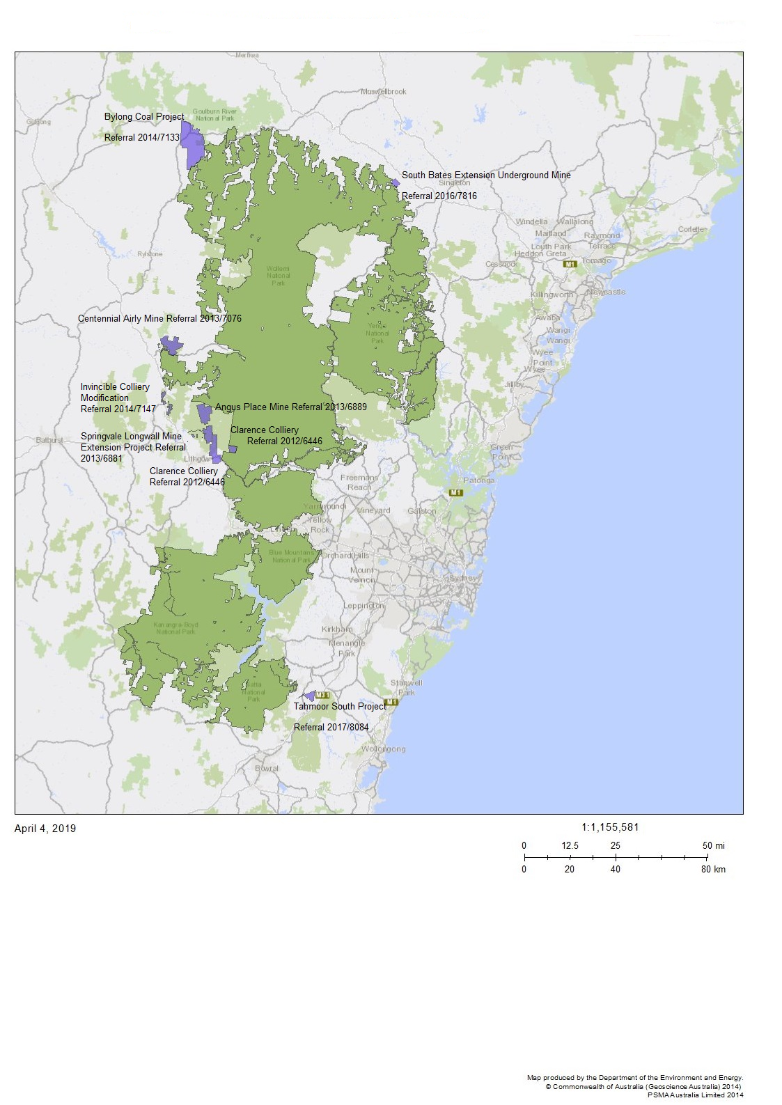

Map 2 Greater Blue Mountains Area – location of coal mining proposals outside of the World Heritage property discussed in section 1.7

1. https://www.environment.nsw.gov.au/topics/parks-reserves-and-protected-areas/types-of-protected-areas/world-heritage-listed-areas/greater-blue-mountains
2. <https://www.environment.nsw.gov.au/topics/parks-reserves-and-protected-areas/park-management/plans-of-management>
3. <https://www.environment.nsw.gov.au/research-and-publications/publications-search/greater-blue-mountains-world-heritage-area-strategic-plan>
4. https://www.environment.nsw.gov.au/-/media/OEH/Corporate-Site/Documents/Parks-reserves-and-protected-areas/Types-of-protected-areas/greater-blue-mountains-world-heritage-area-strategic-plan-addendum-2016-180173.pdf?la=en&hash=6202D26A57F04F976EBF38452467A868C562CAD2
5. *Resilient Valley Resilient Communities*: Hawkesbury-Nepean Valley Flood Risk Management Strategy, (INSW) May 2017. See: <http://www.infrastructure.nsw.gov.au/media/1534/insw_hnvfloodstrategy__1_v2.pdf>
6. Secretary’s Environmental Assessment Requirements, New South Wales Department of Planning and Environment, June 2017. See <https://majorprojects.planningportal.nsw.gov.au/prweb/PRRestService/mp/01/getContent?AttachRef=SSI-8441%2120190319T042108.138%20GMT>
7. <https://westernsydneyairport.gov.au/about/airport-plan/index.aspx>
8. <http://www.environment.gov.au/system/files/resources/245df899-5818-44c1-a1f0-76fb70bb9fc6/files/wollemia-nobilis.pdf>
9. <https://bmnature.info/fauna-gbmwha.shtml>
10. <https://www.publish.csiro.au/zo/Fulltext/ZO18021>