





FPA Australia

FPA Australia

Gaseous Fire Suppression Systems in Australia

Stage 1

|  |  |  |
| --- | --- | --- |
| **Prepared by:** | | |
| Fire Protection Association of Australia | | |
| **Status**: Final | **Version:** 5.0 | **Date:** 6 March 2018 |

Contents

Document Control 3

Glossary 4

Executive Summary 7

Introduction 8

The fire protection industry sector and gaseous fire suppression industry profile in Australia. 10

Sectors using special hazard fire protection 22

Banks and installed banks 35

Limitations and credibility 39

References 40

# Document Control

## REPORT VERSIONS

|  |  |  |  |  |
| --- | --- | --- | --- | --- |
| Version | Name | Role | Details | Date |
| V.01 | Rachael Curtin | Project Manager |  | 20/6/2017 |
| Final | Scott Williams | CEO |  | 12/7/2017 |
| Final | Scott Williams | CEO | Minor updates at the request of DoEE | 11/08/2017 |
| Final V4.0 | Scott Williams | CEO | Minor updates at the request of DoEE | 18/01/2018 |
| Final V5.0 | Scott Williams | CEO | Minor updates at the request of DoEE | 6/3/2018 |
|  |  |  |  |  |

## Related DOCUMENTS

|  |  |
| --- | --- |
| Document Name | Location |
|  |  |
|  |  |
|  |  |
|  |  |
|  |  |
|  |  |

## document APPROVAL

|  |  |  |  |
| --- | --- | --- | --- |
| Name | Role | Signature | Date |
| Scott Williams | CEO |  |  |
|  |  |  |  |
|  |  |  |  |
|  |  |  |  |
|  |  |  |  |
|  |  |  |  |

# Glossary

|  |  |
| --- | --- |
| Chlorofluorocarbons (CFCs) | Molecules containing carbon, fluorine, and chlorine. CFCs are the major ozone depleting substance phased out by the Montreal Protocol on Substances that Deplete the Ozone Layer. Many CFCs are potent greenhouse gases. |
| Extinguishant  Flooding agent  HFC227ea | Electrically non-conducting gaseous fire extinguishant that, upon evaporation, does not leave a residue.  A flooding agent is a product that floods the enclosure to extinguish a fire. FM200® and Halon 1301 are popular flooding agents.  Heptafluoropropane commonly known as FM200® or FE227. Used as a total flooding extinguishment agent and is a replacement for Halon 1301.  Can be used in chemical storage areas, clean rooms, communications, facilities, laboratories, museums, robotics and emergency power facilities. In occupied areas in military vehicles. |
| Gaseous Fire Suppression System | Gaseous Fire Suppression Systems also known as ‘clean agent’ systems use gases to extinguish fires in high value environments where other more common extinguishing agents would not be effective or cause damage. |
| Global Warming Potential (GWP)  Halons | A relative index that enables comparison of the climate effect of various greenhouse gases (and other climate changing agents). Carbon dioxide, the greenhouse gas that causes the greatest radiative forcing because of its abundance is used as the reference gas. GWP is also defined as an index based on the radiative forcing of a pulsed injection of a unit mass of a given well mixed greenhouse gas in the present-day atmosphere, integrated over a chosen time horizon, relative to the radiative forcing of carbon dioxide over the same time horizon. The GWPs represent the combined effect of the differing atmospheric lifetimes (i.e. how long these gases remain in the atmosphere) and their relative effectiveness in absorbing outgoing thermal infrared radiation. The Kyoto Protocol is based on GWPs from pulse emissions over a 100-year time frame.  Halons are fire fighting agents that were introduced into Australia in the early 1970s. They quickly replaced many previously accepted fire fighting products because of their superior fire fighting characteristics and ease of use.  Halons are fully halogenated chemicals that have relatively long lifetimes in the atmosphere. They are broken down in the stratosphere releasing reactive bromine that is extremely damaging to ozone. Reactions involving bromine are estimated to be responsible for 25 per cent of the chemical destruction of ozone over Antarctica and 50 per cent over the Arctic. The ozone depleting potential of halons is 10 times greater than that of chlorofluorocarbons (CFCs). As such, halons are a very aggressive ozone depleting chemical. One kilogram of Halon 1211 can destroy 50 tonnes of ozone. |
| Hydrofluorocarbons (HFCs)  HCFCs  Kyoto Protocol | Chemicals that contain hydrogen fluorine and carbon. They do not deplete the ozone layer and have been used as substitutes for CFCs and HCFCs. Many HFCs are potent greenhouse gases.  Hydrochlorofluorocarbons (HCFCs) are ozone depleting substances, whose structure is very close to that of Chlorofluorocarbons (CFCs), but including one or more hydrogen atoms. Under normal conditions, HCFCs are gases or liquids which evaporate easily.  Negotiated in December 1997 atKyoto, Japan, the Kyoto Protocol is a legally binding agreement under which industrialized countries will reduce their collective emissions of greenhouse gases. |
| Licences | Licences for import, manufacture and export of ODS and SGGs are detailed within the *Ozone Protection and Synthetic Greenhouse Gas Management Act 1989* and include a controlled substances licence, an essential uses licence, a used substances licence and an equipment licence. Extinguishing agent handling licences, extinguishing agent trading authorisations and halon special permits for the fire protection industry are managed through the Ozone Protection and Synthetic Greenhouse Gas Management Regulations 1995. |
| Montreal Protocol  NAF-P-III  NAF-S-III | The Montreal Protocol on Substances that Deplete the Ozone Layer sets binding progressive phase out obligations for developed and developing countries for all the major ozone depleting substances, including CFCs, halons and less damaging transitional chemicals such as HCFCs.  HCFC Blend C. Typically used as a streaming agent. It is a replacement for Halon 1211.  HCFC Blend A. Typically used as a total flooding agent. It is a replacement for Halon 1301. |
| Ozone depleting substances (ODS) | Chemicals that deplete the ozone layer (e.g. HCFCs, CFCs and halon). |
| Ozone depleting potential (ODP) | The ozone depletion potential of a chemical compound is the relative amount of degradation to the ozone layer it can cause with trichlorofluoromethane (R11) being fixed at an ODP of 1.0. |
| Special Hazard | Special Hazards are those hazards that pose special challenges to the design, operation and effectiveness of fire protection systems. These challenges include:   * Intensity or speed of fire. * Materials involved. * Configuration of equipment to be protected. * Vulnerability to damage by water or smoke. |
| Streaming agent | A streaming agent is usually found in a fire extinguisher where the product streams onto the fire. Halon 1211 was a streaming agent hence why it was found in fire extinguishers. |
| Synthetic greenhouse gases (SGGs) | SGGs listed under the Kyoto Protocol, include hydrofluorocarbons (HFCs), perfluorocarbons (PFCs) and sulfur hexafluoride and nitrogen trifluoride (SF6). |

# Executive Summary

This report has been requested by the Department of the Environment and Energy with the aim to produce a ‘brain dump’ type report that will inform future analysis work within the gaseous fire suppression industry in Australia. The development of this report relied on significant input from current serving members of the Fire Protection Industry (ODS & SGG) Board and researching publications and other sources of data. The key outcome is that there is still a lot that is not known within the industry, in particular the installed bank.

Since the early 1980’s it has been acknowledged that the ongoing depletion of the ozone layer and enhanced greenhouse effects causing global warming was unacceptable. Degradation of the ozone layer is known to be exacerbated by the emissions of some of the gaseous fire extinguishing agents used in fire systems and equipment.

The *Montreal Protocol on Substances that Deplete the Ozone Layer* (Montreal Protocol) signed in 1987, was established to protect the [ozone layer](https://en.wikipedia.org/wiki/Ozone_layer) by phasing out the production and import of substances that are responsible for [ozone depletion](https://en.wikipedia.org/wiki/Ozone_depletion) across the globe. This International treaty sets out a mandatory timetable for the phase out of ozone depleting substances.

The majority of gaseous fire suppression systems can be found in the commercial and industrial building, infrastructure and mining and institutional building market segments. The specialist nature of defence, aerospace and marine sectors establishes the need to incorporate gaseous systems to protect critical infrastructure.

The report identifies that the ease of accessing the installed bank data with a reasonable level of confidence is more difficult in primarily one sectors when compared to the others. The most difficult area is also the largest being the building sector. All other sectors have some form of registration system as it is largely equipment based that will enable a reasonable level of confidence in calculating an installed bank.

# Introduction

## OVERVIEW

### Working toward a better understanding of gaseous fire suppression systems in Australia.

Since the early 1980’s it has been acknowledged that the ongoing depletion of the ozone layer and enhanced greenhouse effects causing global warming was unacceptable. Degradation of the ozone layer is known to be exacerbated by the emissions of some of the gaseous fire extinguishing agents used in fire systems and equipment.

The *Montreal Protocol on Substances that Deplete the Ozone Layer* (Montreal Protocol) signed in 1987, was established to protect the [ozone layer](https://en.wikipedia.org/wiki/Ozone_layer) by phasing out the production and import of substances that are responsible for [ozone depletion](https://en.wikipedia.org/wiki/Ozone_depletion) across the globe. This International treaty sets out a mandatory timetable for the phase out of ozone depleting substances.

Some of the most effective fire extinguishing agents are referred to as either, Ozone-Depleting Substances (ODS) or Synthetic Greenhouse Gases (SGG) or both. Certain types of ODS and SGG extinguishing agents are used in what are known as special hazard systems. Special hazard systems include those using fire extinguishing agents such as foam, water mist, condensed aerosols, powder as well as gaseous extinguishing agents.

Special hazard systems are commonly found in building, aviation, defence, marine and mining industries. Their use also extends to other industries, such as information technology, telecommunications, motor racing and cultural facilities such as galleries and libraries. Gaseous systems are a sub-set of special hazard systems. Gaseous systems are used in a relatively small proportion of fire protection systems that operate in facilities where application of water, dry chemical agents, or other types of extinguishing agents are not suitable to protect life, property and the environment.

ODS and SGGs deployed in the fire protection industry, are regulated in Australia under the Ozone Protection and Synthetic Greenhouse Gas Management Act 1989 (the Act).

Halon fire suppressants (ODS’s) were the first group of gases to be phased out internationally under the Montreal Protocol. They ceased being imported at the end of 1992 with new halon no longer available in Australia.

While the implementation of the Act has been highly successful[1], the Australian Government is continuing to improve the efficiency and effectiveness of the Ozone Protection and Synthetic Greenhouse Gas Management. In 2016, countries that are party to the Montreal Protocol reached global (Kigali Amendment) agreement to further reduce emissions of SGGs. Hydrofluorocarbons (HFC) are one type of SGG used to replace ozone depleting substances that have been phased out under the Montreal Protocol[2]. While HFCs do not deplete the ozone layer, they are powerful greenhouse gases that survive in the atmosphere for many years.

Following a Review of the Ozone Protection and Synthetic Greenhouse Gas Management Program, on 30 March 2017 the Minister for the Environment and Energy, the Hon Josh Frydenberg MP, introduced the Ozone Protection and Synthetic Greenhouse Gas Management Legislation Amendment Bill 2017 into Parliament. On the 19 June 2017 this legislation passed through Parliament. The key measure included in the Amendment Bill is the introduction of a phase-down of HFC imports commencing in 2018 and includes a range of complementary compliance and enforcement powers.

In relation to the Fire Protection Services Industry this legislation will commence a phasedown of the most popular gas used within the industry. FM200® (a SGG) is widely utilised due to its physical properties and fire-fighting effectiveness compared to other non-scheduled gases. The fire protection services industry will need to transition over the coming decades to enable this phasedown to occur whilst still providing optimal essential safety measures.

While only employing a small fraction of all ODS and SGG extinguishing agents in the economy, gaseous fire suppression systems are critical services in the facilities that use them.

As there is a requirement to phase-down ODS and SGGs and to preserve life and property protected by gaseous fire suppression systems a more thorough understanding of this industry sector is necessary. This paper provides an overview of the gaseous special hazard fire protection industry sector in Australia to inform, at a later date, a detailed analysis into;

* The bank of special hazard fire protection gases
* Emission rates of special hazard fire protection gases
* Rate of purchase of new gaseous systems equipment
* Rate of replacement for special hazard scheduled gases and equipment
* Rate of retirement of gaseous systems

# The fire protection industry sector and gaseous fire suppression industry profile in Australia.

## The Australian Fire Protection Industry Sector

The special hazards industry sector is part of the fire protection services sector within Australia. The fire protection services industry provides a range of products to the market from sophisticated fire detection and suppression systems to simple smoke alarms and extinguishers. Industry revenue currently sits at around $2.4 billion dollars per annum with expected annualized growth of around 2.6% over the next 5 years[3]. This industry is a significant sector within our economy, providing vital safety services for Australian communities.

The industry’s performance is determined largely by building and infrastructure markets, however ongoing maintenance of existing equipment provides a stable revenue stream for industry participants. An estimated 41.8% of industry revenue comes from commercial and industrial building activities. Design and installation of fire detection and suppressions systems are required in large scale office, retail centres, transport terminals, industrial warehouses and hotels.

Increased exports for Australian mineral and energy commodities has increased demand for fire prevention and detection services over the past five years in the mining sector, however, completion of major mining developments and weaker global commodity prices has created a more recent slump. The mining sector is one of the largest sectors for use of gaseous fire suppression systems.

The IBISworld[4] report, outlines that purchases of fire protection and suppression systems such as fire alarm monitoring systems, smoke detectors, sprinkler systems, foams, dry chemicals and gases will equate to around 41.5% of industry revenue. Some of the industry’s major players are also involved in manufacturing systems and products, whilst most companies source them from local or international specialist manufacturers.

The majority of gaseous fire suppression systems can be found in the commercial and industrial building, infrastructure and mining and institutional building market segments. The specialist nature of Defence, Aerospace and Marine sectors establishes the need to incorporate gaseous systems to protect critical infrastructure.

Figure 1 proceeds an overview of the market segmentation of the fire protection services industry. The segmentation of the market is largely associated with the construction activity which would include buildings, ships, vehicles, etc.

**Figure 1: 2016 -2017 Fire Protection Services – major market segmentation[5]**

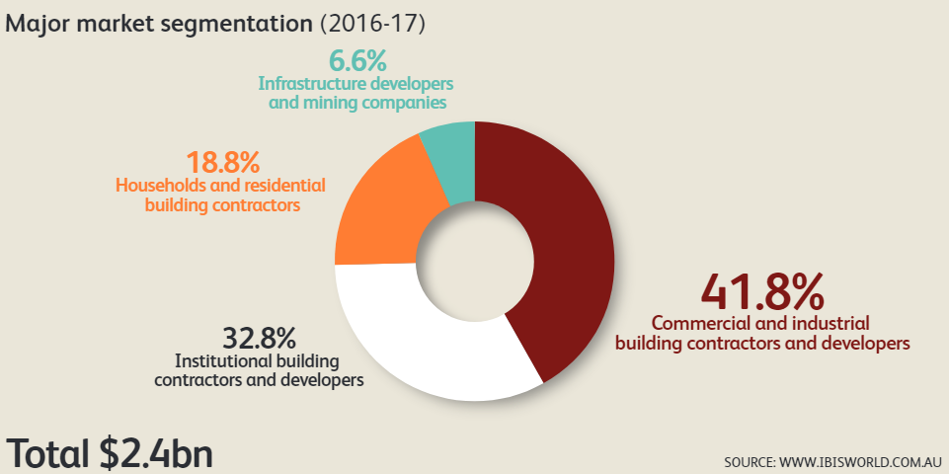

## Ozone depleting SUBSTANCES AND Synthetic Greenhouse Gases extinguishing agents

ODS and SGG are substances listed in Schedule 1 of the Act that can be used to prevent, control or extinguish a fire. Many substances listed in the Act are both ozone-depleting and synthetic greenhouse gases[6].

### Ozone depleting substances

Ozone depleting substances (ODS) are those substances which deplete the ozone layer and are widely used in refrigerators, air conditioners, fire extinguishers, as solvents for cleaning, electronic equipment and as agricultural fumigants. Ozone depleting substances controlled by the Montreal Protocol include:

* Chlorofluorocarbons (CFC’s)
* [Halon](http://www.environment.gov.au/atmosphere/ozone/ods/halon/index.html)
* Carbon tetrachloride (CCl4), Methyl chloroform (CH3CCl3)
* Hydrobromofluorocarbons (HBFC’s)
* Hydrochlorofluorocarbons (HCFC’s)
* [Methyl bromide (CH3Br)](http://www.environment.gov.au/atmosphere/ozone/ods/methylbromide/index.html)
* Bromochloromethane (CH2BrCl)

### Synthetic greenhouse gases (SGG)

Four groups of SGGs are regulated under the *Ozone Protection and Synthetic Greenhouse Gas Management Act 1989*, hydrofluorocarbons (HFC’s), perfluorocarbons (PFC’s), sulphur hexafluoride (SF6) and nitrogen trifluoride.

As well as being used in gaseous fire suppression systems, SGGs are used in a variety of day to day applications including as refrigerants in air conditioning systems and refrigerators and as propellants in aerosol products.

Most SGGs have very high global warming potential (GWP). Global warming potential is calculated using standard ratios to convert the various gases into equivalent amounts of CO2.

## Types of gaseous extinguishing agents

Many different types of extinguishing agents are used in gaseous fire suppression systems around Australia. Each agent has different chemical and physical properties making them more or less suitable for particular applications.

The types of gaseous extinguishing agents used in these systems are divided in to two classes, **synthetic gases** and **inert gases**. Each class of gases has different chemical and physical properties and extinguish fire in different ways. As a result, the design, installation and maintenance needs of gaseous fire suppression systems using extinguishing agents from either class are different[7]. Some synthetic gaseous fire extinguishing agents are ODS others are SGG, some are both ODS & SGG. One new synthetic agent, FK-1-12 (commonly known as Novec 1230) is neither ODS or SGG.

### Synthetic Gases

Synthetic gaseous fire extinguishing agents sometimes referred to as ‘active agents’ due the way they extinguish fires. They are also sometimes referred to as vaporising liquids or halo-carbon gases.

When these agents extinguish a fire they physically cool a fire and interfere with the chemical chain reaction of fire. The combination of physical cooling and chemical interference makes these chemicals very efficient extinguishing agents.

### Inert Gases

Inert gases are another name for the noble gases or rare gases, such as helium, neon, argon, krypton, xenon and radon. These gases are known to be chemically inert – meaning; they do not react chemically with other elements or compounds. The term inert gaseous fire extinguishing agents refers to pure naturally occurring gases found in the earth’s atmosphere (eg. argon, neon or helium) and also includes blends of inert gases with other gases, eg. a mixture of argon and nitrogen. These agents are stored as non-liquefied gases.

Inert gaseous extinguishing agents are sometimes referred to as ‘passive agents’ due to the way they extinguish fires. These agents do not interfere with the chemical chain reaction of a fire. When inert agents extinguish a fire they reduce the amount of oxygen available to keep a fire burning and physically cool a fire through the absorption of heat. Whilst strictly speaking CO2 is not an inert gas it has similar properties and uses in fire protection.

## WHAT IS A SCHEDULED EXTINGUISHING AGENT?

A Scheduled extinguishing agent is a substance referred to in Schedule 1 of the Ozone Protection and Synthetic Greenhouse Gas Management Act 1989, whether existing alone or in a mixture.

People that work with or handle scheduled extinguishing agents, in such a manner that may cause an emission, are required by the Ozone Protection Act to hold an Extinguishing Agent Handling Licence (EAHL)[8].

**Table 1: Most commonly used scheduled extinguishing agents in Australia and their uses[9]**

|  |  |  |
| --- | --- | --- |
| Product Name | Uses | Other name |
| FM200®  FE-227 | Functions as a total flooding agent.  Typical applications could include chemical storage areas, clean rooms, communications facilities, laboratories, museums, robotics and emergency power facilities. | Heptafluoropropane  HFC-227ea |
| Halon-1211 | Typically used as a streaming agent. Requires a halon special permit in Australia. Used in the aviation, shipping and defence sectors. | Bromochlorodifluoromethane  BCF |
| Halon-1301 | Typically used as a flooding agent.  Requires a special permit in Australia. Used in the aviation, shipping and defence sectors. | Bromotrifluoromethane |
| NAF-P-111 | Typically used as a streaming agent. It has been used as a replacement for Halon-1211 portable fire extinguishers and land based applications. | HCFC Blend C |
| NAF-S-111 | Typically used as a total flooding agent and was as a replacement for Halon 1301.  Used in shipping, electric switch rooms, data centers | HCFC Blend A   * HCFC-123 * HCFC-22 * HCFC- 124 |

**Table 2: Less common ODS and SGG extinguishing agents and their uses**

|  |  |  |
| --- | --- | --- |
| **ODS and SGG extinguishing agents which have been used in limited quantities for fire protection** | | |
| Trade name | Uses | Extinguishing agent name |
| CFC-11 | May be found as a propellant in some dry powder fire extinguishers. The import and manufacture of this product is banned in Australia. | Trichlorofluoromethane |
| FC-3-1-10 | Used in total flooding systems. | CEA-410 |
| FE-13FM | Used in total flooding systems. | Trifluoromethane  HFC-23 |
| FE-25 FM | Used in inerting and explosion suppression applications and to retrofit halon 1301 systems. | Pentafluoroethane  HFC- 125 |
| FE-36 FM | Used in portable fire extinguishers.  Used as a replacement for Halon 1211 and for Halon 1301 in local application systems. | Hexafluoropropane  HFC-236fa |
| FE-241 FM | Used both as a total flooding agent for non-occupied spaces and as a streaming agent. | Chlorotetrafluoroethane  HCFC-124 |
| Halon - 2402 | Limited use in military systems. Requires a halon special permit in Australia. | Dibromotetrafluoromethane |
| HCFC-22 | May be found as a propellant in some dry powder fire extinguishers. HCFC’s are being phased out in Australia. The number of these extinguishers in use in Australia is therefore reducing. They may be found in visiting foreign vessels. | Chlorodifluoromethane |
| Halotron®I | Typically used as a streaming agent. | Halotron II: is based on HCFC Blend B and HCFC-123 |
| Halotron®II | Used for total flooding as a replacement for halon -1301. | Halotron II: based on HFC-134a and HFC -125 |

Fire protection applications accounted for approximately 1.3% (54 tonnes) of all bulk ODS and SGGs imported into Australia in 2013, excluding halons.[10] The main scheduled extinguishing agent used in special hazard systems in Australia is FM200®/ FE-227TM. This is followed by some minimal use of NAF-S-III, NAF-P-III, halon 1301 and halon 1211. FE-36 can occasionally be found in specialist streaming applications such as portable fire extinguishers for oil platforms, etc.

**Table 3: Relative Impact of Some Common Scheduled Extinguishing Agents Compared to CO2[11]**

|  |  |  |  |
| --- | --- | --- | --- |
|  | Chemical name | Ozone depleting potential | Global warming potential |
| Carbon Dioxide | CO2 | 0 | 1 |
| CFC 11 | CFCI3 | 1 | 1680 |
| Carbon Tetrachloride | CCI4 | 1.2 | 1380 |
| Halon 1301 | BF3Br | 10 | 6200 |
| FM200®  HFC227ea | C3HF7 | 0 | 2900 |

Table 3 illustrates why halons have been banned in Australia, due to their high ozone depleting potential and GWP. However, it also shows that replacements such as FM200® still have a significant impact on the environment.

## BACKGROUND OF SCHEDULED EXTINGUISHING AGENTS

### What are Halons?

Halons are firefighting agents that were introduced into Australia in the early 1970s[12]. They quickly replaced many previously accepted firefighting products because of their superior firefighting characteristics and physical properties.

Halons are fully halogenated chemicals that have relatively long lifetimes in the atmosphere. They are broken down in the stratosphere releasing reactive bromine that is extremely damaging to ozone. Reactions involving bromine are estimated to be responsible for 25 per cent of the chemical destruction of ozone over Antarctica and 50 per cent over the Arctic. The ozone depleting potential of halons is up to 10 times greater than that of chlorofluorocarbons (CFC’s). As such, halons are a very aggressive ozone depleting chemical. One kilogram of halon 1211 can destroy 50 tonnes of ozone[13].

### History of Halons and SGGs in gaseous fire suppression systems

In Australia, from the early 70’s through to the mid-1980s, halons were the primary fire suppressant employed in gaseous special hazard systems. The exact amount of halon that was imported, installed and used in that period of time is not entirely clear[14]. In 1993, legislation was introduced to ban its importation and manufacture, except for licence holders. The use of halon was restricted under state and territory legislation. Worldwide production of halon 1211 and halon 1301 ceased in 1994 in developed countries and from 2010 in developing countries. Technologies then progressed to see the introduction of alternative substances including FM200®.

### FM200®

Whilst there are other SGGs in the marketplace none have had the uptake like FM200®. It is estimated that FM200® has achieved approximately 80% of the worldwide market for the replacement of halon in fire fighting systems[15]. It was developed as a non ozone depleting replacement for halon 1301.

FM200® easily protects most hazards that were traditionally protected by halon 1301. Its popularity for use in special hazard systems has been driven because of its firefighting effectiveness and relatively low space and weight characteristics. Like Halon 1301, FM200® is safe for use where people work.

FM200® systems are designed to offer extremely fast and effective fire suppression. It is non-conductive and as such is safe for use on energised electrical equipment. It is also a clean agent leaving no residue nor damage to equipment. FM200® achieves extinguishment by physical cooling of the fire (80%) and by interrupting the chemical chain reaction of fire (20%).

FM200® is stored in cylinders of similar design to those for Halon 1301, discharge pipe work requirements are the same as those for Halon 1301.

Because FM200® is not quite as efficient as Halon 1301 it does require more agent to achieve extinguishment. Approximately 1.6 times more FM200®, by volume, is required, however this can normally be accommodated in a slightly larger cylinder/cylinder bank.

### Halon and SGG use today

Today, legislation permits only licence holders in Australia to use scheduled gases which includes halons and other gases including FM200. Licence holders come from predominantly the aviation, building, marine, mining and defence sectors. Stocks of recovered, recycled and reclaimed halon are used to meet these uses, where no practical alternative currently exists.

In addition to the halon installed in fire protection equipment, including spare containers, stocks are maintained in a number of locations. A halon inventory carried out in 1998 identified the following government and commercial sectors holding stocks of halon:

• The National Halon Bank (NHB)

• Fire protection industry

• Aviation industry

• Department of Defence

• Shipping Industry.[16]

This is consistent today.

See the section on Banks for more information.

### Halon and SGG alternatives

A wide variety of alternatives are now available for the majority of traditional halon uses, although individually, none of the current alternatives covers the broad spectrum of applications that halon did. Halon and SGG alternatives include halocarbon gases such as Novec1230, inert gases, water mist, condensed aerosol and oxygen reduction fire prevention systems. There is increasing industry awareness that a more sophisticated approach to fire protection engineering techniques for the given situation is required to provide the most effective fire protection and environmental balance[17].

## What are Special Hazards?

Fire Protection Association Australia (Technical Advisory Committee) defines special hazards as those hazards that pose special challenges to the design, operation and effectiveness of fire protection systems. These challenges include:

* + Intensity or speed of fire.
  + Materials involved.
  + Configuration of equipment to be protected.
  + Vulnerability to damage by water or smoke[18].

## WHAT ARE SPECIAL HAZARD SYSTEMS?

Special hazard systems are designed to function quickly to detect and suppress fire and heat where there is typically a need to protect high value assets, guarantee business continuity and safeguard people and processes. These types of systems can commonly be found in computer rooms, data centers, process control centers and other rooms housing critical infrastructure. They are also used in aircraft and defence applications.

Special Hazards systems can utilise any of the following:

• Gaseous;

• Foam;

• Water mist;

• Aerosol;

• Powder; and

• Wet chemical extinguishing agents.

This report is focused on the gaseous suppression system component of special hazards.

## GASEOUS FIRE SUPPRESSION SYSTEMS

Gaseous fire suppression systems can use ODS’s and SGGs extinguishing agents to suppress fires. These systems are sometimes referred to as ‘clean agent systems’, and are used where there is a need to protect valuable property, goods or equipment, to guarantee that organisations can continue normal operations and keep people safe. They protect valuable business information and knowledge through the provision of fire protection to work areas and environments where water fire suppression is not desirable.

Put simply, gaseous fire suppression systems are used in situations where the impact of a loss is critical and the replacement costs are high.

Gaseous fire suppression systems can be used on many different classes of fires, but typically are designed to suppress fires involving ordinary combustible materials, such as:

* Ordinary combustible solids, such as, wood, paper, cloth, plastics, rubber, coal, and carbon-based compounds (Class A).
* Flammable and combustible liquids and greases, such as, petrol, oil, paint, thinners, kerosene, and alcohol (Class B).
* Flammable gases, such as, LPG, butane, acetylene, hydrogen, natural gas and methane (Class C).
* Electrical fires, such as, computers, switchboards and power-boards (Class E).

Situations where gaseous fire suppression systems are used include:

* Computer rooms, and information technology facilities, eg data processing areas, data storage centres and control rooms.
* Electrical hazards including transformer rooms, switch rooms, substations and control rooms, circuit-breakers and rotating equipment. For example: control rooms for printing a daily newspaper or production line using expensive or hard to replace equipment.
* Rooms, vaults, engine rooms, containers, storage tanks and bins.
* Engines and turbines using flammable fuels, eg back up electricity generating plants or gas turbines.
* Flammable liquid storage areas, laboratories, coal silos, battery storage rooms, waste disposal equipment and dust collectors.
* Manufacturing plants, eg food processing, drying towers, spray booths, printing presses, and semiconductor wet bench dip tanks.
* Aviation industry, eg jet engines, cargo holds and air traffic control towers.
* Military vehicles occupied areas and engines
* Marine industry. For example:
  + engine rooms and machinery spaces,
  + emergency generator rooms
  + pump rooms,
  + flammable liquid stores and handling areas
  + paint lockers (paint storage facilities).
* Critical infrastructure, eg telecommunications and satellite navigation systems, telecommunications facilities, telephone equipment rooms, energy creation and distribution.
* Medical imaging, eg CAT or CT scanning equipment (computed axial tomography).
* Archive storage, eg museum and public libraries storing priceless objects, art and documents.

## LIMITATIONS OF GASEOUS FIRE SUPPRESSION SYSTEMS

Gaseous fire suppression systems are not used to protect:

* Chemicals that contain their own supply of oxygen. For example, cellulose nitrate which is used in gunpowder, nail polish and lacquer finishes.
* Mixtures containing oxidising chemicals. For example, sodium nitrate which is used in fertilisers and explosives.
* Chemicals capable of undergoing auto-thermal decomposition, where a chemical begins to decompose if it reaches a specific temperature.
* Reactive metals, eg the elements sodium, potassium or magnesium.
* Areas where large surfaces are heated (not by a fire) to temperature that breaks down the chemical structure of the extinguishing agent. The agent is then unable to extinguish a fire[19].

## TYPES OF GASEOUS FIRE SUPPRESSION Equipment

Gaseous fire suppression equipment can come in two forms, portable or fixed installation.

### Extinguishers

Gaseous fire extinguishers are available in the marketplace for a variety of uses. Halon extinguishers are still used in air, land and sea applications. Halon alternative, NAF PIII is the most commonly used in other applications. Extinguishing agents used in extinguishing vessels are often referred to as streaming agents.

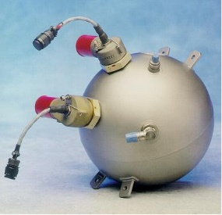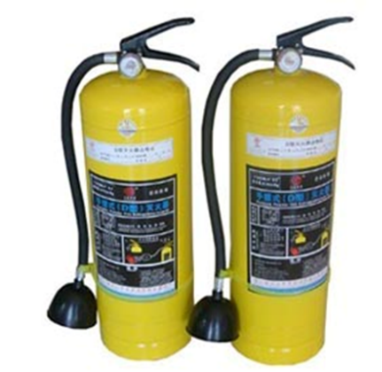

Image 1: Vapourising liquid fire extinguisher Image 2: Aviation Fire Extinguisher Cargo Bay

## Installed gaseous fire suppression systems

Gaseous Fire Suppression Systems use different types of gaseous extinguishing agent to suppress fires through the release of gaseous extinguishing agent into the high-risk areas using purposefully placed discharge nozzles. These systems operate automatically using fire detection devices often connected via a fire indicator panel (FIP).

Installed gaseous fire suppression systems are divided into two types; **total flood systems** and **local application systems.**

### Total Flood Application Systems

Total flood systems are the most common type of gaseous fire suppression system. These systems are used to protect against fire hazards located within an enclosed space. Enclosed spaces must be reasonably gas-tight to allow the design concentration of extinguishing agent to form inside the protected space. The gas concentration needs to be maintained for a set period of time (called the hold or retention time) to make sure the fire does not re-ignite.

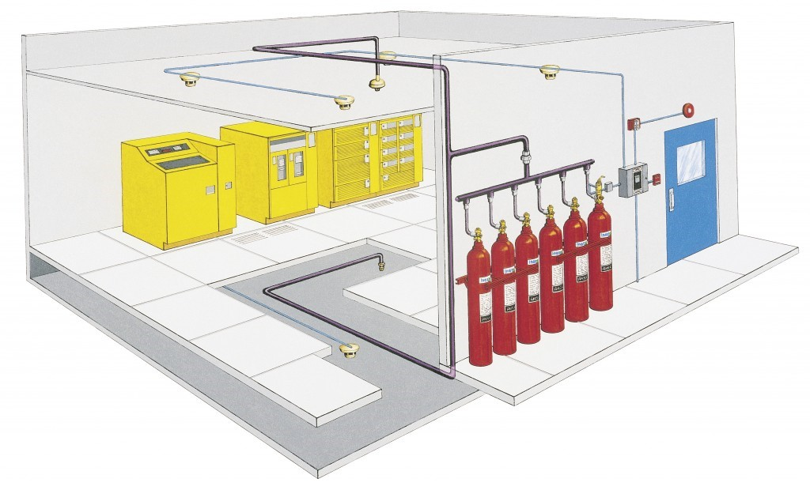

Figure 2: An example of a total flood system[20]

The amount of extinguishing agent held in each system is calculated depending on a range of different factors and each system is designed specifically for each enclosure. Within the ‘relevant sectors using special hazard fire protection’ section of this report, an estimation is provided of the approximate quantity of gas stored in each of the sectors.

When an enclosure system is designed, the key considerations to determine the quantity of gas required includes:

* + The volume of the enclosure
  + The fuel
  + The integrity of the enclosure
  + The altitude of the enclosure
  + The temperature

The amount of extinguishing agent needed by a system is established by calculating the amount of agent required for the minimum expected temperature in the protected space. This can be done using flooding factor tables or equations available from the system manufacturer or specified in AS 4214, *Gaseous fire extinguishing systems (or its replacement: AS 14520, Gaseous fire-extinguishing systems* - *Physical properties and system design*) or international standards, eg NFPA or approvals granted by a Classification Society for marine vessels.

### Life cycle of an installed system

The typical life cycle of a commercial/industrial installed system is around 10 - 20 years. For military and aviation applications the life may be that of the platform it is installed on. Pressure testing of cylinders in an installed system is required every 10 years. The first test phase is a simple process and is not expensive. The 10 year cylinder pressure testing phase requires the system to be decommissioned, cylinders are removed from the site, and agent is removed from the cylinder. The cylinder is pressure tested to ensure it is free from leakage or weaknesses. The system is then recommissioned. As this is a very expensive process this will often instigate a change of system as it is sometimes more economical to replace an old system rather than complete this testing. Each time a new system is installed there is an opportunity to change the extinguishing agent if another effective alternative is available, thus assisting with phase down and phase out of ODS and SGG substances. Any maintenance performed must be in accordance with the manufacturer’s specifications having regard to the applicable Australian Standard for the life cycle of the product. There is a preference to use recovered agent from decommissioned systems that has been returned to specification. [21].

### Local application systems

A local application system is designed to protect a specific piece of equipment, in isolated, unenclosed hazards by applying gaseous extinguishing agent directly onto the fire using strategically positioned nozzles.

# Sectors using special hazard fire protection

There are a number of sectors that use gaseous fire suppression systems. The five major sectors are building, marine, mining, aviation and defence. Oil and gas, transport and motor racing sectors make up a smaller proportion of use[22].

## Overview of the AVIATION sector

Aviation is split into three groups in Australia being private, commercial and military. Within the private sector there are single engine aircraft that may be fitted with a Halon 1211 fire extinguisher. In twin engine aircraft they may have a Halon 1301 system connected to the engines along with a Halon 1211 fire extinguisher. This would be consistent in military aircraft as well. In commercial aircraft there has been some slight changes with the small bottles fitted in the lavatories now using FM200®. These lavatory protection bottles would store approximately 150 grams of FM200® per bottle.

Halon 1211 (also known as BCF) is a streaming agent and predominantly found in portable fire extinguishers in aircraft generally located throughout the cabin, flight deck, crew rest compartment and accessible cargo compartments[23]. Halon 1301 is a flooding agent that is used in the engine, Auxiliary Power Unit (APU), lavatory and cargo bay environments in aircraft.

The Ozone Protection and Synthetic Greenhouse Gas Management Regulations 1995 provides for a holder of a halon special permit to possess halon. As the aviation industry has deemed it difficult to move away from ODSs, the industry is still largely reliant on halons as the main extinguishing agent within aircraft. Analysis has identified that none of the currently available non halon fire-extinguishing and suppression agents could meet the stringent performance requirements to ensure safety of flight[24].

Alternative fire-extinguishing and suppression agents and extinguishing hardware must also be reliable and effective. They must show resilience to extreme temperatures, at various altitudes, in extreme vibration, be compatible with a wide range of materials and equipment (including electronics, fluids, composites, and metals), have toxicity equivalent to or less than halon, and be environmentally preferable.

Extinguishers using other agents are nearly 50 percent larger and two and a half times heavier than Halon extinguishers.

**Figure 2: Comparison of handheld fire extinguisher size and weight[25]**

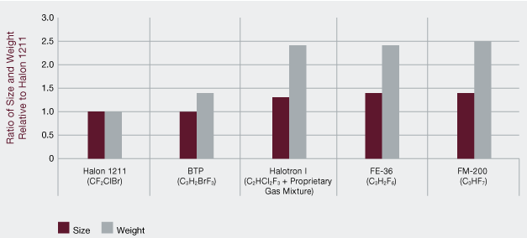

Companies such as Boeing[26] and Kidde have trialed a number of alternatives to halon in both commercial and military aircraft applications. For example; dry chemical powder (DCP) has been tried without success in aircraft but has been installed in military vehicles (Australian M1 tanks have DCP fitted to their engine bays). Boeing has trialed 2-bromotrifluoropropene. Alternative agent approval is proving difficult in the commercial sector, and as such new aircraft such as the Boeing 787 and Airbus A350’s are still fitted with halon, as well as minor quantities of FM200® in the lavatories. The lifespan of these aircraft are 30+ years, therefore it is expected that halon will be in commercial aircraft for a considerable amount of time.

In military applications, Original Equipment Manufacturers (OEM’s) have managed to use alternative agents to halon. An example of this is the Super Hornet aircraft fitted with HFC-125 (FM 25) and the new Australian JSF is fitted with an Engine FX and it’s filled with FE-36.

Europe has a target date in the 2020s to have halon removed from all aircraft however, new aircraft entering service now, B787 & A350 have halon as the extinguishing agent. The subject matter experts advised that it is unlikely that halon will be replaced in aircraft unless a new agent with the same extinguishing capabilities at a 1 to 1 ratio is developed as an alternative[27].

The installed aviation bank is seen to be relatively easy to estimate.

The total bank can be calculated by;

|  |
| --- |
| *Listing the total gases in each type of air craft and ADD Spares MULTIPLY by each type of aircraft in the fleeT* |

An example from the Commercial fleet is the new *Boeing 787-9 aircraft* that contains:

2 engine fire extinguishers

1 APU

7 cargo bay extinguishers

6 portable fire extinguisher

6 lavatory extinguishers

300 kgs of halon

An example from the Military fleet is the *Super Hornet* that contains:

1 engine extinguisher and

4kgs FE25

## Aviation Sector snap shot[28]

|  |  |
| --- | --- |
| Aviation | |
| Gases used | Halon 1211, Halon 1301 and FM200® in small quantities. No alternative agent has been able to offer the same weight/performance and halon is likely to continue to be used for many decades to come. |
| Application | Multi engined jets such as the Boeing 737, Airbus A380  Military aircraft ie. super hornet  Small private aircraft including single and twin engines |
| Where used | Cargo bay  Engine  APU  Lavatory – Note that Potty bottles are now fitted with FM200®.  Cabin (portable extinguishers) |
| System types  What is a typical system? | Cargo bay, APU and engine fixed extinguisher systems and portable  extinguishers |
| How much gas is typically in a system? | Commercial: eg 787-9 has approximately 300kgs halon  Military: eg: super hornet has approximately 4kgs FE25 |
| What is the typical life cycle? | 20 years or the life of the platform. |
| Approximate installed bank | Methodology installed bank  Typical system volume + spares x how many aircraft |
| Bulk storage banks | National Halon Bank (NHB)  Major fire protection service providers |
| Typical supply chain | Commercial service activities: NHB – service provider – to end user  Military service activity: – NHB – service provider – end user or  ADF stock – service provider ­end user  New equipment: OEM – service provider - end user |
| Industry trends | It is expected that the use of halon on aircraft will be in place for some time. |
| Alternatives | Limited and mainly for military operations |

## Overview of the Building Sector

The building sector in terms of gaseous fire suppression systems includes commercial and industrial buildings. FM200® is the predominant SGG used in the building sector. Some of the considerations in selecting the most suitable gas for a particular application include, the environmental properties, whether it is a scheduled extinguishing agent, if it is safe for humans, speed of extinguishment, size of storage area and location of required for cylinders, retention time and initial system, refill & ongoing service costs. Until around 2010 FM200® had around 50% market share and has since been declining due to increased use of inert gases and alternative agents.

A typical building application using FM200® would be between 100-150kgs of agent for a single electrical switch room or server room. Some systems can range to 3 tonne. Anecdotal evidence is being provided that due to the need to establish significantly sized data centres, the size of systems is increasing. This may have a positive effect as small to medium sized organisations are choosing to outsource their data storage requirements thereby reducing the number of smaller sized gaseous fire suppression systems and having a smaller number of larger centres.

Halon should no longer be used in building/commercial applications and the subject matter experts are not aware of any systems in Australia where this would be the situation.

Calculating the installed building bank is the most difficult as gaseous suppression systems in buildings are managed by so many different companies.

The total bank could be calculated in two ways;

|  |
| --- |
| *There are 2 methodologies for calculating the installed bank;*   1. *Import data from 1994 MINUS emissions MINUS destroyed product* 2. *Survey service providers and end users MINUS total gas serviced* |

As the building sector installed bank is the most difficult to calculate, taking the total import figures from 1994 onward and subtracting the combined totals from the aviation, mining, defence and marine sectors minus discharges and destruction we can achieve the total installed bank in the building sector.

It could be argued that the second methodology would be the most accurate however it would also be the most time consuming. However, consideration could be provided to breaking the building sector into like industries and focusing on those areas. Industries could include telecommunications, internet providers and others where it is known that large gaseous suppression systems are installed.

## BUILDING Sector snap shot[29]

|  |  |
| --- | --- |
| Building | |
| Gases used | Halocarbons (eg- FM200®; HFC-227ea),  Inert gases (eg- nitrogen, argon and nitrogen mixtures, argon, nitrogen and carbon dioxide mixtures) and  Perfluoroketones (eg NOVEC 1230; fk 5-1-12). |
| Application | They are used where there is a need to:  Protect High Value Assets  Guarantee Business Continuity  Safeguard People and Processes |
| Where used | Computer Rooms  Information Technology facilities  Electrical Switch Rooms  Control Rooms |
| System types | Cylinders connected to discharge pipework and nozzles  Detection and control system typically initiates automatic discharge |
| How much gas is typically in a system? | There is no typical system as it is dependent on the size of the room, leakage of the room and what is being protected. |
| What is the typical life cycle? | 20 years |
| Approximate installed bank | Large installed base of FM200® and Inert gas systems and some NOVEC 1230  There are 2 methodologies for calculating the installed bank;   1. Import data from 1994 – emissions – destroyed product 2. Survey service providers and end users – total gas serviced |
| Bulk banks | Major service providers, agent manufacturer, equipment OEM’s |
| Typical supply chain | New system: Agent/system importer -> installation contractor -> end user or  Agent system importer – distributor – installation contractor – builder – end user  Servicing systems: end user - service provider – recycle/destruction facility |
| Industry trends | Some movement to increased use of inert gas agents, Novec1230, water mist , condensed aerosol suppression systems and |
| Alternatives | Oxygen reduction fire prevention systems, hybrid system gas/water, gas/dry chemical , water mist/condensed aerosols |

## Overview of DEFENCE industry[30]

Defence is very similar to the aviation sector with the predominant use of halon, although land and maritime systems use SGGs in addition to halon. Whereas halon is used on all the Australian Defence Force’s aircraft platforms, in the Army there is a mix of halon and FM200® over the Army’s fleet of armoured vehicles. New vehicles in the Army service in the coming years will have FM200BC (gaseous and dry chemical powder) and FE36. With the phase out of the (Australian Light Armoured Vehicles) ASLAV’s, the only vehicle using halon in the Army will be the Abrams M1 MBT, with halon in the Crew Bay FX’s.

The Navy utilises halon, FM200® and CO2 in its ships and submarines. Where possible, alternatives to Halon are being installed across its fleet. Over the last 15 years many ships have changed from halon to alternatives such as FM200®. A large proportion of these ships have been decommissioned. Migration has been progressive in this area. NAF was replaced on ANZAC frigates with FM200®. Some of the fleet was converted from halon to NAF S111. The Australian Navy approved the use of FM200® and almost 4,000 kg was used for the halon replacement on Australian Navy Ship HMAS SUCCESS.

The installed bank in the Defence sector is also relatively easy to calculate compared to the building sector as the fleet and their gaseous systems are known.

|  |
| --- |
| *measure the gasesous system volumes on each platform and mulitipy the platforms* |

An example from the Military fleet is the *Super Hornet* that contains:

1 engine extinguisher and

4kgs FE25

Example of military land vehicles are the;

*Australian Light Armored Vehicle (ASLAV)* - 257 vehicles X 15 kgs fire extinguisher = 4 tonnes of halon

*M1 Abrams tanks* - 59 vehicles X 17kg fire extinguisher = 1 tonne of halon

*Bushmaster Protected Mobility Vehicle* - FM200® installed = 4.3 tonnes

## DEFENCE Sector snap shot[31]

|  |  |
| --- | --- |
| Defence | |
| Gases used | Halon , FM200®, NAF |
| Application | Armoured defence vehicles, aircraft, naval ships |
| Where used | Vehicle cabins and engines, aircraft engine, ship engine and machinery rooms |
| System types  How much gas is typically in a system?  What is the typical life cycle? | Portables, fixed systems  Depending on the size of the vessel  Methodology  Platform x systems on platforms |
| Approximate installed bank | Eg. Australian Light Armoured Vehicle (ASLAV) 4 tonnes of halon (257 vehicles  M1 Abrams tanks 1000kgs of halon (59 vehicles)  Bushmaster 4.3 tonnes FM200® installed |
| Other banks | NHB and service providers |
| Typical supply chain | Military service activity: – NHB – service provider – end user or  ADF stock – service provider end user  New equipment: OEM – service provider - end user |
| Industry trends | Vehicles applications are moving away from halons and using FM200® and FE36  Aircraft:  Endeavouring to move away from halon but in very limited applications agents utilised FE25 FE36 |
| Alternatives | Water mist  Condensed aerosols  FE36 |

## OVerview of the maritime sector

## The fire industry's primary concern is to safeguard life, assets and the environment. Safety at sea relies heavily on correct fire protection procedures. This applies to cruise ships, merchant ships and naval vessels and is vitally important for the fishing and pleasure craft fleet.

## Australian Maritime Safety Authority (AMSA) is Australia’s national agency responsible for maritime safety, protection of the marine environment and maritime aviation search and rescue. A statutory authority established under the Australian Maritime Safety Authority Act 1990 (the AMSA Act) AMSA is in control of the safety of domestic commercial vessels and the seafarers who are operating in the domestic commercial industry. AMSA regulates commercial vessel safety around Australia, while state and territory agencies administer safety requirements for private vessels. While AMSA is the single national regulator for commercial vessel safety, the Department of the Environment and Energy regulates the use of scheduled extinguishing agents on these vessels[32].

Halon 1211 and Halon 1301 was primarily used in the marine industry, however, after it was banned from being imported into Australia, FM200®, NAF SIII, condensed aerosols and water mist systems have all been used to replace halon on new vessels. Older marine vessels are allowed to continue using halon in fire protection systems as the costs and practicalities of installing halon alternatives are prohibitive.

Guidelines on Supply of halon to ships in Australian Ports provides practical and realistic advice to minimise the use of halons on ships while recognising their need for essential applications. Non-essential halon systems are to be decommissioned/replaced at or before the next major five-yearly survey (dry docking) of the vessel[33].

In local commercial vessels FM200® would have the biggest market share however condensed aerosols are gaining popularity due to their lower cost and maintenance requirements.

## Foreign flagged vessels – Ocean going vessels, IMO

Foreign flagged vessels must have fire systems in accordance with International Maritime Organisation (IMO) requirements. Halon systems are still permitted and halon can be purchased from the National Halon Bank or companies which hold a Halon Special Permit (HSP) and an Extinguishing Agent Trading Authorisation (EATA). Halon phase out occurred in the late 90’s where halon was exchanged for NAF SII, since NAF SII is being phased out, FM200® is the predominant gas. New vessel builds by Austral in Western Australia and Incat in Tasmania are seeing water mist systems installed.

Access to supplies of halon is limited and minimum quantities will only be provided for recharging gaseous fire suppression systems to ensure safe operation.

## Local commercial vessels

The most commonly used scheduled extinguishing agents are FM-200®, FE-227™ and NAF S-III however NAF S III has not been commonly used for many years. Scheduled extinguishing agents, FM-200®, FE-227™ and NAF S-III, must be obtained from companies holding an EATA. Anecdotal evidence indicates that there are local commercial vessels that are still fitted with halon.

The installed bank for the marine sector can be calculated by acquiring vessel statistics from AMSA and the State Marine Authority. Some assumptions may need to be made as to which vessels contain which agent.

|  |
| --- |
| *measure the gasesous system volumes on each platform and mulitipLy by the number of platforms* |

## MARINE Sector snap shot[34]

|  |  |
| --- | --- |
| Marine[35] | |
| Gases used | Local commercial fleet uses predominantly FM200®, FE-227, NAFS-III. In the late 1990’s halon systems were decommissioned and a 50/50 split of FM200® and NAF SIII. Since this time, the use of alternative technologies such as condensed aerosols and water mist systems has been increased. |
| Application | commercial vessels  passenger ferries  fishing vessels  police vessels  barges  car ferries  tugs  major shipping generally |
| Where used | internal combustiongas turbinesmain or auxiliary propulsionmachinery spacespaint and oil lockerspump and engines roomscontrol rooms |
| System types | Total flood |
| How much gas is typically in a system? | The gas in a typical system depends on the size of the vessel and what it is protecting. It is very difficult to estimate a ‘typical’ system.  A local commercial vessel, for example a fishing boat may have 30kg of FM200® in the engine room |
| What is the typical life cycle? | 20 years |
| Approximate installed bank | Platforms x systems on platforms |
| Typical supply chain | Agent/system importer -> installation contractor -> end user |
| Alternatives | Water Mist, Novec1230, C02 and condensed aerosols |
| Trends | FM200® is decreasing. Trend is toward water mist and smaller local commercial vessels are moving towards condensed aerosols. |

## Overview of the mining sector

Mining applications use scheduled extinguishing agents FM200® and inert gases for site operations and special hazard systems installed in both fixed and mobile equipment. Special hazard systems are common in mobile plants such as large excavators, shovels, draglines, haul trucks and wheeled loaders.

The mining industry sector relies heavily on FM200® with minimal use of other scheduled extinguishing agents. This is because of FM200® and NAF-SIII’s ability to act as leading alternatives to halons, with the added benefit that FM200® leaves no significant post discharge clean-up, obscuration on discharge or damage to sensitive equipment[36].

Due to the nature of mining sites being so isolated there a more filing stations closer to mining sites that allow better turn around to refilling, thus creating large bulk banks.

Calculating the installed mining bank is as difficult as gaseous suppression systems in buildings are managed by so many different companies and have so many different applications.

The total bank can be calculated in two ways;

|  |
| --- |
| *There are 2 methodologies for calculating the installed bank;*  *1) Import data from 1994 MINUS emissions MINUS destroyed product*  *2) Survey service providers and end users MINUS total gas serviced* |

## MINING Sector snap shot[37]

|  |  |
| --- | --- |
| Mining | |
| Gases used | Uses predominantly FM200®, inert gases and to a lesser extent CO2.  Some (increasing) use of alternative technologies such as condensed aerosols and water mist systems. |
| Application | Switch rooms, control rooms, machinery rooms, mobile plant |
| Where used | Protection of control rooms and switch rooms |
| System types | Engineered systems very small 10kgs to thousands of kilograms |
| How much gas is typically in a system? | A typical system is not possible to describe as it depends upon the size of the room, nature of the matter protected and leakage in the room. |
| What is the typical life cycle? | 10 years with the opportunity to extend |
| Approximate installed bank | Large installed bank of FM200®. Many sites likely to continue using FM200® due to size of existing installed bank however there is also a large installed bank of Inert Gas systems.  There are 2 methodologies for calculating the installed bank;   1. Import data from 1994 – emissions – destroyed product 2. Survey service providers and end users – total gas serviced |
| Other banks | Local filling banks run by service providers |
| Typical supply chain | Agent/system importer -> installation contractor -> end user |
| Industry trends | Increasing use of inert gases |
| Alternatives | Condensed Aerosol and water mist systems are used in some niche applications |

# Banks and installed banks

## What are BULk and Installed BankS?

A **bulk bank** is the quantity of stored gaseous agent that is yet to be used in a gaseous suppression system. Bulk banks exist at filling stations/service providers, as spares that are not connected to a system and within the National Halon Bank. The total quantity of product stored is equal to the amount of imported gases bought into Australia since 1994, minus the emissions and destroyed product and minus the installed bank.

An **installed bank** is the amount of gaseous agent stored in a system, whether it be a fixed system or an extinguisher. Installed banks of gaseous agents are found across all of the sectors previously discussed.

## the difference between bulk and installed banks

The difference between and installed bank and a bulk bank is whether the gaseous agent is within a system ready for discharge.

## What is the role of the National Halon Bank?

In 1993, the Australian Government established the National Halon Bank to safely store decommissioned halon for destruction or reclamation to meet the ongoing needs of those industries that were not able to transition to another product.

## Measuring the size of the bulk and installed banks

The subject matter experts believe the ability to measure the size of the bulk and installed banks is a difficult task. This is largely due to there being no controls in place to gather data on the number and size of gaseous fire suppression systems installed. As part of this project the Department provided import data for the last five years. This data only showed the importation of two types of gaseous agents used for fire suppression being HFC–227ea and HFC–236fa. Table 4 is a representation of this data for the fire related imported gases over the past five years.

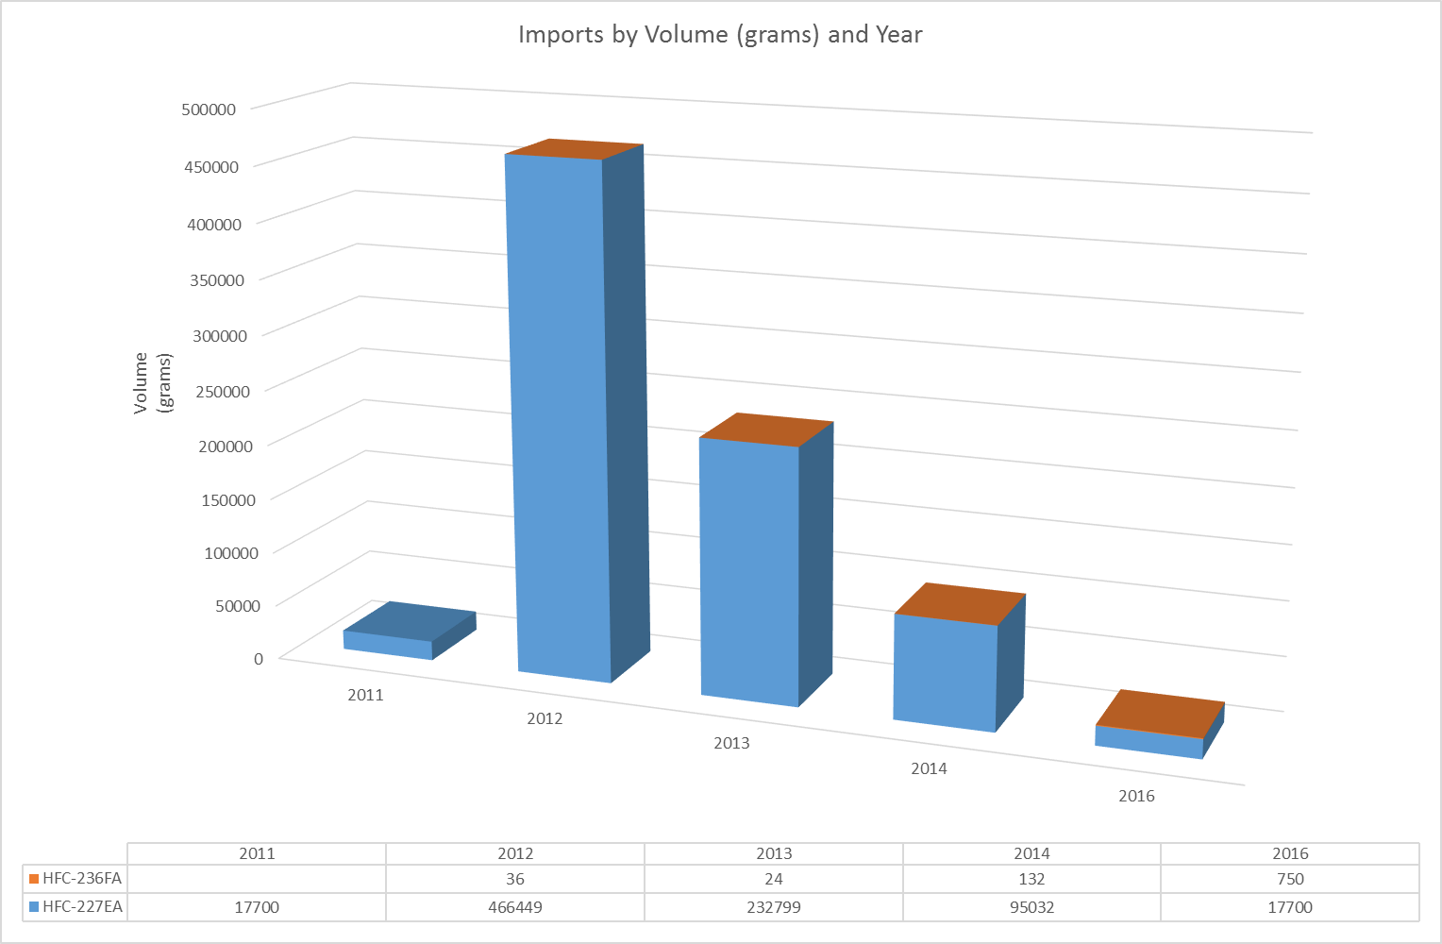**Table 4: Data provided from Department of Environment and Energy Imports from 2011 -2016**

## Banks

Currently the Fire Protection Industry (ODS & SGG) Board collects a variety of data from Extinguishing Agent Trading Authorisation and Halon Special Permit holders. This data shows the storage of various scheduled gases by these fire protection industry permit holders. This does not show the amount of storage in the installed banks.

In July 2012 a carbon tax was introduced that would see the cost of some SGGs double in price. The most widely used gas to be impacted was FM200®. Table 5 shows the spike caused by the tax as bulk purchases were made to combat the impact of this tax. Spikes were also notable in the purchase of NAF PIII and NAFSIII. Government policy change such as the introduction of the carbon tax did make an impact on the market whereby stockpiles of SGGs were imported and stored. Alternatives then became a financially viable option. If a system had been discharged or was due for a costly service it was an opportune time for phasing out SGGs and replacing them with inert gases[38]. Information not recorded is the increase in use of inert gases after July 2012.

The information provided does have limitations in that the Board indicates challenges with ensuring that reporting is provided on a regular basis. There is also an ongoing concern that there are still companies in Australia that are not licensed with the Board and as such this data is not being collected. The Board continues to undertake communication and engagement programs to make every attempt to identify these companies and facilitate compliance with the scheme.

**Table 5: FM200® (kg) held on hand 2013 to 2017[39]**

**Table 6: Halon 1211 (kg) held on hand 2013 - 2017[40]**

**Table 7: Halon 1301 (kg) held on hand 2013 - 2017[41]**

**Table 8: NAF PIII (kg) held on hand 2013 – 2017[42]**

**Table 9: NAF SIII (kg) held on hand 2013 – 2017[43]**

# Limitations and credibility

The scoping of this project required a very short turnaround time. Whilst some key subject matter experts were very accessible others were not, due to the nature of the business having strong international ties. There are also time constraints in the release of data from Federal Government departments as they process requests and seek permission to provide data. It is recommended that time frames for a detailed analysis be generous to allow for these matters in the next phase of the project.

The data obtained in this small overview of the sector raised issues in terms of quality and availability. To establish confidence in the second phase of the project full disclosure will be required to meet the deliverables.

This phase of the project was an overview and did not have detailed data requirements and analysis. Significant input from many subject matter experts in the sector through separate interviews, feedback on drafts, forwarding copies of relevant literature and working together in a 4 hour workshop was undertaken to produce this report. For this reason an overall high level of confidence regarding the accuracy of this report is assumed. The only areas where confidence was seen to be lower is in regard to the data provided as previously mentioned.

# References

Bennett, R (2011) *Replacing halon in Fire Protection Systems: A progress report*. [ONLINE] Available at: <http://www.boeing.com/commercial/aeromagazine/articles/2011_q4/3/>. [Accessed 11 June 2017].

Commonwealth of Australian, Department of Environment and Energy (2015) Synthetic Greenhouse Gases. [ONLINE] Available at: http://www.environment.gov.au/protection/ozone/synthetic-greenhouse-gases. [Accessed 11 June 2017].

Commonwealth of Australia, Department of Environment and Energy (2017) *International HFC phase-down agreed in Kigali*. [ONLINE] Available at: <http://www.environment.gov.au/protection/ozone/montreal-protocol/international-hfc-phase-down>. [Accessed 10 June 2017].

Fire Protection Industry (ODS & SGG) Board, workshop, Box Hill, 14/6/2017

Fire Protection Industry (ODS & SGG) Board, FPIB, 2014. Ozone Depleting Substances and Synthetic Greenhouse Gases (ODS & SGG). Good Practice Guide

Fire Protection Industry (ODS & SGG) Board, Quarterly ODS and SGG Usage Reports

Fire Protection Industry (ODS & SGG) BoardFact Sheet – Scheduled extinguishing agents in the Marine Industry

Environment Australia (2000) *Australian Halon Management Strategy,*

Expert Group (2011) A study into HFC consumption in Australia. [ONLINE] Available at: https://www.environment.gov.au/system/files/resources/5c47433d-fd84-495f-adce-3484e0bc208e/files/hfc-consumption-australia-2013_0.pdf/. [Accessed 4 June 2017].

Kelly, A, (2017) Fire Protection Services in Australia. IBISworld Industry Report, OD5424

Staines, B, (2016) Fire Protection in the building industry - Identifying risks and understanding safety measures. *In National Stakeholder Forum 2016*. Melbourne, 29 September 2017. Melbourne, Australia: FPA Australia. PowerPoint presentation

Tope, H, and Atkinson, M, (2012) Review of Australia's Halon Essential Uses Requirements. Final Report

United Nations Environment Program (2005) A survey of organisations, providers and research involved in the effort to understand and deal with climate change. [ONLINE] Available at: http://www.kyotoprotocol.com. [Accessed 10 June 2017].

Warren, G, (2009) Introducing gaseous fire suppression systems. PRMPFES25C: Inspect, test and maintain gaseous fire suppression systems, Participant guide

1. United Nations Environment Program. 2005. *A survey of organisations, providers and research involved in the effort to understand and deal with climate change*. [ONLINE] Available at: [http://www.kyotoprotocol.com](http://www.kyotoprotocol.com/). [Accessed 10 June 2017].
2. Commonwealth of Australia, Department of Environment and Energy. 2017. International HFC phase-down agreed in Kigali. [ONLINE] Available at: http://www.environment.gov.au/protection/ozone/montreal-protocol/international-hfc-phase-down. [Accessed 10 June 2017].
3. Kelly, A, 2017. Fire Protection Services in Australia. IBIS world Industry Report, OD5424,pg 14
4. Kelly, A, 2017. Fire Protection Services in Australia. IBIS world Industry Report, OD5424,pg 14
5. Kelly, A, 2017. Fire Protection Services in Australia. IBIS world Industry Report, OD5424, pg 12
6. Fire Protection Industry (ODS & SGG) Board, FPIB, 2014. Ozone Depleting Substances and Synthetic Greenhouse Gases (ODS & SGG). Good Practice Guide, 4.
7. Warren, G, 2009. Introducing gaseous fire suppression systems. PRMPFES25C: Inspect, test and maintain gaseous fire suppression systems, Participant guide, 1.
8. Fire Protection Industry (ODS & SGG) Board, *Fact Sheet - Which extinguishing agents are scheduled*, pg1
9. Fire Protection Industry (ODS & SGG) Board (2015), *Analysis of Fire Protection Data*, pg 8
10. Expert Group (2015) *Assessment of environmental impacts from the Ozone Protection and Synthetic Greenhouse Gas Management Act 1989*, pg. 82
11. Fire Protection Industry (ODS & SGG) Board (2015) *Analysis of Fire Protection Data*, pg 8
12. Environment Australia (2000), Australian Halon Management Strategy
13. Tope, H, and Atkinson, M (2012) *Review of Australia's Halon Essential Uses Requirements*. *Final Report*, 1, 1.
14. Fire Protection Industry (ODS & SGG) Board, workshop, Box Hill, 14/6/2017
15. Fire Protection Industry (ODS & SGG) Board, workshop, Box Hill, 14/6/2017
16. Australian Halon Management Strategy, pg 8
17. Fire Protection Industry (ODS & SGG) Board, workshop, Box Hill, 14/6/2017
18. Fire Protection Association Australia (2010) *Terms of Reference – Special Hazard Systems Technical Advisory Committee*, pg1
19. Warren, G, 2009. Introducing gaseous fire suppression systems. PRMPFES25C: Inspect, test and maintain gaseous fire suppression systems, Participant guide, 18
20. Warren, G, 2009. Introducing gaseous fire suppression systems. PRMPFES25C: Inspect, test and maintain gaseous fire suppression systems, Participant guide, 18
21. Fire Protection Industry (ODS & SGG) Board, workshop, Box Hill, 14/6/2017
22. Fire Protection Industry (ODS & SGG) Board, FPIB, 2015. Analysis of Fire Protection data. FPIB discharge report, 7.
23. Tope, H, and Atkinson, M, 2012. Review of Australia's Halon Essential Uses Requirements. *Final Report*, 4
24. R, Bennett. 2011. *Replacing halon in Fire Protection Systems: A progress report*. [ONLINE] Available at: <http://www.boeing.com/commercial/aeromagazine/articles/2011_q4/3/>. [Accessed 11 June 2017].
25. R, Bennett. 2011. *Replacing halon in Fire Protection Systems: A progress report*. [ONLINE] Available at: <http://www.boeing.com/commercial/aeromagazine/articles/2011_q4/3/>. [Accessed 11 June 2017].
26. Tope, H, and Atkinson, M, 2012. Review of Australia's Halon Essential Uses Requirements. *Final Report*, 4
27. Fire Protection Industry (ODS & SGG) Board, workshop, Box Hill, 14/6/2017
28. Fire Protection Industry (ODS & SGG) Board, workshop, Box Hill, 14/6/2017
29. Fire Protection Industry (ODS & SGG) Board, workshop, Box Hill, 14/6/2017
30. Fire Protection Industry (ODS & SGG) Board, workshop, Box Hill, 14/6/2017
31. Fire Protection Industry (ODS & SGG) Board, workshop, Box Hill, 14/6/2017
32. Fire Protection Industry (ODS & SGG) Board (20??) Fact Sheet – Scheduled extinguishing agents in the Marine Industry, pg1
33. Australian Halon Management Strategy, pg 8
34. Fire Protection Industry (ODS & SGG) Board, workshop, Box Hill, 14/6/2017
35.
36. Fire Protection Industry (ODS & SGG) Board 2015, Analysis of Fire Protection Data, pg 33
37. Fire Protection Industry (ODS & SGG) Board, workshop, Box Hill, 14/6/2017
38. Fire Protection Industry (ODS & SGG) Board, workshop, Box Hill, 14/6/2017
39. Fire Protection Industry (ODS & SGG) Board, Quarterly ODS and SGG Usage Reports
40. Fire Protection Industry (ODS & SGG) Board, Quarterly ODS and SGG Usage Reports
41. Fire Protection Industry (ODS & SGG) Board, Quarterly ODS and SGG Usage Reports
42. Fire Protection Industry (ODS & SGG) Board, Quarterly ODS and SGG Usage Reports
43. Fire Protection Industry (ODS & SGG) Board, Quarterly ODS and SGG Usage Reports