|  |
| --- |
| Fusarium wilt of banana (*Fusarium odoratissimum*) |

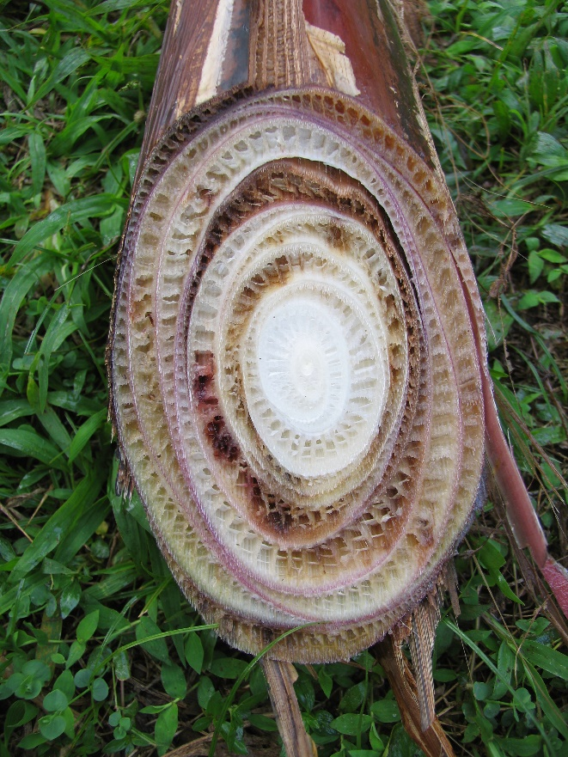

**Likely mode of entry**

This banana disease is readily transmitted in planting material (suckers or rhizome pieces) and infected soil, as well as on farming equipment (knives, etc.), vehicles, machinery, and animals. Local transmission may occur in drainage water.

**Symptoms (Figures 1–2)**

Leaves turn yellow and become necrotic progressively from the oldest to the youngest leaves. The plants wilt and most die before they can produce any fruit, although sometimes fruiting or environmental stress such as wet, dry, or extremely hot conditions will promote the appearance of disease symptoms. The pseudostem (banana tree trunk) discolours yellow, red, or brown in concentric rings (visible when cut through) before an extensive brown rot develops.

**Host range**

This pathogen attacks most varieties of bananas, including the main commercial variety, Cavendish. Some weeds and grasses can also be infected without disease symptoms.

**Biology (Figures 1–2)**

Fusarium wilt is caused by a fungus which produces different spore types including a resting spore that can remain viable in the soil for decades. Spores infect the roots and the fungus spreads up through the plant causing lesions in the pseudostem, restricting circulation of water and nutrients within the plant. The plant develops leaf symptoms, wilts and eventually dies, usually without producing any fruit.

*Fusarium odoratissimum*, was until recently referred to as *F. oxysporum* f. sp. *cubense* tropical race 4, and is often called Panama disease.

**Distribution**

There are several banana-infecting *Fusarium* species throughout the banana-producing regions of the world. *Fusarium odoratissimum* is present in Asia, the Middle East, and parts of South America and Africa. Outbreaks are under quarantine containment in the Northern Territory and Far North Queensland but are considered not eradicable.

**Fig. 1** Fusarium wilt of banana symptoms include discoloured rings in the cut pseudostem (Jeff Daniells, QDAF).

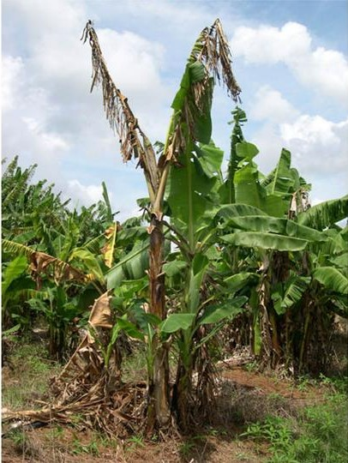

**What to do if you find suspect fusarium wilt of banana**

**Department officers:** Contain the risk, collect plant specimens double-bagged into zip-lock plastic bags and deliver to a department plant pathologist immediately.

**Industry and the public:** **SEE. SECURE. REPORT.**

Secure the goods to limit movement and immediately report your detection to the Department of Agriculture, Fisheries and Forestry on **1800 798 636**.

**Fig. 2** Late symptoms of fusarium wilt include wilting and death (J. Henderson QDPIF).