FARM MANAGEMENT DEPOSITS SCHEME STATISTICS – April 2014
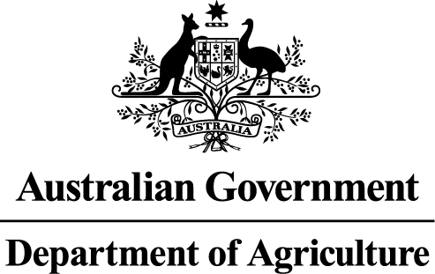
INDUSTRY DESCRIPTION | NSW |  | VIC |  | QLD |  | SA |  | WA |  | TAS |  | ACT & NT |  | NATIONAL TOTALS
INDUSTRY DESCRIPTION | No. of FMD accounts | Value of deposits ($’000) | No. of FMD accounts | Value of deposits ($’000) | No. of FMD accounts | Value of deposits ($’000) | No. of FMD accounts | Value of deposits ($’000) | No. of FMD accounts | Value of deposits ($’000) | No. of FMD accounts | Value of deposits ($’000) | No. of FMD accounts | Value of deposits ($’000) | No. of FMD accounts | Value of deposits ($’000)
HORTICULTURE | 862 | 77,865 | 944 | 91,631 | 985 | 108,453 | 781 | 67,181 | 348 | 39,190 | 128 | 12,847 | 8 | 736 | 4,056 | 397,903
SUGAR | 73 | 3,771 | 5 | 475 | 1,347 | 101,372 | 0 | 0 | 0 | 0 | 0 | 0 | 0 | 0 | 1,425 | 105,618
CROPS | 558 | 41,204 | 400 | 26,713 | 475 | 41,319 | 276 | 15,058 | 78 | 6,589 | 47 | 2,229 | * | * | 1,834 | 133,112
GRAIN | 1,508 | 130,451 | 1,632 | 120,392 | 678 | 66,514 | 2,329 | 216,215 | 1,230 | 156,736 | 17 | 897 | 5 | 776 | 7,399 | 691,981
GRAIN-SHEEP/BEEF | 2,595 | 194,884 | 2,363 | 170,957 | 686 | 55,767 | 1,944 | 160,942 | 1,335 | 148,031 | 49 | 5,319 | 5 | 1,535 | 8,977 | 737,435
BEEF | 1,393 | 83,650 | 992 | 56,212 | 2,279 | 205,295 | 215 | 14,724 | 242 | 19,887 | 158 | 10,093 | 14 | 917 | 5,293 | 390,778
SHEEP-BEEF | 1,168 | 69,596 | 764 | 42,220 | 400 | 31,905 | 463 | 35,964 | 151 | 11,217 | 106 | 5,833 | 5 | 125 | 3,057 | 196,860
SHEEP | 1,031 | 60,900 | 924 | 54,828 | 102 | 9,059 | 497 | 32,952 | 235 | 17,708 | 79 | 5,973 | 5 | 96 | 2,873 | 181,516
PIG | 37 | 2,705 | 24 | 2,450 | 44 | 3,352 | 37 | 3,160 | 10 | 330 | ** | ** | 0 | 0 | 152 | 11,997
INTENSIVE LIVESTOCK | 465 | 33,020 | 327 | 19,885 | 302 | 25,813 | 163 | 10,165 | 69 | 4,202 | 20 | 735 | * | * | 1,346 | 93,820
DAIRY | 350 | 26,527 | 1,904 | 130,542 | 331 | 21,620 | 149 | 12,612 | 61 | 5,070 | 115 | 7,110 | 0 | 0 | 2,910 | 203,481
FORESTRY & FISHING | 227 | 12,494 | 186 | 12,472 | 182 | 12,678 | 118 | 9,593 | 150 | 15,534 | 34 | 1,957 | 0 | 0 | 897 | 64,728
OTHER | 11 | 263 | 20 | 675 | 8 | 306 | *** | *** | *** | *** | *** | *** | 0 | 0 | 39 | 1,244
STATE/TERRITORY TOTAL  # | 10,278 | 737,330 | 10,485 | 729,452 | 7,819 | 683,453 | 6,972 | 578,566 | 3,909 | 424,494 | 753 | 52,993 | 42 | 4,185 | 40,258 | 3,210,473
#Note: The total number of accounts does not indicate the number of primary producers participating in the FMD Scheme as a primary producer may hold multiple FMD accounts.
* Northern Territory and Australian Capital Territory crops and intensive livestock industries FMD accounts and holdings have been aggregated with the respective New South Wales FMD accounts and holdings for privacy reasons.
** Tasmanian pig industry FMD accounts and holdings have been aggregated with the respective New South Wales FMD accounts and holdings for privacy reasons.
*** South Australian, Western Australian and Tasmanian other industry FMD accounts and holdings have been aggregated with the respective Victorian FMD accounts and holdings for privacy reasons.

