|  |
| --- |
| Fire blight (*Erwinia amylovora*) |

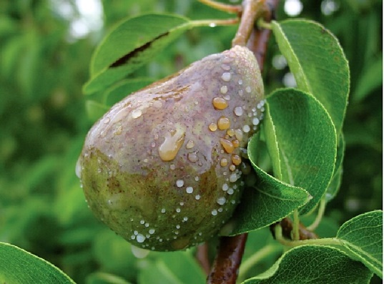

**Likely mode of entry**

This plant disease can be distributed over long distances within infected plant material, including apple and pear fruits, budwood, and susceptible ornamental plants. Short distance spread via infective plant exudates occurs by wind, rain, insects, birds, people, and equipment.

**Symptoms (Figures 1–4)**

Fire blight symptoms are very similar across all host plants, including necrosis and droplets of ooze on infected tissues. The first symptom in infected plants is usually water-soaked, dark green spots on tissue where it has been penetrated by bacteria. This is often on flower clusters which quickly turn brown or black as they die off and is termed ‘blossom blight’. Another typical symptom is ‘shepherd’s crook’ – a bent shoot with deep rust-coloured brown or black leaves, appearing as if it was scorched by fire. Dead sunken areas (cankers) develop which can girdle stems causing more dieback. Infected young fruits are small and dark while older fruits have brown to black lesions, becoming shrivelled and often exuding droplets of bacterial ooze.

**Host range**

Apple, pear, and related trees and shrubs in the family Rosaceae, subfamily Maloideae (pome fruits) including quinces (*Cydonia* spp.), serviceberries(*Amelanchier* spp.), flowering quinces(*Chaenolmeles* spp.), cotoneasters (*Cotoneaster* spp.), hawthorns (*Crataegus* spp.), pyracanthas (*Pyracantha* spp.), blackberries and raspberries (*Rubus* spp.), and mountain ashes (*Sorbus* spp.).

**Biology**

The bacterium *Erwinia amylovora* enters the plant through natural openings and wounds, and forms a gummy exudate called bacterial ooze on infected tissues. Insects such as aphids, ants, bees, beetles, and flies are attracted to this ooze, picking up the bacteria, and inadvertently spreading them to spring blossoms. Bacteria can also be spread by rain splash, wind, and contaminated pruning tools, and can survive winter in sunken cankers on infected branches.

**Distribution**

Probably originating in North America, this plant pathogen has spread throughout much of the Americas, Europe, New Zealand, and parts of Africa, the Middle East and Asia. An incursion during 1997 in Melbourne and Adelaide was eradicated, with the disease no longer present in Australia.

**Fig. 1** The milky ooze coming from this pear contains fire blight bacteria (sorhocam.com).

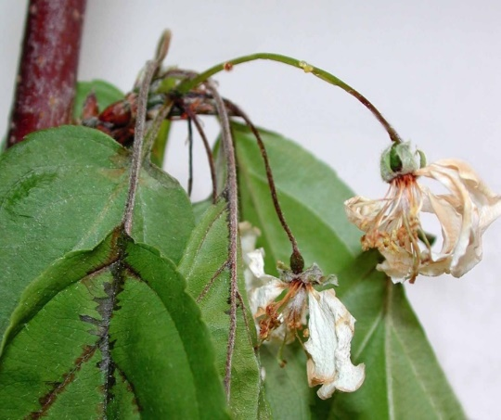

**Fig. 2** Apple blossoms and leaves with early symptoms of fire blight (K.D. Hickey, Cornell).

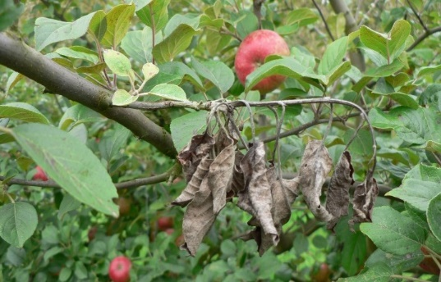

**Fig. 3** A characteristic symptom is ‘shepherd’s crook’, where shoot tips are bent and branches die (David Pickering, NSW DPI).

**What to do if you find suspect fire blight**

**Department officers:** Contain the risk, collect plant specimens double-bagged into zip-lock plastic bags and deliver to a department plant pathologist immediately.

**Industry and the public:** **SEE. SECURE. REPORT.**

Secure the goods to limit movement and immediately report your detection to the Department of Agriculture, Fisheries and Forestry on **1800 798 636**.

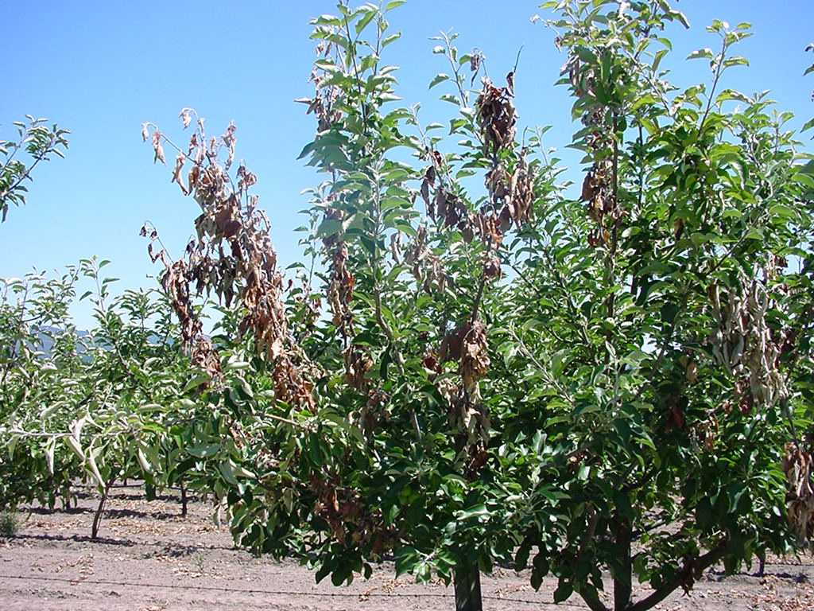

**Fig. 4** An apple tree displaying fire blight symptoms (© IHD, Victoria, Australia).