Quick reference guide: identifying legal timber from Finland
This quick reference guide supports the Country Specific Guideline for Finland. This may be used by businesses importing regulated timber products from Finland to Australia to carry out their due diligence in accordance with the Illegal Logging Prohibition Act 2012 and the associated Illegal Logging Prohibition Regulation 2012.
The Country Specific Guideline provides detailed information on the control of pathways for timber harvested and originating from within Finland and informs Australian importers of what is considered legal timber. It is only applicable for timber products with a Finnish origin of harvest.

What does legal timber ‘look like’ in Finland?
Information that you can gather to demonstrate timber and timber products imported from Finland have been legally harvested include:
- Forest Use Declaration – This is mostly found in electronic form, but also sometimes found as a hard copy paper document. An example of the declaration document is provided in the attached Appendix.
- Certificate of Measurement on Delivery – This is usually a form provided by the purchasing company. It has no standard format, but needs to include information on the parties involved (the seller and buyer); the tree species and timber assortment (logs, pulp, energy wood, damaged trees, etc); volume (by cubic metre); unit price per assortment; and the price and approval of the parties.
About 93% of Finnish forests that are used for commercial purposes have been certified under either the Programme for the Endorsement of Forest Certification (PEFC) endorsed Finnish Forest Certification System (FFCS), or the Forest Stewardship Council (FSC) International certification scheme. Therefore, use of the Timber Legality Framework risk assessment pathway may also be applicable to timber or timber products imported from Finland.
Timber harvesting is predominantly regulated by the Finnish Forest Act (1093/1996) and related amendments. Under the Forest Act, the landowner (or holder of the right of possession or other special right) must make a Forest Use Declaration about their intention to carry out felling.
As a member of the European Union (EU), the European Union Timber Regulation (EUTR) (995/2010) also applies in Finland. This means that operators who place timber and timber products on the EU market must have a due diligence system for timber legality. The Act on the Placing on the Market of Timber and Timber Products (897/2013) implements the EUTR in Finland. The competent authority ensures that the national due diligence system operates in accordance with the law.
For operators who place Finnish timber or timber products on the EU market for the first time, the core of the control system is the Forest Use Declaration document. The declaration, together with a Certificate of Measurement on Delivery, should constitute the core of the operator’s system to demonstrate timber legality. These documents must be stored for at least five years. It is important to note that these documents are not export documents and a Finnish exporter is not required to provide them to Customs when exporting timber or timber products. An Australian importer will need to request such documents from their supplier.
The EUTR also specifies that Finnish importers of timber from outside the EU shall exercise due diligence when placing timber or timber products on the market. Based on the information they have compiled, importers must assess the risks of any illegal activity in the entire preceding supply chain. This information may assist you to complete you due diligence requirements under Australia’s illegal logging laws.

Other relevant information
Specific legislation in relation to timber and timber product transport, possession or processing does not exist, but these activities are conducted in compliance with general rules and regulations. Imports and exports of timber and timber products are also regulated by the European Community customs law.
The Sámi are the only recognised indigenous people within the European Union. Specific agreements have been concluded with the reindeer herding cooperatives of the Sámi region on the use of forestry areas and on the exclusion of the most important pasturelands from forestry operations.

Forest Use Declaration form (sample)
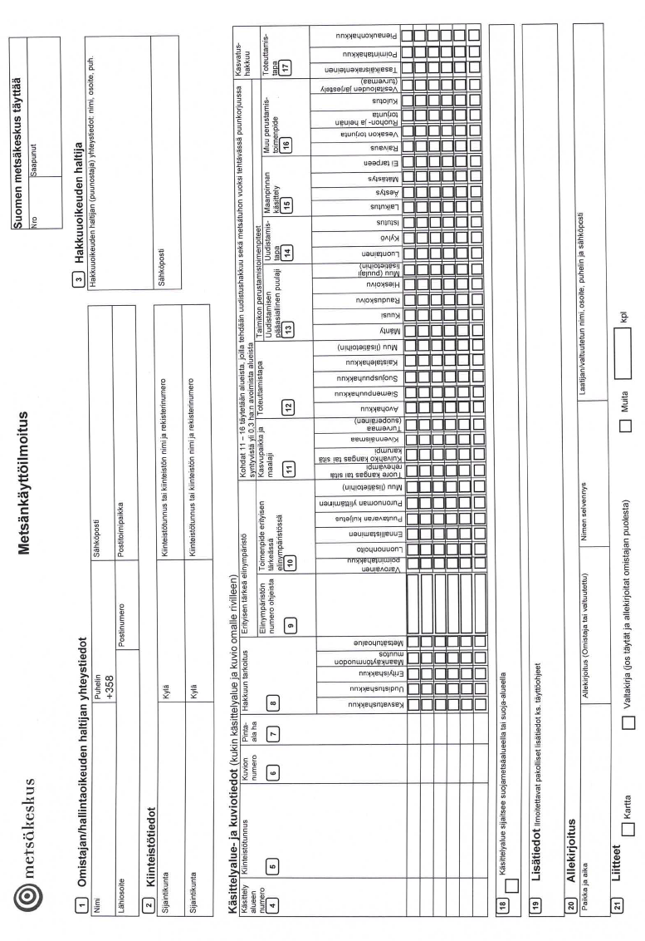
For further information on timber legality in Finland, refer to the Country Specific Guideline for Finland.

Who should I contact for further information?

Australian Government Department of Agriculture, Water and the Environment
GPO Box 858, Canberra ACT 2601
Phone: +61 2 6272 3933
agriculture.gov.au/illegallogging
illegallogging@agriculture.gov.au
Government of Finland Ministry of Agriculture and Forestry
PO Box 30, FI-00023, Government
Phone: +358 (0) 295 16 001
mmm.fi
kirjaamo@mmm.fi

