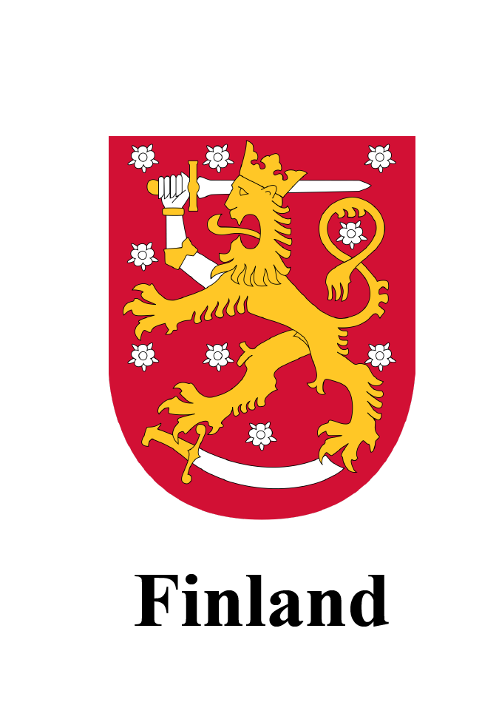
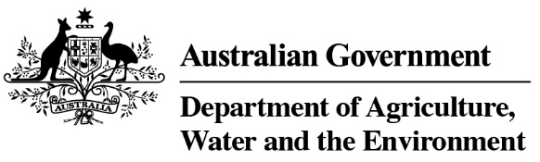

Country specific guideline for Finland

This guideline has been prepared by the Australian Government and the Government of Finland. It is intended to assist businesses importing regulated timber products from Finland into Australia in understanding the regulatory framework in Finland in order for them to carry out their due diligence obligations under the Illegal Logging Prohibition Regulation 2012, which supports the Illegal Logging Prohibition Act 2012.
This guideline was co-endorsed by the Australian and Finnish governments on 16 April 2020.

Contents
Country specific guideline for Finland 1
1. What is required under Australia’s illegal logging laws? 3
2. How to use the Country Specific Guideline (CSG) 3
3. Scope of the CSG for Finland 4
3.1 Timber harvested outside of Finland 4
3.2 Timber processed outside of Finland 4
4. Overview of Forest Management in Finland 5
4.1 Bans or limitations on harvest of specific species 5
5. Timber and timber products imported into Australia from Finland 6
6. Laws and regulations governing forestry in Finland 7
6.1 Forest Act (1093/1996) 7
6.2 Nature Conservation Act (1096/1996) 7
6.3 EU Timber Regulation (EUTR) (995/2010) – Finnish timber 7
6.4 Other relevant legislation 8
6.5 Indigenous people in Finland 9
7. Identifying legal product from Finland 11
7.1 Evidence of Timber Legality 11
7.2 Finland’s timber import controls 11
Who should I contact for further information? 13
Annex A: – Forest Use Declaration form (sample) 14

What is required under Australia’s illegal logging laws?
Australia’s Illegal Logging Prohibition Regulation 2012 (the Regulation) prescribes due diligence for individuals and businesses importing ‘regulated timber products’ and for Australian processors of domestic raw logs. Under the Regulation, importers and processors have to undertake due diligence to minimise the risk of sourcing illegal logged timber.
The due diligence requirements for importers include the following steps:
Step 1: Establish and maintain a due diligence system.
Step 2: Gather information about the timber in the product that is being imported
Step 3: Assess the risk (using one of the three methods outlined in the Regulation)
Step 4: Risk mitigation (if required)
Step 5: Keep records
Further information about the Regulation and the due diligence requirements is available at the Australian Government Department of Agriculture, Water and the Environment’s website (www.agriculture.gov.au/illegallogging).

How to use the Country Specific Guideline (CSG)
This CSG is intended to assist an importer of regulated timber products from Finland to Australia to comply with the Regulation’s due diligence requirements.
In accordance with section 10 of the Regulation, an importer must gather information about the product they are seeking to import, this includes gathering the information or evidence described in this CSG.
The information listed in this CSG is not meant to be an exhaustive list of evidence or documentation required to satisfy the due diligence requirements under the Regulation.
The information gathered by applying this CSG, along with any other information gathered in accordance with the Regulation, needs to be assessed in accordance with the processes outlined in section 12 of the Regulation. This includes giving consideration to any other information the importer knows, or ought reasonably to know, but is not contained in the CSG.
All data included in this document is the most current as available at time of publishing.

Scope of the CSG for Finland
This CSG provides detailed information on the control of pathways for timber harvested and originating from within Finland and informs Australian importers of what is considered legal timber according to Finnish law. It is only applicable for timber products with a Finnish origin of harvest.

3.1 Timber harvested outside of Finland
There may be timber, forest products, or other products that contain timber (wholly or in-part) which were harvested in another country before being imported to Finland. These products do not fall within the scope of this CSG. However the information contained in this CSG may assist Australian importers in conducting their due diligence via one of the alternative risk assessment methods available under the Regulation.

3.2 Timber processed outside of Finland
Timber that is harvested in Finland, but then processed in another country, also does not fall within the scope of this CSG. As a result, importers may not use the CSG risk assessment method to carry out their due diligence on these products. However, the information contained in this document may still assist Australian importers in conducting their due diligence via one of the alternative risk assessment methods available under the Regulation.

Overview of Forest Management in Finland
Finland’s total land area is 30.4 million hectares (ha), and of this area, forests cover approximately 86% (26.2 million ha). On the basis of site productivity, forestry land is divided into productive forest land (20.3 million ha), low productive forest land (2.5 million ha), other forestry land (3.2 million ha) and logging roads etc. (0.2 million ha).
Almost half of the volume of Finland’s timber stock consists of pine (Pinus sylvestris). Other common species are spruce (Picea abies), downy birch (Betula pubescens) and silver birch (Betula pendula). These species make up 97% of the total timber volume of Finnish forests.
Finland’s forest are mainly owned by private individuals (60% of forest land). Other forest owners are the state (26%), private companies such as forest industry companies (9%) and others (5%).
Finland has a total of 2.7 million ha of protected forests, i.e. 12 % of the total area of productive and poorly productive forest land. The area of strictly protected forest in Finland is the highest of European countries. In addition to strictly protected forests, there are 0.4 million ha of forests under restricted forestry use.

4.1 Bans or limitations on harvest of specific species
Finland is a party to the Convention on International Trade in Endangered Species of Wild Fauna and Flora (CITES). Finland bans and/or restricts the harvest or collection of flora and fauna species listed in accordance with the CITES Appendices. All trade in CITES listed species is strictly regulated and must be accompanied by the appropriate documentation where trade is permissible. However, there are currently no CITES listed tree species growing in Finland.
Outside CITES list species, there are no tree species currently banned from being harvested in Finland.

Timber and timber products imported into Australia from Finland
Finland was Australia’s 8th most valuable supplier of regulated timber products in 2018, with a total of A$236 million in imported products.
The following products are the most valuable regulated timber products imported into Australia from Finland (sorted by their 4-digit Harmonized System (HS) tariff code):
Table 1 - List of major regulated timber products imported into Australia by value (2018)
Source: Australian Government Department of Agriculture, Water and the Environment, 2019
HS code | Description | Value ($AUD)
4810 | Paper and paperboard, coated on one or both sides with kaolin (China clay) or other inorganic substances. | $88,346,555
4802 | Uncoated paper and paperboard, of a kind used for writing, printing or other graphic purposes. | $43,865,222
4703 | Chemical wood pulp, soda or sulphate, other than dissolving grades. | $26,733,316
4811 | Paper, paperboard, cellulose wadding and webs of cellulose fibres, coated, impregnated, covered, surface–coloured, surface–decorated or printed. | $24,503,935
4407 | Wood sawn or chipped lengthwise, sliced or peeled, whether or not planed, sanded or end–jointed, of a thickness exceeding 6 mm. | $23,387,642
4418 | Builders’ joinery and carpentry of wood, including cellular wood panels, assembled flooring panels, shingles and shakes. | $20,744,500
4412 | Plywood, veneered panels and similar laminated wood. | $2,010,008
4409 | Continuously shaped wood | $1,580,792
Total, including minor product categories not listed |  | $236,754,442

Laws and regulations governing forestry in Finland

6.1 Forest Act (1093/1996)
In Finland, timber harvesting is predominantly regulated by the Finnish Forest Act (1093/1996), amended as (1085/2013) on 1 January 2014. The purpose of this Act is to promote the economically, ecologically and socially sustainable management and utilisation of forests so that the forests produce a good and sustainable output while their biological diversity is maintained. Suomen metsäkeskus (The Finnish Forest Centre) is the national competent authority responsible for the enforcement of the Forest Act.
The Forest Act applies to the management and commercial utilisation of forests in all areas classified as forestry land. It defines the minimum obligations required of forest owners in caring for their forests and the minimum restrictions on forest use. This Act is not, however, applicable in areas listed in Section 2(1) of the Forest Act, which includes non-forestry areas such as protected areas, wilderness, areas subjected to planning restrictions, and defence firing areas.
According to the Forest Act, the landowner or holder of the right of possession or other special right must make a Forest Use Declaration concerning their intention to carry out felling. A sample declaration, valid in both electronic and paper forms (about 90% are made electronically), is at Annex A and also available at https://www.metsakeskus.fi/sites/default/files/lomake-metsankayttoilmoitus.pdf.
Among the key elements of the Forest Act is defining certain habitats of special importance and providing guidelines as to how these habitats should be managed. It lists a total of seven habitat groups where demanding and endangered species may occur. These so-called ‘key biotopes’ may be considered as small conservation areas within commercial forests.

6.2 Nature Conservation Act (1096/1996)
In Finland, forest use is also restricted by the Nature Conservation Act (1096/1996). The aim of this Act is to preserve the diversity of nature in Finland by ensuring that the favourable conservation status of different natural habitat types and native species is maintained or restored.
Areas protected under the Nature Conservation Act include, for example, national parks, nature reserves and strictly protected nature reserves, natural monuments strictly protected zones in wilderness areas, mires, old-growth and herb-rich forests, eskers, shores and waterfowl habitats, as well as the Special Areas of Conservation (SPAs) of European Union Natura 2000 network.

6.3 EU Timber Regulation (EUTR) (995/2010) – Finnish timber
Similar to Australia’s illegal logging laws, the EU Timber Regulation (EUTR) (995/2010) prohibits the introduction of illegally harvested timber into the European market. It applies to all ‘operators’ who place timber or timber products on the European market for the first time. For Finnish timber harvesting, forest owners who do the timber harvesting and businesses that trade in the timber are considered ‘operators’.
The Act on the Placing on the Market of Timber and Timber Products (897/2013) implements the EUTR in Finland. The main elements of this Act consist of the nomination of the Competent Authority, arrangements for the exchange of information between authorities, and associated penalties.
The EUTR has been applied to all EU countries since 3 March 2013. It also applies to Finnish timber harvesting, with the legality of Finnish timber demonstrated via the control systems laid down in the Finnish Forest Act. These systems constitute the Finnish national Due Diligence System. The Competent Authority ensures that the national Due Diligence System operates in accordance with the law.
The Finnish Food Authority (Ruokavirasto) is the relevant EUTR Competent Authority and is responsible for implementing the EUTR in Finland. They have the right to issue conditions and fines if companies do not implement a suitable Due Diligence System that complies with the legal requirements. The Competent Authority cooperates with the Finnish Forest Centre.
The core of the control systems is the Forest Use Declaration. The main purpose of this form is to inform the Finnish Forest Centre of what harvesting is planned to be conducted; who the forest owner is, and who is the logging right holder. The authority can then verify the planned treatment is legal. Forest Use Declarations need to be submitted by the forest owner to the Finnish Forest Centre a minimum of 10 days before the logging starts. The Declaration must be approved prior to any harvesting taking place. These documents must be stored for at least five years.
The declaration, together with a Certificate of Measurement on Delivery, constitutes the operator’s due diligence system. It is the set of documents that indicate a legal and valid transaction has occurred.
The standard requirements of a Certificate of Measurement on Delivery are laid down in the Timber Measurement Act (414/2013). This requires that the certificate include the following information: the parties (the seller and buyer); tree species and timber assortment (logs, pulp, energy wood, damaged trees); volume (by cubic metre); unit price per assortment; and the price and approval of the parties.
Still, the Certificate of Measurement on Delivery has no standard format. It is usually a form provided by the purchasing company and they are generally confidential between the parties. However, the Finnish competent authorities are able to obtain access to the documents if necessary, eg. Regional forest authorities conducting field audits; substantiated concerns of third parties, etc.

6.4 Other relevant legislation

Land Use and Building Act (132/1999)
According to Section 128(1) of the Land Use and Building Act (132/1999), earthworks, tree felling or other similar actions altering the landscape may not be carried out in specified areas without a permit (restriction on action). However, importers are very unlikely to see timber or timber products originating from such operations.

Timber Measurement Act (414/2013)
The Timber Measurement Act (414/2013) regulates the measurement of timber harvested in Finland. The purpose of this Act is to specify the measurement methods for unprocessed timber and ensure equipment performance and reliability of the measurement results. This Act also provides for a certificate of timber measurement.
A forest owner who sells standing trees receives the certificate of measurement from the buyer after the timber has been measured. The certificate shows the measured volumes of timber, the unit price by timber assortment, and the final sale price. The certificate is signed by both the seller and buyer.

Forest Damages Prevention Act (1087/2013)
The aim of the Forest Damages Prevention Act (1087/2013) is to ensure the continued good health of commercial forests. It also includes provisions on when felled timber must be removed from the forest (depending on what timber it is, spruce or pine), as well as on alternative measures that may be taken if pine timber cannot be removed (including watering the timber, covering the timber, and debarking the timber). The purpose is to prevent insect damage, as well as damage to the surrounding forest.

Other
Specific timber trade legislation does not exist in Finland. Instead, any timber trade needs to take place in compliance with general contractual and proprietary rights, Finnish tax laws and related regulations. No timber products are prohibited for export from Finland.
Specific legislation in relation to timber product transport, possession or processing also does not exist. However, these activities need to be conducted in compliance with general rules and regulations. Export of timber and timber products are also regulated by the European Community customs law.

6.5 Indigenous people in Finland
The Sámi are the only recognised indigenous people within the European Union. The Sámi people live in the Northern parts of Finland, Sweden and Norway, as well as in parts of North-Western Russia.
In Finland, the forestry principles in the Sámi region have been agreed in negotiations between Metsähallitus (a state enterprise which administers state-owned land and water areas), the Sámi Parliament and the Skolt Council. The specific agreements have been concluded with the reindeer herding cooperatives of the Sámi region on the use of forestry areas and on the exclusion of the most important pasturelands from forestry operations.
Metsähallitus and the Association of Reindeer Herding Cooperatives have signed a cooperation agreement which defines ways of reconciling forestry and reindeer husbandry.

Reindeer Husbandry Act (848/1990)
According to the Finnish Reindeer Husbandry Act (848/1990), state lands situated north of the line marked on the map appended to this Act form an area specifically intended for reindeer herding. The land in this area may not be used in a manner that may significantly hinder reindeer herding. There is only a very low rate of timber harvest in reindeer husbandry areas.

Act on Metsähallitus (234/2016)
According to Section 6(2) of the Act on Metsähallitus (234/2016), the management, use and protection of natural resources governed by Metsähallitus in the Sámi Homeland referred to in the Act on the Sámi Parliament (974/1995) shall be adjusted to ensure the conditions of the Sámi people to practice their culture, and the reindeer herding area referred to in the Reindeer Husbandry Act (848/1990) shall be adjusted to fulfill its obligations.

Identifying legal product from Finland

7.1 Evidence of Timber Legality

Timber Legality Frameworks
About 85% of Finnish forests, which are used for commercial purposes, have been certified under the Programme for the Endorsement of Forest Certification (PEFC) endorsed Finnish Forest Certification System (FFCS). The area certified under the Forest Stewardship Council (FSC) international certification scheme represents about 8% of Finnish forests in commercial use.
In most cases, the timber or wood products being imported from Finland will hold certification under at least one of these schemes. Therefore, use of the Timber Legality Framework due diligence pathway established in the Australian Illegal Logging Prohibition Regulation 2012 may also be applicable.
However, where timber or wood product does not hold the above certification, the main documents that may be available to importers to support legality of harvest and placement on the market in Finland, include:
- Forest Use Declaration – see Annex A for a sample form.
- Certificate of Measurement on Delivery
These two documents constitute the operator’s due diligence system. It is the set of documents that indicate that a legal and valid transaction has occurred. These documents are not required to be provided to Customs when exporting timber or timber products from Finland.

7.2 Finland’s timber import controls
While third country harvested timber is not within the scope of this CSG, the following information on the EUTR for timber imported into Finland may support importers to Australia in conducting their due diligence risk assessment process.

EU Timber Regulation (EUTR) (995/2010) – Imported timber from outside the EU
According to the EUTR, timber and wood product importers, or operators, shall exercise due diligence when placing any timber or timber products from outside the EU on the EU market. The placing on the market of illegally harvested timber or products derived from such timber is prohibited. Therefore, operators must use a due diligence system when supplying timber or timber products to the EU market.
The due diligence system provides measures and procedures that enable the traceability of timber and timber products by the operators and access to information on compliance with the applicable legislation. Based on the information they have compiled, operators must assess the risks of any illegal activity in the entire preceding supply chain.
Finland’s law for enforcing the EUTR is the Act on the Placing on the Market of Timber and Timber Products (897/2013). Imports of timber and timber products are also regulated by the European Community customs law.

FLEGT licensing scheme
FLEGT licences can only be issued by countries that have ratified a Voluntary Partnership Agreement (VPA) with the European Union. In Finland, the FLEGT licensing scheme is implemented by the Act on the FLEGT licensing scheme (1425/2014). The Competent Authority responsible for implementation of the FLEGT licensing scheme is the Finnish Food Authority (formerly the Agency for Rural Affairs). FLEGT licences are applied only to the products exported from the FLEGT licenced countries direct to the European Union.

Who should I contact for further information?
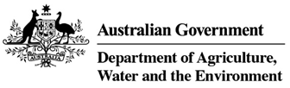 |  | 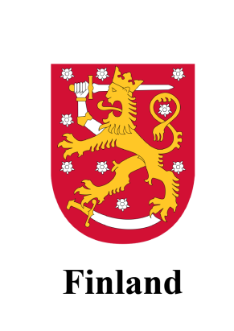
Australian Government  Department of Agriculture, Water and the Environment  GPO Box 858  Canberra ACT 2601  Australia  Phone: +61 (0) 2 6272 3933  Web: agriculture.gov.au/illegallogging  Email: illegallogging@agriculture.gov.au |  | Government of Finland  Ministry of Agriculture and Forestry  PO Box 30, FI-00023 GOVERNMENT  Finland  Phone: +358 (0) 295 16 001  Web: mmm.fi  Email: kirjaamo@mmm.fi

Disclaimer

While reasonable efforts have been made to ensure that the contents of this guideline and the associated quick reference guide are factually correct, the Commonwealth of Australia does not accept responsibility for the accuracy or completeness of the contents and expressly disclaims liability for any loss or damage, however caused, that may be occasioned directly or indirectly through the use of, or reliance on, the contents of this guideline or associated quick reference guide.
This guideline and its associated quick reference guide are made available on the understanding that the Commonwealth of Australia is not providing professional advice. Before relying on this guideline or its associated quick reference guide, readers should obtain appropriate professional advice suitable to their particular circumstances.
Readers should also confirm that this is the most up-to-date available guideline by referring to the Department of Agriculture, Water and the Environment’s website.

Annex A: – Forest Use Declaration form (sample)
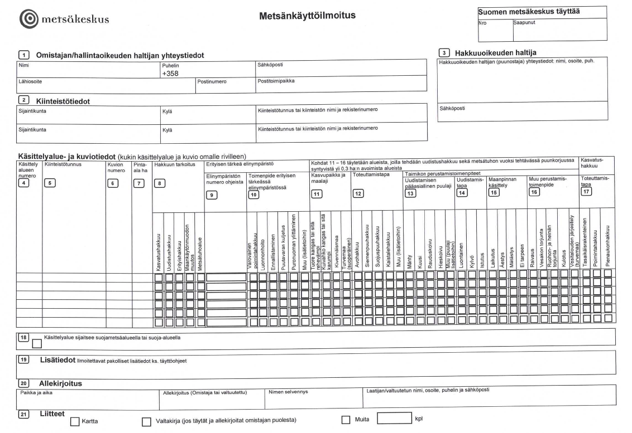

English version of the Forest Act. NB: This legislation is legally binding only in Finnish and Swedish.
English version of the Act.
Further detail on the purpose of this Act can be found here.
Formerly known as the Agency for Rural Affairs, Maaseutuvirasto, or MAVI in Finnish
English version of the Act.

