Heat and cold stress in Bos taurus cattle from southern Australia during long-haul export by sea
Final report: December 2022
Department of Agriculture, Fisheries and Forestry
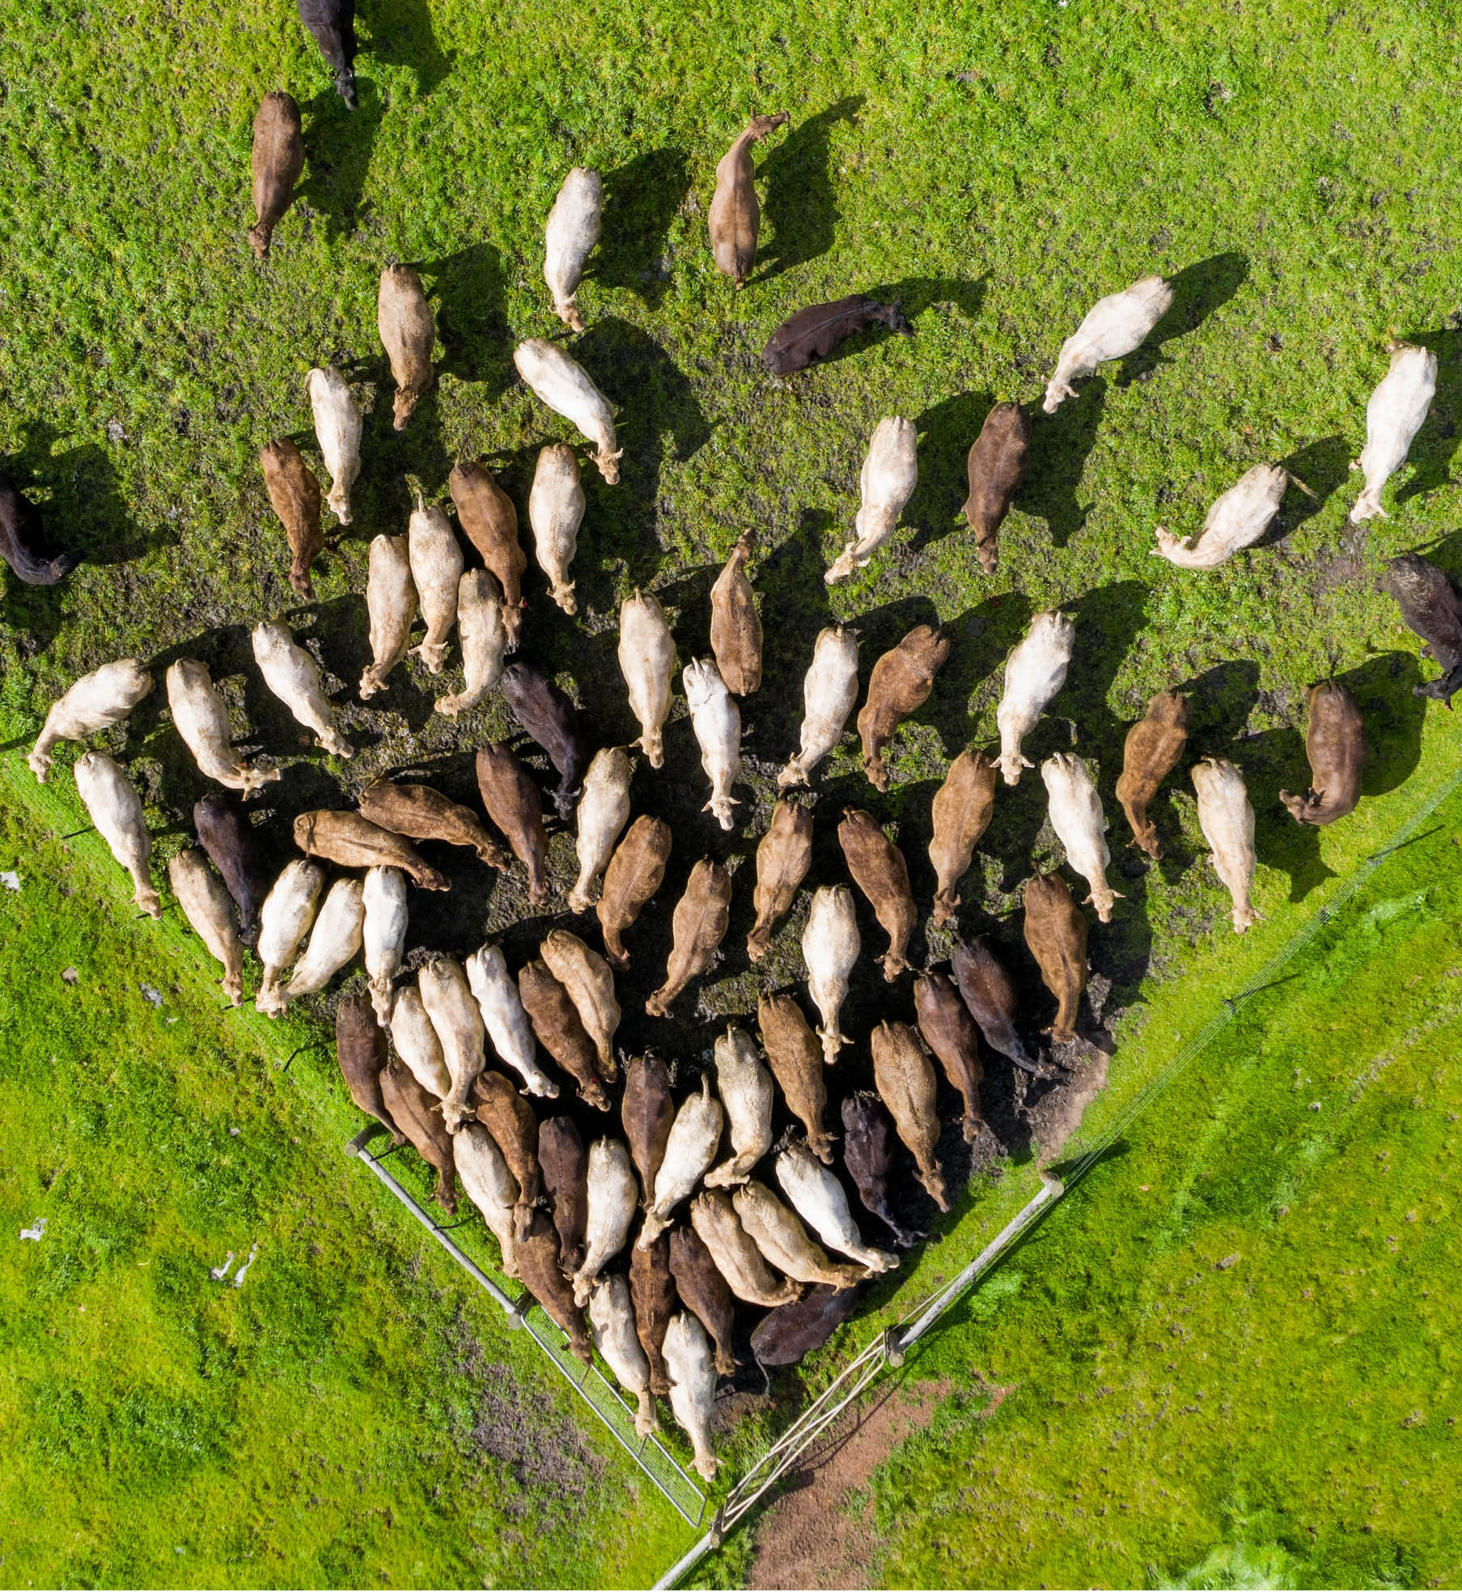
© Commonwealth of Australia 2022
Ownership of intellectual property rights
Unless otherwise noted, copyright (and any other intellectual property rights) in this publication is owned by the Commonwealth of Australia (referred to as the Commonwealth).
Creative Commons licence
All material in this publication is licensed under a Creative Commons Attribution 4.0 International Licence except content supplied by third parties, logos and the Commonwealth Coat of Arms.
Inquiries about the licence and any use of this document should be emailed to copyright@awe.gov.au.

Cataloguing data
This publication (and any material sourced from it) should be attributed as: DAFF 2022, Heat and cold stress in Bos taurus cattle from southern Australia during long-haul export by sea: Final report, Department of Agriculture, Fisheries and Forestry, Canberra, December 2022. CC BY 4.0.
ISBN 978-1-76003-481-8
This publication is available at https Cattle and buffalo exports by sea - DAFF (agriculture.gov.au).
Department of Agriculture, Fisheries and Forestry
GPO Box 858 Canberra ACT 2601
Telephone 1800 900 090
Web Home - DAFF (agriculture.gov.au)
Disclaimer
The Australian Government acting through the Department of Agriculture, Fisheries and Forestry has exercised due care and skill in preparing and compiling the information and data in this publication. Notwithstanding, the Department of Agriculture, Fisheries and Forestry, its employees and advisers disclaim all liability, including liability for negligence and for any loss, damage, injury, expense or cost incurred by any person as a result of accessing, using or relying on any of the information or data in this publication to the maximum extent permitted by law.
Acknowledgements
Dr Jane Heller, Professor Andrew Fisher, Associate Professor Anne Barnes, Dr Hugh Millar and stakeholders who provided submissions.
Accessibility
This document contains mathematical symbols. Screen reader users may need to increase the punctuation level in the screen reader settings to read all content in this document.

Contents
Summary xvi
Findings and recommendations xix
Findings xix
Recommendations xx
1 Introduction 1
1.1 Purpose of the review 1
1.2 Scope of the review 2
1.3 Consultation 3
1.4 Australia’s live cattle export industry 5
1.5 Bos taurus and Bos indicus cattle types 9
2 Overview of voyages 10
2.1 Overview by class of cattle 11
2.2 Overview by northern hemisphere season (NHS and NHW) 12
2.3 Overview by destination region 12
3 Science of heat stress 15
3.1 Physiology of heat stress 15
3.2 Assessing heat load 17
3.3 Managing increased heat load 19
3.4 Animal factors influencing heat tolerance 24
3.5 Cattle thermoregulation 27
3.6 Heat stress thresholds 27
4 Heat load voyage analysis 30
4.1 Evidence of hot conditions 31
4.2 Analysis of risk factors for increased heat load and heat stress-related mortality 34
4.3 Summary of key findings for key risk factors 48
4.4 Discussion and recommendations 49
5 Other heat stress factors 53
5.1 Ventilation and hotspots on decks 53
5.2 Bedding and pad 55
5.3 Water provision 57
5.4 Pregnant cattle 58
5.5 Reporting of heat stress 62
5.6 Discussion (on other heat stress factors) 63
6 Cold stress 67
6.1 Physiology of cold stress 67
6.2 Assessing cold stress 67
6.3 Animal factors influencing cold tolerance 68
6.4 Cold stress thresholds 71
6.5 Cold stress voyage analysis 72
6.6 Summary of key findings 74
6.7 Discussion and recommendations 74
7 Summary of submissions to the draft report 77
7.1 Submissions on heat load and heat stress-related mortality 77
7.2 Other heat stress factors 78
7.3 Submissions on cold stress 80
Appendix A: ASEL 3 standards 82
Appendix B: Heat load mortality table 89
Appendix C: Methodology 90
Appendix D: Feedback from the TEG 93
Appendix E: Submissions to the draft report 96
Glossary 97
References 99

Tables
Table 1 Australian live cattle export destinations by value and volume - five years to 2019-20 5
Table 2 Long-haul export destinations from Australian focus ports, 2020 and 2016-20 7
Table 3 Destination regions, countries and ports 10
Table 4 Review voyages by cattle class 11
Table 5 Number of voyages, cattle exported, voyage duration and mortality rates by region for the period 1 January 2016 to 31 December 2020 12
Table 6 Number of voyages, cattle exported, voyage duration and mortality rates for China by year for the period 1 January 2016 to 31 December 2020 13
Table 7 Number of voyages, cattle exported, voyage duration and mortality rates for the Red Sea by year for the period 1 January 2016 to 31 December 2020 13
Table 8 Number of voyages, cattle exported, voyage duration and mortality rates for the Persian Gulf by year for the period 1 January 2016 to 31 December 2020 14
Table 9 Number of voyages, cattle exported, voyage duration and mortality rates for the Russian Federation by year for the period 1 January 2016 to 31 December 2020 14
Table 10 Behavioural and physiological responses to heat stress in cattle 17
Table 11 Panting score used in the assessment of heat stress in cattle 19
Table 12 Animal and management adjustments to the HLI threshold of the reference animal (healthy, unshaded Angus steer, 100 days on feed) 27
Table 13 Base heat stress threshold and mortality limit values 29
Table 14 WBT risk criteria for heat stress on export vessels 29
Table 15 Maximum voyage wet bulb temperature from 214 voyages (2016-20) 31
Table 16 Summary of voyages with evidence of increased heat load and heat stress-related mortalities according to cattle class 35
Table 17 Summary of voyages with evidence of increased heat load and heat stress-related mortality according to season 38
Table 18 Summary of voyages with evidence of increased heat load and heat stress-related mortalities according to voyage route 43
Table 19 Summary of voyages with evidence of increased heat load and heat stress-related mortalities according to departure port 44
Table 20 Summary of voyages with heat stress-related mortalities according to vessel 48
Table 21 Hotspots identified in voyage reports 54
Table 22 Comparison of the occurrence of abortions on 10 long-haul voyages carrying Bos taurus cattle from southern Australian ports with or without reported response to increased heat load 61
Table 23 Estimated lower critical temperatures for beef cattle 72
Table 24 Summary of voyages and minimum reported ambiet DBT 72
Table 25 Feed requirements for cattle 87
Table 26 Additional minimum veterinary medicines and equipment for pregnant cattle 87

Figures
Figure 1 Proportion of cattle sourced from different regions (WA, NT, Qld, other) entering the live export cattle trade (2018) 6
Figure 2 Number of cattle exported from all Australian ports v. southern focus ports, 2016-20 7
Figure 3 Number of cattle exported from Australian focus ports by class, 2016-20 8
Figure 4 Export destinations for live cattle by number of head, 2016-20 9
Figure 5 Overview of cattle class by destination 12
Figure 6 Relationship between ambient temperature and body core temperature, evaporative heat loss rate and metabolic rate of mammals 16
Figure 7 ASEL 3 pen space allocations for voyages departing from south of latitude 26˚ south - NHS v. NHW with alternative pen space options included 20
Figure 8 The number of voyages and temperature (mean and mean maximum WBT ˚C) by month (2016-20) 32
Figure 9 Distribution of class of cattle by destination 36
Figure 10 Voyages recording heat load by cattle class 36
Figure 11 Voyages recording heat stress-related mortality by cattle class 37
Figure 12 Presence of heat load distributed by month for all voyages 39
Figure 13 Heat stress-related mortalities distributed by month for all voyages 40
Figure 14 Presence of heat load for slaughter class only 40
Figure 15 Heat stress-related mortalities for slaughter class only 41
Figure 16 Voyages recording heat load and/or mortality - by AMJ season 42
Figure 17 Voyages recording heat stress-related mortality - by AMJ season 42
Figure 18 Distribution of departure port by destination 44
Figure 19 Distribution of class of cattle by departure port 45
Figure 20 Voyages reporting increased heat load by vessel 46
Figure 21 Voyages reporting heat stress-related mortality distributed by vessel 46
Figure 22 Distribution of class of cattle by vessel 47
Figure 23 Relationship of feed intake and maintenance requirements to temperature 71
Figure 24 Outcomes of heat load and/or mortality 92
Figure 25 Outcome of mortality, including heat load as an explanatory variable 92

Maps
Map 1 Typical voyage routes from southern Australian ports to destination countries 10
Map 2 Location of maximum deck wet bulb temperature for voyages that recorded at least 1 day at 28 WBT ˚C or above (2016-20) 32
Map 3 Location of the coldest recorded DBT for voyages to China 73

Boxes
Box 1 Findings related to heat load 51
Box 2 Recommendations related to heat load 51
Box 3 Findings related to other heat stress factors 65
Box 4 Recommendations related to other heat stress factors 65
Box 5 Findings related to cold exposure and cold stress 75
Box 6 Recommendations related to cold exposure and cold stress 75

Summary
The Department of Agriculture, Fisheries and Forestry has prepared this report of its review of heat and cold stress in Bos taurus cattle from southern Australia during long-haul export by sea.
This review builds on the 2018–19 review of the Australian Standards for the Export of Livestock (ASEL) by sea (ASEL sea review) by the Technical Advisory Committee (TAC), which made recommendations identifying temperature stress as an issue for the welfare of exported cattle (and buffalo) on long-haul voyages (voyages of 10 days or more).
In preparing the report we reviewed voyage reports for the export of 1,019,563 head of cattle on 214 long-haul voyages over 5 years from 1 January 2016 to 31 December 2020. We reviewed voyages from 5 ports of departure, to 4 destination regions, 9 destination countries and 34 destination ports.
We considered scientific literature, industry research, voyage reports by stockpersons, ship masters, Accredited Veterinarians (AAVs) and Independent Observers (IOs), the ASEL sea review, data from the Bureau of Meteorology (BOM), internal and external stakeholder feedback and other relevant information.
We undertook targeted consultation and formal public consultation. We engaged an independent technical expert group to review and provide feedback on the draft report prior to formal consultation, and the revised report following this. All feedback was considered in detail before the publication of this report. For more information on the consultation processes see section 1.3.
This report provides evidence-based recommendations to improve current export arrangements and support animal welfare during preparation and transport of Bos taurus cattle consignments from southern Australian ports during long-haul export by sea.

Heat stress findings
The department notes that ‘heat load’ and ‘heat stress’ are not synonymous, and has provided definitions for each in the glossary.
This review determined that evidence of increased heat load can occur during long-haul voyages carrying Bos taurus cattle from southern Australia in all classes of cattle (breeder, feeder and slaughter):
- to all destinations
- from all departure ports
- departing during both the northern hemisphere winter (NHW) (November to April inclusive) and northern hemisphere summer (NHS) (May to October inclusive).
It was found that Bos taurus voyages carrying slaughter cattle have a significantly greater risk of increased heat load compared to voyages of feeder cattle and breeder cattle.
This review found the overall voyage mortality rate for the 214 voyages was 0.21%, which is below the notifiable level of 0.5% as defined in ASEL 3. Within this context, it was identified that Bos taurus voyages carrying slaughter cattle have a significantly greater risk of heat stress-related mortality compared to voyages of other classes of cattle. This review identified that two-thirds of heat stress-related mortalities were reported to occur in combination with other diseases, primarily respiratory disease. This finding suggests that susceptibility to increased heat load and heat stress-related mortality may be exacerbated by other health conditions, or similarly, that other health conditions may exacerbate heat stress.
A seasonal pattern was found in the frequency of voyages that reported heat load and heat stress-related mortality, with a higher incidence occurring in the NHS compared to the NHW. The analysis found that approximately 1 in 10 voyages departing in the NHS resulted in at least 1 heat stress-related mortality. This incidence was approximately 1 in 30 for voyages departing in the NHW. The analysis also found that voyages departing in April, May and June had 2.6 times the odds of reporting heat load or heat stress-related mortality than voyages departing during other months of the year.
Important factors that aid monitoring and management of the risk of heat stress during export voyages of Bos taurus cattle from southern Australian ports include:
- improved shipboard monitoring and collection of environmental data
- the use of heat stress risk assessment (HSRA) modelling all year round to all destinations, particularly for Bos taurus slaughter cattle
- identifying hotspots in vessels along with appropriate husbandry and management of cattle
- appropriate selection of animals and the use of preventative disease measures.

Cold stress findings
This review analysed the impact of cold conditions on the welfare of cattle up to the conclusion of unloading at the destination port. No mortalities were attributed to cold stress in the voyages analysed.
This review demonstrated the risk of cold conditions for cattle was greatest during the NHW, particularly for voyages departing from December to February. The final 5 days of the voyage was typically the coldest period with lowest recorded temperatures commonly coinciding with unloading at the destination port.
This review found that 20 of the 214 voyages were identified as having evidence of cold conditions based on either reported environmental conditions such as temperatures of ≤5°C or frozen water in troughs, or behavioural or physiological signs. Thirteen of these voyages recorded temperatures between 5°C and −3°C but reported no evidence of cold stress. Three of these voyages (1.4%) reported cattle showing behavioural or physiological signs of cold stress. The low incidence of cold stress reporting could be attributed to a general lack of awareness of the impacts of cold conditions.
Road transportation and housing conditions in the importing country were beyond the scope of this review. Potential impacts of extreme cold conditions on welfare during road transportation after disembarkation and beyond may be an area for further research.

Impact of ASEL 3
The department has committed to undertaking regular consultative, user-centric updates and reviews of the standards, to ensure they are fit-for-purpose and based on science, evidence and best practice.
Except for 2 months (November and December 2020), all voyages analysed for this review were governed by standards in ASEL 2.3. ASEL 3 was introduced on 1 November 2020. Three in-scope voyages travelled in November and December 2020, governed by standards in ASEL 3.
On 1 November 2020, ASEL 3 was implemented which changed the requirements and conditions under which live cattle are exported. It included new reporting requirements that allow for rigorous scrutiny of voyage outcomes. Where relevant, we have acknowledged the impact of ASEL 3 when discussing findings and recommendations throughout this report.
Changes introduced in ASEL 3 relating to cattle included:
- increases to the default pen space allocation on board vessels for cattle less than 375kg on voyages departing during the NHS, and for cattle less than 490kg during the NHW
- cattle more than 500 kg must not be sourced for export or exported unless under a heavy cattle management plan approved in writing by the department
- southern-sourced pregnant Bos taurus cattle must not be exported on voyages crossing the equator from May to October unless under a management plan approved in writing by the department
- changes to pregnancy requirements so that livestock cannot be exported in the last third of their pregnancy
- increased time in registered establishments for cattle on short-haul voyages
- a requirement that a sufficient quantity of bedding is carried, applied and monitored to mitigate risks to livestock health and welfare
- increased requirements for reporting on animal welfare from registered premises and onboard vessels.
Coinciding with the implementation of ASEL 3 was the introduction of LIVEXCollect, a data collection and management system administered by LiveCorp to improve consistency in the way livestock observations and other measurements are recorded and reported.
The 2021 update of the ASEL has resulted in a new version of the standards, ASEL 3.2. No voyages in the scope of this review travelled under these standards. As a consequence, some of the standards quoted in this review do not apply to current livestock exports.

Findings and recommendations
The findings and recommendations of this review relate to the export of southern-sourced Bos taurus cattle on voyages departing from southern Australian ports.

Findings

Heat load and heat stress-related mortalities
- Increased heat load during long-haul voyages carrying Bos taurus cattle from southern Australia can occur in all classes of cattle (breeder, feeder and slaughter), to all destinations, from all departure ports and departing during both the NHW and NHS.
- Bos taurus slaughter cattle on voyages departing from southern Australian ports are at a higher risk of increased heat load than other classes of cattle.
- Bos taurus slaughter cattle on voyages departing from southern Australian ports are at a higher risk of heat stress-related mortality than breeder cattle.
- Two-thirds of heat-stress related mortalities were identified as ‘combined’ with an underlying disease. This was most commonly respiratory disease.
- Heat stress mitigation strategies employed during voyages were reported.

Other heat stress factors

Hotspots
- Voyage reporting rarely provided any detail on hotspot monitoring and management.

Bedding and pad management
- Welfare consequences of inappropriate pad management were noted on some voyages. The most common pad issue related to wet, sloppy pads in humid conditions.

Pregnant cattle
- There was no clear seasonal trend to the reported occurrence of heat stress risk in pregnant Bos taurus cattle.
- The frequency of voyages reporting premature lactation is low which makes it difficult to determine its significance.

Reporting heat stress
- Daily deck temperature recordings may not accurately reflect actual conditions.
- Evidence of increased heat load (elevated respiratory rates, altered respiratory character, increased panting score or heat stress score) was not consistently recorded or reported.

Cold exposure and cold stress
- Twenty of the 214 voyages were identified as having evidence of cold conditions based on either environmental signs such as temperatures of ≤5°C or evidence of relevant behavioural or physiological signs.
- There were no recorded primary mortalities due to cold stress.
- The cold tolerance of Australian Bos taurus cattle exported to cold climate destinations is not well established.
- Wet conditions are an important consideration on board a livestock vessel when animals are exposed to direct windchill (open decks) and high ventilation rates.
- Mitigation measures for managing Bos taurus cattle in cold conditions are not well established.

Recommendations

Heat load, heat stress-related mortalities and other related factors
- A suitable HSRA should be employed all year round for Bos taurus slaughter cattle exported from southern Australian ports to all destinations.
- Consideration should be given to providing Bos taurus slaughter cattle exported from southern Australian ports during the NHS additional pen space. This may be achieved through the use of a HSRA.
- Vaccination against bovine respiratory disease (BRD) should be considered for voyages of Bos taurus slaughter cattle exported from southern Australian ports during the NHS.
- Ongoing examination of Bos taurus slaughter cattle outcomes should occur, including to assess the benefit of vaccination against BRD where used.
- Further investigation should be undertaken as to why voyages carrying slaughter cattle departing in late autumn and early winter have substantially higher mortality rates than during other months of the year.
- Further investigation should be undertaken as to why voyages departing from Portland have greater odds of heat load compared to voyages departing from Fremantle.
- Further research should be undertaken into the effectiveness and appropriate employment of heat stress mitigation measures.
- Hotspots on vessels should be identified and monitored using standardised and well-maintained data loggers to support the management of cattle in these areas.
- Exporters should implement proactive pad management during voyages. These should include specific contingencies for addressing sloppy pads in hot, humid conditions.
- The next ASEL review should investigate the adequacy of ASEL bedding requirements for long-haul voyages departing from southern Australia and their impact on heat load management.
- In addition to reporting on abortions and births, daily reports should also include instances of premature lactation.
- On board data loggers should be used to improve the monitoring of deck temperatures.

Cold exposure and cold stress
- Further research should be undertaken to determine appropriate critical temperatures that relate to compromised animal welfare for Australian cattle exported to cold climate destinations.
- Consideration should be given to timing and method of deck washing to allow time for cattle coats to dry before the vessel encounters cold conditions.
- Industry should develop guidance for appropriate cold exposure and cold stress mitigation measures on board vessels for cattle in cold conditions.
- Measures to mitigate the risk of cold stress on board vessels should be incorporated into exporters’ ‘adverse weather’ contingency plans.
- A future review of ASEL could consider the implementation of a cold climate management plan to address the risk of cold stress in cattle exported to cold climate destinations.

Introduction
The Australian live cattle export trade provides over $800 million in annual export revenue to the Australian economy and supports the livelihood of many people in regional and rural communities (DAWE 2021). Recognising this, the Australian Government is committed to supporting a sustainable livestock export trade whilst maintaining high standards of animal welfare.
The Review of the Regulatory Capability and Culture of the Department of Agriculture and Water Resources in the Regulation of Live Animal Exports (Moss 2018) recognised the importance of the livestock export industry to the Australian economy. However, it also acknowledged the welfare of exported animals is of significant interest to the Australian community.
In April 2020 the department initiated this review to examine heat and cold stress in Bos taurus cattle from southern Australia during long-haul export by sea (the Bos taurus review). This review builds on the 2018–19 review of the Australian Standards for the Export of Livestock (ASEL) by sea (ASEL sea review) by the Technical Advisory Committee (TAC), which made recommendations regarding temperature stress as an issue for the welfare of exported cattle (and buffalo) on long-haul voyages (voyages of 10 days or more). The recommendations were informed by Independent Observer (IO) voyage reports, which identified some incidents of temperature stress.
In conducting the Bos taurus review, we assessed issues relating to heat and cold stress in Bos taurus cattle from southern Australia during long-haul export by sea on 214 long-haul voyages over five years from 2016 to 2020. We reviewed scientific literature, industry research, voyage reports (by stockpersons, ship masters, accredited veterinarians (AAVs) and IOs), the ASEL sea review, data from the Bureau of Meteorology (BOM), targeted stakeholder feedback, feedback received from public consultation and other relevant information.

Purpose of the review
This review assesses the adequacy of current export arrangements in protecting the welfare of Bos taurus cattle from southern Australia, with regards to temperature stress during export by sea and provides evidence-based recommendations to improve current export arrangements and support animal welfare during sourcing, preparation and export.

Background
Several shipboard issues relating to Bos taurus cattle exports were identified by the TAC in the ASEL sea review. The TAC noted that Bos taurus cattle sourced from southern Australia are at greater risk of heat stress than Bos indicus cattle and that there will be some risk of heat stress (for any livestock) on any voyage that crosses the equator headed for northern hemisphere ports. Recommendations 1 and 2 from the ASEL sea review addressed animal welfare concerns relating to export of southern-sourced Bos taurus cattle crossing the equator, while Recommendation 27 addressed the need for updating the HSRA model.
- Recommendation 1 stated that the revised ASEL should prevent Bos taurus cattle from an area of Australia south of latitude 26° south (southern ports) being sourced for export on voyages that will cross the equator between 1 May to 31 October (inclusive), unless an agreed livestock HSRA indicates the risk is manageable.
Currently only cattle exported to the Middle East during the NHS are required to have a HSRA under ASEL 3. Until the HSRA model has been further developed to include all destinations across the equator, the provision should continue to apply to the Middle East. Once industry has updated the existing HSRA model to enable its application to voyages to any destinations that require equatorial crossing (not just the Middle East), ASEL can be revised to meet this recommendation.
- Recommendation 2 stated that the ASEL prevent pregnant Bos taurus cattle from southern ports being sourced for export on voyages that cross the equator from 1 May to 31 October (inclusive).
Prior to implementation it was determined that there was insufficient evidence to implement a complete prohibition, so a requirement was introduced to allow exporters to export pregnant breeder cattle during this period under an approved management plan (ASEL 3, Standard 1.4.3).
- Recommendation 27 stated that the ASEL be revised over time to require the application of an agreed HSRA to all livestock voyages that cross the equator, at all times of the year, from all Australian ports.
This recommendation is yet to be implemented pending industry improvement of the existing HSRA to incorporate destinations other than the Middle East.
In addition, animal welfare issues relating to temperature stress have been noted in a number of publicly available IO voyage reports and raised in correspondence from RSPCA Australia to the government.

Scope of the review
This review considered voyages transporting animals described as Bos taurus breeds or cross-bred Bos taurus cattle with phenotypical Bos taurus characteristics, sourced and exported from southern regions of Australia (ports south of latitude 26° south) from 1 January 2016 to 31 December 2020. Voyages in the scope of this review are, under ASEL definitions, long-haul (voyages that take 10 days or more but less than 31 days) and extended long-haul (voyages that take 31 days or more). However, for the purpose of this review and for simplicity, the term ‘long-haul’ is used for all voyages that take 10 days or more.
Except for 2 months (November and December 2020), all voyages analysed for this review were governed by standards in ASEL 2.3. ASEL 3 was introduced on 1 November 2020.
Under ASEL 2.3, day 1 of the voyage referred to the first day at sea after leaving the first port of loading. Although ASEL 3 introduced a new definition of voyage length (see Appendix A), this did not impact our voyage analysis because all the voyages within the scope of this review were defined as long-haul or extended long-haul under both ASEL 2.3 and 3.
This review covers Bos taurus cattle exports from 5 ports of departure, to 4 destination regions, 9 destination countries and 34 destination ports. The ports of departure reviewed are Fremantle, Portland, Geelong, Geraldton and Port Adelaide. The destination countries reviewed are China, Israel, Jordan, Kuwait, United Arab Emirates (UAE), Oman, Qatar, Pakistan and the Russian Federation. Japan is excluded as a destination from this review because no consignments were exported to Japan from the southern Australian focus ports.
The unit of measurement in this review was the voyage, rather than the individual animal. Of the 214 voyages analysed in the review, 207 carried a single class of animal. There was insufficient reported data to allow for an analysis at the individual animal level.
Road transportation, housing and other conditions in importing countries were beyond the scope of this review. It is departmental policy that exporters are required to have an Exporter Supply Chain Assurance System (ESCAS) in place for all feeder and slaughter cattle. The ESCAS is a system that assures animal handling and slaughter in an importing country conforms to World Organisation for Animal Health (OIE) animal welfare recommendations. The ESCAS also demonstrates control and traceability of all livestock throughout the supply chain and is independently audited.

Consultation

Key stakeholders
Our process identified the key groups for consultation. We engaged these at varying stages during the review process to ensure all have had an opportunity to provide feedback. Stakeholders include:
- animal welfare organisations
- Australian Maritime Safety Authority
- livestock exporters
- general public
- peak industry and industry-related bodies
- research organisations and academics
- state and territory governments
- veterinarians, including accredited veterinarians.

The consultation process
In undertaking this review, we engaged with stakeholders in targeted consultation and full public consultation processes.
In 2020, we prepared a targeted stakeholder consultation paper which posed questions on specific issues relating to temperature stress including:
- What specific issues about temperature stress concern you for the welfare of Bos taurus cattle including pregnant cattle from southern Australia exported by sea to China?
- What factors and current management practices contribute to good welfare outcomes for all types of Bos taurus cattle exported by sea from southern Australia, particularly for voyages that cross the equator and are over long distances?
- What management practices would enable heat stress to be better managed in exported Bos taurus cattle during selection, preparation, loading, export and at unloading?
- What management practices would enable cold stress to be better managed in exported Bos taurus cattle during selection, preparation, loading, export and at unloading?
- Is there relevant research or other objective evidence you think we should consider in this review? This may include research from your organisation about temperature stress in cattle.
We circulated this paper to key stakeholder groups. We then undertook targeted consultation with these groups to inform this review, including:
- a round of teleconferences to inform the scope of this review and its process
- a written submission process to inform the draft report.
We received 7 written submissions during this targeted consultation process.
On 29 October 2021 the department released the draft report of its review of heat and cold stress in Bos taurus cattle from southern Australia during long-haul export by sea. The report was released for 5 weeks of full public consultation on the Have Your Say platform. The draft report presented key findings and recommendations. Consultation on the draft report concluded on 3 December 2021.
The department received 11 written submissions during the Have Your Say consultation period. We considered in detail the information and evidence in all submissions before finalising the review. For more information about submissions made in response to the release of to the draft report, see section 7.

Independent technical expert group
An independent technical expert group (TEG) was contracted to provide advice and feedback to the department about the content of the review, both before release of the draft report and before release of this final report.
The panel comprised:
- Associate Professor Anne Barnes—Associate Professor in the School of Veterinary Medicine, Murdoch University. An experienced researcher in the livestock export trade particularly heat stress physiology. Other areas of expertise include animal reproduction, thermal and appetite physiology, and animal welfare and behaviour.
- Professor Andrew Fisher—Director, Animal Welfare Science Centre, University of Melbourne. Clinical veterinary experience followed by research programs in livestock health, management and welfare. Former head of the CSIRO’s livestock welfare research group based in Armidale, NSW.
- Dr Hugh Millar—member of the ASEL committee; former Executive Director Biosecurity Victoria and Chief Veterinary Officer for Victoria. Over 40 years’ experience as a veterinarian and biosecurity professional, in areas including animal and plant health, veterinary public health, animal welfare and biosecurity management in the invasive pests sector.
The TEG’s comments, and the department’s responses, can be viewed at Appendix D.

Australia’s live cattle export industry
Australia is one of the largest exporters of live cattle by sea in the world, shipping animals for slaughter and breeding (including dairying) purposes. In 2020, Australia exported 1,082,207 live cattle by sea to 16 destinations on 170 export voyages. Of these, 978,000 were classified as feeder and slaughter cattle, valued at over $1.3 billion. The remaining 131,000 head were classified as breeder and dairy cattle valued at $298 million (Comtrade 2021).
In the 5 years to 2019-20, Indonesia and Vietnam were the 2 largest export destinations for live cattle by both value and volume. China ranked 3rd followed by Israel and the Russian Federation (Table 1).
Table 1 Australian live cattle export destinations by value and volume - five years to 2019-20
Destination | Volume (head) | Value ($m)
Indonesia | 2,892,329 | 3,122
Vietnam | 1,171,810 | 1,810
China | 609,399 | 1,202
Israel | 315,138 | 249
Russian Federation | 155,522 | 355
Total | 5,144,198 | 6,738
Source: DAWE (2020)
The majority of live cattle are exported from northern Australia, including from the Northern Territory, Western Australia and Queensland. Figure 1 shows the ‘head’ number of cattle exported through the adjacent port. For example, 400,000 head of cattle per annum are exported through the Port of Darwin. The percentages indicate the proportion of cattle sold in that region that are sold to live export (Dalgleish, Agar & Herrmann 2018).
Figure 1 Proportion of cattle sourced from different regions (WA, NT, Qld, other) entering the live export cattle trade (2018)
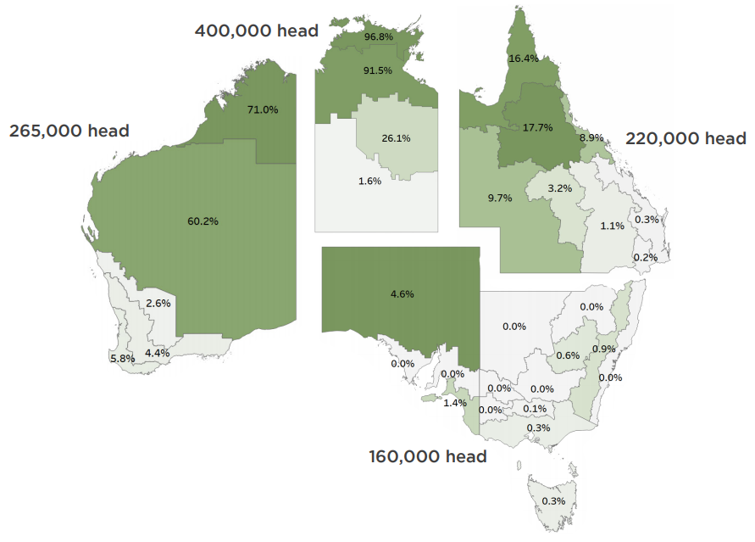
Source: Dalgleish, Agar & Hermann (2018)
In 2020, 72.3% of live cattle exports were on voyages from northern Australia to markets in South-East Asia, notably Indonesia and Vietnam (DAWE 2020). These markets typically import Bos indicus slaughter and feeder cattle. Bos indicus breeds are suited to warmer and tropical climates and are primarily sourced from Queensland and the Northern Territory. Distance to processing plants and the high cost of processing cattle in Australia’s remote north leaves few viable alternatives to live export when marketing cattle from northern Australia (MLA 2020).
Smaller by comparison is Australia’s export of Bos taurus type cattle which are mostly sourced from southern Australia and exported on long-haul voyages. In 2020, 27% of live cattle exports originated in this review’s southern focus ports (Figure 2). Bos taurus beef cattle exports are a mix of lightweight feeders, slaughter cattle and breeding cattle. Bos taurus dairy breeds are also exported from Australia. These are usually high-value animals exported by both air and sea, depending on the destination. The most common markets include China and Japan.
Figure 2 Number of cattle exported from all Australian ports v. southern focus ports, 2016-20
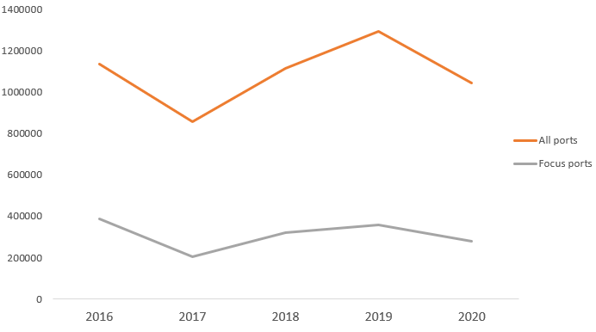
Source: DAWE (2021b)
For the period 2016-2020, long-haul voyages from southern focus ports have exported cattle to 9 destinations. China, Israel and the Russian Federation have dominated the long-haul trade, representing 95% of total exports by volume for the 5 years to 2020 (Table 2). Table 2 shows recent destination and volume data (2020) as well as destination and volume data for the 5 year period analysed in this review.
Table 2 Long-haul export destinations from Australian focus ports, 2020 and 2016-20
Destination | 2020 volume (head) | 2016-20 volume (head)
China | 129,637 | 593,273
Israel (Red Sea) | 37,475 | 277,437
Russian Federation | 30,973 | 137,021
Jordan (Red Sea) | 4,074 | 19,926
Qatar (Persian Gulf) | 2,963 | 10,156
Pakistan (Persian Gulf) | 2,729 | 6,025
Oman (Persian Gulf) | 2,625 | 5,278
Kuwait (Persian Gulf) | 1,179 | 4,617
United Arab Emirates (Persian Gulf) | 560 | 4,318
Total | 212,215 | 1,058,051
Note: For further information regarding focus ports and regions, please refer to Table 3.
A high proportion of cattle exported from southern focus ports are breeder cattle, including dairy cattle. For the period of this review, 60% of exports from southern ports were classified as breeders (Figure 3). By comparison, breeders only made up 14% of cattle exported from all Australian ports in 2020.
Figure 3 Number of cattle exported from Australian focus ports by class, 2016-20
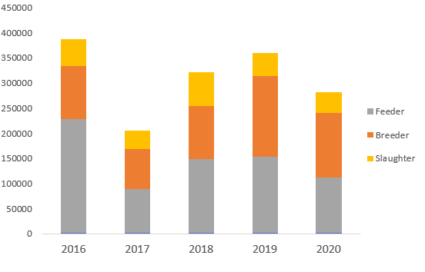
There are two main reasons why there is a high proportion of breeder cattle exported from southern Australia. Firstly, Victoria is a productive dairy region due to the cool temperate climate being suited to British and European high milk yielding dairy breeds. The temperate, mostly tick-free, climate of southern Australia also allows the production of Bos taurus cattle that grow more rapidly, mature earlier and in some opinions, produce superior quality meat compared with Bos indicus animals (Moore et al. 2015). The region has fertile soils and moderate to high annual rainfall which supports growing fodder crops on farm, reducing the requirement for purchasing feed.
Secondly, importers seeking quality beef and dairy Bos taurus breeding animals will source from southern Australia where supply is greatest. The cost of long-haul transport from southern ports is high, relative to shorter journeys from northern Australia. However, some importers are willing to pay the higher cost as a necessary part of the investment they are making in their herds. China’s interest in increasing the genetic profile of its national cattle herd, combined with its growing demand for European-style beef via feeder/slaughter cattle, has seen it continue to grow as a major destination for southern Australian cattle (Figure 4). Supply to many destinations has been negatively impacted due to COVID-19.
Figure 4 Export destinations for live cattle by number of head, 2016-20
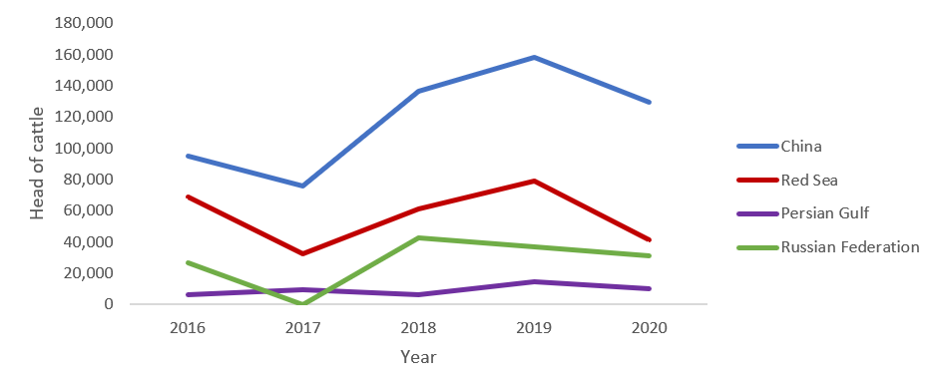
Source: DAWE 2021a

Bos taurus and Bos indicus cattle types
Bos taurus typically refers to British and European breeds of domestic cattle, and in Australia they are most often raised in southern regions. Bos taurus cattle are used for beef or milk production and breeds include Angus, Charolais, Hereford, Holstein-Friesian, Jersey, Limousin, Shorthorn and Simmental breeds. Bos taurus are most commonly exported on long-haul voyages for feeder, slaughter or breeder purposes (Sartori et al. 2010).
Bos indicus refers to cattle which originate in the Indian subcontinent. Bos indicus cattle are well suited to northern Australian climatic conditions due to their increased tolerance for heat. This is attributed to thinner hair coats, generally leaner body condition scores (BCS) and more skin surface area for evaporative heat loss. Bos indicus cattle exported from Australia are largely composed of Brahman, Brahman crosses and composite breeds. Bos indicus breeds and their crosses are exported to markets in South-East Asia as beef feeder or slaughter cattle (Sartori et al. 2010).

Overview of voyages
From 1 January 2016 to 31 December 2020 there were 214 long-haul voyages, consisting of 245 consignments carrying 1,019,563 Bos taurus cattle from southern ports of Australia.
Five ports of departure, 4 destination regions, 9 destination countries and 34 destination ports were identified. Focus ports of departure were Fremantle, Portland, Geelong, Geraldton and Port Adelaide, with destination countries being China, Israel, Jordan, Kuwait, UAE, Oman, Qatar, Pakistan, and the Russian Federation. Typical voyage routes are outlined in Map 1.
Map 1 Typical voyage routes from southern Australian ports to destination countries
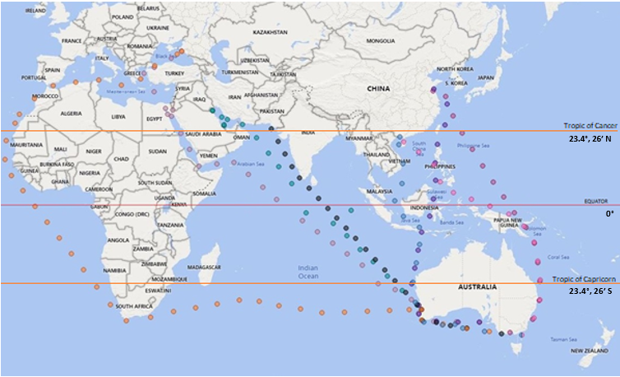
Destination countries were grouped by region to reflect similar voyage routes and environmental conditions likely to be experienced by cattle during voyages by sea (Table 3). As Pakistan-bound export vessels take a similar voyage route as those to Persian Gulf countries, Pakistan has been included in this region. One voyage in 2016 exported animals to both Israel and the Russian Federation and has been included in the Russian region due to the voyage length and route.
Table 3 Destination regions, countries and ports
Region | Country | Port
China | China | Beihai, Caofeidian, Dafeng, Dalian, Dongying, Fuzhou, Huanghua, Jingtang, Lianyungang, Macun Port, Ningbo, Qingdao, Qinhuangdao, Qinzhou, Rizhao, Shidao, Tangshan, Tianjin, Weifang, Xiamen, Yantai
Red Sea | Israel, Jordan | Ashdod, Eilat, Haifa, Aqaba
Persian Gulf | Kuwait, Oman, Pakistan, Qatar, UAE | Kuwait, Shuwaikh, Muscat, Sohar, Sultan Qaboos, Karachi, Doha, Jebel Ali
Russian Federation | Russian Federation | Novorossiysk
From 2016 to 2020, 31 vessels were used to export Bos taurus cattle from southern Australian ports to the specified regions. Frequency of use was variable, with one vessel undertaking just one voyage whilst another vessel undertook 20 voyages. On average, each vessel sailed 7 times.

Overview by class of cattle
Live export cattle are categorised according to end use. Feeder cattle are generally lighter as they will be fattened in the importing country prior to slaughter. In comparison, slaughter cattle are generally heavier with higher BCSs, as they are slaughtered a short period after arrival in destination country. Breeder cattle include cows, heifers and bulls intended to be used for breeding. Voyage data indicates the average weights for breeder and slaughter cattle are around 300kg and 550kg respectively. While exact figures are not available it is estimated that over 80% of breeder exports are dairy breeders.
Under ASEL, feeder and slaughter cattle must be certified as not detectably pregnant prior to export. Breeder cattle must be no more than 190 days pregnant at the scheduled date of discharge in the importing country. See Appendix A for further information on ASEL requirements.
The majority of voyages (60.7%) during the review period carried breeder cattle, with fewer voyages carrying feeder (20.1%) and slaughter (15.9%) classes (Table 4). Seven voyages carried more than one class of cattle (3.2%).
Table 4 Review voyages by cattle class
Cattle class | Count of class | Percentage
Breeder | 130 | 60.7%
Feeder | 43 | 20.1%
Slaughter | 34 | 15.9%
Combined feeder and slaughter | 5 | 2.3%
Combined feeder and breeder | 2 | 0.9%
Total | 214 | 100%

Each destination tends to consistently import the same classes of cattle (Figure 5). China has imported Bos taurus breeder cattle since 2001. Within the review period, an average of 23 voyages carrying breeder cattle to China travelled yearly. The export of slaughter cattle to China by sea is relatively new. It started in 2017 with 4 voyages of slaughter cattle. This increased to 12 slaughter cattle voyages in 2018. Within the review period, all voyages of Bos taurus cattle to the Red Sea region carried feeder cattle, with 5 voyages carrying both feeder and slaughter cattle and one voyage carrying both feeder and breeder cattle. Exports to the Russian Federation are typically feeder cattle. All shipments to Persian Gulf countries, with one exception, carried breeder cattle (Figure 5).
Figure 5 Overview of cattle class by destination
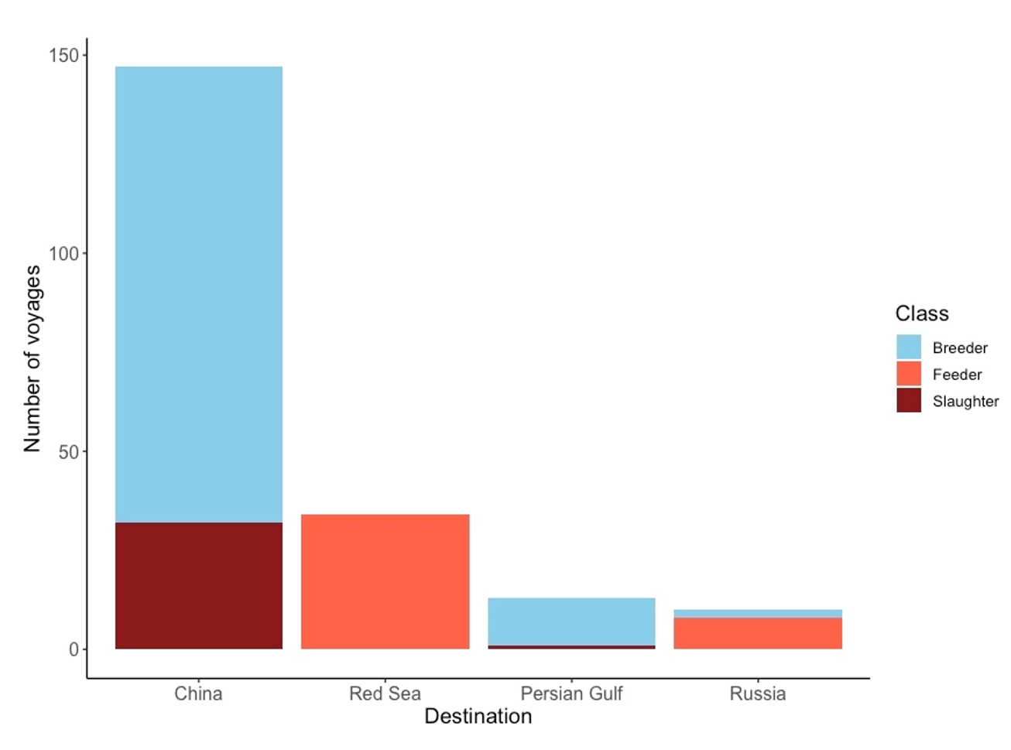

Overview by northern hemisphere season (NHS and NHW)
Of the 214 voyages, 123 (57.5%) departed from warmer conditions in Australia to the NHW. Exports to the Persian Gulf region and to the Russian Federation only occurred during this period. The remainder of voyages (42.3%) departed Australia in colder conditions and travelled to the NHS.

Overview by destination region
The average voyage duration for all regions was 21 days (Table 5). Voyages to China were typically the shortest (average 18 days), with Red Sea and Persian Gulf voyages only slightly longer in duration (23 and 24 days respectively). Voyages to the Russian Federation, whether via the Suez Canal or around southern Africa, were significantly longer in duration (average 38 days, longest 44 days).
Table 5 Number of voyages, cattle exported, voyage duration and mortality rates by region for the period 1 January 2016 to 31 December 2020
Factor | China | Red Sea | Persian Gulf | Russian Federation | Total
Voyages | 149 | 41 | 13 | 11 | 214
Cattle exported | 594,087 | 270,816 | 29,074 | 143,093 | 1,019,563
Average loaded | 3,987 | 6,605 | 2,236 | 13,008 | 4,764
Average duration (days) | 18 | 23 | 24 | 38 | 21
Average mortality rate | 0.20% | 0.20% | 0.18% | 0.28% | 0.20%
The smallest voyage in the period consisted of 230 head of cattle to the Persian Gulf. The largest voyage carried 17,507 cattle to the Russian Federation. Exports to China accounted for 69.6% of voyages and 58.3% of total head loaded. Voyages to China averaged 3,987 head compared to an average of 4,764 head for all voyages. Exports to the Red Sea region accounted for 19.2% of voyages and 26.6% of total head exported, averaging 6,605 head per voyage. The Persian Gulf region and the Russian Federation imported Bos taurus animals the least often, accounting for 2.9% and 14% of exported cattle, and were 6% and 5.1% of total voyages, respectively.
Table 6 Number of voyages, cattle exported, voyage duration and mortality rates for China by year for the period 1 January 2016 to 31 December 2020
Factor | 2016 | 2017 | 2018 | 2019 | 2020 | Total
No. of voyages | 25 | 19 | 36 | 38 | 31 | 149
Cattle exported | 92,629 | 75,487 | 130,221 | 162,753 | 132,997 | 594,087
Average duration (days) | 19 | 19 | 19 | 18 | 18 | 18
Average mortality rate | 0.15% | 0.12% | 0.31% | 0.18% | 0.18% | 0.20%
Mortality rate range | 0 to 0.64% | 0.03 to 0.33% | 0 to 1.51% | 0 to 1.36% | 0.05 to 0.67% | 0 to 1.51%
Voyages with no mortalities | 3 | 0 | 1 | 3 | 0 | 7

In 2016 to 2017, the number of Bos taurus cattle exported to China decreased due to short supply and high cattle prices. Trade volumes almost doubled in 2018 due to strong market demand for the recently established slaughter trade. The volume of cattle exported continued to increase in 2019 but reduced in 2020. It is likely that this was due to the impact of the COVID-19 pandemic.
Table 7 Number of voyages, cattle exported, voyage duration and mortality rates for the Red Sea by year for the period 1 January 2016 to 31 December 2020
Factor | 2016 | 2017 | 2018 | 2019 | 2020 | Total
No. of voyages | 6 | 6 | 11 | 11 | 7 | 41
Cattle exported | 51,200 | 28,902 | 60,803 | 72,788 | 39,616 | 253,309
Average duration (days) | 24 | 21 | 23 | 22 | 21 | 22
Average mortality rate | 0.38% | 0.13% | 0.14% | 0.22% | 0.17% | 0.20%
Mortality rate range | 0.16 to 0.66% | 0 to 0.3% | 0.03 to 0.34% | 0.03 to 0.8% | 0.02 to 0.38% | 0 to 0.8%
Voyages with no mortalities | 0 | 1 | 0 | 0 | 0 | 1

Export trends to the Red Sea region were similar to China. The number of Bos taurus cattle exported decreased significantly from 2016 to 2017 due to supply and price. In 2018, the volume of cattle exported doubled as supply eased and demand increased. In 2020, volumes exported to the region almost halved due to COVID-19 affecting trade.
Table 8 Number of voyages, cattle exported, voyage duration and mortality rates for the Persian Gulf by year for the period 1 January 2016 to 31 December 2020
Factor | 2016 | 2017 | 2018 | 2019 | 2020 | Total
No. of voyages | 4 | 3 | 1 | 3 | 2 | 13
Cattle exported | 5,719 | 6,672 | 1,397 | 9,353 | 5,933 | 29,074
Average duration (days) | 24 | 24 | 25 | 23 | 26 | 24
Average mortality rate | 0.13% | 0.30% | 0.14% | 0.13% | 0.15% | 0.18%
Mortality rate range | 0 to 0.33% | 0.12 to 0.46% | 0 | 0.09 to 0.21% | 0.1 to 0.2% | 0 to 0.46%
Voyages with no mortalities | 1 | 0 | 0 | 0 | 0 | 1

In 2016 to 2020, exports of Bos taurus cattle sourced from southern Australia to the Persian Gulf region only occurred during the NHW. The number of head exported increased slightly from 2016 to 2017. In 2018, numbers significantly decreased to less than a third of the previous year. Exports peaked in 2019 but significantly declined in 2020 due to COVID-19.
Table 9 Number of voyages, cattle exported, voyage duration and mortality rates for the Russian Federation by year for the period 1 January 2016 to 31 December 2020
Factor | 2016 | 2017 | 2018 | 2019 | 2020 | Total
No. of voyages | 2 | 0 | 3 | 4 | 2 | 11
Cattle exported | 34,319 | 0 | 40,962 | 36,839 | 30,973 | 143,093
Average duration (days) | 36 | 0 | 34 | 42 | 38 | 38
Average mortality rate | 0.43% | 0 | 0.27% | 0.16% | 0.38% | 0.28%
Mortality rate range | 0.41 to 0.44% | 0 | 0.17 to 0.44% | 0.08 to 0.22% | 0.34 to 0.41% | 0.08 to 0.44%
Voyages with no mortalities | 0 | 0 | 0 | 0 | 0 | 0
Despite no exports of Bos taurus cattle to the Russian Federation in 2017, exported cattle numbers increased from 2016 to 2018 then declined in 2019 and 2020 with exports only occurring from November to May.

Science of heat stress

Physiology of heat stress
High thermal heat load occurs when animals are subject to hot environmental conditions, especially when accompanied by high humidity, and cannot remove heat generated by metabolic processes in the body (Collins, Hampton & Barnes 2018). A possible outcome of excess heat load is heat stress, for which various definitions are available in scientific papers. According to De Rensis et al. (2015) heat stress occurs when an animal’s normal biological responses to hot conditions can no longer maintain body temperature at its resting level. The Meat and Livestock Australia (MLA) Veterinary Handbook describes heat stress as a state where animals are responding to excessive heat load (Jubb & Perkins 2019). A definition is also provided by Barnes et al. (2004):
Heat stress is a term used to denote a state where an animal is responding to adverse hot conditions. Under such conditions an animal can respond to the heat by making physiological changes and adjustments within the body, so that it can survive in that environment. These changes will act to keep critical systems and mechanisms within the body functioning. However, if the heat load experienced by the animal becomes excessive, the critical functions may no longer be maintained, and clinical disease, collapse and even death can result. Such a situation may be described as severe or clinical heat stress.
An animal’s behavioural and physiological response to high heat load seeks both to increase heat loss and decrease heat gain. The type and magnitude of the physiological and behavioural adjustments influence how well an animal is able to respond to hot conditions.
There is a relationship between the ambient temperature and core body temperature, evaporative heat loss rate, and metabolic rate of mammals as noted in Figure 6 (HSRA Technical Reference Panel 2019). The authors identified 4 zones of ambient temperature, with the narrowest being the thermoneutral zone (TNZ). Wider than this is the prescriptive zone, in which mammals are fully functional and can maintain their core temperature but as the ambient temperature increases, evaporative water loss must increase to reduce thermal heat load. In the zones outside the prescriptive zone, body temperature is no longer maintained with escalating hypothermia and hyperthermia.
Figure 6 Relationship between ambient temperature and body core temperature, evaporative heat loss rate and metabolic rate of mammals
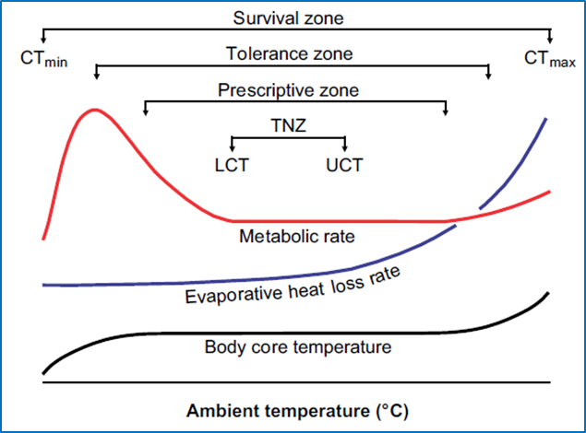
Source: Adapted from Figure 5 Mitchell et al. (2018) and cited by the HSRA Technical Reference Panel (2019)
Sparke et al. (2001) describe 4 means for animals to lose heat including radiation, conduction, convection and evaporation. When environmental temperatures increase toward animal skin temperatures, evaporation becomes the only route for heat loss.
The initial physiological responses in cattle to heat load aim to increase heat loss. These include redirecting blood to the periphery, vasodilation of skin blood vessels and vasoconstriction of vessels supplying internal organs. Evaporation occurs from the skin most effectively as sweat (Sparke et al. 2001). If the loss of heat from the skin is not sufficient to maintain a stable core temperature, additional heat can be lost from the respiratory membranes as the animal pants. The temperature at which panting is initiated to supplement the other heat loss mechanisms will depend on several factors, such as humidity or ventilation, and the effectiveness of initial physiological responses (Barnes et al. 2004). Panting occurs when the temperature and humidity increases because the effectiveness of evaporative heat loss from the skin is reduced. However, if there is high humidity, heat loss from panting becomes less efficient as there is little or no evaporative capacity (Sparke et al. 2001). Prior acclimatisation to heat will also affect how well the animal is able to use means other than panting to maintain normothermia.
In response to increased heat load, cattle will also seek to reduce heat production. Cattle voluntarily decrease feed intake in response to hot conditions. This may be by as much as 25% if fed high energy grain diets (Sparke et al. 2001), although some research suggests this reduction may be up to 100% in extreme heat (Barnes et al. 2004). A decline in dry matter intake has been reported to commence when ambient temperature reaches approximately 25°C to 27°C. However, this threshold is also influenced by diet type and composition (Lees et al. 2019).
Bos indicus cattle are known to be more heat tolerant than Bos taurus cattle. Heat tolerance varies between different genotypes of the same species of Bovidae (section 3.4.1).
Behavioural and physiological changes associated with heat stress in cattle vary according to the severity of the heat stress (Table 10).
Table 10 Behavioural and physiological responses to heat stress in cattle
Mild to moderate heat stress | Severe heat stress
Agitation/distress | Frothy discharge from mouth or nose (pulmonary oedema)
Depression | Ataxia
Tendency to seek shade | Refusal to move
Refusal to lie down or lying in any wet areas | Collapse
Crowding around water troughs | Convulsions
Increased water intake | Coma
Reduced feed intake | Death
Increased respiratory rate | -
Open mouth panting | -
Increased heat rate | -
Elevated rectal temperature | -
Excessive salivation | -
Source: Jubb & Perkins (2019); Parkinson et al. (2019)
We note that there are differing views on what constitutes whether an animal is ‘heat stressed’. Despite much scientific research over many years on the subject of heat stress in livestock, there is yet to be any scientific consensus that clearly identifies the point when an animal changes from responding to increased heat (being heat affected) to being ‘heat stressed’. Heat stress at the extremes appears to be clearly identified, however, the transition point and the impact of duration and respite remain undefined.
In the Animal Welfare Indicators Pilot for the Livestock Export Industry Supply Chain (Collins et al. 2021), industry proposed a range of indicators to assess the ability of livestock to cope with periods of heat and humidity and to better understand the welfare impact of heat. Indicators included panting score, feeding behaviour score, posture, resting, drinking and ruminating. This pilot proposed twice daily recording of panting scores and other measures during voyages, as this would improve the ‘understanding of the welfare impacts of thermal loading in a live export context, as well as the degree and duration of heat that types of livestock can cope with and respond to’.

Assessing heat load

Measuring heat load in the environment
Thermal load can be measured through WBT, Temperature Humidity Index (THI), Heat Load Index (HLI) and Equivalent Temperature Index (ETI). As noted by Collins, Hampton & Barnes (2018), numerous studies have used WBT as the measurement to assess heat load in live animal exports as it incorporates both air temperature and humidity. This is relevant because an animal’s ability to dissipate heat via evaporative means is highly dependent on the level of moisture in the air.
The THI has been widely used to assess heat load in animals (Beatty 2005). According to Collins, Hampton & Barnes (2018) the THI is a calculated index which weights dry bulb and wet bulb temperatures for comparison with animal performance. Its effectiveness in the live export setting is questioned, however, because it does not include important climatic variables, such as airflow and solar load, or animal factors (Gaughan et al. 2008). The THI is not currently used by industry or the department in assessing the risk of heat stress during live export.
The HLI was developed for use by the feedlot industry to assess thermal stress (Gaughan et al. 2008). The base HLI defines a threshold for a reference animal – a black Angus steer, 100 days on feed, BCS of 4+ and no access to shade. The HLI threshold for the reference animal is adjusted up (more heat tolerant) or down (less heat tolerant) for variables such as breed, physiological state, type of feed and temperature of drinking water. It is not currently used to assess heat on live export vessels but provides a simple means to compare heat tolerance.
The Australian feedlot industry uses a web-based service providing weather and heat load forecasts to feedlot operators, called The Cattle Heat Load Toolbox. The model integrates weather station data to predict the Accumulated Heat Load Units (AHLU). The AHLU give an indication of the amount of heat that is accumulated by an animal when it is exposed to hot environmental conditions. AHLU incorporate factors such as intensity and duration of heat, the opportunity to dissipate heat, animal factors and mitigation measures (Burchill et al. 2021). This model is not currently used to assess heat load on live export vessels.
The ETI is a mathematically derived, environmental measure of heat load. It is referenced in the MLA Veterinary Handbook (Jubb & Perkins 2019) and described in an industry publication on ventilation in export vessels (MAMIC 2001). ETI incorporates dry bulb temperature (DBT), relative humidity and wind speed. The ETI is highly correlated with WBT, whereas the THI may be considered as closer to an arithmetic average of DBT and WBT. While ETI is a potentially useful measure of heat stress, the relative complexity of the index against the simple measurement of WBT alone, and the close agreement between ETI and WBT for the regions of interest during export voyages, mean that WBT alone is preferred as a single, practical measure of heat stress potential on board export vessels (MAMIC 2001).

Duration of increased heat load
Duration is an important factor in heat stress but is currently not well defined. Heat stress can result from short periods of extreme heat or extended periods of hot conditions (Collins, Hampton & Barnes 2018). Diurnal and day-to-day variation in deck WBT means that periods of heat stress might be interspersed by respite periods, such as overnight, during which an animal’s physiology can recover. The welfare impacts for cattle experiencing periods of increased WBT are likely to be more severe if there is no respite. However Collins, Hampton & Barnes (2018) and the HSRA Technical Reference Panel (2019) noted that no studies have been conducted on the necessary duration of respite periods needed to protect livestock from heat stress.
The department was unable to assess the effect of duration of increased heat load in this review because daily voyage reports under ASEL 2.3 only required a single daily measure of WBT, DBT and humidity for each deck/hold. Under ASEL 3, daily minimum and maximum WBT, DBT and relative humidity (by deck/hold) is required. For this analysis, the full range of temperatures experienced in any 24 hours was not available. It is possible that cattle experienced periods of respite from hot conditions between daily temperature measurements.

Measuring increased head load in animals
The assessment of increased heat load is best determined from the effects of heat on the animal’s behavioural and physiological responses. An obvious method is the measure of core body temperature, but this is impractical for shipped animals. Panting score is a frequently used practical measure, although panting is both a response to increased thermal exposure and an indication that the animal continues to require heat loss to maintain homeostasis (HSRA Technical Reference Panel 2019).
With increasing heat load, Jubb & Perkins (2019) explain that cattle will sweat, drink more water and increase their respiratory rate. On board export vessels, animals may move towards ventilation fans and away from ship structures that radiate heat near pen areas. Feed intake and rumination is often decreased which may assist in lower metabolic heat output. These physiological and behavioural signs can be useful in assessing livestock response to heat.
Panting scores are a non-invasive, non-intrusive visual tool that may be used in conjunction with respiratory rate and effort as an index of heat stress (HSRA Technical Reference Panel 2019). Gaughan et al. (2008) outlined a panting score table for cattle. A slightly modified version is provided in the MLA Veterinary Handbook and was recommended for continued use by the TAC (Table 11). According to the MLA Veterinary Handbook (Jubb & Perkins 2019), when assessing cattle, if more than 10% of animals have a panting score of 3.5 or higher, then there is a potential for serious losses if steps are not taken quickly to allow animals to dissipate heat.
Table 11 Panting score used in the assessment of heat stress in cattle
Breathing pattern | Panting Score | Respiratory Rate (breaths per minute)
Normal – no panting, difficult to see chest movement | 0 | <40
Slight panting, mouth closed, no drool or foam. Easy to see chest movement | 1 | 40–70
Fast panting, drool or foam present. No open mouth panting | 2 | 70–120
As for 2, but occasional open mouth panting. Tongue not protruding | 2.5 | 70–120
Open mouth + some drooling. Neck extended and head usually up | 3 | 120–160
As for 3 but with tongue out slightly and occasionally fully extended for short periods. Excessive drooling | 3.5 | 120–160
Open mouth with tongue fully extended for prolonged periods + excessive drooling. Neck extended and head up | 4 | >160
As for 4 but head held down. Cattle “breathe” from the flank. Drooling may cease | 4.5 | Variable – RR may decrease
Source: MLA Veterinary Handbook (Jubb & Perkins 2019) adapted from Gaughan et al. (2008)

Managing increased heat load

Stocking density and pen space allocation
Stocking density considerations relevant to Australian livestock exports were discussed extensively by the TAC during the 2018 ASEL sea review:
It is universally accepted that the amount of space provided to animals during periods of confinement is critically important for their health and welfare. Stocking density governs important elements of body posture and behaviour, including social interaction. It also affects access to fodder and water, influences susceptibility to disease and has a strong influence on heat load experienced by confined animals (ASEL Review Technical Advisory Committee 2018).
Allometry is the study of the relationship between body size to animal shape and behaviour. The TAC recommended that allometric principles were incorporated into ASEL 3 for calculating pen space allocations, with the proviso that no animal will receive less space than under ASEL 2.3.
For cattle, the TAC determined that animal welfare outcomes on most export voyages could be improved if animals are provided with more space. The TAC recommended that the default pen space allocation for cattle voyages be based on a “k” value of 0.030. This was implemented in ASEL 3.
Other considerations also impacting pen space allocations for cattle exported from Australia include latitude of departure, time of year, pregnancy status, breed, horn length, weight thresholds and exporter performance. Under ASEL 2.3, pen space allocation for cattle differed depending on the departure port and time of year. In some circumstances, Bos taurus cattle also required a stocking density as per a HSRA (outlined below). Cattle with excessive horn length could only be exported with approval. Under ASEL 3 additional requirements were implemented, including for an approved management plan for heavy (over 500kg) cattle, cattle with excessive horn length and pregnant cattle in some circumstances. An alternative (reduced) pen space, equivalent to ASEL 2.3 pen space, was retained for demonstrated high performing exporters.
For pen space allocation purposes, Australian departure ports are divided into ports north of latitude 26° South (northern ports) and those south of latitude 26° South (southern ports). Figure 7 shows the relationships between the pen space allocations for voyages that depart southern Australian ports during NHS and those that depart during the NHW, under ASEL 3.
Figure 7 ASEL 3 pen space allocations for voyages departing from south of latitude 26˚ south - NHS v. NHW with alternative pen space options included
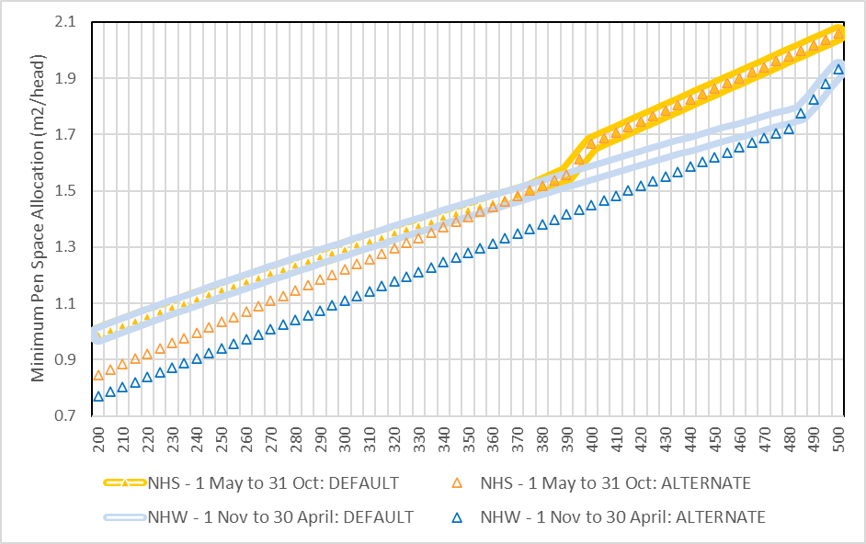
Alternative pen space allocations are available to exporters who meet the criteria set out in department’s Alternative Minimum Pen Space Allocation Policy.
For exports departing in the NHS, the default and alternative pen space allowances are the same for cattle over 370kg. For exports departing in the NHW, the default and alternative pen space allowances are the same for cattle over 485kg. This aligns with the TAC’s recommendations and is a result of the minimum pen space allowances under ASEL 2.3 for heavier cattle being greater than the pen space allowance calculated using the allometric formula with a k value of 0.030.
Pen space allowances make some provision for a normal range of climatic conditions, but not for exposure to periods of high heat and humidity. Efforts to manage this welfare risk factor have been made through the application of a HSRA model. MLA developed a proprietary HSRA model called ‘HotStuff’ which manipulates stocking densities depending on a variety of inputs. It relies on climatology data from specific export routes and destinations. The most recent version in use, ‘HotStuff’ Version 4, was released in 2012 and has been applied to sheep and cattle exports to the Middle East. ‘HotStuff’ Version 4 does not include climatology data for non-Middle East countries so is not applicable to many of the destinations considered in this report. The TAC recommended ‘HotStuff’ be upgraded to cover all destinations for Australian livestock exported by sea. The recommendation was accepted by the Australian Government, however, at the time of writing an updated version of ‘HotStuff’ has not been released.

Impacts of stocking density on heat stress
There are direct and indirect impacts of stocking density on heat stress. The more cattle that are in a pen or on the deck of a ship:
- the more metabolic heat is produced per cubic metre of pen/deck space, which drives up the WBT of the immediate environment – called ‘wet bulb rise’
- the more the bodies of the cattle physically obstruct the flow of air through the pen, reducing the removal of metabolic heat and humidity generated from respiration and the pad
- the more urine and faeces per square metre is added to the pad, leading to higher humidity and associated WBTs
- the less space there is for cattle to adopt an optimal posture for heat loss (typically standing and physically separated from animals around them)
- the more difficulty cattle may have freely accessing water when required.

Mitigation measures
Voyage reports frequently acknowledged crew proactively and reactively used a variety of mitigation measures for hot conditions, to improve livestock welfare. These measures included washing decks, wetting cattle, alternating vessel path, deploying fans, opening hatches on decks, rearranging/moving animals, minimising unnecessary handling and altering the provision and type of fodder. Industry publications including the MLA Veterinary Handbook (Jubb & Perkins 2019) and the LiveCorp Shipboard Stockies Guide (LiveCorp 2020) detail mitigation measures to assist livestock in hot conditions.
Lees et al. (2019) state ‘the provision of alleviation strategies is paramount in supporting animals to achieve comfort’. They note that environmental modification to mitigate heat load has traditionally focused on reducing solar radiation by using shade structures and increasing air movement around livestock. We understand that while shade provision to reduce solar radiation may be an important strategy in the feedlot industry, it is of less relevance on live export vessels where cattle are housed on decks, and is therefore not discussed further in this review.
Mitigation measures employed during a voyage can be grouped into the following categories:
- modification of the environment surrounding livestock (changing stocking densities, provision of air movement, wetting cattle and pad management)
- nutritional management
- reducing other stressors.
Risk management measures were occasionally noted to begin at loading with the placement of higher risk cattle in the best ventilated pens. Adjustments to stocking densities were frequently reported where cattle were rearranged or moved in response to hot conditions or ‘hotspots’, such as pens in proximity of the vessel’s engine. For example, on one voyage ‘[the crew] reduced density in pens by spreading animals between pens and opening gates between pens to create more space’ and ‘crew moved animals from closed decks to open decks where possible’. On occasion, movement of animals was noted prior to expected hot conditions, presumably to minimise handling during peak heat load. These measures aimed to reduce stocking densities and therefore reduce the impact of metabolic heat production.
Voyage reports noted that crew often deployed fans to increase air movement during hot conditions. An IO noted ‘there was a specific equatorial plan for high temperature periods involving zig-zagging the vessel to increase air flow through the decks, the installation of fans for some pens and a program of washing down cattle decks and pens.’ One AAV reported ‘extra fans were placed in ‘hotspots’ and in front of higher risk animals … after recognising some areas as being hotter than others’.
The LiveCorp Shipboard Stockies Guide (LiveCorp 2020) suggests ensuring ventilation systems are functioning to full capacity and identifying ventilation dead-spots such as bulkheads, as strategies for heat mitigation.
Wetting cattle during a voyage was occasionally noted in voyage reports. Wetting enhances the impact of air movement in cooling animals, with the benefit coming from the evaporation of water from the skin surface (Brown-Brandl & Tami 2018). This paper states that to maximise heat loss when wetting cattle, the hair coat of the animal must be saturated to the skin surface and then allowed to dry completely. Misting tends to set on the top of the hair coat and does not have the same effect as saturation. Voyage reports did not contain detail on whether this degree of wetting was achieved or its efficacy as a mitigation measure. A study by Gaughan et al. (2008) investigated the effectiveness of water application and air movement as a heat mitigation tool for cattle. It concluded that actively cooling cattle after maximum ambient temperature occurred was more effective than cooling at the actual time when ambient temperatures peaked. Combined wetting and ventilation as key management strategies were confirmed in this study.
Deck washing is a routine husbandry practice during long-haul voyages to manage the pad. It is employed as a management strategy as a wet pad can contribute to lameness problems and also be a source of heat and humidity. During warm, humid conditions, cattle drink more and urinate more which means pads may become wet and sloppy with limited ability to dry. Deck washing removes the pad and may have an added benefit of directly cooling deck infrastructures, depending on the extent that water temperature is below deck temperatures (MAMIC 2001).
The frequency of deck washing varied from every second day to a couple of times during a voyage. Washes were commonly employed as the vessel neared the equatorial region. The effectiveness of washing decks as a mitigation strategy during hot conditions was occasionally reported. One voyage report stated ‘all pads remained firm until the equator, where increased humidity caused the pens to become clay or mud-like, to sloppy. Three-day wash cycles, for most of the voyage, ensured the health and welfare of the animals’.
Control over both the provision of water and feed are potentially important in managing heat stress risk. Voyage reports have noted crew regularly assessing the number and placement of water troughs during hot periods. This has been enhanced by the adoption of automated watering systems on 29 of the 31 voyages analysed. Savage et al. (2008) stated that offering chilled water to animals may be a useful method to decrease body temperature during times of high heat load but noted that cattle will drink greater volumes of warm water. The department would welcome feedback on the efficacy and practicality of chilled water as a heat mitigation measure on board livestock vessels.
Altering the energy content of feed and the timing of feeding has been shown to influence body temperature and heat tolerance (Mader et al. 2015; Barnes et al. 2008). Cattle are known to reduce feed intake during hot conditions, which reduces the heat generated by metabolic digestion (Sparke et al. 2001). One voyage report stated a temporary feed reduction was used effectively to manage heat load in equatorial zones. Reducing the energy content of feed, usually by increasing the roughage component, was commonly noted. Lees et al. (2019) discuss dietary management strategies for cattle during hot conditions, particularly in the feedlot and dairy industries. Strategies include use of feed additives such as betaine, probiotic yeast supplements and antioxidants, as well as managing the proportion of roughage in the diet and altering feeding time to reduce metabolic heat loads during the hottest hours of the day. Lees et al. (2019) state there is considerable variability in the success of these techniques during heat load periods and that further studies are required to ensure the appropriateness of nutritional supplements as a heat load mitigation tool.
The use of electrolytes was noted on a couple of voyages. Electrolytes are generally found in water and feed in sufficient quantities to meet physiological needs. Studies by Barnes et al. (2004) and Barnes et al. (2008), showed that the use of electrolytes resulted in a moderate, short-term increase in water and feed intake in some classes of animals. However, results have been difficult to replicate, with other studies indicating there is little benefit above offering palatable water (Beatty 2005). Further, a study by Banney et al. (2009) indicated that the use of electrolytes may increase urination, making their use an additional consideration for bedding management.
Voyage reports often mention minimising unnecessary handling and disturbance of animals to avoid unnecessary physical exertion. This management practice, particularly if used in combination with other practices outlined above, could reduce the impact of hot conditions.
Determining the effectiveness and appropriate use of mitigation measures is outside the scope of this review. Further analysis to determine the most effective mitigation strategies to manage heat stress risk is recommended.

Animal factors influencing heat tolerance
The review of the literature and targeted consultation highlighted the animal factors that may influence an animal’s ability to tolerate heat.

Genotype (Bos indicus v. Bos taurus)
Bos indicus cattle are more heat tolerant than Bos taurus cattle. This has been demonstrated extensively in scientific studies (Barnes et al. 2004; Gaughan et al. 2010; Islam et al. 2020) where, under similar conditions, Bos taurus showed more clinical signs of increased heat load compared to Bos indicus. This is attributed to Bos indicus having thinner and shorter coats, generally leaner BCSs, lower metabolic rates and greater skin surface area for evaporative heat loss (Adams & Thornber 2008).
Field studies in Australian feedlots have shown pure and crossbred Bos taurus cattle have higher panting scores at the same HLI compared to Bos indicus cattle (Gaughan et al. 2010). Islam et al. (2020) also examined panting as an indicator of heat stress in cattle. No effect of sex, body weight or docility score was found for individual cattle, however, panting duration was less for Bos indicus and Bos indicus crosses (>50% Bos indicus).
A voyage stocking both Bos taurus and Bos indicus cattle in 1995 reported a mortality rate of >28.4% and identified heat stress as a significant cause (More, Stacey & Buckley 2003). All mortalities were Bos taurus type cattle suggesting genotype was a significant heat stress risk factor. Data from this voyage formed part of the body of evidence used to create industry’s HSRA software, ‘HotStuff’.

Body condition score and fat deposition
Larger animals with higher BCSs have more difficulty dissipating heat (McCarthy & Banhazi 2016). Approximately 70 to 80% of evaporative cooling in cattle occurs through the skin. The greater the surface area, the more effective the evaporative cooling process. In relative terms, surface area to volume ratio decreases as an animal becomes fatter. Consequently, larger animals have a reduced capacity compared to smaller animals for heat loss from the body (Adams & Thornber 2008).
Obesity or fatness is also recognised as a risk factor because fat has strong insulating properties. Fat has low thermal conductivity and lower blood supply therefore there is less ability for heat to dissipate from and via fatty tissues (Adams & Thornber 2008).

Acclimatisation
Animals are capable of modifying their behavioural, physiological and morphological characteristics, or a combination of these, in response to the thermal environment (Lees et al. 2019). Acclimatisation is the process of adaptation by an animal to certain environmental conditions. According to Barnes et al. (2004), it involves changes to the animal’s metabolic rate as well as changes to the skin surface and the animal’s coat. Significant differences in heat production from acclimatised versus non-acclimatised cattle have been demonstrated (Robinson, Ames & Milliken 1986). Literature indicates that acclimatisation in cattle starts within 2 weeks of exposure to conditions and takes 4 to 7 weeks to complete (Adams & Thornber 2008). Bianca (1959) demonstrated that exposure of calves to either a hot-dry or hot-humid environment for various daily periods over 3 weeks resulted in acclimatisation with increased rates of sweating and lower metabolic heat production. Long-haul voyages in this review from southern Australian ports take around 3 weeks, except for voyages to the Russian Federation, which are longer. This is unlikely to be sufficient time for acclimatisation particularly because of the variability of climate conditions over the course of a voyage. Collins, Hampton & Barnes (2018) suggest acclimatisation to heat or cold should be in place before voyage departure.

Coat colour and length
Coat colour will influence the extent to which an animal absorbs solar radiation and is a major factor in heat tolerance (Gaughan et al. 2008). The influence of coat colour on heat tolerance was studied by Islam et al. (2020) who found that white coloured cattle panted less during the day than dark or tan coloured cattle. Coat colour is less important in the live export setting except where cattle on open decks are exposed to direct sunlight.
Coat length can adversely affect an animal’s ability to shed heat through evaporative heat loss (McCarthy & Banhazi 2016). Therefore, cattle with longhair coats are more likely to accumulate heat (Jubb & Perkins 2019). Longer coats can be a breed characteristic of Bos taurus breeds or typical of animals acclimatised to cooler conditions.

Concurrent illness
Sick and recovering cattle are more susceptible to heat stress (Gaughan et al. 2008). Lees et al. (2019) noted that ‘the health status of an animal can significantly influence the ability to cope with heat load conditions’. A study by Brown-Brandl et al. (2006) reported that animals with a previous treatment history for pneumonia, anytime from birth to slaughter, had respiration rates that were on average 10.5% higher compared to those never diagnosed or treated. The net effect of fever related to illness and concurrent exposure to heat load increases the risk of adverse outcomes including death.
The most common cause of mortality during live export was reported as BRD (Moore et al. 2015). BRD negatively impacts an animal’s ability to utilise evaporative cooling via the respiratory tract which may increase their susceptibility to heat stress. Similarly, increased heat load can also impact an animal’s immune response to disease (Bagath et al. 2019).

Diet
Cattle voluntarily decrease feed intake in response to hot conditions. Sparke et al. (2001) found that cattle fed a high energy grain diet decreased their feed intake by as much as 25%. Barnes et al. (2004) noted that in hot conditions (32°C WBT) Bos taurus cattle were ‘eating virtually nothing’. A decline in dry matter intake (DMI) has been reported to commence when ambient temperature reaches approximately 25°C to 27°C. However, this threshold is also influenced by diet type and composition (Lees et al. 2019).
The energy density of feed can influence heat tolerance. One study demonstrated that cattle fed a highly fermentable diet exhibited more signs of heat stress compared to cattle fed a slowly-fermentable diet under the same environmental conditions (Kennedy 2008). The HLI studies indicate that cattle on grain fed diets are more susceptible to heat however McCarthy & Fitzmaurice (2016) suggests that this is ‘a proxy for both bodyweight and fatness. Both bodyweight and fatness are likely to increase with days on feed’.
ASEL 2.3 required that the shipboard ration must not contain more than 30% by weight of wheat, barley or corn, unless the livestock had been adapted to the ration over a period of at least 2 weeks before export, and for those exported from southern ports, at least 1% of the feed was to be chaff or hay. ASEL 3 applied the requirement for chaff or hay to all cattle voyages and increased the amount to at least 2% for extended long-haul voyages.
The influence of diet on heat tolerance is well recognised within the live export industry. Targeted consultation indicated that slaughter cattle are often fully or partially grain-fed, and this practice likely increases for this class when exported in autumn and winter. Idris et al. (2021) stated that cattle susceptibility to heat stress is increased for those ‘kept on high levels of nutrition for the purpose of maximising growth rates’.
A common mitigation measure during times of high heat load is to ‘temporarily reduce or cease feeding of concentrate and consider a higher roughage proportion in ration’ (Jubb & Perkins 2019).

Age
Very old or very young animals have reduced ability to tolerate heat due to impaired or immature thermoregulatory systems (Hartman 2015). Under ASEL 3, cattle less than 200kg sourced for export by sea require a light cattle management plan approved in writing by the department and must reach an individual liveweight of 200kg prior to export. The management plan must outline measures to manage health and welfare of light cattle during preparation. The export of very old or very young cattle rarely occurs.

The Heat Load Index (HLI)
The HLI threshold demonstrates differences in heat tolerance of different genotypes and the influence of other factors such as health status, days on concentrate feed, acclimatisation and drinking water temperature. The HLI threshold at which an animal gains heat was defined for a reference animal: a grain fed, healthy, black Bos taurus steer with a BCS of 4+, with no access to shade. Adjustments to the reference HLI threshold for different variables are also defined (Table 12). Some variables, such as Bos indicus breed, can increase heat tolerance, shown as a positive adjustment in the table, whereas some factors such as illness or lack of acclimatisation can reduced tolerance, showing as a negative adjustment.

Table 12 Animal and management adjustments to the HLI threshold of the reference animal (healthy, unshaded Angus steer, 100 days on feed)
Item | Relative effect on HLI threshold of reference steer
Bos taurus (British) | 0
Bos taurus (European) | +3
Bos indicus 50% | +7
Bos indicus 100% | +10
Healthy | 0
Sick/recovering | −5
Acclimated | 0
Not acclimated | −5
Days on feed 0–80 days | +2
Days on feed 130+ days | −3
Drinking water temperature: 15–20°C | −1
Drinking water temperature: 21–30°C | 0
Drinking water temperature: 31–35°C | −1
Source: Gaughan et al. (2008)
The HLI shows that sick, unacclimatised and grain-fed animals (>130 days) are more susceptible to heat stress. The influence of drinking water is also noted and is discussed in more detail in section 3.3.

Cattle thermoregulation
Thermoregulation is the mechanism by which animals, in this case cattle, maintain a stable core body temperature independent of external temperature variation. Thermoregulation utilises a range of physiological and behavioural mechanisms that assist an animal to maintain its core body temperature within a narrow range for optimal functioning of body processes. For cattle, the core body temperature range is between 36.7°C and 39.1°C (Cunningham 2002).
Cattle are most productive when the temperature of their environment stays within the TNZ. The TNZ is the range of ambient temperatures within which an animal can maintain its body temperature, with no requirement to either increase heat production or heat loss. Bounding the TNZ is the lower critical temperature (LCT) and the upper critical temperature (UCT). Mitchell et al. (2018) state the LCT and UCT are not tolerance limits but rather, they are points beyond which animals must use active physiologic responses to maintain thermoregulation. In addition, the TNZ and its boundary points may be quite variable and will depend upon many factors including wind chill, wet or dry coat, coat length, BCS, age, concurrent illness, nutrition and acclimatisation. In this sense, the TNZ is an elastic zone with flexible upper and lower boundaries (Wagner 1988). Section 3.2 discusses the TNZ and other thermoregulatory zones.

Heat stress thresholds
Maunsell Australia Pty Ltd (2003) described the HST as ‘the maximum ambient WBT at which heat balance of the deep body temperature can be controlled using available mechanisms of heat loss’. This is supported by Barnes et al. (2004) who state that the HST is the WBT at which cattle are no longer able to maintain their normal body temperature. These definitions would suggest that the HST itself is not a measure of poor welfare but rather the maximum temperature at which an animal maintains homeostasis.
For this review, we did not seek to determine temperatures for HSTs for exported live Bos taurus cattle. The literature review identified a range of WBTs that could be considered too hot and may contribute to poor welfare. This guided our analysis. The assessment of increased heat load was not specific to recorded WBTs but based on voyage reports of physiological and behavioural responses to heat. This section of the report provides a summary of Bos taurus cattle HSTs reported in the literature.
Barnes et al. (2004) conducted a series of experiments to describe the physiology of heat stress in cattle and sheep. The experiments held Bos taurus cattle weighing between 300–400kg, in temperature controlled-rooms where the WBT was gradually increased to a peak of 32°C and then maintained for 5 days. The experiments showed that the mean body temperature of 39.5°C was consistently exceeded at ambient temperatures between 28°C and 30°C WBT. At 32°C WBT, cattle demonstrated clinical signs of heat stress including depression, inappetence, drooling, increased respiratory rates and open mouth panting.
More, Stacey & Buckley (2003) investigated the maiden voyage of the MV Becrux carrying sheep and cattle from Australia to the Middle East. The cattle mortality rate was >28.5% with all mortalities being Bos taurus cattle. While Bos indicus cattle may have experienced heat stress during this voyage, they did not die. The authors estimated the HST of the cattle was ‘probably no greater than 27°C WBT, and possibly lower, for many of the cattle due to a range of factors including complete lack of acclimatisation, high condition scores’. The HST of the Bos taurus cattle on this voyage was estimated to be 7.3°C WBT lower than Bos indicus cattle.
An industry paper describing the development of the HRSA model ‘HotStuff’, provides a table of HSTs for various breeds of cattle (Table 13) (Maunsell Australia Pty Ltd 2003). According to this research, a 300kg Bos taurus beef breed with a BCS of 3, a mid-season coat and spring/summer acclimatised for southern Australia has a HST of 30°C WBT. A Bos taurus dairy breed with the same characteristics has a HST of 28.2°C WBT. Bos indicus and Bos indicus crosses by comparison have higher HSTs than Bos taurus cattle.
Table 13 also lists mortality limits (MLs) which are described as the WBT at which an animal will die. It is important to note that the difference between the base HST and the base ML ranges from 3.2°C to 4.7°C WBT.

Table 13 Base heat stress threshold and mortality limit values
Base Parameter |  | Bos taurus |  | Bos indicus
Base Parameter |  | Beef | Dairy | Beef | 25% indicus | 50% indicus
Weight (kg) |  | 300 | 300 | 300 | 300 | 300
Core temperature (°C) |  | 40 | 40 | 40 | 40 | 40
Body condition score (BCS) |  | 3 | 3 | 3 | 3 | 3
Coat |  | Mid | Mid | n/a | n/a | n/a
Acclimatisation (WBT) |  | 15 | 15 | 15 | 15 | 16
Base HST (WBT) |  | 30 | 28.2 | 32.5 | 31.25 | 31.875
Base ML (WBT) |  | 33.2 | 32.9 | 36.0 | 34.6 | 35.3
Source: Maunsell Australia Pty Ltd (2003)
*n/a Not applicable
The MLA Veterinary Handbook (Jubb & Perkins 2019) provides guidance on WBTs with regards to heat stress (Table 14). It notes that Bos taurus cattle are comfortable below 26°C WBT but that over 30°C WBT is considered a ‘danger’ zone.
Table 14 WBT risk criteria for heat stress on export vessels
 | Safe | Caution | Danger
Bos indicus cattle | < 28°C | 28–31°C (non-acclimatised)  30–33°C (acclimatised) | >31°C (non-acclimatised)  >33°C (acclimatised)
Bos taurus cattle | <26°C | 26–30°C | >30°C
Source: Jubb & Perkins (2019)

Heat load voyage analysis
Industry submissions, the literature review and the data available from end-of-voyage, daily and IO reports identified 4 possible risk factors that may be associated with increased heat load and heat stress-related mortalities. These were:
- cattle class - breeder, feeder, slaughter
- season of departure - either NHW or NHS or April, May, June season (AMJ season)
- destination region - China, Persian Gulf, Red Sea, the Russian Federation
- departure port - Portland, Geelong, Port Adelaide, Fremantle, Geraldton
The objective of this analysis was to adopt an epidemiologically-sound approach to determine any association between these risk factors and increased heat load or heat stress-related mortalities on long-haul voyages of Bos taurus cattle from southern Australia. The partitioning of the effect of these 4 factors (class, season, destination and departure port) on increased heat load and heat stress-related mortalities was to allow the exploration of increased heat load and heat stress-related mortality separately, rather than relying only on mortality as a welfare indicator.
The department collated data from voyages that reported signs of increased heat load and/or heat stress-related mortality.
Our case definition for a voyage reporting increased heat load was ‘any voyage where daily reports recorded behavioural and physiological responses to increased heat’. The behavioural and physiological signs that indicated cattle were thermoregulating included any combination of the following: reports of increased water consumption, decreased feed consumption, increased respiratory rate/character, increased panting score/heat stress score or heat stress-related morbidity/death. Alterations in food or water consumption alone were not considered conclusive evidence of a physiological response to heat. The department’s analysis of voyages recording instances of heat load is discussed in section 4.2.1.
Our case definition for a voyage reporting heat stress-related mortality was ‘any mortality where the cause of death was reported by the AAV or stockperson to be due to heat stress or associated with heat stress’. The department’s analysis of voyages reporting at least one heat stress-related mortality is discussed in section 4.2.3.
We found that determining the occurrence of heat stress as distinct from a normal physiological response to heat was challenging:
- Science has not yet determined the explicit moment or threshold that cattle become heat stressed, and existing views among stakeholders interested in the livestock export trade vary significantly. This moment or threshold varies between species of cattle, and with other factors, for reasons discussed in section 3.4.
- Under ASEL 2.3, reporting requirements for daily voyage reports were limited:
  - A single measure per day of respiratory character (normal, panting or gasping) was the minimum heat stress-related reporting requirement. In some cases this may have been presented as a single measure per deck. Around 2018-19 some exporters voluntarily included daily deck heat stress measures and/or panting scores in voyage reports. Rankings were not necessarily consistent and it is unclear what panting score system was used (possibly that described in the MLA Veterinary Handbook).
  - A single measure of respiratory character or panting score per voyage or per deck per day means the reporter provided an ‘averaged’ reading even if it applied across species. This measure does not provide any information about the range of behaviours across the vessel. It also does not provide visibility about what happened in between daily reports.
  - Voyage reporting also only provided a single average temperature for each deck per day. This means we have limited knowledge of the range of temperatures experienced or the effect of duration of high temperatures and limited ability to determine if the cattle were experiencing periods of respite.

Evidence of hot conditions
Voyage reports under ASEL 2.3 provide a single average daily deck temperature as well as ambient temperatures and bridge temperatures. The time that temperatures are recorded is assumed to be at the same time each day but this was not reported. The department was therefore unable to assess daily temperature ranges.
The department collated maximum WBTs reported for each voyage (Table 15). The average maximum daily WBT across all voyages was 29.2°C WBT with a range of 25°C WBT to 34°C WBT. The highest maximum of 34°C WBT was recorded on one voyage in April. Out of 214 voyages, 213 (99.5%) voyages recorded at least one day of 26°C WBT or greater while 75 voyages (35%) recorded a maximum of 30°C WBT or greater.
Table 15 Maximum voyage wet bulb temperature from 214 voyages (2016-20)
Maximum temperature on voyage (°C WBT) | Voyages with at least 1 day at or above maximum temperature
26 | 213 (99.5%)
28 | 189 (88.3%)
30 | 75 (35.0%)
32 | 16 (7.5%)
34 | 1 (0.5%)

The average maximum WBT was similar for vessels departing from Australian ports in the NHW (29.1°C WBT) compared to the NHS (29.3°C WBT). The mean maximums for all voyages calculated for each month are displayed in Figure 8 along with the hottest voyage for each month. The monthly average maximum ranged from 31°C to 34°C WBT (Figure 8) reflecting the relatively consistent equatorial temperatures across the year.
Figure 8 The number of voyages and temperature (mean and mean maximum WBT ˚C) by month (2016-20)
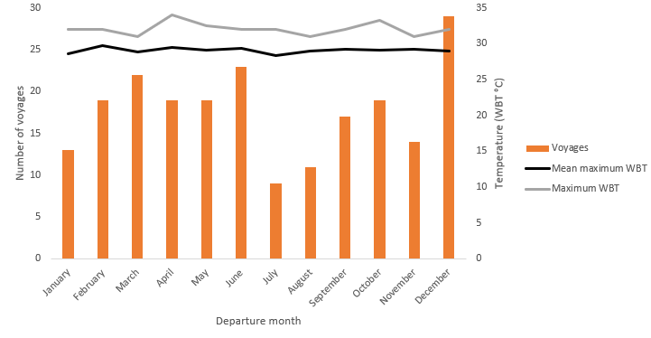
The geographical location (latitude and longitude) of the first day of the maximum deck temperature (°C WBT) for each voyage is shown in Map 2. The equatorial region is known to be a location where hot, humid conditions occur. However, this depiction shows that the hottest part of a voyage may occur at other locations along voyage routes.
Map 2 Location of maximum deck wet bulb temperature for voyages that recorded at least 1 day at 28 WBT ˚C or above (2016-20)
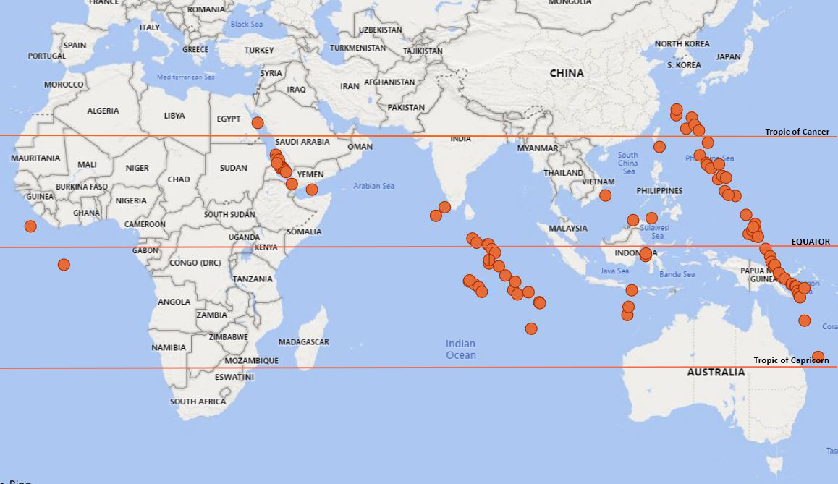

Voyages reporting evidence of increased heat load
We collated data on voyages which reported evidence of increased heat load in cattle. As stated in section 4 of this report, our case definition for voyages reporting increased heat load was ‘any voyage where daily reports recorded behavioural and physiological responses to increased heat’.
Variations in respiratory rate and character offer stronger evidence of increased heat load. Under ASEL 2.3, daily reporting required an assessment of the respiratory character ranked from 1 to 3 (1=normal, 2=panting, 3=gasping). In some instances exporters used different ‘models’ for recording respiratory characteristics, for example, some included a heat stress score ranked from 1 to 3 (1=normal (no stress), 2=mild stress, 3=severe stress).
Respiratory character (2 or 3) and heat stress score (2 or 3) were recorded as evidence of a response to increased heat load. Commentaries on the responses of cattle to hot conditions were also assessed from the general comments sections of daily, end of voyage or IO reports.
Of the 214 voyages reviewed:
- fifty-three voyages (24.8%) documented either elevated respiratory rate/character of 2 or 3 or elevated heat stress score of 2 or 3
- heat-associated behaviours were documented in 49 (22.9%) voyages. They were noted as an increase in water consumption (31 voyages), decrease in feed consumption in (12 voyages) or both (6 voyages).

Summary of voyages reporting increased heat load
- Approximately 1 in 4 long-haul voyages carrying Bos taurus cattle from southern Australia reported evidence of increased heat load.
- These voyages covered all classes of cattle, to all destinations and from all departure ports in the review and departed during both the NHW and NHS.

Voyages recording heat stress-related mortality
We reviewed voyage reports that recorded at least one mortality identified to be related to heat stress. Our case definition for heat stress-related mortality was any mortality where the cause of death was reported by the AAV or stockperson to be due to heat stress or associated with heat stress. Each heat stress-related mortality was classified as either primary, ‘combined’ or other. A primary heat stress mortality was recorded where the reporting clearly identified heat stress as the cause of death. A ‘combined’ heat stress mortality was recorded where the cause of death was not attributed to heat stress alone but often listed as a differential diagnosis with other diseases. The ‘other’ heat stress mortality category included deaths associated with heat stress in the reports that were unable to be classified as primary or combined. Due to the limited detail provided in some voyage reports, the analysis was not able to validate the accuracy of the reported causes of death.
Fourteen of the 214 voyages (6.5 %) reported mortalities related to heat stress. The average maximum temperature on these 14 voyages was 30.3°C WBT with a range of 27.6°C WBT to 34.0°C WBT. A total of 85 head of cattle, ranging from 1 to 42 cattle mortalities per voyage, were identified as heat stress-related mortalities from these 14 voyages (Appendix B).
Primary heat stress-related mortalities accounted for 17.6% of these mortalities (n=15) and ‘other’ heat stress-related mortalities constituted 16.5% (n=14). Two-thirds of the heat stress-related mortalities were classified as combined heat stress-related deaths (65.8%; n=56). Respiratory disease represented 85.7% (48 of 56) of the comorbidities (diseases reported in the combined heat stress-related mortalities). Other examples of documented comorbidities included ‘infection’, ‘gastro-enteritis’ and ‘bloat’.
Eleven voyages (22%) with heat stress-related mortalities occurred in 2018 while one voyage with heat stress-related mortalities occurred in each of 2016 (2.7%), 2017 (3.6%) and 2020 (2.4%). The reason for these annual variations is beyond the scope of this review. While unconfirmed, issues raised by the Awassi footage released in 2018 may have increased awareness and reporting of heat stress in 2018. Additionally, the export of slaughter cattle to China commenced with 4 voyages in 2017 and 12 voyages in 2018. Eleven of the 2018 voyages (22%) reported evidence of increased heat load. By comparison, only 6 voyages in each of 2019 (11%) and 2020 (14%) reported evidence of increased heat load.

Summary of heat stress-related mortality
- 6.5% of voyages recorded at least one heat stress-related mortality.
- Approximately two-thirds of heat stress-related mortalities were reported to be associated with another condition, most commonly underlying respiratory disease.

Analysis of risk factors for increased heat load and heat stress-related mortality
Although 214 voyages were reviewed for this report, only 204 voyages were included in the detailed statistical analysis. Ten voyages were removed to simplify the analysis because they either contained consignments by multiple exporters or were mixed class consignments. The occurrence of a heat load event or heat stress-related mortality could not be accurately split by exporter or class of cattle based on the available data.
For the 204 voyages reviewed in the detailed statistical analysis, voyage destinations included China (72% of voyages, n = 147), the Persian Gulf (6.4%, n = 13), the Red Sea (16.7%, n = 34) and the Russian Federation (4.9%, n = 10). Voyages departed from 5 departure ports including Portland (58.3%, n = 119), Fremantle (32.8%, n = 67) and Geelong (8.8%, n = 18). Most voyages had only one departure port (90.2%, n = 184) but some recorded two (9.8%, n = 20). Classes of cattle were categorised as breeder (63.2%, n = 129), feeder (20.6%, n = 42) or slaughter (16.2%, n = 33). Season was categorised as AMJ season or ASEL season (either NHW or NHS). The ASEL season reflects the variation in stocking density on voyages according to season of departure. NHW voyages were 57.8% of total voyages (n = 118) and NHS voyages were 42.3% of total voyages (n = 86). Voyages departing in the AMJ season made up 27.4% of total voyages (n = 56). The mean duration of voyages was 20.3 days (sd = 5.29 days). Voyages were operated by 23 different exporters using 31 unique vessels with each vessel undertaking between 1 to 20 voyages.
The methodology performed in our analysis is outlined in Appendix C. We performed initial univariable and subsequent multivariable analyses. The univariable analyses compared each of the 2 possible outcomes (presence or absence of heat load events and heat stress-related mortality) with each of the 5 potential risk factors (class of cattle, ASEL season, AMJ season, destination and departure port). Acknowledging the complexities of voyages and that many variables may impact voyage outcomes, multivariable analyses was then performed. These were undertaken to assess the significance of more than one variable at once on the occurrence of voyages reporting increased heat load and voyages reporting heat stress-related mortality. The multivariable model was developed using standard model building strategies to assess the effect of cattle class, departure port, ASEL season and AMJ season on the occurrence of voyages reporting increased heat load and heat stress-related mortality. Outcomes of the multivariable analyses are discussed below.

Collinearity
An association was identified between destination and class (P < 0.001) as visualised in Figure 9. This is because the same class of cattle is typically exported to the same destination. Similarly, associations were identified between destination and departure port (P < 0.001) and class of cattle and departure port (P < 0.001). Variable selection for the multivariable models was guided by this collinearity.

Cattle class
Of the 214 voyages reviewed in the general analysis 60.7% were breeder cattle (n=130), 20.1% feeder cattle (n=43), 15.9% slaughter cattle (n=34) and 3.3% were mixed class (n=7) voyages. Evidence of a response to increased heat load was reported in approximately 1 in 3 voyages carrying slaughter cattle, while approximately 1 in 4 voyages carrying slaughter cattle reported at least one heat stress-related mortality. Voyages reporting evidence of increased heat load were less frequent for feeder and breeder cattle than for slaughter cattle. For breeder cattle, 1 in 10 voyages reported evidence of increased heat load while heat stress-related mortalities were rare (1 in 66 voyages). For feeder cattle approximately 1 in 5 voyages reported evidence of increased heat load and 1 in 14 voyages reported a heat stress-related mortality (Table 16).
Table 16 Summary of voyages with evidence of increased heat load and heat stress-related mortalities according to cattle class
Evidence | Breeder | Feeder | Slaughter | Mixed voyages | Total
Increased heat load | 31/130 (10.0%) | 7/43 (16.3%) | 13/34 (38.2%) | 2/7 (28.6%) | 53/214 (24.8%)
Heat stress-related mortality | 2/130 (1.5%) | 3/43 (7.0%) | 9/34 (26.5%) | 0 | 14/214 (6.5%)
Total | 130 | 43 | 34 | 7 | 214

Of the 204 voyages included in the detailed statistical analysis, 129 voyages carried breeder cattle, 33 voyages carried slaughter cattle and 42 voyages carried feeder cattle. 6.4% of voyages (n = 13) reported heat stress-related mortality events, and 25% (n = 51) of voyages reported increased heat load and/or heat stress-related mortality events. Voyages recording heat load by cattle class and heat stress-related mortality by cattle class are shown in Figure 10 and Figure 11.
Figure 9 Distribution of class of cattle by destination
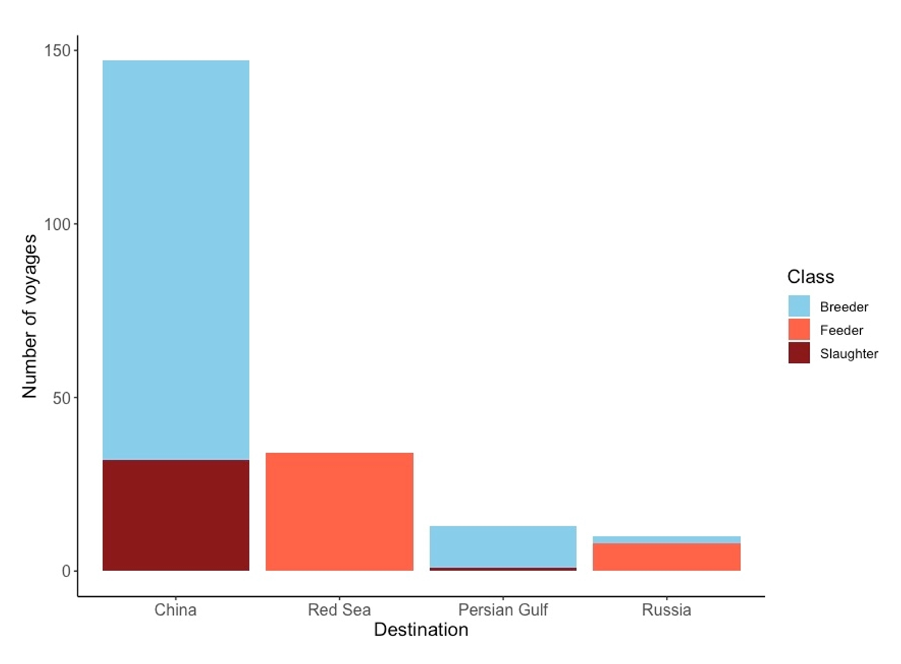
Note: Figure 9 is based on the detailed statistical analysis of 204 voyages.
Figure 10 Voyages recording heat load by cattle class
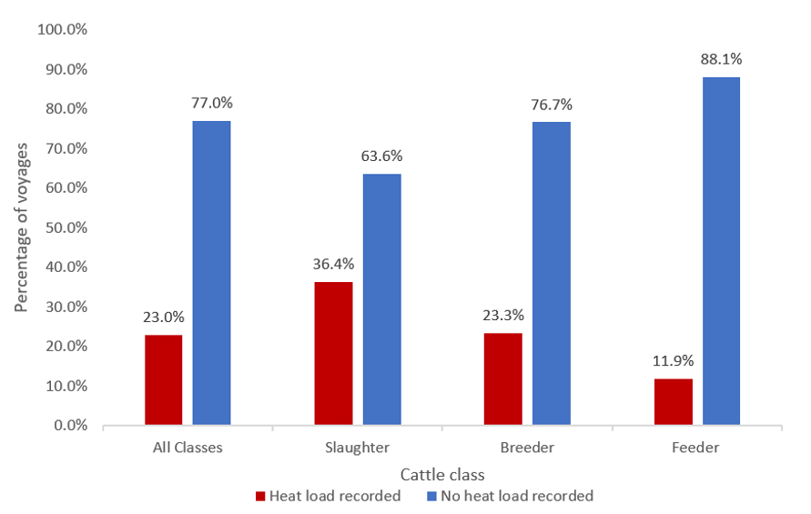
Note: Figure 10 is based on the detailed statistical analysis of 204 voyages
Figure 11 Voyages recording heat stress-related mortality by cattle class
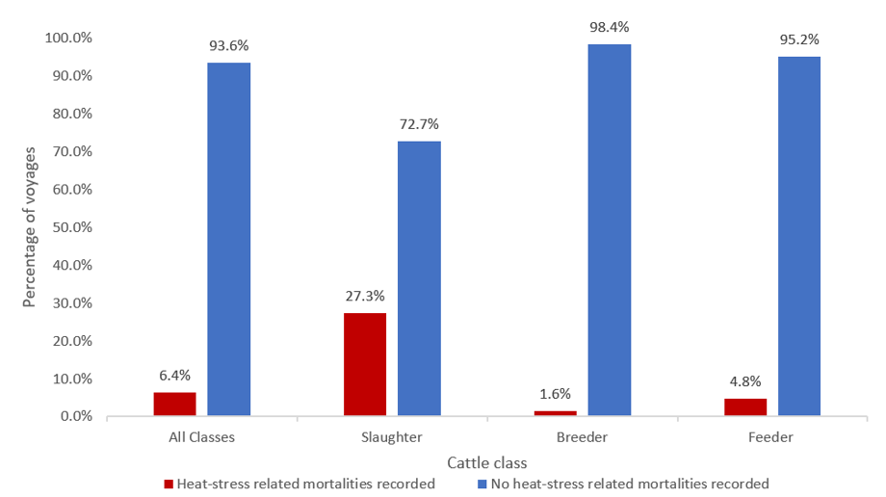
Note: Figure 11 is based on the detailed statistical analysis of 204 voyages
For the outcome of increased heat load, analysis identified a significant association between cattle class (P = 0.041), departure port (P = 0.048) and AMJ season (P = 0.025). In this model there was no significant effect of ASEL season (P = 0.63). Voyages carrying slaughter cattle were found to have a significantly greater risk, with 4.0 times the odds (95% Confidence Interval (CI) 1.42 – 12.05) of experiencing increased heat load than breeder cattle voyages (P = 0.010) and 4.33 times the odds (95% CI 1.34 – 15.95) than feeder cattle voyages (P = 0.018). The only significant departure port difference was between Portland and Fremantle, with voyages departing Portland having 3.38 times the odds of heat load compared to Fremantle (P = 0.023). A significant effect of AMJ season was also identified, with voyages departing in April, May and June associated with 2.43 times the odds (95% CI 1.12 – 5.33) of heat load than those departing at other times of the year (P=0.025).
For the outcome of heat stress-related mortality, analysis identified a significant effect of heat load (P < 0.001) and cattle class (P < 0.001). In this model, there was no significant effect of ASEL season, AMJ season or departure port (however, it should be noted that the effect of some of these variables are likely mediated through the effect of the presence of heat load in this model). Within this model, it was found that the presence of increased heat load is associated with 7.28 times the odds (95% CI 1.65 – 37.13) of mortality than voyages without increased heat load. It was also found that slaughter class animals have 38.8 times the odds (95% CI 4.80 – 561.10) of heat stress-related mortality compared with breeder animals (P = 0.02) but do not have significantly different odds of heat stress related mortality compared with feeder animals (P = 0.077; 95% CI 0.93 – 40.98).

Summary of cattle class analysis
A significant association was identified between cattle class and the occurrence of heat load during a voyage.
- over 1 in 3 slaughter cattle voyages (33.4%) experienced increased heat load. More than 1 in 4 of these voyages (27.3%) reported at least 1 heat stress-related mortality
- slaughter cattle voyages have 4 times the odds (95% CI 1.42 – 12.05) of experiencing increased heat load than breeder cattle voyages (P = 0.010) and
- slaughter cattle voyages have 4.33 times the odds (95% CI 1.34 – 15.95) of experiencing increased heat load than feeder cattle voyages (P = 0.018).
Voyages carrying slaughter cattle reported significantly more heat stress-related mortalities compared to voyages carrying breeder cattle, independent of the effect of increased heat load.
- voyages carrying slaughter cattle have 38.8 times the odds (95% CI 4.80 – 561.10) of reporting heat stress-related mortalities compared with breeder cattle voyages.

Season of voyage departure
Fewer of the 214 voyages departed Australia in the NHS (42.5%; n=91) compared to the NHW (57.5%; n=123). A greater proportion of voyages with evidence of heat load occurred during the NHS (28.6%; n=26) compared to NHW (22.0%; n=27).
Ten of the 14 voyages with heat stress-related mortalities occurred in the NHS. This equated to about 1 in 10 voyages during the NHS (11%). Voyages during the NHW resulted in heat stress-related mortalities less frequently (3.3% of voyages) (Table 17).
Table 17 Summary of voyages with evidence of increased heat load and heat stress-related mortality according to season
Type | NHS | NHW | Total
Total voyages | 91 | 123 | 214
Voyages with evidence of increased heat load | 26/91 (28.6%) | 27/123 (22.0%) | 53/214 (24.8%)
Voyages with mortalities due to heat load | 10/91 (11.0%) | 4/123 (3.3%) | 14/214 (6.5%)

The relationship between season and heat load and heat stress-related mortality was explored further in our analysis. Partitioning the analysis by 6-month ASEL seasons reduces the ability to assess significance of weather-determined seasonality. In part, the analysis of the effect of ASEL season reflects the variations in stocking density on voyages departing in each season (NHW v. NHS). As noted in Figure 12 and Figure 13, when the analysis is performed by month there appears to be a seasonal pattern in the frequency of voyages reporting increased heat load and voyages reporting heat stress-related mortality. Increased frequency occurred in voyages departing in late autumn/early winter, particularly in the months April, May and June and particularly for slaughter cattle (Figure 14 and Figure 15).
When analysing the effect of the AMJ season, we found that even accounting for the changes to stocking density in accordance with the ASEL season, there is still a significant effect of AMJ season on the outcomes of heat load. While no effect of AMJ season was found on mortality independent of the effect of heat load, the significant effect of heat load on mortality that was identified includes an effect of AMJ season, as reported above (one submission included an analysis of voyage mortality rates due to any causes distinct from specifically heat stress-related mortalities, as in this analysis). This analysis identified a strong seasonal pattern in mortality rates for voyages carrying slaughter cattle. Mortality rates were substantially higher for autumn and winter departures, than for the spring and summer. The high mortality rates for voyages carrying slaughter cattle in the autumn were strongly influenced by May departures. This observation is supported by the findings of this review. The submission did not attempt to attribute cause to this seasonal pattern. Further investigations into the reasons for the significant effect of AMJ season on the outcome of increased heat load is warranted.
Figure 12 Presence of heat load distributed by month for all voyages
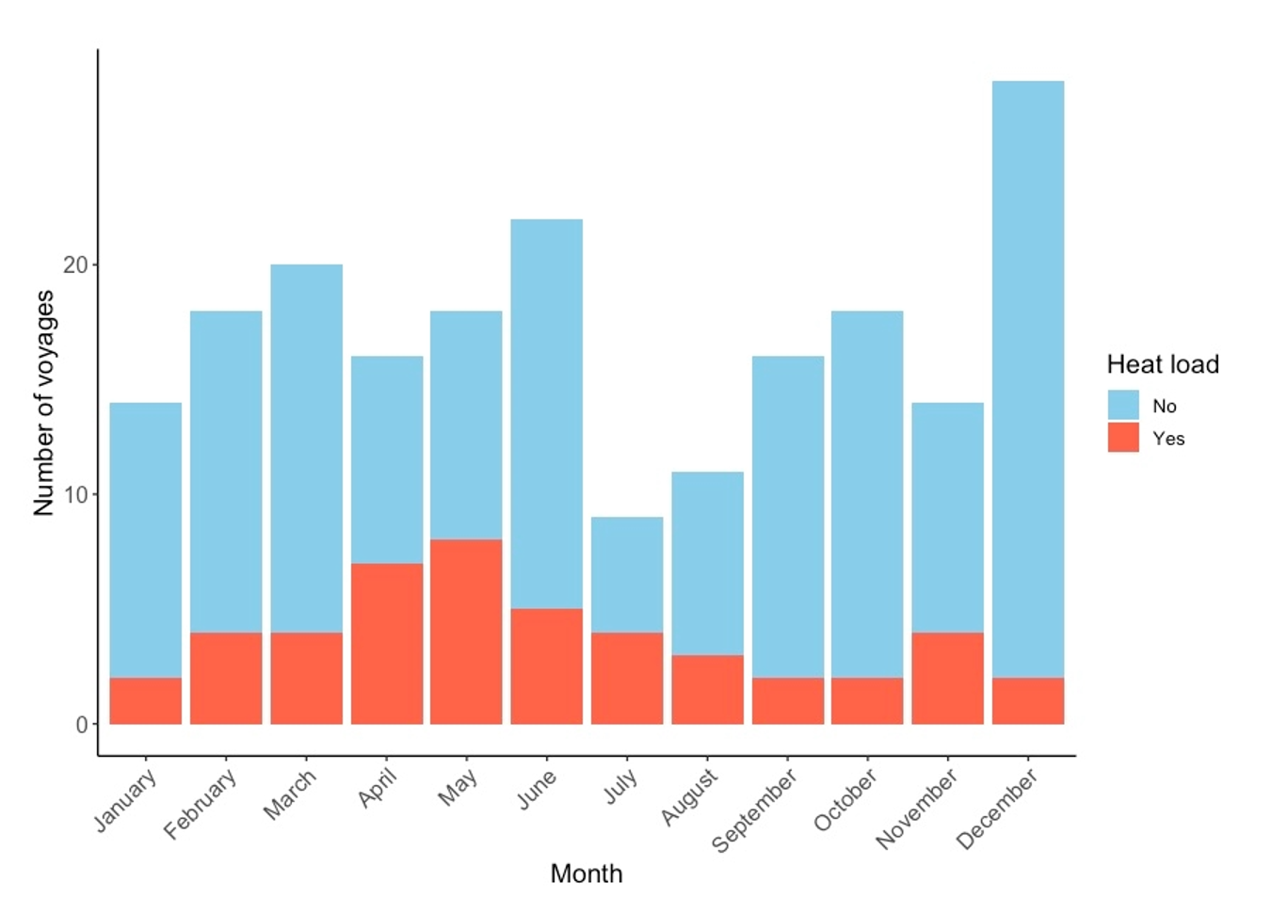
Note: figure 12 is based on the detailed statistical analysis of 204 voyages
Figure 13 Heat stress-related mortalities distributed by month for all voyages
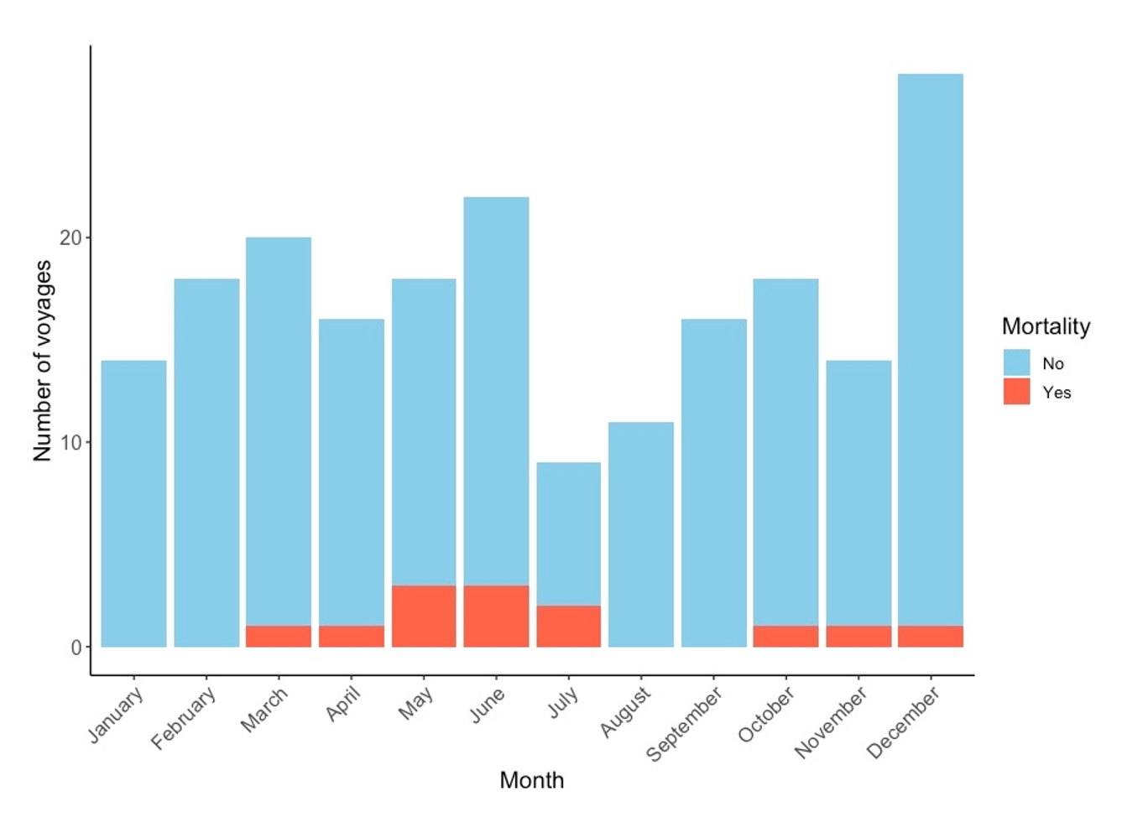
Note: Figure 13 is based on the detailed statistical analysis of 204 voyages
Figure 14 Presence of heat load for slaughter class only
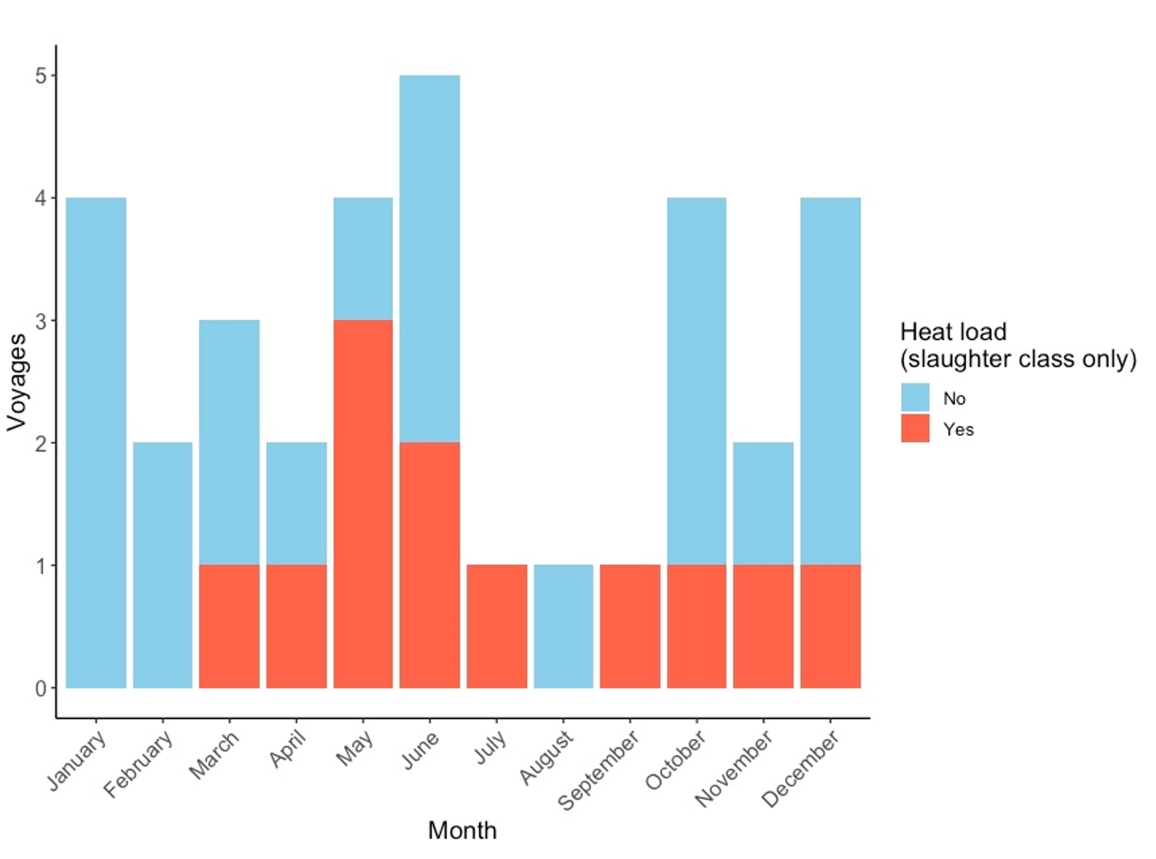
Note: figure 14 is based on the detailed statistical analysis of 204 voyages
Figure 15 Heat stress-related mortalities for slaughter class only
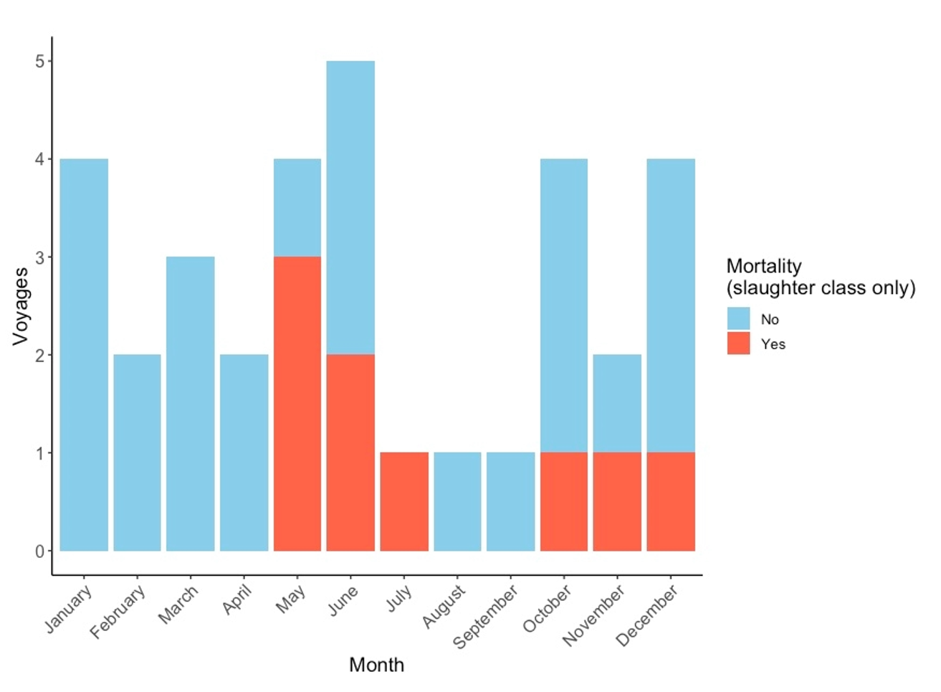
Note: figure 15 is based on the detailed statistical analysis of 204 voyages
One submission included an analysis of voyage mortality rates due to any causes (distinct from specifically heat stress-related mortalities, as in this analysis). This analysis identified a strong seasonal pattern in mortality rates for voyages carrying slaughter cattle. Mortality rates were substantially higher for autumn and winter departures, than for the spring and summer. The high mortality rates for voyages carrying slaughter cattle in the autumn were strongly influenced by May departures. This observation is supported by the findings of this review. The submission did not attempt to attribute cause to this seasonal pattern. Further investigations into the reasons for the significant effect of AMJ season on the outcome of increased heat load is warranted.
Figure 16 Voyages recording heat load and/or mortality - by AMJ season
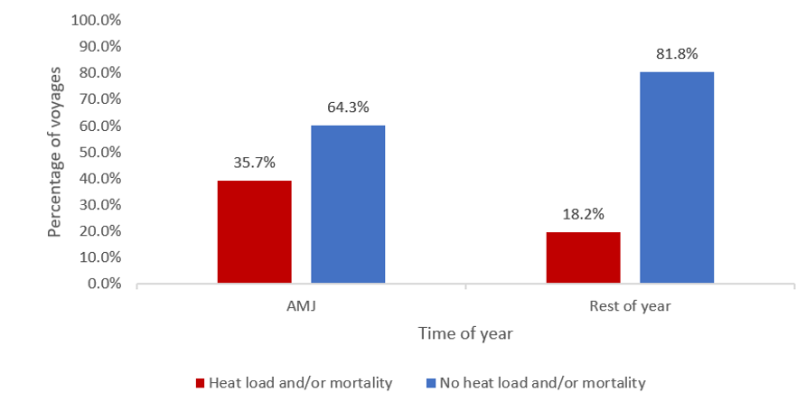
Note: figure 16 is based on the detailed statistical analysis of 204 voyages
Figure 17 Voyages recording heat stress-related mortality - by AMJ season
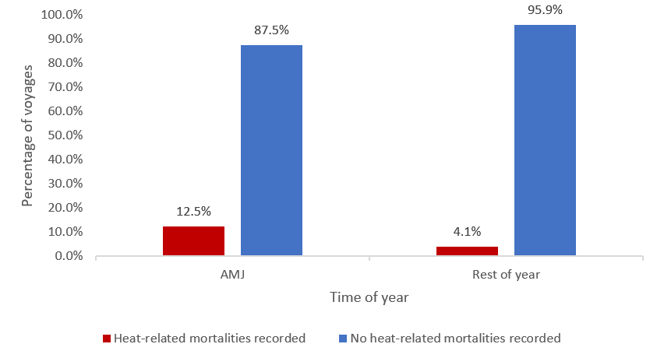
Note: figure 17 is based on the detailed statistical analysis of 204 voyages

Summary of seasonal departure analysis
- A greater proportion of voyages with evidence of increased heat load occurred during the NHS (28.6%; n=26) compared to NHW (22.0%; n=27).
- Reports from approximately 1 in 10 voyages departing in the NHS indicated at least 1 heat stress-related mortality. A lower proportion of voyages departing in the NHW reported at least 1 heat stress-related mortality (1 in 30).
- Voyages that departed in April, May or June had 2.6 times the odds (95%CI 1.22 – 5.63) of reporting heat load or heat stress-related mortality than those departing during other months of the year.
- Further investigations into the substantially higher mortality rates for slaughter cattle on voyages departing in the AMJ season would be useful to explain the trend.

Voyage destination region
The proportion of voyages with evidence of increased heat load by destination region ranged from 18.2% (the Russian Federation) to 46.2% (Persian Gulf), however these 2 destination regions recorded the smallest sample sizes (Table 18). China and Red Sea, with larger voyage numbers, accounted for 24.2% and 22.0% of voyages with evidence of increased heat load, respectively.
The 14 voyages with heat stress-related mortalities occurred on voyages to China (n=11) and the Red Sea (n=3). These 2 destination regions accounted for 88.8% of the in-scope voyages (190/214). Heat stress-related mortalities did not occur on voyages to the Persian Gulf and the Russian Federation, however few voyages went to these locations overall and those that did departed during the NHW (Table 18).
Univariable statistical analyses found no significant association between destination region and heat load (P = 0.166), heat stress-related mortality (P = 0.94) or heat load and/or heat stress-related mortality (P = 0.258). Destination was not able to be analysed at the multivariable level due to collinearity with other variables (see methodology in Appendix C).
Table 18 Summary of voyages with evidence of increased heat load and heat stress-related mortalities according to voyage route
 | China | Red Sea | Persian Gulf | Russian Federation | Total
Total voyages | 149 | 41 | 13 | 11 | 214
Voyages with evidence of increased heat load | 36/149 (24.2%) | 9/41 (22.0%) | 6 (46.2%) | 2/11 (18.2%) | 53/214 (24.8%)
Voyages with heat stress-related mortalities | 11/149 (7.4%) | 3/149 (2.0%) | 0 | 0 | 14/214 (6.5%)

Summary of destination analysis
This analysis did not find any significant association between destination region and voyages reporting evidence of increased heat load or heat stress-related mortality.

Departure port
This review analysed departures from 5 southern Australian ports: Portland, Geelong, Port Adelaide, Fremantle and Geraldton. The significance of departure port was analysed for the risk of experiencing increased heat load or heat stress-related mortality. Port Adelaide and Geraldton were removed from the analysis because of the small number of departures (n = 3 for Port Adelaide and n = 1 for Geraldton). All departures from these ports were associated with heat load events, potentially introducing bias for associations with other departure ports which recorded much greater numbers of voyage departures.
Table 19 Summary of voyages with evidence of increased heat load and heat stress-related mortalities according to departure port
Port | Total voyages | Voyages with evidence of increased heat load | Voyages with heat stress-related mortalities
Fremantle | 61 | 12 | 7
Fremantle, Portland | 10 | 0 | 0
Geelong | 16 | 5 | 1
Geelong, Fremantle | 2 | 0 | 0
Geraldton | 1 | 1 | 0
Port Adelaide, Fremantle | 4 | 3 | 1
Portland | 111 | 30 | 5
Portland, Fremantle | 9 | 2 | 0
Total | 214 | 53 | 14

Figure 18 Distribution of departure port by destination
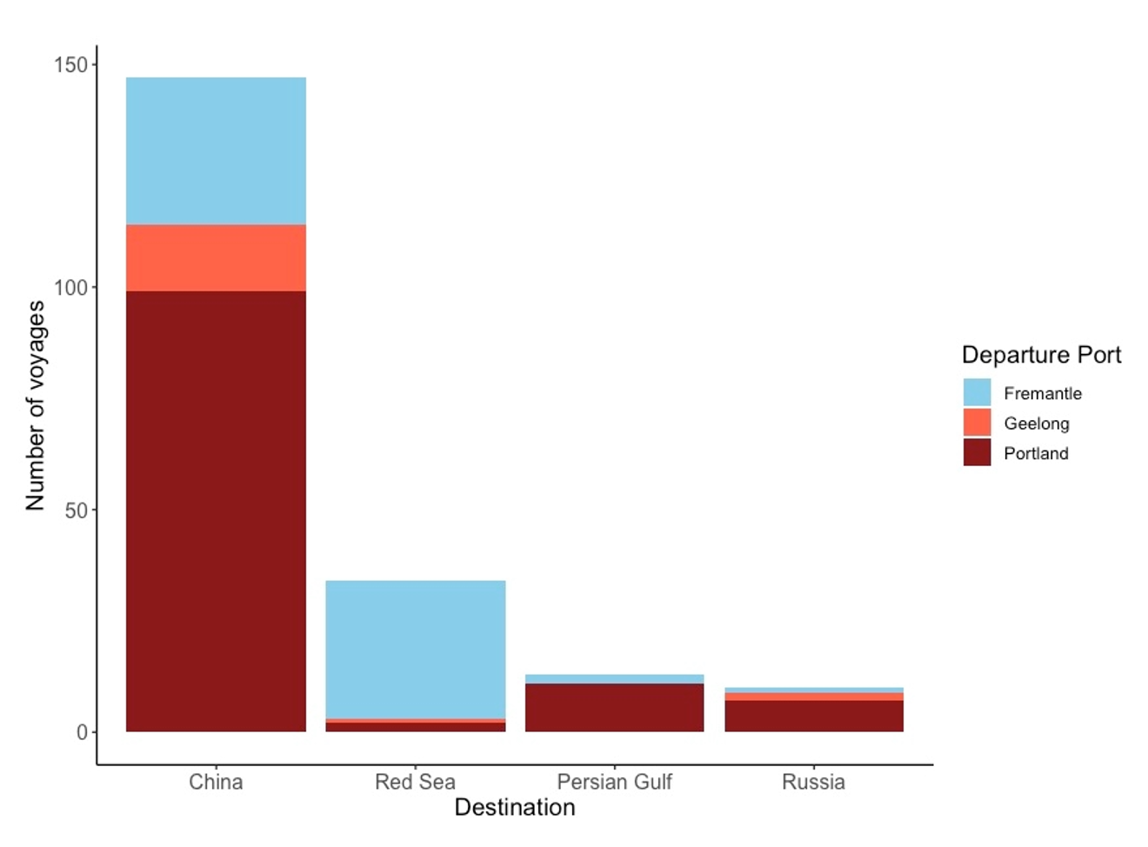
Note: figure 18 is based on the detailed statistical analysis of 204 voyages
Figure 19 Distribution of class of cattle by departure port
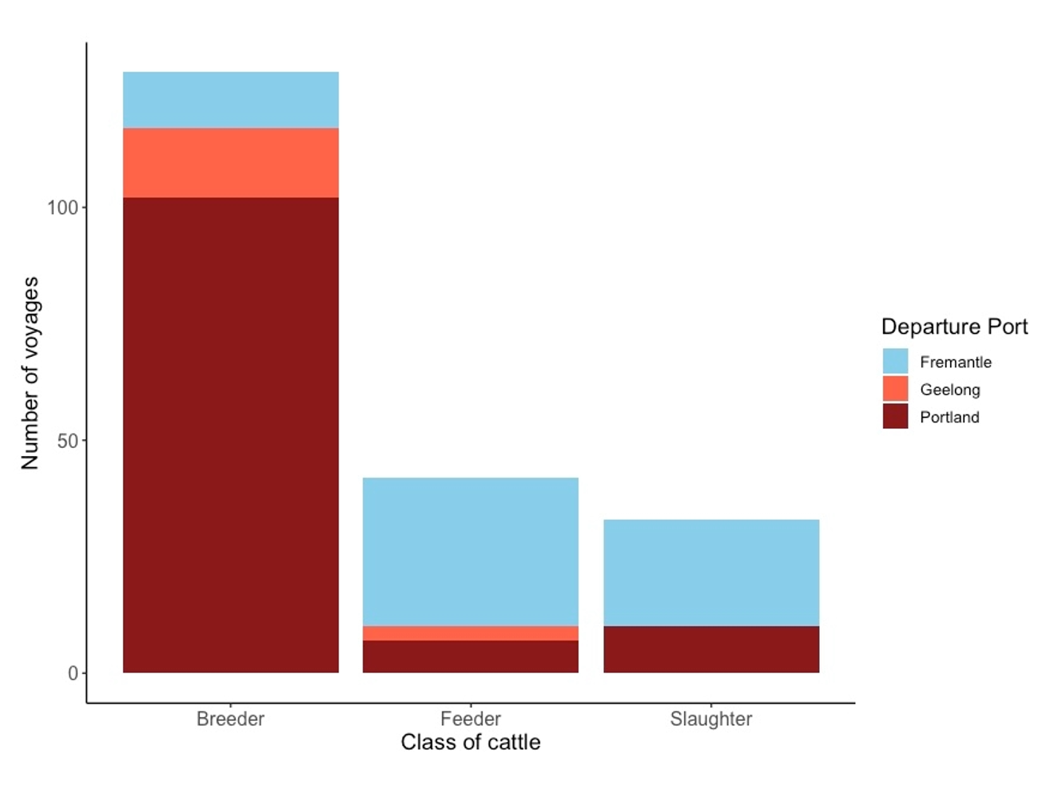
Note: figure 19 is based on the detailed statistical analysis of 204 voyages
A significant effect of departure port was found in the multivariable analysis with Portland having greater odds of heat load compared to Fremantle and a trend towards greater odds of heat load from Geelong compared to Fremantle. Further investigation beyond the scope of this review is warranted to explore this potential association.
This analysis did not identify a significant association between departure port and the outcome of heat stress-related mortality.

Summary of departure port analysis
- A significant association was found between the occurrence of voyages reporting increased heat load and departure port.
- Voyages departing from Portland have 3.38 times the odds of heat load compared with voyages departing from Fremantle (P = 0.023).

Vessel
The analysis reviewed the evidence of increased heat load or heat stress-related mortalities on vessels. Thirty-one unique vessels performing between one and 20 voyages were identified as having an occurrence of heat stress or heat stress-related mortalities.
Evidence of increased heat load was recorded on 74% of vessels (n=23). Eleven of these vessels recorded more than one heat load voyage (Figure 20). Nine vessels were associated with heat stress-related mortalities (Figure 21). Three vessels reported more than one mortality event (Table 19).
Figure 20 Voyages reporting increased heat load by vessel
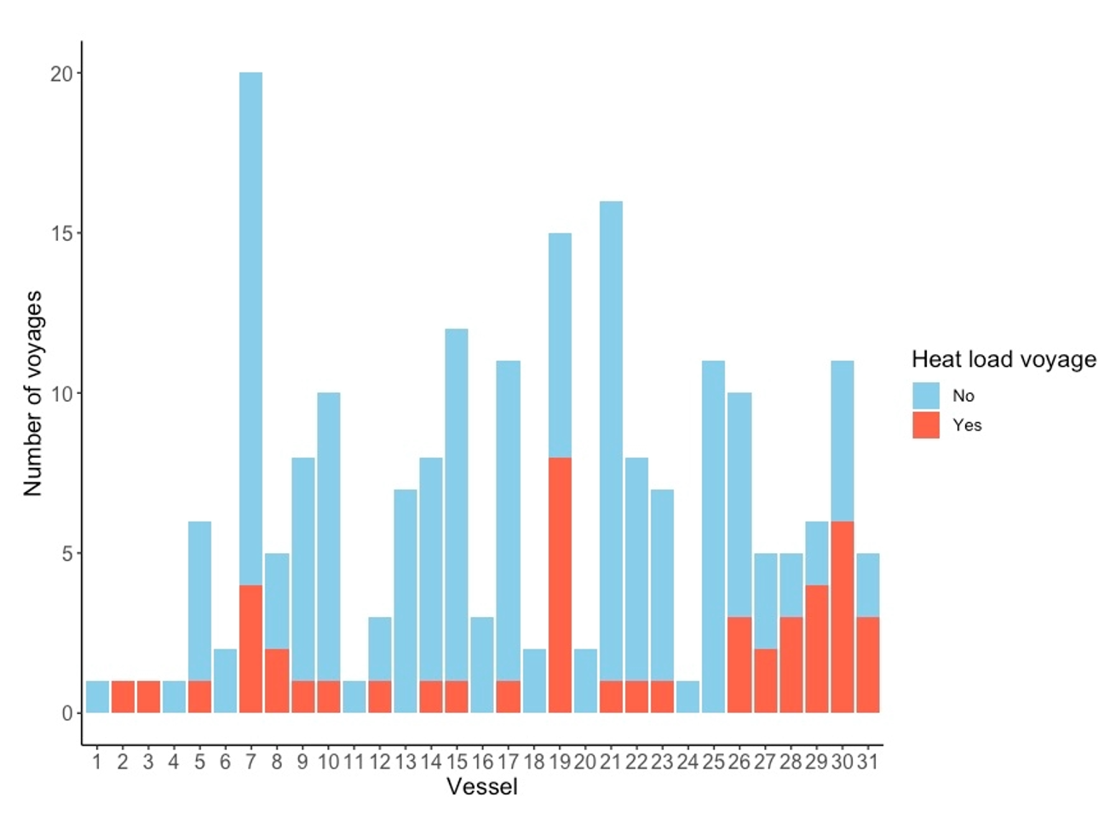
Note: figure 20 is based on the detailed statistical analysis of 204 voyages
Figure 21 Voyages reporting heat stress-related mortality distributed by vessel
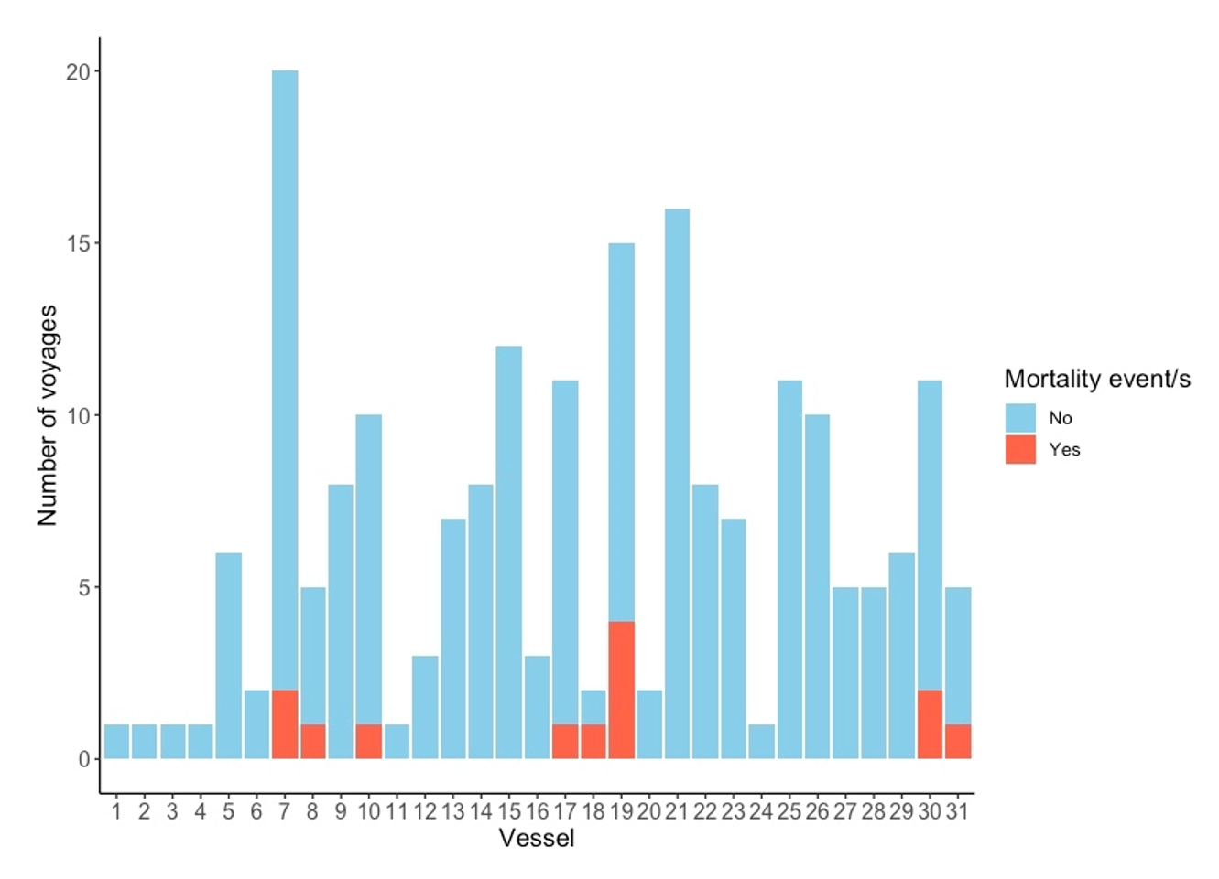
Note: figure 21 is based on the detailed statistical analysis of 204 voyages
The analysis also showed that some vessels tend to export the same class of cattle, as visualised in Figure 22.
Figure 22 Distribution of class of cattle by vessel
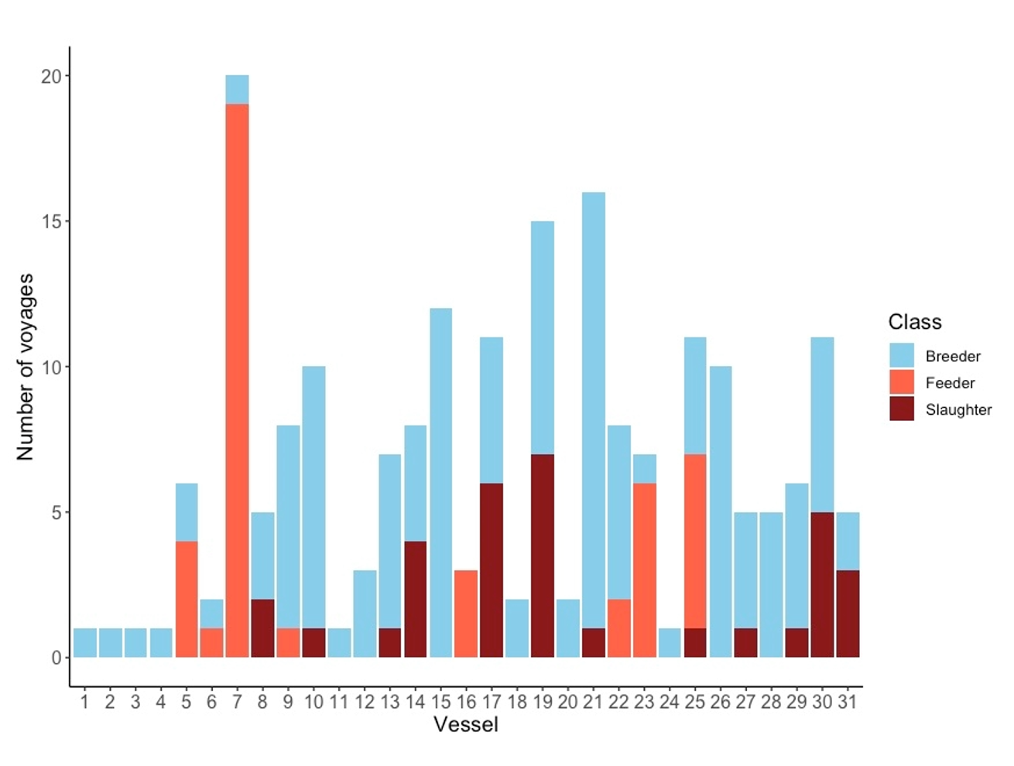
Note: figure 22 is based on the detailed statistical analysis of 204 voyages
For each vessel, we analysed the ratio of voyages which reported heat stress-related mortality to total voyages undertaken. This ratio was between 1 in 2 (50%) and 1 in 12 (8%). However, some of these vessels only conducted a small number of voyages during the review period so significance is unclear. Table 20 shows the frequency and ratio of heat stress-related mortalities for vessels and voyages. Vessel 'F' reported 1 voyage with heat-stress related mortalities from a total of 2 voyages (50%). In contrast, vessel 'G' reported 4 voyages from a total of 15 voyages with heat stress-related mortalities (27%). There are factors relating to vessels, such as ventilation rates and the impact of changes to air flow requirements which had to be implemented by 1 January 2020 under Marine Order 43 (2018), that may influence voyage outcome. Further analysis of the influence of vessel on heat stress outcomes is necessary to determine significance.

Table 20 Summary of voyages with heat stress-related mortalities according to vessel
Vessel (de-identified) | Total number of voyages included in the scope of this review (of 214) | Frequency of voyages with at least 1 mortality due to heat stress (of 14) | Ratio
A | 3 | 1 | 1:3
B | 20 | 2 | 1:10
C | 5 | 1 | 1:5
D | 10 | 1 | 1:10
E | 12 | 1 | 1:12
F | 2 | 1 | 1:2
G | 15 | 4 | 1:3.75
H | 11 | 2 | 1:5.5
I | 5 | 1 | 1:5

Summary of vessel analysis
- Some vessels appear to be overrepresented in terms of increased heat load and heat stress-related mortalities, noting that some vessels may more often carry slaughter cattle, which are at increased risk of heat stress-related mortalities.
- The analysis did not establish the significance of any particular vessel to the occurrence of heat stress outcomes.

Summary of key findings for key risk factors

Heat load
- Approximately 1 in 4 long-haul voyages carrying Bos taurus cattle from southern Australia reported signs of increased heat load in 1 or more animals.
- These voyages covered all classes of cattle, to all destinations and from all departure ports in the review and departed during both the NHW and NHS.

Heat stress-related mortality
- 6.5% of voyages recorded at least one heat stress-related mortality.
- Approximately 2 in 3 heat stress-related mortalities were in combination with another issue. This issue was most commonly respiratory disease.

Class of cattle
- There is a significant association between voyages reporting increased heat load and class of cattle (P = 0.044), with voyages carrying slaughter cattle at a greater risk of increased heat load.
- There is a significant association between heat stress-related mortality and class of cattle (P < 0.001), with voyages carrying slaughter cattle at increased risk of heat stressed-related mortality.
- Voyages carrying slaughter cattle have 38.8 times the odds (95%CI 4.80 – 561.10) of heat stress-related mortality compared with breeder cattle voyages.

Season
- Approximately 1 in 10 voyages departing in the NHS reported at least 1 heat stress-related mortality.
- A lower proportion of departures in the NHW reported a heat stress-related mortality (1 in 30).
- Voyages that departed in April, May or June had 2.6 times (95%CI 1.22 – 5.63) the odds of reporting increased heat load or a heat stress-related mortality than those departing during other months of the year.

Destination
- The analysis did not establish a significant association between destination region and reporting of increased heat load or heat stress-related mortality.

Departure port
- A significant association was found between voyages reporting increased heat load and departure port (P = 0.048).
- Voyages departing from Portland have 3.38 times the odds of increased heat load compared with voyages departing from Fremantle (P = 0.023).

Vessel
- The analysis did not establish the significance of any vessel to the occurrence of heat stress outcomes.

Discussion and recommendations

Challenges faced
One of the challenges encountered during this review was that the analysis was highly dependent on voyage reports and therefore limited by the quality and quantity of available data in these reports. Determining the reliability of the reported data for accuracy and completeness was also challenging. There were some inconsistencies in voyage reporting which could not be explained. For example, some voyages recorded high deck temperatures, where historical studies suggest the cattle should have been showing evidence of increased heat load, but no evidence was reported. It is not known if this reflected reality or inaccurate reporting. Additionally, 2 voyages included reports of at least 1 heat stress-related mortality, but with no reports that other cattle were showing signs of responding to increased heat. This seems illogical and raises questions about the accuracy and completeness of the dataset. This is further discussed in section 5.5.
Under ASEL 2.3, reporting requirements for daily voyage reports were limited. For example, a single measure per voyage per day of respiratory character or panting score was the minimum heat stress related reporting requirement. This means reports provided an ‘averaged’ measure, without the ability to report on the range of cattle behaviours observed across the vessel. It also does not provide visibility about what happened in between daily reports. Voyage reporting also only provided a single average deck temperature per day, meaning we have limited knowledge of the temperature range, the effect of duration of high temperatures and limited ability to determine if cattle were experiencing periods of respite. Where exporters included daily deck heat stress measures and/or panting score, it is unclear whether the rankings within these were consistent and it is unclear what panting score system was used (possibly that described in the MLA Veterinary Handbook). Some reports did include panting score definitions.
The timing and nature of changes introduced on 1 November 2020 under ASEL 3 made it challenging to determine how many pertinent factors may have changed or improved through ASEL 3 alone. The department notes that changes introduced under ASEL 3 may address some of the welfare issues raised in this export supply chain. We have tried to acknowledge these improvements when discussing findings and recommendations throughout this report.
Some voyage data was complex or limited and unable to be included in the analysis. For example, of the 214 voyages reviewed, only 204 voyages were included in the detailed statistical analysis. Ten voyages were removed from the total of 214 to simplify the analysis because they contained consignments by two exporters or two departure ports. The occurrence of heat load events or heat stress-related mortality could not be accurately split by exporter or departure port based on the available data. Departure ports Port Adelaide and Geraldton were removed from the detailed analysis because of their small number of departures but relatively higher incidence of heat load and heat stress-related mortality. Their inclusion could have biased significance. In another example, the large number of vessels meant that it was not possible to include vessels as a variable in the analysis.
There was significant interaction and ‘confounding’ by inter-relating voyage factors which made the analysis challenging. For example, some vessels tended to carry the same class of cattle, and the same class of cattle were typically exported to the same destination. These collinearity issues constrained any reasonable analysis that considered the significance of both variables. We acknowledge it may not be possible to fully ‘correct’ for some of these confounding factors.

Discussion
The increased risk of heat load and heat stress-related mortality in slaughter cattle may be explained by several factors. The smaller surface area-to-mass ratio of these animals make it more challenging to dissipate heat. Slaughter cattle are usually heavier (average weight of over 500kg) and fatter than other classes of livestock.
Another potential risk factor for slaughter cattle is their diet, often grain or high in grain, which may increase metabolic heat production. As acknowledged in section 3.4, cattle fed a highly fermentable diet to increase growth rates are at greater risk of heat stress. The department does not have oversight on the feeding strategy of cattle prior to their entry into a registered establishment. However, under ASEL 3, if the onboard diet is to consist of more than 30% by weight of wheat, barley or corn, the livestock must have been adapted to the ration over a period of at least 2 weeks prior to export. Once in a registered establishment, we understand that all cattle are adjusted to the shipboard ration. A common mitigation measure on live export ships during times of high heat is to ‘temporarily reduce or cease feeding of concentrate and consider a higher roughage proportion in ration’ (Jubb & Perkins 2019). Standard 5.1.10 in the ASEL states that feed provisions must be appropriate for the species, class, weight, age, voyage length and expected weather conditions.
Two thirds of heat stress-related mortalities were identified as occurring in combination with other diseases, primarily respiratory disease. This suggests that concurrent illness may exacerbate susceptibility to heat stress, or similarly, that heat stress may be exacerbated by other health conditions. The high prevalence of respiratory disease in conjunction with reported heat stress-related mortality in our analysis is consistent with findings documented in literature (Lees et al. 2019). Cattle that are transported are at risk of BRD. A vaccination is available that provides protection from the most common aetiological agents of BRD. Vaccination of cattle, particularly slaughter cattle, may therefore reduce heat stress mortalities by reducing the occurrence of underlying disease.
Heat stress-related mortality was significantly associated with timing of departure. Voyages that departed in the AMJ season had 2.6 times the odds (95% CI 1.22 – 5.63) of heat load or heat stress-related mortality than those departing during other months of the year. This analysis did not identify a significant association between departure port and the outcome of heat stress-related mortality.
Additional risk management measures for heat stress should be considered for long-haul slaughter cattle exports. Providing cattle additional space during the voyage, particularly during the AMJ season, may lead to reduced heat load through greater evaporative heat loss and a reduced WBT deck rise. This could be achieved by providing cattle with more space in line with the HSRA model or a suitable allometric calculation.
Section 3.3.3 details the heat stress mitigation strategies employed during voyages. These include washing decks and wetting animals, altering navigation strategies such as zig-zagging vessels, managing hotspots and the manure pad, and feeding an increased proportion of chaff. It is unclear if these strategies are used as a planned approach or a reactive measure to mitigate heat stress. Voyage reports rarely commented on or compared the effectiveness of heat mitigation strategies.
We suggest that further research into heat stress mitigation strategies by industry is warranted.
Box 1 Findings related to heat load
Heat load and heat stress-related mortalities
1) Increased heat load during long-haul voyages carrying Bos taurus cattle from southern Australia can occur in all classes of cattle (breeder, feeder and slaughter), to all destinations, from all departure ports and departing during both the NHW and NHS.
2) Bos taurus slaughter cattle on voyages departing from southern Australian ports are at a higher risk of increased heat load than other classes of cattle.
3) Bos taurus slaughter cattle on voyages departing from southern Australian ports are at a higher risk of heat stress-related mortality than breeder cattle.
4) Two-thirds of heat-stress related mortalities were identified as ‘combined’ with an underlying disease. This was most commonly respiratory disease.
5) Heat stress mitigation strategies employed during voyages were reported.
Box 2 Recommendations related to heat load
Heat load, heat stress-related mortalities and other related factors
1) A suitable HSRA should be employed all year round for Bos taurus slaughter cattle exported from southern Australian ports to all destinations.
2) Consideration should be given to providing Bos taurus slaughter cattle exported from southern Australian ports during the NHS additional pen space. This may be achieved through the use of a HSRA.
3) Vaccination against BRD should be considered for voyages of Bos taurus slaughter cattle exported from southern Australian ports during the NHS.
4) Ongoing examination of Bos taurus slaughter cattle outcomes should occur, including to assess the benefit of vaccination against BRD where used.
5) Further investigation should be undertaken on why voyages carrying slaughter cattle departing in late autumn and early winter have substantially higher mortality rates than during other months of the year.
6) Further investigation should be undertaken as to why voyages departing from Portland have greater odds of heat load compared to voyages departing from Fremantle.
7) Further research should be undertaken into the effectiveness and appropriate employment of heat stress mitigation measures.

Other heat stress factors

Ventilation and hotspots on decks
The OIE Terrestrial Animal Health Code Chapter 7.2 Transport of Animals by Sea (OIE 2018) includes a generic requirement that the ventilation system must be adequate to meet the thermo-regulatory needs of the animals being transported. Details regarding how to achieve this are not explained and minimum requirements for air change rates, air flow rates over livestock pens or air quality parameters are not stipulated.
Australian ventilation requirements, efficacy and auditing are the responsibility of the Australian Maritime Safety Authority (AMSA). Standards applicable to ventilation of live export vessels are detailed in Marine Order 43 and Appendix A. ASEL 3 also requires daily and end of voyage reports to include any issues relating to ventilation.
MAMIC (2001) noted that the major source of deck heat is livestock-derived, from metabolic heat output. Adequate ventilation is necessary to maintain conditions on decks to support welfare and physiological needs of livestock. It is also necessary to remove deck-side pollutants such as carbon dioxide and ammonia.
Ambient heat influences conditions experienced on decks. Additional heat sources on decks include inefficient air intake systems (motor and fan inefficiencies), which blow frictional heat into the decks, and radiated heat from walls (near engine rooms and fuel tanks), and ceilings (especially uppermost deck). Inefficient intake systems can add as much as 15% of the heat produced by livestock. Radiated heat can be significant in specific locations, also adding an amount of heat equivalent to 15% of the heat produced by cattle (MAMIC 2001).

Voyage analysis of ventilation and hotspots
We analysed voyage reports for comments relating to ventilation and hotspots. Voyage reporting on ventilation was varied. Reports for:
- 65/214 (30.4%) voyages had no comment about the ventilation
- 104/214 (48.6%) voyages included subjective comments such as ‘good’, ‘excellent’ and ‘adequate’ regarding the effectiveness of the ventilation
- 45/214 (21%) voyages included objective comments on functionality of the ventilation system, such as whether it worked throughout the voyage without issues or disruptions.
Reporting for 2 voyages provided actual airflow measurements. The department understands that real-time airflow measurements during the voyage is possible, however, it was not clear in either case whether these were real time measurements or reporting of the vessel’s known capability.
Comments regarding issues with ventilation were infrequent. This may be because the ventilation generally worked well or may be due to under-reporting. Twenty one out of the 214 voyages (9.8%) reported hotspots particularly near the engine room and on closed decks (Table 21).
It was not uncommon for the same vessel to receive both good comments on ventilation for one voyage and poor comments for another voyage. Reasons for this may be factors such as different ambient conditions, class of stock, stocking levels and competency/experience of the reporter.
The AAV on one voyage speculated that temperature readings on some decks were not representative of the whole deck because thermometers were placed near ventilation outlets or located centrally. Two IO reports noted that the wet bulb thermometers were not working accurately.
In a number of reports, it was noted that hotspots were destocked or lightly stocked if conditions became too warm. Rarely further detail was provided however in one report, the AAV made the following recommendation about stowage near a hotspot:
It is strongly recommended that at this time of the year, the most heat tolerant cattle (ex-pastoral or Bos Indicus infused) be stowed in Hold 3 (on this vessel) particularly in the areas adjacent to the exhaust vents.
Only one voyage report provided a description of the temperature of the hotspot compared to surrounding pens. It noted that radiation heat from the engine room increased temperatures next to the engine room walls by 2°C compared to surrounding pens. The actual temperature was not noted.
Table 21 Hotspots identified in voyage reports
Vessel* | Location | Comment from reports
1 | ‘aft section near engines’ | ‘High temperatures’
2 | Aft Deck 4 hold 2 | ‘some known hotspots stocked lightly’  ‘Inadequate airflow to most pens in this location’
3 | - | ‘additional fans for slow extraction areas’
4 | Deck 5 hold 3 | This location was noted to be hotter than other decks
5 | - | ‘some known hotspots lightly stocked’
6 | Deck 4  Deck 5–7 | ‘pens under exhaust fans destocked’  ‘ventilation intake tower near engine room caused nearby pens to be up to 2°C warmer’
7 | - | ‘areas of higher humidity had lower stocking density’
8 | - | ‘one intake tower close to engine room doors can result in hot air intake’
9 | - | ‘Some deficiency in airflow to small areas relative to outside conditions’
10 | - | ‘Few hotspots, nearby pens lightly stocked’
11 | Deck 4 hold 3 | Hottest deck due to proximity to engine room
12 | Deck 4 hold 3 | AAV noted hotspots near engine room
13 | Decks 4 & 5, hold 3 | Highest heat loads observed in these areas
14 | Hold 3 | Hottest area
15 | Deck 2 and Deck 4 | ‘Hottest areas were deck 2 near the engine room and the whole of deck 4’
16 | Decks 1–3 | Increased heat load noted on these decks
*vessel labels in Table 21 do not match other lists of vessels

Summary of ventilation and hotspots
- Issues with vessel ventilation systems were reported infrequently.
- Sixteen vessels reported hotspots with 9.8% of voyages reporting hotspots.
- Voyage reporting rarely provided any detail on hotspot monitoring and management unless conditions were warm enough to warrant movement of animals.
- It is not clear from voyage reports how closely hotspot conditions were monitored, the extent of hotspot temperature differences with surrounding pens and whether there was any pre-determined approach or guidelines to managing hotspot areas.
- No correlation was found between apparent hotspots and the reporting of heat stress-related mortality.
- Daily report templates have since been updated and now list the number of pen hotspots per deck.

Bedding and pad
ASEL 3 sets out the minimum requirements with regards to bedding on voyages. The standards require that bedding provisions be:
  - applied in a sufficient quantity that allows pens to be maintained in a manner that ensures the health and welfare of the livestock and minimises slipping, injuries, abrasions, lameness, pugging and faecal coating; and
  - applied to slippage risk areas of laneways and ramps prior to and during loading and unloading using a material that minimises slipping during loading and unloading; and
  - be monitored routinely (at least daily) to ensure consistency and depth is appropriate to mitigate risks to the health or welfare of the livestock (Standard 5.1.18).
Bedding provides comfort and traction for livestock, improves air quality, absorbs moisture on decks and reduces humidity. The manure pad develops over pen flooring and is made up of bedding material, faeces, urine and environmental moisture. In most environmental conditions the ship’s ventilation system draws moisture out of the pad allowing a firm to tacky layer to develop (Jubb & Perkins 2019).
Voyage reporting identified that hot and humid conditions, for example around the equator, often resulted in wet and sloppy pads. High ambient temperatures on a deck will cause an increase in the amount of water consumed by the livestock and when water consumption increases, urine output will also increase. The manure pad will deteriorate when animals are producing more liquid waste than the bedding can absorb and the ventilation system can evaporate. The evaporation of moisture from the manure pad will also make conditions more humid on decks (McCarthy & Banhazi 2016).
With regards to heat stress, the main welfare risks from bedding relate to wet, sloppy pads and the amount of faeces. Wet pads can result in poor welfare conditions (Banney, Henderson & Caston 2009; McCarthy & Banhazi 2016) including:
- coat contamination which particularly affects medium to heavy-coated animals; when marked, this can impact the animal’s ability to dissipate body heat
- limited mobility and access to all areas of a pen
- lameness and abrasions due to soft feet
- poor air quality due to ammonia
- unhygienic conditions which support the spread of disease
- reluctance to lie down, drink and feed.
There may be differences in the way the manure pad is managed at different times of the year. For example, in the NHW, it may be possible to undertake a final wash 3–4 days prior to arrival, with the pad remaining dry and in good condition. In the NHS, undertaking a deck wash as closely as possible to arrival is ideal, as the pad is likely to deteriorate very quickly at this time of year. Additionally, for breeder cattle consignments, washdown may be left as late as possible to ensure ‘clean’ livestock on arrival for the importers.
The importance of pad management has been noted in industry publications (Banney, Henderson & Caston 2009; McCarthy & Banhazi 2016). These relay the importance of pre-determined deck washing plans and use of an appropriate substrate in sufficient amounts to assist pad development and moisture absorption.
Banney, Henderson & Caston (2009) noted that:
Based on current mortality rates and estimates of poor health attributable to bedding management, the cost of bedding is not likely to be recouped by a reduction in mortality rates alone. However, while the cost of bedding may not be justified purely in commercial terms through reductions in mortalities, lameness and possible live weight loss, addressing the welfare issues through bedding management will have a positive impact on the animal welfare image of the industry, assisting its long-term viability.
McCarthy and Banhazi (2016) also evaluated bedding additives (such as gypsum) to help reduce ammonia production, however they state the ‘sheer bulk of manure added to the bedding each day overwhelms any possible effects of bedding additives’. They go on to state ‘there is nothing in the current literature that appears to have practical application to the onboard situation at this point in time. The possible exception is impregnating sawdust with some sort of acid (acetic) prior to spreading’.

Voyage analysis of bedding and pad
Deck washing was regularly noted in voyage reports. This was often implemented as the vessel neared humid conditions around the equator as well as at other times. The frequency of deck washes varied from not at all (n=2) to as often as every second day. Most voyage reports noted that deck washing and substrate (sawdust or wood shavings) application was readily and appropriately used to support pad management.
It was rarely clear whether the approach to deck washing was pre-determined or ad hoc. Issues with deck washing included inadequate water pressure, poor drainage resulting in flooding of pens or wet pads, and inadequate frequency.
The most common pad issue related to wet, sloppy pads (n=44) which can contribute to coat contamination and increased humidity. Issues with flooding or leaking pipes and troughs as well as digestion changes in response to new weather conditions were reported to have contributed to these pad issues. A small number of voyages noted that the pad was poorly managed. This was observed or noted to be because deck washing was not frequent enough (n=6), or there was insufficient substrate or substrate was sparingly used (n=8). Reported welfare consequences of inadequate pad management included coat contamination (n=1), lameness (n=4) and ammonia build up in the environment (n=2).

Summary of bedding and pad
- Sloppy pads were noted on 44 of 214 voyages (20.6%)
- Pad management was usually reported to be adequate with appropriate use of substrate and deck washing
- Fourteen of 214 voyages (6.5%) reported inadequate pad management
- Welfare consequences of inappropriate pad management included coat contamination, lameness, ammonia build up, and increased humidity.

Water provision
Clinical observations of animals subject to high environmental heat and humidity include an increase in evaporative heat loss and an increase in water consumption (Barnes et al. 2008; Beatty 2005; Stockman 2009). It is imperative that cattle have an adequate source of clean drinking water during periods of high environmental temperatures.

Voyage analysis of water provision
The analysis identified voyages that recorded minor and major water provision issues and the corresponding actions taken during these voyages. Many of these issues were found to be minor and short-term and were addressed during the voyage. Examples are given below.

Displaced water troughs
There were accounts of poorly secured water troughs being knocked off railings on 3 voyages. In these instances, IOs reported that the issues were addressed by the crew through regular monitoring and reinstalling displaced troughs. On all 3 voyages IOs onboard reported that sufficient water was available throughout the voyage.

Water supply system issues and empty water troughs
Issues with water supply were noted on 15 (7% of) voyages. Minor and temporary issues included broken floats or valves (n=3), troughs knocked off railings (n=3), cessation to water supply for cleaning (n=4) or unknown (n=2). These issues were rectified without any reported impact to health and welfare of cattle.
More significant issues with water supply were noted on 3 (1.4% of) voyages:
- The IO report for one voyage noted issues with empty water troughs. There were several non-systemic causes. Two pens did not have water for a period when water valves were not turned on after cleaning. Empty troughs were also caused by float valves being incorrectly set. Two decks were out of water for 45 minutes when higher demand for water could not supply upper decks. These issues were addressed by the crew at the time they were noted.
- On one voyage the IO report noted that drinking water to the upper decks was not supplied ad libitum on days 5, 7, 10–13, 15 and 17–18 as evidenced by the presence of empty water troughs. Remedial action by the crew was undertaken on each occasion to resolve the issue and supply water. After longer outages, the cattle were queuing to drink. The department referred the water supply issue to the exporter and AMSA.
- Another voyage reported issues with ad libitum water supply. Water and feed troughs were not properly secured to the rails and were regularly pushed off the rails by cattle. Several issues were identified relating to hose connections, broken isolating switches and a lack of spare parts. These issues meant it was not possible to leave the deck water on without supervision. Many troughs were disconnected each day when staff were not on the deck. This issue was referred to AMSA which applied conditions to the vessel’s Australian Certificate for the Carriage of Livestock (ACCL), preventing it from undertaking long‐haul voyages (i.e. ≥10 days) until actions were taken to address the drainage and trough issues. Subsequent reporting by IOs on this vessel noted only minor issues which were readily fixed.

Water quality
Issues with water quality were identified on 9 voyages. Most of these were readily addressed by the crew. Issues with rust or rusty discolouration were noted on 2 voyages. On one of these voyages the IO reported water lines were flushed to clear the contamination. The other voyage did not carry an IO, but the voyage report noted that the water supply needed regular attention due to rust, although no disruption to water supply was reported.

Difficulty in operating nose bowls
On 2 voyages it was noted that animals were experiencing initial difficulties in operating nose bowls. On 1 voyage the cattle took 1 to 2 days to become accustomed to using the nose bowls. A number of voyages noted that the use of nose bowls was monitored closely.

Summary of water provision
- Issues with the provision of water were reported on 7% of voyages, while 1.4% of voyages reported more significant water supply issues
- Water issues were generally non-systemic in nature, and usually rectified at the time
- More significant issues raised by IOs were addressed with the exporter or AMSA.

Pregnant cattle
Scientific literature describes that increased heat load impairs numerous functions associated with fertility and establishing and maintaining pregnancy (Lees et al. 2019) which may be relevant to the export of breeders. Heat stress may be detrimental to early-stage pregnancy and the period prior to full establishment of the placenta (De Rensis, Garcia-Ispierto & Lopez-Gatius 2015).
Appropriate heat stress thresholds for pregnant cattle have not been clearly defined. A study of 6 pregnant dairy heifers at 3–5 months gestation (average weight 420 ± 19kg) found the heat stress threshold to be 27°C to 28°C WBT (Barnes et al. 2008). This was based on an increase in mean daily body temperature up to 1°C and clinical signs of heat stress such as open mouth panting. Further literature on the influence of breed, weight, class, acclimatisation, duration of hot conditions and influence of live export conditions specific to pregnant cattle was not found.
The risks associated with heat stress in pregnant cattle mainly referred to the risk of abortion and, to a lesser extent, premature lactation in pregnant and non-pregnant dairy heifers. Gaps in evidentiary knowledge on heat stress were also highlighted, as outlined in Collins, Hampton & Barnes (2018) such as 'experimental manipulation of variables that influence heat load, further assessment of the HSRA and development of a suite of animal welfare indicators to identify at risk animals before severe heat stress occurs'. These gaps pose challenges to policy development.

Australian Standards for the Export of Livestock
Except for 2 months (November and December 2020), all voyages analysed for this review were governed by standards in ASEL 2.3. The ASEL 3 standards (which commenced on 1 November 2020) include requirements relating to the export of pregnant cattle (Appendix A).
These include:
- pregnancy testing
- the maximum gestation period permitted for exported cattle at the time of arrival at the destination
- that an AAV must accompany voyages with pregnant cattle (unless otherwise agreed)
- 15% extra space
- additional feed requirements
- additional veterinary medicines and equipment
- an approved pregnant cattle management plan for southern sourced Bos taurus cattle on voyages crossing the equator from 1 May to 31 October.
There are some significant changes to the management of pregnant cattle within ASEL 3 that may reduce the risk of heat stress in pregnant cattle. This includes providing additional space, a reduction in permitted maximum gestation and the use of a pregnant cattle management plan for certain exports (see Standards applicable to pregnant cattle).
There is a provision for 15% additional space for pregnant cattle over the default and alternative space requirements. Under ASEL 3 pregnant cattle receive 15–34% additional space compared to ASEL 2.3 depending on body weight. For example, pregnant heifers weighing between 280kg and 320kg exported between 1 May and 31 October on default space allocation will be provided 24% to 20% (respectively) additional space compared to the allocation under ASEL 2.3.
ASEL 3 requires that southern sourced pregnant Bos taurus cattle crossing the equator from May to October are exported under a management plan approved in writing by the department. This was not a requirement under ASEL 2.3. The management plan must include details of how the exporter intends to manage animal health and welfare risks associated with sourcing and exporting. Particular focus is placed on mitigation measures to address risk of injury and stresses (that may lead to heat stress, abortion and early births, premature lactation and other health and welfare issues).

Voyage analysis of pregnant cattle
Of the 214 voyages analysed for this review, 132 loaded cattle classified as ‘breeders’. It was found that at least 41 of these voyages included pregnant cattle.
Prior to the introduction of ASEL 3, exporters intending to ship pregnant cattle were required to produce pregnancy certificates which were validated by regional veterinary officers. These records were unavailable to the department when undertaking this review, posing a challenge for the analysis of thermal stress in pregnant cattle. The number of known voyages carrying pregnant cattle was determined by searching TRACE (Tracking Animal Certification for Export) documents for any confirmation of pregnant cattle. A load plan is not a core document so in most voyages, the location of pregnant cattle is unknown which limits the ability to attribute deck-specific observations.
These data challenges limited the validity and depth of this analysis and it is uncertain to what degree it is representative of pregnant cattle export voyages. The introduction of LIVEXCollect reporting under ASEL 3 is expected to significantly improve reporting on pregnant cattle. LIVEXcollect requires reporting of whether a pregnant cattle management plan has been implemented, the occurrence of abortions and births and any relevant details.
Noting reporting limitations, a summary of the 41 voyages is provided below.
- Twenty-one of 41 (51%) voyages departed during the NHS.
- Destination countries included China (35), Oman/Pakistan (1), Oman/UAE (1) and Pakistan (4).
- The mortality rates for these voyages ranged from 0.00% to 0.46% with a mean voyage mortality rate of 0.16%.
- Forty of 41 voyages recorded a maximum WBT of 26°C or more for at least 1 day. The highest WBT, 32°C, was recorded on 2 voyages. The mean maximum WBT was 29.0°C.
- Nineteen of 41 (46%) voyages recorded evidence of cattle responding to hot conditions.
- These 19 voyages noted increased water consumption (n=14) and/or a decrease in feed consumption (n=7).
- Twelve of these voyages noted alterations to respiratory character (11) and/or increased panting score/heat stress score (n=5).
- Eleven of these voyages departed during the NHS while 8 departed during the NHW.
- There were no reports of mortalities of pregnant adult cattle attributed to heat stress.
- Ten of 41 (24%) voyages recorded 1 or more abortions.
Of the 10 voyages that recorded abortions, 1 voyage recorded 3 abortions with the main differential diagnosis noted as heat stress. Two voyages recorded 2 abortions and 7 voyages recorded 1 abortion. From voyage records, it was not possible to determine the stage of pregnancy that the abortions occurred. No reasons were provided for the abortions reported on the latter 9 voyages. Of these 9 voyages, 5 also reported physiological responses to increased heat load (increased respiratory character or panting score). The remaining 4 voyages did not include reports of any cattle response to heat load. This information is provided in Table 22.
Table 22 Comparison of the occurrence of abortions on 10 long-haul voyages carrying Bos taurus cattle from southern Australian ports with or without reported response to increased heat load
Category | Reporting criteria | No. of voyages with reports of cattle response to heat load and abortions | No. of voyages with no reports of cattle response to heat load and abortions
Destination | China | 4 | 3
Destination | Oman/UAE | 1 | 0
Destination | Pakistan | 1 | 1
No. of abortions | Three abortions | 1 | 0
No. of abortions | Two abortions | 1 | 1
No. of abortions | One abortion | 4 | 3
Reason for abortion | Abortion reported to be related to increased heat load | 1 | 0
Reason for abortion | No reason provided for abortion | 5 | 4
Departure period | NHS | 4 | 1
Departure period | NHW | 2 | 3
Source: DAWE (2020)
The one voyage that reported abortions with the main differential diagnosis noted as heat stress, departed Portland in March bound for Pakistan transporting Bos taurus dairy cattle with an average weight of 365kg. Two cattle mortalities unrelated to heat stress were recorded on this voyage. From day 13 until discharge on day 24, deck temperatures ranged from 27°C WBT to 29°C WBT. From day 13 until day 22 (10 days), respiration was noted to be ‘generally normal with intermittent panting’. The exception to this was day 21 when ‘some open mouth panting’ was noted. The abortions occurred on day 17, 22 and 24. Voyage records did not report whether other differential diagnoses were investigated as the cause of abortions. The extended duration of hot conditions may have been a factor associated with the abortions.
There is no clear seasonal effect on abortions. Five of the 10 voyages where abortions were reported departed during the NHS, and 5 departed during the NHW. Of voyages that reported responses to heat load and noted abortions, 4 departed during the NHS and 2 departed during the NHW. The sample is small and no clear seasonal influence can be deduced with regards to heat stress related risk to pregnant cattle. This concurs with the general findings of the heat load analysis.
Premature lactation is a poorly understood and rarely documented condition in exported dairy cattle. Mansell et al. (2012) state that premature lactation has been reported in exported dairy breeds of cattle but not in beef breeds. The syndrome involves the rapid development of the udder and the commencement of lactation not associated with calving.
Premature lactation was reported on 2 of the 41 voyages analysed. Both of these voyages reported signs of increased heat load in cattle. One departed during the NHS and recorded a maximum temperature of 28.6°C WBT. The other departed during the NHW and recorded a maximum of 31°C WBT. In both cases the cattle were managed by feeding chaff and moved to cooler areas of the vessel where possible.
The frequency of voyages reporting premature lactation is small which makes it difficult to determine its significance.

Summary of pregnant cattle
- Ten of 41 voyages carrying pregnant cattle reported 1 or more abortions.
- One voyage recorded abortions related to heat stress.
- There was no clear seasonal trend to the reported occurrence of heat stress risk in pregnant cattle.
- Under ASEL 3, pregnant cattle are receiving additional space and must travel under an approved pregnant cattle management plan.
- Improved reporting on pregnancy, abortions and premature lactation could assist future analyses.

Reporting of heat stress
The assessment of 214 voyages for evidence of heat load noted some reporting anomalies. Four of the 14 voyages with reports of heat stress-related mortalities did not report any other evidence of hot conditions, such as increased respiratory rate or heat stress score in any other cattle on board the vessel. It would be reasonable to deduce that if a voyage reported a heat stress-related mortality, other cattle on the voyage would likely have demonstrated elevated respiration rates or other signs of heat stress.
Voyages with WBTs that would be considered hot (based on available literature on HSTs) did not always report evidence of heat stress. In total, 15.4% (n=33) of voyages reported maximum deck WBTs of 30°C or greater with no reported evidence of heat stress. One voyage carrying feeder and slaughter cattle reported a mortality rate of 1.8% for lines of cattle housed on one particular deck (overall voyage mortality rate was 0.8%). This voyage recorded 9 consecutive days with maximum deck WBTs at ≥28°C. This period included 3 consecutive days of maximum deck WBTs at 30°C. Mortalities were mostly attributed to pneumonia or ‘unknown’ causes, with no mention of hot conditions contributing to mortalities. In addition, every daily report recorded the same respiratory rate and a respiratory character rating of ‘1’ (‘normal’). Examples such as this raise the possibility that reporting could be limited or inaccurate.
Some inconsistencies may be attributed to the fact that reporting requirements under ASEL 2.3 were limited. Historical reporting only allowed for a single entry per deck per day for relevant physiological and behavioural signs. This means daily reports recorded a single rank of respiratory character or heat stress score per deck, with no ability to capture the number of animals displaying these signs. This would result in the reporter ‘averaging out’ symptoms for each deck. The time of day that inspections and reporting occur may also influence the overall scores, with voyages completing reporting requirements at cooler times of day likely to produce lower scores. Additionally, records were often abbreviated or with vague statements, meaning it was not always possible to determine their accuracy and completeness.
This issue may be alleviated by the introduction of LIVEXCollect on 1 November 2020. LIVEXCollect is a data collection and management system administered by LiveCorp for use on livestock export vessels to improve consistency in the way livestock observations and other measurements are recorded and reported. The LIVEXCollect forms standardise data entry and reporting in accordance with ASEL, allowing for improved data aggregation and analysis. Daily and end of voyage reporting is then provided to the department in a consistent form. This aligns with findings in the Inspector-General of Live Animal Exports report on monitoring and reporting during livestock export voyages (March 2020). The Inspector-General recommended improvements to the quality, standards and analysis of reported data.
The Moss review (2018) noted that inconsistencies may be attributed to an unwillingness to raise concerns by the person reporting. Moss noted that ‘AAVs appear have an inherently conflicted role. While they are required to report to the department on animal welfare issues, they are either employed, or engaged by exporters or contracted on a consignment-by-consignment basis’. We did not receive any submissions from AAVs or other parties that referred to this issue.
Another issue relates to the fact that daily deck temperature recordings may not accurately reflect overall conditions. Data loggers on live export voyages to the Middle East regularly record variations in WBT of 6°C within a 24-hour period, especially near the start and end of voyages when the distance from the equator is greatest. Closer to the equator, daily WBT fluctuations are more typically 1–3°C in a 24-hour period.
WBT reporting provides further challenges. Several voyage reports note that some of the wet bulb thermometers were not reading accurately. A number of voyages might record one temperature in the daily report but note temperatures exceeding these in reporting commentary. This indicates that having a set time each day to note temperatures in daily reports does not capture the actual range experienced for that day. Having an appreciation for diurnal temperature variations and the extent of respite periods during hot conditions can provide important information to AAVs and stockpersons monitoring a voyage where cattle are at risk of heat stress (HSRA Technical Reference Panel 2019).

Summary of reporting heat stress
- Evidence of heat stress (elevated respiratory rates, altered respiratory character, increased panting score or heat stress score) was not consistently recorded or reported.
- The maximum temperature recording may be inaccurate in some voyage reports.
- The introduction of LIVEXCollect reporting under ASEL 3 is expected to significantly improve reporting on livestock observations and temperature measurements relating to heat stress.

Discussion (on other heat stress factors)

Ventilation and hotspots
Voyage reporting indicates that many vessels have hotspots. It is possible that stockpersons and crew are monitoring these areas more closely, but this is not clear from voyage reports. Only one voyage reported a temperature difference between a hotspot and surrounding areas, but otherwise actual conditions in these areas are not reported. It is difficult to assess specifically how hotspots should be monitored and managed without an understanding of temperatures experienced. Improved accuracy and recording of diurnal ranges of deck temperatures could be assisted by the use of data loggers on all long-haul cattle voyages. Placement and maintenance of these data loggers is also of critical importance.
Reducing stocking rates in affected pens assists airflow around animals to support evaporative cooling and provides cattle with easier access to water troughs. However, if conditions are hot enough, a single animal in a hot pen will still be at risk of heat stress. This highlights the value of using data loggers to continually record temperatures in affected areas and provide real-time alerts of high temperatures. This will assist decision making around the use of pens in hotspots and appropriate mitigation measures.

Bedding and pad
In this analysis, 20.6% of voyages reported sloppy and wet pads. Exporters are required to include pad management plans in their approved arrangements. This also includes instructional material for stockpersons and AAVs. The pad management plan should include an intention to discuss pad management during the daily meeting, the provision of highly absorbent bedding substrate and clear instructions for the use of substrate on board vessels. We acknowledge that under ASEL 3 there are additional requirements regarding bedding application and monitoring. This may influence pad management outcomes in the future. Accurate reporting on pad issues will assist when making assessments regarding adequacy of bedding requirements. A future ASEL review should investigate the adequacy of bedding required under ASEL 3 for long-haul voyages from southern Australian ports.
Although, beyond the scope of this review, further research could determine the welfare implications of different types of bedding, under different conditions including heat and ammonia measurements.

Pregnant cattle
The appraisal of 41 voyages that included pregnant Bos taurus breeder cattle from southern Australian ports noted the occurrence of abortions on 10 voyages. Six of these voyages also reported evidence of heat stress, while 4 voyages reported no evidence of heat stress. Voyages reporting abortions were split evenly between NHS departures (n=5) and NHW departures (n=5). Of the 6 voyages with abortions and evidence of heat stress, 4 departed in the NHS and 2 departed in the NHW. Although case numbers are small, these findings do not show a strong association between the risk of abortion and any particular northern hemisphere season.
ASEL 3 Standards applicable to pregnant cattle provides additional pen space for pregnant cattle which may mitigate the risk of heat stress and associated abortion. Additionally, ASEL 3 only permits the export of pregnant southern sourced Bos taurus cattle on voyages crossing the equator from 1 May to 31 October under an approved pregnant cattle management plan. We recommend that future reviews of ASEL consider the effectiveness of these pregnant cattle management plans in reducing the risk of heat stress, and whether the management plans should be employed for all months of the year.

Reporting
This review identified inconsistent reporting of heat stress signs such as panting scores. Consistency has been improved with the implementation of ASEL 3 and the coinciding introduction of LIVEXCollect. The new reporting system now uses 3 categories and provides guidance for assigning panting scores. There is also a project underway to develop training on the LIVEXCollect panting score categories. The department will continue to work with industry to review the efficacy of cattle panting scores.

Water provision
Issues with water quality and supply during voyages were not systemic. In general, minor issues were associated with mechanical problems and corrective measures were taken immediately. Issues concerning water delivery interruptions and water quality were vessel specific. Reports indicate that where significant issues were identified the necessary corrective measures were taken by the crew. Exporters were notified of any major repairs or improvements that were needed before future voyages. Significant water provision issues were not noted as a systemic failure on long-haul voyages carrying Bos taurus cattle from southern Australian ports.
Some aspects of thermal stress that were raised in submissions are beyond the scope of this review, including vessel design and infrastructure, training and experience of veterinarians and stock people. We encourage ongoing research and discussion into the issue of heat stress in cattle.
Box 3 Findings related to other heat stress factors
Hotspots
6. Voyage reporting rarely provided any detail on hotspot monitoring and management.
Bedding and pad management
7. Welfare consequences of inappropriate pad management were noted on some voyages. The most common pad issue related to wet, sloppy pads in humid conditions.
Pregnant cattle
8. There was no clear seasonal trend to the reported occurrence of heat stress risk in pregnant Bos taurus cattle.
9. The frequency of voyages reporting premature lactation is small which makes it difficult to determine its significance.
Reporting heat stress
10. Daily deck temperature recordings may not accurately reflect actual conditions.
11. Evidence of heat load (elevated respiratory rates, altered respiratory character, increased panting score or heat stress score) was not consistently recorded or reported.
Box 4 Recommendations related to other heat stress factors
Heat load, heat stress-related mortalities and other related factors
8. Hotspots on vessels should be identified and monitored using standardised and well-maintained data loggers to support the management of cattle in these areas.
9. Exporters should implement proactive pad management during voyages. These should include specific contingencies for addressing sloppy pads in hot, humid conditions.
10. The next ASEL review should investigate the adequacy of ASEL bedding requirements for long-haul voyages out of southern Australia and their impact on heat load management.
11. In addition to reporting on abortions and births, daily reports should also include instances reporting of premature lactation.
12. On board data loggers should be used to improve the monitoring of deck temperatures.

Cold stress

Physiology of cold stress
Cold stress has been described in a number of ways in scientific literature. According to Abbas et al. 2020, temperatures below the TNZ threshold can result in cold stress. Wagner (1988) states that as the temperature declines below the LCT, cold stress on an animal increases.
When ambient temperature drops below the LCT, cattle expend extra energy and increase heat production to maintain normothermia. The main physiological response of animals under cold stress is to increase heat production (for example, by shivering) and decrease heat dissipation to maintain a constant body temperature. Cattle increase heat production and decrease heat loss by increasing their metabolic rate and cardiac output, redistributing of blood flow (including by cutaneous vasoconstriction), and mobilising fat stores and glucose for metabolism (Broucek et al. 1991). Wagner (1988) states the increase in metabolic rate during cold periods can be as much as 20–30%.
Cattle increase feed intake in order to meet the increased energy demand and a failure to do so results in weight loss (Wagner 1988). A decrease in water intake has also been noted (Anderson et al. 2011).

Assessing cold stress

Measuring cold stress in animals
As noted in section 3.2.3 of this report, measuring core body temperature is an accurate method for assessing response to both hot and cold conditions. However, as this remains impractical during live cattle voyages, assessing behavioural and physiological responses to cold conditions may be more appropriate. Behavioural and physiological signs of cold stress in cattle include (EFSA 2011; European Commission 2017; Young 1983):
- low core body temperature (less than 35°C)
- increased appetite/feeding
- reduced water consumption
- reduced movement
- grouping or huddling
- shivering
- weight loss / reduced body condition
- increased respiratory effort and increased heart rate
- erratic behaviour
- collapse / inability to rise from a lying position
- death.

Measuring cold stress in the environment
There is minimal literature directly relating to cold environmental conditions and the export of livestock by sea. Scientific articles on cold stress found during our literature review were predominantly from North America, Europe or the Russian Federation. General literature and descriptions of cold stress use DBT as a measure, as well as identifying windchill and moisture (rain, snow) as being critical factors influencing the ability of cattle to tolerate cold temperatures (Wagner 1988, Young 1983). Rain and wind are influential, especially in combination, due to the rapid cooling effect of air movement on wet surfaces.
The impact of windchill on the ‘effective’ temperature experienced by the cattle is likely to be significant (Marston et al. 1998; Tarr 2007). For example, at wind speeds of 16km/h, ‘effective’ temperatures may be lowered by 6–7°C.
We note that industry has developed information manuals including the Beef Breeder Manual for cold winter climates (Miller, Cobiac & Inerbaev 2015) and the Cold Climate Destination Checklist for Cattle (LiveCorp & MLA 2020). This checklist identifies environmental conditions to assess, including that:
- the facility has appropriate shelter to mitigate wind chill
- the water supply system and drinkers are able to function in freezing conditions
- there is a plan in place to increase the energy density of the ration to account for the metabolic demands of conditions that are below the TNZ.

Animal factors influencing cold tolerance
Beef cattle that are composed primarily of Bos taurus genetics are adapted to cool climates and are known to tolerate cold temperatures remarkably well. Young (1983) stated that:
Cold-adapted adult ruminants on full feed and with substantial thermal insulation are very cold hardy and have generally very low LCTs such that in dry, cold, agricultural regions they rarely experience direct cold stress.
This description acknowledges the variety of animal factors in play. Animal factors influencing cold tolerance include breed, acclimation, nutrition, age, BCS and coat condition.

Cattle breed and age
Bos taurus have a better ability to adapt to cold conditions than Bos indicus. Brahman calves have, for example, been shown to experience more difficulties adapting to cold environments compared with crossbred calves (Roland et al. 2016). In a study by Godfrey et al. (1991) Brahman calves showed reduced ability to respond to cold conditions and had impaired thermoregulation compared to crossbred calves. The Brahman calves had lower rectal temperatures and were less able to use energy-containing blood constituents (glucose, triglycerides, fatty acids) to increase their body temperature when exposed to cold conditions (4°C ).
Ferguson et al. (2008) state that:
Older, reasonably well-grown animals … are more tolerant of cold weather than thinner, younger animals. This is partly due to increased muscle and fat and a greater body volume to surface area ratio which lessens heat loss to the environment.
Phillips (2008) and Wagner (1988) suggest that adult cattle in good condition can tolerate cold stress due to their size and the heat of food digestion. Morignat et al. (2018) showed that cattle of all ages were at risk of mortality if cold exposure was prolonged. While cattle under 200kg can be sourced for export by sea under an approved ‘light cattle management plan’, cattle must be at least 200kg at the time of export.

Body condition score
Cattle with lower BCS are much more susceptible to cold stress than cattle with a higher BCS (Tarr 2007). Large fat deposits in cattle with higher BCS provide insulation and energy reserves when exposed to cold conditions (Anderson et al. 2011).
ASEL 3.2 (standard 1.4.4) requires that cattle must not be sourced for export or exported unless they have been assessed by a competent stock handler against the relevant cattle body condition scoring tables.
The susceptibility of leaner animals to cold conditions should be taken into account by exporters when assessing any request to export animals under a light cattle management plan and vessel load plan.

Cold thickness and condition
An animal’s coat plays an important role in an animal’s tolerance of cold conditions (LiveCorp & MLA 2020). This is dependent on coat thickness, moisture content and windchill factors.
Coat thickness varies depending on season, climate, breed and genotype. Cattle with thicker coats have been identified as having lower LCTs (Marston et al. 1998). Cattle adapted to colder climates prior to export are likely to have thicker coats, impacting their susceptibility to heat stress and tolerance of cold conditions.
Mader & Griffin (2015) describe that an animal’s energy requirements to maintain normothermia in cold conditions might double if the coat is wet and muddy, particularly if there is no protection from wind. Anderson et al. (2011) also noted the compounding impact of wind chill exposure in developing the cold stress.
Wet conditions are an important consideration on board a livestock vessel when animals are exposed to direct windchill (open decks) and high ventilation rates. To ensure coats are not wet or muddy as a vessel nears cold conditions, consideration should be given to pad management and the timing and method of deck washing to avoid wetting of livestock and allow time for coats to dry.
The Cold Climate Destination Checklist for Cattle (LiveCorp & MLA 2020) indicates that cattle with a heavy winter coat have a much lower LCT (−8°C) than non-adapted cattle with a slick summer coat (+15°C). Cattle exported from an Australian summer to a northern winter will not have the insulation of a heavy winter coat. The LCT is also affected by wet and muddy coats.

Acclimatisation
Acclimatisation is discussed in relation to heat tolerance in section 3.4.3. The same principles are relevant to an animal’s tolerance of cold conditions.
Ferguson et al. (2008) identify that ‘cold stress would only arise as a potential issue during sudden changes of cold, wet and windy weather, especially if there is no shelter from the wind … where the cattle have not previously adapted’. The Cold Climate Destination Checklist for Cattle (LiveCorp & MLA 2020) states ‘the adaptive response or acclimation process with changes in behaviour, in metabolic rate and in dry matter intake … takes several weeks to occur’.
Examples of seasonal acclimatisation to cold include increased thickness of hair coat, fat deposition and increased feed intake (Roy & Collier 2012). Young (1981) and Brown-Brandl et al. (2003) state that metabolic rate and heat production increase with cold climate and decrease with warm climate. Animals kept permanently under cold climatic conditions exhibit an increased basal metabolic rate and a reduced UCT and LCT (Webster et al. 1970; Young 1983; Robinson et al. 1986).

Diet
Maintaining feed quality and quantity is essential for cattle to maintain, or gain, body weight during exposure to cold conditions. Adequate energy from a quality diet supports metabolic heat production to maintain normothermia during cold stress conditions.
Maintenance energy requirements for cattle can increase dramatically with increasing coldness below the TNZ. Feedlot studies by Bourdon et al. (1984) showed increases in maintenance requirements of up to 25–37%. Tarr et al (2007) cited that the general rule for every degree that ambient temperature is below the LCT, cattle require approximately 2% increase in energy requirement. The Cold Climate Destination Checklist for Cattle (LiveCorp & MLA 2020) states a higher energy requirement of 1.8 to 2% for every 1°C drop in effective temperature below their LCT.
Beef cattle subjected to conditions below the LCT will voluntarily increase feed intake subject to feed accessibility and availability. This may be by as much as 5 to 10% above thermoneutral maintenance intake for ambient temperatures ranging from −5°C to −15°C (Anderson et al. 2011). The higher feed intake raises body heat production in response to cold exposure by increasing metabolic rate (heart rate, respiration, and blood flow). Figure 23 (adapted from NRC 1981) shows the correlation between feed intake and maintenance energy requirements at different ambient temperatures.
Figure 23 Relationship of feed intake and maintenance requirements to temperature
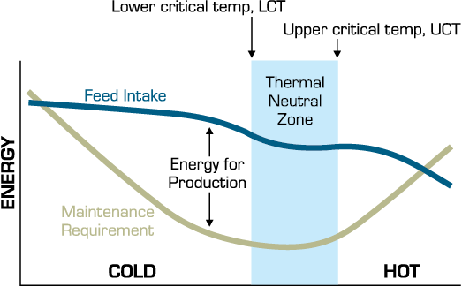
Source: Anderson et al. (2011), adapted from NRC 1981
Timing of feeding influences the timing of heat output. Konandreas, Anderson & Addis (1982) noted that during severe cold conditions, feeding cows later in the day ensured that feed-related increases in metabolic heat production coincided with colder conditions at night. Wagner (1988) noted that drinking excessively cold water or being unable to access water because it is frozen can exacerbate cold stress by reducing feed intake. In cattle, feed intake is linked to water intake and, in cold weather, warming the water will increase feed intake (Petersen et al. 2016).

Other factors influencing cold tolerance
Ferguson et al. (2008) state that ‘an animal lying in wet and muddy terrain will lose much more body heat than an animal lying on dry ground, and this effect is more of a problem in cold, wet and windy conditions’. This finding came from research which focused on cattle in feedlots in Australia but the principle may apply to cattle on live export voyages. The temperature of the pad and whether it impacts on animal welfare could be an area for further investigation.

Cold stress thresholds
The literature on cold stress mostly relates to northern hemisphere conditions with a general focus on appropriate management of production animals through winter and extreme cold conditions. Conditions described in literature can be significantly colder (as low as −35°C) than those experienced on livestock vessels during export from southern Australia.
A wide range of LCTs are described in literature such as 0°C (Broucek, Letkovicová & Kovalcuj 1991), 4°C for dairy breeds (Abbas et al. 2020), 5°C for dairy breeds (De Rensis, Garcia-Ispierto & López-Gatius 2015) and −21°C for acclimatised beef cattle in northern United States (Anderson et al. 2011). According to Young (1983) ‘lactating and fattening cattle are extremely cold-hardy and rarely experience climatic conditions below their lower critical temperature’.
The Cold Climate Destination Checklist for Cattle (LiveCorp & MLA 2020) aims to address the unique risks to the health and welfare of cattle associated with their delivery into conditions below cattle TNZ. The paper noted that cattle with summer coats have an LCT of 15°C, while cattle with thick winter coats may have an LCT of −8°C. While these temperatures were not referenced in the guidance paper, they appear to match those outlined in a report by Marston et al. (1998) which provided guidelines for LCTs for beef cattle in Kansas (Table 23). The same thresholds are also noted by the Ontario Ministry of Agriculture, Food and Rural Affairs (Tarr 2007).
Table 23 Estimated lower critical temperatures for beef cattle
Coat description | Critical temperature °C
Summer or wet coat | 15°C
Dry autumn coat | 7°C
Dry winter coat | 0°C
Dry heavy winter coat | −8°C
Source: Marston et al. (1998)
It is difficult to interpret the significance of these LCTs. Marston et al. (1998) do not provide information on the research undertaken to determine the LCTs, nor the relevant animal factors such as age, breed, class and BCS that influenced the findings. As such, cattle in Victoria might be accustomed to mean monthly minimum temperatures in summer ranging from 13°C to 14.6°C (BOM 2021) of which an LCT of 15°C for a dry summer coat appears high.

Cold stress voyage analysis

Description of voyages
Twenty of the 214 voyages (9.3%) were identified as reporting ambient temperatures of ≤5°C DBT or included evidence of cold conditions based on behavioural, physiological, or environmental signs. The average minimum temperature for these 20 voyages was 3.2°C DBT, while the lowest minimum was −7°C DBT (Table 24).
Thirteen of these 20 voyages did not report evidence of cold stress, despite 11 voyages reporting minimum DBT between 2°C and 5°C and 2 voyages reporting minimum DBT of −0.3°C and −3°C.
Table 24 Summary of voyages and minimum reported ambiet DBT
Minimum temperature (°C DBT) | Voyages with at least 1 day at or below the minimum temperature
≤−7 | 1
−6 to −3 | 2
−3 to 0 | 2
>1 to 5 | 15
Total | 20

Some voyage reports recorded a wide temperature variation during the course of the voyage with the average difference of 17.6°C between minimum and maximum WBTs.
Eighteen of the 20 voyages were destined for ports in the northern half of China (Map 3) and 2 voyages to Israel, with 1 voyage additionally discharging cattle in the Russian Federation. Four of the 5 voyages reporting the coldest temperatures departed during December 2018, December 2020 and early February 2016, coinciding with the NHW.
Map 3 Location of the coldest recorded DBT for voyages to China
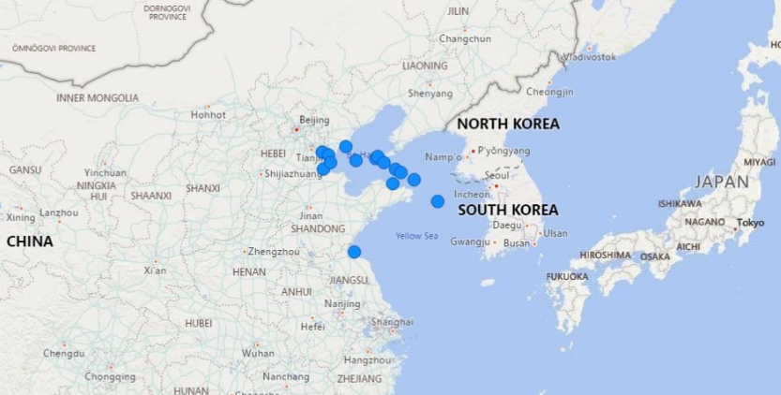Source: DAWE (2020)
All voyages recording DBTs of 5°C or less departed Australia between the months of October and April (inclusive).
Increasingly cold temperatures were most often recorded in the final 5 days of the voyages. The temperature profile of the final 5 days for cold voyages with complete daily reports (n=9) was assessed. The average change in temperature between 5 days prior to arrival and the final temperature recorded was 16°C, with a range of 2°C to 24°C.

Observations of cold conditions
Seven of the 20 voyages reported evidence of cold conditions, either reporting animal responses to cold or environmental issues associated with cold. Of these 7 voyages, 2 carried feeder cattle, 2 carried breeder cattle and 3 carried slaughter cattle. The 7 voyages recorded minimum DBT of 5°C (n=5), 10°C (n=1) and 16.9°C (n=1).
Three of the 7 voyages reported behavioural or physiological signs of cold conditions including:
- shivering when the minimum deck DBT was −1°C
- decreased water consumption when DBT was 10°C
- cattle reported to be ‘cold, wet and windblown’ with temperatures of 13.6°C WBT/17.2°C DBT after rough seas and high winds flooded the lowest open deck in the Great Australian Bight. Excluding this voyage, the average minimum was 2.5°C DBT.
Another 3 of the 7 voyages, on 3 different vessels, documented environmental issues with frozen water troughs or pipes with minimum deck DBT of 0°C, −1°C and −7°C. In these instances water was provided manually by the crew.
One of the 7 voyages reported cattle were euthanased as their BCS was too low to support the environment they were entering.

Summary of key findings

Cold stress:
- Twenty of the 214 voyages were identified as having evidence of cold conditions based on either reported temperature of ≤5°C or environmental signs such as frozen water in pipes, or behavioural and physiological signs
- Of the 20 voyages:
  - 13 recorded cold temperatures between 5°C and −3°C DBT but reported no evidence of cold stress
  - 3 reported behavioural or physiological signs or evidence of cold conditions (1.4% of voyages in this review)
- Average minimum temperature was 3.2°C DBT and the average difference between minimum and maximum WBTs was 17.6°C
- During the final 5 days there was an average decrease of 9.1°C DBT over a 24-hour period
- All voyages recording DBT ≤5°C departed Australia between the months of October and April (inclusive)
- There were no recorded primary mortalities due to cold stress.

Discussion and recommendations
As discussed in section 4.4 our analysis was highly dependent on voyage reports and therefore limited by the quality and quantity of available data in these reports.
The analysis demonstrated that the risk of cold conditions in all classes of cattle is greatest during the NHW particularly for exports departing from December to February. The coldest part of the journey appears to be during unloading in northern ports. The scope of this review ends at unloading. There is limited reporting of environmental conditions and the management of cattle beyond this point including the suitability of transportation and feedlot infrastructure to protect cattle from cold stress. The department receives ESCAS audit reports for feeder and slaughter cattle in the destination market.
In total, only 3 voyages reported behavioural and physiological signs of cold conditions in cattle, such as shivering. It could not be determined from voyage reports whether these signs were indicative of cattle reacting to cold conditions or actual cold stress, noting that the term ‘cold stress’ was not used in any voyage reports. The low incidence of reporting of cold stress is possibly attributed to a general lack of awareness of how to recognise and mitigate the impacts of cold conditions.
Extremely cold drinking water could be a welfare concern, particularly if it causes cattle to reduce or cease drinking. While reduced drinking was reported on one voyage (at deck DBT of 10°C), the impact on welfare was not recorded. Further research into the impact of drinking water temperatures on cattle behaviour might help to improve animal welfare outcomes.
Increased availability of dietary energy when cattle experience cold conditions could present a simple mitigation measure. Other measures such as the adjustment to the temperature of the water, and timing and method of deck washing if a vessel is approaching cold conditions, should also be considered. Further examination of mitigation measures employed on vessels is encouraged.
At one port the AAV euthanased a number of “skinny/depressed” cattle prior to discharge on welfare grounds. The AAV determined that the cattle were not in sufficient body condition to survive transportation to the feedlot. This highlights the importance of a cattle body score condition and susceptibility to cold stress.
More reporting and data collection regarding cold stress should take account of the LCTs described in the Cold Climate Destination Checklist for Cattle (LiveCorp & MLA 2020) noted in section 6.3.5. Establishing the bounds of the TNZ for Australian cattle across different seasons could be an area for future research. We note that the MLA Veterinary Handbook (Jubb & Perkins 2019) and the LiveCorp Stockies Guide (Jubb & Perkins 2019) contain limited information about cold stress.
ASEL requires that written contingency plans be prepared to address a number of animal welfare challenges including adverse weather conditions. It is not clear to what extent appropriate management of cattle in cold conditions is incorporated into the contingency plans. Future reviews of ASEL could consider the implementation of a cold climate management plan to address the risk of cold stress in cattle exported to cold climate destinations.
Box 5 Findings related to cold exposure and cold stress
12. Twenty of the 214 voyages were identified as having evidence of cold conditions based on either environmental signs such as temperatures of ≤5°C or evidence of relevant behavioural or physiological signs.
13. There were no recorded primary mortalities due to cold stress.
14. The cold tolerance of Australian Bos taurus cattle exported to cold climate destinations is not well established.
15. Wet conditions are an important consideration on board a livestock vessel when animals are exposed to direct windchill (open decks) and high ventilation rates.
16. Mitigation measures for managing Bos taurus cattle in cold conditions are not well established.
Box 6 Recommendations related to cold exposure and cold stress
13. Further research should be undertaken to determine appropriate critical temperatures that relate to compromised animal welfare for Australian cattle exported to cold climate destinations.
14. Consideration should be given to timing and method of deck washing to allow time for cattle coats to dry before the vessel encounters cold conditions.
15. Industry should develop guidance for appropriate cold exposure and cold stress mitigation measures on board vessels for cattle in cold conditions.
16. Measures to mitigate the risk of cold stress on board vessels should be incorporated into exporters’ ‘adverse weather’ contingency plans.
17. A future review of ASEL could consider the implementation of a cold climate management plan to address the risk of cold stress in cattle exported to cold climate destinations.

Summary of submissions to the draft report
The department received 11 written submissions during the Have Your Say consultation period. We considered the information and evidence in all submissions in detail before finalising this review.
Key issues raised across the submissions have been briefly summarised below. Submissions can be read in full at the department’s cattle and buffalo exports by sea webpage.

Submissions on heat load and heat stress-related mortality

Stocking density and pen space allocation
Section 3.3.1 examines the impact of using allometric pen space allowances (with a k-value of 0.030) on animal welfare outcomes on voyages. One submission stated that cattle loaded at southern Australian ports require space allowances calculated using a minimum k-value ≥ 0.033 to reduce the risk of adverse welfare outcomes (Petherick & Phillips 2009). We note this study was based on intensive housing systems and that the authors noted this space allowance calculation would ‘require verification… under different thermal conditions and, for transportation, under different conditions of vehicular/vessel stability.’ The space allowance currently required under ASEL 3 is based on recommendations of the TAC following the 2018 ASEL sea review.
By contrast, another submission noted that additional space allowances for slaughter cattle should be postponed pending substantial data on ASEL 3 outcomes. Determining any additional space through the application of the HSRA was also suggested.
Concerns were also raised in a confidential submission regarding the movement of cattle between pens to create more space and reduce stocking densities (and thereby reducing the impact of metabolic heat production). This submission claimed that ship masters would likely discourage opening gates between pens as there could be a risk to animals being thrown around in rough seas in large pens, and that it could impact the stability of the vessel. It is noted that this practice, known as long penning, is not permitted under Australian Maritime Safety Authority (AMSA) regulations due to the risk of structural failure.
Further information regarding the recommendation to increase pen space allowances for Bos taurus slaughter can be found in section 4.4.2.

Diagnosis of heat stress-related mortality
One submission noted that voyages may not be accompanied by a veterinarian but by a stockperson and questioned the adequacy of their training in veterinary pathology and physiology. Concerns about the ability of stockpersons to correctly diagnose heat stress or other health issues was raised within this submission. Other submissions stated that there should be a veterinarian present on every live export ship, or at the very least on every long-haul Bos taurus voyage. We note that the Accredited Stockpersons training managed by Livecorp covers the onboard management of cattle including the risk factors and management of heat stress. The Shipboard Stockie’s Guide (LiveCorp 2020) also describes the signs, symptoms and management of commonly occurring cattle diseases. In the event that a cause of death is unknown, Accredited Stockpersons are trained to perform post-mortems to determine the cause of death. Another submission questioned if pre-export preparations, based on importing country requirements, may have an impact on heat load and heat stress-related mortalities during voyages. The submitter suggested that breeder consignments may have more careful and considered stock selection and better preparation practices, making them less likely to die due to heat stress. The department notes that breeder cattle imports to some markets have requirements for vaccination against BRD, while imports of feeder and slaughter to the same markets do not. It was the view of this submitter that higher valued animals (such as breeder cattle) are possibly less likely to be euthanased if experiencing health or welfare issues, and that crew members may employ additional measures to improve the outcome for higher value animals. The submitter was concerned this may cause the mortality figures in our review to be ‘skewed’. The department’s analysis on voyages reporting increased heat load is discussed in section 4.
Concerns regarding heat mitigation measures were raised in a confidential submission. The submission stated that in hot conditions hatches above the heads of cattle on top deck are likely to be opened, and that this can improve air flow but may also lead to exposure to direct sunlight. The submission also raised concerns about wetting cattle as a cooling measure as it can sometimes lead to increased humidity, particularly on closed decks, which could lead to a worsening of environmental conditions.
Another submission questioned the effectiveness of ‘zig-zagging’ to increase air flow through decks, particularly in closed deck vessels.
One submission suggested that genomic selection of cattle can improve heat tolerance. This long-term heat mitigation measure was determined to be beyond the scope of this review.
The department’s analysis of mitigation measures is discussed in section 3.3.2.

Other heat stress factors

Use of data loggers and hotspots on decks
One submission noted that the use of data loggers was a considerable regulatory burden, and that establishing ship-wide connectivity needs to be a pre-requisite before imposing this additional requirement. This statement was supported by another submission which stated that the Bos taurus report needed to present considerably more evidence on the need for loggers to demonstrate that the benefits would exceed the costs.
By contrast, another submission stated that ‘multiple, well-maintained data loggers must be added to every deck, including hotspots, of every ship carrying livestock’. This submission called for the use of blockchain technology to support the deployment of data loggers on all live export vessels and also suggested the department should insist on requiring simultaneous CCTV footage of representative pens on all decks. Another submission called for all video footage on live export vessels to be made available for independent assessment.
Submitters’ views on hotspots were also varied and conflicting. One submission claimed that hotspots are ‘well known’ on certain vessels yet industry does nothing to alleviate or improve these areas. Other submissions requested the department recommend hotspots be noted in the HSRA and load plan for each voyage or suggested that hotspot areas must be required to have improved permanent ventilation (not portable fans). If this is not possible, it was suggested that these areas should not be stocked.
By contrast, another submission stated that IO reports provide documented evidence that hotspots are actively managed during voyages.
The department’s analysis of hotspots is discussed in section 5.1.

Bedding and pad
Some submissions queried the adequacy of bedding provisions under ASEL 3, with one stating ‘bedding volumes are inadequate from a welfare perspective’. One submission suggested that ASEL could be amended to allow the current bedding volume for every 4 days of the voyage, as deck washing often appeared to be undertaken on a 4 day cycle. Another suggestion was that additives to bedding (such as gypsum) could be considered to help reduce ammonia production, however, McCarthy and Banhazi (2016) state the ‘sheer bulk of manure added to the bedding each day overwhelms any possible effects of bedding additives’.
Conflicting views on pad management were received in some submissions. For example, one submission stated strategic deck washing reduced the volume of wet manure on decks and could lower humidity within pens, whereas another submission stated deck washing could increase deck humidity. One submission stated that, in high temperature conditions, the heat from a deep and boggy pad can increase the temperature of the floor under the pad and heat up the pens underneath.
Two submissions stated that industry was committed to develop best-practice guidance on pad management. These submissions recognised that pad management represents one of the major tasks of an AAV or stockperson during a voyage. One of these submissions proposed conducting industry training sessions on pad management and ascertaining the need for additional and ongoing training.
The department’s analysis of bedding and pad management is discussed in section 5.6.2.

Pregnant cattle
One submission stated that the causes of premature lactation remain in the realm of research and that it was ‘inconsistent with the principles of good regulation to mandate the collection of specific items of data’ relating to it. However, another submission supported the department’s findings and recommendations on this issue and stated that 'documentation of the occurrence of premature lactation during voyages, accompanied by detailed information regarding livestock factors, environmental conditions and resource management could improve our understanding of this issue'.
The department’s findings on premature lactation are discussed at section 5.4.

Reporting of heat stress
Concerns were raised in some submissions about the reliability of reported data. A confidential submission suggested that there may be a possible ‘skewing’, particularly of mortality data. It was stated that higher value animals, such as breeder cattle, may be less likely to be euthanased if experiencing health issues during voyages. The view of the submitter was that AAVs and stockpersons may employ additional measures to improve the health and welfare outcomes of higher value animals, and that the consequent reporting would impact the findings of this review. The department would welcome further evidence or research on the management of different classes of cattle.
This submission also questioned whether all heat stress-related mortalities were reported as such. It was the view of the submitter that there was a reluctance to declare a mortality as heat stress-related as there was a perception that listing heat stress as the cause of death reflected poorly on the vessel operators.
Another submission stated the issue of inaccurate reporting and under-reporting of heat stress had been previously raised with the department and included in a paper co-authored by Vets Against Live Export (VALE) and a RSPCA officer. The VALE paper analysed issues the department had already identified through its normal regulatory processes, including issues around food and water provision, exposure to heat and cold, bedding provisions, loading and unloading issues, and whether an AAV was present on board the ship. Where the VALE’s analysis of some issues differed from the department’s analysis, this was due to the comprehensive data assessed in this review and the department taking the impact on animal welfare into account. For example, the VALE paper analysed departmental mortality reports and summaries of IO reports for 37 cattle voyages from Australia to China from July 2018 to December 2019. By contrast, this review analysed data from 214 voyages travelling between January 2016 and December 2020 (see section 2).

Diet
Some submissions raised the influence of a grain fed diet on thermal tolerance. One submission indicated that slaughter cattle are often fully or partially grain-fed, and this practice likely increases for this class when exported in autumn and winter.
Another submission suggested that further research could be undertaken to enhance the understanding of the role of diet in heat stress. It noted that ‘research, to better define metabolic heat outputs directly relevant to diets and feed intakes typically encountered on livestock vessels, and their impact on individual animals and on deck temperatures…may improve management of…heat stress on livestock vessels.’
The department’s analysis of stocking density and pen space allocation is discussed in section 3.3.1.

Submissions on cold stress

Cold stress management
One submission stated that the analysis and findings of this review did not justify the cold stress-related recommendations, and that cold stress is not a significant welfare issue for voyages within the scope of this review. By contrast, another submission stated that ‘we consider cold stress to also be a significant animal welfare concern requiring equal consideration [to heat stress]’.
One submission noted that cold stress in cattle may only become evident upon arrival at the importing country when, under cold conditions there may be inadequate feed available to meet the increased metabolic demands of the thermoregulatory system. Conditions on arrival were determined to be outside the scope of this review.
The possibility of concurrent illnesses increasing susceptibility to cold stress was also raised in a submission. The department did not find specific references that identified a link between concurrent illness and cold stress during the literature review. Concerns about the welfare impact of temperature variations were raised in a submission. We have not identified scientific research discussing the significance of wide temperature variation on cattle welfare (or other species). Another submission noted that conditions can be so cold as to impact normal watering operations on vessels, for example the freezing and fracturing of water lines. No feeding issues related to cold conditions were identified in the voyage reports analysed for this review. However, some reports noted that crew undertook manual watering if water pipes were frozen. The department’s analysis of cold stress voyages is discussed at section 6.5.

Temperature reporting
It was suggested in one submission that deck temperatures, rather than ambient temperatures, should be used as a reference point for cold conditions. Typically, deck temperatures are 1-3°C higher than ambient temperature. Another submission recommended the use of temperature control measures stating that ‘air conditioning temperature control measures are required to address cold stress conditions’.

Oversight in the destination country
One submission suggested it should be mandatory that Australian veterinarians accompany cattle in the destination country for a minimum of 2 weeks during the NHW. This was supported by another submission which suggested that the department should have oversight into cattle welfare outcomes in destination countries. Both issues were outside the scope of the review.

Weather and acclimatisation
One submission stated that, based on our classification of ‘cold conditions’, there are many times and locations in Australia which would also be classified as ‘cold’. We note that in the context of this review, we were aiming to analyse the impact of the relatively rapid onset of cold conditions, often in the last few days of a voyage, which does not allow time for acclimatisation.
The department’s analysis of cold tolerance is discussed in section 6.3.

Appendix A: ASEL 3 standards
The following standards were implemented under ASEL 3 (DAWE 2020) and applied to voyages in this analysis that departed in November and December 2020. Revisions, some significant, were made to some of the following standards under ASEL 3.2, which was published on 18 November 2021 and can be accessed at the department’s ASEL standards webpage.

Voyage length
Definitions Voyage means the period from the time the first animal is loaded onto the vessel (the first day of the voyage) until the time the last animal is unloaded at the final port of disembarkation.

Heat stress
Standard 1.4.2 Cattle sourced for export must have an individual liveweight of 200kg to 500kg. Animals outside of these weights must not be sourced for export, unless otherwise provided:
a) for cattle less than 200kg, in a light cattle management plan approved in writing by the department, or
b) for cattle more than 500kg, in a heavy cattle management plan approved in writing by the department.
Standard 1.4.3 Bos taurus cattle sourced for export from any area of Australia south of latitude 26° south must only be exported on voyages that cross the equator and depart between 1 May and 31 October (inclusive) if:
a) they have been determined in accordance with the conditions in Standard 1.4.5, or Standard 1.4.6 and 1.4.7, to be not detectably pregnant, unless otherwise provided in a pregnant southern sourced Bos taurus cattle crossing the equator from May to October management plan approved in writing by the department; and
b) for cattle to or through the Middle East, a heat stress risk assessment indicates that the risk is manageable (less than 2% risk of a 5% mortality).
Standard 1.4.4 Cattle must not be sourced for export or exported unless they have been assessed by a competent stock handler against the cattle body condition scoring in Table 2 and have a BCS of 2 to 6 (inclusive) (on a scale of 1 to 7), unless they are Bos taurus cattle sourced for export from, or exported through, any area of Australia north of latitude 26° south between 1 October and 31 December (inclusive), then they must have a BCS of 2 or more but less than 5 (on a scale of 1 to 7).
Standard 3.4.2 The minimum length of time that cattle must remain in a registered establishment prior to departure for the port is 2 clear days for short or long–haul voyages, or 3 clear days for extended long–haul voyages. For any clear day on which animals are subject to a feed or water curfew, an additional clear day is required.

Standards applicable to ventilation and air quality
Standard 5.1.19 When livestock for export are loaded on vessels with enclosed decks, the ventilation system must be run continuously from the commencement of loading until the last animal has been unloaded.
Standard 5.1.20 Ammonia levels in a representative number of pens must be measured daily. If ammonia levels exceed or are likely to exceed 25ppm in any livestock spaces, appropriate reduction measures must be implemented.
a) Compliance with this standard will be delayed for a 12-month period (from the date this version is in force) while the use of available ammonia detection devices on vessels is tested.
ASEL 3 also requires reporting with regards to ventilation. Daily reports must include any notes about ventilation issues including:
- Detail of issue(s)
- Period of time of issue(s)
- Deck(s) affected
- Impact on animals
End of voyage reports should provide a summary of any ventilation issues.
Additionally, the requirements for ventilation on livestock vessels from AMSA are in Marine Order 43, Sch 2 pt 2:
- For a vessel constructed or converted for the carriage of livestock after 26 May 2004 — the mechanical ventilation system must provide air from a source of supply, with a velocity across a pen of at least 0.5 ms−1.
Sch 2 pt 2 s2.3(4):
- For a vessel constructed or converted for the carriage of livestock before 27 May 2004 — the mechanical ventilation system must, after 31 December 2019, provide air from a source of supply, with a velocity across a pen of at least 0.5 ms-1.
Sch 2 pt 2 s2.4(4):
- However, if a solid structure or the vessel’s side impedes the flow of air in an area of the pen, AMSA may approve, for up to 4% of the area of the pen, a velocity less than 0.5 ms-1 but more than 0.2 ms-1.

Standards applicable to feed provision
Standard 5.1.10 Feed and water provisions must be appropriate for the species, class, weight and age of livestock, voyage length and expected weather conditions.
Standard 5.1.11 All livestock must be provided with adequate trough space during the voyage to ensure each animal can meet its daily requirements for feed and water without risk to their health or welfare.
Standard 5.1.12 Livestock must have access to suitable feed and ad libitum water:
a) as soon as possible and no more than 12 hours after being loaded on the vessel; and
b) for water, within maximum water deprivation times equal to those set out in the Land Transport Standards; and
d) of a quality to maintain good health, hydration and welfare and satisfy energy requirements for the duration of the voyage, including loading and unloading, and in the event of delay.
Standard 5.1.14 The ration fed on the vessel must comply with these conditions:
a) the ration must not contain more than 30% by weight of wheat, barley or corn, unless the livestock have been adapted to the ration over a period of at least 2 weeks prior to export; and
b) all pelleted feed must be accompanied by a manufacturer's declaration that states it is manufactured in accordance with the Australian Code of Good Manufacturing Practice for the Feed Milling Industry (2009); and
c) all Australian-origin feed from a previous voyage that is suitable for livestock consumption may remain in a feed storage tank provided that:
i) each tank is completely emptied, and feed discarded at least once in every 90 days; and
ii) all feed that is no longer suitable for livestock consumption is emptied in its entirety before further feed is loaded; and
iii) records are maintained of the emptying of feed storage tanks and are available for inspection.
Standard 5.1.15 All voyages (noting this includes the days of loading and unloading) must carry adequate reserves of feed to ensure livestock can continue to be fed in accordance with the minimum daily requirements even if delays occur. The additional reserve that must be carried on the vessel to be used only in the event of delay is a minimum of 3 days of feed for cattle, buffalo, sheep and goats.
Standard 5.3.7 Feed loaded and provided to cattle exported on voyages of: 30 days or less, must include at least 1% of the required feed as chaff and/or hay; and
a) 31 days or more and where an exporter has approval under Standard 5.1.17 to export cattle on extended long-haul voyages, must include at least 2% of the required feed as chaff and/or hay
Standard 5 of ASEL 3 addresses the feed requirements for cattle including minimum quantities/head/day for different classes of cattle and dictates the provision of supplementary feed types for in appetent animals.

Standards applicable to water provision
(In addition to the reference to water in the standards related to feed)
Standard 5.1.13 There must be no water curfew applied prior to unloading of livestock at ports in the Middle East between 1 May and 31 October (inclusive).
Standard 5.1.16 The minimum additional reserve of water that must be carried on the vessel to be used in the event of delay is 3 days of daily water maintenance requirements for all livestock on board. Allowance may be made for fresh water produced on the vessel while at sea.

Standards applicable to pad management
Standard 5.1.18 Bedding provisions must be loaded for all voyages and:
a) Applied in a sufficient quantity that allows pens to be maintained in a manner that ensures the health and welfare of the livestock and minimises slipping, injuries, abrasions, lameness, pugging and faecal coating; and
b) Applied prior to and during loading and unloading to minimise slipping during loading and unloading; and
c) Be monitored routinely (at least daily) to ensure consistency and depth is appropriate to mitigate risks to the health or welfare of the livestock.
Standard 5.3.8 Cattle exported on voyages of 10 days or more must be provided with sawdust, rice hulls or similar bedding material to be used exclusively for bedding at a rate of at least 7 tonnes or 25mᶾ for every 1,000m² of cattle pen space. This does not apply to cattle loaded from a port north of latitude 26˚ south and exported to South-East Asia.

Standards applicable to pregnant cattle
Standard 1.1.7 Female livestock must not be treated with a prostaglandin drug:
a) within the 60 day period prior to export unless they have been pregnancy tested immediately before prostaglandin treatment and declared to be in the first trimester of pregnancy or not detectably pregnant; nor
b) within 14 days prior to export.
Standard 1.4.3 Bos taurus cattle sourced for export from any area of Australia south of latitude 26° south must only be exported on voyages that cross the equator and depart between 1 May and 31 October (inclusive) if:
a) they have been determined in accordance with the conditions in Standard 1.4.5, or Standard 1.4.6 and 1.4.7, to be not detectably pregnant, unless otherwise provided in a pregnant southern sourced Bos taurus cattle crossing the equator from May to October management plan approved in writing by the department; and
b) for cattle to or through the Middle East, a heat stress risk assessment indicates that the risk is manageable (less than 2% risk of a 5% mortality).
Standard 1.4.5 Female cattle sourced for export as feeder or slaughter animals must:
d) be pregnancy tested within 30 days prior to export, by registered veterinarian or competent pregnancy tester who must certify in writing that the animal is not detectably pregnant and include with the certification the date of the procedure; and
e) undergo the above pregnancy testing by a registered veterinarian if the animal is too small to be manually palpated, who must base the certification on assessment of the animal by a method other than manual palpation.
Standard 1.4.6 Female cattle sourced for export as breeder animals must be no more than 190 days pregnant at the scheduled date of discharge in the importing country. In order to demonstrate this, the cattle must be pregnancy tested:
a) by a registered veterinarian using an approved blood test; and
i) if the test result is negative, be certified in writing as not detectably pregnant; or
ii) if the test result is positive, undergo testing as per b) or c) below; or
b) by a registered veterinarian that attests to current experience and competency in cattle pregnancy diagnosis, using manual palpation and only if the voyage is less than 10 days; and
i) if the test result is negative, be certified in writing as not detectably pregnant; or
ii) if the test result is positive, be certified in writing as pregnant with number of days pregnant stated; or
c) by a registered veterinarian that is accredited under the PREgCHECK (NCPD) Scheme, using manual palpation or an alternative method if the veterinarian determines that the animal is too small to be manually palpated safely; and
i) if the test result is negative, be certified in writing as not detectably pregnant; or
ii) if the test result is positive, be certified in writing as pregnant with number of days pregnant stated; and
d) with the certification stating the animal’s individual NLIS identification number and date of the procedure, and where accredited PREgCHECK tester is used, the name of the accredited tester, their accreditation number and a statement of their accreditation.
Standard 1.4.7 Pregnancy test certification for Standard 1.4.6 is valid for:
a) 30 days for pregnant cattle, unless an exporter has applied for a certification validity extension, and received approval in writing from the department, prior to loading; and
b) 60 days for not detectably pregnant cattle, from the date of the procedure or collection of blood sample.
Standard 4.1.9 Unless the exporter has approval under Standard 4.1.10, an AAV must accompany each consignment of livestock and must remain with the consignment until the last animal has been unloaded at the final port of disembarkation in these circumstances:
a) if the voyage is expected to be an extended long-haul voyage; and
b) on voyages with pregnant livestock; and
c) any other voyage when directed by the department.
Standard 5.3.1 The minimum pen space allowances for cattle exported by sea are contained in Table 9, Table 10a, Table 10b, Table 11a, Table 11b, Table 12a and Table 12b. These penning criteria apply:
a) where a curfew of more than 12 hours will be undertaken at the registered establishment prior to transport to the port of embarkation, a curfew factor of an additional 5% must be applied when calculating liveweight (cumulative with other additional space requirements and must be calculated first); and
b) the weight of each animal in a pen must not vary from pen average weight by 50kg. The pen average weight is calculated by dividing the total weight of the cattle in the pen by the number of cattle in the pen; and
c) for pregnant cattle, a minimum additional 15% space must be provided; and
d) cattle without horns may be penned with cattle with horns up to 12cm in length and where the horns are tipped (blunt); and
e) cattle outside of the weights shown in Table 9, Table 10a, Table 10b, Table 11a, Table 11b, Table 12a and Table 12b must only be sourced for export or exported in accordance with a light or heavy cattle management plan where an exporter has approval under Standard 1.4.2.
Table 25 Feed requirements for cattle
Class of cattle | Minimum feed allowance/head/day (% liveweight)
Cattle weighing less than 250kg | 2.5
Breeding heifers with 6 or fewer permanent incisor teeth (regardless of pregnancy status) | 2.5
Pregnant cows | 2.5
Other classes of cattle | 2.0

Standard 5.3.9 The minimum veterinary medicines and equipment to be carried on the vessel are in Table 14. Additional veterinary medicines and equipment to be carried on voyages with pregnant cattle are in Table 15. Additional veterinary medicines and equipment may be necessary if there are other classes of cattle in the voyage.
Table 26 Additional minimum veterinary medicines and equipment for pregnant cattle
Medicines and equipment | Minimum requirement
Obstetrical lubricant | 5 litres per 2,000 cattle
Calving ropes | 1 set per vessel
Obstetrical gloves | 1 box per vessel
Oxytocin | 50 ml per 1,000 cattle
Additional chlorohexidine (or equivalent) | 5 litres per vessel
Iodine (umbilical treatment) | 1 litre per vessel
Uterine pessaries | 10 per 2,000 cattle
Surgical equipment | Adequate to conduct a caesarean section

Cold stress
Standard 1.4.2 Cattle sourced for export must have an individual liveweight of 200kg to 500kg. Animals outside of these weights must not be sourced for export, unless otherwise provided:
a) for cattle less than 200kg, in a light cattle management plan approved in writing by the department, or
b) for cattle more than 500kg, in a heavy cattle management plan approved in writing by the department.
Standard 4.1.18 Contingency plans, including procedures for contacting the exporter, must be prepared in writing for each consignment that address:
a) mechanical breakdown of the vessel or functionality relevant to maintaining the livestock’s health and welfare; and
b) a feed and/or water shortage during the voyage; and
c) the satisfactory tending, feeding and watering of the livestock in the event of a malfunction of the automatic feeding or watering systems, without compromising the safe navigation of the vessel; and
d) an outbreak of a disease during the voyage; and
e) adverse weather conditions during the voyage; and
f) rejection of the consignment by the overseas country.

Appendix B: Heat load mortality table
Vessel | Exporter | Departure month | Departure year | Voyage Duration (days) | Destination | Cattle class | Average cattle liveweight (kg)* | Max WBT (°C) | Voyage mortalities (head) | Voyage mortality rate (%) | Heat stress-related mortalities |  |  |  | Comorbidities
 |  |  |  |  |  |  |  |  |  |  | Total | Primary | Secondary | Other
A | B | Apr | 2018 | 30 | Red Sea | Feeder | 300 | 34.0 | 15 | 0.26 | 3 | - | 3 | - | infection, clostridia, bloat
B | A | Jun | 2018 | 22 | Red Sea | Feeder | 300 | 29.5 | 1 | 0.03 | 1 | - | 1 | - | none stated
B | D | Mar | 2018 | 22 | Red Sea | Feeder | - | 27.6 | 13 | 0.28 | 1 | - | 1 | - | respiratory disease (BRD)
C | C | Dec | 2018 | 22 | China | Slaughter | 571 | 30.1 | 2 | 0.14 | 1 | - | - | 1 | none stated
D | E | May | 2018 | 17 | China | Slaughter | - | 33.0 | 46 | 1.45 | 42 | - | 42 | - | respiratory disease (BRD)
E | F | May | 2020 | 14 | China | Slaughter | 510 | 29.0 | 10 | 0.54 | 4 | 1 | 3 | - | gastroenteritis
F | A | Apr | 2018 | 21 | China | Breeder | - | 32.0 | 11 | 0.48 | 2 | - | 2 | - | pneumonia
G | C | Oct | 2018 | 15 | China | Slaughter | 540 | 30.0 | 1 | 0.05 | 1 | - | - | 1 | none stated
G | C | May | 2018 | 14 | China | Slaughter | - | 30.0 | 10 | 0.56 | 8 | - | - | 8 | none stated
G | C | Jun | 2018 | 20 | China | Slaughter | 562 | 28.5 | 13 | 0.67 | 4 | - | - | 4 | none stated
G | E | Jul | 2016 | 18 | China | Breeder | - | 29.0 | 3 | 0.07 | 1 | - | 1 | - | respiratory compromise
H | E | Nov | 2017 | 18 | China | Slaughter | - | 29.0 | 5 | 0.21 | 1 | - | 1 | - | lameness
H | E | Jul | 2018 | 18 | China | Slaughter | 598 | 32.0 | 33 | 1.51 | 15 | 14 | 1 | - | none stated
I | E | Jun | 2018 | 17 | China | Slaughter | - | 31.0 | 17 | 0.67 | 1 | - | 1 | - | respiratory disease

Appendix C: Methodology
Data was collected from various forms of voyage reports for departures during the time period 1 January 2016 to 31 December 2020. Data sources included daily and end of voyage reports from AAVs and stockpersons, Australian Maritime Safety Authority (AMSA) master’s reports, IO reports, exporter documents and reportable mortality reports.
For each voyage general information was recorded, including:
- vessel
- exporter
- voyage start and end date
- voyage duration
- departure port and destination port and country
- the cattle breed and or class
- number of cattle loaded
- pregnancy status (where information was available)
- total mortalities and mortality rate.
Observations for each voyage were also captured to ascertain the presence and extent of heat or cold stress. These included:
- maximum and minimum recorded temperatures on cattle decks, and total range experienced
- geographical location of maximum and minimum deck temperatures when maximum WBT ≥26°C or minimum WBT ≤5°C, respectively
- cattle behaviour attributed to or typically representative of increased heat load or cold conditions (see section 3.2 and section 6.2)
- ventilation and hotspot issues
- mortalities attributed to heat or cold stress
- management strategies implemented to decrease the effects of or prevent heat and cold stress, including effectiveness of strategy if reported
- additional relevant observations provided by reporting persons.
A statistical analysis was conducted for voyages that reported evidence of increased heat load or heat stress-related mortalities. These voyages were analysed for associations with class of cattle, season, destination, departure port and number of departure ports (single or multiple).

Descriptive Analysis
A descriptive analysis was performed in the first instance to describe each variable independently in terms of distribution and to visualise relationships between two variables where possible.
All voyages with the exception of one recorded a single destination. Seven voyages recorded two classes of cattle on board, whereas the rest recorded only one. For the purpose of analysis, the single voyage with two destinations was treated as two voyages – one for each destination. This decision was made because the overlapping nature of the voyage route of the second destination with the first and the lack of mortality or heat load on this voyage, allowed accurate categorisation for both destinations. Conversely, the records with multiple classes of cattle were excluded from the statistical analysis, due to lack of capacity to identify which class was affected by heat load or mortality from the data available. Post-hoc repeated analyses with these records duplicated was performed to ensure that results did not differ significantly through exclusion of these records.
Where multiple ports of departure were listed only the first was used in analysis. In addition, the data associated with departure ports of Port Adelaide and Geraldton were removed for further analysis as there were small numbers recorded (n = 3 for Port Adelaide and n = 1 for Geraldton) and all were associated with heat load events. This potentially introduces bias for associations with other departure ports (which recorded vastly greater number of voyage departures.

Univariable analysis
Univariable analyses were performed, comparing outcome variables (evidence of increased heat load, heat stress-related mortality, and heat load and/or heat stress-related mortality) with potential explanatory variables (class of cattle, season, AMJ season, destination, departure port and number of departure ports (single or multiple)). All variables were categorical in nature therefore Chi square tests were used for these.

Heat load as an outcome
The analysis explored the significance of voyage characteristics that may contribute to the occurrence of increased heat load. Univariable analyses identified a significant association between voyages reporting increased heat load and class of cattle (P = 0.044) and AMJ season (P=0.014). No significant association was identified between voyages reporting increased heat heat load and destination (P = 0.166), season (NHW vs NHS)(P = 0.570), departure port (P = 0.136) or whether single or multiple departure ports were used (P = 0.173).

Heat stress-related mortality as an outcome
This analysis explored the univariable association of voyages reporting heat stress-related mortality with cattle class, season of departure (ASEL or AMJ), destination and departure port. A significant association was identified between heat stress-related mortality and cattle class (P < 0.001) and AMJ season (P=0.048) but not with destination (P = 0.94), departure port (P = 0.229), number of departure ports (P = 0.622) or ASEL season (P = 0.078).

Multivariable analysis
Multivariable analyses were specified, using generalised linear models with binomial link functions. Two Directed Acyclic Graphs (DAG) was used to identify variables for inclusion in the models (Figure 24 and Figure 25). Variables were assessed for inclusion in the final model by forwards and backwards stepwise selection. Model comparison was performed using likelihood ratio tests, with models with significantly lower residual deviance favoured. Significance was set at P < 0.05. All statistical analyses were performed in R.
The large number of categories in the vessel variable meant that it was not possible to include this variable in the analyses, however class, season and departure port were all considered for inclusion as identified in the methods. The decision to exclude destination from all models was made due to the collinearity issues identified above.
Figure 24 Outcomes of heat load and/or mortality
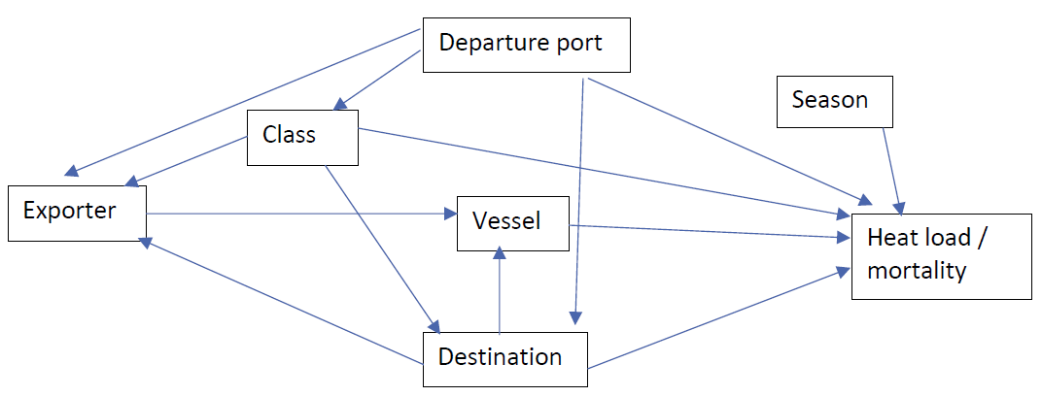
Figure 25 Outcome of mortality, including heat load as an explanatory variable
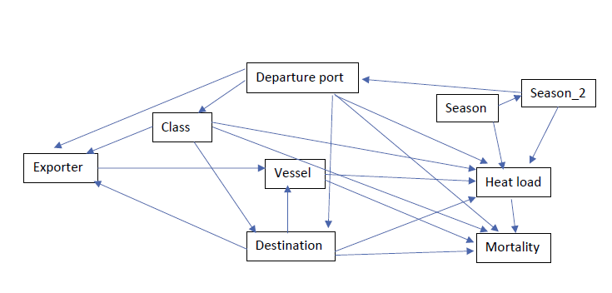

Appendix D: Feedback from the TEG

The technical expert group
An independent technical expert group (TEG) was contracted to provide advice and feedback to the department about the content of the review before release of the draft for comment and before the release of the final report. The panel included:
- Associate Professor Anne Barnes – Associate Professor in the School of Veterinary Medicine, Murdoch University. An experienced researcher in the livestock export trade particularly heat stress physiology. Other areas of expertise include animal reproduction, thermal and appetite physiology, and animal welfare and behaviour.
- Professor Andrew Fisher—Director, Animal Welfare Science Centre, University of Melbourne. Clinical veterinary experience followed by research programs in livestock health, management and welfare. Formerly head of the CSIRO’s livestock welfare research group based in Armidale, NSW.
- Dr Hugh Millar – member of the ASEL committee; former Executive Director Biosecurity Victoria and Chief Veterinary Officer for Victoria. Dr Millar has over 40 years’ experience as a veterinarian and biosecurity professional, in areas including animal and plant health, veterinary public health, animal welfare and biosecurity management in the invasive pests sector.

Feedback on the draft report
The TEG was complimentary of the structure and content of the draft report, describing it as a ‘substantive’ piece of work. The TEG provided general formatting and editorial suggestions which were incorporated into the draft report.
The TEG also provided written feedback focusing on a number of key points. The department supported all suggestions made by the TEG and addressed every suggestion in the relevant section of the draft report, with increased commentary, evidence and explanation. This feedback is outlined below.

Comments and suggestions on the Summary and Recommendations
The TEG stated that for understandable reasons much of the focus of the draft report was on heat stress but suggested that we include more content about cold stress findings in the summary.
The TEG recommended we include increased justification and explanation for some recommendations. The TEG identified one recommendation where it was unclear if there was sufficient justification for its inclusion. This recommendation was removed prior to public consultation on the draft report.
The TEG commented that numbering recommendations would also help readability.

Comments on discussion of ASEL
The TEG commented that the timing and nature of the introduction of ASEL 3 made it difficult to determine how many factors may change or improve through ASEL 3 alone. They acknowledged the report does highlight where recent or proposed ASEL 3 changes may be relevant to the findings and recommendations and were pleased to see that a number of ASEL review recommendations were borne out by the analysis in the draft report. The TEG suggested we ensure we clearly identify what is expected to change in response to ASEL 3 and what will not change. Analysis of the impact of changes introduced under ASEL 3 could be included in a future review of ASEL.

Need for clear case definitions
The TEG noted the analysis in the draft report hinges upon the definition of a heat load event and a heat stress-related mortality. The draft report would benefit from increased clarity on how we have defined these 2 terms. The TEG recommended greater explanation of causes of death, and a clear case definition for what we included as a primary heat stress death, or any other type of mortality. They commented that we should include some discussion on the weaknesses and strengths of this approach, and acknowledgment that it may not be possible from voyage reports to determine when animals had moved from a physiological response to heat to an overly stressed response.

Comments on the statistical analysis
The TEG stated that overall, our findings were reasonable based on the analysis, accepting data limitations, and that the recommendations follow logically. The TEG suggested we provide more information on the methodology used in the statistical analyses, to enable an informed person to evaluate the robustness of that methodology and to be able to theoretically replicate the process. This information would be acceptable in an appendix. The TEG commented the analysis was highly dependent on voyage reports and thus limited by the available data. Further explanation of constraints and limitations would be useful to give some context. The TEG acknowledged the presence of many interacting and confounding factors which made the analysis difficult. The report does endeavour to address this issue, but it could indicate it was not always possible to ‘correct’ for some confounding factors.

Comments and suggestions to include analysis of port of departure
The TEG suggested our report could be improved by including an analysis based on port of departure. We have identified that southern Australian ports are part of the problem faced on long-haul voyages, and the TEG suggest we investigate this further. This may identify significant differences in the way animals are prepared at different ports. The TEG noted that departure port is an important factor influencing outcomes during live sheep exports.

Comments on voyage reports
The TEG identified that voyage reports available within the scope of this review, had significant limitations regarding their usefulness for analysis of heat and cold stress. There could be a recommendation to improve voyage reporting in relevant ways to provide more robust data going forward. Collection of better data is recommended but also to make that data accessible and available for future analysis. Extra recommendations were included in the draft report, focusing on heat load reporting and deck temperature records.

Feedback on the final report
The TEG provided written feedback focusing on a number of key points. In general, the TEG stated the final report displayed appropriate justification and explanation for the recommendations. The department supported all suggestions made by the TEG and addressed every suggestion in the relevant section of the final report. This feedback is outlined below.

Comments on the use of heat load terminology
The TEG noted that previous feedback in relation to the definition of voyages reporting increased heat load and heat stress-related mortality had been incorporated into the report but suggested that surrounding descriptors should be used more consistently throughout. The use of ‘increased’ or ‘excessive’ to describe the degree of heat load was noted as an example where greater uniformity was needed.
The TEG commented that we could further acknowledge the continuum of responses to increasing heat.

Suggestions on how to better incorporate external submissions
The TEG suggested that external submissions should be addressed in a separate section rather than referenced throughout the report. It was commented that this would provide the responses with the relevant context and highlight the differing views of submitters whilst preserving the flow of the scientific analysis in the main text.
The TEG noted that referencing these submissions throughout the report prevented readers from determining which submissions were supported by background data.

Comments on discussion of abortions
The TEG identified some of the challenges associated with analysing information relating to abortion. It was noted that whilst the report does acknowledge the challenges of analysing this information, that there is not sufficient data to diagnose or further investigate the cause of abortions. The TEG suggested that less emphasis should be placed on this issue given that it was not possible to link abortions to specific events.

Appendix E: Submissions to the draft report

Contributor | Recommendations supported | Recommendations supported with changes | Recommendations not supported | Comment
Agriculture Victoria | 1-17 | - | - | The submission supported all recommendations in full
ALEC | 1 | 3,9 | 2,8,11,14-17 | The submission raised concerns about increasing regulation
LiveCorp | 1 | 3,9 | 2, 8,11,12,17 | The submission raised concerns about increasing regulation
RSPCA | 12, 14-18 | 1,2,3,4,8,10,11,13 | 5,6 | The submission advocated for an expansion of the recommendations to increase existing regulation
VALE | 9,11,17 | 1,2,3,4,8,10,12,14,15,16 | - | The submission advocated for an expansion of the recommendations to increase existing regulation
Note: The department received 11 submissions to the draft report. Six submissions did not directly address or refer to individual recommendations in the draft report and were not included in this table summary. These submissions were received from Animals Australia, Kookaburra Veterinary Employment, National Farmers’ Federation, a member of the public and two confidential contributors. Submissions (other than those marked confidential) can be read in full at the department’s cattle and buffalo exports by sea webpage.

Glossary
Term | Definition
Accredited Veterinarian (AAV) | A veterinarian who is accredited under the Export Control (Animals) Rules 2021 to carry out duties in relation to the export of livestock (DAWE 2020)
ad libitum | The availability of food and water at all times with the quantity and frequency of consumption being the free choice of the animal (DAWE 2020)
adverse weather | Temperature and climatic conditions (such as rain, hail, snow, wind, humidity, heat, storms, cyclones, heatwaves and drought) that either individually or in combination, are likely to expose livestock to heat or cold stress, cause injury and/or result in other unfavourable animal health or welfare outcomes (DAWE 2020)
allometry | The relationship of body size to shape, anatomy, physiology and behaviour
AMJ | April, March and June
ASEL season | The NHS or NHW periods
Australian Maritime Safety Authority (AMSA) | Australia's national agency responsible for maritime safety, protection of the marine environment, and maritime aviation search and rescue
Australian Standards for the Export of Livestock (ASEL) | The set requirements for exporting livestock from Australia by sea and air
breeder cattle | Cattle that are exported for the purposes of breeding in the destination country
body condition score (BCS) | Visual assessment of an animal’s weight based on relative proportions of muscle and fat
collinearity | A statistical correlation between 2 or more variables
confidence interval (CI) | A range of values based on the observed data which are likely to contain the true unknown value for a specified proportion of the time
consignment | A group of cattle that are under export preparation by one exporter and are destined for export or have been exported from a single seaport or airport
dry bulb temperature (DBT) | The temperature of air measured by a thermometer freely exposed to the air but shielded from radiation and moisture (BOM 2021)
‘effective’ temperature | The actual temperature experienced by cattle during cold conditions. The contributory factors to determine the effective temperature include ambient temperature, wind, and humidity
feeder cattle | Cattle that are exported to be fattened prior to slaughter
heat stress risk assessment (HSRA) | An assessment performed using a heat stress model that combines weather statistics, vessel parameters and animal heat tolerance factors to determine the pen space allocation for the livestock for an intended voyage to predict the risk of mortality or heat stress
heat load | An animal’s thermal balance incorporating the cumulative effects of animal factors (long hair, fatness) and environmental conditions (hot and humid weather) on thermal comfort
heat stress | Excessive heat load
heat stress threshold | The wet bulb temperature when the animal’s core temperature is 0.5°C above when it would otherwise have been (Maunsell 2003)
Independent observer (IO) | Authorised officers under the live animal exports legislation, acting in a regulatory capacity to undertake specific regulatory monitoring activities aimed at ensuring compliance
long-haul voyage | A voyage that is 10 days or more in duration
lower critical temperature (LCT) | The lowest temperature an animal can tolerate before it will need to increase its metabolic rate to increase body temperature
mortality limit (ML) | The wet bulb temperature (WBT) at which the animal will die
multivariable analysis | The type of statistical model used to assess the relationship between several variables: An assessment of independent relationships whilst adjusting for potential cofounders
near markets | Export destinations located south of latitude 15° north, east of longitude 90° east, and west of longitude 180°
NHS | Northern hemisphere summer (1 May to 31 October inclusive)
NHW | Northern hemisphere winter (1 November to 30 April inclusive)
odds | The probability that an event will occur over the probability that the event will not occur (e.g. the likelihood of heat stress occurrence when cattle are exposed to hot conditions)
odds ratio | A measure of association between an exposure and an outcome
pen air turnover | The ratio of actual ventilation flow (typically in mᶾ/hour) to the pen air being ventilated (in m²). The result is a measure that has the dimensions of velocity (m/hour) (Jubb & Perkins 2019)
slaughter cattle | Cattle that are exported for slaughter upon arrival at destination port
Technical Advisory Committee (TAC) | The technical group that reviewed the Australian Standards for the Export of Livestock (ASEL) (ASEL sea review) and in Independent Observer (IO) voyage reports
temperature humidity index (THI) | An indicator of heat load risk. Calculated by combining the measurement of environmental temperature and humidity
thermoneutral zone (TNZ) | The range of environmental temperatures at which metabolic rate is basal, with no requirement to either increase heat production or use additional processes to lose heat (HSRA final report)
upper critical temperature (UCT) | The highest temperature an animal can tolerate before it will need to decrease its metabolic rate to reduce body temperature
wet bulb temperature (WBT) | The temperature read by a thermometer with the bulb covered by a water-soaked cloth over which air is passed
wind chill | The cooling effect of skin exposure to wind and low temperature

References
Abbas, Z, Hu, L, Fang, H, Sammad, A, Kang, L, Brito, LF, Xu, Q & Wang, Y 2020, Association analysis of polymorphisms in the 5' flanking region of the HSP70 gene with blood biochemical parameters of lactating Holstein cows under heat and cold stress, Animals, vol. 10, no. 11, pp. 1-15, DOI:10.3390/ani10112016, accessed 19 October 2021.
Adams, D & Thornber, P 2008, ‘Epidemiology, ethics and managing risks for physiological and behavioural stability of animals during long distance transportation’, Veterinaria Italiana, vol. 44, no.1, pp. 165-76., accessed 19 October 2021.
AMSA 2020, Transporting livestock from Australia, Australian Maritime Safety Authority, Canberra, accessed 19 October 2021.
Anderson, V, Ilse, B, Dhuyvetter, J, Stoltenow, C, Burr, D, Schroeder, T & Ingebretson, T (ed) 2011-2016, Winter management of the beef cow herd, NSDU Extension Service, Fargo, North Dakota, accessed 19 October 2021.
ASEL Review Technical Advisory Committee 2018, Review of the Australian Standards for the Export of Livestock: Sea Transport - Final report, Department of Agriculture and Water Resources, Canberra, accessed 19 October 2021.
Bagath, M, Krishnan, G, Devaraj, C, Rashamol, V.P, Pragna, P, Lees, AM, Sejian, V, ‘The impact of heat stress on the immune system in dairy cattle: A review’, Research in Veterinary Science, vol. 126, DOI: https://doi.org/10.1016/j.rvsc.2019.08.011, accessed 11 March 2022.
Banney, S, Henderson, A & Caston, K 2009, Management of bedding during the livestock export process, Meat & Livestock Australia Limited, Sydney, accessed 19 October 2021.
Barnes, A, Beatty, D, Stockman, C, Maloney, S & Taplin, R 2008, Electrolyte supplementation of export cattle, and further investigations in the heat stress threshold of sheep and dairy cattle, final report, Meat & Livestock Australia Limited, Sydney, accessed 19 October 2021.
Barnes, A, Beatty, D, Taylor, E, Stockman, C, Malone, S & McCarthy, M 2004, Physiology of heat stress in cattle and sheep, Meat & Livestock Australia Limited, Sydney, accessed 19 October 2021.
Barnes, A, Wickham, S, Admiraal, R, Miller, D, Collins, T, Stockman, C & Fleming P 2018, ‘Characterization of inappetent sheep in a feedlot using radio-tracking technology’, Journal of Animal Science, vol. 96, no. 1, pp.902-911, accessed 19 October 2021.
Beatty, D 2005, ‘Prolonged and continuous heat stress in cattle: physiology, welfare, and electrolyte and nutritional interventions’ [PhD thesis], Murdoch University Research Repository, Perth, accessed 19 October 2021.
Bianca, W 1959, ‘Acclimatisation of calves to a hot humid environment’, The Journal of Agricultural Science, vol. 52, no. 3, pp. 305-312, accessed 19 October 2021.
BOM 2021, Climate statistics for Australian locations, Bureau of Meteorology, Canberra, accessed 19 October 2021.
Bourdon, RM, Johnson DE & Ames, DR 1984, ‘Simulated effects of cold stress on maintenance requirements of beef cattle,’ Colorado State University, Colorado.
Broucek, J, Letkovicová, M & Kovalcuj, K 1991, ‘Estimation of cold stress effect on dairy cows’, International Journal of Biometeorology, vol. 35, no. 1, pp. 29-32, accessed 19 October 2021.
Brown-Brandl, TM, Eigenberg, JA & Nienaber, JA 2006, Heat stress risk factors of feedlot heifers, Livestock Science, vol. 105, no. 1-3, pp. 57-68, DOI: https://doi.org/10.1016/j.livsci.2006.04.025, accessed 19 October 2021.
Brown-Brandl, Tami M 2018 Understanding heat stress in beef cattle, Revista Brasileira Zootecnia, vol. 47, DOI: https://doi.org/10.1590/rbz4720160414, accessed 19 October 2021.
Burchill, M, Blanckensee, S, Killip, C 2021 Cattle Heat Load Toolbox 2019 to 2021, final report, Meat & Livestock Australia Limited, Sydney, accessed 19 October 2021.
Butler, L, Daly, R & Wright, C 2006, Cold stress and newborn calves, Extension Extra, no. 73, p. 4, accessed 19 October 2021.
Collins, T, Hampton, J & Barnes, A 2018, A systematic review of heat load in Australian livestock transported by sea, Animals, vol. 8, no. 10, DOI: 10.3390/ani8100164, accessed 19 October 2021.
Collins, T, Willis RS, Dunston-Clarke EJ, Barnes A, Miller D & Fleming PA 2021, Animal Welfare Indicators Pilot for the Livestock Export Industry Supply Chain, final report, Meat & Livestock Australia Limited, Sydney, accessed 19 October 2021.
Consortium of the Animal Transport Guides Project (2017-rev1). Revision May 2018. Guide to good practices for the transport of cattle, Lelystad, accessed 19 October 2021.
Cunningham J & Klein B (2002) Textbook of veterinary physiology. Saunders, Philadelphia.
Dalgleish, M, Agar, O & Herrmann, R 2018, Value analysis of the Australian live cattle trade - key highlights, Meat & Livestock Australia Limited, Sydney, accessed 19 October 2021.
De Rensis, F, Garcia-Ispierto, I & López-Gatius, F 2015, ‘Seasonal heat stress: clinical implications and hormone treatments for the fertility of dairy cows’, Theriogenology, vol. 84, no. 5, pp. 659-666, DOI: 10.1016/j.theriogenology.2015.04.021, accessed 19 October 2021.
DAWE 2020, Australian Standards for the Export of Livestock (3.1 edn), Department of Agriculture Water and the Environment, Canberra, accessed 19 October 2021.
DAWE 2021a, ‘All livestock exports’, Department of Agriculture, Water and the Environment, Canberra, accessed 19 October 2021.
-- -- 2021b, ‘Reports to parliament’, Canberra. Accessed 19 October 2021.
DAWE 2021, ‘Voyage length calculations under ASEL', Transitioning to Australian Standards for the Export of Livestock (ASEL) 3.0, Department of Agriculture, Water and the Environment, Canberra, accessed 19 October 2021.
EFSA 2011, ‘Scientific opinion concerning the welfare of animals during transport’, EFSA Journal, vol. 9, no. 1, pp. 1-125, DOI: https://doi.org/10.2903/j.efsa.2011.1966, accessed 19 October 2021.
Ferguson, D, Colditz, I & Fisher A, 2008, Animal welfare assessment in cattle feedlots – A review, final report, Meat & Livestock Australia Limited, Sydney, accessed October 2021.
Gaughan, JB, Mader, TL, Holt, SM & Lisle, A 2008, ‘A new heat load index for feedlot cattle’, Journal of Animal Science, vol. 86, no. 1, pp. 226-34, DOI: 10.2527/jas.2007-0305, accessed 19 October 2021.
Gaughan, JB, Mader, TL, Holt, SM, Sullivan, ML & Hahn, GL 2010, Assessing the heat tolerance of 17 beef cattle genotypes, International Journal of Biometeorology, vol. 54, no. 6, pp. 617-627, DOI: 10.1007/s00484-009-0233-4, accessed 19 October 2021.
Godfrey, RW, Smith, SD, Guthrie, MJ, Stanko, RL, Neuendorff, DA & Randel, RD 1991, ‘Physiological responses of newborn Bos indicus and Bos indicus x Bos taurus calves after exposure to cold’, Journal of Animal Science, vol. 69, no. 1, pp. 258-63, DOI: 10.2527/1991.691258x, accessed 19 October 2021.
Hansen, PJ 2019, Reproductive physiology of the heat-stressed dairy cow: implications for fertility and assisted reproduction, Animal Reproduction, vol. 16, no. 3, pp. 497-507, DOI: 10.21451/1984-3143-ar2019-0053, accessed 19 October 2021.
Hartman, D, 2015, Heat stress and beef cattle, Pennsylvania State University, Pennsylvania, accessed 19 October 2021.
HSRA Technical Reference Panel 2019, Final report by the heat stress risk assessment technical reference panel, Department of Agriculture and Water Resources, Canberra, accessed 19 October 2021.
Idris, M, Uddin, J, Sullivan, M, McNeill, DM & Phillips, CJC 2021, Non-invasive physiological indicators of heat stress in cattle, Animals, vol. 11, no. 71, pp. 1-16, DOI: https://doi.org/10.3390/ani11010071, accessed 19 October 2021.
Islam, MA, Lomax, S, Doughty, AK, Islam, MR & Clark, CEF 2020, Automated monitoring of panting for feedlot cattle: sensor system accuracy and individual variability, Animals, vol. 10, no.9, DOI: https://doi.org/10.3390/ani10091518, accessed 19 October 2021.
Jubb, T & Perkins, N 2019, ‘The Veterinary Handbook for the Livestock Export Industry’, Australian Livestock Export Corporation and Meat & Livestock Australia Limited, Sydney, accessed 19 October 2021.
Kennedy, PM 2008, Amelioration of heat stress in feedlot cattle by dietary means, final report, Meat & Livestock Australia Limited, Sydney, accessed 19 October 2021.
Konandreas, PA & Anderson, FM, 1982, Cattle herd dynamics: an integer and stochastic model for evaluating production alternatives, ILCA Research Report No. 2, The International Livestock Centre for Africa, Nairobi, accessed 19 October 2021.
Lees, AM, Sejian, V, Wallage, AL, Steel, CC, Mader, TL, Lees, JC & Gaughan, JB 2019, The impact of heat load on cattle, Animals, vol. 9, no. 6, pp. 322-42, DOI: 10.3390/ani9060322, accessed 19 October 2021.
LiveCorp 2020, ‘Shipboard Stockie's Guide’, The Australian Livestock Export Corporation.
LiveCorp & MLA 2020, Cold climate destination checklist for cattle, The Australian Livestock Export Corporation and Meat & Livestock Australia Limited, Sydney, accessed 19 October 2021.
Mader, T & Griffin, D 2015, ‘Management of cattle exposed to adverse environmental conditions’, Veterinary Clinics of North America: Food Animal Practice, vol. 31, no. 2, pp. 247-58, DOI: 10.1016/j.cvfa.2015.03.006, accessed 19 October 2021.
MAMIC 2001, Investigation of the ventilation efficacy on livestock vessels, final report, Meat & Livestock Australia Limited, Sydney, accessed 19 October 2021.
Mansell, PD, Beggs, DS, Jubb, TF, Pyman, MFS & Fisher, AD 2012, Premature lactation in exported dairy cattle, Meat & Livestock Australia Limited, Sydney, accessed 19 October 2021.
Marston, TT, Blasi, DA, Brazle, FK & Kuhl, GL 1998, Beef Cow Nutrition Guide, Kansas State University, Kansas, accessed 19 October 2021.
Maunsell Australia Pty Ltd 2003, Development of a heat stress risk management model, final report, Meat & Livestock Australia Limited, Sydney, accessed 19 October 2021.
McCarthy, M & Banhazi, T 2016, Bedding management and air quality on livestock vessels: a literature review, final report, Meat & Livestock Australia Limited, Sydney, accessed 19 October 2021.
McCarthy, M & Fitzmaurice, L 2016, Heat load forecasting review, Meat & Livestock Australia Limited, Sydney, accessed 19 October 2021.
Miller, S, Cobiac, M & Inerbaev, B 2015, Beef breeder manual for cold winter climates, Meat & Livestock Australia Limited, Sydney, accessed 19 October 2021.
Mitchell, D, Snelling, EP, Hetem RS, Maloney SK, Strauss WM & Fuller A 2018, Revisiting concepts of thermal physiology: Predicting responses of mammals to climate change, Journal of Animal Ecology, vol. 87, no. 4. pp. 956-973, DOI: https://doi.org/10.1111/1365-2656.12818, accessed 19 October 2021.
MLA 2020, State of the Industry Report (The Australian red meat and livestock industry) 2020, Meat & Livestock Australia Limited, Sydney, accessed 19 October 2021.
Moore, SJ, Madin, B, Norman, G & Perkins, NR 2015, Risk factors for mortality in cattle during live export from Australia by sea, Australian Veterinary Journal, vol. 93, no. 10, pp. 339-48, DOI: 10.1111/avj.12355, accessed 19 October 2021.
More, SJ, Stacey, CBH & Buckley, BW 2003, ‘Risk management during export of livestock from Australia. 2. Heat stress.’, Animal welfare session, International Symposia on Veterinary Epidemiology and Economics, Vina del Mar, pp. 1-160, accessed 19 October 2021.
Morignat, E, Gay, E, Vinard, J, Sala, C, Calavas, D & Hénaux, V 2018, Impact of heat and cold waves on female cattle mortality beyond the effect of extreme temperatures, Journal of Thermal Biology, vol. 78, pp. 374-80, DOI: 10.1016/j.jtherbio.2018.11.001, accessed 19 October 2021.
Moss, P 2018, Review of the regulatory capability and culture of the Department of Agriculture and Water Resources in the regulation of live animal exports, Canberra, accessed 19 October 2021.
OIE 2018, ‘Chapter 7.2. Transport of Animals by Sea’, Terrestrial Animal Health Code, World Organisation for Animal Health.
Parkinson, T, Vermunt, J, Malmo, J & Laven, R 2019, Diseases of cattle in Australasia: A Comprehensive Textbook (2 edn), Massey University Press, Auckland, accessed 19 October 2021.
Petersen, IT, Hoyniak, CP, McQuillan, ME, Bates, JE & Staples, AD 2016, Measuring the development of inhibitory control: The challenge of heterotypic continuity, Dev Rev, vol. 40, pp. 25-71, DOI: 10.1016/j.dr.2016.02.001, accessed 19 October 2021.
Phillips, CJC 2008, ‘The welfare of livestock during sea transport’, in Appleby, M (ed) Long distance transport and welfare of farm animals, CAB International, UK, pp. 137-56.
Robinson, JB, Ames, DR & Milliken, GA 1986, ‘Heat production of cattle acclimated to cold, thermoneutrality and heat when exposed to thermoneutrality and heat stress’, Journal of Animal Science, vol. 62, no. 5, pp. 1434-1440, DOI: 10.2527/jas1986.6251434x, accessed 19 October 2021.
Roland, L, Drillich, M, Klein-Jöbstl, D & Iwersen, M 2016, Invited review: Influence of climatic conditions on the development, performance, and health of calves, Journal of Dairy Science, vol. 99, no. 4, pp. 2438-52, DOI: https://doi.org/10.3168/jds.2015-9901, accessed 19 October 2021.
Roy, KS & Collier RJ 2012, ‘Regulation of acclimation to environmental stress’, in Collier, RJ & Collier JL (eds), Environmental Physiology of Livestock, Wiley-Blackwell, London, pp. 49-54, DOI: https://doi.org/10.1002/9781119949091.ch4, accessed 19 October 2021.
Rusche, W 2021, ‘Management and dietary strategies to mitigate environmental stressors in northern plains cattle feeding systems’, [PhD Dissertation], South Dakota State University, South Dakota, accessed 19 October 2021.
Sartori, R, Bastos, MR, Baruselli, PS, Gimenes, LU, Ereno, RL, Barros, CM 2010, ‘Physiological differences and implications to reproductive management of Bos taurus and Bos indicus cattle in a tropical environment’, Reproduction in Domestic Ruminants, vol. 67, pp. 357-75, DOI: 10.7313/upo9781907284991.028, accessed 19 October 2021.
Savage, D, Nolan, J, Godwin, I, Mayer, D, Aoetpah, A, Nguyen, T, Baillie, N, Rheinberger T & Lawlor, C 2008, ‘Water and feed intake responses of sheep to drinking water temperature in hot conditions’, Australian Journal of Experimental Agriculture, vol 48, pp 1004-1047, DOI: https://doi.org/10.1071/EA08056, accessed 19 October 2021.
Sparke, EJ, Young, BA, Gaughan, JB, Holt, M & Goodwin, PJ 2001, Heat load in feedlot cattle, Meat & Livestock Australia Limited, Sydney, accessed 19 October 2021.
Stockman, C 2009, Quantitative assessment of cattle behaviours on board livestock ships, Meat & Livestock Australia Limited, Sydney, accessed 19 October 2021.
Tarr, B 2007, Cold stress in cows, Ministry of Agriculture, Food and Rural Affairs, Ontario, accessed 19 October 2021.
UN Comtrade 2021, UN Comtrade Database, United Nations Statistics Division, New York, accessed 19 October 2021.
Wagner, DG 1988, Effects of cold stress on cattle performance and management factors to reduce cold stress and improve performance, The Bovine Practitioner, vol. 23, pp. 88-93, DOI: https://doi.org/10.21423/bovine-vol0no23p88-93, accessed 19 October 2021.
Xu, Q, Wang, Y, Hu, L & Kang, L 2018, ‘The effect of temperature stress on milk production traits and blood biochemical parameters of Chinese Holstein cows’, Proceedings of the World Congress on Genetics Applied to Livestock Production, Volume Electronic Poster Session - Genetic Gain - In Challenging Environments, 95, accessed 19 October 2021.
Young, BA 1983, ‘Ruminant cold stress: effect on production’, Journal of Animal Science, vol. 57, no. 6, pp. 1601-1607, DOI: 10.2527/jas1983.5761601x, accessed 19 October 2021.

