# Australian seafood export outlook 2022 – February 2022

Australia exports premium seafood products, primarily to Asia. The export outlook for Australia Atlantic Salmon is strong. Ongoing COVID-19 outbreaks and reduced exports to China are expected keep rock lobster exports below previous highs.

## Australian seafood export overview

* Between 2018–19 and 2020–21, Australia exported an average of $1.4 billion of seafood each year.
* Australian seafood exports are usually high value, transported by air freight and consumed in Asian markets (approximately 90%).
* Australia’s largest seafood exports by value are rock lobster, salmon, abalone and tuna.
* Since 2017–18, China has been the largest market for Australian seafood. Trade disruptions with China have shifted some products to Hong Kong, Japan, the United States, Taiwan, Vietnam and Thailand.
* The COVID-19 pandemic has negatively affected Australian seafood exports.
  + Movement restrictions reduced demand for seafood through restaurant closures and a shift to home cooking, where high-end seafood is less likely to be used.
  + Supply chain disruptions caused by the pandemic continue to impact the ability for seafood products to reach overseas markets.

**Figure 1 Australian seafood exports by commodity (2018–19 to 2020–21)**

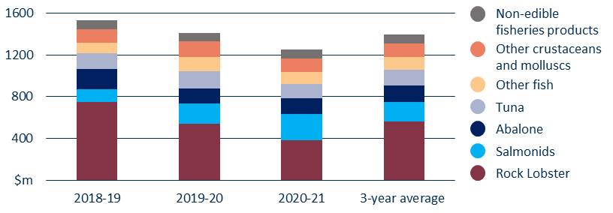

## Outlook for seafood exports in 2022

* Ongoing COVID-19 outbreaks and movement restrictions, and uncertainty in the China market have hampered the recovery of rock lobster exports. Exports are unlikely to return to the 2018–19 highs until these issues are resolved.
  + Rock lobster is being diverted to new markets, sold domestically or production is being postponed. Building new markets takes time and may be associated with lower prices.
* Australian Atlantic Salmon production and exports are expected to increase.
  + Historically, only a relatively small percentage of salmon production has been exported.
  + In recent years, increased production and rising global demand have seen Australian salmon exports increase sharply, from $137 million in 2017–18 to $252 million in 2020–21. Export values are expected to increase further in 2021–22.

**Figure 2 Australian seafood exports by country (2017–18 to 2020–21)**

