# Regulation of live sheep exports to, or through, the Middle East during the Northern Hemisphere summer

Frequently asked questions

## The decision

On 31 March 2020 the department announced its decision on conditions for live sheep exports to, or through, the Middle East during the Northern Hemisphere summer.

Live sheep exports by sea to, or through, the Middle East are prohibited from leaving Australia between 1 June and 14 September. This applies from 2020 onwards.

Additional prohibition periods apply to Qatar and Oman. Departures from Australia are prohibited to:

* Qatar between 22 May and 22 September
* Oman between 8 May and 14 September

Additional requirements for all voyages from 1 May to 31 October include:

1. no more than 2 ports of discharge for voyages:
   * a) arriving in the Middle East on or after 1 June in that year; or
   * b) departing Australia between 15 and 30 September in that year
2. sheep should be exported with the shortest wool or hair length possible and this must be not greater than 25mm for each animal specified in the [Australian Standards for the Export of Livestock](https://www.agriculture.gov.au/export/controlled-goods/live-animals/livestock/australian-standards-livestock) (ASEL)
3. body condition score of exported sheep must be 2 or 3, which for practical purposes means the body condition score must be 2 or more and less than 4, on the scale of 1 to 5 specified in the ASEL
4. temperatures on all voyages must be monitored with automated environmental measurement devices and this monitoring reported to the department
5. the requirement for a Heat Stress Risk Assessment during the Northern Hemisphere summer has been removed (for sheep only).

A prohibition period was introduced under the Australian Meat and Live-stock Industry (Prohibition of Export of Sheep by Sea to Middle East—Northern Summer) Order 2020. The order came into force on 1 May 2020.

Exporters were also required to comply with the Australian Meat and Live-stock Industry (Export of Sheep by Sea to Middle East) Order 2018; the Australian Meat and Live-stock Industry (Export of Sheep by Sea to Middle East—Northern Winter) Order 2018. These requirements are in addition to those set out in the ASEL.

On 28 March 2021, the Export Control (Animals) Rules 2021, replaced those Orders.

## Questions and answers

### Why did the department implement requirements for live sheep exports during the Northern Hemisphere summer?

The requirements were introduced to achieve a balance between improved animal welfare outcomes and the long-term viability of the sheep export trade.

The details of these requirements were settled after extensive consultation, research and consideration of the best available science.

The requirements reduce the risk of heat stress in sheep exported during the Northern Hemisphere summer to a very low level.

### What is the duration of the prohibition?

The requirements prohibit the export of live sheep by sea to, or through, the Middle East from 1 June to 14 September (3.5 months). It applies from 2020 onwards to all ports with additional prohibition periods for Qatar and Oman.

### Why are there additional prohibited periods for Qatar and Oman?

The extended prohibition periods are required to adequately manage the risk of heat stress in sheep exported to these countries.

A combination of heat and humidity cause the greatest adverse heat stress impacts on sheep.

It is hotter and more humid for longer in Qatar and Oman during the Northern Hemisphere summer. Therefore there is an increased risk of heat stress to sheep exported to these destinations for a longer period, compared to other destinations in the Middle East.

### How does the regulation improve the welfare of exported sheep?

The changes reduce the risk of heat stress in sheep exported to the Middle East during the Northern Hemisphere summer by:

* prohibiting exports during the hottest part of the Northern Hemisphere summer
* limiting the duration of exposure to hot humid conditions on vessels, for example by having no more than 2 ports of discharge during the shoulder period
* requiring that all exported sheep have appropriate wool/hair length and body condition to better cope with hot conditions.

### What information did the department consider in developing the regulation?

We considered information and feedback from:

* the regulation impact statement (RIS) process in 2019 and 2020
* climatological data from the Bureau of Meteorology for 95th percentile ambient temperatures
* public consultations, including meetings with animal welfare organisations, peak bodies, industry representatives and producers
* reviews including the Heat Stress Risk Assessment (HSRA) Review and McCarthy Review
* animal welfare outcomes under the 2019 Northern Hemisphere summer conditions
* voyage and independent observer reports from the 2019 Northern Hemisphere summer.

### Did the department undertake public consultation when developing the regulation?

We undertook extensive consultation on the issue of heat stress in sheep. We did this by talking directly to farmers, exporters, industry organisations and animal welfare bodies, and by seeking written views.

We consulted on the ‘[Live sheep exports to, or through, the Middle East—Northern Hemisphere summer](https://www.agriculture.gov.au/export/controlled-goods/live-animals/livestock/history/review-northern-summer#final-ris-stage)’ draft RIS from 20 December 2019 to 3 February 2020. We received 21 submissions and over 1400 templated campaign responses (via RSPCA Australia). We also held face-to-face meetings in Perth and Adelaide, as well as other consultative meetings.

We consulted publicly on the RIS discussion paper from 27 September to 4 November 2019. The discussion paper received 66 submissions.

We also conducted 2 separate consultations on the HSRA Review and 2 consultations on conditions for the 2019 Northern Hemisphere summer.

We considered all feedback, as well as the information noted above, when developing the requirements.

### Why are the conditions different to the conditions proposed in the draft RIS?

We released a draft RIS to get feedback and to check our thinking. Feedback to the draft RIS identified:

* unintended potential negative animal welfare impacts of requiring a 15mm wool length maximum limit
* practical difficulties in assessing a half a point body condition score, that would not be consistent with current industry practice
* unintended negative diplomatic, trade and economic implications of prohibition periods and number of discharge ports.

We analysed concerns in detail and adjusted the conditions to the extent possible.

These amendments were expected to have minimal impact on animal welfare.

### What is the department’s reasoning for a body condition score of 2 or 3?

The legislated body condition score of 2 or 3, (on a scale of 1 to 5 as per the ASEL), selects for lighter sheep that are more heat tolerant. This body condition score can be interpreted for practical purposes as at least 2, but less than 4. That is, a sheep at a body condition score of 4 would be too heavy but a sheep approaching a body condition score of 4, but still less than 4, would be acceptable.

The diagram below illustrates this point:

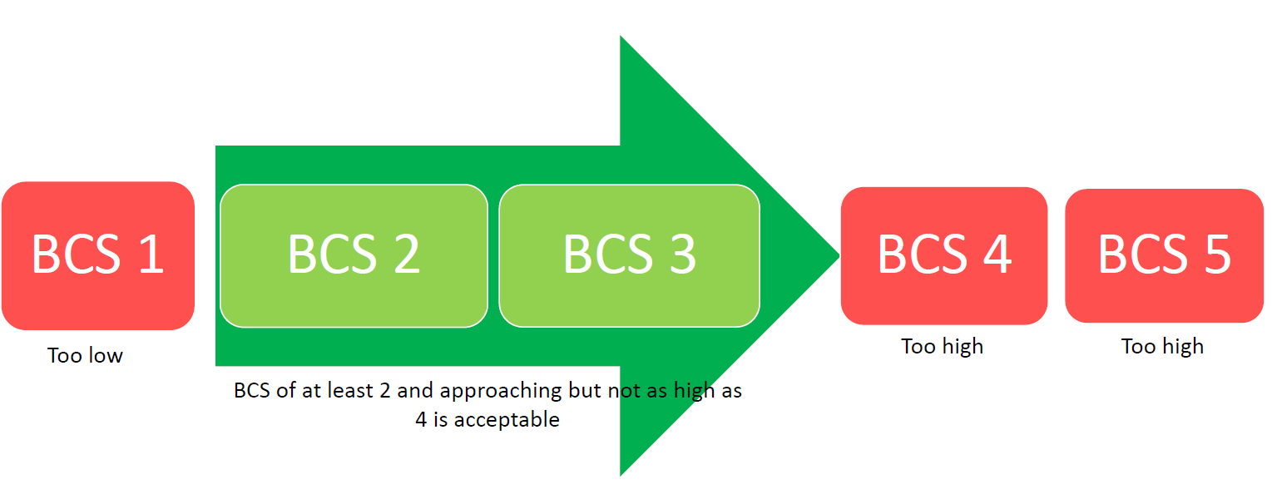

Industry research recognises that a higher body condition score can impact on a sheep’s heat tolerance. A 2005 report by Meat and Livestock Australia (MLA) noted that ‘fatter animals have a number of extra risk factors and have more difficulty adjusting to extreme heat’ and that ‘animals in condition score 4 or 5 are given a higher risk, and may require more space in the ship (lower pen density) or if the risk is high enough, prevented from travelling altogether’.

According to industry’s inputs to the HSRA model, all sheep exported to the Middle East during the Northern Hemisphere summer in the past 4 years (2016-2019) had a body condition score of 2 or 3, with over 80% listed as having a body condition score of 2.

This BCS requirement serves to reduce the incidence of heat stress in exported sheep while not being overly burdensome for industry.

### Why did the department remove the requirement to use the existing HSRA?

On voyages to the Middle East during the Northern Hemisphere summer, sheep already had more space under the pen space allowance changes introduced in 2018, than were provided under the previous ASEL (Version 2.3) and current HSRA model.

Therefore, the existing HSRA served no purpose during this period and was an unnecessary regulatory burden.

### When is the revised HSRA model expected to be developed?

The current HSRA model is owned by industry. Industry has commissioned research into animal welfare indicators that will support its revision of the model. It is unclear when revision of the model will be finalised.

### Why was option 2 of the RIS chosen over option 3?

The objective of the RIS process was to find a balance between animal welfare outcomes and the economics of the trade. Option 2 was considered to do this most effectively. Option 3 was found to further reduce the animal welfare risk but to have greater adverse impacts on producers and the industry as a whole.

Potential impacts of option 3 included a greater risk of loss of market share to international competitors, who generally apply less stringent animal welfare criteria.

Although a 6 month prohibition (option 3) effectively removed the risk of heat stress for Northern Hemisphere summer voyages, option 2 reduced the risk to very low and reduced the costs imposed on affected industries.

### Why was option 3 changed in the RIS?

Option 3 was changed from implementation of a revised HSRA model, consistent with recommendations of the HSRA Review (draft RIS) to a 6 month prohibition on live sheep exports (1 May to 31 October) until a revised HSRA model is available (final RIS). This was done to clearly describe the anticipated outcome from the HSRA panel’s recommendation to implement a revised HSRA model. It should be noted the panel also recognised that more research was needed to examine the effect of diurnal and day-to-day variations in temperature to determine the influence of duration of exposure.

### What was foreseen as the impact of the regulation on industry?

The conditions better manage the risk of heat stress in exported sheep and support the long-term viability of the trade.

The requirements limit the period sheep can be turned off to live exports each year, but still allow for turn off during April and May. While exporters are unable to export sheep to the Middle East during the hottest part of the Northern Hemisphere summer, improved animal welfare outcomes should improve community support for the trade.

### Will the department review the effectiveness of the regulation?

We are undertaking a formal review after the 2021 Northern Hemisphere summer.

We will consider voyage outcomes and whether the regulatory conditions are fit for purpose.

The reviews will also give us the opportunity to review new science and research regarding heat stress in sheep and animal welfare indicators.

### How has the department communicated the regulatory changes to industry?

We issued a media release, sent advice, held a teleconference and updated our website.

We also advised stakeholders via an export advisory notice.

### When did the regulation come into force, and for how long will it apply?

The requirements came in effect on 1 May 2020. They remain in place until no longer required.

On 28 March 2021, the Export Control (Animals) Rules 2021, replaced the previous Orders. The requirements set out in the previous Orders have been retained in the Rules and in ASEL.