January 2025
Australia’s illegal logging laws

Navigating New Rules: Transitioning to new arrangements
This factsheet provides information to support importers and processors transition to new arrangements under Australia’s illegal logging laws from 3 March 2025.
These laws have been reformed to ensure they remain effective to combat illegal logging and promote the trade of legal timber products in Australia. As of 3 March, the reformed laws will be set out in two pieces of legislation:
- Illegal Logging Prohibition Amendment (Strengthening Measures to Prevent Illegal Timber Trade) Act 2024 (Amendment Act)
- Illegal Logging Prohibition Rules 2024 (the Rules).
If you import wood, pulp or paper products into Australia, or process Australian-grown raw logs, these laws may affect you.

What’s changing for importers and processors?
From 3 March 2025 the Rules will replace the existing Illegal Logging Prohibition Regulation 2012 (the Regulation) and introduce changes to due diligence requirements. It is up to you to understand your responsibilities as an importer of timber and/or timber products, or a processor of Australian-grown raw logs.
The fundamental steps of your due diligence requirements will remain unchanged, that is:
- a written due diligence system
- information gathering
- risk assessment
- risk mitigation
- record keeping.
The requirement to respond to a request for information from the department also remains the same. However, there are key changes to some steps:
- The three risk assessment methods in the current Regulation (Country Specific Guidelines or State Specific Guidelines, Timber Legality Frameworks and Regulated Risk Factors) will be replaced with two distinct risk assessment pathways for:
- Certified timber and timber products/raw logs
- Non-certified timber and timber products/raw logs.
- There is a new repeat due diligence exception. This will allow you to rely on a previous risk assessment and risk mitigation measures if you import or process the same timber, timber products, or raw logs from the same supplier within a 12 month period. You can use this exception regardless of the certification status of your timber or timber products.
- There is an exemption for processors who are also the person/entity who harvested the raw log.
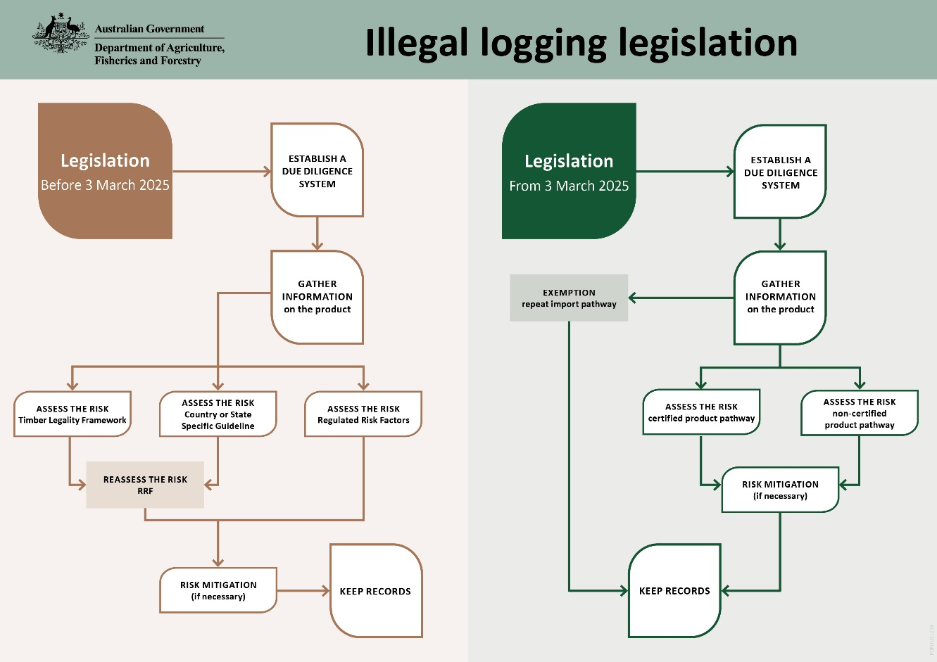
In addition, the Amendment Act introduces powers for the department to undertake certain activities, including:
- Use timber testing technologies to verify claims of species and origin of timber and timber products at the border and under a warrant.
  - We will not commence these activities immediately.
  - We recently undertook a timber testing trial to understand how best to implement timber testing activities under these new powers.
- We will update the regulated community on this accordingly. Publishing details of criminal convictions, civil penalty orders, orders of enforceable undertakings under the Act and anonymous timber testing results on our website.
  - We will only publish instances of breaches where non-compliance is repeated or very serious and where it is considered in the public interest to do so.
  - The intent of these new powers is to inform the regulated community of findings that will assist due diligence efforts, to encourage compliance with the laws and educate the public and consumers to encourage selection and purchase of legally harvested timber and timber products.
- More flexible enforcement options including injunctions, enforceable undertakings and tiered offences.
  - These will provide more options to ensure our compliance responses can remain proportionate to the level and nature of non-compliance.
- Requirement to provide notice to the department before importing or processing regulated timber, timber products or raw logs.
  - This requirement will not come into effect on 3 March 2025, as it relies on a new IT system that is still being developed. We will update you as this progresses.
  - We will update the regulated community on this accordingly.
Importantly, we will continue to work with individuals and entities to educate and facilitate future compliance.

Audits and compliance
We appreciate that these changed legal requirements will involve changes to your internal processes and we remain committed to supporting compliance within the regulated community.
As such, for the first six months of the Rules being in effect (from 3 March 2025 – early September 2025), we will conduct audits as usual, but will focus on education and guidance for non-compliance matters relating to the application of new/changed due diligence arrangements.
We may still take further action for non-compliance matters relating to due diligence requirements that remain unchanged.

More information
We will provide detailed guidance material on our website to support you prior to new arrangements coming into effect.
Email IlegalLogging@aff.gov.au
Acknowledgement of Country
We acknowledge the continuous connection of First Nations Traditional Owners and Custodians to the lands, seas and waters of Australia. We recognise their care for and cultivation of Country. We pay respect to Elders past and present, and recognise their knowledge and contribution to the productivity, innovation and sustainability of Australia’s agriculture, fisheries and forestry industries..
© Commonwealth of Australia 2025
Unless otherwise noted, copyright (and any other intellectual property rights) in this publication is owned by the Commonwealth of Australia (referred to as the Commonwealth).
All material in this publication is licensed under a Creative Commons Attribution 4.0 International Licence except content supplied by third parties, logos and the Commonwealth Coat of Arms.
The Australian Government acting through the Department of Agriculture, Fisheries and Forestry has exercised due care and skill in preparing and compiling the information and data in this publication. Notwithstanding, the Department of Agriculture, Fisheries and Forestry, its employees and advisers disclaim all liability, including liability for negligence and for any loss, damage, injury, expense or cost incurred by any person as a result of accessing, using or relying on any of the information or data in this publication to the maximum extent permitted by law.

