

**Department of Agriculture, Fisheries and Forestry**

**National Residue**

**Survey 2022–23**

Macadamia

The National Residue Survey (NRS) operates within the Australian Government Department of Agriculture, Fisheries and Forestry, and since 1992 has been funded by industries through levies and direct contracts.

The NRS is an essential part of Australia’s pesticide and veterinary medicine residue management framework, providing verification of good agricultural practice in support of chemical control-of-use legislation and guidelines.

NRS programs monitor the levels of, and associated risks from, pesticides and veterinary medicine residues and contaminants in Australian food products. The programs help to facilitate and encourage ongoing access to domestic and export markets. The NRS supports Australia’s primary producers and food processors who provide quality animal, grain and horticulture products which meet both Australian and relevant international standards.

Key points

* In 2022–23, the overall compliance with Australian standards was 100%.
* The macadamia industry has an unbroken record of 100% compliance since program commencement in 1996.

**The macadamia residue   
monitoring program**

The macadamia residue monitoring program is a cooperative arrangement between the National Residue Survey, the Australian Macadamia Society and macadamia processing plants. Since 1996, the program has been funded by the NRS component of the statutory levy on macadamia production.

The program involves the testing of Australian macadamias for a range of chemical residues and environmental contaminants, which ensures the macadamia industry can meet quality assurance and market access requirements for domestic and international markets.

* Australian macadamia producers continue to demonstrate a high degree of good agricultural practice.
* The National Residue Survey’s quality management system (QMS) is certified to ISO standard 9001:2015.

[agriculture.gov.au](http://agriculture.gov.au)

Department of Agriculture, Fisheries and Forestry

**Sample collection**

Samples are collected at macadamia processing plants in accordance with NRS procedures. 100 to 150 samples of macadamia nuts are collected from 7 processing plants located in northern New South Wales and Queensland. Once collected, samples are freighted to the contract laboratory for analysis. All sample data collected is entered into the NRS Information Management System and residue testing result reports are automatically generated for the macadamia processing plants.

**Analytical screens**

Analytical screens are developed in consultation with the industry and take into account chemicals registered in Australia, chemical residue profiles and overseas market requirements.

Macadamia samples are screened for a range

of insecticides, herbicides, fungicides, and

environmental contaminants, as shown in Table 1.

**Results**

In 2022-23, a total of 112 macadamia samples were collected for analysis. The results were compared with the Australian standards and where appropriate, relevant international standards.

A summary of Macadamia compliance rates against the Australian MRL standards over the past 10 years is provided in Table 2.

The results highlight excellent compliance with Australian standards and demonstrate the strong commitment of the macadamia industry to good agricultural practices. The excellent compliance rates help maintain the reputation and integrity of Australian macadamia nuts in international and domestic markets.

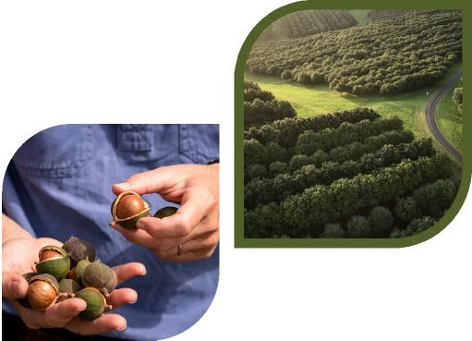

Images supplied by Australian Macadamia Society

The 2022-23 financial year datasets for the macadamia program are located on the department’s website [agriculture.gov.au/nrs-results-publications](http://agriculture.gov.au/nrs-results-publications)

**Table 1.** Analytical screens for the macadamia program

**Analytical Chemical group Analytes screen**

Over 94 analytes including acephate, abamectin,

bifenthrin, diazinon, malathion, pyrethrins and spinosad

Over 55 analytes including azoxystrobin,

Fungicides boscalid, captan,

iprodione, fludioxonil and propiconazole

Multi-residue

screen

pesticide

aldrin, chlordane, DDT, dieldrin,

Organochlorines endosulfan,

endrin, HCB, HCH,

heptachlor, lindane and mirex

Physiological diphenylamine Modifier

amitrole, chlormequat,

dichlorprop, diclofop,

Specific Herbicides

herbicides fluazifop, glufosinate,   
diquat, flamprop, glyphosate, haloxyfop, paraquat and quizalofop

Metals Elements arsenic, cadmium,

copper, lead and mercury

Insecticides

|  |  |  |
| --- | --- | --- |
|  |  |  |
|  |  | [agriculture.gov.au](http://agriculture.gov.au) |
|  |  |  |

Department of Agriculture, Fisheries and Forestry

**Laboratory selection and performance**

The NRS contracts laboratories to analyse animal and plant product samples for pesticide/veterinary medicine residues and environmental contaminants.

Laboratories are selected through the Australian Government procurement process based on their proficiency and value for money. Laboratories must be accredited to international standard ISO/ IEC 17025 at commencement of testing.

Contracted laboratories are proficiency tested by the NRS to ensure the validity of their analytical results and technical competence.

The NRS has been accredited by the National Association of Testing Authorities as a proficiency test provider since July 2005.

**Table 2.** Compliance rates for the past 10 years relative to Australian standards

|  |  |  |
| --- | --- | --- |
| **Years** | **Samples collected** | **Compliance rates**  **(%)** |
| 2013 – 14 | 126 | 100 |
| 2014 – 15 | 112 | 100 |
| 2015 – 16 | 135 | 100 |
| 2016 – 17 | 129 | 100 |
| 2017 – 18 | 123 | 100 |
| 2018 – 19 | 128 | 100 |
| 2019 – 20 | 110 | 100 |
| 2020 – 21 | 128 | 100 |
| 2021 – 22 | 126 | 100 |
| 2022 – 23 | 112 | 100 |

**International export markets**

The NRS maintains information on maximum   
residue limits (MRLs) that apply to Australia and   
major export markets for industries supported   
by the NRS. All analysis results are checked   
for compliance with Australian standards and   
relevant international MRLs.

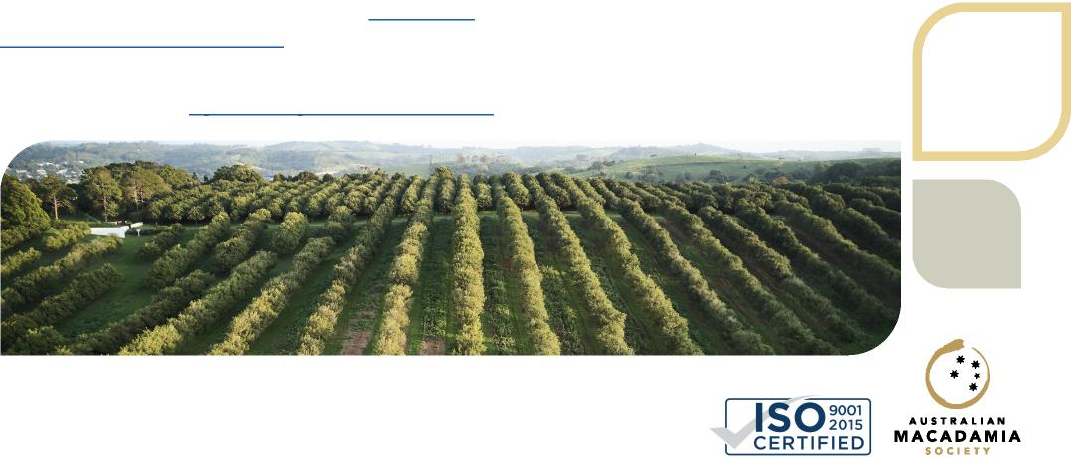

For the Australian MRL standard see legislation. [gov.au/Details/F2023L01350](http://gov.au/Details/F2023L01350)

For MRL standards for some international export markets see links at [agriculture.gov.au/nrs-databases](http://agriculture.gov.au/nrs-databases)

Image supplied by Australian Macadamia Society



**General enquiries**

Phone 1800 900 090

**Postal address**

National Residue Survey

GPO Box 858, Canberra ACT 2601 Australia

[agriculture.gov.au/nrs](http://agriculture.gov.au/nrs)

Email [nrs@agriculture.gov.au](mailto:nrs@agriculture.gov.au)

© Commonwealth of Australia, 2023.

This publication is licensed by Commonwealth of Australia under a Creative Commons Attribution 4.0 International licence.



AG R102.0823