# Keep Australia foot-and-mouth disease free

Travelling to Australia or receiving international mail?

## What is foot-and-mouth disease?

Foot-and-mouth disease (FMD) is a highly contagious animal disease that affects all cloven-hoofed animals including cattle, buffalo, sheep, goats, deer, pigs and camels.

FMD can survive in frozen, chilled and freeze-dried foods including meat and dairy products.

It is not present in Australia. An outbreak would cause sickness in animals, and greatly impact Australian meat (beef, lamb and pork) and dairy farmers.

There is no threat to human health from this disease.

## What goods can carry foot-and-mouth disease?

* Dairy products and meat products containing beef, lamb and pork.
* Items such as clothing, shoes and equipment used on farms, in rural or wilderness areas, markets, zoos or near animals.
* Animal skins, camping and hunting equipment and trophies.

## How do I stop the spread of foot-and-mouth disease?

DON’T

* Bring meat or dairy products to Australia in your baggage.
* Buy meat or dairy products online from overseas sellers.

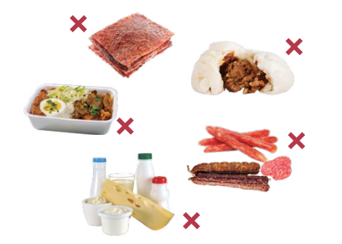

DO

* Tell family and friends overseas not to send you any meat or dairy products.
* Check biosecurity import conditions before sending goods to Australia – agriculture.gov.au/bicon.
* Clean any equipment, clothing and shoes thoroughly before you send them or travel to Australia.
* Declare and present any risk goods to a biosecurity officer for inspection on arrival in Australia or put it in a bin.
* Declare if you have visited a rural area or been in contact with, or near, farm animals.
* Avoid farms and livestock for the first seven days after arriving in Australia.

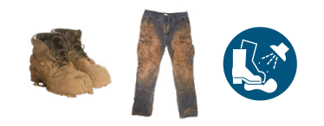

Serious penalties apply if you breach Australia’s biosecurity laws. You may be given an infringement notice. Your visa may also be cancelled and, if so, you will be refused entry into Australia and could face a three-year ban.

It’s everyone’s responsibility to help keep Australia free from FMD.

To learn more, visit: [agriculture.gov.au/biosecurity-trade/pests-diseases-weeds/animal/fmd](https://www.agriculture.gov.au/biosecurity-trade/pests-diseases-weeds/animal/fmd)