February 2025

# New import permit requirements:

# Brassicaceous and Cucurbitaceous seed for sowing

## Overview

We are introducing a mandatory import permit requirement for certain species of Brassicaceous and Cucurbitaceous seed that are imported for an end use of sowing.

This requirement will commence on 1 July 2025 and apply to imports from any country.

Importers may apply for import permits through BICON from 1 April 2025.

## What is changing

From 1 July 2025, an import permit will be required for the following Brassicaceous and Cucurbitaceous seed (including all synonyms and subordinate taxa) that are imported for sowing from any country:

* Brassicaceous seed
  + *Brassica rapa* (turnip, bok choy)
  + *Eruca vesicaria* (rocket)
  + *Raphanus sativus* (radish)
* Cucurbitaceae seed
  + *Citrullus lanatus* (watermelon)
  + *Cucumis melo* (cantaloupe)
  + *Cucumis sativus* (cucumber)
  + *Cucurbita maxima* (winter squash, pumpkin)
  + *Cucurbita moschata* (butternut squash, pumpkin)
  + *Cucurbita pepo* (zucchini)
  + *Lagenaria siceraria* (bottle gourd)
  + *Trichosanthes cucumerina* (snake gourd)

To reduce the number of permits required and the associated costs to importers, import permits for specified vegetable seeds will be:

* Issued for all countries of export and
* Valid for 2 years.

## Import permit applications

* Importers may apply early for an import permit from 1 April 2025.
* To apply for an import permit through BICON, use the ‘vegetable seed for sowing’ application form via the relevant BICON case for the seed species you wish to import.
  + Please note that you can apply for multiple species of vegetable seed using this form, subject to fees and charges.

## Fees and charges

The minimum assessment fee for one import permit covers up to 6 vegetable seed products.

If you apply for 7 or more vegetable seed products, an additional import permit will need to be issued, and your application will be subject to additional permit assessment charges.

|  |  |
| --- | --- |
| **Scenario 1:**  Applied for one product  Outcome: Single permit will be issued, and minimum assessment fee as per application will be charged. | **Scenario 2:**  Applied for 8 products  Outcome: Two permits will be issued; an additional assessment fee applies. |
| Screenshot of scenario 1 interface where user selects one commodity from a list of 8 options | Screenshot of scenario 1 interface where user selects all commodities from a list of 8 options |

## Will the validity period of my existing vegetable seed permit be extended?

* No - Existing permits will remain valid for a one-year period.
* The validity period of 2 years applies only to newly issued permits that take effect on or after 1 July 2025.

## Transition arrangements

Consignments of seeds that arrive in Australian territory:

* Up until 30 June 2025 will be permitted entry without an import permit
* On or after 1 July 2025 will **not** be permitted entry without a valid import permit, and may be directed for export or disposal.

## How do I apply for a permit?

Step 1: Apply for a vegetable seed permit (e.g. watermelon seed) via the *Citrullus lanatus* seed for sowing BICON Case.

Step 2: Complete application form details for watermelon seed.

Step 3: If you wish to add additional vegetable seeds (e.g. cucumber seed) to the application form, click ‘Add another commodity’.

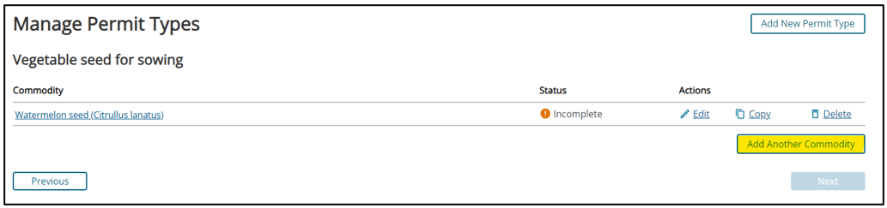

Step 4: Select the additional vegetable seeds from the commodity list (e.g. cucumber seed) and add to application.

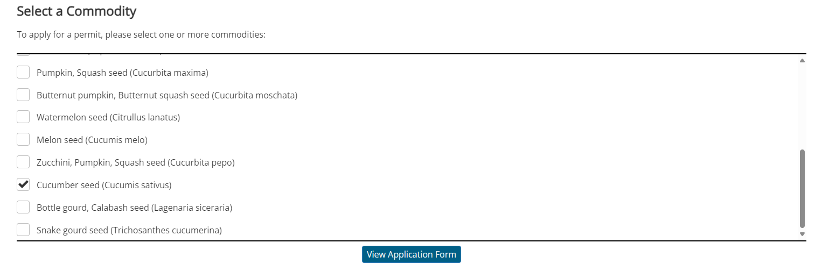

Step 5: Complete form details for additional commodities by clicking ‘edit’.

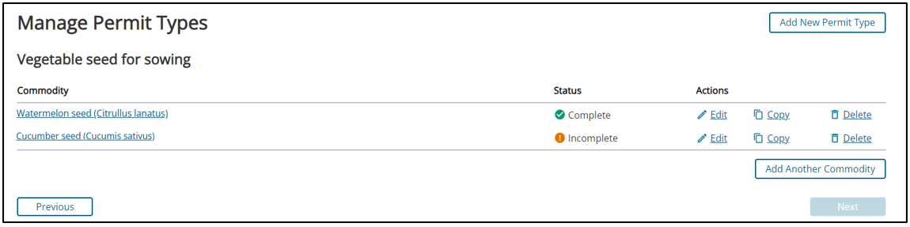

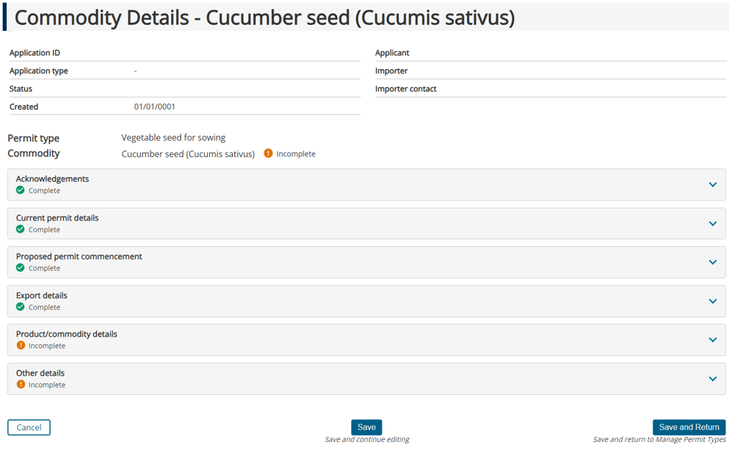

Step 6: Submit application with payment as usual.

### More information

Please contact Plant Import Operations on 1800 900 090 or email imports@aff.gov.au (with the subject line of the email ‘Plant T2 - Seed for sowing’).

For further guidance on import permit applications, visit:

[Guidance on how to apply for an import permit](https://www.agriculture.gov.au/import/online-services/bicon/bicon-permit)

[Fees and charges for import permits](https://www.agriculture.gov.au/import/online-services/bicon/fees-import-permits).

**Acknowledgement of Country**

We acknowledge the continuous connection of First Nations Traditional Owners and Custodians to the lands, seas and waters of Australia. We recognise their care for and cultivation of Country. We pay respect to Elders past and present, and recognise their knowledge and contribution to the productivity, innovation and sustainability of Australia’s agriculture, fisheries and forestry industries.

© Commonwealth of Australia 2025

Unless otherwise noted, copyright (and any other intellectual property rights) in this publication is owned by the Commonwealth of Australia (referred to as the Commonwealth).

All material in this publication is licensed under a [Creative Commons Attribution 4.0 International Licence](https://creativecommons.org/licenses/by/4.0/legalcode) except content supplied by third parties, logos and the Commonwealth Coat of Arms.

The Australian Government acting through the Department of Agriculture, Fisheries and Forestry has exercised due care and skill in preparing and compiling the information and data in this publication. Notwithstanding, the Department of Agriculture, Fisheries and Forestry, its employees and advisers disclaim all liability, including liability for negligence and for any loss, damage, injury, expense or cost incurred by any person as a result of accessing, using or relying on any of the information or data in this publication to the maximum extent permitted by law.