**Purpose**

January

2023

Departmental logo
Australian Government Department of Agriculture, Fisheries and Forestry

**Export Meat Operational Guideline**

# 3.15 Retention



This document outlines the retention process to be adhered to at export-registered meat establishments that have an on-plant departmental presence.

**Scope**

This document covers retention of:

* animals that have not passed for unconditional slaughter
* meat and meat products that have not been passed fit for human consumption
* non-compliant areas, equipment, conveyances or services.

**Legislative basis**

As per the Rules made under the *Export Control Act 2020*:

* carcase and carcase parts may be retained for final disposition (9-24 of the Export Control (Meat and Meat Products) Rules 2021, 9-23 of the Export Control (Poultry and Poultry Meat Products) Rules 2021, 9-24 of the Export Control (Rabbit and Ratite Meat and Rabbit and Ratite Meat Products) Rules 2021, 9-22 of the Export Control (Wild Game Meat and Wild Game Meat Products) Rules 2021)
* things/areas/establishments/conveyances that are used, or apparently used to prepare or transport meat or meat products may be secured or retained for the purposes of carrying out an assessment or inspection, applying a treatment or a disposition (9-30 of the Export Control (Meat and Meat Products) Rules 2021, 9-28 of the Export Control (Poultry and Poultry Meat Products) Rules 2021, 9-32 of the Export Control (Rabbit and Ratite Meat and Rabbit and Ratite Meat Products) Rules 2021), 9-28 of the Export Control (Wild Game Meat and Wild Game Meat Products) Rules 2021).

**In this document**

Retention card/tag terminology 3

Retention at ante-mortem inspection 3

Suspect and emergency slaughter/kill 3

Withheld from slaughter 4

Condemned 4

Retention of carcase and/or carcase parts on the slaughter floor 4

Retention of product for further inspection and disposition 4

Retention of establishment’s areas, facilities, equipment or other things 5

Related material 5

Appendix 1: Roles and responsibilities 6

On-Plant Veterinarian 6

Food Safety Meat Assessor 6

Australian Government Authorised Officer 6

Porcine Ante Mortem Inspectors 6

Summary table of responsibilities/permissions 7

Appendix 2: Definitions 7

## Retention card/tag terminology

The retention process uses a card or tags for identification of animals, meat or meat products, and non-compliant areas, equipment, conveyances or services. Table 1 below details terminology for the new card and tag terms in comparison to previous ECA tag/card terms.

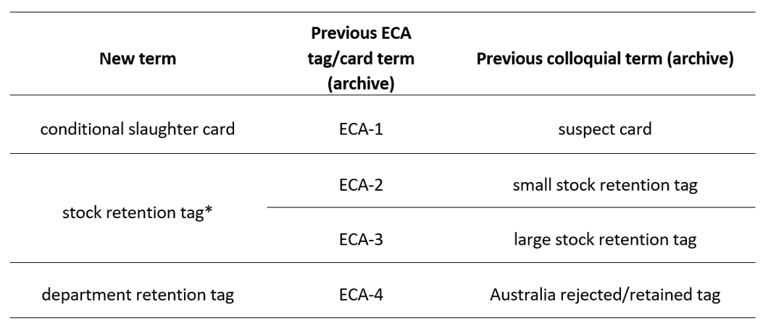Table 1 New and previous card/tag terminology

**\*** A single ‘stock retention tag’ will be used for both small and large stock and will replace the ECA-2 (small stock retention) tag and ECA-3 (large stock retention) tag.

## Retention at ante-mortem inspection

Stock will be determined as unsuitable for unconditional slaughter where dispositions are either:

* suspect
* emergency slaughter / emergency kill (commonly referred to as ‘EKs’)
* withheld from slaughter for treatment
* condemned.

These animals become ‘retained’. A **conditional slaughter card** with identification details and ante-mortem remarks accompanies the animal and the animal’s carcase (following slaughter) to the post-mortem inspection point.

Conditional slaughter cards have post-mortem findings and disposition of the carcase and carcase parts recorded on the reverse of the card and are retained for auditing purposes.

### Suspect and emergency slaughter/kill

The assigning and disposition of conditional slaughter cards is generally restricted to On‑Plant Veterinarians (OPVs). When the OPV is unavailable, the Food Safety Meat Assessor (FSMA) may assign a conditional slaughter card and may apply a disposition to emergency slaughter/kill animals where the animal is showing **no signs of disease**. Where there are signs of disease, the disposition needs to be postponed until the OPV becomes available.

On pig establishments, Australian Government Authorised Officers (AAOs) and Porcine Ante-Mortem Inspectors (PAMIs) are permitted to perform ante-mortem inspection under the supervision of an OPV. For pig establishments only, if emergency slaughter animals are identified by AAOs and PAMIs, and the OPV is unavailable, the authorised officer is permitted to order the humane slaughter of the animal. The OPV must be informed of the circumstances as soon as possible.

Suspect and emergency slaughter/kill animals are slaughtered and processed as arranged with establishment management to accommodate:

* the hygiene requirements for processing suspect animals
* attendance of the OPV at the post-mortem inspection.

The head, viscera and carcase (or sides) of suspect and emergency slaughter/kill animals are inspected by FSMAs or AAOs under OPV supervision or are set aside for OPV inspection and disposition.

The OPV confirms/determines the disposition of the carcase and carcase parts based on head, viscera and carcase inspection findings. An FSMA may confirm/determine this disposition in certain circumstances (see Table 2 Permissions for assignment, removal and disposition of retention tags).

### Withheld from slaughter

Animals withheld from slaughter are treated as agreed with establishment management and are returned for ante‑mortem inspection by the OPV. For example, soiled animals would be cleaned and re-presented for ante-mortem inspection.

### Condemned

Condemned animals are humanely destroyed and conveyed to establishment channels for handling such material.

## Retention of carcase and/or carcase parts on the slaughter floor

Carcases or carcase parts identified as requiring further inspection or treatment prior to passing as ‘fit for human consumption’:

* have a **stock retention tag** applied by an OPV, FSMA or AAO (establishment retention tags as written into the establishment’s approved arrangement (AA) are also acceptable for this purpose)
* are directed to establishment retain rail
* are checked for performance following treatment as detailed in the establishment’s AA
* once cleared, have the stock retention tags removed under direction of an OPV, FSMA or AAO (as appropriate).

Where carcase/carcase parts cannot initially be provided with a disposition on the slaughter floor:

* a **department retention tag** is applied by an OPV or FSMA
* establishment management are advised that a request will be made to the OPV or FSMA to attend to make an inspection and apply a disposition
* the OPV or FSMA examines retained carcase/carcase parts on the slaughter floor and makes a disposition as per the Australian Standard for the Hygienic Production and Transportation of Meat and Meat Products for Human Consumption (AS4696)
* disposition may include further retention under department retention for a later assessment, after chilling, following the outcome of laboratory testing (at establishment request), or during boning
* final disposition is made by the OPV or FSMA, and establishment management is informed
* department retention tags are removed by the OPV or FSMA and filed; and records are made of the department retention tag issued and subsequent disposition for auditing purposes.

## Retention of product for further inspection and disposition

Product may require further inspection, examples may include:

* cartoned product for species testing
* bagged carcases for residue testing
* product returned from overseas due to contamination or deterioration.

Where product is determined as requiring further inspection or retention by departmental authorised officers:

* establishment management is notified
* a department retention tag (denoting product must be retained) is applied with identification and details of retention
* disposition of the product is managed as directed by the Field Operations Manager (FOM) / Area Technical Manager (ATM), or on receipt of testing results
* following disposition on the product, the department retention tag is removed and retained
* records are made of the department retention tag issued and subsequent disposition for auditing purposes
* any corrective and/or preventive action related to retention is recorded in the Retention Register and in the Meat Establishment Verification System (MEVS), as appropriate.

If, following discussion with the OPV, establishment management disagrees with the disposition made on the carcase or carcase parts, they may seek a review.

## Retention of establishment’s areas, facilities, equipment or other things

Areas, facilities, equipment or other things may need to be retained at times, where these items are determined as being unfit for service. This may occur, for example, where an item is expected to affect the eligibility of product for export with continued use.

Where areas, facilities, equipment or other things require rejection from service:

* establishment management is notified
* a department retention tag is filled out and applied (as appropriate) to denote the item is rejected from use
* disposition of affected areas/facilities/equipment/other things is managed following corrective action by the establishment
* the department retention tag is removed when the item is passed as ‘fit for service’
* the department retention tag is retained and corrective and/or preventive action related to retention is recorded in the Retention Register and additionally through MEVS, as appropriate.

This relates to retention by the establishment on the department’s behalf under the approved arrangement, as well as retention by departmental officers.

## Related material

The following related material is available on the internet:

* Webpage: [*Export Control Act 2020*](https://www.legislation.gov.au/Series/C2020A00012)
* Webpage: [Export Control (Meat and Meat Products) Rules 2021](https://www.legislation.gov.au/Series/F2021L00334)
* Webpage: [Export Control (Wild Game Meat and Wild Game Meat Products) Rules 2021](https://www.legislation.gov.au/Series/F2021L00313)
* Webpage: [Export Control (Rabbit and Ratite Meat and Rabbit and Ratite Meat Products) Rules 2021](https://www.legislation.gov.au/Series/F2021L00308)
* Webpage: [Export Control (Poultry Meat and Poultry Meat Products) Rules 2021](https://www.legislation.gov.au/Series/F2021L00310)

## Appendix 1: Roles and responsibilities

### On-Plant Veterinarian

* Complete conditional slaughter cards after ante-mortem inspection for animals unable to be passed for unconditional slaughter.
* Apply stock retention tags or department retention tags as required to affected carcases or carcase parts.
* Apply department retention tags to affected areas/equipment/conveyances/services.
* Manage disposition of conditional slaughter cards, stock retention tags or department retention tags for carcases or carcase parts that have been retained.
* Manage disposition of areas/equipment/conveyances/services retained with department retention tags.
* Remove stock retention tags or department retention tags from affected carcases or carcase parts subsequent to assessment.
* Remove department retention tags from affected areas/equipment/conveyances/services subsequent to assessment.
* Retain completed conditional slaughter cards and dispositions for auditing.
* Retain completed department retention tags and dispositions for auditing.

### Food Safety Meat Assessor

* Apply stock retention tags or department retention tags as required to affected carcases or carcase parts.
* Apply department retention tags to affected areas/equipment/conveyances/services.
* Manage disposition of stock retention tags or department retention tags for carcases or carcase parts that have been retained.
* Manage disposition of retained areas/equipment/conveyances/services with department retention tags.
* Remove stock retention tags or department retention tags from affected carcases or carcase parts subsequent to assessment.
* Remove department retention tags from affected areas/equipment/conveyances/services subsequent to assessment.

### Australian Government Authorised Officer

* Apply stock retention tags as required to affected carcases or carcase parts.
* Manage disposition of stock retention tags for carcases or carcase parts that have been retained.
* Remove stock retention tags from retained carcases or carcase parts subsequent to assessment.
* If emergency slaughter animals are identified **at pig plants**, and the OPV is unavailable, assign a conditional slaughter card to allow the expeditious humane slaughter of the animal.

### Porcine Ante Mortem Inspectors

* Undertake ante-mortem inspection on a pig abattoir under the supervision of the OPV.
* If emergency slaughter animals are identified, and the OPV is unavailable, assign a conditional slaughter card to allow the expeditious humane slaughter of the animal.

### Summary table of responsibilities/permissions

The summary table in this section identifies which roles may assign, remove and make disposition on the different retention card/tag types (conditional slaughter, stock retention, department retention).

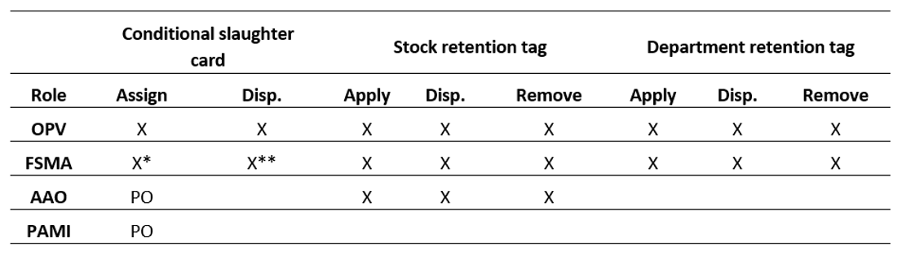Table 2 Permissions for assignment, removal and disposition of retention tags

**Disp.** Disposition. **PO** Pig only establishments. **PAMI** Porcine Ante-Mortem Inspector. **X** Role may perform the task. **X\*** Role may perform the task for emergency slaughter/kill or suspect stock only (in absence of OPV). **X\*\*** Role may perform the task for emergency slaughter/kill only if the animal is showing no signs of disease (in absence of OPV). **PO** When at a pig establishment, the role may perform the task for emergency slaughter/kill or suspect stock only (in absence of OPV).

Note: AAOs are not permitted to apply or remove department retention tags. AAOs are not permitted to make a disposition on carcases or carcase parts that are subject to control by department retention tag(s). Company retention tags (which must be described in the AA) can be applied by an AAO for bone-under-supervision when an FSMA or OPV is not available to apply a department retention tag in a timely manner. Where required, a department retention tag will then be applied to the meat and/or meat product by an FSMA or OPV when available, and carcase and/or carcase part details subsequently recorded in the department Retention Register.

## Appendix 2: Definitions

approved arrangement (AA)

An approved arrangement under Chapter 5 of the *Export Control Act 2020*.

An arrangement for a kind of export operations in relation to a kind of prescribed goods approved by the secretary.

An approved arrangement:

* documents the controls and processes to be followed when undertaking export operations in relation to prescribed goods for export
* enables the Secretary of the Department of Agriculture, Fisheries and Forestry to have oversight of specific export operations.

Australian Government Authorised Officer (AAO)

A Meat Safety Inspector who is authorised under Chapter 9 Part 4 of the Export Control (Meat and Meat Products) Rules 2021 to perform the services for the purposes of the Australian Export Meat Inspection System (AEMIS). They are employed either by an establishment or by a third-party service provider.

Australian Meat Standard

The Australian Meat Standard refers to AS 4696, the ‘Australian Standard for the Hygienic Production and Transportation of Meat and Meat Products for Human Consumption’.

authorised officer

An authorised officer is a person authorised by the Secretary (or a delegate of the Secretary) of the Department of Agriculture, Fisheries and Forestry under the *Export Control Act 2020* (the Act) Section 291.

The 3 types of authorised officers are:

* Commonwealth authorised officers—officers or employees of the Department of Agriculture, Fisheries and Forestry
* state or territory authorised officers—officers or employees of a state or territory body authorised under the Act
* third-party authorised officers—persons authorised by the Secretary following an application process.

conditional slaughter card

A conditional slaughter card is used during ante-mortem inspection to identify animals not suitable to be passed for unconditional slaughter.

Conditional slaughter cards must be used to identify:

* conditional slaughter (suspect and emergency slaughter/kill) animals
* animals rejected from slaughter.

department retention tag

A department retention tag is an approved identification tag used at post-mortem inspection where the product has not yet received a disposition. The department retention tag was previously known as the ‘Australia retained/rejected tag’. The retained carcases or carcase parts that are affixed with a department retention tag are subject to further investigation or treatment and must not have an ‘AI stamp’ (Australia Inspected stamp) or tag applied whilst under departmental retention. Department retention tags may also be applied to equipment or work areas that require retention, or carcases or cartons of meat that have received a disposition but are affected by a condition that warrants their control.

disposition

A decision, condition or other requirement applied by one or more authorised officer(s) gained from sampling and analysing information on ante-mortem and post-mortem inspection of admitted animals, carcases, carcase parts, meat and meat products that must be complied with as required by the *Export Control Act 2020* and subordinate legislation.

Food Safety Meat Assessor (FSMA)

A Commonwealth authorised officer that performs the functions of a meat safety inspector specified in the Australian Meat Standard.

On-Plant Veterinarian (OPV)

A Commonwealth authorised officer with veterinary qualifications authorised to execute duties on-plant under the export legislation.

Porcine Ante-Mortem Inspector (PAMI)

A meat safety inspector who is authorised, through a deed of obligation under the Export Control Act, to undertake ante-mortem inspection on a pig abattoir under the supervision of the OPV. They are employed either by an establishment or by a third-party service provider.

large stock

Adult cattle, buffaloes, horses, deer, donkeys and camels.

Meat Establishment Verification System (MEVS)

The department’s on-plant verification system used at abattoirs, wild game processing plants and independent boning rooms.

small stock

Small ruminants (lamb, sheep and goats), calves and pigs.

retain rail

The section of the slaughter floor chain where carcases or carcase sides are held for further examination.

Retention Register

The departmental register where records are held of product or things/areas/establishments/conveyances that have been retained with a department retention tag.

stock retention tag

An approved identification tag used on the slaughter floor (following slaughter) for small or large stock where there is a need to highlight carcases or carcase parts for further examination or treatment on the slaughter floor.

suspect stock / emergency slaughter/kill animals

Animal(s) identified with conditional slaughter cards that should be inspected and have final disposition carried out by the OPV or under the OPV’s direct supervision.