# Export Assurance Reform for non-prescribed goods: outcomes of public consultations and next steps



© Commonwealth of Australia 2024

**Ownership of intellectual property rights**

Unless otherwise noted, copyright (and any other intellectual property rights) in this publication is owned by the Commonwealth of Australia (referred to as the Commonwealth).

**Creative Commons licence**

All material in this publication is licensed under a [Creative Commons Attribution 4.0 International Licence](https://creativecommons.org/licenses/by/4.0/legalcode) except content supplied by third parties, logos and the Commonwealth Coat of Arms.



**Cataloguing data**

This publication (and any material sourced from it) should be attributed as: DAFF 2024*: Export Assurance Reform for non-prescribed goods: outcomes of public consultations and next steps*, Department of Agriculture, Fisheries and Forestry, Canberra. CC BY 4.0.

This publication is available at [agriculture.gov.au/biosecurity-trade/export/controlled-goods/non-prescribed-goods/export-assurance-reform](https://www.agriculture.gov.au/biosecurity-trade/export/controlled-goods/non-prescribed-goods/export-assurance-reform).

Department of Agriculture, Fisheries and Forestry

GPO Box 858 Canberra ACT 2601

Telephone 1800 900 090

Web [agriculture.gov.au](https://www.agriculture.gov.au/publications)

**Disclaimer**

The Australian Government acting through the Department of Agriculture, Fisheries and Forestry has exercised due care and skill in preparing and compiling the information and data in this publication. Notwithstanding, the Department of Agriculture, Fisheries and Forestry, its employees and advisers disclaim all liability, including liability for negligence and for any loss, damage, injury, expense or cost incurred by any person as a result of accessing, using or relying on any of the information or data in this publication to the maximum extent permitted by law.

**Acknowledgements**

The authors thank interview and survey participants for their input and the members of the Industry Reform Committee for their wisdom and advice.

**Acknowledgement of Country**

We acknowledge the continuous connection of First Nations Traditional Owners and Custodians to the lands, seas and waters of Australia. We recognise their care for and cultivation of Country. We pay respect to Elders past and present, and recognise their knowledge and contribution to the productivity, innovation and sustainability of Australia’s agriculture, fisheries and forestry industries.

Contents

Introduction 15

1.1 Issues with current arrangements 16

1.2 Options for reform 16

1.3 Government response 17

2 Regulate to assure goods 18

2.1 Appropriate regulation 18

3 Impacts for industry 19

3.1 Progressive regulation of commodities 19

3.2 Ongoing impact assessments 19

3.3 Fees and charges 19

3.4 Support for industry 19

4 Next steps 20

4.1 Industry working groups 20

4.2 General Products Rule 20

4.3 More information 20

Appendix A: Consultation 21

Targeted industry consultation 2023 and 2024 21

Industry Reform Committee 22

Have Your Say 23

Appendix B: Have Your Say feedback 24

Industries that participated 24

Commodities represented 24

Responses to survey questions 25

Glossary 33

Figures

Figure 1 Tiers of regulation under the new regulatory model 18

Figure 2 Has your organisation been required to meet new importing country requirements in the last 2 years? 25

Figure 3 Are you aware of any export assurance that cannot be met by the provision of a government certificate? 25

Figure 4 Are there aspects of your industry where additional regulation could improve your industry’s access to new markets? 25

Figure 5 Do you think that the current sharing of costs is fair throughout the supply chain? 26

Figure 6 If we removed admin actions, how would this affect your business? 26

Figure 7 Of the 3 options presented, which option is your preferred option? 26

Tables

Table 1 Summary of responses received from Have Your Say on Export Assurance reform 26

## Introduction

Australia needs export assurance systems and processes that are efficient, fit for purpose and flexible enough to accommodate the growing success of our export industries, new products and changing risks. Industry and the department are working together to develop a new regulatory model for non-prescribed goods (NPGs). This paper is a report on the findings of our consultations to date and an outline of next steps.

Both industry and the department have identified the regulatory framework for the export of NPGs requires reform. Australian exporters operate within a landscape of ever-changing importing country requirements, which are increasing in number and complexity. The success of NPG industries reflected through growth in trade, is expected to continue and as such, the number of assurance activities provided by the government will need to increase.

‘Non-prescribed goods’ is a category of goods defined under the Export Control Act 2020(the Act). The Act provides the legal framework for the regulation of agricultural exports. It divides these into 2 categories – prescribed and non-prescribed goods. Prescribed goods, such as meat, dairy and fish must meet the conditions set out in commodity rules to be exported; for NPGs there are no prescribed (that is, mandatory) export conditions.

NPGs include wool, rendered products, skins and hides, pet food, stock feed, feed additives, honey, processed foods, blood and pharmaceutical products and numerous other products. Historically, these products have required very little regulatory oversight, but this is no longer the case. This reform will give producers of these commodities the government assurances they need to continue to trade in a changing market environment.

Three options for reform were put to industry and consulted though a Have Your Say survey and submission process in August and September 2024. A summary of the feedback we received through the consultation can be found in Appendix A. Most respondents identified Option 2 (regulate to assure goods) as the preferred option. This option involves a new regulatory model that applies rules based on country and commodity combinations. A summary of responses may be found in Appendix B.

### Issues with current arrangements

This reform addresses 3 broad issues in the current exporting arrangements:

1. **Importing countries require more assurances**

Australian exporters operate within a landscape of ever-changing importing country requirements, which are increasing in number and complexity. This trend is expected to continue, and so the number of assurance activities provided by the government will need to increase.

In addition, importing countries now expect new types of government assurances. Historically, countries have used importing country requirements to protect their population, livestock and crops from pests and disease. This is now expanding to address concerns regarding traceability and sustainability, as well as a desire for increased oversight of the production process.

1. **Cost recovery is not appropriately attributed to where the costs originate**

The current legislative framework creates a single charge point for NPGs, issuing an export certificate. This does not reflect the time and cost to the department of undertaking administrative activities and providing additional services to assure trading partners. This single charge point also imposes the full cost of the assurance system onto the applicant for a certificate rather than charging at the points of the supply chain where services are provided. In this way, the current system is not transparent or equitable and does not meet the standards set out in the Australian Government’s charging framework.

1. **Unsustainable administrative practises**

Under the current system, we issue government certificates under the Act to provide assurances for NPGs to foreign countries. Where a foreign country requires additional assurances outside of a certificate (e.g. audit of a manufacturing establishment), this assurance is achieved via administrative actions.

Although effective, due to the growth and now size and complexity of the NPG export sector, this system has become complicated, inequitable and unsustainable. The current system is administratively tedious and burdensome on government and industry. Reform is needed to put a new regulatory system in place that can handle the current size of NPG export industries and allow for future growth.

### Options for reform

In identifying options for reform of the NPG export framework, the department consulted widely with industry and within the department and developed 3 options to achieve the reform objectives:

1. Maintain current administrative arrangements – This option involves continuing the current system with minimal changes to the administration of NPG export assurance. However, there would be updates to the cost recovery arrangements to seek to properly attribute costs to where they originate. It would mean persisting with administrative actions to manage increased importing country requirements and facing ongoing challenges in cost recovery and efficient regulatory oversight. This option does not address the identified need for reform and is likely to result in continued inefficiencies as we deliver services for the growing NPG industries.
2. Regulate to assure exports – This option proposes introducing a new commodity and country-based approach to export assurance. This would involve development of legislation that would see modest changes to the existing system and provide robust assurances to meeting importing country requirements. It is suitable for addressing the identified challenges in the current NPG export system. This option would remove the need for administrative actions, in favour of other regulatory tools. In addition, all exporters will be required to hold an export licence and each consignment exported would require an export permit.
3. Regulate to control exports – This option specifies that legislation would be developed like the commodity-specific rules for current prescribed (controlled) goods, such as meat, milk, fish, eggs and plants. Such new legislation would prescribe more comprehensive regulatory requirements for goods exported from Australia, with the intention of providing a higher level of regulation and control and adopting a minimum standard that applies to all NPGs.

### Government response

The feedback received in the consultation will inform the development of the reform going forward. The responses to the consultation process generally support Option 2 (regulate to assure goods) that was proposed in the *Export Assurance Reform: Options Paper*. Those who provided feedback largely agree that a new framework is required to resolve the issues with the current system.

The department will look to implement Option 2 and will prescribe NPGs using a General Products Rule under the Act. This will appropriately address the issues identified within this paper without introducing unnecessary burden on industry.

This will be accomplished by:

* regulating assurance processes to confirm that importing country requirements are met
* prescribing export conditions to meet importing country requirements when required
* providing a mechanism for stopping trade of specific goods to specific countries when required
* providing a mechanism to trace specific consignments of goods
* removing reliance on administrative activities.

In implementing these reforms, the department will seek to minimise administrative burden for industry and the department.

## Regulate to assure goods

### Appropriate regulation

The new regulatory model will prescribe goods to assure importing countries that their requirements have been met (Figure 1). This model will ensure regulation is as heavy as it needs to be and as light as it can be.

Figure 1 Tiers of regulation under the new regulatory model

A diagram of the 3 categories of goods under the new regulatory model. 
‘Non-prescribed goods’ will be redefined under the current system. Government certificate provisions will remain available, but these goods will be not otherwise regulated. 
‘Prescribed (assured) goods’ is a new category of goods for which additional assurance is required. These will be regulated based on their export markets to assure importing countries and manage identified risks using licences, permits, certificates and other tools as needed.
‘Prescribed (controlled) goods’ are regulated through commodity rules, using certificates and other tools to ensure a consistent standard of exported goods to all markets. There will be no change to this category. 

The model for regulating these goods is unique and will use export licences, certificates and permits to provide the regulatory basis for export. Additional regulatory requirements will be applied if needed to meet an importing country requirement.

Unlike the current regulatory model for other prescribed commodities, we will impose minimal requirements that are set by importing countries. Any additional regulatory requirements for specific countries will be identified in a schedule to the General Products Rule. This creates a regulatory environment that is as heavy as it needs to be and as light as it can be.

## Impacts for industry

### Progressive regulation of commodities

The department aims to prescribe goods industry-by-industry in a staggered rollout to minimise disruption to trade. We have listened to and will continue to work closely with industry through the process to co-design the implementation of new regulatory requirements.

Industries identified for reform include wool, rendered products, skins and hides, pet food, stock feed, feed additives, processed foods and beverages, honey, pharmaceutical, technical and blood products. The order in which these commodities are reformed will be determined in consultation with industry.

### Ongoing impact assessments

The Office of Impact Analysis (OIA) conducted an early assessment of the reform (OIA23-05843 - Export Assurance Reform – Non-prescribed Goods) and rated the burden as ‘no more than minimal’. The department has committed to review burden as each commodity is regulated. We will conduct a detailed impact analysis if there is material change.

### Fees and charges

Changes to fees and charges for departmental services will be consulted with industry in line with the department’s Cost Recovery Implementation Statement (CRIS) process.

### Support for industry

The department will work with industry to provide information throughout the transition to the new regulatory model. Materials will be developed in consultation with industry representatives.

## Next steps

The department will now begin preparing to implement the reforms industry-by-industry beginning with the rendered goods industry.

### Industry working groups

The department will form an Industry Working Group (IWG) for each industry being reformed. Each IWG will be comprised of industry representatives who will co-design elements of the reform with the department.

### General Products Rule

The department is currently working to develop a new General Products Rule which will enable these reforms. We will work with the IWG to co-design elements to ensure any new regulation are fit for purpose.

### More information

For information about Export Assurance Reform, visit [Export Assurance Reform for non-prescribed goods](https://www.agriculture.gov.au/biosecurity-trade/export/controlled-goods/non-prescribed-goods/export-assurance-reform) or email the [NPGreform@aff.gov.au](mailto:NPGreform@aff.gov.au).

## Appendix A: Consultation

### Targeted industry consultation 2023 and 2024

In March to May 2023, NPG industry representative groups were asked to identify strengths, weaknesses, opportunities and threats to their industry through the lenses of market access and importing country requirements, regulation and assurance.

Feedback from this round of consultation produced these themes from industry:

1. Regulation that delivers and improves – Industries understand and accept the need for regulation that is appropriate, fit for purpose and that supports and strengthens the reputation and value of their commodities. They see regulation as a means of improving the quality and reputation of goods and the discipline of their industries. However, they also want less paperwork, simpler processes, co-regulation and clear reasons for any increase in regulatory burden.
2. A bolder regulator – Industries expressed a desire for the department to be bolder in their regulatory activities. This theme was broad and included providing a loud voice for industry in strengthening the national biosecurity system to protect exports from threats posed by animal diseases and animal welfare issues. They want broader government intervention to fight non-tariff barriers to trade, including the disclosure of intellectual property when registering products for import.

They encouraged the department to lobby hard with importing countries for a scientific basis for requirements and consistent interpretation of legislation and importing country requirements. Industries seek regulatory solutions to support product claims, counter fraud and address non-compliance. They want greater involvement from the department in managing detained consignments, working towards simpler listing arrangements, expanding residue monitoring, opening new markets and championing Australia’s production systems.

1. A regulator that walks the line – Industries are aware of the line that the department walks between fulfilling its regulatory responsibilities and creating the environment for Australian exports to thrive. They are pleased with the close relationship they have with the department and appreciate Micor and the flow of information about changes to importing country requirements. They challenged the department to improve by providing single doorways into departmental functions and sharing information on issues, market access activities and disease preparedness.
2. Competent and compliant industries – The theme of competent and compliant industries covers the breadth of industry experience and willingness to encourage appropriate regulation to support export activities. These positive attributes should be promoted by the department in gaining and maintaining market access and supporting the good reputation we have as a trading nation.
3. Accreditation and certification – An opportunity exists to develop or support existing accreditation or certification schemes to demonstrate unique and market-valued aspects of Australian exports. Industries identified a broad range of categories that could benefit, including animal welfare, carbon neutrality, deforestation, labour, aspects of sustainability and environmental claims.
4. Formal recognition of third-party systems and approaches –This theme aligns with the department’s future regulatory model and underscores the importance of departmental recognition of industry systems, standards and accreditation schemes to minimise duplication and costs associated with providing assurance and compliance with importing country requirements.
5. Funding additional services – This theme was implied more than stated. Industries want the department to do more for them, be able to respond to industries’ needs and work harder to stop markets from closing. There was a general understanding that funding for this work comes from fees and charges imposed by the department (cost recovery). Increases in fees and charges should be planned and expected so that industries can manage any change.
6. Digitalisation – Industries accept that technology plays an important part in providing assurance for exports. They would like to see manual applications and certificates eliminated, faster uptake of eCert, more flexibility in modifying certificates, harmonisation and interoperability between computer systems, better traceability and an increase in technology in automating assurance requirements.
7. Strategic foresighting – Industries suggest we seek more research and share information on potential threats and opportunities. They want to know about new assurance requirements and animal disease risks and how they relate to market access. These insights could be sourced from our international posts, research and from the industries themselves. Strategic foresight helps us to anticipate and better prepare and explore different plausible futures that could arise, and the opportunities and challenges they could present.

### Industry Reform Committee

In April 2024, nominations from industry were sought to convene an Industry Reform Committee (IRC) to provide expert advice and feedback on the choice of a model for reform and act as a conduit between government and industry, providing industry views directly into the reform process.

The following organisations are represented on the IRC:

* Australian Council of Wool Exporters and Processors
* Australian Hide, Skin and Leather Exporters Association
* Australian Honey Bee Industry Council
* Australian Renderers Association
* Feed Ingredients and Additives Association Australia
* Pet Food Industry Association of Australia
* Stock Feed Manufacturers’ Council of Australia
* Animal Medicines Australia (joined September 2024).

Options for reform were presented to the Industry Reform Committee at its meeting on 11 June 2024. The committee reviewed the department’s proposed options and endorsed the options paper to be presented to industry.

### Have Your Say

From 29 July to 6 September 2024, we used the department’s Have Your Say platform to seek public feedback on the Export Assurance Reform Options Paper. This paper set out the reasons for reform, and 3 potential options:

1. Minor adjustments to current arrangements – which would maintain current administrative arrangements, with changes to the cost recovery arrangement and minimal changes to administration
2. Regulate to assure goods – which would introduce a new, commodity and country-based approach to export assurance
3. Regulate to control goods – which would create an export control rule for each commodity like the commodity-specific rules for currently prescribed goods.

A summary of feedback from this consultation process may be found in Appendix B.

## Appendix B: Have Your Say feedback

A total of 14 unique survey responses, including 8 submissions were received during the Have Your Say process that ran from 29 July 2024 to 6 September 2024. Overall, industry has chosen Option 2 as their preferred method of addressing the issues presented the department’s options paper.

### Industries that participated

* Animal feed
* Beef Processing
* Beef Rendering
* Feed Ingredients
* Food
* Hygiene, personal care, specialty products
* Meat
* Pet food
* Skins and Hides
* Wool

### Commodities represented

* Cosmetics
* Cultivated meat
* Honey, dressings, sauces, jams
* Inedible meat
* Meat
* Pet food
* Rendered products
* Skins and hides
* Spray Dried Blood Products
* Wool

### Responses to survey questions

Figure 2 Has your organisation been required to meet new importing country requirements in the last 2 years?

****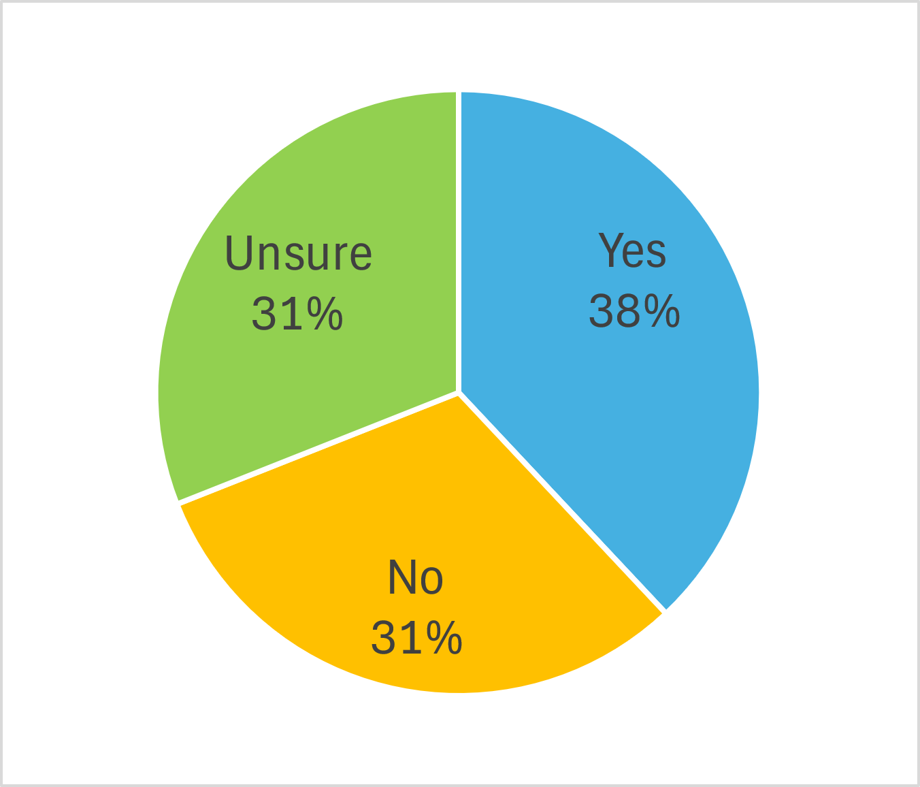****

Figure 3 Are you aware of any export assurance that cannot be met by the provision of a government certificate?

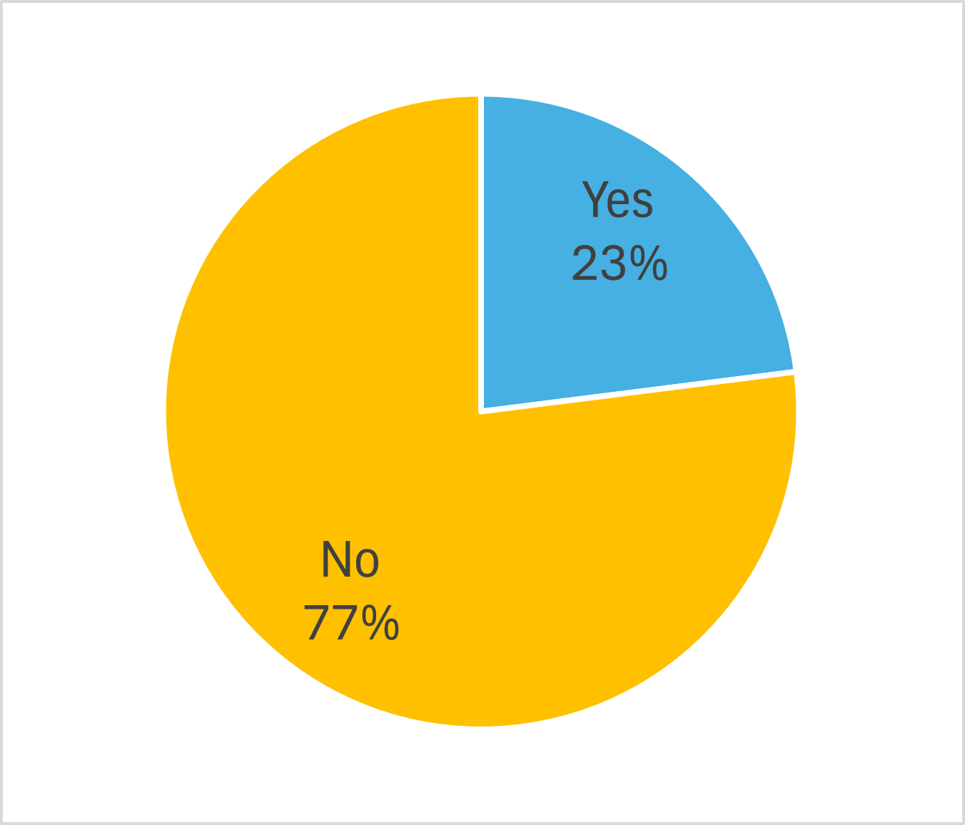

Figure 4 Are there aspects of your industry where additional regulation could improve your industry’s access to new markets?

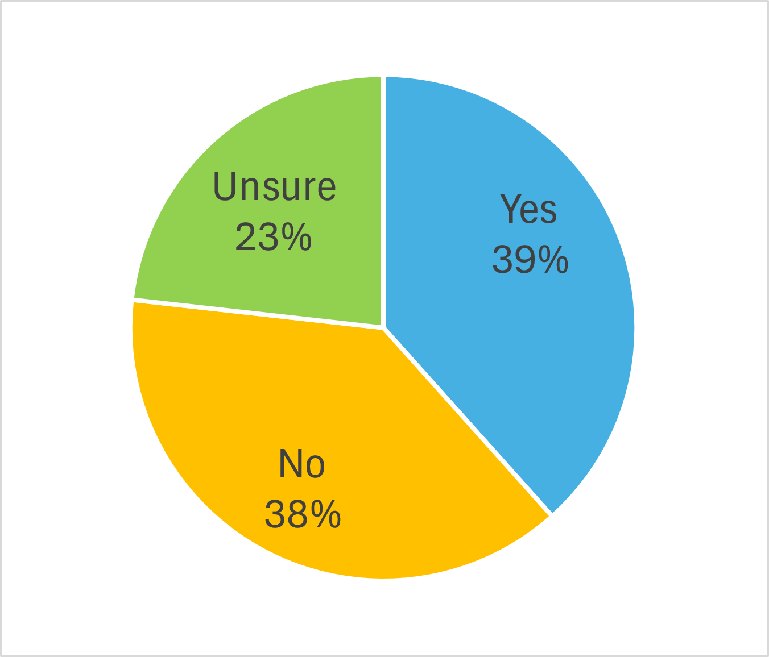

Figure 5 Do you think that the current sharing of costs is fair throughout the supply chain?

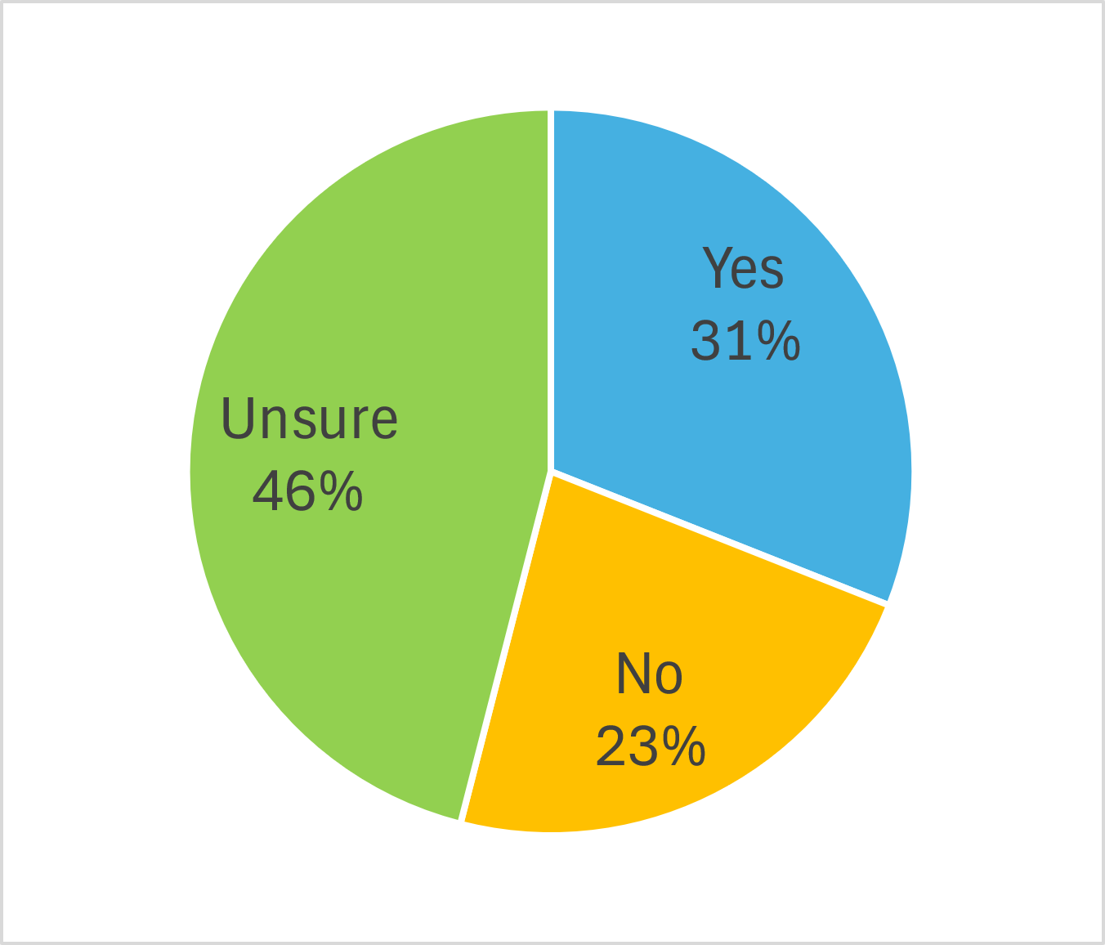

Figure 6 If we removed admin actions, how would this affect your business?

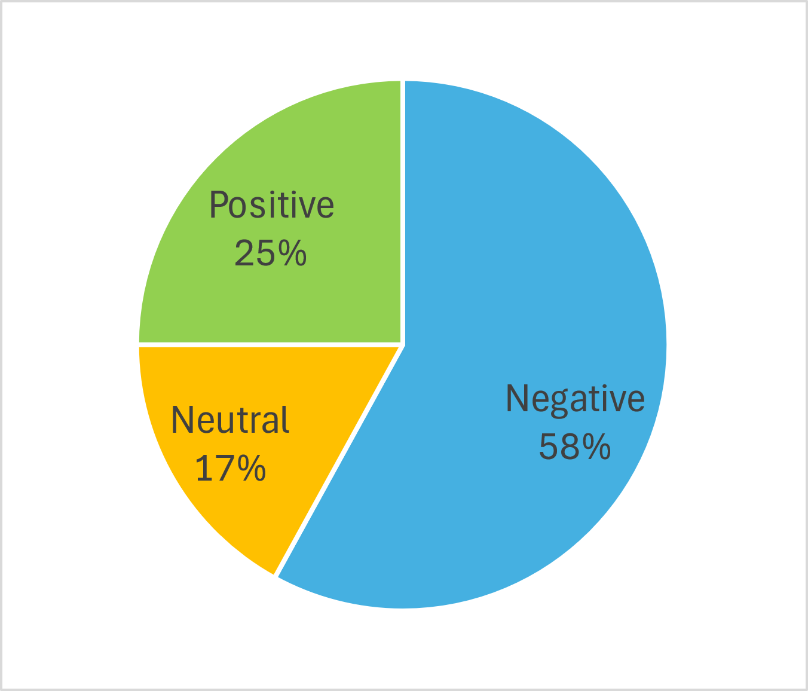

Figure 7 Of the 3 options presented, which option is your preferred option?

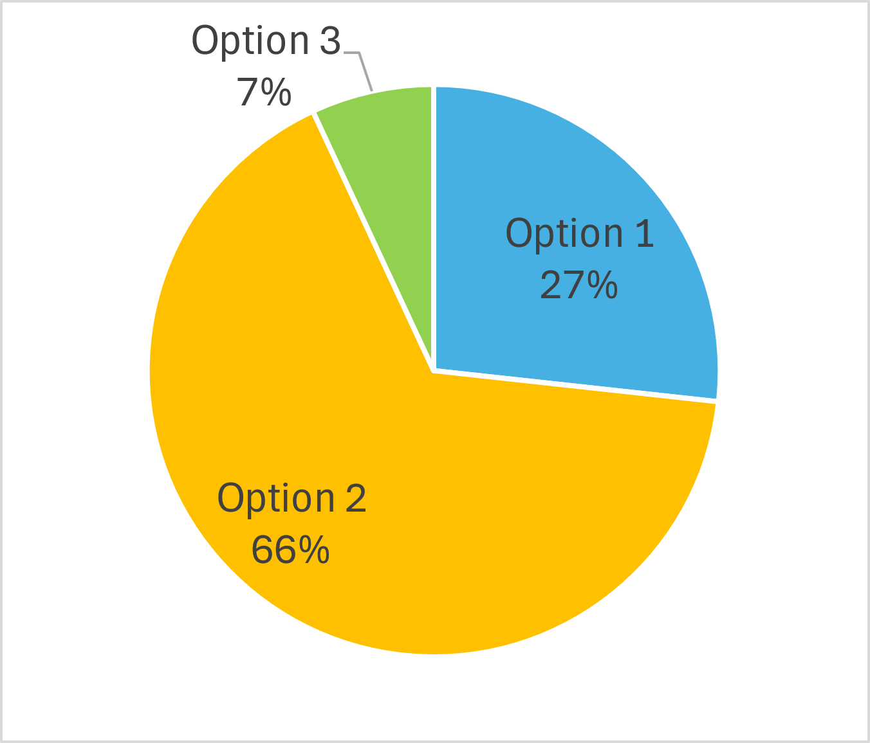

Table 1 Summary of responses received from Have Your Say on Export Assurance reform

| ID | Position | Stakeholder | Relevant comment | Departmental response |
| --- | --- | --- | --- | --- |
| 1 | Option 1 | Exporter > Inedible meat | Submission not for publication. | N/A |
| 2 | Option 2 | Processor > Pet food | Submission not for publication. | N/A |
| 3 | Option 2 | NFP > Animal feed | Submission not for publication. | N/A |
| 4 | Option 1 | Exporter/processor > Meat | Submission not for publication. | N/A |
| 5 | Option 2 | Rendered products > Academic | There needs to be higher standards for the products being exported. Audits for the rendering plants and tighter requirements for exports. | Agree |
| 6 | Option 2 | Wool | Option 1 does not seem to address the problems adequately. Option 3 seems overly heavy-handed and expensive. | Agree |
| The big uncertainty is the additional costs of export licences and permits, and whether they would obviate the need for current certificates (origin, health). | The department acknowledges that there will be changes to fees and charges for departmental services.  We note that the options paper pre-empted increases in fees and charges regardless of which option was selected.  These will be consulted with industry in line with the department’s consultation through the Cost Recovery Implementation Statement (CRIS) process. |
| 7 | Option 2 | Feed ingredients (blood meal) | Submission not for publication. | N/A |
| 8 | Option 2 | Accord submission | See S3 | N/A |
| 9 | Option 1 | Nolan Meats submission | See S4 | N/A |
| 10 | Option 2 | Cellular Agriculture Australia submission | See S5 | N/A |
| 11 | Option 2 | Beerenberg Family Farm | NPG products, particularly honey, would benefit with regulation to assist exporters – especially since diseases are coming into Australia that affect honey, eggs and dairy. Food processers like us use these 3 ingredients and it can affect perception of clean products that Australia is famous for. | Agree |
| There may be an increasing requirement for labelling in foreign languages before export. Standard food labelling with the rest of the world like HS Codes. | Agree |
| Could this be tied in with the Australian Trusted Trader system somehow? Then a one-time export permit would be monitored by the TT system. | Agree in principle  We will explore this suggestion |
| 12 | Option 3 | Anon | Submission not for publication. | N/A |
| 13 | Option 2 | PFIAA Submission (S6) | See S6 | N/A |
| 14 |  | DUPLICATE SUBMISSION | N/A | N/A |
| 15 | Option 1 | Vetalogica | Whilst administrative costs must be further attributed to the user of such services, the current departmental administrative tools are effective for business. Any further administrative requirement by business will be cumbersome and prove troublesome and inefficient for small/medium businesses such as mine. | Agree with qualification  The department does not believe that the current administrative tools are sustainable. |
| Maintaining the current system would minimise the already myriad of bureaucracy that small/medium business must endure to conduct their business. Although increasing regulation of NPG would potentially be more beneficial for the department, consideration must also be given to businesses who already suffer increasing bureaucracy and adherence to ever increasing regulation. | Agree in principle  The department will introduce regulation that is as heavy as it needs to be and as light as it can be to minimise burden for businesses. |
| The current system must be assessed for existing complaints from importing countries. If such a change will only serve to slightly increase/or not increase such complaints, then such an endeavour is futile. In effect, if importing countries are experiencing adherence to attestations and declarations then we mustn't change to a more regulatory approach. | Disagree  The department does not believe that the current administrative tools are sustainable given the evolving demands of international trade. |
| Option 1 is ideal. Maintain administrative tools whilst increasing the burden of costs to the user of such services. | Disagree  The department does not believe that the current administrative tools are sustainable. |
| If an importing country or the Department requires an audit of a manufacturing facility, then such an audit should be allowed to be undertaken by any JSANZ approved auditing firm (that the manufacturing facility elects based on availability of services and costs). All JSANZ approved auditing firms are versed and capable of conducting such auditing services and considering that all JSANZ approved auditing bodies undertake their required compliance and licensing, moving to restrict business to being able to only have their audits conducted by the Department or in the case of the PFIAA, where members are only able to use the services of Aus-meat is senseless. I have always maintained that the PFIAA have created a situation where there is significant conflict with respect to anti-competitive behaviour. | Agree in principle  The reform has a principle of reusing existing industry or government schemes before creating anything new. Your comments will be considered by the Industry Working Group |
| 16 | Option 2 | Australian Skins, Leather and Hides Exporters Association | * Provide assurance * Provide confidence * Legal standing * Ability to prosecute * Minimal impact on operations | Agree |
| S1 |  | Feed ingredients and additives | Questions requirement for a Certificate of Free Sale (CFS)  CFS should be charged at the same or similar rate as CFS’s provided by the APVMA.  New rules should include a provision similar to the APVMA’s legislation for furthering trade and commerce both within and outside of Australia for Australian manufacturers of feed additives | Agree in principle  Suggestions will be considered by the Industry Working Group. |
| S2 | Option 2 | Australian Council of Wool Exporters and Processors (ACWEP) | ACWEP appreciates and understands the problems for government described in ‘Export assurance reform: options paper’. We accept the need for reform to ensure the export assurance system is sustainable over the long term. | Agree |
| Of the 3 options presented in the paper, ACWEP provides in-principle support for option 2, regulation to assure exports. However, we will be keen to understand the cost implications on wool exporters of new requirements such as export licenses and export permits. | Agree  Costs will be determined in consultation with industry |
| S3 | Option 2 | Accord (peak national industry association representing manufacturers and marketers of hygiene, cosmetic and specialty products) | Of the options presented in the Options Paper, Accord support Option 2, regulate to assure exports. It is our understanding that Option 2 will provide the necessary certainty and transparency for exporters by providing a regulatory framework, while allowing flexibility to cater to changing needs of commodities, importing countries and exporters. We look forward to working with DAFF to deliver these outcomes. | Agree |
| The Options paper notes that under Option 2, all exporters will be required to hold an export licence and each consignment exported would require a permit. We would appreciate further details of this process so that we can better understand the impact on the internal processes for our exporting companies. | This will be consulted through the Industry Working Group |
| Accord supports cost recovery of export assurance programme that is financially sustainable. DAFF should cost recover appropriately so that the services it provides for exporters can continue. We look forward to receiving the proposed cost for annual exporter licence fee and export permit fee per consignment in due course. | Agree |
| S4 | Option 1 | Nolan Meats | Administrative Arrangements is the best of the 3 options put forward. In this the current system is maintained with some increased costs, it does however have the chance that it limits access for some markets. | Agree in part  The department does not believe that the current administrative tools are sustainable. |
| Nolan Meats finds options 2 and 3 highly undesirable as both lead to more legislation, more red tape, more costs and less productivity as the papers get shuffled. | Disagree  The department will introduce regulation that is as heavy as it needs to be and as light as it can be to minimise burden for businesses. |
| Nolan Meats has the view that a 4th option has been missed, this is the option where industry takes a proactive lead in demonstrating assurance. History has shown that when industry takes a lead in setting standards and championing a robust assurance system, there are increases in productivity, reductions in cost for both industry and government. Strong industry lead systems supported by 3rd party audits of those systems such as ARA Code of Practice and the supporting audits shifts costs back down the supply chain and costs away from DAFF. With strong industry run programs it allows the department to shift to a systems-based approach. Where the department endorses an industry program standard and then the organisation wishing to export submits evidence of compliance to the industry program as part of their application. | Agree with qualification  The reform has a principle of reusing existing industry or government schemes before creating anything new. Your comments will be considered by the Industry Working Group. |
| The industry program approach addresses all 3 items raised as the need for reform. It spreads the costs along the supply chain, it increases the assurance of goods and it reduces the administrative processes and cost for DAFF. | Agree |
| S5 | Option 2 | Cellular Agriculture Australia | Feedback on the 3 policy options  Option 1. Maintain existing administrative arrangements with changes to cost recovery arrangements and some administrative changes In order to create an efficient and responsive system that underpins new products in export markets, CAA does not support the status quo. | Agree |
| Option 2. Regulate to assure exports  This appears to be the most appropriate approach for the cellular agriculture sector in balancing an efficient export system with the safety and quality reputation that comes with government assurance. | Agree |
| However, it is critical that the NPG category remains in place. Cellular agriculture products are still in various stages of commercialisation, with limited market approvals globally. Therefore, exporting as a non-prescribed good will be the likely practice in the short to medium term. | Agree |
| CAA would also need clarification on a commodity definition for cellular agriculture products and whether they would qualify for the assured goods category. The technology and manufacture of cellular agriculture products is still evolving, making prescribing regulatory requirements difficult in the short to medium term. Noting items are proposed to be progressively prescribed, the sector would seek to shape the regulatory requirements (noting this may be some years away). | Agree |
| As a new and emerging sector, the cost of export assurance must not be a barrier to trade. | Agree |
| Option 3. Regulate to control exports CAA would not support this option, mainly due to the sector’s nascency and diversity, which would make defining a regulatory requirement for all products difficult and costly. It could also lead to regulatory requirements that quickly become no longer fit for purpose as the technologies and products evolve. | Agree |
| Conclusion  The nascency of the cellular agriculture sector means exporting as a non-prescribed good will be the likely practice in the short to medium term. | Agree |
| CAA agrees that assurance is an important way to build trust in exported products. Of the 3 policy options CAA supports ‘Option 2 – Regulate to assure exports,’ because it maintains the NPG category for new products but provides a pathway to assurance as the sector matures. | Agree |
| The sector would require additional information about the definitions of commodities and how it could support development of any regulatory requirements. | Agree |
| S6 | Option 2 | PFIAA | Government certificates do not assure for pet food safety, whereas AS5812 does maintain the ingredients, processing (including recipes/formulations) and labelling are fit for purpose, are understood by pet owners and meet importing country requirements. | Agree |
| Option 2 provides more flexibility and will introduce options to better ensure the pet food industry more broadly meets expected standards. Addressing the challenges requires a proactive approach, continuous learning, and strategic planning. | Agree |
| The proposed reforms should typically aim to introduce a more comprehensive regulatory framework to manage and mitigate risks, which benefits exporters and the regulator. | Agree |
| Introducing the requirement to be audited against AS5812 would ensure all pet food exporters are aligned and compliant with Australian and international standards and meet importing country requirements. These enhanced compliance and quality controls will ensure goods meet the required expectations through a fair and robust system. A more robust framework will enhance confidence among our trading partners, potentially boosting export trade. | Agree in principle  The reform has a principle of reusing existing industry or government schemes before creating anything new. Your comments will be considered by the Industry Working Group. |
| The PFIAA suggests that Option 2 would create a more resilient, quality driven and competitive pet food export sector. | Agree |

## Glossary

| Term | Definition |
| --- | --- |
| administrative actions | Activities conducted by the department that are not specifically required by the Export Control Act 2020, and which industry voluntarily take part in, for example, maintaining a country listing for a non-prescribed good to a specific market. |
| Assurance | Where the competent authority confirms that the requirement of an importing country has been met. |
| Audit | A regulatory tool provided under chapter 9 of the Export Control Act 2020 whereby the Secretary may require an audit to be carried out of export operations permitted or approved under the Act, such as at an accredited property, a registered establishment, covered by an approved arrangement, by a person who applied for or has an export permit or government certificate. Activities to facilitate an audit includes onsite visits, taking, testing and analysing samples, examination and verification of records and documents in relation to export operations being carried out. Audits may also be conducted in relation to the performance of functions and the exercise of powers under the Act by certain persons, such as third party authorised assessors. |
| co-design | A consultation process where the department works together with industry to develop an application of the Export Assurance Reform model. |
| Consult | A process whereby the department seeks information from industry to inform policy development. The Export Assurance Reform project uses the International Association for Public Participation 2 (IAP2) spectrum of public participation to identify the appropriate consultation types to gain the most from the experience and ideas of industry. |
| cost recovery | Cost recovery involves the Australian Government charging the non-government sector some or all of the efficient costs of a specific government activity. That activity may include the provision of goods, services or regulation, or a combination of them. |
| export licence | A regulatory tool provided under chapter 6 of the Export Control Act 2020 whereby the Secretary may grant a licence to carry out one or more kinds of export operations in relation to one or more kinds of prescribed goods. |
| export permit | A regulatory tool provided under chapter 7 of the Export Control Act 2020 whereby the Secretary may grant a permit to export certain kinds of prescribed goods. |
| government certificate | A regulatory tool provided under part 3 of chapter 2 of the Export Control Act 2020 whereby the Secretary may issue a certificate that attests to certain aspects of goods that are to be or have been exported. |
| non-prescribed goods | Goods that are not prescribed goods under the Export Control Act 2020 and the export control rules. |
| prescribed goods | Goods that are prescribed by the export control rules for the purposes of subsection 28(1) of the Export Control Act 2020. |
| regulatory model | The set of regulatory tools needed to regulate a specific good for export. The Export Assurance Reform model refers to prescribing regulatory tools from the Export Control Act 2020 in specific country–commodity combinations. |
| regulatory tool | Measures used for the regulation of the export of goods provided by the Export Control Act 2020 and export control rules, generally by providing the performance of functions and exercise of powers by certain persons, such as the Secretary. |
| schedule | A part of a piece of legislation (e.g. an Act or instrument such as a rules instrument) that attaches to the end of main provisions, which is usually dependant on those provisions, such as where the schedule provides for how those provisions are to apply in specific circumstances.  In the context of the new Export Control Rule, the schedule will be a table that lists the regulatory requirements for export of a particular good to a particular country or countries. |