**Joint Interagency Taskforce: Exotic Animal Disease  
Preparedness**

Report

5 September 2022

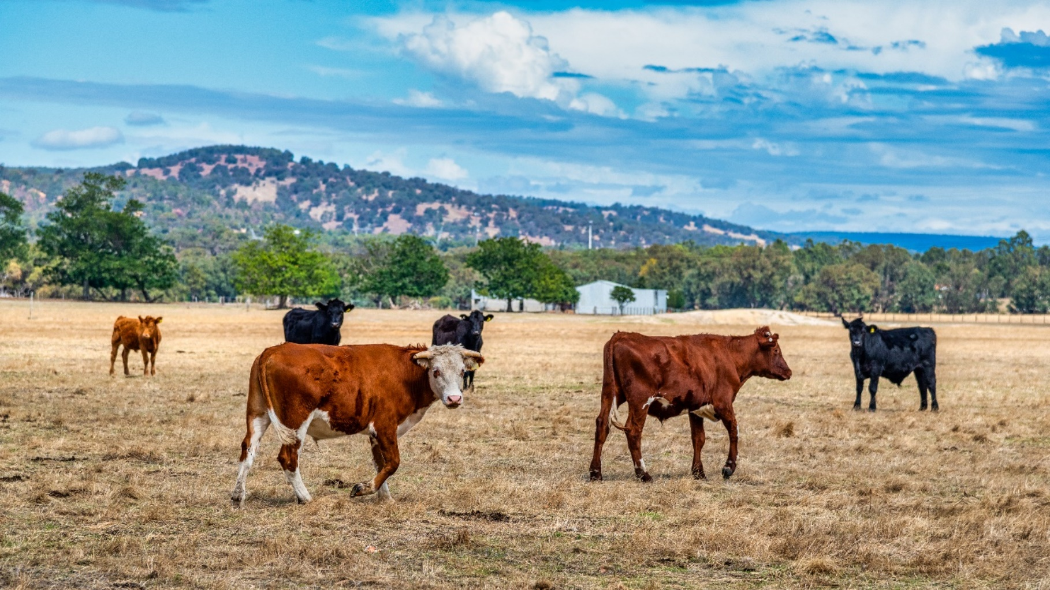© Commonwealth of Australia 2022

**Ownership of intellectual property rights**

Unless otherwise noted, copyright (and any other intellectual property rights) in this publication is owned by the Commonwealth of Australia (referred to as the Commonwealth).

**Creative Commons licence**

All material in this publication is licensed under a [Creative Commons Attribution 4.0 International Licence](https://creativecommons.org/licenses/by/4.0/legalcode) except content supplied by third parties, logos and the Commonwealth Coat of Arms.

Inquiries about the licence and any use of this document should be emailed to [copyright@agriculture.gov.au](mailto:copyright@agriculture.gov.au).



**Cataloguing data**

This publication (and any material sourced from it) should be attributed as: DAFF 2022, *Joint Interagency Taskforce: Exotic Animal Disease Preparedness,* Department of Agriculture, Fisheries and Forestry and Department of Home Affairs, Canberra, September. CC BY 4.0.

Department of Agriculture, Fisheries and Forestry

GPO Box 858 Canberra ACT 2601

Telephone 1800 900 090

Web [agriculture.gov.au](https://www.agriculture.gov.au/)

**Disclaimer**

The Australian Government acting through the Department of Agriculture, Fisheries and Forestry has exercised due care and skill in preparing and compiling the information and data in this publication. Notwithstanding, the Department of Agriculture, Fisheries and Forestry, its employees and advisers disclaim all liability, including liability for negligence and for any loss, damage, injury, expense or cost incurred by any person as a result of accessing, using or relying on any of the information or data in this publication to the maximum extent permitted by law.

**Acknowledgement of Country**

We acknowledge the Traditional Custodians of Australia and their continuing connection to land and sea, waters, environment and community. We pay our respects to the Traditional Custodians of the lands we live and work on, their culture, and their Elders past and present.

## Terms and abbreviations

|  |  |
| --- | --- |
| Term or Acronym | Definition or spelt out acronym |
| ABARES | Australian Bureau of Agricultural and Resource Economics and Sciences |
| ACDP | Australian Centre for Disease Preparedness |
| ADPF | Australian Disaster Preparedness Framework |
| AGCMF | Australian Government Crisis Management Framework |
| AUSBIOAGPLAN | Australian Government Biosecurity and Agricultural Response Plan |
| Biosecurity Act | Commonwealth Biosecurity Act 2015 |
| CASP | Crisis Appreciation Strategic Planning |
| CCEAD | Consultative Committee on Emergency Animal Diseases |
| CEBRA | Centre of Excellence for Biosecurity Risk Analysis |
| CIRP | Critical Incident Response Plan |
| COAG | Council of Australian Governments |
| DAFF | The Australian Government Department of Agriculture, Fisheries and Forestry |
| Director of Biosecurity | The Secretary of the Australian Government Department of Agriculture, Fisheries and Forestry |
| EAD | Emergency Animal Disease |
| EMA | Emergency Management Australia |
| FMD | Foot-and-Mouth Disease |
| IAHER | International Animal Health Emergency Response |
| IGAB | Intergovernmental Agreement on Biosecurity |
| IGB | Inspector-General of Biosecurity |
| LSD | Lumpy Skin Disease |
| MOU | Memorandum of Understanding |
| NBCEN | National Biosecurity Communication and Engagement Network |
| NEMA | National Emergency Management Agency |
| NMG | National Management Group |
| PPF | Prohibited Pig Feed |
| RSPCA | Royal Society for the Prevention of Cruelty to Animals |
| UK | United Kingdom |
| WOAH | World Organisation for Animal Health (formerly the Office International des Epizooties) |

This page left intentionally blank

## Letter of Transmittal

Dear Minister,

On 8 August 2022 you formally requested that we co-lead a time-limited taskforce and report to you by 5 September 2022.

The taskforce was requested to:

* Ensure that all biosecurity plans are integrated with the Australian Government Crisis Management Framework and with State and Territory emergency management arrangements.
* Undertake a series of FMD and LSD incursion scenarios to determine respective roles and responsibilities, and identify additional actions necessary to ensure we are in a position to quickly contain and/or eradicate the disease and mitigate the consequences should an outbreak occur.
* Provide advice to Government on additional efforts or measures that might be necessary, including additional regulatory or legal measures or additional personnel if applicable.

The taskforce included officials from the Australian Defence Force, Australian Border Force, NEMA and DAFF, supported by Animal Health Australia. The taskforce brought together experts in biosecurity, animal health, logistics, crisis planning, national preparedness and response.

The taskforce has delivered on these outcomes, and this report outlines 14 recommendations for consideration that will enhance the existing system and ensure that Australia is better prepared should there be an incursion of Foot and Mouth and Lumpy Skin Disease.

We present you with the Joint Interagency Taskforce: Exotic Animal Disease Preparedness report.

Yours Sincerely

**Joe Buffone Kerren Crosthwaite**

This page left intentionally blank

Contents

Terms and abbreviations iii

Letter of Transmittal v

Taskforce Terms of Reference ix

About this report x

Executive summary 1

Recommendations 1

Introduction 5

Background and context to the establishment of the Taskforce 5

Part 1 – Exotic animal diseases – context and background 7

Australia’s biosecurity system is collaborative and effective 7

An EAD outbreak in Australia would have significant consequences 7

Preparing for an incursion – Australia’s biosecurity planning 10

Australia has learned from previous outbreaks and reviews - here and overseas 11

Part 2 – The Taskforce’s approach and activities 13

Methodology 13

Ensuring our plans are understood, integrated and ready to use 14

Scenario-based discussions 14

Communications 20

Commonwealth, Jurisdiction and Industry Engagement 20

Stakeholder mapping 21

Part 3 – Findings and recommendations 23

National leadership, accountability and coordination will allow speed to decision and action 23

National crisis communications can be strengthened through the creation of a national strategy 23

National data and intelligence capability will enable more effective decision making 24

National plans and policies should be regularly monitored, tested, reviewed and updated to ensure they remain appropriate for the scale of response that would be warranted by an incursion of an EAD 24

Workforce capacity 25

Mission critical supplies 26

Working with states and territories 26

References 27

Appendices 28

Appendix A: Exercise Paratus – National Biosecurity Emergency Response Exercise Program 28

Appendix B: Biosecurity emergency management arrangements integration with Australian Government Crisis Management Framework (AGCMF) 29

Appendix C: Crisis Appreciation and Strategic Planning – Foot and Mouth and Lumpy Skin Disease 30

Appendix D: Livestock stakeholder map by activity 32

Appendix E: Conceptual Model for an Integrated National Coordination Framework 33

Appendix F: Report on exercises undertaken by the Joint Interagency Taskforce on Exotic Animal Disease Preparedness 34

**Figures**

Figure 1: Livestock numbers and distribution in Australia 2020–21 8

Figure 2: CEBRA estimated probability of an internationally notifiable EAD incursion in the 5 years from 2022 9

Figure 3: The relationship between consequence, intensity, and the limitation of risk treatment effectiveness that close down spaces for effective leadership and decision-making 16

**Scenarios**

Scenario 1: Northern Australia scenario-based discussion 14

Scenario 2: Southern Australia scenario-based discussion 14

Scenario 3: National livestock standstill discussion 14

## Taskforce Terms of Reference

Joint Interagency Taskforce - Exotic Animal Disease Preparedness   
8 August 2022 to 5 September 2022

Context

The confirmation of a widespread outbreak of Foot and Mouth Disease (FMD) in Indonesia has increased the risk of an incursion of this disease, or of another Exotic Animal Disease like Lumpy Skin Disease (LSD), in Australia.

Commensurate with this risk, it is prudent to elevate overall national preparedness to ensure that response plans are well prepared in place in every state and territory, that all affected Commonwealth agencies are aware of the part they would need to play and that current biosecurity and emergency response arrangements and tested, and strengthened if necessary.

Objectives and scope

The taskforce will:

a. Bring together affected stakeholders from across commonwealth, state and territory governments and key industry bodies to assess the level of preparedness for an EAD outbreak and the adequacy and appropriateness of national and state level biosecurity plans and arrangements.

b. Ensure that all biosecurity plans are integrated with the Australian Government Crisis Management Framework and with State and Territory emergency management arrangements.

c. Undertake a series of FMD and LSD incursion scenarios to determine respective roles and responsibilities, and identify additional actions necessary to ensure we are in a position to quickly contain and/or eradicate the disease and mitigate the consequences should an outbreak occur.

d. Provide advice to Government on additional efforts or measures that might be necessary, including additional regulatory or legal measures or additional personnel if applicable.

Governance

The taskforce will report to the Minister for Agriculture, Fisheries and Forestry and Minister for Emergency Management.

It will engage regularly with the Secretary of the Department of Agriculture, Fisheries and Forestry (DAFF), recognising his legislated role as Director of Biosecurity, and the Secretary of the Department of Home Affairs, given his responsibility for Emergency Management Australia (EMA).

Resources

The taskforce will be jointly led by the Director-General of EMA and a First Assistant Secretary from DAFF. It will be staffed by up to 20 officers from EMA, DAFF and other relevant agencies, seconded to the taskforce for an initial period of four weeks.

Deliverables

The taskforce will provide a report to the Minister for Agriculture, Fisheries and Forestry and Minister for Emergency Management by 5 September 2022. This report will provide an assessment of the level of preparedness for an EAD outbreak in Australia, and advice about additional efforts or measures that may be required to address any deficiencies identified.

## About this report

This report sets out the Joint Interagency Taskforce’s (the taskforce) advice to the Minister. It describes the work the taskforce undertook and evidence it relied upon to inform its findings and observations about the level of preparedness for an EAD outbreak in Australia. It makes 14 recommendations about additional activities that could be undertaken to increase the level of preparedness.

**Part 1** sets out background and context for the management of exotic animal diseases in Australia, including how we plan for an outbreak and lessons learned from previous incidents in Australia, overseas, and reviews.

**Part 2** details the work conducted by the taskforce. This includes the development of a Crisis Appreciation Strategic Planning (CASP) document and an analysis of current capability. Three scenario-based discussions were conducted with representatives from Commonwealth, state and territory biosecurity and emergency management agencies, and industry.

**Part 3** outlines the taskforce’s findings and recommendations.

## Executive summary

Australia has a world-class biosecurity system. This has kept Australia free of serious animal diseases such as foot-and-mouth disease (FMD) and Lumpy Skin Disease (LSD) for 150 years. This has allowed for the significant economic benefits that flow from our disease-free status. Preventing an LSD and FMD incursion remains the priority for the Australian government.

The response to even a single detection of FMD and LSD in Australia would require a coordinated national effort. The speed and scale required for such a response would require the engagement of the emergency management system to fully utilise the nation’s crisis management resources. It is prudent to ensure that the system as a whole is at a level of preparedness commensurate with the potential consequences of an incursion, and that the biosecurity and emergency response systems at all levels of government are prepared for that need operate in a joint environment. It is also important that industry, government, and the Australian community have confidence in and awareness of the planning that underpins the system for biosecurity response.

The taskforce, with just four weeks to undertake its work, focused on activities that would utilise and build upon existing structures, expertise and plans, in a structured, efficient manner. It undertook structured crisis appreciation and planning, a series of scenario-based discussions, one-on-one and group engagements, and desktop reviews of existing plans and reviews, to consider the level of preparedness of the system to respond to an EAD incursion.

It found that EAD response arrangements are comprehensive and well-understood by system participants. These response arrangements are regularly used, with success, in responding to biosecurity incidents.

**Overall, the system is strong, in particular in prevention and mitigation, and the system is sound.**

Throughout its activities, the taskforce heard that the scale and speed of response required in the case of an FMD or LSD incursion would be significant and therefore place considerable pressure on the system. It would require a level of immediate and sustained effort that would be assisted by undertaking specific additional preparedness actions now, before resources are diverted by an active incident.

These additional actions are captured in the following recommendations. The recommendations build upon the detailed, well-rehearsed animal health response plans already in place, suggesting actions where national leadership or additional focus would benefit the system’s ability to respond at speed and scale.

The taskforce also identified a number of matters that the Minister may wish to raise with State and Territory Agriculture Ministers that are not the responsibility of the Commonwealth.

### Recommendations

#### National leadership, accountability and coordination will allow speed to decision and action

##### Recommendation 1

That Government consider updating the national coordination architecture to ensure closer integration of the National Coordination Mechanism and the DAFF-led National Coordination Centre (a suggested structure for consideration is provided at **Appendix E: Closer integration of the National Coordination Mechanism and the DAFF-led National Coordination Centre**).

##### Recommendation 2

That Government consider negotiation of a new instrument to replace the 2002 Council of Australian Governments (COAG) memorandum of understanding on FMD, to align with contemporary crisis management arrangements, to operate beneath the Intergovernmental Agreement on Biosecurity.

#### National crisis communications can be strengthened through the creation of a national strategy

##### Recommendation 3

Building upon the work of NBCEN, that Government consider engaging a crisis communications consultancy to accelerate the development of a national crisis communications strategy and ‘playbook’ to set out strategies, decision-making frameworks and pre-prepared content for initial actions across key time horizons (one hour, six hours, twelve hours, twenty-four hours, three days and seven days).

#### National data and intelligence capability will enable more effective decision making

##### Recommendation 4

Building on the recommendations from the Matthews and Craik reviews, that Government consider establishing a national biosecurity data and intelligence capability that informs the national collection, processing and dissemination of intelligence to inform decision making on biosecurity preparedness and responses at the federal level. This capability would integrate data from various sources to develop national current (e.g. situation dashboards) and estimative intelligence products (e.g. strategic indicators and warning problems) that inform crisis response, contingency planning and decision making.

##### Recommendation 5

That Government consider commissioning modelling to determine likely weather events that could transport LSD virus infected vectors to a location where they could infect livestock, to enhance surveillance to increase the chances of early detection of an incursion.

#### National plans and policies should be regularly monitored, tested, reviewed and updated to ensure they remain appropriate for the scale of response that would be warranted by an incursion of an EAD

##### Recommendation 6

That all jurisdictions review and rationalise with a purpose of modernising and maturing key response plans and policies more than three years old (for example standard operating procedures and response manuals) to ensure they are contemporary and incorporate lessons from COVID-19 and recent hazard events, i.e., Black Summer Bushfires.

##### Recommendation 7

That action on recommendations in this report, accepted by the Minister, be reported to the Minister quarterly.

##### Recommendation 8

That Government consider expanding upon its work through Exercise Paratus to:

* include a tabletop exercise which explores the application of state and territory and Commonwealth biosecurity legislation in respect to an LSD or FMD incursion.
* support AHA to fully exercise the system and processes for vaccine import, and exercise with the states and territories for the distribution of both LSD and FMD to ensure there are no critical delays should vaccines need to be quickly imported and distributed.
* develop an ongoing schedule to review and exercise plans and documentation beyond the life of Exercise Paratus, with responsibilities assigned to specific roles. These exercises could include the Minister and include a focus on resource modelling.
* re-exercise the International Animal Health Emergency Response (IAHER) manual, including follow-up with international partners, and include the Department of Home Affairs to pre-determine and exercise the processes for securing international assistance under the IAHER, including the most efficient visa process.

##### Recommendation 9

That Government consider expanding on current work across government to conduct modelling of potential economic impacts and develop a just-in-case policy response for support and recovery to respond to second and third order consequences in the event of an EAD outbreak.

##### Recommendation 10

That NEMA and DAFF work with Defence to develop contingency plans to support nationwide biosecurity response activities in an EAD outbreak. Envisaged roles include planning and operational support for logistics, movement control and liaison functions, although this has not been consulted with Defence.

##### Recommendation 11

That DAFF work across government to consider options for creating more opportunities for First Nations people and Traditional Owners to participate in and benefit from biosecurity activities including surveillance and feral animal management.

#### Workforce capacity

##### Recommendation 12

That Government consider working with jurisdictions to develop a system-wide strategy for national animal disease response workforce capacity and training, noting DAFF’s previous Vet Reserve program could be used as a guide.

#### Mission critical supplies

##### Recommendation 13

That DAFF, jurisdictions and industry should work together to develop a resource plan, including identifying the mission critical supplies needed to operationalise response plans.

#### Working with states and territories

##### Recommendation 14

That Government consider further work with the jurisdictions on:

* a national approach to interstate border control and permitting to ensure efficient and effective interstate border security movements as part of the enforcement of a livestock standstill or movement controls.
* continuing engagement by biosecurity agencies with relevant emergency management agencies to ensure that there is alignment and integration of incident management structures.
* reflecting the common definition for prohibited pig feed (PPF) and the feeding of PPF developed and endorsed by Animal Health Committee (AHC) in state and territory legislation.
* review and update of plans for:
* carcass disposal sites, and where relevant establish agreements for the movement of carcasses between local government areas for disposal
* accessing remote or isolated livestock, particularly in Northern Australia, including during adverse weather or flooding, for surveillance, testing or other activities
* cold-chain management of vaccines
* options to utilise personnel from workforces that would be stood down as a consequence of an FMD or LSD outbreak.

## Introduction

### Background and context to the establishment of the taskforce

The Joint Interagency Exotic Animal Disease Preparedness Taskforce (the taskforce) was established by Senator the Honourable Murray Watt, Minister for Agriculture, Fisheries and Forestry and Minister for Emergency Management to ensure Australia is fully prepared to respond swiftly to growing biosecurity threats.

This contributes to the third part of Australia’s three-pronged approach to keeping Australia FMD and LSD-free - helping our neighbours deal with the outbreak; strengthening our biosecurity borders; and enhancing our preparedness at home, should an incursion occur.

Minister Watt requested that the taskforce provide him with advice about the level of preparedness, across all levels of government, to respond to an incursion.

The taskforce was co-led by Ms Kerren Crosthwaite, First Assistant Secretary, Department of Agriculture, Fisheries and Forestry (DAFF) and Mr Joe Buffone PSM, Deputy Co-ordinator General of the National Emergency Management Agency (NEMA), previously Emergency Management Australia (EMA). The taskforce included officials from the Australian Defence Force, Australian Border Force, NEMA and DAFF, supported by Animal Health Australia (AHA). The taskforce brought together experts in biosecurity, animal health, logistics, crisis planning, national preparedness and response.

The taskforce has focused on exotic animal diseases, particularly FMD and LSD.

FMD and LSD are not present in Australia. The risk of an FMD or LSD incursion is low. Expert judgment has assessed the risk of an FMD incursion in the next five years at 11.6 per cent, and   
28 per cent for LSD. However, the impact of any incursion would be significant – the Australian Bureau of Agriculture and Resource Economics and Sciences (ABARES) estimated in 2022 that a large FMD incursion across multiple states could have a direct economic impact of around $80 billion over 10 years.

States and territories are the first responders to any incident that occurs within their jurisdiction and have primary responsibility for emergency management activities, including for biosecurity.

The taskforce has worked across Federal, State and Territory Governments as well as with industry and Indigenous Communities. The taskforce set out to ensure that the well-developed biosecurity plans that are already in place can effectively respond to an outbreak and can integrate with existing emergency/disaster management arrangements within all jurisdictions and nationally. The taskforce also considered what might be needed to mitigate the non-biosecurity related consequences of an incursion.

The taskforce’s recommendations are geared toward cultivating a readiness mindset across and between the Emergency Management and Biosecurity systems. Appreciation of the scope and scale of a potential outbreak will ensure that there is capability and capacity in place to rapidly respond to an outbreak and sustain this effort for a number of months.

The taskforce’s recommendations focus on the national system. To ensure consistency and that the excellent work that has already been put into biosecurity plans is not duplicated, the taskforce has been informed by:

* the work of recommendations made as part of previous reviews
* the [National Biosecurity Strategy](https://www.biosecurity.gov.au/about/national-biosecurity-committee/nbs) (DAFF 2022a)
* the [Commonwealth Biosecurity 2030 Action Plan 2022](https://www.agriculture.gov.au/biosecurity-trade/policy/commonwealth-biosecurity-2030) (DAWE 2021)
* animal response action plans
* [DAFF’s (2022b) submission](https://www.aph.gov.au/DocumentStore.ashx?id=07501a27-3d91-45f9-949b-820c8847f1db&subId=721564) to the Rural and Regional Affairs Transport References Committee: Adequacy of Australia’s biosecurity measures and response preparedness, in particular with respect to FMD and Varroa mite
* consultations with stakeholders
* a series of national scenario-based discussions on LSD and FMD.

The taskforce ran over four weeks from 8 August to 5 September 2022. It conducted three scenario-based discussions: two with a focus on Northern and Southern Australia, and a national livestock standstill exercise.

The taskforce has completed extensive stakeholder mapping, including Commonwealth, state and territory emergency management and biosecurity agencies, producers, industry associations and peak bodies as well as associated service providers.

All elements of the taskforce’s work focused on five response phases:

* coordination architecture
* movement control
* tracing and surveillance
* vaccination
* destruction, disposal and decontamination.

The taskforce has considered the current level of national preparedness and has made 14 recommendations for action that would build on existing planning and capacity and increase the preparedness of the national system for the speed and scale of response likely to be needed should Australia face an incursion of an EAD.

## Part 1 – Exotic animal diseases – context and background

### Australia’s biosecurity system is collaborative and effective

Australia has a world-class biosecurity system. This system safeguards our country from the costly and disruptive impacts of devastating pests and diseases. Agriculture makes a huge contribution to our environment, human health, the social fabric, including our farming systems, of our country, and the wider economy. Stringent biosecurity controls safeguard our market access and reputation as a supplier of world-class produce.

Australia's biosecurity system is a collaborative effort between Commonwealth and state governments and industry. It is a continual process involving activities offshore, at the border and onshore.

The *Biosecurity Act 2015* (Biosecurity Act) aims to manage biosecurity risks to human health, agriculture, native flora and fauna and the environment. It also covers Australia's international rights and obligations and lists specific diseases which are contagious and capable of causing severe harm to human health.

### An EAD outbreak in Australia would have significant consequences

Australia’s world-class meat cattle and livestock industry is widely dispersed across the country. ABARES has calculated the distribution and number of livestock numbers in 2020–21 as per Figure 1, below.

Figure 1: Livestock numbers and distribution in Australia 2020–21

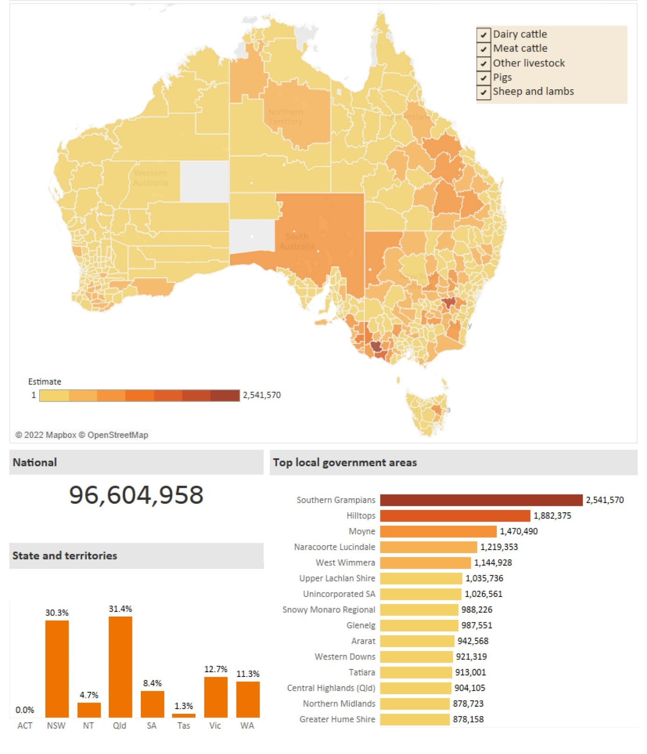

Notes: Scope of the census is based on businesses reporting agricultural activity with an estimated value of agricultural operations of $40,000 or greater. Estimates used correspondence between 2021 SA2 regions and local government areas.

Data sources: Agricultural Commodities, Australia 2020–21 (ABARES), Australian Bureau of Statistics July 2022

Australia is also home to feral deer, goat, horse, pig and water buffalo populations. These animals could increase the speed, coverage and extent of an EAD outbreak. An EAD outbreak in the feral animal population could make controlling the outbreak more complicated and protracted.

A clear and shared understanding of the scope and scale of any EAD outbreak is crucial in terms of good risk management, planning and preparedness.

LSD and FMD outbreaks have occurred in many of Australia’s close neighbours and trading partners. Australia is LSD and FMD free. Ensuring these diseases do not enter Australia remains the highest priority of Australia’s biosecurity efforts.

Over the last 18 months, DAFF worked with the Centre of Excellence for Biosecurity Risk Analysis (CEBRA), based in the University of Melbourne, which undertook three rapid structured expert judgement exercises. These exercises helped to characterise the threat Australia faces from specified EADs.

As noted by DAFF in its submission to the Rural and Regional Affairs Transport References Committee: Adequacy of Australia’s biosecurity measures and response preparedness, in particular with respect to FMD and Varroa mite:

‘Earlier in 2022, structured export judgement workshops assessed the risk of a FMD incursion occurring in Australia in the next five years as 11.6 per cent and 28 per cent for LSD. These assessments took into account the occurrence of an outbreak of FMD and LSD in all provinces of Indonesia, including Bali. This was an increase from 9 per cent and 8 per cent for FMD and LSD respectively from the 2021 estimates, which was prior to either disease being detected in Indonesia. The combined estimated probability of an outbreak in Australia of any one of FMD, LSD, African Horse Sickness or African Swine Fever was 56 per cent (Figure 9) over a five-year period.’

A figure (Figure 9) from the [Senate submission](https://www.aph.gov.au/DocumentStore.ashx?id=07501a27-3d91-45f9-949b-820c8847f1db&subId=721564) is provided here, at Figure 2.

Figure 2: CEBRA estimated probability of an internationally notifiable EAD incursion in the 5 years from 2022

A grid of 4 boxes showing exotic animal diseases with an icon of affected animals and a value for the estimated probability of an incursion. 
Icon of a cow and a sheep - Foot-and-mouth disease 11.6% range 1 — 19% 
Icon of a pig -African swine fever 21% range 5 — 39% 
Icon of a cow -Lumpy skin disease 28% range 4 — 56% 
Icon of a horse -African horse sickness 13% range 1 — 31% 
To the right of the grid of 4 boxes is a large right brace character pointing to a 56% Combined estimated probability

Note: Values are from CEBRA's rapid structured expert judgement exercises:

1 All percentage probabilities denotes the mean of participant estimates between the 0.1 quantile and 0.9 quantile

2 All estimated ranges denote the 0.1 quantile and 0.9 quantile – providing an 80 per cent coverage interval.

Source: Department of Agriculture, Fisheries and Forestry – submission to Rural and Regional Affairs Transport References Committee: Adequacy of Australia’s biosecurity measures and response preparedness, in particular with respect to FMD and Varroa mite.

FMD is a highly contagious disease which affects cattle, buffalo, pigs, sheep, goats, deer and camelids which are those animals with a cloven hoof. The FMD virus is carried by live animals and in meat and dairy products, as well as in soil, bones, untreated hides, vehicles and equipment used with these animals. It spreads through close contact between animals. It can also be carried on people’s clothing and footwear or by the wind and survive in frozen, chilled and freeze-dried foods.

An incursion of the virus would have severe consequences for Australia’s animal health and trade. If FMD established here it could cost us up to $80 billion over 10 years.

LSD is a serious disease of cattle and water buffalo. The disease is spread primarily by biting insects such as certain species of flies, mosquitoes and possibly ticks. The disease can also be spread by fomites through things such as contaminated equipment and in some cases directly from animal to animal. It has never occurred in Australia.

If LSD were to occur in Australia, this would have significant consequences for our beef, water buffalo, and dairy cattle industries, along with substantial trade impacts if Australia was no longer recognised as being free from LSD. The cost of an LSD incursion would also see severe economic losses to Australia’s meat processing sector.

There is no threat to food safety or human health from either FMD or LSD.

### Preparing for an incursion – Australia’s biosecurity planning

DAFF is a lead agency under the Australian Government Crisis Management Framework (AGCMF). DAFF maintains a suite of emergency management arrangements, including:

* The [Australian Government Biosecurity and Agricultural Response Plan](https://www.agriculture.gov.au/sites/default/files/documents/ausbioagplan.pdf) (AUSBIOAGPLAN) – which describes the coordination arrangements between Australian Government agencies during the response to plant and animal biosecurity incidents and agricultural incidents.
* The Critical Incident Response Plan (CIRP) – which sets out DAFF’s internal incident management arrangements where national-level or strategic departmental coordination is required.
* The national biosecurity emergency response agreements (cost-sharing deeds) and associated plans (i.e., [Australian Veterinary Emergency Plan](https://animalhealthaustralia.com.au/ausvetplan/) AUSVETPLAN) also complement the AGCMF arrangements. The diagram in **Appendix B: Biosecurity emergency management arrangements integration with Australian Government Crisis Management Framework (AGCMF)** shows the relevant coordination arrangements.

DAFF has established Exercise Paratus; a national biosecurity emergency response exercise program with a focus on better understanding whole-of-government response arrangements. Exercise Paratus is a two-year exercise program to explore, investigate and test biosecurity response arrangements to ensure that Australia is ready to respond to a significant excursion (see **Appendix A: Exercise Paratus – National Biosecurity Emergency Response Exercise Program**).

Exercise Paratus will:

* conduct a series of seminars and discussion exercises to explore Commonwealth, DAFF and jurisdictional arrangements
* conduct multi-agency functional exercises to assess our readiness to respond to a significant biosecurity emergency
* engage with Commonwealth, state, territory and Industry partners to explore challenges and solutions

Focus areas have been identified as:

* **Legislation:** exploring the triggers to use, and application of, emergency legislative powers
* **Coordination:** enhancing internal capabilities and explore the roles and responsibilities of Commonwealth agencies
* **Escalation:** exploring the role of the Commonwealth during an escalating and nationally significant biosecurity emergency

Jurisdictions and industry sectors have also been undertaking their own response exercises in concert with Exercise Paratus.

### Australia has learned from previous outbreaks and reviews - here and overseas

DAFF has implemented learnings from FMD outbreaks in other countries. It has also conducted and participated in exercises to enhance Australia’s preparedness for exotic animal disease outbreaks, including implementing and managing a national livestock standstill.

The United Kingdom’s (UK) experience (National Audit Office 2002) of a FMD outbreak in 2001 goes some way to illustrate the potential impacts of an outbreak in Australia. When the FMD outbreak occurred in 2001, it resulted in the destruction of over 6 million animals. The economic cost was in excess of £8 billion.

The impacts of the FMD outbreak were felt way beyond livestock owners. Significant impacts were felt across the UK’s tourism, small business and education sectors. The FMD outbreak contributed to a significant impact on mental health in the short, medium and long terms.

The UK was successfully declared FMD-free in January 2002, 11 months after the first detection of FMD. It is also important to note that not all outbreaks of FMD are large. The UK experienced a much smaller outbreak of FMD in 2007 but its impacts were still significant (Anderson 2008).

In 2010, both Japan and the Republic of Korea experienced large FMD outbreaks which required extensive programs to control the disease. The 2010–11 Korean outbreak is estimated to have cost the government some 3 trillion Korean won, equivalent to about $US 2.7 billion.

In 2011, DAFF commissioned Mr Ken Matthews AO, former Secretary of a predecessor department, to provide a qualitative assessment of Australia's readiness to respond to the threat of FMD. 11 areas were highlighted for improvement (Matthews 2011).

Significant advances have been made in bolstering Australia’s defences against the threat of FMD – as well as many other serious exotic animal diseases – since the Matthews review was released in 2011. DAFF has made significant advancements against all of the 11 areas identified.

In July 2017, Dr Wendy Craik, chair of the independent Intergovernmental Agreement on Biosecurity (IGAB) review panel, presented the final IGAB report: Priorities for Australia’s biosecurity system, to the Agriculture Ministers’ Forum (Craik et al. 2017).

The review recommended changes for a refreshed intergovernmental agreement and identified changes that would better reflect and acknowledge the critical roles of the many non-government stakeholders across the national system.

More information about lessons learned from previous outbreaks and outbreaks and reviews is detailed in DAFF’s submission to the Rural and Regional Affairs Transport References Committee: Adequacy of Australia’s biosecurity measures and response preparedness, in particular with respect to FMD and Varroa mite.

## Part 2 – The Taskforce’s approach and activities

### Methodology

Crisis Appreciation and Strategic Planning (CASP) employs a structured, systematic methodology to analyse complex scenarios. CASP is a set of tools that allows timely integration of information from multiple sources and the exploration of how government, not for profit and private sector efforts can integrate to provide a unified response. The CASP underpinned all work conducted by the taskforce in terms of assessing preparedness. A summary of the CASP (**Appendix C: CASP Preparedness and Response)**.

The mission that underpinned all of the taskforce activities and planning was: all governments and affected industries collaboratively eradicate FMD/LSD in the shortest possible time, while minimising social, economic, animal welfare and environmental impacts, and maintaining public trust in trade, investment and Australia’s biosecurity system.

Planning considered six different priorities in a response to an EAD outbreak:

* maintain and enforce biosecurity controls and prevent entry of infectious agents and reduce livestock vulnerability
* protect livelihoods and economic stability
* protect industries and sectors through education of FMD and LSD risks
* provide timely and accurate information and warnings
* maintain and enhance relationships with domestic and international stakeholders
* ensure that animal welfare principles are upheld.

Six major response phases were identified and informed all activities:

* coordination (architecture)
* communication (public messaging and internal notifications)
* movement control
* tracing and surveillance
* vaccination
* destruction, disposal and decontamination.

In line with the CASP, scenarios and planning focused on:

* the most likely and most dangerous scenarios
* capabilities required to operationalise the AUSVETPLAN strategy
* capacity of the jurisdictions to operationalise the AUSVETPLAN strategy
* social and cultural licence considerations
* known issues and novel risks that may be encountered during a response.

The end state sought in all of the activities conducted by the taskforce was: That Australia is prepared for an FMD or LSD outbreak and ready to mount a rapid and effective response coordinated between the Commonwealth, jurisdictions and industry, setting the conditions for a return to normal agricultural and trade conditions and public confidence in Australia’s biosecurity system, and that harm has been minimised to Australian communities.

### Ensuring our plans are understood, integrated and ready to use

The taskforce conducted a gap analysis of existing plans to respond to an incursion of LSD and/or FMD. A gap analysis is an exercise that specifically identifies the gaps or deficiencies between the current and desired state and the action steps needed to ensure that Australia is prepared to respond to an outbreak.

This analysis has a focus on the national system. To ensure consistency and that the excellent work already put into biosecurity plans is not duplicated, preparedness planning has been informed by:

* scenario-based exercises, national livestock standstill discussion, desk top analysis of reports, gap analysis, CASP and stakeholder engagement conducted by the taskforce
* work in response of recommendations made as part of previous reviews
* lessons learned from COVID-19 and recent fires and floods
* the Commonwealth Biosecurity 2030 Action Plan 2022
* existing plans and policies, largely summarised in DAFF’s submission to the Rural and Regional Affairs Transport References Committee: Adequacy of Australia’s biosecurity measures and response preparedness, in particular with respect to FMD and Varroa mite.

The Australian Disaster Preparedness Framework (ADPF) sets out an approach to support the development of capability to effectively prepare for and manage severe to catastrophic disasters. Capability is the collective ability and power to deliver and sustain an effect within a speciﬁc context and timeframe. Capacity is the key determinant of how long a capability can be sustained at a particular level of ability.

The level of capability is determined by the combination of ability and capacity across the following core elements: Governance, Processes, Systems, People and Resources. The ADPF has been considered in the taskforce’s activities.

The gap analysis focused on the actions required to uplift whole of government capability and capacity for an FMD or LSD response, grouped using the ADPF core capability elements.

The gap analysis has informed the finding and reactions identified in this report.

### Scenario-based discussions

Three scenario-based discussions were conducted by the taskforce. Each had a different focus:

* **Northern Australia**, focusing on Northern Territory, Queensland and Western Australia, conducted on 12 August 2022
* **Southern Australia**, focusing on the Australian Capital Territory, New South Wales, South Australia, Tasmania and Victoria, conducted on 16 August 2022
* a N**ational** livestock standstill exercise involving all states and territories, conducted on 29 August 2022.

Each of the jurisdictions was asked to assess their own levels of preparedness to respond to an incursion when participating in the discussions. The level of attendance and participation by the jurisdictions was outstanding, and greatly contributed to the effectiveness of the discussions.

The jurisdictions involved in the discussion contemplated an incursion of FMD and LSD, incorporating the most dangerous scenarios. On 12 August 2022, a scenario-based discussion was conducted focusing on Northern Australia. Participants from the Northern Territory, Queensland and Western Australia were involved in the discussion. The discussion was facilitated by the taskforce.

Scenario 1: Northern Australia scenario-based discussion

Northern Australia scenario-based discussion overview

The scenario explored a hypothetical FMD outbreak at a farm following delivery of 100 head of cattle from a northern jurisdiction sale yard. A Control Area is established in response to the outbreak. It is likely that the disease has spread to the unmanaged feral buffalo population. Tracing has established that cattle from the original sale yards had been trucked into Western Australia and to an export yard for export to Indonesia.

On 16 August 2022, a scenario-based discussion was conducted focusing on Southern Australia. Participants from the Australian Capital Territory, New South Wales, South Australia Tasmania and Victoria were involved in the discussion. The discussion was facilitated by the taskforce.

Scenario 2: Southern Australia scenario-based discussion

Southern Australia scenario-based discussion overview

The scenario explored a hypothetical situation in which there is already an LSD outbreak in Northern Australia (for the purpose of the scenario only). Southern resources have been deployed to assist with this response. A case of FMD is confirmed in a pig farm in Victoria. The farm borders other properties with susceptible animals. Tracing confirms that 20 pigs from the affected farm were sold and transported to a neighbouring jurisdiction. Cattle at the Naracoorte Sale Yards were identified with FMD symptoms.

The taskforce conducted a national livestock standstill scenario discussion on 29 August 2022. This exercise brought together Commonwealth, state and territory emergency management and biosecurity agencies from across the country. The taskforce also included key industry representatives in the discussion.

Scenario 3: National livestock standstill discussion

National livestock standstill overview

The hypothetical exercise contemplated the time taken to analyse the first sample of cattle with FMD like symptoms, by a state-based biosecurity lab and by the Australian Centre for Disease Preparedness. During this period, the Consultative Committee on Emergency Animal Diseases (CCEAD) is convened and shortly after the National Management Group (NMG) authorises a national livestock standstill. Additional cases are identified and property owners are notified of the incursion. Media coverage, with a focus on animal welfare issues commences within 30 hours. At this point other impacted states have been identified and the CCEAD is convened to consider an extension of the national livestock standstill.

A summary report providing details about all three scenarios is at **Appendix F: Report on exercises undertaken by the Joint Interagency Taskforce on Exotic Animal Disease Preparedness**.

#### Key themes from scenario-based discussions

The discussion highlighted some key themes.

Themes that emerged in both the northern and southern scenarios were as follows:

* the need for strong, consistent and recognisable national leadership
* integration between Commonwealth, State and Territory biosecurity legislation
* the need for early identification and decision making to support a rapid FMD or LSD response
* the need to build on historical and legacy biosecurity work
* coordination of public information and messaging across all stakeholders
* second, third and fourth order consequences
* social and cultural licence
* integration of technology, systems and data.

Participants in all discussions expressed a need for Australian Government national leadership and coordination in preparedness, planning and response. Experiences through the COVID-19 pandemic and recent fire and flood disasters have provided valuable lessons in the mechanisms of emergency management. Learnings from the pandemic were evident when participants discussed the need for strong and consistent messaging. There is an opportunity to leverage these learnings to further integrate technical biosecurity coordination with Australian Government crisis arrangements, and in ensuring plans are in place for effective crisis communications.

COVID-19 experiences also informed observations during the scenario discussions about the handling of broad consequences across the community. Any FMD or LSD outbreak could have significant effects on other sectors including food and grocery, healthcare, hospitality, tourism, trade, mental health, banking and finance. Stakeholders raised changes in societal expectations, involvement of issue motivated groups, and considerations about cultural licence and animal welfare. Societal concern about destruction and disposal activities, evidenced by the UK’s experience in 2001, would require management.

Commonwealth, state and territory biosecurity legislation would all be activated in the event of an outbreak. A national livestock standstill would be enacted through agreement and individual state powers, not through national legislation.

Discussions revealed a high level of expertise and understanding within and between jurisdictions about animal disease prevention and mitigation. These arrangements have proven effective for incidents of a manageable scale. Participants indicated that the speed and scale of a response to an EAD mean that it is worth testing these arrangements to ensure they are as robust and well understood as possible in that context.

This is well illustrated in the Crosweller and Tshakert (2019) article ‘Climate change and disasters: The ethics of leadership’. A heuristic model (see Figure 3) depicts the intensity and consequence of an event. In the event of an FMD or LSD incursion this would occur immediately. This has been validated from the lessons to be learnt report from the UK 2001 outbreak, the Matthews Review, and the outcomes from the series of scenario-based discussions in which participants spoke about the impact of an LSD or FMD incursion as being catastrophic on a number of fronts and the risk that a response is beyond the limits of risk treatment effectiveness.

Figure 3: The relationship between consequence, intensity, and the limitation of risk treatment effectiveness that close down spaces for effective leadership and decision-making

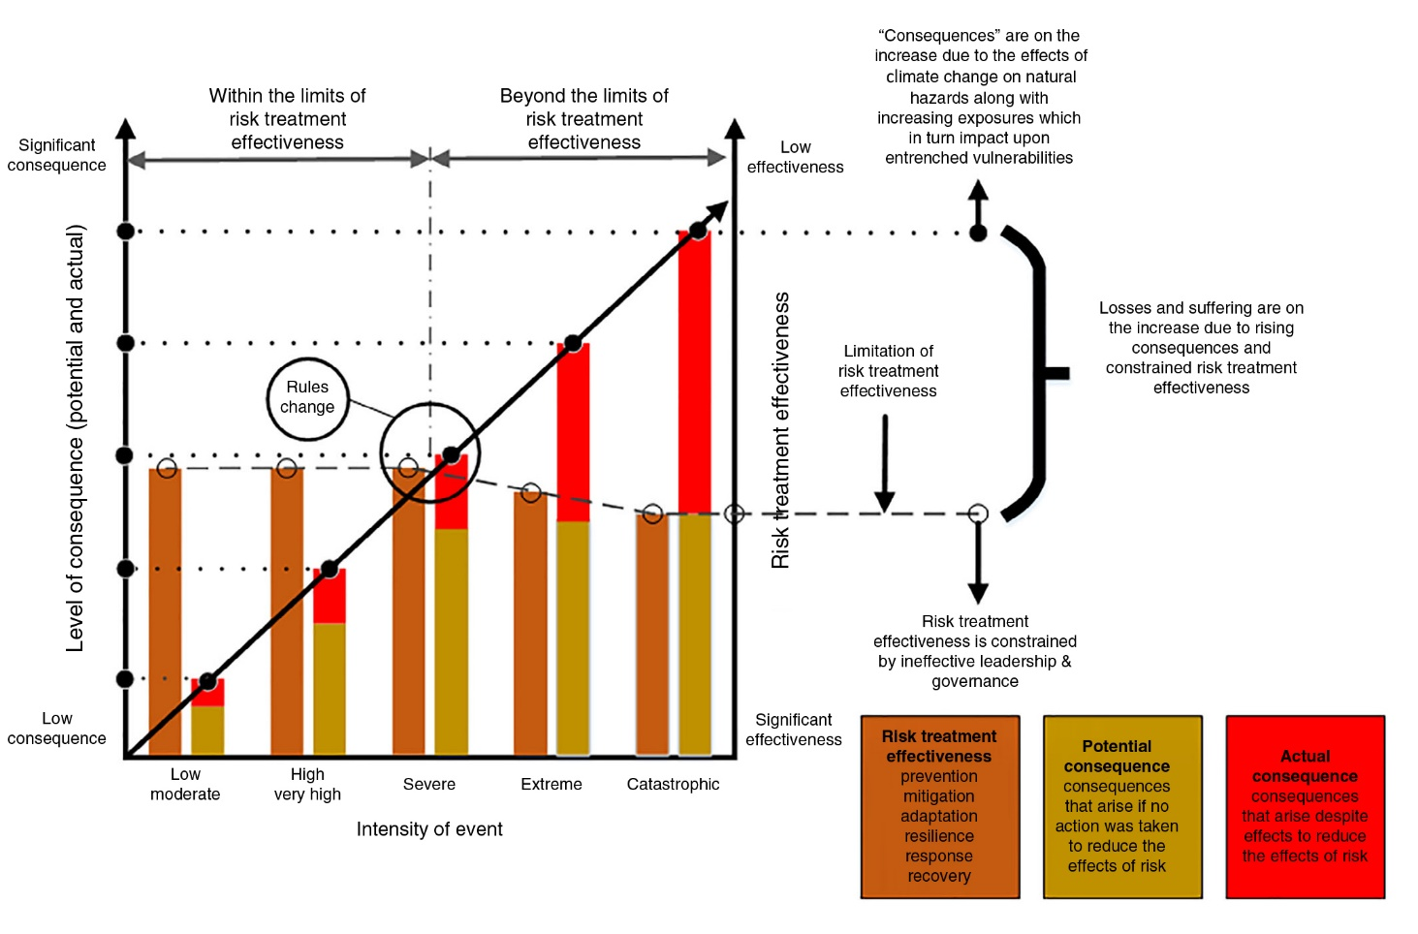

Source: Crosweller and Tschakert 2019. Reproduced with the permission of the authors.

Participants appreciated that intelligence and data would be critical to inform the response to an outbreak. The Commonwealth, states, territories and industry would all have different needs for data and reporting during an outbreak. Stakeholders identified the importance of continuing to move towards a holistic and integrated national traceability system. The ability to quickly access, synthesise and rely upon data to produce useable intelligence at the National level would be critical to manage an incursion of an EAD. The National Joint Common Operating Picture, NEMA’s near-real-time all hazards geospatial platform and dashboard designed analyse and to display all active nationally significant disasters and crisis events, has been valuable in synchronising data across stakeholders during a crisis, and its use could be further explored.

This work is already well advanced. Work is being undertaken by all jurisdictions to urgently develop national traceability requirements, including the development of a national approach to electronic identification for sheep and goats that received in principle support from agriculture ministers in July 2022.

Participants sought confirmation that Australia has plans for quickly acquiring specialist skills such as veterinarians and epidemiologists from overseas. Jurisdictions indicated their capacity to rapidly scale-up is likely to be limited by workforce shortages across the system.

Based on observations and comments through the scenario-based discussions, some mission critical supplies are already impacted by current supply chain issues. This would be further exacerbated in the event of an incursion. This would impact the ability to operationalise response plans.

Discussions confirmed the view that considerable advancements in biosecurity arrangements have been made over the last 20 years, and that this provides an excellent foundation for a future response to an EAD outbreak. However, discussions also supported the proposition that regular reviews to ensure the currency of this work is prudent.

Issues raised just in the Northern scenario-based discussion were:

* need for alignment of existing biosecurity and emergency management response at all levels of government
* operationalising biosecurity arrangements
* relief and recovery financial support
* state, territory and Commonwealth capacity
* Enhancing early detection programs.

Smaller jurisdictions indicate that their capacity to respond to an outbreak would be quickly exhausted. This pressure would be experienced by all jurisdictions within a short period, which participants identified as 72 hours. This would be further exacerbated if there were a concurrent disaster, which would be the case in the most dangerous scenario (e.g. a fire, flood or cyclone).

Financial relief was discussed during the northern exercise in relation to the need for a shared understanding of support should an incursion occur. Relief was discussed in relation to both short- and long-term recovery. During the Northern scenario-based discussion, the need for economic modelling of a recovery was needed in the preparation phase to ensure communities were offered the support they needed to recover in the fastest possible time.

Feral animals are more of an issue in Northern jurisdictions and relied on in Indigenous communities as a harvestable resource. Compensation arrangements, set by state and territory legislation with costs shared by jurisdictions, the Commonwealth and industry through the Emergency Animal Disease Response Agreement, do not cover feral animals.

The vast land mass and dispersed nature of the animal population in Northern Australia presents specific surveillance challenges. Access can be hampered in certain seasons due to weather conditions. This may provide an opportunity for additional surveillance and training across all parts of the livestock system in Northern Australia. This would build on the excellent work already being conducted by Indigenous rangers who play an integral part in caring for Country by monitoring what is happening to the plants, animals and oceans in Northern Australia.

Issues unique to the Southern scenario-based discussion were:

* up to date plans and biosecurity arrangements
* national permit systems
* animal welfare considerations/compensation
* national sharing and coordination of resources
* contract workforces
* mission critical stores.

The need to create enduring preparedness to respond to an EAD outbreak was a focus, especially relating to ensuring that biosecurity response plans were kept up to date.

New South Wales is in the final stages of developing a permit system that could be deployed during an EAD incursion to assist with movement controls. There is no permitting standard across all jurisdictions. This was acknowledged as a potential impediment to time critical livestock movement controls and may warrant further exploration by the jurisdictions.

Participants raised questions relating to certainty of compensation in relation to welfare slaughter. When contemplating the difficulties that communities were likely to face during an incursion, discussions also contemplated the availability and stockpiles of mission critical stores that were currently available in each of the jurisdictions that could be relied on immediately.

The supplementation of both Commonwealth, state and territory resources, with a contingent workforce was contemplated to assist with the response phases required over a sustained period.

The national stock standstill scenario discussion confirmed the themes raised through both the Northern and Southern discussions.

The discussion focused on at what point a national stock standstill would be called. Jurisdictions with large land masses noted that confirmation of samples could take up to 48 hours due to distances to travel. Participants discussed the need for speed to action and decision, based on preliminary testing and the presence of symptoms, alongside the need for certainty and confirmation before taking actions. State and territory Chief Veterinary Officers indicated that they would prefer early engagement.

It was observed that the impact of social media would need to be appropriately managed. Information, which may not be accurate, being shared by social media could precipitate market effects ahead of any laboratory confirmation. To manage this and ensure leadership throughout an incursion, particularly in the early hours and days, it was suggested that a predetermined and pre-cleared set of holding lines and talking points be developed in the form of a ‘playbook’. The Commonwealth noted that the NBCEN would play an active role in the development and dissemination of information in the event of an FMD outbreak.

A number of jurisdictions explained that they have predetermined spokespeople to assist with message delivery and noted the value of working with key industry members to reinforce one another’s messaging.

The need to coordinate messaging to ensure consistency was considered. This was explored through the example of national call centres that would be established in the event of an LSD or FMD incursion.

Participants explored the need for coordinated data to support decision making, and the utility of a national dashboard. Participants from various states and territories identified that collecting data during an active response may present difficulties and may take weeks to aggregate.

The second and third order consequences of an incursion were also explored. These were identified to have the potential to be wide ranging from profound impacts on the economy at a national level due to a loss of trade to a personal level of financial hardship. Other disasters and the pandemic have led to response fatigue and depletion of responders. The welfare of people involved in animal slaughter was discussed and the UK’s 2001 FMD experience was referenced in this context.

Major supply chain disruptions were anticipated, as well as panic buying due to a public lack of awareness or understanding of the movement controls in place.

Participants showed tremendous good will and cooperation during the discussion and expressed a willingness to share information and build upon Australia’s world class system.

### Communications

The taskforce examined the wealth of EAD communications material already available from Commonwealth, state and territory and key industry bodies, and AHA. Available communications fall into three broad categories:

* communication material
* workshops and webinars
* awareness activities.

In the event of an EAD outbreak there will be a need for nationally coordinated communications. All discussion exercises highlighted the need for a clear, coordinated plan for communication. The National Biosecurity Communication and Engagement Network (NBCEN) is a group of communication managers from the Australian, state and territory agriculture agencies (and several supporting organisations) tasked with producing and disseminating nationally consistent public information in response to biosecurity incidents. To support NBCEN implement elements of AUSVETPLAN, the Biosecurity Incident Public Information Manuals set out how public information should be operationalised and resourced during a biosecurity incident.

Given the priority placed on communications by stakeholders in the jurisdictions, industry and the Commonwealth, it would be prudent to have a focused effort to review and, if necessary, build upon, communications plans and materials to allow for strong and rapid communication in the event of an outbreak. This strong early response would contribute to nationally consistent messaging, demonstrate strong leadership and support the integrated national coordination architecture.

### Commonwealth, jurisdiction and industry engagement

The taskforce engaged with Commonwealth, jurisdiction and industry representatives. Specific engagement meetings have included:

* Northern Territory (NT) Cattlemen's Association, Northern Territory Buffalo Association, Northern Land Council. These are important stakeholders to work with in detecting and managing an outbreak in the NT. The key themes were training for cohorts that muster and handle livestock in the early parts of the supply chain, encouraging business opportunities to muster feral livestock on indigenous land to assist in proactive management and detection of LSD or FMD.
* A National Coordination Mechanism meeting was convened on 17 August 2022. This meeting brought together representatives from Biosecurity and Emergency Management from across Australia. This meeting provided an update on the work of the taskforce and the themes identified in the Northern and Southern scenario-based discussions.
* The Director General of Emergency Management Australia, Joe Buffone, informed over 1,900 industry stakeholders of the taskforce’s activities in the third industry webinar series hosted by the National Farmer’s Federation (NFF). providing updates on FMD as well as LSD on 24 August 2022. The taskforce co-leads met with NFF on 5 September 2022 to advise them of the key themes identified.
* Invited representatives from the dairy, beef, goat, pig, sheep, stock and station agents, saleyard operators, transport operators, and meat processors to observe the national livestock standstill scenario on 29 August 2022 to provide:
* Visibility of the work of the taskforce
* an understanding of current processes from a NEMA, DAFF and AHA perspective.
* An Australian Government Crisis and Recovery Committee Preparedness meeting was convened on 30 August 2002. This meeting informed senior Commonwealth officials of preparedness gaps identified in the northern and southern scenarios and the national livestock standstill scenario.
* The taskforce met with the Royal Society for the Prevention of Cruelty to Animals (RSPCA) to discuss the animal welfare issues that would need to be managed in the event of an outbreak of exotic disease, and to discuss the RSPCA’s role during a response.
* A National Coordination Mechanism meeting was convened on 1 September 2022. This brought together supermarkets, food service industry representative bodies and Food Standards Australia New Zealand. This meeting provided an update on the work of the taskforce and the themes identified in the Northern and Southern scenario-based discussions and national livestock standstill.
* The taskforce consulted with the Australian Council of Trade Unions, with follow-up engagement planned with the Australian Workers Union and the Australian Meat Industry Employees Union to highlight workforce issues that may arise in the event of an outbreak of exotic animal disease, and flag further involvement in developing workforce strategies.

### Stakeholder mapping

A key element of the work of the taskforce has been to identify and bring together affected stakeholders from across Commonwealth, state and territory governments and key industry bodies in the context of preparedness for an EAD outbreak.

To carry out its role, and to assist in future coordination and engagement the taskforce has compiled a current list of:

* members of the National Biosecurity Committee
* Australian animal producer groups that would be affected by an EAD outbreak
* industry representatives and industry peak bodies
* stakeholders identified as part of the DAFF Exotic Animal Diseases Taskforce[1] , this includes DAFF officials, cross Government contacts, state and territory jurisdictions, key industry associations and the Australian Centre for Disease Preparedness (ACDP) [2]
* The Chief Veterinary Officers for Australian and each state or territory
* Taskforce jurisdiction and Commonwealth reference groups
* Taskforce industry reference groups

**Appendix D: Livestock stakeholder map by activity** illustrates the range of stakeholders in Australia’s livestock production ecosystem up to the point at which livestock products enter first stage food processing or enter wool stores. The taskforce concluded that a map of this nature may assist people who may be called into a response at short notice without a comprehensive background in agriculture to better understand the roles of various stakeholders in the livestock production process.

This mapping process assisted the taskforce to ensure that significant stakeholders (or their industry representatives) were included in discussions with or information from the taskforce and will help inform future work on communication strategies.

## Part 3 – Findings and recommendations

### National leadership, accountability and coordination will allow speed to decision and action

#### Finding 1:

There is strong support for Australian Government national leadership in preparedness, planning and response.

This was highlighted through the scenario discussions and engagement with stakeholders, noting that States and territories are the first responders to any incident that occurs within their jurisdiction and have primary responsibility for emergency management activities, including for biosecurity; and noting the shared responsibility of industry.

Lessons from COVID and the recent fire and flood disasters have elevated public expectations of national leadership when a crisis or disaster is of national significance. Lessons from the UK 2001 FMD outbreak also highlighted the importance of national leadership and speed to action and decisions.

The roles and responsibilities of the Australian Government and States and Territories are being explored through Exercise Paratus in 2022-23.

##### Recommendation 1

That Government consider updating the national coordination architecture to ensure closer integration of the National Coordination Mechanism and the DAFF-led National Coordination Centre (a suggested structure for consideration is provided at **Appendix E: Closer integration of the National Coordination Mechanism and the DAFF-led National Coordination Centre**)

##### Recommendation 2

That Government consider negotiation of a new instrument to replace the 2002 COAG memorandum of understanding on FMD, to align with contemporary crisis management arrangements, to operate beneath the Intergovernmental Agreement on Biosecurity.

### National crisis communications can be strengthened through the creation of a national strategy

#### Finding 2:

The Commonwealth, states/territories and industry have established communications frameworks and pre-prepared messages to be deployed during a biosecurity incident. The National Biosecurity Communication and Engagement Network (NBCEN) has commenced work on national communications and engagement plans. These communications frameworks and NBCEN have been proven effective for smaller scale incidents. The speed and scale of a response to an EAD, and lessons learned from COVID and recent fire and flood disasters, warrant a review of these arrangements.

##### Recommendation 3

Building upon the work of NBCEN, that Government consider engaging a crisis communications consultancy to accelerate the development of a national crisis communications strategy and ‘playbook’ to set out strategies, decision-making frameworks and pre-prepared content for initial actions across key time horizons (one hour, six hours, twelve hours, twenty-four hours, three days and seven days).

### National data and intelligence capability will enable more effective decision making

#### Finding 3:

National coordination would be required to provide a common operating picture to enable rapid, coordinated decision-making.

There are a range of systems, data streams and processes at the state/territory and industry level, which are not able to be quickly or easily integrated at the national level. States and territories identified that having a national dashboard was a critical aspect of managing an EAD incursion.

It is important to use modelling to understand where the highest risk regions are to inform targeted surveillance and managing a response.

There is a need for a holistic and integrated national traceability system. The taskforce notes that in-principle agreement has been reached between all state and territory governments and the federal government on rolling out a mandated sheep electronic identification system.

##### Recommendation 4

Building on the recommendations from the Matthews and Craik reviews, that Government consider establishing a national biosecurity data and intelligence capability that informs the national collection, processing and dissemination of intelligence to inform decision making on biosecurity preparedness and responses at the federal level. This capability would integrate data from various sources to develop national current (e.g. situation dashboards) and estimative intelligence products (e.g. strategic indicators and warning problems) that inform crisis response, contingency planning and decision making.

##### Recommendation 5

That Government consider commissioning modelling to determine likely weather events that could transport LSD virus infected vectors to a location where they could infect livestock to enhance surveillance to increase the chances of early detection of an incursion.

### National plans and policies should be regularly monitored, tested, reviewed and updated to ensure they remain appropriate for the scale of response that would be warranted by an incursion of an EAD

#### Finding 4:

The Taskforce’s scenario discussions have revealed a high level of expertise and understanding within and between jurisdictions about animal disease prevention and mitigation. Industry is also well-connected into this system.

The speed and scale of a national LSD and/or FMD response would be greater than that for other, more routine, incidents. This is illustrated by the heuristic model. Integration between biosecurity and emergency management agencies continues to mature. It is important that the system as a whole has confidence in and visibility of this preparedness. We note that the review of the AUSVETPLAN FMD response strategy is in the process of being completed by AHA.

##### Recommendation 6

That all jurisdictions review and rationalise with a purpose of modernising and maturing key response plans and policies more than three years old (for example standard operating procedures and response manuals) to ensure they are contemporary and incorporate lessons from COVID-19 and recent hazard events, i.e., Black Summer Bushfires.

##### Recommendation 7

That action on recommendations in this report, accepted by the Minister, be reported to the Minister quarterly.

##### Recommendation 8

That Government consider expanding upon its work through Exercise Paratus to:

* include a tabletop exercise which explores the application of state and territory and Commonwealth biosecurity legislation in respect to an LSD or FMD incursion.
* support AHA to fully exercise the system and processes for vaccine import, and exercise with the states and territories for the distribution of both LSD and FMD to ensure there are no critical delays should vaccines need to be quickly imported and distributed.
* develop an ongoing schedule to review and exercise plans and documentation beyond the life of Exercise Paratus, with responsibilities assigned to specific roles. These exercises could include the minister and include a focus on resource modelling.
* re-exercise the International Animal Health Emergency Response (IAHER) manual, including follow-up with international partners, and include the Department of Home Affairs to pre-determine and exercise the processes for securing international assistance under the IAHER, including the most efficient visa process.

##### Recommendation 9

That Government consider expanding on current work across government to conduct modelling of potential economic impacts and develop a just-in-case policy response for support and recovery to respond to second and third order consequences in the event of an EAD outbreak.

##### Recommendation 10

That NEMA and DAFF work with Defence to develop contingency plans to support nationwide biosecurity response activities in an EAD outbreak. Envisaged roles include planning and operational support for logistics, movement control and liaison functions, although this has not been consulted with Defence.

##### Recommendation 11

That DAFF work across government to consider options for creating more opportunities for First Nations people and Traditional Owners to participate in and benefit from biosecurity activities including surveillance and feral animal management.

### Workforce capacity

#### Finding 5:

All jurisdictions will need to be able to quickly identify and deploy capability in the event of an EAD incursion. Australia has plans for quickly acquiring specialist skills such as veterinarians and epidemiologists from overseas. Jurisdictions have indicated their capacity to rapidly scale-up is likely to be limited by workforce shortages across the system.

An initial 72-hour stock standstill will be a critical period for resources. The next phase of the response will require concurrent response and will include assess and approve stock movement permits, biosecurity orders, testing and quarantining of properties. A strategic and coordinated approach to the deployment of workers in an incursion is warranted. Unions should be consulted in the development of such a strategy, where appropriate.

##### Recommendation 12

That Government consider working with jurisdictions to develop a system-wide strategy for national animal disease response workforce capacity and training, noting DAFF’s previous Vet Reserve program could be used as a guide.

### Mission critical supplies

#### Finding 6:

Based on observations and comments through the scenario-based discussions, there are already mission critical supplies that are already impacted by current supply chain issues, this will be further exacerbated in the event of an incursion. This would impact the ability to operationalise response plans.

##### Recommendation 13

That DAFF, jurisdictions and industry should work together to develop a resource plan, including identifying the mission critical supplies needed to operationalise response plans.

### Working with states and territories

#### Finding 7:

The taskforce experienced strong engagement from state and territory biosecurity and emergency management agencies, including throughs the three scenario-based discussions.

##### Recommendation 14

That Government consider further work with the jurisdictions on:

* a national approach to interstate border control and permitting to ensure efficient and effective interstate border security movements as part of the enforcement of a livestock standstill or movement controls.
* continuing engagement by biosecurity agencies with relevant emergency management agencies to ensure that there is alignment and integration of incident management structures.
* reflecting the common definition for prohibited pig feed (PPF) and the feeding of PPF developed and endorsed by Animal Health Committee (AHC) in state and territory legislation.
* review and update of plans for:
* carcass disposal sites, and where relevant establish agreements for the movement of carcasses between local government areas for disposal
* accessing remote or isolated livestock, particularly in Northern Australia, including during adverse weather or flooding, for surveillance, testing or other activities
* cold-chain management of vaccines
* options to utilise personnel from workforces that would be stood down as a consequence of an FMD or LSD outbreak.

## References

ABARES 2022, [Direct economic impacts of a foot-and-mouth (FMD) disease incursion in Australia, An update of ABARES 2013 estimate](https://www.agriculture.gov.au/abares/research-topics/biosecurity/biosecurity-economics/fmd-update-of-2013-estimate), Department of Agriculture, Fisheries and Forestry, Canberra, accessed 2 September 2022.

Anderson, I 2008, [Foot and Mouth Disease 2007: A Review and Lessons Learned](https://www.gov.uk/government/publications/foot-and-mouth-disease-2007-a-review-and-lessons-learned), *House of Commons papers: 2007-08*, vol 312, accessed 5 September 2022.

DAFF 2022a, [National Biosecurity Strategy](https://www.biosecurity.gov.au/about/national-biosecurity-committee/nbs), Department of Agriculture, Fisheries and Forestry, Canberra, August.

DAFF 2022b, [Submission to the Rural and Regional Affairs and Transport References Committee: Adequacy of Australia’s biosecurity measures and response preparedness, in particular with respect to foot-and-mouth disease and Varroa mite](https://www.aph.gov.au/Parliamentary_Business/Committees/Senate/Rural_and_Regional_Affairs_and_Transport/FMDBiosecurity/Submissions), submission no 73 to the Senate Rural and Regional Affairs and Transport References Committee into Adequacy of Australia’s biosecurity measures and response preparedness, in particular with respect to foot-and-mouth disease and varroa mite, Department of Agriculture, Fisheries and Forestry, accessed 2 September 2022.

DAWE 2021, [Commonwealth Biosecurity 2030: Action Plan 2022](https://www.agriculture.gov.au/biosecurity-trade/policy/commonwealth-biosecurity-2030#Commonwealth_Biosecurity_Action), Department of Agriculture, Water and the Environment, Canberra.

Craik, W, Palmer, D & Sheldrake, R 2017, [Priorities for Australia’s biosecurity system](https://www.agriculture.gov.au/biosecurity-trade/policy/partnerships/nbc/intergovernmental-agreement-on-biosecurity/igabreview/igab-final-report), An independent review of the capacity of the national biosecurity system and its underpinning Intergovernmental Agreement, Commonwealth of Australia, Canberra.

Crosweller, M and Tschakert, P 2019, [Climate change and disasters: The ethics of leadership](https://wires.onlinelibrary.wiley.com/doi/abs/10.1002/wcc.624), *WIREs Clim Change*, vol. 11, no. 2, DOI: [10.1002/wcc.624](https://doi.org/10.1002/wcc.624)

Matthews, K 2011, [A review of Australia’s preparedness for the threat of foot-and mouth disease](https://www.agriculture.gov.au/biosecurity-trade/pests-diseases-weeds/animal/fmd/review-foot-and-mouth-disease), Department of Agriculture, Fisheries and Forestry, Canberra.

National Audit Office (2002), [The 2001 Outbreak of Foot and Mouth Disease](https://www.nao.org.uk/reports/the-2001-outbreak-of-foot-and-mouth-disease/), London, England.

## Appendices

### Appendix A: Exercise Paratus – National Biosecurity Emergency Response Exercise Program

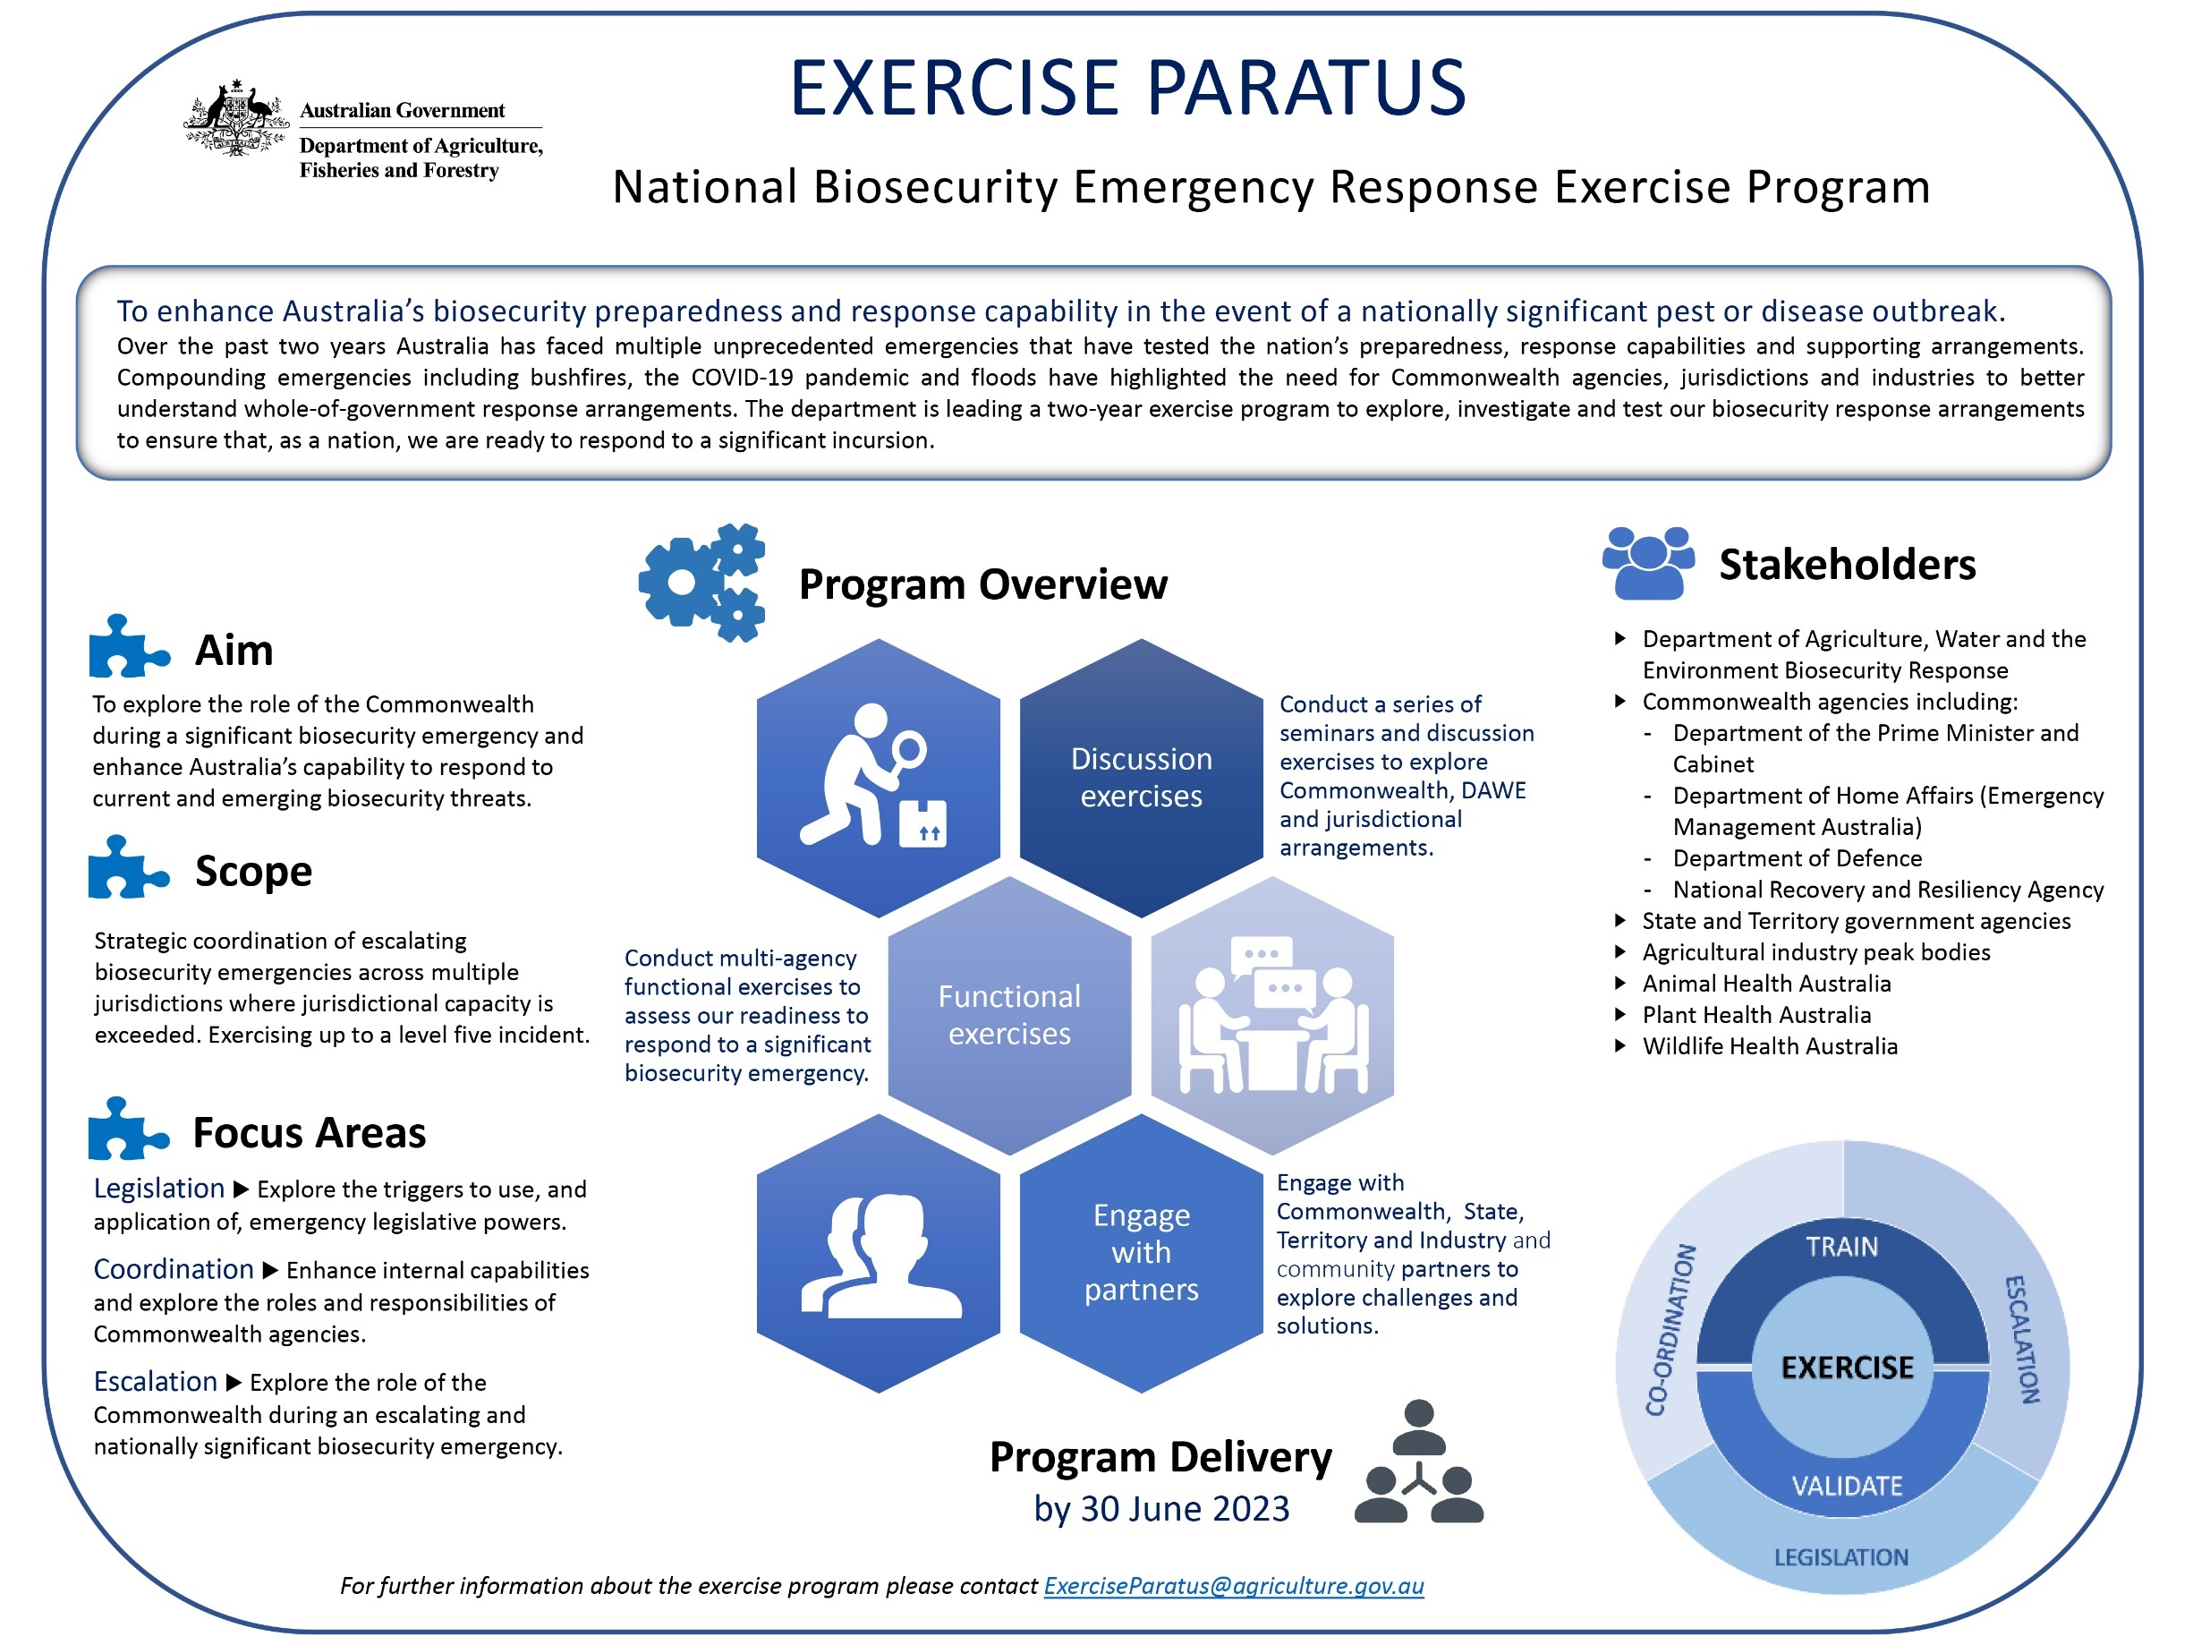

Source: Department of Agriculture, Fisheries and Forestry

### Appendix B: Biosecurity emergency management arrangements integration with Australian Government Crisis Management Framework (AGCMF)

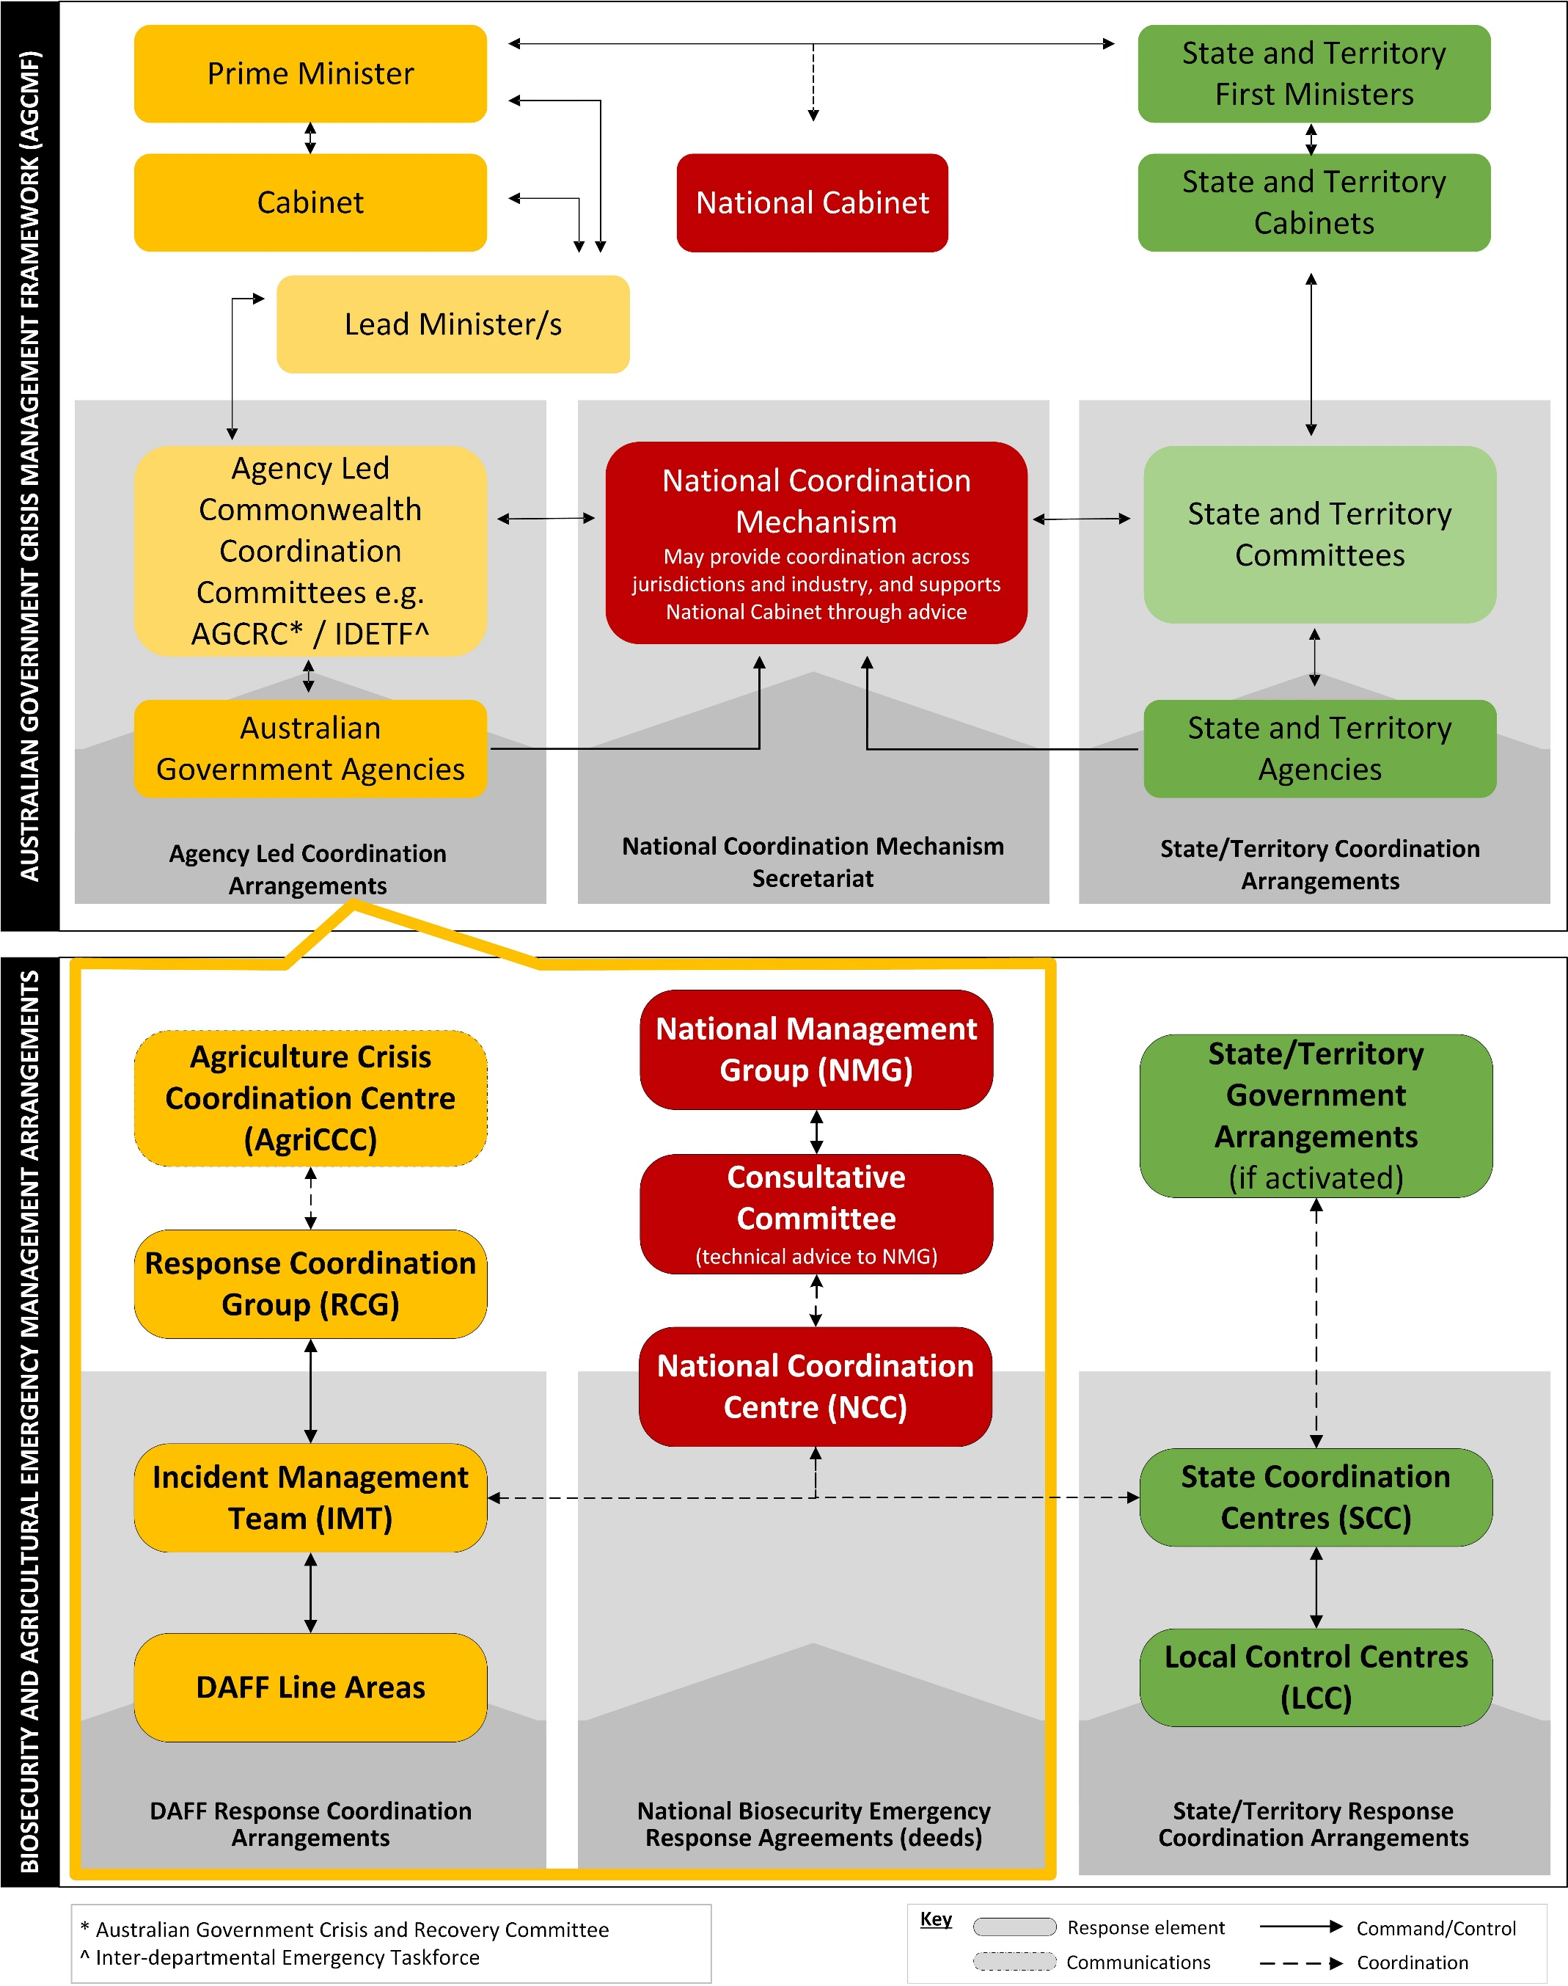

Source: AUSBIOAGPLAN

### Appendix C: Crisis Appreciation and Strategic Planning – Foot and Mouth and Lumpy Skin Disease

#### Preparedness

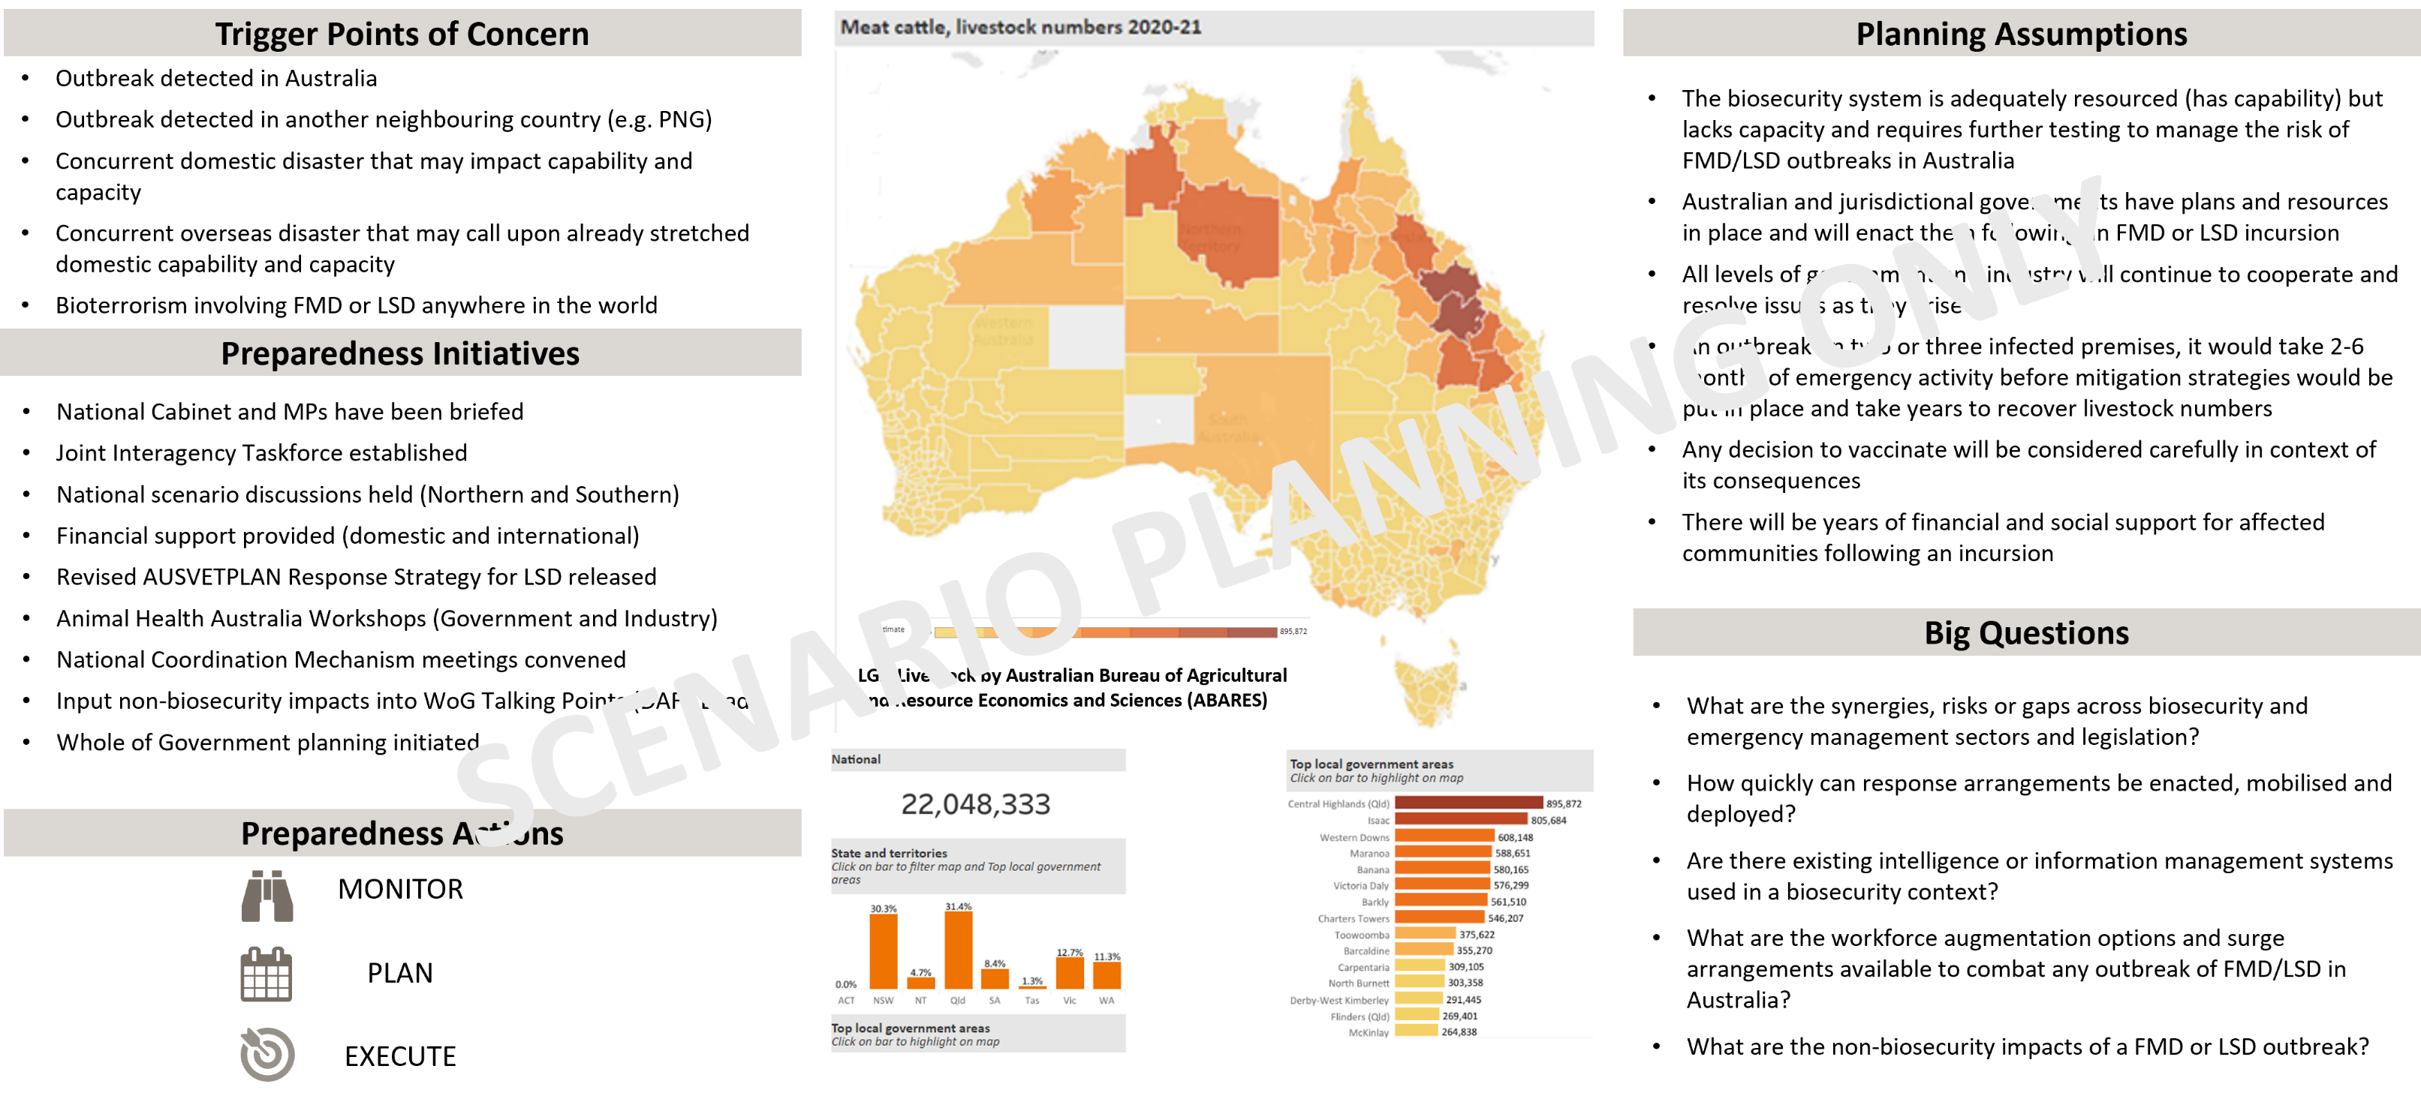

Source: Joint Interagency Taskforce: Exotic Animal Preparedness

#### Response

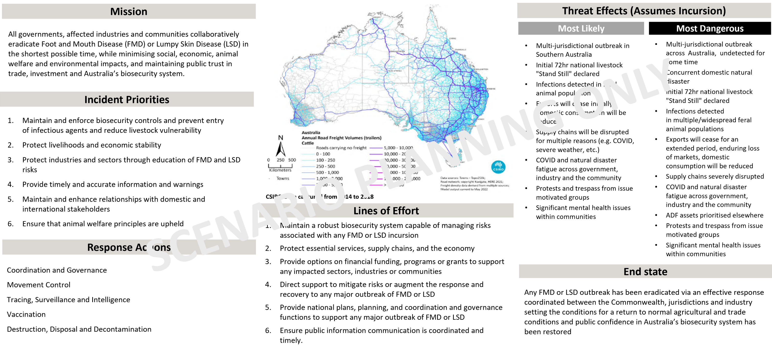

Source: Joint Interagency Taskforce: Exotic Animal Preparedness:

### A stakeholder map illustrating livestock stakeholders in Australia by their activity. The first activity is livestock production, with livestock producers, dairy producers and intensive livestock enterprises identified as key stakeholders. The second activity is livestock processor or export facilitator, with dairy processors, wool stores, live exporters, and meat processors identified as key stakeholders. The third activity is feral production, with feral livestock identified as the main actor. The fourth activity is Service provider that does not hold livestock, with banks and financiers, raw milk transporters, road and rail freight transporters, livestock transporters, stock and station agents, and rural shows, expos or events identified as the key stakeholders. The fifth and final activity is Service provider that holds but may not sustain livestock, with the saleyard, either physical or online, identified as the key stakeholder. The map is surrounded by further, detailed text on several stakeholders.Appendix D: Livestock stakeholder map by activity

Source: Joint Interagency Taskforce: Exotic Animal Disease Preparedness

### Appendix E: Conceptual Model for an Integrated National Coordination Framework

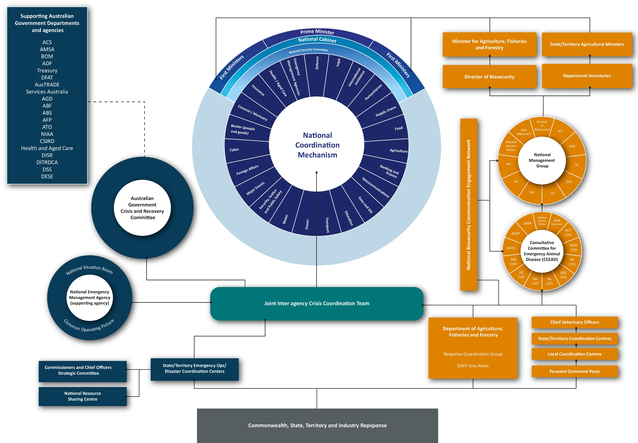

Source: Joint Interagency Taskforce: Exotic Animal Disease Preparedness

### Appendix F: Report on exercises undertaken by the Joint Interagency Taskforce on Exotic Animal Disease Preparedness

#### Background

On Thursday, 4 August 2022, Senator the Hon Murray Watt announced that the Commonwealth was establishing a taskforce to ensure that Australia is fully prepared to response swiftly to growing biosecurity threats such as Lumpy Skin Disease (LSD) and Foot and Mouth Disease (FMD).

Through scenario-based discussion exercises the Joint Interagency Taskforce for Exotic Animal Disease Preparedness (the Taskforce) explored the current level of preparedness. These exercises were conducted with all Australian Government agencies, state and territory governments and industry who will have a role in responding to an incursion. Exercise participants included biosecurity and enforcement agencies to explore the current coordination architecture arrangements.

Between 5 August 2022 and 5 September 2022, the Taskforce developed and delivered three exercises for all states and territories, non-government organisations and industry partners. These exercises included:

1. Northern Australia Scenario Based Discussion
2. Southern Australia Scenario Based Discussion
3. National Livestock Stand Still Discussion Exercise

This report provides an overview of each of the exercises including scenario. The findings from the exercises may inform subsequent action by government and industry to further enhance Australia’s preparedness to manage the threat of biosecurity threats.

#### Benefits of exercising

Exercises are controlled, objective-driven activities used for testing, practising or evaluating processes or capabilities. Exercises are an essential component of preparedness and should be used to enhance capability and contribute to continuous improvement.

#### Discussion exercises

Discussion exercises are built around discussion of a scenario. Participants explore issues in depth and provide verbal responses to situations. Discussion exercises are useful for developing agreed approaches to particular events, assessing the effectiveness of plans, building relationships, and exploring novel ideas or approaches to managing emergencies. Discussion exercises often involve personnel who work at a strategic level brainstorming solutions to problems.

#### Threat effects

The Taskforce representatives included officials from the Department of Agriculture, Fisheries and Forestry (DAFF), the National Emergency Management Agency (NEMA) (formerly Emergency Management Australia), the Australian Defence Force and Australian Border Force. Technical experts supported the design and delivery of all products.

To assist with the design and development of exercises, Taskforce members developed threat effects which are predictions that require planners and technical experts to consider the ‘most likely’ and ‘most dangerous’ incidents. These predictions rely on Taskforce members collective expertise, experience and what is known about the hazard. Scenario design and development was based on the ‘most dangerous’ threat affect.

#### Most likely

##### First order consequences

* Multi-jurisdictional outbreak in Northern Australia
* Initial 72hr national livestock "Stand Still" declared
* Infections detected in feral animal population adjacent to outbreak
* Exports will cease initially, domestic consumption will be reduced

##### Secondary and tertiary consequences

* Supply chains will be disrupted for multiple reasons (e.g. COVID, severe weather, etc)
* COVID and natural disaster fatigue across government, industry and the community
* Protests and trespass from issue motivated groups
* Significant mental health issues within communities

#### Most dangerous

##### First order consequences

* Multi-jurisdictional outbreak in Northern and Southern Australia, goes undetected for some time
* Concurrent domestic natural disaster
* Initial 72hr national livestock "Stand Still" declared
* Infections detected in multiple/widespread feral animal populations
* Exports will cease for an extended period, enduring loss of markets, domestic consumption will be reduced

##### Secondary and tertiary consequences

* Supply chains severely disrupted
* COVID-19 and natural disaster fatigue across government, industry and the community
* Australian Defence Force assets prioritised elsewhere
* Protests and trespass from issue motivated groups
* Significant mental health issues within communities

#### Northern Australia Scenario Based Discussion

The Northern Australia Scenario Based Discussion was held on Friday, 12 August 2022. The exercise was conducted with senior officials from northern Australian jurisdictions: Northern Territory, Western Australia and Queensland.

The exercise was conducted as a hybrid meeting with participants located together or attending virtually and observers viewing the event online via a Microsoft Teams meeting. The scenario-based discussion was held over three hours and included participants from biosecurity and emergency management agencies who would have a role in the event of a biosecurity outbreak.

##### Aim

This scenario-based discussion aimed to explore the pressure points and issues relative to the northern jurisdictions and Commonwealth capacities and capabilities, including those to operationalise AUSVETPLAN strategies in response to an LSD and/or FMD incursion.

##### Objectives

The objectives were to understand the pressure points and issues relating to:

1. coordination architecture
2. movement controls
3. tracing and surveillance
4. vaccination
5. destruction, disposal and decontamination of animals, animal products and infected premises

As well as the direct impacts on agricultural producers the activity will also sought to understand second and third order consequences.

##### Scope

In scope

* FMD and LSD
* Coordination architecture and arrangements
* AUSVETPLAN Disease Strategies for FMD and LSD
* Potential hazards that may impact a response
* Animal welfare, environmental and social impacts
* Capabilities and capacities to support response activities
* Effects of legislation on response

Out of scope

* Consideration of other biosecurity emergency diseases
* Emergency Animal Disease Response Agreement (EADRA)
* Long-term recovery measures
* Legislation changes

##### Exercise scenario (hypothetical example only)

A farmer purchases 100 head of cattle from a neighbouring northern jurisdiction at sale yards which arrive by truck and are released to paddock. There are unmanaged feral buffalo in the paddocks nearby the boundary fences.

Four days after receiving the cattle, the farmer notices three cows are lame and salivating. The farmer calls the local vet and explains the symptoms. The vet advises to call the Emergency Animal Disease watch hotline and later arrives to take samples.

The lab samples are confirmed to be positive for FMD. The lab’s Director calls the jurisdictions Chief Veterinary Officer who in turn advises the Australia Chief Veterinary Officer. The farmer is advised of a presumptive diagnosis and the samples are sent to the Australian Centre for Disease Preparedness (ACDP) who confirms the diagnoses of FMD.

An emergency Gazette Notice has been published to establish a disease control program for a distance of 5km and establishes a Control Area. Tracing confirms that a further six decks of cattle from the sale yards had been trucked to Western Australia two weeks earlier. The same carriers had also transported four decks of cattle to an export yard five days ago where they were awaiting export to Indonesia.

The Biosecurity Hotline has received a call from an indigenous ranger reporting that there has been a number of dead buffalo calves around a water hole 25km from the boundary fences of the first property.

##### Key observations

Following the Northern Australia Scenario Based Discussion, thirteen key themes were identified which include:

1. National leadership
2. Integration across biosecurity legislation
3. Financial relief and recovery for biosecurity hazards
4. Coordination of public information and messaging across all stakeholders
5. Alignment of existing coordination architecture
6. Early decision making is critical to supporting a rapid FMD or LSD response
7. Operationalising biosecurity response arrangements
8. Integration of technology, systems and data
9. Second, third, fourth order consequences
10. Social and cultural licencing
11. Building on historical and legacy biosecurity work
12. State and territory and Commonwealth capacity
13. Enhancing early detection programs

##### Attendees

The exercise was undertaken in a hybrid fashion with participants located virtually and in person. Each jurisdiction’s Chief Veterinary Officer and Police Commissioner or Deputy Commissioner was in attendance. Approximately 50 individuals participated (recognising that people who attended virtually may have had multiple people in the room) and represented the following agencies:

|  |  |
| --- | --- |
| Jurisdiction | Agency |
| Northern Territory | Department of Industry, Tourism and Trade |
|  | Police Fire and Emergency Services |
|  | Department of Chief Minister and Cabinet |
| Queensland | Department of Agriculture and Fisheries |
|  | Queensland Fire and Emergency Services |
|  | Queensland Police Services |
| Western Australia | Department of Primary Industries and Regional Development |
|  | Department of Fire and Emergency Services |
|  | Western Australia Police Force |
| Australian Government | National Emergency Management Agency, formerly Emergency Management Australia |
|  | Department of Agriculture, Fisheries and Forestry |
| Non-government | Animal Health Australia |
|  | Southern Australia Scenario Based Discussion |

The Southern Australia Scenario Based Discussion was held on Tuesday, 16 August 2022. The exercise was conducted with senior officials from Southern Australian jurisdictions: Australian Capital Territory, Victoria, New South Wales, Tasmania and South Australia, and included Western Australia as an observer due to their borders.

The exercise was conducted as a hybrid meeting with participants located together or attending virtually and observers viewing the event online via a Microsoft Teams meeting. The scenario-based discussion was held over three hours and included participants from biosecurity and emergency management agencies who would have a role in the event of a biosecurity outbreak.

##### Aim

This scenario-based discussion aimed to explore the pressure points and issues relative to the southern jurisdictions’ capacities and capabilities, including those to operationalise AUSVETPLAN strategies in response to an LSD and/or FMD incursion.

##### Objectives

The objectives were to understand the pressure points and issues relating to:

1. coordination architecture
2. movement controls
3. tracing and surveillance
4. vaccination
5. destruction, disposal and decontamination of animals, animal products and infected premises

As well as the direct impacts on agricultural producers the activity will also seek to understand second and third order consequences.

##### Scope

In scope

* FMD and LSD
* Coordination architecture and arrangements
* AUSVETPLAN Disease Strategies for FMD and LSD
* Potential hazards that may impact a response
* Animal welfare, environmental and social impacts
* Capabilities and capacities to support response activities
* Effects of legislation on response

Out of scope

* Consideration of other biosecurity emergency diseases
* Emergency Animal Disease Response Agreement (EADRA)
* Long-term recovery measures
* Legislation changes

##### Exercise scenario (hypothetical example only)

Northern Australia is currently responding to a lumpy-skin-disease incursion and southern resources have been deployed to assist with response activities.

Following a significant amount of rainfall in Victoria, a pig farmer notices that four pigs are lame however he assumes this is due to the soft ground and does not investigate further.

Five days later, the farmer notices blisters and ulcers forming on the top of the snouts of the pigs and there are now more animals showing signs of lameness, with some lying down and refusing to move. A number of farmers from this region have travelled to the National Farmers Federation conference in Launceston. Due to the wet conditions the farmers shoes and some belongings have been contaminated with mud and soil.

There are a number of farms in the area that have a mixed array of susceptible animals which include dairy and meat cows, sheep and goats. The sheep and goat farms neighbour the affected pig farm and there are often problems with the animals getting through fences and moving between properties.

The concerned farmer calls the local vet to seek advice. The vet takes samples which are sent to a lab and are confirmed to be positive for FMD. The lab’s Director calls the jurisdictions Chief Veterinary Officer who in turn advises the Australia Chief Veterinary Officer. The farmer is advised of a presumptive diagnosis and the property is placed under quarantine while the samples are sent to the Australian Centre for Disease Preparedness (ACDP).

Tracing confirms that a truckload of pigs from the affected farm in Victoria were transported to New South Wales three days prior to the blisters and ulcers forming.

Concurrently, a number of farmers across South Australia are beginning to report cattle displaying clinical signs of FMD following their purchase at sale yards in Naracoorte.

##### Key observations

Following the Southern Australia Scenario Based Discussion, fourteen key themes were identified which include:

1. National leadership
2. Early action and decision making is critical to supporting a rapid FMD or LSD response
3. Building on historical and legacy biosecurity work
4. Synchronise and understand the overlay of biosecurity legislation and emergency management legislation
5. Alignment of existing coordination architecture
6. Coordination of public information and messaging across all stakeholders
7. Integration of technology, systems and data
8. Second, Third, Fourth Order Consequences
9. Implementation of a national permit system
10. Social and cultural licencing
11. Compensation for welfare slaughter
12. Mission critical stores
13. Availability and prioritisation of resources
14. National Live Stock Standstill

##### Attendees

The exercises was undertaken in a hybrid fashion with participants located virtually and in person. Each jurisdiction’s Chief Veterinary Officer and Police Commissioner or Deputy Commissioner was in attendance. Approximately 55 individuals participated (recognising that people who attended virtually may have had multiple people in the room) and represented the following agencies:

|  |  |
| --- | --- |
| Jurisdiction | Agency |
| Australian Capital Territory | Conservation, Biosecurity, Biodiversity and Water Directorate |
|  | Territory and Municipal Services Directorate |
|  | Australian Capital Territory Police |
| New South Wales | Department of Primary Industries |
|  | Office of the Environment and Heritage |
|  | New South Wales Police |
| South Australia | Department of Primary Industries and Regions |
|  | South Australia Police |
| Victoria | Department of Jobs, Precincts and Regions |
|  | Victoria Police |
| Tasmania | Department of Primary Industries, Parks, Water and Environment |
|  | Biosecurity Tasmania |
|  | Tasmania Police |
| Australian Government | National Emergency Management Agency, formerly Emergency Management Australia |
|  | Department of Agriculture, Fisheries and Forestry |
| Non-government | Animal Health Australia |

#### National Livestock Stand Still Discussion Exercise

The National Livestock Standstill (NLSS) Discussion Exercise (DISCEX) was held on Monday, 29 August 2022 and was a collaborative effort between national, state and territory government agencies, industry organisations and AHA. Through a scenario driven discussion, the NLSS DISCEX explored existing response arrangements, decision making, communication and coordination for a NLSS.

The NLSS DISCEX provided an opportunity to explore preparedness activities occurring across the nation. This report recognises that government agencies and industry organisations have already implemented or are implementing actions to address various aspects of preparedness.

##### Aim

This discussion exercise aimed to explore national and jurisdictional arrangements for implementing and managing a NLSS in order to identify vulnerabilities within the biosecurity and/or emergency management sector in response to an FMD incursion.

##### Objectives

The objectives of the NLSS DISCEX exercise were:

1. Explore national and jurisdictional decision-making processes in declaring a NLSS.
2. Validate national and jurisdictional arrangements for implementing a NLSS.
3. Explore mechanisms for communicating with stakeholders during implementation of a NLSS.
4. Validate coordination within and between government and non-government agencies during a NLSS.
5. Identify second and third order consequences which may have a long-lasting impact on a national scale.

##### Scope

In scope

* FMD
* Biosecurity architecture and arrangements
* Emergency Management architecture and arrangements
* AUSVETPLAN Disease Strategies for FMD
* Potential hazards that may impact a response
* Animal welfare, environmental and social impacts
* Capabilities and capacities to support response activities
* Effects of legislation on response
* Tracing and surveillance activities
* Destruction, disposal and decontamination activities
* International assistance

Out of scope

* Consideration of other biosecurity emergency diseases
* Long-term recovery measures
* Legislation changes
* Consideration of vaccination during the NLSS

##### Exercise conduct

The NLSS DISCEX explored five themes through a progressive scenario discussion. The five themes included:

1. Speed to action
2. Coordination architecture
3. Crisis communications
4. Data management
5. Resource capacity, including mission critical supplies

##### Scenario Part 1 (hypothetical example only)

On the morning on Monday, 29 August 2022, the owner of a property in the Darling Downs in Queensland calls his veterinarian to check his breeding bulls, which were showing signs of lameness and drooling. The veterinarian suspects the cattle could be infected with foot-and-mouth disease virus and calls the regional government veterinarian, based in Toowoomba, for a second opinion.

Upon inspecting the cattle, the government veterinarian agrees that the clinical signs in the cattle are very similar to those caused by FMD. He informs the Queensland Chief Veterinary Officer. The owner is directed to prohibit any movements on to or off the property. This sparks social media attention of a near-by local and shortly after posts begin appearing of Facebook.

The government vet collects appropriate samples at 1200hrs and they are sent to the state biosecurity sciences lab in Brisbane for initial diagnostics. They arrive at 2pm for initial diagnostics, with PCR results expected by 1800hrs. A sample is also flown to the Australian Centre for Disease Preparedness (ACDP) in Geelong for confirmatory diagnosis. The sample arrives at 8pm, with PCR results expected by 0000hrs.

While awaiting state lab results, Queensland CVO, Dr Allison Crook, informs all necessary personnel—including the head of ACDP and Dr Mark Schipp, the Australian Chief Veterinary Officer—that there is a strong suspicion of FMD on a cattle property in Queensland. It is agreed that the Consultative Committee on Emergency Animal Diseases (CCEAD) should be convened.

##### Scenario Part 2 (hypothetical example only)

At 1800hrs on Monday, 29 August 2022, the Queensland state lab advises Dr Crook, that the samples were positive for FMD. Results from ACDP are still pending. Dr Schipp convenes CCEAD to meet at 2000hrs. By this time, preliminary livestock movement information from the infected property has been collected, this includes:

* 27 August: 8 bulls to Manjimup, Western Australia
* 25 August: 3 bulls to Childers, Queensland
* 20 August: 4 bulls to Mt Gambier, South Australia
* 18 August: 5 bulls to Casino, New South Wales
* 17 August: 2 bulls to Nowhere Else, Tasmania
* 16 August: 1 bull to Tharwa, Australian Capital Territory

At 0030hrs on Tuesday, 30 August 2022, ACDP confirms the diagnosis of FMD and notifies the Dr Crook and Dr Schipp. CCEAD has made a recommendation to the National Management Group that a National Livestock Standstill be implemented. NMG convenes at 0500hrs on Tuesday, 30 August 2022 and agrees to the course of action and authorises a National Livestock Standstill be implemented.

##### Scenario Part 3 (hypothetical example only)

At 0800 hours on Tuesday, 30 August FMD is suspected on a further two cattle properties, a piggery in Queensland’s Darling Downs and a mixed beef-sheep property in southern Queensland near the border with New South Wales. The properties have been placed under quarantine and a range of control measures have been implemented.

The properties that received the bulls from Darling Downs have also been quarantined and testing of animals is being carried out.

Due to the standstill, sale yards in Queensland, New South Wales, Victoria, Tasmania and Western Australia currently have over 60, 000 cattle and sheep that have been held overnight. Across the country, there have been a number of trucks that have not heard about the National Livestock Standstill and have started unloading livestock at the Gunnedah sale yards.

As at 1600 hours on Tuesday, 30 August, properties in WA, Qld, SA, NSW, Tas and ACT, who received bulls from the farm in Darling Downs, are advised that initial diagnostics are indicating that FMD is present however ACDP will be required to provide final confirmation.

As FMD is now is considered to be in multiple jurisdictions, this is a level 4 incident and the Department of Agriculture, Fisheries and Forestry assumes responsibility for the National Emergency Animal Disease Response Plan through the National Coordination Centre.

##### Scenario Part 4 (hypothetical example only)

On Tuesday, the 6pm news has caught the public’s attention regarding the detection of FMD in multiple states and territories. Social media campaigns on animal welfare are starting to circulate particularly regarding lack of availability of fodder and water for animals held up in yards or feedlots and animals remaining on vehicles for long periods of time. The media is also starting to report about the availability and use of vaccine however there is misinformation about its use for treatment.

Additionally, there is growing agitation across the country regarding food security and resistance to movement controls following the COVID-19 lock downs. Areas across Australia are witnessing increased social unease. There has been a massive spike in calls to agriculture departments by producers about how to respond.

##### Scenario Part 5 (hypothetical example only)

By Wednesday, 31 August at 1000 hours, tracing data indicates that the incursion is widespread across the nation. Trace back data from Queensland suggests that infected stud cattle were infected by store cattle on the same property purchased from the Northern Territory and the disease has been present for some time. It is assumed that there is widespread infection in multiple states and territories. This will require an expansion of tracing and surveillance operations in all states and territories.

As at 1200 hrs on Thursday, 1 September CCEAD are going to convene shortly and discuss whether they will be recommending that NMG extend the National Livestock Standstill.

##### Key observations

Following the NLSS DISCEX, seven key themes were identified which include:

1. Current biosecurity structures are reliant on various consultative committees which may inhibit speed to action / decision
2. National coordination will be critical in order to maintain public trust
3. The learnings of COVID-19 should be considered with respect to biosecurity arrangements
4. Resourcing capacity is limited and it is unlikely that states and territories will be able to provide support through sharing arrangements
5. Industry partners will be pivotal during a response and may provide a greater level of trust than government
6. There will be a need for the ability to swiftly and accurately collect and aggregate data which will support decision making
7. Second and third order consequences may have an additional economic effect on Australia, for example tourism.

##### Attendees

The exercises was undertaken in a hybrid fashion with participants located virtually and in person. There was strong representation by the Australian Government, state and territory government (including biosecurity and police agencies), non-government organisations and industry partners.

Approximately 200 individuals participated (recognising that people who attended virtually may have had multiple people in the room) and represented the following agencies:

|  |  |
| --- | --- |
| Jurisdiction | Agency |
| Australian Capital Territory | Australian Capital Territory Police |
|  | Conservation, Biosecurity, Biodiversity and Water Directorate |
|  | Territory and Municipal Services Directorate |
| New South Wales | Department of Primary Industries |
|  | New South Wales Police |
|  | Office of the Environment and Heritage |
| Northern Territory | Department of Chief Minister and Cabinet |
|  | Department of Industry, Tourism and Trade |
|  | Police Fire and Emergency Services |
| Queensland | Department of Agriculture and Fisheries |
|  | Queensland Fire and Emergency Services |
|  | Queensland Police Services |
| South Australia | Department of Primary Industries and Regions |
|  | South Australia Police |
| Tasmania | Biosecurity Tasmania |
|  | Department of Natural Resources and Environment Tasmania |
|  | Department of Primary Industries, Parks, Water and Environment |
|  | State Emergency Services |
|  | Tasmania Police |
| Victoria | Agriculture Victoria |
|  | Department of Jobs, Precincts and Regions |
|  | Victoria Police |
| Western Australia | Department of Fire and Emergency Services |
|  | Department of Primary Industries and Regional Development |
|  | Western Australia Police Force |
| Australian Government | Australian Border Force |
|  | Bureau of Meteorology |
|  | Department of Agriculture, Fisheries and Forestry |
|  | Department of Defence |
|  | Department of Foreign Affairs and Trade |
|  | Department of Industry, Science and Resources |
|  | Department of Infrastructure, Transport, Regional Development, Communications and the Arts |
|  | Department of Social Services |
|  | Department of the Prime Minister and Cabinet |
|  | National Emergency Management Agency (formerly Emergency Management Australia) |
|  | National Indigenous Australians Agency |
|  | Services Australia |
|  | The Treasury |
| Non-government Organisations | Animal Health Australia |
| Industry partners | Australian Dairy Farmers |
|  | Australian Live Exporters Council |
|  | Australian Livestock and Property Agents Association |
|  | Australian Livestock Markets' Association |
|  | Australian Meat Industry Council |
|  | National Farmers Federation |
|  | Northern Territory Cattlemen’s Association |
|  | Sheep Producers Australia |

1. Note: As of 22 August 2022, the DAFF Exotic Animal Diseases Taskforce has been transitioned into the Animal Strategy and Coordination branch within the Biosecurity Animal Division of DAFF. This will support an enduring capacity to respond to an EAD outbreak
2. Although there would be a preliminary diagnosis of either LSD or FMD, this would need to be confirmed by the ACDP. This confirmation would trigger notification to the World Organisation for Animal Health (WOAH) of the outbreak.