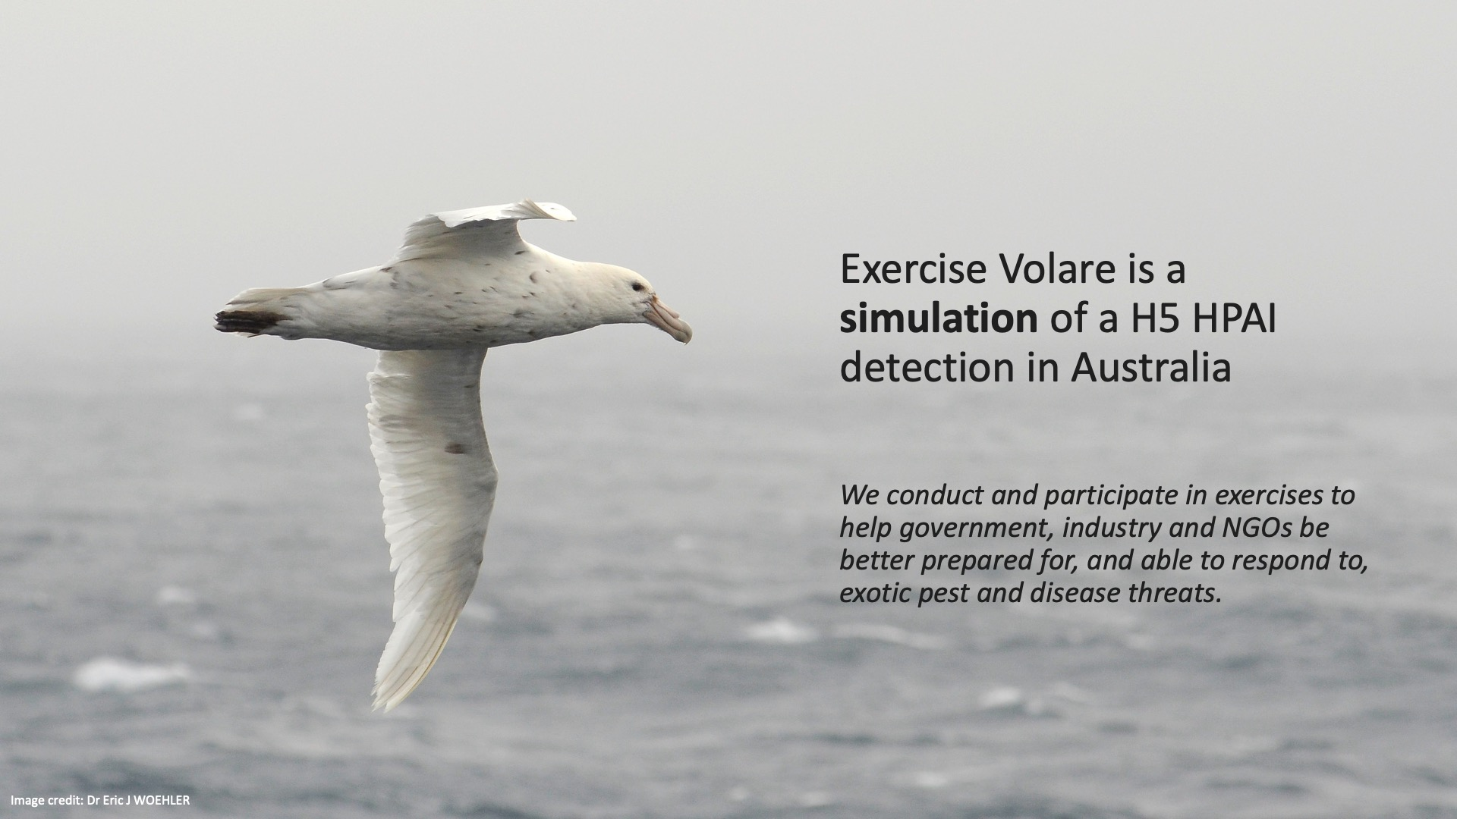

Webinar Summary
  - Strengthening Australia’s preparedness for H5 avian influenza (bird flu)
HPAI Preparedness Taskforce
  - 16 December 2024

Contents

Contents 2
Webinar Summary 3
Global H5 Bird Flu Situation and Surveillance 3
Scenario walk through - national, jurisdictional, and local 4
Conclusion 5

Webinar Summary
The Department of Agriculture, Fisheries and Forestry (DAFF) hosted a webinar on October 4, 2024, to discuss Australia’s preparedness for H5 bird flu and key outcomes from the simulation exercise "Exercise Volare." The event brought together experts in animal and wildlife health, public health, and biosecurity to provide updates on the global H5 bird flu situation, national response strategies, and preparedness measures.
Report prepared by ContentGroup on behalf of the HPAI Preparedness Taskforce.

Global H5 Bird Flu Situation and Surveillance

Global H5 HPAI situation, impacts, entry pathways (2:30)
Dr. Tiggy Grillo, a veterinarian from Wildlife Health Australia, provided an overview of the global situation of H5 bird flu. The current strain, H5N1 clade 2.3.4.4b, has spread rapidly since 2021, affecting wildlife in Asia, Europe, Africa, North and South America, and recently reaching Antarctica. Australia remains one of the few continents free of this strain, though its proximity to infected migratory birds poses a significant risk. Dr Grillo explained that migratory birds from Asia and North America could introduce the virus, making constant surveillance and preparedness essential.
Surveillance in Australia (8:25)
Dr. Guy Weerasinghe from DAFF’s Northern Australia Quarantine Strategy (NAQS) discussed the surveillance efforts underway in Northern Australia to detect early signs of H5 bird flu. His team collaborates with 65 indigenous ranger groups to monitor wildlife and migratory birds. This strategy aims to detect diseases that could enter the country through unregulated means, and their surveillance network has been expanded to include seabirds and other wildlife along the coastline​.
National crisis arrangements (15:37)
Joe Buffone, Deputy Coordinator General from the National Emergency Management Agency, discussed how Australia’s national crisis management framework supports biosecurity efforts in the face of H5 bird flu. Buffone emphasised coordination, collaboration, and communication as the central pillars of the national response to crises. He also outlined the scalable, tiered approach used by the federal government to ensure national and state coordination during preparedness and potential outbreaks​.
Exercise Volare – what, when, who, why (23:00)
Brant Smith, First Assistant Secretary of the Biosecurity Animal Division within DAFF, along with Dr. Bertie Hennecke, Chief Environmental Biosecurity Officer, and Dr Beth Cookson, Chief Veterinary Officer, provided an overview of Exercise Volare, a series of scenario-based discussion exercises which explored Australia's response to a hypothetical incursion of H5 bird flu in wildlife. These exercises brought together representatives from the environment, agriculture, and health sectors across all levels of government, as well as industry stakeholders, to discuss what a coordinated national response would look like if the virus were detected in Australian wildlife.
The exercise simulated an outbreak in South Australia’s Coorong National Park, focusing on how to manage an influx of cases in both wildlife and humans. The results highlighted the need for national coordination and rapid response in the event of an outbreak, with particular emphasis on shared situational awareness, unified communications, and cross-sectoral collaboration​.

Scenario walk through - national, jurisdictional, and local
Introduction to scenario (25.33)
Dr. Bertie Henneke provided an overview of the simulated scenario used in Exercise Volare, which involved an outbreak of H5 bird flu in South Australia's Coorong National Park. Dr. Henneke described how the virus would be detected in wildlife, such as birds and marine mammals, and the subsequent steps that would be taken in response, including sample collection, testing, and coordination with various agencies. He emphasised the importance of a nationally coordinated response and detailed the potential impacts of such an outbreak on both wildlife and human populations, stressing the need for effective communication and collaboration across sectors.

Initial reporting and national response arrangements (28.26)
Dr. Beth Cookson, Australian Chief Veterinary Officer, outlined the response protocols to a potential H5 bird flu outbreak. She explained that state and territory biosecurity agencies would lead the on-ground response, supported by national coordination. In the event of an outbreak, the first response would involve collecting samples for testing, with confirmatory results processed at the CSIRO’s Australian Centre for Disease Preparedness. Dr. Cookson highlighted the importance of the Emergency Animal Disease Response Agreement (EADRA), which facilitates a collective response by governments and industry. She also discussed the need for collaboration across agriculture, environment, and health sectors under a One Health approach, emphasising Australia's international obligations to report confirmed cases to the World Organisation for Animal Health. Additionally, she noted that wildlife would be a significant focus of monitoring and management, as the virus could pose long-term threats to both wildlife populations and public health.

Planning and response for threatened species (47:03)
Dr. Fiona Fraser, Australia’s Threatened Species Commissioner, discussed the potentially severe impact of H5 bird flu on Australia’s unique and already vulnerable wildlife. With over 500 bird species and 56 mammal species affected globally, the disease could have devastating consequences for species like the Australian sea lion, which are already endangered. Fraser discussed the importance of a proactive approach, including species-specific risk assessments, to identify which wildlife populations are most at risk. These efforts include prioritising biosecurity measures, habitat protection, and mitigating other threats like predation or environmental degradation that could exacerbate the impacts of an H5 bird flu outbreak. Additionally, she highlighted efforts to boost the resilience of species, particularly those in captivity, through enhanced biosecurity practices and vaccination trials. Collaborating with stakeholders, such as zoos and aquariums, forms a critical part of preparedness to protect Australia's irreplaceable biodiversity from the threat of H5 bird flu.
Combat jurisdiction in managing an outbreak in wildlife
Dr. Sophie Bass from South Australia's Department of Environment and Water discussed the preparedness and response measures for an H5 bird flu outbreak, focusing on key sites such as the Coorong National Park and Seal Bay Conservation Park. She outlined the importance of site-specific risk assessments, response planning, and surveillance efforts, especially concerning threatened species and areas with high wildlife and public interaction. Sophie also emphasised the need for careful carcass management and potential public access restrictions to mitigate the spread of the virus while balancing conservation efforts with public health concerns.
What do we anticipate? (54:03)
Simone Vitali from Wildlife Health Australia provided insight into the potential impact of mass mortality events on wildlife if H5 bird flu reaches Australia. She discussed the difficulty in managing such events, noting that the prognosis for infected birds and mammals is extremely poor, and most infected individuals would not survive. Vitali emphasised the importance of promoting wildlife resilience and preparedness to manage the inevitable consequences of an outbreak​.
Coordinated communications (1:03:00)
Carmel Curran, Assistant Secretary of the Communication and Media Branch at DAFF, discussed the coordination of government communications in the event of an H5 bird flu outbreak. She emphasised the importance of clear, consistent, and accessible information during crises. To achieve this, a national approach is being taken through the National Biosecurity Communication and Engagement Network, which includes representatives from states, territories, and key organisations. This network is developing national talking points and communication products tailored to various sectors, such as wildlife carers, poultry workers, and First Nations people. Carmel also highlighted the need to counter misinformation, the use of trusted information sources, and the deployment of communication channels like print, radio, television, and social media to reach diverse audiences.
Human health (1:07:02)
Dr. Sarah Britton from the interim Australian Centre for Disease Control (CDC) highlighted the potential human health risks associated with H5 bird flu. Although the risk of human-to-human transmission remains low, cases of human infection have been reported globally, particularly among individuals in close contact with infected birds. The CDC is working closely with agricultural and environmental sectors to ensure a One Health approach, integrating animal, human, and environmental health in the response to H5 bird flu ​.

Conclusion
Summary of the session, themes, work and high-level next steps (1:12:20)
Justine Saunders, Deputy Secretary at the Department of Agriculture, Fisheries and Forestry (DAFF), provided a summary of the key themes and outcomes from Exercise Volare, focusing on Australia's preparedness for a H5 bird flu outbreak. She emphasised that an incursion would require a complex, cross-sectoral response involving agriculture, wildlife, and human health sectors. Ms Saunders discussed the need for improved national coordination, communication, and collaboration across state and federal levels, including better alignment with emergency management mechanisms. Key preparedness actions include boosting surveillance, establishing sustainable governance frameworks, developing site- and species-specific response plans, and exploring vaccination options for both poultry and threatened wildlife species. She also highlighted the importance of integrating Indigenous knowledge into the planning process and ensuring that all stakeholders are prepared to respond swiftly to an outbreak, with a particular focus on communication strategies and education.
Q&A with Speakers (1:17:40)
The Q&A session of the webinar focused on various technical and operational aspects related to Australia’s preparedness for H5 bird flu. Here is a summary and overview of the questions that were addressed:
- Lab Preparedness and Network:
  - A question was asked about the size and preparedness of the veterinary lab network in Australia. The response highlighted a robust network of state and territory labs, coordinated by the Australian Centre for Disease Preparedness, with capacity tested in previous exercises like Exercise Waterhole.
- Vaccine Emergency Registration:
  - There was an inquiry about whether emergency registration had been sought for vaccines. The response confirmed ongoing assessments and planning for the use of vaccines in captive wildlife populations, particularly threatened species, with examples drawn from practices in other countries.
- Bird Banders' Role:
  - The involvement of the federal bird and bat banding office in monitoring was also queried. It was confirmed that communication with bird banders is ongoing, with information being distributed via newsletters like Flightlines.
- Environmental Decision-making Framework:
  - The integration of environmental and wildlife-related actions into the broader biosecurity framework was discussed. The response clarified that a susceptibility analysis is being conducted to guide decisions on threatened species and significant sites, ensuring agencies are empowered to take prompt actions.
- Human Health Risk from H5 Exposure:
  - An inquiry about the primary mode of human H5 exposure (direct contact vs airborne transmission) was addressed. It was explained that exposure could occur through direct contact with infected animals or contaminated surfaces, and potentially through aerosolised droplets.
- Inclusion of First Nations People:
  - A critical question regarding the meaningful inclusion of First Nations people in state-level response frameworks, especially in light of ongoing truth-telling processes, was raised. The response outlined various collaborative mechanisms, including partnerships with the National Indigenous Australian Agency and direct engagement through ranger programs.
The webinar provided a comprehensive overview of Australia’s efforts to prepare for an H5 bird flu outbreak, emphasising the importance of national coordination, cross-sectoral collaboration, and proactive planning. Through initiatives like Exercise Volare and ongoing surveillance efforts, the country is working to mitigate the risks posed by H5 bird flu and protect its wildlife, agricultural industries, and human populations.

