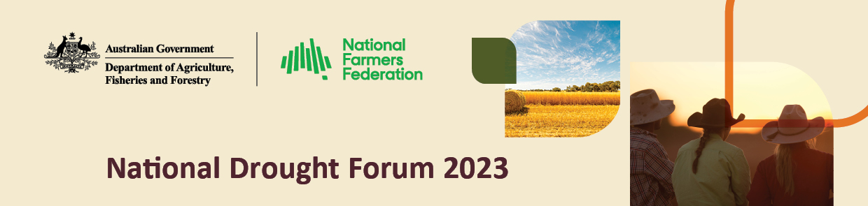

26 September 2023 – Rockhampton

Event summary

On 26 September 2023, the National Drought Forum was held in Rockhampton, Queensland, to reflect on the progress made in drought reform, policy and programs and discuss what further work needs to be done.

The Forum, co-hosted by the Department of Agriculture, Fisheries and Forestry and the National Farmers’ Federation, centred on the theme “building, connecting, partnering”**.** It brought together representatives from Australian, state, territory and local governments, national, state and industry farming bodies, the finance sector, charities and other stakeholders with a role and interest in strengthening our approach to drought response, resilience and preparedness. They shared their views on how to help rural Australia get ready for and withstand drought.

Speakers at the Forum’s plenary session included Treasurer the Hon. Dr Jim Chalmers MP, Minister for Agriculture, Fisheries and Forestry Senator the Hon. Murray Watt, and National Farmers’ Federation chief executive officer Tony Mahar.

Announcements made at the Forum included:

* the $38.8 million extension of the Rural Financial Counselling Service for another 2 years from July 2024.
* the release of the Productivity Commission’s final report into the Future Drought Fund.
* the release of regional drought resilience plans for 5 regions in Queensland: Fitzroy and Capricornia, Darling Downs, Torres Strait and Cape York, Burdekin and Charters Towers, and the South West. These are the first plans in Queensland to be developed under the Future Drought Fund’s Regional Drought Resilience Planning program.
* the appointment of a new consultative committee for the Future Drought Fund. Mr Brent Finlay has been reappointed Committee Chair and 4 new members have been appointed: Professor Bronwyn Harch, Mr Joshua Gilbert, Ms Lucinda Corrigan and Mr Ashley Herbert.

The plenary addresses noted:

* drought is part of the bigger picture of climate change. Treasury analysis of the economy-wide impact of disasters and a warming climate forecasts that Australian crop yields could be 4 per cent lower by 2063 if action is not taken, costing about $1.8 billion in GDP in today’s dollars.
* Australian agriculture is responding to these challenges by adapting how it farms and working towards increasing sustainable farming practices.
* the Australian Government supports the sector’s ambitions, through the first National Statement on Climate Change in Agriculture as well as its work towards an Agriculture and Land Sector Plan, new drought plan, the next National Drought Agreement with the states and territories, new drought indicators and a drought early warning system.
* the National Farmers Federation’s national drought policy also prioritises long-term preparedness, sustainability, resilience and risk management.
* it is important to talk about drought before farmers reach crisis point. A National Farmer Wellbeing Report released earlier this year 30% of respondents reported their mental health had declined in the last 2 years and almost a third had attempted self-harm or suicide. The arrival of El Nino could further erode farmers’ social and financial wellbeing.
* every El Nino is different, and it is not the only factor affecting our climate.
* every farmer or community is also different, and drought policy and programs should take account of that diversity, including First Nations perspectives.
* people and organisations on the ground have valuable insights to offer government on its approach to drought.
* the Forum aims to tap into that expertise and build ongoing connections with stakeholders present to better support farmers and rural communities.

The presentations and panel sessions that followed centred on:

* decision-making in drought. The presentations and discussion focused on how farmers, rural communities and governments make decisions before, during and after drought, and the data, tools and systems available to support them.
* financial resilience. The panel question and answer session explored how we can help farmers build financial resilience and what is getting in their way.
* community-led action on drought. The presentations and discussion highlighted the need to engage the whole community when preparing for, managing through and recovering from drought, and what that looks like from the ground up.

Forum participants split into groups to workshop specific issues, including:

* the next 4-year funding cycle for the Future Drought Fund. Participants were briefed on the Fund’s aims and achievements, the Productivity Commission report findings into the Fund, and the next steps and opportunities for engagement on the direction of its investment from 2024-25 to 2028-29**.** Participants discussed how best to drive change, support locally-led solutions, build capacity, and balance private vs public good.
* the Australian Government framework for responding to drought. Participants described the social, economic and environmental impacts of drought, discussed how long farmers and rural communities can draw on their own resources to manage drought, and identified factors affecting their capacity to prepare for and recover from drought.
* communication and engagement on drought. Participants discussed their roles and responsibilities across the drought cycle, who farmers and rural communities turned to for drought information, the type of information needed, and how it is best expressed. They explored the pros and cons of a departmental proposal for a National Drought Network to support ongoing, open engagement with stakeholders after the Forum.

The day finished with a panel session on climate and sustainability. The presentations and discussion centred on the compounding effects of climate change on drought, and the overlap between sustainable and drought resilient farming practices.

A timeline of upcoming drought policy consultations and events was presented at the Forum. The Australian Government invited participants to share and have their say on future policy documents including the draft drought resilience funding plan for the Future Drought Fund, the draft Australian Government drought plan, the Agriculture and Land Sector Plan, and the review of the Regional Investment Corporation Act.

For more information, visit [agriculture.gov.au/drought-policy](https://www.agriculture.gov.au/agriculture-land/farm-food-drought/drought/drought-policy)*.*