**EXDOC**

Exporter Interface System

Specification

Errata Set 47

Version 8.9

Issue date: 12 January 2021

# Introduction

This document lists amendments that have been identified for Version 9.1 of the Exporter Interface System Specification issued January 2021. It follows Errata Set 46. Please update your copy of the specification as appropriate.

Within the following document where there are changes to segment or data rules the entire segment has been reproduced with the changes to the rules underlined. Where text has been deleted the text is displayed in the sections below with lines through the text. Where text has been added the text is underlined in the sections below.

Exdoc (RFP) Adaptation of SANCRT

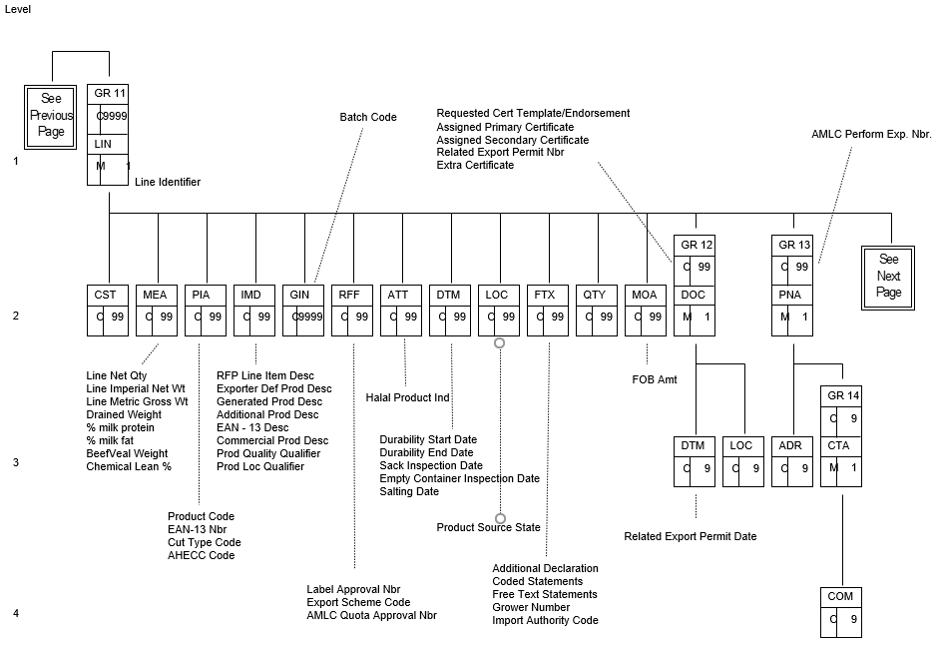

**Figure 8 - EXDOC (RFP) Adaptation of SANCRT – Part 3**

**RFP Data Item Mapping**

| Data Item | | |  |  | Group | Seg | Element | Description | Value/Comment |
| --- | --- | --- | --- | --- | --- | --- | --- | --- | --- |
|  |  | **RFP Line** | | | | | | | |
| Durability Start Date | | |  |  | LIN GR11 | DTM | C507/2005 | Date/time/period qualifier | 194 (Start Date) |
|  | | |  |  |  |  | C507/2380 | Durability start date | Value, date of prescribed format |
|  | | |  |  |  |  | C507/2379 | Date/time/period format qualifier | 102 (CCYYMMDD) |
|  | | |  |  |  |  |  |  |  |
| Processing Establishment Number/Name | | |  |  | LIN GR19 | PNA | 3035 | Party qualifier | MP (Manufacturing Plant) |