# Epizootic haematopoietic necrosis (EHN)

Also known as infection with epizootic haematopoietic necrosis virus (EHNV)

From Aquatic animal diseases significant to Australia: identification field guide, 5th edition

Figure 1 Mass mortality of redfin perch (Perca fluviatilis) due to EHN

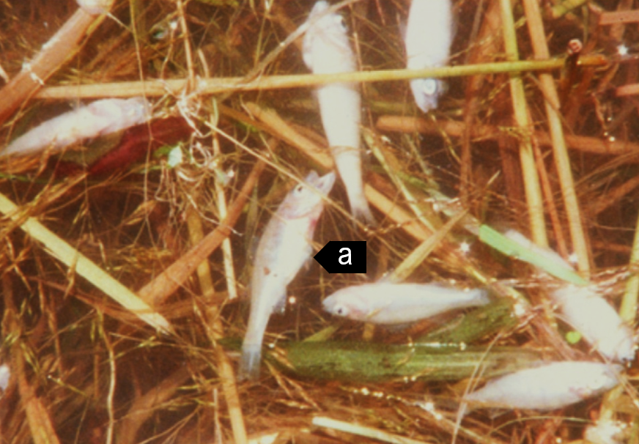

Note: Affected individuals showing signs of EHN including swollen abdomen (a) and small size.

Source: J Humphrey

Figure 2 Redfin perch (Perca fluviatilis) experimentally infected with EHNV

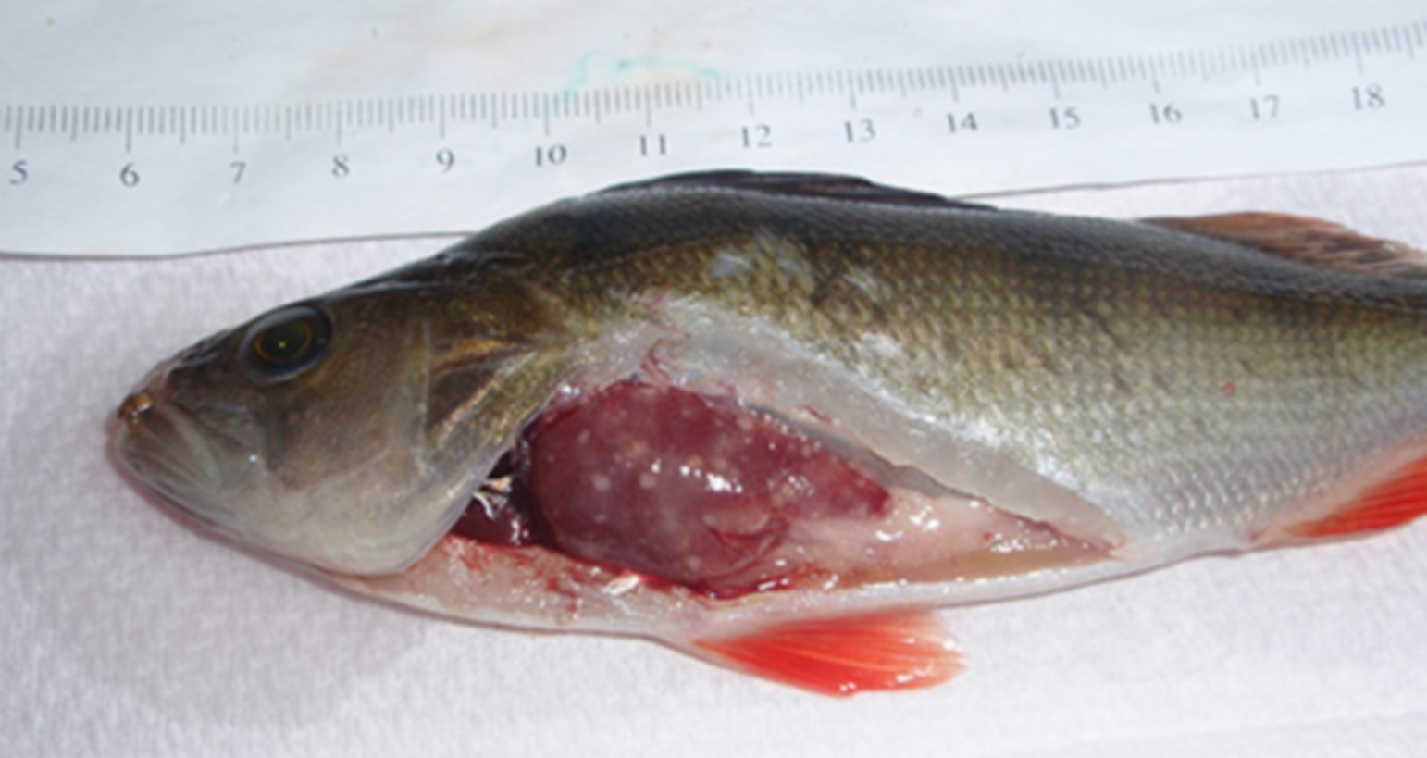

Note: Grossly visible multifocal necrotic foci in the liver.

Source: R Whittington

## Signs of disease

Important: Animals with this disease may show one or more of these signs, but the pathogen may still be present in the absence of any signs.

Disease signs at the farm, tank or pond level are:

* hundreds or thousands of small (less than 10cm long), dead fish found on the downwind bank of the water body
* large numbers of fish-eating birds (such as seagulls) at the water surface
* loss of appetite
* juveniles (less than 25mm long) swimming in a disorientated fashion at the surface
* occasional adults affected when the disease first arrives in an area.

Gross pathological signs are:

* swollen abdomen
* darkened skin colour
* petechial (pinpoint) haemorrhages at the base of the fins
* haemorrhaging of the gills
* dead fish
* enlargement of the kidney, liver and spleen
* focal white to yellow liver lesions.

Microscopic pathological signs are:

* coagulative or liquefactive necrosis of the liver, kidney and spleen
* necrotic lesions in the heart, pancreas, gastrointestinal tract and gills
* small numbers of basophilic intracytoplasmic inclusion bodies surrounding necrotic areas of the liver and kidney.

## Disease agent

EHN is caused by infection with epizootic haematopoietic necrosis virus (EHNV), belonging to the genus Ranavirus within the family Iridoviridae. Closely related ranaviruses cause similar systemic necrotising iridovirus syndromes in sheatfish and catfish in Europe (European sheatfish virus and European catfish virus; also in this guide).

## Host range

Table 1 Species known to be susceptible to EHNV

| Common name | Scientific name |
| --- | --- |
| Macquarie perch | Macquaria australasica |
| Mosquito fish | Gambusia affinis |
| Mountain galaxias | Galaxias olidus |
| Murray coda | Maccullochella peelii |
| Rainbow troutb | Oncorhynchus mykiss |
| Redfin perchb or European perch | Perca fluviatilis |
| Silver perch | Bidyanus bidyanus |
| Piscivorous birds | Various genera and species |

**a** Demonstrated to carry EHNV subclinically. **b** Naturally susceptible. Note: Other species have been shown to be experimentally susceptible.

## Presence in Australia

EHN has been officially reported from the Australian Capital Territory, New South Wales, South Australia and Victoria.

Map 1 Presence of EHN, by jurisdiction

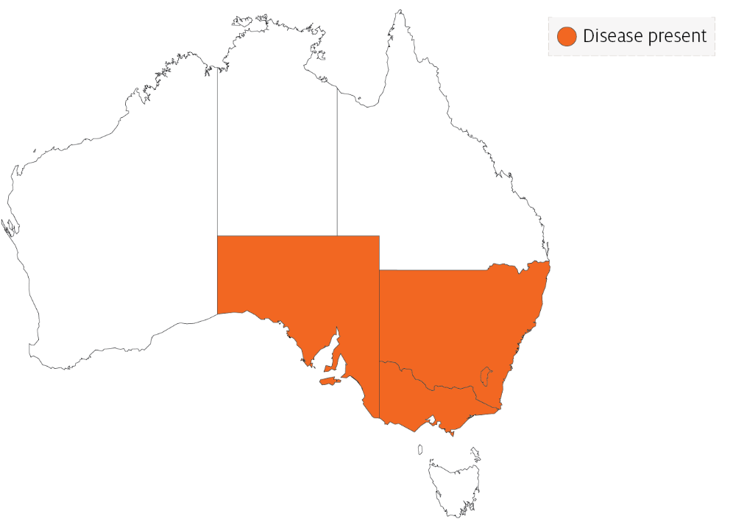

## Epidemiology

* EHN is usually seen in Australia as large kills of small redfin perch. High mortality can also occur among older perch in newly affected areas.
* Clinical outbreaks are typically seen in fingerlings and juvenile fish, associated with poor water quality and/or certain water temperatures (between 11°C and 17°C in rainbow trout and above 12°C in redfin perch).
* Mortalities occur over a short period (several weeks) in summer, and then the disease may disappear from an area for years.
* Low mortality rates over a period of months have been reported in young, farmed rainbow trout.
* Infectivity is less severe in rainbow trout than in redfin perch, with the disease mainly affecting fingerlings less than 125mm long.
* Low-grade mortalities with covert EHNV infection can also occur in juvenile fish. Care must be taken when moving redfin perch and rainbow trout from the known geographical range of EHNV to areas where it is exotic, unless freedom from disease can be adequately demonstrated.
* EHN is a resistant virus, surviving for months in water, persisting in frozen fish tissues for more than two years and in frozen fish carcases for at least one year.
* EHNV may be carried on equipment including nets and boats, in fish (live or dead) used for bait and via the gut, feathers, feet and bill of piscivorous birds.

## Differential diagnosis

The list of similar diseases in the next section refers only to the diseases covered by this field guide. Gross pathological signs may also be representative of diseases not included in this guide. Do not rely on gross signs to provide a definitive diagnosis. Use them as a tool to help identify the listed diseases that most closely account for the observed signs.

## Similar diseases

Enteric red mouth disease, furunculosis, infection with HPR-deleted or HPR0 infectious salmon anaemia virus, infectious haematopoietic necrosis (IHN), infectious pancreatic necrosis (IPN), viral haemorrhagic septicaemia (VHS) and whirling disease.

## Sample collection

Only trained personnel should collect samples. Using only gross pathological signs to differentiate between diseases is not reliable, and some aquatic animal disease agents pose a risk to humans. If you are not appropriately trained, phone your state or territory hotline number and report your observations. If you have to collect samples, the agency taking your call will advise you on the appropriate course of action. Local or district fisheries or veterinary authorities may also advise on sampling.

## Emergency disease hotline

See something you think is this disease? Report it. Even if you’re not sure.

Call the Emergency Animal Disease Watch Hotline on **1800 675 888**. They will refer you to the right state or territory agency.

## Further reading

CEFAS International Database on Aquatic Animal Diseases [Epizootic Haematopoietic Necrosis](https://www.cefas.co.uk/international-database-on-aquatic-animal-diseases/disease-data/?id=44)

World Organisation for Animal Health [Manual of diagnostic tests for aquatic animals](http://www.oie.int/en/international-standard-setting/aquatic-manual/access-online)

These hyperlinks were correct at the time of publication.

## Contact details

Emergency Animal Disease Watch Hotline 1800 675 888

Email [AAH@agriculture.gov.au](mailto:AAH@agriculture.gov.au)Website [agriculture.gov.au/pests-diseases-weeds/aquatic](http://www.agriculture.gov.au/pests-diseases-weeds/aquatic)

© Commonwealth of Australia 2020

This work is copyright. It may be reproduced in whole or in part subject to the inclusion of an acknowledgement of the source and no commercial usage or sale.