# Help Card: New Zealand eCertificate

## Introduction

This help card summarises the country-specific requirements to support our paperless eCertificate exchange with New Zealand’s Ministry for Primary Industries (NZMPI). This Help Card supports brokers and importers when lodging eCertificates for NZMPI, including for the clearance of goods under approved arrangement class 19.2 Automatic Entry Processing for Commodities (AEPCOMM). More information can be found on our eCertificate imports website: <http://agriculture.gov.au/eCertimports>

## Paperless eCertificate exchange with New Zealand

Since August 2020, New Zealand (NZ) no longer issues paper phytosanitary or sanitary certificates. Original paper certificates will continue to be provided for zoo sanitary certificates (live animals and reproductive material) and goods arriving as accompanied passenger baggage or via mail. Importers and brokers are given a certificate number where a phytosanitary or sanitary certificate is required for import clearance. The NZ exporter gives this to importers and brokers with other import documentation. This eCertificate number must be provided to the department for assessment, as per Table 1. More information can be found on our eCertificate imports website: <https://www.agriculture.gov.au/biosecurity-trade/import/online-services/electronic-certification>

Table 1 New Zealand eCertificate format

| **Trading partner** | **Government certificate type** | **AQIS document type** | **AQIS document number format** | **Status of exchange** |
| --- | --- | --- | --- | --- |
| New Zealand | Phytosanitary | NZPHYTO | NZL2020/EXAMPLE/36923 | Paperless |
| Sanitary | NZSANITARY | NZL2020/EFL123/123096 | Paperless |

### Import declarations processed under approved arrangement class 19.2 from New Zealand

NZ exporters must provide the certificate details of the phytosanitary or sanitary certificate (refer to section 3) that will be used for the clearance of goods lodged under approved arrangement class 19.2. Accredited persons must access the [External Verification for eCertificates (EVE)](https://www.agriculture.gov.au/biosecurity-trade/import/online-services/EVE) system to view the certificate (and any attachments) in order to conduct the assessment via class 19.2. With the introduction of the EVE system, copies of phytosanitary certificates or extracts of sanitary certificates are no longer required to be kept as evidence under the approved arrangement class 19.2 operating conditions.

Refer to our eCertificate imports website for more information on lodging import declarations under approved arrangement class 19.2: <https://www.agriculture.gov.au/biosecurity-trade/import/online-services/electronic-certification>

## Documentation to support clearance under approved arrangement class 19.2

### New Zealand copy phytosanitary certificate

Below are two examples of copy phytosanitary certificates.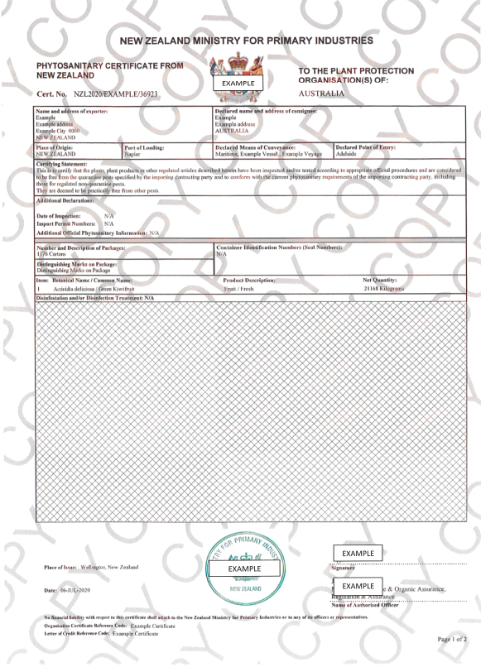

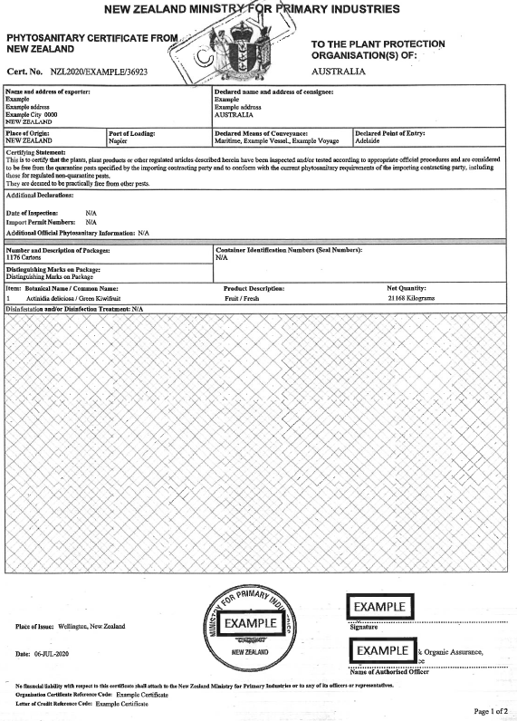

### New Zealand extract phytosanitary certificate

Below is an example of the extract sanitary certificate. This may be provided as an email extract direct from the NZ MPI eCertificate system or a PDF extract. The status will say approved/acknowledged.

|  |  |  |  |
| --- | --- | --- | --- |
| NZL 2020/EFL 123/123096 | This is not an Official Assurance and is for information purposes only.  Extract of Export Certificate data as at 14-Aug-2020 16:18 | | |
| Status: | Approved on 14-Aug-2020 16:16 | | |
| Approved By: | John Smith, Official Inspector | | |
| Header Details | | | |
| Template Id: | AU300.11 – Certificate for Fish or Fish Product Exported to Australia | | |
| Importing Country: | Australia | | |
| Consignor: | EFL123. Nice Fisheries LTD, AUCKLAND 5520 | | |
| Importer Name: | FRESH SEAFOOD LTD | | |
| Importer Address: | Green Street 55 Importer City Melbourne, VICTORIA 3003 Importer | | |
| Post Code: | – | | |
| Importer Country: | Australia | | |
| Means of Transport: | Air | | |
| Carrier Name: | AIR NEW ZEALAND | | |
| Conveyance Reference: | NZ 125 | | |
| Port of Loading: | NZAKL – Auckland [AUK], New Zealand | | |
| Port of Discharge: | AUMEL – Melbourne (VIC), Australia | | |
| Unofficial Commercial Information: | – | | |
| Declarations | – | | |
| Health Attestation | – | | |
| AU300.11/1N | I certify that the products: | | |
| AU300.11/2N | a. were processed in establishments operating in accordance with New Zealand law; | | |
| AU300.11/3N | b. were processed in accordance with New Zealand regulatory requirements for items intended for human consumption; | | |
| AU300.11/4N | c. are of New Zealand origin | | |
| AU300.11/7N | d. were derived from fish caught in New Zealand's Exclusive Economic Zone (EEZ) or in adjacent international waters. | | |
| Official Information: | | | |
| Product Item Details – 3 Product Items (12 in total) | | | |
| Product Item 1 | | | |
| Outermost: 1 Cartons | | CHILLED WHOLE GURNARD | Net Weight: 9.50 kg |
| Species:  Chelidonichthys kumu | | Identification Marks:  1A1B | Container (& Seal) Numbers:  Not Applicable |
| Processing Premises:  PH5000, Green Fisheries Limited, 1 Wagener Place, Epsom, AUCKLAND, New Zealand | | | |
| Product Item 2 | | | |
| Outermost: 8 Cartons | | CHILLED WHOLE JOHN DORY | Net Weight: 71.50 kg |
| Species:  Zeus faber | | Identification Marks:  ABC1 | Container (& Seal) Numbers:  Not Applicable |
| Processing Premises:  PH5000, Green Fisheries Limited, 1 Wagener Place, Epsom, AUCKLAND, New Zealand | | | |
| Product Item 3 | | | |
| Outermost: 3 Cartons | | CHILLED WHOLE RED SCORPION FISH | Net Weight: 58.40 kg |
| Species: | | Identification Marks: | Container (& Seal) Numbers:  Not Applicable |
| Processing Premises:  PH5000, Green Fisheries Limited, 1 Wagener Place, Epsom, AUCKLAND, New Zealand | | | |

# Contact

Phone 1800 900 090

Email ecertadministrator@agriculture.gov.au

Web agriculture.gov.au/Ecertimports

**Acknowledgement of Country**

We acknowledge the Traditional Custodians of Australia and their continuing connection to land and sea, waters, environment and community. We pay our respects to the Traditional Custodians of the lands we live and work on, their culture, and their Elders past and present.

© Commonwealth of Australia 2022

Unless otherwise noted, copyright (and any other intellectual property rights) in this publication is owned by the Commonwealth of Australia (referred to as the Commonwealth).

All material in this publication is licensed under a Creative Commons Attribution 4.0 International Licence except content supplied by third parties, logos and the Commonwealth Coat of Arms.

The Australian Government acting through the Department of Agriculture, Fisheries and Forestry has exercised due care and skill in preparing and compiling the information and data in this publication. Notwithstanding, the Department of Agriculture, Fisheries and Forestry, its employees and advisers disclaim all liability, including liability for negligence and for any loss, damage, injury, expense or cost incurred by any person as a result of accessing, using or relying on any of the information or data in this publication to the maximum extent permitted by law.