Dragon fruit from the Philippines: biosecurity import requirements final report
August 2023

© Commonwealth of Australia 2023
Ownership of intellectual property rights
Unless otherwise noted, copyright (and any other intellectual property rights) in this publication is owned by the Commonwealth of Australia (referred to as the Commonwealth).
Creative Commons licence
All material in this publication is licensed under a Creative Commons Attribution 4.0 International Licence except content supplied by third parties, logos and the Commonwealth Coat of Arms.

Cataloguing data
This publication (and any material sourced from it) should be attributed as: DAFF 2023, Dragon fruit from the Philippines: biosecurity import requirements final report, Department of Agriculture, Fisheries and Forestry, Canberra, CC BY 4.0.
This publication is available at agriculture.gov.au/biosecurity-trade/policy/risk-analysis/plant/dragon-fruit-from-Philippines.
Department of Agriculture, Fisheries and Forestry
GPO Box 858 Canberra ACT 2601
Telephone 1800 900 090
Web agriculture.gov.au
Email: plantstakeholders@agriculture.gov.au
Disclaimer
The Australian Government acting through the Department of Agriculture, Fisheries and Forestry has exercised due care and skill in preparing and compiling the information and data in this publication. Notwithstanding, the Department of Agriculture, Fisheries and Forestry, its employees and advisers disclaim all liability, including liability for negligence and for any loss, damage, injury, expense or cost incurred by any person as a result of accessing, using or relying on any of the information or data in this publication to the maximum extent permitted by law.
Acknowledgement of Country
We acknowledge the Traditional Custodians of Australia and their continuing connection to land and sea, waters, environment and community. We pay our respects to the Traditional Custodians of the lands we live and work on, their culture, and their Elders past and present.

Contents
Summary vii
1 Introduction 1
1.1 Australia’s biosecurity policy framework 1
1.2 This risk analysis 1
2 Commercial production practices for dragon fruit in the Philippines 9
2.1 Considerations used in estimating unrestricted risk 9
2.2 Production areas of dragon fruit 9
2.3 Climate in production areas 11
2.4 Pre-harvest 13
2.5 Harvesting and handling procedures 19
2.6 Post-harvest 20
2.7 Export capability 26
3 Pest risk assessments for quarantine pests 28
3.1 Summary of outcomes of pest initiation and categorisation 28
3.2 Pests requiring further pest risk assessment 28
3.3 Overview of pest risk assessment 29
3.4 Fruit flies 30
3.5 Mealybugs 35
3.6 Thrips 37
3.7 Pest risk assessment conclusions 39
4 Pest risk management 42
4.1 Pest risk management measures and phytosanitary procedures 42
4.2 Operational system for the assurance, maintenance and verification of phytosanitary status 46
4.3 Uncategorised pests 50
4.4 Review of processes 50
4.5 Meeting Australia’s food laws 51
5 Conclusion 52
Appendix A: Method for pest risk analysis 53
Appendix B: Initiation and categorisation for pests of dragon fruit from the Philippines 66
Appendix C: Stakeholder comments 97
Glossary, acronyms and abbreviations 99
References 104
Figures
Figure 1.1 Diagram of the cross section of a dragon fruit showing key parts of the fruit 3
Figure 1.2 Process flow diagram for conducting a risk analysis and implementing trade 6
Map 4 Four climate types of the Philippines 11
Figure 2.1 Mean monthly minimum and maximum temperatures and mean monthly rainfall in the main production areas of dragon fruit in the Philippines 12
Figure 2.2 Selenicereus monacanthus fruit and segments showing red flesh and seeds and a cross-section of Selenicereus undatus showing white flesh and seeds 14
Figure 2.3 Dragon fruit plantations with bordering tree lines 16
Figure 2.4 Dragon fruit stem cuttings tied to cement posts using plastic string 16
Figure 2.5 Trained dragon fruit stem forming a crown structure 17
Figure 2.6 Stripped dragon fruit trunks with exposed stem 19
Figure 2.7 Harvesting dragon fruit 20
Figure 2.8 Harvested fruit in receival area 21
Figure 2.9 Dragon fruit being graded and sorted into different crates based on size and quality 22
Figure 2.10 Plastic covered fruit being packed into boxes 23
Figure 2.11 Summary of operational steps for dragon fruit grown in the Philippines for export 25
Table 3.2 Quarantine mealybug species for dragon fruit from the Philippines 35
Table 3.4 Quarantine and regulated thrips species for dragon fruit from the Philippines 37
Figure 3.1 Overview of the PRA decision process for dragon fruit from the Philippines 41
Figure A.1 Decision rules for determining the impact score for each direct and indirect criterion, based on the level of impact and the magnitude of impact 61
Tables
Table 2.1 Area and volume of the top 5 dragon fruit producing regions of the Philippines (2021) 10
Table 2.2 Current area and production of dragon fruit in the Philippines (2012-2021) 26
Table 3.1 Quarantine pests and regulated thrips potentially associated with dragon fruit from the Philippines, and requiring further pest risk assessment 29
Table 3.3 Risk estimates for quarantine mealybugs 35
Table 3.5 Risk estimates for quarantine thrips 38
Table 3.6 Risk estimates for emerging quarantine orthotospoviruses vectored by regulated thrips 38
Table 3.7 Pest risk assessment conclusions for pests, and pest groups, associated with the pathway of dragon fruit from the Philippines 40
Table 4.1 Recommended risk management measures for quarantine pests and regulated articles potentially associated with dragon fruit from the Philippines 43
Table A.1 Nomenclature of likelihoods 57
Table A.2 Matrix of rules for combining likelihoods 58
Table A.3 Decision rules for determining the overall consequence rating for each pest 62
Table A.4 Risk estimation matrix 62
Maps
Map 1 Map of Australia vi
Map 2 A guide to Australia’s bio-climatic zones vi
Map 3 Main production areas of dragon fruit in the Philippines marked by red boxes 10

Map 1 Map of Australia
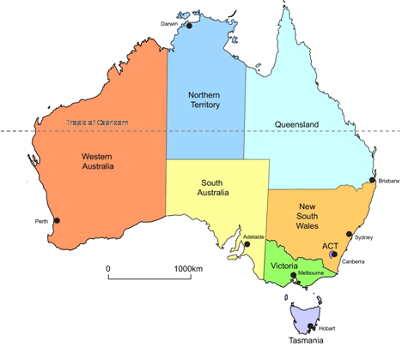
Map 2 A guide to Australia’s bio-climatic zones
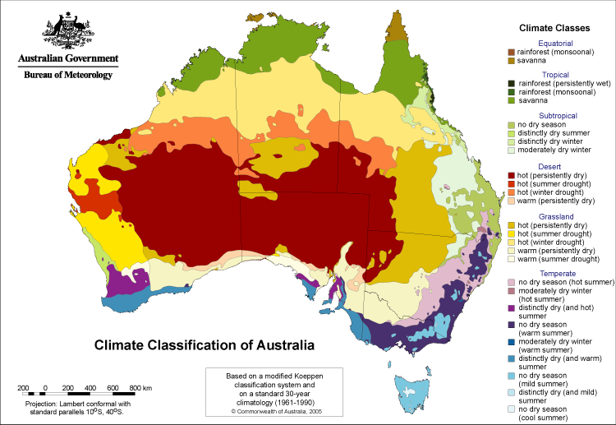

Summary
The Australian Government Department of Agriculture, Fisheries and Forestry (the department) has prepared this final report to assess the proposal by the Republic of the Philippines (the Philippines) for market access to Australia for dragon fruit for human consumption.
Australia currently permits the importation of dragon fruit from Vietnam for human consumption, provided Australian biosecurity import conditions are met. An import risk analysis for dragon fruit from Indonesia has also been completed, however, import conditions are yet to be finalised for this pathway.
This final report recommends that the importation of commercially produced dragon fruit to Australia from all commercial production areas of the Philippines can be permitted, subject to a range of biosecurity requirements.
This final report contains details of plant pests that are of biosecurity concern to Australia and are potentially associated with the importation of dragon fruit from the Philippines. The term ‘pests’ includes both arthropod pests and pathogens. This report also contains risk assessments for the identified quarantine pests and regulated articles, and, where required, recommended risk management measures to reduce the biosecurity risk to an acceptable level, that is, to achieve the appropriate level of protection (ALOP) for Australia.
Eight pests have been identified in this risk analysis as requiring risk management measures to reduce the biosecurity risk to an acceptable level. These pests are:
- fruit flies: oriental fruit fly (Bactrocera dorsalis) and melon fly (Zeugodacus cucurbitae)
- mealybugs: grey pineapple mealybug (Dysmicoccus neobrevipes), papaya mealybug (Paracoccus marginatus) and Jack Beardsley mealybug (Pseudococcus jackbeardsleyi)
- thrips: western flower thrips (Frankliniella occidentalis), chilli thrips (Scirtothrips dorsalis) and melon thrips (Thrips palmi).
Of these 8 pests:
- seven are quarantine pests, including western flower thrips and melon thrips which are also identified as regulated articles as they are capable of harbouring and spreading emerging orthotospoviruses that are quarantine pests for Australia
- chilli thrips is a non-quarantine pest as it is present in Australia. However, it was identified as a regulated article for Australia as it is capable of harbouring and spreading quarantine orthotospoviruses.
The identified pests are the same, or of the same pest groups, as those associated with other horticultural commodities that have been analysed previously by the department.
The recommended risk management measures take account of regional differences in pest distribution within Australia. Western flower thrips has been identified as a regional quarantine pest for the Northern Territory and melon thrips has been identified as a regional quarantine pest for South Australia and Western Australia. These pests are considered regional quarantine pests as interstate quarantine regulations and enforcement are in place to prevent the introduction and distribution of these pests into the respective jurisdictions.
In this final report the department recommends a range of risk management measures, combined with operational systems, to reduce the risks posed by the 8 identified pests to achieve the ALOP for Australia. The recommended measures are:
- for fruit flies:
  - pest free areas, pest free places of production or pest free production sites, or
  - fruit treatment considered to be effective against fruit flies such as irradiation or vapour heat treatment
- for mealybugs and thrips:
  - pre-export visual inspection and, if found, remedial action.
Written comments on the draft report were received from 5 stakeholders. The department has made changes to the risk analysis following consideration of the stakeholder comments on the draft report and a subsequent review of literature. These changes include:
- removal of the fungus Fusarium fujikuroi from ‘Appendix B: Initiation and categorisation for pests of dragon fruit from the Philippines’, due to a lack of evidence associating this fungus with dragon fruit in the Philippines
- addition of ‘Appendix C: Stakeholder comments’, which summarises the key technical issues raised by stakeholders, and how these issues have been considered by the department in this final report
- minor corrections, rewording and editorial changes for consistency, accuracy, clarity and web-accessibility.

Introduction

Australia’s biosecurity policy framework
Australia’s biosecurity policies aim to protect Australia against the risks that may arise from exotic pests entering, establishing and spreading in Australia, thereby threatening Australia’s unique flora and fauna, as well as those agricultural industries that are relatively free from serious pests.
The risk analysis process is an important part of Australia’s biosecurity policy development. It enables the Australian Government to formally consider the level of biosecurity risk that may be associated with proposals to import goods into Australia. If the biosecurity risks do not achieve the appropriate level of protection (ALOP) for Australia, risk management measures are recommended to reduce the risks to an acceptable level. If the risks cannot be reduced to an acceptable level, the goods will not be imported into Australia until suitable measures are identified or developed.
Successive Australian governments have maintained a stringent, but not a zero risk, approach to the management of biosecurity risks. This approach is expressed in terms of the ALOP for Australia, which is defined in the Biosecurity Act 2015 as providing a high level of protection aimed at reducing risk to a very low level, but not to zero.
Australia’s risk analyses are undertaken by the Department of Agriculture, Fisheries and Forestry using technical and scientific experts in relevant fields and involve consultation with stakeholders at various stages during the process.
Risk analyses may take the form of a biosecurity import risk analysis (BIRA) or a review of biosecurity import requirements (such as scientific review of existing policy and import conditions, pest-specific assessments, weed risk assessments, biological control agent assessments or scientific advice).
Further information about Australia’s biosecurity framework is provided in the Biosecurity Import Risk Analysis Guidelines 2016 located on the Department of Agriculture, Fisheries and Forestry website at agriculture.gov.au/biosecurity-trade/policy/risk-analysis/guidelines.

This risk analysis

Background
The Republic of the Philippines, Department of Agriculture (the Philippines DA) formally requested market access to Australia for dragon fruit for human consumption in a submission received in October 2018. This submission provided information on the pests associated with dragon fruit in the Philippines, including the plant parts affected. Information was also provided on the standard commercial production practices for dragon fruit in the Philippines.
On 21 February 2022, the department notified stakeholders of the decision to progress a request for market access for dragon fruit from the Philippines as a review of biosecurity import requirements. This analysis is conducted in accordance with the Biosecurity Act 2015.
In June 2022, officers from the department visited production areas for dragon fruit from the Philippines. The objective of this visit was to observe commercial production, pest management and other export practices.

Scope
The scope of this risk analysis is to consider the biosecurity risk that may be associated with the pathway of imported dragon fruit (Selenicereus spp. that were previously known as Hylocereus spp., and hybrids thereof) from the Philippines, produced using standard commercial production practices as described in Chapter 2, for human consumption in Australia.
In this risk analysis, dragon fruit are defined as the entire fruit with the flesh, seeds, skin (including full bracts) and a small portion (0.5–1 cm) of the areole and cut stem (Figure 1.1).
The main edible dragon fruit species were previously classified as being in the genus Hylocereus and were assessed under this name in the previous risk assessments for dragon fruit from Vietnam (DAWR 2017b) and dragon fruit from Indonesia (DAWR 2018). Recently, phylogenetic DNA analysis revised this taxonomy, concluding that there is no separation between Hylocereus and the broader flowering cactus genus Selenicereus. Therefore, edible dragon fruit species are now classified as being part of the Selenicereus genus (Korotkova, Borsch & Arias 2017).
This risk analysis only covers commercially grown edible dragon fruit species of the genus Selenicereus produced for export in Philippine dragon fruit production regions. All other Selenicereus species are excluded from the scope of this report. The main dragon fruit species grown in the Philippines and considered likely for export are listed in section 2.4.1.
Figure 1.1 Diagram of the cross section of a dragon fruit showing key parts of the fruit
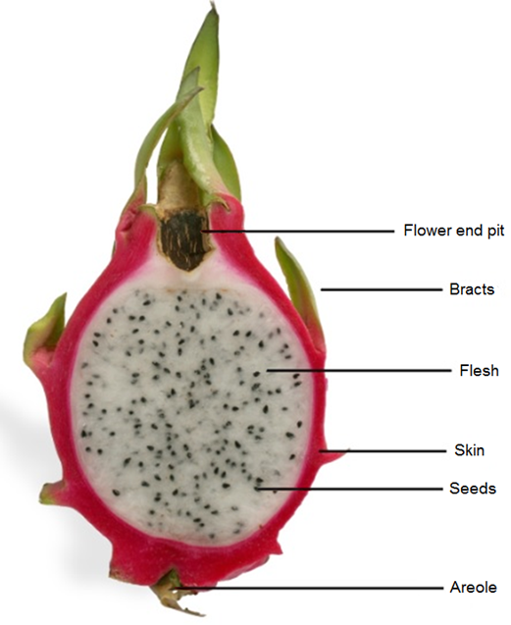

Existing policy

International policy
Import policies exist for fresh dragon fruit for human consumption from Vietnam (DAWR 2017b) and Indonesia (DAWR 2018). Australia also has existing import policies for Philippine mangoes (AQIS 1999), pineapples (Biosecurity Australia 2002) and bananas (Biosecurity Australia 2008).
The biosecurity import conditions for these commodity pathways, except for Indonesian dragon fruit and Philippine bananas, for which conditions are yet to be finalised, can be found at the Biosecurity Import Conditions (BICON) system on the department’s website at bicon.agriculture.gov.au/BiconWeb4.0.
A preliminary assessment has identified that the potential pests of biosecurity concern for dragon fruit from the Philippines are the same, or of the same pest groups, as those associated with other horticultural commodities that have been assessed previously by the department, and for which risk management measures are established.
The department has reviewed all the pests and pest groups previously identified in existing policies and, where relevant, the information in those assessments has been considered in this risk analysis. The department has also reviewed the latest scientific literature and other information to ensure that the previous assessments are still valid.
The biosecurity risk posed by thrips and the orthotospoviruses they transmit was previously assessed for all countries in the Final group pest risk analysis for thrips and orthotospoviruses on fresh fruit, vegetable, cut-flower and foliage imports (thrips Group PRA) (DAWR 2017a).
The biosecurity risk posed by mealybugs and the viruses they transmit was previously assessed for all countries in the Final group pest risk analysis for mealybugs and the viruses they transmit on fresh fruit, vegetable, cut-flower and foliage imports (mealybugs Group PRA) (DAWR 2019).
The biosecurity risk posed by soft and hard scale insects was previously assessed for all countries in the Final group pest risk analysis for soft and hard scale insects on fresh fruit, vegetable, cut-flower and foliage imports (scales Group PRA) (DAWE 2021).
These Group policies are applicable for dragon fruit from The Philippines. The department has determined that the information in those Group policies can be adopted for the species under consideration in this risk analysis.

Domestic arrangements
The Australian Government is responsible for regulating the movement of goods such as plants and plant products into and out of Australia. The state and territory governments are responsible for plant health controls within their individual jurisdiction. Legislation relating to resource management or plant health may be used by state and territory government agencies to control interstate movement of plants and their products. After imported plants and plant products have been cleared by Australian Government biosecurity officers, they may be subject to interstate movement regulations/arrangements. It is the importer’s responsibility to identify and ensure compliance with all requirements.

Contaminating pests
In addition to the pests of dragon fruit from the Philippines that are assessed in this risk analysis, other organisms may arrive with the imported commodity. These organisms may include pests considered not to be associated with the fruit pathway, pests of other crops, or predators and parasitoids of arthropods. The department considers these organisms to be contaminating pests (‘contaminants’) that could pose sanitary (to human or animal life or health) or phytosanitary (to plant life or health) risks. These risks are identified and addressed using existing operational procedures that require an inspection of all consignments during processing and preparation for export. Consignments will also undergo a verification process on arrival in Australia. The department will investigate whether any pest identified through import verification processes may be of biosecurity concern to Australia and may thus require remedial action.

Consultation
On 21 February 2022, the department notified stakeholders, in Biosecurity Advice 2022-P01, of the commencement of a review of biosecurity import requirements to assess a proposal by the Philippines for market access to Australia for dragon fruit for human consumption.
Prior to, and following the announcement of this decision, the department engaged with the Australian Dragon Fruit Growers Association, Growcom and NT Farmers Association.
The department has also consulted with the government of the Philippines and Australian state and territory governments during the preparation of this report.
The draft report was released on 9 December 2022 (Biosecurity Advice 2022-P11) for an extended stakeholder consultation period of 75 days that concluded on 22 February 2023. The extension of the consultation period was due to the end of year holiday shutdown period.
The department received written submissions on the draft report from 5 stakeholders. All submissions received during the consultation period, and issues raised by stakeholders throughout the risk analysis process, were carefully considered and, where relevant, changes were made to the final report. A summary of key technical stakeholder comments and how they were considered is provided in Appendix C.

Overview of this pest risk analysis
A pest risk analysis (PRA) is 'the process of evaluating biological or other scientific and economic evidence to determine whether an organism is a pest, whether it should be regulated, and the strength of any phytosanitary measures to be taken against it'. A pest is ‘any species, strain or biotype of plant, animal, or pathogenic agent injurious to plants or plant products’ (FAO 2023a). This definition is also applied in the Biosecurity Act 2015.
The department conducted this PRA in accordance with Australia’s method for pest risk analysis (Appendix A), which is consistent with the International Standards for Phytosanitary Measures (ISPMs), including ISPM 2: Framework for pest risk analysis (FAO 2019a) and ISPM 11: Pest risk analysis for quarantine pests (FAO 2019b), and the WTO Agreement on the Application of Sanitary and Phytosanitary Measures (the SPS Agreement) (WTO 1995).
A summary of the process used by the department to conduct a risk analysis is provided in Figure 1.2.
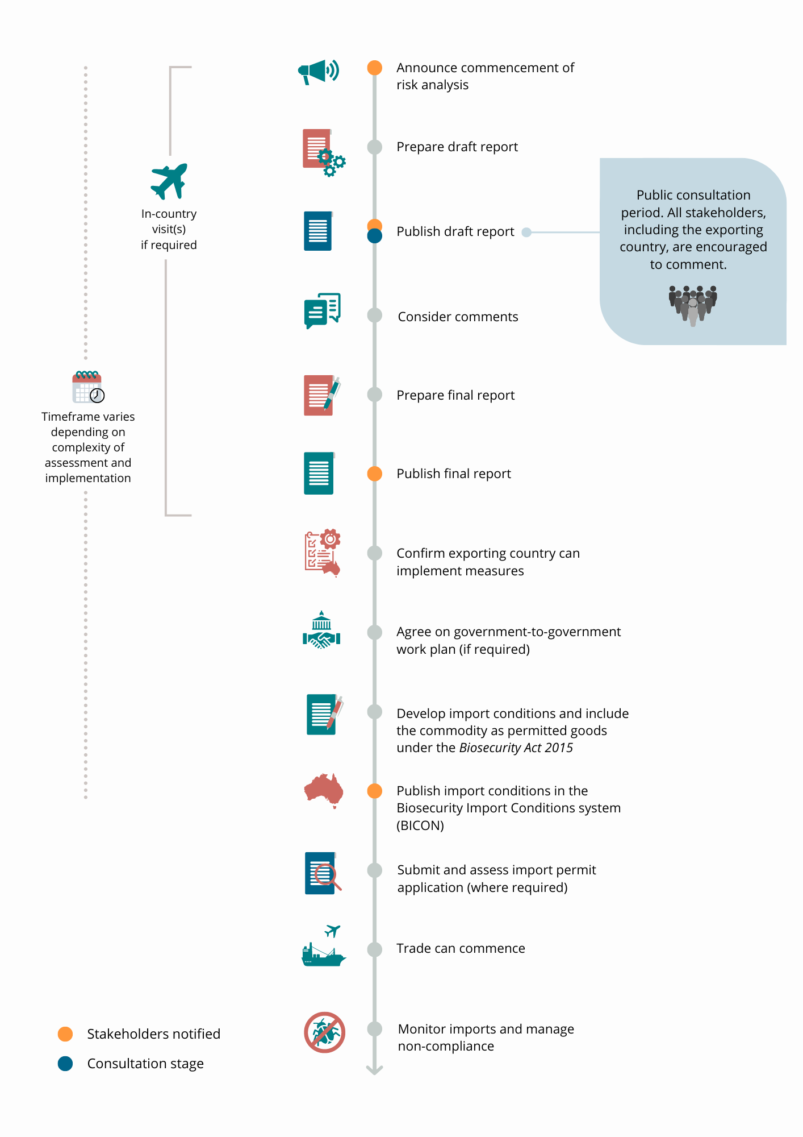
Figure 1.2 Process flow diagram for conducting a risk analysis and implementing trade
The PRA was conducted in the following 3 consecutive stages:
- Initiation—identification of:
  - the pathway being assessed in the risk analysis
  - the pest(s) that have potential to be associated with the pathway and are of biosecurity concern and should be considered for analysis in relation to the identified PRA area.
- Pest risk assessment—this was conducted in 2 sequential steps:
2a. Pest categorisation: examination of each pest identified in stage 1 to determine whether it is a quarantine pest and requires further pest risk assessment.
2b. Further pest risk assessment: evaluation of the likelihoods of the introduction (entry and establishment) and spread, and the magnitude of the potential consequences of the quarantine pest(s). The combination of the likelihoods and consequences gives an overall estimate of the biosecurity risk of the pest, known as the unrestricted risk estimate (URE).
- Pest risk management—the process of identifying and proposing/recommending required phytosanitary measures to reduce the biosecurity risk to achieve the ALOP for Australia where the URE is determined as not achieving the ALOP for Australia. Restricted risk is estimated with these phytosanitary measure(s) applied.
A phytosanitary measure is ‘any legislation, regulation or official procedure having the purpose to prevent the introduction or spread of quarantine pests, or to limit the economic impact of regulated non-quarantine pests’ (FAO 2023a).
For further information on the:
- method for PRA see: Appendix A
- terms used in this risk analysis see: Glossary, acronyms and abbreviations at the end of this report
- pathway being assessed in this risk analysis see: section 1.2.2
- initiation and pest categorisation see: Appendix B
- commercial production practices and potential export capabilities of dragon fruit in the Philippines see: Chapter 2
- pest risk assessments for pests/pest groups identified in Appendix B as requiring further pest risk assessment see: Chapter 3
- risk management measures for pests/pest groups assessed in Chapter 3 as not achieving the ALOP for Australia see: Chapter 4.

Next steps
The final report will be published on the department’s website along with a notice advising stakeholders of the release. The department will also notify the proposer, the registered stakeholders and the WTO Secretariat about the release of the final report. Publication of the final report represents the end of the risk analysis process.
Before any trade in dragon fruit from the Philippines commences, the department will verify that the Philippines can implement the required pest risk management measures (as specified in section 4.1), and operational system for the assurance, maintenance and verification of phytosanitary status (as specified in section 4.2). On verification of these requirements, the import conditions for dragon fruit from the Philippines will be published on BICON.

Commercial production practices for dragon fruit in the Philippines
This chapter provides information on the pre-harvest, harvest and post-harvest practices considered to be standard practices in the Philippines for the production of dragon fruit for export. It also outlines the export capability of the Philippines.

Considerations used in estimating unrestricted risk
The Philippines provided a technical market access submission to Australia that included information on commercial production practices of dragon fruit in the Philippines.
The department visited dragon fruit export production areas in the Cavite and Batangas provinces in the Calabarzon region of the Philippines in June 2022, to observe pest status and production practices for dragon fruit. The department’s observations, and additional information provided during and after the visits confirmed the production, harvest, processing and packing procedures described in this chapter as standard commercial production practices for dragon fruit for export.
The information provided by the Philippines and gathered by the department during the visit has been supplemented with data from published literature and other sources and has been taken into consideration when estimating the unrestricted risks of pests that may be associated with import of this commodity.
In estimating the likelihood of pest introduction, it was considered that the pre-harvest, harvest and post-harvest production practices for dragon fruit, as described in this chapter, are implemented by all growers and packing houses for all species of dragon fruit produced for export.

Production areas of dragon fruit
The Philippine dragon fruit industry is a new and emerging industry that has taken several years to become established. Dragon fruit was originally a backyard ornamental plant that is now commercially cultivated (Eusebio & Alaban 2018) across the whole of the Philippines with production mainly focused on supplying the domestic market. Production is expanding as the fruit becomes more profitable to produce. Some farmers have replaced coffee and pineapple plantations with dragon fruit, due to its increasing value (Tepora 2019).
The majority of dragon fruit is produced in 5 regions of the country: Ilocos Region, Cagayan Valley, Central Luzon, Calabarzon and Central Visayas (Table 2.1) (BPI 2022). From 2015 to 2021, production volumes were low and fluctuated each year according to local conditions.
The main production areas are identified in Map 3.
Map 3 Main production areas of dragon fruit in the Philippines marked by red boxes
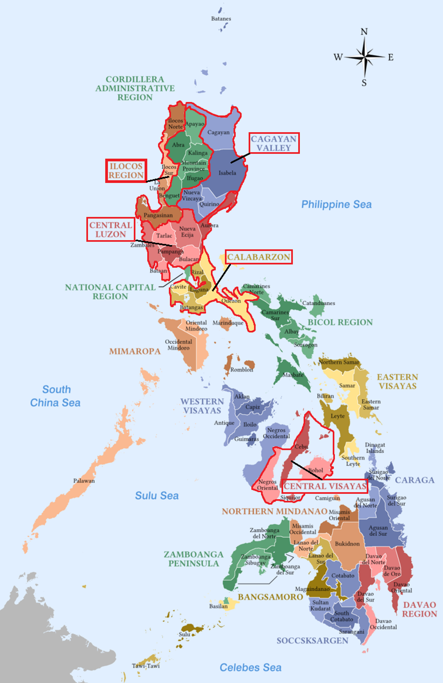
Dragon fruit is grown throughout the Philippines. The different growing regions are represented by different colours. The red boxes indicate the main production areas that are most likely to produce for export. Source: Department of Agriculture (2020)
Table 2.1 Area and volume of the top 5 dragon fruit producing regions of the Philippines (2021)
Region | Area planted (hectares) | Production (tonnes)
Ilocos Region | 177.7 | 568.7
Cagayan Valley | 140.0 | 455.4
Central Luzon | 40.5 | 239.6
Calabarzon | 57.3 | 185.1
Central Visayas | 76.0 | 173.5
Source: BPI (2022)

Climate in production areas
The Philippines has a tropical climate, which is characterised by relatively high temperature, high humidity and abundant rainfall. The mean annual temperature across the Philippines is 26.6°C. The coolest month is January, averaging 25.5°C and the warmest is May, averaging 28.3°C. Areas of high altitude have cooler than overall average weather (PAGASA 2021). Figure 2.1 shows mean monthly minimum and maximum temperatures, as well as mean monthly rainfall in the cities of major dragon fruit growing regions.
The Philippines’ climate can be divided into 2 seasons, the wet season from June to November and dry season from December to May. Depending on the amount of rainfall and length of the dry season, the country can be split into 4 climate types (Map 4). Generally, the 2 climates (Types 2 and 4) on the north-eastern and south-eastern coasts receive high amounts of rain and barely have a dry season. The central Philippine region (Type 3) has a short dry season, and the west coast (Type 1) has both a pronounced dry and wet season (PAGASA 2021).
Map 4 Four climate types of the Philippines
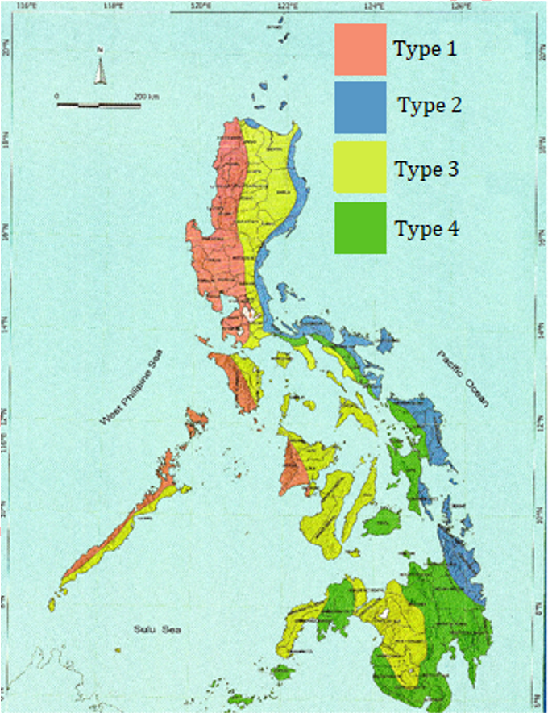
Source: Department of Agriculture (2020); PAGASA (2021)
Figure 2.1 Mean monthly minimum and maximum temperatures and mean monthly rainfall in the main production areas of dragon fruit in the Philippines
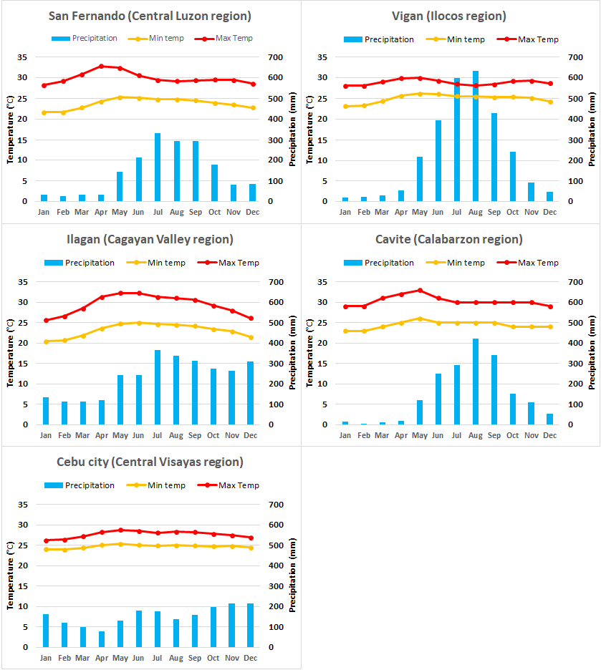
Source: Climate-data.org (2023)

Pre-harvest

Cultivars
There are a number of different dragon fruit species and varieties that can differ in appearance, taste and growing requirements.
Generally, all species of dragon fruit display certain similar fruit characteristics. The fruit is consistently spherical or oval shaped with waxy skin from which numerous bracts protrude over the whole fruit. At the tip of the fruit is a flower end pit and the base at the other end is connected directly to the plant stem. The fruit flesh is uniform and evenly filled with small edible black seeds (Le Bellec, Vaillant & Imbert 2006).
Dragon fruit was first introduced into the Philippines in 1992 using nursery stock from Vietnam and Taiwan (Department of Agriculture 2020). The white-fleshed variety was initially produced on a small farm in the Cavite region, which soon expanded to other farms in this region and then into other areas of the country (Department of Agriculture 2020). Since its introduction, production has expanded to include several varieties and species of edible dragon fruit.
The Philippines DA identified 2 species currently produced in the Philippines (Selenicereus monacanthus and S. undatus; previously known as Hylocereus monacanthus and H. undatus) as likely to be exported to Australia. A description of these species is provided below, and images of the fruits are in Figure 2.2.
- Selenicereus monacanthus (synonym = S. polyrhizus) — The plant of S. monacanthus has slender stems and produces 25–30 cm long flowers with red margins and yellow stigma. The fruit is oblong in shape, 10–12 cm in diameter, weighs 130–350 g and the skin is scarlet in colour. The surface is covered in bracts of varying size. The flesh is red with many small black edible seeds (Le Bellec, Vaillant & Imbert 2006).
- Selenicereus undatus — The plant of S. undatus has long green stems and produces flowers up to 29 cm long that are green on the outside and white on the inside. The oblong shaped fruit is 15–22 cm long weighing 300–800 g. The fruit skin is rosy red and covered with large and long red bracts with green tips. The flesh is white with many small black edible seeds (Le Bellec, Vaillant & Imbert 2006).
Figure 2.2 Selenicereus monacanthus fruit and segments showing red flesh and seeds and a cross-section of Selenicereus undatus showing white flesh and seeds
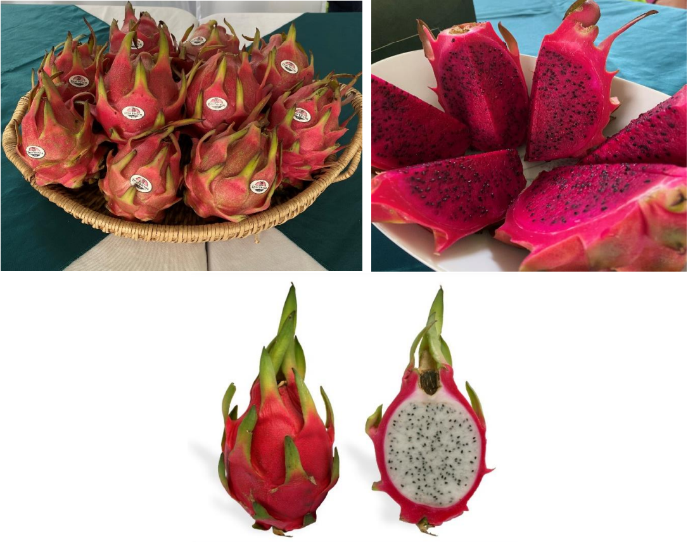
Source: Wikipedia
Two other species (S. costaricensis and S. megalanthus; previously known as Hylocereus costaricensis and H. megalanthus) are also commonly produced in the Philippines. While the Philippines DA has not currently identified these species for export to Australia, they are also produced in the Philippines and could potentially be exported. Therefore, they have been specifically included and described below.
- Selenicereus costaricensis — The plant of S. costaricensis has stout waxy white stems and produces 25–30 cm long flowers with red margins on the petals (Le Bellec, Vaillant & Imbert 2006). The fruit is ovoid in shape, 10–15 cm in diameter, weighs 250–600 g, and the skin is scarlet in colour. The surface is covered in bracts of varying size. The flesh is reddish-purple with many small black edible seeds (Le Bellec, Vaillant & Imbert 2006).
- Selenicereus megalanthus — The fruit of S. megalanthus is oblong in shape and typically smaller than other varieties of dragon fruit, weighing as little as 120 g (Nerd & Mizrahi 1998). The fruit surface is covered in bracts that are smaller and more uniform in shape than other species and the skin is yellow in colour. The flesh is white with many small black edible seeds (Nerd & Mizrahi 1998).
It is uncertain whether S. costaricensis, S. monacanthus and S. polyrhizus should continue to be split into separate species. Each of the names are often identified in the literature as a synonym of one or both of the other 2 species, depending on the source (Korotkova, Borsch & Arias 2017; Paśko et al. 2021; Temak et al. 2018). A phylogenetic study by Korotkova, Borsch and Arias (2017) concluded further analysis is required to determine whether these are the same or separate species.

Cultivation practices
Dragon fruit are tropical, climbing, semi-epiphytic cacti. They have roots below ground and aerial roots that enable them to attach to and climb over any natural or artificial support structures (Le Bellec, Vaillant & Imbert 2006).

Cuttings
Dragon fruit was initially introduced to the Philippines using nursery stock from Vietnam and Taiwan (Department of Agriculture 2020). The Philippines currently allows the importation of dragon fruit cuttings and seedlings for propagation from China, Korea, Malaysia, Peru, Singapore, Taiwan, Thailand and Vietnam (NPQSD 2022). However, the importation of cuttings or seedlings is not common practice as good quality, healthy cuttings are readily available from established plantations in the Philippines.
Cuttings of the entire stem or 15–20 cm long segments are taken from healthy plants, dipped in fungicide and left to dry. Healthy cuttings are then selected to be planted and treated with rooting hormones to improve rooting. The cuttings can be stored in a cool, dry area for approximately 1 to 2 weeks before planting. The stem cuttings are planted using a well-drained potting medium (Pascua, Pascua & Gabriel 2015) or planted directly into the ground.
While dragon fruit can be grown from seed, this is not recommended for planting as they are slow growing compared to propagation from cuttings and the plants grown from seed may not be true to type (Department of Agriculture 2020).

Planting
Dragon fruit on export farms are grown as a single crop, usually in rural areas, often surrounded by roadside fruit stalls and small farms growing other crops for personal consumption such as banana, corn, durian and pineapple.
Dragon fruit plants are grown in open fields (Figure 2.3) with direct exposure to sunlight, and well-draining, sandy soil with high organic matter (Department of Agriculture 2020; Pascua, Pascua & Gabriel 2015). Dragon fruit farms that have been converted from other crops often have trees planted as a windbreak or other remnant trees from the previous crop still bordering the farm (Figure 2.3).
Figure 2.3 Dragon fruit plantations with bordering tree lines
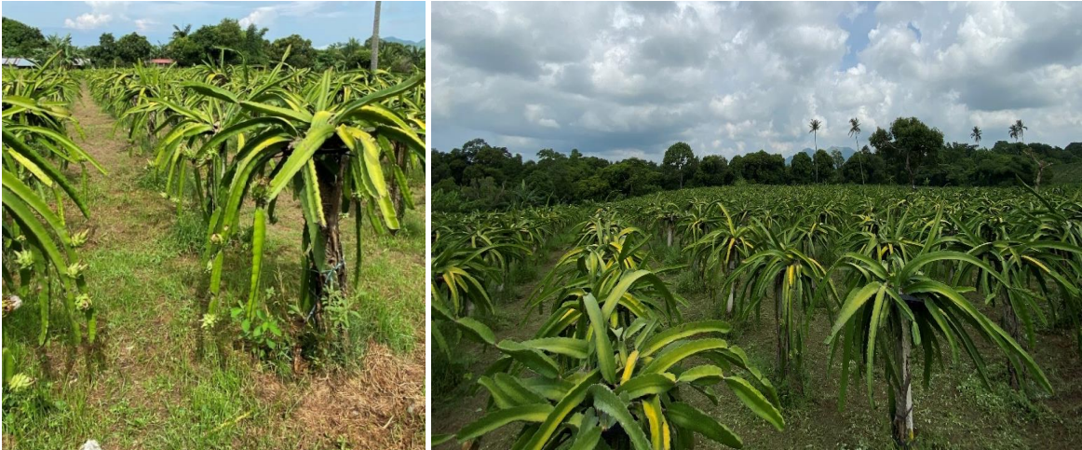
Dragon fruit plants require support structures to grow effectively. Two-metre-high cement, PVC or wooden posts are placed into mounded rows as support for the plant (Department of Agriculture 2020; Pascua, Pascua & Gabriel 2015). The posts are buried in the ground with a planting distance 2–3 metres between posts and 2.5–4 metres between rows (Department of Agriculture 2020; Pascua, Pascua & Gabriel 2015). Used tyres, steel bars or alternative materials are used to make a crown at the top of the posts.
Approximately 2–4 stem cuttings or propagules are planted into the soil around the base of each support post and tied to the post using plastic string (Figure 2.4). This provides stability and a structure for the plant to climb (Pascua, Pascua & Gabriel 2015).
Figure 2.4 Dragon fruit stem cuttings tied to cement posts using plastic string
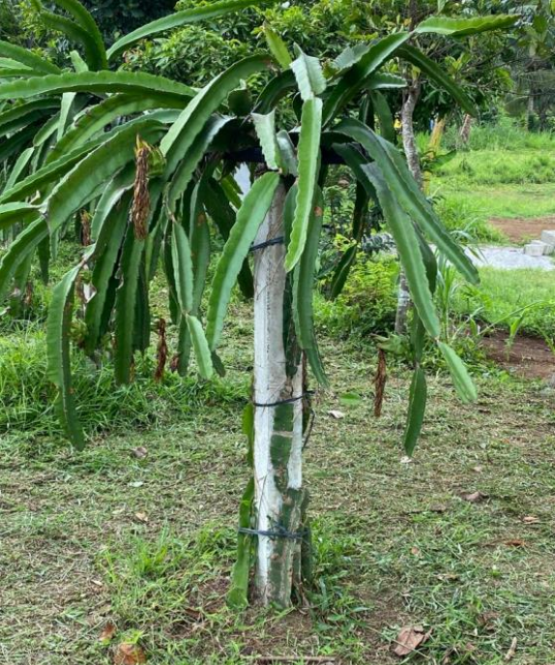
The stems of the dragon fruit plants are trained to grow towards the crown of the structure and are topped when approximately 1 metre high to promote growth into multiple shoots. The shoots branch out and spread around the crown of the structure to form an umbrella-like canopy (Pascua, Pascua & Gabriel 2015) (Figure 2.5).
Figure 2.5 Trained dragon fruit stem forming a crown structure
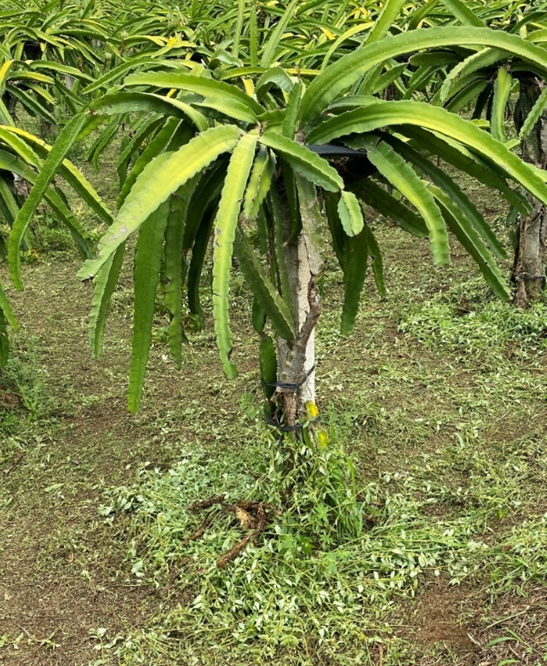
Dragon fruit is a shallow rooted plant with most roots concentrated in the top 15–30 cm of the soil. Organic fertilisers are used liberally at the base of the post and incorporated into the soil before planting. Inorganic fertilisers are applied approximately every 3 months 5–8 cm away from the base of the plant to prevent direct contact. Foliar fertiliser is also applied every 2 weeks during the establishment period (Pascua, Pascua & Gabriel 2015). Fertilisers that contain around 30% calcium are applied during the fruiting stage to prevent fruit split. It is common practice to not use fertilisers that contain nitrogen during the fruiting stage, as it induces growth of new stems. Bio-fertilisers such as Mykovam, Bio-N or vermicompost are also used as cheaper alternatives to synthetic fertilisers in some farms (Eusebio & Alaban 2018).

Planting time
New dragon fruit propagation material is planted during the wet season (June to November) to save on both irrigation costs and to ensure that the crop coincides with the subsequent flowering season (Pascua, Pascua & Gabriel 2015).

Pruning and weeding
Stems are pruned with sterile secateurs to create an open, manageable, productive canopy. Low hanging stems or additional shoots that develop at the base of the plants are removed. Pruned stems are usually disposed of by burial away from the plants. Any stems with possible disease symptoms such as stem canker or anthracnose are pruned and deep buried offsite. Pruned healthy stems can be used as new planting materials if required.
Weeds, grass and other vegetation around the diameter of each post are mechanically removed (Pascua, Pascua & Gabriel 2015). Cut grass is piled onto the planting mounds to act as mulch for water retention during the summer months.

Bagging
Plastic, cloth or paper bags can be used to cover fruit to prevent fruit fly infestation (Eusebio & Alaban 2018; Pascua, Pascua & Gabriel 2015). This practice is not standard across all commercial production areas but is recommended as a practice in areas where fruit flies are a problem.

Irrigation
Newly planted dragon fruit are generally irrigated twice each week. Plants are irrigated just after fertilisation (Pascua, Pascua & Gabriel 2015) and frequently throughout the dry season (Department of Agriculture 2020). The frequency and amount of watering required is dependent on the amount of rainfall in the production area.
The posts of the growing structure are also wet to enhance the growth of aerial roots from the underside of the stems that provide anchorage for climbing (Pascua, Pascua & Gabriel 2015).

Forced flower induction
Dragon fruit is photoperiodic, blooming under long daylight conditions. Artificial lighting, during periods of the night, is used to extend the harvesting period when the length of daylight time is insufficient to induce flowering. For example, one export orchard in the Philippines used artificial lighting every night between 7pm and 1am in September to extend its production season by 3 months. In this instance six-watt light emitting diode (LED) bulbs or 26-watt compact fluorescent lamps (CFL) were suspended at the centre of 4 posts of dragon fruit plants, 1.5 metres above the ground to achieve the desired effect.

Pest management
A range of pests can occur on commercially grown dragon fruit plants such as fungi and insects, including fruit flies. Relevant pest management practices are independently assessed and applied by farm managers to manage pests or diseases specific to the production area (Eusebio & Alaban 2018). Staff are trained to identify pests and apply the appropriate management practices.
Stem canker due to fungal infection is one of the main diseases of concern affecting dragon fruit production in the Philippines. Stem canker is managed through pruning to ensure sufficient aeration around the canopy at the top of the plant. The increased aeration limits conditions that are favourable for fungi to grow and cause the cankers.
Soft rot and anthracnose are fungal diseases that affect dragon fruit plants and contribute to low fruit yield (Eusebio & Alaban 2018). Anthracnose caused by fungi affects the base stems close to the surface of the soil. Infected stems are stripped down to their woody stem using a technique called ‘scraping’. This management practice removes the source of spores and reduces likelihood of fungal infection (Figure 2.6). Canopy stems infected by soft rot or anthracnose are removed from the plant through pruning. Infected stems are deep buried offsite to avoid re-infection. Application of copper-based fungicide and good soil health are also used to combat these diseases (Eusebio & Alaban 2018).
Figure 2.6 Stripped dragon fruit trunks with exposed stem
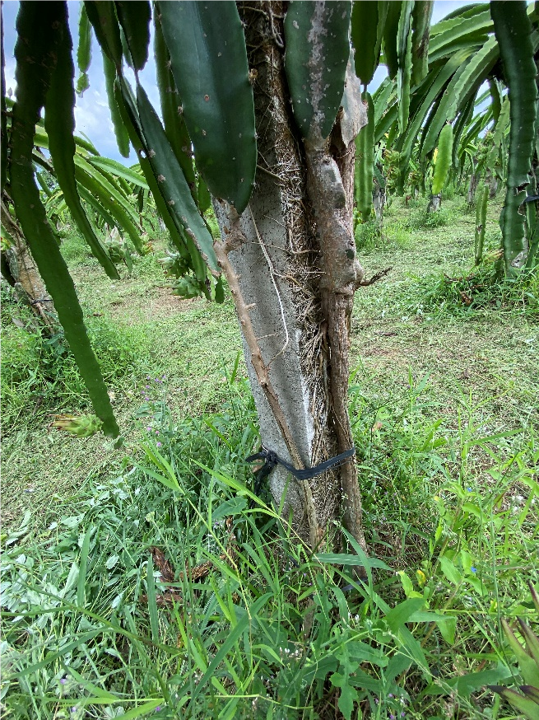
Crops are monitored for pests and diseases daily. Growers and farmhands inspect the plants and any obvious external feeding pests encountered are physically removed and squashed. Soap spray solutions or chlorpyrifos-based insecticides are also used to control the presence of pests such as ants and scale insects (Eusebio & Alaban 2018; Pascua, Pascua & Gabriel 2015).
The Philippines DA oversees the national fruit fly monitoring and surveillance program to assess the distribution and prevalence of key fruit fly pests across the country. In some circumstances farms use methyl eugenol traps, as well as bagging, to prevent fruit fly attacks (Eusebio & Alaban 2018; Pascua, Pascua & Gabriel 2015).

Harvesting and handling procedures
A newly established plant takes around 18 months to bear fruit, and plants can live up to 30 years. The main dragon fruit production period is between May and October, although it can extend through to December with the use of artificial lighting.
Dragon fruit is harvested approximately 25 to 45 days after flowering, when the fruit skin starts to change from green to a ripened colour (for example, scarlet or rosy red depending on the species), signifying that the fruit has reached its appropriate level of ripeness (Department of Agriculture 2020; Rodeo, Castro & Esguerra 2018). Fruits harvested up to 50 days after flowering are sweeter and heavier, however, have a relatively shorter shelf life. The Philippines National Standard for dragon fruit (Department of Trade & Industry‚ Philippines 2013) sets out the requirements of fruit maturity for fruit supplied to consumers.
The fruit is harvested manually using a sterilised garden knife, scissors, secateurs or pruning shears to cut the fruit from the stems. A ‘v’ shape is cut into the stem and a small stem piece often remains attached to the fruit (Figure 2.7). Harvested fruits are collected in plastic crates in the field prior to transfer to the packing house (Pascua, Pascua & Gabriel 2015).
Figure 2.7 Harvesting dragon fruit
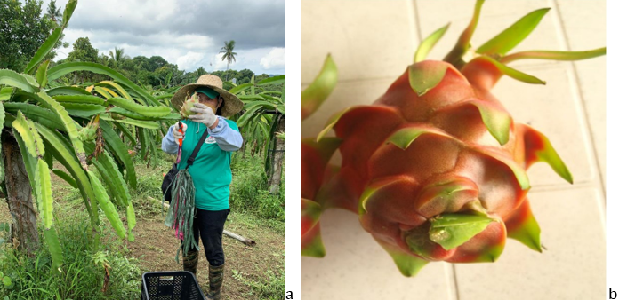
a: Dragon fruit being harvested with pruning shears and collected in a plastic crate. b: Dragon fruit with small portion of stem remaining on the fruit. Source: (Department of Agriculture 2020)

Post-harvest

Packing house processes
Packing house operations in the Philippines are described as being “not sophisticated due to a limited number of [processes] done before marketing” (Rodeo, Castro & Esguerra 2018). This is largely attributed to the current focus on supplying the domestic market. For small- to medium-scale producers, harvested fruit are sorted in packing houses constructed on the farm (Rodeo, Castro & Esguerra 2018). Packing houses used for processing fruit must be registered and have their standard operating procedures that describe operational practices approved with the Philippines DA, prior to export.

Fruit receival, pre-sorting and cleaning
Harvested fruit are put in plastic crates and taken to the packing house either by farmhands or via trucks, utility vehicles or closed vans depending on the distance of the production site from packing location (Rodeo, Castro & Esguerra 2018).
The fruit are unloaded in the receiving area, documentation checked, and fruit weighed and labelled to indicate their production site, harvest date and sorting date (Figure 2.8). If required, fruit are pre-sorted at this stage, accepting fruit that are fit for market, or rejecting based on poor quality or observed damage.
Washing of the fruit is currently not done as part of the packing house processes, however, trimming of the stem and wiping of the fruit is sometimes done at this stage to remove dirt and increase fruit appeal (Rodeo, Castro & Esguerra 2018). Industrial-sized fans are also used to dry harvested wet fruit before packing, when necessary, to decrease the chance of post-harvest rot. Applying high pressure air to fruit during the packing processes to remove arthropod pests that may be present during packing is not currently used but may be introduced if required. Fruit are usually processed on the same day that they are harvested.
Figure 2.8 Harvested fruit in receival area
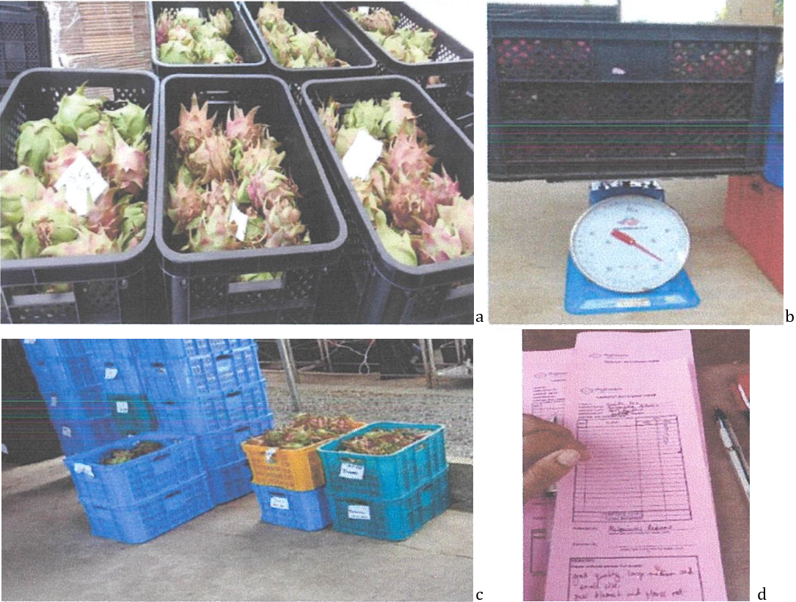
a: Fruit in crates in receival area with traceability cards. b: Crates of dragon fruit being weighed c: Labelled crates after documentation checks. d: Harvested fruit documents being checked. Source: (BPI 2022)

Grading and sorting
Grading and sorting take place in a separate room to the receival area. Fruit are examined by workers, graded by size and quality and then sorted into different crates based on grade (Figure 2.9). The Philippine government has developed a Philippine National Standard (PNS) for the classification, grading and quality requirements for fresh dragon fruit intended for both domestic and international markets. Based on the PNS, dragon fruit can be classified into 3 classes, Extra class, Class I and Class II (Department of Trade & Industry‚ Philippines 2013). However, growers, traders and owners of commercial dragon fruit farms in the Philippines often implement additional quality classifications based on buyers’ requirements when preparing the fruit for market. If graded fruit meets the Extra class quality requirements it can be reserved for export, otherwise high-class fruit goes to supermarkets and wholesale fruit markets, while lower class fruit goes to wet markets, is fed to livestock or used for processing (Rodeo, Castro & Esguerra 2018).
To satisfy the minimum quality requirements of the PNS, fresh dragon fruit in all classes must be:
  - whole, ripe, firm, sound, clean and free of any visible foreign matter
  - fresh in appearance
  - practically free of pests affecting the general appearance of the produce
  - practically free of damage caused by pests
  - free of abnormal external moisture excluding condensation following cold storage
  - free of any foreign smell and/or taste
  - free of cracks in the skin
  - have a peduncle between 0.5–1.0 cm in length
  - thornless.
In addition, the dragon fruit must have reached an appropriate degree of development and ripeness in accordance with the characteristics of the variety and/or type and the area in which they are grown (Department of Trade & Industry‚ Philippines 2013).
Figure 2.9 Dragon fruit being graded and sorted into different crates based on size and quality
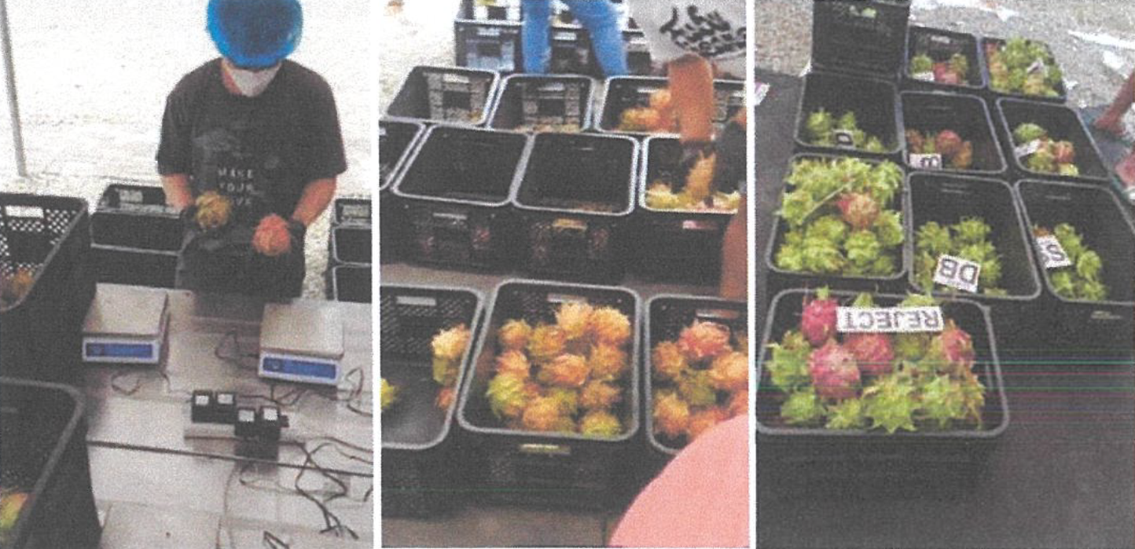
Source: (BPI 2022)

Packing
After grading and sorting, fruit are moved to a separate area to be packed into boxes or cartons for market delivery. It is a requirement that export-registered packing houses handle and pack fruit in accordance with the appropriate sections of the Recommended International Code of Practice for Packaging and Transport, the Code of Hygienic Practice for Fresh Fruit and Vegetables and other Codes (Department of Trade & Industry‚ Philippines 2013).
Packing houses are designed to ensure fruit are processed in a clean and hygienic environment. For example, the packing area of an export-registered packing house visited was enclosed with white plastic sheets, with thick black ground sheets to avoid crates being contaminated by insect pests and dirt while packing. The fruit are placed inside boxes or cartons according to market requirements. Boxes usually have holes on the sides, which allow air circulation during transport and contain a plastic insert (Figure 2.10). The materials used for packing must be new, clean, and of a quality which avoids causing damage to the produce (Department of Trade & Industry‚ Philippines 2013). The number of fruit in each box depends on the box and fruit size and market requirements. Commonly, around 24–28 fruit are placed in each box. Boxed fruit are stored in the consolidation room until ready for loading.
Packing houses are used to pack fruit intended for both export and domestic markets. Therefore, packing houses ensure fruit intended for the different markets are packed at separate times, with cleaning being undertaken between activities, to ensure cross-contamination does not occur.
Figure 2.10 Plastic covered fruit being packed into boxes
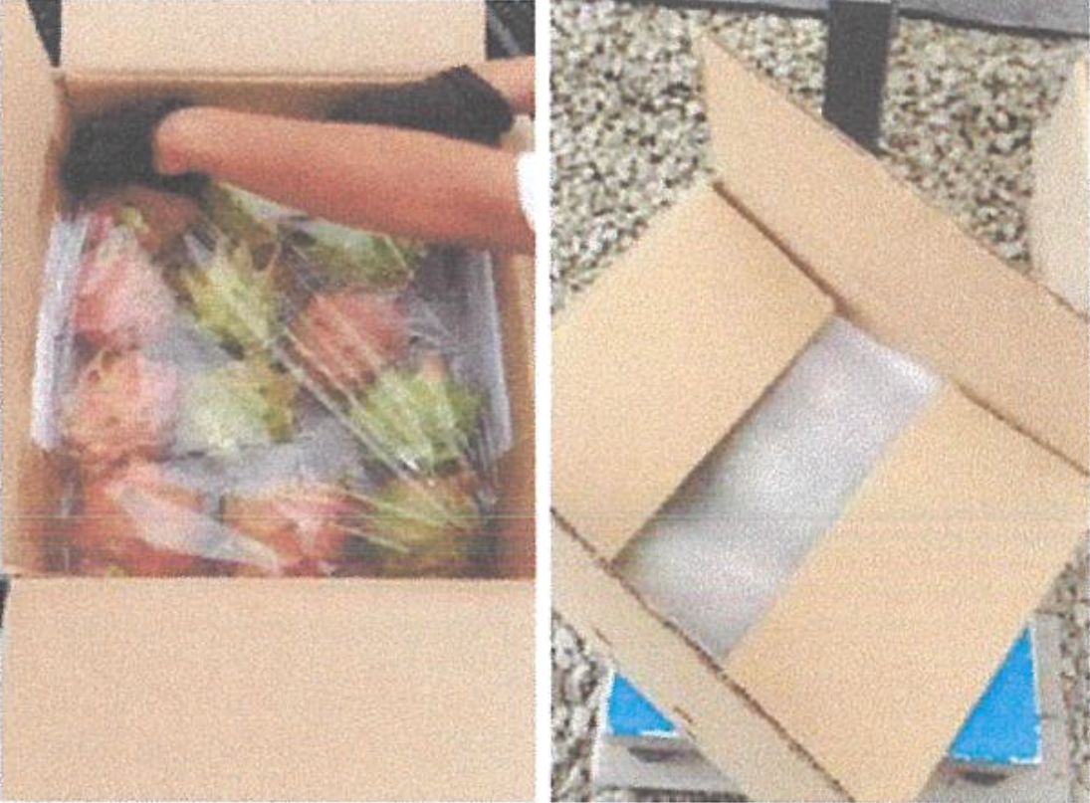
Source: (BPI 2022)

Storage
Dragon fruit is a non-climacteric fruit, and its overall quality starts to decline after harvest (Tepora 2019). Cold storage at 5°C and 90% relative humidity can be used to keep the fruit fresh for between 17 and 40 days (Pascua, Pascua & Gabriel 2015; Tepora 2019). Fruit that are not put in cold storage can be stored for 3 to 4 days at ambient temperature, or 1 week or 2 weeks at 20°C or 14°C respectively (Tepora 2019). Currently, post-harvest cold storage facilities and technologies are lacking in the Philippines, causing post-harvest losses during storage and transportation (Tridge 2022). Harvested fruit are mostly packed and delivered within 24 hours to combat the lack of cold storage facilities (Rodeo, Castro & Esguerra 2018).

Phytosanitary inspection
Prior to export, all consignments of fresh dragon fruit are required to undergo a phytosanitary inspection by Philippines DA approved personnel, as described in section 4.2.6. If the consignment is found to be free of pests and meets the requirements of importation, it is issued with a phytosanitary certificate. Currently, the Philippines exports dragon fruit only to markets that do not require phytosanitary certification. Phytosanitary inspection and certification procedures for exporting dragon fruit would need to be established before trade to Australia could commence.

Transport
Packed fruit boxes are loaded into small trucks or non-refrigerated vans and delivered to ports for export. Transportation generally occurs in the evening to avoid excess heat during transportation, which can affect shelf life. Fruit are then transported by sea or air to the destination country.
A summary of the operational steps for dragon fruit grown in the Philippines for export is provided in Figure 2.11.
Figure 2.11 Summary of operational steps for dragon fruit grown in the Philippines for export
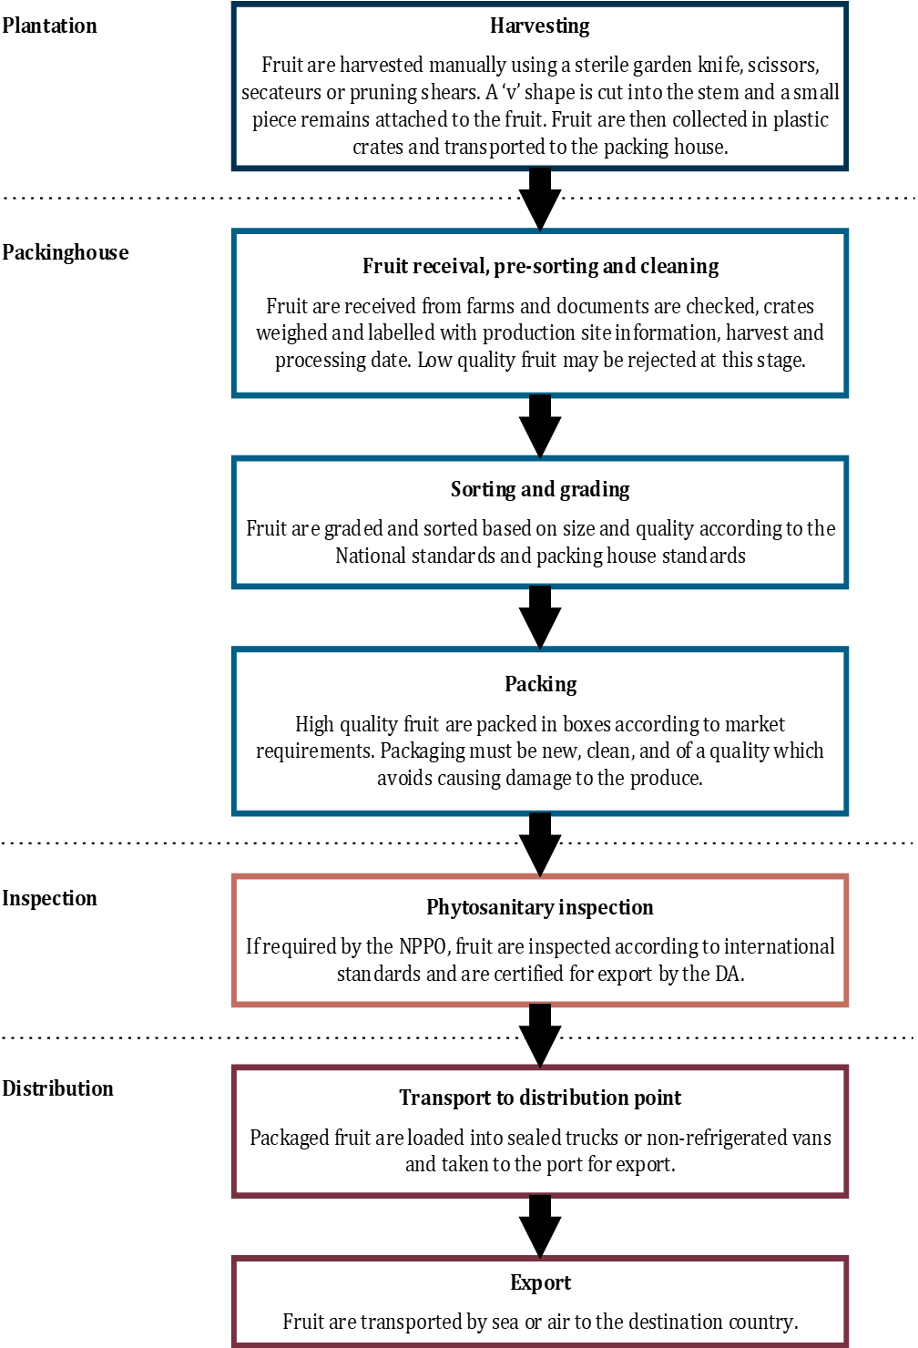

Export capability

Production statistics
Currently, Philippine dragon fruit production only accounts for a small proportion of the global market, producing approximately 2,090 tonnes of dragon fruit in 2021 (BPI 2022). In comparison, Vietnam the largest producer of dragon fruit, produced approximately 1.4 million tonnes in 2021 (Tridge 2022).
However, the dragon fruit production areas and volumes have increased in the Philippines in recent years, with more growth forecasted (Tridge 2022). In 2012, dragon fruit production area and average annual production were 182 hectares and 256 metric tonnes, respectively. This had increased to 596 hectares and 2090 metric tonnes in 2021 (BPI 2022; Department of Agriculture 2020; Tridge 2022) (Table 2.2). Production is forecast to further increase with expected rising demand in the coming years, with one source forecasting the production area to reach approximately 12,000 hectares by 2025 (Tridge 2022).
Over time, the average yield per hectare has also increased due to initiatives by government, private farms and the Growers’ association. In 2012, the average yield was 1.41 metric tonnes per hectare compared to 3.25 metric tonnes per hectare in 2017. In 2022, a commercial plantation approved for export in the Calabarzon region produced 12–15 metric tonnes per hectare from newly established plantations, and up to 20 metric tonnes per hectare for established plantations.
Compared to other ASEAN countries, the Philippines has relatively low production yield per hectare, since most of the production areas have marginal environmental conditions for agriculture (Pascua, Pascua & Gabriel 2015; Rodeo, Castro & Esguerra 2018) and the industry is still developing the best methods for production. Growers, provincial government and universities have recently partnered to improve production quality and marketing (Tridge 2022).
Table 2.2 Current area and production of dragon fruit in the Philippines (2012-2021)
Year | Crop Area (hectares) | Yield (tonnes)
2012 | 181.9 | 256.5
2013 | 223.5 | 411.5
2014 | 295.4 | 671.8
2015 | 329.3 | 863.5
2016 | 407.6 | 1,237.8
2017 | 472.5 | 1,462.5
2018 | 499.4 | 1,435.4
2019 | 539.0 | 1,751.2
2020 | 582.7 | 1,863.8
2021 | 596.8 | 2,091.0
Source: BPI (2022); Department of Agriculture (2020); Tridge (2022)

Export statistics
Information provided by the Philippines DA indicates the Philippines started exporting dragon fruit in 2009. Exports have generally been sporadic and in very low volumes to Bahrain, Canada, China, Japan, Qatar, Singapore, South Korea, United Arab Emirates and the United Kingdom. Exports have been of both the yellow skin variety and red skin and flesh variety of dragon fruit (BPI 2022; Department of Agriculture 2020). Volumes of dragon fruit exports are low, with the largest volume being 24 metric tonnes, exported in 2021.

Export season
The Philippine production period for dragon fruit is between May and October, although it can extend into December with the use of artificial lighting.

Pest risk assessments for quarantine pests

Summary of outcomes of pest initiation and categorisation
The initiation process (Appendix B) identified 79 pests as being associated with dragon fruit in the Philippines.
Of these 79 pests, the pest categorisation process (Appendix B) identified:
- 62 pests as already present in Australia and not under official control, and therefore not requiring further assessment
- 8 pests as not having potential to enter on the commercially produced dragon fruit from the Philippines pathway, and therefore not requiring further assessment
- one pest as not having potential to establish and spread in Australia, and therefore not requiring further assessment.
The remaining 8 pests were assessed as having potential to establish, spread and cause consequences in Australia, and therefore requiring further pest risk assessment.
In applying the Group PRAs, 3 quarantine pests for each of the mealybug and thrips groups were categorised on the import pathway and listed in the pest categorisation (Appendix B). However, if any other quarantine pests or regulated articles not included in this risk analysis and/or in the respective Group PRA are detected at pre-export inspection or on arrival in Australia, the appropriate Group policy will also apply to those pests. The application of the Group PRAs to this risk analysis is outlined in Appendix A in section A2.7.

Pests requiring further pest risk assessment
The 8 pests, associated with commercially produced dragon fruit for export from the Philippines, identified as requiring further pest risk assessment are listed in Table 3.1. Of these 8 pests:
- 7 are quarantine pests and one is a regulated article for Australia as it vectors emerging quarantine orthotospoviruses
- 2 of the 7 quarantine pests are also regulated articles for Australia as they vector emerging quarantine orthotospoviruses
- 2 of the 7 quarantine pests are regional quarantine pests as, whilst they have been recorded in some regions of Australia, interstate quarantine regulations are in place and enforced.
Table 3.1 Quarantine pests and regulated thrips potentially associated with dragon fruit from the Philippines, and requiring further pest risk assessment
Pest/pest group | Scientific name | Common name | Policy status/region
Fruit flies  [Diptera: Tephritidae] | Bactrocera dorsalis | oriental fruit fly | EP
 | Zeugodacus cucurbitae | melon fly | EP
Mealybugs  [Hemiptera: Pseudococcidae] | Dysmicoccus neobrevipes | grey pineapple mealybug | GP
 | Paracoccus marginatus | papaya mealybug | GP
 | Pseudococcus jackbeardsleyi | Jack Beardsley mealybug | GP
Thrips  [Thysanoptera: Thripidae] | Frankliniella occidentalis a | western flower thrips | GP, NT
 | Scirtothrips dorsalis | chilli thrips | GP, RA
 | Thrips palmi a | melon thrips | GP, SA, WA
a: Quarantine thrips species that is also identified as a regulated article for Australia as it vectors emerging quarantine orthotospoviruses. EP: Species has been assessed previously and import policy already exists. GP: Species has been assessed previously in a Group PRA, and the Group PRA has been applied. RA: Regulated article. NT: Regional quarantine pest for the Northern Territory. SA: Regional quarantine pest for South Australia. WA: Regional quarantine pest for Western Australia.

Overview of pest risk assessment
This chapter assesses, for each of the pests or pest groups identified in Table 3.1, the likelihoods of entry, establishment and spread, and the magnitude of the associated potential consequences these species may cause if they were to enter, establish and spread in Australia.
All of the pests or pest groups in Table 3.1 have been assessed previously by the department. Where appropriate, the outcomes of the previous assessments for these pests have been adopted for this risk analysis, unless new information is available that suggests the risk would be different. The acronym ‘EP’ is used to identify species assessed previously and for which import policy already exists. The adoption of outcomes from previous assessments is outlined in Appendix A in section A2.6.
The biosecurity risk posed by mealybugs and the viruses they transmit was previously assessed for all countries in the mealybugs Group PRA (DAWR 2019), which has been applied to this assessment of dragon fruit from the Philippines.
The biosecurity risk posed by thrips and the orthotospoviruses they transmit was previously assessed for all countries in the thrips Group PRA (DAWR 2017a), which has been applied to this assessment of dragon fruit from the Philippines.
The acronym ‘GP’ is used to identify species assessed previously in a Group PRA and for which a Group PRA was applied. The application of the Group PRAs to this risk analysis is outlined in Appendix A in section A2.7. A summary of assessment from the Group PRAs is presented for the relevant pests and/or regulated thrips in this chapter for convenience.
A summary of the likelihood, consequence and URE ratings obtained in each pest risk assessment is provided in Table 3.7. An overview of the decision process at the initiation, pest categorisation and pest risk assessment stages of this PRA is presented diagrammatically in Figure 3.1.

Fruit flies
Bactrocera dorsalis (EP) and Zeugodacus cucurbitae (EP)
The species of fruit flies identified as quarantine pests associated with dragon fruit in the Philippines are Oriental fruit fly (Bactrocera dorsalis) and melon fly (Zeugodacus cucurbitae). These species belong to the Tephritidae family, a group of fruit flies considered to be among the most damaging pests of horticultural crops. These fruit fly species are not present in Australia and therefore are quarantine pests for all of Australia.
In this assessment B. dorsalis and Z. cucurbitae have been grouped together as they have common biological characteristics and are considered to pose similar risks. In this assessment, the term ‘fruit flies’ is used to refer to these 2 species. The scientific name is used when the information is about a specific species.
On the basis of phylogenetic relationship analysis, melon fly (Bactrocera cucurbitae) has been proposed to be placed in the genus Zeugodacus (De Meyer et al. 2015; Virgilio et al. 2015). Current and past literature refers to melon fly under both the former (B. cucurbitae) and current (Z. cucurbitae) scientific names. This document uses the currently accepted name, Z. cucurbitae.
Bactrocera dorsalis and Z. cucurbitae are reported to be present across the Philippines (CABI 2023; Hu et al. 2008).
Tephritid fruit flies have 4 life stages: egg, larva, pupa and adult. Over the course of an adult female’s lifetime, Z. cucurbitae can lay up to 1,000 eggs and B. dorsalis can lay between 1,200 and 1,500 eggs (Gerson & Applebaum 2014; Weems, Heppner & Fasulo 2018). Adult flies oviposit eggs below the fruit skin and hatched larvae feed within the fruit (Fletcher 1989). Upon maturity, fruit fly larvae drop to the ground and pupate in the soil, forming a tan/dark brown puparium (Christenson & Foote 1960; Weems, Heppner & Fasulo 2018). Adult fruit flies can survive for more than a year and produce several generations annually, depending on diet and temperature (Christenson & Foote 1960; Weems, Heppner & Fasulo 2018). Fruit flies are primarily dispersed by transfer of infested fruit. However, adult flies of some species have a strong capacity for independent flight (Fletcher 1989; Qureshi et al. 1975).
Bactrocera dorsalis and Z. cucurbitae have been assessed previously in the existing policies for various horticultural commodities, including longans and lychees from China and Thailand (DAFF 2004), and dragon fruit from Vietnam (DAWR 2017b) and Indonesia (DAWR 2018). In those policies, the URE for B. dorsalis and Z. cucurbitae was assessed as High, which does not achieve the ALOP for Australia. Therefore, specific risk management measures are required for B. dorsalis and Z. cucurbitae on those pathways.
The assessment for B. dorsalis and Z. cucurbitae for dragon fruit from the Philippines builds on these previous assessments. However, there may be differences in commercial production practices, climatic conditions and pest prevalence between the previously assessed commodity/country pathways, and that of dragon fruit from the Philippines. These potential differences make it necessary to re-assess the likelihood that B. dorsalis and Z. cucurbitae will arrive in Australia in a viable state on the dragon fruit from the Philippines pathway.
Previous assessments for B. dorsalis and Z. cucurbitae in the existing policies rated the likelihood of distribution as High.
Dragon fruit from the Philippines are expected to be distributed in Australia in a similar way to the previously assessed commodity/country pathways. Dragon fruit are likely to be distributed to various destinations in Australia for sale. They may be distributed through large fresh produce wholesale markets and then to supermarkets or other sellers, or directly to smaller retailers and then to consumers. Most fruit waste would be generally disposed of via municipal waste facilities, reducing the risk of fruit flies distributing to a host. However, a small quantity may be discarded in the environment. Any fruit flies present in discarded dragon fruit may disperse to new hosts, as adult fruit flies are highly mobile and could fly to nearby host plants. Fruit flies have wide host ranges and there will likely be hosts present year-round in Australia. Therefore, the time of year when importation occurs will not affect the likelihood of distribution for these pests. On this basis, the same rating of High for the likelihood of distribution for B. dorsalis and Z. cucurbitae in previous assessments is adopted for the dragon fruit from the Philippines pathway.
The likelihoods of establishment and spread of B. dorsalis and Z. cucurbitae in Australia from the dragon fruit from the Philippines pathway have been assessed as similar to those of the previous assessments of High and High, respectively. Those likelihoods relate specifically to events that occur in Australia and are essentially independent of the import pathway. The consequences of the entry, establishment and spread of B. dorsalis and Z. cucurbitae in Australia are also independent of the import pathway and have been assessed as being similar to those previous risk assessments of High. The existing ratings for the likelihoods of establishment and spread, and the rating for the overall consequences for B. dorsalis and Z. cucurbitae in previous assessments have been adopted for the dragon fruit from the Philippines pathway.
In addition, the department has reviewed the latest literature—for example, Follett, Haynes and Dominiak (2021); Hicks et al. (2019); Huang et al. (2020); Lian et al. (2021); Zhao et al. (2021). No new information has been identified that would significantly change the risk ratings for distribution, establishment, spread and consequences as set out for B. dorsalis and Z. cucurbitae in the existing policies.
The risk scenario of biosecurity concern is that fruit fly eggs or larvae may be present within dragon fruit imported from the Philippines.

Likelihood of entry
The likelihood of entry is considered in 2 parts, the likelihood of importation and the likelihood of distribution, which consider pre-border and post-border issues, respectively.
Likelihood of importation
The likelihood that B. dorsalis and Z. cucurbitae will arrive in Australia in a viable state with the importation of dragon fruit from the Philippines is assessed as: High.
The likelihood of importation is assessed as High because dragon fruit is recorded as a suitable host for B. dorsalis and Z. cucurbitae. Substantial infestation of dragon fruit by these fruit flies is common in countries/regions where they occur, including the Philippines. Fruit with early stages of infestation may not show visible symptoms and may remain undetected during harvest and post-harvest procedures. Also, if any immature life stages are present in fruit, they are likely to remain viable during storage and transport.
The following information provides supporting evidence for this assessment.
Dragon fruit is a suitable host for B. dorsalis and Z. cucurbitae and substantial infestation of dragon fruit by these species is common in countries/regions where they occur, including the Philippines.
- Dragon fruit has been reported as being a good and very good host for B. dorsalis and Z. cucurbitae, respectively (Follett, Haynes & Dominiak 2021), with in-field host suitability studies in Hawaii finding up to 30% of sampled dragon fruit being infested with these fruit flies (McQuate 2010).
- In Vietnam, B. dorsalis has been reported as being one of the most economically important pests of dragon fruit (Khanh et al. 2016) infesting up to 28% of dragon fruit in areas where no control measures are applied (Hien et al. 2020).
- In Hawaii, Z. cucurbitae was found infesting 8% of randomly sampled mature dragon fruit from an orchard at the end of the fruiting season, with infestation rates being equivalent to approximately 100 pupae per kg on average (McQuate 2010).
- In the Philippines, an in-field insect monitoring study trapped a large number of B. dorsalis flies in dragon fruit plantations during the fruiting stage (Estigoy & Estigoy 2015). Twenty-five percent of damaged fruit in this survey were found to be heavily infested by the species (Estigoy & Estigoy 2015).
Infested dragon fruit may not show obvious symptoms at harvest and may therefore remain undetected during harvest and post-harvest procedures.
- Fruit flies lay their eggs beneath the skin of the fruit, taking advantage of crevices, pre-existing damage and other oviposition sites (Bateman 1972). Symptoms of fruit fly infestation may not be apparent until larval development is well advanced, so the eggs and early larval instars can be difficult to detect (Cantrell, Chadwick & Cahill 2002; Putulan et al. 2004). If oviposition occurs shortly before harvest, the affected fruit are unlikely to show obvious symptoms and will therefore be unlikely to be detected and culled during harvesting and post-harvest handling processes.
Fruit fly eggs and larvae will remain viable during transport and storage.
- The development time of fruit flies is inversely dependent on temperature, with development time increasing at lower ambient temperature (Duyck, Sterlin & Quilici 2004; Fletcher 1989; Mkiga & Mwatawala 2015).
- Currently in the Philippines, dragon fruit is not stored or transported at cold temperatures post-harvest (Rodeo, Castro & Esguerra 2018; Tridge 2022).
- The Philippines average temperatures range between 23°C and 32°C, with a yearly average of approximately 26.6°C (Climate-data.org 2023; PAGASA 2021).
- The lower developmental thresholds for B. dorsalis and Z. cucurbitae larvae are approximately 6.2°C and 13.4°C, respectively, which are far below the minimum temperatures in the Philippines (Climate-data.org 2023; Michel et al. 2021; Mkiga & Mwatawala 2015).
For the reasons outlined, the likelihood of importation of B. dorsalis and Z. cucurbitae on imported dragon fruit from the Philippines is assessed as High.
Likelihood of distribution
The likelihood that B. dorsalis and Z. cucurbitae will be distributed within Australia in a viable state as a result of the processing, sale or disposal of dragon fruit from the Philippines, and subsequently transfer to a susceptible part of a host is likely to be similar to fruit flies on previously assessed pathways. The same rating of High for the likelihood of distribution for these pests in previous assessments is adopted for dragon fruit from the Philippines.
Overall likelihood of entry
The overall likelihood of entry is determined as High by combining the re-assessed likelihood of importation of High with the adopted likelihood of distribution of High, using the matrix of rules in Table A.2.

Likelihoods of establishment and spread
The likelihoods of establishment and spread for B. dorsalis and Z. cucurbitae are independent of the import pathway and are considered similar to those in previously assessed pathways.
Based on the existing import policies for these pests, the likelihoods of establishment and spread are assessed as High and High, respectively.

Overall likelihood of entry, establishment and spread
The overall likelihood of entry, establishment and spread is determined by combining the individual likelihoods of entry, of establishment and of spread using the matrix of rules in Table A.2.
The overall likelihood that B. dorsalis and Z. cucurbitae will enter Australia as a result of trade in dragon fruit from the Philippines, be distributed in a viable state to a susceptible part of a host, establish in Australia and subsequently spread within Australia is assessed as High.

Consequences
The potential consequences of the entry, establishment and spread of B. dorsalis and Z. cucurbitae in Australia are similar to those in the previously assessed pathways. The overall consequences in the previous assessments were assessed as High. The overall consequences for B. dorsalis and Z. cucurbitae on the dragon fruit from the Philippines pathway are also assessed as High.

Unrestricted risk estimate
Unrestricted risk is the result of combining the overall likelihood of entry, establishment and spread with the outcome of overall consequences. The likelihood and consequences are combined using the risk estimation matrix shown in Table A.4.
Unrestricted risk estimate for Bactrocera dorsalis and Zeugodacus cucurbitae
Overall likelihood of entry, establishment and spread | High
Consequences | High
Unrestricted risk | High
The URE for B. dorsalis and Z. cucurbitae on the dragon fruit from the Philippines pathway is assessed as High, which does not achieve the ALOP for Australia. Therefore, specific risk management measures are required for B. dorsalis and Z. cucurbitae on this pathway.

Mealybugs
Dysmicoccus neobrevipes (GP), Paracoccus marginatus (GP), Pseudococcus jackbeardsleyi (GP)
Three mealybug species were identified on the dragon fruit from the Philippines pathway as a quarantine pest for Australia: Dysmicoccus neobrevipes (grey pineapple mealybug), Paracoccus marginatus (papaya mealybug) and Pseudococcus jackbeardsleyi (Jack Beardsley mealybug) (Table 3.2).
The indicative likelihood of entry for all quarantine mealybugs is assessed in the mealybugs Group PRA as Moderate (DAWR 2019). Dysmicoccus neobrevipes, P. marginatus and P. jackbeardsleyi are reported from the Philippines and are associated with the fruit of dragon fruit (Doan et al. 2016; García Morales et al. 2023; Ruíz Ronquillo 2021; Sartiami et al. 2019; USDA-APHIS 2008). Standard packing house processes and transportation are not expected to eliminate these mealybugs on the pathway. After assessment of relevant pathway-specific factors (sections A2.6 and A2.7) for dragon fruit from the Philippines, the likelihood of entry of Moderate was verified as appropriate for these mealybug species on this pathway (Table 3.2).
Table 3.2 Quarantine mealybug species for dragon fruit from the Philippines
Pest | In mealybugs Group PRA | Quarantine pest | On dragon fruit pathway | Likelihood of entry
Dysmicoccus neobrevipes | Yes | Yes | Yes | Moderate
Paracoccus marginatus | Yes | Yes | Yes | Moderate
Pseudococcus jackbeardsleyi | Yes | Yes | Yes | Moderate
A summary of the risk assessment for quarantine mealybugs is presented in Table 3.3 for convenience.
Table 3.3 Risk estimates for quarantine mealybugs
Risk component | Rating for quarantine mealybugs
Likelihood of entry (importation x distribution) | Moderate (High x Moderate)
Likelihood of establishment | High
Likelihood of spread | High
Overall likelihood of entry, establishment and spread | Moderate
Consequences | Low
Unrestricted risk | Low
As assessed in the mealybugs Group PRA, the indicative URE for mealybugs is Low (Table 3.3) which does not achieve the ALOP for Australia. This indicative URE is considered to be applicable for the quarantine mealybugs species present on the dragon fruit from the Philippines pathway. Therefore, specific risk management measures are required for the quarantine mealybugs on this pathway.
In the mealybugs Group PRA, viruses of biosecurity concern transmitted by mealybugs were assessed to have an ‘indicative’ URE of ‘Very low’ for plant import pathways, including the fresh fruit pathway. This is because mealybugs can only transmit viruses for a short period of time (semi-persistent transmission) and these viruses also have a limited host range compared to their mealybug vectors. These biological factors make it very unlikely for the viruses vectored by mealybugs on imported fresh fruit to be transmitted to a suitable host plant in Australia. The URE of ‘Very low’ achieves the ALOP for Australia, therefore, no specific risk management measures are required for the viruses transmitted by mealybugs on this pathway.
This risk assessment, which is based on the mealybugs Group PRA, applies to all quarantine mealybugs on the dragon fruit from the Philippines pathway, irrespective of their specific identification in this document. This is explained in section A2.7.

Thrips
Frankliniella occidentalis (GP, NT), Scirtothrips dorsalis (GP, RA), Thrips palmi (GP, SA, WA)
Three thrips species were identified on the dragon fruit from the Philippines pathway as quarantine pests and/or regulated articles for Australia: Frankliniella occidentalis (western flower thrips), Scirtothrips dorsalis (chili thrips) and Thrips palmi (melon thrips) (Table 3.4).
Frankliniella occidentalis is not recorded as present in the Northern Territory and is assessed as a regional quarantine pest for that territory. Thrips palmi is not recorded as present in South Australia and is assessed as a regional quarantine pest for that state. Thrips palmi is present but not widely distributed in Western Australia, and is assessed as a pest of regional concern for all areas of Western Australia outside the Ord River Irrigation Area (Shire of Wyndham-East Kimberley).
Frankliniella occidentalis, S. dorsalis and T. palmi are identified as regulated articles for Australia because they are capable of harbouring and spreading (vectoring) emerging orthotospoviruses that are quarantine pests for Australia, as detailed in the thrips Group PRA (DAWR 2017a). A regulated article is defined by the IPPC as 'any plant, plant product, storage place, packaging, conveyance, container, soil and any other organism, object or material capable of harbouring or spreading pests, deemed to require phytosanitary measures, particularly where international transportation is involved' (FAO 2023a). For simplicity, thrips identified as a regulated article are referred to as 'regulated thrips' in this assessment.
The indicative likelihood of entry for all quarantine and regulated thrips is assessed in the thrips Group PRA as Moderate (DAWR 2017a). Frankliniella occidentalis, S. dorsalis and T. palmi are reported from the Philippines (CABI 2023; Kajita et al. 1996; Mintu & Reyes 2018; Wang et al. 2010) and are associated with dragon fruit (Carrillo, Duncan & Peña 2021; Huang & Chiu 2018; Meza et al. 2020). Standard packing house processes and transportation are not expected to eliminate these thrips from the pathway. After assessment of relevant pathway-specific factors (sections A2.6 and A2.7) for dragon fruit from the Philippines, the likelihood of entry of Moderate was verified as appropriate for these thrips on this pathway (Table 3.4).
Table 3.4 Quarantine and regulated thrips species for dragon fruit from the Philippines
Pest | In thrips Group PRA | Quarantine pest | Regulated thrips | On dragon fruit pathway | Likelihood of entry
Frankliniella occidentalis | Yes | Yes (NT) | Yes | Yes | Moderate
Scirtothrips dorsalis | Yes | No | Yes | Yes | Moderate
Thrips palmi | Yes | Yes (SA, WA) | Yes | Yes | Moderate
NT: Regional quarantine pest for the Northern Territory. SA: Regional quarantine pest for South Australia. WA: Regional quarantine pest for Western Australia.
A summary of the risk assessment for quarantine thrips is presented in Table 3.5 for convenience.
Table 3.5 Risk estimates for quarantine thrips
Risk component | Rating for quarantine thrips
Likelihood of entry (importation x distribution) | Moderate (High x Moderate)
Likelihood of establishment | High
Likelihood of spread | High
Overall likelihood of entry, establishment and spread | Moderate
Consequences | Low
Unrestricted risk | Low
As assessed in the thrips Group PRA, the indicative URE for thrips is Low (Table 3.5) which does not achieve the ALOP for Australia. This indicative URE is considered to be applicable for the quarantine thrips and regulated thrips species present on the dragon fruit from the Philippines pathway. Therefore, specific risk management measures are required for the quarantine thrips and regulated thrips on this pathway.
As the thrips species F. occidentalis, S. dorsalis and T. palmi vector orthotospoviruses that are quarantine pests for Australia, a summary of the risk assessment for quarantine orthotospoviruses transmitted by thrips is presented in Table 3.6 for convenience.
Table 3.6 Risk estimates for emerging quarantine orthotospoviruses vectored by regulated thrips
Risk component | Rating for emerging quarantine orthotospoviruses (a)
Likelihood of entry (importation x distribution) | Low (Moderate x Moderate)
Likelihood of establishment | Moderate
Likelihood of spread | High
Overall likelihood of entry, establishment and spread | Low
Consequences | Moderate
Unrestricted risk | Low
a: Risk estimates for orthotospoviruses adopted from the thrips Group PRA (DAWR 2017a).
As assessed in the thrips Group PRA, the URE for emerging quarantine orthotospoviruses transmitted by regulated thrips is Low (Table 3.6), which does not achieve the ALOP for Australia.
This URE is considered to be applicable for the emerging orthotospoviruses known to be vectored by the thrips species present on the dragon fruit from the Philippines pathway. Therefore, specific risk management measures are required for the regulated thrips to mitigate the risks posed by emerging quarantine orthotospoviruses in order to achieve the ALOP for Australia.
This risk assessment, which is based on the thrips Group PRA, applies to all phytophagous quarantine thrips and regulated thrips on the dragon fruit from the Philippines pathway, irrespective of their specific identification in this document. This is explained in section A2.7.

Pest risk assessment conclusions
Likelihood ratings and the consequences estimate for individual quarantine pests and regulated articles are set out in Table 3.7.
Of the 8 pests for which a further pest risk assessment was conducted:
- The UREs for the 8 pests were assessed as not achieving the ALOP for Australia, and thus specific risk management measures are required for these pests on this pathway. These pests are:
  - oriental fruit fly (Bactrocera dorsalis)
  - melon fly (Zeugodacus cucurbitae)
  - grey pineapple mealybug (Dysmicoccus neobrevipes)
  - papaya mealybug (Paracoccus marginatus)
  - Jack Beardsley mealybug (Pseudococcus jackbeardsleyi)
  - western flower thrips (Frankliniella occidentalis)
  - chilli thrips (Scirtothrips dorsalis)
  - melon thrips (Thrips palmi)
- Chilli thrips (S. dorsalis), as well as the 2 quarantine thrips species (F. occidentalis and T. palmi), were also identified as regulated articles for Australia due to their potential to introduce emerging quarantine orthotospoviruses into Australia. The URE for quarantine orthotospoviruses transmitted by thrips was assessed in the thrips Group PRA (DAWR 2017a) as not achieving the ALOP for Australia, and thus specific risk management measures are required for these regulated articles on this pathway.
An overview of the decision process at the initiation, pest categorisation and pest risk assessment stages of the pest risk analysis for dragon fruit from the Philippines is presented in Figure 3.1.

Table 3.7 Pest risk assessment conclusions for pests, and pest groups, associated with the pathway of dragon fruit from the Philippines
 | Likelihood of |  |  |  |  |  | Consequences | URE
Pest name | Importation | Distribution | Entry | Establishment | Spread | EES
Fruit flies [Diptera: Tephritidae]
Bactrocera dorsalis (EP) | High | High | High | High | High | High | High | High
Zeugodacus cucurbitae (EP) | High | High | High | High | High | High | High | High
Mealybugs [Hemiptera: Pseudococcidae]
Dysmicoccus neobrevipes (GP) | High | Moderate | Moderate | High | High | Moderate | Low | Low
Paracoccus marginatus (GP) | High | Moderate | Moderate | High | High | Moderate | Low | Low
Pseudococcus jackbeardsleyi (GP) | High | Moderate | Moderate | High | High | Moderate | Low | Low
Thrips [Thysanoptera: Thripidae]
Frankliniella occidentalis (GP, NT) a | High | Moderate | Moderate | High | High | Moderate | Low | Low
Scirtothrips dorsalis (GP, RA) | High | Moderate | Moderate | High | High | Moderate | Low | Low
Thrips palmi (GP, SA, WA) a | High | Moderate | Moderate | High | High | Moderate | Low | Low
Orthotospoviruses [Bunyavirales: Tospoviridae] vectored by Frankliniella occidentalis, Scirtothrips dorsalis and Thrips palmi
Listed in the thrips group PRA (GP) | Moderate | Moderate | Low | Moderate | High | Low | Moderate | Low
a: Quarantine thrips species that is also identified as a regulated article for Australia as it vectors emerging quarantine orthotospoviruses; this table also presents the risk estimates for these viruses from the thrips Group PRA (DAWR 2017a). EP: Species has been assessed previously and import policy already exists. GP: Species has been assessed previously in a Group PRA, and the Group PRA has been applied. NT: Regional quarantine pest for the Northern Territory. RA: Regulated article. SA: Regional quarantine pest for South Australia. WA: Regional quarantine pest for Western Australia. EES: Overall likelihood of entry, establishment and spread. URE: Unrestricted risk estimate.

Figure 3.1 Overview of the PRA decision process for dragon fruit from the Philippines
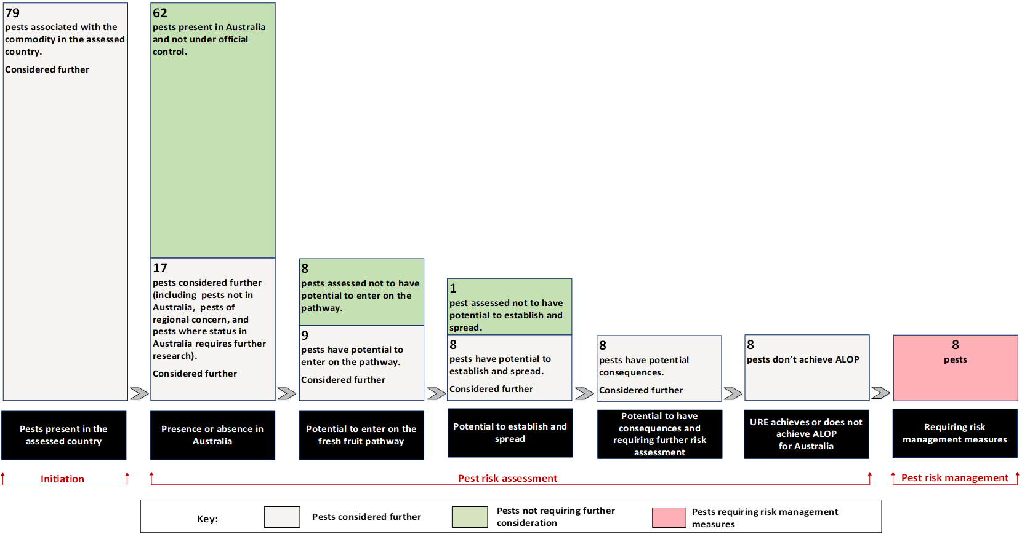

Pest risk management
Pest risk management evaluates and selects options for measures for quarantine pests and regulated articles identified, in Chapter 3, as having a URE that does not achieve the ALOP for Australia. This chapter recommends specific risk management measures for those quarantine pests and regulated articles (section 4.1). It also recommends an operational system for the assurance, maintenance and verification of phytosanitary status (section 4.2). Both specific risk management measures (section 4.1) and the operational system (section 4.2) are required to reduce the risk of introduction of these quarantine pests and regulated articles to achieve the ALOP for Australia. These measures are in addition to existing commercial production practices for dragon fruit in the Philippines, as described in Chapter 2, as these practices have been considered in assessing the URE.

Pest risk management measures and phytosanitary procedures
This section describes the recommended risk management measures for the 7 quarantine pests (2 of which are also regulated articles) and one regulated article assessed, in Chapter 3, as having a URE that does not achieve the ALOP for Australia.
Historical trade and pest interception data of other similar pathways, as described in section 4.1.1, have been considered in determining the appropriate risk management measures for the importation of dragon fruit from the Philippines.

Analysis of pest interception data
Fresh dragon fruit consignments have only been imported into Australia in a moderate amount. Between September 2017 and July 2022, approximately 543 consignments of fresh dragon fruit were imported into Australia, totalling approximately 3,790 tonnes. Examination of interception data from imports of fresh dragon fruit found very few detections of live quarantine pests and contaminating pests such as spiders and ants. Where pests of biosecurity concern were detected, remedial action was taken to manage the risk appropriately.

Risk management measures for quarantine pests and regulated articles associated with dragon fruit from the Philippines
Recommended specific risk management measures for the 7 quarantine pests (2 of which are also regulated articles) and one regulated article associated with dragon fruit from the Philippines are listed in Table 4.1.
Table 4.1 Recommended risk management measures for quarantine pests and regulated articles potentially associated with dragon fruit from the Philippines
Pest/pest group | Scientific name | Common name | Measures
Fruit flies  [Diptera: Tephritidae] | Bactrocera dorsalis [EP] | Oriental fruit fly | PFA, PFPP or PFPS a  OR  Fruit treatment considered effective against Bactrocera dorsalis and Zeugodacus cucurbitae (e.g., vapour heat treatment or irradiation)
 | Zeugodacus cucurbitae [EP] | Melon fly
Mealybugs  [Hemiptera: Pseudococcidae] | Dysmicoccus neobrevipes [GP] | Grey pineapple mealybug | Pre-export visual inspection and, if found, remedial action b
 | Paracoccus marginatus [GP] | Papaya mealybug
 | Pseudococcus jackbeardsleyi [GP] | Jack Beardsley mealybug
Thrips  [Thysanoptera: Thripidae] | Frankliniella occidentalis [GP, NT] c | Western flower thrips | Pre-export visual inspection and, if found, remedial action b
 | Scirtothrips dorsalis [GP, RA] | Chilli thrips
 | Thrips palmi [GP, SA, WA] c | Melon thrips
a: PFA is pest free areas, PFPP is pest free places of production or PFPS is pest free production sites. b: Remedial action may include treatment of the consignment to ensure that the pest is no longer viable or withdrawal of the consignment from export to Australia. c: Quarantine thrips species that is also identified as a regulated article for Australia as it vectors emerging quarantine orthotospoviruses assessed in the thrips Group PRA (DAWR 2017a) as posing an unrestricted risk that does not achieve the ALOP for Australia. EP: Species has been assessed previously and import policy already exists. RA: Regulated article. GP: Species has been assessed previously in a Group PRA, and the Group PRA has been applied. NT: Regional quarantine pest for the Northern Territory. WA: Regional quarantine pest for Western Australia.
The Australian Government Department of Agriculture, Fisheries and Forestry (the department) recommends the following specific risk management measures for the identified quarantine pests and regulated articles:
- for Bactrocera dorsalis (oriental fruit fly) and Zeugodacus cucurbitae (melon fly)
  - pest free areas, pest free places of production or pest free production sites, or
  - fruit treatment considered to be effective against fruit flies (such as vapour heat treatment or irradiation)
- for thrips and mealybugs
  - pre-export visual inspection and, if found, remedial action.

Measures for fruit flies
For B. dorsalis and Z. cucurbitae, the department recommends the options of pest free areas, pest free places of production or pest free production sites or fruit treatment considered to be effective against all life stages associated with export dragon fruit, such as irradiation or vapour heat treatment. The objective of this recommended measure is to reduce the risk associated with these pests to achieve the ALOP for Australia when applied in combination with the operational system outlined in section 4.2.

Recommended measure 1: Pest free areas, pest free places of production or pest free production sites
The requirements for establishing and maintaining pest free areas are set out in ISPM 4: Requirements for the establishment of pest free areas (FAO 2017) and, more specifically, ISPM 26: Establishment of pest free areas for fruit flies (Tephritidae) (FAO 2018). The requirements for establishing and maintaining pest free places of production (PFPP) and pest free production sites (PFPS) are set out in ISPM 10: Requirements for the establishment of pest free places of production and pest free production sites (FAO 2016a).
Monitoring and trapping of fruit flies in the specified export orchards and packing houses would be required, consistent with the procedures recommended in ISPM 26 (FAO 2018). In the event of the detection of any fruit fly species of economic importance in the identified PFA, PFPP or PFPS, the Philippines DA would be required to notify the department within 48 hours of detection. The department would then assess the pest species, number of fruit flies and specific information on individual fruit flies detected, such as life stage, sex and gravidity of females, and the circumstances of the detection before advising the Philippines DA of any action to be taken. If fruit flies were detected during pre-export inspection or during on-arrival inspection, trade under the PFA, PFPP or PFPS pathway would be suspended immediately, pending the outcome of an investigation.
Should the Philippines wish to use PFA, PFPP or PFPS as a measure to manage the risk posed by fruit flies, the Philippines DA would need to provide a submission demonstrating the establishment of these to the department. The submission demonstrating PFA must fulfil requirements as set out in ISPM 4 (FAO 2017) and ISPM 26 (FAO 2018), and the submission demonstrating PFPP or PFPS must fulfil requirements as set out in ISPM 10 (FAO 2016a). The submission is subject to approval by the department.

Recommended measure 2: Fruit treatment – irradiation
Fruit treatment known to be effective against all life stages of fruit flies associated with export dragon fruit such as irradiation applied pre-export may be used as a phytosanitary measure for B. dorsalis and Z. cucurbitae. The requirements for using irradiation as a phytosanitary measure are set out in ISPM 18: Guidelines for the use of irradiation as a phytosanitary measure (FAO 2023b). Irradiation is recognised as an effective method for pest risk management when performed in approved facilities and at specific dose rates recognised as effective for target pest groups. Irradiation dose rates up to a maximum of 1000 Gy are permitted for quarantine purposes for fresh fruit and vegetables, including dragon fruit, by Food Standards Australia New Zealand (FSANZ 2021).
The department proposes a treatment schedule of 150 Gy minimum absorbed dose, consistent with ISPM 28 Annex 7: Irradiation treatment for fruit flies of the family Tephritidae (generic) (FAO 2021) for B. dorsalis and Z. cucurbitae.
The use of irradiation as a phytosanitary measure is subject to the department’s approval of the irradiation facilities identified by the Philippines DA. Should the Philippines wish to use irradiation as a phytosanitary measure, the Philippines DA would need to provide a submission to the department. The submission must fulfil requirements as set out in ISPM 18 (FAO 2023b).

Recommended measure 3: Fruit treatment – vapour heat treatment
Vapour heat treatment (VHT) is used as an effective disinfestation treatment for fruit fly species in certain fruits in international trade. Australia accepts VHT as an effective phytosanitary measure for the disinfestation of B. dorsalis and Z. cucurbitae on the pathways associated with fresh dragon fruit from Indonesia and Vietnam.
The department has reviewed efficacy data in support of the use of VHT to manage fruit flies in dragon fruit and considers it suitable to manage B. dorsalis and Z. cucurbitae. The recommended treatment is:
- Forty minutes at a pulp temperature of 46.5°C or greater with a relative humidity of 90% or above.
The use of VHT as a phytosanitary measure is subject to the department’s approval of the treatment facilities identified by the Philippines DA. Should the Philippines wish to use VHT as a phytosanitary measure, the Philippines DA would need to provide a submission to the department.

Measures for mealybugs and thrips
For Dysmicoccus neobrevipes, Paracoccus marginatus, Pseudococcus jackbeardsleyi, Frankliniella occidentalis, Scirtothrips dorsalis and Thrips palmi, the department recommends the option of pre-export visual inspection and, if found, remedial action. The method used for visual inspection must be able to detect all life stages of these pests, for example by using a hand lens, where necessary. The inspection should be consistent with ISPM 23: Guidelines for inspection (FAO 2019c) and ISPM 31: Methodologies for sampling of consignments (FAO 2016b) and provide a 95% level of confidence that infestation greater than 0.5% will be detected. The objective of this recommended measure is to reduce the risk associated with these pests to achieve the ALOP for Australia when applied in combination with the operational system outlined in section 4.2.

Recommended measure: Pre-export visual inspection and, if found, remedial action
All consignments of dragon fruit for export to Australia must be inspected by the Philippines DA in accordance with ISPM 23 (FAO 2019c) and ISPM 31 (FAO 2016b). Each consignment must be found free of the mealybugs Dysmicoccus neobrevipes, Paracoccus marginatus and Pseudococcus jackbeardsleyi, and the thrips Frankliniella occidentalis, Scirtothrips dorsalis and Thrips palmi, or any other quarantine mealybugs or thrips not specifically identified in this import risk analysis. Export consignments found to contain any of these pests must be subjected to remedial action. Remedial action may include withdrawing the consignment from export to Australia, or application of an approved treatment to ensure that the pest is no longer viable.

Consideration of alternative measures
Consistent with the principle of equivalence detailed in ISPM 11: Pest risk analysis for quarantine pests (FAO 2019b), the department will consider any alternative measure proposed by the Philippines DA. Alternative measures must demonstrably manage the target pests to achieve the ALOP for Australia. Evaluation of any such measure will require a technical submission from the Philippines DA that details the proposed measure, including suitable information to support the claimed efficacy, for consideration by the department.

Operational system for the assurance, maintenance and verification of phytosanitary status
A system of operational procedures is necessary to ensure recommended specific risk management measures (section 4.1) are effectively applied, the phytosanitary status of dragon fruit from the Philippines is maintained, and these can be verified.

A system of traceability to source orchards
The objectives of this recommended procedure are to ensure that:
- dragon fruit are sourced only from orchards producing commercial quality fruit
- orchards from which dragon fruit are sourced can be identified, so that any investigation and corrective action can be targeted in the event that pests of biosecurity concern to Australia are intercepted
- where dragon fruit is grown/produced in an approved PFA, PFPP or PFPS, it can be verified that all fruit was sourced from the approved area, place or site and produced and exported under the conditions for that pathway.
The Philippines DA must establish a system to enable traceability to where dragon fruit for export to Australia are sourced. The Philippines DA must ensure that export dragon fruit growers are aware of pests of biosecurity concern for Australia and have systems in place to produce export quality fruit that meet Australia's requirements.
Where a pest risk management measure involving pest monitoring and controls during production and at harvest (such as PFA, PFPP, PFPS or systems approach) is used, export orchards must be registered with the Philippines DA before commencement of each harvest season. Records of registered orchards and the Philippines DA audits must be kept by the Philippines DA and must be made available to the department upon request.

Registration of packing houses and treatment providers, and auditing of procedures
The objectives of this recommended procedure are to ensure that:
- commercial quality dragon fruit are sourced only from packing houses that are approved by the Philippines DA
- where applicable, treatment providers are approved by the Philippines DA and capable of applying a treatment that suitably manages the target pests.
Dragon fruit export packing houses are registered with the Philippines DA before the commencement of each harvest season. The Philippines DA is required to ensure that the registered packing houses are suitably equipped and have a system in place to carry out the specified phytosanitary activities. The list of registered packing houses and records of the Philippines DA audits must be kept by the Philippines DA and must be made available to the department upon request.
In circumstances where dragon fruit undergo pre-export treatment, this process must be undertaken by treatment providers that have been registered with and audited by the Philippines DA for that purpose. Records of the Philippines DA registration requirements and audits must be made available to the department upon request.
The approval of treatment providers by the Philippines DA must include verification that suitable systems are in place to ensure compliance with treatment requirements. This may include:
- documented procedures to ensure dragon fruit are appropriately treated and safeguarded post treatment
- staff training to ensure compliance with procedures
- record-keeping procedures
- suitability of facilities and equipment
- the Philippines DA's system of oversight of treatment application.
The department provides final approval of facilities, following review of regulatory oversight provided by the Philippines DA and the capability demonstrated by the facility. Site visits may be required for the department to have assurance that treatment can be applied accurately and consistently.

Packaging, labelling and containers
The objectives of this recommended procedure are to ensure that:
- dragon fruit intended for export to Australia, and associated packaging, are not contaminated by quarantine pests or regulated articles (as defined in ISPM 5: Glossary of phytosanitary terms (FAO 2023a))
- unprocessed packaging material is not imported with dragon fruit from the Philippines. Unprocessed packaging material is not permitted as it may vector pests identified as not being on the pathway, or pests not known to be associated with dragon fruit
- all wood material associated with the consignment used in packaging and transport of dragon fruit complies with the department’s import requirements, as published on BICON
- secure packaging is used for export of dragon fruit from the Philippines to Australia, to prevent re-infestation during storage and transport and prevent escape of pests during clearance procedures on arrival in Australia. Packaging must meet Australia's secure packaging options published on BICON
- consignments are made insect proof and secure, by using at least one of the following secure consignment options:
  - integral cartons: produce may be packed in integral (fully enclosed) cartons (packages) with boxes having no ventilation holes and lids tightly fixed to the bases
  - ventilation holes of cartons covered: cartons (packages) with ventilation holes must have the holes covered/sealed with a mesh/screen of no more than 1.6 mm pore size and not less than 0.16 mm strand thickness. Alternatively, the vent holes may be taped over
  - polythene liners: vented cartons (packages) with sealed polythene liners/bags within are acceptable (folded polythene bags are acceptable)
  - meshed or shrink wrapped pallets or Unit Load Devices (ULDs): ULDs transporting cartons with open ventilation holes/gaps, or palletised cartons with ventilation holes/gaps must be fully covered or wrapped with polyethylene/plastic/foil sheet or mesh/screen of no more than 1.6 mm diameter pore size and not less than 0.16 mm strand thickness
  - produce transported in fully enclosed containers: cartons (packages) with holes as loose boxes or on pallets may be transported in fully enclosed containers. Enclosed containers include 6-sided containers with solid sides, or ULDs with tarpaulin sides that have no holes or gaps. The container must be transported to the inspection point intact
- packaged dragon fruit from the Philippines must be labelled with sufficient identification for the purposes of traceability. This may include:
  - for treated product: the treatment facility name/number and treatment identification reference/number
  - for dragon fruit where the measures include pre-harvest controls/orchard freedom: the orchard reference number
  - for dragon fruit where phytosanitary measures are applied at the packing house: the packing house reference/number
- where applicable, packaged dragon fruit from the Philippines that has undergone irradiation treatment is labelled with a statement that the dragon fruit has been treated with ionising radiation.
Export packing houses and treatment providers (where applicable) must ensure packaging and labelling are suitable to maintain phytosanitary status of the export consignments.

Specific conditions for storage and movement
The objective of this recommended procedure is to ensure that the quarantine integrity of the dragon fruit is maintained during storage and movement.
Treated and/or inspected dragon fruit for export to Australia must be kept secure and segregated at all times from any fruit for domestic or other markets, and from untreated/un-inspected product, to prevent mixing or cross-contamination. The area set aside for goods to Australia must be clearly identified with signage.

Freedom from trash
The objective of this recommended procedure is to ensure that dragon fruit for export are free from trash (for example, loose stem and leaf material, seeds, soil, animal matter/parts or other extraneous material) and foreign matter.
Freedom from trash will be confirmed by the inspection procedures. Export lots or consignments found to contain trash or foreign matter must be withdrawn from export unless approved remedial action, such as reconditioning, is available and applied to the export consignment and then re-inspected.

Pre-export phytosanitary inspection and certification by the Philippines DA
The objective of these recommended procedures is to ensure that Australia’s import conditions have been met. All consignments of dragon fruit from the Philippines for export to Australia must be inspected by the Philippines DA and found free of pests of biosecurity concern for Australia. Pre-export visual inspection must be undertaken by the Philippines DA in accordance with ISPM 23: Guidelines for inspection (FAO 2019c) and consistent with the principles of ISPM 31: Methodologies for sampling of consignments (FAO 2016b). Any netting or artificial wrapping material must be removed during the inspection.
All consignments must be inspected prior to export in accordance with official procedures for all visually-detectable quarantine pests and regulated articles (including trash). Sampling and inspection methods should be consistent with ISPM 23 (FAO 2019c) and ISPM 31 (FAO 2016b) and provide a 95% level of confidence that infestation greater than 0.5% will be detected. For a consignment equal to or greater than 1,000 units (one unit being one dragon fruit), this is equivalent to a 600 unit sample randomly selected across the consignment. Any netting or artificial wrapping material must be removed during the inspection.
A phytosanitary certificate must be issued for each consignment upon completion of pre-export inspection and treatment to certify that the required risk management measures have been undertaken prior to export and that the consignment meets Australia’s import requirements.
Each phytosanitary certificate must include:
- a description of the consignment (including traceability information)
- details of disinfestation treatments (if required) which includes approved facility name and address, date of treatment and, where irradiation is used, absorbed dose (target and measured)
- additional declarations that may be required such as identification of the consignment as being sourced from a recognised pest free area, pest free place of production or pest free production site.
Some treatments (such as irradiation) may also require treatment certificates that accompany the phytosanitary certificate. BICON will describe when treatment certificates are required.

Phytosanitary inspection by the Department of Agriculture, Fisheries and Forestry
The objectives of this recommended procedure are to ensure that:
- consignments comply with Australian import requirements
- consignments are as described on the phytosanitary certificate
- quarantine integrity has been maintained.
On arrival in Australia, the department will:
- assess documentation to verify that the consignment is as described on the phytosanitary certificate, that required phytosanitary actions have been undertaken, and that product security has been maintained
- verify that the biosecurity status of consignments of dragon fruit from the Philippines meet Australia’s import requirements. When inspecting consignments, the department will randomly sample 600 units, or equivalent, per phytosanitary certificate and apply an inspection method suitable for the commodity.

Remedial action(s) for non-compliance
The objectives of remedial action(s) for non-compliance are to ensure that:
- any quarantine pest or regulated article, including trash, is addressed by remedial action, as appropriate
- non-compliance with import requirements is addressed, as appropriate.
Any consignment that fails to meet Australia’s import requirements will be subject to suitable remedial treatment where an effective treatment is available for the identified biosecurity risks. Where an effective treatment is not available, the imported consignment will be exported or destroyed.
Other actions, including partial or complete suspension of the import pathway, may be taken depending on the identity and/or importance of the pest intercepted, for example, fruit flies of economic importance, or pests for which PFAs, PFPPs or PFPSs are established.
In the event that consignments of dragon fruit from the Philippines are repeatedly non-compliant, the department may require enhanced risk management measures, including mandatory phytosanitary treatment. The department reserves the right to suspend imports (either all imports, or imports from specific pathways) and to conduct an audit of the risk management systems. Imports will be allowed to recommence only when the department is satisfied that appropriate corrective action has been undertaken.

Uncategorised pests
If an organism that has not been categorised, including a contaminant pest, is detected on dragon fruit on arrival in Australia, it will require assessment by the department to determine its quarantine status and whether phytosanitary action is required.
Assessment is also required if the detected species was categorised as not having the potential to be on the import pathway. If the detected species was categorised as being on the pathway but assessed as having an unrestricted risk that achieves the ALOP for Australia, then it may require reassessment. The detection of any pests of biosecurity concern not already identified in the analysis may result in remedial action and/or temporary suspension of trade while a review is conducted to ensure that existing measures continue to provide the ALOP for Australia.

Review of processes

Verification of protocol
Prior to or during the first season of trade, the department will verify the implementation of the required import requirements including registration, operational procedures and treatment providers, where applicable. This may involve representatives from the department visiting areas in the Philippines that produce dragon fruit for export to Australia.

Review of policy
The department will review the import policy after a suitable volume of trade has been achieved to ensure import requirements continue to be appropriate to manage the biosecurity risk of the pathway. In addition, the department reserves the right to review the import policy as deemed necessary. This may include if there is reason to believe that the pest or phytosanitary status in the Philippines has changed, or where alternative risk management or compliance-based intervention options become available.
The Philippines DA must inform the department immediately on the detection of any new pests of dragon fruit in the Philippines that might be of potential biosecurity concern to Australia.

Meeting Australia’s food laws
In addition to meeting Australia's biosecurity laws, imported food for human consumption must comply with the requirements of the Imported Food Control Act 1992, as well as Australian state and territory food laws. Among other things, these laws require all food, including imported food, to meet the standards set out in the Australia New Zealand Food Standards Code (the Code).
Food Standards Australia New Zealand (FSANZ) is responsible for developing and maintaining the Code. The Code is available at foodstandards.gov.au/code/Pages/default.aspx.
The department administers the Imported Food Control Act 1992 which supports the inspection and testing of imported food to verify its safety and compliance with Australia's food standards, including the Code. This is undertaken through a risk-based border inspection program, the Imported Food Inspection Scheme. More information about this scheme is available at agriculture.gov.au/biosecurity-trade/import/goods/food/inspection-testing/ifis.
Standards 1.1.1, 1.1.2 and 1.4.4 of the Code specify that a food for sale must not consist of, or have as an ingredient or a component, a prohibited or restricted plant or fungus; unless expressly permitted by the Code. The prohibited and restricted plants and fungi are listed in Schedules 23 and 24 of the Code, respectively.
Standard 1.4.2 and Schedules 20, 21 and 22 of the Code set out the maximum residue limits and extraneous residue limits for agricultural or veterinary chemicals that are permitted in foods for sale, including imported food. Standard 1.1.1 of the Code specifies that a food must not have, as an ingredient or a component, a detectable amount of an agvet chemical, or a metabolite or a degradation product of the agvet chemical; unless expressly permitted by the Code.
Certain imported food, including some minimally processed horticulture products, must be covered by a food safety management certificate to be imported into Australia. The certificate provides evidence that a food has been produced through a food safety management system. This system must have appropriate controls in place to manage food safety hazards. More information about the foods that require a food safety management certificate and how to comply is available at agriculture.gov.au/biosecurity-trade/import/goods/food/lodge/safety-management-certificates.

Conclusion
This final risk analysis report was conducted to assess the proposal by the Philippines for market access to Australia for dragon fruit for human consumption.
The risk analysis was conducted in accordance with Australia's method for pest risk analysis (Appendix A), which is consistent with the International Standards for Phytosanitary Measures (ISPMs), including ISPM 2: Framework for pest risk analysis (FAO 2019a) and ISPM 11: Pest risk analysis for quarantine pests (FAO 2019b), and the WTO Agreement on the Application of Sanitary and Phytosanitary Measures (WTO 1995).
In conclusion, this final report recommends that the importation of commercially produced dragon fruit to Australia from all commercial production areas of the Philippines can be permitted, subject to a range of biosecurity requirements outlined in Chapter 4.
The findings of this final report are based on a comprehensive analysis of scientific literature and other relevant information.
The department considers that the risk management measures recommended in this report will provide an appropriate level of protection against the quarantine pests and regulated articles identified as associated with the trade of dragon fruit from the Philippines.
All fresh fruit, including dragon fruit from the Philippines, have been determined by the Director of Biosecurity to be conditionally non-prohibited goods under s174 of the Biosecurity Act 2015. Conditionally non-prohibited goods cannot be brought or imported into Australia unless they meet specific import conditions.
This report, upon its finalisation, provides the basis for import conditions for dragon fruit from the Philippines for human consumption. The import conditions will be communicated on BICON. The publication of import conditions on BICON is subject to the Philippines being able to demonstrate that processes and procedures are in place to implement the required risk management measures.

Appendix A: Method for pest risk analysis
This section sets out the method for the pest risk analysis (PRA) used by the Department of Agriculture, Fisheries and Forestry (the department). This method is consistent with the International Standards for Phytosanitary Measures (ISPMs), including ISPM 2: Framework for pest risk analysis (FAO 2019a) and ISPM 11: Pest risk analysis for quarantine pests (FAO 2019b) and the WTO Agreement on the Application of Sanitary and Phytosanitary Measures (WTO 1995).
A PRA is ‘the process of evaluating biological or other scientific and economic evidence to determine whether an organism is a pest, whether it should be regulated, and the strength of any phytosanitary measures to be taken against it’ (FAO 2023a). A pest is 'any species, strain or biotype of plant, animal, or pathogenic agent, injurious to plants or plant products' (FAO 2023a). A ‘quarantine pest’ is 'a pest of potential economic importance to the area endangered thereby and not yet present there, or present but not widely distributed and being officially controlled' (FAO 2023a).
Biosecurity risk consists of 2 major components: the likelihood of a pest entering, establishing and spreading in Australia for a defined import pathway; and the consequences should this happen. These 2 components are combined to give an overall estimate of the pest risk for the defined import pathway.
Unrestricted risk is estimated taking into account, where applicable, the existing commercial production practices of the exporting country and procedures that occur on arrival in Australia. These procedures include verification by the department that the consignment received is as described on the commercial documents and its integrity has been maintained.
Restricted risk is estimated with phytosanitary measure(s) applied. A phytosanitary measure is ‘any legislation, regulation or official procedure having the purpose to prevent the introduction or spread of quarantine pests, or to limit the economic impact of regulated non-quarantine pests’ (FAO 2023a).
A PRA is conducted in 3 consecutive stages: initiation (A1), pest risk assessment (A2) and pest risk management (A3).
- Stage 1: Initiation
Initiation identifies the pest(s) and pathway(s) that are of biosecurity concern and should be considered for risk analysis in relation to the identified PRA area.
A pathway is ‘any means that allows the entry or spread of a pest’ (FAO 2023a). For this risk analysis, the ‘pathway’ being assessed is defined in Chapter 1 (section 1.2.2).
For this risk analysis, the ‘PRA area’ is defined as Australia for pests that are absent, or of limited distribution and under official control. For areas with regional freedom from a pest, the ‘PRA area’ may be defined based on a state or territory of Australia or may be defined as a region of Australia consisting of parts of a state or territory or several states or territories.
According to ISPM 11 (FAO 2019b), the PRA process may be initiated as a result of:
- the identification of a pathway that presents a potential pest hazard. For example, international trade is requested for a commodity not previously imported into the country or a commodity from a new area or new country of origin
- the identification of a pest that may require phytosanitary measures. For example, a new pest risk is identified by scientific research, a pest is repeatedly intercepted, a request is made to import an organism, or an organism is identified as a vector of other pests
- the review or revision of a policy. For example, a country’s decision is taken to review phytosanitary regulations, requirements or operations or a new treatment or loss of a treatment system, a new process, or new information impacts on an earlier decision.
The basis for the initiation of this risk analysis is defined in Chapter 1 (section 1.2.1).
The primary elements in the initiation stage are:
- identity of the pests
- potential association of each pest with the pathway being assessed.
The identity of the pests is presented at species level by the species’ scientific name in most instances, but a lower taxonomic level may be used where appropriate. Synonyms are provided where the current scientific name differs from that provided by the exporting country’s National Plant Protection Organisation (NPPO) or where the cited literature used a different scientific name.
The potential association of each pest with the pathway being assessed considers information on:
  - association of the pest with the host plant/commodity and
  - the presence or absence of the pest in the exporting country/region relevant to the pathway being assessed.
- Stage 2: Pest risk assessment
The process for pest risk assessment includes 2 sequential steps:
- pest categorisation (A2.1)
- further pest risk assessment, which includes evaluation of the likelihoods of the introduction (entry and establishment) and spread of a pest (A2.2), and evaluation of the magnitude of the associated potential consequences (A2.3).
- Pest categorisation
Pest categorisation examines the pests identified in the initiation stage (A1) to determine which of these pests meet the definition of a quarantine pest and require further pest risk assessment.
ISPM 11 (FAO 2019b) states that 'The opportunity to eliminate an organism or organisms from consideration before in-depth examination is undertaken is a valuable characteristic of the categorisation process. An advantage of pest categorisation is that it can be done with relatively little information; however information should be sufficient to adequately carry out the categorisation'. In line with ISPM 11, the department utilises the pest categorisation step to screen out some pests from further consideration where appropriate. For each pest that is not present in Australia, or is present but under official control, the department assesses its potential to enter (importation and distribution) on the pathway being assessed and, if having potential to enter, its potential to establish and spread in the PRA area. For a pest to cause economic consequences, the pest will need to enter, establish and spread in the PRA area. Therefore, pests that do not have potential to enter on the pathway being assessed, or have potential to enter but do not have potential to establish and spread in the PRA area, are not considered further. The potential for economic consequences is then assessed for pests that have potential to enter, establish and spread in the PRA area. Further pest risk assessments are then undertaken for pests that have potential to cause economic consequences, i.e., pests that meet the criteria for a quarantine pest.
Pest categorisation uses the following primary elements to identify the quarantine pests and to screen out some pests from further consideration where appropriate for the pathway being assessed:
- presence or absence and regulatory status in the PRA area
- potential for entry, establishment and spread in the PRA area
- potential for economic consequences in the PRA area.
- Assessment of the likelihood of entry, establishment and spread
ISPM 11 (FAO 2019b) provides details of how to assess the ‘probability of entry’, ‘probability of establishment’ and ‘probability of spread’ of a pest. The SPS Agreement (WTO 1995) uses the term ‘likelihood’ rather than ‘probability’ for these estimates. In qualitative PRAs, the department uses the term ‘likelihood’ as the descriptor. The use of the term ‘probability’ is limited to the direct quotation of ISPM definitions.
A summary of the assessment process is given here, followed by a description of the qualitative methodology used in this risk analysis.
- Likelihood of entry
The likelihood of entry describes the likelihood that a quarantine pest will enter Australia when a given commodity is imported, be distributed in a viable state in the PRA area and subsequently be transferred to a host.
For the purpose of considering the likelihood of entry, the department divides this step into 2 components:
- Likelihood of importation—the likelihood that a pest will arrive in Australia in a viable state when a given commodity is imported
- Likelihood of distribution— the likelihood that the pest will be distributed in a viable state, as a result of the processing, sale or disposal of the commodity, in the PRA area and subsequently transfer to a susceptible part of a host.
Factors to be considered in the likelihood of importation may include:
- likelihood of the pest being associated with the pathway at origin
  - prevalence of the pest in the source area
  - occurrence of the pest in a life-stage that would be associated with the commodity
  - mode of trade (for example, bulk, packed)
  - volume and frequency of movement along each pathway
  - seasonal timing of imports
  - pest management, cultural and commercial procedures applied at the place of origin (for example, application of plant protection products, handling, culling, and grading)
- likelihood of survival of the pest during transport or storage
  - speed and conditions of transport and duration and conditions of storage compared with the duration of the life cycle of the pest
  - vulnerability of the life-stages of the pest during transport or storage
  - prevalence of the pest likely to be associated with a consignment
  - commercial procedures (for example, refrigeration) applied to consignments during transport and storage in the country of origin, and during transport to Australia
- likelihood of pest surviving existing pest management procedures.
Factors to be considered in the likelihood of distribution may include:
- commercial procedures (for example, refrigeration) applied to consignments during distribution in Australia
- dispersal mechanisms of the pest, including vectors, to allow movement from the pathway to a suitable host
- whether the imported commodity is to be sent to a few or many destination points in the PRA area
- proximity of entry, transit and destination points to suitable hosts
- time of year at which import takes place
- intended use of the commodity (for example, for planting, processing or consumption)
- risks from by-products and waste.
- Likelihood of establishment
Establishment is defined as the ‘perpetuation, for the foreseeable future, of a pest within an area after entry’ (FAO 2023a). In order to estimate the likelihood of establishment of a pest, reliable biological information (for example, lifecycle, host range, epidemiology, survival) is obtained from the areas where the pest currently occurs. The situation in the PRA area can then be compared with that in the areas where it currently occurs and expert judgement used to assess the likelihood of establishment.
Factors to be considered in the likelihood of establishment in the PRA area may include:
- availability of suitable hosts, alternate hosts and vectors in the PRA areas
  - prevalence of hosts and alternate hosts in the PRA area
  - whether hosts and alternate hosts occur within sufficient geographic proximity to allow the pest to complete its life cycle
  - whether there are other plant species, which could prove to be suitable hosts in the absence of usual host species
  - whether a vector, if needed for dispersal of the pest, is already present in the PRA area or likely to be introduced
- suitability of environment in the PRA area
  - factors in the environment in the PRA area (for example, suitability of climate, soil, pest and host competition) that are critical to the development of the pest, its host and if applicable its vector, and to their ability to survive periods of climatic stress and complete their life cycles
- cultural practices and control measures in the PRA area that may influence the ability of the pest to establish
- other characteristics of the pest
  - reproductive strategy of the pest and method of pest survival
  - potential for adaptation of the pest
  - minimum population needed for establishment.
- Likelihood of spread
Spread is defined as ‘the expansion of the geographical distribution of a pest within an area’ (FAO 2023a). The likelihood of spread considers the factors relevant to the movement of the pest, after establishment on a host plant or plants, to other susceptible host plants of the same or different species in other areas. In order to estimate the likelihood of spread of the pest, reliable biological information is obtained from areas where the pest currently occurs. The situation in the PRA area is then carefully compared with that in the areas where the pest currently occurs and expert judgement used to assess the likelihood of spread.
Factors to be considered in the likelihood of spread may include:
- suitability of the natural and/or managed environment for natural spread of the pest
- presence of natural barriers
- potential for movement with commodities, conveyances or by vectors
- intended use of the commodity
- potential vectors of the pest in the PRA area
- potential natural enemies of the pest in the PRA area.
- Assigning likelihoods for entry, establishment and spread
Likelihoods are assigned to each step of entry, establishment and spread. Six qualitative likelihood descriptors are used: High; Moderate; Low; Very Low; Extremely Low; and Negligible. Definitions for these descriptors and their indicative ranges are given in Table A.1. The indicative ranges are only provided to illustrate the boundaries of the descriptors and are not used beyond this purpose in qualitative PRAs. These indicative ranges provide guidance to the risk analyst and promote consistency between different pest risk assessments.
Table A.1 Nomenclature of likelihoods
Likelihood | Descriptive definition | Indicative range
High | The event would be very likely to occur | 0.7 < to ≤ 1
Moderate | The event would occur with an even likelihood | 0.3 < to ≤ 0.7
Low | The event would be unlikely to occur | 0.05 < to ≤ 0.3
Very Low | The event would be very unlikely to occur | 0.001 < to ≤ 0.05
Extremely Low | The event would be extremely unlikely to occur | 0.000001 < to ≤ 0.001
Negligible | The event would almost certainly not occur | 0 < to ≤ 0.000001
- Combining likelihoods
The likelihood of entry is determined by combining the likelihood that the pest will be imported into the PRA area and the likelihood that the pest will be distributed within the PRA area, using a matrix of rules (Table A.2). This matrix is then used to combine the likelihood of entry and the likelihood of establishment, and the likelihood of entry and establishment is then combined with the likelihood of spread to determine the overall likelihood of entry, establishment and spread.
For example, if a descriptor of Low is assigned for the likelihood of importation, Moderate for the likelihood of distribution, High for the likelihood of establishment and Very Low for the likelihood of spread, then the likelihood of importation of Low and the likelihood of distribution of Moderate are combined to give a likelihood of Low for entry. The likelihood for entry is then combined with the likelihood assigned for establishment of High to give a likelihood for entry and establishment of Low. The likelihood for entry and establishment is then combined with the likelihood assigned for spread of Very Low to give the overall likelihood for entry, establishment and spread of Very Low. This can be summarised as:
importation x distribution = entry [E] Low x Moderate = Low
entry x establishment = [EE] Low x High = Low
[EE] x spread = [EES] Low x Very Low = Very Low
Table A.2 Matrix of rules for combining likelihoods
 | High | Moderate | Low | Very Low | Extremely Low | Negligible
High | High | Moderate | Low | Very Low | Extremely Low | Negligible
Moderate | – | Low | Low | Very Low | Extremely Low | Negligible
Low | – | – | Very Low | Very Low | Extremely Low | Negligible
Very Low | – | – | – | Extremely Low | Extremely Low | Negligible
Extremely Low | – | – | – | – | Negligible | Negligible
Negligible | – | – | – | – | – | Negligible

Time and volume of trade
One factor affecting the likelihood of entry is the volume and duration of trade. If all other conditions remain the same, the overall likelihood of entry will increase as time passes and the overall volume of trade increases.
The department normally considers the likelihood of entry on the basis of the estimated volume of one year’s trade. This is a convenient value for the analysis that is relatively easy to estimate and allows for expert consideration of seasonal variations in pest presence, incidence and behaviour to be taken into account. The consideration of the likelihood of entry, establishment and spread and subsequent consequences takes into account events that might happen over a number of years even though only one year’s volume of trade is being considered. This difference reflects biological and ecological facts, for example where a pest or disease may establish in the year of import but spread may take many years.
The use of a one year volume of trade has been taken into account when setting up the matrix that is used to estimate the risk and therefore any policy based on this analysis does not simply apply to one year of trade. Policy decisions that are based on the department’s method that uses the estimated volume of one year’s trade are consistent with Australia’s policy on appropriate level of protection and meet the Australian Government’s requirement for ongoing quarantine protection. If there are substantial changes in the volume and nature of the trade in specific commodities then the department will review the risk analysis and, if necessary, provide updated policy advice.
- Assessment of potential consequences
In estimating the potential consequences of a pest if the pest were to enter, establish and spread in Australia, the department uses a 2-step process. In the first step, a qualitative descriptor of the impact is assigned to each of the direct and indirect criteria in terms of the level of impact and the magnitude of impact. The second step involves combining the impacts for each of the criteria to obtain an ‘overall consequences’ estimation.
Step 1: Assessing direct and indirect impacts
Direct pest impacts are considered in the context of the impacts on:
- the life or health of plants and plant products
This may include pest impacts on the life or health of the plants and production effects (yield or quality) either at harvest or during storage.
  - Where applicable, pest impacts on the life or health of humans or of animals and animal products may also be considered.
- other aspects of the environment.
Indirect pest impacts are considered in the context of the impacts on:
- eradication and control
This may include pest impacts on new or modified eradication, control, surveillance or monitoring and compensation strategies or programs.
- domestic trade
This may include pest impacts on domestic trade or industry, including changes in domestic consumer demand for a product resulting from quality changes and effects on other industries supplying inputs to, or using outputs from, directly affected industries.
- international trade
This may include pest impacts on international trade, including loss of markets, meeting new technical requirements to enter or maintain markets and changes in international consumer demand for a product resulting from quality changes.
- non-commercial and environment
This may include pest impacts on the community and environment, including reduced tourism, reduced rural and regional economic viability, loss of social amenity, and any ‘side effects’ of control measures.
For each of these direct and indirect criteria, the level of impact is estimated over 4 geographic levels, defined as:
- Local–an aggregate of households or enterprises (a rural community, a town or a local government area)
- District–a geographically or geopolitically associated collection of aggregates (generally a recognised section of a state or territory, such as ‘Far North Queensland’)
- Regional–a geographically or geopolitically associated collection of districts in a geographic area (generally a state or territory, although there may be exceptions with larger states such as Western Australia)
- National–Australia wide (Australian mainland states and territories and Tasmania).
For each criterion, the magnitude of impact at each of these geographic levels is described using 4 categories, defined as:
- Unlikely to be discernible–pest impact is not usually distinguishable from normal day-to-day variation in the criterion
- Minor significance–expected to lead to a minor increase in mortality/morbidity of hosts or a minor decrease in production but not expected to threaten the economic viability of production. Expected to decrease the value of non-commercial criteria but not threaten the criterion’s intrinsic value. Effects would generally be reversible.
- Significant–expected to threaten the economic viability of production through a moderate increase in mortality/morbidity of hosts, or a moderate decrease in production. Expected to significantly diminish or threaten the intrinsic value of non-commercial criteria. Effects may not be reversible.
- Major significance–expected to threaten the economic viability through a large increase in mortality/morbidity of hosts, or a large decrease in production. Expected to severely or irreversibly damage the intrinsic ‘value’ of non-commercial criteria.
Each individual direct or indirect impact is given an impact score (A–G) using the decision rules in Figure A.1. This is done by determining which of the shaded cells with bold font in Figure A.1 correspond to the level and magnitude of the particular impact.
The following are considered during this process:
- At each geographic level below 'National', an impact more serious than ‘Minor significance’ is considered at least 'Minor significance' at the level above. For example, a ‘Significant’ impact at the state or territory level is considered equivalent to at least a ‘Minor significance’ impact at the national level.
- If the impact of a pest at a given level is in multiple states or territories, districts or regions or local areas, it is considered to represent at least the same magnitude of impact at the next highest geographic level. For example, a ‘Minor significance’ impact in multiple states or territories represents a ‘Minor significance’ impact at the national level.
- The geographic distribution of an impact does not necessarily determine the impact. For example, an outbreak could occur on one orchard/farm, but the impact could potentially still be considered at a state or national level.
Figure A.1 Decision rules for determining the impact score for each direct and indirect criterion, based on the level of impact and the magnitude of impact
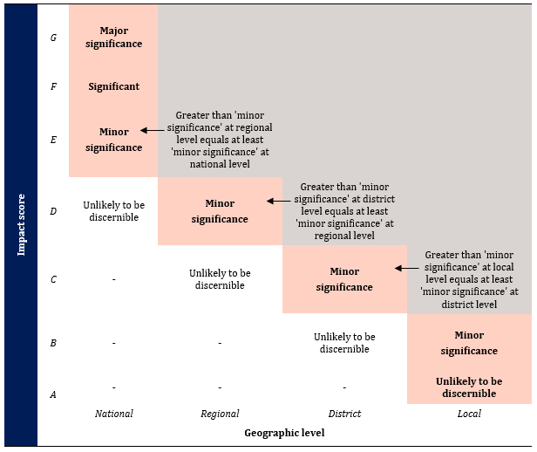
For each criterion:
- the level of impact is estimated over 4 geographic levels: local, district, regional and national
- the magnitude of impact at each of the 4 geographic levels is described using 4 categories: unlikely to be discernible, minor significance, significant and major significance
- an impact score (A–G) is assigned by determining which of the shaded cells with bold font correspond to the level and magnitude of impact.
Step2: Combining direct and indirect impacts
The overall consequence for each pest or each group of pests is achieved by combining the impact scores (A–G) for each direct and indirect criterion using the decision rules in Table A.3. These rules are mutually exclusive, and are assessed in numerical order until one applies. For example, if the first rule does not apply, the second rule is considered, and so on.
Table A.3 Decision rules for determining the overall consequence rating for each pest
Rule | The impact scores for consequences of direct and indirect criteria | Overall consequence rating
1 | Any criterion has an impact of ‘G’; or  more than one criterion has an impact of ‘F’; or  a single criterion has an impact of ‘F’ and each remaining criterion an ‘E’. | Extreme
2 | A single criterion has an impact of ‘F’; or  all criteria have an impact of ‘E’. | High
3 | One or more criteria have an impact of ‘E’; or  all criteria have an impact of ‘D’. | Moderate
4 | One or more criteria have an impact of ‘D’; or  all criteria have an impact of ‘C’. | Low
5 | One or more criteria have an impact of ‘C’; or  all criteria have an impact of ‘B’. | Very Low
6 | One or more but not all criteria have an impact of ‘B’, and all remaining criteria have an impact of ‘A’; or  all criteria have an impact of ‘A’. | Negligible
- Estimation of the unrestricted risk
Once the assessment of the likelihood of entry, establishment and spread and for potential consequences are completed, the unrestricted risk can be determined for each pest or each group of pests. This is determined by using a risk estimation matrix (Table A.4) to combine the estimates of the likelihood of entry, establishment and spread and the overall consequences of pest establishment and spread.
When interpreting the risk estimation matrix, note the descriptors for each axis are similar (for example, Low, Moderate, High) but the vertical axis refers to likelihood and the horizontal axis refers to consequences. Accordingly, a Low likelihood combined with High consequences, is not the same as a High likelihood combined with Low consequences—the matrix is not symmetrical. For example, the former combination would give an unrestricted risk rating of Moderate, whereas, the latter would give a Low rating.
Table A.4 Risk estimation matrix
Likelihood of pest entry, establishment and spread | Consequences of pest entry, establishment and spread
 | Negligible | Very Low | Low | Moderate | High | Extreme
High | Negligible risk | Very Low risk | Low risk | Moderate risk | High risk | Extreme risk
Moderate | Negligible risk | Very Low risk | Low risk | Moderate risk | High risk | Extreme risk
Low | Negligible risk | Negligible risk | Very Low risk | Low risk | Moderate risk | High risk
Very Low | Negligible risk | Negligible risk | Negligible risk | Very Low risk | Low risk | Moderate risk
Extremely Low | Negligible risk | Negligible risk | Negligible risk | Negligible risk | Very Low risk | Low risk
Negligible | Negligible risk | Negligible risk | Negligible risk | Negligible risk | Negligible risk | Very Low risk
- The appropriate level of protection (ALOP) for Australia
The SPS Agreement defines the concept of an ‘appropriate level of sanitary or phytosanitary protection (ALOP)’ as the level of protection deemed appropriate by the WTO Member establishing a sanitary or phytosanitary measure to protect human, animal or plant life or health within its territory.
Like many other countries, Australia expresses its ALOP in qualitative terms. The ALOP for Australia, which reflects community expectations through government policy, is currently expressed as providing a high level of sanitary or phytosanitary protection aimed at reducing risk to a very low level, but not to zero. The band of cells in Table A.4 marked ‘Very Low risk’ represents the ALOP for Australia.
- Adoption of outcomes from previous assessments
Outcomes of previous risk assessments have been adopted in this assessment for pests for which the risk profile is assessed as comparable to previously assessed situations.
The prospective adoption of previous risk assessment ratings for the likelihood of importation and the likelihood of distribution is considered on a case-by-case basis by comparing factors relevant to the pathway being assessed with those assessed previously. For assessment of the likelihood of importation, factors considered/compared include the commodity type, the prevalence of the pest and commercial production practices in the exporting country/region. For assessment of the likelihood of distribution of a pest the factors considered/compared include the commodity type, the ways the imported produce will be distributed within Australia as a result of the processing, sale or disposal of the imported produce, and the time of year when importation occurs and the availability and susceptibility of hosts at that time. After comparing these factors and reviewing the latest literature, previously determined ratings may be adopted if the department considers the likelihoods for the pathway being assessed to be comparable to those assigned in the previous assessment(s), and there is no new information to suggest that the ratings assigned in the previous assessment(s) have changed.
The likelihoods of establishment and of spread of a pest species in the PRA area will be comparable between risk assessments, regardless of the import pathway through which the pest has entered the PRA area. This is because these likelihoods relate specifically to conditions and events that occur in the PRA area, and are independent of the import pathway. Similarly, the estimate of potential consequences associated with a pest species is also independent of the import pathway. Therefore, the likelihoods of establishment and of spread of a pest, and the estimate of potential consequences, are directly comparable between assessments. If there is no new information available that would significantly change the ratings for establishment or spread or the consequences the pests may cause, the ratings assigned in the previous assessments for these components may be adopted with confidence.
- Application of Group PRAs to this risk analysis
The Group PRAs that were applied to this risk analysis are:
- the Final group pest risk analysis for thrips and orthotospoviruses on fresh fruit, vegetable, cut-flower and foliage imports (thrips Group PRA) (DAWR 2017a).
- the Final group pest risk analysis for mealybugs and the viruses they transmit on fresh fruit, vegetable, cut-flower and foliage imports (mealybugs Group PRA) (DAWR 2019).
- the Final group pest risk analysis for soft and hard scale insects on fresh fruit, vegetable, cut-flower and foliage imports (scales Group PRA) (DAWE 2021).
The Group PRA approach is consistent with relevant international standards and requirements–including ISPM 2: Framework for Pest Risk Analysis (FAO 2019a), ISPM 11: Pest Risk Analysis for Quarantine Pests (FAO 2019b) and the SPS Agreement (WTO 1995). ISPM 2 states that ‘Specific organisms may … be analysed individually, or in groups where individual species share common biological characteristics.’
Risk estimates derived from a Group PRA are ‘indicative’ in character. This is because the likelihood of entry (the combined likelihoods of importation and distribution) can be influenced by a range of pathway-specific factors, as explained in section A2.6. Therefore, the indicative likelihood of entry from a Group PRA needs to be verified on a case-by-case basis.
In contrast, and as noted in section A2.6, the risk factors considered in the likelihoods of establishment and spread, and the potential consequences associated with a pest species are not pathway-specific, and are therefore comparable across all import pathways within the scope of the Group PRA. This is because at these latter stages of the risk analysis the pest is assumed to have already found a host within Australia at or beyond its point of entry. Therefore, unless there is specific evidence to suggest otherwise, a Group PRA assessment can be applied as the default outcome for any pest species on a plant import pathway once the previously assigned likelihood of entry has been verified.
In a scenario where the likelihood of entry for a pest species on a commodity is assessed as different to the indicative estimate, the Group PRA-derived likelihoods of establishment and spread and the estimate of consequences can still be used, but the overall risk rating (the URE) may change.
Application of Group policy involves identification of up to 3 species of each relevant group associated with the import pathway. However, if any other quarantine pests or regulated articles not included in this risk analysis and/or in the relevant group policies are detected at pre-export or on arrival in Australia, the relevant Group policy will also apply.
- Stage 3: Pest risk management
Pest risk management describes the process of identifying and implementing phytosanitary measures to manage risks to achieve the ALOP for Australia, while ensuring that any negative effects on trade are minimised.
The conclusions from pest risk assessment are used to decide whether risk management is required and if so, the appropriate measures to be used. Where the unrestricted risk estimate does not achieve the ALOP for Australia, risk management measures are required to reduce this risk to a very low level. The guiding principle for risk management is to manage risk to achieve the ALOP for Australia. The effectiveness of any proposed/recommended phytosanitary measures (or combination of measures) is evaluated, using the same approach as used to evaluate the unrestricted risk. This ensures the restricted risk for the relevant pest or pests achieves the ALOP for Australia.
ISPM 11 (FAO 2019b) provides details on the identification and selection of appropriate risk management options and notes that the choice of measures should be based on their effectiveness in reducing the likelihood of entry of the pest.
Examples given of measures commonly applied to traded commodities include:
- options for consignments—for example, inspection or testing for freedom from pests, prohibition of parts of the host, a pre-entry or post-entry quarantine system, specified conditions on preparation of the consignment, specified treatment of the consignment, restrictions on end-use, distribution and periods of entry of the commodity
- options preventing or reducing infestation in the crop—for example, treatment of the crop, restriction on the composition of a consignment so it is composed of plants belonging to resistant or less susceptible species, harvesting of plants at a certain age or specified time of the year, production in a certification scheme
- options ensuring that the area, place or site of production or crop is free from the pest—for example, pest-free area, pest-free place of production or pest-free production site
- options for other types of pathways—for example, consider natural spread, measures for human travellers and their baggage, cleaning or disinfestations of contaminated machinery
- options within the importing country—for example, surveillance and eradication programs
- prohibition of commodities—if no satisfactory measure can be found.

Appendix B: Initiation and categorisation for pests of dragon fruit from the Philippines
The pest categorisation table does not represent a comprehensive list of all the pests associated with fresh commercially produced dragon fruit from the Philippines. Reference to soil-borne nematodes, soil-borne pathogens, wood-borer pests, root pests or pathogens, and secondary pests has not been made, as they are not directly related to the export pathway of dragon fruit and would be addressed by Australia’s current approach to contaminating pests.
The steps in the initiation and categorisation processes are considered sequentially, with the assessment terminating at ‘Yes’ for column 3 (except for pests that are present, but under official control and/or pests of regional concern), or at the first ‘No’ for columns 4, 5, 6 or 7. In the final column of the table (column 8) the acronyms ‘EP’, 'GP', ‘RA’, ‘NT’, ‘SA’ and ‘WA’ are used. The acronym ‘EP’ (existing policy) is used for pests that have been assessed by Australia and for which a policy exists. The acronym 'GP' (Group policy) is used for pests that have been assessed by Australia in a Group policy. The acronym 'RA' (regulated article) is used for pests that are known to vector pathogens of biosecurity concern and are therefore regulated articles. The acronym for the state or territory for which regional pest status is considered, such as ‘NT’ (Northern Territory), ‘SA’ (South Australia) or ‘WA’ (Western Australia), is used to identify organisms that have been recorded in some regions of Australia, and due to interstate quarantine regulations are considered regional quarantine pests.
The Final group pest risk analysis for thrips and orthotospoviruses on fresh fruit, vegetable, cut-flower and foliage imports (DAWR 2017a), the Final group pest risk analysis for mealybugs and the viruses they transmit on fresh fruit, vegetable, cut-flower and foliage imports (DAWR 2019) and the Final group pest risk analysis for soft and hard scale insects on fresh fruit, vegetable, cut-flower and foliage imports (DAWE 2021) have been applied in this risk analysis. Application of Group policy involves identification of up to 3 species of each relevant group associated with the commodity pathway. However, if any other quarantine pests or regulated articles not included in this risk analysis and/or in the relevant Group policies are detected at pre-export or on-arrival in Australia, the relevant Group policy will also apply.
The department is aware of the recent changes in fungal nomenclature which ended the separate naming of different states of fungi with a pleomorphic life cycle. However, as the nomenclature for these fungi is in a phase of transition and many priorities of names are still to be resolved, this report uses the generally accepted names and provides alternatively used names as synonyms, where required. The department is also aware of the changes in nomenclature of arthropod species based on the latest morphological and molecular reviews. As official lists of accepted fungus and arthropod names become available, these accepted names will be adopted.
A detailed description of the method used for a pest risk analysis is provided in Appendix A.

 |  |  | Potential to enter on pathway
Pest | Present in the Philippines | Present within Australia | Potential for importation | Potential for distribution | Potential for establishment and spread | Potential for economic consequences | Pest risk assessment required
ARTHROPODS
Coleoptera
Araecerus fasciculatus (De Geer, 1775)  [Anthribidae]  Coffee bean weevil | Yes (Pascua, Pascua & Gabriel 2015) | Yes. NSW, Vic., WA (APPD 2023) | Assessment not required | Assessment not required | Assessment not required | Assessment not required | No
Cheilomenes sexmaculata (Fabricius, 1781)  Synonym: Coccinella sexmaculata Fabricius, 1781  [Coccinellidae] | Yes (Estigoy & Estigoy 2015) | Yes. NT, WA (ABRS 2023) | Assessment not required | Assessment not required | Assessment not required | Assessment not required | No
Protaetia fusca (Herbst, 1790)  [Scarabaeidae]  Mango flower beetle | Yes (Woodruff 2006) | Yes. NSW, NT, Qld, WA (APPD 2023) | Assessment not required | Assessment not required | Assessment not required | Assessment not required | No
Dermaptera
Nala lividipes (Dufour, 1820)  [Nalinae]  Black field earwig | Yes (Estigoy & Estigoy 2015) | Yes. NSW, NT, Qld, SA, Tas, Vic., WA (ABRS 2023) | Assessment not required | Assessment not required | Assessment not required | Assessment not required | No
Diptera
Bactrocera dorsalis (Hendel, 1912)  Synonyms: Bactrocera invadens Drew, Tsuruta & White, 2005, B. papayae Drew & Hancock, 1994 and B. philippinensis Drew & Hancock, 1994 have been synonymised with B. dorsalis  [Tephritidae]  Oriental fruit fly | Yes (CABI 2023; Department of Agriculture 2020) | No. Eradicated from mainland Australia (Hancock et al. 2000) | Yes. Dragon fruit is reported as a good host for B. dorsalis (Follett, Haynes & Dominiak 2021) and the species has been reported as an economic pest in dragon fruit growing regions (Estigoy & Estigoy 2015; Khanh et al. 2016; McQuate 2010). Adult fruit flies lay their eggs beneath the skin of the fruit of host plants (Bateman 1972) and larvae feed and develop within the fruit (Christenson & Foote 1960). | Yes. Dragon fruit will be distributed across Australia for sale. Immature stages that could be potentially present in imported dragon fruit, could pupate and develop into adults and disperse to new hosts available in Australia. | Yes. Bactrocera dorsalis is a highly polyphagous species with a host range of over 250 cultivated and wild fruit (CABI 2023; Clarke et al. 2005; Mau & Martin Kessing 2007), including hosts grown commercially across Australia such as avocado, citrus, guava and mango (CABI 2023). Bactrocera dorsalis is distributed across sub-Saharan Africa, Asia and several islands in Oceania including Papua New Guinea and Hawaii (CABI 2023; Jiang et al. 2014; Vargas, Pinero & Leblanc 2015), which have similar climates to parts of Australia. The species large host range and geographic distribution suggests it could establish and spread in Australia. | Yes. Bactrocera dorsalis is one of the world’s most destructive fruit fly pests (CABI 2023; Clarke et al. 2005; Mau & Martin Kessing 2007; Qin et al. 2018). Bactrocera dorsalis is highly polyphagous and a major pest of avocado, citrus, and mango (CABI 2023; Follett, Haynes & Dominiak 2021), which are all commercial crops of economic importance to Australia. Without control, direct damage of up to 100% of fruit has been reported on mango in Africa (Nankinga et al. 2014). Previous eradication campaigns conducted in Australia for this pest cost approximately AUD$39 million, (Cantrell, Chadwick & Cahill 2002; Plant Health Australia 2008). | Yes (EP)
Zeugodacus cucurbitae (Coquillett, 1899)  Synonym: Bactrocera cucurbitae Coquillet, 1899  [Tephritidae]  Melon fly | Yes (CABI 2023; Hu et al. 2008) | No records found | Yes. Dragon fruit is a reported as a very good host for Z. cucurbitae (Follett, Haynes & Dominiak 2021) has been found infesting the fruit of dragon fruit in commercial production (McQuate 2010).  Adult fruit flies lay their eggs beneath the skin of the fruit of the host plant (Bateman 1972) and the larvae feed and develop within the fruit (Christenson & Foote 1960). | Yes. Dragon fruit will be distributed across Australia for sale. Immature stages that could be potentially present in imported dragon fruit, could pupate and develop into adults and disperse to new hosts available in Australia. | Yes. Zeugodacus cucurbitae is widely distributed throughout India, Southeast Asia and Central Africa (CABI 2023; Dhillon et al. 2005), which have similar climates to parts of Australia. Zeugodacus cucurbitae is highly polyphagous and infests a large number of species including squash, cucumber, pumpkin, rockmelon, watermelon and beans (McQuate & Teruya 2015; White & Elson-Harris 1992), which are commercially grown in Australia. Its host range and geographic distribution suggest it could establish and spread in Australia. | Yes. Zeugodacus cucurbitae is reported to damage 81 host plant species (Allwood et al. 1999; Dhillon et al. 2005; FDACS 2017), causing up to 100% damage depending on host species and the season (CABI 2023; Dhillon et al. 2005). Zeugodacus cucurbitae is a major pest of cucurbit crops including melons and pumpkins, as well as beans, which are all commercial crops of economic importance to Australia. | Yes (EP)
Hemiptera
Aphis aurantii (Boyer de Fonscolombe, 1841)  Synonym: Toxoptera aurantii (Boyer de Fonscolombe, 1841)  [Aphididae]  Black citrus aphid | Yes (Tahori & Hazan 1970; Tepora 2021) | Yes. NSW, NT, Qld, Vic., Tas., WA (APPD 2023) | Assessment not required | Assessment not required | Assessment not required | Assessment not required | No
Aphis craccivora Koch, 1854  [Aphididae]  Cowpea aphid | Yes (Estigoy & Estigoy 2015) | Yes. NSW, NT, Qld, Tas., Vic., WA (APPD 2023; Hollis & Eastop 2005) | Assessment not required | Assessment not required | Assessment not required | Assessment not required | No
Aphis gossypii Glover, 1877  [Aphididae]  Cotton aphid | Yes (Amalin, Vasquez & Vander Zaag 1991; Herradura et al. 2003) | Yes. NSW, NT, Qld, SA, Tas., Vic., WA (APPD 2023) | Assessment not required | Assessment not required | Assessment not required | Assessment not required | No
Aphis odinae (Van de Goot, 1917)  Synonym: Toxoptera odinae (Van der Groot, 1917)  [Aphididae]  Mango aphid | Yes (Calilung 1976) | No records found | No. The primary hosts of A. odinae are mango and several species of shrub (Blackman & Eastop 2018; Lokeshwari et al. 2014). There is only one record in the literature of this species occuring on dragon fruit in Indonesia and it is unclear whether it feeds upon the fruit (Octaviani 2012). Aphis odinae is commonly found feeding on the underside of leaves along the main veins and in dense colonies on shoots of host plants and only occasionly found on the fruit of some hosts (Maruthadurai & Singh 2017). Aphis odinae has been established for many years in the Philippines (Calilung 1976), however, there is no evidence of it occuring on dragon fruit or being present in commercial dragon fruit production areas in the Philippines or any other country outside of Indonesia. | Assessment not required | Assessment not required | Assessment not required | No
Brachycaudus helichrysi (Kaltenbach, 1843)  [Aphididae]  Leaf-curl plum aphid | Yes (Calilung 1976) | Yes. NSW, Qld, Tas., Vic., WA (APPD 2023) | Assessment not required | Assessment not required | Assessment not required | Assessment not required | No
Diaspis boisduvalii Signoret, 1869  [Diaspididae]  Boisduval scale | Yes (García Morales et al. 2023) | Yes. NSW, Qld, Tas., Vic. (APPD 2023), WA (Government of Western Australia 2023) | Assessment not required | Assessment not required | Assessment not required | Assessment not required | No
Dysmicoccus neobrevipes Beardsley, 1959  [Pseudococcidae]  Grey pineapple mealybug | Yes (García Morales et al. 2023) | No. (García Morales et al. 2023) | Yes. Dysmicoccus neobrevipes occurs on the flowers, fruit and stems of dragon fruit (Doan et al. 2016; USDA-APHIS 2008). The species feeds on host plants by sucking phloem sap from the plant tissue (CABI 2023). Dysmicoccus neobrevipes are small (1.5 mm long) (CABI 2023) and could escape detection during harvest and packing house processes. | Yes. This species is highly polyphagous with hosts in 40 families and 67 genera (García Morales et al. 2023). Many hosts are available in Australia. Imported dragon fruit will likely be distributed throughout Australia via the wholesale and retail trade pathway. Mealybugs present on discarded dragon fruit waste could potentially disperse to a new host within close proximity. | Yes. Assessed in the mealybugs Group PRA (DAWR 2019) | Yes. Assessed in the mealybugs Group PRA (DAWR 2019) | Yes (GP)
Mictis longicornis Westwood, 1842  [Coreidae]  Rose coreid | Yes (Waterhouse 1993) | No records found | No. This species is known to feed externally on the stem, branches and flowers of the host plant, including dragon fruit (Điểu & Huỳnh 2009; Kalshoven 1981; Muniappan et al. 2012; USDA-APHIS 2011). There is no evidence of this species occurring on the fruit of dragon fruit. | Assessment not required | Assessment not required | Assessment not required | No
Nezara viridula (Linnaeus, 1758)  [Pentatomidae]  Green vegetable bug | Yes (Jones 1988; McPherson 2018) | Yes. NSW, NT, Qld, SA, Tas., Vic., WA (APPD 2023; McPherson 2018) | Assessment not required | Assessment not required | Assessment not required | Assessment not required | No
Paracoccus marginatus Williams & Granara de Willink, 1992  [Pseudococcidae]  Papaya mealybug | Yes (García Morales et al. 2023) | No. (García Morales et al. 2023) | Yes. Paracoccus marginatus has been reported feeding on the mature fruit of dragon fruit in aggregations (Ruíz Ronquillo 2021). Adults and nymphs feed on the host plant by sucking phloem sap from the plant tissue (CABI 2023; Ruíz Ronquillo 2021). Paracoccus marginatus adults are small (2-3.5 mm long) (CABI 2023) and could escape detection during harvest and packing house processes. | Yes. Paracoccus marginatus is highly polyphagous with hosts in 54 families and 171 genera (García Morales et al. 2023). Many hosts are available in Australia. Imported dragon fruit will likely be distributed throughout Australia via the wholesale and retail trade pathway. Mealybugs present on discarded dragon fruit waste could potentially disperse to a new host within close proximity. | Yes. Assessed in the mealybugs Group PRA (DAWR 2019) | Yes. Assessed in the mealybugs Group PRA (DAWR 2019) | Yes (GP)
Pentalonia nigronervosa Coquerel, 1859  [Aphididae]  Banana aphid | Yes (Aguilar et al. 2014; Lomerio & Calilung 1993) | Yes. NSW, Qld, NT, WA (APPD 2023; Foottit et al. 2010) | Assessment not required | Assessment not required | Assessment not required | Assessment not required | No
Pseudococcus jackbeardsleyi Gimpel & Miller, 1996  [Pseudococcidae]  Jack Beardsley mealybug | Yes (García Morales et al. 2023) | Yes. Under official control (National) (Queensland Government 2023). Present in the Torres Strait and restricted to the regulated quarantine zone in the northern part of Cape York Peninsula, mainland Australia. There is legislation in place to prevent the spread of this species (QDAF 2020). | Yes. Pseudococcus jackbeardsleyi is reported as a pest of dragon fruit and commonly occurs on the fruit surface near the areole, in the fruit crevices or in the flower pit end (Sartiami et al. 2019). Adults feed individually or in aggregations on the fruit, commonly on or underneath the bracts (Rezeki et al. 2021; Sartiami et al. 2019). | Yes. Pseudococcus jackbeardsleyi is highly polyphagous with hosts in 54 families and 114 genera (García Morales et al. 2023). Many hosts are available in Australia. Imported dragon fruit will likely be distributed throughout Australia via the wholesale and retail trade pathway. Mealybugs present on discarded dragon fruit waste could potentially disperse to a new host within close proximity. | Yes. Assessed in the mealybugs Group PRA (DAWR 2019) | Yes. Assessed in the mealybugs Group PRA (DAWR 2019) | Yes (GP)
Hymenoptera
Solenopsis geminata Fabricius, 1804  [Formicidae]  Tropical fire ant | Yes (Estigoy & Estigoy 2015) | Yes. Under official control (Regional) for WA and Qld (Government of Western Australia 2023; Queensland Government 2023). Present in NSW, NT (APPD 2023) and undergoing eradication in parts of mainland Australia. (Lenancker & CSIRO 2018). | Yes. Adult S. geminata workers feed externally on dragon fruit skin (Estigoy & Estigoy 2015). Infestations of adult ants and any feeding damage caused by the adult would be conspicuous and infested or damaged fruits are likely to be removed during standard production and pack-house procedures.  However, due to their small size (2-5 mm) and high mobility there is the potential that individual ants could hide in cryptic locations such as under bracts or in the flower pit end. | Yes. Solenopsis geminata are scavenger ants able to feed on a large range of fruits, waste food, proteins and honeydew excreted by aphids and mealybugs (AntWeb 2023; CABI 2023). Imported dragon fruit will likely be distributed throughout Australia via the wholesale and retail trade pathway. Ants are highly mobile and, if present in discarded dragon fruit waste, could potentially disperse to a new host or scavenge other food within the area. | No. New colonies of ants require a fertilised queen to establish. After mating, S. geminata queens drop their wings and burrow into the soil in open sunny areas to start laying eggs and form a new colony in a large, exposed soil mound (AntWeb 2023; CABI 2023). Occasionally they will also burrow into sand or gravel (CABI 2023). There is no evidence that new colonies are formed in cracks or crevices in trees or other inanimate objects above ground level. Reproductive queens would therefore not be present on the fruit pathway. Worker ants that feed on the fruit of dragon fruit and manage to complete the pathway would not be able to establish a new colony upon arrival. | Assessment not required | No
Lepidoptera
Agrotis ipsilon (Hufnagel, 1766)  [Noctuidae]  Black cutworm | Yes (Waterhouse 1993) | Yes. NSW, NT, Qld, Tas, WA (APPD 2023) | Assessment not required | Assessment not required | Assessment not required | Assessment not required | No
Cryptothelea fuscescens Snellen, 1879  Synoynm: Eumeta fuscescens Snellen  [Psychidae] | Yes (Pascua, Pascua & Gabriel 2015; Tepora 2021) | No records found | No. Although dragon fruit is a host, larvae of C. fuscescens feed on leaves (Tepora 2021). This pest is not known to be associated with the fruit. | Assessment not required | Assessment not required | Assessment not required | No
Orgyia australis Walker, 1855  [Erebidae]  Tussock moth | Yes (Pascua, Pascua & Gabriel 2015; Tepora 2019) | Yes. NSW, Qld, WA (APPD 2023) | Assessment not required | Assessment not required | Assessment not required | Assessment not required | No
Papilio demoleus libanius Fruchstorfer, 1908  [Papilionidae]  Chequered swallowtail | Yes (Pascua, Pascua & Gabriel 2015; Wiemers 2007) | No records found. A different sub-species, P. demoleus sthenelus, is known to be present in NSW, NT, Qld, SA, Vic. and WA (ALA 2023; APPD 2023). | No. Although dragon fruit is a host (Tepora 2021), P. demoleus libanius lays eggs on the leaves of the host plant and the larvae feed on leaves (CABI 2023). This pest is not known to be associated with the fruit. | Assessment not required | Assessment not required | Assessment not required | No
Spodoptera exigua (Hubner, 1808)  [Noctuidae]  Beet armyworm | Yes (Montecalvo & Navasero 2021) | Yes. NSW, NT, Qld, SA, Tas., Vic., WA (APPD 2023) | Assessment not required | Assessment not required | Assessment not required | Assessment not required | No
Spodoptera litura (Fabricius, 1775)  [Noctuidae]  Tobacco cutworm | Yes (Ulrichs & Mewis 2004) | Yes. NSW, NT, Qld, WA (APPD 2023) | Assessment not required | Assessment not required | Assessment not required | Assessment not required | No
Thysanoptera
Frankliniella occidentalis (Pergande, 1895)  [Thripidae]  Western flower thrips | Yes (Wang et al. 2010) | Yes. Under official control (Regional) for NT (DPIR 2018). Present in NSW, Qld, Tas., Vic., WA (APPD 2023) | Yes. Frankliniella occidentalis is a common pest of dragon fruit. Eggs are oviposited into the flowers and young fruit of host plants, and larvae and adults feed on the fruit and flower of dragon fruit (Carrillo, Duncan & Peña 2021; Meza et al. 2020). F. occidentalis is routinely intercepted on horticultural products at the Australian border (DAWR 2017a). | Yes. Frankliniella occidentalis has a wide host range of crop plants (Mound, Tree & Paris 2023), with many hosts being available in Australia. Imported dragon fruit will be distributed throughout Australia via the wholesale and retail trade pathway. Thrips present on discarded dragon fruit waste could potentially disperse to a new host within proximity. | Yes. Assessed in the thrips Group PRA (DAWR 2017a) | Yes. Assessed in the thrips Group PRA (DAWR 2017a) | Yes (GP, NT)
Scirtothrips dorsalis Hood, 1919  [Thripidae]  Chilli thrips | Yes (CABI 2023; Kumar et al. 2013) | Yes. NSW, NT, Qld, WA (APPD 2023; Government of Western Australia 2023).  Scirtothrips dorsalis was previously assessed in the thrips group PRA as a vector of quarantine orthotospoviruses. Therefore, it is a regulated article for Australia (DAWR 2017a) | Yes. Scirtothrips dorsalis is a common pest of dragon fruit. Eggs are oviposited into the flowers and young fruit of host plants, and larvae and adults feed on the flower and fruit of dragon fruit (Carrillo, Duncan & Peña 2021; Tran et al. 2018). Scirtothrips spp. are routinely intercepted on horticultural products at the Australian border (DAWR 2017a). | Yes. Scirtothrips dorsalis has a wide host range including crops and ornamentals (CABI 2023), with many hosts being available in Australia. Imported dragon fruit will be distributed throughout Australia via the wholesale and retail trade pathway. Thrips present on discarded dragon fruit waste could potentially disperse to a new host within close proximity. | Yes. The emerging quarantine orthotospoviruses vectored by this thrips have potential for establishment and spread (DAWR 2017a). | Yes. The emerging quarantine orthotospoviruses vectored by this thrips have potential to cause consequences (DAWR 2017a). | Yes (GP, RA)
Thrips palmi Karny, 1925  [Thripidae]  Melon thrips | Yes (Kajita et al. 1996) | Yes. Under official control (Regional) for SA (PIRSA 2022) and WA (Government of Western Australia 2023). Present In NSW, NT, Qld, WA (APPD 2023; Government of Western Australia 2023) | Yes. Thrips palmi is a common pest of dragon fruit. Eggs are oviposited into the flowers and young fruit of host plants, and larvae and adults feed on the flower and fruit of dragon fruit (Carrillo, Duncan & Peña 2021; Tran et al. 2018). Members of this genus are frequently intercepted on horticultural products at the Australian border (DAWR 2017a). | Yes. Thrips palmi has a wide host range of crop plants (CABI 2023), with many hosts being available in Australia. Imported dragon fruit will be distributed throughout Australia via the wholesale and retail trade pathway. Thrips present on discarded dragon fruit waste could potentially disperse to a new host within close proximity. | Yes. Assessed in the thrips Group PRA (DAWR 2017a) | Yes. Assessed in the thrips Group PRA (DAWR 2017a) | Yes (GP, SA, WA)
MOLLUSCS
Stylommatophora
Lissachatina fulica Bowdich, 1822  [Achatinidae]  Giant African snail | Yes (CABI 2023; EPPO 2023) | No. Lissachatina fulica was eradicated following an incursion in Queensland in 1977 (Business Queensland 2019). | No. There is limited evidence of L. fulica occuring on dragon fruit (Gołdyn et al. 2016; Tepora 2021) and no evidence of it occuring on the fruit of dragon fruit. This species mainly feeds on stems, leaves and roots of host plants (Mead 1961; Raut & Ghose 1984).  Lissachatina fulica is a large snail and is likely to be removed during standard production and packing house procedures. | Assessment not required | Assessment not required | Assessment not required | No
BACTERIA
Dickeya sp. ‘Dragon fruit’. Samson et al. 2005  Synonym: Erwinia chrysanthemi Burkholder et. al. 1953  [Enterobacterales: Enterobacteriaceae]  Fruit soft rot  Note: Previous assessments have refered to the species Erwinia chrysanthemi, which has recently been split into thirteen Dickeya species (Parte et al. 2023). It is not certain which Dickeya species the records reported in the literature refer to. | Yes (CABI EPPO 2020) | Uncertain. The literature refers to infection by Erwinia chrysanthemi, which has recently been reclassified into multiple species within the new genus Dickeya (Marrero et al. 2013; Samson et al. 2005)  Due to the uncertainty around the taxonomy of this complex, the identity of the species recorded from either Australia or the Philippines cannot be confidently assessed without in-depth molecular examination. | No. The Dickeya sp. reported occurs on flowers and young fruit of dragon fruit, initially forming water-soaked blisters and obvious secondary infections that can spread to the whole fruit within 12-24 hours (Hieu & Hoa 2015; Hoa et al. 2014). The pathogen mainly colonises dead and decaying plant material, soil, water and lesions in the stems (Hieu & Hoa 2015; Hoa et al. 2014).  Due to the rapid development of symptoms on young, infected fruit it is likely the fruit will not develop to full maturity or mature fruit will have obvious signs of infection and will be removed during standard commercial production and packing house practices. | Assessment not required | Assessment not required | Assessment not required | No
Dickeya zeae Samson et al. 2005  [Enterobacterales: Enterobacteriaceae] | Yes (Hu et al. 2018) | Yes. NSW, Qld, Vic. (APPD 2023; Li et al. 2020) | Assessment not required | Assessment not required | Assessment not required | Assessment not required | No
Enterobacter cloacae (Jordan) Hormaeche and Edwards, 1960  [Enterobacterales: Enterobacteriaceae] | Yes (Suzuki et al. 2020; Tepora 2019) | Yes. NSW, Qld, WA (APPD 2023; Sidjabat et al. 2015) | Assessment not required | Assessment not required | Assessment not required | Assessment not required | No
Paenibacillus polymyxa (Prazmowski 1880) Ash et al. 1994  [Bacillales: Paenibacillaceae] | Yes (Cottyn et al. 2009) | Yes. SA (APPD 2023) | Assessment not required | Assessment not required | Assessment not required | Assessment not required | No
Pectobacterium carotovorum (Jones), Waldee, 1945  Synonym: Erwinia carotovora (Jones, 1901) Berge et al. 1923 (Approved lists 1980)  [Enterobacterales: Enterobacteriaceae] | Yes (Daengsubha & Quimio 1981) | Yes. NSW, Qld, SA, Vic. (APPD 2023; Horne 2002) | Assessment not required | Assessment not required | Assessment not required | Assessment not required | No
Serratia marcescens Bizio, 1823  [Enterobacterales: Yersiniaceae] | Yes (Pascual, Tepora & Tumolva 2016; Tepora 2019) | Yes. NSW, Qld, Vic. (APPD 2023; Lloyd et al. 1986) | Assessment not required | Assessment not required | Assessment not required | Assessment not required | No
CHROMALVEOLATA
Globisporangium irregulare (Buisman) Uzuhashi, Tojo & Kakish.  Synonym: Pythium irregulare Buisman, 1927  [Peronosporales: Pythiaceae]  Root rot citronelle | Yes (CABI 2011) | Yes. NSW, Qld, Vic., SA, Tas., WA (APPD 2023) | Assessment not required | Assessment not required | Assessment not required | Assessment not required | No
Phytophthora cactorum (Iebert & Cohn) Schröter  [Peronosporales: Peronosporacaea]  Apple collar rot | Yes (Portales 2011) | Yes. NSW, Qld, SA, Vic., WA (APPD 2023) | Assessment not required | Assessment not required | Assessment not required | Assessment not required | No
Phytophthora nicotianae Breda de Haan  Synonym: Phytophthora parasitica Dastur  [Peronosporales: Peronosporaceae]  Black shank | Yes (Portales 2011) | Yes. NSW, NT, Qld, SA, Vic., WA (APPD 2023; Government of Western Australia 2023) | Assessment not required | Assessment not required | Assessment not required | Assessment not required | No
Pythium aphanidermatum (Edson) Fitzpatrick, 1915  [Peronosporales: Pythiaceae]  Damping-off | Yes (CABI 2023) | Yes. NSW, Qld, Vic., WA (APPD 2023) | Assessment not required | Assessment not required | Assessment not required | Assessment not required | No
FUNGI
Alternaria alternata (Fr.) Keissl.  [Pleosporales: Pleosporaceae]  Alternaria leaf spot | Yes (Farr & Rossman 2023) | Yes. NSW, NT, Qld, SA, Tas., Vic., WA (APPD 2023) | Assessment not required | Assessment not required | Assessment not required | Assessment not required | No
Aspergillus awamori Nakaz.  Synonym: Aspergillus niger var. awamori (Nakaz.) Al-Musallam  [Eurotiales: Trichocomaceae] | Yes (Hipol et al. 2014) | Yes. WA (Leong 2005) | Assessment not required | Assessment not required | Assessment not required | Assessment not required | No
Aspergillus clavatus Desm.  [Eurotiales: Trichocomaceae] | Yes (Alvindia, Kobayashi & Tanda 2002; Ebarvia, dela Cruz & dela Cruz 2017) | Yes. Qld, Vic., WA (APPD 2023) | Assessment not required | Assessment not required | Assessment not required | Assessment not required | No
Aspergillus flavus var. columnaris Raper & Fennell  [Eurotiales: Trichocomaceae] | Yes (Diamante 1986) | No records found for this variant, but A. flavus is recorded in NSW, NT, Qld, Vic., WA (APPD 2023; Government of Western Australia 2023) | No. There has been only one report of this pest on the fruit of dragon fruit (Le et al. 2000). This quality assurance system report incidentally lists a number of fungi found on the stored fruit used in the study. There is no other evidence supporting Aspergillus flavus var. columnaris being a pest of dragon fruit. Aspergillus spp. are spoilage fungi that occur on damaged fruit (Pitt & Hocking 2009). | Assessment not required | Assessment not required | Assessment not required | No
Aspergillus fumigatus Fresen.  [Eurotiales: Trichocomaceae] | Yes (Alvindia, Kobayashi & Tanda 2002; Tepora 2019) | Yes. NSW, Qld, WA (APPD 2023) | Assessment not required | Assessment not required | Assessment not required | Assessment not required | No
Aspergillus niger Tiegh.  [Eurotiales: Trichocomaceae]  Collar rot | Yes (Alvindia, Kobayashi & Tanda 2002; Ebarvia, dela Cruz & dela Cruz 2017) | Yes. NSW, NT, Qld, SA, Vic., WA (APPD 2023; Government of Western Australia 2023) | Assessment not required | Assessment not required | Assessment not required | Assessment not required | No
Aspergillus oryzae (Ahlb.) Cohn  Synonym: Aspergillus flavus var. oryzae (Ahlb.) Kurtzman, M.J. Smiley, Robnett & Wicklow  [Eurotiales: Trichocomaceae] | Yes (Ebarvia, dela Cruz & dela Cruz 2017) | Yes. Aspergillus oryzae is listed by the department as an approved microorganism for use in bio remedial products and fertilisers and is therefore assumed to be present throughout Australia (DAFF 2023). | Assessment not required | Assessment not required | Assessment not required | Assessment not required | No
Aspergillus tubingensis Mosseray  [Eurotiales: Trichocomaceae] | Yes (Guerrero et al. 2019) | Yes (Varga et al. 2004) | Assessment not required | Assessment not required | Assessment not required | Assessment not required | No
Athelia rolfsii (Curzi) C. C. Tu & Kimbr.  Synonym: Sclerotium rolfsii Sacc.  [Atheliales: Atheliaceae]  Sclerotium rot | Yes (Acabal et al. 2019) | Yes. NSW, NT, Qld, SA, Vic., WA (APPD 2023) | Assessment not required | Assessment not required | Assessment not required | Assessment not required | No
Aureobasidium pullulans (de Bary) G. Arnaud  [Dothideales: Saccotheciaceae] | Yes (Horváth et al. 2020) | Yes. NSW, Qld, SA, Tas., Vic., WA (APPD 2023; Government of Western Australia 2023) | Assessment not required | Assessment not required | Assessment not required | Assessment not required | No
Botrytis cinerea Pers.  [Helotiales: Sclerotiniaceae]  Grey mould | Yes (Yap & Halos 1995) | Yes. NSW, Qld, SA, Tas., Vic., WA (APPD 2023) | Assessment not required | Assessment not required | Assessment not required | Assessment not required | No
Botryosphaeria dothidea (Moug.) Ces. & De Not.  [Botryosphaeriales: Botryosphaeriaceae] | Yes (Kobayashi & De Guzman 1988) | Yes. NSW, Qld, Vic., WA (APPD 2023) | Assessment not required | Assessment not required | Assessment not required | Assessment not required | No
Cladosporium herbarum (Pers.) Link  [Capnodiales: Cladosporiaceae] | Yes (Angelito 1984) | Yes. NSW, Qld, SA, Tas., Vic., WA (APPD 2023) | Assessment not required | Assessment not required | Assessment not required | Assessment not required | No
Cladosporium oxysporum Berk. & M.A Curtis  [Capnodiales: Mycosphaerellaceae] | Yes (Macalinao et al. 2017) | Yes. NSW, NT, Qld, Vic., WA (APPD 2023) | Assessment not required | Assessment not required | Assessment not required | Assessment not required | No
Colletotrichum fructicola Prihastuti, L. Cai & K.D. Hyde  Synonym: Glomerella cingulata var. minor Wollenw.  [Glomerellales: Glomerellaceae]  Bitter rot | Yes (Dela Cueva et al. 2021) | Yes. NSW, Qld, Vic. (APPD 2023; Shivas et al. 2016) | Assessment not required | Assessment not required | Assessment not required | Assessment not required | No
Colletotrichum gloeosporioides (Penz.) Penz. & Sacc.  Synonym: Glomerella cingulata (Stoneman) Spaud. & H. Schrenk  [Glomerellales: Glomerellaceae]  Anthracnose | Yes (Alvindia, Kobayashi & Tanda 2002; Tepora 2019) | Yes. NSW, NT, Qld, Vic., WA (APPD 2023) | Assessment not required | Assessment not required | Assessment not required | Assessment not required | No
Colletotrichum musae (Berk. & M.A Curtis) Arx  [Glomerellales: Glomerellaceae]  Tip rot of banana | Yes (Alvindia, Kobayashi & Tanda 2002) | Yes. NSW, Qld, Vic., WA (APPD 2023) | Assessment not required | Assessment not required | Assessment not required | Assessment not required | No
Colletotrichum tropicale Rojas, Rehner & Samuels  [Glomerellales: Glomerellaceae] | Yes (Evallo et al. 2022) | No records found | No. Colletotrichum tropicale has only been reported infecting the stem of dragon fruit (Evallo et al. 2022). | Assessment not required | Assessment not required | Assessment not required | No
Colletotrichum truncatum (Schwein.) Andrus & W.D. Moore  Synonym: Colletotrichum capsici (Syd. & P. Syd.) E. J. Butler & Bisby  [Glomerellales: Glomerellaceae] | Yes (Department of Agriculture 2020; Laurel, Magdalita & Dela Cueva 2021) | Yes. NSW, NT, Qld, WA (APPD 2023) Qld, WA (ALA 2023; Ash et al. 2014) | Assessment not required | Assessment not required | Assessment not required | Assessment not required | No
Corynespora cassiicola (Berk. & M.A. Curtis) C.T. Wei  [Pleosporales: Corynesporascaceae]  Leaf spot | Yes (Dimayacyac & Balendres 2021) | Yes. NSW, NT, Qld, Vic. (APPD 2023), WA (Government of Western Australia 2023) | Assessment not required | Assessment not required | Assessment not required | Assessment not required | No
Curvularia lunata (Wakker) Boedijn  Synonym: Cochliobolus lunatus R.R. Nelson & F.A. Haasis  [Pleosporales: Pleosporaceae] | Yes (Alvindia, Kobayashi & Tanda 2002) | Yes. NSW, Qld, Vic., WA (APPD 2023) | Assessment not required | Assessment not required | Assessment not required | Assessment not required | No
Curvularia oryzae Bugnic.  [Pleosporales: Pleosporaceae] | Yes (de Luna, Watson & Paulitz 2002) | Yes. Qld, Tas. (APPD 2023) | Assessment not required | Assessment not required | Assessment not required | Assessment not required | No
Fusarium chlamydosporum Wollenw. & Reinking  Synonym: Fusarium sporotrichioides Sherb.  [Hypocreales: Nectriaceae]  Cotton wilt | Yes (Alberto & Otanes 2016) | Yes. NSW, Qld, Tas., Vic., WA (APPD 2023) | Assessment not required | Assessment not required | Assessment not required | Assessment not required | No
Fusarium equiseti (Corda) Sacc.  Synonym: Gibberella intricans Wollenw.  [Hypocreales: Nectriaceae]  Brown rot | Yes (Alvindia, Kobayashi & Tanda 2002) | Yes. NSW, Qld, SA, Tas., Vic., WA (APPD 2023) | Assessment not required | Assessment not required | Assessment not required | Assessment not required | No
Fusarium incarnatum (Roberge ex Desm.) Sacc.  Synonym: Fusarium semitectum Berk. & Ravenel  [Hypocreales: Nectriaceae] | Yes (Samaco & dela Cueva 2019) | Yes. NSW, NT, Qld, Vic., WA (GBIF Secretariat 2023; Government of Western Australia 2023) | Assessment not required | Assessment not required | Assessment not required | Assessment not required | No
Fusarium lateritium Nees  Synonym: Gibberella baccata (Wallr.) Sacc.  [Hypocreales: Nectriaceae] | Yes (Clark & Hoy 1994) | Yes. NSW, Qld, SA, Tas., Vic., WA (APPD 2023; Clark & Hoy 1994) | Assessment not required | Assessment not required | Assessment not required | Assessment not required | No
Fusarium oxysporum Schltdl.  [Hypocreales: Nectriaceae] | Yes (Alvindia, Kobayashi & Tanda 2002) | Yes. NSW, NT, Qld, SA, Tas., Vic., WA (APPD 2023; Clark & Hoy 1994) | Assessment not required | Assessment not required | Assessment not required | Assessment not required | No
Fusarium proliferatum (Matsush.) Nirenberg ex Gerlach & Nirenberg  [Hypocreales: Nectriaceae] | Yes (Pascual et al. 2016; Pascual, Tepora & Tumolva 2016) | Yes. NSW, Qld, SA, Tas., Vic., WA (APPD 2023; Elmer et al. 1999) | Assessment not required | Assessment not required | Assessment not required | Assessment not required | No
Fusarium sambucinum Fuckel  Synonym: Fusarium roseum Link  [Hypocreales: Nectriaceae] | Yes (Clark & Hoy 1994) | Yes. NSW, Qld, SA, Tas., Vic., WA (APPD 2023; Clark & Hoy 1994) | Assessment not required | Assessment not required | Assessment not required | Assessment not required | No
Fusarium verticillioides (Sacc.) Nirenberg  Synonym: Gibberella moniliformis Wineland  [Hypocreales: Nectriaceae] | Yes (Alvindia, Kobayashi & Tanda 2002) | Yes. NSW, Qld, Vic. (APPD 2023) | Assessment not required | Assessment not required | Assessment not required | Assessment not required | No
Lasiodiplodia theobromae (Pat) Griffon & Maubl.  [Botryosphaeriales: Botryosphaeriaceae]  Diploid pod rot of cocoa | Yes (Alvindia, Kobayashi & Tanda 2002) | Yes. NSW, NT, Qld, SA, WA (APPD 2023; Pitt et al. 2010; Sacdalan et al. 2012; Scarlett et al. 2019) | Assessment not required | Assessment not required | Assessment not required | Assessment not required | No
Neocosmospora solani (Mart.) L. Lombard & Crous  Synonym: Fusarium solani (Mart.) Sacc.  [Hypocreales: Nectriaceae]  Root rot | Yes (Alvindia, Kobayashi & Tanda 2002) | Yes. NSW, Qld, SA, Tas., Vic., WA (APPD 2023) | Assessment not required | Assessment not required | Assessment not required | Assessment not required | No
Neoscytalidium dimidiatum (Penz.) Crous & Slippers  [Botryosphaeriales: Botryosphaeriaceae]  Stem canker disease | Yes (Xu et al. 2018) | Yes. NT, WA (APPD 2023) | Assessment not required | Assessment not required | Assessment not required | Assessment not required | No
Nigrospora sphaerica (Sacc.) E.W Mason  [Trichosphaeriales: Trichosphaeriaceae] | Yes (Taguiam et al. 2020a) | Yes. NSW, Qld, Vic., WA (APPD 2023) | Assessment not required | Assessment not required | Assessment not required | Assessment not required | No
Penicillium glabrum (Wehmer) Westling  [Eurotiales: Trichocomaceae] | Yes (Pascual, Tepora & Tumolva 2016; Tepora 2019) | Yes. NSW, Vic., WA (APPD 2023; Fisher, Petrini & Sutton 1993; Houbraken et al. 2014) | Assessment not required | Assessment not required | Assessment not required | Assessment not required | No
Pestalotiopsis versicolor (Speg.) Steyaert  [Xylariales: Amphisphaeriaceae] | Yes (Pascual, Tepora & Tumolva 2016) | Yes. NSW, NT, Qld, Vic., WA (APPD 2023; Jeewon et al. 2003) | Assessment not required | Assessment not required | Assessment not required | Assessment not required | No
Phyllosticta sorghina Sacc., Michelia (Sacc.) Aveskamp, Gruyter & Verkley  Synonyms: Epicoccum sorghinum (Sacc.) Aveskamp, Gruyter & Verkley, Phoma sorghina (Sacc.) Boerema, Dorenb, & Kesteren  [Pleosporales: Didymellaceae] | Yes (Taguiam et al. 2020b) | Yes. NSW, NT, Qld, SA (APPD 2023) | Assessment not required | Assessment not required | Assessment not required | Assessment not required | No
Rhizoctonia solani J.G Kühn  Synonym: Thanatephorus cucumeris (A.B Frank) Donk  [Cantharellales: Ceratobasidiaceae]  Rhizoctonia bud rot | Yes (CABI 2023) | Yes. NSW, NT, Qld, SA, Tas., Vic., WA (APPD 2023) | Assessment not required | Assessment not required | Assessment not required | Assessment not required | No
Thielaviopsis paradoxa (De Seynes) Höhn  Synonym: Ceratocystis paradoxa (De Seynes) C. Moreau  [Microascales: Ceratocystidaceae]  Black rot of pineapple | Yes (CABI EPPO 1987; Pascual, Tepora & Tumolva 2016) | Yes. NSW, NT, Qld, WA (APPD 2023) | Assessment not required | Assessment not required | Assessment not required | Assessment not required | No
VIRUSES
Cactus Virus X  (CVX)  [Alphaflexiviridae: Potexvirus] | Yes (Pascual, Tepora & Tumolva 2016) | Yes. Vic, WA (PHA 2020) | Assessment not required | Assessment not required | Assessment not required | Assessment not required | No
Group policy
No soft scale species associated with commercially produced dragon fruit were identified by the Philippines in their Technical Market Access Submission. Application of the Final group pest risk analysis for soft and hard scale insects on fresh fruit, vegetable, cut-flower and foliage imports (DAWE 2021) did not identify any soft scales that are associated with the dragon fruit from the Philippines pathway. A further literature search found no soft scale species that are likely to be present on the dragon fruit from the Philippines pathway.
No hard scale species associated with commercially produced dragon fruit were identified by the Philippines in their Technical Market Access Submission. Application of the Final group pest risk analysis for soft and hard scale insects on fresh fruit, vegetable, cut-flower and foliage imports (DAWE 2021) identified one regional quarantine hard scale, Diaspis boisduvalli, associated with the dragon fruit from the Philippines pathway. However, further evidence confirmed this pest is not under official control and is considered a non-quarantine pest (Government of Western Australia 2023). A further literature search found no hard scale species that are likely to be present on the dragon fruit from the Philippines pathway.

Appendix C: Stakeholder comments
This section outlines key technical issues raised by stakeholders during consultation on the draft report, and the department’s responses. Additional information on other issues raised by stakeholders, which are outside the scope of this technical report, is available on the department’s website.
Issue 1: Consideration of alternative measures for fruit flies
The International Standard for Phytosanitary measures (ISPM) 11: Pest risk analysis for quarantine pests (FAO 2019b) provides details on the process for identifying and selecting appropriate risk management options. Consistent with ISPM 11, the effectiveness of the risk management measures recommended for Bactrocera dorsalis and Zeugodacus cucurbitae in this report has been evaluated and considered appropriate in reducing the biosecurity risk of these fruit flies to achieve the appropriate level of protection (ALOP) for Australia.
Consistent with the principle of equivalence detailed in ISPM 11, the department will consider any alternative measure proposed by the Philippines Department of Agriculture (DA). The use of any alternative measure is subject to approval by the department. The department’s approach to considering alternative measures to manage pests of concern is explained in section 4.1.3.
Any alternative measure must demonstrably manage the target pests to achieve the ALOP for Australia. Should the Philippines wish to propose an alternative measure to manage the risk posed by B. dorsalis and Z. cucurbitae, the Philippines DA would need to provide an appropriate technical submission for consideration by the department. The submission should detail the proposed measure, including suitable information to demonstrate the efficacy of the measure against these fruit fly species as set out in the relevant ISPMs, if available.
Issue 2: How is the biosecurity risk managed?
The department uses import risk analysis as a tool to consider the level of biosecurity risk that may be associated with the importation of a commodity from a specific country, and to identify ways to manage those risks. If there are no risk management measures that can reduce the biosecurity risk to achieve the ALOP for Australia, trade will not be permitted.
Australia’s method for pest risk analysis (Appendix A) was followed throughout this risk analysis for dragon fruit from the Philippines. This method for pest risk analysis has been used since the early 2000s and is consistent with the ISPMs, including ISPM 2: Framework for pest risk analysis (FAO 2019a) and ISPM 11: Pest risk analysis for quarantine pests (FAO 2019b), as well as the WTO Agreement on the Application of Sanitary and Phytosanitary Measures (the SPS Agreement) (WTO 1995).
As outlined in Appendix A, the biosecurity risk of a pest consists of 2 major components: the likelihood of the pest entering, establishing and spreading in Australia for the defined import pathway and the consequences should this happen. These 2 components are combined to give an overall unrestricted risk estimate (URE) of the pest for the defined import pathway.
If any pest’s URE is determined to not achieve the ALOP for Australia, risk management measures are required to reduce this risk to very low or lower, therefore achieving the ALOP.
As outlined in Chapter 4, both the recommended risk management measures for specific pests or pest groups (section 4.1) and the operational system for the assurance, maintenance and verification of phytosanitary status (section 4.2) are required to reduce the risk to achieve the ALOP for Australia. Before the import conditions can be published on BICON and trade can commence, the Philippines must demonstrate that processes and procedures are in place to implement the required risk management measures and operational systems.
Goods arriving in Australia that do not meet Australia’s import conditions will be exported, treated or destroyed, as specified in section 4.2.8. If non-compliance with import conditions occurs, the department reserves the right to suspend imports and conduct an audit of the risk management systems. In this situation, imports would only start again when the department is satisfied that appropriate corrective action has been taken.

Glossary, acronyms and abbreviations
Term or abbreviation | Definition
ACT | Australian Capital Territory
Additional declaration | A statement that is required by an importing country to be entered on a phytosanitary certificate and which provides specific additional information on a consignment in relation to regulated pests or regulated articles (FAO 2023a).
Appropriate level of protection (ALOP) | The level of protection deemed appropriate by the Member establishing a sanitary or phytosanitary measure to protect human, animal or plant life or health within its territory (WTO 1995).
Appropriate level of protection (ALOP) for Australia | The Biosecurity Act 2015 defines the appropriate level of protection (or ALOP) for Australia as a high level of sanitary and phytosanitary protection aimed at reducing biosecurity risks to very low, but not to zero.
Area | An officially defined country, part of a country or all or parts of several countries (FAO 2023a).
Area of low pest prevalence | An area, whether all of a country, part of a country, or all or parts of several countries, as identified by the competent authorities, in which a specific pest is present at low levels and which is subject to effective surveillance or control (FAO 2023a).
Areole | A modified axillary bud on a cactus from which spines grow (Altesor & Ezcurra 2003). The flowers (and subsequent fruit) of Selenicereus species (dragon fruit included within the scope of this risk analysis) grow from the areoles (Jiang et al. 2012).
Arthropod | The largest phylum of animals, including the insects, arachnids and crustaceans.
Asexual reproduction | The development of a new individual from a single cell or group of cells in the absence of meiosis.
Australian territory | Australian territory as referenced in the Biosecurity Act 2015 refers to Australia, Christmas Island and Cocos (Keeling) Islands and any external Territory to which that provision extends.
BA | Biosecurity Advice
BICON | Australia's Biosecurity Import Conditions system  bicon.agriculture.gov.au/BiconWeb4.0
Biosecurity | The prevention of the entry, establishment or spread of unwanted pests and infectious disease agents to protect human, animal or plant health or life, and the environment.
Biosecurity import risk analysis (BIRA) | The Biosecurity Act 2015 defines a BIRA as an evaluation of the level of biosecurity risk associated with particular goods, or a particular class of goods, that may be imported, or proposed to be imported, into Australian territory, including, if necessary, the identification of conditions that must be met to manage the level of biosecurity risk associated with the goods, or the class of goods, to a level that achieves the ALOP for Australia. The risk analysis process is regulated under legislation.
Biosecurity measures | The Biosecurity Act 2015 defines biosecurity measures as measures to manage any of the following: biosecurity risk, the risk of contagion of a listed human disease, the risk of listed human diseases entering, emerging, establishing themselves or spreading in Australian territory, and biosecurity emergencies and human biosecurity emergencies.
Biosecurity risk | The Biosecurity Act 2015 refers to biosecurity risk as the likelihood of a disease or pest entering, establishing or spreading in Australian territory, and the potential for the disease or pest causing harm to human, animal or plant health, the environment, economic or community activities.
Bract | A modified or specialised leaf associated with the reproductive part of the plant, often the flower or fruit. In dragon fruit the bracts are part of the fruit skin and not connected to the stem.
Consignment | A quantity of plants, plant products or other articles being moved from one country to another and covered, when required, by a single phytosanitary certificate (a consignment may be composed of one or more commodities or lots) (FAO 2023a).
Control (of a pest) | Suppression, containment or eradication of a pest population (FAO 2023a).
Crawler | Intermediate mobile nymph stage of certain arthropods.
Endangered area | An area where ecological factors favour the establishment of a pest whose presence in the area will result in economically important loss (FAO 2023a).
Endemic | Belonging to, native to, or prevalent in a particular geography, area or environment.
Entry (of a pest) | Movement of a pest into an area where it is not yet present, or present but not widely distributed and being officially controlled (FAO 2023a).
EP | Existing policy. This denotes that a pest species has previously been assessed in another policy published by the department.
Establishment (of a pest) | Perpetuation, for the foreseeable future, of a pest within an area after entry (FAO 2023a).
FAO | Food and Agriculture Organization of the United Nations
Fresh | Living; not dried, deep-frozen or otherwise conserved (FAO 2023a).
FSANZ | Food Standards Australia New Zealand (foodstandards.gov.au/Pages/default.aspx) and the Australia New Zealand Food Standards Code (foodstandards.gov.au/code/Pages/default.aspx)
Fumigation | A method of pest control that completely fills an area with gaseous pesticides to suffocate or poison the pests within.
Genus | A taxonomic category ranking below a family and above a species and generally consisting of a group of species exhibiting similar characteristics. In taxonomic nomenclature the genus name is used, either alone or followed by a Latin adjective or epithet, to form the name of a species.
Goods | The Biosecurity Act 2015 defines goods as an animal, a plant (whether moveable or not), a sample or specimen of a disease agent, a pest, mail or any other article, substance or thing (including, but not limited to, any kind of moveable property).
GP | Group policy. This refers to the Final group pest risk analysis for thrips and orthotospoviruses on fresh fruit, vegetable, cut-flower and foliage imports (thrips Group PRA) (DAWR 2017a), the Final group pest risk analysis for mealybugs and the viruses they transmit on fresh fruit, vegetable, cut-flower and foliage imports (mealybugs Group PRA) (DAWR 2019) and the Final group pest risk analysis for soft and hard scale insects on fresh fruit, vegetable, cut-flower and foliage imports (scales Group PRA) (DAWE 2021).
Host | An organism that harbours a parasite, mutual partner, or commensal partner, typically providing nourishment and shelter.
Host range | Species capable, under natural conditions, of sustaining a specific pest or other organism (FAO 2023a).
Import permit | Official document authorising importation of a commodity in accordance with specified phytosanitary import requirements (FAO 2023a).
Infection | The internal ‘endophytic’ colonisation of a plant, or plant organ, and is generally associated with the development of disease symptoms as the integrity of cells and/or biological processes are disrupted.
Infestation (of a commodity) | Presence in a commodity of a living pest of the plant or plant product concerned. Infestation includes infection (FAO 2023a).
Inspection | Official visual examination of plants, plant products or other regulated articles to determine if pests are present or to determine compliance with phytosanitary regulations (FAO 2023a).
Intended use | Declared purpose for which plants, plant products or other articles are imported, produced or used (FAO 2023a).
Interception (of a pest) | The detection of a pest during inspection or testing of an imported consignment (FAO 2023a).
International Plant Protection Convention (IPPC) | The IPPC is an international plant health agreement, established in 1952, that aims to protect cultivated and wild plants by preventing the introduction and spread of pests. The IPPC provides an international framework for plant protection that includes developing International Standards for Phytosanitary Measures (ISPMs) for safeguarding plant resources.
International Standard for Phytosanitary Measures (ISPM) | An international standard adopted by the Conference of the Food and Agriculture Organization, the Interim Commission on Phytosanitary Measures or the Commission on Phytosanitary Measures, established under the IPPC (FAO 2023a).
Introduction (of a pest) | The entry of a pest resulting in its establishment (FAO 2023a).
Larva | A juvenile form of animal with indirect development, undergoing metamorphosis (for example, insects or amphibians).
Lot | A number of units of a single commodity, identifiable by its homogeneity of composition, origin et cetera, forming part of a consignment (FAO 2023a). Within this report a ‘lot’ refers to a quantity of fruit of a single variety, harvested from a single production site during a single pick and packed at one time.
Mature fruit | Commercial maturity is the start of the ripening process. The ripening process will then continue and provide a product that is acceptable to consumers. Maturity assessments include colour, starch, index, soluble solids content, flesh firmness, acidity, and ethylene production rate.
National Plant Protection Organization (NPPO) | Official service established by a government to discharge the functions specified by the IPPC (FAO 2023a).
NSW | The state of New South Wales in Australia.
NT | The Northern Territory of Australia.
Nymph | The immature form of some insect species that undergoes incomplete metamorphosis. It is not to be confused with larva, as its overall form is already that of the adult.
Official control | The active enforcement of mandatory phytosanitary regulations and the application of mandatory phytosanitary procedures with the objective of eradication or containment of quarantine pests or for the management of regulated non-quarantine pests (FAO 2023a).
Pathogen | A biological agent that can cause disease to its host.
Pathway | Any means that allows the entry or spread of a pest (FAO 2023a).
Pest | Any species, strain or biotype of plant, animal, or pathogenic agent injurious to plants or plant products (FAO 2023a).
Pest categorisation | The process for determining whether a pest has or has not the characteristics of a quarantine pest or those of a regulated non-quarantine pest (FAO 2023a).
Pest free area (PFA) | An area in which a specific pest is absent as demonstrated by scientific evidence and in which, where appropriate, this condition is being officially maintained (FAO 2023a).
Pest free place of production (PFPP) | Place of production in which a specific pest is absent as demonstrated by scientific evidence and in which, where appropriate, this condition is being officially maintained for a defined period (FAO 2023a).
Pest free production site (PFPS) | A production site in which a specific pest is absent, as demonstrated by scientific evidence, and in which, where appropriate, this condition is being officially maintained for a defined period (FAO 2023a).
Pest risk analysis (PRA) | The process of evaluating biological or other scientific and economic evidence to determine whether an organism is a pest, whether it should be regulated, and the strength of any phytosanitary measures to be taken against it (FAO 2023a).
Pest risk assessment (for quarantine pests) | Evaluation of the probability of the introduction and spread of a pest and the magnitude of the associated potential economic consequences (FAO 2023a).
Pest risk assessment (for regulated non-quarantine pests) | Evaluation of the probability that a pest in plants for planting affects the intended use of those plants with an economically unacceptable impact (FAO 2023a).
Pest risk management (for quarantine pests) | Evaluation and selection of options to reduce the risk of introduction and spread of a pest (FAO 2023a).
Pest risk management (for regulated non-quarantine pests) | Evaluation and selection of options to reduce the risk that a pest in plants for planting causes an economically unacceptable impact on the intended use of those plants (FAO 2023a).
Pest status (in an area) | Presence or absence, at the present time, of a pest in an area, including where appropriate its distribution, as officially determined using expert judgement on the basis of current and historical pest records and other information (FAO 2023a).
The Philippines DA | Republic of the Philippines, Department of Agriculture
Phytosanitary certificate | An official paper document or its official electronic equivalent, consistent with the model certificates of the IPPC, attesting that a consignment meets phytosanitary import requirements (FAO 2023a).
Phytosanitary certification | Use of phytosanitary procedures leading to the issue of a phytosanitary certificate (FAO 2023a).
Phytosanitary measure | Phytosanitary relates to the health of plants. Any legislation, regulation or official procedure having the purpose to prevent the introduction or spread of quarantine pests, or to limit the economic impact of regulated non-quarantine pests (FAO 2023a). In this risk analysis the term ‘phytosanitary measure’ and ‘risk management measure’ may be used interchangeably.
Phytosanitary procedure | Any official method for implementing phytosanitary measures including the performance of inspections, tests, surveillance or treatments in connection with regulated pests (FAO 2023a).
Phytosanitary regulation | Official rule to prevent the introduction or spread of quarantine pests, or to limit the economic impact of regulated non-quarantine pests, including establishment of procedures for phytosanitary certification (FAO 2023a).
Polyphagous | Feeding on a relatively large number of hosts from different plant family and/or genera.
PRA area | Area in relation to which a pest risk analysis is conducted (FAO 2023a).
Production site | In this report, a production site is a continuous planting of dragon fruit plants treated as a single unit for pest management purposes. If a property is subdivided into one or more units for pest management purposes, then each unit is a production site.
Qld | The state of Queensland in Australia.
Quarantine | Official confinement of regulated articles, pests or beneficial organisms for inspection, testing, treatment, observation or research (FAO 2023a).
Quarantine pest | A pest of potential economic importance to the area endangered thereby and not yet present there, or present but not widely distributed and being officially controlled (FAO 2023a).
Regulated article (RA) | Any plant, plant product, storage place, packaging, conveyance, container, soil and any other organism, object or material capable of harbouring or spreading pests, deemed to require phytosanitary measures, particularly where international transportation is involved (FAO 2023a).
Regulated non-quarantine pest | A non-quarantine pest whose presence in plants for planting affects the intended use of those plants with an economically unacceptable impact and which is therefore regulated within the territory of the importing contracting party (FAO 2023a).
Regulated pest | A quarantine pest or a regulated non-quarantine pest (FAO 2023a).
Restricted risk | Restricted risk is the risk estimate when risk management measures are applied.
Risk analysis | Refers to the technical or scientific process for assessing the level of biosecurity risk associated with the goods, or the class of goods, and if necessary, the identification of conditions that must be met to manage the level of biosecurity risk associated with the goods, or class of goods to a level that achieves the ALOP for Australia.
Risk management measure | Conditions that must be met to manage the level of biosecurity risk associated with the goods or the class of goods, to a level that achieves the ALOP for Australia. In this risk analysis, the term ‘risk management measure’ and ‘phytosanitary measure’ may be used interchangeably.
SA | The state of South Australia.
Spread (of a pest) | Expansion of the geographical distribution of a pest within an area (FAO 2023a).
SPS Agreement | WTO Agreement on the Application of Sanitary and Phytosanitary Measures.
Stakeholders | Government agencies, individuals, community or industry groups or organizations, whether in Australia or overseas, including the proponent/applicant for a specific proposal, who have an interest in the policy issues.
Surveillance | An official process which collects and records data on pest presence or absence by survey, monitoring or other procedures (FAO 2023a).
Systems approach(es) | The integration of different risk management measures, at least 2 of which act independently, and which cumulatively achieve the appropriate level of protection against regulated pests.
Tas. | The state of Tasmania in Australia.
Trash | Soil, splinters, twigs, leaves and other plant material, other than fruit as defined in the scope of this risk analysis.  For example, stem and leaf material, seeds, soil, animal matter/parts or other extraneous material
Treatment (as a phytosanitary measure) | Official procedure for killing, inactivating, removing, rendering infertile or devitalising regulated pests (FAO 2023a).
Unrestricted risk | Unrestricted risk estimates apply in the absence of risk management measures.
Vector | In this report, a vector is an organism that is capable of harbouring and spreading a pest from one host to another.
Viable | Alive, able to germinate or capable of growth and/or development.
Vic. | The state of Victoria in Australia.
WA | The state of Western Australia.
WTO | World Trade Organization

References
All web links in references were accessible and active on week of 26 June 2023.
ABRS 2023, ‘Australian Faunal Directory’, Australian Biological Resources Study (ABRS), Canberra, Australia, available at https://biodiversity.org.au/afd/home, accessed 2023.
Acabal, BD, Jr, Dalisay, TU, Groenwald, JZ, Crous, PW & Cumagun, CJR 2019, ‘Athelia rolfsii (=Sclerotium rolfsii) infects banana in the Philippines’, Australasian Plant Disease Notes, vol. 14, 10, https://doi.org/10.1007/s13314-019-0341-x.
Aguilar, CH, Lasalita-Zapico, F, Namocatcat, J, Fortich, A & Bojadores, RM 2014, ‘Farmers' perceptions about banana insect pests and integrated pest management (IPM) systems in SocSarGen, Mindanao, Philippines’, IPCBEE, vol. 63, no. 5, pp. 22-7.
ALA 2023, ‘Atlas of Living Australia (ALA)’, Commonwealth Scientific and Industrial Research Organisation (CSIRO), Canberra, Australia, available at https://www.ala.org.au/, accessed 2023.
Alberto, RT & Otanes, AT 2016, ‘Morphological and molecular identification and fungicide sensitivity assay of pathogens attacking guyabano (Annona muricata) in Philippines’, Plant Pathology & Quarantine, vol. 6, no. 1, pp. 60-79.
Allwood, AJ, Chinajariyawong, A, Drew, RAI, Hamacek, EL, Hancock, DL, Hengsawad, C, Jipanin, JC, Jirasurat, M, Kong Krong, C, Kritsaneepaiboon, S, Leong, CTS & Vijaysegaran, S 1999, ‘Host plant records for fruit flies (Diptera: Tephritidae) in Southeast Asia’, Raffles Bulletin of Zoology, vol. Supplement No 7, pp. 1-92.
Altesor, A & Ezcurra, E 2003, ‘Functional morphology and evolution of stem succulence in cacti’, Journal of Arid Environments, vol. 53, pp. 557-67.
Alvindia, DG, Kobayashi, T & Tanda, S 2002, ‘Identification of fungi isolated from non-chemical banana fruits and farms in the Philippines’, Journal of Agricultural Science, Tokyo University of Agriculture, vol. 47, no. 2, pp. 78-97.
Amalin, DM, Vasquez, EA & Vander Zaag, P 1991, ‘Note: arthropods of sweet potato in the Philippines’, The Philippine Agriculturalist, vol. 74, no. 1, pp. 39-50.
Angelito, FI 1984, ‘Survey of the seed-borne fungi of common weed species in CLSU’, CLSU Scientific Journal, vol. 5, no. 2, p. 21.
AntWeb 2023, ‘AntWeb Version 8.83.4’, California Academy of Sciences, available at https://www.antweb.org/, accessed 2023.
APPD 2023, ‘Australian Plant Pest Database, online database’, Plant Health Australia, available at https://www.appd.net.au/, accessed 2023.
AQIS 1999, Final import risk analysis on the proposal to change the treatment for mango (Mangifera indica L.) fruit from the Republic of the Philippines, Australian Quarantine and Inspection Service, Canberra, available at https://www.agriculture.gov.au/biosecurity-trade/policy/risk-analysis/plant/mangoes-phillippines.
Ash, A, Gleeson, T, Cui, H, Hall, M, Heyhoe, E, Higgins, A, Hopwood, G, MaclLeod, N, Paini, D, Pant, H, Poulton, P, Prestwidge, D, Webster, T & Wilson, P 2014, Northern Australia: food and fibre supply chains study – appendixes, CSIRO & ABARES, Australia.
Bateman, MA 1972, ‘The ecology of fruit flies’, Annual Review of Entomology, vol. 17, pp. 493-518.
Biosecurity Australia 2002, Import risk analysis (IRA) for the importation of fresh pineapple fruit, Biosecurity Australia, Department of Agriculture, Fisheries and Forestry, Canberra, available at https://www.agriculture.gov.au/biosecurity-trade/policy/risk-analysis/plant/pineapples.
-- -- 2008, Final import risk analysis report for the importation of Cavendish bananas from the Philippines. Part A, B and C, Biosecurity Australia, Department of Agriculture, Fisheries and Forestry, Canberra, available at https://www.agriculture.gov.au/biosecurity-trade/policy/risk-analysis/plant/banana-philippines.
Blackman, RL & Eastop, VF 2018, Aphids on the world's plants, http://www.aphidsonworldsplants.info/.
BPI 2022, Response to request for technical information, Department of Agriculture Bureau of Plant Industry (BPI), The Philippines.
Business Queensland 2019, ‘Giant African snail’, Priority plant pests and diseases, Queensland State Government, available at https://www.business.qld.gov.au/industries/farms-fishing-forestry/agriculture/crop-growing/priority-pest-disease/giant-african-snail.
CABI 2011, ‘Pythium irregulare. [Distribution map]’, CABI Digital Library, CAB International, available at https://doi.org/10.1079/DMPD/20113091526.
-- -- 2023, ‘CABI Compendium: Crop Protection’, CAB International, Wallingford, UK, available at https://www.cabidigitallibrary.org/product/qc, accessed 2023.
CABI EPPO 1987, Commonwealth Institute of Entomology, distribution maps of plant diseases, map no. 142: Ceratocystis paradoxa (Dade) C. Moreau, available at http://www.cabi.org/dmpd/FullTextPDF/2004/20046500142.pdf (pdf 104 kb).
-- -- 2020, Data Sheets on Quarantine Pests: Erwinia chrysanthemi, EPPO Global Database, European and Mediterranean Plant Protection Organization, available at https://gd.eppo.int/taxon/ERWICH/documents.
Calilung, VJ 1976, ‘New records and additional notes on Philippine aphids (Aphidoidea: Homoptera)’, Philippine Agriculturist, vol. 60, pp. 147-73.
Cantrell, BK, Chadwick, B & Cahill, A 2002, Fruit fly fighters: eradication of the papaya fruit fly, CSIRO Publishing, Collingwood.
Carrillo, D, Duncan, R & Peña, JE 2021, Pitaya (dragon fruit) (Hylocereus undatus) pests and beneficial insects, ENY-2050, University of Florida IFAS Extension, available at https://edis.ifas.ufl.edu/publication/IN1292.
Christenson, LD & Foote, RH 1960, ‘Biology of fruit flies’, Annual Review of Entomology, vol. 5, pp. 171-92.
Clark, CA & Hoy, MW 1994, ‘Isolation of Fusarium lateritium from sweet potato seed’, Plant Disease, vol. 78, pp. 585-7.
Clarke, AR, Armstrong, KF, Carmichael, AE, Milne, JR, Raghu, S, Roderick, GK & Yeates, DK 2005, ‘Invasive phytophagous pests arising through a recent tropical evolutionary radiation: the Bactrocera dorsalis complex of fruit flies’, Annual Review of Entomology, vol. 50, pp. 293-319.
Climate-data.org 2023, ‘Climate-data.org - climate data for cities worldwide’, AM Online Projects, available at https://en.climate-data.org/, accessed 2023.
Cottyn, B, Debode, J, Regalado, E, Mew, TW & Swings, J 2009, ‘Phenotypic and genetic diversity of rice seed-associated bacteria and their role in pathogenicity and biological control’, Journal of Applied Microbiology, vol. 107, pp. 885-97.
Daengsubha, W & Quimio, AJ 1981, ‘Vegetable soft rot bacteria in the Philippines’, paper presented at The Second Southeast Asian Symposium on Plant Diseases in the Tropics, Bangkok, Thailand, 20-26 October.
DAFF 2004, Longan and lychee fruit from the People's Republic of China and Thailand: Final import risk analysis report - Part A and Part B, Department of Agriculture, Fisheries and Forestry, Canberra, available at https://www.agriculture.gov.au/biosecurity-trade/policy/risk-analysis/plant/longans-lychees-chinathailand.
-- -- 2023, ‘Biosecurity Import Conditions system (BICON)’, Australian Government Department of Agriculture, Fisheries and Forestry (DAFF), Canberra, Australia, available at https://www.agriculture.gov.au/biosecurity-trade/import/online-services/bicon, accessed 2023.
DAWE 2021, Final group pest risk analysis for soft and hard scale insects on fresh fruit, vegetable, cut-flower and foliage imports, Department of Agriculture, Water and the Environment, Canberra, available at https://www.agriculture.gov.au/biosecurity-trade/policy/risk-analysis/group-pest-risk-analyses/scales.
DAWR 2017a, Final group pest risk analysis for thrips and orthotospoviruses on fresh fruit, vegetable, cut-flower and foliage imports, Department of Agriculture and Water Resources, Canberra, available at https://www.agriculture.gov.au/biosecurity-trade/policy/risk-analysis/group-pest-risk-analyses/group-pra-thrips-orthotospoviruses/final-report.
-- -- 2017b, Final report for the review of biosecurity import requirements for fresh dragon fruit from Vietnam, Department of Agriculture and Water Resources, Canberra, Australia, available at https://www.agriculture.gov.au/biosecurity-trade/policy/risk-analysis/plant/dragon-fruit-from-vietnam/final-report.
-- -- 2018, Final report for the review of biosecurity import requirements for fresh dragon fruit from Indonesia, Department of Agriculture and Water Resources, Canberra, Australia, available at https://www.agriculture.gov.au/biosecurity-trade/policy/risk-analysis/plant/dragon-fruit-indonesia.
-- -- 2019, Final group pest risk analysis for mealybugs and the viruses they transmit on fresh fruit, vegetable, cut-flower and foliage imports, Department of Agriculture and Water Resources, Canberra, available at https://www.agriculture.gov.au/biosecurity-trade/policy/risk-analysis/group-pest-risk-analyses/mealybugs/final-report.
de Luna, LZ, Watson, AK & Paulitz, TC 2002, ‘Reaction of rice (Oryza sativa) cultivars to penetration and infection by Curvularia tuberculata and C. oryzae’, Plant Disease, vol. 86, no. 5, pp. 470-6.
De Meyer, M, Delatte, H, Mwatawala, M, Quilici, S, Vayssieres, JF & Virgilio, M 2015, ‘A review of the current knowledge on Zeugodacus cucurbitae (Coquillett) (Diptera, Tephritidae) in Africa, with a list of species included in Zeugodacus’, ZooKeys, vol. 540, pp. 539-57.
Dela Cueva, FM, Laurel, NR, Dalisay, TU & Sison, MLJ 2021, ‘Identification and characterisation of Colletotrichum fructicola, C. tropicale and C. theobromicola causing mango anthracnose in the Philippines’, Archives of Phytopathology and Plant Protection, vol. 54, no. 19-20, pp. 1989-2006.
Department of Agriculture 2020, Technical submission on dragon fruit/pitaya/pithaya: Hylocereus spp., Department of Agriculture of the Philippines, Bureau of Plant Industry, Manila, the Philippines.
Department of Trade & Industry‚ Philippines 2013, Fresh fruits – dragon fruit (pitahayas) – classification and grading, Philippine National Standard, PNS/BAFPS 115:2013 ICS 67.080.10, Bureau of Product Standards, The Philippines.
Dhillon, MK, Singh, R, Naresh, JS & Sharma, HC 2005, ‘The melon fruit fly, Bactrocera cucurbitae: a review of its biology and management’, Journal of Insect Science, vol. 5, no. 1, 40, https://doi.org/10.1093/jis/5.1.40.
Diamante, JC 1986, Screening of microorganisms for improved saccharogenic and proteolytic activities on root crop-based soy sauce, Visayas State College of Agriculture, Pangasugan, Baybay City, Leyte, the Philippines.
Điểu, LT & Huỳnh, NV 2009, ‘Điều tra thành phần loài sâu hại, thiên địch và ruồi đục trái trên cây thanh long tại tỉnh Long An’ (Surveys on the species composition of insect pests, natural enemies and fruit flies on dragon fruit trees at Long An province), Tạp chí Khoa học, vol. 11, pp. 1-10.
Dimayacyac, DA & Balendres, MA 2021, ‘Commelina benghalensis harbors Corynespora cassiicola, the tomato target spot pathogen’, International Journal of Pest Management, vol. 67, https://doi.org/10.1080/09670874.2021.1980246.
Doan, TT, Nguyen, TK, Vo, TKL, Nguyen, TL, Cao, CC, Tran, TTA & Nguyen, HHT 2016, ‘Phytosanitary irradiation of the mealybugs, Dysmicoccus neobrevipes, Planococcus lilacinus, and Planococcus minor (Hemiptera: Pseudococcidae), infesting dragon fruit in Vietnam’, Florida Entomologist, vol. 99, pp. 159-65.
DPIR 2018, ‘Northern Territory 2018 Plant quarantine manual’, Department of Primary Industry and Resources (DPIR), Northern Territory Government, Darwin, available at https://dpir.nt.gov.au/__data/assets/pdf_file/0011/396587/Plant-Quarantine-Manual.pdf (pdf 1.05 mb).
Duyck, PF, Sterlin, JF & Quilici, S 2004, ‘Survival and development of different life stages of Bactrocera zonata (Diptera: Tephritidae) reared at five constant temperatures compared to other fruit fly species’, Bulletin of Entomological Research, vol. 94, pp. 89-93.
Ebarvia, ML, dela Cruz, JA & dela Cruz, TEE 2017, ‘P71: molecular identification and aflatoxin screening of Aspergillus isolated from Philippine dried fish products’, paper presented at 3rd IMEKOFOODS Metrology Promoting Harmonization & Standardization in Food & Nutrition, Thessaloniki, Greece, 1-4 October.
Elmer, WH, Summerell, BA, Burgess, LW & Nigh, EL, Jr 1999, ‘Vegetative compatibility groups in Fusarium proliferatum from asparagus in Australia’, Mycologia, vol. 91, no. 4, pp. 650-4.
EPPO 2023, ‘EPPO Global Database’, European and Mediterranean Plant Protection Organization (EPPO), available at https://gd.eppo.int/, accessed 2023.
Estigoy, JH & Estigoy, MAS 2015, ‘Population dynamics of insects associated with dragon fruit (Hylocereus sp.)’, Journal of Agricultural Technology, vol. 11, pp. 1-18.
Eusebio, JE & Alaban, CS 2018, Current status of dragon fruit and its prospects in the Philippines, Food & Fertilizer Technology Center Agricultural Policy Platform (FFTC-AP), available at https://ap.fftc.org.tw/article/1295.
Evallo, E, Taguiam, JD, Bengoa, J, Maghirang, R & Balendres, MA 2022, ‘First report of Colletotrichum tropicale on dragon fruit and the response of three Selenicereus species to anthrocnose’, International Journal of Pest Management, https://doi.org/10.1080/09670874.2022.2027551 [epub ahead of print], accessed 4 February 2022.
FAO 2016a, International Standards for Phytosanitary Measures (ISPM) no. 10: Requirements for the establishment of pest free places of production and pest free production sites, Secretariat of the International Plant Protection Convention, Food and Agriculture Organization of the United Nations, Rome, Italy, available at https://www.ippc.int/en/core-activities/standards-setting/ispms/.
-- -- 2016b, International Standards for Phytosanitary Measures (ISPM) no. 31: Methodologies for sampling of consignments, Secretariat of the International Plant Protection Convention, Food and Agriculture Organization of the United Nations, Rome, Italy, available at https://www.ippc.int/en/core-activities/standards-setting/ispms/.
-- -- 2017, International Standards for Phytosanitary Measures (ISPM) no. 4: Requirements for the establishment of pest free areas, Secretariat of the International Plant Protection Convention, Food and Agriculture Organization of the United Nations, Rome, Italy, available at https://www.ippc.int/en/core-activities/standards-setting/ispms/.
-- -- 2018, International Standards for Phytosanitary Measures (ISPM) no. 26: Establishment of pest free areas for fruit flies (Tephritidae), Secretariat of the International Plant Protection Convention, Food and Agriculture Organization of the United Nations, Rome, Italy, available at https://www.ippc.int/en/core-activities/standards-setting/ispms/.
-- -- 2019a, International Standards for Phytosanitary Measures (ISPM) no. 2: Framework for pest risk analysis, Secretariat of the International Plant Protection Convention, Food and Agriculture Organization of the United Nations, Rome, Italy, available at https://www.ippc.int/en/core-activities/standards-setting/ispms/.
-- -- 2019b, International Standards for Phytosanitary Measures (ISPM) no. 11: Pest risk analysis for quarantine pests, Secretariat of the International Plant Protection Convention, Food and Agriculture Organization (FAO) of the United Nations, Rome, Italy, available at https://www.ippc.int/en/core-activities/standards-setting/ispms/.
-- -- 2019c, International Standards for Phytosanitary Measures (ISPM) no. 23: Guidelines for inspection, Secretariat of the International Plant Protection Convention, Food and Agriculture Organization of the United Nations, Rome, Italy, available at https://www.ippc.int/en/core-activities/standards-setting/ispms/.
-- -- 2021, International Standards for Phytosanitary Measures (ISPM) no. 28 Annex 07 (2009): Irradiation treatment for fruit flies of the family Tephritidae (generic), Secretariat of the International Plant Protection Convention, Food and Agriculture Organization of the United Nations, Rome, Italy, available at https://www.ippc.int/en/core-activities/standards-setting/ispms/.
-- -- 2023a, International Standards for Phytosanitary Measures (ISPM) no. 5: Glossary of phytosanitary terms, Secretariat of the International Plant Protection Convention, Food and Agriculture Organization of the United Nations, Rome, Italy, available at https://www.ippc.int/en/core-activities/standards-setting/ispms/.
-- -- 2023b, International Standards for Phytosanitary Measures (ISPM) no. 18: Guidelines for the use of irradiation as a phytosanitary measure, Secretariat of the International Plant Protection Convention, Food and Agriculture Organization of the United Nations, Rome, Italy, available at https://www.ippc.int/en/core-activities/standards-setting/ispms/.
Farr, DF & Rossman, AY 2023, ‘Fungal Databases’, U.S. National Fungal Collections, ARS, USDA, available at https://nt.ars-grin.gov/fungaldatabases/, accessed 2023.
FDACS 2017, ‘Fruit Fly Pests’, Florida Department of Agriculture and Consumer Services, USA, available at https://www.fdacs.gov/content/download/9756/file/FruitFlyPests.pdf (pdf 2.2 mb).
Fisher, PJ, Petrini, O & Sutton, BC 1993, ‘A comparative study of fungal endophytes in leaves, xylem and bark of Eucalyptus in Australia and England’, Sydowia, vol. 45, pp. 338-45.
Fletcher, BS 1989, ‘Life history strategies of tephritid fruit flies’, in Fruit flies, their biology, natural enemies and control, vol. 3B, Robinson, AS & Hooper, G (eds), Elsevier Science Publishers B.V., Amsterdam.
Follett, PA, Haynes, FEM & Dominiak, BC 2021, ‘Host suitability index for polyphagous tephritid fruit flies’, Journal of Economic Entomology, vol. 114, no. 3, pp. 1021-34.
Foottit, RG, Maw, HEL, Pike, KS & Mller, RH 2010, ‘The identity of Pentalonia nigronervosa Coquerel and P. caladii van der Goot (Hemiptera: Aphididae) based on molecular and morphometric analysis’, Zootaxa, vol. 2358, pp. 25-38.
FSANZ 2021, Amendment No. 201 (Application A1193 – irradiation as a phytosanitary measure for all fresh fruit and vegetables) Variation, FSC 142, Commonwealth of Australia, available at https://www.foodstandards.gov.au/code/changes/gazette/Pages/Amendment%20No201.aspx.
García Morales, M, Denno, BD, Miller, DR, Miller, GL, Ben-Dov, Y & Hardy, NB 2023, ‘ScaleNet: A literature-based model of scale insect biology and systematics’, Database, DOI 10.1093/database/bav118, available at http://scalenet.info/, accessed 2023.
GBIF Secretariat 2023, ‘GBIF Network: Free and open access to biodiversity data’, Global Biodiversity Information Facility (GBIF), Copenhagen, Denmark, available at https://www.gbif.org/, accessed 2023.
Gerson, U & Applebaum, S 2014, Bactrocera zonata (Saunders), Plant pests of the Middle East, The Hebrew University of Jerusalem, Israel, available at http://www.agri.huji.ac.il/mepests/pest/Bactrocera_zonata/.
Gołdyn, B, Guayasamín, PR, Sanchez, KA & Hepting, L 2016, ‘Notes on the distribution and invasion potential of Achatina fulica Bowdich, 1822 (Gastropoda: Pulmonata: Achatinidae) in Ecuador’, Folia Malacologica, vol. 24, no. 2, pp. 85-90.
Government of Western Australia 2023, ‘Western Australia Organism List (WAOL)’, Department of Primary Industries and Regional Development, Perth (WA) Australia, available at https://www.agric.wa.gov.au/bam/western-australian-organism-list-waol, accessed 2023.
Guerrero, JJG, Dalisay, TU, Pangga, IB & Organo, ND 2019, ‘Siderophores of fungi from Lipa clay loam soil, Philippines’, Philippine Journal of Systematic Biology, vol. 13, no. 1, pp. 71-84.
Hancock, DL, Hamacek, E, Lloyd, AC & Elson-Harris, MM 2000, The distribution and host plants of fruit flies (Diptera: Tephritidae) in Australia, Department of Primary Industries, Brisbane.
Herradura, LE, Magnaye, LV, Alforque, MA, Lobres, MAA & Kenyon, L 2003, ‘Transmission of Banana bract mosaic virus by three aphid species in the Philippines’, Journal of Tropical Plant Pathology, vol. 39, pp. 58-64.
Hicks, CB, Bloem, K, Pallipparambil, GR & Hartzog, HM 2019, ‘Reported long-distance flight of the invasive oriental fruit fly and its trade implications’, in Area-wide management of fruit fly pests, CRC Press, Florida, USA.
Hien, NTT, Trang, VTT, Thanh, VV, Lien, HK, Thang, DĐ, Xuyen, LT & Pereira, R 2020, ‘Fruit fly area-wide integrated pest management in dragon fruit in Binh Thuan Province, Viet Nam’, in Area-wide management of fruit fly pests, Pérez-Staples, D, Díaz-Fleischer, F, Montoya, P & Vera, MT (eds), CRC Press, Boca Raton (FL) USA.
Hieu, NT & Hoa, NV 2015, ‘Management strategies of major pitaya diseases in Vietnam’, paper presented at International Workshop on Improving Pitaya Production and Marketing, Fengshan, Kaohsiung, Taiwan, 7-9 September.
Hipol, RM, Magtoto, LM, Tamang, SMA & Damatac, AM, II 2014, ‘Antioxidant activities of fungal endophytes isolated from strawberry Fragaria x ananassa fruit’, Electronic Journal of Biology, vol. 10, no. 4, pp. 107-12.
Hoa, NV, Hieu, NT, Hanh, TTM, Uyen, DTK & Dien, LQ 2014, ‘Emerging infectious diseases and insect pests of dragon fruit, passionfruit, citrus, longan’, paper presented at Workshop on Increasing Production and Market Access for Tropical Fruit in Southeast Asia, Southern Horticultural Research Institute (SOFRI), Long Dihn, Chau Thanh, Tien Giang, Viet Nam, 13-17 October.
Hollis, D & Eastop, VF 2005, ‘Superfamily Aphidoidea’, Australian Faunal Directory, Australian Biological Resources Study, Canberra, available at https://biodiversity.org.au/afd/taxa/APHIDOIDEA.
Horne, P 2002, Development of practical IPM for table grape production, FR00036, Horticulture Australia Limited, Sydney.
Horváth, E, Sipiczki, M, Csoma, H & Miklós, I 2020, ‘Assaying the effect of yeasts on growth of fungi associated with disease’, BMC Microbiology, vol. 20, 320, https://doi.org/10.1186/s12866-020-01942-0.
Houbraken, J, Visagie, CM, Meijer, M, Frisvad, JC, Busby, PE, Pitt, JI, Seifert, KA, Louise-Seize, G, Demirel, R, Yilmaz, N, Jacobs, K, Christensen, M & Samson, RA 2014, ‘A taxonomic and phylogenetic revision of Penicillium section Aspergilloides’, Studies in Mycology, vol. 78, pp. 373-451.
Hu, J, Zhang, JL, Nardi, F & Zhang, RL 2008, ‘Population genetic structure of the melon fly, Bactrocera cucurbitae (Diptera: Tephritidae), from China and Southeast Asia’, Genetica, vol. 134, pp. 319-24.
Hu, M, Li, JL, Chen, R, Li, WJ, Feng, LW, Shi, L, Xue, Y, Feng, XY, Zhang, LH & Zhou, JN 2018, ‘Dickeya zeae strains isolated from rice, banana and clivia rot plants show great virulence differentials’, BMC Microbiology, vol. 18, 136, https://doi.org/10.1186/s12866-018-1300-y.
Huang, Y, Gu, X, Peng, X, Tao, M, Peng, L, Chen, G & Zhang, X 2020, ‘Effect of short-term low temperature on the growth, development, and reproduction of Bactrocera tau (Diptera: Tephritidae) and Bactrocera cucurbitae’, Journal of Economic Entomology, vol. 113, no. 5, pp. 2141-9.
Huang, YB & Chiu, YC 2018, Insect pest management for pitaya in Taiwan, Dragon Fruit Network, Taipei, Taiwan.
Jeewon, R, Liew, ECY, Simpson, JA, Hodgkiss, IJ & Hyde, KD 2003, ‘Phylogenetic significance of morphological characters in the taxonomy of Pestalotiopsis species’, Molecular Phylogenetics and Evolution, vol. 27, pp. 372-83.
Jiang, F, Jin, Q, Liang, L, Zhang, AB & Li, ZH 2014, ‘Existence of species complex largely reduced barcoding success for invasive species of Tephritidae: a case study in Bactrocera spp.’, Molecular Ecology Resources, vol. 2014, DOI 10.1111/1755-0998.12259.
Jiang, Y, Liao, Y, Lin, T, Lee, C, Yen, C & Yang, W 2012, ‘The photoperiod-regulated bud formation of red pitaya (Hylocereus sp.)’, Horticultural Science, vol. 47, pp. 1063-7.
Jones, WA 1988, ‘World review of the parasitoids of the southern green stink bug, Nezara viridula (L.) (Heteroptera: Pentatomidae)’, Annals of the Entomological Society of America, vol. 81, no. 2, pp. 262-73.
Kajita, H, Hirose, Y, Takagi, M, Okajima, S, Napompeth, B & Buranapanichpan, S 1996, ‘Host plants and abundance of Thrips palmi Karny (Thysanoptera: Thripidae), an important pest of vegetables in Southeast Asia’, Applied Entomology & Zoology, vol. 31, no. 1, pp. 87-94.
Kalshoven, LGE 1981, Pests of crops in Indonesia, P.T. Ichtiar Baru - Van Hoeve, Jakarta, Indonesia.
Khanh, LD, Khai, LQ, Hien, NTT, Thanh, VV, Trang, VTT, Vijaysegaran, S & Pereira, R 2016, ‘Area-wide suppression of Bactrocera fruit flies in dragon fruit orchards in Binh Thuan, Viet Nam’, Proceedings of the 9th International Symposium on Fruit Flies of Economic Importance, Bangkok, Thailand, 12-16 May 2014, pp. 93-100.
Kobayashi, T & De Guzman, ED 1988, ‘Notes on tree diseases and associated micro-oraganisms observed from 1977 to 1985 in the Philippines’, JARQ, vol. 22, no. 1, pp. 64-70.
Korotkova, N, Borsch, T & Arias, S 2017, ‘A phylogenetic framework for the Hylocereeae (Cactaceae) and implications for the circumscription of the genera’, Phytotaxa, vol. 327, no. 1, https://doi.org/10.11646/phytotaxa.327.1.1.
Kumar, V, Kakkar, G, McKenzie, CL, Seal, DR & Osborne, LS 2013, ‘An overview of chilli thrips, Scirtothrips dorsalis (Thysanoptera: Thripidae) biology, distribution and management’, in Weed and pest control-conventional and new challenges, Soloneski, S (ed), IntechOpen, London, UK.
Laurel, NR, Magdalita, PM & Dela Cueva, FM 2021, ‘Identification and characterization of Colletotrichum brevisporum and C. truncatum causing papaya anthracnose in the Philippines’, Journal of Phytopathology, vol. 169, pp. 692-700.
Le Bellec, F, Vaillant, F & Imbert, E 2006, ‘Pitahaya (Hylocereus spp.): a new fruit crop, a market with a future’, Fruits, vol. 61, no. 4, pp. 237-50.
Le, VT, Nguyen, N, Nguyen, DD, Dang, TKT, Nguyen, CT, Dang, VHM, Chau, NH & Trinh, NL 2000, ‘Quality assurance system for dragon fruit’, ACIAR Proceedings Series, Ho Chi Minh City, 9-12 November 1999, ACIAR, pp. 101-14.
Lenancker, P & CSIRO 2018, ‘Fact sheet: Tropical fire ants’, Invasive Species Council, available at https://invasives.org.au/wp-content/uploads/2018/05/Fact-Sheet-Tropical-fire-ants-2018-June-1.pdf (pdf 1,387 kb).
Leong, SL 2005, ‘Black Aspergillus species: implications for ochratoxin A in Australian grapes and wine’, PhD Thesis, University of Adelaide.
Li, J, Hu, M, Xue, Y, Chen, X, Lu, G, Zhang, L & Zhou, J 2020, ‘Screening, identification and efficacy evaluation of antagonistic bacteria for biocontrol of soft rot disease caused by Dickeya zeae’, Microorganisms, vol. 8, 697, DOI 10.3390/microorganisms8050697.
Lian, Y, Wang, A, Zeng, B, Yang, H, Li, J, Peng, S & Zhou, S 2021, ‘Effects of multi-scale climate change on the distribution of invasive insect populations and the development of ecological services: a case study of Zeugodacus cucurbitae (Coquillett)’, DOI 10.21203/rs.3.rs-845374/v1 [epub ahead of print], accessed 14/12/2021. pp. 1-23.
Lloyd, AC, Drew, RAI, Teakle, DS & Hayward, AC 1986, ‘Bacteria associated with some Dacus species (Diptera: Tephritidae) and their host fruit in Queensland’, Australian Journal of Biological Sciences, vol. 39, pp. 361-8.
Lokeshwari, D, Varghese, A, Shivashankar, S, Krishna Kumar, NK, Manjunatha, H & Venugopalan, R 2014, ‘Effect of Aphis odinae (Hemiptera: Aphididae) infestation on sugars and amino acid content in mango’, African Entomology, vol. 22, no. 4, pp. 823-7.
Lomerio, EO & Calilung, VJ 1993, ‘Comparative development of Pentalonia nigronervosa Coq. on five host plants’, Philippine Entomologist, vol. 9, no. 1, pp. 101-51.
Macalinao, CAM, Magsino, EA, Alzona, FD, Sandoval, RFC & Caoili, BL 2017, ‘Preliminary pathogenicity tests of potential entomopathogenic fungi isolated from coconut scale insects (Aspidiotus spp.)’, The Philippine Entomologist, vol. 31, no. 2, pp. 144-5.
Marrero, G, Schneider, KL, Jenkins, DM & Alvarez, AM 2013, ‘Phylogeny and classification of Dickeya based on multilocus sequence analysis’, International Journal of Systematic and Evolutionary Microbiology, vol. 63, pp. 3524-39.
Maruthadurai, R & Singh, NP 2017, ‘A report on occurrence of aphidophagous predators of Aphis odinae (ven der Groot) (Hemiptera: Aphididae) in cashew ecosystem from Goa, India’, Journal of Threatened Taxa, vol. 9, no. 2, pp. 9858-61.
Mau, RFL & Martin Kessing, JL 2007, Bactrocera dorsalis (Hendel), Crop Knowledge Master, available at http://www.extento.hawaii.edu/kbase/crop/Type/bactro_d.htm.
McPherson, JE 2018, Invasive stink bugs and related species (Pentatomoidea): biology, higher systematics, semiochemistry, and management, Taylor & Francis Group, Boca Raton, FL.
McQuate, GT 2010, ‘Tephritid fruit fly populations in a dragonfruit orchard in Hawaii: border plant use and infestation rate’, Proceedings of the Hawaiian Entomological Society, vol. 42, pp. 41-8.
McQuate, GT & Teruya, T 2015, ‘Melon fly, Bactrocera cucurbitae (Diptera: Tephritidae), infestation in host fruits in the Southwestern Islands of Japan before the initiation of island-wide population suppression, as recorded in publications of Japanese public institutions’, International Journal of Insect Science, vol. 7, pp. 27-37.
Mead, AR 1961, The giant African snail: a problem in economic malacology, The University of Chicago Press, Chicago.
Meza, K, Cusme, M, Velasquez, J & Chirinos, D 2020, ‘Thrips (Thysanoptera) associated with pitahaya Selenicerus undatus (Haw.) D.R. Hunt species, population levels and some natural enemies’, La Granja: Revista de Ciencias de la Vida, vol. 32, no. 2, pp. 91-103.
Michel, ADK, Fiaboe, KKM, Kekeunou, S, Nanga, SN, Kuate, AF, Tonnang, HEZ, Gnanvossou, D & Hanna, R 2021, ‘Temperature-based phenology model to predict the development, survival, and reproduction of the oriental fruit fly Bactrocera dorsalis’, Journal of Thermal Biology, vol. 97, 102877, https://doi.org/10.1016/j.jtherbio.2021.102877.
Mintu, CB & Reyes, CP 2018, ‘Frankliniella intonsa (Trybom), a thrips species infesting strawberry in La Trinidad, Benguet Province, Philippines’, Asia Life Sciences, vol. 27, no. 2, pp. 377-83.
Mkiga, AM & Mwatawala, MW 2015, ‘Developmental biology of Zeugodacus cucurbitae (Diptera: Tephritidae) in three cucurbitaceous hosts at different temperature regimes’, Journal of Insect Science, vol. 15, no. 1, 160, DOI 10.1093/jisesa/iev141.
Montecalvo, MP & Navasero, MM 2021, ‘Metarhizium (=Nomuraea) rileyi (Farlow) Samson from Spodoptera exigua (Hübner) cross infects fall armyworm, Spodoptera frugiperda (J.E. Smith) (Lepidoptera: Noctuidae) larvae’, Philippine Journal of Science, vol. 150, no. 1, pp. 193-9.
Mound, LA, Tree, DJ & Paris, D 2023, ‘OzThrips: Thysanoptera in Australia’, available at http://www.ozthrips.org/, accessed 2023.
Muniappan, R, Shepard, BM, Carner, GR & Ooi, PAC 2012, Arthropod pests of horticultural crops in tropical Asia, CABI International, Wallingford.
Nankinga, CM, Isabirye, BE, Muyinza, H, Rwomushana, I, Stevenson, PC, Mayamba, A, Aool, W & Akol, AM 2014, ‘Fruit fly infestation in mango: a threat to the horticultural sector in Uganda’, Uganda Journal of Agricultural Sciences, vol. 15, no. 1, pp. 1-14.
Nerd, A & Mizrahi, Y 1998, ‘Fruit development and ripening in yellow pitaya’, Journal of the American Society for Horticultural Science, vol. 123, no. 4, pp. 560-2.
NPQSD 2022, How to import plants/plant products, National Plant Quarantine Services Division (NPQSD), Bureau of Plant Industry, Manila, the Philippines, https://npqsd.bpi-npqsd.com.ph/import/.
Octaviani, RD 2012, ‘Hama dan penyakit tanaman buah naga (Hylocereus sp.) serta budidayanya di Yogyakarta (Pests and diseases of dragon fruit (Hylocereus sp.) and its cultivation in Yogyakarta)’, Bachelor of Agriculture Essay, Bogor Agricultural University.
PAGASA 2021, ‘Climate of the Philippines’, Philippine Atmospheric, Geophysical and Astronomical Services Administration (PAGASA), Republic of the Philippines, available at http://bagong.pagasa.dost.gov.ph/information/climate-philippines.
Parte, AC, Sardà Carbasse, J, Meier-Kothoff, JP, Reimer, LC & Göker, M 2023, ‘LPSN — List of Prokaryotic names with Standing in Nomenclature’, Leibniz Institute DSMZ-German Collection of Microorganisms and Cell Cultures GmbH, Braunschweig, Germany, available at https://www.bacterio.net/, accessed 2023.
Pascua, LT, Pascua, ME & Gabriel, LS 2015, ‘Dragon fruit production and marketing in the Philippines: its status, constraints and prospects’, in Improving pitaya production and marketing, Jiang, YL, Liu, PC & Huang, PH (eds), Food and Fertilizer Technology Center, Taipei, Taiwan.
Pascual, CB, Barcos, AKS, Mandap, JAL & Ocampo, ETM 2016, ‘Fumonisin-producing Fusarium species causing ear rot of corn in the Philippines’, Philippine Journal of Crop Science, vol. 41, no. 1, pp. 12-21.
Pascual, CB, Tepora, TF & Tumolva, JAB 2016, ‘Pitaya diseases in the Philippines’, paper presented at Regional workshop on the control of dragon fruit diseases, Khon Kaen, Thailand, 4-8 September.
Paśko, P, Galanty, A, Zagrodzki, P, Yang, GK, Luksirikul, P, Weisz, M & Gorinstein, S 2021, ‘Bioactivity and cytotoxicity of different species of pitaya fruits - a comparative study with advanced chemometric analysis’, Food Bioscience, vol. 40, 100888, https://doi.org/10.1016/j.fbio.2021.100888.
PHA 2020, The National plant biosecurity status report 2019, Plant Health Australia, Canberra, ACT, available at https://www.planthealthaustralia.com.au/national-programs/national-plant-biosecurity-status-report/.
PIRSA 2022, Plant quarantine standard: South Australia, Version 17.3, Primary Industries and Regions, South Australia (PIRSA), Adelaide (SA) Australia, available at https://www.pir.sa.gov.au/biosecurity/plant_health.
Pitt, JI & Hocking, AD 2009, Fungi and food spoilage, Springer Science & Business Media, Sydney.
Pitt, WM, Huang, R, Steel, CC & Savocchia, S 2010, ‘Identification, distribution and current taxonomy of Botryosphaeriaceae species associated with grapevine decline in New South Wales and South Australia’, Australian Journal of Grape and Wine Research, vol. 16, pp. 258-71.
Plant Health Australia 2008, Draft national fruit fly strategy, March 2008, Plant Health Australia, Canberra.
Portales, JM 2011, ‘Phytophthora diseases in the Philippines’, in Diversity and management of Phytophthora in Southeast Asia. ACIAR Monograph No.14, Drenth, A & Guest, DI (eds), Australian Centre for International Agricultural Research, Canberra.
Putulan, D, Sar, S, Drew, RAI, Raghu, S & Clarke, AR 2004, ‘Fruit and vegetable movement on domestic flights in Papua New Guinea and the risk of spreading pest fruit-flies (Diptera: Tephritidae)’, International Journal of Pest Management, vol. 50, no. 1, pp. 17-22.
QDAF 2020, ‘Priority plant pests and diseases: Jack Beardsley mealybug’, Queensland Government Department of Agriculture and Fisheries, Brisbane, Australia, available at https://www.business.qld.gov.au/industries/farms-fishing-forestry/agriculture/crop-growing/priority-pest-disease/jack-beardsley-mealybug.
Qin, YJ, Krosch, MN, Schutze, MK, Zhang, Y, Wang, XX, Prabhakar, CS, Susanto, A, Hee, AKW, Ekesi, S, Badji, K, Khan, M, Wu, JJ, Wang, QL, Yan, G, Zhu, LH, Zhao, ZH, Liu, LJ, Clarke, AR & Li, ZH 2018, ‘Population structure of a global agricultural invasive pest, Bactrocera dorsalis (Diptera: Tephritidae)’, Evolutionary Applications, vol. 11, no. 10, pp. 1990-2003.
Queensland Government 2023, Biosecurity Act 2014: Biosecurity regulation 2016 current as at 1 March 2023, Queensland Government, Australia, https://www.legislation.qld.gov.au/view/html/inforce/current/act-2014-007.
Qureshi, ZA, Ashraf, M, Bughio, AR & Siddiqui, QH 1975, ‘Population fluctuation and dispersal studies of the fruit fly, Dacus zonatus Saunders’, Proceedings of the symposium on the sterility principle for insect control jointly organised by the International Atomic Energy Agency and the Food and Agriculture Organization of the United Nations, Innsbruck, 22-26 July 1974, pp. 201-7.
Raut, S & Ghose, KC 1984, Pestiferous land snails of India, Zoological Survey of India, Calcutta.
Rezeki, MS, Harahap, IS, Sartiami, D, Irmansyah & Watson, GW 2021, ‘Identification key to nymphal and adult mealybugs (Hemiptera: Pseudococcidae) associated with dragon fruits in Indonesia’, Biodiversitas, vol. 22, no. 8, pp. 3113-8.
Rodeo, AJD, Castro, AC & Esguerra, EB 2018, ‘Postharvest handling of dragon fruit (Hylocereus spp.) in the Philippines’, paper presented at Dragon Fruit Regional Network Initiation Workshop and Steering Committee, Taipei, Taiwan, 22-27 April.
Ruíz Ronquillo, EA 2021, ‘Identificacíon de insectos plaga an el cultivo de la pitahaya (Hylocereus undatus) en la provincia del Guayas’, Bachelors of Science Thesis, Universidad de Guayaquil.
Sacdalan, A, Galea, V, Goulter, K, Elliot, L & Van Klinken, RD 2012, ‘Preliminary investigations of the Mimosa pigra dieback phenomenon’, paper presented at the Eighteenth Australasian Weeds Conference, Melbourne (Vic.) Australia, 8-11 October.
Samaco, MA & dela Cueva, FM 2019, ‘Molecular characterization of Fusarium spp. associated with sugarcane pokkah boeng from the Philippines using partial translation elongation factor-1 α (TEF-1 α) gene sequences’, Sugar Tech, vol. 21, no. 4, pp. 619-30.
Samson, R, Legendre, JB, Christen, R, Fischer-Le Saux, M, Achouak, W & Gardan, L 2005, ‘Transfer of Pectobacterium chrysanthemi (Burkholder et al. 1953) Brenner et al.1973 and Brenneria paradisiaca to the genus Dickeya gen. nov. as Dickeya chrysanthemi comb. nov. and Dickeya paradisiaca comb. nov. and delineation of four novel species, Dickeya dadantii sp.nov., Dickeya dianthicola sp.nov., Dickeya dieffenbachiae sp.nov. and Dickeya zeae sp.nov.’, International Journal of Systematic and Evolutionary Microbiology, vol. 55, pp. 1415-27.
Sartiami, D, Saptayanti, N, Syahputra, E, Mardiasih, WP & Desmawati 2019, ‘Mealybugs (Hemiptera: Pseudococcidae) associated with dragon fruit in Indonesia’, Advances in Biological Sciences Research, vol. 8, pp. 29-34.
Scarlett, KA, Shuttleworth, LA, Collins, D, Rothwell, CT, Guest, DI & Daniel, R 2019, ‘Botryosphaeriales associated with stem blight and dieback of blueberry (Vaccinium spp.) in New South Wales and Western Australia’, Australasian Plant Pathology, vol. 48, pp. 45–57.
Shivas, RG, Tan, YP, Edwards, J, Dinh, Q, Maxwell, A, Andjic, V, Liberato, JR, Anderson, C, Beasley, DR, Bransgrove, K, Coates, LM, Cowan, K, Daniel, R, Dean, JR, Lomavatu, MF, Mercado-Escueta, D, Mitchell, RW, Thangavel, R, Tran-Nguyen, LTT & Weir, BS 2016, ‘Colletotrichum species in Australia’, Australasian Plant Pathology, vol. 45, no. 5, pp. 447-64.
Sidjabat, HE, Townell, N, Nimmo, GR, Robson, J, Vohra, R, Davis, L, Heney, C & Paterson, DL 2015, ‘Dominanance of IMP-4-producing Enterobacter cloacae among carbapenemase-producing Enterobacteriaceae in Australia’, Antimicrobial Agents and Chemotherapy, vol. 59, no. 7, pp. 4059-66.
Suzuki, Y, Nazareno, PJ, Nakano, R, Mondoy, M, Nakano, A, Bugayong, MP, Bilar, J, Perez, MV, Medina, EJ, Saito-Obata, M, Saito, M, Nakashima, K, Oshitani, H & Yano, H 2020, ‘Environmental presence and genetic characteristics of carbapenemase-producing Enterobacteriaceae from hospital sewage and river water in the Philippines’, Applied and Environmental Microbiology, vol. 86, e01906-19, https://doi.org/10.1128/AEM.01906-19.
Taguiam, JD, Evallo, E, Bengoa, J, Maghirang, R & Balendres, MA 2020a, ‘Detection of Nigrospora sphaerica in the Philippines and the susceptibility of three Hylocereus species to reddish-brown spot disease’, Journal of the Professional Association for Cactus Development, vol. 22, pp. 49-61.
-- -- 2020b, ‘Pathogenicity of Epicoccum sorghinum towards dragon fruits (Hylocereus species) and in vitro evaluation of chemicals with antifungal activity’, Journal of Phytopathology, vol. 168, pp. 303-10.
Tahori, AS & Hazan, A 1970, ‘Rearing of the black citrus aphid Toxoptera aurantii on chemically defined diets’, Journal of Insect Physiology, vol. 16, pp. 1975-81.
Temak, Y, Cholke, P, Mule, A, Shingade, A, Narote, S, Kagde, A, Lagad, R & Sake, V 2018, ‘In vivo and In vitro evaluation of antimicrobial activity of peel extracts of red dragon fruit (Hylocereus polyrhizus)’, International Journal of Research in Pharmacy and Pharmaceutical Sciences, vol. 3, no. 5, pp. 24-6.
Tepora, TF 2019, Problems and opportunities of dragon fruit production in the Philippines, 6097, Food and Fertilizer Technology Centre for the Asian and Pacific Region, Taipei, available at http://ap.fftc.org.tw/ap_db.php?id=1040&print=1.
-- -- 2021, Issues & problems in dragon fruit production, Cavite State University, Indang, Cavite, the Philippines.
Tran, TMH, Nguyen, TCG, Nguyen, VH & Muniappan, R 2018, ‘Study on morphology, biology of Thrips palmi and efficiency of different concentration of neem leaf extract on dragon fruit’, Journal of Vietnam Agricultural Science and Technology, vol. 1, no. 3, pp. 108-13.
Tridge 2022, Custom report: dragon fruit, Presented to Australian Department of Agriculture, Water and the Environment, c2022-03-17, Tridge Co., Ltd.
Ulrichs, CH & Mewis, I 2004, ‘Seasonal abundance of two armyworm species, Spodoptera exitgua (Hubner) and Spodoptera litura (F.) in the Philippines’, Communications in Agricultural and Applied Biological Sciences, vol. 69, no. 3, pp. 323-8.
USDA-APHIS 2008, Importation of red dragon fruit (red pitaya) (Hylocereus spp.*) from Vietnam: a pathway-initiated risk assessment, United States Department of Agriculture (USDA) and Animal and Plant Health Inspection Service (APHIS), Raleigh (NC) USA.
-- -- 2011, Pest list for the importation of dragon fruit (multiple genera and species) into the Continental United States from Thailand, January 7, 2011: Ver. 2, United States Department of Agriculture Animal and Plant Health Inspection Service, Raleigh (NC) USA.
Varga, J, Juhász, Á, Kevei, F & Kozakiewicz, Z 2004, ‘Molecular diversity of agriculturally important Aspergillus species’, European Journal of Plant Pathology, vol. 110, pp. 627-40.
Vargas, RI, Pinero, JC & Leblanc, L 2015, ‘An overview of pest species of Bactrocera fruit flies (Diptera: Tephritidae) and the integration of biopesticides with other biological approaches for their management with a focus on the Pacific region’, Insects, vol. 6, pp. 297-318.
Virgilio, M, Jordaens, K, Verwimp, C, White, I & De Meyer, M 2015, ‘Higher phylogeny of frugivorous flies (Diptera, Tephritidae, Dacini): localised partition conflicts and a novel generic classification’, Molecular Phylogenetics and Evolution, vol. 85, pp. 171-9.
Wang, CL, Lin, FC, Chiu, YC & Shih, HT 2010, ‘Species of Frankliniella Trybom (Thysanoptera: Thripidae) from the Asian-Pacific area’, Zoological Studies, vol. 49, no. 6, pp. 824-38.
Waterhouse, DF 1993, The major arthropod pests and weeds of agriculture in Southeast Asia: distribution, importance and origin, Monograph No. 21, Australian Centre for International Agricultural Research (ACIAR), Canberra.
Weems, HV, Heppner, JB & Fasulo, TR 2018, ‘Melon fly, Bactrocera cucurbitae (Coquillet) (Insecta: Diptera: Tephritidae)’, Featured Creatures, University of Florida, Florida, USA, available at https://entnemdept.ufl.edu/creatures/fruit/tropical/melon_fly.htm.
White, IM & Elson-Harris, MM 1992, Fruit flies of economic significance: their identification and bionomics, CAB International, Wallingford, U.K.
Wiemers, M 2007, ‘Invasion of the lime swallowtail Papilio demoleus L. (Papilionidae) into SE Asia’, Berichte des Naturwissenschaftlich-medizinischen Vereins in Innsbruck, vol. 17 (suppl.), pp. 268-9.
Woodruff, RE 2006, ‘The Asian mango flower beetle, Protaetia fusca (Herbst), and Euphoria sepulcralis (Fabricius) in Florida and the West Indies (Coleoptera: Scarabaeidae: Cetoniinae)’, Insecta Mundi, vol. 20, no. 3-4, pp. 227-31.
WTO 1995, Agreement on the application of sanitary and phytosanitary measures, World Trade Organization, Geneva, available at https://www.wto.org/english/docs_e/legal_e/15-sps.pdf (pdf 91 kb).
Xu, M, Peng, Y, Qi, Z, Yan, Z, Yang, L, He, MD, Li, QX, Liu, CL, Ruan, YZ, Wei, SS, Xie, J, Xia, YQ & Tang, H 2018, ‘Identification of Neoscytalidium dimidiatum causing canker disease of pitaya in Hainan, China’, Australasian Plant Pathology, vol. 47, pp. 547-53.
Yap, RA & Halos, PSM 1995, ‘Isolation, enumeration and identification of oil-degrading fungi in Pasig River’, The Philippine Journal of Biotechnology, vol. 6, no. 1, pp. 29-40.
Zhao, Z, Zhang, Y, Avila, GA, Han, P, Pan, X, Qin, Y, Li, Z, Reddy, GVP, Van Kleunen, M & Hui, C 2021, ‘Climate change and invasion expansion jointly reshape geographic ranges of invasive tephritid fruit flies’, Research Square, https://doi.org/10.21203/rs.3.rs-733983/v1 [epub ahead of print], accessed 7 December 2021.

