Draft import risk analysis report for fresh salacca (snake fruit) from Indonesia

February 2014

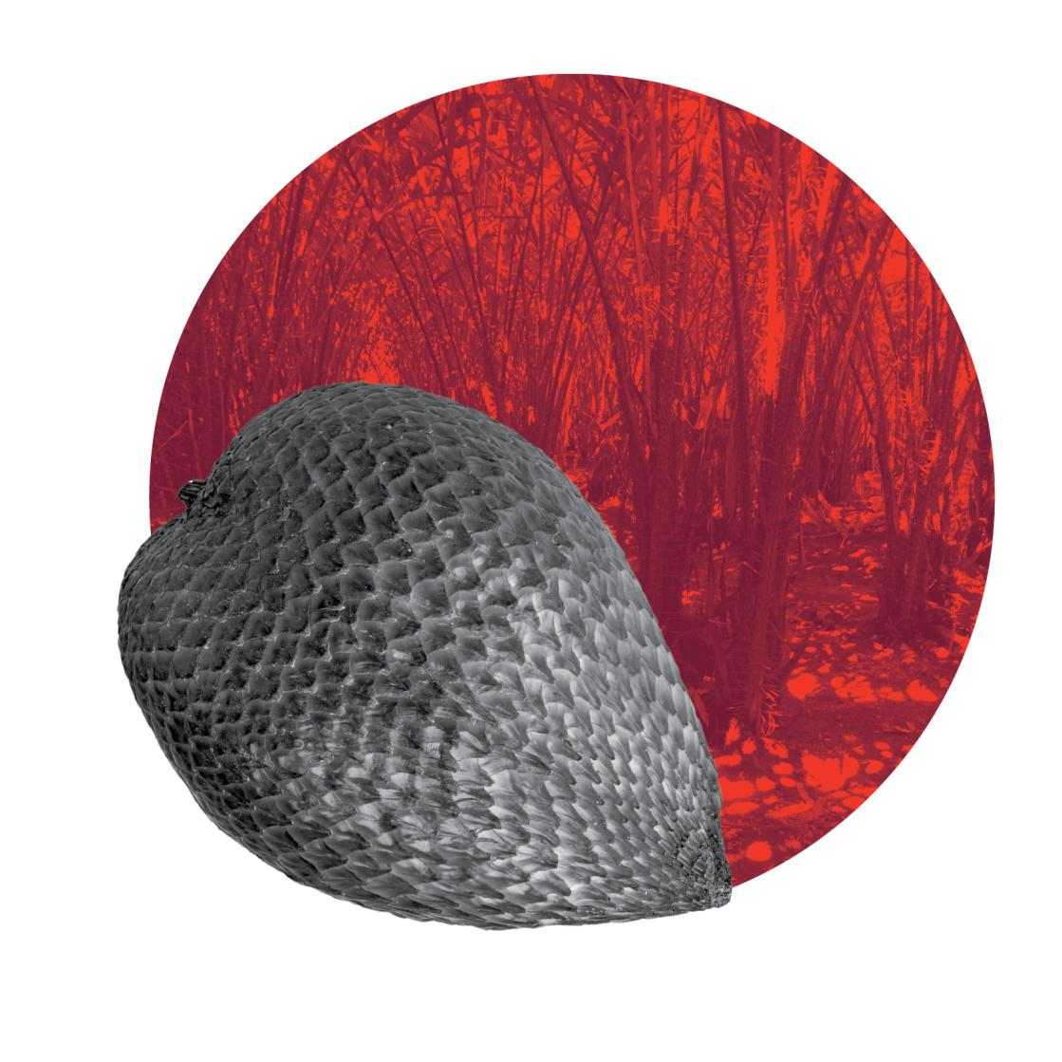

© Commonwealth of Australia
Ownership of intellectual property rights
Unless otherwise noted, copyright (and any other intellectual property rights, if any) in this publication is owned by the Commonwealth of Australia (referred to as the Commonwealth).
Creative Commons licence
All material in this publication is licensed under a Creative Commons Attribution 3.0 Australia Licence, save for content supplied by third parties, photographic images, logos, and the Commonwealth Coat of Arms.
Creative Commons Attribution 3.0 Australia Licence is a standard form licence agreement that allows you to copy, distribute, transmit and adapt this publication provided that you attribute the work. A summary of the licence terms is available from creativecommons.org/licenses/by/3.0/au/deed.en. The full licence terms are available from creativecommons.org/licenses/by/3.0/au/legalcode.
This publication (and any material sourced from it) should be attributed as:
Australian Department of Agriculture (2014) Draft import risk analysis report for fresh salacca (snake fruit) from Indonesia. CC BY 3.0.
Cataloguing data
Australian Department of Agriculture (2014) Draft import risk analysis report for fresh salacca (snake fruit) from Indonesia, Department of Agriculture, Canberra.
Internet
Draft import risk analysis report for fresh salacca (snake fruit) from Indonesia is available at daff.gov.au.
Inquiries regarding the licence and any use of this document should be sent to: copyright@daff.gov.au.
Disclaimer
The Australian Government acting through the Department of Agriculture has exercised due care and skill in the preparation and compilation of the information in this publication. Notwithstanding, the Department of Agriculture, its employees and advisers disclaim all liability, including liability for negligence, for any loss, damage, injury, expense or cost incurred by any person as a result of accessing, using or relying upon any of the information in this publication to the maximum extent permitted by law.
Submissions
This draft report has been issued to give all interested parties an opportunity to comment and draw attention to any scientific, technical, or other gaps in the data, misinterpretations and errors. Any comments should be submitted to the Australian Department of Agriculture within the comment period stated in the related Biosecurity Advice on the website. The draft report will then be revised as necessary to take account of the comments received and a provisional final report prepared.
Comments on the draft report should be submitted to:
Biosecurity Plant
Australian Department of Agriculture
GPO Box 858
Canberra ACT 2601, Australia
Telephone +61 2 6272 3933
Facsimile +61 2 6272 3307
Email plant@daff.gov.au
Website daff.gov.au/biosecurity

Contents
Acronyms and abbreviations vii
Abbreviations of units viii
Summary 1
Description of salacca 3
1 Introduction 5
1.1 Australia’s biosecurity policy framework 5
1.2 This import risk analysis 5
2 Method for pest risk analysis 9
2.1 Stage 1: Initiation 9
2.2 Stage 2: Pest risk assessment 10
2.3 Stage 3: Pest risk management 17
3 Indonesia’s commercial production practices for salacca 19
3.1 Assumptions used in estimating unrestricted risk 19
3.2 Climate in production areas 19
3.3 Pre-harvest 21
3.4 Harvesting and handling procedures 27
3.5 Post-harvest 27
3.6 Export capability 32
4 Pest risk assessments for quarantine pests 33
4.1 Mealybugs 34
4.2 Oil palm bunch rot 39
4.3 Pest risk assessment conclusions 45
5 Pest risk management 47
5.1 Pest risk management measures and phytosanitary procedures 47
5.2 Operational system for the maintenance and verification of phytosanitary status 48
5.3 Uncategorised pests 50
5.4 Review of policy 51
5.5 Meeting Australia’s food standards 51
6 Conclusion 53
Appendix A: Initiation and categorisation for pests of fresh salacca fruit from Indonesia 57
Appendix B Additional quarantine pest data 71
Appendix C Biosecurity framework 73
Glossary 79
References 83

List of tables
Table 2.1 Nomenclature for qualitative likelihoods 13
Table 2.2 Matrix of rules for combining qualitative likelihoods 13
Table 2.3 Decision rules for determining the consequence impact score based on the magnitude of consequences at four geographic scales 16
Table 2.4 Decision rules for determining the overall consequence rating for each pest 16
Table 2.5 Risk estimation matrix 17
Table 3.1 Harvest periods for Indonesia’s main salacca production areas 27
Table 3.2 Volume (t) of Indonesian salacca fruit exports from 2010-2013 (to March) 32
Table 4.1 Quarantine pests for salacca (snake fruit) from Indonesia 33
Table 4.2 Summary of unrestricted risk estimates for quarantine pests associated with fresh salacca (snake fruit) from Indonesia 46

List of figures
Figure 1 Map of Australia vi
Figure 2 A guide to Australia’s bio-climatic zones vi
Figure 3 Morphological components of a salacca plant 3
Figure 4 Morphological components of a salacca fruit 4
Figure 5 Male (left) and female (right) salacca flowers 4
Figure 6 Main commercial salacca production areas in Indonesia 20
Figure 7 Average minimum and maximum monthly temperature (°C) and rainfall (mm) for the main salacca production area, Yogyakarta 21
Figure 8 Salacca cultivars grown in the main commercial production areas of Indonesia 22
Figure 9 Planting pattern for salacca. 2 x 2 m spacing (left) and cluster planting (right) 23
Figure 10 Burial pits for pruned material, fruit and plant debris 24
Figure 11 Fertilisation applied to base of plant (left) and flood (furrow) irrigation (right) 25
Figure 12 Female flower (left) and male flower (right) 26
Figure 13 Hand pollination by tapping male flower above female flower (left) and flower covered after pollination to protect from the weather (right) 26
Figure 14 Fruit initially sorted at the collection house into plastic crates (left) and placed in closed truck (right) for transport to packing house 28
Figure 15 Fruit mechanically cleaned by passing over a conveyor belt fitted with brushes 29
Figure 16 Sorting and grading of cleaned fruit before packing for export 29
Figure 17 Weighing and sealing of packed salacca fruit 30
Figure 18 Inspection of fruit by IAQA officers 30
Figure 19 Summary of orchard and post-harvest steps for salacca fruit grown in Indonesia for export 31

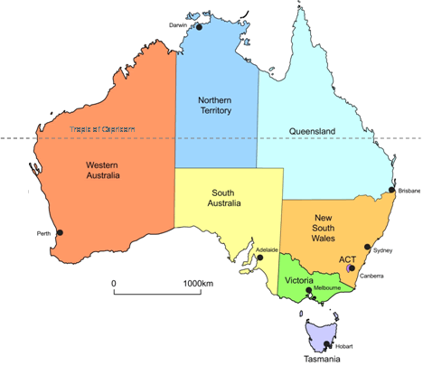
Figure 1 Map of Australia

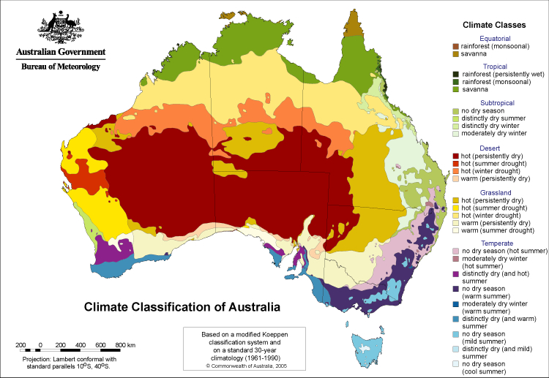
Figure 2 A guide to Australia’s bio-climatic zones

Acronyms and abbreviations
Term or abbreviation | Definition
ACT | Australian Capital Territory
ALOP | Appropriate level of protection
BA | Biosecurity Advice
CABI | CAB International, Wallingford, UK
CSIRO | Commonwealth Scientific and Industrial Research Organisation
DAFF | Acronym of the former Australian Government Department of Agriculture, Fisheries and Forestry, which is now Department of Agriculture
EP | Existing policy
EPPO | European and Mediterranean Plant Protection Organisation
FAO | Food and Agriculture Organization of the United Nations
GAP | Good Agricultural Practice
GHP | Good Handling Practice
IAQA | Indonesian Agricultural Quarantine Agency
IPC | International Phytosanitary Certificate
IPM | Integrated Pest Management
IPPC | International Plant Protection Convention
IRA | Import Risk Analysis
IRAAP | Import Risk Analysis Appeals Panel
ISPM | International Standard for Phytosanitary Measures
NSW | New South Wales
NPPO | National Plant Protection Organisation
NT | Northern Territory
OIE | World Organisation for animal health
PRA | Pest risk analysis
Qld | Queensland
SA | South Australia
SOP | Standard Operating Procedure
SPS | Sanitary and Phytosanitary
Tas. | Tasmania
Vic. | Victoria
WA | Western Australia
WTO | World Trade Organization

Abbreviations of units
Term or abbreviation | Definition
ºC | Degree Celsius
cm | Centimetre
ha | Hectare
kg | Kilogram
km | Kilometre
m | Metre
mm | Millimetre
t | Tonne

Summary
The Australian Government Department of Agriculture has prepared this draft report to assess a proposal from Indonesia for market access to Australia for fresh salacca (snake fruit).
This draft report identifies four pests of potential quarantine concern to Australia associated with the trade of fresh salacca fruit from Indonesia. These are mealybugs from three genera (Dysmicoccus sp., Planococcus sp., Pseudococcus sp.) and one fungus (Marasmius palmivorus).
Assessments of the risks associated with these quarantine pests were conducted. The pest risk assessments conclude that the unrestricted risk for all four quarantine pests does not exceed Australia’s appropriate level of protection (ALOP).
This draft report proposes that Indonesia’s existing commercial production practices for the production of fresh salacca fruit for export, combined with a system of operational procedures to ensure quarantine standards are met, will provide an appropriate level of protection to address any risks of quarantine pests entering Australia. In particular:
- Salacca fruit is to be produced for export to Australia in accordance with Indonesia’s national standard for farm certification of Good Agricultural Practices (GAP) with specific Standard Operating Procedures (SOP) for the production, pest management, harvesting, packing, inspection and certification of fresh salacca fruit.
- Salacca fruit for export to Australia must originate from orchards and packing houses registered with and audited by the Indonesian Agricultural Quarantine Agency (referred to as IAQA).
- Salacca fruit packed for export to Australia must be undamaged, clean and free from any pests, soil, and other plant materials.
- Supporting operational systems will verify the phytosanitary status of exported salacca fruit. This includes the provision of phytosanitary certificates by IAQA.
This draft report contains details of the risk assessments for pests of quarantine concern and the commercial production practices for the production of fresh salacca fruit from Indonesia so that interested parties can provide comments and submissions to the Australian Department of Agriculture within the consultation time period.

Description of salacca
Salacca (Salacca zalacca (Gaertner) Voss) is a species of palm (family Arecaceae). It is short-stemmed, growing in compact clumps formed by successive branching from a central point at ground level. Roots are borne from the trunk where it comes in contact with the soil (Figure 3). The plant is about 6 m tall and can be productive for 50 years or more (Lestari 2005).
The leaves of salacca are pinnate and large, up to 10 m long and 1.5 m wide. Each leaf has a 2 m long petiole and numerous leaflets measuring 20–70 cm long and 2–11 cm wide. The upper surface of the leaflets is dark green and shiny, while the lower surface is light green. Numerous long, strong, grey to blackish spine clusters are distributed along the petiole at intervals of 3–5 cm (Paull 2008; Supapvanich et al. 2011) (Figure 3).
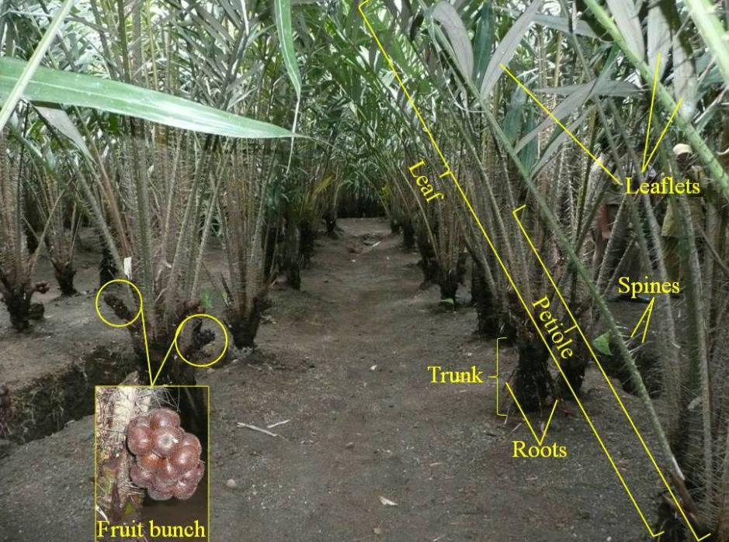
Figure 3 Morphological components of a salacca plant

Fruit grows in bunches of 15–40 fruits at the base of the palm (Figure 3). They are oval in shape, measuring 5–7 cm by 5 cm in size, rounded at the top and tapering to a point at the base. The skin is comprised of regularly arranged scales that end in a small, fragile spine or prickle, giving it the appearance of a snake or reptile skin. The scales develop from the epicarp (skin) and are thin and strong. The flesh is cream colour and usually consists of three segments, with 1–2 large dark brown inedible seeds (Figure 4).
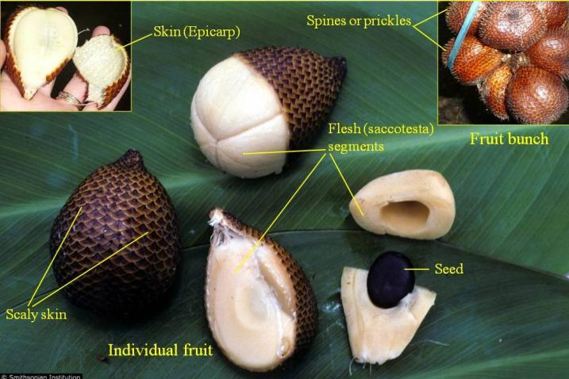
Figure 4 Morphological components of a salacca fruit
The salacca palm is dioecious, that is, the male and female flowers are produced on separate individual plants. This means a male plant must be planted near fruit-bearing female plants for pollination to occur. The male inflorescences are closely packed in finger-like spadices (spikes with a fleshy or thickened stem enclosed in a spathe), 50–100 mm long, occurring in bunches of 4–12 spadices. The female inflorescences are shorter, 20–30 mm long and are composed of 1–3 spadices (Lestari 2005; Paull 2008; Supapvanich et al. 2011) (Figure 5).
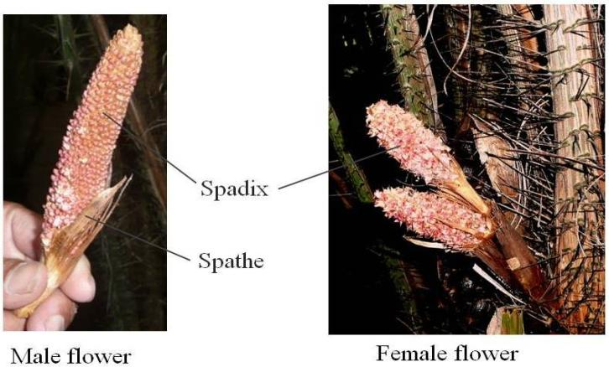
Figure 5 Male (left) and female (right) salacca flowers

Introduction

Australia’s biosecurity policy framework
Australia's biosecurity policies aim to protect Australia against the risks that may arise from exotic pests entering, establishing and spreading in Australia, thereby threatening Australia's unique flora and fauna, as well as those agricultural industries that are relatively free from serious pests.
The risk analysis process is an important part of Australia's biosecurity policies. It enables the Australian Government to formally consider the risks that could be associated with proposals to import new products into Australia. If the risks are found to exceed Australia’s appropriate level of protection (ALOP), risk management measures are proposed to reduce the risks to an acceptable level. But, if it is not possible to reduce the risks to an acceptable level, then no trade will be allowed.
Successive Australian Governments have maintained a conservative, but not a zero-risk, approach to the management of biosecurity risks. This approach is expressed in terms of Australia's ALOP, which reflects community expectations through government policy and is currently described as providing a high level of protection aimed at reducing risk to a very low level, but not to zero.
Australia’s risk analyses are undertaken by the Department of Agriculture using technical and scientific experts in relevant fields, and involve consultation with stakeholders at various stages during the process.
The Department of Agriculture’s assessment may take the form of an import risk analysis (IRA), a non-regulated analysis of existing policy, or technical advice.
Further information about Australia’s biosecurity framework is provided in Appendix C of this report and in the Import Risk Analysis Handbook 2011 located on the Department of Agriculture website www.daff.gov.au.

This import risk analysis

Background
The Indonesian Agricultural Quarantine Agency (IAQA) formally requested market access to Australia for fresh salacca (snake fruit) in a submission received on 21 March 2011 (IAQA 2011). IAQA submitted an updated market access request on 8 August 2012 (IAQA 2012b). The submissions included information on the pests associated with salacca crops in Indonesia, including the plant part affected, and the standard commercial production practices for fresh salacca in Indonesia.
On 21 December 2012, the Department of Agriculture formally announced the commencement of this risk analysis, advising that it would be progressed as a standard import risk analysis, using the process described in the Import Risk Analysis Handbook 2011.

Scope
The scope of this risk analysis is to consider the quarantine risk that may be associated with the importation of commercially produced fresh salacca fruit (Salacca zalacca (Gaertner) Voss) from Indonesia, for human consumption in Australia.
In this risk analysis, fresh salacca fruit is defined as individual, oval shaped fruit that tapers towards the base and is rounded at the top. The fruit skin is covered with regularly arranged scales that encase the sarcotesta (flesh) and seeds (Figure 4).
This risk analysis covers all commercially produced fresh salacca fruit of all varieties/cultivars and the provinces/regions of Indonesia in which they are grown for export.

Existing policy
International policy
Australia does not import fresh salacca fruit from any country. There is no import policy for fresh salacca fruit. An assessment of the pests associated with this commodity has not been conducted and there are no established risk management measures for fresh salacca fruit.
Domestic arrangements
The Commonwealth Government is responsible for regulating the movement of plants and plant products into and out of Australia. However, the state and territory governments are responsible for plant health controls within their individual jurisdiction. Legislation relating to resource management or plant health may be used by state and territory government agencies to control interstate movement of plants and their products. It is the importer’s responsibility to identify, and ensure compliance with all requirements.

Contaminating pests
In addition to the pests of fresh salacca fruit from Indonesia that are assessed in this risk analysis, there are other organisms that may arrive with the imported commodity. These organisms could include pests of other crops or predators and parasitoids of other arthropods. The Department of Agriculture considers these organisms to be contaminating pests that could pose sanitary and phytosanitary risks. These risks are addressed by existing operational procedures that require a 600 unit inspection, or equivalent, of all consignments, and investigation of any pest that may be of quarantine concern to Australia.

Consultation
The Department of Agriculture contacted the Australian tropical fruit industry through its representative body, Tropical & Exotic Fruit Australia, for an initial consultation on the request by Indonesia to export fresh salacca fruit to Australia.
On 21 December 2012, the department notified stakeholders in Biosecurity Advice (BA) 2012/28 of the formal commencement of a regulated import risk analysis to consider a proposal from Indonesia for market access to Australia for fresh salacca fruit.
The Department of Agriculture has regularly consulted with IAQA and Australian state and territory government departments during the preparation of this draft report. The department provided a draft pest categorisation to IAQA and Australian state and territory government departments on 2 July 2013 for their advance consideration of regional pests, prior to the formal release of this draft report.

Next Steps
This draft report gives stakeholders the opportunity to comment and draw attention to any scientific, technical, or other gaps in the data, misinterpretations and errors.
The Department of Agriculture will consider submissions received on the draft report and may consult informally with stakeholders. The department will revise the draft report as appropriate.
The Department of Agriculture will then prepare a provisional final report, taking into account stakeholder comments. The report will be distributed to the proposer and registered stakeholders and the documents will be placed on the department website.
The regulated timeframe for an import risk analysis (IRA) ends when a provisional final report is issued.
Stakeholders who believe there was a significant deviation from the IRA process set out in the Import Risk Analysis Handbook 2011 that adversely affected their interests may appeal to the Import Risk Analysis Appeals Panel (IRAAP). Appeals must be lodged within 30 days of the publication of the provisional final IRA report.
The appeals process is independent of the Department of Agriculture. It is a non-judicial review that is not part of the regulated process.
Further details of the appeal process may be found at Annex 6 of the IRA Handbook.
At the conclusion of the appeal process and after any issues arising from the IRAAP process has been addressed, the Department of Agriculture will provide the final IRA report.
The Director of Animal and Plant Quarantine will then make a determination. The determination provides a policy framework for decisions on whether or not to grant an import permit and any conditions that may be attached to a permit.
A policy determination represents the completion of the IRA process.
The Department of Agriculture notifies the proposer, registered stakeholders and the WTO Secretariat of the determination. The determination will also be placed on the department website.

Method for pest risk analysis
This chapter sets out the method used for the pest risk analysis (PRA) in this report. The Department of Agriculture has conducted this PRA in accordance with the International Standards for Phytosanitary Measures (ISPMs), including ISPM 2: Framework for pest risk analysis (FAO 2007) and ISPM 11: Pest risk analysis for quarantine pests (FAO 2013) that have been developed under the SPS Agreement (WTO 1995).
A PRA is ‘the process of evaluating biological or other scientific and economic evidence to determine whether an organism is a pest, whether it should be regulated, and the strength of any phytosanitary measures to be taken against it’ (FAO 2012). A pest is ‘any species, strain or biotype of plant, animal, or pathogenic agent injurious to plants or plant products’ (FAO 2012).
Quarantine risk consists of two major components: the probability of a pest entering, establishing and spreading in Australia from imports; and the consequences should this happen. These two components are combined to give an overall estimate of the risk.
Unrestricted risk is estimated taking into account the existing commercial production practices of the exporting country and that, on arrival in Australia, the Department of Agriculture will verify that the consignment received is as described on the commercial documents and its integrity has been maintained.
Restricted risk is estimated with phytosanitary measure(s) applied. A phytosanitary measure is ‘any legislation, regulation or official procedure having the purpose to prevent the introduction and/or spread of quarantine pests, or to limit the economic impact of regulated non-quarantine pests’ (FAO 2012).
A glossary of the terms used is provided at the back of this report.
The PRAs are conducted in the following three consecutive stages: initiation, pest risk assessment and pest risk management.

Stage 1: Initiation
Initiation identifies the pest(s) and pathway(s) that are of quarantine concern and should be considered for risk analysis in relation to the identified PRA area.
The initiation point for this risk analysis was the receipt of a technical submission from IAQA for access to the Australian market for fresh salacca fruit.
Appendix A of this risk analysis report lists the pests with the potential to be associated with the exported commodity produced using commercial production and packing procedures. Appendix A does not present a comprehensive list of all the pests associated with the entire plant, but concentrates on the pests that could be on the assessed commodity. Contaminating pests that have no specific relation to the commodity or the export pathway have not been listed and would be addressed by Australia’s current approach to contaminating pests.
The identity of the pests is given in Appendix A. The species name is used in most instances but a lower taxonomic level is used where appropriate. Synonyms are provided where the current scientific name differs from that provided by the Indonesian Agricultural Quarantine Agency or where the cited literature used a different scientific name.
For this risk analysis, the ‘PRA area’ is defined as Australia for pests that are absent, or of limited distribution and under official control. For areas with regional freedom from a pest, the ‘PRA area’ may be defined on the basis of a state or territory of Australia or may be defined as a region of Australia consisting of parts of a state or territory or several states or territories.
For pests that had been considered by the Department of Agriculture in other risk assessments and for which import policies already exist, a judgement based on the specific circumstances was made on the likelihood of entry of pests on the commodity and whether existing policy is adequate to manage the risks associated with its import. Where appropriate, the previous risk assessment was taken into consideration when developing the new policy.

Stage 2: Pest risk assessment
A pest risk assessment (for quarantine pests) is the ‘evaluation of the probability of the introduction and spread of a pest and of the magnitude of the associated potential economic consequences’ (FAO 2012).
In this risk analysis, pest risk assessment was divided into the following interrelated processes:

Pest categorisation
Pest categorisation identifies which of the pests with the potential to be on the commodity are quarantine pests for Australia and require pest risk assessment. A ‘quarantine pest’ is a pest of potential economic importance to the area endangered thereby and not yet present there, or present but not widely distributed and being officially controlled, as defined in ISPM 5: Glossary of phytosanitary terms (FAO 2012).
The pests identified in Stage 1 were categorised using the following primary elements to identify the quarantine pests for the commodity being assessed:
- identity of the pest
- presence or absence in the PRA area
- regulatory status
- potential for establishment and spread in the PRA area
- potential for economic consequences (including environmental consequences) in the PRA area.
Initiation and categorisation steps are presented in Appendix A. The quarantine pests identified are carried forward for pest risk assessment and are listed in Table 4.1.

Assessment of the probability of entry, establishment and spread
Details of how to assess the ‘probability of entry’, ‘probability of establishment’ and ‘probability of spread’ of a pest are given in ISPM 11 (FAO 2013). A summary of this process is given below, followed by a description of the qualitative methodology used in this risk analysis.
Probability of entry
The probability of entry describes the probability that a quarantine pest will enter Australia as a result of trade in a given commodity, be distributed in a viable state in the PRA area and subsequently be transferred to a host. It is based on pathway scenarios depicting necessary steps in the sourcing of the commodity for export, its processing, transport and storage, its use in Australia and the generation and disposal of waste. In particular, the ability of the pest to survive is considered for each of these various stages.
The probability of entry estimates, for the quarantine pests for a commodity, are based on the use of the existing commercial production, packaging and shipping practices of the exporting country. Details of the existing commercial production practices for the commodity are set out in Chapter 3. These practices are taken into consideration by the Department of Agriculture when estimating the probability of entry.
For the purpose of considering the probability of entry, the department divides this step into two components:
- Probability of importation: the probability that a pest will arrive in Australia when a given commodity is imported.
- Probability of distribution: the probability that the pest will be distributed, as a result of the processing, sale or disposal of the commodity, in the PRA area and subsequently transfer to a susceptible part of a host.
Factors considered in the probability of importation include:
- distribution and incidence of the pest in the source area
- occurrence of the pest in a life-stage that would be associated with the commodity
- mode of trade (e.g. bulk, packed)
- volume and frequency of movement of the commodity along each pathway
- seasonal timing of imports
- pest management, cultural and commercial procedures applied at the place of origin
- speed of transport and conditions of storage compared with the duration of the lifecycle of the pest
- vulnerability of the life-stages of the pest during transport or storage
- incidence of the pest likely to be associated with a consignment
- commercial procedures (e.g. refrigeration) applied to consignments during transport and storage in the country of origin, and during transport to Australia.
Factors considered in the probability of distribution include:
- commercial procedures (e.g. refrigeration) applied to consignments during distribution in Australia
- dispersal mechanisms of the pest, including vectors, to allow movement from the pathway to a host
- whether the imported commodity is to be sent to a few or many destination points in the PRA area
- proximity of entry, transit and destination points to hosts
- time of year at which import takes place
- intended use of the commodity (e.g. for planting, processing or consumption)
- risks from by-products and waste.
Probability of establishment
Establishment is defined as the ‘perpetuation for the foreseeable future, of a pest within an area after entry’ (FAO 2012). In order to estimate the probability of establishment of a pest, reliable biological information (lifecycle, host range, epidemiology, survival, etc.) is obtained from the areas where the pest currently occurs. The situation in the PRA area can then be compared with that in the areas where it currently occurs and expert judgement used to assess the probability of establishment.
Factors considered in the probability of establishment in the PRA area include:
- availability of hosts, alternative hosts and vectors
- suitability of the environment
- reproductive strategy and potential for adaptation
- minimum population needed for establishment
- cultural practices and control measures.
Probability of spread
Spread is defined as ‘the expansion of the geographical distribution of a pest within an area’ (FAO 2012). The probability of spread considers the factors relevant to the movement of the pest, after establishment on a host plant or plants, to other susceptible host plants of the same or different species in other areas. In order to estimate the probability of spread of the pest, reliable biological information is obtained from areas where the pest currently occurs. The situation in the PRA area is then carefully compared with that in the areas where the pest currently occurs and expert judgement used to assess the probability of spread.
Factors considered in the probability of spread include:
- suitability of the natural and/or managed environment for natural spread of the pest
- presence of natural barriers
- potential for movement with commodities, conveyances or by vectors
- intended use of the commodity
- potential vectors of the pest in the PRA area
- potential natural enemies of the pest in the PRA area.
Assigning qualitative likelihoods for the probability of entry, establishment and spread
In its qualitative PRAs, the Department of Agriculture uses the term ‘likelihood’ for the descriptors it uses for its estimates of probability of entry, establishment and spread. Qualitative likelihoods are assigned to each step of entry, establishment and spread. Six descriptors are used: high; moderate; low; very low; extremely low; and negligible (Table 2.1). Descriptive definitions for these descriptors and their indicative probability ranges are given in Table 2.1. The indicative probability ranges are only provided to illustrate the boundaries of the descriptors and are not used beyond this purpose in qualitative PRAs. These indicative probability ranges provide guidance to the risk analyst and promote consistency between different pest risk assessments.
Table 2.1 Nomenclature for qualitative likelihoods
Likelihood | Descriptive definition | Indicative probability (P) range
High | The event would be very likely to occur | 0.7 < P ≤ 1
Moderate | The event would occur with an even probability | 0.3 < P ≤ 0.7
Low | The event would be unlikely to occur | 0.05 < P ≤ 0.3
Very low | The event would be very unlikely to occur | 0.001 < P ≤ 0.05
Extremely low | The event would be extremely unlikely to occur | 0.000001 < P ≤ 0.001
Negligible | The event would almost certainly not occur | 0 < P ≤ 0.000001
The likelihood of entry is determined by combining the likelihood that the pest will be imported into the PRA area and the likelihood that the pest will be distributed within the PRA area, using a matrix of rules (Table 2.2). This matrix is then used to combine the likelihood of entry and the likelihood of establishment, and the likelihood of entry and establishment is then combined with the likelihood of spread to determine the overall likelihood of entry, establishment and spread.
For example, if the probability of importation is assigned a likelihood of ‘low’ and the probability of distribution is assigned a likelihood of ‘moderate’, then they are combined to give a likelihood of ‘low’ for the probability of entry. The likelihood for the probability of entry is then combined with the likelihood assigned to the probability of establishment (e.g. ‘high’) to give a likelihood for the probability of entry and establishment of ‘low’. The likelihood for the probability of entry and establishment is then combined with the likelihood assigned to the probability of spread (e.g. ‘very low’) to give the overall likelihood for the probability of entry, establishment and spread of ‘very low’. A working example is provided below;
P [importation] x P [distribution] = P [entry] e.g. low x moderate = low
P [entry] x P [establishment] = P [EE] e.g. low x high = low
P [EE] x [spread] = P [EES] e.g. low x very low = very low

Table 2.2 Matrix of rules for combining qualitative likelihoods
 | High | Moderate | Low | Very low | Extremely low | Negligible
High | High | Moderate | Low | Very low | Extremely low | Negligible
Moderate |  | Low | Low | Very low | Extremely low | Negligible
Low |  |  | Very low | Very low | Extremely low | Negligible
Very low |  |  |  | Extremely low | Extremely low | Negligible
Extremely low |  |  |  |  | Negligible | Negligible
Negligible |  |  |  |  |  | Negligible

Time and volume of trade
One factor affecting the likelihood of entry is the volume and duration of trade. If all other conditions remain the same, the overall likelihood of entry will increase as time passes and the overall volume of trade increases.
The Department of Agriculture normally considers the likelihood of entry on the basis of the estimated volume of one year’s trade. This is a convenient value for the analysis that is relatively easy to estimate and allows for expert consideration of seasonal variations in pest presence, incidence and behaviour to be taken into account. The consideration of the likelihood of entry, establishment and spread and subsequent consequences takes into account events that might happen over a number of years even though only one year’s volume of trade is being considered. This difference reflects biological and ecological facts, for example where a pest or disease may establish in the year of import but spread may take many years.
The use of a one year volume of trade has been taken into account when setting up the matrix that is used to estimate the risk and therefore any policy based on this analysis does not simply apply to one year of trade. Policy decisions that are based on the Department of Agriculture’s method that uses the estimated volume of one year’s trade are consistent with Australia’s policy on appropriate level of protection and meet the Australian Government’s requirement for ongoing quarantine protection. Of course, if there are substantial changes in the volume and nature of the trade in specific commodities then the department has an obligation to review the risk analysis and, if necessary, provide updated policy advice.
In assessing the volume of trade in this risk analysis, the department assumed that a very small volume of trade will occur (refer to section 3.6 Export capability).

Assessment of potential consequences
The objective of the consequence assessment is to provide a structured and transparent analysis of the likely consequences if the pests or disease agents were to enter, establish and spread in Australia. The assessment considers direct and indirect pest effects and their economic and environmental consequences. The requirements for assessing potential consequences are given in Article 5.3 of the SPS Agreement (WTO 1995), ISPM 5 (FAO 2012) and ISPM 11 (FAO 2013).
Direct pest effects are considered in the context of the effects on:
- plant life or health
- other aspects of the environment.
Indirect pest effects are considered in the context of the effects on:
- eradication, control, etc.
- domestic trade
- international trade
- environment.
For each of these six criteria, the consequences were estimated over four geographic levels, defined as:
Local: an aggregate of households or enterprises (a rural community, a town or a local government area).
District: a geographically or geopolitically associated collection of aggregates (generally a recognised section of a state or territory, such as ‘Far North Queensland’).
Regional: a geographically or geopolitically associated collection of districts in a geographic area (generally a state or territory, although there may be exceptions with larger states such as Western Australia).
National: Australia wide (Australian mainland states and territories and Tasmania).
For each criterion, the magnitude of the potential consequence at each of these levels was described using four categories, defined as:
Indiscernible: pest impact unlikely to be noticeable.
Minor significance: expected to lead to a minor increase in mortality/morbidity of hosts or a minor decrease in production but not expected to threaten the economic viability of production. Expected to decrease the value of non-commercial criteria but not threaten the criterion’s intrinsic value. Effects would generally be reversible.
Significant: expected to threaten the economic viability of production through a moderate increase in mortality/morbidity of hosts, or a moderate decrease in production. Expected to significantly diminish or threaten the intrinsic value of non-commercial criteria. Effects may not be reversible.
Major significance: expected to threaten the economic viability through a large increase in mortality/morbidity of hosts, or a large decrease in production. Expected to severely or irreversibly damage the intrinsic ‘value’ of non-commercial criteria.
The estimates of the magnitude of the potential consequences over the four geographic levels were translated into a qualitative impact score (A-G) using table 2.3. For example, a consequence with a magnitude of ‘significant’ at the ‘district’ level will have a consequence impact score of D.

Table 2.3 Decision rules for determining the consequence impact score based on the magnitude of consequences at four geographic scales
 |  | Geographic scale
 |  | Local | District | Region | Nation
Magnitude | Indiscernible | A | A | A | A
Magnitude | Minor significance | B | C | D | E
Magnitude | Significant | C | D | E | F
Magnitude | Major significance | D | E | F | G
The overall consequence for each pest is achieved by combining the qualitative impact scores (A–G) for each direct and indirect consequence using a series of decision rules (Table 2.4). These rules are mutually exclusive, and are assessed in numerical order until one applies.
Rule | The impact scores for consequences of direct and indirect criteria | Overall consequence rating
1 | Any criterion has an impact of ‘G’; or  more than one criterion has an impact of ‘F’; or  a single criterion has an impact of ‘F’ and each remaining criterion an ‘E’. | Extreme
2 | A single criterion has an impact of ‘F’; or  all criteria have an impact of ‘E’. | High
3 | One or more criteria have an impact of ‘E’; or  all criteria have an impact of ‘D’. | Moderate
4 | One or more criteria have an impact of ‘D’; or  all criteria have an impact of ‘C’. | Low
5 | One or more criteria have an impact of ‘C’; or  all criteria have an impact of ‘B’. | Very Low
6 | One or more but not all criteria have an impact of ‘B’, and  all remaining criteria have an impact of ‘A’. | Negligible
Table 2.4 Decision rules for determining the overall consequence rating for each pest

Estimation of the unrestricted risk
Once the above assessments are completed, the unrestricted risk can be determined for each pest or groups of pests. This is determined by using a risk estimation matrix (Table 2.5) to combine the estimates of the probability of entry, establishment and spread and the overall consequences of pest establishment and spread. Therefore, risk is the product of likelihood and consequence.
When interpreting the risk estimation matrix, note the descriptors for each axis are similar (e.g. low, moderate, high) but the vertical axis refers to likelihood and the horizontal axis refers to consequences. Accordingly, a ‘low’ likelihood combined with ‘high’ consequences, is not the same as a ‘high’ likelihood combined with ‘low’ consequences – the matrix is not symmetrical. For example, the former combination would give an unrestricted risk rating of ‘moderate’, whereas, the latter would be rated as a ‘low’ unrestricted risk.

Table 2.5 Risk estimation matrix
Likelihood of pest entry, establishment and spread | High | Negligible risk | Very low risk | Low risk | Moderate risk | High risk | Extreme risk
Likelihood of pest entry, establishment and spread | Moderate | Negligible risk | Very low risk | Low risk | Moderate risk | High risk | Extreme risk
Likelihood of pest entry, establishment and spread | Low | Negligible risk | Negligible risk | Very low risk | Low risk | Moderate risk | High risk
Likelihood of pest entry, establishment and spread | Very low | Negligible risk | Negligible risk | Negligible risk | Very low risk | Low risk | Moderate risk
Likelihood of pest entry, establishment and spread | Extremely low | Negligible risk | Negligible risk | Negligible risk | Negligible risk | Very low risk | Low risk
Likelihood of pest entry, establishment and spread | Negligible | Negligible risk | Negligible risk | Negligible risk | Negligible risk | Negligible risk | Very low risk
 |  | Negligible | Very low | Low | Moderate | High | Extreme
 |  | Consequences of pest entry, establishment and spread

Australia’s appropriate level of protection (ALOP)
The SPS Agreement defines the concept of an ‘appropriate level of sanitary or phytosanitary protection (ALOP)’ as the level of protection deemed appropriate by the WTO Member establishing a sanitary or phytosanitary measure to protect human, animal or plant life or health within its territory.
Like many other countries, Australia expresses its ALOP in qualitative terms. Australia’s ALOP, which reflects community expectations through government policy, is currently expressed as providing a high level of sanitary or phytosanitary protection aimed at reducing risk to a very low level, but not to zero. The band of cells in Table 2.5 marked ‘very low risk’ represents Australia’s ALOP.

Stage 3: Pest risk management
Pest risk management describes the process of identifying and implementing phytosanitary measures to manage risks to achieve Australia’s ALOP, while ensuring that any negative effects on trade are minimised.
The conclusions from pest risk assessment are used to decide whether risk management is required and if so, the appropriate measures to be used. Where the unrestricted risk estimate exceeds Australia’s ALOP, risk management measures are required to reduce this risk to a very low level. The guiding principle for risk management is to manage risk to achieve Australia’s ALOP. The effectiveness of any proposed phytosanitary measures (or combination of measures) is evaluated, using the same approach as used to evaluate the unrestricted risk, to ensure it reduces the restricted risk for the relevant pest or pests to meet Australia’s ALOP.
ISPM 11 (FAO 2013) provides details on the identification and selection of appropriate risk management options and notes that the choice of measures should be based on their effectiveness in reducing the probability of entry of the pest.
Examples given of measures commonly applied to traded commodities include:
- options for consignments – e.g., inspection or testing for freedom from pests, prohibition of parts of the host, a pre-entry or post-entry quarantine system, specified conditions on preparation of the consignment, specified treatment of the consignment, restrictions on end-use, distribution and periods of entry of the commodity
- options preventing or reducing infestation in the crop – e.g., treatment of the crop, restriction on the composition of a consignment so it is composed of plants belonging to resistant or less susceptible species, harvesting of plants at a certain age or specified time of the year, production in a certification scheme
- options ensuring that the area, place or site of production or crop is free from the pest – e.g., pest-free area, pest-free place of production or pest-free production site
- options for other types of pathways – e.g., consider natural spread, measures for human travellers and their baggage, cleaning or disinfestations of contaminated machinery
- options within the importing country – e.g., surveillance and eradication programs
- prohibition of commodities – if no satisfactory measure can be found.
Risk management measures are identified for each quarantine pest where the risk exceeds Australia’s ALOP. These are presented in Chapter 5 of this report.

Indonesia’s commercial production practices for salacca
This chapter provides information on the pre-harvest, harvest and post-harvest practices considered to be standard practices in Indonesia for the production of fresh salacca fruit for export. The export capability of Indonesia is also outlined.

Assumptions used in estimating unrestricted risk
Indonesia provided Australia with information on the standard commercial practices used in the production of salacca in different provinces/regions and for all commercially produced salacca cultivars in Indonesia. This information was complemented with data from other sources and was taken into consideration when estimating the unrestricted risks of pests that may be associated with the import of this commodity.
Indonesia has stated that salacca will be produced for export to Australia in accordance with Indonesia’s farm certification scheme for Good Agriculture Practices (GAP) (Indonesian Ministry of Agriculture 2012b) with specific Standard Operating Procedures (SOP) (Indonesian Ministry of Agriculture 2011). This program ensures fruit is produced following a national standard to prevent risks associated with production, harvesting and post-harvesting processes. The SOP for salacca outlines the standard practice of on-farm production activities (i.e. registration and certification, use of seeds/plant varieties, cultivation, fertilisation, crop protection, irrigation and harvest procedures), as well as that of local industries where the produce is processed and packed for sale.
Officers from the Department of Agriculture visited salacca production areas in Yogyakarta and Central Java from 15-19 April 2013, to verify the pest status and observe the harvest, processing and packing procedures for export of salacca fruit. The department’s observations and additional information provided during the visit confirmed the production and processing procedures described in this chapter as standard commercial production practices for fresh salacca fruit for export.
The pre-harvest, harvest and post-harvest practices described in this chapter were observed during the verification visit and reflect Indonesia’s GAP and SOP for producing salacca for export.

Climate in production areas
Salacca is grown across all of Indonesia. However, the main salacca commercial production areas are in the provinces/districts of Central Java (Banjarnegara and Magelang regencies), Yogyakarta special region (Sleman regency) and Bali (Bebandem regency) (Figure 6) (IAQA 2012a).
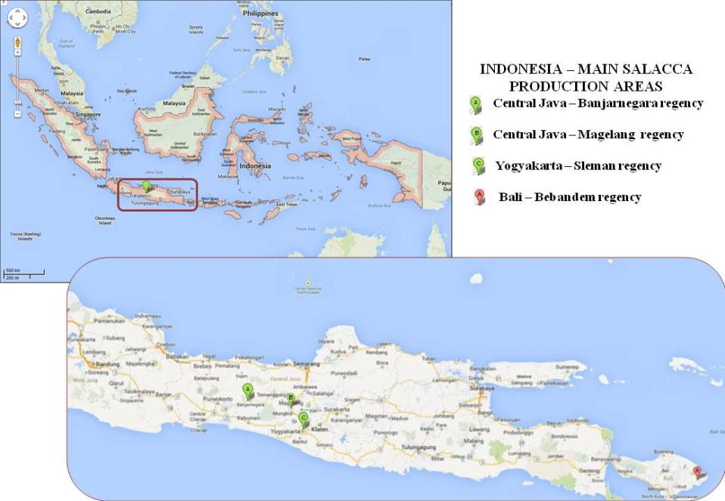
Figure 6 Main commercial salacca production areas in Indonesia
Indonesia is located close to the equator, which means that the climate is almost entirely tropical (hot and humid). The temperature remains fairly constant throughout the year. Seasonal variation is dominated by precipitation.
The climate of Java features two seasons; the wet or rainy season and the dry monsoon season. The western monsoon brings the rainy season from October to April, while the eastern monsoons bring the dry weather that occurs from May to September. The dry season does not mean there is no rain, but less rain with tropical showers occurring in the afternoons. The humidity is high throughout the year with the average humidity being 75% (JavaIndonesia.org 2011).
The climate of Central Java, Yogyakarta and Bali is similar. The average daily temperature for Central Java ranges between 23 °C and 30 °C (HotelTravel.com 2013), and for Yogyakarta, 25 °C and 28 °C (Weatherbase 2013). The average temperature in Bali is around 28 °C throughout the year (Weatherbase 2013). The volume of rainfall varies across Java, decreasing from west to east (Yamada 1997). The average annual rainfall for the central area of Java is around 2000 mm per year (JavaIndonesia.org 2011).
The average minimum and maximum monthly temperatures recorded over the past 14 years and the average monthly rainfall recorded over the past 65 years for Yogyakarta, near the main commercial production areas for salacca, are shown in Figure 7.

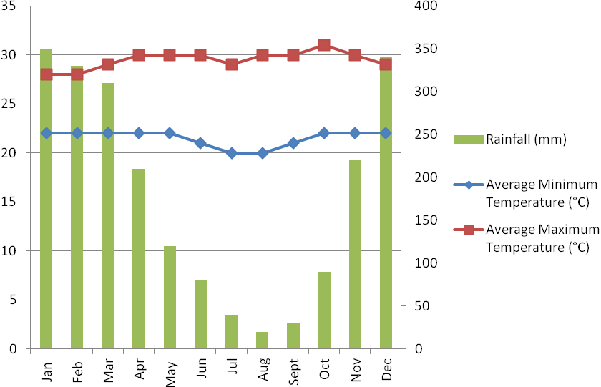
Source: Weatherbase 2013 Yogyakarta, Indonesia http://www.weatherbase.com.
Figure 7 Average minimum and maximum monthly temperature (°C) and rainfall (mm) for the main salacca production area, Yogyakarta

Pre-harvest

Cultivars
Salacca zalacca (Gaertner) Voss, with the synonym S. edulis (Reinw.) is the most important commercial species grown in Indonesia for the domestic and export market (Supapvanich et al. 2011). In Indonesia there are over 30 cultivars of salacca, which are often distinguished by their place of origin, fruit taste, fruit texture or fruit colour (Kusumo 1995; Supapvanich et al. 2011).
Different salacca cultivars suit different cultivation areas. In the main salacca production areas of Central Java, Yogyakarta and Bali, the cultivars grown commercially for the domestic and export market are S. zalacca c.v. pondoh, S. zalacca c.v. nglumut and S. zalacca c.v. gula pasir (IAQA 2012a) (Figure 8). Currently, S. zalacca c.v. pondoh is divided into three sub cultivars ‘pondoh super’, ‘pondoh hitam’ and ‘pondoh manggala’. These cultivars can be differentiated by the colour of the leaf, stem, fruit kernels, peel and pulp, fruit size and weight and fruit taste (Lestari 2005).
S. zalacca c.v. pondoh S. zalacca c.v. nglumut S. zalacca c.v. gula pasir
Figure 8 Salacca cultivars grown in the main commercial production areas of Indonesia

Cultivation practices
Propagation
The salacca plant is primarily propagated by vegetative methods such as sucker grafting or layering (IAQA 2012a). Layering is a technique that enables a portion of an aerial stem to grow roots while still attached to the parent plant. After 3-6 months of age, or when the shoot is around 80 cm high with 2-3 leaf midribs, it is separated from the parent plant and placed in a bamboo bag for transplanting in the field (IAQA 2012a).
Seeds can also be used for salacca propagation (Kusumo 1995). Where seeds are used they are sourced from a certified seed breeder, registered with IAQA (Indonesian Ministry of Agriculture 2011). Seeds used immediately after removal from the fruit will germinate readily, within less than one week, under humid and shady conditions (Schuiling and Mogea 1991). Around six months after sowing, when the seedling is about 80 cm high with 2-3 leaf midribs, the seedling can be transferred to the field (Schuiling and Mogea 1991).
Planting and cultivation
Salacca is a tropical plant, requiring high temperatures and high humidity as well as appropriate rainfall and light intensity for tree growth and fruit development.
Salacca grows best in humid tropical lowland conditions where the average annual rainfall is 1700–3100 mm per year. The rainfall should be uniformly distributed (200–400 mm per month) with only a short dry season. Salacca plants have a superficial root system and require well distributed rainfall, otherwise a high water table or irrigation is needed (Lestari 2005). Uniform water availability supports regular flowering and fruiting (Schuiling and Mogea 1991; Lestari 2005; Paull and Duarte 2012).
The appropriate temperature for salacca cultivation is between 20 °C and 32 °C. Young salacca is usually grown under shade with a light intensity of around 30% to 80% full sunlight (Lestari 2005). Young salacca plants grow faster and have higher production when shaded; therefore propagated material is initially grown under shading plants such as banana, jackfruit or mango (Paull and Duarte 2012). Mature plants do not normally require shading as they begin to self-shade and shade each other.
Salacca can adapt to sandy or clay soil but prefers a free draining soil with organic content. Salacca grows best in soil with a pH of 6-7 but can grow in soil with a pH ranging from 4.5 - 7.5 (Lestari 2005).
Propagated plants are transplanted to the field early in the rainy season. Planting density is usually around 2000 plants/plant clusters per hectare or at a spacing of 2 x 2 m (IAQA 2012a). As salacca is dioecious (male and female flowers produced on separate individual plants), both male and female plants are planted together in the orchard. The male plants are planted one year prior to the female plants (IAQA 2012a) at a ratio of 1 male to 20-30 female plants (IAQA 2011).
Plants are often planted in clusters of 2-3 (Figure 9). Around 10 kg of organic matter or compost is incorporated into the planting hole during planting (IAQA 2012a).
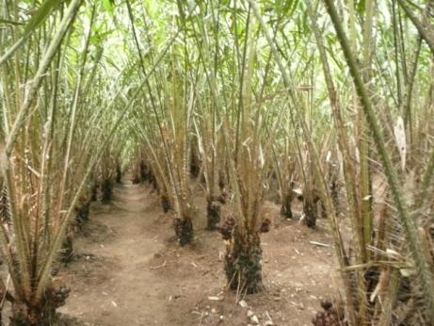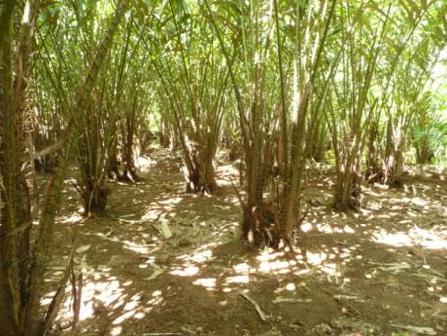
Figure 9 Planting pattern for salacca. 2 x 2 m spacing (left) and cluster planting (right)
Pruning
Plants are pruned to maintain aeration through the orchard, optimise light interception, stimulate blooming (growth of female flowers), and improve fruit quality (Indonesian Ministry of Agriculture 2011; IAQA 2012a). Plants are manually pruned twice a month and more often during blooming or fruiting (Sukewijaya et al. 2009). Suckers (or shoots rising from the trunk or roots that develop into a new plant) in each cluster are periodically controlled to maintain the plant density and farm humidity. The ideal number of plants per cluster is two (Sukewijaya et al. 2009) and the optimum number of leaves per plant is 7-8 (Indonesian Ministry of Agriculture 2011). Overhanging, damaged, old, and dead/dried leaves are removed. Plants are also pruned after harvest to ensure optimum plant growth (Sukewijaya et al. 2009).
The pruned material is buried in deep pits (Figure 10), dug in the field between the rows of salacca plants (Indonesian Ministry of Agriculture 2011).
Fruit thinning
Fruit is thinned to reduce the number of fruit per bunch so that there is enough space for the remaining fruit to develop. Fruit thinning ensures fruit is produced to its optimum quality and quantity (Indonesian Ministry of Agriculture 2011). Fruit is first thinned two months after pollination, when it is the size of a marble. Fruits that are abnormal, damaged by pests and diseases, or in a wedged position are removed by prying the fruit from the bunch (Indonesian Ministry of Agriculture 2011). The fruit is thinned a second time, one month after the first thinning, to a level of around 20 fruit per bunch.
Fruit removed through the thinning process are also buried (along with the pruned material) in pits dug between the rows of salacca plants (Figure 10).
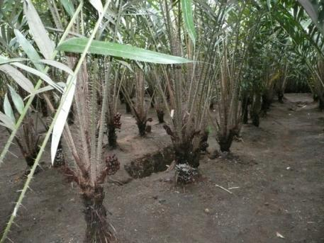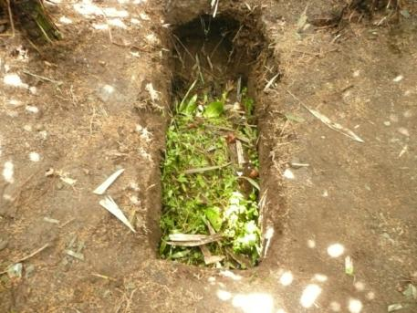
Figure 10 Burial pits for pruned material, fruit and plant debris
Weeding/sanitation
The orchard is initially cleaned of weeds two months after seedlings are transplanted in the field and then three times a month for a further two months. As the plant canopy develops, fewer weeds are present, and the orchard floor is sanitised at least once a month (IAQA 2012a) to remove any weeds, ground cover or fallen debris.
Fertilisation
Fertiliser is applied twice a year to maintain the nutrient condition in the soil and provide balanced nutrients for plant growth and development, improve fruit yield, and enhance plant productivity. Around 5-10 kg of organic fertiliser is applied to each plant before and after the rainy season (IAQA 2012a). A 15 cm trench is dug around the plant with a hoe. The fertiliser is sprinkled into the hole and covered with soil (Figure 11).
Irrigation
Salacca plants are usually flood irrigated. Water is pumped from channels through pipes and directed to flow down small trenches or furrows running through the orchard. The salacca plants are grown on the ridges between the furrows (Figure 11).
Irrigation is necessary during the dry season if the superficial root system of the plant cannot reach the water table (Schuiling and Mogea 1991). Irrigation is required following dry spells of more than 10 days to ensure adequate nutrient absorption and optimum plant growth. Increased irrigation is necessary in the initial growing stage of the salacca plant (Indonesian Ministry of Agriculture 2011). It is important that salacca plants are well irrigated especially when the plant is likely to be under stress such as after pruning or during fruit development. Less irrigation is required during the flowering stages and close to harvest (Indonesian Ministry of Agriculture 2011), to minimise rotting.
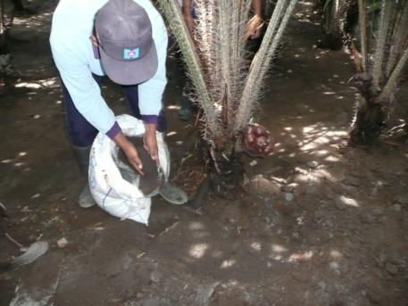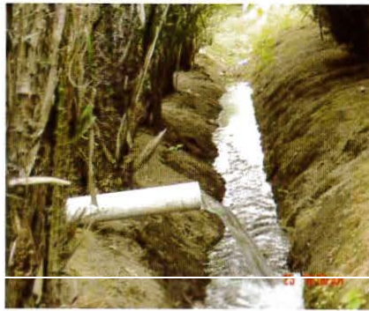
Figure 11 Fertilisation applied to base of plant (left) and flood (furrow) irrigation (right)
Pollination
Salacca plants are dioecious, producing either a male or female flower in the one plant. Around 2-4 years after propagation, the salacca plant will start flowering (Lestari 2005). It may be productive for up to 50 years. A dry period is not required to induce flowering, which can occur throughout the year.
Although natural pollination occurs by wind, rain or insects (Lestari 2005), manual pollination is carried out to improve fruit set (Supapvanich et al. 2011). The female flower opens for 1-3 days and will start to wilt if not pollinated within this time. The male flower also opens for 1-3 days and after 3 days will start wilting (Lestari 2005). The best time for pollination is the second day of blossom (Lestari 2005). Farmers walk the orchard daily, examining the readiness of the male and female flowers to ensure the pollination period is not missed.
Female flowers are ready to be fertilised when the sheath is dark brown, and the flower buds are red, opened and scented (Figure 12). The male flower, often referred to as a cob or spike (Figure 12), is cut from the stem and tapped over the female flower, to release its pollen. One male cob bears thousands of pollen grains and can pollinate 10-30 female flowers. A small piece of the cob is cut off and placed on top of the female flower to ensure adequate pollination occurs. The female flower and male cob is covered with a lid (made from leaves or plastic bottles) to protect it from rain and wind providing a chance for pollination to occur (Figure 13). The lid is removed 3-5 days after pollination (Indonesian Ministry of Agriculture 2011).

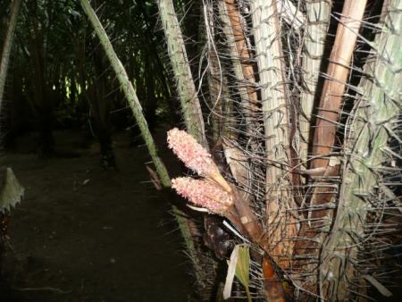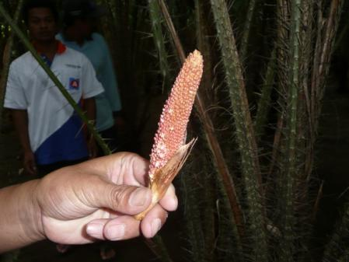
Figure 12 Female flower (left) and male flower (right)
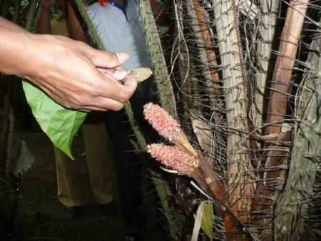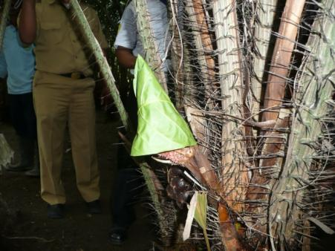
Figure 13 Hand pollination by tapping male flower above female flower (left) and flower covered after pollination to protect from the weather (right)

Pest management
The following information on pest and disease management was provided by Indonesia.
All export salacca fruit are produced in orchards registered by Indonesia’s Ministry of Agriculture which are certified to operate in accordance with Indonesia’s farm certification scheme for Good Agriculture Practice (GAP) with specific standard operating procedures for the production of salacca.
Each registered orchard follows the national guidelines developed by the Directorate of Horticulture Crop Protection and the Directorate of Food Crop Protection, covering pest monitoring and surveillance. The two directorates are responsible for instructing and overseeing the implementation of these guidelines. The pest monitoring and surveillance plan ensures orchards are monitored and inspected for pests and diseases by trained pest observers. Regional and central Food Crop and Horticulture Protection Centres are responsible for maintaining the inspection records and associated laboratories manage the diagnostics of arthropods and pathogens.
Only a relatively small number of pests and diseases are associated with salacca. Pesticides are not commonly used to control pests and diseases, but rather an integrated pest management (IPM) program that includes orchard hygiene, pruning, fertilisation, good pollination, orchard monitoring and surveillance, and the removal of damaged/diseased plant material.

Harvesting and handling procedures
Salacca is a non-climacteric fruit (Sari 2008), which means fruit does not ripen further once harvested. Fruit texture or pulp firmness is an important factor in evaluating the quality of fruit and determining when the fruit is ready for harvest. Salacca fruit is harvested at 70% maturity, when the pulp firmness, fruit size and weight are considered optimal. This is usually around 4-6 months after pollination.
Other factors that determine when the fruit is ready for harvest include the loss of tiny spines or prickles on the skin surface; the skin and seed has turned a blackish brown or dark yellow colour; the flesh has turned a yellowish white colour and no longer clings to the seed; and the fruit has a good aroma and flavour (Sukewijaya et al. 2009; Indonesian Ministry of Agriculture 2011).
Although fruit is produced all year round, the main harvest period is during the rainy months of November to January, with a secondary peak from May to July (Prihatman 2000; Ashari 2002) (Table 3.1).
Table 3.1 Harvest periods for Indonesia’s main salacca production areas
Harvest period | Jan | Feb | Mar | Apr | May | Jun | Jul | Aug | Sep | Oct | Nov | Dec
Main harvest period
Secondary harvest period
Harvesting is done manually. For the domestic market, the fruit bunches are cut from the plant with a knife or sickle and placed into bamboo baskets. For the international market, individual fruit is separated from the bunch with a twisting action, inspected for damage, placed into plastic crates and taken to the collection house for initial sorting. For traceability purposes, fruit from registered farms are placed in blue or green plastic crates, whereas non-registered farms are placed in crates of other colours or bamboo baskets.

Post-harvest

Collection house
Harvested fruit are taken to a collection house, which is often located close to the orchard. Collection houses are responsible for receiving fruit from registered farmer groups from a defined production area.
The collection house usually consists of an open or brick house with a concrete floor. Here, fruit harvested from export-registered farms is kept separate from that of non-registered farms.
Harvested salacca fruit are sorted and graded according to size, maturity level, uniformity and quality of fruit (IAQA 2012a). The fruit is graded into four classes (IAQA 2012a):
- Grade A – 8 to 12 fruit per kg
- Grade B – 13 to 17 fruit per kg
- Grade C – 18 to 22 fruit per kg
- Grade D – 22 to 26 fruit per kg
Fruit are cleaned manually with a brush to remove any soil and sorted into 40 kg plastic crates provided by the packing house. Any damaged or defective fruit are downgraded and placed in bamboo baskets for sale to the domestic market. Crates are weighed and labelled with a 4-digit collection house code (date, district, and collection house and farmer identification number).
There are no storage facilities at the collection house, and harvested fruit are transported daily to the packing house in enclosed trucks (Figure 14). Depending on where the packing house is located, transport may take up to 12 hours.
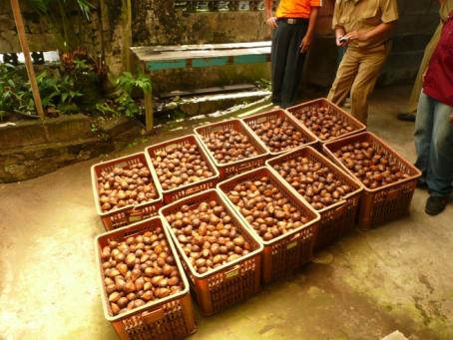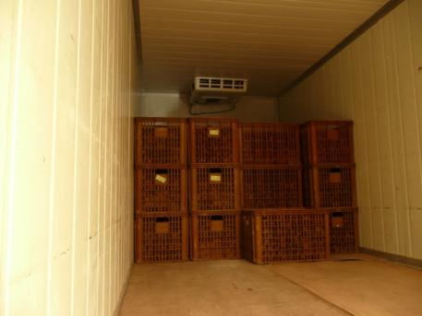
Figure 14 Fruit initially sorted at the collection house into plastic crates (left) and placed in closed truck (right) for transport to packing house

Packing house
Export fruit are packed at facilities that have been registered under the Directorate General of Processing and Marketing of Agriculture Products and are certified to follow Good Handling Practices (GHP) and able to process salacca for the export market.
Receival
Fruit arrive in covered trucks and are unloaded at the designated receival area of the packing house. Here the fruit is weighed and the documentation checked. The arrival date, name of supplier, transportation identity, total weight, and farm identity are all recorded by the packing house for traceability purposes.
Cleaning
Fruit are mechanically cleaned by passing along a conveyor belt fitted with brushes (Figure 15). The fruit are brushed for an extended period of time to remove soil, tiny spines on the surface of the fruit, debris, and any other unwanted materials.
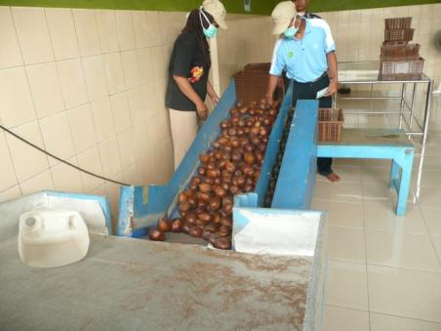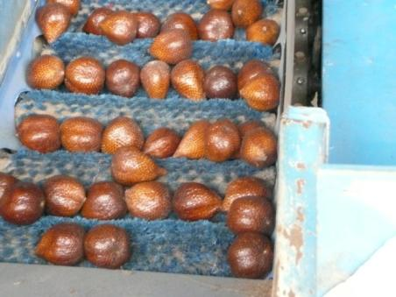
Figure 15 Fruit mechanically cleaned by passing over a conveyor belt fitted with brushes
Sorting and grading
Cleaned fruit are sorted and graded according to size and quality (Figure 16). Fruit that is damaged or does not meet the export quality standard is removed by the packing house staff before packing for export. The criteria for export quality fruit are as follows:
- fruit maturity of 70%
- fruit average size around 13-17 fruit per kg (depending on the export market)
- fruit free of damage, dirt, rot and other abnormalities
- fruit skin intact, with no cracks or punctures.
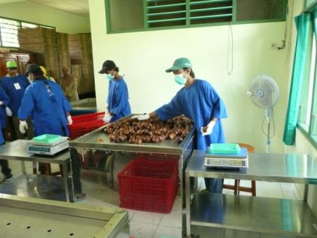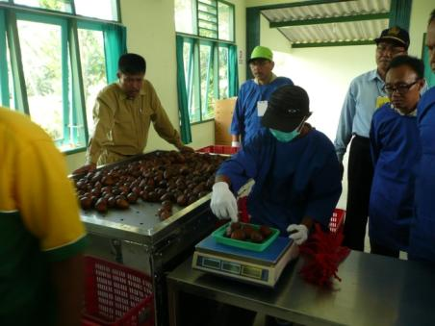
Figure 16 Sorting and grading of cleaned fruit before packing for export
Packaging and storage
Export fruit are generally packed into 9 kg clean plastic crates lined with paper. However, the packaging material may differ according to the importing country’s requirements.
The plastic crates are sealed with a plastic strap and weighed (Figure 17). Each crate is clearly labelled with the packing house name and reference code, product name, packing date, and export destination, for quality assurance and quarantine trace-back purposes.
Packed and sealed crates are stacked in a separate room, where they are stored for a short period of time, before being loaded onto trucks for export. Storage rooms must be free from pests, dry, clean and secure (IAQA 2012a). Fruit for domestic and export markets are stored separately.
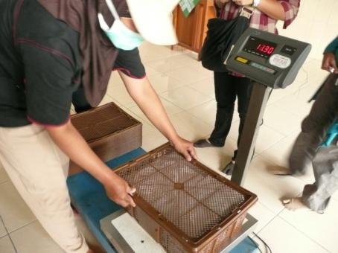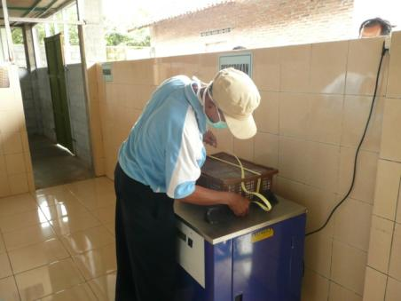
Figure 17 Weighing and sealing of packed salacca fruit

Phytosanitary inspection
Packed salacca fruit is inspected in designated quarantine inspection facilities by IAQA inspectors to meet the phytosanitary requirements of the importing country (Figure 18). Inspection may occur at either the registered packing house, in an approved inspection room, or at the exit point prior to export (IAQA 2013b). Only salacca fruit that meet the requirements of the importing country are issued with a phytosanitary certificate for export.
Fruit for export that has been inspected and certified by IAQA must be maintained under secure conditions during storage and movement to ensure the fruit is secured from damage and pest re-infestation.
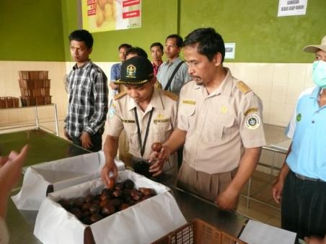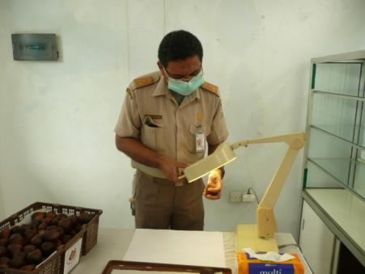
Figure 18 Inspection of fruit by IAQA officers

Transport
Packed fruit is loaded from the storage facility into closed refrigerated trucks or containers and sealed. Refrigerated containers are transported directly from the packing house to the port or airport (IAQA 2012a). Although airfreight is the preferred means of transport, salacca fruit may also be exported to Australia by sea in refrigerated shipping containers.
The transportation of salacca fruit from Indonesia to Australia, i.e. from packing house to arrival, may take 1-7 days by air and 16-19 days by sea (Australia Trade and Shipping 2012).
Figure 19 summarises the post-harvest steps (collection house, packing house and distribution) for salacca fruit grown in Indonesia for export (adapted from IAQA 2012).

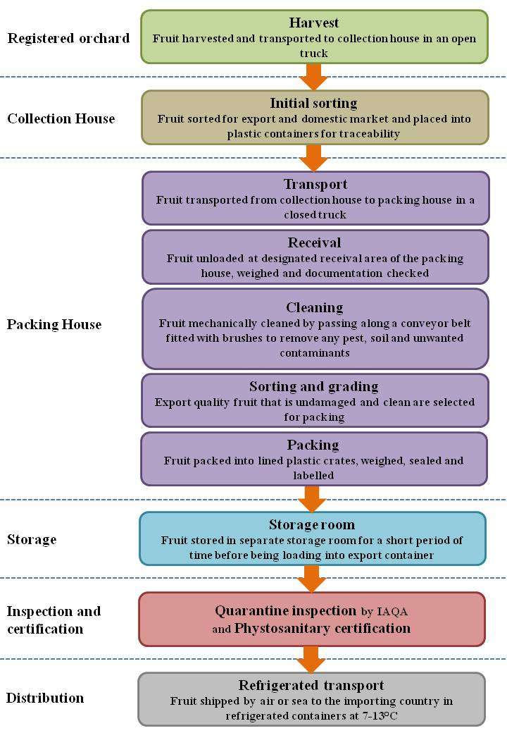
Figure 19 Summary of orchard and post-harvest steps for salacca fruit grown in Indonesia for export

Export capability

Production statistics
Salacca is grown across all of Indonesia, with the main commercial production areas located in the provinces/districts of Central Java (Banjarnegara and Magelang regencies), Yogyakarta special region (Sleman regency) and Bali (Bebandem regency). Around 60-70% of the world’s salacca is produced from these regions (Dimyati et al. 2008).
Production statistics for salacca was given by IAQA during the visit. According to IAQA, the national production area for salacca in 2011 was 24 728 ha with an annual production volume of just over one million tonnes (IAQA 2013a).
Since 2005, there has been an increase in the demand for salacca fruit both domestically and internationally. The Indonesian government, in collaboration with the respective institutions at provincial and district levels, set up a program to ensure continuous supply and consistent quality of produce through the implementation of GAP. This program has resulted in an increase in production of salacca and it is expected that as more farms are registered under this program the volume of salacca produced for export will increase.
According to IAQA, in 2013 there were 3 257 salacca farms covering 547 ha from the Sleman and Magelang districts that are registered with IAQA and certified to operate in accordance with GAP.

Export statistics
Indonesia exports fresh salacca fruit to China, Hong Kong, Singapore, Malaysia and the Philippines (IAQA 2012a), with China as the main export market.
Table 3.2 summarises the salacca exports from Indonesia to its main markets from 2010 to March 2013 as reported by IAQA during the verification visit.
Table 3.2 Volume (t) of Indonesian salacca fruit exports from 2010-2013 (to March)
Country | 2010 | 2011 | 2012 | 2013 (to March)
China | 106 | 147 | 162 | 95
Singapore |  | 1
Malaysia |  |  |  | 0.03
The Indonesian government has advised that initially, around 2-4 tonnes of salacca are likely to be exported annually to Australia. However, this amount may increase in following years.

Export season
Salacca fruit are produced all year round with the main harvest season from November to January with a secondary peak from May to July (Prihatman 2000; Ashari 2002).
IAQA has indicated that fruit is likely to be exported to Australia during the main production months of November to January.

Pest risk assessments for quarantine pests
Quarantine pests associated with fresh salacca fruit from Indonesia are identified in the pest categorisation process (Appendix A). This chapter assesses the probability of the entry, establishment and spread of these pests and the likelihood of associated potential economic, including environmental, consequences.
Pest categorisation identified four quarantine pests associated with salacca fruit from Indonesia. Table 4.1 identifies these quarantine pests. Additional quarantine pest data are given in Appendix B.
Assessments of risks associated with these pests are presented in this chapter.
Table 4.1 Quarantine pests for salacca (snake fruit) from Indonesia
Pest
Mealybugs [Hemiptera: Pseudococcidae]
Dysmicoccus sp.
Planococcus sp.
Pseudococcus sp.
Oil palm bunch rot [Agaricales: Marasmiaceae]
Marasmius palmivorus Sharples

Mealybugs
Dysmicoccus sp., Planococcus sp., Pseudococcus sp.
The biological characteristics and behaviours on the importation pathway of Dysmicoccus, Planococcus and Pseudococcus are considered sufficiently similar to justify combining them into a single assessment. In this assessment, the term ‘mealybug’ is used to refer to these three unidentified species unless otherwise specified.
Dysmicoccus, Planococcus and Pseudococcus belong to the Pseudococcidae or mealybug family. Mealybugs are highly polyphagous and have been recorded on a wide range of host plants, including salacca. Mealybugs of these three genera have been reported on salacca in Indonesia, but have not been identified to species level. Apart from having been reported on salacca, there is no other specific biological information available for these three unidentified species. Thus, information for other mealybug species of the three genera has also been used for this assessment.
There are a number of Dysmicoccus, Planococcus and Pseudococcus species, reported in Indonesia, that attack other plant species within the Arecaceae (the palm family). For example, coconut palm, betel nut palm and date palm are hosts of Dysmicoccus finitimus and D. lepelleyi (Williams 2004); Planococcus lilacinus and P. minor (Ben-Dov 2012); and Pseudococcus cryptus (Williams 2004). These mealybug species are quarantine pests to Australia, with Planococcus minor being a pest of regional quarantine concern to Western Australia.
Mealybugs prefer warm, humid, sheltered sites away from adverse climatic conditions and natural enemies. Many mealybug species pose serious problems to agriculture, particularly when introduced into new areas of the world where their natural enemies are not present (Miller et al. 2002).
In general, mealybugs are small, oval, soft-bodied insects that are covered with a white, cottony or mealy wax secretion that is moisture repellent and protects them against desiccation (Furness and Charles 1994; Osborne et al. 2005). Mealybugs are sucking insects that injure their hosts by extracting large quantities of plant sap. Extensive feeding weakens and stunts plants leading to leaf distortion, premature leaf drop, dieback and even plant death (Osborne et al. 2005). Mealybugs may also cause indirect damage by injecting toxins or plant pathogens into host plants. For example, P. lilacinus transmits Ceylon cocoa virus in Sri Lanka (Williams 2004). Mealybugs deposit a waste product, ‘honeydew’ on the leaves and fruit as they feed. Honeydew serves as a food source for ants and may act as substrate for sooty mould growth (Osborne et al. 2005). Sooty mould affects photosynthesis and makes the plant, including the fruit, unsightly.
Mealybugs develop through a number of nymphal (immature instar) stages before undergoing a final moult into the adult form. Female mealybugs develop through four instars. Adult female mealybugs are wingless and similar in appearance to the nymphal stage only slightly larger. This contrasts with male mealybugs, which have five instars (Williams 2004), with the adult male emerging from a cocoon as a tiny winged form. The male adults do not feed, having no mouth parts, and their sole purpose is to locate a female and mate. Mealybugs reproduce sexually and parthenogenetically, that is, without a mate. Some female mealybugs (for example, P. lilacinus) give birth to live first instar nymphs (Miller et al. 2007). Females are capable of producing large number of eggs and may lay over 600 eggs (Osborne et al. 2005). The eggs are laid in compact waxy sacs attached to the stems, leaves or fruit of host plants. Females die shortly after the eggs are laid. The eggs hatch in approximately 1–2 weeks into tiny first instar nymphs called crawlers (Ooi et al. 2002). First and second instar nymphs or crawlers are mobile and primary dispersal stages in a mealybug’s life cycle. Other nymphal stages and adult female mealybugs are generally immobile (Franco et al. 2004).
The risk scenario of concern for mealybugs is the presence of eggs, crawlers, nymphs or adult females on imported salacca fruit.

Probability of entry
The probability of entry is considered in two parts, the probability of importation and the probability of distribution, which consider pre-border and post-border issues, respectively.

Probability of importation
The likelihood that Dysmicoccus sp., Planococcus sp. or Pseudococcus sp. will arrive in Australia with the importation of fresh salacca fruit from Indonesia is: MODERATE.
Supporting information for this assessment is provided below:
- Mealybugs have been reported on the fruit of salacca in Indonesia (Indonesian Ministry of Agriculture 2012a; Indonesian Ministry of Agriculture 2013).
- Mealybugs feed by inserting their long sucking mouthparts into the leaves, stem or fruit of host plants. This process anchors the mealybugs to the plant where they usually remain (Williams 2004). Once feeding begins, they secrete a waxy mealy coating that helps protect their bodies.
- Mealybugs can be easily detected during harvest, processing and packing due to the morphology of the fruit. Salacca fruit is round or oval in shape, rounded at the base and tapers at the top. There is no place for mealybugs to hide on the fruit surface. Additionally, mealybugs are whitish and mealy in appearance which contrasts with the dark brown colour of salacca fruit.
- During processing and packing salacca fruit are manually and then mechanically brushed with rollers for an extended period of time. This process would likely dislodge and remove nymphs and adults of mealybugs present on the surface of the fruit.
- Salacca fruit are stored and transported at 13 °C or less. Mealybugs are likely to survive storage and transportation as some species are tolerant of low temperatures. For example, Pseudococcus affinis can survive for up to 42 days at 0 °C (Hoy and Whiting 1997).
- There is a potential for viable mealybugs to be associated with salacca fruit after cold storage and transportation as mealybugs have been detected by a number of countries on imported fruit commodities during on-arrival inspection (Williams 2004). It is feasible that species assessed here could also survive transportation.
The association of mealybugs with the fruit, the small size, sessile nature of most life stages and the potential for the species to survive the temperatures associated with transportation moderated by the fact that mealybugs are detected and removed during the processing and packing procedures support a likelihood estimate for importation of ‘moderate’.

Probability of distribution
The likelihood that Dysmicoccus sp., Planococcus sp. or Pseudococcus sp. will be distributed within Australia in a viable state as a result of the processing, sale or disposal of salacca fruit from Indonesia and subsequently transfer to a susceptible part of a host is: MODERATE.
Supporting information for this assessment is provided below:
- Salacca fruit may be distributed throughout Australia for retail sale, as the intended use of the commodity is human consumption. Waste material may be generated.
- Mealybug eggs, nymphs and adult females may remain on the surface of the fruit during distribution via wholesale or retail sale. The unconsumed parts of the fruit, especially the skin of infested fruit, are likely to end up in fruit waste, which may further aid distribution of viable mealybugs. Disposal of infested fruit is likely to be by commercial or domestic rubbish systems or where the fruit is consumed. Some fruit may be disposed of in the home garden which provides an opportunity for the mealybugs to transfer to susceptible hosts in the vicinity.
- Crawlers (first instar nymphs) are the primary dispersal phase and are capable of active dispersal by crawling and passive dispersal by wind currents (Hely et al. 1982; Rohrbach et al. 1988). However, mealybugs can survive for only a short time (approximately one day) without feeding (Osborne et al. 2005).
- Adult females can only crawl a few metres, restricting their ability to move from discarded fruit waste to a suitable host. However, they may be transported by attendant ant species (Williams 2004).
- Once mealybugs find a suitable feeding site they become sessile. They insert their mouthparts into the host plant and remain permanently attached.
- Mealybugs are highly polyphagous and attack a wide range of host plants from a number of plant families including fruit, nut, palm, forest and ornamental shade trees, flowering ornamental plants, ground covers and vegetables (see Appendix B). Host plants are widely available in Australia.
The wide range and readily availability of hosts combined with the chance of dispersal near suitable hosts moderated by the short dispersal range of crawlers and adult females, the sessile nature of the other life stages and ability to survive for only a short time without feeding, support a likelihood estimate for distribution of ‘moderate’.

Overall probability of entry (importation × distribution)
The overall probability of entry is determined by combining the probabilities of importation and of distribution using the matrix of rules shown in Table 2.2.
The likelihood that Dysmicoccus sp., Planococcus sp. or Pseudococcus sp. will enter Australia as a result of trade in salacca fruit from Indonesia and be distributed in a viable state to a susceptible host is: LOW.

Probability of establishment and spread
As there is no other specific biological information available for assessing the establishment and spread of these three unidentified mealybugs, apart from being reported on salacca fruit, the previous assessments for other mealybug species of the same genera are considered applicable to these species.
Many species of Dysmicoccus, Planococcus and Pseudococcus have been assessed in previous pest risk analyses, such as apples from New Zealand (Biosecurity Australia 2006), unshu mandarin from Japan (Biosecurity Australia 2009), stone fruit from USA (Biosecurity Australia 2010), mangosteen from Thailand (DAFF 2004a) and longan and lychee from China and Thailand (DAFF 2004b). The ratings of the probability of establishment and of spread of Dysmicoccus, Planococcus or Pseudococcus are consistently the same for all the assessed species as these probabilities relate specifically to events that occur in Australia and are largely independent of the importation pathway. It is considered that the probability of establishment and of spread for Dysmicoccus sp., Planococcus sp. or Pseudococcus sp. would be the same as the species previously assessed. The ratings of the previous assessment are provided below:
Probability of establishment: HIGH
Probability of spread: HIGH

Overall probability of entry, establishment and spread
The overall probability of entry, establishment and spread is determined by combining the probability of entry, of establishment and of spread using the matrix of rules shown in Table 2.2.
The likelihood that Dysmicoccus sp., Planococcus sp. or Pseudococcus sp. will enter Australia as a result of trade in salacca from Indonesia, be distributed in a viable state to a susceptible host, establish in Australia and subsequently spread within Australia is: LOW.

Consequences
As there is no other specific biological information available for assessing the consequence of these three unidentified mealybugs, apart from being reported on salacca fruit, the previous assessments for other mealybug species of the same genera are considered applicable to these species.
Many species of Dysmicoccus, Planococcus and Pseudococcus have been assessed in previous pest risk analyses, such as in apples from New Zealand (Biosecurity Australia 2006), unshu mandarin from Japan (Biosecurity Australia 2009), stone fruit from USA (Biosecurity Australia 2010), mangosteen from Thailand (DAFF 2004a) and longan and lychee from China and Thailand (DAFF 2004b). The overall consequence has consistently been assessed as ‘low’ for all mealybug species. It is considered that the consequences of the establishment of Dysmicoccus sp., Planococcus sp. or Pseudococcus sp. in Australia would be the same as previously assessed for other species. For example, the estimate of impact scores for mealybug species assessed in mangosteen from Thailand (DAFF 2004a) and longan and lychee from China and Thailand (DAFF 2004b) are provided below. As the ratings in 2004 were conducted on a scale from A to F, they have been adjusted to reflect a current rating scale from A to G.
Plant life or heath D
Any other aspects of the environment B
Eradication, control, etc. C
Domestic trade C
International trade C
Environment B
Based on the decision rules described in Table 2.4, that is, where the consequences of a pest with respect to one or more criteria are ‘D’, the overall consequences are estimated to be LOW.

Unrestricted risk estimate
Unrestricted risk is the result of combining the probability of entry, establishment and spread with the estimate of consequences. Probabilities and consequences are combined using the risk estimation matrix shown in Table 2.5.
Unrestricted risk estimate for Dysmicoccus sp., Planococcus sp. and Pseudococcus sp.
Overall probability of entry, establishment and spread | Low
Consequences | Low
Unrestricted risk | Very Low
As indicated, the unrestricted risk estimate for Dysmicoccus sp., Planococcus sp. and Pseudococcus sp. has been assessed as ‘very low’, which achieves Australia’s ALOP. Therefore, no specific risk management measures are required for these pests.

Oil palm bunch rot
Marasmius palmivorus
The fungus Marasmius palmivorus belongs to the family Marasmiaceae. It is an important disease of oil palms, coconut palms and rubber trees, causing fruit bunch rot of oil palms (Holliday 1980); leaf, bud and embryo rot of coconuts (CABI 2013); and white fan blight on the trunk of rubber trees (Sharples 1936).
Reports of M. palmivorus on salacca are rare. It has been shown to cause fruit bunch rot in salacca in Thailand (Pinitpaitoon 2003). In Indonesia, the pathogen has been reported to cause flower wilt of salacca (Kusumo 1995; Sukewijaya et al. 2009), but reports of salacca fruit rot caused by M. palmivorus are absent.
It should be noted that the principal salacca species commercially grown in Thailand (Salacca wallichiana) and Indonesia (S. zalacca) are different. Pinitpaitoon’s (2003) study was conducted on S. wallichiana ‘Nern Wong’, which may explain the different observation to those made in Indonesia.
Marasmius palmivorus is primarily a saprophytic fungus that grows on rotting organic material. It becomes pathogenic once the fungus has colonised a large mass of dead and decaying plant material and attained a certain inoculum potential. The amount of inoculum required to induce infection is not known. However, infection by a small amount of spores or mycelium is unlikely (Turner 1981). In oil palms, the most common inoculum source is a fruit bunch that has failed to develop or has been left to rot on the palm after maturity (Turner 1981; CABI 2013). At this stage, the mycelium spreads to other parts of the palm, including healthy fruit bunches, inflorescences, leaf bases and the fronds immediately behind the fruit bunches (Holliday 1980; Turner 1981). Removing potential infection foci, such as rotting bunches and dead inflorescences, is important in preventing the pathogen from changing from saprophytic to pathogenic and slows down the spread of the disease (Turner 1965).
In the early stages of infection of oil palms, whitish to pinkish-white mycelium extends over the surface of young fruit bunches, affecting only the tissues between the individual fruits (Turner 1981). In the later stages of infection, the fungus penetrates the flesh causing the fruit to rot (Turner 1981). Similarly, symptoms of an early infection on salacca are the presence of dense pinkish-white mycelium covering the fruit surface. As the infection progresses the fruit skin becomes black and soft, followed by brown wet rot on the flesh that is clearly defined from the healthy tissue (Pinitpaitoon 2003).
The fungus spreads by mycelium, rhizomorphs or spores (Turner 1981; CABI 2013). A single spore germinates into mycelium. Sometimes a large number of mycelia grow closely, interwoven to form structures called rhizomorphs. Two compatible mycelia join to give rise to spore-bearing fruiting bodies (sporophores). When the mycelium of M. palmivorus has extensively colonised the inoculum source, it produces large numbers of sporophores (Turner 1981). On S. wallichiana, these have been described as delicate and mushroom-like with a straight stalk of 2.0–2.5 cm in length and a cap of approximately 2.0–4.0 cm in diameter (Pinitpaitoon 2003). On oil palm, size and appearance of sporophores are influenced by weather conditions. In wet conditions they are white in colour with a cap diameter of 2.5–7.5 cm and a stalk length of 2.5–3.5 cm. Under drier and unfavourable conditions, sporophores are still produced. However, they are pinkish in colour with a smaller cap diameter of 1–2 cm and a proportionally shorter stalk length (Turner 1981).
Marasmius palmivorus favours periods of wet weather with prolonged moist conditions for development (Turner 1981). Outbreaks of oil palm bunch rot are associated with inadequate pollination, restricted pollen movement, high density planting, and high humidity generated from a dense canopy cover (Turner 1981).
The risk scenario of concern for Marasmius palmivorus is the fungus may be present on imported salacca fruit.

Probability of entry
The probability of entry is considered in two parts, the probability of importation and the probability of distribution, which consider pre-border and post-border issues, respectively.

Probability of importation
The likelihood that M. palmivorus will arrive in Australia with the importation of fresh salacca fruit from Indonesia is: VERY LOW.
Supporting information for this assessment is provided below:
- Marasmius palmivorus is a saprophytic fungus common in tropical forests (Holliday 1980). It is reported from only a few countries, including Indonesia (Turner 1981; CABI 2013).
- Marasmius palmivorus infects all growing stages of Salacca wallichiana in Thailand (Pinitpaitoon 2003). However, in Indonesia it is reported to affect the inflorescences of S. zalacca (Kusumo 1995; Lestari 2005) but not the developed fruit.
- Symptoms of M. palmivorus on salacca fruit would be obvious (Lestari 2005; Sukewijaya et al. 2009). Early infection is characterised by the appearance of white or pink mycelium growing over the surface of developing fruit bunches (Pinitpaitoon 2003). As the infection progresses, the fruit skin becomes black and soft, followed by brown wet rot on the flesh that is clearly defined from the healthy tissue (Pinitpaitoon 2003).
- Sporophores are clearly visible and affected fruit would be removed during cultivation, harvesting and processing.
- Indonesia has stated that all export salacca fruit are produced in accordance with Indonesia’s farm certification scheme for Good Agriculture Practices (GAP). This program ensures export fruit are produced following the guidelines developed for farm management (i.e. cultivation, orchard hygiene, and harvesting practices), and pest monitoring and surveillance. The prevalence of the fungus will be limited in salacca orchards operating under GAP. Fruit, foliage and inflorescences colonised by the fungus would be removed during pest monitoring and inspection. Additionally, potential infection foci such as dead material and fruit bunches that have aborted development or are poorly pollinated would be removed during orchard sanitation.
- Fruit are harvested by individually separating the fruit from the bunch. Any fruit showing symptoms of the disease are likely to be culled at this point.
- Harvested fruit are inspected, sorted, graded and culled firstly at the collection house and again at the packing house. Fruit showing symptoms of the disease would be removed during these processes.
- During processing and packing, salacca fruit are mechanically brushed with rollers for an extended period of time. This process would likely remove spores or mycelium present on the surface of the fruit.
Marasmius palmivorus is present in Indonesia on salacca, but it affects the flowers and not the fruit. Although M. palmivorus affects salacca fruit in Thailand, the salacca species affected is different to the species commercially grown in Indonesia. The unlikely association of M. palmivorus with the fruit of salacca species grown in Indonesia, as well as the fact that mycelium and sporophores are easily detected and likely to be removed during farm cultivation practices, harvesting and packing procedures all support a likelihood estimate for importation of ‘very low’.

Probability of distribution
The likelihood that M. palmivorus will be distributed within Australia in a viable state as a result of the processing, sale or disposal of salacca fruit from Indonesia and subsequently transfer to a susceptible part of a host is: LOW.
Supporting information for this assessment is provided below:
- Salacca fruit may be distributed throughout Australia for retail sale, as the intended use of the commodity is human consumption. Spores and mycelium may remain on the surface of the fruit during distribution via wholesale or retail sale. Waste material would be generated.
- Salacca fruit with any obvious symptoms of infection would be unmarketable and unlikely to be sold. Infected fruit are likely to be disposed of in municipal tips, posing little risk of exposure to a suitable host. However, fruit with only minor symptoms, could still be distributed for sale.
- Consumer generated waste could result in small quantities of fruit waste being discarded in urban, rural and natural localities including domestic composts, along roadsides or in other environments. There is some potential for consumer waste to be disposed of in environments which may provide an opportunity for the pathogen to develop and spread.
- Marasmius palmivorus prefers periods of wet weather with prolonged moist conditions and high humidity for development (Turner 1965). Low rainfall, cold temperatures or dry weather conditions are less favourable for disease development (Pinitpaitoon 2003). Climatic conditions suitable for M. palmivorus to develop may exist in the tropical regions of northern Australia.
- Natural dispersal of the fungus occurs via spores or through the spread of mycelia from diseased to healthy plant material, once it has reached a suitable inoculum level (Turner 1965).
- Marasmius palmivorus is primarily saprophytic, living on dead and decaying plant material (Turner 1965). Such material may be present where the infected fruit is discarded.
- The fungus becomes infective when it has colonised a large mass of dead or decomposing plant material (Turner 1965). At this stage the status of the fungus changes from saprophytic to pathogenetic (Turner 1965), enabling the fungus to disperse to receptive host tissue. Although it is unclear in the literature what the minimum inoculum load is required for infection, it is considered that the quantity of inoculum is important and infection by spores or a small amount of mycelium is unlikely (Turner 1981).
- Oil palms, coconuts and rubber are the primary hosts of M. palmivorus (Turner 1965; CABI 2013). Hosts of M. palmivorus are limited in distribution to the tropical and subtropical areas of Australia.
The possibility that M. palmivorus may enter the environment via association with discarded fruit and wind dispersed spores or mycelium spread, moderated by the limited inoculum quantity on fruit waste and the limited availability of receptive hosts and climatic conditions suitable for development, support a likelihood estimate for distribution of ‘low’.

Overall probability of entry (importation × distribution)
The overall probability of entry is determined by combining the probabilities of importation and of distribution using the matrix of rules shown in Table 2.2.
The likelihood that M. palmivorus will enter Australia as a result of trade in salacca fruit from Indonesia and be distributed in a viable state to a susceptible host is: VERY LOW.

Probability of establishment
The likelihood that M. palmivorus will establish within Australia based on a comparison of factors in the source and destination areas that affect pest survival and reproduction is: HIGH.
Supporting information for this assessment is provided below:
- The primary hosts of M. palmivorus are oil palms, coconuts and rubber (Holliday 1980). Host plants are present in the tropical and subtropical regions of Australia. However, the limited distribution of hosts decreases the probability of the pathogen being able to establish in other regions of Australia.
- Marasmius palmivorus is saprophytic and may survive and spread as mycelium on decaying material from plants other than the recorded host species (CABI 2013).
- Sporophores are produced following extensive colonisation of the fungus. The fruiting bodies of M. palmivorus shrivel in dry weather, but are cable of revival when the weather conditions become favourable.
- The development of M. palmivorus is favoured by periods of wet weather with prolonged moist conditions and high humidity (Turner 1965). Climatic conditions within the tropical and subtropical regions of Australia would be favourable for the establishment of M. palmivorus.
Suitability of the Australian environment, the saprophytic nature of the pathogen and the presence of some suitable hosts support a likelihood estimate for establishment of ‘high’.

Probability of spread
The likelihood that M. palmivorus will spread within Australia, based on a comparison of factors in the source and destination areas that affect the expansion of the geographic distribution of the pest is: HIGH.
Supporting information for this assessment is provided below:
- Natural spread of M. palmivorus is by mycelium, rhizomorphs or spores (CABI 2013).
- Marasmius palmivorus spores are dispersed to a suitable host by wind (Turner 1965).
- Sporophores are produced following extensive colonisation of the fungus. The development of M. palmivorus is favoured by periods of wet weather with prolonged moist conditions and high humidity (Turner 1965; Pinitpaitoon 2003). Suitable climatic conditions exist in areas of Australia suggesting that M. palmivorus has the potential to spread in Australia.
- Marasmius palmivorus is primarily saprophytic, living on dead and moist decaying plant material (Turner 1965). Marasmius palmivorus can grow vigorously in these sites and produce fruiting bodies (Turner 1981) under favourable climatic conditions, aiding in the spread of the fungus.
- Marasmius palmivorus becomes pathogenic after it has colonised a suitable substrate and has attained a certain inoculum potential (Turner 1965). The large volume of colonised material provides a sufficiently large reserve to increase the inoculum potential of the fungus so that it can spread from the infection source to healthy plant material.
- Marasmius palmivorus is known to infect oil palms, coconut and rubber. Minor hosts include cacao, tea, and coffee (Holliday 1980). Host plants are present in the tropical and subtropical regions of Australia.
Suitable climatic conditions required for germination, natural dispersal mechanisms, host availability as well as the ability for M. palmivorus to persist in saprophytic form, support a likelihood estimate of spread of ‘high’.

Overall probability of entry, establishment and spread
The overall probability of entry, establishment and spread is determined by combining the probabilities of entry, of establishment and of spread using the matrix of ‘rules’ are shown in Table 2.2.
The likelihood that M. palmivorus will enter Australia as a result of trade in salacca fruit from Indonesia, be distributed in a viable state to a susceptible host, establish in Australia and subsequently spread within Australia is: VERY LOW.

Consequences
The consequences of the establishment of M. palmivorus in Australia have been estimated according to the methods described in Table 2.3.
Based on the decision rules described in Table 2.4, that is, where the consequences of a pest with respect to one or more criteria are ‘C’, the overall consequences are estimated to be VERY LOW.
Reasoning for these ratings is provided below:
Criterion | Estimate and rationale
Direct
Plant life or health | C –Minor significance at the district level:  - Marasmius palmivorus is an economically important disease of oil palm and coconut. It causes fruit bunch rot of oil palms and leaf, bud and embryo rot of coconuts (CABI 2013). Embryo and shoot rot disease of coconut is a persistent problem in germinating beds, sometimes causing significant losses. In Malaysia, incidents of 20-30% of freshly picked coconuts contaminated with the fungus have been recorded (Tey and Chan 1978).  - It also causes the rare infection known as white fan blight on the trunks of rubber trees (CABI 2013).  - Australia does not have a significant oil palm, coconut or rubber industry.  - The pathogen only causes serious damage in areas with poor horticulture practices resulting in abundance of potential infection foci where appropriate climatic conditions stimulate development.  - Marasmius palmivorus requires periods of wet weather with prolonged moist conditions and high humidity for development (Turner 1965). Plants grown in drier and hotter climates are unlikely to be affected.
Other aspects of the environment | A – Indiscernible at the local level:  - There are no known direct consequences of M. palmivorus on other aspects of the environment.
Indirect
Eradication, control etc. | C – Minor significance at the district level:  - Because of the widespread occurrence of M. palmivorus as a saprophyte, complete eradication of the fungus is impossible (CABI 2013).  - Several fungicides are effective against M. palmivorus. However, chemical control is not usually necessary under good field management practices. Adequate control can usually be obtained through the removal of potential infection foci, such as rotting fruit bunches, dead male inflorescences, poorly pollinated bunches, rotting material from the crown, and large frond bases close to the crown (Turner 1965).  - In oil palms, fungicides can be used to treat partially infected fruit bunches so that they can continue developing and mature normally (Turner 1965), preventing the need to remove the bunch completely.
Domestic trade | B – Minor significance at the local level:  - If M. palmivorus became established in the production areas of potential host commodities some losses may occur if restrictions are placed on domestic trade. These restrictions may lead to loss of markets.
International trade | B – Minor significance at the local level:  - The presence of M. palmivorus in areas where potential host commodities are produced may limit access to overseas markets where the pathogen is not present. While production of commercial hosts is small in Australia, it could be more difficult for Australia to access international markets where quarantine restrictions may be in place for this pathogen.
Environmental and non-commercial | B – Minor significance at the local level:  - Additional fungicide applications or other control measures may be required to control this pathogen on susceptible hosts. This may have a minor impact on the environment.

Unrestricted risk estimate
Unrestricted risk is the result of combining the probability of entry, establishment and spread with the estimate of consequences. Probabilities and consequences are combined using the risk estimation matrix shown in Table 2.5.
Unrestricted risk estimate for M. palmivorus
Overall probability of entry, establishment and spread | Very low
Consequences | Very low
Unrestricted risk | Negligible
As indicated, the unrestricted risk estimate for M. palmivorus has been assessed as ‘negligible’, which achieves Australia’s ALOP. Therefore, no specific risk management measures are required for this pest.

Pest risk assessment conclusions

Key to Table 4.2 (starting next page)
Likelihoods for entry, establishment and spread
N negligible
EL extremely low
VL very low
L low
M moderate
H high
P[EES] overall probability of entry, establishment and spread
Assessment of consequences from pest entry, establishment and spread
PLH plant life or health
OE other aspects of the environment
EC eradication, control etc.
DT domestic trade
IT international trade
ENC environmental and non-commercial
A-G consequence impact scores are detailed in section 2.2.3
A Indiscernible at the local level
B Minor significance at the at the local level
C Significant at the local level
D Significant at the district level
E Significant at the regional level
F Significant at the national level
G Major significance at the national level
URE unrestricted risk estimate. This is expressed on an ascending scale from negligible to extreme.

Table 4.2 Summary of unrestricted risk estimates for quarantine pests associated with fresh salacca (snake fruit) from Indonesia
 | Likelihood of |  |  |  |  |  |  | Consequences |  |  |  |  |  |  |  | URE
Pest name | Entry |  |  | Establishment | Spread |  | P[EES] |  |  |  |  |  |  |  |  | URE
Pest name | Importation | Distribution | Overall | Establishment |  |  | P[EES] | Direct |  |  | Indirect |  |  |  | Overall | URE
 |  |  |  |  |  |  |  | PLH |  | OE | EC | DT | IT | ENC | Overall | URE
Mealybugs [Hemiptera: Pseudococcidae]
Dysmicoccus sp. | Moderate | Moderate | Low | High |  | High | Low | D | B |  | C | C | C | B | Low | Very low
Planococcus sp. | Moderate | Moderate | Low | High |  | High | Low | D | B |  | C | C | C | B | Low | Very low
Pseudococcus sp. | Moderate | Moderate | Low | High |  | High | Low | D | B |  | C | C | C | B | Low | Very low
Oil palm bunch rot [Agaricales: Marasmiaceae]
Marasmius palmivorus | Very low | Low | Very low | High |  | High | Very low | C | A |  | C | B | B | B | Very low | Negligible

Pest risk management
This chapter provides information on the management of quarantine pests and the operational procedures for the maintenance and verification of the phytosanitary status for fresh salacca fruit from Indonesia.

Pest risk management measures and phytosanitary procedures
Quarantine pests associated with fresh salacca fruit from Indonesia are identified in the pest categorisation process (Appendix A). An assessment of the risks associated with these pests is presented in Chapter 4.
Pest risk management evaluates and selects options for measures to reduce the risk of entry, establishment or spread of quarantine pests for Australia where they have been assessed to have an unrestricted risk above Australia’s ALOP. In calculating the unrestricted risk, existing commercial production practices in Indonesia have been considered, as have post-harvest procedures and the packing of fruit.
The conclusion from the pest risk assessments is that the unrestricted risk estimate for all four quarantine pests achieves Australia’s ALOP.
The Department of Agriculture considers that Indonesia’s existing commercial production practices (pre-harvest, harvest and post-harvest practices) for the production of fresh salacca fruit for export, and a system of operational procedures will provide an appropriate level of protection against the quarantine pests associated with the trade of fresh salacca fruit from Indonesia. The effectiveness of these practices and procedures will be verified by the Department of Agriculture when consignments arrive in Australia.
Indonesia has proposed the following general framework for the management of pests and procedures for production of salacca fruit for export to Australia (IAQA 2011; IAQA 2013a).
- Legislation: Salacca is to be produced for export to Australia in accordance with Indonesia’s farm certification scheme for Good Agriculture Practices (GAP) with specific Standard Operating Procedures (SOP).
- Registration: Salacca fruit for export to Australia must originate from orchards and packing houses registered with and audited by IAQA.
- Packing house management: A sanitation program must be carried out in packing houses to ensure they are kept clean. The waste fruit must be collected and disposed of regularly. The processing line must be specifically used to grade export fruit from registered orchards. Fruit that does not meet Australia’s requirements must not be processed (cleaned and packed) at the same time as fruit processed for export to Australia. IAQA officers or IAQA accredited personnel will ensure that all fruit packed for Australia are undamaged and free from any pests, soil, parts of plant (leaves, stems/branches), and other plant debris.
- Packaging and labelling: New and clean cartons or plastic crates must be used for packing fruit. Plant-derived packing materials must not be used, including during the harvesting of fruit. For the convenience of tracing the origin of any problem, all cartons/crates must be labelled ‘For Australia’, with the reference code and name of packing house, lot number, number of cartons/crates in each lot, commodity name and packing date.
- Storage and transport: The quarantine integrity of export fruit to Australia must be maintained during storage and movement. The storage facilities should be clean and hygienic. Fruit for export to Australia must be stored in a separate room from fruit destined for other export markets and the domestic market. Fruit must be maintained under secure conditions during storage and movement to prevent contamination or pest re-infestation.
- Pre-export inspection and certification: IAQA will conduct the phytosanitary inspection and, if the consignment meets the requirements outlined below, issue a phytosanitary certificate.
- The Department of Agriculture has considered the components of Indonesia’s proposed general framework. The department has also visited salacca production areas in Indonesia and observed, collected and assessed information related to the framework proposed by Indonesia for registration and management of orchards and packing houses, pest management, storage and transport.

Operational system for the maintenance and verification of phytosanitary status
A system of operational procedures is necessary to ensure that the phytosanitary status of salacca fruit from Indonesia is maintained and verified during the process of production and export to Australia. This is to ensure that the proposed production, harvest and packing procedures have been met and maintained.

Registration of export orchards by IAQA
The objectives of this recommended procedure are to ensure that salacca fruit is sourced from registered export orchards producing export quality fruit, as the pest risk assessment is based on existing commercial production practices.
It is recommended that participating export orchards be registered and audited by IAQA before commencement of harvest each season. IAQA should maintain a current list of registered orchards in order to facilitate trace-back of any consignment.

Registration of packing house and auditing of procedures
The objectives of this recommended procedure are to ensure that:
- salacca fruit is packed only in registered packing houses, processing export quality fruit, as the pest risk assessments are based on existing commercial packing procedures
- references to the packing house (by registration number or reference code and packing house name) are clearly stated on crates/boxes destined for export of salacca fruit to Australia for trace-back and auditing purposes.
- It is recommended that packing houses be registered and audited by IAQA before the commencement of harvest each season. IAQA must provide the Australian Department of Agriculture with a list of registered packing houses prior to season commencement each year and inform the department of any changes to registrations during the season. This list must be maintained as current by IAQA in order to facilitate trace-back of any consignment.

Packaging and labelling
The objectives of this recommended procedure are to ensure that:
- salacca fruit proposed for export to Australia and all associated packaging is not contaminated by quarantine pests or regulated articles
  - regulated articles are any items other than salacca. Regulated articles may include plant, plant product, soil and any other organisms, object or material capable of harbouring or spreading pests, deemed to require phytosanitary measures, particularly where international transportation is involved
  - in this report, salacca is defined as individual fruit which is covered with regularly arranged scales that encase the flesh and seeds, but not other plant parts (section 1.2.2)
- unprocessed packing material (which may vector pests not identified as being on the pathway and pests not known to be associated with salacca fruit) is not imported with fresh salacca fruit
- all wood material used in packaging of fresh salacca fruit complies with the Australian Department of Agriculture conditions
- secure packaging is used during storage and transport to Australia and must meet Australia’s general import conditions for fresh fruits and vegetables, available at http://apps.daff.gov.au’icon32/asp/ex_querycontent.asp
- the packaged salacca fruit are labelled with the packing house name and reference code for the purpose of trace-back
- the phytosanitary status of the fruit must be clearly identified.

Specific conditions for storage and movement
The objectives of this recommended procedure are to ensure that:
- fresh salacca fruit for export to Australia that has been inspected is kept secure and segregated at all times from any fruit for domestic or other markets, to prevent mixing or cross-contamination
- the quarantine integrity of the commodity during storage and movement is maintained.

Freedom from trash
All salacca fruit must be free from trash (e.g. stem and leaf material, seeds, soil, animal matter/parts or other extraneous material) and foreign matter. Freedom from trash will be confirmed by the inspection procedures. Export lots or consignments found to contain trash or foreign matter should be withdrawn from export unless approved remedial action is available and applied to the export consignment and then re-inspected.

Pre-export phytosanitary inspection and certification by IAQA
The objectives of this recommended procedure are to ensure that:
- all consignments have been inspected in accordance with official procedures for all visually detectable quarantine pests and other regulated articles at a standard 600 unit sampling rate or equivalent per phytosanitary certificate
- an international phytosanitary certificate (IPC) is issued for each consignment upon completion of pre-export inspection to verify that the relevant measures have been undertaken offshore
- each IPC includes:
- a description of the consignment (including orchard registration number or reference code and packing house details)
and
- an additional declaration that ‘The fruit in this consignment has been produced in Indonesia in accordance with the conditions governing entry of fresh salacca fruit to Australia and inspected and found free of quarantine pests’.

On-arrival verification by the Department of Agriculture
The objectives of this recommended procedure are to ensure that:
- consignments comply with Australian import requirements
- consignments are as described on the phytosanitary certificate and quarantine integrity has been maintained.

Remedial action(s) for non-compliance
The objectives of remedial action(s) for non-compliance are to ensure that:
- any quarantine risk is addressed by remedial action, as appropriate
- non-compliance with import requirements is addressed, as appropriate.
Any consignment that fails to meet Australia’s import conditions will be subject to a suitable remedial treatment, if one is available, re-exported from Australia, or destroyed.
Separate to the corrective measures mentioned above, there may be other actions necessary depending on the specific pest intercepted and the agreed risk management strategy put in place against that pest.
If product repeatedly fails inspection, then the Australian Department of Agriculture reserves the right to suspend the export program and conduct an audit of the production and export systems. The program will recommence only when the Australian Department of Agriculture is satisfied that appropriate corrective action has been taken.

Uncategorised pests
If an organism, including contaminant pests/pathogens, that has not been categorised is detected on fresh salacca fruit either in Indonesia or on-arrival in Australia, it will require assessment by the Australian Department of Agriculture to determine its quarantine status and whether phytosanitary action is required. Assessment is also required if the detected species was categorised as not likely to be on the import pathway. If the detected species was categorised as on the pathway but assessed as having an unrestricted risk that achieves Australia’s ALOP due to the rating for likelihood of importation, then it would require reassessment. The detection of any pests of quarantine concern not already identified in the analysis may result in remedial action and/or temporary suspension of trade while a review is conducted to ensure that existing measures continue to provide the appropriate level of protection for Australia.

Review of policy
The Department of Agriculture reserves the right to review the import policy after the first year of trade or when there is reason to believe that the pest or phytosanitary status in Indonesia has changed.
IAQA must inform the Australian Department of Agriculture immediately on detection in Indonesia of any new pests of salacca that are of potential quarantine concern to Australia or of a significant change in the application of existing commercial practices considered in this report.

Meeting Australia’s food standards
Imported food for human consumption must satisfy Australia‘s food standards. Australian law requires that all food, including imported food, meets the standards set out in the Australia New Zealand Food Standards Code (hereafter referred to as ‘the Code’). Food Standards Australia New Zealand (FSANZ) is responsible for developing and maintaining the Code, including Standard 1.4.2, maximum residue limits (MRLs), available at www.comlaw.gov.au/Details/F2014C00035. The standards apply to all food in Australia, irrespective of whether it is grown domestically or imported.
If a specific chemical is used on imported foods to control pests and diseases, then any resulting residues must not exceed the specific MRLs in Standard 1.4.2 of the Code for that food.
If there is no MRL listed in the Code for a specific food (or a composite, processed food), then there must be no detectable residues in that specific food.
Where an exporting country uses a chemical for which there is no current listed Australian MRL, there are mechanisms to consider establishing an Australian MRL by harmonising with an MRL established by the Codex Alimentarius Commission (Codex) or by a regulatory authority in a recognised jurisdiction. The mechanisms include applications, submissions or consideration as part of a FSANZ proposal to vary the Code. The application process, including the explanation of establishment of MRLs in Australia, is described at www.foodstandards.gov.au/foodstandards/changingthecode/.

Conclusion
The findings of this draft import risk analysis report for fresh salacca fruit from Indonesian are based on a comprehensive scientific analysis of relevant literature.
The Department of Agriculture considers that Indonesia’s existing commercial production practices, (pre-harvest, harvest, and post-harvest practices) for the production of fresh salacca fruit for export, as well as Indonesia’s proposed general framework for the management of pest and procedures, and a system of operational procedures to ensure that quarantine standards are met, will provide an appropriate level of protection against the quarantine pests associated with the trade of fresh salacca fruit from Indonesia.

Appendixes

Appendix A: Initiation and categorisation for pests of fresh salacca fruit from Indonesia
The steps in the initiation and categorisation processes are considered sequentially, with the assessment terminating at ‘Yes’ for column 3 (except for pests that are present, but under official control and/or pests of regional concern) or the first ‘No’ for columns 4, 5 or 6.
Details of the method used in this risk analysis are given in Chapter 2: Method for pest risk analysis.
Pest | Present in Indonesia | Present in Australia | Potential to be on pathway | Potential for establishment and spread | Potential for economic consequences | Pest risk assessment required
ARTHROPODS
Order Coleoptera
Adoretus sinicus Burmeister, 1855  [Scarabaeidae]  Chinese rose beetle | Yes  (CABI 1981) | No records found | No  Adults feed on salacca leaves (Furutani et al. 1995). Larvae live in the soil and feed on dead plant tissue (Mau and Martin Kessing 1991; McQuate and Jameson 2011). | Assessment not required | Assessment not required |  | No
Callispa elegans Baly, 1876  [Chrysomelidae]  Leaf beetle | Yes  (Staines 2011) | No records found | No  Callispa adults and larvae feed on salacca leaves (Steiner 2001). | Assessment not required | Assessment not required |  | No
Callispa pusilla Gestro, 1896  [Chrysomelidae]  Leaf beetle | Yes  (Staines 2011) | No records found | No  Callispa adults and larvae feed on salacca leaves (Steiner 2001). | Assessment not required | Assessment not required |  | No
Carpophilus sp.  [Nitidulidae]  Dried-fruit beetles | Yes  Various Carpophilus species are present in Indonesia (Kalshoven 1981) | Various Carpophilus species are present in Australia (Plant Health Australia 2001).  However, Carpophilus species present in Indonesia may not be the same species present in Australia warranting further assessment. | No  Primarily a pest of stored products (Kalshoven 1981), and associated with ripe, rotten and dried fruits (Leschen and Marris 2005). Some Carpophilus species are known to attack healthy fruit (Leschen and Marris 2005) but not salacca.  No records have been found which associate Carpophilus sp. with salacca fruit. | Assessment not required | Assessment not required |  | No
Holotrichia javana Brenske, 1892  Synonym: Phyllophaga javana  [Scarabaeidae]  White grub | Yes  (Kalshoven 1981) | No records found | No  Adults feed on salacca leaves (Wardani and Sugiyarto 2009). Larvae attack roots, stems and bark of salacca (Maryati and Sugiyarto 2009). | Assessment not required | Assessment not required |  | No
Lepidiota stigma (Fabricius, 1798)  [Scarabaeidae]  Sugarcane white grub | Yes  (Kalshoven 1981; IAQA 2011) | No records found | No  Adults feed on salacca leaves (Sukewijaya et al. 2009). Larvae attack the roots of salacca (Sukewijaya et al. 2009). | Assessment not required | Assessment not required |  | No
Nodocnemus sp.  [Curculionidae] | Yes  (Schuiling and Mogea 1991) | No records found | No  A pollinating insect, associated with the flowers of salacca (Schuiling and Mogea 1991; Paull 2008).  Although there are reports that Nodocnemus sp. can cause damage by boring into the young fruit bunches (Schuiling and Mogea 1991; Paull 2008), the larvae bore into the fruit stalk rather than the developing fruit (IAQA 2013, pers. comm., 19 April).  Adults are attracted to decaying fruit but not sound undamaged fruit (IAQA 2013, pers. comm., 19 April). | Assessment not required | Assessment not required |  | No
Omotemnus miniatocrinitus Chevrolat, 1882  [Curculionidae] | Yes  (Maddison 1993) | No records found | No  Larvae tunnel into the top of the palm trunk (Schuiling and Mogea 1991).  Adults attack rotting/overripe fruit (Tjahjadi 1989). | Assessment not required | Assessment not required |  | No
Omotemnus serrirostris Boheman, 1845  [Curculionidae] | Yes  (Faust 1891) | No records found | No  Larvae tunnel into the top of the palm trunk (Tjahjadi 1989; Schuiling and Mogea 1991). | Assessment not required | Assessment not required |  | No
Pistosia inornata (Gestro, 1892)  Synonym: Wallacea inornata Gestro, 1892  [Chrysomelidae] | Yes  (Staines 2011) | No records found | No  Adults and larvae feed on salacca leaves (Steiner 2001). | Assessment not required | Assessment not required |  | No
Rhynchophorus ferrugineus (Olivier, 1790)  [Curculionidae]  Red palm weevil | Yes  (Kalshoven 1981; IAQA 2011) | No records found | No  Eggs are laid in wounds along the trunk or in the crown (Kalshoven 1981; IAQA 2011). Larvae feed on the soft plant tissue in the crown, at the base of leaf petioles, within the upper part of the trunk, and in the bole of palms (Kalshoven 1981; EPPO 2008; IAQA 2011). | Assessment not required | Assessment not required |  | No
Rhynchophorus palmarum (Linnaeus, 1758)  [Curculionidae]  South American palm weevil | Yes  (Mogea 1978) | No records found | No  Adults are pollinators and feed on the nectar-like secretion in the basal part of flowers of salacca (Mogea 1978; Lestari 2005). Eggs are laid in or on the trunk near the crown (Molet et al. 2011), and larvae feed on the soft plant tissue in the palm crown (EPPO 2005). | Assessment not required | Assessment not required |  | No
Order Hemiptera
Astegopteryx nipae (van der Goot, 1917)  [Aphididae]  Pemphigid aphid | Yes  (Kalshoven 1981) | No records found | No  Found on the leaves of palms, including salacca (Kalshoven 1981) | Assessment not required | Assessment not required |  | No
Astegopteryx rappardi Hille Ris Lambers, 1953  [Aphididae]  Pemphigid aphid | Yes  (Kalshoven 1981) | No records found | No  Found on the leaves of palms, including salacca (Kalshoven 1981; Maddison 1993) | Assessment not required | Assessment not required |  | No
Cerataphis lataniae (Boisduval, 1867)  Synonym: Cerataphis palmae Ghesquiere, 1934  [Aphididae]  Palm aphid | Yes  (Kalshoven 1981) | Yes  NSW, Qld (CSIRO 2005)  Not present in WA (Poole 2010) | No  Found on the leaves of palms (Maddison 1993), including salacca (Essig 1956). | Assessment not required | Assessment not required |  | No
Dysmicoccus sp.  [Pseudococcidae] | Yes  Dysmicoccus sp. was found on salacca fruit by the Department of Agriculture during the verification visit to Indonesia of 15-19 April 2013. | Various species of Dysmicoccus are present in Australia (Plant Health Australia 2001).  However, there are some Dysmicoccus species e.g. D. lepelleyi, and D. finitimus present in Indonesia but not in Australia therefore warranting further assessment. | Yes  Dysmicoccus sp. was found on salacca fruit during the verification visit. | Yes  Dysmicoccus spp. are highly polyphagous attacking a broad range of plant genera (Williams 2004). Susceptible hosts are freely available across Australia. | Yes  Mealybugs are among the most destructive of insect pests as they feed on almost all parts of plants, and have also been reported as disease vectors. (Williams 2004). Fruit quality can be reduced by the presence of secondary sooty mould.  Several species of Dysmicoccus are considered economically important pests, causing significant damage to horticulture crops such as pineapple, banana and sugar cane (Williams 2004). |  | Yes
Ischnaspis longirostris (Signoret, 1882)  [Diaspididae]  Black thread scale | Yes  (Kalshoven 1981) | Yes  NT, Qld (Plant Health Australia 2001)  Not present in WA (Poole 2010) | No  Mainly found on the leaves of host plants (Kalshoven 1981; Maddison 1993) and occasionally on bark and fruit of palms (Howard et al. 2001; Watson 2005).  No records have been found which associate Ischnaspis longirostris with salacca fruit. | Assessment not required | Assessment not required |  | No
Planococcus sp.  [Pseudococcidae] | Yes  (Indonesian Ministry of Agriculture 2013) | Various species of Planococcus are present in Australia (Plant Health Australia 2001).  However, there are some Planococcus species e.g. P. dischidiae present in Indonesia but not in Australia; and P. minor not in Western Australia therefore warranting further assessment. | Yes  Associated with the aerial parts of host plants such as flowers, leaves, petioles and fruit (Kalshoven 1981; Indonesian Ministry of Agriculture 2013). Can be found on salacca fruit (Indonesian Ministry of Agriculture 2013). | Yes  Planococcus spp. are highly polyphagous attacking a broad range of plant genera (Williams 2004). Susceptible hosts are freely available across Australia.  Many species of mealybugs are considered invasive, rapidly becoming established when introduced into new areas (Miller et al. 2002). | Yes  Mealybugs are among the most destructive of insect pests as they feed on almost all parts of plants, and have also been reported as disease vectors (Williams 2004). Fruit quality can be reduced by the presence of secondary sooty mould.  Several species of Planococcus are considered economically important pests. For example, P. lilacinus causes damage to important horticulture crops in southern Asia such as coffee, cocoa and lychee (Williams 2004). |  | Yes
Pseudococcus sp.  [Pseudococcidae] | Yes  (Indonesian Ministry of Agriculture 2012a) | Various species of Pseudococcus are present in Australia (Plant Health Australia 2001).  However, there are some Pseudococcus species e.g. P. cryptus present in Indonesia but not in Australia therefore warranting further assessment. | Yes  Mainly associated with the leaves of salacca plant. However, can be found on fruit during periods of heavy infestation (Indonesian Ministry of Agriculture 2012a). | Yes  Pseudococcus spp. are highly polyphagous attacking a broad range of plant genera (Williams 2004). Susceptible hosts are freely available across Australia. | Yes  Mealybugs are among the most destructive of insect pests as they feed on almost all parts of plants, and have also been reported as disease vectors. (Williams 2004). Fruit quality can be reduced by the presence of secondary sooty mould.  Several species of Pseudococcus are considered economically important pests on fruits and ornamentals from numerous countries (CABI 2013). |  | Yes
Pseudococcus longispinus (Targiono Tozzetti, 1867)  [Pseudococcidae]  Long tailed mealybug | Yes  (Kalshoven 1981; Williams 2004) | Yes  All states and territories (Plant Health Australia 2001; CSIRO 2005) | Assessment not required | Assessment not required | Assessment not required |  | No
Tolumnia sp.  [Pentatomidae] | Yes  (Kalshoven 1981; Schuiling and Mogea 1991) | No records found | No  Reported to feed on salacca palm but not to cause significant damage to the plant (Schuiling and Mogea 1991). Tolumnia spp. would not remain on the fruit during harvesting operations due to its size and flight behaviour. | Assessment not required | Assessment not required |  | No
Order Hymenoptera
Trigona sp.  [Apidae]  Sugarbag bee, stingless bee | Yes  (Mogea 1978; Rasmussen 2008) | Yes  Various Trigona species are present in Australia (Plant Health Australia 2001).  However, Trigona species present in Australia may not be the same species present in Indonesia, therefore warranting further assessment. | No  A pollinator, found on the inflorescences of salacca plant (Mogea 1978). | Assessment not required | Assessment not required |  | No
Order Lepidoptera
Amathusia ochraceofusca ochraceofusca Honrath, 1888  [Nymphalidae] | Yes  (Cleary et al. 2004) | No records found | No  Eggs are laid and larvae feed on the leaves of palms, including salacca (Steiner 2001). | Assessment not required | Assessment not required |  | No
Artona catoxantha (Hampson, 1892)  Synonym: Brachartona catoxantha Hampson, 1892  [Zygaenidae]  Coconut leaf moth | Yes  (Kalshoven 1981; Howard et al. 2001) | No  One record of a single female present in Qld. However, it is likely that the species was introduced and is now extinct or that the specimen was mislabelled (CABI 2013). | No  Adults are a pollinator and feed on the flowers of palms (Howard et al. 2001; CABI 2013). Eggs are laid in groups on the undersides of leaves and larvae feed on the leaves of host plants (Kalshoven 1981; CABI 2013), including salacca (Maddison 1993). | Assessment not required | Assessment not required |  | No
Darna sp.  [Limacodidae] | Yes  (Kalshoven 1981; Suharyanto 2009) | No records found | No  Larvae feed on the leaves of palms (Kalshoven 1981; Howard et al. 2001), including salacca (Suharyanto 2009). | Assessment not required | Assessment not required |  | No
Hidari irava (Moore, 1858)  [Hesperiidae]  Coconut skipper | Yes  (Kalshoven 1981) | No records found | No  Hidari species reported on salacca plant (Schuiling and Mogea 1991). Eggs are laid on palm fronds (Howard et al. 2001). The caterpillars live and feed on the fronds of palms (Lever 1979; Kalshoven 1981). | Assessment not required | Assessment not required |  | No
Lotongus avesta (Hewitson, 1868)  [Hesperiidae] | Yes  (Cleary et al. 2004) | No records found | No  Eggs are laid and larvae feed on leaves of palms, including salacca (Steiner 2001). | Assessment not required | Assessment not required |  | No
Parasa lepida (Cramer, 1799)  [Limacodidae] | Yes  (Kalshoven 1981) | No  One record of a single adult collected from WA (Plant Health Australia 2001; Poole 2010) in 1920. However, it is likely that P. lepida did not establish as there has been no records since (Government of Western Australia 2013, pers. comm., 11 July). | No  Eggs are laid and larvae feed on the leaves of palms (Kalshoven 1981; Howard et al. 2001), including salacca (Suharyanto 2009). | Assessment not required | Assessment not required |  | No
Ploneta diducta (Snellen, 1900)  Synonym: Darna diducta  [Limacodidae] | Yes  (Kalshoven 1981) | No records found | No  Larvae feed on leaves of palms (Kalshoven 1981). | Assessment not required | Assessment not required |  | No
Setora sp. (Walker, 1855)  [Limacodidae] | Yes  (Suharyanto 2009) | No records found | No  Eggs are laid and larvae feed on the leaves of palms (Howard et al. 2001), including salacca (Suharyanto 2009). | Assessment not required | Assessment not required |  | No
Order Orthoptera
Sexava coriacea (Linnaeus, 1758)  [Tettigoniidae]  Long-horned grasshopper | Yes  (Kalshoven 1981) | No records found | No  Feeds on leaves of palms, including salacca (Kalshoven 1981). | Assessment not required | Assessment not required |  | No
Sexava karnyi Leefmans, 1927  [Tettigoniidae] | Yes  (Kalshoven 1981) | No records found | No  Feeds on leaves of palms, including salacca (Kalshoven 1981). | Assessment not required | Assessment not required |  | No
Sexava nubila (Stål, 1874)  [Tettigoniidae] | Yes  (Kalshoven 1981) | No records found | No  Feeds on leaves of palms, including salacca (Kalshoven 1981). | Assessment not required | Assessment not required |  | No
BACTERIA
Pectobacterium carotovorum subsp. carotovorum (Jones 1901) Hauben et al. 1999  Synonym: Erwinia carotovora subsp. carotovora (Jones 1901) Bergey et al. 1923  [Enterobacteriales: Enterobacteriaceae]  Bacterial soft rot | Yes  (Institut Pertanian Bogor 2011) | Yes  NSW, Qld, Vic, WA, Tas (CABI 2013) | Assessment not required | Assessment not required | Assessment not required |  | No
FUNGI
Aspergillus sp.  [Eurotiales: Trichocomaceae] | Yes  (Sukewijaya et al. 2009) | Many Aspergillus species are present in Australia (Plant Health Australia 2001).  However, Aspergillus species present in Indonesia may not be the same species present in Australia therefore warranting further assessment. | Yes  Causes fruit rot of salacca in association with Thielaviopsis paradoxa and Fusarium sp. (Mahfud et al. in Lestari 2005; Sukewijaya et al. 2009. | Yes  Aspergillus species are common saprobes that disperse easily on air currents and grow on a wide range of organic substances, especially in the tropics where the humidity is high (Alexopoulos 1962). | No  While Aspergillus has been reported causing fruit wilt in Indonesia in association with Thielaviopsis paradoxa and Fusarium sp. it is likely that T. paradoxa is the primary pathogen. Thielaviopsis paradoxa has been identified as the main fungus that causes a complete rot of developing palm fruits (Robertson 1962).  Aspergillus is considered to be an opportunistic pathogen that invades via wounds or due to a weakened state of the host (de Lucca 2007).  The only report of Aspergillus sp. on salacca fruit is by Mahfud et al. 1993 in Lestari 2005. The Department of Agriculture did not find any published information for Aspergillus species causing economic damage to the production of salacca in Indonesia. | No
Cercospora sp.  [Capnodiales: Mycosphaerellaceae] | Yes  (Yogyakarta Department of Agriculture 2012) | Yes  Various Cercospora species are present in Australia (Plant Health Australia 2001).  However, Cercospora species present in Indonesia may not be the same species present in Australia and warrants further assessment. | No  Causes leaf diseases of coconut and other palm plants, including salacca (Yogyakarta Department of Agriculture 2012). | Assessment not required | Assessment not required | No
Fusarium sp.  [Hypocreales: Nectriaceae] | Yes  (Institut Pertanian Bogor 2011) | Many Fusarium species are present in Australia (Plant Health Australia 2001).  However, Fusarium species present in Australia may not be the same species present in Indonesia and warrants further assessment. | Yes  Fusarium sp. reported causing fruit wilt of salacca in association with Thielaviopsis paradoxa and Aspergillus sp. (Mahfud et al. 1993 in Lestari 2005). | Yes  Fusarium species are widely distributed in the soil and on subterranean and aerial plant parts, plant debris and other organic substrates throughout the world (Booth 1971; Nelson et al. 1994).  Spores are easily dispersed by wind currents and water splash.  Fusarium species are common in tropical and temperate regions and are also found in desert and alpine areas (Booth 1971; Nelson et al. 1994). Environments like these exist in various parts of Australia. | No  While Fusarium species has been reported causing fruit wilt in Indonesia in association with Thielaviopsis paradoxa and Aspergillus sp. it is likely that T. paradoxa is the primary pathogen. Ceratocystis paradoxa has been identified as the main fungus that causes a complete rot of the developing palm fruits (Robertson 1962).  Although there are a number of Fusarium species that are associated with palms in Indonesia, the only report of Fusarium sp on salacca fruit is by Mahfud et al. 1993 in Lestari 2005. The Department of Agriculture did not find any published information for Fusarium species causing economic damage to the production of salacca in Indonesia.  Additionally, the known Fusarium species reported as causing economic damage to palms in Indonesia (F. incarnatum, F. solani, F. oxysporum, F. proliferatum) (Suwandi et al. 2012) are present in Australia. | No
Lasiodiplodia theobromae (Pat.) Griffon & Maubl.  Synonym: Botryodiplodia theobromae Pat.  Teleomorph: Botryosphaeria rhodina (Berk. & M.A. Curtis) Arx  [Botryosphaeriales: Botryosphaeriaceae]  Stem end rot | Yes  (Institut Pertanian Bogor 2011; CABI 2013) | Yes  NSW, NT, Qld, SA, WA (Plant Health Australia 2001) | Assessment not required | Assessment not required | Assessment not required | No
Lembosia zalaccae Hansf.  [Capnodiales: Asterinaceae] | Yes  (Hansford 1954) | No records found | No  Associated with the foliage of salacca (Hansford 1954) | Assessment not required | Assessment not required | No
Marasmiellus javanicus Retnowati  [Agaricales: Marasmiaceae] | Yes  (Retnowati 2012) | No records found | No  Marasmiellus javanicus is saprophytic, degrading leafy or woody debris of plants (Retnowati 2012). Occurs singly or gregariously on woody parts (trunk) of salacca (Retnowati 2012). | Assessment not required | Assessment not required | No
Marasmius palmivorus Sharples  [Agaricales: Marasmiaceae]  Oil palm bunch rot | Yes  (Farr and Rossman 2013; CABI 2013) | No records found | Yes  Associated with the flowers of salacca (Paull 2008).  Known to affect fruit of oil palm and coconut in all countries where they are cultivated commercially (CABI 2013), including Indonesia (Institut Pertanian Bogor 2011).  Causes fruit rot of salacca in Thailand (Pinitpaitoon 2003). However, fruit rot association on salacca in Indonesia is unknown. | Yes  The primary hosts are oil palms, coconuts and rubber (Holliday 1980). Host plants are present in the tropical and subtropical regions of Australia.  Marasmius palmivorus is saprophytic, growing on a wide range of dead plant matter, suggesting that it may have a wider host range than has been recorded (CABI 2013).  Marasmius palmivorus spreads from one food source to another by strands or rhizomorphs, or as airborne spores (CABI 2013). | Yes  Marasmius palmivorus is an economically important disease on coconut and oil palm. On coconut, the disease prevents the germination of nuts and retards the growth of seedlings (CABI 2013). | Yes
Mycena sp.  [Agaricales: Mycenaceae] | Yes  (Schuiling and Mogea 1991) | Various Mycena species are present in Australia (Plant Health Australia 2001; Grgurinovic 2003).  However, Mycena species present in Indonesia may not be the same species present in Australia and warrants further assessment. | Yes  White mycelium overgrows on the fruit bunches causing the fruit to rot (Schuiling and Mogea 1991). | A number of Mycena species are present throughout Australia (Grgurinovic 2003) and occur in a range of habitats including tropical, subtropical and cool temperate rainforests and wet and dry sclerophyll forests (Grgurinovic 2003).  Mycena are saprophytic, growing on a wide range of dead or decaying organic material (Kuo 2010). | No  Mycena spp. are commonly saprophytes or parasites of woody plant tissues (Kuo 2010).  While Mycena sp. has been reported to grow on fruit bunches (Schuiling and Mogea 1991), it actually grows on the woody fruit stalk rather than the fruit (as observed during the verification visit). | No
Pestalotia sp.  [Xylariales: Amphisphaeriaceae]  Leaf spot | Yes  (Prihatman 2000; Sukewijaya et al. 2009) | Various Pestalotia species are present in Australia (Plant Health Australia 2001).  However, Pestalotia species present in Indonesia may not be the same species present in Australia and warrants further assessment. | No  Causes black spots on the leaves of salacca (Schuiling and Mogea 1991; Prihatman 2000; Lestari 2005; Paull 2008; Sukewijaya et al. 2009). | Assessment not required | Assessment not required | No
Pestalotiopsis palmarum (Cooke) Steyaert  [Xylariales: Amphisphaeriaceae]  Pestalotiopsis leaf spot | Yes  (IAQA 2011) | Yes  NSW, NT, Qld, Vic., WA (Plant Health Australia 2001) | Assessment not required | Assessment not required | Assessment not required | No
Phanerochaete salmonicolor (Berk. & Broome) Jülich  Synonym: Erythricium salmonicolor (Berk. & Broome) Burds.; Corticium salmonicolor Berk. & Broome  [Polyporales: Phanerochaetaceae]  Pink disease | Yes  (Institut Pertanian Bogor 2011) | Yes  NSW, NT, Qld (Plant Health Australia 2001)  A regulated pest for WA (Government of Western Australia 2013) | No  There appears to be only one primary report of P. salmonicolor as a pest of salacca, affecting trunks, fronds and fruit. This was mentioned in a monography on the horticulture of Salacca (Tjahjadi 1989). Other reports in the literature appear to draw on Tjahjadi (1989) without primary observations.  There is an apparent absence of primary observations and herbarium specimens, and there is no other report of P. salmonicolor affecting any monocot (including palms) worldwide. The fungus causes cankers on a wide range of woody species, including tropical crops, fruit and forest trees (Farr and Rossman 2013; CABI 2013).  Taken together, it is most likely that Tjahjadi (1989) has misidentified the species and that the observed fungus is a different basidiomycete. | Assessment not required | Assessment not required | No
Thielaviopsis paradoxa (De Seynes) Hohn. 1904  Synonym: Chalara paradoxa (De Seynes) Sacc. 1892  Teleomorph: Ceratocystis paradoxa (Dade) C. Moreau  [Microascales: Ceratocystidaceae] | Yes  (Farr and Rossman 2013)} | Yes  NSW, Vic., NT, WA, Qld (Simmonds 1966; Plant Health Australia 2001) | Assessment not required | Assessment not required | Assessment not required | No
PLANTAE: Ulvophyceae
Order Trentepohliales
Cephaleuros virescens Künze  [Trentepohliales: Trentepohliaceae]  Algal leaf spot | Yes  (Shivas et al. 1996; Semangun 2000) | Yes  NSW, NT, Qld, Vic., WA (Plant Health Australia 2001) | Assessment not required | Assessment not required | Assessment not required | No

Appendix B Additional quarantine pest data
Quarantine pest | Dysmicoccus sp.
Synonyms | None
Common name(s)
Main hosts | Apart from salacca, no information on other hosts is available. However, species of Dysmicoccus includes are usually polyphagous (Ben-Dov 2012).
Distribution | Presence in Australia: Species of the genus Dysmicoccus are present in Australia. However, it is uncertain if this unidentified species is present.  Presence in Indonesia: Yes, observed on salacca in Indonesia during the verification visit by the Department of Agriculture in April 2013.  Presence elsewhere: Uncertain.
Quarantine pest | Planococcus sp.
Synonyms | None
Common name(s)
Main hosts | Apart from salacca, no information on other hosts is available. However, species of Planococcus are usually polyphagous (Ben-Dov 2012).
Distribution | Presence in Australia: Species of the genus Planococcus are present in Australia. However, it is uncertain if this unidentified species is present.  Presence in Indonesia: Yes (Indonesian Ministry of Agriculture 2013).  Presence elsewhere: Uncertain.
Quarantine pest | Pseudococcus sp.
Synonyms | None
Common name(s)
Main hosts | Apart from salacca, no information on other hosts is available. However, species of Pseudococcus are usually polyphagous (Ben-Dov 2012).
Distribution | Presence in Australia: Species of the genus Pseudococcus are present in Australia. However, it is uncertain if this unidentified species is present.  Presence in Indonesia: Yes (Indonesian Ministry of Agriculture 2012a).  Presence elsewhere: Uncertain.
Quarantine pest | Marasmius palmivorus Sharples
Synonyms | Marasmiellius palmivorus (Sharples) Desjardin comb. Prov.  Note: Wilson and Desjardin (2005) revised the genus Marasmius and renamed Marasmius palmivorus Sharples as Marasmiellius palmivorus (Sharples) Desjardin comb. Prov. (Pong et al. 2012). However, the proposed new name is still under review and not officially recognised.
Common name(s) | Oil palm bunch rot
Main hosts | Oil palms, coconuts, rubber, salacca (Pinitpaitoon 2003; CABI 2013).
Distribution | Presence in Australia: No records found  Presence in Indonesia: Yes (Turner 1965; CABI 2013)  Presence elsewhere: Reported from a few countries in Asia (India, Malaysia), Africa (Nigeria, Congo Democratic Republic), Central and South America (Trinidad and Tobago, Colombia), Oceania (Fiji and Papua New Guinea) (CABI 2013).

Appendix C Biosecurity framework
Australia’s biosecurity policies
The objective of Australia’s biosecurity policies and risk management measures is the prevention or control of the entry, establishment or spread of pests and diseases that could cause significant harm to people, animals, plants and other aspects of the environment.
Australia has diverse native flora and fauna and a large agricultural sector, and is relatively free from the more significant pests and diseases present in other countries. Therefore, successive Australian Governments have maintained a conservative, but not a zero-risk, approach to the management of biosecurity risks. This approach is consistent with the World Trade Organization’s (WTO’s) Agreement on the Application of Sanitary and Phytosanitary Measures (SPS Agreement).
The SPS Agreement defines the concept of an ‘appropriate level of protection’ (ALOP) as the level of protection deemed appropriate by a WTO Member establishing a sanitary or phytosanitary measure to protect human, animal or plant life or health within its territory. Among a number of obligations, a WTO Member should take into account the objective of minimising negative trade effects in setting its ALOP.
Like many other countries, Australia expresses its ALOP in qualitative terms. Australia’s ALOP, which reflects community expectations through Australian Government policy, is currently expressed as providing a high level of sanitary and phytosanitary protection, aimed at reducing risk to a very low level, but not to zero.
Consistent with the SPS Agreement, in conducting risk analyses Australia takes into account as relevant economic factors:
- the potential damage in terms of loss of production or sales in the event of the entry, establishment or spread of a pest or disease in the territory of Australia
- the costs of control or eradication of a pest or disease
- and the relative cost-effectiveness of alternative approaches to limiting risks.
Roles and responsibilities within Australia’s quarantine system
Australia protects its human, animal and plant life or health through a comprehensive quarantine system that covers the quarantine continuum, from pre-border to border and post-border activities.
Pre-border, Australia participates in international standard-setting bodies, undertakes risk analyses, develops offshore quarantine arrangements where appropriate, and engages with our neighbours to counter the spread of exotic pests and diseases.
At the border, Australia screens vessels (including aircraft), people and goods entering the country to detect potential threats to Australian human, animal and plant health.
The Australian Government also undertakes targeted measures at the immediate post-border level within Australia. This includes national co-ordination of emergency responses to pest and disease incursions. The movement of goods of quarantine concern within Australia’s border is the responsibility of relevant state and territory authorities, which undertake inter- and intra-state quarantine operations that reflect regional differences in pest and disease status, as a part of their wider plant and animal health responsibilities.
Roles and responsibilities within the Department
The Australian Government Department of Agriculture is responsible for the Australian Government’s animal and plant biosecurity policy development and the establishment of risk management measures. The Secretary of the department is appointed as the Director of Animal and Plant Quarantine under the Quarantine Act 1908 (the Act).
The department takes the lead in biosecurity and quarantine policy development and the establishment and implementation of risk management measures across the biosecurity continuum, and:
- Pre-border conducts risk analyses, including IRAs, and develops recommendations for biosecurity policy as well as providing quarantine policy advice to the Director of Animal and Plant Quarantine
- At the border develops operational procedures, makes a range of quarantine decisions under the Act (including import permit decisions under delegation from the Director of Animal and Plant Quarantine) and delivers quarantine services
- Post-border coordinates pest and disease preparedness, emergency responses and liaison on inter- and intra-state quarantine arrangements for the Australian Government, in conjunction with Australia’s state and territory governments.
Roles and responsibilities of other government agencies
State and territory governments play a vital role in the quarantine continuum. The department works in partnership with state and territory governments to address regional differences in pest and disease status and risk within Australia, and develops appropriate sanitary and phytosanitary measures to account for those differences. Australia’s partnership approach to quarantine is supported by a formal Memorandum of Understanding that provides for consultation between the Australian Government and the state and territory governments.
Depending on the nature of the good being imported or proposed for importation, the Department of Agriculture may consult other Australian Government authorities or agencies in developing its recommendations and providing advice.
As well as a Director of Animal and Plant Quarantine, the Act provides for a Director of Human Quarantine. The Australian Government Department of Health is responsible for human health aspects of quarantine and Australia’s Chief Medical Officer within that Department holds the position of Director of Human Quarantine. The Department of Agriculture may, where appropriate, consult with that Department on relevant matters that may have implications for human health.
The Act also requires the Director of Animal and Plant Quarantine, before making certain decisions, to request advice from the Environment Minister and to take the advice into account when making those decisions. The Australian Government Department of the Environment is responsible under the Environment Protection and Biodiversity Conservation Act 1999 for assessing the environmental impact associated with proposals to import live species. Anyone proposing to import such material should contact the Department of the Environment directly for further information.
When undertaking risk analyses, the Department of Agriculture consults with the Department of the Environment about environmental issues and may use or refer to the Department of the Environment’s assessment.
Australian quarantine legislation
The Australian quarantine system is supported by Commonwealth, state and territory quarantine laws. Under the Australian Constitution, the Commonwealth Government does not have exclusive power to make laws in relation to quarantine, and as a result, Commonwealth and state quarantine laws can co-exist.
Commonwealth quarantine laws are contained in the Quarantine Act 1908 and subordinate legislation including the Quarantine Regulations 2000, the Quarantine Proclamation 1998, the Quarantine (Cocos Islands) Proclamation 2004 and the Quarantine (Christmas Island) Proclamation 2004.
The quarantine proclamations identify goods, which cannot be imported, into Australia, the Cocos Islands and or Christmas Island unless the Director of Animal and Plant Quarantine or delegate grants an import permit or unless they comply with other conditions specified in the proclamations. Section 70 of the Quarantine Proclamation 1998, section 34 of the Quarantine (Cocos Islands) Proclamation 2004 and section 34 of the Quarantine (Christmas Island) Proclamation 2004 specify the things a Director of Animal and Plant Quarantine must take into account when deciding whether to grant a permit.
In particular, a Director of Animal and Plant Quarantine (or delegate):
- must consider the level of quarantine risk if the permit were granted, and
- must consider whether, if the permit were granted, the imposition of conditions would be necessary to limit the level of quarantine risk to one that is acceptably low, and
- for a permit to import a seed of a plant that was produced by genetic manipulation – must take into account any risk assessment prepared, and any decision made, in relation to the seed under the Gene Technology Act, and
- may take into account anything else that he or she knows is relevant.
The level of quarantine risk is defined in section 5D of the Quarantine Act 1908. The definition is as follows:
reference in this Act to a level of quarantine risk is a reference to:
(a) the probability of:
(i) a disease or pest being introduced, established or spread in Australia, the Cocos Islands or Christmas Island; and
(ii) the disease or pest causing harm to human beings, animals, plants, other aspects of the environment, or economic activities; and
(b) the probable extent of the harm.
The Quarantine Regulations 2000 were amended in 2007 to regulate keys steps of the import risk analysis process. The Regulations:
- define both a standard and an expanded IRA;
- identify certain steps, which must be included in each type of IRA;
- specify time limits for certain steps and overall timeframes for the completion of IRAs (up to 24 months for a standard IRA and up to 30 months for an expanded IRA);
- specify publication requirements;
- make provision for termination of an IRA; and
- allow for a partially completed risk analysis to be completed as an IRA under the Regulations.
The Regulations are available at http://www.comlaw.gov.au
International agreements and standards
The process set out in the Import Risk Analysis Handbook 2011 is consistent with Australia’s international obligations under the SPS Agreement. It also takes into account relevant international standards on risk assessment developed under the International Plant Protection Convention (IPPC) and by the World Organisation for Animal Health (OIE).
Australia bases its national risk management measures on international standards where they exist and when they achieve Australia’s ALOP. Otherwise, Australia exercises its right under the SPS Agreement to apply science-based sanitary and phytosanitary measures that are not more trade restrictive than required to achieve Australia’s ALOP.
Notification obligations
Under the transparency provisions of the SPS Agreement, WTO Members are required, among other things, to notify other members of proposed sanitary or phytosanitary regulations, or changes to existing regulations, that are not substantially the same as the content of an international standard and that may have a significant effect on trade of other WTO Members.
Risk analysis
Within Australia’s quarantine framework, the Australian Government uses risk analyses to assist it in considering the level of quarantine risk that may be associated with the importation or proposed importation of animals, plants or other goods.
In conducting a risk analysis, the Department of Agriculture:
- identifies the pests and diseases of quarantine concern that may be carried by the good
- assesses the likelihood that an identified pest or disease would enter, establish or spread
- assesses the probable extent of the harm that would result.
If the assessed level of quarantine risk exceeds Australia’s ALOP, the Department of Agriculture will consider whether there are any risk management measures that will reduce quarantine risk to achieve the ALOP. If there are no risk management measures that reduce the risk to that level, trade will not be allowed.
Risk analyses may be carried out by the Department of Agriculture’s specialists, but may also involve relevant experts from state and territory agencies, the Commonwealth Scientific and Industrial Research Organisation (CSIRO), universities and industry to access the technical expertise needed for a particular analysis.
Risk analyses are conducted across a spectrum of scientific complexity and available scientific information. An IRA is a type of risk analysis with key steps regulated under the Quarantine Regulations 2000. The Department of Agriculture’s assessment of risk may also take the form of a non-regulated analysis of existing policy or technical advice. Further information on the types of risk analysis is provided in the Import Risk Analysis Handbook 2011.

Glossary
Term or abbreviation | Definition
Additional declaration | A statement that is required by an importing country to be entered on a phytosanitary certificate and which provides specific additional information on a consignment in relation to regulated pests (FAO 2012).
Appropriate level of protection (ALOP) | The level of protection deemed appropriate by the Member establishing a sanitary or phytosanitary measure to protect human, animal or plant life or health within its territory (WTO 1995).
Area | An officially defined country, part of a country or all or parts of several countries (FAO 2012).
Area of low pest prevalence | An area, whether all of a country, part of a country, or all parts of several countries, as identified by the competent authorities, in which a specific pest occurs at low levels and which is subject to effective surveillance, control or eradication measures (FAO 2012).
Arthropod | The largest phylum of animals, including the insects, arachnids and crustaceans.
Asexual reproduction | Reproduction that occurs without the union of male and female gametes, as in binary fission or budding.
Basidiospore | A sexually produced fungal spore borne on a basidium.
Basidium | A special form of sporophore, characteristic of basidiomycetous fungi, on which the sexual spores are borne.
Canker | An open wound in the stem of a tree or shrub caused by injury or parasites.
Conidia | Asexual spores formed at the tip of a hyphal branch in fungi.
Consignment | A quantity of plants, plant products or other articles being moved from one country to another and covered, when required, by a single phytosanitary certificate (a consignment may be composed of one or more commodities or lots) (FAO 2012).
Control (of a pest) | Suppression, containment or eradication of a pest population (FAO 2012).
Crawler | Intermediate mobile nymph stage of certain Arthropods.
Cultivar | A cultivar is a plant or grouping of plants selected for desirable characteristics that can be maintained by propagation.
Diapause | Period of suspended development/growth occurring in some insects, in which metabolism is decreased.
Dioecious | Dioecious plants have male (staminate) flowers on one plant, and female (pistillate) flowers on another plant.
DAFF | The Commonwealth Department of Agriculture (previously called the Department of Agriculture, Fisheries and Forestry).
Endangered area | An area where ecological factors favour the establishment of a pest whose presence in the area will result in economically important loss (FAO 2012).
Endemic | Belonging to, native to, or prevalent in a particular geography, area or environment.
Entry (of a pest) | Movement of a pest into an area where it is not yet present, or present but not widely distributed and being officially controlled (FAO 2012).
Epicarp | The outermost layer of the pericarp of fruits (skin).
Establishment (of a pest) | Perpetuation, for the foreseeable future, of a pest within an area after entry (FAO 2012).
Fecundity | The fertility of an organism.
Fresh | Living; not dried, deep-frozen or otherwise conserved (FAO 2012).
Genus | A taxonomic category ranking below a family and above a species and generally consisting of a group of species exhibiting similar characteristics. In taxonomic nomenclature the genus name is used, either alone or followed by a Latin adjective or epithet, to form the name of a species.
Host | An organism that harbours a parasite, mutual partner, or commensal partner, typically providing nourishment and shelter.
Host range | Species capable, under natural conditions, of sustaining a specific pest or other organism (FAO 2012).
Hypha | Threadlike filaments forming the mycelium of a fungus.
Import permit | Official document authorising importation of a commodity in accordance with specified phytosanitary import requirements (FAO 2012).
Import risk analysis | An administrative process through which quarantine policy is developed or reviewed, incorporating risk assessment, risk management and risk communication.
Infection | The internal ‘endophytic’ colonisation of a plant, or plant organ, and is generally associated with the development of disease symptoms as the integrity of cells and/or biological processes are disrupted.
Infestation (of a commodity) | Presence in a commodity of a living pest of the plant or plant product concerned. Infestation includes infection (FAO 2012).
Inflorescence | The part of the plant that consists of the flower-bearing stalks.
Inspection | Official visual examination of plants, plant products or other regulated articles to determine if pests are present or to determine compliance with phytosanitary regulations (FAO 2012).
Instar | An insect in any one of its periods of post-embyrionic growth between moults.
Intended use | Declared purpose for which plants, plant products, or other regulated articles are imported, produced or used (FAO 2012).
Interception (of a pest) | The detection of a pest during inspection or testing of an imported consignment (FAO 2012).
International Standard for Phytosanitary Measures (ISPM) | An international standard adopted by the Conference of the Food and Agriculture Organization, the Interim Commission on Phytosanitary Measures or the Commission on Phytosanitary Measures, established under the IPCC (FAO 2012).
Introduction (of a pest) | The entry of a pest resulting in its establishment (FAO 2012).
Larva | A juvenile form of animal with indirect development, undergoing metamorphosis (for example, insects or amphibians).
Leaflets | Any of the subdivisions of a compound leaf (a leaf consisting of two or more leaflets borne on the same leafstalk), such as a fern leaf.
Lenticel | Any of numerous pores in the stem of a woody plant allowing exchange of gases between the plant and the exterior.
Lot | A number of units of a single commodity, identifiable by its homogeneity of composition, origin etc., forming part of a consignment (FAO 2012). Within this report a ‘lot’ refers to a quantity of fruit of a single variety, harvested from a single production site during a single pick and packed at one time.
Mature fruit | Commercial maturity is the start of the ripening process. The ripening process will then continue and provide a product that is consumer-acceptable. Maturity assessments include colour, starch, index, soluble solids content, flesh firmness, acidity, and ethylene production rate.
Morphology | The biological study of the form and structure of living things.
Mortality | The total number of organisms killed by a particular disease.
Mycelium | The vegetative body of fungi composed of a mass of branching filaments (or hyphae), that spread throughout the nutrient substratum.
National Plant Protection Organization (NPPO) | Official service established by a government to discharge the functions specified by the IPPC (FAO 2012).
Non-climacteric fruit | Non-climacteric fruit are fruits that once harvested do not ripen further.
Nymph | The immature form of some insect species that undergoes incomplete metamorphosis, It is not to be confused with larva, as its overall form is already that of the adult.
Official control | The active enforcement of mandatory phytosanitary regulations and the application of mandatory phytosanitary procedures with the objective of eradication or containment of quarantine pests or for the management of regulated non-quarantine pests (FAO 2012).
Orchard | A contiguous area of salacca palm operated as a single entity. Within this report a single orchard is covered under one registration and is issued a unique indentifying number.
Parthenogenesis | Production of an embryo from unfertilised egg.
Pathogen | A biological agent that can cause disease to its host.
Pathway | Any means that allows the entry or spread of a pest (FAO 2012).
Pericarp | The part of a fruit enclosing the seeds that develops from the wall of the ovary.
Pest | Any species, strain or biotype of plant, animal, or pathogenic agent injurious to plants or plant products (FAO 2012).
Pest categorisation | The process for determining whether a pest has or has not the characteristics of a quarantine pest or those of a regulated non-quarantine pest (FAO 2012).
Pest free area (PFA) | An area in which a specific pest does not occur as demonstrated by scientific evidence and in which, where appropriate, this condition is being officially maintained (FAO 2012).
Pest free place of production | Place of production in which a specific pest does not occur as demonstrated by scientific evidence and in which, where appropriate, this condition is being officially maintained for a defined period (FAO 2012).
Pest free production site | A defined portion of a place of production in which a specific pest does not occur as demonstrated by scientific evidence and in which, where appropriate, this condition is being officially maintained for a defined period and that is managed as a separate unit in the same way as a pest free place of production (FAO 2012).
Pest risk analysis (PRA) | The process of evaluating biological or other scientific and economic evidence to determine whether an organism is a pest, whether it should be regulated, and the strength of any phytosanitary measures to be taken against it (FAO 2012).
Pest risk assessment (for quarantine pests) | Evaluation of the probability of the introduction and spread of a pest and of the magnitude of the associated potential economic consequences (FAO 2012).
Pest risk assessment (for regulated non-quarantine pests) | Evaluation of the probability that a pest in plants for planting affects the indented use of those plants with an economically unacceptable impact (FAO 2012).
Pest risk management (for quarantine pests) | Evaluation and selection of options to reduce the risk of introduction and spread of a pest (FAO 2012).
Pest risk management (for regulated non-quarantine pests) | Evaluation and selection of options to reduce the risk that a pest in plants for planting causes an economically unacceptable impact on the intended use of those plants (FAO 2012).
Pest status (in an area) | Presence or absence, at the present time, of a pest in an area, including where appropriate its distribution, as officially determined using expert judgement on the basis of current and historical pest records and other information (FAO 2012).
Petiole | The stalk by which a leaf is attached to the rest of the plant.
Photosynthesis | A process by which plants and other organisms use light energy, normally from the sun, to synthesise nutrients from carbon dioxide and water into chemical energy that can be used to fuel the organisms' activities.
Phytosanitary certificate | An official paper document or its official electronic equivalent, consistent with the model of certificates of the IPPC, attesting that a consignment meets phytosanitary import requirements (FAO 2012).
Phytosanitary certification | Use of phytosanitary procedures leading to the issue of a phytosanitary certificate (FAO 2012).
Phytosanitary measure | Any legislation, regulation or official procedure having the purpose to prevent the introduction and/or spread of quarantine pests, or to limit the economic impact of regulated non-quarantine pests (FAO 2012).
Phytosanitary procedure | Any official method for implementing phytosanitary measures including the performance of inspections, tests, surveillance or treatments in connection with regulated pests (FAO 2012).
Phytosanitary regulation | Official rule to prevent the introduction and/or spread of quarantine pests, or to limit the economic impact of regulated non-quarantine pests, including establishment of procedures for phytosanitary certification (FAO 2012).
Pinnate | Parts or branches arranged on each side of a common axis such as leaflets growing opposite each other in pairs on either side of the stem.
Plant propagation | Production of more plants by seeds, cuttings, grafting or other methods.
Polyphagous | Feeding on a relatively large number of hosts from different plant family and/or genera.
PRA area | Area in relation to which a pest risk analysis is conducted (FAO 2012).
Practically free | Of a consignment, field or place of production, without pests (or a specific pests) in numbers or quantities in excess of those that can be expected to result from, and be consistent with good cultural and handling practices employed in the production and marketing of the commodity (FAO 2012).
Production site | In this report, a production site is a continuous planting of salacca palms treated as a single unit for pest management purposes. If an orchard is subdivided into one or more units for pest management purposes, then each unit is a production site. If the orchard is not subdivided, then the orchard is also the production site.
Pupa | An inactive life stage that only occurs in insects that undergo complete metamorphosis, for example butterflies and moths (Lepidoptera), beetles (Coleoptera) and bees, wasps and ants (Hymenoptera).
Quarantine | Official confinement of regulated articles for observation and research or for further inspection, testing or treatment (FAO 2012).
Quarantine pest | A pest of potential economic importance to the area endangered thereby and not yet present there, or present but not widely distributed and being officially controlled (FAO 2012).
Regulated article | Any plant, plant product, storage place, packaging, conveyance, container, soil and any other organism, object or material capable of harbouring or spreading pests, deemed to require phytosanitary measures, particularly where international transportation is involved (FAO 2012).
Regulated non-quarantine pest | A non-quarantine pest whose presence in plants for planting affects the intended use of those plants with an economically unacceptable impact and which is therefore regulated within the territory of the importing contracting party (FAO 2012).
Regulated pest | A quarantine pest or a regulated non-quarantine pest (FAO 2012).
Restricted risk | Risk estimate with phytosanitary measure(s) applied.
Rhizomorph | A dense mass of hyphae forming a root-like structure characteristic of many fungi.
Spadix | A fleshy spike of minute flowers usually enclosed within a spathe.
Saprophyte | An organism deriving its nourishment from dead organic matter.
Sexual reproduction | Reproduction characterised by the union of male and female gametes.
Spore | A reproductive body produced by bacteria, fungi, various plants and some protozoans that develops into a new individual.
Sporophore | An organ in fungi that produces or carries spores.
Spread (of a pest) | Expansion of the geographical distribution of a pest within an area (FAO 2012).
SPS Agreement | WTO Agreement on the Application of Sanitary and Phytosanitary Measures.
Stakeholders | Government agencies, individuals, community or industry groups or organizations, whether in Australia or overseas, including the proponent/applicant for a specific proposal, who have an interest in the policy issues.
Surveillance | An official process which collects and records data on pest occurrence or absence by surveying, monitoring or other procedures (FAO 2012).
Systems approach(es) | The integration of different risk management measures, at least two of which act independently, and which cumulatively achieve the appropriate level of protection against regulated pests.
Trash | Soil, splinters, twigs, leaves, and other plant material, other than fruit stalks.
Treatment | Official procedure for the killing, inactivation or removal of pests, or for rendering pests infertile or for devitalisation (FAO 2012).
Unrestricted risk | Unrestricted risk estimates apply in the absence of risk mitigation measures.
Vector | An organism that does not cause disease itself, but which causes infection by conveying pathogens from one host to another.
Viable | Alive, able to germinate or capable of growth.

References
Alexopoulos CJ (1962) Introductory mycology. John Wiley & Sons, Inc., New York and London.
Ashari S (2002) On the agronomy and botany of Salak (Salacca zalacca). PhD thesis, Wageningen University, The Netherlands.
Australia Trade and Shipping (2012) Australia shipping timetable: imports. http://www.australiatrade.com.au/Timetables/Imports/Asia.htm Accessed 12 January 2012.
Ben-Dov Y (2012) Pseudococcidae. ScaleNet, Catalogue Query Results. http://www.sel.barc.usda.gov/scalenet/scalenet.htm Accessed 2012.
Biosecurity Australia (2006) Final import risk analysis report for apples from New Zealand: part a, b and c. Biosecurity Australia, Department of Agriculture, Fisheries and Forestry, Canberra.
Biosecurity Australia (2009) Final import risk analysis report for fresh unshu mandarin fruit from Shizuoka prefecture in Japan. Department of Agriculture, Fisheries and Forestry, Canberra.
Biosecurity Australia (2010) Final import risk analysis report for fresh stone fruit from California, Idaho, Oregon and Washington. Biosecurity Australia, Department of Agriculture, Fisheries and Forestry, Canberra.
Booth C (1971) The genus Fusarium. Commonwealth Mycological Institute, Kew, Surrey, England.
CABI (1981) Distribution maps of plant pests, map no. 424: Adoretus siniscus Burm. CAB International. http://www.cabi.org/dmpp/FullTextPDF/2005/20056600424.pdf Accessed 3 December 2012.
CABI (2013) Crop Protection Compendium. CAB International, Wallingford, UK. http://www.cabi.org/cpc Accessed 2013.
Cleary DFR, Mooers AO, Eichhorn AO, van Tolk J, de Jong R, Menken SBJ (2004) Diversity and community composition of butterflies and odonates in an ENSO-induced fire affected habitat mosaic: a case study from East Kalimantan, Indonesia. Oikos 105: 426–446.
CSIRO (2005) Australian insect common names version 1.53. http://www.ces.csiro.au/aicn/name_s/b_1.htm Accessed 2012.
DAFF (2004a) Final import risk analysis report: Mangosteen fruit from Thailand. Department of Agriculture, Fisheries and Forestry, Canberra.
DAFF (2004b) Longan and lychee fruit from the People's Republic of China and Thailand: Final import risk analysis report - Part A and Part B. Department of Agriculture, Fisheries and Forestry, Canberra.
de Lucca AJ (2007) Harmful fungi in both agriculture and medicine. Revista Iberoamericana de Micología 24: 3–13.
Dimyati A, Kuntarsih S, Iswari D, Nurcahya Y (2008) Meeting the requirements of international market for salacca (case study: export challenge of salacca 'pondoh' variety to China). Ministry of Agriculture of the Republic of Indonesia. http://www.eoq.hu/iama/conf/1202_paper.pdf Accessed 13 August 2012.
EPPO (2005) Data sheets on quarantine pests: Rhynchophorus palmarum. EPPO Bulletin 35: 468–471.
EPPO (2008) Data sheets on quarantine pests: Rhynchophorus ferrugineus. EPPO Bulletin 38: 55–59.
Essig EO (1956) Homoptera: Aphididae. Insects of Micronesia 6: 15–37.
FAO (2007) International Standards for Phytosanitary Measures (ISPM) no. 2: Framework for pest risk analysis. Food and Agriculture Organization of the United Nations, Rome.
FAO (2012) International Standards for Phytosanitary Measures (ISPM) no. 5: Glossary of phytosanitary terms. Food and Agriculture Organisation of the United Nations, Rome.
FAO (2013) International Standards for Phytosanitary Measures (ISPM) no. 11: Pest risk analysis for quarantine pests. Food and Agriculture Organization of the United Nations, Rome.
Farr DF, Rossman AY (2013) Fungal Databases, Systematic Mycology and Microbiology Laboratory, ARS, USDA. http://nt.ars-grin.gov/fungaldatabases/index.cfm Accessed 2013.
Faust J (1891) Zur Charakteristik der Gattung Omotemnus Chevr. Deutsche Entomologische Zeitschrift 2: 337–345.
Franco JC, Sumo P, da Silva EB, Blumberg D, Mendel Z (2004) Management strategies of mealybug pests of citrus in Mediterranean countries. Phytoparasitica 32: 507–522.
Furness GO, Charles JG (1994) Mealybugs. In Nicholas P, Margery P, Wachtel M (eds) Diseases and pests 54–55. Winetitles, Adelaide.
Furutani SC, Tsutsumi LHA, Hession RO, Yoshimura ER (1995) Field assessment of Chinese rose beetle, Adoretus sinicus Burmeister, feeding damage. Journal of Hawaiian and Pacific Agriculture 6: 55–59.
Government of Western Australia (2013) Western Australia Organism List (WAOL) under the Biosecurity and Agriculture Management Act 2007.
Grgurinovic CA (2003) The genus Mycena in south-eastern Australia. Fungal Diversity Press and the Australian Biological Resources Study, Canberra.
Hansford CG (1954) Some Microthyriales and other fungi from Indonesia. Reinwardtia 3: 113–144.
Hely PC, Pasfield G, Gellatley JG (1982) Insect pests of fruit and vegetables in NSW. Department of Agriculture, Sydney.
Holliday P (1980) Fungus diseases of tropical crops. Courier Dover Publications, New York.
HotelTravel.com (2013) Central Java weather. HotelTravel.com. http://www.hoteltravel.com/indonesia/central_java/central-java-weather.htm Accessed 12 June 2013.
Howard FW, Moore D, Giblin-Davis RM, Abad RG (2001) Insects on palms. CABI Publishing, Wallingford.
Hoy LE, Whiting DC (1997) Low-temperature storage as a postharvest treatment to control (Pseudococcus affinis) (Homoptera: Pseudococcidae) on royal gala apples. Entomological Society of America: Annual Meeting 90: 1377–1381.
IAQA (2011) Import proposal: salacca fresh fruit. Ministry of Agriculture, Agency for Agricultural Quarantine of Indonesia, Indonesia.
IAQA (2012b) Technical information of salacca fruit. Ministry of Agriculture, Agency for Agricultural Quarantine of Indonesia, Indonesia.
IAQA (2012a) Technical information of salacca fruit. Ministry of Agriculture, Indonesia Agriculture Quarantine Agency, Centre for Plant Quarantine and Biosafety, Indonesia.
IAQA (2013a) Presentation: "Salacca fruit and quality assurance" farm registration system. Directorate of Fruit Cultivation and Post Harvest, Directorate General of Horticulture, Ministry of Agriculture.
IAQA (2013b) Presentation: Export certification system for salacca fresh fruits. Center for Plant Quarantine and Biosafety, Indonesian Agricultural Quarantine Agency, Ministry of Agriculture.
Indonesian Ministry of Agriculture (2011) Buku saku salak. Direktorat Budidaya dan Pascapanen Buah, Direktorat Jenderal Hortikultura, Indonesia.
Indonesian Ministry of Agriculture (2012a) OPT Tan buah: Salak. Kementerian Pertanian, Direktorat Jenderal Hortikultura, Direktorat Perlindungan Hortikultura. http://ditlin.hortikultura.go.id Accessed 7 May 2013a.
Indonesian Ministry of Agriculture (2012b) Regulation of the Minister of Agriculture No. 48/Permentan/OT.140/10/2009: Good Agricultural Practices for Fruits and Vegetables. pp. 1–28. Indonesian Directorate of Culture and Post-harvest Fruit, Jakarta, Indonesia.
Indonesian Ministry of Agriculture (2013) Pengenalan dan pengendalian (OPT) salak. Laboratorium Pengamatan Hama Penyakit Temanggung. Temanggung, Indonesia.
Institut Pertanian Bogor (2011) Opété: Basidata hama dan penyakit tanaman. Departemen Proteksi Tanaman - IPB. http://www.opete.info/ Accessed 2013.
JavaIndonesia.org (2011) Climate, weather and temperature of Java Indonesia. JavaIndonesia.org all about java Indonesia. http://www.javaindonesia.org/general/climate-weather-temperature-java-indonesia/ Accessed 11 June 2013.
Kalshoven LGE (1981) Pests of crops in Indonesia. P.T. Ichtiar Baru - Van Hoeve, Jakarta, Indonesia.
Kuo M (2010) Mycenoid mushrooms. MushroomExpert.Com. http://www.mushroomexpert.com/mycenoid.html Accessed 4 June 2013.
Kusumo S (1995) Salak, a prideful fruit of Indonesia. Indonesian Agricultural Research and Development Journal 17: 19–23.
Leschen RAB, Marris JWM (2005) Carpophilus (Coleoptera: Nitidulidae) of New Zealand with notes on Australian species. Landcare Research contract report: LC0405/153. Landcare Research New Zealand Ltd, New Zealand.
Lestari R (2005) Ecophysiology and postharvest quality of salak (Salacca zalacca (Gaertn.) Voss). PhD thesis in Agriculture thesis, Logos Verlag, Berlin.
Lever RJAW (1979) Pests of the coconut palm. Food and Agriculture Organization of the United Nations, Rome.
Maddison PA (1993) UNDP/FAO-SPEC survey of agricultural pests and diseases in the South Pacific: pests and other fauna associated with plants, with botanical accounts of plants. Technical report: volume 3, Manaaki Whenua, Landcare Research, Auckland.
Maryati K, Sugiyarto (2009) Characterization of white grub (Melolonthidae; Coleoptera) in salak plantation based on morphology and protein banding pattern. Nusantara Bioscience 1: 72–77.
Mau RFL, Martin Kessing JL (1991) Adoretus sinicus (Burmeister). Crop Knowledge Master. http://www.extento.hawaii.edu/Kbase/Crop/Type/adoretus.htm Accessed November 2010.
McQuate GT, Jameson ML (2011) Distinguishing male and female Chinese rose beetles, Adoretus sinicus, with an overview of Adoretus species of biosecurity concern. Journal of Insect Science 11: 1–18.
Miller DR, Miller GL, Watson GW (2002) Invasive species of mealybugs (Hemiptera: Pseudococcidae) and their threat to US agriculture. Proceedings of the Entomological Society of Washington 104: 825–836.
Miller DR, Rung A, Venable GL, Gill RJ, Williams DJ (2007) Scale insects - mealybugs: identification tools for species of quarantine significance. http://www.sel.barc.usda.gov/ScaleKeys/ScaleInsectsHome/ScaleInsectsMealybugs.html Accessed 21 November 2013.
Mogea JP (1978) Pollination in Salacca edulis. Principes 22: 56–63.
Molet, Roda TAL, Jackson LD, Salas B (2011) CPHST pest datasheet for Rhynchophorus palmarum. USDA-APHIS-PPQ-CPHST. www.aphis.usda.gov/plant_health/plant_pest_info/palmweevil/downloads/Rhynchophoruspalmarum_v5.pdf Accessed 16 October 2012.
Nelson PE, Dignani MC, Anaissie EJ (1994) Taxonomy, biology, and clinical aspects of Fusarium species. Clinical Microbiology Reviews 7 No. 4: 479–504.
Ooi PAC, Winotai A, Peña JE (2002) Pests of minor tropical fruits. In Peña JE, Sharp JL, Wysoki M (eds) Tropical fruit pests and pollinators: biology, economic importance, natural enemies and control 315–321. CAB International, Wallingford.
Osborne LS, Durant LO, Jackson M, Fooshee C (2005) Mealybugs: introduction to mealybugs. Insect and related pests of flowers and foliage plants: some important, common, and potential pests in the southeastern United States. http://www.mrec.ifas.ufl.edu/lso/entomol/ncstate/mealy.htm Accessed 6 May 2008.
Paull RE (2008) Salacca zalacca - salak. In Janick J, Paull RE (eds) The encyclopaedia of fruit and nuts 153–156. CAB International, Cambridge, USA and Oxfordshire, UK.
Paull RE, Duarte O (2012) Palms. Tropical Fruits 2nd edn, 191–222. CABI, Wallingford,UK.
Pinitpaitoon O (2003) Salacca's disease in Chantaburi the east of Thailand. The sixth National Plant Protection Conference, November 24-27 2003. pp. 790–816. 105, Khon Kaen, Thailand.
Plant Health Australia (2001) Australian plant pest database, online database. www.planthealthaustralia.com.au/appd Accessed 2013.
Pong VM, Abidin ZMA, Almaliky BSA, Kadir J, Wong MY (2012) Isolation, fruiting and pathogenicity of Marasmiellus palmivorus (Sharples) Desjardin (comb. prov.) in oil palm plantations in West Malaysia. Pertanika Journal of Tropical Agricultural Science 35: 1–37.
Poole MC (2010) An annotated catalogue of insect and allied species associated with Western Australian agriculture and related industries: perennial draft, July 2010. Department of Agriculture and Food, Government of Western Australia.
Prihatman (2000) Salak (Salacca edulis). Kantor Deputi Menegristek Bidang Pendayagunaan dan Pemasyarakatan Ilmu Pengetahuan dan Teknologi, Thamrin, Jakarta.
Rasmussen C (2008) Molecular phylogeny of stingless bees: insights into divergence times, biogeography, and nest architecture evolution (Hymenoptera: Apidae: Meliponini). PhD thesis in Philosophy thesis, University of Illinois at Urbana-Champaign Graduate College, Urbana, Illinois.
Retnowati A (2012) Taxonomic study of the genus Marasmiellus Murrill in Java and Bali. PhD Biology Studies thesis, University Indonesia, Depok.
Robertson JS (1962) Dry basal rot, a new disease of oil palms caused by Ceratocystis paradoxa (Dade) Moreau. Transactions of the British Mycological Society 45: 475–478.
Rohrbach KG, Beardsley JW Jr, German TL, Reimer NJ, Sanford WG (1988) Mealybug wilt, mealybugs and ants on pineapple. Plant Disease 72: 558–565.
Sari OK (2008) Studi budidaya dan penanganan pasca panen Salak pondoh (Salacca zalacca Gaertner Voss.) di wilayah kabupaten Sleman. Bachelor of Agriculture thesis, Bogor Agriculture University, Indonesia (in Indonesian).
Schuiling DL, Mogea JP (1991) Salacca zalacca (Gaertner) Voss. In Verheij EWM, Coronel RE (eds) Plant resources of South East Asia No 2: Edible fruits and nuts 281–284. Pudoc, Wageningen.
Semangun H (2000) Penyakit-penyakit tanaman perkebunan di Indonesia. Gadjah Mada University Press, Yogyakarta.
Sharples A (1936) Diseases and pests of rubber trees. Macmillan and Co., Limited, St Martin's street, London.
Shivas RG, Suyoko S, Raga N, Hyde KD (1996) Some disease-associated microorganisms on plants in Irian Jaya, Indonesia. Australasian Plant Pathology 25: 36–49.
Simmonds JH (1966) Host index of plant diseases in Queensland. Department of Primary Industries, Brisbane.
Staines CL (2011) Tribe Callispini Chapuis 1875. Catalog of the hispines of the World (Coleoptera: Chrysomelidae: Cassidinae). http://entomology.si.edu/Collections_Coleoptera-Hispines.html Accessed 5 December 2012.
Steiner H (2001) Rattan und Insekten - eine vergleichende Studie der Herbivorenfauna von Calamus manan und anderen Palmenarten auf der Halbinsel Malaysia. PhD thesis, Johann Wolfgang Goethe Universität, Frankfurt am Main.
Suharyanto (2009) Pengenalan gejala serangan hama pada tanaman buah buahan. Dunia pertanian. http://lestaritani.blogspot.com.au/2009/03/pengenalan-gejala-serangan-hama-pada.html Accessed 24 August 2012.
Sukewijaya IM, Rai IN, Mahendra MS (2009) Development of Salak bali as an organic fruit. Asian Journal of Food and Agro-Industry Special Issue: S37–S43.
Supapvanich S, Megia R, Ding P (2011) Salak (Salacca zalacca (Gaertner) Voss). In Yahia EM (ed) Postharvest biology and technology of tropical and subtropical fruits 4 edn, 335–349. Woodhead Publishing Limited, Cambridge, UK.
Suwandi, Akino S, Komdo N (2012) Common spear rot of oil palm in Indonesia. Plant Disease 96: 537–543.
Tey CC, Chan E (1978) Diseases of coconut palms in Peninsular Malaysia. Proceedings of the International Conference on Cocoa and Coconuts 21-24 June 692–702. Kuala Lumpur, Malaysia.
Tjahjadi (1989) Bertanam Salak. Kanisius, Yogyakarta.
Turner PD (1965) Marasmius infection of oil palms in Malaya-a review. The Planter 41: 387–393.
Turner PD (1981) Oil palm diseases and disorders. Oxford University Press, Kuala Lumpur.
Wardani S, Sugiyarto (2009) Characterization of white grubs (Melolonthidae: Coleoptera) at salak pondoh agroecosystem in Mount Merapi based on isozymic banding patterns. Nusantara Bioscience 1: 38–42.
Watson GW (2005) Diaspididae: Ischnaspis longirostris. Arthropods of Economic Importance. http://wbd.etibioinformatics.nl/bis/diaspididae.php?menuentry=soorten&id=129 Accessed 30 September 2011.
Weatherbase (2013) Yogyakarta, Indonesia weather. http://www.weatherbase.com/weather/weather.php3?s=35869&cityname=Yogyakarta-Indonesia Accessed 29 August 2013.
Williams DJ (2004) Mealybugs of Southern Asia. Natural History Museum and Southdene, Kuala Lumpur.
WTO (1995) Agreement on the application of sanitary and phytosanitary measures. World Trade Organization, Geneva.
Yamada I (1997) Tropical rain forests of Southeast Asia: a forest ecologist's view. University of Hawaii Press, Honolulu.
Yogyakarta Department of Agriculture (2012) Daftar organisme pengganggu tumbuhan (OPT): tanaman Salak pondoh. Yogyakarta Department of Agriculture, Yogyakarta, Indonesia.

A pest is any species, strain or biotype of plant, animal, or pathogenic agent injurious to plants or plant products.
In earlier qualitative IRAs, the scale for the impact scores went from A to F and did not explicitly allow for the rating ‘indiscernible’ at all four levels. This combination might be applicable for some criteria. In this report, the impact scale of A-F has changed to become B-G and a new lowest category A (‘indiscernible’ at all four levels) was added. The rules for combining impacts in Table 2.4 were adjusted accordingly.
The decision rules for determining the consequence impact score are presented in a simpler form in Table 2.3 from earlier IRAs, to make the table easier to use. The outcome of the decision rules is the same as the previous table and makes no difference to the final impact score.
This pest categorisation table does not represent a comprehensive list of all the pests associated with the entire plant of an imported commodity. Reference to soilborne nematodes, soilborne pathogens, wood borer pests, root pests or pathogens, and secondary pests have not been listed or have been deleted from the table, as they are not directly related to the export pathway of fresh salacca fruit and would be addressed by Australia’s current approach to contaminating pests.
The Australian Government Department of Health is responsible for human health aspects of quarantine.

