 

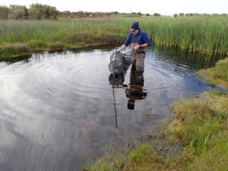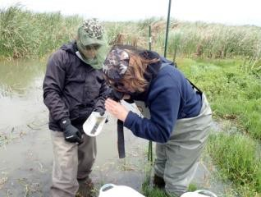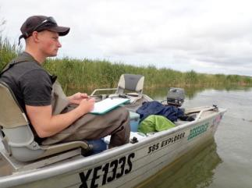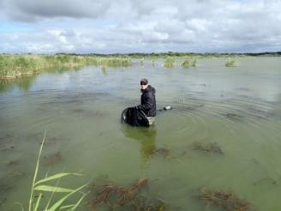

**Determining the status of Yarra Pygmy Perch in the Murray–Darling Basin**

Report to the Murray–Darling Basin Authority and the Commonwealth Environmental Water Office

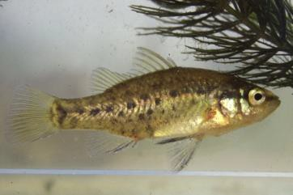

#### Scotte Wedderburn, Nick Whiterod and Daniel C. Gwinn

**April 2019**

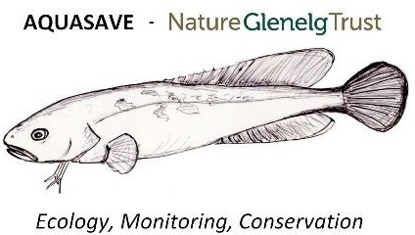

© The University of Adelaide

With the exception of the Commonwealth Coat of Arms, and the Murray–Darling Basin Authority, the Commonwealth Environmental Water Office, the University of Adelaide and the Aquasave – Nature Glenelg Trust logos, photographs and presented data, all material presented in this document is provided under a Creative Commons Attribution

4.0 International licence (https://creativecommons.org/licences/by/4.0/).

For the avoidance of any doubt, this licence only applies to the material set out in this document.



The details of the licence are available on the Creative Commons website (accessible using the links provided) as is the full legal code for the CC BY 4.0 licence (https://creativecommons.org/licences/by/4.0/legalcode).

The University of Adelaide’s preference is that this publication be attributed (and any material sourced from it) using the following:

Publication title: Determining the status of Yarra Pygmy Perch in the Murray–Darling Basin

Source: Licensed from the University of Adelaide under a Creative Commons Attribution 4.0 International Licence

The contents of this publication do not purport to represent the position of the Commonwealth of Australia, the MDBA, or the Commonwealth Environmental Water Office in any way and are presented for the purpose of informing and stimulating discussion for improved management of the Basin's natural resources.

To the extent permitted by law, the copyright holders (including its employees and consultants) exclude all liability to any person for any consequences, including but not limited to all losses, damages, costs, expenses and any other compensation, arising directly or indirectly from using this report (in part or in whole) and any information or material contained in it.

#### Contact us

Inquiries regarding the licence and any use of the document are welcome at:

[stuart.little@mdba.gov.au](mailto:stuart.little@mdba.gov.au)

## Contents

Acknowledgements 4

Summary 5

Introduction 6

Materials and methods 8

Fish sampling 8

Survey design 8

Habitat measures 10

Data analyses and interpretation 10

Model formulation 10

Model fit and reduction 12

Results 13

Fish summary 13

Habitat summary 15

Predictive modelling 17

Fish assemblage 18

Fish–habitat relationships 19

Yarra Pygmy Perch 23

Discussion 24

Management recommendations 26

References 26

Appendix 1 Some previous records of Yarra Pygmy Perch 31

Appendix 2 Model fitting methods 32

## Acknowledgements

This project was funded by the Murray–Darling Basin Authority and the Commonwealth Environmental Water Office. The project was managed by Stuart Little of the Murray– Darling Basin Authority. We acknowledge the people of the Ngarrindjeri Nation as the traditional custodians of the land on which this study was undertaken. Thank you to the landholders and managers who allowed access to sites, and to Ruan Gannon, Tom Hiatt and Dr Sylvia Zukowski who provided field assistance. Fish surveys were conducted in accordance with the University of Adelaide’s Animal Ethics policy (approval S-2018- 094), the *National Parks and Wildlife Act 1972* (Permit to Undertake Scientific Research: Q26018-8), and the *Fisheries Management Act 2007* (permits MP0105 and ME9903009).

## Summary

The current study relates to the precarious nature of the threatened small-bodied fish, Yarra Pygmy Perch (*Nannoperca obscura*), in the Murray–Darling Basin (MDB). The objective of this study is to assess the status of Yarra Pygmy Perch in the MDB. The study tests the hypothesis that Yarra Pygmy Perch is still present in low, but detectable, abundance in the MDB. This is tested using a tri-replicate survey within its only known range in the river system – wetlands associated with Lake Alexandrina in South Australia. The survey data is modelled to estimate, with statistical confidence, the likelihood of the species being present. The study also aims to gain information about other threatened fish species and Redfin Perch (*Perca fluviatilis*) which is a perceived threat. The outcomes of the study will inform conservation responses required to aid the recovery of Yarra Pygmy Perch.

The targeted survey included sites where Yarra Pygmy Perch was recorded before the Millennium Drought and at 2011–15 reintroduction sites. Several new sites were selected based on favourable prevailing conditions, which included channels and wetlands on Hindmarsh Island, and habitats in the Currency Creek, Finniss River and Goolwa Channel areas. Thirty two sites were surveyed three times in November– December 2018. Several habitat components were measured. A multi-species Bayesian hierarchical model was constructed to explain patterns in fish abundance relative to habitat characteristics. The survey design also enabled assessment using probability of detection to account for the likelihood of false absences of fishes at sites.

Twenty-two fish species were recorded in the surveys, which included five alien species. Yarra Pygmy Perch was not detected. Southern Pygmy Perch was detected at 12 sites ranging in abundances from 1 to >100 fish. Murray Hardyhead was detected at seven sites but in low abundances. Juvenile piscivorous Redfin Perch were detected in low to high abundances, ranging from several to >100 fish, at all but one site. Notably, the surveys recorded some of the earliest detections of a novel alien fish in the lakes, the Oriental Weatherloach (*Misgurnus anguillicaudatus*). Habitat conditions at sites were within the expected parameters for wetlands fringing Lake Alexandrina.

The predicted occurrence, abundance and detection probability varied highly among species. The alien Redfin Perch was one of the most common fish species in the assemblage with the highest maximum relative abundance. Southern Pygmy Perch had the highest average estimated occupancy of the threatened fishes and low estimated relative abundance which suggests it is rare in the surveyed fish assemblage. The model estimated that occupancy and relative abundance of Yarra Pygmy Perch is close to zero, indicating it is one of the rarest fish species in the assemblage. The estimated occurrence probability for the 32 sites was 0.0113 for Yarra Pygmy Perch. This equates to a probability of extirpation (the loss of a species from a region) across these sites of 99%, strongly supporting the hypothesis of local extirpation. Unexpectedly, pH was the strongest determinant of variation in relative abundance in space and among fish species.

The results show there is a high likelihood that Yarra Pygmy Perch is currently absent in the MDB or, at best, extremely rare and close to extirpation. The population recovery of Yarra Pygmy Perch in the MDB relies heavily on the remaining captive fish for future reintroductions. These remaining fish require careful management, and the opportunity for reintroductions is closing due to issues associated with maintaining Yarra Pygmy Perch in closed refuge sites for extended periods.

## Introduction

Native freshwater fish populations are under severe stress worldwide due to over- fishing, alien species, river regulation, over-exploitation of water and the consequences of climate change (Darwall and Freyhof 2016; Lévêque et al. 2008). Most threatened fishes are ‘ecological specialists’ dependant on specific habitats or other ecological needs that often are created by the natural flow regime (Devictor et al. 2010; Lévêque et al. 2008). Therefore, ecological specialists are sensitive to changes associated with altered (timing and duration) and reduced river flows and the resultant habitat changes (Aarts et al. 2004; Dudley and Platania 2007). The impacts on ecological cues and processes can lead to the loss of obligate habitats, reduction in prey availability and disruption to movement (Dudley and Platania 2007; Puckridge et al. 1998). The proliferation of some alien fishes in regulated rivers increase pressure on the already disadvantaged native fishes (Pool and Olden 2015). Combined with these factors, the increased frequency of drought due to climate change further impacts on native fish populations in temperate rivers (Chessman 2013; Matthews and Marsh-Matthews 2003; Morrongiello et al. 2011).

Regulation has profoundly altered the ecological character of rivers in the Murray– Darling Basin (MDB), which discharges at the mouth of the River Murray in South Australia. Natural flow regimes, formerly dictated by erratic rainfall and highly variable flows, promoted riverine heterogeneity that included a variety of wetland habitats (Robinson et al. 2015). The installation of main channel weirs, altered flow regimes and swampland reclamation have drastically altered the physical character of the lower River Murray (Leblanc et al. 2012; Walker 2006). Consequently, habitat fragmentations, loss of lotic habitats and reduction in wetland habitat diversity have significantly impacted on the nature of the lower River Murray in South Australia (Bice et al. 2017; Geddes et al. 2016). These impacts are evident in the Ramsar-listed final reaches of the river, which includes Lake Alexandrina, Lake Albert, the Coorong lagoons and the estuary (Mosley et al. 2018). Further, the lakes are separated from the Murray estuary by five barrages along the southern margins of Lake Alexandrina. Regulation, drought and flow reductions over recent decades have severely impacted on the ecological character of the region, including extinctions of invertebrates, changes to the floristic composition, and the population collapse of several small-bodied fishes (Nicol and Ganf 2017; Walker et al. 2018; Wedderburn et al. 2014).

Extensive regulation in the MDB has simplified the formerly biologically and functionally diverse fish assemblage of the lower River Murray (see review by Wedderburn et al. 2017a). There are 35 native fishes in the lower River Murray, and approximately two- thirds are small-bodied species (adults <300 mm long: Hammer et al. 2012; Ye and Hammer 2009). Several of the smallest fishes (adults <100 mm long) are ecological specialist requiring specific wetland habitat and hydrological conditions. These ecological specialists have obligate habitat requirements associated with the natural character of the river, including wetlands with complex macrophytes and abundant invertebrate prey (Wedderburn et al. 2017b). The low levels of natural disturbance caused by regulation have homogenised wetlands (e.g. stable water levels, uniform habitats: Bice et al. 2017). These conditions apparently favour ecological generalists, often alien fish species (e.g. Common Carp *Cyprinus carpio*; Redfin Perch *Perca fluviatilis*) and have reduced the volume of obligate micro-habitats for ecological specialists. Some wetlands associated with Lake Alexandrina, however, are somewhat more dynamic due to the fluctuating nature of lake water levels, which are sometimes managed by authorities.

Many native fish populations in the lower River Murray have declined since regulation, and more so in the last few decades. Twenty-five years ago Walker and Thoms (1993) highlighted that approximately 20 fish species were threatened with extinction following an assessment by Lloyd and Walker (1986), and that extinctions were well advanced for five species. A more recent assessment classed three species as ‘Extinct’ (e.g. Trout Cod *Maccullochella macquariensis*), four species as ‘Critically Endangered’, nine species as ‘Endangered’ and two species as ‘Vulnerable’ in the lower River Murray in South Australia (Hammer et al. 2009). An informal working group called ‘Big (Little) Four’, comprised of scientists and natural resource managers, meet irregularly to discuss and plan for the conservation of Murray Hardyhead (*Craterocephalus fluviatilis*), Southern Purple-spotted Gudgeon (*Mogurnda adspersa*), Southern Pygmy Perch (*Nannoperca australis*) and Yarra Pygmy Perch (*Nannoperca obscura*) – four small-bodied freshwater fishes that are threatened with extinction in the lower River Murray. The under- resourced working group, however, has a limited capacity to improve the conservation status of the four threatened fishes.

The current study relates to the precarious nature of Yarra Pygmy Perch in the lower River Murray. Yarra Pygmy Perch is ‘Vulnerable’ under the *Environment Protection and Biodiversity Conservation Act 1999* (EPBC Act), ‘Vulnerable’ under the International Union for the Conservation of Nature’s (IUCN) Red List of Threatened Species, and ‘Critically Endangered’ in South Australia due to population decline and regional extinctions (Hammer et al. 2009; Saddlier et al. 2013; Wager and Jackson 1993). Yarra Pygmy Perch occurs in several major catchments in south-eastern Australia, but the genetically unique population in the MDB has only been recorded from Lake Alexandrina (Brauer et al. 2013; Hammer et al. 2010). More recently, the species only inhabited south-western Lake Alexandrina where the earliest monitoring programs in the lakes identified abundant populations (Hammer et al. 2002; Higham et al. 2005; Wedderburn and Hammer 2003). Critical water shortages during the Millennium Drought resulted in broad-scale drying and loss of its obligate habitat (Hammer et al. 2013; Kingsford et al. 2011). Subsequently, wild populations of the species were last recorded in 2008 during condition monitoring associated with the MDBA’s The Living Murray (TLM) initiative (Bice et al. 2008; Wedderburn and Barnes 2018). Prior to its demise, approximately 200 Yarra Pygmy Perch were rescued in 2007 and 2008 to breed in captivity and surrogate refuges before reintroductions in 2011–12 and 2015 following drought (Bice et al. 2014). Yarra Pygmy Perch is unrecorded in the MDB since small numbers of stocked fish were re- captured in late 2015 (Wedderburn and Barnes 2018; Wedderburn et al. 2016). Notably, captive and surrogate populations are still available for potential future reintroductions (Whiterod 2019).

The objective of this study is to determine the status of Yarra Pygmy Perch in the MDB. Specifically, the study tests the hypothesis that Yarra Pygmy Perch is still present in low, but detectable, abundance in the MDB. The hypothesis is tested using a robust three replicate survey design where the data can be modelled to estimate, with statistical confidence, the likelihood of the species being present. The study utilised the results for the closely-related Southern Pygmy Perch in recent TLM condition monitoring to guide the survey design for targeting Yarra Pygmy Perch. The study also aims to gain information about other threatened fish species and Redfin Perch (perceived threat), including their current levels of occupancy and relationships with habitat. The outcomes of the study will inform conservation responses required to aid the recovery of Yarra Pygmy Perch in the MDB.

## Materials and methods

# Fish sampling

The surveys targeted sites where Yarra Pygmy Perch was most likely to occur, including where the species occurred before drought, and at 2011–15 reintroduction sites. Several new sites were selected based on favourable prevailing conditions, which included channels and wetlands on Hindmarsh Island, and habitats in the Currency Creek, Finniss River and Goolwa Channel areas. Fyke nets are currently the most effective device for capturing pygmy perches based on current abundances (Wedderburn 2018). Seining is inefficient due to the heavily vegetated habitats preferred by Yarra Pygmy Perch and Southern Pygmy Perch (Wedderburn and Barnes 2016a; Wedderburn and Barnes 2017; Wedderburn and Barnes 2018).

Thirty-two sites were surveyed three times between the 5th of November and the 14th of December 2018 (Table 1; Figure 1). Subsequent surveys at each site occurred within three days of the last survey, but usually over three consecutive days. Three single- leader fyke nets (5-mm half mesh) were set overnight at all sites on the three occasions, and placed perpendicular to the bank or angled when in narrow channels or deep water (i.e. corresponding to TLM condition monitoring methods). Grids (50-mm) at the entrances of nets excluded turtles and fish that might harm threatened fish, but are not expected to affect their ability to capture fish <250 mm long (cf. Fratto et al. 2008). Fish were identified to species and enumerated with total length (TL, to the nearest millimetre) recorded for threatened fish and Redfin Perch. All pygmy perch captured were photographed.

# Survey design

In an occupancy study, the extent of the species’ habitation in its natural range (proportion of survey sites detected) is determined while taking into account false absences (‘imperfect detection’) in sampling by conducting replicate surveys using binomial modelling (MacKenzie et al. 2003; Mackenzie et al. 2018). This approach was implemented for TLM condition monitoring of threatened fishes in Lake Alexandrina and Lake Albert after Wayne Robinson (biostatistician, Charles Sturt University) was contracted by the MDBA to examine and refine the monitoring program to produce scientifically robust survey methods (Robinson 2015). Importantly, the current survey builds on TLM condition monitoring methods, especially around the value of additional sites in accounting for imperfect detection, and by the discovery of new sites inhabited by threatened fishes.

The optimum number of replicate surveys of an occupancy study can be based on the results of a pilot study, on studies carried out for the same or similar species in comparable circumstances or on expert opinion (Guillera-Arroita et al. 2010; Mackenzie et al. 2018). There was no occupancy data available for Yarra Pygmy Perch which accounted for imperfect detection. To derive the optimal number of replicate surveys to be carried out at each sampling site in the current study, results for the closely-related Southern Pygmy Perch were used because it was recorded in the last three TLM condition monitoring surveys of 17 sites that accounted for imperfect detection (Wedderburn and Barnes 2018). The results of two replicate surveys at 17 sites in the last 3 years of TLM condition monitoring showed three replicate surveys were required to reliably detect Yarra Pygmy Perch in an occupancy study within the constraints of available resources (Guillera-Arroita et al. 2010).

Table 1. Sites surveyed in November–December 2018 (UTM zone 54H, WGS84).

|  |  |  |  |
| --- | --- | --- | --- |
| **Site** | **Site description** | **Easting** | **Northing** |
| **1** | Boundary Creek 300 m upstream of barrage | 314665 | 6063722 |
| **2** | Wyndgate (Premier’s reintroduction site) | 309485 | 6066535 |
| **3** | Hunters Creek upstream of Denver Road | 309491 | 6066326 |
| **4** | North off Hunters Creek | 309443 | 6066642 |
| **5** | Channel off Steamer Drain | 310426 | 6066005 |
| **6** | Hunters Creek upstream of paddock crossing | 309925 | 6066257 |
| **7** | Hunters Creek downstream of Denver Road | 308753 | 6066314 |
| **8** | Hindmarsh Island east (tyre reef) | 313878 | 6067174 |
| **9** | Long Island wetland | 317464 | 6066094 |
| **10** | Mouth of Steamers Drain | 310192 | 6065866 |
| **11** | Dunn Lagoon–Goose Island wetland | 313252 | 6069417 |
| **12** | Boundary Creek downstream of entrance | 315601 | 6065868 |
| **13** | Wetland off Finniss River downstream of Wally's Wharf | 303558 | 6079222 |
| **14** | Currency Creek–Goolwa Channel | 302539 | 6070159 |
| **15** | Near Blue Lagoon 2 site | 303762 | 6079508 |
| **16** | Black Swamp | 304679 | 6076719 |
| **17** | Black Swamp at the Tookayerta confluence | 304483 | 6077288 |
| **18** | Finniss River–Goolwa Channel junction | 308249 | 6071109 |
| **19** | Eastick Creek mouth | 311624 | 6065344 |
| **20** | Shadows Lagoon south | 310784 | 6067009 |
| **21** | Mundoo Barrage | 309822 | 6065322 |
| **22** | Shadows Lagoon west | 310636 | 6067375 |
| **23** | Hindmarsh Island opposite Clayton | 312465 | 6068378 |
| **24** | Clayton Bay | 311122 | 6070520 |
| **25** | Shadows Lagoon at Wells’ property shoreline | 311165 | 6067555 |
| **26** | Shadows Lagoon opposite Wells’ property shoreline | 311042 | 6067544 |
| **27** | Shadows Lagoon–Boggy Creek | 311500 | 6066907 |
| **28** | Currency Creek arm | 301206 | 6071493 |
| **29** | Currency Creek Game Reserve | 304194 | 6070730 |
| **30** | Hindmarsh Island opposite Currency Creek | 305291 | 6069807 |
| **31** | Boggy Creek upstream of mouth | 311055 | 6065766 |
| **32** | Channel off Hunters Creek u/s Denver Road crossing | 309207 | 6066576 |

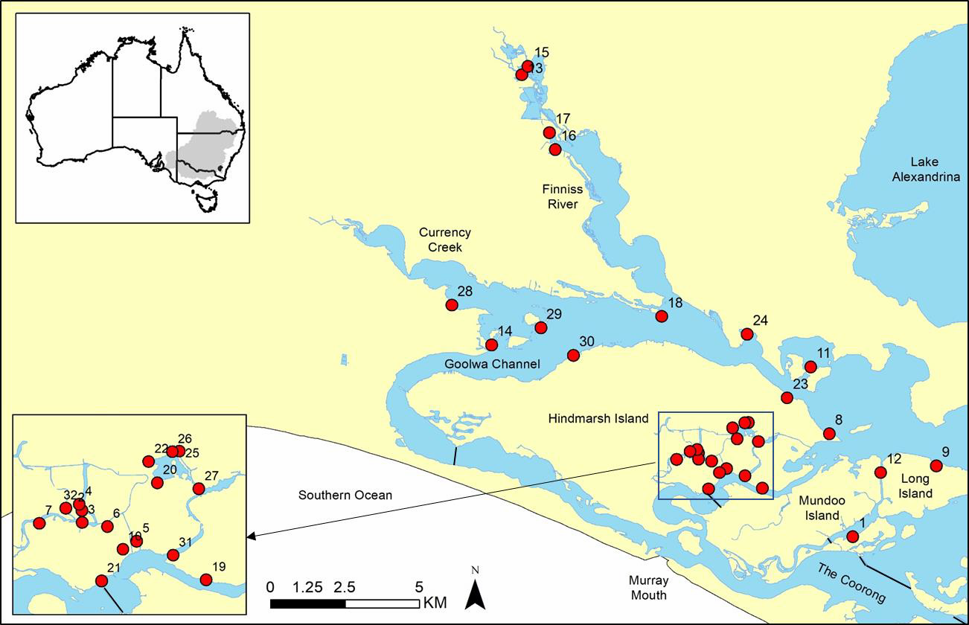

Figure 1. Study region showing the 32 sites surveyed in November–December 2018.

# Habitat measures

Electrical Conductivity (EC) units (*µ*Scm-1), pH and Temperature (°C) were recorded using a TPS WP-81 meter. Secchi depth (cm) was measured. Several other habitat variables were recorded, chosen based on their potential importance to threatened fish populations, including average water depth (five measures approximately 1 m apart, beginning 1 m from the bank, or five measures equally spaced if in a narrow channel) and aquatic plant cover (estimated percentage of each key species covering the site). Importantly, the habitat assessments also identify potential reintroduction sites should a future Yarra Pygmy Perch recovery program commence.

# Data analyses and interpretation

Model formulation

A multi-species Bayesian hierarchical model was constructed to explain patterns in fish abundance relative to habitat characteristics. The model has three distinct hierarchical layers, including a sub-model that describes the inclusion of species in the assemblage, a sub-model that describes the spatial distribution of fish abundance given their inclusion in the assemblage, and a sub-model that describes the probability of detecting fish given their abundance.

The inclusion of fish species in the assemblage was modelled as, 𝑤𝑖~Bernoulli(0.5). For species that are observed in our data set, *wi* will take the value of one, indicating complete certainty in the presence of the species in the assemblage. Alternatively, for the Yarra Pygmy Perch that was not recorded in the data, *wi* will take the value of one or zero in proportion to the support for their presence or absence from the fish

assemblage. Thus, the mean of the posterior distribution of *wi* for Yarra Pygmy Perch can be interpreted as the probability that the species is extant in the study region, where the mean of the posterior of *wi* can be interpreted as the probability that the species is extirpated.

The model assumes that abundance of fish is a latent random variable 𝑁𝑖,𝑗,𝑘 described by a Poisson distribution as, 𝑁𝑖,𝑗~Poisson(𝑤𝑖𝜆𝑖,𝑗), where 𝑤𝑖𝜆𝑖,𝑗,𝑘 is the Poisson mean for species *i* at site *j* that is conditional on its inclusion in the species assemblage (i.e. 𝑤𝑖 = 1). This model formalizes the assumption that the abundance of each species is effectively constant at the site across replicate surveys. To accommodate the model, we reduced our catch data to binary incidences at the net scale and summed the incidences across the three nets for each replicate survey. Thus, the summarized data, represented as 𝑦𝑖,𝑗,𝑘 can take the value of zero when a species is not detected in any of the three nets on a given survey, up to a value of three when a species is detected in all three nets on a given survey. We assumed that these data were the result of a Binomial process as, 𝑦𝑖,𝑗,𝑘~Binomial(𝑝𝑖,𝑗, 3), where 𝑝𝑖,𝑗 represents the conditional detection probability of the species at site *j*, and the value 3 is the number of nets set on each survey. We linked the model of abundance with detection by specifying the relationship between the probability of detecting the species and the local abundance of the species

𝑖,𝑗

per Royle and Nichols (2003) as, 𝑝𝑖,𝑗

= 1 − (1 − 𝑟𝑖,𝑗

)𝑁𝑖,𝑗 , where 𝑟

is the capture probability

(i.e. the proportion of 𝑁𝑖,𝑗 that is captured by one replicate sample at a site). This formulation essentially models the detection probability 𝑝𝑖,𝑗 as a random effect defined by the value of 𝑟𝑖,𝑗, the relationship between 𝑝𝑖,𝑗 and 𝑁𝑖,𝑗 and the mixing distribution of

𝑁𝑖,𝑗~Poisson(𝑤𝑖𝜆𝑖,𝑗) to account for variation in 𝑝𝑖,𝑗 due to variation in abundance of fish among sites.

Covariates were incorporated into the abundance sub-model with a log link as:

|  |  |
| --- | --- |
| log(𝜆𝑖,𝑗) = 𝛽1,𝑖 + 𝛽2,𝑖𝐷𝑗 + 𝛽3,𝑖𝑉𝑗 + 𝛽4,𝑖𝑝𝐻𝑗 | (1) |

where 𝛽1,𝑖 is the species-specific intercept of the model representing the average log- scale abundance of species *i* across sites and surveys. The parameters 𝛽2,𝑖 through 𝛽4,𝑖 are species-specific covariate effects with 𝐷𝑗,𝑘 representing the average water depth at the site, 𝑉𝑗,𝑘 representing the percent submerged vegetation coverage at the site, and

𝑝𝐻𝑗,𝑘 representing the average pH at the site. We incorporated covariates into the detection sub-model with a logit link as:

|  |  |
| --- | --- |
| logit(𝑟𝑖,𝑗) = 𝜂1,𝑖 + 𝜂2,𝑖𝑆𝑗 + 𝜂3,𝑖𝐷𝑗 + 𝜂4,𝑖𝑇𝑗 + 𝜂5,𝑖𝐶𝑗 + 𝜂6,𝑖𝑉𝑗 + 𝜂7,𝑖𝑆𝑗,𝑘𝐷𝑗 | (2) |

where 𝜂1,𝑖 is the intercept of the detection sub-model representing the average logit- scale capture probability for each species. The parameters 𝜂2,𝑖 through 𝜂7,𝑖 are species- specific covariate effects with 𝑆𝑗,𝑘 representing water clarity (i.e. secchi depth), 𝑇𝑗,𝑘 representing the water temperature, 𝐶𝑗,𝑘 representing the electrical conductivity (EC) of the water, and 𝑆𝑗,𝑘𝐷𝑗,𝑘 representing the potential interaction between water clarity and depth on capture probability. All taxon-specific parameters (𝛽1,𝑖−𝛽4,𝑖 and 𝜂1,𝑖 − 𝜂7,𝑖) were specified as random effects drawn from Normal distributions as, 𝜃𝑚,𝑗~Normal(𝜇𝑚, 𝜎𝑚), where *m* indicates the parameter, 𝜇𝑘 and 𝜎𝑘 are the estimated means and standard deviations of the parameter across species.

Model fit and reduction

Model fit was evaluated for each species in the full model with Bayesian p-values (*Bp*, Kéry 2010). The Bayesian p-value is a posterior predictive check that provides a measure of under- or over-dispersion of the data relative to the model (Broms et al. 2016; Hooten and Hobbs 2015). The model fit evaluation was performed by simulating the survey data directly from the model for each Markov Chain Monte Carlo (MCMC) iteration, summing the incidence data for each species across sites, and calculating a Chi-squared discrepancy between the simulated and expected values (i.e. predicted 𝜒2) and observed and expected values (i.e. observed 𝜒2) for each species. The simulated data are considered ‘perfect’ because they are generated directly from the model and, thus, the resulting 𝜒2 represents the fit of the model when all model assumptions are perfectly met (Kéry 2010). We then created a fit metric that is equal to zero when the

𝜒2 was greater for the observed data than the simulated data and is equal to one, otherwise. The *Bp* was then calculated as the mean of the posterior sample of the fit metric for each species, where a mean of 0.5 indicates perfect model fit to the data and a mean approaching 1 or 0 indicates under- or over-dispersion of the data relative to the model, respectively. We considered models with *Bp* >0.11 and <0.89 to have no statistical difference between the observed and predicted distributions (approximating

𝛼 = 0.05), and thus demonstrate adequate model fit.

Because of the complexity of our model selection problem (i.e. the number of species and covariate combinations is >308), we chose to perform model selection using Stochastic Search Variable Selection (SSVS). Using SSVS to produce models with desirable predictive properties was first introduced by George and McCollock (1993) but has been thoroughly discussed in more recent ecological literature (Hooten and Hobbs 2015; O’Hara and Sillanpaa 2009; Tenan et al. 2014). A modified form of SSVS is used in the current study to evaluate support for each 𝛽 parameter as species-specific (i.e.

𝛽𝑘,𝑗), invariant across species (i.e. 𝛽𝑘,𝑗 = 𝜇𝑘) or equal to zero (i.e. excluded from the model, 𝛽𝑘,𝑗 = 𝜇𝑘 = 0). This is achieved by including a set of indicator variables into the model. Typically, these indicators are binary draws from a Bernoulli distribution and indicate when a parameter is included or excluded from the model. For the current model selection problem, we include and exclude sets of parameters; thus, the prior for

each indicator variable was specified as, 𝐼𝑘~Categorical ((1 , 1 , 1)), indicating equal prior

3 3 3

support for either of the three hypotheses for each covariate. The posterior values of the indicator variables can be interpreted as support for the predictive potential of the model term and the parameters and predictions from the full model are automatically model averaged accounting for structural uncertainty.

## Results

# Fish summary

Twenty-two fish species were recorded in the three replicate surveys, which included five alien species (Table 2). Yarra Pygmy Perch was undetected. Southern Pygmy Perch was detected at 12 sites ranging in abundances from 1 to >100 fish. The overall high number of young-of-the-year (YOY) Southern Pygmy Perch (NANAUS1; <35 mm TL), results mostly from one site on Hindmarsh Island that was isolated for most other fish species. Adult Southern Pygmy Perch (NANAUS2) were detected at 10 sites at numbers ranging from one to >10 fish. Murray Hardyhead was detected at seven sites but in low abundances, and often in breeding condition. Alien Redfin Perch was detected at all but one site, and often in high abundance. The overall higher numbers of YOY Redfin Perch (PERFLU1; <80 mm TL), results mainly from the first of the three surveys at site 21 adjacent to the Mundoo Barrage, and relatively high abundances at several other sites. Juvenile Redfin Perch (PERFLU2) large enough to consume fish (confirmed during the surveys) were detected at all but one site in low to high abundances. Notably, the surveys recorded some of the earliest detections of a novel alien fish in the lakes, the Oriental Weatherloach (*Misgurnus anguillicaudatus*).

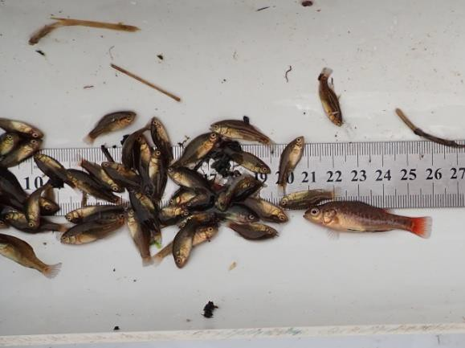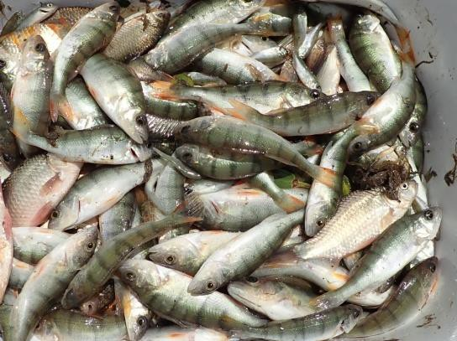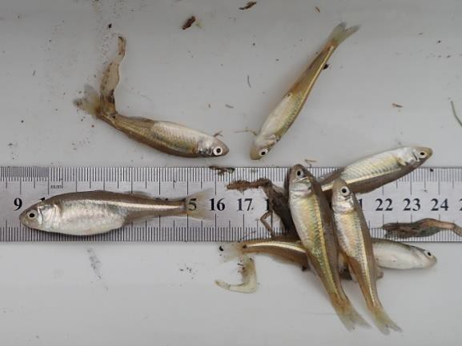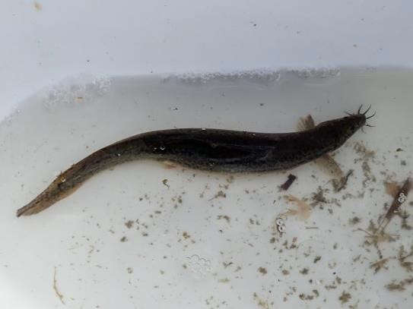

|  |  |
| --- | --- |
|  |  |
|  |  |

One adult and many young-of-the-year Southern Pygmy Perch from site 32 Shadows Lagoon on Hindmarsh Island (top left); Murray Hardyhead in breeding condition from site 22 Shadows Lagoon (top right); juvenile piscivorous Redfin Perch from site 26 Shadows Lagoon (bottom left); Oriental Weatherloach from site 1 Boundary Creek (bottom right).

Table 2. Number of sites recorded and total abundance of each fish species captured in three surveys of 32 sites in November–December 2018.

|  |  |  |  |  |
| --- | --- | --- | --- | --- |
| **Species code** | **Common name** | **Scientific name** | **Sites** | **Abundance** |
| NANOBS | Yarra Pygmy Perch | *Nannoperca obscura* | 0 | 0 |
| NANAUS | Southern Pygmy Perch | *Nannoperca australis* | 12 | 776 |
| NANAUS1 | Young-of-the-year | (<35 mm) | 8 | 687 |
| NANAUS2 | Adult fish |  | 10 | 89 |
| CRAFLU | Murray Hardyhead | *Craterocephalus fluviatilis* | 6 | 37 |
| CRASTE | Unspecked Hardyhead | *Craterocephalus fulvus* | 23 | 600 |
| NEMERE | Bony Herring | *Nematalosa erebi* | 25 | 1280 |
| PHIGRA | Flathead Gudgeon | *Philypnodon grandiceps* | 30 | 3330 |
| PHIMAC | Dwarf Flathead Gudgeon | *Philypnodon macrostomus* | 30 | 269 |
| HYPSPP | Carp Gudgeon | *Hypseleotris* spp. | 31 | 370 |
| RETSEM | Australian Smelt | *Retropinna semoni* | 25 | 240 |
| MACAMB | Golden Perch | *Macquaria ambigua* | 12 | 30 |
| MELFLU | Murray Rainbowfish | *Melanotaenia fluviatilis* | 0 | 0 |
| PSEURV | Congolli | *Pseudaphritis urvillii* | 31 | 484 |
| GALMAC | Common Galaxias | *Galaxias maculatus* | 32 | 3755 |
| ATHMIC | Smallmouth Hardyhead | *Atherinosoma microstoma* | 8 | 165 |
| PSEOLO | Blue-spot Goby | *Pseudogobius olorum* | 4 | 22 |
| TASLAS | Lagoon Goby | *Tasmanogobius lasti* | 14 | 79 |
| AFUTAM | Tamar River Goby | *Afurcagobius tamarensis* | 0 | 0 |
| ALDFOS | Yellow-eye Mullet | *Aldrichetta fosteri* | 2 | 4 |
| HYPVIT | Sandy Sprat | *Hyperlophus vittatus* | 1 | 4 |
| MISANG | Oriental Weatherloach | *Misgurnus anguillicaudatus* | 3 | 5 |
| CYPCAR | Common Carp | *Cyprinus carpio* | 29 | 427 |
| CARAUR | Goldfish | *Carassius auratus* | 22 | 135 |
| PERFLU | Redfin Perch | *Perca fluviatilis* | 31 | 9794 |
| PERFLU1 | Young-of-the-year | (<80 mm) | 27 | 8229 |
| PERFLU2 | Juvenile piscivorous |  | 31 | 1565 |
| GAMHOL | Eastern Gambusia | *Gambusia holbrooki* | 13 | 185 |

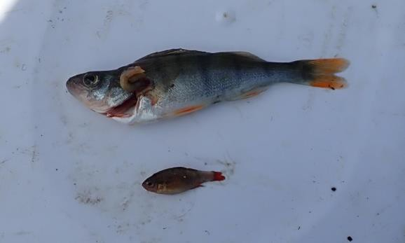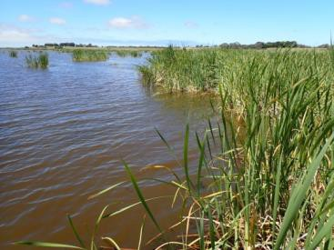

Southern Pygmy Perch removed from the gut of a juvenile Redfin Perch captured at site 17 in Black Swamp.

# Habitat summary

Lake Alexandrina water levels can vary (e.g. influenced by winds), and the effects are amplified on water levels in fringing wetlands. The lake water level at Milang, on the northern shoreline of Lake Alexandrina, ranged between 0.467 and 0.789 m above the Australian Height Datum (AHD; sea level) during the survey period, but generally was between 0.70 and 0.75 m AHD (Department for Environment and Water, unpublished data). The values represent normal managed water levels for Lake Alexandrina.

Habitat conditions at the 32 sites were within the expected parameters for wetlands fringing Lake Alexandrina over late spring to early summer. Data from the three surveys provided averages for each habitat variable (Table 3). Average salinity, measured as EC, ranged from 918 *µ*Scm-1 at site 23 to 4012 *µ*Scm-1 at site 21 adjacent to the Mundoo Barrage (i.e. salt-water intrusion). The ranges of pH 7.5–8.9 and water temperature 15.8–22.8 °C were within the tolerances of all fishes inhabiting the Lower Lakes (Lintermans 2007). The other three measured variables had greater variation. Secchi depth (water ‘clarity’) ranged from 17 cm at a site on Shadows Lagoon during strong winds (sediment stirred up) to 61 cm at site 17 where clear spring water from Tookayerta Creek meets the Finniss River. Water depths ranged from 38 cm at the shallow sites of Shadows Lagoon to 114 cm where Tookayerta Creek meets the Finniss River. The lowest aquatic plant cover was 5% at site 25 on Shadows Lagoon, yet other sites on the lagoon were much higher (31–67%). Aquatic plant cover was ≥60% at six sites, but generally ranged between 30 and 60%. The dominant aquatic plant genera in order of highest to lowest abundances were *Typha*, *Myriophyllum*, *Ceratophyllum*, *Phragmites*, *Vallisneria*, *Scheonoplectus*, *Ludwigia*, *Triglochin* and *Potamogeton*.

|  |  |
| --- | --- |
|  |  |
|  |  |

Habitats included combinations of *Typha* and *Myriophyllum* at site 11 Dunn Lagoon (top left), *Typha* and *Ludwigia* at site 27 Shadows Lagoon–Boggy Creek (top right), *Typha* and *Scheonoplectus* at site 28 Currency Creek (bottom left), and *Scheonoplectus* and *Ceratophyllum* at site 6 Hindmarsh Island (bottom right).

Table 3. Average habitat measures from three replicate surveys in November–December 2018.

|  |  |  |  |  |  |  |
| --- | --- | --- | --- | --- | --- | --- |
| **Site** | **EC**  (*µ*Scm-1) | **pH** | **Secchi** (cm) | **Temp.** (°C) | **Depth** (cm) | **Aquatic plants** (%) |
| **1** | 1932 | 8.0 | 27 | 19.4 | 52 | 36 |
| **2** | 1312 | 7.8 | 20 | 16.9 | 49 | 35 |
| **3** | 1884 | 7.9 | 27 | 16.6 | 69 | 43 |
| **4** | 1989 | 7.8 | 18 | 16.9 | 71 | 37 |
| **5** | 1384 | 7.6 | 65 | 18.6 | 80 | 67 |
| **6** | 1711 | 7.7 | 38 | 16.8 | 91 | 52 |
| **7** | 1844 | 7.8 | 24 | 17.0 | 61 | 37 |
| **8** | 1060 | 8.6 | 27 | 19.8 | 61 | 37 |
| **9** | 1111 | 7.4 | 34 | 20.5 | 51 | 60 |
| **10** | 1319 | 8.4 | 48 | 19.8 | 74 | 55 |
| **11** | 927 | 8.4 | 39 | 18.6 | 71 | 54 |
| **12** | 1266 | 8.7 | 32 | 20.4 | 61 | 57 |
| **13** | 1929 | 7.6 | 27 | 21.8 | 72 | 43 |
| **14** | 1069 | 8.5 | 44 | 19.6 | 99 | 68 |
| **15** | 2063 | 7.6 | 33 | 21.4 | 80 | 48 |
| **16** | 1737 | 7.8 | 39 | 21.8 | 109 | 43 |
| **17** | 1375 | 7.6 | 61 | 22.8 | 114 | 68 |
| **18** | 1088 | 8.7 | 32 | 19.1 | 63 | 21 |
| **19** | 1439 | 8.9 | 31 | 16.8 | 47 | 34 |
| **20** | 1258 | 8.0 | 23 | 18.3 | 35 | 57 |
| **21** | 4012 | 8.1 | 33 | 17.5 | 70 | 50 |
| **22** | 1641 | 7.9 | 19 | 15.8 | 38 | 31 |
| **23** | 918 | 8.7 | 27 | 18.4 | 87 | 31 |
| **24** | 991 | 8.5 | 25 | 19.3 | 60 | 24 |
| **25** | 1230 | 8.0 | 18 | 15.3 | 57 | 5 |
| **26** | 1309 | 7.9 | 17 | 16.4 | 56 | 52 |
| **27** | 1061 | 7.6 | 18 | 17.6 | 44 | 67 |
| **28** | 1394 | 8.3 | 43 | 19.6 | 79 | 34 |
| **29** | 1283 | 8.2 | 48 | 17.8 | 82 | 52 |
| **30** | 1175 | 8.0 | 53 | 19.0 | 81 | 65 |
| **31** | 1303 | 8.4 | 42 | 18.9 | 98 | 26 |
| **32** | 1831 | 7.5 | 49 | 17.9 | 49 | 33 |

# Predictive modelling

Our model converged for all parameters and demonstrated adequate fit for all species as indicated by Bayesian p-values between 0.1 and 0.9 (Table 4). The Bayesian p-value for Yarra Pygmy Perch (NANOBS) is not applicable given it was undetected in the surveys.

Table 4. Summaries of the total number of sites each species was detected, the total detections and the model fit. A Bayesian p-value of 0.5 indicates perfect fit, whereas values approaching 0 or 1 indicate over or under dispersion, respectively. Values between 0.1 and 0.9 indicate adequate model fit.

|  |  |  |  |
| --- | --- | --- | --- |
| **Species code** | **Sites detected** | **Total detections** | **Bayesian p-value** |
| ALDFOR | 2 | 4 | 0.60 |
| ATHMIC | 8 | 20 | 0.42 |
| CARAUR | 22 | 68 | 0.50 |
| CRAFLU | 6 | 14 | 0.46 |
| CRASTE | 23 | 115 | 0.50 |
| CYPCAR | 29 | 144 | 0.48 |
| GAMHOL | 13 | 39 | 0.45 |
| HYPSPP | 31 | 130 | 0.48 |
| HYPVIT | 1 | 2 | 0.57 |
| MACAMB | 12 | 26 | 0.49 |
| MISANG | 3 | 5 | 0.53 |
| NANAUS1 | 8 | 21 | 0.49 |
| NANAUS2 | 10 | 43 | 0.51 |
| NANOBS | 0 | 0 | NA |
| NEMERE | 25 | 150 | 0.50 |
| PERFLU | 31 | 248 | 0.53 |
| PERFLU1 | 27 | 168 | 0.51 |
| PERFLU2 | 31 | 234 | 0.54 |
| PHIGRA | 30 | 250 | 0.55 |
| PHIMAC | 30 | 124 | 0.51 |
| PSEOLO | 4 | 12 | 0.49 |
| PSEURV | 31 | 179 | 0.48 |
| RETSEM | 25 | 86 | 0.52 |
| TASLAS | 14 | 34 | 0.47 |

Fish assemblage

The predicted occupancy probability (proportion of survey sites where species occurs), relative abundance and capture probability (proportion of total abundance captured in one fyke net at a site when it is present) varied highly among species (Figure 2). Occupancy was high (between 0.9 and 1.0) for several freshwater and two diadromous fishes. The alien Redfin Perch (PERFLU) was one of the most common fish species in the assemblage with the highest maximum estimated average occupancy of 0.995 ±0.002 and relative abundance of 7.45 ±0.66 (SE), and its estimated average capture probability of 0.37 ±0.02 was higher than most species (i.e. for one fyke net at one site for one survey). Juvenile piscivorous Redfin Perch (PERFLU2) had high estimated average occupancy (0.979 ±0.004), relative abundance (4.67 ±0.30) and capture probability (0.38 ±0.02). The estimated average relative abundance of YOY Redfin Perch was much lower (2.14 ±0.09) than the juvenile Redfin Perch, but was higher than most other fishes in the assemblage.

The other freshwater fishes with high occupancy consisted of ecological generalists, with exception of Dwarf Flathead Gudgeon (*Philypnodon macrostomus*; PHIMAC;

0.95 ±0.01) which was also common during the surveys with estimated average relative abundance of 3.60 ±0.23. The diadromous Congolli (*Pseudaphritis urvillii*; PSEURV) and Common Galaxias (*Galaxias maculatus*; GALMAC) also have a high estimated occupancy (0.96 ±0.006 and 0.98 ±0.004, respectively), presumably due to the close proximity of Lake Alexandrina to the estuary.

Southern Pygmy Perch (NANAUS) had the highest average estimated occupancy of the threatened fishes at 0.51 ±0.02, but corresponded to a low estimated average relative abundance of 0.73 ±0.04 which suggests it is rare in the surveyed fish assemblage. When comparing YOY (NANAUS1) and adult Southern Pygmy Perch (NANAUS2), average estimated occupancy was lower for YOY (0.37 ±0.02 and 0.40 ±0.02, respectively). Similarly, the estimated average relative abundance of YOY is somewhat lower than adult Southern Pygmy Perch (0.48 ±0.04 and 0.53 ±0.03, respectively). Capture probability was low for both groups but is significantly lower for YOY Southern Pygmy Perch compared to adults (0.14 ±0.01 and 0.21 ±0.01, respectively).

The average estimated occupancy of 0.40 ±0.03 for Murray Hardyhead (CRAFLU) was relatively low and corresponded to a low average relative abundance (0.56 ±0.07) and probability of capture (0.07 ±0.01); therefore, suggesting the species is rare in the fish assemblage. Alternatively, fyke nets are not the best sampling device to target the species thereby over-emphasising its rarity in the current study (cf. Wedderburn 2018).

The model estimates that capture probability of Yarra Pygmy Perch (NANOBS) was

* 1. ±0.03 (i.e. similar to Southern Pygmy Perch), but occupancy and relative abundance were close to zero. Yarra Pygmy Perch, therefore, is one of the rarest species in the fish community. The extremely low predicted occurrence and abundance of Yarra Pygmy Perch suggests local extirpation as a probable hypothesis.

TASLAS RETSEM PSEURV PSEOLO PHIMAC PHIGRA PERFLU2 PERFLU1 PERFLU NEMERE NANOBS NANAUS2 NANAUS1 NANAUS MISANG MACAMB HYPVIT HYPSPP GAMHOL GALMAC CYPCAR CRASTE CRAFLU CARAUR ATHMIC ALDFOR

Species code

### Occupancy Abundance Capture prob.

* + 1. (b) (c)

|  |  |  |  |  |  |
| --- | --- | --- | --- | --- | --- |
|  | | | |  | |
|  | | | | | |
|  | | | | | |
|  |  | | | | |
|  | | | | | |
|  | | | | | |
|  | | | | | |
|  | | | | |  |
|  | | | | | |
|  | | | | |  |
|  | | | | | |
|  | |  | | | |
|  | |
|  | | |  | | |

0.0 0.4 0.8 0 2 4 6 0.0 0.4 0.8



|  |  |  |  |
| --- | --- | --- | --- |
|  | | | |
|  | | |  |
|  |  | | |
|  | | | |
|  | |  | |

### Parameter value

Figure 2. Average estimated occupancy probability (a), relative abundance (b), and capture probability (c) for each fish species.

Fish–habitat relationships

The following interpretation of results focuses on the fish species of interest as related to the objective and aims of this study.

Relative abundance varied substantially among species (Figure 3; panel a). Relative abundance was similar for YOY (NANAUS1) and adult (NANAUS2) Southern Pygmy Perch, and for the species combined (NANAUS). The relative abundance of Murray Hardyhead (CRAFLU) was similar to Southern Pygmy Perch. The lowest relative abundance estimated by the model was for Yarra Pygmy Perch (NANOBS). The highest estimated abundance was for Redfin Perch (PERFLU).

There appears to be no relationship between water depth or percentage aquatic plant cover and abundance for any of the fishes across the range of these variables in the data (panels b and c). The relative abundance of species was somewhat variable among different levels of pH (panel d). There was a significant negative relationship for Southern Pygmy Perch where pH was the strongest predictor of its abundance. There was a significant positive relationship for Redfin Perch where pH was a predictor of its abundance, and particularly YOY fish (PERFLU1).

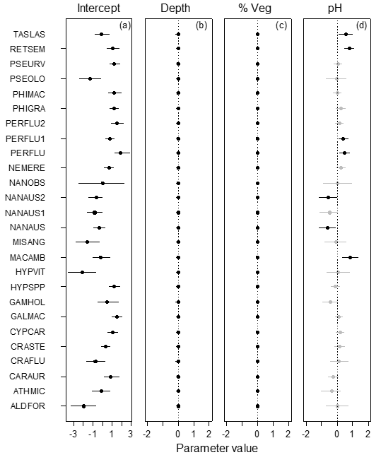

Figure 3. Posterior summaries of species-specific parameters of the relative abundance sub-model. The points represent the parameter point estimates (mean of the posterior distribution) and the error bars represent the 95% Bayesian credible intervals. Points and error bars in black indicate that the covariate effect was statistically different at an α = 0.05 level. Points and error bars in grey are not statistically different than zero. Panel (a) is the intercept of the model, representing the average species-specific relative abundance on the log scale. Panel (b), (c), and (d) are the site level covariates of average site depth, percent aquatic plant coverage, and water pH, respectively.

The species-specific relationships between capture probability and habitat parameters were assessed (Figure 4). The average capture probability varied among species (panel a) where the least negative is the highest. For example, Flathead Gudgeon (*Philypnodon grandiceps*; PHIGRA) has the highest average capture probability. Values on the x-axis indicate the strength of the response for the habitat parameter, where values that are highly negative or highly positive indicate a strong relationship (i.e. points and error bars in black).

Salinity (‘Cond’) and percentage vegetation cover (‘Veg’) had the least influence on capture probability. Water clarity (‘Clarity’), however, was the strongest driver determining variation in capture probability across sites and species, yet this relationship was moderated by depth (see ‘Dep:Clr’). Specifically, the negative impact of water clarity on capture probability tended to become reduced at deeper sites (panel g). This is evident for piscivorous Redfin Perch (PERFLU2), for example. The result for the relationship between water clarity and Southern Pygmy Perch in all groups, however, is opposite that of other species, where increased water clarity increases capture probability.

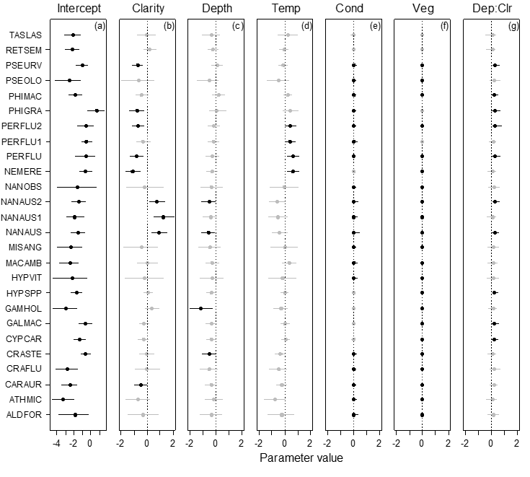

Figure 4. Posterior summaries of species-specific parameters of the capture probability sub- model. The points represent the parameter point estimates (mean of the posterior distribution) and the error bars represent the 95% Bayesian credible intervals. Points and error bars in black indicate that the covariate effect was statistically different at an α = 0.05 level. Points and error bars in grey are not statistically different than zero. Panel (a) is the intercept of the model, representing the average species-specific capture probability on the logit scale. Panel

* + 1. through (g) are the covariates with potential influence on capture probability. The covariates are water clarity (b), water depth (c), water temperature (d), electrical conductivity (e), percent coverage of aquatic plants (f), and an interaction between the influence of water depth and clarity (g).

The strongest determinant of variation in relative abundance in space and among fish species was pH (Table 5). Depth and aquatic plant cover (% Vegetation) appeared to have no influence on relative abundance across species. Water clarity, depth and temperature were important determinants of species-specific capture probability, and their influence varies across species. Conductivity and aquatic plant cover have little influence on capture probability using fyke nets.

Table 5. Model selection results. The posterior probability that the parameter in the far-left column is equal to zero (3rd column), non- zero but invariant among species (4th column), or a species-specific random effect (5th column).

|  |  |  |  |  |
| --- | --- | --- | --- | --- |
| Parameter | Covariate description | Zero  𝛽𝑘,𝑗 = 0 | Invariant  𝛽𝑘,𝑗 = 𝜇𝑘 | Species-specific  𝛽𝑘,𝑗 = 𝑁(𝜇𝜅, 𝜎𝑘) |
| Abundance model | | | | |
| 𝛽2,𝑗 | Depth | 0.88 | 0.10 | 0.02 |
| 𝛽3,𝑗 | % Vegetation | 0.95 | 0.04 | 0.01 |
| 𝛽4,𝑗 | pH | 0.00 | 0.00 | 1.00 |
| Detection model | | | | |
| 𝜂2,𝑗 | Clarity | 0.00 | 0.00 | 1.00 |
| 𝜂3,𝑗 | Depth | 0.00 | 0.05 | 0.94 |
| 𝜂4,𝑗 | Temperature | 0.00 | 0.00 | 1.00 |
| 𝜂5,𝑗 | Conductivity | 0.85 | 0.09 | 0.06 |
| 𝜂6,𝑗 | % Vegetation | 0.94 | 0.04 | 0.01 |
| 𝜂7,𝑗 | Depth:Clarity | 0.00 | 0.52 | 0.48 |

Yarra Pygmy Perch

The modelled data estimates a non-zero probability that Yarra Pygmy Perch was present at the survey sites despite being undetected. This non-zero value results because fish sampling is imperfect and it is virtually impossible to eliminate the possibility that a species is present but undetected. However, the estimated occurrence probability across the 32 sites surveyed in this study was 1% (parameter value 0.0113). This equates to a probability of extirpation across these sites of 99%, thereby strongly supporting the hypothesis of local extirpation.

## Discussion

The objective of this study was to assess the status of Yarra Pygmy Perch in the MDB. The species has only been identified from Lake Alexandrina, with no records from upstream of the River Murray confluence (Hammer et al. 2009; Lintermans 2007). Therefore, the current study targeted sites within this contemporary range; either where it was relatively abundant in the early 2000s, was reintroduced, or where habitat appeared suitable (Appendix 1). Yarra Pygmy Perch was not detected in the current study. The replicate survey design enabled assessment using probability of detection to account for the likelihood of false absences at sites. The modelling results show there was low probability that Yarra Pygmy Perch was present at the 32 sites surveyed in this study.

Data from the detected fish species was used to predict variables that help define the population status of Yarra Pygmy Perch, despite it being undetected in the study. The models highlight two important factors regarding Yarra Pygmy Perch. First, modelling estimated that the species has the lowest relative abundance (i.e. close to zero) and is therefore the rarest fish in the assemblage. Second, modelling estimated the probability that Yarra Pygmy Perch occupied any of the 32 sites surveyed in November–December 2018 was only 1%, thereby indicating only a minor chance the species was missed in the surveys. Therefore, the study provides strong evidence that Yarra Pygmy Perch is currently absent in the MDB or, at best, extremely rare and close to extirpation.

Recent data regarding the closely related Southern Pygmy Perch provided guidance for selecting the sampling methods and also for assessing the population status of Yarra Pygmy Perch. The pygmy perches were extirpated from Lake Alexandrina during the Millennium Drought (Wedderburn et al. 2014). They were reintroduced to the Hindmarsh Island region in 2011 and 2012 (Bice et al. 2014). The distribution and abundance of Southern Pygmy Perch has increased in recent years, suggesting early success of the reintroduction program (Wedderburn and Barnes 2018). Also, natural recolonisation is apparent in wetlands where Tookayerta Creek meets the Finniss River, probably due to fish immigrating from the Tookayerta catchment where the species is more prevalent (Whiterod et al. 2015). Conversely, there is no evidence that Yarra Pygmy Perch has recovered. Data from the current survey has, however, provided an adequate assessment of the status of Yarra Pygmy Perch through the use of statistical models.

Some of the findings for Southern Pygmy Perch are relevant to Yarra Pygmy Perch given their close taxonomic relationship, and similarities in size and habitat preferences (Lintermans 2007). Findings of the current study show Southern Pygmy Perch is relatively abundant at several sites, although it is a relatively rare species overall. Some sites held the first records of Southern Pygmy Perch since the drought. Notably, there is consistency between the estimated occupancy in the current survey of 32 sites (0.51 ±0.02) and the 17 sites surveyed only twice in March 2018 condition monitoring (0.53 ±0.15: Wedderburn and Barnes 2018). There are seasonal differences between the monitoring events to consider, yet the findings at least demonstrate the improved accuracy (i.e. lower standard error in the current study) gained from additional sites and replicate surveys which should be considered in future monitoring of threatened small-bodied fish populations including Yarra Pygmy Perch.

Unexpectedly, there is a significant relationship for Southern Pygmy Perch where pH is the strongest predictor of its abundance. Indeed, pH was the strongest determinant of variation in relative abundance for most fish species in the assemblage. It is unlikely

that the presence and abundance of Southern Pygmy Perch, or other fishes, is directly influenced by pH because values (7.4-8.9) were always within the normal range of tolerance. Therefore, pH could have some bearing on other variables that influence where Southern Pygmy Perch inhabits – possibly prey abundances, for example, given that pH plays a key role in structuring zooplankton assemblages (Yin and Niu 2008). During the final attempt to reintroduce Yarra Pygmy Perch in November 2015, a TLM intervention monitoring project identified cladocerans as a key prey item (Wedderburn et al. 2016). It may be that cladocerans are more abundant at lower pH and therefore encourage the presence of pygmy perch (cf. Locke and Sprules 1993; Potts and Fryer 1979; Yan et al. 2008). The hypothesis that the presence and abundance of the pygmy perches is indirectly influenced by the effect of pH on prey availability is worthy of testing given that hydrological management of Lake Alexandrina may influence the habitat variable.

A comparison of YOY and adult Southern Pygmy Perch in this study suggests some differences. It is expected that YOY Southern Pygmy Perch have at least equal levels of occupancy and are present in higher abundances than adult fish in November and December soon after the breeding season. The average estimated occupancy, however, is lower for YOY yet probability of detection is comparable with adult fish. Apart from site 6 (isolated wetland due to a blocked culvert) where hundreds of YOY Southern Pygmy Perch were captured, there were very few YOY fish detected at sites. The observations suggest there may be limitations to recruitment across most of the study region. The most likely explanation is that when other fishes are present the increases in competition and predation impact on recruitment. This is an important factor requiring further investigation because it is likely the same applies to Yarra Pygmy Perch, and may be a factor contributing to failed reintroduction attempts.

Interactions with invasive species can hinder the recovery of some fishes (Wilson et al. 2008). One factor that may be manageable for reintroductions and population recovery of the pygmy perches is the presence and abundance of piscivorous Redfin Perch. A study undertaken in Lake Alexandrina in 2011 showed that Redfin Perch switched their diet to piscivory when they reached approximately 90-mm long or 6-months of age, and small-bodied native fishes were a major prey item (Wedderburn and Barnes 2016b). There were two distinct cohorts recorded in the current study, and the larger piscivorous Redfin Perch had one of the highest relative abundances in the fish assemblage. Opportunistic observations of this fish group during the survey revealed native fish were regularly consumed, although possibly while trapped in a fyke net. There appears to be enough evidence from the current study and other publications to suggest that Redfin Perch will inhibit the recovery of Yarra Pygmy Perch. This is likely to occur through direct predation of predator-naïve fish soon after reintroduction, and by predation on YOY fish which will impact on recruitment success.

Murray Hardyhead is another of the Big (Little) Four threatened fishes detected in the current survey which provided some information about its occupancy, probability of detection and habitat preferences. The abundance of Murray Hardyhead increased in the Lake Alexandrina region between 2011 and 2016 following the Millennium Drought (Wedderburn and Barnes 2016a). Its abundance in more recent condition monitoring suggests numbers are declining while occupancy remains consistent. The average estimated occupancy in the current study (0.40 ±0.03) is similar to the March 2018 condition monitoring assessment (0.45 ±0.32: Wedderburn and Barnes 2018). The low relative abundance of Murray Hardyhead suggest it is a rare fish in the assemblage.

There was no significant relationship between the abundance of Murray Hardyhead and habitat variables in the current study. The results for estimated relative abundance and detection probability of Murray hardyhead, however, should be examined further. Specifically, Wedderburn (2018) demonstrates that fyke nets are less effective for surveys of Murray Hardyhead than seine netting therefore habitat relationships may be better revealed with more accurate readings for the threatened species.

## Management recommendations

Yarra Pygmy Perch faces an uncertain future in the MDB. The most pressing need is to establish self-sustaining populations in its former habitats, and a number of suitable sites were identified in the current study. Threatened fish that have been extirpated have the capacity for population recovery through translocations that enable recolonisation (Kiernan et al. 2012). This is only possible if there is backup capacity (i.e. captive facilities and surrogate refuge populations) remaining that can be used in a reintroduction program (Lintermans 2013). The results of the current study indicate that population recovery of Yarra Pygmy Perch in the MDB relies heavily on careful management of the remaining captive fish for future reintroductions. The window of opportunity is closing, however, due to biological and genetic issues associated with maintaining Yarra Pygmy Perch in captive facilities and surrogate refuges for the last several years (Whiterod 2019). For example, the current stocks are derived from only 200 fish collected from the wild in 2007, so inbreeding depression may be impacting on fecundity. Further, several of the surrogate populations (e.g. in farm dams) have been lost for unknown reasons. Small-scale emergency works have been instigated to secure backup capacity through the Big (Little) Four working group. A recent translocation strategy for Yarra Pygmy Perch and other threatened small-bodied fishes of the region provides guidance for managing the currently held assets, establishing a breeding and reintroduction program, and monitoring and evaluation (Whiterod 2019). A long-term commitment to the translocation strategy, along with consideration of management interventions, such as actively managing water levels, alien species control (especially Redfin Perch: Gwinn and Ingram 2018) and habitat enhancement will be necessary.

## References

Aarts, B. G. W., F. W. B. Van den Brink and P. H. Nienhuis, 2004. Habitat loss as the main cause of the slow recovery of fish faunas of regulated large rivers in Europe: the transversal floodplain gradient. River Research and Applications 20:3–23.

Bice, C., N. Whiterod and B. Zampatti, 2014. The Critical Fish Habitat Project: Assessment of reintroduction success of threatened species in the Coorong, Lower Lakes and Murray Mouth region 2011‒2014. SARDI Aquatic Sciences, Adelaide, 39.

Bice, C., P. Wilson and Q. Ye, 2008. Threatened fish populations in the Lower Lakes of the River Murray in spring 2007 and summer 2008. SARDI Aquatic Sciences, Adelaide, 31.

Bice, C. M., M. S. Gibbs, N. N. Kilsby, M. Mallen-Cooper and B. P. Zampatti, 2017. Putting the “river” back into the lower River Murray: quantifying the hydraulic impact of river regulation to guide ecological restoration. Transactions of the Royal Society of South Australia 141:108–131.

Bice, C. M. and Q. Ye, 2007. Monitoring threatened fish communities on Hindmarsh Island, in the Lower Lakes of the River Murray, South Australia, in the summers of 2006 and 2007 with reference to baseline data from 2005. SARDI Aquatic Sciences, Adelaide, 47.

Brauer, C. J., P. J. Unmack, M. P. Hammer, M. Adams and L. B. Beheregaray, 2013. Catchment-scale conservation units identified for the threatened Yarra pygmy perch (*Nannoperca obscura*) in highly modified river systems. PLoS One 8:e82953.

Broms, K. M., M. B. Hooten and R. M. Fitzpatrick, 2016. Model selection and assessment for multi-species occupancy models. Ecology 97:1759–1770.

Chessman, B. C., 2013. Identifying species at risk from climate change: Traits predict the drought vulnerability of freshwater fishes. Biological Conservation 160:40–49.

Darwall, W. and J. Freyhof, 2016. Lost fishes, who is counting? The extent of the threat to freshwater fish biodiversity. In Closs, G., M. Krkosek & J. Olden (eds) Conservation of freshwater fishes. Cambridge University Press, Cambridge, 1–36.

Devictor, V., J. Clavel, R. Julliard, S. Lavergne, D. Mouillot, W. Thuiller, P. Venail, S. Villéger and N. Mouquet, 2010. Defining and measuring ecological specialization. Journal of Applied Ecology 47:15–25.

Dudley, R. K. and S. P. Platania, 2007. Flow regulation and fragmentation imperil pelagic-spawning riverine fishes. Ecological Applications 17:2074–2086.

Fratto, Z. W., V. A. Barko and J. S. Scheibe, 2008. Development and efficacy of a bycatch reduction device for Wisconsin-type fyke nets deployed in freshwater systems. Chelonian Conservation and Biology 7:205–212.

Geddes, M. C., R. J. Shiel and J. Francis, 2016. Zooplankton in the Murray estuary and Coorong during flow and no-flow periods. Transactions of the Royal Society of South Australia 140:74–89.

George, E. I. and R. E. McCollock, 1993. Variable selection via Gibbs sampling. Journal of the American Statistical Association 88:881–889.

Guillera-Arroita, G., M. S. Ridout and B. J. T. Morgan, 2010. Design of occupancy studies with imperfect detection. Methods in Ecology and Evolution 1:131–139.

Gwinn, D. C. and B. A. Ingram, 2018. Optimising fishery characteristics through control of an invasive species: strategies for redfin perch control in Lake Purrumete, Australia. Marine and Freshwater Research 69:1333-1345.

Hammer, M., S. Wedderburn and J. van Weenan, 2009. Action Plan for South Australian Freshwater Fishes. Native Fish Australia (SA), Adelaide.

Hammer, M., S. Wedderburn and S. Westergaard, 2002. Freshwater fishes. In Brandle,

R. (ed) A Biological Survey of the Murray Mouth Reserves, South Australia. Department for Environment and Heritage, Adelaide, 54–61.

Hammer, M. P., M. Adams and R. Foster, 2012. Update to the catalogue of South Australian freshwater fishes (Petromyzontida & Actinopterygii). Zootaxa 3593:59–74.

Hammer, M. P., C. M. Bice, A. Hall, A. Frears, A. Watt, N. S. Whiterod, L. B. Beheregaray,

J. O. Harris and B. P. Zampatti, 2013. Freshwater fish conservation in the face of critical water shortages in the southern Murray–Darling Basin, Australia. Marine and Freshwater Research 64:807–821.

Hammer, M. P., P. J. Unmack, M. Adams, J. B. Johnson and K. F. Walker, 2010. Phylogeographic structure in the threatened Yarra pygmy perch *Nannoperca obscura* (Teleostei: Percichthyidae) has major implications for declining populations. Conservation Genetics 11:213–223.

Higham, J., Q. Ye and B. Smith, 2005. Murray-Darling Basin Drought Monitoring: Monitoring Small Bodied Fish in the Lower Murray During and After Drought Conditions in 2003-2004. SARDI Aquatic Sciences, Adelaide, 40.

Hooten, M. B. and N. T. Hobbs, 2015. A guide to Bayesian model selection for ecologists. Ecological Monographs 85:3–28.

Kéry, M., 2010. Introduction to WinBUGS for ecologists: Bayesian approach to regression, ANOVA, mixed models and related analyses. Elsevier, Oxford.

Kiernan, J. D., P. B. Moyle and P. K. Crain, 2012. Restoring native fish assemblages to a regulated California stream using the natural flow regime concept. Ecological Applications 22:1472–1482.

Kingsford, R., K. Walker, R. Lester, P. Fairweather, J. Sammut and M. Geddes, 2011. A Ramsar wetland in crisis - the Coorong, Lower Lakes and Murray Mouth, Australia. Marine and Freshwater Research 62:255–265.

Leblanc, M., S. Tweed, A. Van Dijk and B. Timbal, 2012. A review of historic and future hydrological changes in the Murray-Darling Basin. Global and Planetary Change 80– 81:226–246.

Lévêque, C., T. Oberdorff, D. Paugy, M. L. J. Stiassny and P. A. Tedesco, 2008. Global diversity of fish (Pisces) in freshwater. Hydrobiologia 595:545–567.

Lintermans, M., 2007. Fishes of the Murray–Darling Basin: An Introductory Guide, MDBC Publication No. 10/07 edn. Murray–Darling Basin Commission, Canberra.

Lintermans, M., 2013. A review of on-ground recovery actions for threatened freshwater fish in Australia. Marine and Freshwater Research 64:775–791.

Lloyd, L. N. and K. F. Walker, 1986. Distribution and conservation status of small freshwater fish in the River Murray, South Australia. Transactions of the Royal Society of South Australia 110:49–57.

Locke, A. and W. G. Sprules, 1993. Effects of experimental acidification on zooplankton population and community dynamics. Canadian Journal of Fisheries and Aquatic Science 50:1238-1247.

MacKenzie, D. I., J. D. Nichols, J. E. Hines, M. E. Knutson and A. B. Franklin, 2003. Estimating site occupancy, colonization, and local extinction when a species is detected imperfectly. Ecology 84:2200–2207.

Mackenzie, D. I., J. D. Nichols, J. A. Royle, K. H. Pollock, L. L. Bailey and J. E. Hines, 2018. Occupancy estimation and modeling: Inferring patterns and dynamics of species occurence, 2nd edn. Elsevier Academic Press, New York.

Matthews, W. J. and E. Marsh-Matthews, 2003. Effects of drought on fish across axes of space, time and ecological complexity. Freshwater Biology 48:1232–1253.

Morrongiello, J. R., S. J. Beatty, J. C. Bennett, D. A. Crook, D. N. E. N. Ikedife, M. J. Kennard, A. Kerezsy, M. Lintermans, D. G. McNeil, B. J. Pusey and T. Rayner, 2011. Climate change and its implications for Australia’s freshwater fish. Marine and Freshwater Research 62:1082-1098.

Mosley, L., Q. Ye, S. Shepherd, S. Hemming and R. Fitzpatrick (eds), 2018. Natural History of the Coorong, Lower Lakes, and Murray Mouth Region (Yarluwar-Ruwe). Royal Society of South Australia Inc. and University of Adelaide Press, Adelaide.

Nicol, J. M. and G. G. Ganf, 2017. A botanical, ecological and hydrological contribution to understanding the Lower River Murray and beyond. Transactions of the Royal Society of South Australia 141:92–107.

O’Hara, R. B. and M. J. Sillanpaa, 2009. A review of Bayesian variable selection methods: what, how and which. Bayesian Analysis 4:85–118.

Pool, T. K. and J. D. Olden, 2015. Assessing long-term fish responses and short-term solutions to flow regulation in a dryland river basin. Ecology of Freshwater Fish 24:56– 66.

Potts, W. T. W. and G. Fryer, 1979. The Effects of pH and Salt Content on Sodium Balance in *Daphina magna* and *Acantholeberis curvirostris* (Crustacea: Cladocera). Journal of Comparative Physiology 129:289–294.

Puckridge, J. T., F. Sheldon, K. F. Walker and A. J. Boulton, 1998. Flow variability and the ecology of large rivers. Marine and Freshwater Research 49:55–72.

Robinson, S. J., N. J. Souter, N. G. Bean, J. V. Ross, R. M. Thompson and K. T. Bjornsson, 2015. Statistical description of wetland hydrological connectivity to the River Murray in South Australia under both natural and regulated conditions. Journal of Hydrology 531:929–939.

Robinson, W. A., 2015. The Living Murray Condition Monitoring Plan Refinement Project: Summary Report. Charles Sturt University, 95.

Royle, J. A. and J. D. Nichols, 2003. Estimating abundance from repeated presence– absence data or point counts. Ecology 84:777–790.

Saddlier, S., J. Koehn and M. Hammer, 2013. Let's not forget the small fishes: conservation of two threatened species of pygmy perch in south-eastern Australia. Marine and Freshwater Research 64:874–886.

Tenan, S., R. B. O’Hara, I. Hendriks and G. Tavecchia, 2014. Bayesian model selection: The steepest mountain to climb. Ecological Modelling 283:62–69.

Wager, R. and P. Jackson, 1993. The Action Plan for Australian Freshwater Fishes. Australian Nature Conservation Agency, Canberra.

Walker, K. F., 2006. Serial weirs, cumulative effects: the Lower River Murray, Australia. In Kingsford, R. (ed) The ecology of desert rivers. Cambridge University Press, Cambridge, 248–279.

Walker, K. F., T. A. Corbin, C. R. Cummings, M. C. Geddes, P. M. Goonan, M. J. Kokkin,

R. E. Lester, C. P. Madden, P. K. McEvoy, N. Whiterod and S. Zukowski, 2018. Freshwater Macro-Invertebrates. In Mosley, L., Q. Ye, S. Shepherd, S. Hemming & R. Fitzpatrick (eds) Natural History of the Coorong, Lower Lakes, and Murray Mouth Region (Yarluwar-Ruwe). Royal Society of South Australia, Adelaide, 349–370.

Walker, K. F. and M. C. Thoms, 1993. Environmental effects of flow regulation on the Lower River Murray, Australia. Regulated Rivers: Research and Management 8:103– 119.

Wedderburn, S. and T. Barnes, 2016a. Condition Monitoring of Threatened Fish Populations in Lake Alexandrina and Lake Albert. The University of Adelaide, Adelaide.

Wedderburn, S. and T. Barnes, 2017. Condition Monitoring of Threatened Fish Populations in Lake Alexandrina and Lake Albert. The University of Adelaide, Adelaide.

Wedderburn, S. and T. Barnes, 2018. Condition Monitoring of Threatened Fish Populations in Lake Alexandrina and Lake Albert. The Univeristy of Adelaide, Adelaide.

Wedderburn, S. and M. Hammer, 2003. The Lower Lakes Fish Inventory: Distribution and Conservation of Freshwater Fishes of the Ramsar Convention Wetland at the Terminus of the Murray Darling Basin, South Australia. Native Fish Australia (SA), Adelaide, 38.

Wedderburn, S. D., 2018. Multi-species monitoring of rare wetland fishes should account for imperfect detection of sampling devices. Wetlands Ecology and Management 26:1107–1120.

Wedderburn, S. D. and T. C. Barnes, 2016b. Piscivory by alien redfin perch (*Perca fluviatilis*) begins earlier than anticipated in two contrasting habitats of Lake Alexandrina, South Australia. Australian Journal of Zoology 64:1–7.

Wedderburn, S. D., T. C. Barnes and K. A. Hillyard, 2014. Shifts in fish assemblages indicate failed recovery of threatened species following prolonged drought in terminating lakes of the Murray–Darling Basin, Australia. Hydrobiologia 730:179–190.

Wedderburn, S. D., M. P. Hammer, C. M. Bice, L. N. Lloyd, N. S. Whiterod and B. P. Zampatti, 2017a. Flow regulation simplifies a lowland fish assemblage in the Lower River Murray, South Australia. Transactions of the Royal Society of South Australia 141:169– 192.

Wedderburn, S., J. Nicol and R. Shiel, 2017b. Assessing Obligate Habitat of Threatened Pygmy Perches in Lake Alexandrina. The University of Adelaide, Adelaide.

Wedderburn, S. D., R. J. Shiel and T. C. Barnes, 2016. Ecological responses to a managed watering event coinciding with restocking of Yarra pygmy perch. The University of Adelaide, Adelaide.

Whiterod, N., 2019. A translocation strategy to ensure the long-term future for threatened small-bodied freshwater fishes in the South Australian section of the Murray- Darling Basin. A report to Natural Resources, SA Murray-Darling Basin, Goolwa Beach.

Whiterod, N. S., M. P. Hammer and L. Vilizzi, 2015. Spatial and temporal variability in fish community structure in Mediterranean climate temporary streams. Fundamental and Applied Limnology 187/2:135–150.

Wilson, S. K., S. C. Burgess, A. J. Cheal, M. Emslie, R. N. Fisher, I. Miller, N. V. C. Poluniun and P. A. Sweatman, 2008. Habitat utilization by coral reef fish: implications for specialists vs. generalists in a changing environment. Journal of Animal Ecology 77:220–228.

Yan, N. D., K. M. Somers, R. E. Girard, A. M. Paterson, W. Keller, C. W. Ramcharan, J.

A. Rusak, R. Ingram, G. E. Morgan and J. M. Gunn, 2008. Long-term trends in zooplankton of Dorset, Antario, lakes: the probable interactive effects of changes in pH, total phosophorous, dissolved organinc carbon, and predators. Canadian Journal of Fisheries and Aquatic Science 65:862–877.

Ye, Q. and M. Hammer, 2009. Fishes. In Jennings, J. T. (ed) Natural History of the Riverland and Murraylands. Royal Society of South Australia, Adelaide, 334–352.

Yin, X. W. and C. J. Niu, 2008. Effect of pH on survival, reproduction, egg viability and growth rate of five closely related rotifer species. Aquatic Ecology 42:607–616.

## Appendix 1 Some previous records of Yarra Pygmy Perch

Numbers of Yarra Pygmy Perch recorded in some earlier surveys prior to population decline during drought and following reintroductions after the drought.

|  |  |  |  |
| --- | --- | --- | --- |
| **Current site number** | **Previous site number** | **Date recorded** | **Abundance** |
| 1 | 1A | October 2007 | 1 |
| 1 | 1A | February 2008 | 12 |
| 2 | 2B | February 2005 | 1 |
| 2 | 2B | February 2006 | 8 |
| 3 | ML03-64C | July 2003 | 2 |
| 3 | 6B | February 2005 | 11 |
| 3 | 6B | February 2007 | 20 |
| 4 | ML03-02C | January 2003 | 24 |
| 5 | 5D | November 2012 | 1* |
| 5 | 5E | November 2015 | 2* |
| 6 | 4B | February 2005 | 13 |
| 6 | 4B | February 2006 | 66 |
| 6 | ML03-06C | January 2003 | 25 |
| 6 | ML03-06C | July 2003 | 7 |
| 7 | 5B | February 2007 | 1 |
| 7 | ML03-07C | January 2003 | 35 |
| 10 | ML03-03C | January 2003 | 200 |
| 20 | 68E | November 2015 | 1* |
| 21 | 11B | February 2005 | 4 |
| 21 | ML03-11C | July 2003 | 4 |
| 25 | 34D | April 2014 | 1* |
| 25 | 34E | November 2015 | 3* |
| 31 | ML03-04C | January 2003 | 5 |
| 31 | ML03-04C | July 2003 | 1 |

A(Bice and Ye 2007); B(Bice et al. 2008); C(Higham et al. 2005); D(Bice et al. 2014);

E(Wedderburn et al. 2016); *recorded following reintroductions.

## Appendix 2 Model fitting methods

#### Model fitting methods for multi-taxa model

The posterior distributions of all parameters were estimated using a Gibbs sampler implemented in JAGS (Plummer 2003). We called JAGS from program R (R Core Team 2015) using the library R2jags (Su and Yajima 2015). All prior distributions of logit- scale effect parameters (*μ1*-*μ5*) were specified as diffuse normal distributions. Priors for precision parameters (*σ1*-*σ5*) were specified as uniform distributions with a range between 0.01 and 100 and were verified to not influence the range of posterior distributions. Inference was drawn from 10,000 posterior samples taken from two chains of 106 samples thinned to every 100. We discarded the first 500,000 values of each chain to remove the effects of initial values. Convergence was diagnosed for each model by visual inspection of the MCMC chains for adequate mixing and stationarity and by using the Gelman-Rubin statistic (with values < 1.1 indicating convergence; Kery 2010, Gelmin et al., 2004).

#### References

Dorazio, R.M., N. J. Gotelli, and A.M. Ellison. 2011. Modern methods of estimating biodiversity from presence absence surveys. Biodiversity loss in a changing planet (eds

O. Grillo and G. Venora). InTeck, Rijeka Croatia.

Plummer, M. 2003. JAGS: a program for analysis of Bayesian graphical models using Gibbs sampling. In: Proceedings of the 3rd International Workshop on Distributed Statistical computing (DSC 2003). March, pp. 20-22.

R Core Team 2015. R: A language and environment for statistical computing. R Foundation for Statistical Computing, Vienna, Austria. URL [http://www.R-project.org/.](http://www.R-project.org/)

Su, Y. S., and M. Yajima. 2015. R2jags: Using R to Run 'JAGS'. R package version 0.5-

6. [http://CRAN.R-project.org/package=R2jags](http://CRAN.R-project.org/package%3DR2jags)

Gelman A., J.B. Carlin, H.S. Stern, and D.B. Rubin. 2004. Bayesian Data Analysis. Boca Raton: Chapman and Hall.

Kery M. 2010. Introduction to WinBUGS for Ecologists: Bayesian approach to regression, ANOVA, mixed models and related analyses: Academic Press. 320 p.