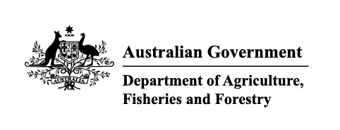

# Instrument revoking a holding order under section 15(2) of the *Imported Food Control Act 1992*

The listed holding orders, having satisfied the circumstances under which the orders will be revoked, are revoked under section 15(2) of the Imported Food Control Act 1992 (the Act).

The circumstances being that the Secretary or delegate is satisfied that the basis for the order no longer applies.

| Holding order number | Date revoked |
| --- | --- |
| 18314 | 1/12/2023 |
| 16765 | 1/12/2023 |
| 18859 | 4/12/2023 |
| 15133 | 7/12/2023 |
| 18580 | 7/12/2023 |
| 18705 | 7/12/2023 |
| 18605 | 7/12/2023 |
| 18655 | 7/12/2023 |
| 17846 | 7/12/2023 |
| 18088 | 7/12/2023 |
| 18195 | 7/12/2023 |
| 18194 | 7/12/2023 |
| 18238 | 7/12/2023 |
| 18307 | 22/12/2023 |
| 18273 | 22/12/2023 |
| 18563 | 22/12/2023 |
| 18573 | 22/12/2023 |
| 18625 | 22/12/2023 |
| 18246 | 22/12/2023 |

| Delegate position number | Date |
| --- | --- |
| 100091 | 29/01/2024 |

Delegate of the secretary for the purposes of section 15(2) of the Act*.*