

**Meeting 95**

**AGENDA**

**6 July 2023
  
9:30am – 1:00pm
  
Department of Agriculture, Fisheries and Forestry,
  
Agriculture House
  
70 Northbourne Avenue, Canberra City
  
Room: 02.022 Tiger Orchid**

|  |  |  |  |  |
| --- | --- | --- | --- | --- |
| **#** | **Item** | **Lead/s** | **Timing** | **Papers** |
|  | **Welcome and introductions.**  1. Chair’s opening remarks | Chair | 9.30am – 10:00am | No |
|  | **Minutes and Actions – DCCC Mtg 94, 6 April 2023** | Chair | 10.00am – 10.05am | Yes |
|  | **Items for discussion**  1. Sustainable biosecurity funding prioritisation  2. Biosecurity Cost Recovery Arrangements: status - next steps | Colin Hunter  Paul Douglas | 10.05am – 10:35am  10:35am – 11:05am |  |
| **Short break: 11.05am – 11.15am** | | | | |
| 3. | **Items for discussion cont...**  **3.** STEPS (Simplified Targeting and Enhanced Processing System) | Tina Hutchison | 11.15am – 11:50am |  |
| 4. | **Industry Information Exchange** | DCCC members | 11:50pm – 12:20pm | No |
| 5. | **Updates for noting (discussion by exception)**  **1. Reform**   1. National Biosecurity Strategy – 2023 Action Plan & progress 2. Biosecurity Trusted Importer Program Update (Green Lane) 3. Biosecurity Portal 4. AA 14.4 Rural Tailgate Inspections - update 5. AEPCOMM update   **2. Legislation**  a. Amendments to the *Biosecurity Act 2015*  **3. Specific issues**  a. BMSB  **4. Enforcement**   1. Compliance activities snapshot 2. Audits - Cargo pathway snapshot, analysis and findings |  | 12:20pm – 12:50pm | Yes |
| 6. | **Other Business**  1. Closing remarks; next meeting | Chair | 12:50pm – 1:00pm | No |

Teams Meeting
  
**Click here to join the meeting
  
Join with a video conferencing device** [- 597361658@t.plcm.vc](mailto:-_597361658@t.plcm.vc) - Video Conference ID: 133 680 363 3
  
**Or call in (audio only)** +61 2 7208 4605, 779780074# Australia, Sydney Phone Conference ID: 779 780 074#

**Attendees:**

**Departmental**

Chair, Tina Hutchison, First Assistant Secretary (In person) Biosecurity Operations Division (BOD)

Peta Lane, First Assistant Secretary Biosecurity Strategy and Reform Division (BSRD)

Peter Timson, First Assistant Secretary Compliance and Enforcement Division (CED)

Colin Hunter, First Assistant Secretary (guest, item 3.1) Biosecurity Funding Sustainability

Therese Hemmingsen, Assistant Secretary (item 3.1) Biosecurity Funding Sustainability

Jo Laduzko, Assistant Secretary (in person) Pathway Policy Cargo and Conveyances/BOD

Holly Buckle, Assistant Secretary (in person) Cargo Operations (VIC, SA, WA, TAS)/BOD

Andrew Patterson, Assistant Secretary (in person) Cargo Operations (NSW, QLD, NT, ACT) Regulatory Assurance/BOD

Brett Liebich, Assistant Secretary (V) Operational Intelligence and Coordination/CED

Bryan Downie, Assistant Secretary (V) Investigations/CED

Rose Cracknell, (in person) (guest item 5) Risk, Intelligence and Strategy/BSRD

Duane Roberts, Director (guest, item 3.2) (in person) Cost Recovery/BOD

Paul Douglas, Director (guest, item 3.2) (in person) Cost Recovery Biosecurity/Funding and Revenue/ESG

Caroline Gibson, Assistant Secretary (V) (guest item 5) Compliance Control and Strategy/CED

Richard Keane, Principal Director (V) (guest item 5) Innovation Legislation and Engagement/BSRD

**Industry**

Dianne Tipping (in person) Export Council of Australia

Carolyn Macgill (in person) Food and Beverage Importers Association

Bradley Leonard (in person) International Forwarders and Custom Brokers Association of Australia

Michael Gallacher (in person) Ports Australia

Paul Bagnall (V) Conference of Asia Pacific Express Carriers

Greg Carroll (V) Australia Post

Tony McDonald Federal Chambers of Automotive Industries

Scott Carson (V) International Forwarders and Custom Brokers Association of Australia

Sal Milici (V) Freight and Trade Alliance

Peter Van Duyn (V) International Cargo Handling Coordination Association

Melwyn Noronha (apology) Shipping Australia Limited

**Secretariat**

Angela Cressy Industry Partnerships and Engagement/BOD

Page 2 | 2



**DCCC Meeting 94 – 6th April 2023
  
MEETING MINUTES**

**9:30am – 1:00pm**

**Department of Agriculture, Fisheries and Forestry,
  
CQ2 Building, 70 Northbourne Avenue, Canberra City
  
Room: CQ2 02.037 Scribbly Gum
  
*Microsoft Teams Meeting\***

**Departmental Attendees:**

Chair, Tina Hutchison, First Assistant Secretary Biosecurity Operations Division (BOD)

Peta Lane, First Assistant Secretary (11.30am – 1pm) Biosecurity Strategy and Reform Division (BSRD)

Rose Cracknell, A/g Assistant Secretary Cargo & Conveyances Policy and Detection

Capability / BOD

Lee Cale, Assistant Secretary Cargo Operations (VIC, SA, WA, TAS) / BOD

Andrew Patterson, Assistant Secretary Cargo Operations (NSW, QLD, NT, ACT) and

Regulatory Assurance/BOD

Matthew Campbell, Assistant Secretary Audit and Assurance/CED

Caroline Gibson, Assistant Secretary Compliance Controls and Strategy/CED

Anna Brezzo, Assistant Secretary Investigations/CED

Rachel Short, Assistant Secretary Funding and Revenue/Finance and Investment (F&I)

Paul Douglas, Director (guest, Item 3.1) Cost Recovery Biosecurity/Funding and Revenue/F&I

Ben Rowntree, Director Sea Cargo Policy/ Cargo and Conveyances Policy and

Detection Capability/BOD

Duane Roberts, Director Cost recovery/BOD

**Industry Attendees:**

Greg Carroll Australia Post

Dianne Tipping Export Council of Australia

Tony McDonald Federal Chambers of Automotive Industries

Carolyn Macgill Food and Beverage Importers Association

Sal Milici Freight and Trade Alliance

Melwyn Noronha Shipping Australia Limited

Paul Bagnall Conference of Asia Pacific Express Carriers

Paul Damkjaer International Forwarders & Customs Brokers Assoc. of Australia

Bradley Leonard International Forwarders & Customs Brokers Assoc. of Australia

**Observer:**

Craig Birchall Qantas Airways Ltd

**Apologies:**

Peter Timson, First Assistant Secretary Compliance and Enforcement Division (CED)

Michael Gallacher Ports Australia

Peter Van Duyn International Cargo Handling Coordination Association

**Secretariat**

Hayley Goodman Branch Coordinator & Admin Assistant, Cargo & Conveyance Policy and Detection Capability /BOD

**Item 1 - Welcome and Introductions:**

Department of Agriculture, Fisheries and Forestry

Page 1 of 6



The Chair Ms Tina Hutchison, First Assistant Secretary, Biosecurity Operations Division, opened the 94th DCCC meeting by welcoming all and acknowledging country, and making a special mention of elder Wally Bell, who performed a Welcome to Country at the recent National Biosecurity Forum, and whose connection to the land goes back 35,000 years.

Chairing the meeting for the first time, Ms Hutchison acknowledged the work progressed during the tenure of the former Chair Colin Hunter and briefly summarised her experience across biosecurity system policy, reform and pathways and most recently live animal exports. Tina reiterated the importance of interconnectedness of the biosecurity system and working openly and respectfully with industry stakeholders.

The Chair then asked the committee to introduce themselves and their respective roles at the meeting in an “around the room” fashion.

**Opening remarks:** The Chair raised the difficult fiscal environment faced by the department. Two major pieces of work that are

currently underway to stabilise biosecurity funding is the cost recovery review and consultation and the longer-term development of the sustainable biosecurity funding model currently under consideration by the government.

The first is the consultation paper which is out for consultation and is about price adjustments, but we also have a plan to manage cost recovery arrangements differently in the future. The second piece of work is the longer-term Biosecurity Sustainable Funding which is currently being considered as part of the budget. Irrespective of these two significant pieces of work, the next financial year will continue to be fairly constrained so it’s important to be clear on collective priorities of the impressive array of work underway within the department. Being clear on what work will deliver best benefit for importers and effectiveness for the department. Currently there has been a significant impact on other projects such as the digital biosecurity reform work due to the focus on resources for critical programs.

Ms Macgill requested a listing of activities to feedback priorities to the department which the group agreed to provide.

• **Action Item 1** – department will provide key projects listing to DCCC members and a practical engagement process.

**Item 2 – Previous Minutes and Actions – DCCC Mtg 93, 22 November 2022:**

Members accepted the **93rd meeting minutes** as final. Members also noted the actions of previous meetings are complete, progressing or are considered a key ongoing priority.

Agreement for ongoing commitments/activities NOT to be reflected as action items but retained separately from the action items as a prioritisation.

➢ Please see attachment A - DCCC Action Register for updated item status and key prioritisation activities listing.

**Item 3 – Items for Discussion:**

**3.1 Biosecurity Cost Recovery Arrangement Review: (Rachel Short and Paul Douglas)**

Consultation paper released two weeks ago around changes to fees and charges to the biosecurity cost recovery arrangement. The online

feedback “have your say” forum has been very well utilised. The consultation paper outlines the increased cost to deliver regulatory activities, the department's cost calculation methodologies and the reasons for the proposed changes to fees and charges.

Ms Short presented a slideshow outlining the purpose of the review, the changes to the biosecurity system and how we need to afford to keep pace. It outlined the biosecurity cost recovery arrangement and stabilising the cost recovery base to continue important regulatory activities. We will brief government with the results of the consultation process and any changes to fees and charges will only occur after a decision of government and amendments to our current charging legislation. We do anticipate that prices would come into effect from 1st July subject to government decisions and then legislative process.

Mr Douglas continued the presentation by explaining that the cost recovery work forecast costs for next year and there's no sense in this in which we're trying to recover for previous years or of any loss or deficit that exists. This is purely about forecasting our costs and what does that look like in terms of managing our risks, managing the threats, what kind of capability do we need and how to build into that cost is just what we would naturally be doing anyway in terms of making things better and improving things for ourselves and for industry, but not on the scale that the biosecurity sustainable funding work would seek to do. The gap between costs and revenue in 2023-24 is forecast to be around $36.4 million.

Discussion ensued regarding two pieces of work regarding charging points and where existing gaps exist and whether we have the charges right. The department needs to identify the funding source for the work we do and the charging points we have available and forecast with industry engagement to keep it modern, useful and structured correctly. The first step is just about a price increase on the prices we currently have. Stakeholder engagement and industry input are really important, and we would be looking for that every year. One of the key things is the assumptions that we make about our projected volume and industry are best placed to tell us whether we're getting that right or wrong or if we need to adjust anything. Correct assumptions are important to our model and in

Department of Agriculture, Fisheries and Forestry

Page 2 | 6



determining those fees and charges because we really are projecting what the volumes are going to be in a in a future year. So, we will require genuine and evidenced feedback and transparency on both sides from industry and the department.

Over 60% of Biosecurity Operations Division (BOD) were cost recovered last year, and 40% appropriation funded by government which

is largely a sustainable funding conversation. Mr Douglas explained proposed volumes for key activities and the major elements of
  
forecast cost base for 2023-24, including proposed key changes that look at regulatory effort and changes in the biosecurity system.

**Key discussion points:**

* Mr Carroll questioned whether increased fees and charges would fund better biosecurity services to industry or future projects. The Chair clarified that this is a price increase to match effort with cost and that improving interactions with industry is a focused aspect of the sustainable biosecurity funding model.
* Members discussed the decisions and timing of government through the budget process and that it is unlikely to be affecting any base cost recovery fees and charges in 23/24.
* Ms Macgill questioned the frequency of review of the baseline service delivery which includes current time frames with staffing numbers which has been historically every eight years. Response clarified that it is the departments intention to conduct annual reviews including a consultation process and to apply indexation to minimise impact to industry. A more comprehensive review including a consultation process is more likely every two years.
* Mr Carroll discussed the requirement to understand the cost base built into each component of biosecurity to help industry as a collective. Chair responded that we would expect to have that information and feedback at the CRIS (Cost Recovery Implementation Statement).
* Mr Milici requested clarification that if commercial vessels come from international waters into Australia, they are only paying one arrival charge. It's not how many times you visit the ports, the charge is per ship? Chair responded that yes that is our understanding but will check and respond shortly.
* Mr Carroll requested the volume growth on the SAC pathways which Mr Douglas responded that we have historical information on SAC but not projected forecast growth as this work sits outside of biosecurity cost recovery at the moment.
* Mr Noronha asked if the department has considered the free trade agreements that Australia is signing with countries, do we anticipate any volume growth out of that? Mr Douglas responded that not principally at this time, but the team will look at this more closely to determine whether it should be.
* Discussion continued with Mr Damkjaer recommending a base formula for the funding model to which the group agreed would improve the departments transparency. Industry would see fee for service increase and therefore expect service levels to go up and we need to be very clear that these increases are just for continuation of ongoing services. It will take time to increase capability such as training new staff and upskilling to balance workload demand with workforce capacity.
* Mr Carroll asked for clarity over both inbound and outbound FID transactions and also Australia post has released their inside Australian online shopping which will alter volume growth and forecasting. Industry estimating in 2023, 1 in 3 dollars will be spent online which has potential for more biosecurity risk to enter Australia from global providers.
* Discussion about letting industry know that truth of the costs and that there will not be an immediate increase in service levels, but it is coming with workforce building capacity. Authentic and transparent communication is key.
* Ms Hutchison advised the ‘have your say’ forum will be open until the 24th of April and also there will be a “town hall” style meeting on 13th April which Lee Cale and Duane Roberts will be attending to give people an opportunity to engage with the department who may not have contact through representative bodies.
* **Action item 3.1:** Paul Douglas and Greg Carroll – to converse and align the specifics on the cost recovery base model so that it is useful for all participants, industry and department alike, in terms of terminology and transparency within a useful timeframe.
* **Action item 3.1**: Paul Douglas asked for DCCC comment as to whether the departments forecast volumes for key activities in the cost recovery model look reasonable based on industry forecasts.
* **Action item 3.1**: Paul Douglas to confirm port charge is per vessel not per port in the cost recovery document.
* **Action item 3.1:** Paul Douglas to provide information on the volume growth of the SAC pathway.
* **Action item 3.1:** Greg Carroll to connect with Duane and Paul Douglas and share the Inside Australia Online Shopping document from Australia Post.

➢ Please see attachment B - Biosecurity cost recovery arrangement review slideshow as presented in the meeting. **\*\*Break: 11:00am – 11.10am\*\***

**3.2 Document Assessment: (Lee Cale and Andrew Patterson)**

Department of Agriculture, Fisheries and Forestry

Page 3 | 6



Ms Cale reported on current assessment times for biosecurity entries which is currently 4 business days which places us 2 days over our published service level standards. Imported food entries are currently 3 business days which places us 1 day over our published service level standards. 37 imported food entries were sitting at that one day over, 400 biosecurity entries sitting at 2 days over.

During the onset of the peak season (including BMSB season), where workloads increase, additional short-term strategies were put in place in an effort to not fall behind with the anticipated increased workloads. This combined with January, which saw an unusual lull in numbers of entries lodged, resulted in an almost immediate turnaround of assessments. The removal of the short-term strategies saw a return to “normal” volumes of entries being lodged by industry. Combined with IT outages and public holidays attributed to dropping outside of the published service standards. The inability to work non cost recovered overtime then exacerbated the ability to catch up/stay within service standards. An IIAN was released reminding those industry members of the ability to request cost recovered overtime for document assessment if the wished to do so (noting budget constraints do not support working non cost recovered overtime).

Mr Patterson reported that there has been an improvement in the wait times for inspections as roughly only a third of assessments lead to an inspection. So, where the delay focus used to be on assessments, we look at the whole process and where the choke points are which throughout last year with the implementation of the scheduling system and IT systems issues, we had a different choke point but now this works a lot better, and we are finding that there is not as much of a flow on effect.

**Key discussion points:**

* Mr Leonard asked what the ratio is of fully trained staff to those with less experience. Ms Cale responded that since January last year we have recruited 70 new staff into assessments and have also lost some of our more experienced staff which are highly sought after in other areas of the department. Existing staff continue to become more competent. Assessments leadership had done an analysis to identify what critical staffing profile is needed compared with what we consider is a sustainable staffing level. This work, balanced with our budget constraints, will play out in a recruitment process. Whilst we may not be able to recruit to our preferred level, we have continued the process in readiness for the next FY budget outcomes.
* Group discussed that overtime is always subject to officer availability. Our advice to industry is if you want assessments or inspections undertaken outside of standard hours, then requests should be made early in order to finalise the workforce required. The group also discussed reasonable notification or notice to people to perform over time.
* Mr Leonard and Ms Cale advised the members the overtime email cut off requests are non-jurisdictional. So cut off is 11:00 AM in the relevant region.
* Mr Carroll asked if there was a knowledge article or website update to remind key industry of minimum documentation requirements so when there is a noncompliance, they go to the back of the queue and don’t hold up the compliant clients. Ms Cale advised that the system is not able to operate like this, but these reminders are frequent to industry members. The Chair advised she had been introduced to an information system from the biosecurity analytics centre that allows us to see how certain players are behaving in the imports system. We need to think about how we would use that information and how we can usefully get it back to the people who need it to help inform them about getting things right the first time and to free up the system for compliant parties.

**3.3 Open Discussion - DCCC meeting format:**

The Chair asked the meeting members if they are happy with the meeting rhythm, the content and that the information is worthwhile and that we're focusing on the right things. General consensus was affirmative. Mr Milici commented that special guests with timely content would be welcome. Ms Macgill commented that progress on action items with clear deliverable timeframes is important which comes down to communication.

**Item 4 – Industry Information Exchange**

**4.1 Update on the latest in shipping: (Sal M)**

The Chair introduced Mr Milici, Freight and Trade Alliance to lead the item on the latest in shipping.

* **Action item 4.1:** Secretariat to circulate supporting summary report produced by Mr Milici

➢ Please see attachment C - Shipping report summary by Mr Milici.

**Craig Birchall** – if the attendee’s want an IATA update, he will find it and circulate it.

**Tony McDonald** – From a new motor vehicles perspective we have some immediate challenges and have implemented strategies to clear the terminal of contaminated vehicles in Melbourne. Unfortunately, of course, with Melbourne being bypassed by shipping lines to a large extent now that's pushed a lot of congestion on the Port Kembla, Brisbane and Adelaide terminals. Our main focus now is on longer term offshore mitigation. Mr McDonald thanked Lee Cale and Caroline Gibson for the ongoing support.

**Paul Damkjaer** – Communication from DAFF and ABF is critical to troubleshoot problems. Ms Cale agreed and commented that industry engagement is an important part of the process but noted this issue was not a result of DAFF resourcing or process undertaken by DAFF, but rather an industry congestion problem. Contaminated vehicles are clogging up the ports/terminals and FCAI is the industry lead on this issue as the peak automotive industry body. Vehicle manufacturers are talking to us about the offshore measures they are putting in place to reduce this and we are now starting to see evidence of this working.

Department of Agriculture, Fisheries and Forestry

Page 4 | 6



**Carolyn Macgill** – Industry had a lot of questions around Operation Avoca and the potential implications for importers due to the 30 tonnes of material secured at the facility. Industry wants an outcome that is not just focused on one incident and people seem to have a mistrust of Redline and a fear of being exposed.

**Melwyn Noronha** – Shipping has learnt lessons from covid and the oversupply and overdemand. Overdemand is now starting to balance out and ships are now putting into place better biofouling management plans, and we are having constructive meetings with the department about that. We are also looking at efficiencies in how bulk inspections are undertaken. With 5600 container ships on the water, we will probably start to see some shipping lines move into scrapping or they will move into other threads.

**Item 5 - Updates for noting (discussion by exception)**3 updates were discussed by members:

**5.1a National Biosecurity Strategy – comprehensive update (Peta Lane)**

One of the pieces of work we are assisting the National Biosecurity Committee with is the strategy which was released in 2022. A National Implementation Committee (NIC) has been established to support the implementation.

The intention is to develop an annual implementation plan and action plan through the NIC and dedicated working groups. There has been a particular focus placed on strong culture and partnerships – one of the six strategy priorities and this may be an early focus of the

implementation work. We have some tight timeframes in which to deliver, which is something we have been discussing with the NIC.

**5.1e AA 14.4 Rural Tailgate Inspections**

Mr Milici raised the Class 14.4 uptake. Members noted that the uptake was at 14% and wanted to discuss how to increase the roll out.

Ms Cracknell responded with mentioning the targeted industry live event sessions that were rolled out last year as part of the taskforce and whilst uptake remains low there has been substantial subscription in terms of approved arrangements that are in place. It's now up to industry to utilise that initiative. Mr Rowntree advised there is increasing uptake on the 14.4 and a video for participants to drive uptake is being developed. 14.4 RTG result lodgement is going into the portal next week so the AA's will be able to submit their results through the portal as well.

Group discussed how to drive the uptake and whether further industry conferences is a good place to have the conversation. It’s the transport companies, approved arrangements and freight forwarders that book the tailgates so we need to drive the change with brokers who could recommend the 14.4 inspections and drive the change.

. **Action item 5.1e**: Connectivity group establishment consisting of Sal Milici and Brad Leonard with Andrew Patterson, Lee Cale and Rose Cracknell, to identify the messaging required for industry 14.4 AA uptake and push the message to the end users and decision makers in forums. Update to be provided by the 6th of July DCCC meeting.

**5.2 Legislation**

Mr Birchall noted an increase in terms of penalties going from 120 units to 1000 units and asked for the background on this. Ms Lane discussed a comprehensive review of penalties 4 years ago, which is still ongoing, where the offense provisions did not match up to the penalties in other legislation. Happy to provide more clarity around this and critique provisions out of session.

. **Action item 5.2:** (Matthew Campbell) to provide a paper on July 6th DCCC meeting with what is happening in audit across cargo with industry and a trend analysis on findings on where we are finding non compliances and how we are tracking with audits. We have developed a prioritisation framework with key drivers being legislative and market access driven in addition to significant noncompliance. Matt to reach out to DCCC members for information that they want to see.

Ms Lane noted for interest that Commissioner Outram and the Secretary met 6th April to discuss collaboration on Western Sydney airport, sustainable funding and STS. There is a strong commitment to working together and cross agency collaboration two or three times a year. Discussion around digital reform and how it fits in with STS was an action item that came out of a previous meeting and how we will manage this. The heads of each of the agencies had similar challenges so strong relationships will be key.

**Item 6 – Other business**

**6.1 Closing remarks; next meeting:**

Chair informed the committee that today’s meeting is being recorded for the minutes and is not intended to be kept and confirmed there are no declaration of conflicts of interest among today’s members. Chair thanked the committee for attending the meeting and for the engagement and participation involved and asked if the committee has a preference to meet in person which was received in the affirmative. Chair to get back to committee on location of the next meeting. Happy Easter and travel safely.

**Meeting closed 13:00hrs**

Department of Agriculture, Fisheries and Forestry

Page 5 | 6



**•** Next meeting scheduled for **6th July 2023** location TBA.

|  |  |  |  |  |
| --- | --- | --- | --- | --- |
| **DCCC KEY ONGOING PRIORITISATION ACTIVITIES:**  > Secretariat - Arrange **IGB** to attend future DCCC meetings as required to update members on the progress of reviews.  > Secretariat - Arrange for an update on **Biosecurity Digital Reform** as a standing item at future meetings as required.  > DCCC members - Ongoing discussions and **shared information** on how we take learnings from ‘COVID related’ global supply chain shocks to support future preparedness and what areas could be prone to the next wave of **global supply chain disruptions**.  > Chair - **STS** opportunity for presentation to DCCC later in the year and to ensure STS agenda is connected to the Agriculture Ministers Forum (AGMIN) agenda.  > Secretariat to invite AS Matthew Campbell Audit & Assurance to further DCCC meetings. | | | | |
| **Item No.** | **Item Name** | **Action Arising** | **Responsible** | **Status** |
| 1 | Key Project  Listing | Arrange a key project listing to be provided to industry reps to feedback priorities to the Department. | Tina Hutchison | To be distributed prior to next meeting in July 2023. |
| 3.1 | Cost recovery  base model | To converse and align the specifics on the cost recovery base model so that it is useful for all participants. | Paul Douglas & Greg Carroll | To be conducted prior to next meeting in July 2023. |
| 3.1 | Forecast volumes | DCCC to comment to Paul Douglas regarding whether the Departments forecast volumes for key activities in the cost recovery model match industry forecasts. | Paul Douglas & all industry  participants. | Comments to be provided prior to the next meeting in July 2023. |
| 3.1 | Port charge clarification | Investigate and confirm that the port charge in the cost recovery document refers to per vessel not per port. | Paul Douglas | Clarification to be provided as soon as possible. |
| 3.1 | SAC pathway volume growth | Information to be delivered to Greg Carroll on the volume growth of the SAC pathway. | Paul Douglas | To be provided prior to the next meeting in July 2023. |
| 3.1 | Inside Australia online shopping report | Report generated from Australia Post titled Inside Australia online shopping to be shared with Duane Roberts and Paul Douglas. | Greg Carroll | To be shared prior to the next meeting in July 2023. |
| 4.1 | FTA shipping report summary | FTA shipping report summary produced by Sal Milici to be distributed to DCCC with Meeting 94 minutes. | Secretariat | Complete |
| 5.1e | 14.4 Rural Tailgate uptake connectivity group | Establish a 14.4 RTG uptake connectivity group - Sal Milici and Brad Leonard with Andrew Patterson, Lee Cale and Rose Cracknell - to identify required messaging and drive message to end users in forums. | Rose Cracknell | Results to be presented at DCCC 95 meeting in July 2023 |
| 5.2 | Audit services noncompliance trend analysis report | Report on audit services and  noncompliance trend analysis to DCCC at next meeting. | Matthew Campbell | To be presented at DCCC 95 meeting in July 2023 |

Department of Agriculture, Fisheries and Forestry

Page 6 | 6

Mtg 95 – Item 2 Alt A: Mtg 94 ACTIONS

|  |  |  |  |  |
| --- | --- | --- | --- | --- |
| **Meeting 94 Actions- 6 April 2023** | | | | |
| **#** | **Item Name** | **Action** | **Responsible** | **Status** |
| 1 | Key Project Listing | Arrange a key project listing to be provided to industry reps to feedback priorities to the Department. | Tina Hutchison | **MEETING 95 – 6 JULY 2023 - DCCC chair to update members**. |
| 3.1 | Cost recovery base model | To converse and align the specifics on the cost recovery base model so that it is useful for all participants. | Paul Douglas/ Greg  Carroll | **COMPLETE** - Meeting conducted 20/6 |
| 3.1 | Forecast volumes | DCCC to comment to Paul Douglas regarding whether the Departments forecast volumes for key activities in the cost recovery model match industry forecasts. | Paul Douglas/industry  participants. | **COMPLETE** – NIL comments provided to Paul Douglas |
| 3.1 | Port charge  clarification | Investigate and confirm that the port charge in the cost recovery document refers to per vessel not per port. | Paul Douglas | **COMPLETE** – 13/6 charge confirmed as per vessel arrival via email |
| 3.1 | SAC pathway volume growth | Information to be delivered to Greg Carroll on the volume growth of the SAC pathway. | Paul Douglas | **COMPLETE** – S9/6 SAC pathway Report emailed to Greg Carroll |
| 3.1 | Inside Australia online shopping report | Report generated from Australia Post titled Inside Australia online shopping to be shared with Duane Roberts and Paul Douglas. | Greg Carroll | **COMPLETE** – 2/6 Australia Post report shared with Duane Roberts and Paul Douglas |
| 4.1 | FTA shipping report summary | FTA shipping report summary produced by Sal Milici to be distributed to DCCC with Meeting 94 minutes. | Secretariat | **COMPLETE** – 28/4 FTA shipping report distributed with minutes |
| 5.1e | 14.4 Rural Tailgate uptake connectivity group | Establish a 14.4 RTG uptake connectivity group- Sal Milici and Brad Leonard with Andrew Patterson, Lee Cale and Rose Cracknell - to identify required messaging and drive message to end users in forums. | Rose Cracknell | **MEETING 95 – 6 JULY 2023 results to be provided** |
| 5.2 | Audit noncompliance trend analysis report | Report on audit services and noncompliance trend analysis to DCCC at next meeting. | Matthew Campbell | **COMPLETE** – Mtg 95 6 July 2023 final paper provided |

|  |  |  |  |
| --- | --- | --- | --- |
| **To be scheduled - DCCC Action deliverables** | | | |
|  | Arrange IGB to attend future DCCC meetings as required to update members on the progress of reviews. | Secretariat | **November 2023 TBC** |
|  | Arrange for an update on Biosecurity Digital Reform as a standing item at future meetings as required. | Secretariat | **November 2023 TBC** |
|  | Ongoing discussions and shared information on how we take learnings from ‘COVID related’ global supply chain shocks to support future preparedness and what areas could be prone to the next wave of global supply chain disruptions. | All | **Chair TC timing and form** |
|  | STS opportunity for presentation to DCCC later in the year and to ensure STS agenda is connected to the Agriculture Ministers Forum (AGMIN) agenda. | Secretariat/Chair | **November 2023 TBC** |



DCCC information paper suitable for sharing
  
**DCCC Meeting 95 – 6 July 2023**

**Agenda Item 5.1b**

**Biosecurity Trusted Importer Program (Green Lane)**

**For INFORMATION**

**PURPOSE**

This is an information only paper for DCCC members to provide an update on implementation of the new Biosecurity Trusted Importer Program.

**KEY POINTS**

* The Green Lane Program is a trust-based arrangement that will deliver reduced border intervention for highly compliant importers and free up departmental resources to focus on areas of higher risk and priority.
* The department is currently finalising the necessary frameworks and mechanisms to ensure that the Green Lane Program is ready to be implemented.
* The program is now expected to roll out in the second half of 2023. The priority is to transition the successful Green Lane pilot businesses to the new arrangements before opening the program to other importers.
* The application process will involve completion of a self-assessment tool, which will help interested businesses understand what is required to participate in the Green Lane, including program processes and timeframes.
* The Green Lane Program will not suit all importers; however, the department offers other schemes that may better align with their supply chain pathways and business models.
* The 2021-22 Green Lane Proof of Concept trial involved pilots with seven importers with varying business models and sizes, from different sectors of the industry.

**CLEARED BY**

*Rose Cracknell, Assistant Secretary, Pathway Policy – Cargo and Conveyances*

**ATTACHMENT**

A: Green Lane update July 2023 (recap of the Green Lane program, for reference)

**DCCC Mtg 95**

**Attachment A: Greenlane Update July 2023**

**BIOSECURITY TRUSTED IMPORTER PROGRAM (GREEN LANE)**

|  |  |  |  |
| --- | --- | --- | --- |
|  |  |  |  |
|  | **What is it? A game-changer – a trust-based arrangement delivering reduced border intervention for highly compliant importers** |
|  |  |

+ In-scope: Import FIDs, importers must have an ABN/ACN; a minimum two-year trading history; strong compliance with import conditions; capacity to participate in Discovery phase.

+ Out-of-scope: SAC, specified high-risk goods (to be confirmed with risk owners) and goods subject to mandatory inspection/treatment on arrival.

+ The arrangements will be for the supply chain assessed – commodity/s, country of origin, supplier and cargo type - subject to a level of ongoing assurance and verification activity. It will not

necessarily cover an importer’s entire business.

+ Green Lane importers will still be required to meet all import conditions and hold appropriate import documentation for consignments (including permits, treatment certifications

and mandatory declarations), but will not have to lodge these documents with the department unless for assurance purposes.

+ Assurance will include:

- compliance verification document assessment and inspection at the border – a sample-based activity similar to CCV

- periodic post-border desktop audits – a sample-based review of consignment import documentation

- quadrennial system review – revalidation of the approved end-to-end supply chain

+ Compliance management will be specific to the Green Lane arrangement and include incentives for ongoing compliance and proportionate responses to any identified non-compliance.

|  |  |  |  |
| --- | --- | --- | --- |
|  | |  | **How will it work?** |
|  |  |  |  |

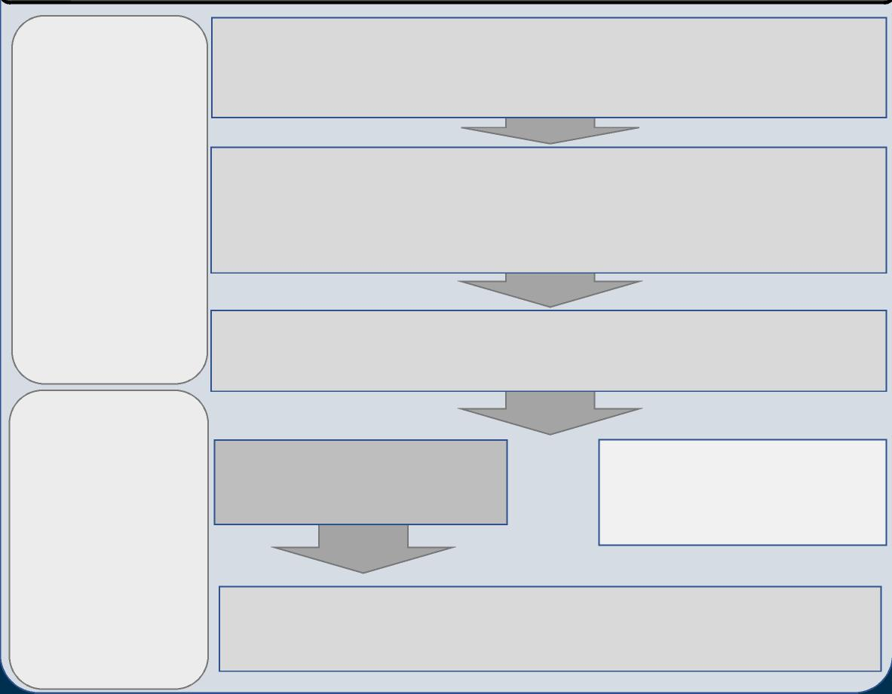

DAFF’s decision will be based on:

- the assessment - the importer’s capacity to participate in an ongoing program - the value an importers’

participation would bring to relieving border congestion

**Outcome**

**Application, discory and**

Li**ve** at all **analysis phase**

This phase will take several months and be dependent on importers’ capacity and capability to work with the DAFF program team.

**Detailed supply chain mapping and risk assessment:** if selected for
  
assessment, importers’ supply chains will be comprehensively mapped from
  
product/supplier onboarding through to distribution in Australia. This will be
  
followed by a risk assessment of commodity and non-commodity risks against
  
the strength of the controls.

**Importer self assessment tool:** to provide DAFF with information about the
  
maturity of supply chain controls, and give importers an understanding of the
  
type of information and level of detail required to be considered for the

an Airports via mobile

program. Some importers may decide not to proceed at this stage.

**Ongoing assurance activities, including at-border verification, periodic supply chain control desk-audit and quadrennial supply chain re-validation.**

Enter the Biosecurity Trusted Importer Program

**Control testing:** a selection of key controls identified in the supply chain
  
mapping stage will be tested to verify they are effectively managing
  
biosecurity risk.

or

Not recommended for the
  
Biosecurity Trusted Importer
  
Program. Improvement
  
opportunities highlighted.



**Lessons learned - a Green Lane arrangement will not suit all importers,**

**but other regulatory pathways may better align with their businesses.**

|  |  |  |  |  |
| --- | --- | --- | --- | --- |
|  |  |  |  |  |
| Translating trial insights into the Green Lane | While highly compliant through border |
|  | program, potential applicants will need: |  | clearance activities, some importers: |  |
|  | * Strong, systematised biosecurity controls |  | * May not be able to demonstrate the level |  |
|  | embedded in their supply chains and a |  | of control and influence over their supply |  |
|  | willingness and capacity to further |  | chains to meet the requirements of the |  |
|  | enhance those controls. |  | program. |  |
|  | * Capacity and capability to share supply |  | * Struggle to gain access to or share data |  |
|  | chain data and information in a |  | through either difficulty reaching offshore |  |
|  | partnership arrangement to better |  | to obtain it from a third party or central |  |
|  | manage biosecurity risk. |  | office, or face ICT/business security and commercial in confidence protocols. |  |



***Next steps (2nd half of 2023)***

**Wave 1**

Put in place
  
necessary
  
framework and
  
mechanisms for
  
Green Lane
  
Program

**Wave 3**

Program launch,
  
open to
  
applications
  
from other
  
importers
  
**(2nd half of
  
2023)**

**Wave 2**

Successful trial
  
participants
  
transition to new
  
arrangements

**Implementation**

**Revised timeline**(pending legal
  
framework and
  
funding)

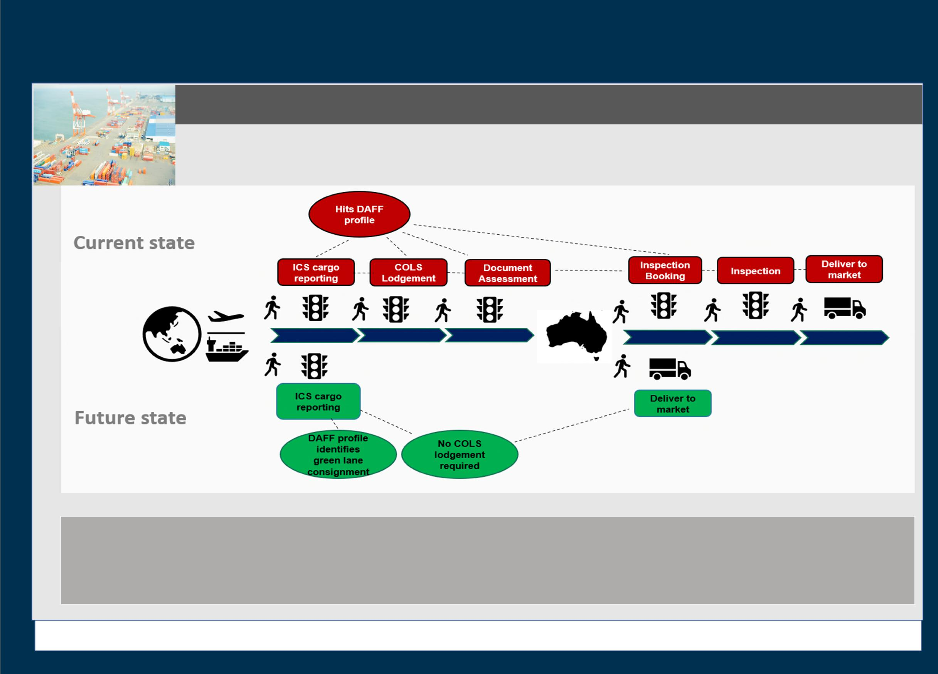

**DCCC Mtg 95**

**Attachment A: Greenlane Update July 2023**

**BIOSECURITY TRUSTED IMPORTER PROGRAM (GREEN LANE)**

•

* Green lane importer must fully comply with all import conditions (including permits, mandatory treatments, certifications and declarations) and be able to provide relevant supporting documentation on request.

**Recap of what this will look like in reality – simplified diagram**

* Commodities subject to outcomes other than ‘release on documents’ will be excluded.
* Importers will be required to notify significant changes to their supply chain(s) or their controls in response to those changes.

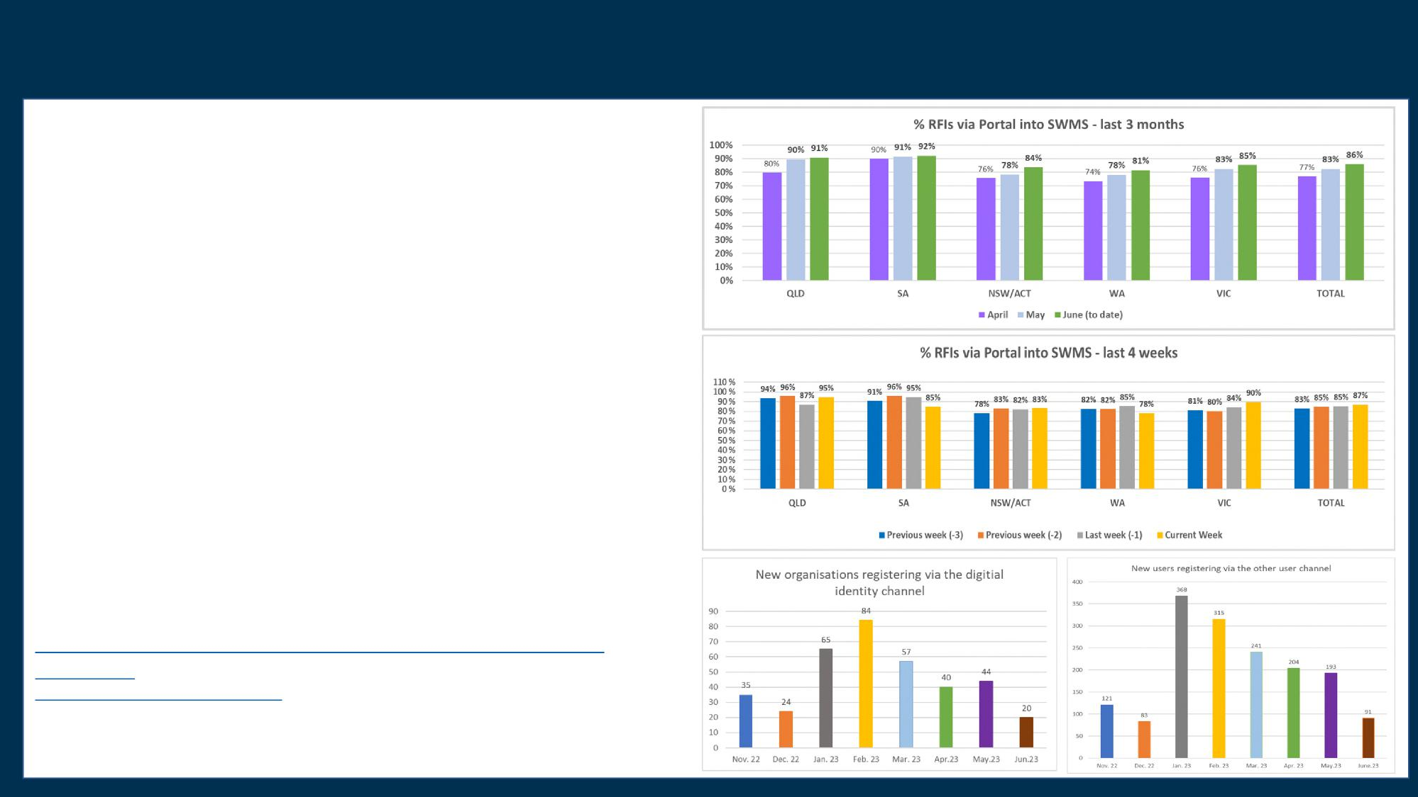

**Mtg 95 - Item 5.1c Biosecurity Portal - useage at w/e 16 June 2023**

**Portal usage**

There have been 58,652 (including cancelled) import RFIs lodged via the Portal since March 2022. The June (to date) national Portal utilisation is 86%. A 3% increase on the May 2023 percentage of 83%. Over the same period:

* NSW recorded a 6% increase from 78% to 84%
* WA recorded a 4% increase from 78% to 81%
* VIC recorded a 2% increase from 83% to 85%
* QLD and SA recorded a 1% increase from 90% to 91% and 91% to 92% respectively.

National Portal utilisation remained above 80% for the preceding four weeks, topping at 87% for the week 10 to 16 June 2023.

**New Portal Users**

There have been 842 new client organisations register via the myGovID channel since March 2022ive and at2292 allusers register Australianvia the Other User Airportschannel since Junevia 2022. Theremobile was increased uptake in the number of organisations and users registering for the Portal post the IIAN announcement of the closure of the email channel for import request for inspections in December 2022. This increased registration has declined post February but there continues to be a steady number of new clients registering each month.

**Portal Support**

The department continues to improve its Portal support materials introducing Quick Tips and Frequently Asked Questions on the Portal web page. Support materials can be found at <https://www.agriculture.gov.au/biosecurity-trade/import/online-services/biosecurity->

portal/guides - If you require further support, please contact the Portal Support Team at [biosecurityportal@agriculture.gov.au](mailto:biosecurityportal@agriculture.gov.au) or on 1800 900 090.



DCCC paper suitable for sharing
  
**DCCC Meeting 95 – 6 July 2023**

**Agenda Item 5.1d**

**AA 14.4 Rural Tailgate Inspections**

**For INFORMATION**

**PURPOSE**

This is an information only paper for DCCC members to note the update on the use and outcomes of Approved Arrangement (Class 14.4) Rural Tailgate Inspection.

**KEY POINTS**

* The department implemented a new Approved Arrangement (Class 14.4) in August 2022 that authorises approved Biosecurity Industry Participants (BIPs) to conduct low risk tailgate inspections on sea containers destined for delivery and unpack in rural classified areas.
* The department has identified that on average 75-80 percent of all RTG directions issued per month are eligible for class 14.4. There are currently 39 sites approved for class 14.4 activities across all states with all but three sites having performed at least one inspection to 1 June 2023.
* To 1 June 2023 approximately 2,300 rural tailgate inspections have been performed by industry. This has allowed the department to reallocate up to 575 hours of inspection time to higher biosecurity risk intervention. During this same period the department estimates a further 17,380 industry eligible inspections were performed by the department, equating to approximately 4,300 hours of Departmental inspection time.
* Usage of the class 14.4 by industry remains lower than expected with the month-on-month volume of directions being lodged for industry inspection seeing only slight increases. Monthly reporting for May 2023 showed that 399 out of 2,212 or 18 percent of all eligible directions were selected to be inspected under class 14.4. A copy of the May snapshot can be found at Attachment 1.
* New functionally was added to the Biosecurity portal in early April allowing industry tailgate inspection outcomes to be managed online. While the portal is the preferred method of submission by the department, approximately 90 percent of all lodgements received in May were still made using the rural tailgate container inspection record PDF form.
* The department has been taking an educational approach to the ongoing enquiries around the changes to the issuance of Final Directions under the arrangement, with additional information provided to support CCG officers and engagement with industry bodies on expectations. The BIP is responsible for the release from biosecurity control (through the creation of the record of release). The record created by the BIP after conducting the inspection is all that’s required to indicate the container(s) are released from biosecurity control and replaces the departmental AIMS Final and Release notice. While BIPs are not required to provide this record of release, the department strongly encourages that the relevant importer or agent (broker) is provided with a copy for their record keeping and assurance purposes.
* The department will be publishing supporting material for industry, including an informative text document and video tutorial on the Department’s website in early July. We had hoped to publish the

UNCLASSIFIED Page 1 of 2

DCCC paper suitable for sharing

supporting material earlier but have taken some extra time for further internal and external consultation to ensure it was fit for purpose. The materials were developed in response to industry feedback to increase BIP confidence in utilising the arrangement and subsequently increase use of the class. The team has received positive feedback on the material and are excited to get to publication.

* The department has begun work to expand the Class 14.4 arrangement to allow rural destined containers with commodity concerns that are cleared on documentation to be added to the scope of the class 14.4 and inspected by the BIP.
* A phased approach working with department commodity risk owners could see expanded class conditions that authorises almost all rural tailgate inspection activities (as directed by the department) to become eligible. A small proportion of inspections may remain with the department where post border controls or physical inspection activities are required as part of specific commodity concerns.

**BACKGROUND**

* The department partnered with industry on a new class of approved arrangement – (Class 14.4). The class has been developed to provide for BIPs to perform rural tailgate inspections on impediment-free containers (those with no other concerns apart from rural concerns) destined for unpack in rural destinations. These inspections must continue to be performed at class 1.1 and class 1.3 sea and air freight depot approved arrangement sites.
* Class 14.4 provides the department with confidence that biosecurity risk to rural areas continues to be appropriately managed, with prescribed risk management measures and controls through the approved arrangement conditions. Class 14.4 will also allow biosecurity officer expertise to be redirected away from performing low-risk inspections and towards higher biosecurity risk goods and emerging risk pathways.
* The department undertook a phased approach (including a private Beta) to implementation. This ensured that the supporting processes, systems, and the class 14.4 approved arrangement conditions were fit-for-purpose before wider implementation. Class 14.4 AA conditions was opened to all class 1.1 and 1.3 industry participants wishing to apply to carry out rural tailgate inspections from 8 August 2022 via the department’s website.

**CLEARED BY**

*Rose Cracknell A/g Assistant Secretary, Pathway Policy, Cargo and Conveyances, Biosecurity Operations Division*

**ATTACHMENT**

A: AA Class 14.4 May 2023 Snapshot

UNCLASSIFIED Page 2 of 2



DCCC paper suitable for sharing

**DCCC Meeting 95 – 6 July 2023
  
Agenda Item 5.2a**

**Legislation: Amendments to the *Biosecurity Act 2015***

**PURPOSE**

This is an information only paper for DCCC members to note key information management provisions

under the ***Biosecurity Act 2015*** as inserted by the ***Biosecurity Amendment (Strengthening Biosecurity) Act 2022*** and the introduction of the ***Biosecurity Amendment (Advanced Compliance Measures) Bill 2023*.**

This paper provides an update of legislative updates under *the Biosecurity Act 2015* (Biosecurity Act). ***Biosecurity Amendment (Strengthening Biosecurity) Act 2022 – Schedule 3 – Information management***

* The *Biosecurity Amendment (Strengthening Biosecurity) Act 2022* (Strengthening Biosecurity Act) received the Royal Assent on 5 December 2022. Schedule 3, containing information management amendments to the Biosecurity Act, commenced on 6 June 2023.
* Schedule 3 replaced the existing information sharing provisions in Division 2 of Part 2 of Chapter 11 of the Biosecurity Act with new provisions that enable streamlined and more effective sharing of information for the purposes of administration of the Act. This includes sharing of information with Commonwealth, state and territory bodies, law enforcement bodies, for biosecurity-related research purposes, and international bodies for the purposes of managing biosecurity risks.
* Human health information and other protected information will continue to be afforded appropriate safeguards with criminal and civil sanctions, including infringement notices, for unauthorised use and disclosure.
* More information will continue to be made available to stakeholders via the Department’s website - <https://www.agriculture.gov.au/biosecurity-trade/policy/legislation/biosecurity-legislation/information-sharing-updates>

***Biosecurity Amendment (Advanced Compliance Measures) Bill 2023***

* The *Biosecurity Amendment (Advanced Compliance Measures) Bill 2023* was introduced into Parliament on 21 June 2023. A summary of these amendments can be found at Attachment A.

**CLEARED BY**

Rich Keane, Principal Director, Innovation, Legislation, Education and Research Branch, DAFF.

**ATTACHMENTS**

Attachment A: Summary of the *Biosecurity Amendment (Advanced Compliance Measures) Bill 2023*

Page 1 of 1

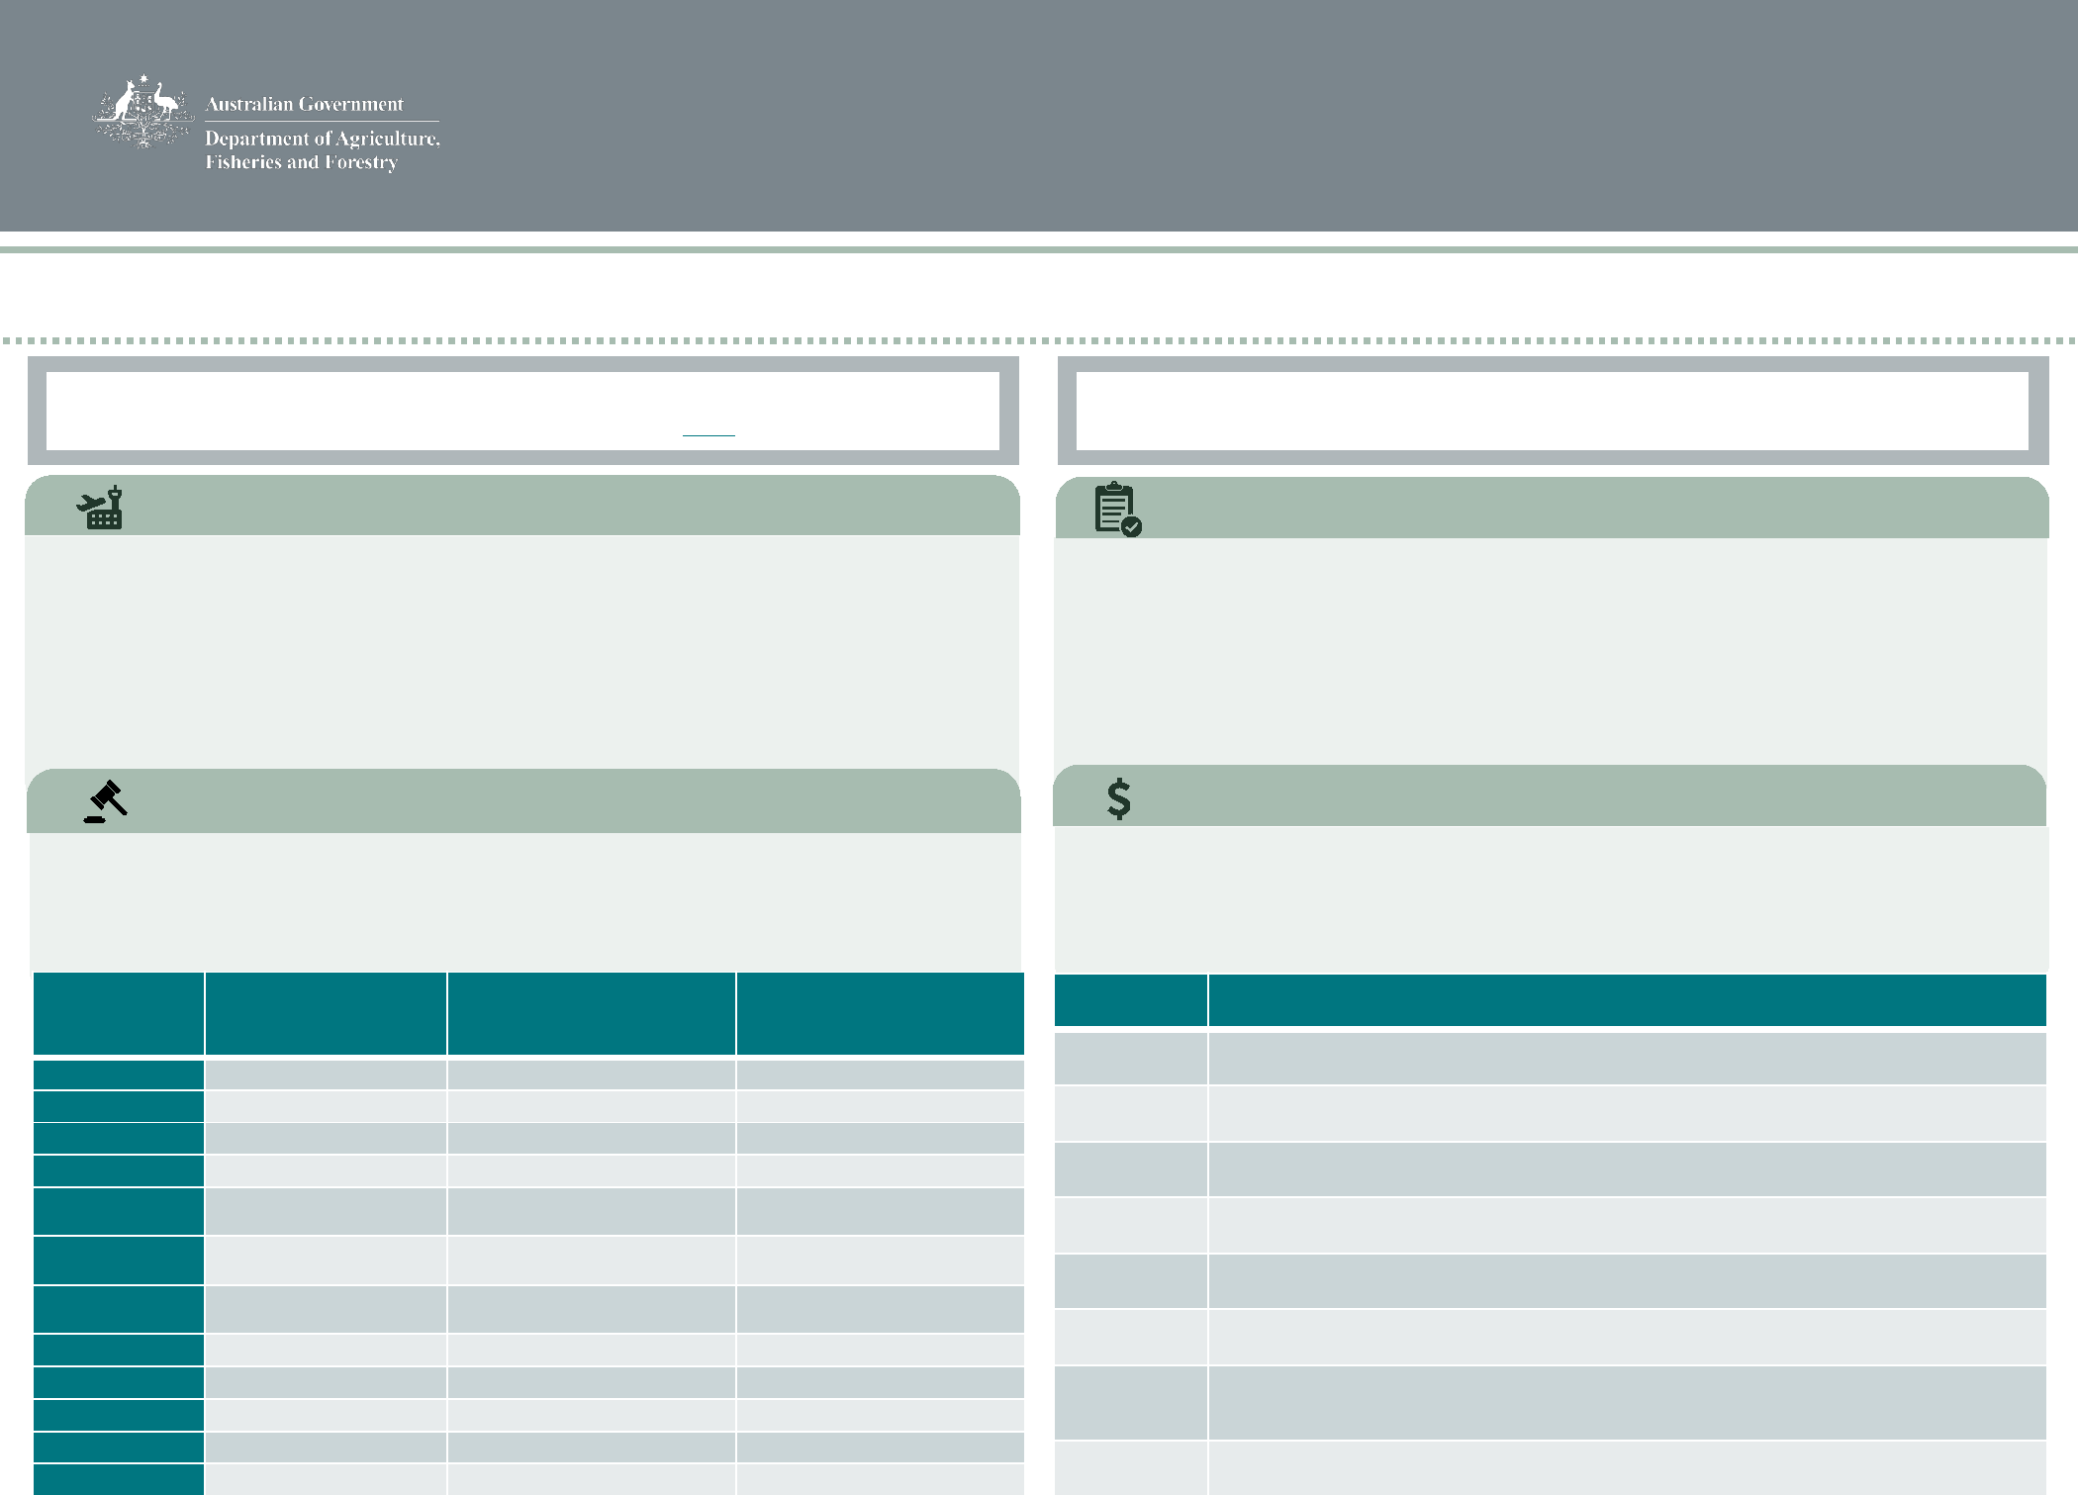

*Biosecurity Amendment (Advanced Compliance*

*Measures) Bill 2023*

The **Advanced Compliance Measures Bill** will amend the *Biosecurity Act 2015* to give effect to **four measures** to strengthen our regulatory tools and enhance our ability to take non-**compliance action against those who jeopardise Australia’s biosecurity status by breaking th**e law

The Bill was introduced into Parliament on 21 June 2023.
  
Details of the Bill can be found on [here](https://www.aph.gov.au/Parliamentary_Business/Bills_Legislation/Bills_Search_Results/Result?bId=r7051).

All measures in the Bill will **commence** the day after the Bill receives the Royal

Assent

|  |  |  |  |
| --- | --- | --- | --- |
| **Provision** | **Current amount  (penalty units (pu))** | **New amount  (penalty units (pu))** | **Penalty amount from 1**  **July 2023**  **(penalty units (pu))** |
| **ss 46(1)** | 30 pu ($8,250) | 150 pu ($41,250) | 150 pu ($46,950) |
| **ss 46(2)** | 30 pu ($8,250) | 1,000 pu ($275,000) | 1,000 pu ($313,000) |
| **ss 46(3)** | 30 pu ($8,250) | 150 pu ($41,250) | 150 pu ($46,950) |
| **s 52** | 120 pu ($33,000) | 150 pu ($41,250) | 150 pu ($46,950) |
| **ss 110(6)** | 30 pu ($8,250) | 120 pu ($33,000) | 120 pu ($37,560) |
| **ss 111(3)** | 30 pu ($8,250) | 120 pu ($33,000) | 120 pu ($37,560) |
| **ss 112(4)** | 30 pu ($8,250) | 120 pu ($33,000) | 120 pu ($37,560) |
| **s 116** | 30 pu ($8,250) | 120 pu ($33,000) | 120 pu ($37,560) |
| **s 438** | 120 pu ($33,000) | 600 pu ($165,000) | 600 pu ($187,800) |
| **s 439** | 120 pu ($33,000) | 600 pu ($165,000) | 600 pu ($187,800) |
| **s 532** | 60 pu ($16,500) | 600 pu ($165,000) | 600 pu ($187,800) |
| **s 533** | 60 pu ($16,500) | 600 pu ($165,000) | 600 pu ($187,800) |

**This measure will**:

* enable a biosecurity officer to require an arriving international traveller to produce their passport for specific purposes
* introduce a new civil penalty provision of **120 penalty units** ($33,000 or $37,560 from 1 July 2023) for non-compliance with the new measure, and is subject to an infringement notice of **12 penalty units** ($3,300 or $3,756 from 1 July 2023)
* Provide further data, such as non-compliance history, on travellers for future profiling

**This measure will:**

* increase civil penalties for a range of provisions to better reflect the potential impact to Australia’s biosecurity and human health status (see table below):

**Traveller information**

**Civil penalties**

|  |  |
| --- | --- |
| **Strict liability offences and infringement notices** | |
| **This measure will**:   * attach strict liability offences and the ability to issue infringement notices for low-    level, high-volume contraventions of a range of provisions (see table below): | |
| **Provision** | **Description** |
| s 140 | Contravening a direction given under paragraph 135(2)(b) or 138(1)(a) |
| s 185 | Bringing or importing prohibited or suspended goods into Australian territory |
| s 187 | Contravening conditions of a permit (including suspended or revoked permits) |
| s 243 | Contravening a direction given under Division 2 of Part 4 of Chapter 4 of the Act |
| s 251 | Contravening a direction given under Division 3 of Part 4 of Chapter 4 of the Act |
| s 350 | Contravening a direction given under paragraph 347(1)(a), (b) or (c) of the Act |
| s 428 | Failure to carry out biosecurity activities in accordance with approved arrangement |
| s 429 | Contravening a direction to manage biosecurity risks |

**This measure will**:

* streamline the process for issuing a show cause notice to a biosecurity industry participant (BIP) for breaching an approved arrangement
* provide an option to issue a written formal reprimand to a BIP as an alternative to other sanctions or non-compliance action

**Approved arrangements**



DCCC paper suitable for sharing
  
**DCCC Meeting 95 – 6 July 2023**

**Agenda Item 5.3b**

**BMSB Response**

**INFORMATION**

**PURPOSE**

This is an information only paper for DCCC members to note key information relating to the 2022-23 BMSB season.

**KEY POINTS**

The 2022-23 BMSB Season commenced on 1 September 2022. Cargo loaded on board a vessel after 30 April 2023 are not subject to the 2022-23 BMSB measures.

Key information and statistics relating to the season can be found on the Placemat at **Attachment A**.

Further information on the BMSB measures can be provided to DCCC members upon request via the DCCC Secretariat.

**CLEARED BY**

*Rose Cracknell, A/g Assistant Secretary, Pathway Policy – Cargo & Conveyances*

**ATTACHMENT**

A: 2022-23 BMSB Season Placemat

UNCLASSIFIED

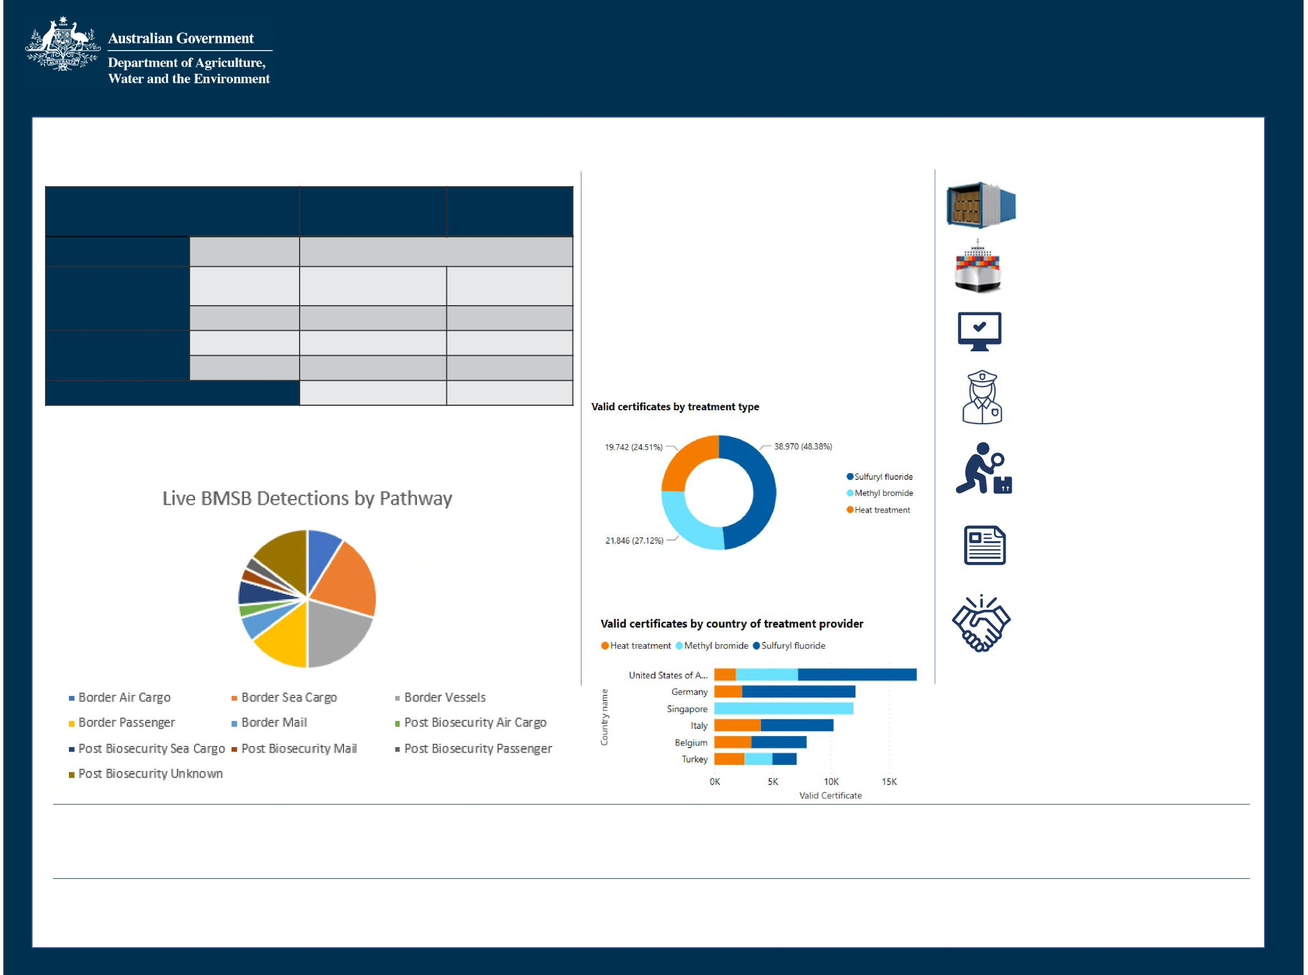

Biosecurity Operations Division

2022-23 BMSB Season

**13 June 2023**

**61,366** containers and 206 break bulk units Whitelisted

**107,112** Full Import Declarations (entries) referred for BMSB

**8,315** consignments with a BMSB profile directed for inspection

**5,199** BMSB entries lodged through AEPCOMM

**18** entities approved for the Safeguarding Arrangement scheme

The Brown Marmorated Stink Bug (BMSB) seasonal measures apply to targeted goods manufactured in or shipped from target risk countries between 1 September to 30 April (inclusive).

**BMSB Detections Offshore Treatments**

|  |  |  |  |
| --- | --- | --- | --- |
|  | | **21-22 Season** | **22-23 Season** |
| **Detection Point** | **Condition** | **Number of detections** | |
| **Biosecurity**  **Intervention Point** | **Alive** | 12 | 24 |
| **Dead** |  | 144143 |
| **Post Biosecurity** | **Alive** |  | 610 |
| **Dead** |  | 67 |
| **Total Detections** | |  | 168184 |

Note: Detection figures are not total insect numbers, i.e. one detection may have consisted of multiple actual insects.

**Non-compliance**

The department has directed 65 consignments for export due to arriving non-compliant to import conditions. This includes 14 break bulk consignments and 48 open top and flat rack containers arriving untreated. 8 of these exceeded the 120 hour post treatment window requirements and 3 FCL consignments arriving untreated that were unable to be treated onshore.

**BMSB Target risk countries:** Albania, Andorra, Armenia, Austria, Azerbaijan, Belgium, Bosnia and Herzegovina, Bulgaria, Canada, Croatia, Czechia, France, Georgia, Germany, Greece, Hungary, Italy, Kazakhstan, Kosovo, Liechtenstein, Luxembourg, Montenegro, Moldova, Netherlands, Poland, Portugal, Republic of North Macedonia, Romania, Russia, Serbia, Slovakia, Slovenia, Spain, Switzerland, Turkey, Ukraine, United States of America. Japan is targeted for heightened vessel surveillance only.

**80,547**

Valid treatment certificates lodged.

**52,072**

**18,843**

Containers treated offshore

Break Bulk units treated offshore

**232** Approved offshore treatment providers

**5** Offshore treatment provider suspended

**Valid certificates by treatment type**

**Top 6 – Valid certificates by country**

**Key Statistics**

**90,096** containers referred for BMSB concerns

**396** voyages by Roll-On Roll-Off vessels. **205** Seasonal Pest Inspections conducted



DCCC paper suitable for sharing

**DCCC Meeting 95 – 6 July 2023
  
Agenda Item 5.4a**

**Compliance Activities Snapshot
  
PURPOSE**

This is an information only paper for DCCC members to provide a snapshot of compliance activities for Quarter 3, financial year 2022-23

**KEY POINTS**

The Compliance Activities Snapshot (**Attachment A**) provides an overview of activities and assessments conducted by the department from 1 January to 31 March 2022.

Further information on the compliance activities can be provided, where possible, to DCCC members upon request via the DCCC Secretariat.

**CLEARED BY**

*Tiffany Byers, Ag. Assistant Secretary, Operational Intelligence & Coordination, Compliance and Enforcement Division*

**ATTACHMENTS**

Attachment A: Compliance Activities Snapshot – Third Quarter Statistics - Financial Year 2022-23

Page 1 of 1

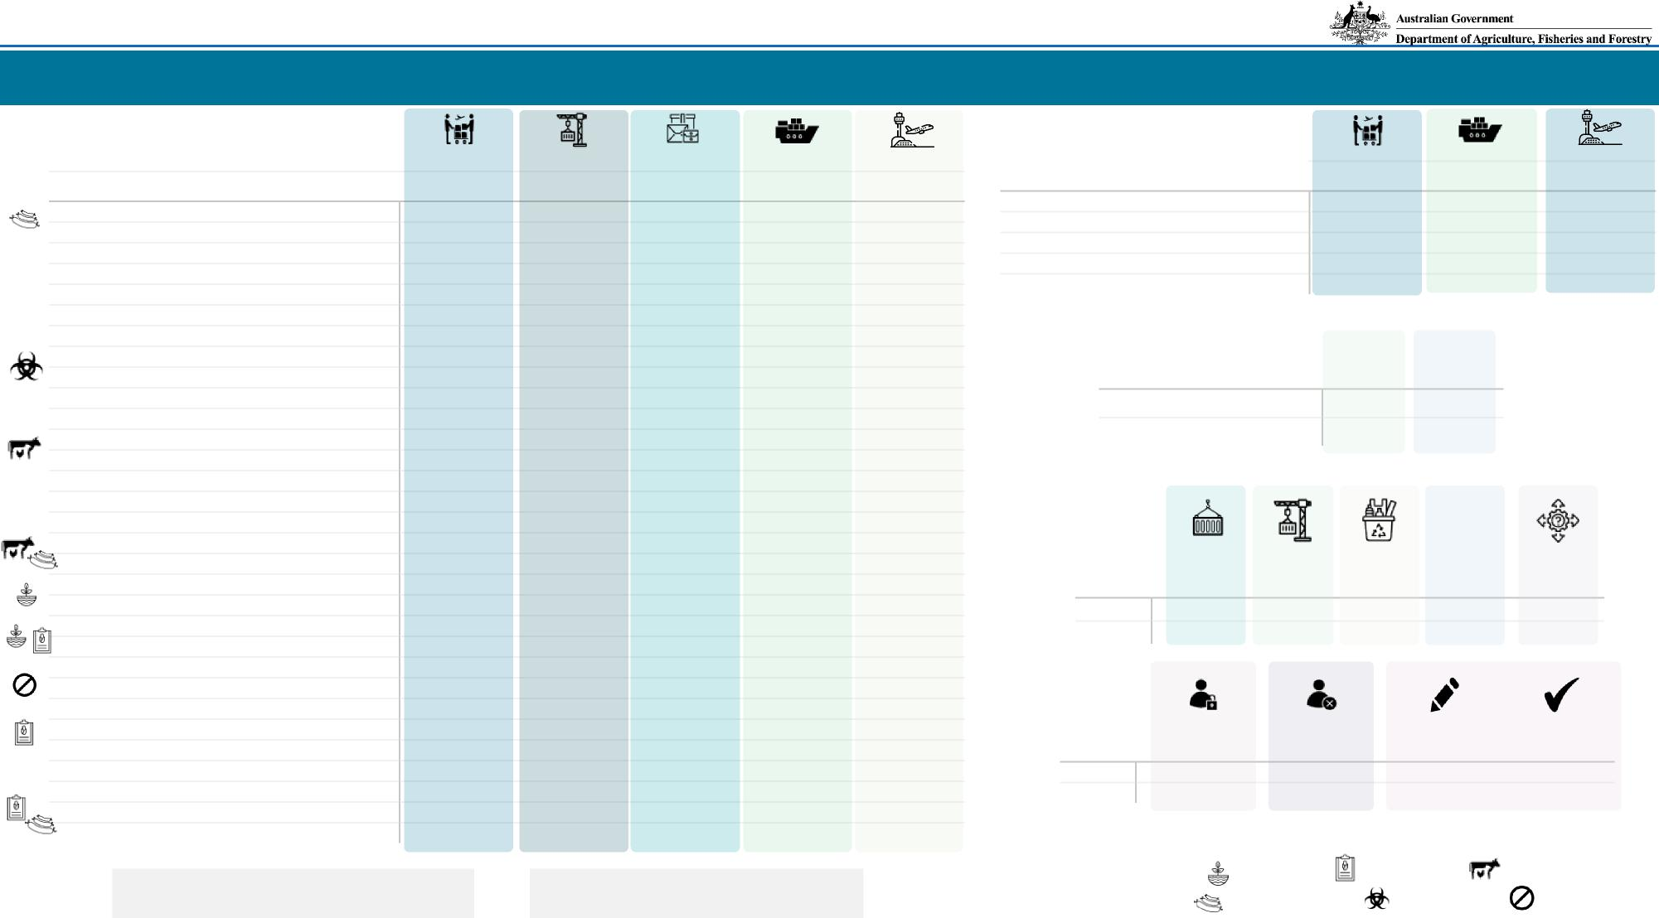

Pow D op

**Compliance and Enforcement Division Compliance Activities - Third Quarter Statistics - Financial Year 2022/23**

**Key investigations statistics:** 107 current investigations 7 briefs of evidence lodged with the Commonwealth Director of Public Prosecutions (5 investigations) 2 matters before the courts (concerning 3 entities)

**Total number of investigations commenced Quarter:**

**37**

**Total number investigations commenced FYTD:**

**79**

*Live plants; Plant products; Live animals;*

*Animal products; Biosecurity risk; Non-commodity*

|  |  |  |
| --- | --- | --- |
| **tigations Commenced During Quarter** | **Air Cargo** | |
|  | **Quarter** | **FYTD** |
| **Animal Product** |  |  |
| Biosecurity Act 2015 | 1 | 4 |
| Biosecurity Act 2015 & Criminal Code |  | 1 |
| Biosecurity Act 2015 & Imported Food Control Act |  | 1 |
| Export Control Act 2020 |  |  |
| Imported Food Control Act |  |  |
| Imported Food Control Act & Export Control Act 2020 |  |  |
| **Biosecurity Risk** |  |  |
| Biosecurity Act 2015 |  | 1 |
| Biosecurity Act 2015 & Criminal Code |  |  |
| Imported Food Control Act |  | 1 |
| **Live Animals** |  |  |
| Biosecurity Act 2015 | 2 | 4 |
| Biosecurity Act 2015 & Criminal Code | 1 | 1 |
| Biosecurity Act 2015, Criminal Code & EPBC Act | 1 | 1 |
| Export Control Act 2020 | 1 | 1 |
| **Live Animals & Animal Product** |  |  |
| Biosecurity Act 2015 | 1 | 1 |
| **Live Plants** |  |  |
| Biosecurity Act 2015 |  | 3 |
| **Live Plants & Plant Product** |  |  |
| Biosecurity Act 2015 |  |  |
| **Non-Commodity** |  |  |
| Biosecurity Act 2015 |  |  |
| **Plant Product** |  |  |
| Biosecurity Act 2015 |  | 2 |
| Export Control Act 2020 |  |  |
| Imported Food Control Act |  |  |
| **Plant Product & Animal Product** |  |  |
| Biosecurity Act 2015 | 1 | 3 |
| Imported Food Control Act |  |  |

|  |  |  |  |  |  |  |  |
| --- | --- | --- | --- | --- | --- | --- | --- |
| **Export** | | **Mail** |  | **Sea Cargo** | | **Travellers** | |
| **Quarter** | **FYTD** | **Quarter** | **FYTD** | **Quarter** | **FYTD** | **Quarter** | **FYTD** |
|  |  |  |  |  |  |  |  |
|  |  |  |  | 7 | 7 |  |  |
|  |  |  |  |  | 2 |  |  |
|  |  |  |  |  |  |  |  |
| 1 | 2 |  |  |  |  |  |  |
|  |  |  |  | 2 | 2 |  |  |
|  |  |  |  | 1 | 1 |  |  |
|  |  |  |  |  |  |  |  |
|  |  |  |  | 3 | 6 | 1 | 2 |
|  |  |  |  |  | 1 |  |  |
|  |  |  |  |  |  |  |  |
|  |  |  |  |  |  |  |  |
|  |  | 3 | 3 |  |  | 1 | 4 |
|  |  |  |  |  |  |  |  |
|  |  |  |  |  |  |  |  |
| 1 | 2 |  |  |  |  |  |  |
|  |  |  |  |  |  |  |  |
|  |  |  |  |  |  |  |  |
|  |  |  |  |  |  |  |  |
|  |  | 1 | 1 | 1 | 1 |  |  |
|  |  |  |  |  |  |  |  |
|  |  |  | 1 |  |  |  |  |
|  |  |  |  |  |  |  |  |
|  |  | 1 | 1 |  | 1 |  |  |
|  |  |  |  |  |  |  |  |
|  |  | 1 | 1 | 2 | 3 |  |  |
|  | 4 |  |  |  |  |  |  |
|  |  |  |  | 2 | 9 |  |  |
|  |  |  |  |  |  |  |  |
|  |  |  |  |  |  |  |  |
|  |  |  |  | 1 | 1 |  |  |

**Inves**

**Biosecurity Act\***

**Imported Food Control Act\***

**Quarter**

1

3

**FYTD**

4

6

**Infringement Notices**

**\*Note:** Company 60 penalty units = $13,320

|  |  |  |  |
| --- | --- | --- | --- |
| **Briefs of Evidence Submitted to  Commonwealth Director of Public  Prosecutions** | **Air Cargo** | | **Sea Cargo** |
| **Quarter** | **FYTD** | **Quarter FYTD** |
| **Live animal** |  |  |  |
| Biosecurity Act 2015 & Export Control Act 1982 |  |  | 1 |
| Crimes Act 1914 (Cth) |  |  |  |
| **Live Plants** |  |  |  |
| Biosecurity Act 2015 | 2 | 2 |  |

**Fit and Proper
  
Persons
  
assessments**

**Waste**



**Total**

**Quarter**

8

633

149

479

5

**FYTD**

56

1443

16

1949

450

**Approved Arrangements**



**Quarter**

**FYTD**

0

0

**Corrective Actions Issued**

1158 373

341 327

**Corrective Actions Resolved**

**Revoked**

0

0

***Legend:***

**Suspended**

**Quarter FYTD**

1

**Travellers**

**Adverse Decisions**

**Imports**

**Exports**