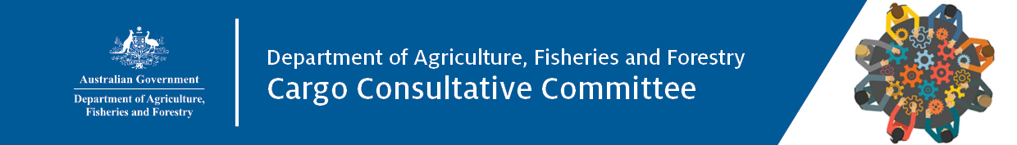

Meeting 96
AGENDA
15 November 2023
9:30am – 1:00pm
Teams meeting
Click here to join the meeting

# | Item | Lead/s | Timing | Papers
 | Welcome and introductions.  - Chair’s opening remarks and introductions | Chair | 9.30am – 9.50am | No
 | Minutes and Actions – DCCC Mtg 95, 6 July 2023 | Chair | 9.50am – 10.00am | Yes
 | Items for discussion  - Forward priorities for BOD - resetting strategic industry engagement agenda  - Simplified Targeting and Enhanced Processing System (STEPS) – advancing our cargo systems | Jo Laduzko  Nin Hyne | 10.00am – 10:30am  10:30am – 11:00am | No  No
Short break: 11.00am – 11.10am
 | Items for discussion cont…  - Future efforts across the Self Assessed Clearance (SAC) item pathway  - Cargo update | Jo Laduzko  Andrea Kondos | 11.10am – 11:40am  11:40am – 12:00pm | No  No
 | Industry Information Exchange | DCCC members | 12.00pm – 12:30pm | No
 | Inspector General of Biosecurity - review update | Lloyd Klumpp | 12:30pm – 12:50pm | No
 | Other Business  - Closing remarks  - 2024 forward meeting dates | Chair | 12:50pm – 1:00pm | No

Attendees:
Departmental
Chair, Tina Hutchison, First Assistant Secretary Biosecurity Operations Division (BOD)
Bronwen Jaggers, First Assistant Secretary Biosecurity Strategy and Reform Division (BSRD)
Peter Timson, First Assistant Secretary Compliance and Enforcement Division (CED)
Jo Laduzko, Assistant Secretary Cargo and Conveyances Policy and Detection Capability/BOD
Holly Buckle, Assistant Secretary (Apology) Cargo Operations (VIC, SA, WA, TAS)/BOD
Andrew Patterson, Assistant Secretary (Apology) Cargo Operations (NSW, QLD, NT, ACT) Regulatory Assurance/BOD
Andrea Kondos, A/g Assistant Secretary (Proxy) Cargo Operations (NSW, QLD, NT, ACT) Regulatory Assurance/BOD
Victoria Bowen, Assistant Secretary Cargo Operations South/BOD
Brett Liebich, Assistant Secretary (Apology) Operational Intelligence and Coordination/CED
Mirelle Anthony, A/g Assistant Secretary (Proxy) Operational Intelligence and Coordination/CED
Matthew Campbell, Assistant Secretary Audit and Assurance/CED
Anna Brezzo, Assistant Secretary Investigations/CED
Bronwyn Dwyer, A/g Assistant Secretary Risk Intelligence and Strategy/BSRD
Kylie Baker, Director Approved Arrangements/CED

Industry
Dianne Tipping Export Council of Australia
Carolyn Macgill Food and Beverage Importers Association
Bradley Leonard International Forwarders and Custom Brokers Association of Australia
Michael Gallacher (Apology) Ports Australia
Paul Bagnall Conference of Asia Pacific Express Carriers
Greg Carroll Australia Post
Dianne O’Hara (Apology) Federal Chambers of Automotive Industries
Scott Carson International Forwarders and Custom Brokers Association of Australia
Sal Milici Freight and Trade Alliance
Peter Van Duyn International Cargo Handling Coordination Association
Melwyn Noronha Shipping Australia Limited
Craig Birchall Qantas Airways Ltd
Stephen Pearse Board of Airline Representatives

Secretariat
Angela Cressy Industry Partnerships & Strategic Engagement /BOD

