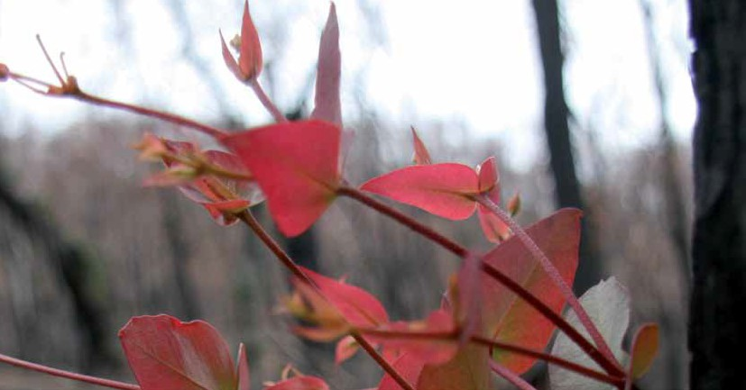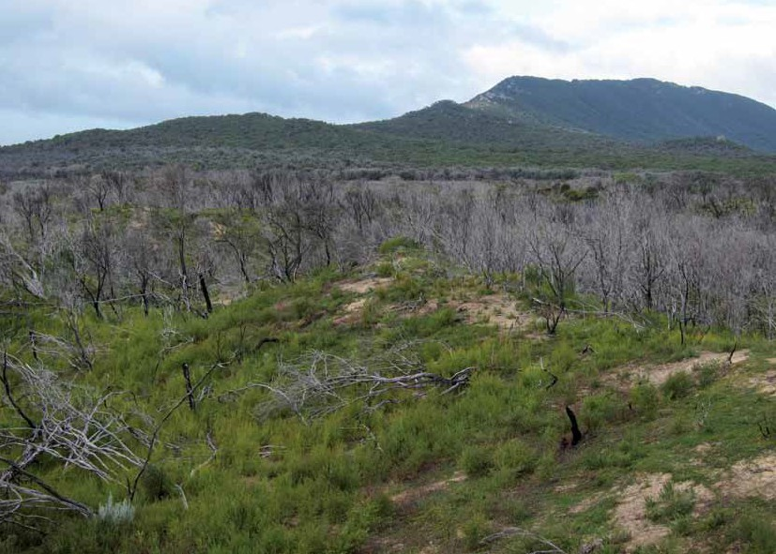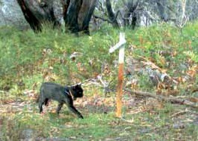

Field assessment of the Curiosity® bait for management of Feral Cats after fire at Wilsons Promontory National Park

Black Saturday Victoria 2009 – Natural values fire recovery program

**Michael Johnston**

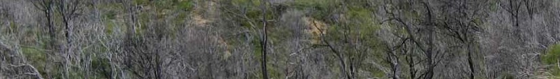

### Field assessment of the Curiosity® bait for management of Feral Cats after fire at Wilsons Promontory National Park.

**Michael Johnston**

Arthur Rylah Institute for Environmental Research 123 Brown Street, Heidelberg VIC 3084

**This project is No. 20 of the program ‘Rebuilding Together’ funded by the Victorian and Commonwealth governments’ Statewide Bushfire Recovery Plan, launched October 2009.**

Published by the Victorian Government Department of Sustainability and Environment, February 2012

© The State of Victoria Department of Sustainability and Environment 2012

This publication is copyright. No part may be reproduced by any person except in accordance with the provision of the *Copyright Act 1968.*

Authorised by the Victorian Government, 8 Nicholson St, East Melbourne

Print managed by Finsbury Green Printed on recycled paper

ISBN 978-1-74287-440-1 (print)

ISBN 978-1-74287-441-8 (online)

For more information contact the DSE Customer Service Centre 136 186

**Disclaimer**: This publication may be of assistance to you but the State of Victoria and its employees do not

guarantee that the publication is without flaw of any kind or is wholly appropriate for your particular purposes and therefore disclaims all liability for any error, loss or other consequence which may arise from you relying on any information in this publication.

**Accessibility**: if you would like to receive this publication in an accessible format, such as large print or audio, please telephone 136 186, 1800 122 969 (TTY), or email [customer.service@dse.vic.gov.au](mailto:customer.service@dse.vic.gov.au)

**Citation**: Johnston, M.J. (2012). Field assessment of the Curiosity® bait for management of Feral Cats after fire at Wilsons Promontory National Park: Black Saturday Victoria 2009 – Natural values fire recovery program. Department of Sustainability and Environment, Heidelberg, Victoria.

**Front cover photo**: Looking over burnt vegetation towards the Vereker Range (Dave Caldwell). Inset: Feral cat fitted with GPS datalogger collar (Reconyx automated camera).

All photographs in this report are by Michael Johnston unless otherwise credited.

Contents

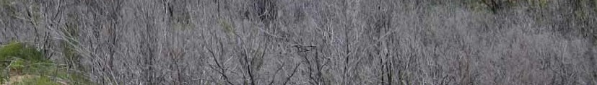

Acknowledgements v

Summary vi

1. Background 1
2. Methods 2
   1. Study areas 2
   2. Fire history 4
   3. Trapping 6
   4. Radio-telemetry collars 7
   5. Monitoring of collared animals 8
   6. Automated cameras 8
   7. Baiting 12
   8. Post bait monitoring 14
   9. Weather 14
3. Results 15
   1. Trapping 15
   2. Baiting 16
   3. Automated cameras 22
   4. Cat activity in relation to fire 23
4. Discussion 33
5. Conclusions 36

References 37

**i**



List of tables and figures

Tables

Table 1. Weather observations in the study site between 9–14 May 2011. 14

Table 2. Details of trapped Feral Cats and Red Foxes at Wilsons Promontory National Park. 15

Table 3. The fate of collared animals following application of Curiosity® baits. 17

Table 4. The occupancy of target and non-target species prior to and following application of Curiosity® baits

at Wilsons Promontory National Park. 22

Table 5. Cat location in relation to use of burnt areas at Wilsons Promontory National Park. 23

**ii**



Figures

Figure 1. Proposed and actual study sites within the Wilsons Promontory National Park. 2

Figure 2. Topographic detail of the fi study site. 3

Figure 3. Extent of fires at Wilsons Promontory National Park since 2002. 4

Figure 4. Proposed extent of Little Drift ecological burn (SG-W05a). 5

Figure 5. Location of cage and leghold trap sites. 6

Figure 6. A ‘walk-through’ set containing two leghold traps. 7

Figure 7. Cat 2 fi with GPS datalogger collar. 7

Figure 8. Processing and fi collar to Fox 3. 7

Figure 9. Location of ‘bush’ and ‘track’ automated cameras. 9

Figure 10. Long-nosed Bandicoot (*Perameles nasuta*) photographed at a ‘bush camera’ site. 10

Figure 11. Uncollared (a) Feral Cat and (b) Red Fox photographed by an automated camera at a ‘track camera’ site. 11

Figure 12. Arrangement of baits, drop tube and stopwatch inside helicopter. Inset shows

microswitch for automatic logging of dropped bait. 12

Figure 13. Pattern of Curiosity® bait application at Wilsons Promontory National Park. 13

Figure 14. Sample baits checked on 11 May 2011 were rain damaged and not attractive. 16

Figure 15. Location of Cat 1 while baits were attractive and palatable. 18

Figure 16. Location of Cat 2 while baits were attractive and palatable. 18

Figure 17. Location of Cat 3 while baits were attractive and palatable. 19

Figure 18. Location of Cat 6 while baits were attractive and palatable. 19

Figure 19. Location of Cat 8 while baits were attractive and palatable. 20

Figure 20. Location of Cat 9 while baits were attractive and palatable. 20

Figure 21. Location of Cat 10 while baits were attractive and palatable. 21

Figure 22. Example of the extent of Little Drift ecological burn. 23

Figure 23. Locations used by Cat 1 in relation to fire events at Wilsons Promontory National Park before

and after the Little Drift ecological burn. 24

**iii**



Figure 24. Locations used by Cat 2 in relation to fire events at Wilsons Promontory National Park before

and after the Little Drift ecological burn. 25

Figure 25. Locations used by Cat 3 in relation to fire events at Wilsons Promontory National Park before

and after the Little Drift ecological burn. 26

Figure 26. Locations used by Cat 5 in relation to fire events at Wilsons Promontory National Park. 27

Figure 27. Locations used by Cat 6 in relation to fire events at Wilsons Promontory National Park. 28

Figure 28. Locations used by Cat 8 in relation to fire events at Wilsons Promontory National Park. 29

Figure 29. Locations used by Cat 9 in relation to fire events at Wilsons Promontory National Park. 30

Figure 30. Locations used by Cat 10 in relation to fire events at Wilsons Promontory National Park. 31

Figure 31. Home range (MCP95%) of Feral Cats at Wilsons Promontory National Park. 32

**iv**

Acknowledgements

This project is No. 20 of the program ‘Rebuilding Together’ funded by the Victorian and Commonwealth governments’ Statewide Bushfire Recovery Plan, launched October 2009. I would like to thank Stephen Smith (Natural Values Fire Recovery Coordinator, Department of Sustainability and Environment (DSE)) for facilitating this project. Drafts of this report have been improved with comments received from Alan Robley and Lindy Lumsden.

This project benefited from contributions by many people with specialist skills. In addition to the author, trapping for Feral Cats and Red Foxes was undertaken by Mike Onus and Neil Hamilton (Department of Environment and

Parks Victoria staff based at Wilsons Promontory National Park provided valued logistical support.

This project required considerable field work and I thank the families left at home for their tolerance during these periods. Robert and Afton Johnston are thanked for the use of their caravan throughout the project.

The Curiosity® bait has been developed by collaborative research undertaken by the DSEWPaC, DEC-WA, DSE – Victoria and Scientec Research Pty Ltd. The bait matrix is patented under Patent No. AU 781829 and the toxicant encapsulation technology by Australian Provisional Patent

Conservation – Western Australia), Frank Gigliotti (General

Application 2008903572. Curiosity®

is a registered

Dogs Body Technical Services), Mark Fenby, Les Dunn Snr. and Jnr. (Outfoxed Pest Control), Tim Schmolling and Ken Ferguson (Weed and Wildlife Control) and Michael Lindeman (DSE).

All aspects of this study relating to Lace Monitors were undertaken by Tim Jessop, Tim Lockwood and Michael Kearney (University of Melbourne, Zoology Department).

Assistance with the installation of automated cameras was provided by Dave Caldwell, Tim Gentles, Kelby Douglas and Aileen Collyer (Wildlife Unlimited).

The aerial application of Curiosity® baits was undertaken by David Empey, John Lucas, Tim Brown and Flint Horn (Paton Air) with on-ground support from Dan Rogers and Rob Jarvis (Parks Victoria).

Advice and support from Dave Algar (DEC-WA) and Julie Quinn (Department of Sustainability, Environment, Water, People and Communities – Australian Government) is gratefully acknowledged. Michael O’Donoghue, Jim Morris and Jed Buchanan (Scientec Research Pty Ltd) manufactured the baits and toxic doses. Michael Scroggie and Paul Moloney (DSE) provided suggestions and undertook the statistical analysis in the study design. Peter Griffioen and Michael Basson (DSE) assisted with data preparation and GIS imagery.

trademark owned by the Australian Government.

Numerous permits were required to undertake this work;

* Animal Ethics Committee protocol 10.15 (DSE)
* Scientific permit 10005622 was issued under the

*Wildlife Act 1975* and *National Parks Act 1975* (DSE)

* Conduct of a trial in which death is the endpoint (Department of Primary Industries – Bureau of Animal Welfare)
* Field Trial Permit 11822 (Australian Pesticides and Veterinary Medicines Authority)
* A permit for the use of a firearm in a national park was issued by Parks Victoria
* A flight plan approved by the Victorian State Aircraft Unit according to SAUP 4.01.



**v**

# Summary



### Land managers of conservation estate have few techniques that can be employed to effectively manage the impacts that Feral Cat populations present to native wildlife species. Large fire events can cause significant immediate loss of wildlife and can also increase the likelihood of predation of surviving native fauna over the longer term given the loss of vegetative cover. This study investigated the efficacy of application of the Curiosity® poison bait to assist in the management of Feral Cats after The Cathedral

### fire at Wilsons Promontory National Park in February 2009.

### Baits were applied over a 90 km2 area from helicopter and also along management tracks on 9 May 2011. Heavy rain and hail fell across the site within 30 hours of bait application and rendered the baits unattractive to cats, limiting the effectiveness of the baiting.

### Results indicated that four of eight radio-collared Feral Cats and none of four foxes were poisoned in this study. The use of GPS datalogger collars facilitated data analysis by assessing cat locations with respect to their potential for encountering bait. There did not appear to be a relationship between the home range used by Feral Cats and the fire history at this site. However, this could be an artefact of the two year interval between the fire event and the start of this study. An additional controlled burn at the site did not provide any unequivocal evidence.

### Despite inconclusive results achieved in this study, it is believed that the Curiosity® bait could be used to manage Feral Cat and possibly also fox populations after large fire events following registration of the product as an agricultural chemical.

**vi**

# 1 Background

Feral Cats are classified as those cats (*Felis catus*) that live and reproduce in the wild and survive by hunting or scavenging (DEWHA 2008). Populations of Feral Cats are

distributed across all Australian states, territories and many offshore islands (Abbott and Burbidge 1995; Dickman 1996). Predation by Feral Cats is nominated as a cause of decline of over eighty, Australian listed wildlife species under the Commonwealth *Environment Protection and Biodiversity Conservation Act 1999*. Cats are known to predate a wide range of small to medium wildlife species—invertebrates, birds, reptiles and mammals with body mass 10 g – 3.5 kg (Dickman 1996)—but may also compete for resources such as food and den sites with native species. This impact is likely to be particularly important for potential prey species after broad scale landscape change such as occurs with large bushfire events.

A lightning strike ignited a bushfire on ‘The Cathedral’ mountain within Wilsons Promontory National Park, Victoria on the 8th February 2009. This fire burnt 25,200 ha over a five week period (Parks Victoria 2009). The fire occurred

at the end of a sustained period of below average rainfall (Teague *et al.* 2010) and would have initially impacted wildlife populations with the loss of individual animals during the fire. However, a longer term impact was the ‘resource loss’, i.e. food and shelter, that followed in the burnt area and potential for ‘resource crowding’ in the adjoining unburnt area during the recovery process.

Invasive predators, such as Feral Cats and Red Foxes (*Vulpes vulpes*), are thought to benefit from fire events given the initial food availability of dead and injured animals (Meek and Saunders 2000). The burnt area and edge created by the fire would also lead to a ready prey resource that is likely to be more vulnerable given the absence of vegetative cover (Meek and Saunders 2000; Russell *et al.* 2003).

The methods available to manage and mitigate the impact of invasive predators on wildlife species vary between the two species in this study. In the case of the Red Fox population, there are a range of registered poison meat baits available in addition to shooting and trapping.

These management activities can be undertaken rapidly by skilled practitioners, when considered necessary. However, the techniques currently available for managing Feral Cat populations in Victoria are limited with agencies such as Parks Victoria only able to utilise shooting or cage traps. These techniques are not effective over broad scale or remote areas such as Wilsons Promontory National Park given the limited access and requirement for frequent (daily) visitation by skilled labour.

This project firstly sought to investigate aspects of Feral Cat activity in relation to fire events and secondly, to determine whether a prototype poison bait product could be effective at managing the resident population of Feral Cats. Assessing the impact on Red Fox populations was an additional objective. The results from this project will contribute towards the registration of the Curiosity® bait as an agricultural chemical and then subsequently become available for authorised agencies to utilise, increasing the management tools available for these species.



**1**

# Methods

## Study areas

This project was initially planned to be undertaken in the north-east of Wilsons Promontory National Park (Figure 1). This site (east of Millers Landing and north of Five Mile Road) was chosen as it had been extensively burnt in The Cathedral bushfire in February 2009 and is infrequently visited by people. This would minimise complications associated

with the conduct of the study in what is one of Victoria’s most frequently visited National Parks. However, it became apparent during the planning stages that the logistics of conducting the study in this area were insurmountable given that no vehicular access was possible. The area north of Five

Mile Road is managed as a wilderness area and as such does not have maintained tracks.

The site was revised to include the Yanakie Isthmus and a 5 kilometre wide strip along the Five Mile Road. This 160 km2 area included approximately 80 km of vehicle tracks. Trapping was conducted throughout this area and included areas of vegetation that had not been burnt in 2009.

Further revision to the site was necessary given the extensive damage and subsequent closure of Five Mile Road following a large storm event on the 22 April 2011, during which 370 mm rain fell within a 24 hour period. The study site was necessarily reduced to a 90 km2 area (Figure 2).

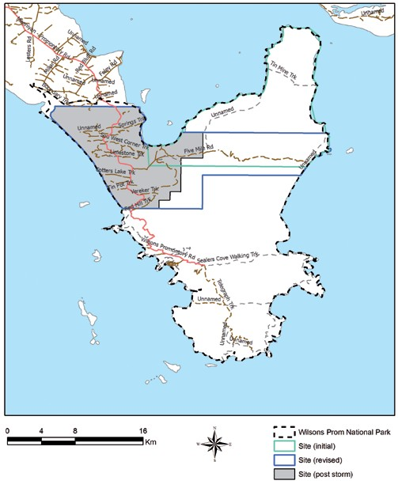

Figure 1. Proposed and actual study sites within the Wilsons Promontory National Park.

**2**

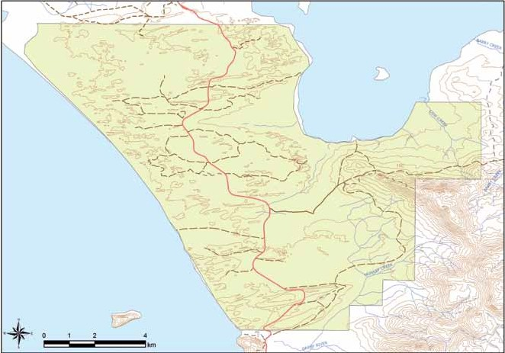

Figure 2. Topographic detail of the final study site.

**3**

## Fire history

A lightning strike ignited a bushfire north of The Cathedral, a mountain at the north end of Sealers Cove on the 8 February 2009. This fire burnt 25,200 ha (Figure 3) over a five week period (Parks Victoria 2009). Five other fire events have occurred within the Wilsons Promontory NP since 2002 but these affected areas outside of this project’s study area.

Parks Victoria ignited the Little Drift Track ecological burn within the study area on the 1 April 2011. The burn was bounded by Spring Track (southern edge) and Little Drift Track (northern edge) – see Figure 4. The forecast conditions for this day did meet, but were on the outer edge of, fire prescriptions with lowest temperature and wind speed and highest relative humidity. Fuel moisture was also just below maximum (J. Whelan, pers. comm.).

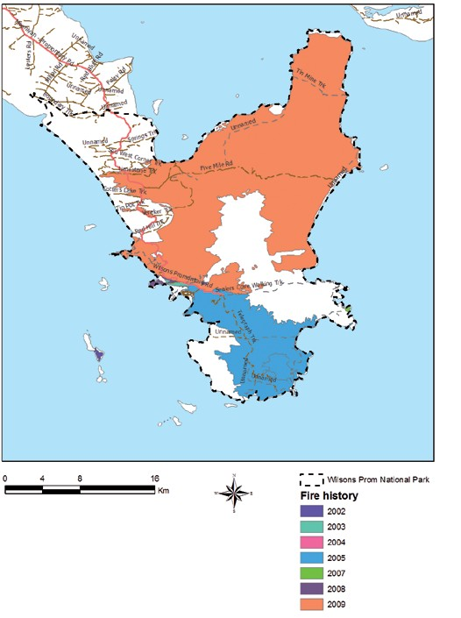

Figure 3. Extent of fires at Wilsons Promontory National Park since 2002.

**4**

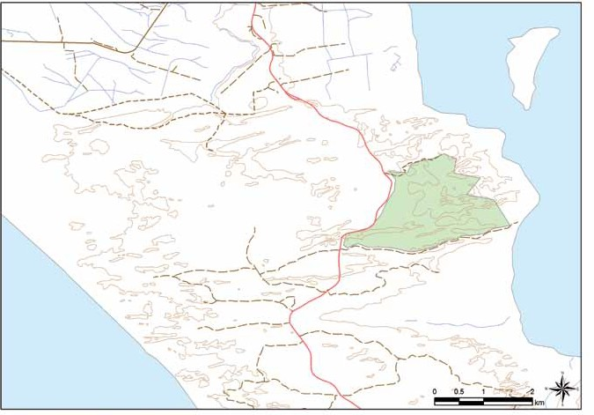

Figure 4. Proposed extent of Little Drift ecological burn (SG-W05a).

**5**

## Trapping

Trapping for Feral Cats and Red Foxes occurred over two periods, 8 February – 4 March and 4–15 April 2011.

Trapping for Feral Cats was undertaken using treadle- operated cage traps (P&L Wire, Frankston) baited with fried chicken pieces suspended from the rear of the trap. These traps were in good condition and were known to be a successful design (Johnston, unpublished data). Cage traps (n=25) were set by experienced trappers in locations where Feral Cats had been trapped in previous years such as fence lines, stockyards, on the periphery of grassy clearings and near rabbit warrens.

Trapping for Red Foxes was undertaken using rubber- padded leghold traps (Duke #1.5, West Point, USA). These

traps were modified prior to use with a stronger base plate, additional swivels and were waxed and dyed by Outfoxed Pest Control. Leghold traps were set at 500 m intervals along every vehicle-accessible track within the study area (Figure 5). Trap sets used in the first trapping period were predominantly ‘dirt hole’ sets that utilised a single trap in a single entrance cubby.

A variety of olfactory and food lures were utilised at trap sets including Cat-astrophic (a proprietary product developed by Outfoxed Pest Control), blended cat urine

and faecal material, fried chicken meat, tuna oil and whole, dead, laboratory mice. Audio lures (Feline Audio Phonic, Westcare Industries, Nedlands, Western Australia) were used at many sites.

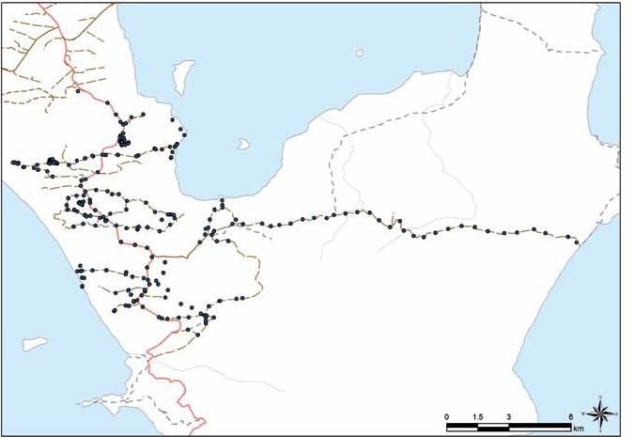

Figure 5. Location of cage and leghold trap sites.

**6**

A different leghold trap set design was utilised in the second trapping period. Traps were used in pairs in ‘walk-through’ sets with cat faecal material as the lure (Figure 6). These

sets were constructed on the side of vehicle tracks at 500 m intervals. All traps were checked twice daily.

Figure 6. A ‘walk-through’ set containing two leghold traps (Neil Hamilton and Mike Onus).

## Radio-telemetry collars

Trapped Feral Cats and foxes were restrained with a catch pole and covered with a blanket. A dose of sedative (Zoletil® 100, Virbac, Milperra, Australia or Dormitor®, Pfizer Animal Health, West Ryde, Australia) was administered into the thigh according to label prescriptions. The sex and body mass of animals was identified and recorded. Anusol® (Johnson and Johnson Pacific, Ultimo, Australia) cream was massaged into the trapped leg to ensure recovery of blood circulation. Radio transmitting collars were fitted to most trapped animals with the exception of one young fox cub that was released without a collar. GPS datalogger / VHF collars (Sirtrack Ltd, Havelock North, NZ) were fitted to Feral Cats that had a body mass of over 3.2 kg. These collars

had a mass of 140 g and were configured to record a GPS location every 3 hours with an automated collar drop off timed for 0100 hrs on the 23 May 2011 (Figure 7).

Figure 7. Cat 2 fi with GPS datalogger collar. Note shaved fur and Anusol® cream applied to trapped foot.

A VHF only collar (Sirtrack Ltd) was fitted to foxes and one Feral Cat that was considered too small to wear a GPS collar (Figure 8). All collars transmitted within the 173 MHz band and included a mortality sensor that became active if no movement was detected for a period of ten hours. The fur of each animal was clipped with an identifying mark on each side and on the forehead.

Animals were released at the location where they were trapped following recovery from sedation in the case of Zoletil or administration of Anti-Sedan® (Pfizer Animal Health, West Ryde, Australia).

Figure 8. Processing and fi collar to Fox 3.

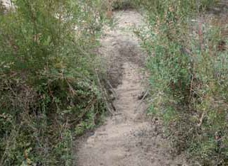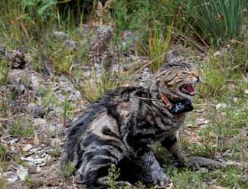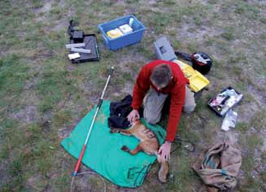

**7**

## Monitoring of collared animals

The status (alive or dead) of all collared animals was checked several times prior to baiting. No attempt was made to directly observe the animals during these surveys but instead relied on the mortality sensor to indicate whether the animal was alive or not. An Australis 26K VHF receiver and handheld 3 element yagi antenna (Titley Electronics, Ballina,

Australia) were used to search for and assess the status of each collared animal. Most animals could be detected

from locations with higher elevation within the study area. However, more intensive searching was conducted for collared animals which could not be detected from hills using an omni-directional antenna fitted to the roof of a 4WD vehicle driven slowly along the tracks within the study

area. The location where the VHF transmission was detected

## Automated cameras

Automated cameras were installed at positions throughout the study area (Figure 9) to assess presence of Feral Cats and foxes prior to and following baiting (see front cover image). Cameras were set both on and off tracks. Forty- seven cameras were used in off track locations and provided with a food lure (pilchards) over a period of 14 days prior to (i.e. 6–18 April) and following (e.g. 19–31 May) application of baits. All cameras were configured to record three photos at every motion detection with no pause between detections.

The location of these ‘bush’ cameras was determined using a semi-random process. The study site was partitioned

into three areas (labelled A – C) based on fire history and

was recorded. A thorough search was undertaken on the 8

topography. All 1 km2

cells where access was expected

May (i.e. the day before baiting) to determine the status of each collared animal.

Analysis of data collected by GPS collars was undertaken using ArcView 3.3 Geographic Information System software (ESRI, Redlands, USA) that included the Home Range Extension 1.1 (Rodgers and Carr 1998). The home range

of cats was determined using the 95% Minimum Convex Polygon function.

to be very difficult were ruled out and the remaining cells

were numbered. A series of random three digit X and Y axis numbers that had been generated from the software

program ‘R’ were fitted against each cell to form a complete geographic UTM reference.



**8**

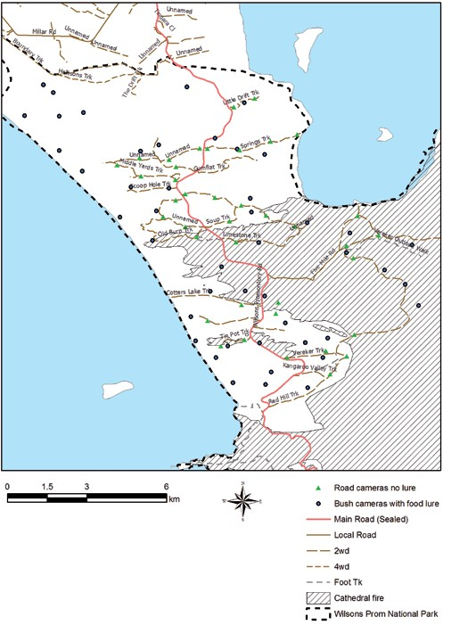

Figure 9. Location of ‘bush’ and ‘track’ automated cameras.

**9**

Each site was prepared such that the camera was mounted on a stake facing south and the surrounding vegetation cut back to minimise photographs of moving vegetation only. A PVC bait holder was cable-tied onto a timber stake at a height of 50 cm at a distance of 3 m south from the camera. Two pilchards were housed in a 150 mm length of 30 mm diameter PVC tube that had been drilled so as to facilitate the movement of air through the device (Figure 10). Cameras used in the pre-bait assessment consisted of 12 Reconyx Rapidfire semi-covert LED HC500, 3 Reconyx covert HC600, and 31 Reconyx RC60. Cameras used in the post bait assessment were 12 semi-covert LED HC500 and 34 Reconyx covert HC600.

aim. A series of set-up photos were taken in which a white board was held in front of the camera such that the location details and date were recorded.

All photographs were reviewed with the species that been photographed identified. The presence and / or absence of a species at each site on a daily basis was entered into a

Microsoft Excel worksheet (i.e. 1= present, 0 = not present, NA= camera not active).

Each species was modelled using maximum likelihood approach for estimating the occupancy (ψ) and detection

(*p*) rates (MacKenzie *et al.* 2002; MacKenzie *et al.*. 2006). The location of the camera (bush or track) and the presence

Cameras were also used without lures to record activity

of Curiosity®

baits were considered as factors affecting

at locations on tracks. Cameras used to monitor activity on tracks were set at locations approximately 50 m from the start of management tracks and then at one kilometre intervals from these points. These 39 cameras were mounted on trees and aimed to photograph animals using

the tracks (Figure 11). At the time of installation, all cameras were test-fired to confirm functionality and correctness of

the occupancy and detection. The complete set of nested

models under interaction was considered. The model with the smallest second order AIC (AICc) was considered the best model for each species. The software package “unmarked” in ‘R’ was used to conduct the analysis (R Development Core Team 2011).

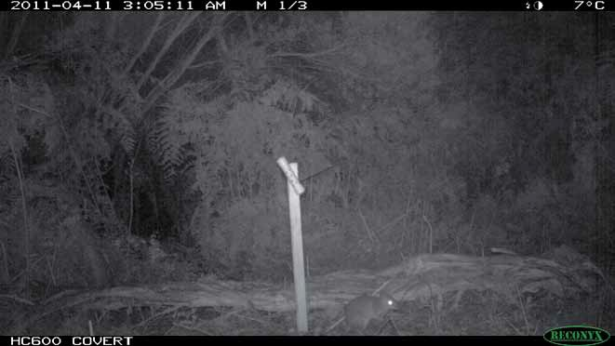

Figure 10. Long-nosed bandicoot (*Perameles nasuta*) photographed at a ‘bush camera’ site.

**10**

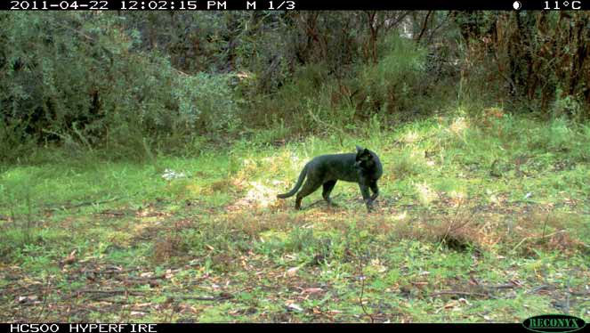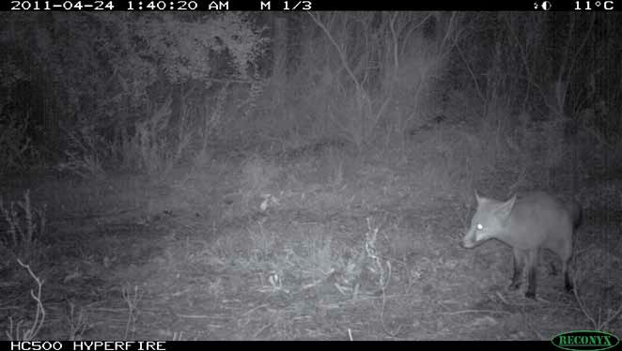

Figure 11. Uncollared (a) Feral Cat and (b) Red Fox photographed by an automated camera at a ‘track camera’ site. (a)

(b)

**11**

## Baiting

All baits were produced by Scientec Research in the period between January and April 2011 and comprised baits from a variety of batches1. Baits were manufactured using a recipe modified from that used to make Eradicat® baits (Algar *et al.* 2007; Johnston *et al.* 2011). Baits are composed of 70% minced kangaroo meat, 20% chicken

fat, and 10% digest and flavour enhancers (Patent No. AU 781829). The pH of minced meat used in the Curiosity® baits is buffered to 7.5 using sodium carbonate. One encapsulated pellet containing a formulation of ~80 mg para-aminopropiophenone (PAPP) and solubilising excipient compounds was manually inserted into each bait. Baits were counted into bags of 200, cryovaced and then stored frozen prior to use in this study.

Baits were transported to the field site on the 8 March and allowed to thaw overnight on a series of racks arranged

in a shed at the Yanakie depot. A gas jet heater was used to direct heat onto the baits on the 9 May. This completed the thawing process and ‘sweated’ the baits which caused aromatic chicken oils to exude from the sausage skin.

Baits were placed into 40 L crates and loaded into the rear of a Bell JetRanger III helicopter (Paton Air Services,

Maindample). This aircraft was fitted with a bait drop chute in the floor (Figure 12) that incorporated a microswitch mechanism that automatically recorded a waypoint in the aircraft navigation system (Trimble, Sunnyvale, USA). A large text digital clock that was configured to countdown 10 seconds repetitively was fixed in view of the bombardier who sat in the rear of the aircraft. The pilot maintained verbal communications with the bombardier to advise of entry into no-bait areas.

Figure 12. Arrangement of baits, drop tube and stopwatch inside helicopter. Inset shows microswitch for automatic logging of dropped bait.

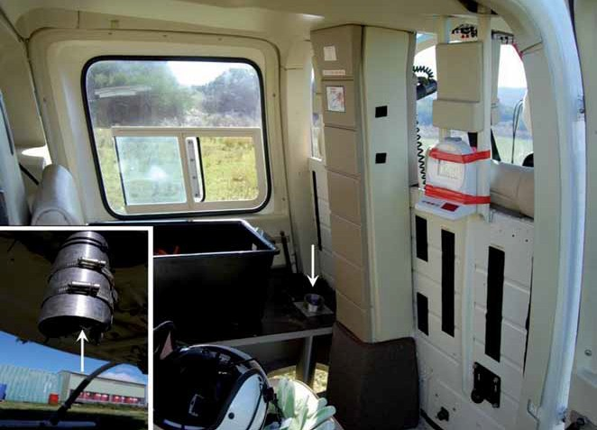

1 Baits used were sourced from Scientec batch numbers 5308, 5309, 5325, 5327, 5328, 5329, 5330, 5335, 5336, 5332, 5340 and 5350.

The pilot was instructed to fly at a speed of 20 knots and at a height of 20 m above tree height. Flight lines, including no-bait areas, were generated in Google Earth software and had been pre-loaded into the aircraft navigation system.

The bombardier was instructed to drop five baits every ten seconds. Baits were not dropped from the aircraft over high visitor use areas, such as over walking tracks in the Millers Landing area and over the Wilsons Promontory Road.

A practice baiting exercise was conducted over the two runways at the Yanakie airstrip to confirm that the

procedures and data recording systems were functioning correctly. Non-toxic baits made with red coloured skins (to improve visibility) were used for this exercise. Both runways were searched and the location of each bait was recorded using a differential GPS device (Trimble Pathfinder ProXRT GPS receiver / Trimble Nomad computer with ArcPad 8.0 software). The data was displayed in ArcView 3.3 with the distance measured between the location where the baits exited the aircraft and where they landed. These distances were then averaged across each cluster of five baits.

A crate of toxic baits were loaded into the aircraft following completion of the practice baiting exercise. East-west

transects were flown at 1000 m intervals over the site with baits applied at a rate of 50 baits/km2 (Figure 13). Additional bait transects were flown along two coastlines in this

site, i.e. Cotter Beach and Corner Inlet coast, to optimise opportunity for bait encounter by cats and foxes using these areas. The helicopter returned to the airstrip to load crates of toxic baits when each was emptied.

Baits were also distributed at 100 m intervals along all vehicle accessible tracks within the study area from a 4WD utility vehicle moving at 20 km/h. These baits included gold coloured glitter to indicate that they were a ‘road bait’ rather than an ‘air bait’. A bait handler sat on the tailgate of the vehicle and dropped a bait at intervals indicated by the driver using the car horn. These baits were placed in the centre of the track so as to ensure that they would not be driven over and also to provide equal opportunity for encounter by cats walking along the track. The Wilsons Promontory Road was baited at 50 m intervals along alternating sides of the road edge in two passes. A GPS waypoint was created at each bait location by the driver.

Aerial baiting was completed by 1600 hrs and road baiting by 1730hrs on 9 May 2011.

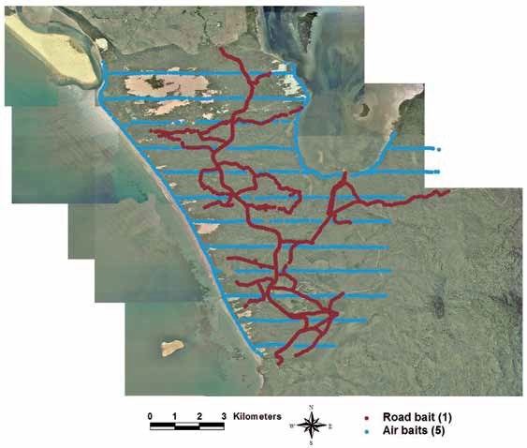

Figure 13. Pattern of Curiosity® bait application at Wilsons Promontory National Park.

## Post bait monitoring

Monitoring of collared animals was initiated on 11 May 2011 and continued for seven days using the procedures described above. Collars that were in ‘mortality mode’; either via death of the animals or collar drop-off (set for 0100 hrs 23 May 2011), were recovered. These sites were photographed and the location recorded using a GPS unit. Carcasses were removed from the site and were weighed prior to conduct of a post mortem. The colour of soft tissues in the mouth (tongue and gums) were noted as pale tissues are indicative of hypoxia caused by PAPP intoxication. The stomach contents were also removed, inspected and photographed with observations made as to the amount and type of material in the stomach as well as presence of

## Weather

Parks Victoria collects basic weather data at the Yanakie office using a ‘Vantage Pro2’ weather station (Davis Instruments, South Windsor, Australia). The field site extends approximately 13 kilometres to the south from this location. Field observations by the author were collected and rainfall, maximum and minimum temperature data were extracted from the Parks Victoria dataset for the study period. The attractiveness and palatability of baits is known to decrease following rainfall and, as such, data reflecting the weather over the period 9–14 May is provided in this report.

The weather observed over the critical dates, with respect to

glitter.

bait availability, of 9–14th

May 2011 is included in Table 4.

A total of 37.8 mm rain fell at the Yanakie office during this



period. Table 1. Weather observations in the study site between 9–14 May 2011.

|  |  |  |  |  |
| --- | --- | --- | --- | --- |
| **Date** | **Field Observation** | **Max Temp (˚C)** | **Min Temp (˚C) Rainfall (mm)**  **0000hrs to 0000hrs** | |
| 9 May | Mostly sunny with very light showers | 14.9 | 5.7 | nil |
| 10 May | Fine and cool. Rain and hail overnight. | 14.8 | 6.3 | 2.0 |
| 11 May | Rain and hail. Short sunny periods | 11.5 | 7.1 | 13.8 |
| 12 May | Overcast and rain | 14.6 | 6.7 | 10.0 |
| 13 May | Rain and strong wind | 14.7 | 8.6 | 8.2 |
| 14 May | Mostly fine, one light shower. | 13.6 | 8.1 | 3.8 |

# Results

## Trapping

A total of ten Feral Cats and seven Red Foxes were trapped in this study (Table 1). Four cats and seven foxes were trapped in the first session (n= 2037 leghold trap nights, n= 640 cage trap nights). The remaining six cats were trapped in April (n= 653 leghold trap nights). All cats and foxes were trapped in leghold traps. Cat 5 was observed to be lactating. Cat 6 was retrapped on the 13th April 2011.

Captures of non-target species occurred in both cage and leghold traps as outlined below.

Cage trap: Australian Magpie *Gymnorhina tibicen* (4), Australian Raven *Corvus coronoides* (2), Short-beaked Echidna *Tachyglossus aculeatus* (2).

Leghold trap; Australian Magpie (3), Pied Currawong *Strepera graculina* (4), Common Wombat *Vombatus ursinus* (6), European Rabbit *Oryctolagus cuniculus* (2), Long-nosed Bandicoot (1) and Black Wallaby *Wallabia bicolor* (2).

One wombat and teo rabbits were euthanased while all other animals were released unharmed.

Non-target species, including Wombat, Emu *Dromaius novaehollandiae*, Hog Deer *Axis porcinus* and Eastern Grey Kangaroos *Macropus giganteus*, were responsible for frequently ‘closing’ or ‘springing’ traps across the site, as evidenced by footprints or other diagnostic signs.



Table 2. Details of trapped Feral Cats and Red Foxes at Wilsons Promontory National Park.

|  |  |  |  |  |
| --- | --- | --- | --- | --- |
| **ID** | **Sex, body mass (kg), colour** | **Location** | **Date** | **Collar** |
| Cat 1 | M, 4.3, black | 0436982 5692037 | 20 Feb | GPS / VHF 173.0280 |
| Cat 2 | M, 3.5, tabby | 0440159 5693184 | 21 Feb | GPS /VHF 173.2386 |
| Cat 3 | M, 3.6, tabby | 0435698 5692578 | 24 Feb | GPS / VHF 173.1980 |
| Cat 4 | F, 2.0, black | 0433615 5695166 | 1 Mar | VHF only 173.6789 |
| Cat 5 | F, 2.8, black and white | 0435943 5693713 | 7 Apr | GPS/ VHF 173.0891 |
| Cat 6 | M, 3.8, tabby | 0435564 5693713  0436171 5692155 (re-trap) | 7 Apr  13 Apr | GPS / VHF 173.0784 |
| Cat 7 | M, 4.8, tabby | 0434358 5693404 | 8 Apr | GPS / VHF 173.0658 |
| Cat 8 | F, 2.8, tabby | 0434341 5695451 | 10 Apr | GPS/VHF 173. 3584 |
| Cat 9 | M, 3.7, tabby | 0437536 5695785 | 11 Apr | GPS / VHF 173.1583 |
| Cat 10 | M, 4.7, tabby | 0437536 5695785 | 15 Apr | GPS / VHF 173. 1200 |
| Fox 1 | F, 3.0 | 0453176 5691741 | 17 Feb | VHF only 173.519 |
| Fox 2 | F, 2.1 | 0453176 5691741 | 18 Feb | VHF only 173.6380 |
| Fox 3 | M, 4.8 | 0435764 5692399 | 20 Feb | VHF only 173.5790 |
| Fox 4 | F, 2.6 | 0440159 5693184 | 22 Feb | Not collared – juvenile |
| Fox 5 | F, 3.9 | 0434575 5692107 | 26 Feb | VHF only 173.5014 |
| Fox 6 | M, 3.5 | 0440151 569340 | 2 Mar | VHF only 173.5395 |
| Fox 7 | M 3.6 | 0439871 5687776 | 5 Mar | VHF only 173.6590 |

## Baiting

Twenty ‘practice baiting’ drops were undertaken at the Yanakie airstrip which demonstrated that each cluster of five baits landed within an average of 10.1 m (range 8.5 –

13.3 m) of the location where they exited the aircraft. In the case of 13 of these sites, it is not clear which baits relate to particular ‘drop sites’ as multiple bait drops were recorded. As such, these data were removed from the analysis, although including them made little change to the outcome (12.0 m; range 8.5 – 21.8 m). The bombardier was observed to have released 6 baits on 4 drop sites and 4 baits at 1 drop site. Baits from each ‘drop group’ landed within an average radius of 2.4 m (range 1.2 – 4.5 m).

All radio-collared cats, with the exception of Cat 7, were detected on 8 May 2011 (i.e. the day prior to baiting).

Cat 7 was last detected alive on the 20 April 2011. The collar fitted to Cat 5 indicated that this animal had died on 17 April 2011. It is therefore assumed that eight collared cats were alive when baits were applied.

Four of eight cats (50%) were recovered dead and were later confirmed to have consumed bait(s). Three of these cats had consumed aerially deployed bait(s) while the presence of glitter indicated that one cat had consumed road bait(s). Five collars were recovered following drop-off from cats that had not died (Table 2).

Four of six collared foxes were assumed to be alive within the study area when baits were applied. The collar fitted to one of the four foxes was heard to indicate mortality mode on the 14 May 2011 but the signal was not relocated and the animal has not been recovered (Table 2). The remaining three foxes survived the baiting program. As a result, it is not possible to say anything further about foxes.

Heavy rain and hail greatly reduced the attractiveness and palatability of baits on the evening of the 10 May. Baits were not considered ‘attractive and palatable’ when samples were checked on 11 May 2011 (Figure 14).

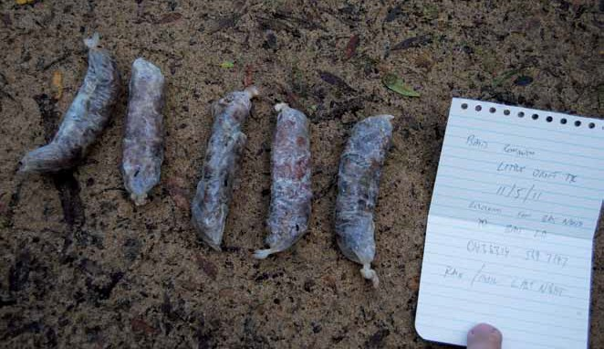

Figure 14. Sample baits checked on 11 May 2011 were rain damaged and not attractive.



Table 3. The fate of collared animals following application of Curiosity® baits. Note: Fox 4 was too small to wear a collar.

|  |  |  |  |  |
| --- | --- | --- | --- | --- |
| **ID** | **Died / Survived** | **Location of collar recovery** | **First record at point of death.** | **Body mass (kg) when recovered** |
| Cat 1 | Survived | 0437215 5690386 |  |  |
| Cat 2 | Survived | 0449553 5690862 |  |  |
| Cat 3 | Died (air baits) | 0436003 5694396 | 0200 hrs 10 May 2011 | 3.6 |
| Cat 4 | Died (air baits) | 0432147 5695399 | Dead by 13 May 2011 | 1.9 |
| Cat 5 | Died prior to baiting | 0437045 5691830 | 17 April 2011 | Too decomposed |
| Cat 6 | Survived | 0435222 5690862 |  |  |
| Cat 7 | Died prior to baiting? |  |  |  |
| Cat 8 | Died (road bait) | 0434459 5695097 | 0344 hrs 10 May 2011 | 2.0 |
| Cat 9 | Died (air bait) | 0437492 5695516 | 2056 hrs 9 May 2011 | 3.4 |
| Cat 10 | Survived | 0437804 5693038 |  |  |
| Fox 1 | Outside study area |  |  |  |
| Fox 2 | Outside study area |  |  |  |
| Fox 3 | Died? Faulty transmitter? Body not located. |  |  |  |
| Fox 5 | Survived |  |  |  |
| Fox 6 | Survived. |  |  |  |
| Fox 7 | Survived |  |  |  |

Cat 1 – The GPS collar indicated that this cat crossed the Wilsons Promontory Road between 1448 hrs 9 May and 0248 hrs 10 May 2011 (Figure 15). During this time it may have encountered bait(s). This cat

re-crossed the same road after 1048 hrs on the 11 May 2011. Baits were rain affected by this time. This cat survived.

Cat 2 – The GPS collar indicated that this cat crossed baited transects

between 1039 and 1439 hrs on the 9 May 2011. Baiting on these transects was undertaken between 1402 and 1418 hrs. It is possible that the baits were not laid when the cat crossed these transects. The cat also crossed baited transects between; 1439 and 1839 hrs 9 May, 0639 and 1039 hrs on

the 10 May and 1439 and 1839 hrs on the 11 May 2011(Figure 16). This cat survived.

Figure 15. Location of Cat 1 while baits were attractive and palatable.

Figure 16. Location of Cat 2 while baits were attractive and palatable.

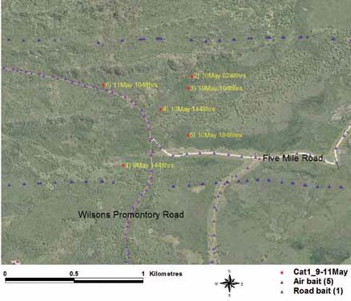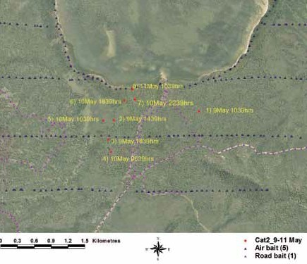

**18**

Cat 3 – This cat died following consumption of aerially applied Curiosity® bait and encountered these baits between 1601 hrs 9 May and 1200 hrs 10 May 2011 (Figure 17).

Figure 17. Location of Cat 3 while baits were attractive and palatable.

Cat 4 – This cat was fitted with a VHF-only collar. It died following consumption of aerially deployed Curiosity® bait(s).

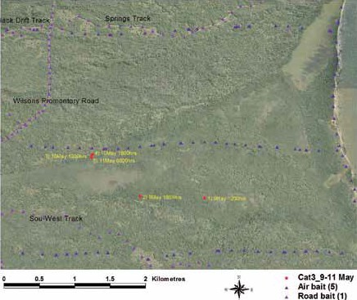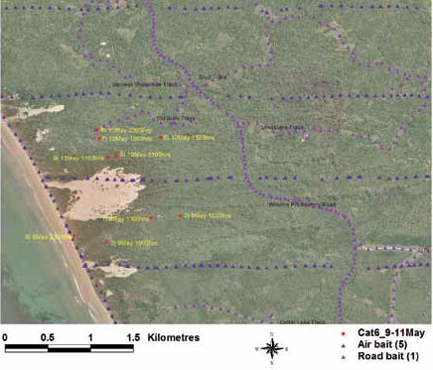

Cat 5 – This cat died prior to baiting.

Cat 6 – The GPS collar indicated that this cat crossed baited transects

between 2303 hrs 9 May and 1103 hrs

1. May 2011 and was later within 27 metres of a baited location at 2303 hrs on the 10 May 2011 (Figure 18). This cat survived.

Figure 18. Location of Cat 6 while baits were attractive and palatable.

Cat 7 – This cat was last determined to be alive on the 20 April 2011. Despite considerable search effort this cat was not able to be relocated. Transmitter failure or long distance movement are possible explanations.

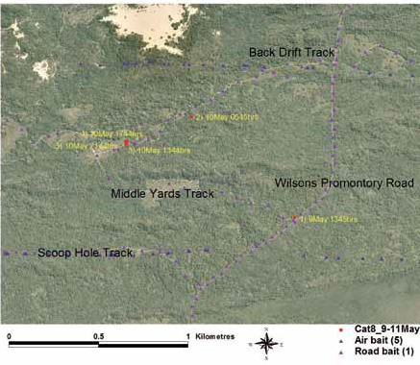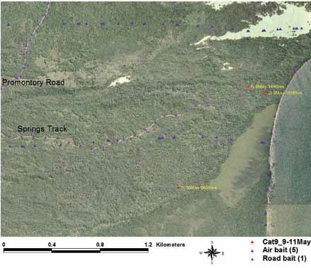

Cat 8 – This cat died from consumption of Curiosity® bait(s) applied on the road transect – indicated by the observation of gold coloured glitter in the stomach during post mortem examination (Figure 19). It was recorded close to road baits a number of times.

Cat 9 – This cat died following consumption of aerially deployed Curiosity® bait. It is likely to have encountered bait(s) between 1856 hrs 9 May and 0656 hrs 10 May 2011

(Figure 20).

Figure 19. Location of Cat 8 while baits were attractive and palatable.

Figure 20. Location of Cat 9 while baits were attractive and palatable.

Cat 10 – The GPS collar indicated that this cat crossed baited transects between 1520 hrs –1920 hrs on 10 May, and then also at 0721 hrs on 11 May 2011. This cat may have

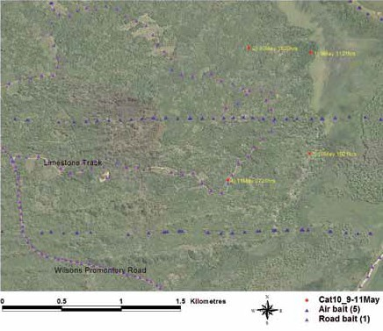

crossed transects several times to reach its recorded position at 1521 hrs on

1. May 2011 or indeed could have transited along the Limestone Track to reach its position at this time (Figure 21). This cat survived.

Figure 21. Location of Cat 10 while baits were attractive and palatable.

## Automated cameras

The occupancy rate of Feral Cats throughout the site found support for the hypothesis that the two camera methodologies (i.e. camera in bush with a food lure or

camera on track with no lure) indicated different occupancy rates. Occupancy rates were estimated to be almost 80% higher when assessed using the track cameras. However, a change in occupancy rate of the Feral Cat population in the post baiting survey; attributable to application of Curiosity® baits (Table 3), was not well supported. Cats were detected at 12 bush and 21 track camera sites prior to baiting and 11 bush and 15 track sites after baiting. Note that there is no attempt to identify repeat ‘capture’ of individuals in this analysis.

Similar data applies in the case of Red Foxes with occupancy only affected by the location of the camera, i.e. bush / track

but not the presence of baits. Foxes were only detected by cameras placed in the track locations throughout both monitoring periods.

The only species that supported different occupancy rates after baiting were Pied Currawong *Strepera graculina* and Hog Deer *Axis porcinus*. There was a difference between the two survey periods (prior to and following baiting)

for currawongs with occupancy reduced following the application of baits. Hog Deer were detected at more bush sites in pre-baiting surveys than in the post-baiting survey.

The model with the most support for each species and the estimated occupancy rates from data collected with automated cameras at bush and track sites is presented in Table 4. The estimated detection rates are not included in the table as they are not of interest in this study.

Table 4. The occupancy of target and non-target species prior to and following application of Curiosity® baits at Wilsons Promontory National Park.



|  |  |  |  |
| --- | --- | --- | --- |
| **Species** | **Best Model** | **Estimated occupancy**  **Bush camera Road camera with lure Pre-bait without lure Pre-bait**  **(Post-bait) (Post-bait)** | |
| Feral Cat | Ψ(Location)*p*(.) | 0.295 | 0.526 |
| *Felis catus* | (0.295) | (0.526) |
| Red Fox | Ψ(.)*p*(Location) | 0.515 | 0.092 |
| *Vulpes vulpes* | (0.515) | (0.092) |
| Common Wombat | Ψ(.)*p*(Bait*Location) | 0.821 | 0.821 |
| *Vombatus ursinus* | (0.821) | (0.821) |
| Black Wallaby | Ψ(.)*p*(Bait*Location) | 0.736 | 0.736 |
| *Wallabia bicolor* | (0.736) | (0.736) |
| Hog Deer | Ψ(Bait+Location), *p*(Location) | 0.438 | 0.680 |
| *Axis porcinus* | (0.285) | (0.521) |
| European Rabbit | Ψ(Location)*p*(Bait) | 0.165 | 0.301 |
| *Oryctolagus cuniculus* | (0.165) | (0.301) |
| Australian Raven | Ψ(Location)*p*(Bait*Location) | 0.081 | 0.786 |
| *Corvus coronoides* | (0.081) | (0.786) |
| Australian Magpie | Ψ(.)*p*(.) | 0.142 | 0.142 |
| Gymnorhina tibicen | (0.142) | (0.142) |
| Pied Currawong | Ψ(Bait+Location)*p*(Location) | 0.189 | 0.494 |
| *Strepera graculina* | (0.079) | (0.266) |
| Common Bronzewing Pigeon | Ψ(.)*p*(Location) | 0.330 | 0.330 |
| *Phaps chalcoptera* | (0.330) | (0.330) |
| Emu | Ψ(.)*p*(Bait+Location) | 0.742 | 0.742 |
| *Dromaius novaehollandiae* | (0.742) | (0.742) |

## Cat activity in relation to fire

The Little Drift ecological burn was conducted on 1 April 2011. The aim of the burn was to reduce the cover teatree. The burn was considered unsuccessful in that <5% of the planned burn area was ignited (Figure 22; J. Whelan, pers. comm.).

Figure 22. Example of the extent of Little Drift ecological burn.

The location data sourced from cats fitted with GPS datalogger collars was divided into periods representing the pre- and post ignition of the Little Drift ecological burn (Table 5). Figures 23 to 30 illustrate the locations used by Feral Cats throughout this study. The aerial photograph used as the background image for these figures was taken in February 2008. Note that cats 5–10 were trapped and fitted with a collar after the ignition of the Little Drift burn. No data is shown for Cat 4 as it was fitted with a VHF only collar and Cat 7 as this collar could not be relocated. All activity data was collected approximately two years after The Cathedral bushfire.

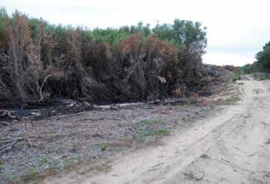

Table 5. Cat location in relation to use of burnt areas at Wilsons Promontory National Park.

|  |  |  |  |
| --- | --- | --- | --- |
| **Cat Identifier** | **No. of GPS data points recorded** | **% points within the area burnt by The Cathedral bushfire** | **% points within the area burnt by the Little Drift burn** |
| 1 | 307 | 100 | 0 |
| 2 | 357 | 100 | 0 |
| 3 | 292 | 48 | 0 |
| 4 | 2 | 0 | 0 |
| 5 | 17 | 58 | 0 |
| 6 | 174 | 66 | 0 |
| 7 | 1 | 0 | 0 |
| 8 | 90 | 0 | 0.03 |
| 9 | 65 | 0 | 0.09 |
| 10 | 87 | 84 | 0 |

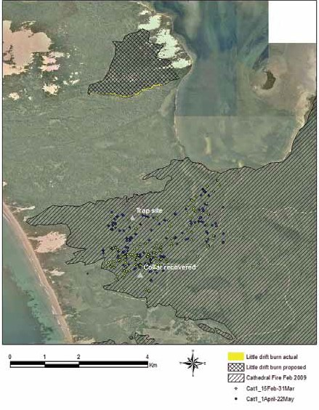

Cat 1 – Home range was calculated to be 778 ha (95% MCP).

Figure 23. Locations used by Cat 1 in relation to fire events at Wilsons Promontory National Park before and after the Little Drift ecological burn.

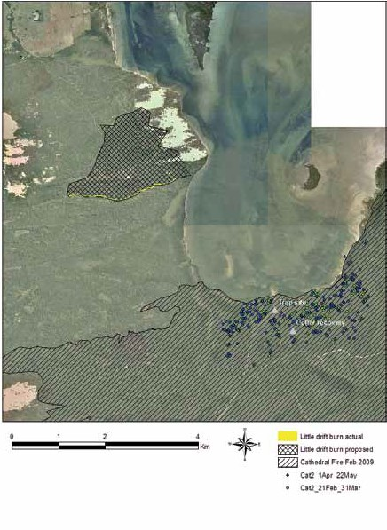

Cat 2 – Home range was calculated to be 370 ha (95% MCP).

Figure 24. Locations used by Cat 2 in relation to fire events at Wilsons Promontory National Park before and after the Little Drift ecological burn.

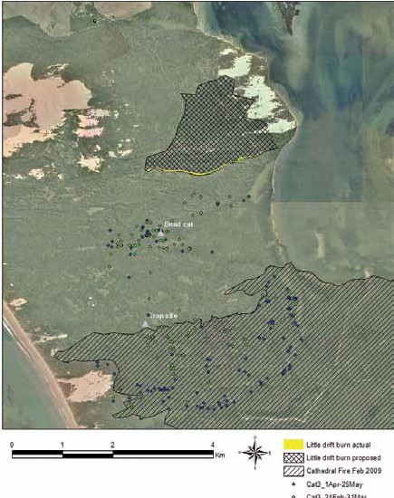

Cat 3 – Home range was calculated to be 1362 ha (95% MCP).

Figure 25. Locations used by Cat 3 in relation to fire events at Wilsons Promontory National Park before and after the Little Drift ecological burn.

**26**

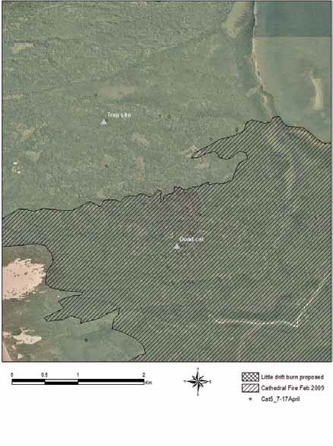

Cat 5 – There was insufficient data collected to accurately defi a home range size.

Figure 26. Locations used by Cat 5 in relation to fire events at Wilsons Promontory National Park.

**27**

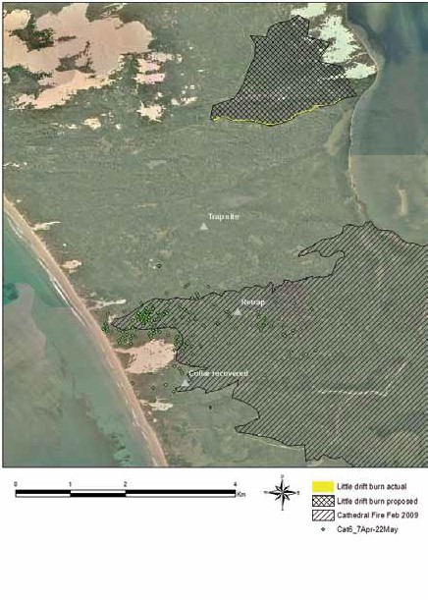

Cat 6 – Home range was calculated to be 499 ha (95% MCP).

Figure 27. Locations used by Cat 6 in relation to fire events at Wilsons Promontory National Park.

**28**

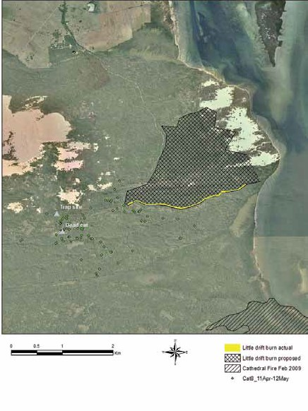

Cat 8 – Home range was calculated to be 294 ha (95% MCP).

Figure 28. Locations used by Cat 8 in relation to fire events at Wilsons Promontory National Park.

**29**

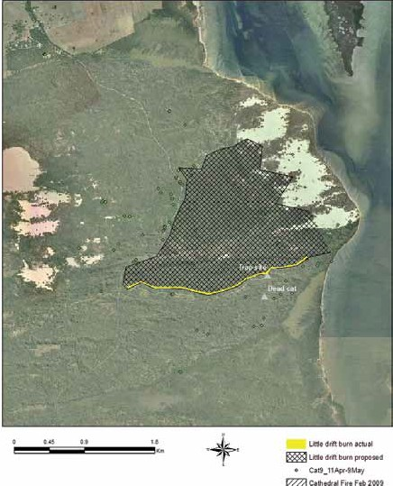

Cat 9 – Home range was calculated to be 653 ha (95% MCP).

Figure 29. Locations used by Cat 9 in relation to fire events at Wilsons Promontory National Park.

**30**

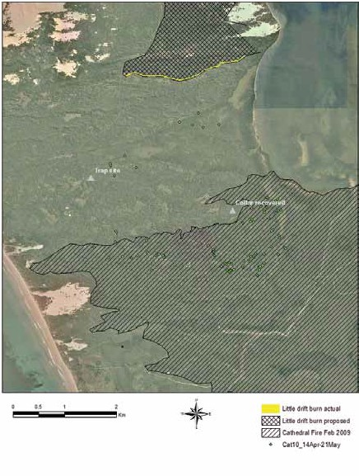

Cat 10 – Home range was calculated to be 800 ha (95% MCP).

Figure 30. Locations used by Cat 10 in relation to fire events at Wilsons Promontory National Park.

**31**

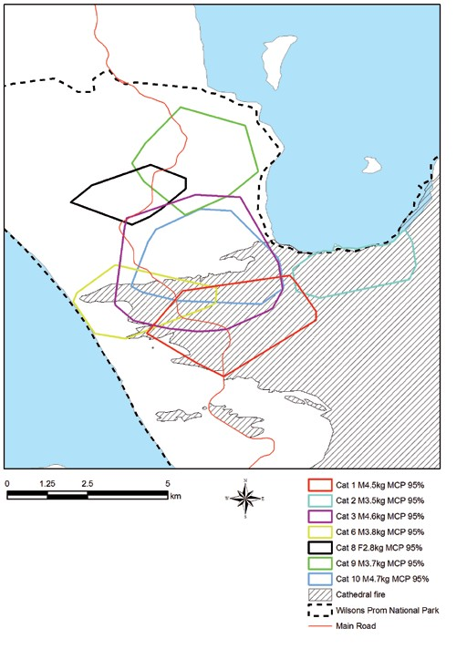

The home ranges of the collared Feral Cats in this study were observed to have considerable overlap (Figure 31). The presence or absence of recent fire did not influence cat ranging behaviour.

Figure 31. Home range (MCP95%) of Feral Cats at Wilsons Promontory National Park.

**32**

# 4 Discussion

Historic records indicate that Feral Cats have been abundant throughout Wilsons Promontory National Park with “dozens” of cats reported to be killed during poisoning programs in 1967/68 and yet the species remained widespread and common in 1971 (Seebeck and Mansergh 1998). However, most recent management has been restricted to the use of cage traps on an opportunistic

basis such as at times when funding was available (G. Kerr and D. Bone pers. comm.). This study was the first field efficacy assessment of the Curiosity® bait conducted on mainland Victoria and follows a previous study undertaken within French Island National Park (Johnston *et al.* 2011). The present study was designed to collect data that would assist land managers, such as Parks Victoria, with the management of Feral Cat populations by a) demonstrating that the Curiosity® bait was effective in a reducing the population, b) assessing the impact of the bait use on non- target wildlife species (including Red Foxes), c) illustrating the home range behaviour of Feral Cats at the site with particular reference to identifying the impact of fire.

The study was timed to take place during early winter as previous studies (Algar *et al.* 2007; Johnston *et al.* 2011) have indicated that optimal bait consumption occurs when Feral Cats are food stressed. While no specific study has been made of Feral Cat diet at this site (J. Whelan, pers. comm.), likely dietary staples such as juvenile rabbits and small reptiles are generally not present or active at this time. Acquisition of the necessary permits for the conduct of the study also impacted the timing of project activities with, for example, the Australian Pesticides and Veterinary Medicines Authority field trial permit received 13 months after submission.

The procedures used in the present study were designed to assess both the efficacy of the Curiosity® bait on Feral Cats and the immediate impact of the bait on non-target wildlife species. While the target species in this case was the Feral Cat, it was expected that the presence of the Red Fox at the site would influence cat behaviour and, as such, some aspects of the monitoring program were designed to investigate

any population change in this species also, i.e. did the baits kill foxes as well. Pen studies have indicated that foxes will consume and die as a result of consuming Curiosity® baits (Johnston and Gigliotti, unpublished data). As a result, a sample of the resident Feral Cat and fox population were trapped and fitted with radio-telemetry collars. However, far greater information was collected on the activity of Feral Cats as these were fitted with GPS datalogger collars – excluding one sub-adult cat tat was under the required body mass to wear the 140 g GPS devices.

Ten Feral Cats were fitted with radio-telemetry collars and monitored at intervals through the study. This monitoring consisted of irregular checks from distant locations to ascertain whether the cat was alive or dead – indicated by the rate of transmitted VHF tones on the collar. The project was designed such that the GPS datalogger collars

were planned to be fitted in February/March and were

pre-programmed to drop off the cats on the 23 May 2011. Poor trap success during the February/March period (four cats/seven foxes) led to an additional trapping period being undertaken in April which led to a further six cats being trapped. This reduced the amount of activity data collected on Feral Cats throughout the site. The reasons for the low trap success are thought to relate in part to the trapping technique used and lower-than-expected cat activity on the road network at this time. Cat footprints were observed far less frequently on sandy sections of vehicle tracks during the February period compared to April. All traps used were in good order and operated by competent professional contract trappers as well as experienced departmental staff. The improved trap success during April may also be due to use of a ‘walk-through’ set rather than the ‘dirt-hole’ or ‘cubby’ sets (Sullivan 2003) used in February/March.

The baiting efficacy achieved in this study (i.e. four of eight known alive collared cats poisoned) was acceptable given that baits were only attractive and palatable for a period

of less than 30 hours. A greater efficacy rate would have been expected if the heavy rain and hail had not made bait less attractive and unpalatable. Studies at other sites have indicated that baits are generally consumed by cats within the first three days but cats have died from consuming poison baits at day+10 (Johnston *et al.* 2010; Johnston

*et al.* 2011). The actual date of baiting in this study was determined in consultation with the Bureau of Meteorology forecasters and a variety of other logistical issues, i.e.the availability of necessary support staff, aircraft, receipt of permits. Additionally, the baits had to be laid at least ten days prior to the pre-determined collar drop-off date of

23 May. In this case, while the weather was ideal over the Easter holiday period in late March, the operation was necessarily planned to avoid this period given the high number of park visitors in the study site during this time. Less favourable weather was experienced after the Easter break.

The techniques used for successful application of baits intended for Feral Cats has been developed largely in the semi-arid zone of Western Australia (Algar and Burrows 2004; Algar *et al.* 2007; Moseby 2011). However, there have been several studies conducted in south-eastern Australia (Johnston *et al.* 2007, 2011). Greater baiting efficacy has been achieved during periods of cool dry weather (Algar *et al.* 2007; Johnston *et al.* 2011). The bait density and pattern used in this study at Wilsons Promontory National Park was developed in accordance with best practice techniques presented in the literature.

The use of a helicopter provides a more accurate and evenly distributed bait pattern than the fixed wing aircraft used in other studies (Thompson 1990; Robley 2011). The pattern of ground spread indicated that the baits dropped from the aircraft were ‘clumped’ rather than ‘spread’ evenly across the landscape. This suggests that animals that encountered



**33**

aerially-delivered baits were likely to detect multiple baits. The absence of aerially-delivered baits in buffer areas at this site, such as over roads or high visitor use areas, did not lead to unbaited ‘refuges’ given that ground baiting was also undertaken in these areas. One of the four collared cats that died from consumption of a Curiosity® bait was found to have consumed ‘ground-laid’ baits. This was indicated by the presence of glitter observed in the stomach during post- mortem examination of the cat.

The impact on non-target species was assessed using a variety of techniques including dedicated searching, detections by automatic cameras and incidental

observations. A key non-target species in this study was the Lace Monitor *Varanus varius* as the limited study that had been conducted to date indicated that this species is particularly susceptible to the toxin used in the Curiosity® bait, i.e. para-aminopropiophenone (S. Humphries,

pers. comm.). Both DSE Wildlife Atlas records as well as observations by Parks Victoria staff (J. Whelan and E.

Seymour, pers. comm.) indicate that Lace Monitors have been recorded infrequently throughout Wilsons Promontory National Park. The baiting program had always been planned to be undertaken in the cooler weather of late Autumn so as to minimise the impact on reptile species generally, both from the perspective of minimising their exposure to poison baits but more specifically to minimise the alternative food available to Feral Cats. In addition, a specialised sub-project was developed to assess the impact of the baiting program on Lace Monitors. This work was designed and undertaken by varanid specialists from Melbourne University (Jessop *et al.* 2011). Results from work at sites with similar vegetation communities and abundant monitor populations indicated that (non-toxic) baits were consumed and would have lead to the death of monitors had toxic baits been used. However, as targeted trapping and camera surveys throughout the Wilsons Promontory National Park field site conducted prior to application of Curiosity® baits failed to detect any Lace Monitors, it was determined that the overall baiting program would have an undetectable impact on the local population.

Parks Victoria undertakes an annual trapping program for small mammals at discrete sites throughout the Yanakie Isthmus. The results from this annual work were to be used as a reference point as a part of the monitoring

of any impact on non-target mammal species following application of Curiosity® baits. However, this work was not undertaken given that Parks Victoria staff were heavily

engaged in recovery operations following the impact of the 22 April 2011 storm event. While this meant that dedicated monitoring for this guild of species was not possible,

some data was collected using species photographed at automated cameras which is presented in Table 4. This data itself should be considered incidental as the use of cameras was not intended for, or baited with lures that would be attractive to, a wide range of small – medium mammal species. For example, in the case of the Long-

nosed Bandicoot, this species was photographed at six sites prior to baiting and two sites following baiting. While bandicoots are thought to be highly susceptible to PAPP (S.

Humphries, pers. comm.) these species are considered to be unlikely to be exposed to toxic doses of the PAPP toxicant. Specific trials, with captive and free-ranging animals, that investigated the potential for exposure of a range of small- medium sized mammals indicated a reliable rejection of

the encapsulated pellet used within the Curiosity® bait product (Hetherington *et al.* 2007; Forster 2009; Johnston, unpublished data).

The camera data indicated that there was no significant difference in site occupancy by Feral Cats throughout this study that could be attributed to application of Curiosity® baits on the 9 May 2011. The analysis indicated that there was a difference in the occupancy between bush and track cameras. However, this result is probably due to other factors, such as lure choice, rather than reflecting

a real absence of cats in ‘bush’ sites. The data collected from the cats fitted with GPS datalogger collars indicates that Feral Cats at this site are predominantly found away from established tracks. In this study, pilchards housed in perforated plastic devices were used as a food lure and it was noted that the meat rapidly putresced in the pre-bait monitoring period due to hot weather. Putrescent meat is not attractive to Feral Cats and, as such, the detection rate of the bush cameras was, not surprisingly, lower. The

cameras placed on road locations proved a more effective monitoring technique in this study in terms of detecting and photographing Feral Cats. However, there was no significant difference in occupancy / detections of Feral Cats between the pre- and post bait surveys. It is assumed that the rapid deterioration in bait attractiveness brought about by the rain and hail experienced on the evening of 10/11 May 2011 resulted in a low rate of bait consumption across the Feral Cat population resident at this site. However, it is not known whether any cats survived consumption of a toxic bait. This assessment could ordinarily be made by assessing presence of Rhodamine B bands in facial whiskers (Fisher *et al.* 1999; Fisher 2000). However, the density of vegetation at the site precluded the use of VHF-guided hunting of collared cats.

A similar explanation is probable with the observed impact on the population of Red Foxes with respect to expected detection at bush camera sites and choice of lure. Foxes are readily detected by automated cameras with food lures in off-track situations (Robley pers. comm.), although

foxes may be more frequently detected in road locations in densely vegetated areas (Towerton *et al.* 2011). Preliminary trials have demonstrated that captive Red Foxes (n=4) can be poisoned with Curiosity® baits (Johnston and Gigliotti, unpublished data). The observed survival of foxes (4 of 4) in this study suggests that further research is warranted to determine the attractiveness and palatability of Curiosity® baits to free-ranging animals.



**34**

The analysis detected a decline in occupancy of Pied Currawong during the post-baiting surveys. It is proposed that this result may be reflective of other factors such as seasonal behaviour or migration as no currawongs have been photographed interacting with (i.e. consuming) baits in this study. Indeed, while currawongs have been

photographed or observed being in close proximity (~2m) to baits, no behaviour suggesting interest in, or consumption of, baits has been collected during this and previous studies on Tasman Island (TAS) or French Island (VIC). Ravens were photographed removing baits that had been placed in front of some road cameras. Pen studies (F. Gigliotti, pers. comm) have indicated that ravens will reliably remove the toxic pellet from Curiosity® baits. Bait removal by corvids has lead to reduced opportunity for bait encounter by target species in field studies using automated cameras at this site as well as French Island, Tasman Island and the Flinders Ranges (Johnston unpublished data).

Chesterfield (1998) details the known fire history within the Wilsons Promontory National Park over the period 1863

– 1957 and notes that extensive and severe fires occurred throughout this time. Fire has been used extensively by successive land managers to achieve a variety of ‘productive outcomes’ such as clearing, stimulating growth or reducing potential for bushfire. While little detail exists of the use of fire by traditional owners at this site, it is likely that fire was used with the objective of creating favourable conditions for hunting or collecting vegetative resources for food, medicines, tool making etc. The frequency, seasonality and severity of burning throughout Wilsons Promontory is likely

to have changed following the arrival of European colonisers with the establishment of a cattle station in 1853 and timber-getting in 1863 (Chesterfield 1998; Gillbank 1998).

The altered fire regimes, as well as change in abundance in the populations of grazing animals, have contributed to dramatic changes in the landscape such as succession of heathland and banksia woodland to extensive even-aged

copses of Ti-tree *Leptospermum laevigatum* throughout the Yanakie Isthmus (Bennett 1994).

‘The Cathedral’ fire was ignited by a lightning strike at 1800 hrs on 8 February 2009 and burned 25,200 km2 area before being declared ‘under control’ on 14 March 2009 (Teague *et al.* 2010). Similarly to historic bushfires, this fire occurred following a sustained period of rainfall

deficiency (Chesterfield 1998; Teague *et al.* 2010). Evidence was presented at the Victorian Bushfires Royal Commission (Teague *et al.* 2010) that suggested the “whole of south- east Australia [had] suffered a severe and protracted drought which [was] without historical precedent”. It

is likely that populations of some native species may have already been depressed as a result of the sustained drought. However, it is difficult to determine the impact The Cathedral bushfire had on the viability of wildlife

populations given the absence of broad scale pre and post fire survey data.

Only limited conclusions can be drawn from this study on the response of exotic predators, such as Feral Cats and foxes, to fire events. This is probably due to the two year period that occurred between the ‘The Cathedral’ fire event (i.e. February / March 2009) and the conduct of this study. Efforts to collect data on this issue in relation to the Little Drift ecological burn were frustrated by there being

insufficient cats collared at the time of ignition and also that the burn itself was not successful.

The location data generated by the GPS datalogger collars in this study indicates that there was no obvious bias in cat behaviour with respect to favouring or avoiding burnt areas. The data is probably more reflective of conventional home range activity patterns with home range size varying in response to food resources and seasonal breeding behaviour. During the term of this study, the home range of seven Feral Cats (6M, 1F) was calculated to be between 294 – 1362 ha using the MCP95% analysis tool. It should

be noted that the data is biased towards behaviour of male cats and that further data is required on the behaviour of females.

While not apparent in this study, fire may have a greater influence on Feral Cat behaviour during the weeks after the event when the cats exploit the burnt areas and edges. A current PhD study in the north-west of Western Australia has collected data that suggests intentional investigatory behaviour by an adult male Feral Cat in response to

recent fire. This data indicates that the animal undertook considerable and direct travel outside its original ‘home range’ to the edge of the burnt area where it remained for 20 days before returning to the point of origin (H. McGregor, pers. comm.).



**35**

# 5 Conclusions



The current tools available to land managers, such as Parks Victoria, for the management of Feral Cat populations

in Victoria are labour intensive and able to only affect control over relatively small areas. Effective poison baits, that have minimal impact on non-target species, would provide conservation agencies with a more cost-effective tool. However, in order to achieve the optimal population reduction, the bait must be applied at times when suitable weather is forecast to a) ensure that the baits remain attractive and palatable for as long as possible, b) minimise competition for baits by other carnivores such as goannas, and c) ensure that alternative food sources for cats are minimised. Dates may be more flexible in an operational use of baits given that agencies are less likely to have artificial ‘deadlines’ imposed on their work such as occurred in this study with the combination of a period of poor weather and a looming collar drop-off date. This study demonstrated that the Curiosity® bait was attractive and lethal to four

of eight feral collared cats that were known to be alive. Limited conclusions can be made about the survival of the other four cats, given that it is unknown whether they encountered bait, and/or consumed it, and/or survived.

Changes made to the bait distribution pattern (i.e. flight transects at 500 m intervals) and more frequent acquisition of locations from GPS datalogger collars (i.e. 30 mins) at the time of baiting would provide greater data to analyse. The use of VHF telemetry-guided hunting for the surviving collared cats would also provide an opportunity to assess whether cats consumed bait and survived.

This study did not detect a relationship between fire behaviour and use of the landscape by Feral Cats. There are several possible reasons for this, including; a) the lack of pre-fire data for Feral Cats at this site that can be used for

comparison, b) the two year interval between The Cathedral fire and this study, and c) failure of Little Drift ecological burn which meant that little pre- and post fire data could be collected.

**36**

# References

Abbott, I. and Burbidge, A.A. (1995). The occurrence of mammal species on the islands of Australia: a summary of existing knowledge. *CALMScience*, **1**, 259–324.

Algar, D., Angus, G.J., Williams, M.R., Mellican, A.E. (2007).

Influence of bait type, weather and prey abundance on bait uptake by feral cats (*Felis catus*) on Peron Peninsula, Western Australia. *Conservation Science Western Australia* **6 (1)**, 109–149.

Bennett, L.T. (1994). The Expansion of *Leptospermum laevigatum* on the Yanakie Isthmus, Wilson’s Promontory, Under Changes in the Burning and Grazing Regimes.

*Australian Journal of Botany* **42**, 555–564.

Chesterfield, E.A. (1998). Fire History: Wilsons Promontory National Park. *The Victorian Naturalist* **115 (6)**, 337–342.

DEWHA (2008). Background document for the threat abatement plan for predation by feral cats, Department of Environment, Water, Heritage and the Arts, Canberra.

Dickman, C. (1996). Overview of the impacts of feral cats on Australian native fauna. Australian Nature Conservation Agency. Canberra.

Fisher, P., Algar, D., Sinagra, J. (1999). Use of Rhodamine B as a systemic bait marker for feral cats (*Felis catus*). *Wildlife*

MacKenzie, D.I. and Nichols, J.D. (2006). Occupancy Estimation and Modeling. San Diego, California, USA.

Meek, P.D. and Saunders, G. (2000). Home range and movement of foxes (*Vulpes vulpes*) in coastal New South Wales, Australia. *Wildlife Research*, **27**, 663–668.

Parks Victoria (2009). Wilsons Promontory National Park: Visiting after The Cathedral fire 2009. Parknotes series, Melbourne.

R Development Core Team (2005). R: A language and environment for statistical computing. R Foundation for Statistical Computing. Vienna, Austria.

Rodgers, A.R. and Carr, A.P. (1998). HRE: The Home Range Extension for ArcView. Ontario Ministry of Natural

Resources, Centre for Northern Forest Ecosystem Research, Thunder Bay, Ontario, Canada.

Russell, B.G., Smith, B. and Augee, M.L. (2003). Changes to a population of common ringtail possums (*Pseudocheirus peregrinus*) after fire. *Wildife Research* **30**, 389–396.

Seebeck, J. and Mansergh, I. (1998). Mammals introduced to Wilsons Promontory. *The Victorian Naturalist*. **115 (6)**, 350–356.

st

*Research* **26**, 281–285.

Sullivan, H. (2003). Canines 2000: 21

Century techniques

Fisher, P. (2000). Rhodamine B as a marker for the assessment of bait uptake by non-target animals. Vertebrate Pest Research Department Technical Series No. 4. Department of Natural Resources and Environment.

Gillbank, L. (1998). The Wood and the Trees. A Muellerian memoir of Wilsons Promontory by the late Baron Ferdinand von Mueller (1825–96). *The Victorian Naturalist* **115 (6)**,

286–291.

Jessop, T., Lockwood, T., Kearney, M. and Johnston,

M. (2011). Evaluating and predicting non-target bait consumption of the Curiosity® bait with specific reference to a native predator, the lace monitor. Unpublished report for the Department of Sustainability and Environment. The University of Melbourne, Department of Zoology.

Johnston, M.J., Shaw, M.J., Robley, A., and Schedvin, N.K. (2007). Bait uptake by feral cats on French Island, Victoria. *Australian Mammalogy* **29 (1)**, 77–84.

Johnston, M., Algar, D., O’Donoghue, M. and Morris. (2011). Field efficacy of the Curiosity® feral cat bait on three Australian islands. 166–171. In: Veitch, C.R.; Clout, M.N. and Towns, D.R. (*eds*.). Island invasives: eradication and management. IUCN, Gland, Switzerland.

MacKenzie, D.I., Nichols, J.D., Lachman, G.B., Droege,

S., Royle, J.R. and Langtimm, C.A. (2002). Estimating site occupancy rates when detection probabilities are less than one. *Ecology* **83 (8)**, 2248–2255.

for trapping fox and coyote. Published by Sullivan

Promotions, Blue Creek, Ohio, USA.

Teague, B., McLeod, R. and Pascoe, S. (2010). 2009 Victorian Bushfires Royal Commission – Final Report. Parliament of Victoria, ISBN 978-0-9807408-1-3.

Towerton, A.L., Penman, T.D., Kavanagh, R. and Dickman,

C.R. (2011). Detecting pest and prey responses to fox control across the landscape using remote cameras. *Wildlife Research* **38**, 208–220.



**37**



**38**