**The objectives and purposes of the action.**

The key objective of this research project is to explore the biology, ecology, geomorphology and oceanography at the deepest part of Australia’s Marine Park Network and the numerous other deep-sea environments within Australia’s EEZ encapsulated within the network of Australia Marine Parks off Western Australia. We will utilise a suite of scientific equipment (MBES, oceanographic, video, and traps) to understand how physical process and structure in the deep sea relate to the biology and ecology of organisms.

**The equipment and methods used to comply with the EPBC Act Regulations.**

UWA is proposing to use the Pangaea Ocean Explorer (POE) to conduct this survey. The POE has a multibeam echosounder (MBES) which will provide bathymetric data prior to the deployment of baited landers. The POE is a 58 m (10.97 m beam and 4.2 m draft) motor yacht with a hull mounted MBES. The MBES is a Kongsberg EM304. All MBES operations are undertaken in the open ocean (i.e. >3000m water depth) far from the coastline and shallow water features. MBES operations in the ocean open do not herd whales into environments where they can become stranded. MBES data are utilised onboard the POE to identify locations to deploy landers. The Kongsberg EM304 has an operating frequency of 26 – 34 kHz and nominal frequency of 30 kHz. Further technical specifications are attached in Appendix 2.

Landers (Figure 1 and Figure 2) are deployed from the POE and free-fall to the seafloor. Each lander will remain on the seafloor for ~8 hours. Upon acoustic release of weights, the lander will float to the surface where it is collected by the POE. Each lander is equipped with a duel baited camera system to visual record mobile species a conductivity, temperature and depth (CTD) recorder, acoustic current doppler sensor, and three styles of traps. The first is a rectangular trap measuring 47 cm wide, 20 cm high and 67 cm long, and housed inside the lander frame. The second trap is an opera trap measuring 87 cm long, 50 cm wide and 30 cm high. The funnel opening is 22 cm and the internal ring is 12 cm. Both traps have a 15 mm square mesh size. The third trap is a hoop style net with an opening of 90 cm in diameter and made from 20 x 20 mm knotless nylon netting.

Timing: Both MBES and lander operations will occur from the eastern Diamantina Fracture Zone (DFZ), across the Naturalist Plateau into the Perth Abyssal Plain and conclude on the western side of Perth Canyon (Figure 2). This survey is scheduled for the second half of March and first half of April 2022. This will coincide with foraging aggregation of Pygmy Blue whales (November – May) and include approximately 10 days of vessel movement and MBES in foraging areas identified as Biologically Important Areas (BIA; Department of Agriculture, Water and the Environment). While unfortunately overlapping with this peak time, this period coincides with the ideal weather period and ensures the safety of personnel whilst working so far offshore.

**What steps will be taken to minimise impacts on cetaceans.**

We will adopt several strategies to reduce impacts to blue and pygmy blue whales whilst operating inside BIAs. These include:

* Use two observers during multibeam operations to look for whales.
* Only start the equipment if whales have not been sighted within 1km over a 30 minute period.
* Use a soft start whereby power is increased gradually over a 30 minute period.
* Use the minimum source level to achieve the result needed.
* Shutdown the multibeam equipment if whales are within 500 m of the vessel.
* Observe minimum approach distances for all cetaceans as per the National Whale and Dolphin Watching Guidelines, with the distance extended for blue whales to 500m in all directions around the whale.
* Operate MBES between 6am and 6pm during times of good visibility.
* Reduce vessel speed to as low as reasonably practical and safe from 6pm to 6am with a maximum speed of 10 knots as per recommendation in the [National Strategy for Reducing Vessel Strike on Cetaceans and other Marine Megafauna](https://www.awe.gov.au/sites/default/files/documents/vessel-strike-strategy.pdf).

Due to requirement for multibeam operations to occur during day time hours and the expansive study area, transiting between sites will occur over night. As mentioned above, we will reduce speeds during transiting and the hours from 6pm and 6am to as low as reasonably practical and safe. The vessel will not travel faster than it requires to reach the study site by 6am with a maximum speed of 10 knots.

With regards to lander deployments:

* Landers will only be deployed if whales have not been sighted within 1 km over a 30 minute period.
* Lander ascent will only be triggered if whales have not been sighted within 1 km of the surfacing site within 30 minutes.
* Vessel tenders will be deployed and at the surfacing location to monitoring the surfacing of the lander and secure it once at the surface. Crew onboard tenders will monitor the traps and further secure them if they appear come loose.
* Traps are affixed to the lander with stainless steel fixings rated far beyond the weight of the traps.

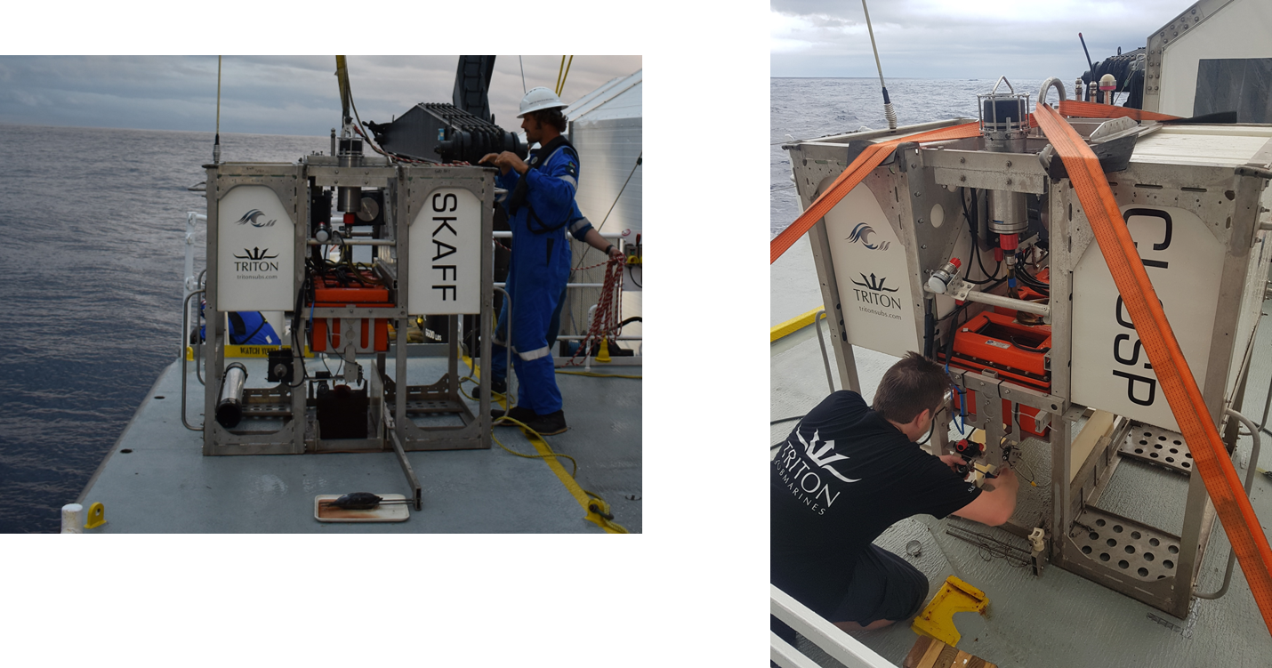

Figure 1: Example of landers.

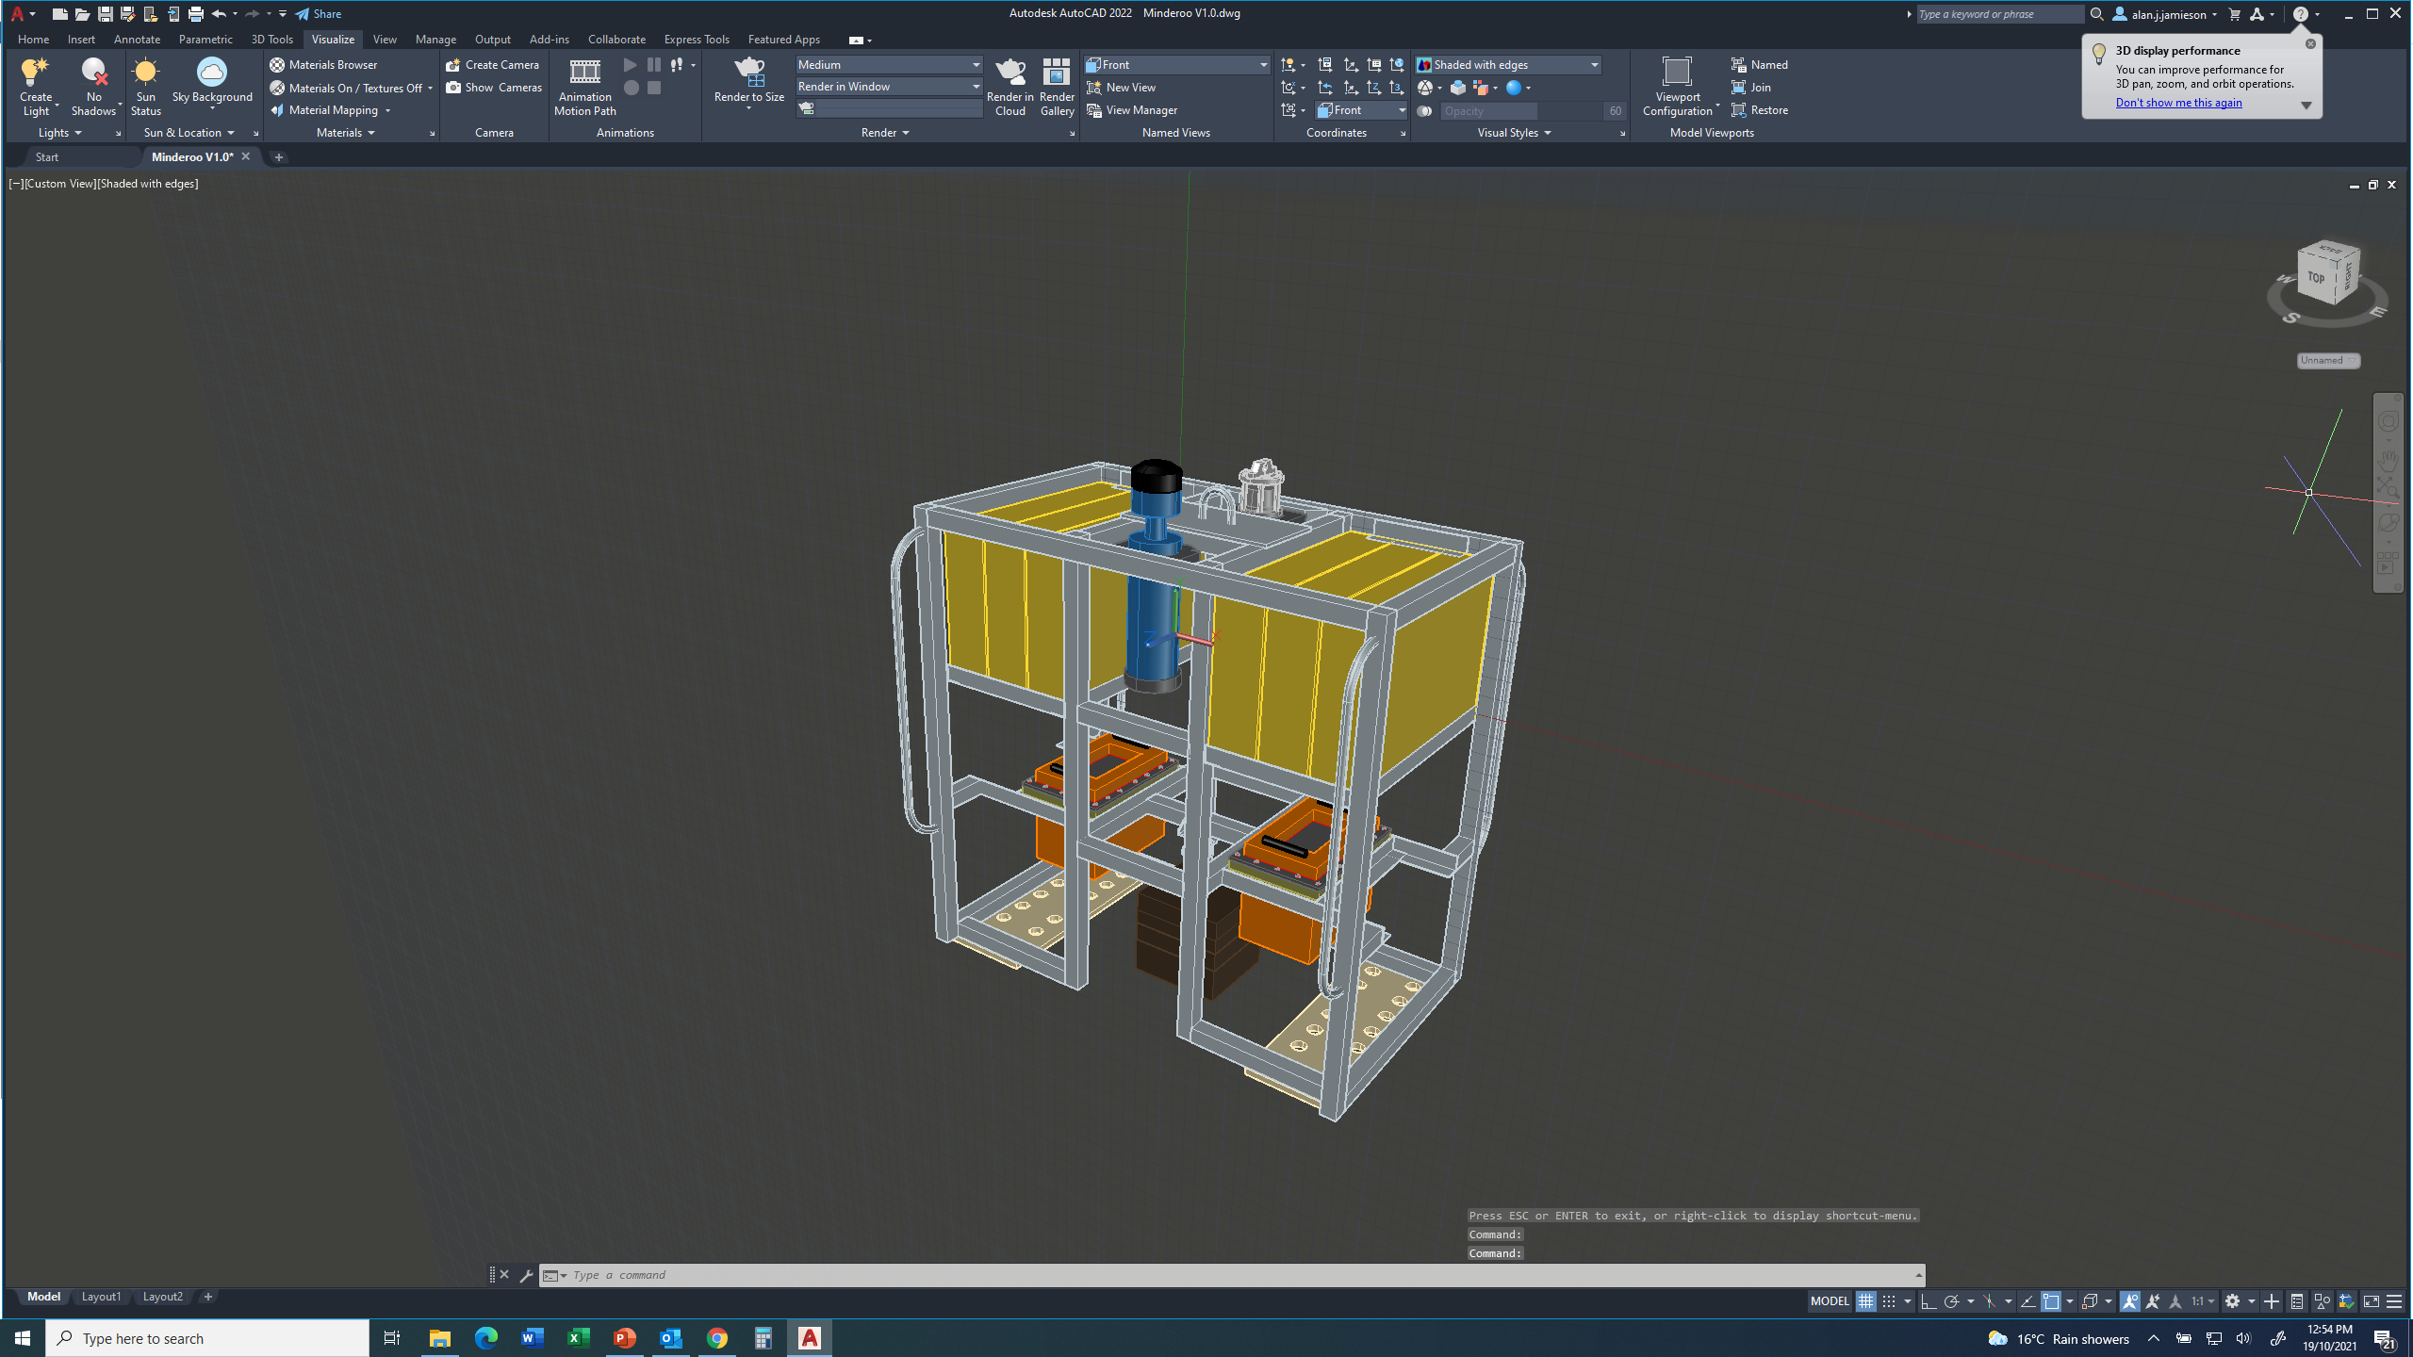

Figure 2: Drawing of lander frame under construction. Design is similar to those pictured in Figure 2.

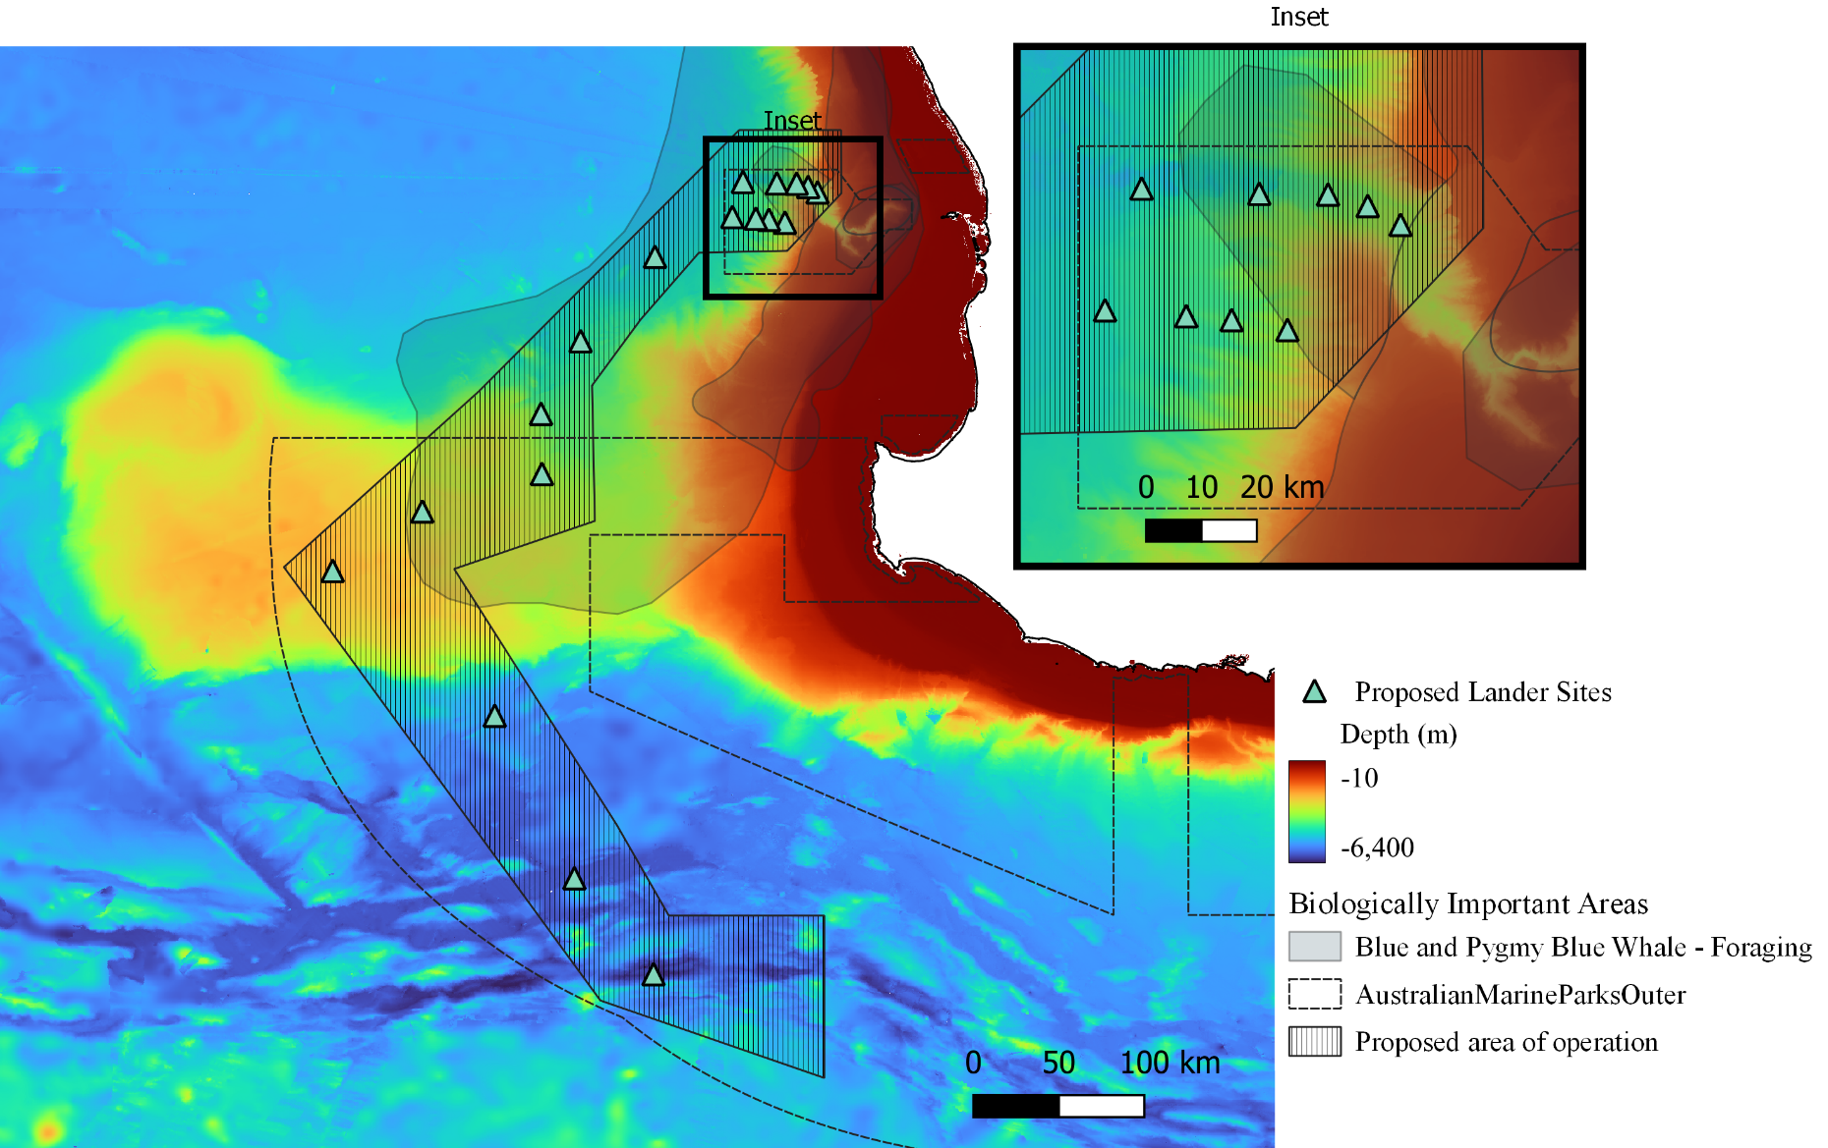

Figure 3: Map of Proposed study area including an area of operation for MBES (hatched). Blue and Pygmy Blue whales are known to forage in the transparent blue/grey areas from November to May and have been identified as Biologically Important Areas.