Country Specific Guideline

for Italy

This guideline has been prepared by the Australian Government and the Government of Italy. It is intended to assist businesses importing regulated timber products from Italy into Australia in understanding the regulatory framework in Italy in order for them to carry out their due diligence obligations under the Illegal Logging Prohibition Regulation 2012, which supports the Illegal Logging Prohibition Act 2012.

This guideline was co-endorsed by the Australian and Italian governments on 19 December 2022.

Contents
Country Specific Guideline 1
for Italy 1
1 What is required under Australia’s Illegal Logging Laws? 3
2 How to use the Country Specific Guideline (CSG) 3
3 Scope of the CSG for Italy 4
3.1 Timber harvested outside of Italy 4
4 Overview of forest management in Italy 4
4.1 Key public authorities responsible for forest sector 5
4.2 Bans or limitations on harvest of specific species 5
5 Timber products exported from Italy to Australia 6
6 Laws and regulations governing forestry in Italy 6
6.1 Private and public forest timber harvesting 7
6.2 Domestic timber processing 8
6.3 Transportation and exportation of timber 9
7 Identifying legal product from Italy 10
7.1 Evidence of timber legality 11
7.2 Timber Legality Frameworks 12
7.3 Italy’s timber import controls 12
8 Who should I contact for further information? 14
Annex 1a: Authorisation to harvest - Application form (example in Lazio Region) 15
Annex 1b: Authorisation to harvest - Permit (example in Lazio Region) 17
Annex 2a: Notice to harvest - Application form (example in Lazio Region) 22
Annex 2b: Notice to harvest - Permit (example in Lazio Region) 24
Annex 3: Transport Document Form 25
Annex 4: Table of regional Italian forestry laws 27
Annex 5: Regions and Autonomous Provinces of Italy 35

What is required under Australia’s Illegal Logging Laws?
Australia’s Illegal Logging Prohibition Act 2012 (the Act) and Illegal Logging Prohibition Regulation 2012 (the Regulation) have been designed to support the trade of legal timber products into the Australian market.
The Act establishes Australia’s framework for combatting illegal logging and makes it a criminal offence to intentionally, knowingly or recklessly import wood, pulp and paper products into Australia or process domestically grown raw logs in Australia that have been illegally logged. It also requires businesses to undertake ‘due diligence’ on ‘regulated timber products’.
The due diligence requirements for importers include the following steps:
Step 1: Establish and maintain a documented due diligence system.
Step 2: Gather information about the timber in the product that is being imported
Step 3: Assess the risk (using one of the three methods outlined in the Regulation)
Step 4: Risk mitigation (if required)
Step 5: Keep records.
Further information about Australia’s illegal logging laws and the due diligence requirements is available at the Australian Government Department of Agriculture, Fisheries and Forestry’s website (www.agriculture.gov.au/agriculture-land/forestry/policies/illegal-logging and www.agriculture.gov.au/agriculture-land/forestry/policies/illegal-logging/importers/due-diligence).

How to use the Country Specific Guideline (CSG)
This CSG is intended to assist importers that import regulated timber products from Italy into Australia, made of timber harvested within Italy, to comply with the due diligence requirements.
In accordance with section 10 of the Regulation, an importer must gather information about the product they are seeking to import, this may include gathering the information or evidence described in this CSG.
The information listed in this CSG is not meant to be an exhaustive list of evidence or documentation required to satisfy the due diligence requirements under the Regulation.
The information gathered by applying this CSG, along with any other information gathered in accordance with the Regulation, needs to be assessed in accordance with the processes outlined in section 12 of the Regulation. This includes giving consideration to any other information the importer knows, or ought reasonably to know, but is not contained in the CSG.
All data included in this document is the most current as available at time of publishing.

Scope of the CSG for Italy
This CSG provides detailed information on the control of pathways for timber harvested and originating from within Italy and informs Australian importers of what is considered legal timber. It is only applicable for timber or timber products harvested, processed and (where applicable) manufactured in Italy, and exported directly to Australia.

Timber harvested outside of Italy
There may be timber, forest products or products which contain timber, wholly or in-part, which was harvested in another country, before it was imported to Italy. These products are not in-scope of this CSG. However, information contained in this document may assist importers in conducting due diligence through another available pathway.
3.2 Timber processed outside of Italy
Timber that is harvested in Italy, but then processed in another country, also does not fall within the scope of this CSG. As a result, importers may not use the CSG risk assessment method to carry out their due diligence on these products. However, the information contained in this document may still assist Australian importers in conducting their due diligence via one of the alternative risk assessment methods available under the Regulation.

Overview of forest management in Italy
Forests cover approximately 32.5%, or 11.5 million hectares, of Italy’s national land area (FAO Global Forest Resource Assessment 2020). Approximately 93% of all forests are considered naturally-regenerated forest; a limited percentage (less than 1%) are classified as primary forests and about 6.7% forest are planted. The harvesting of timber is forbidden in ‘naturalistic core areas’, while it is regulated by stricter rules in protected areas such as natural parks or natural reserves.

Native species that are of commercial significance include Pinus spp. (pine), Castanea spp. (chestnut), Quercus spp. (oak), and Picea abies (Norway spruce), among others. Plantations include Populus spp., Eucalyptus spp., Pseudotsuga menziesii (Douglas Fir), Pinus radiata, and a range of other broadleaved species.

In 2020, timber yields were estimated to be around 9 million m³ (EUROSTAT, 2021). Approximately 4 million m³ (44%) was used as firewood, and 5 million m³ (56%) as industrial wood.

There are three sources of timber:

- Private industrial timber – timber from private forests with industrial timber production.
- State/public industrial timber – timber from state forests with industrial timber production.
- Coppice forest (firewood) – timber harvested in coppice forest and used for firewood.

Approximately two-thirds (66%) of Italian forests are privately owned and mostly by individuals. The remaining forests (34%) are public, with the majority managed by local municipalities (65.5%). Data on plantation ownership is not available.

Key public authorities responsible for forest sector
The two main national-level authorities in Italy responsible for forestry are the Ministry of Agriculture, Food Sovereignty and Forests, and Comando unità forestali, ambientali e agroalimentari (CUFA) of the Carabinieri.

Ministry of Agriculture, Food Sovereignty and Forests (In Italian: Ministero dell’Agricoltura, della Sovranità alimentare e delle Foreste - MASAF) ) through the General Directorate of Mountain Economy and Forests (DIFOR) develops national policies related to forestry. Among its competences is the representation and protection of national forestry interests at European and international level and connection with regional forestry policies; it also plays the role of National Competent Authority for the implementation of EU Regulations related to the timber trade (Reg. EU 995/2010- EUTR and Reg. EC 2173/2005- FLEGT), pursuant to the Legislative Decree 30 October 2010, No. 178.

CUFA of the Carabinieri is the national Law Enforcement Authority responsible for forestry and other environmental issues. The CUFA has its own specialised units, including the Ecological Operational Unit, and the Carabinieri Command for the Protection of the Environment. CUFA is responsible for protecting Italy's natural resources, the environment, countryside and ecosystems, especially national parks and national forests. As all Carabinieri departments, it is under the authority of the Ministry of Defence, but MASAF and the Ministry of Ecological Transition (MiTE) direct CUFA on its specialised environmental tasks. Its specialised duties include arresting poachers, investigating environmental violations, illegal building, counterfeit foods, safeguarding protected animal species, enforcing endangered species laws, and preventing and fighting wildfires.

In Italy, CUFA also has responsibility for managing compliance and enforcement activities related to the Convention on International Trade in Endangered Species (CITES), the European Union Timber Regulation (EUTR) and the Forest Law Enforcement, Governance & Trade (FLEGT) Regulation.
The management of forest resources is entrusted to the Regions and Autonomous Provinces that provide for laws and regulations on the matter.

Bans or limitations on harvest of specific species
Italy is a party to CITES, and according to the UN Environment Programme – World Conservation Monitoring Centre (UNEP-WCMC) and CITES Species database (2015), no tree species within the CITES Appendices are found in Italy.

Italy has some protected tree species, which are included in the International Union for Conservation of Nature (IUCN) List (such as Abies nebrodensis and Zelkova sicula, endemic species), however, none are used for timber production. Further information about IUCN’s European Red List of Trees is available at IUNC’s website (iucn.org/resources/publication/european-red-list-trees).

The National legislation on implementation and management of Washington Convention in Italy. L. n. 150 del 7 Febbraio 1992 further describes restrictions and penalties associated with illegal timber harvesting. The legislation is available at: http://www.normattiva.it/uri-res/N2Ls?urn:nir:stato:legge:1992;150

Timber products exported from Italy to Australia
In 2019-20, Italy was Australia’s ninth most valuable supplier of regulated timber products, with a total trade value of AU$184.3 million. This included AU$97.8 million in furniture and AU$57.4 million in paper products.

Laws and regulations governing forestry in Italy
Italy’s forest sector is regulated by regional, national, and European laws. See Annex 4 for further details on the applicable regional laws within Italy.

Consolidated Text on Forests and Forest Supply Chains
On 3 April 2018, the ‘National Forest Framework Law on Silviculture and Forestry Chains’ came into force (Legislative Decree 3 April 2018, n. 34, Testo unico in materia di foreste e filiere forestali). The consolidated legislation provides for uniform and common guidelines, and the coordination of legislation between the Regions and the Autonomous Provinces, and the competent Ministers. The legislation addresses changes related to forest institutions and legislative frameworks at European and global level over the past 17 years (including the legislation for combating illegal logging, such as FLEGT and EU Timber Regulations). The document also organises forest planning (art.6), formalising the requirement to define the National Forest Strategy and the National Forest Planning and Forest Management Planning documents, enhancing the concept of public and private responsibility in the protection, conservation and enhancement of the forests.

Attention is also given to the skills and professionalism of those who work in the forest, to product and process certification, to the enhancement of timber and non-timber products and to the supply of ecosystem services generated by forest-environmental commitments and additional sustainable management interventions.

European Union Timber Regulation (EUTR) No 995/2010
Similar to Australia’s illegal logging laws, the European Union’s Timber Regulation (EUTR) (995/2010) prohibits the introduction of illegally harvested timber into the EU market. It applies to all ‘operators’ who place timber or timber products on the EU market for the first time. For Italian timber harvesting, forest owners who do the timber harvesting and businesses that trade in the timber are considered ’operators’.

The EUTR, which came into force on 3 March 2013, applies to all European Union member states including Italy. According to Article 6 of Regulation 995, the EUTR requires that operators have a due diligence system in place to ensure the legality of the timber they source.

The legislative decree n. 178 of 30 October 2014, n.178 “recante attuazione del regolamento (CE) n. 2173/2005 relativo all’istituzione di un sistema di licenze FLEGT per le importazioni di legname nella Comunità europea e del regolamento (UE) n. 995/2010 che stabilisce gli obblighi degli operatori che commercializzano legno e prodotti da esso derivati” implements the EUTR in Italy, by establishing the relevant Competent Authority, the need for a due diligence system, and the associated penalties. The Competent Authority ensures that the national due diligence system operates in accordance with the law.

The Ministry of Agriculture, Food Sovereignty and Forests – General Directorate of Mountain Economy and Forests is the Competent Authority responsible for implementing the EUTR in Italy. They have the right to issue conditions and fines, through the CUFA (the Enforcement Authority), if companies do not implement a suitable due diligence system that complies with the legal requirements.
On July 2021, national EUTR guidelines for domestic timber operators were published on the website of the Ministry of Agriculture, Food Sovereignty and Forests. These provide further guidance for domestic timber operators on complying with the obligations under the EUTR.

Private and public forest timber harvesting
Obtaining authorisation for wood removal (harvesting) is mandatory across Italy with some exceptions provided for by regional / provincial laws. This authorisation is granted by the technical offices of Regions and Autonomous provinces, or by other forest management authorities such as a consortium of municipalities or mountain communities, park authorities, and other bodies competent in the field of authorisation procedures for forest management activities as provided for regional/provincial regulation.

In Italy, there are 20 regions and two autonomous provinces (Annex 5); each is responsible for authorising timber removal within its territory. No payments are required for the right to harvest timber in Italy.

Due to the highly differentiated regional frameworks, harvesting permits have different names and follow different issuance procedures depending on the region/autonomous province where harvesting occurs. In general, harvesting permits can be distinguished as one of two broad categories:

- Harvesting notifications: required for small-scale harvesting operations (i.e. small areas, limited volumes according to thresholds defined by regional/provincial laws), especially in coppice forests. These normally involve a simpler and quicker procedure than those related to the issue of a harvesting licence or permit. An example can be found at Annex 2.
- Harvesting licences/permits/projects: required for medium to large-scale operations, particularly when occurring in high forests and/or in areas subject to legal restrictions (e.g. environmental, landscape or hydrogeological restrictions). These usually imply longer assessment/approval procedures (examples at Annex 1). The difference between a harvesting notification and a harvesting licence or permit concerns the quantity of wood to be harvested and the presence of environmental, landscape or hydrogeological levels of protection.

The only difference between private and public forests is that the public forests, according to RDL 3267/1923 art. 130, shall be managed in compliance with formally approved forest management plans (referred to as Piani economici or Piani di assestamento) or equivalent instruments (such as simplified plans, pluriannual plans, cutting plans, etc.). Once approved these plans become binding.
Planning is normally not compulsory for private forest areas (except for specific cases defined by regional forest laws) which are generally managed in compliance with existing regulations. Procedures for the development, submission, approval and renewal of management plans are defined by relevant regional/provincial regulations. The forest management plans, or equivalent instruments are developed by forestry technicians (graduates in agriculture and forestry sciences) who are paid by the public bodies that own the forest targeted for timber harvesting, or by the private owner if forest is privately owned. The management plans are approved by the Region or Autonomous province, and in the case of forest areas inside natural parks, by the Park Authority. Pursuant to article 6 of the Legislative Decree 3 April 2018, n. 34, forest planning, carried out at various levels, is placed at the centre of the new national forest strategy in order to favor the protection, conservation and integrated and multifunctional management of both public and private forests. For this reason, in recent years public funds have been allocated to promote the implementation of forest management plans or equivalent instruments also in privately owned forests. Regional authorities must confirm the validity of a harvesting permit, which requires field inspections. Inspections confirm that harvesting has taken place within the limits specified in the harvesting permit, and that information regarding the area, species, volumes and other information given in the harvesting permit is correct, and within limits prescribed in the legislation. The first field inspection is carried out by the forestry technical officers of the Region or the Autonomous Province prior to the issuing of the harvesting permit. Subsequent field inspections are carried out after or during the timber harvesting by forestry technicians appointed by the municipality, or other public bodies in whose territory the timber harvesting occurs. Other checks on compliance with national/regional/provincial forest legislation are carried out by CUFA. Harvesting permits should be consistent with the associated forest management plan or equivalent instruments, where an approved plan exists.

Owing to historical tradition, some communities (usually in mountainous areas) have special rights to harvest and use forest products for household timber and fuel consumption. These are rights to timber harvest for self-consumption and are not intended to produce timber for trading.

Domestic timber processing
Where the EUTR applies and the industry member, in this case the processor, puts for the first time in the market timber products, i.e. carries the cutting of the trees and the first transformation of timber, has to collect information about the sub-national region or the concession of harvest (as per Article 3, “Information concerning the operator’s supply” of the Commission Implementing Regulation (EU) No. 607/2012). Specifically, for timber harvested in Italy, the operator is the entity that distributes or uses the timber in its own business once it has been harvested, and they must comply with the prohibition on placing illegally harvested timber on the market and the obligation to exercise due diligence.

On the contrary, Italian timber processors who use timber or timber products already placed on the EU market and purchased from other suppliers, have the only obligation to guarantee the traceability of their sellers and their buyers are pursuant to the EUTR provisions.
In case of timber for structural use, an Italian Ministry of Infrastructure decree from January 2008 provides that timber workers are obligated to trace the timber they buy, whether generated domestically or internationally. In these cases the finished (processed) product must be able to be connected back to the timber producer, for example through invoices, register of suppliers or other documentation attesting all the trade steps. This traceability need not extend to the point of harvest.

For domestic timber, the existing assurance systems, ordered by national laws and EU Regulations, are those described above for domestic timber harvesting and for wood for structural use. There is also increasing use of certified domestic or imported timber under the Programme for the Endorsement of Forest Certification scheme, the Forest Stewardship Council certification scheme, or other verified third-party schemes.

Most wood used for processing and fuel in Italy is imported from Europe. The main source countries, comprising about 85% of all imports, are Austria, Germany, France, Croatia and Slovenia. The remaining 15% of imported goods come from other continents (Asia, America and Africa, in order of value). These products are subject to the requirements of the EUTR.

Transportation and exportation of timber
Legally required documents or records for the transport of goods in Italy (including timber and timber products) are the following:

- Transport document (In Italian: Documento di Trasporto, DdT), see Annex 3
- Invoice (if issued together with the shipment)
- Delivery note (In Italian: Nota di consegna)
- Waybill (In Italia: Lettera di vettura)
- Bill of lading (in Italian: Polizza di carico)

The DPR n. 627/1978, art. 1 indicates that when shipping products or goods, these shall be accompanied by documentation containing:

- information on the sender
- information on the recipient and
- description (nature, quality, quantity and appearance) of transported goods. No specific requirements or references are defined on this point.

As defined by the Decree n. 472/1996 these details must be reported within the transport documents or, as an alternative, within the invoice if this is shipped together with products/goods.

If sale documentation (i.e. an invoice) is not included with the shipment of a certain product/good, then transport documentation (or equivalent) shall be issued indicating:

- shipping date,
- details of the sender, recipient, and carrier,
- description of the shipped goods (type and quality), and
- quantity of goods.

Two copies of each transport document shall be issued: one is to be kept by the sender, the second one by the recipient. The documents must be retained for at least 10 years (see Civil Code, art. 2220). The transport document should be included with the shipment or, as an alternative, it may be sent on the same shipping date via post, e-mail, fax or courier.

Italian exporters also must provide export documentation to the National Customs Agency that includes details of:

- type of goods
- the origin of product
- means of transport (truck, container, railroad car, airplane flight number)
- references to transport documentation, and specific authorisation (as phytosanitary certification) if requested by the country of destination, and
- country of destination.

Information included within the export documentation should correspond with the customs bill. Goods should be identified according to the Combined Nomenclature System.
The National Customs Agency will authorise the export only after an analysis of the export documentation is completed.

As regards to phytosanitary measures, Italy has adopted the European Directive n. 2002/89/CE, on the Protection against organisms harmful to plants and plant products, through D.lgs. n. 214/2005. According to art. 3 of this law, timber, woodchips, sawdust and wood residues, as well as timber used for packaging, transport or protection is subject to phytosanitary controls performed by national and regional Phytosanitary Services. The Combined Nomenclature codes subject to these requirements are listed under Annex V, Part A to the Decreto Legislativo. n. 214/2005. All producers and wholesalers of these products must be authorised by Phytosanitary Services in order to place them on the market.

In regard to compliance with International Standards For Phytosanitary Measures No. 15 – Standard for phytosanitary requirements of wooden packaging, adopted at EU-scale with European Directive 2004/102 CE and made compulsory by several countries globally, applications for packaging that has been produced or has received heat treatment in Italy shall be addressed to ConLegno, which has been appointed as the entity in charge of managing this matter (DM 13th July 2015).

Identifying legal product from Italy
With the exception of protected timber in ‘naturalistic core areas’, all types of timber may be legally harvested in Italy. Some restrictions are provided for some endemic tree species (see the European Red List of Trees) but they are usually species without commercial value and without interest for timber production.

Evidence of timber legality
Importers in Australia should ask the Italian exporter for evidence of the regional or provincial authorisation to harvest timber, where applicable. This authorisation will ensure that local requirements have been complied with.

According to the different regional/provincial laws, harvesting permits have different names and follow different issuance procedures depending on the region/autonomous province where harvesting occurs. Refer to Section 6.1 for further details about this.

While documents vary between the regions, meaning there is no standard authorisation form, commonalities exist. Harvest notifications and permits should contain the following minimum information, regardless of region:

- Cadastral and topographic planimetry, reporting the limits of the cutting area, of the road system usable for access to the cutting area, the logging tracks, the temporary timber storage areas.
- Identification of the forest company responsible for cutting activities and the related works.
- Identification of the forest owner of the cutting area.
- Description of the forest (age, silvicultural system and treatment, specific composition, possible presence of renewal- in the silvicultural system it is mandatory to distinguish between high forest, simple coppice, coppice with reserves).
- Presence of constraints (environmental, landscape, hydro-geological etc.).

The following are example documents that may be available to request:

- Authorisation to harvest form and permit – see Annex 1a and 1b (an example from a province of Lazio region).
- Notice to harvest form and permit– see Annex 2a and 2b (an example from a province of Lazio region).

Documents that importers can ask to view related to the legal transport of goods in Italy, including timber and timber products, include the following (greater detail previously provided in section 6.3):

- Transport document (In Italian: Documento di Trasporto, DdT), see Annex 3
- Invoice (if issued together with the shipment)
- Delivery note (In Italian: Nota di consegna)
- Waybill (In Italia: Lettera di vettura)
- Bill of lading (in Italian: Polizza di carico).

Timber Legality Frameworks
There are two forestry certification schemes in operation in Italy. Both schemes are recognised under Australia’s illegal logging laws and can be used to support the due diligence requirements for importers. These two schemes are:

- the Italian Forest Certification Scheme (PEFC Italy) – a Programme for the Endorsement of Forest Certification (PEFC) endorsed scheme, and
- the Forest Stewardship Council (FSC).

If the timber or wood product being imported into Australia has full chain of custody certification under either of these schemes, the importer may be able to use the Timber Legality Framework risk assessment pathway. Further information on this pathway and how it can be used to support a due diligence process can be found at the Department of Agriculture, Fisheries and Forestry: agriculture.gov.au/forestry/policies/illegal-logging/importers/due-diligence#option-3a--timber-legality-framework.

Italy’s timber import controls
While third country harvested timber is not within the scope of this CSG, the following information on the EUTR for timber imported into Italy may support importers to Australia in conducting their due diligence risk assessment process.

EU Timber Regulation (EUTR) (995/2010) – Imported timber from outside the EU
According to the EUTR, timber and wood product importers, or operators, shall exercise due diligence when placing any timber or timber products from outside the EU on the EU market. The placing on the market of illegally harvested timber or products derived from such timber is prohibited. Therefore, operators must use a due diligence system when supplying timber or timber products to the EU market.

The due diligence system provides measures and procedures that enable the traceability of timber and timber products by the operators and access to information on compliance with the applicable legislation. Based on the information they have compiled, operators must assess the risks of illegal activity in the entire preceding supply chain.

Italy’s law for enforcing the EUTR is the Legislative Decree n. 178/2014. Imports of timber and timber products are also regulated by the European Community customs law.

In Italy, under the EUTR, operators can define their own due diligence system or can use one designed, continuously updated and verified by a monitoring organisation. The monitoring organisations are private or public legal entities, duly recognised by the European Commission, which can help operators (who do not intend to develop their own system of due diligence) to satisfy EUTR provisions.

The European Commission has recognised the consortium, Conlegno (conlegno.eu), and CSI S.p.A. (csi-spa.eu) monitoring organisations in Italy under the EUTR. Their role is also to provide advice on the documents that operators receive from suppliers from outside the EU.

Who should I contact for further information?
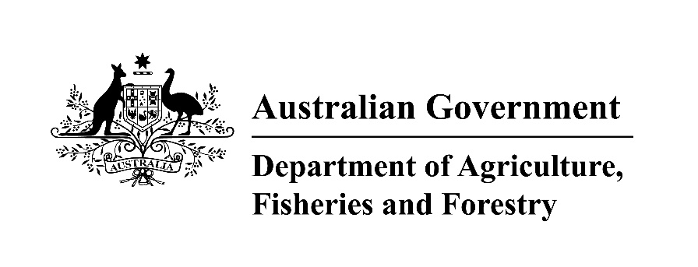 |  | 
Australian Government  Address: Department of Agriculture, Fisheries and Forestry  GPO Box 858  Canberra ACT 2601  Phone: +61 2 6272 3933  Web: agriculture.gov.au/illegal-logging  Email: illegallogging@agriculture.gov.au |  | Italian Government  Address: Ministry of Agriculture, Food Sovereignty and Forests – General Directorate of Mountain Economy and Forests  Via XX Settembre, 20 Rome (IT)  Phone: +39 06 4665 2606  Web: politicheagricole.it  Email: difor3@politicheagricole.it

Disclaimer
While reasonable efforts have been made to ensure that the contents of this guideline and the associated quick reference guide are factually correct, the Commonwealth of Australia and Italian Ministry of Agriculture, Food Sovereignty and Forests does not accept responsibility for the accuracy or completeness of the contents and expressly disclaims liability for any loss or damage, however caused, that may be occasioned directly or indirectly through the use of, or reliance on, the contents of this guideline or associated quick reference guide.

This guideline and its associated quick reference guide is made available on the understanding that the Commonwealth of Australia is not providing professional advice. Before relying on this guideline or its associated quick reference guide, readers should obtain appropriate professional advice suitable to their particular circumstances.

Readers should also confirm that this is the most up-to-date available guideline by referring to the Department of Agriculture, Fisheries and Forestry website.

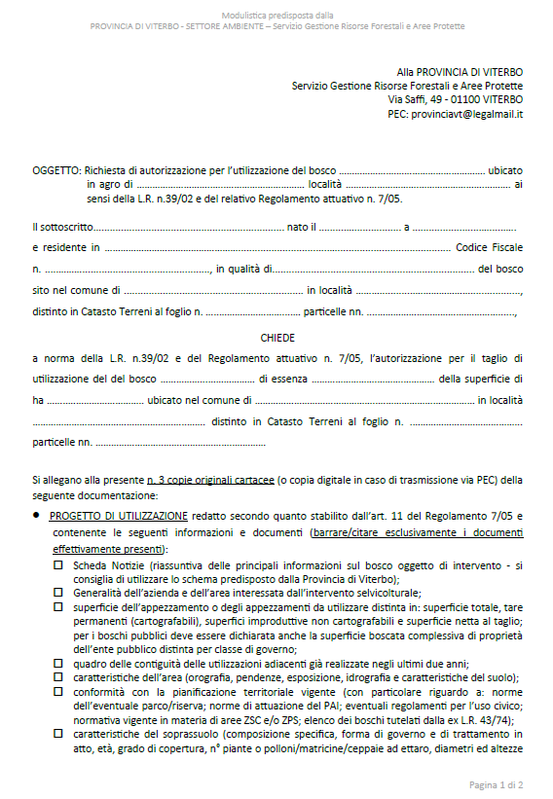
Annex 1a: Authorisation to harvest - Application form (example in Lazio Region)
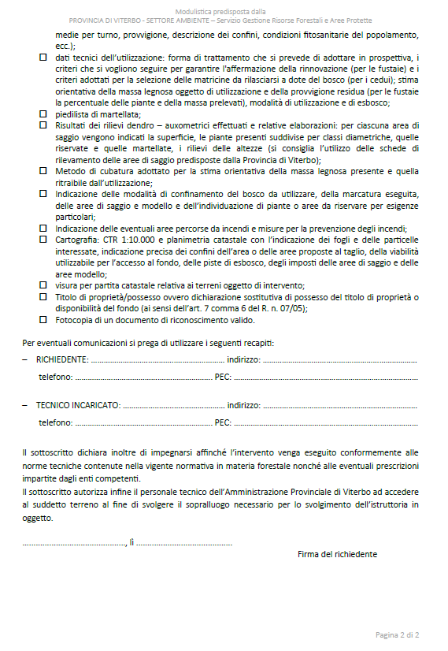

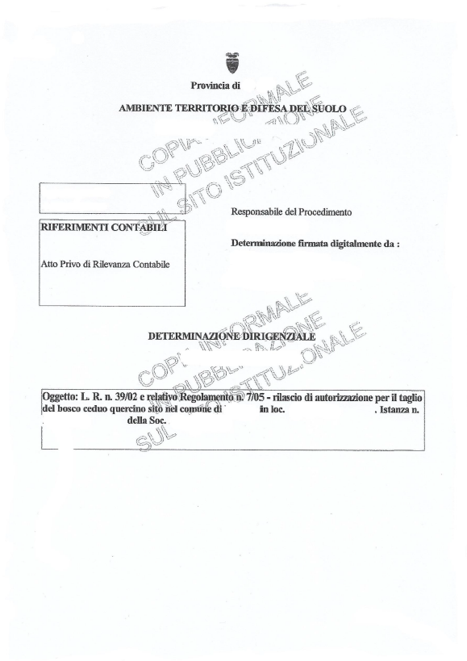
Annex 1b: Authorisation to harvest - Permit (example in Lazio Region)
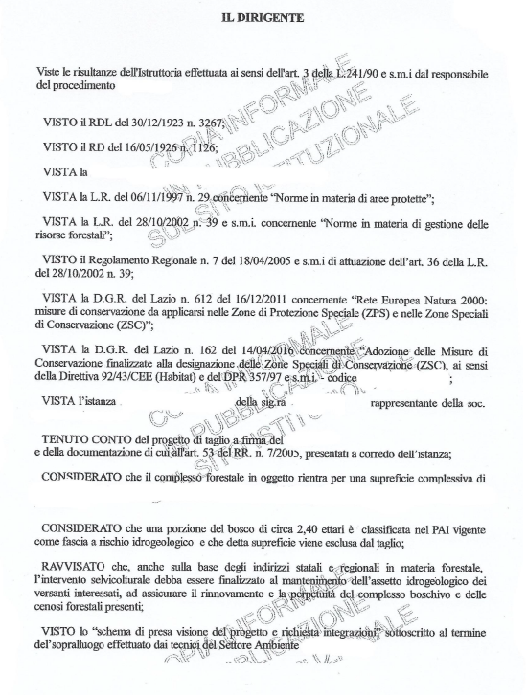
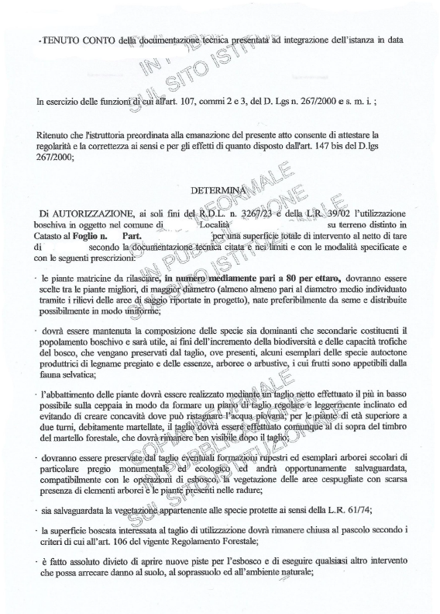
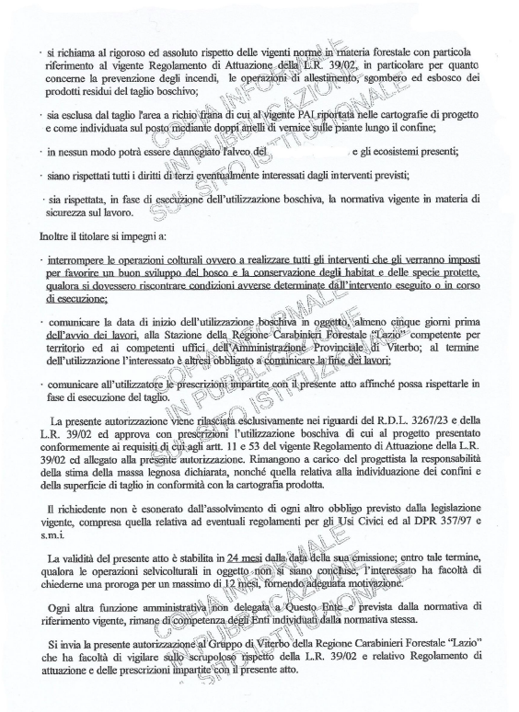
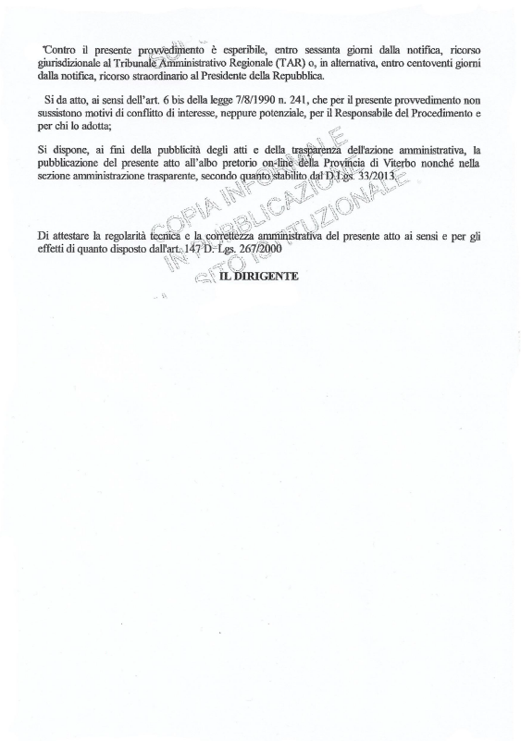

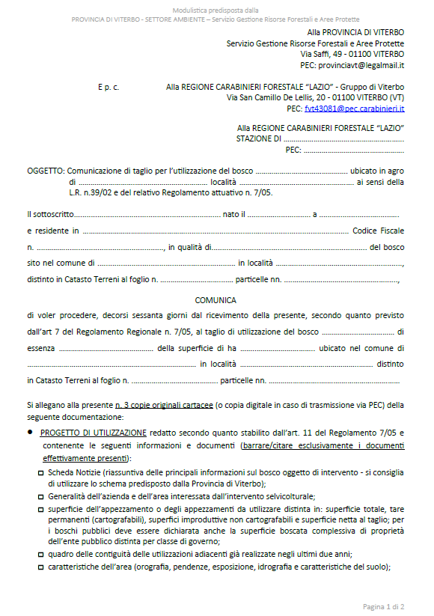
Annex 2a: Notice to harvest - Application form (example in Lazio Region)
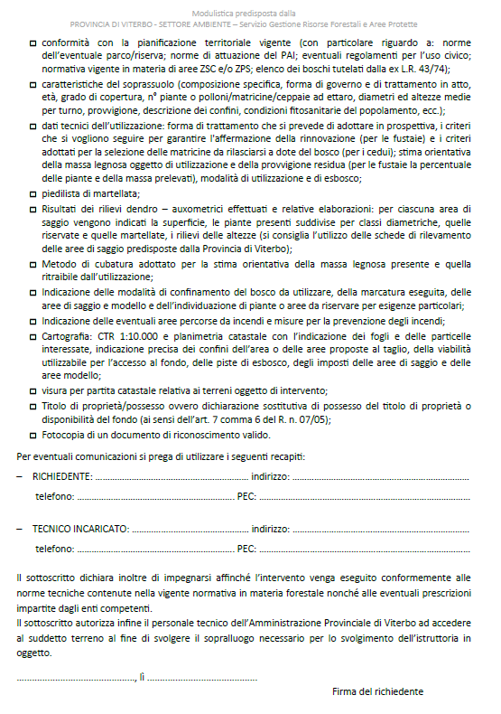

Annex 2b: Notice to harvest - Permit (example in Lazio Region)
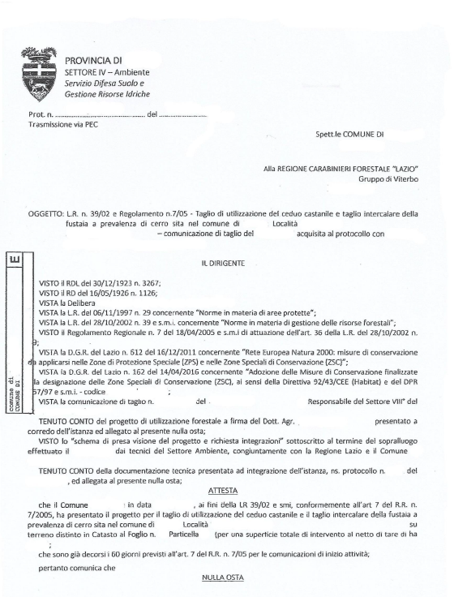
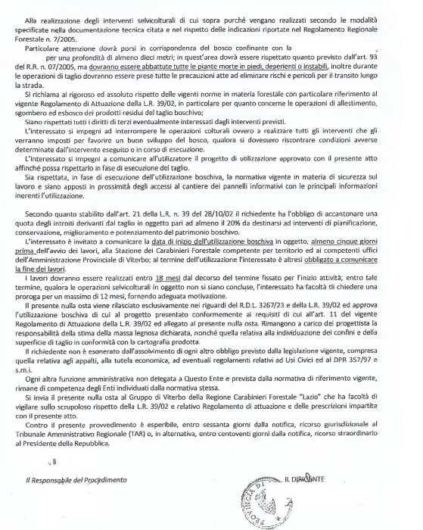

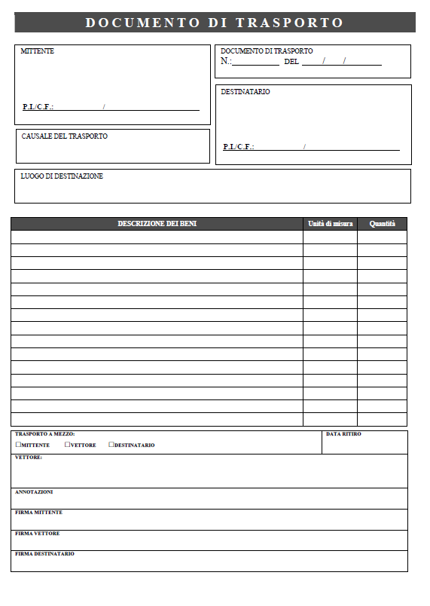
Annex 3: Transport Document Form

Annex 4: Table of regional Italian forestry laws
REGION/ AUTONOMOUS PROVINCE | FOREST LAW | TITLE | IMPLEMENTING LEGISLATION
Piedmont | L.R. n. 4 of 10 February 2009 (B.U. 12 February 2009, Suppl. To No. 6) | "Management and economic promotion of forests" | Regional Regulation n. 8/2020 “Regulation of the register of companies in Piedmont that carry out forestry works or services referred to article 10, paragraph 8, letter a) of Legislative Decree no. 34. Repeal of the Regional Regulation 8 February 2010, n. 2.”  Regional Regulation n. 8/2011 " Forestry regulation for the implementation of art. 13 of the L. R. 10 February 2009, n. 4 (Management and economic promotion of forests). Repeal of the R.R. 15 February 2010, n. 4, R.R. 4 November 2010, n. 17 and R.R. 3 August 2011, n. 5.”  Regional Regulation n. 2/2017 “Regional Regulation for the implementation of the article 3, paragraph 3 ter of the Regional Law 10 February 2009, n. 4 (Management and economic promotion of forests).”  D.G.R. 6 February 2017, n. 23-4637 “L.R. 4/2009, article 19. Provisions on the transformation of the forest to other land use and approval of the criteria and procedures for compensation.”
Valle d'Aosta | L.R. n. 4 of 22 August 1958 (B.U. Valle d'Aosta 30 August 1958) | "Regional rules on forests and mountain lands" | L.R. n. 44 del 27/07/1989 “Regulations concerning forestry sites, the legal status and economic treatment of the relative employees.”  L.R. n. 3 del 01/02/2010 “Discipline of regional aid for forests.”
Lombardy | L.R. n. 31 of 5 December 2008 (B.U. First Supplement Ordinance of 10 December 2008, n. 50) | "Consolidated text of regional laws on agriculture, forests, fisheries and rural development" | R.R. n. 5 of 20 July 2007 "Regional Forestry Regulations" amended by R.R. n. 1 of 19 January 2010, RR n. 1 of 14 February 2011.
Autonomous  Province of Bolzano* | Provincial Law n. 21 of 21 October 1996 (B.U. 5 November 1996, No. 50, Supplement III) | "Forest system" | DPGP n. 29 of 31st July 2000 and subsequent amendments and additions “Regulation of the forest system.”
Autonomous  Province of Trento* | Provincial Law of 23 May 2007, n. 11 (B.U. 5 June 2007, No. 23, supplement n. 2). | "Government of the forest and mountain territory, waterways and protected areas" | DPP of 21 August 2008, n. 34-141/ Leg.,  DPP of 26 August 2008, n. 35-142/ Leg.,  DPP of 3 November 2008, n. 50-157/ Leg.  DPP of 3 November 2008, n. 51-158/ Leg.  DPP of 27 April 2010, n. 13-45/Leg.  DPP of 14 April 2011, n. 8-158/ Leg.
Veneto | L.R. n. 52 of September 13, 1978 | "Regional Forest Law" | Regional Regulation n. 2 of 7 February 2020 “Prescriptions of principle and regional forest police.”
Friuli-Venezia Giulia | L.R. n. 9 of 23 April 2007 (B.U. 2 May 2007, n. 18) | "Rules on forest resources" | Regional Presidential Decree of 28 December 2012, n. 0274 / Pres. “Forest regulation implementing art. 95 of the L.R. 23 April 2007, n. 9.”  Regional Presidential Decree of 14 April 2016, n. 73 - Regulation containing the methods and criteria for the granting of contributions for the preparation and revision of forest management plans and forest information sheets - article 41 ter. paragraphs 2 and 3, of the regional law 23 April 2007 No. 9 (Rules on forest resources).  Regional Presidential Decree of 8 August 2014, n. 166 - Regulation containing the procedures and criteria for the granting of contributions for forestry interventions referred to in article 41 ter, paragraph 4, letter d) of the regional law 23 April 2007, No. 9 (Rules on forest resources).  Regional Presidential Decree of 20 March 2009, n. 74 - Regulation for the protection of flora and fauna of community importance and of regional interest, in execution of article 96 of the regional law of 23 April 2007, No. 9 (Rules on forest resources).
Liguria | L.R. n. 4 of 22 January 1999 (B.U. 10 February 1999, n. 3) | "Rules concerning forests and hydrogeological assets" | R.R. n. 1 of 29 June 1999 “Regulation for the prescriptions of principle and regional forest police.”
Emilia Romagna | L.R. n. 30 of 04 September 1981 (B.U. 8 September 1981, No. 107) | "Incentives for the development and enhancement of forest resources, with particular reference to the mountain area" | Regional Regulation n. 3 of the 1st August 2018 “Approval of the Regional Forest Regulation for the implementation of article 13 of the L.R. No. 30/1981.”
Tuscany | L.R. n. 39 of 21 March 2000 (B.U. March 31, 2000, No. 14 Part One)  (amended by l.r. 31 January 2001, n. 6; l.r. 2 January 2003, n.1, l.r. 2 August 2004, n. 40; l.r. 3 January 2005, n. 1; l.r. 27 July 2007, n. 45; l.r. 14 December 2009, n. 75; l.r. 29 December 2010, n. 65; l.r. 27 December 2012, n. 80; l.r. 9 August 2013, n. 47; l.r. 15 April 2014, n. 22; l.r. 30 October 2015, n. 70, l.r. 27 January 2016 n. 4; l.r.12 April 2016 n. 26; l.r. 31 March 2017, n. 15; l.r. 20 March 2018, n. 11, l.r. 7 January 2019, n. 3) | "Forestry Law of Tuscany" | DPGR n. 48 / R of 8 August 2003 "Tuscany Forestry Regulation" (amended by DPGR No. 32 / R of 16 March 2010, DPGR n. 53/R of 5 May 2015, DPGR 11/R of 19 February 2019 and DPGR 56/R/2020 of 8 July 2020- Regulation for the implementation of the article 13, paragraph 5 of the Regional Law 21 March 2000, n.39 (Forestry Law of Tuscany) – Regional register of agricultural and forestry companies.
Umbria | L.R. n. 28 of November 19, 2001 (B.U. November 28, 2001, No. 58, Supplement ord. N. 1) | "Regional Consolidated Text for the forests" | RR n. 7 of 17 December 2002, n. 7 "Regulation for the implementation of the regional law of 19 November 2001, No. 28."
Marche | L.R. n. 6 of 23 February 2005 (B.U. March 10, 2005, No. 25) | "Regional Forest Law" | DCR of 26 February 2009, n. 114, “Regional Forest Plan (Regional Law 23 February 2005, n. 6, article 4).”  DGR of 17 December 2018, n. 1732, “R.D.L. n. 3267/1923, articles 8, 9 e 10 - R.D. n. 1126/1926, Chapter II. Legislative Decree n. 42/2004, art. 149, paragraph 1, letter c). Legislative Decree n. 34/2018, art. 7, paragraph 3. L.R. n. 6/2005 and subsequent amendments, art. 11, paragraph 2. D.A. n. 114/2009, Regional Forest Plan, Public forest intervention n. 1. Adoption of the " Prescriptions of principle and regional forest police- Discipline of forest management activities"- Repeal of the DD.GG.RR. nos. 2585/2001 and 16/2017.”  DGR of the 1st October 2018, n. 1268, “Regulation (EU) n. 995/2010 of the European Parliament and of the Council of 20 October 2010, European Timber Regulation (EUTR), “Due Diligence”, on the origin and marketing of wood. Amendments and additions to the DGR n. 36/2018 for the implementation of the indications of the Ministry of Agriculture, Food Sovereignty and Forests (MASAF), the competent national authority for the implementation of the EUTR."
Lazio | L.R. n. 39 of 28 October 2002 (B.U. n. 32 of 20 November 2002 -Suppl. Ord. N. 7) | "Rules for the management of forest resources" | Regional Regulation n. 7 of 18 April 2005 "Regulation for the implementation of art. 36 of the L.R. 28 October 2002, n. 39 "amended by the Regional Regulation of 26 April 2006, No. 3, the R.R. 23 February 2010, No. 1.  DGR n. 992 of 20 December 2019 (B.U. n. 3 of 9 January 2020)- Adoption of the Regional Regulation "Amendments to RR of 18 April 2005, n.7 (Implementing Regulation of art. 36 of Regional Law 28.10.2002, n. 39" Rules on the management of forest resources”).  DGR n. 126 of 14 February 2005 – Guidelines for the sustainable development of regional silvo-pastoral heritage and general scheme for sustainable planning of forest resources, procedures in approval, co-financing and implementation.
Abruzzo | L.R. n. 3 of 4 January 2014 (BUR n. 3 of 10 January 2014); | "Organic law on the protection and enhancement of forests, pastures and the forest heritage of the Abruzzo region" | Pending the drafting of the forestry regulation required by law, the PMPF (Prescriptions of principle and regional forest police) in force are operating.
Basilicata | L.R. n. 42 of 10/11/1998 (B.U. No. 65 of 13 November 1998) | "Regulation on forests" | D.G.R. n. 678/2019 and D.P.G.R. n. 231 of the 1st October 2019: “Regulation containing the rules for the cutting of woods in the absence of Forest Management Plans referred to D.G.R.n. 956/2000 and n. 678/2017. Amendments and additions.”  D.G.R. 30 April 2008 n. 613 “Guidelines for the drafting of Forest Management Plans.”  D.G.R. n. 412 of the 31st March 2015 published on BUR n. 16 of 16 April 2015 and subsequent amendments and additions “Provisions on Hydrogeological Constraint-RDL 3267/23 "Reorganization and Reform of Legislation on Forests and Mountain Lands". L.R. 42/1998 "Forestry Regulations, Art. 16-2. Additions to articles 16, 17,18 of D.G.R. n. 412 of the 31st March 2015.  DGR n. 113 – “New Regulation on Regional Register of forest companies established and approved by DGR 3427/99.”
Calabria | L.R. n. 45 of 12 October 2012 (BUR No. 19 of 16 October 2012, Extraordinary Supplement No. 2 of 20 October 2012) | "Management, protection and enhancement of the regional forest heritage" | RR n. 9 of 10 June 2015 "Regulation for the management of coppice forests in Calabria"; DGR n. 548 of 16 December 2016"Guidelines for updating the Regional Forest Plan and guidelines for the drafting of Forest Management Plans."  Annex to DGR n. 548 of 16 December 2016- Guidelines for the Regional Forest Plan and guidelines for the drafting of the Forest Management Plans.
Campania | L.R. 7 May 1996, n. 11 (BUR  n. 29 of the 21st May 1996) and subsequent amendments and additions | "Amendments and additions to the Regional Law of February 13th 1987, No. 13, concerning the delegation in matters of economy, mountain reclamation and soil protection" | Regional Regulation of 28 September 2017, n. 3 “Regulation for the protection and sustainable management of the regional forest heritage.”  Price list for the drafting of Forest Management Plans.  Annex A to D.G.R. n. 84/2018 (Amendments and additions to the price list for the drafting of Forest Management Plans).
Molise | L.R. n. 6 of 18 January 2000 (B.U. n. 2 of the 1st February 2000) | "Regional Forest Law" | Regional Law of 9 September 2011, n. 19. (Amendments and additions to the Regional Law n. 6 of 18 January 2000).  Regional Law of 22 January 2014, n. 2 (Amendments to the article 18 of the Regional Law n. 6 of 18 January 2000).  DGR n. 1229 of 4 October 2004 and amended with DGR n. 57 of 8 February 2005 "Technical- administrative regulation and price list for the drafting and revision of forest management plans."
Puglia | L.R. November 30, 2000, n.18 (B.U. Puglia 13 December 2000, No. 147) | "Allocation of administrative functions and tasks in the fields of forests, civil protection and fight against forest fires" | RR n. 10 of 30 June 2009 “Forest cuttings” amended by RR n. 29of 27 November 2009; RR n. 21 of 12 November 2013 "Implementation of articles 20 bis and 20 ter of L.R. of 30 November 2000, n. 18 - Forest transformation with compensation "; RR n. 9 of 11 March 2015 - "Rules for lands subject to hydrogeological constraints."  http://foreste.regione.puglia.it/tagli-boschivi.
Sardinia | L.R. n. 8 of 27 April 2016 (BUR No. 21 of 28 April 2016) | "Forest Law of Sardinia" | Decree of the Councilor for the Defence of the Environment no. 24 / CFVA of 23 August 2006 "General and Forestry Police Prescriptions."  Regional Council Resolution No. 38/11 of 18 September 2012 “Implementation of Legislative Decree 386/2003-Community Directive 105/1999 EC. Application provisions in the regional context of the methods of production and marketing of forest propagation material. Implementation of the strategic operational project No. 3 of the regional environmental forest plan". Annex to the Regional Council Resolution No. 38/11 of 18 September 2012.  Regional Council Resolution No. 30/30 of 20 June 2017 “Guidelines for the preparation of detailed forestry plans (P.F.P). Regional Law 8/2016 art.9 " and related Annex 1 and Annex 2.  Regional Council Resolution No. 11/21 of 11 March 2020 - Amendment of the Council Resolution of 02/10/2018, No. 48/26 concerning the “Regulations on the implementation of compensatory afforestation and on the payment of adequate security deposits. Regional Law 8/2016 art.21 paragraph 5."  Annex to the Regional Council Resolution No. 11/21 of 11 March 2020.
Sicily | L.R. 6-4-1996 n. 16 (BUR 11 aprile 1996, n. 17), e successive modifiche ed integrazioni di cui alla L.R. 14-4-2006 n. 14 (GURS 21 aprile 2006 n. 21) | "Reorganization of forestry and flora protection legislation " | Regional Council Decree 85/2016 "Guidelines for the preparation of the forest management plan."  Prescriptions of Principle and Forest Police.
Italy | L. No. 34 of 2018 (G.U. No. 92 of April 20, 2018) | "Consolidated text on forests and forestry chains" | Ministerial Decree of 28 October 2021 “Provisions for the definition of the minimum national criteria for the elaboration of forestry plans of territorial orientation and forest management plans.”

Annex 5: Regions and Autonomous Provinces of Italy
Region/Autonomous Province | Responsible Authority
Piedmont | Direzione Ambiente, Energia e Territorio - Settore Foreste
Valle d'Aosta | Regione Autonoma Valle d’Aosta  Dipartimento risorse naturali e Corpo forestale  Struttura foreste e sentieristica  Località Amérique 127/a- 11020 Quart (Valle d’Aosta)  risorse_naturali@pec.regione.vda.it  forestazione-sentieristica@regione.vda.it
Lombardy | Direzione Generale: Agricoltura, Alimentazione e Sistemi Verdi  Unità Organizzativa: Sviluppo di sistemi forestali, agricoltura di montagna, uso e tutela del suolo agricolo e politiche faunistico-venatorie  Struttura: Sviluppo delle politiche forestali e agroambientali  Piazza Città di Lombardia, 1 - 20124 Milano (MI)  mail foreste@regione.lombardia.it
Autonomous Province of Bolzano* | Amministrazione Provincia Bolzano. Dipartimento Agricoltura, Foreste, Turismo e Protezione civile. Ripartizione Foreste.  Palazzo 6 - Peter Brugger, via Brennero 6  39100 Bolzano
Autonomous Province of Trento* | Servizio Foreste, via Trener 3, 38123 Trento
Veneto | Direzione AdG FEASR e Foreste (https://www.regione.veneto.it/web/agricoltura-e-foreste/foreste )
Friuli-Venezia Giulia | Direzione centrale risorse agroalimentari, forestali e ittiche. Servizio Foreste e Corpo forestale  Via Sabbadini, 31, 33100 Udine  corpoforestale@certregione.fvg.it
Liguria | Settore Politiche della natura e delle aree interne, protette e marina, parchi e biodiversità – Dott. Federico Marenco – tel. 0105484983  email federico.marenco@regione.liguria.it
Emilia Romagna | Servizio Aree Protette, Foreste e Sviluppo della Montagna  Viale della Fiera 8, 40127 Bologna  tel. 051.527.6080/6094 fax 051.527.6957  e-mail: segrprn@regione.emilia-romagna.it  e-mail certificata: segrprn@postacert.regione.emilia-romagna.it
Tuscany | Regione Toscana, Direzione Agricoltura e Sviluppo rurale. Settore Forestazione. Usi civici. Agroambiente
Umbria | Agenzia Forestale Regionale (AFOR) delegata dalla Regione Umbria
Marche | Servizio Politiche agroalimentari – Posizione di Funzione Interventi nel settore forestale e dell’irrigazione e SDA di Ancona – Via Tiziano, n. 44 – 60125 Ancona  PEC: regione.marche.pfcsi@emarche.it
Lazio | Direzione Regionale Agricoltura, Promozione della Filiera e della Cultura del Cibo, Caccia e Pesca, Foreste  Area Pianificazione Agricola Regionale, Governo del Territorio e Regime delle Autorizzazioni. Risorse Forestali
Abruzzo | Giunta Regionale – Dipartimento Agricoltura– Servizio Foreste e Parchi  Via Salaria Antica Est 27 B – L’Aquila  dpd021@regione.abruzzo.it  dpd021@pec.regione.abruzzo.it
Basilicata | Dipartimento Politiche Agricole e Forestali  Ufficio Foreste e Tutela del Territorio
Calabria | Dipartimento 8 Agricoltura e risorse Agroalimentari – UOA Politiche della Montagna, Foreste e Forestazione e Difesa del suolo
Campania | Regione Campania – Direzione Generale per le Politiche Agricole, Alimentari e Forestali – Unità Operativa Dirigenziale Ufficio Centrale Foreste e Caccia
Molise | Dipartimento Servizio Fitosanitario Regionale Tutela e valorizzazione della Montagna e delle foreste Biodiversità e sviluppo sostenibile.  Via G. Vico 4 - 86100 CAMPOBASSO pec: regionemolise@cert.regione.molise.it
Puglia | Sezione gestione Sostenibile e Tutela delle Risorse Forestali e Naturali – Servizio Risorse Forestali
Sardinia | Assessorato della difesa dell’ambiente:  Direzione generale della difesa dell’ambiente  Direzione generale del Corpo forestale e di vigilanza ambientale.
Sicily | Comando del Corpo Forestale della Regione Siciliana
*For Trentino-Alto Adige Region, forestry is one of the competences attributed to the Autonomous Provinces of Trento and Bolzano.

For the purposes of the Illegal Logging Prohibition Act 2012, a ‘regulated timber product’ is a product listed in Schedule 1 to the Regulation.
Naturalistic core areas are the integral natural reserves representing the systems and components of the most significant biological, hydrological, geomorphological and landscape value of the Park and are intended exclusively for the conservation of the natural environment in its entirety.

