

Exports system instruction

# Completion of a phytosanitary certificate

**Direction to staff**

This is official instructional material of the Department of Agriculture, Fisheries and Forestry (the department). Failure to comply with it may result in a breach of relevant legislation and/or the code of conduct under section 13(5) of the *Public Service Act 1999.*

## Purpose of this document

This document details how users can prepare:

* a request for permit (RFP) in third-party software to raise compliant phytosanitary certificate.
* a compliant manual phytosanitary certificate.

__________________________________________________________________________________

**Contents**

This document contains the following topics.

Purpose of this document 1

Section 1: Phytosanitary certificates 3

Section 2: Name and address of exporter 3

Section 3: Declared name and address of consignee 4

Section 4: Import permit details 4

Section 5: Place of origin and place origin code 5

Section 5.1: Grain consignments 5

Section 5.2: Horticulture consignments 5

Section 6: Place of issue and code 5

Section 6.1: Grain consignments 5

Section 6.2: Horticulture consignments 6

Section 7: Country of final destination and international country code 6

Section 8: To plant protection organisation of 6

Section 9: Declared means of conveyance 6

Section 10: Declared point of entry/destination city 6

Section 11: Distinguishing/shipping marks 7

Section 12: Container and seal numbers 7

Section 12.1: Seal numbers 7

Section 13: Consignment description 8

Section 13.1: Number & description of packages 8

Section 13.2: Name of product 8

Section 13.3: Additional product description 9

Section 13.4: Intended use / supplementary code 9

Section 13.5: Product part 9

Section 13.6: Product condition 10

Section 13.7: Quantity declared 10

Section 13.8: Botanical name of plants 10

Section 13.9: Total net contents 11

Section 13.10: Number of packages (total) 11

Section 13.11: Mass (total) 11

Section 14: Commodity/AHECC code 11

Section 15: Disinfestaion and/or disinfection treatment 11

Section 16: Additional declaration/endorsement number 13

Section 17: Name of inspector, inspection date and code 13

Section 18: Certificate number 13

Section 19: Name of delegate 13

Section 20: Signature of delegate 13

Section 21: Phytosanitary static endorsement statement 13

Document information 14

Version history 14

Appendix A: Definitions 15

Appendix B: Samples of completed phytosanitary certificates 16

Appendix C: Examples of consignment descriptions 21

Appendix D: Grain product description requirements 22

Appendix E: Horticulture product description requirements 23

## Section 1: Phytosanitary certificates

This guide refers to all phytosanitary certificates:

* phytosanitary certificates issued through EXDOC
* electronic phytosanitary certificates
* manual phytosanitary certificates.

Phytosanitary certificates issued through EXDOC are paper-based certificates that are electronically dated, signed, stamped and printed on security paper. They are the department’s primary form of phytosanitary certificates and are issued by exporters submitting RFPs in their third party software.

Electronic phytosanitary certificates are paperless and are issued through the department’s electronic certification system (e-Cert). e-Cert is an electronic government to government system, integrated with EXDOC, which allows the transmission of export certificate data directly with the importing country, in place of a paper phytosanitary certificate. Electronic phytosanitary certificates are issued by exporters submitting RFPs in their third party software.

Manual phytosanitary certificates are a paper-based form prepared by the exporter and issued by the department with a manual stamp and signature. Manual phytosanitary certificates are only available as a contingency measure and can only be issued in very limited circumstances such as an EXDOC system outage

The Phytosanitary certificate template is available on the department’s [website](https://www.agriculture.gov.au/biosecurity-trade/export/controlled-goods/plants-plant-products/certificates-declarations-forms#phytosanitary-certificate).

Terms and definitions used within this document are provided in Appendix A.

Samples of completed phytosanitary certificates are provided in Appendix B.

## Section 2: Name and address of exporter

This field must list the name and address of the exporter (company) in full, which must be located in Australia. If the exporter details are for an overseas entity, an Australian entity may act on their behalf. The exporter must provide a written statement attesting to the arrangement for the AO to validate at the time of inspection and upload the statement to PEMS. The address of the exporter should be either a physical or a postal address. The inclusion of both a physical and postal address is not permitted.

The inclusion of a person’s name as the exporter is only permitted if the consignment being exported is for non-commercial purposes (for example, orchids in flasks). Non-commercial consignments will usually be small quantities.

Information not permitted in this field includes:

* telephone numbers
* facsimile numbers
* Australian business numbers (ABNs)
* both a physical and a postal address.

In the RFP, the exporter details can only be listed if the exporter is registered with the department and issued an exporter number. The exporter details will be listed in the RFP based on an exporter number associated with the registration. However, the full exporter details will print on the phytosanitary certificate.

For manual certificates, the exporter details listed on the phytosanitary certificate must be the same as the details listed on the Notice of intention (EX28).

See the department website about [registering as an exporter using third-party software](https://www.agriculture.gov.au/biosecurity-trade/export/certification/exdoc/register).

## Section 3: Declared name and address of consignee

This field is required to list the name and address of the consignee, only 35 characters can be entered per line for this field. Consignee details should have sufficient information to enable the importing country to confirm the identity of the consignee.The consignee must be the company details that the consignment is being exported to, including a physical or postal address in the destination country.

Consignee details can differ to the destination country. However, the importing country may require the consignee to be located in the destination country. It is the exporter’s commercial risk if the exporter chooses to list a consignee in a country different to the destination country.

The consignee details on the import permit may differ to the consignee details on the phytosanitary certificate, if permitted by the National Plant Protection Organisation (NPPO) of the importing country, and the exporter accepts any associated risks.

Listing a personal name as the consignee is only permitted if the consignment is being exported for non-commercial purposes (for example, orchids in flasks, research material).

Where the consignee is not known, ‘To order’ may be used if the National Plant Protection Organisation of the importing country permits the use of the term and the exporter accepts any associated risks.

The following details are not permitted in this field:

* telephone numbers
* both a physical and postal address
* facsimile numbers
* ABNs
* multiple addresses
* the words ‘head office’ or ‘factory’ (or derivative of)
* the word ‘consignee’ as the consignee name.

## Section 4: Import permit details

If an import permit is required by the importing country, it is required to be listed in this field. The import permit number must be listed exactly as it is shown on the document. The import permit issue date must be listed in the RFP in Australian date format dd/mm/yyyy. Both the import permit number and issue date are required at all times.

If an import permit is not required by the importing country, enter the words ‘not supplied’.

In the RFP, if import permit details are not entered, the text ‘not supplied’ will automatically print on the phytosanitary certificate.

## Section 5: Place of origin and place origin code

This field is required to list the place of origin for the consignment. There are different rules for grain and horticulture consignments to determine what constitutes the place of origin.

### Section 5.1: Grain consignments

For all grain consignments, this refers to the state and postcode of where the inspection is conducted.

In the RFP, the place of origin details are sourced from the establishment details in the RFP. These details are displayed by entering the four digit establishment number where the inspection is conducted. The state and postcode of the registered establishment will print on the phytosanitary certificate.

### Section 5.2: Horticulture consignments

For all horticulture consignments, this refers to the region where the product is sourced/produced or where the product is inspected.

In the RFP, the place of origin is sourced from the region code field. This is the three letter code entered into the system that identifies where the product is sourced/produced or inspected. Only the state of the region and the postcode will print on the phytosanitary certificate.

If the region is not available from the list, request a new region code to be set up by emailing the [Business Systems Program](mailto:EXDOCPlantPrograms@agriculture.gov.au).

When completing the place of origin field for horticulture choose the appropriate action depending on your scenario (Table 1).

Table 1 Completing place of origin field, horticulture

| Scenario | Action |
| --- | --- |
| Where the consignment consists of a single line of product or several lines of product that are all sourced from the one region. | Enter the place of origin as the state where the product(s) were produced/sourced and the postcode in the code field. |
| Where the consignment consists of several lines of product which are sourced from different locations but have been consolidated at the one establishment for inspection. | Enter the place of origin as the state where the inspection establishment is located and the postcode in the code field. |
| The consignment consists of several lines of product which are sourced direct from a market floor. | Enter the place of origin as the state where the market is located and the postcode of the market in the code field. |

## Section 6: Place of issue and code

This field is required to record the place and postcode where the phytosanitary certificate is being issued.

There are different rules for grain and horticulture consignments to determine what constitutes the place of issue.

### Section 6.1: Grain consignments

In the RFP, the place of issue and code is sourced from the region code field. The region code is the location where the inspection was conducted.

### Section 6.2: Horticulture consignments

In the RFP, the place of issue is sourced from the establishment number field.

## Section 7: Country of final destination and international country code

This field is required to list the country of final destination, followed by the International Organisation for Standardisation (ISO) two letter country code. A list of country codes are available in the [Manual of Importing Country Requirements (Micor) Plants](http://micor.agriculture.gov.au/Plants/Pages/default.aspx).

The final destination country is the internationally accepted name of the country to which the consignment is inspected and certified to.  
In the RFP, the destination country is listed by entering the two letter country code and the full country name will print on the phytosanitary certificate.

## Section 8: To plant protection organisation of

This field is required to list the plant protection organisation of the final destination country.

In the RFP, this information does not need to be entered as it will be automatically sourced from the destination country field in the RFP.

## Section 9: Declared means of conveyance

This field is required to list the declared means of conveyance for the consignment, which is either air, sea or mail.

In the RFP, select the mode of transport and enter the relevant details listed in Table 2.

Table 2 Mode of transport

| Mode of transport | Information to be entered |
| --- | --- |
| Air | * flight details, flight number and departure date * if the flight number is unknown, the text AIR can be listed in the flight number field and the flight details field can remain blank. |
| Mail | * departure date * courier company must be listed in the shipping company field * vessel name and voyage number fields do not need to be completed. |
| Sea | * vessel name, voyage number, shipping company and departure date * for bulk vessel grain consignments, the voyage number isn’t mandatory however, the shipping company and vessel name must be included * if the shipping details are unknown, the text SEA can be listed in the voyage number field and the vessel name field can remain blank. |

## Section 10: Declared point of entry/destination city

This field must contain the declared point of entry, which is also the place of importation or place of final clearance. The use of a country name or terms such as port, freeport or similar are not permitted in this field.

If the declared point of entry is in a landlocked country, the transit port is permitted, for example: ‘Kathmandu via Calcutta’.

For bulk grain shipments where the consignment will be discharged in multiple ports, the declared point of entry may be populated with the text ALL (NAME OF COUNTRY) PORTS.

## Section 11: Distinguishing/shipping marks

The information that can be entered in this field must relate, as the name applies, to marks on the package or lot numbers. This information must be verified by the authorised officer at the time of inspection and recorded on the Export Compliance Record (ECR).

For some horticulture protocol markets information relating to registered packhouse or vineyards must be entered in this field. For further information please see [protocols in Micor Plants](http://micor.agriculture.gov.au/Plants/Pages/Protocols.aspx).

Examples of common distinguishing marks required by the importing country are listed in Table 3.

Table 3 Common distinguishing marks

| Commodity | Distinguishing marks |
| --- | --- |
| Grain | lot number |
| Horticulture | PACKHOUSE NO: XXXX |

In the RFP, the shipping marks field is to be used to enter distinguishing/shipping marks. The information entered into this field will print on the phytosanitary certificate in the left hand column ‘distinguishing marks and container numbers’.

## Section 12: Container and seal numbers

This field is where container information is entered (where required).

Container numbers are compulsory for all grain and horticulture consignments transported by sea, with the exception of the below scenarios:

* if a consignment is loaded into ‘Less than a Container Load’ (LCL)
* if a consignment is bulk loaded into a ships hold.

Container details include four letters followed by six or seven numbers.

Grain—container numbers are verified and certification will not be issued manually or through your third-party software if container details are not listed.

Horticulture—consignment can be authorised, but certification will not be issued manually or through your third-party software until container/seal numbers are entered. This excludes protocol horticulture RFPs utilising In-Transit Cold Treatment (ITCT).

### Section 12.1: Seal numbers

Seal numbers must be entered underneath or next to the relevant container number (with separating symbol ‘/’). Seal numbers can only be included if container numbers are listed.

For some horticulture protocol markets, seal numbers must be verified by the authorised officer and listed on the phytosanitary certificate. With the exception of this scenario, seal numbers are not verified by authorised officers and are not required to be listed on the phytosanitary certificate.

In the RFP, there are specific fields for container and seal numbers.

## Section 13: Consignment description

The description of the consignment consists of a number of elements as described below. For further information on how to set up the description of the consignment, refer to Appendix C.

### Section 13.1: Number & description of packages

This field contains the type and quantity of packages and is to be used to describe the outer package details of the consignments such as cartons, flasks, bags, bales.

In the RFP, this information is sourced from the outer package details which contains the package type and quantity.

If you wish to further describe your consignment packaging (for example, intermediate, inner) these descriptions will appear under the ‘name of produce/quantity declared’ field on the phytosanitary certificate, see Appendix B.

Table 4 shows an example of outer, intermediate and inner package description.

Table 4 Package description

|  |  |
| --- | --- |
| Package type | Number and description of packages |
| Outer: | 1 CARTON |
| Intermediate: | 2 TRAYS |
| Inner: | 4 PUNNETS |

Figure 1 shows an example of outer, intermediate and inner package description as rendered on a phytosanitary certificate.

Figure 1 Phytosanitary certificate package description

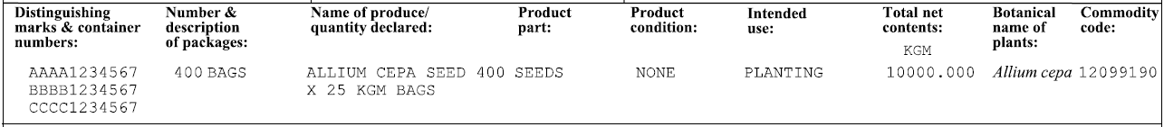

### Section 13.2: Name of product

This field is required to list the name of the produce and the quantity.

The ‘name of produce’ field is the primary descriptor of the product and should be a basic common commodity name (for example, barley, sorghum, mung beans, apples, carrots, capsicums), as listed in the relevant Micor case. If a product does not have a common name, the botanical name is to be used.

If the product contains a mix or blend of ingredients, a broad commodity description such as stockfeed or lettuce mix is acceptable, providing there is an existing Micor Plants case that aligns with the generic description.

In the RFP, the name of the produce is sourced from the three letter product code. The product code is linked to a common and botanical name, or only a botanical name. Both descriptions will print on the phytosanitary certificate. Some highly processed products such as stockfeed are only linked to a common name and only the common name will be printed on the phytosanitary certificate.

The following information is not permitted to describe the produce:

* quality descriptors (for example, milling or hard type)
* fruit class or grade
* carton types (for example, CC, C6)
* organic statements.

### Section 13.3: Additional product description

This field can be used to enter an additional product description to further describe the product being certified. This information will be displayed under the ‘Name of produce/quantity declared’ section of the phytosantiray certificate.

Additional product descriptions may include:

* Product origin for re-export product, for example Origin of China (for further information on re-export see [Phytosanitary certificate for re-export EX25](https://www.agriculture.gov.au/sites/default/files/documents/ex25.pdf))
* Forestry products where the generic description code is used (for example, LOG) and there is no associated botanical name connected to the EXDOC product code
* The cubic metre weight for timber/log products.

### Section 13.4: Intended use / supplementary code

This information is used to further describe the intended use of the consignment.

**Note:** This information is mandatory for both grain and horticulture products.

Table 5 shows a full list of all intended use and the associated codes.

Table 5 intended use

|  |  |
| --- | --- |
| Code | Description |
| **GC** | Consumption |
| **GD** | Decoration |
| **GS** | Planting |
| **GP** | Processing |
| **GH** | Sprouting for counsumption |
| **GR** | Research |
| **GF** | Stockfeed |

For further information about how to use intended use/supplementary code refer to Appendix D for grain consignments and Appendix E for horticulture consingments.

### Section 13.5: Product part

This information is used to further describe the product part of the consignment.

Table 6 shows a full list of all product parts and the associated codes.

Table 6 Product part

|  |  |  |  |
| --- | --- | --- | --- |
| Code | Description | Code | Description |
| **0001** | Seeds | **0015** | Flowers |
| **0002** | Plants | **0016** | Foliage |
| **0003** | Bulbs | **0017** | Branches |
| **0004** | Tubers | **0018** | Fruits |
| **0005** | Minitubers | **0019** | Vegetables |
| **0006** | Rhizomes | **0020** | Wood |
| **0007** | Stolons | **0021** | Wood packaging material |
| **0008** | Corms | **0022** | Barrel |
| **0009** | Budwood | **0023** | Firewood |
| **0010** | Cuttings | **0024** | Bark |
| **0011** | Pollen | **0025** | Soil |
| **0012** | Buds | **0026** | Peat |
| **0013** | Plantlets | **0027** | Machinery |
| **0014** | Grain |  |  |

For further information about how to use product part refer to Appendix D for grain consignments and Appendix E for horticulture consingments.

### Section 13.6: Product condition

This information is used to further describe the product condition of the consignment.

Table 7 shows a full list of product conditions and the associated codes.

Table 7 Product condition

|  |  |  |  |
| --- | --- | --- | --- |
| Code | Description | Code | Description |
| **0001** | Rooted | **0013** | Fresh |
| **0002** | Unrooted | **0014** | Frozen |
| **0003** | Bare - rooted | **0015** | With growing media |
| **0004** | Without leave or flowers | **0016** | Potted |
| **0005** | Dormant | **0017** | Chemical pressue impregnated |
| **0006** | With bark | **0018** | Heat treated |
| **0007** | Debarked | **0019** | Ddust |
| **0008** | Bark-free | **0020** | Shavings |
| **0009** | Dried | **0021** | Round |
| **0010** | Chopped | **0022** | Sawn |
| **0011** | Peeled | **0023** | Chips |
| **0012** | Shelled | **0024** | Cut |

For further information about how to use product part refer to Appendix D for grain consignments and Appendix E for horticulture consingments.

### Section 13.7: Quantity declared

The ‘quantity declared’ field is to include the number of packages and the individual weight of each package but is not compulsory.

In the RFP, the ‘quantity declared’ field on the phytosanitary certificate draws information from the intermediate and inner package fields of the RFP and is only printed on the phytosanitary certificate if the individual weight of each package is entered into the RFP.

### Section 13.8: Botanical name of plants

The botanical or scientific name of the consignment is always required, with the exception of highly processed commodities such as stockfeed. As per the International Standards for Phytosanitary Measures (ISPM 12), the consignment must be described at least to genus level. However, the species level is preferred.

In the RFP, the botanical name is sourced from the three letter product code in the RFP and does not need to be entered.

### Section 13.9: Total net contents

The ‘total net contents’ only prints on electronic phytosanitary certificates issued from your third-party software. In the RFP, this information is sourced from the net metric weight field and is related to the net weight of each line in the RFP, excluding any external packaging.

### Section 13.10: Number of packages (total)

The total number of packages in the consignment, in digits, is required in this field. The total number of packages must match the information in the number and description of packages field. No other information is to be included in this field. However, if the consignment is bulk loaded, the word bulk is permitted.

In the RFP, the ‘number of packages total’ field and the ‘number and description of packages’ field are populated from the outer package field.

### Section 13.11: Mass (total)

This field is required to contain the total net mass of the consignment, excluding any external packaging. Include the metric unit of mass for example, GRM (grams), KGM (kilograms), TNE (tonnes). The use of imperial weight measurements are not permitted.

## Section 14: Commodity/AHECC code

This mandatory field must contain the appropriate ABS [Australian Harmonised Export Commodity Code (AHECC)](https://www.abs.gov.au/statistics/classifications/australian-harmonized-export-commodity-classification-ahecc/latest-release).

No importing country commodity code (often referred to as tariff code) is permitted on the phytosanitary certificate. It is the responsibility of the exporter to ensure the code is correct and not misleading.

## Section 15: Disinfestaion and/or disinfection treatment

If the importing country requires the product to be treated, treatment details are to be included in this field and certified on the phytosanitary certificate (unless otherwise stated in Micor).

Specific treatments are mandatory for certain commodities before entry will be permitted by the importing country. Treatment details including the type of treatment, rate and duration are published in [Micor Plants](http://micor.agriculture.gov.au/Plants/Pages/default.aspx).

Any treatments undertaken by exporters which are not an importing country requirement will not be certified on the phytosanitary certificate and are not to be included in the RFP.

Table 8 shows the information that is to be included for treatment details.

Table 8 Treatment information

| Information | Example |
| --- | --- |
| Date | date(s) the treatment commenced and concluded. |
| Treatment | type of treatment undertaken. For example, fumigation, cold disinfestation, precooled. |
| Chemical | name of the chemical used (if applicable). For example, methyl bromide, phosphine, thiram. |
| Concentration | rate of application. For example, 48GRM/M3, 2.5GRM per litre, 4GRM A.I. per 1000KGM seed. Application rates can be abbreviated using the following: GRM, KGM, M3, TNE. |
| Duration | length of time the product was treated. |
| Temperature | temperature applied in metric units. For example 21 degrees Celsius. |
| Additional information | populate with additional information applicable to the treatment undertaken, or if more than one treatment is to be certified. For manual certification, if there is no information to be populated in this box it needs to be ruled through. |

Examples of accepted treatment details are listed in 9.

Table 9 Treatment details

| Treatment | Treatment details |
| --- | --- |
| COLD | AT OR BELOW 2 DEGREES CELSIUS FOR 14 DAYS |
| DIPPED | IN FENAMIPHOS AT 1.6GRM A.I. PER LITRE OF WATER FOR 30 MINUTES |
| DIPPED | IN 400 PPM DIMETHOATE OF TOLERANCE +/-6% (+/-24 PPM) FOR ONE MINUTE OR MORE |
| DUSTED | WITH THIRAM AT 4GRM AI/1000GRM SEED |
| FUMIGATION | WITH PHOSPHINE AT 1.1GRM/M3 FOR 96 HOURS AT 21 DEGREES CELCIUS |
| FUMIGATION | WITH METHYL BROMIDE AT 32GRM/M3 FOR 2 HOURS AT 21 DEGREES CELSIUS |
| FUMIGATION | WITH METHYL BROMIDE AT 64 GRM/M3 AT 21 DEGREES CELSIUS FOR 2 HOURS |
| FUNGICIDE | WITH CARBOXIN AT 0.8GRM A.I. PER KG SEED AND THIRAM AT 1GRM A.I. PER KG SEED |
| FUNGICIDE | DUSTED WITH THIRAM AT 4GRM A.I./1000GRM SEEDS |
| INSECTICIDE | WITH CHLORYRIFOS 200ML A.I PER 200L AT 24 DEGREES CELCIUS FOR 15 MINUTES |
| KILN DRIED | AT 84 DEGREES CELSIUS FOR 48 HOURS. MOISTURE CONTENT OF 10-14% |
| SLURRY | WITH THIRAM AT 1GRM PER 1000GRM SEED, CARBOXIN AT 1GRM PER 1000GRM SEED, METALAXY-M AT 0.35GRM PER 1000GRM SEED, CHLORPYRIFOS -METHYL AT 0.001GRM PER 1000GRM SEED, S-METHOPRENE AT 0.0006GRM PER 1000GRM SEED, IMIDACLOPRID AT 2.58GRM PER 1000GRM SEED AND FLUDIOXONIL AT 0.1GRM PER 1000GRM SEED |

**Note:** The capitalised treatment and treatment details appear as they are rendered on the phytosanitary certificate.

Examples of treatment details/text that are not acceptable:

* abbreviation of the word Celsius, hours or degrees
* variations of GRM (grams) or KGM (kilograms)
* information such as at rate of or the word ambient or a general statement about temperature
* imperial measurements.

For manual certificates, if no treatment is recorded, a line must be drawn through the appropriate boxes before the certificate is signed.

In the RFP, the treatment details are to be left blank if treatment is not required. The text ‘no treatments certified’ will automatically be applied to the phytosanitary certificate.

In the RFP, the treatment type is to be entered by selecting a code (abbreviation) used to describe the treatment. The abbreviated code will print on the phytosanitary certificate as the entire word. Treatment details and the start and end date are to be free texted into the appropriate fields.

For example, if the code FUMIG is selected and the treatment details, start and end date are populated, treatment details will appear on the phytosanitary certificate as:

12/02/2016 – 14/02/2016 FUMIGATED WITH METHYL BROMIDE AT 24GRM/M3 AT 21 DEGREES CELSIUS FOR 48 HOURS

## Section 16: Additional declaration/endorsement number

This field is required to contain the appropriate additional declarations/endorsement number (if required).

In the RFP, the additional declaration is to be included by entering the endorsement number as listed in Micor Plants. If no additional declaration number is entered, the text ‘no additional declaration’ will be automatically applied to the phytosanitary certificate.

For manual certificates, the additional declarations/endorsement text is to be written exactly as it is published in [Micor Plants](http://micor.agriculture.gov.au/Plants/Pages/default.aspx). If no additional declaration is required, this section should be completed with the text ‘No Additional Declaration’. Any remaining space in this field should be ruled through.

## Section 17: Name of inspector, inspection date and code

The name of the authorised officer who performed the inspection, the inspection date/s and the postcode of where the inspection was undertaken must be recorded by the authorised officer. This is required for all consignments.

If the consignment was inspected by more than one officer, the name of either the last officer or the senior officer performing the inspection is to be inserted in this field.

## Section 18: Certificate number

This field contains the unique certificate number for the phytosanitary certificate issued.

For manual certificates, the authorised officer performing the inspection must record a unique certificate number. To be assigned a unique certificate number, the authorised officer must email [Assessment Services – Export](mailto:PlantExportsNDH@agriculture.gov.au).

Certificate numbers are automatically generated for electronic certification.

## Section 19: Name of delegate

The delegate issuing the phytosanitary certificate must record their full name in this field.

In the RFP, the delegate is automatically assigned as the delegate from the horticulture or grain program.

## Section 20: Signature of delegate

This field contains the signature of the delegate who issued the phytosanitary certificate.

Phytosanitary certificates generated by third-party software are issued with an electronic signature and seal that is automatically applied by the system.

For manual phytosanitary certificates, the delegate who is issuing the phytosanitary certificate must sign and stamp this field. All phytosanitary certificates issued (including any copies) must bear the delegate signature and official stamp/seal. Stamps alone are not permitted.

## Section 21: Phytosanitary static endorsement statement

The static endorsement is displayed on all manual and electronic phytosanitary certificates and can’t be amended or removed.

This statement certifies that the consignments comply with importing country requirements in relation to regulated and non-regulated pests, disease, soil and weed seed.

Figure 2 shows the static endorsement statement that appears on the phytosanitary certificate.

**Figure 2 Static endorsement statement**



## Document information

The following table contains administrative metadata.

| Instructional Material Library document ID | IMLS-9-9832 |
| --- | --- |
| Instructional material owner | Director, Business Systems Program |
| Risk rating | Low |
| **Review period** | Due for review within 4 years of the most recent approved date. |

## Version history

The following table details the published date and amendment details for this document.

| Version | Date | Date last approved | Review type | Summary of review |
| --- | --- | --- | --- | --- |
| 1 | 9/10/2024 | 9/10/2024 | New document | First publication of this document. Moving the existing document to a new department format. |

## 

## Appendix A: Definitions

The following table defines terms (and their abbreviations) used in this document.

| Term | Definition |
| --- | --- |
| Department | Department of Agriculture, Fisheries and Forestry |
| Electronic Data Interface (EDI) user | The registered person or business responsible for raising RFPs. EDI users are able to raise RFPs through third-party software that communicates with EXDOC. |
| EXDOC | EXDOC is a software application developed by the Department of Agriculture for the purpose of managing export documentation for primary produce. EXDOC electronically processes notices of intention to export (EX28) and where required provide certification for grain and horticulture products. |
| Exporter | The party responsible for selling goods to a consignee in another country and who makes the export declaration. |
| Exporter declaration number (EDN) | The Exporter Declaration Number provides Department of Immigration and Border Protection with details about goods intended for export. |
| Export permit | A number that confirms the eligibility of goods for export and facilitates the exit of these goods from Australia. |
| Inspection | Involves the physical examination of plants and plant products to determine compliance with biosecurity and importing country conditions. |
| Micor (plants) | Manual of Importing Country Requirements (Micor) is an online manual that contains information about the conditions to export plants and plant products, including fruit, vegetables, growing media, seeds, nut, grains, cut flowers and timber from Australia. |
| Notice of intention (EX28) | A form required for the export of prescribed goods for which an export permit must be issued. The form is submitted by the exporter and contains information describing the product, its overseas destination, and other details, for example describing consignor, consignee and transport details. |
| Phytosanitary certificate | Phytosanitary certificates are issued to indicate that a consignment of plants, plant products or other regulated articles meet specified phytosanitary import requirements and are in conformity with the certifying statement of the appropriate model certificate. Phytosanitary certificates should only be issued for this purpose. |
| Request for permit (RFP) | Request for Permit to export. This is the electronic form of the Notice of Intention to Export (EX28). |
| Third-party software | The software utilised by EDI users to communicate with EXDOC and raise RFPs. |

## 

## Appendix B: Samples of completed phytosanitary certificates

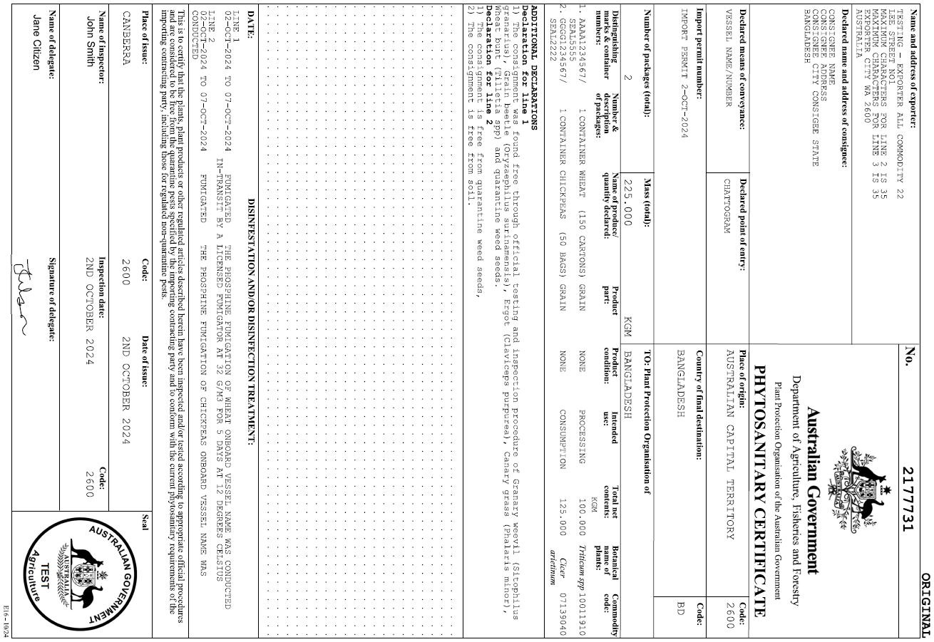

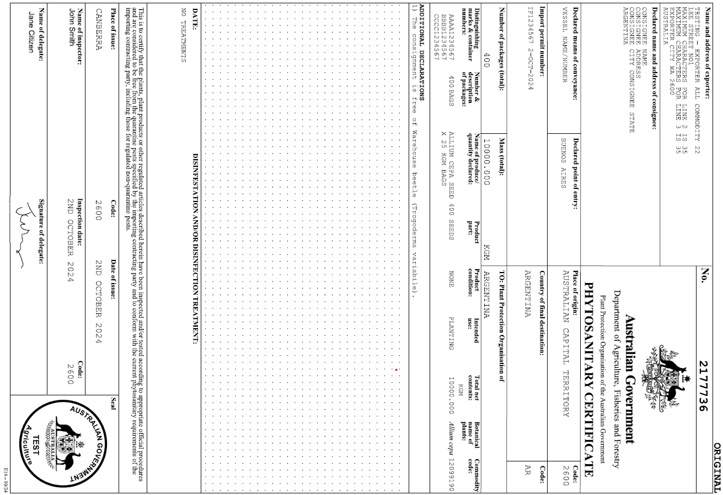

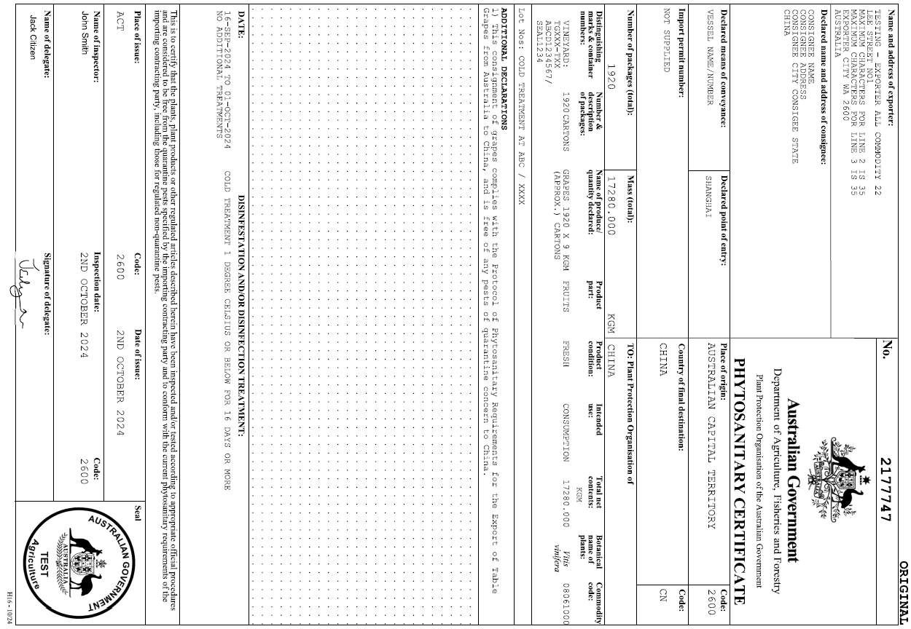

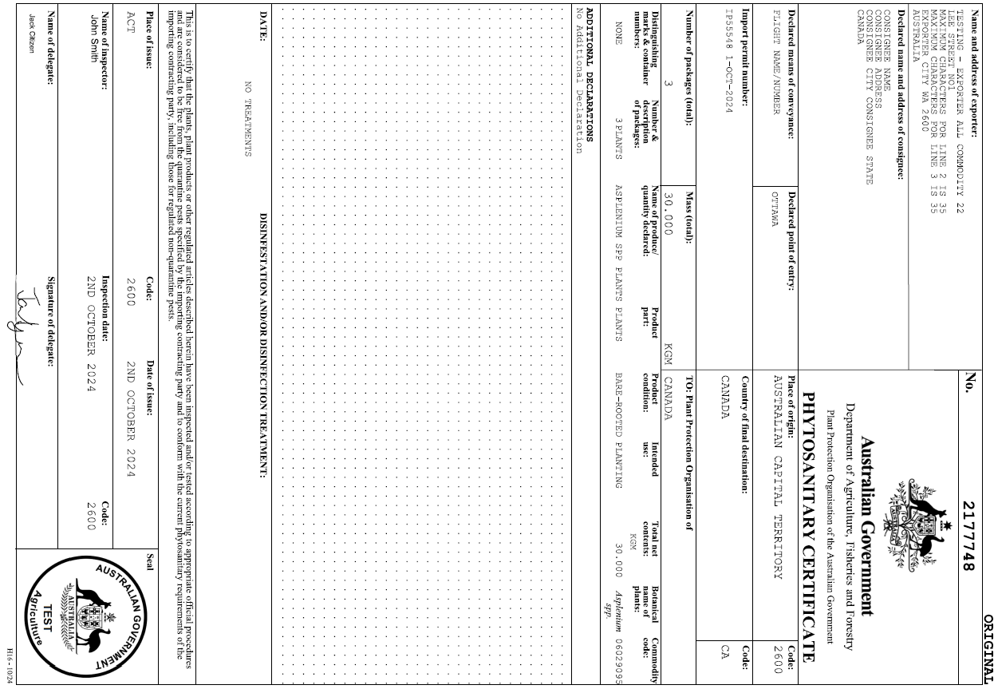

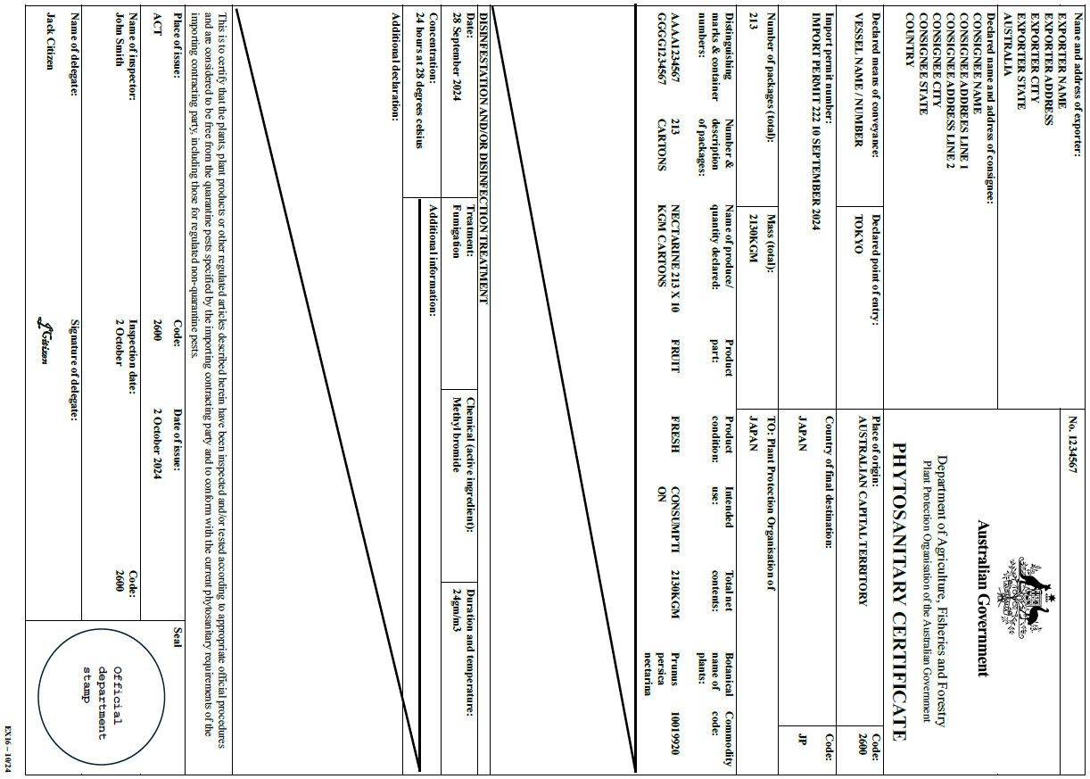

## Appendix C: Examples of consignment descriptions

| Number/description of packages | Name of produce/quantity declared | Product Part: | Product Condition: | Intended use: | Total net contents: | Botanical name | Commodity code: |
| --- | --- | --- | --- | --- | --- | --- | --- |
| 480 BAGS | LUCERNE SEED 480 X 25 KGM BAGS | NONE | NONE | STOCKFEED | 12000KGM | *Medicago sativa* | 11090000 |
| BULK | WHEAT 60000TNE | GRAIN | NONE | PROCESSING | 60000TNE | *Triticum spp* | 10019920 |
| 213 CARTONS  104 CARTONS  104 CARTONS | NECTARINE 213 X 10 KGM CARTONS  APRICOTS 104 X 10 KGM CARTONS  PEACHES 104 X 10 KGM CARTONS | FRUIT  FRUIT  FRUIT | FRESH  FRESH  FRESH | COMSUMPTION  CONSUMPTION  CONSUMPTION | 2130KGM  1040KGM  1040KGM | *Prunus persica nectarina*  *Prunus armeniaca*  *Prunus persica* | 10019920  10019920  10019920 |
| 1848 CARTONS | GRAPES | FRUIT | FRESH | CONSUMPTION | 1848 KGM | *Vitis vinifera* | 10019920 |
| 5 CONTAINERS | CHICKPEAS | GRAIN | NONE | PROCESSING | 80MT | *Cicer arietinum* | 07132030 |
| 950 BAGS | ALMOND NUTS 950 X20 KGM BAGS | GRAIN | NONE | CONSUMPTION | 19000KGM | *Prunus dulcis* | 19000KGM |
| 1 PLANT | ARAUCARIA SPP PLANTS | PLANTS | ROOTED | PLANTING | 3KGM | *Araucaria spp* | 08021200 |
| 7 PLANTS  20 PLANTS | DIOON SPINULOSUM PLANTS  HOWEA FORSTERIANA PLANTS | PLANTS  PLANTS | BARE ROOTED  BARE ROOTED | PLANTING  PLANTING | 7NO  20NO | *Dioon spinulosum*  *Howea forsteriana* | 06021000  06021000 |
| 25 CARTONS | BANKSIA PRIONOTES – CUT FLOWERS | FLOWERS | NONE | DECORATION | 458SS | *Banksia prionotes* | 06031960 |
| 3 FLASKS | DENDROBIUM VIOLACEUM ORCHID PLANTS | PLANTLETS | UNROOTED | PLANTING | 0.396KGM | *Dendrobium violaceum* | 06012000 |

## Appendix D: Grain product description requirements

| **Micor group** | **Micor end use** | **RFP - Intended use/ supplementary code** | **RFP - Product part** | **RFP - Product condition** |
| --- | --- | --- | --- | --- |
| Grain/seeds | Consumption | Consumption | Grain | * |
| Grain/seeds | Processing | Processing | Grain | * |
| Grain/seeds | Research | Research | Seeds | * |
| Grain/seeds | Sowing | Planting | Seeds | * |
| Grain/seeds | Sprouting | Sprouting for consumption | Seeds | * |
| Logs | Processing | Processing | Wood | With bark, or  Debarked  *Based on product* |
| Nuts | Consumption | Consumption | Grain | * |
| Processed plant products | Consumption | Consumption | Grain | * |
| Processed plant products | Other | *Refer to Micor case* | *Refer to Micor case* | *Refer to Micor case* |
| Processed plant products | Processing | Processing | Grain | * |
| Processed plant products | Stockfeed | Stockfeed | * | * |
| Processed Timber | Processing | Processing | Wood | * |
| Timber | Processing | Processing | Wood | Sawn, or  *  *Based on product* |
| Woodchips | Processing | Processing | Wood | * |
| N/A | Bark | Processing | Bark | * |
| N/A | Growing media | Planting | * | * |
| N/A | Stockfeed | Stockfeed | * | * |
| N/A | Wood packaging | Processing | Wood packaging material | * |

**Note:** * leave this field blank in the system. When leaving the field blank EXDOC will automatically populate the certificate with ‘NONE’. When completing a manual certificate write NONE when the field should be left blank.

## Appendix E: Horticulture product description requirements

| Micor group | Micor end use | RFP - Intended use/ supplementary code | RFP - Product part | RFP - Product condition |
| --- | --- | --- | --- | --- |
| Cut flowers/ foliage | Dried | Decoration | Flowers, or  Foliage  *Based on product* | * |
| Cut flowers/ foliage | Fresh | Decoration | Flowers, or  Foliage  *Based on product* | * |
| Cut flowers/ foliage | Research | Research | Flowers, or  Foliage  *Based on product* | * |
| Fruit | Dried | Consumption | Fruit | Dried |
| Fruit | Fresh | Consumption | Fruit | Fresh |
| Fruit | Research | Research | Fruit | Fresh, or  Dried  *Based on Micor case* |
| Pollen | N/A | Planting | Pollen | * |
| Nursery stock | Inoculant | Planting | Plants | * |
| Nursery stock | Bulb/Tubers | Planting | Bulbs, or  Tubers  *Based on product* | * |
| Nursery stock | Cuttings | Planting | Cuttings | * |
| Nursery stock | Plants | Planting | Plants | Rooted, or  Unrooted, or  Bare-rooted |
| Nursery stock | Research | Research | Plant, or  Plantlets  *Based on Micor case* | Rooted, or  Unrooted, or  Bare-rooted |
| Nursery stock | Tissue culture | Planting | Plantlets | Rooted, or  Unrooted, or  Bare-rooted |
| Vegetables | Dried | Consumption | Vegetable | Dried |
| Vegetables | Fresh | Consumption | Vegetable | Fresh |
| N/A | Packing material | Processing | * | * |

**Note:** * leave this field blank in the system. When leaving the field blank EXDOC will automatically populate the certificate with ‘NONE’. When completing a manual certificate write NONE when the field should be left blank.