Plant Export Operations Branch

User Guide
Completion of Export Certification for Plant and Plant Products

Guide to completion of Certificate as to Condition (EX46A)

INTRODUCTION 3
SCOPE 3
COMPLETING THE CERTIFICATE AS TO CONDITION 3
ROLES AND RESPONSIBILITIES 3
1. NAME AND ADDRESS OF EXPORTER 4
2. CONSIGNEE'S NAME AND ADDRESS 5
3. VESSEL AIRCRAFT DETAILS 6
4. COUNTRY OF ORIGIN (IF NOT AUSTRALIA) 6
5. PORT OF LOADING 7
6. DATE OF DEPARTURE 7
7. COUNTRY OF FINAL DESTINATION 8
8. DECLARED POINT OF ENTRY 8
9. EXPORT PERMIT NO(S) 9
10. DESCRIPTION OF THE CONSIGNMENT 9
11. SHIPPING MARKS AND CONTAINER NUMBERS 9
12. CONTAINER NUMBERS 10
13. SEAL NUMBERS 10
14. DESCRIPTION OF GOODS 11
15. ADDITIONAL PRODUCT DESCRIPTIONS 12
16. TOTAL NET CONTENTS 13
17. ADDITIONAL CERTIFICATION IF APPLICABLE 13
18. SIGNATURE AND NAME OF AUTHORISED OFFICER 14
19. DATE 14
20. DEPARTMENT OF AGRICULTURE SEAL 14
21. SAMPLE FORM – CERTIFICATE AS TO CONDITION (EX46A) 16

INTRODUCTION
This guideline will assist clients and Authorised Officers (AO) to prepare a Certificate as to Condition. Information on why a Certificate as to Condition is prepared is available in the Plant Export Operations Manual on the department’s website https://www.agriculture.gov.au/biosecurity-trade/export/controlled-goods/plants-plant-products/plantexportsmanual

SCOPE
This guideline is for clients of the department who have a need to prepare a Certificate as to Condition and for AO’s who issue a Certificate as to Condition. Client means the exporter, exporter’s representative or person responsible for the prescribed goods presented for inspection.
This user guide should be used in conjunction with the Completion of a Phytosanitary Certificate user guide that is available on the department’s website at https://www.agriculture.gov.au/biosecurity-trade/export/controlled-goods/plants-plant-products/certificates-declarations-forms#phytosanitary-certificate

Exporters are to adopt EXDOC standards for all export certification completion. This will allow them to ensure that all parties involved in the clearance of the consignment are familiar with a consistent standard of certification. Further information on EXDOC standards are available through the regional office. Regional office contacts are available on the department’s website at https://www.agriculture.gov.au/about/contact/our-offices

COMPLETING THE CERTIFICATE AS TO CONDITION
The Certificate as to Condition (EX46A) template is available on the department’s website at https://www.agriculture.gov.au/biosecurity-trade/export/controlled-goods/plants-plant-products/certificates-declarations-forms#certificate-as-to-condition

ROLES AND RESPONSIBILITIES
The Certificate as to Condition is prepared by the client and completed and verified, then issued by the Authorised Officer. The table below outlines the responsibilities of the client and the AO.

RESPONSIBILITY | SECTION
Client | To complete Sections 1-17
Authorised Officer | To verify information in Sections 1-17  To complete Sections 18-20

NAME AND ADDRESS OF EXPORTER
Enter the name and address of the exporter in full. The name and address refers to the details of the exporter (company) who is located in Australia. This field may include an overseas company name, if the company has an office based in Australia, the Australian address must be used as the address details. The address of the exporter should be either a physical or a postal address. The inclusion of both a physical and postal address is not permitted.

The inclusions of names of a person as the exporter is only permitted if the consignment being exported is for non-commercial purposes (eg: orchids in flasks). Non commercial consignments will usually be small quantities.
The exporter details are required in order to comply with the International Plant Protection Committee (IPPC) specifications for trace back purposes.

Telephone numbers, facsimile numbers and/or ABNs are not permitted as part of the exporter details.

The exporter details certified to on the phytosanitary certificate (and any other associated export certificates or forms) must be the same as the details that are on the Notice of Intention form (NOI).

Example of completed Exporter details:

Postal address
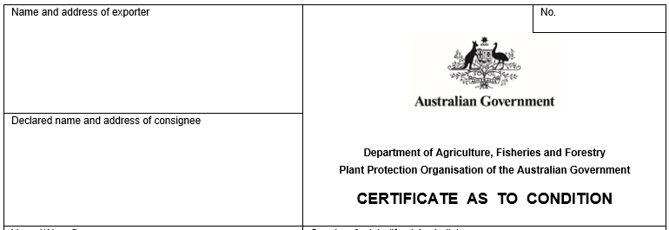
GMK EXPORTS
PO BOX 68
FREMANTLE 6160 WA

Physical address
GMK EXPORTS
112 SILVER HWY
FREMANTLE 6160 WA

CONSIGNEE'S NAME AND ADDRESS
Enter the name and address of the consignee. The consignee name should be the name of the company the consignee is being exported to. The inclusion of a name as the consignee is only permitted if the consignment being exported is for non-commercial purposes. (eg: orchids in flasks, research material). The address of the consignee should be either a physical or a postal address.

This field must not be left blank and should contain sufficient detail to enable the importing National Plant Protection Office (NPPO) to confirm the identity of the consignee.

Any variations to the consignee details are to be emailed to the Canberra Office at exdocplantprograms@agriculture.gov.au before certification is accepted and issued.

The words ’to order’ can be included as the consignee name, if the consignee is a bank entity. The use of ‘to order’ is not preferred and clients should avoid including this where possible.

Some countries (eg: United Kingdom) have prohibited the application of To Order or Bank details as consignee details on the Phytosanitary Certificate.

The inclusions of the following details are not permitted in this field:

- Telephone numbers
- both a physical and postal address
- Facsimile numbers
- ABNs
- Multiple addresses
- the words head office or factory (or derivative of)
- the word ‘consignee’ as the consignee name

Example of completed Consignee details:
Postal address
TOP ONE IMPORT EMPORIUM
BOX 11259
HAMAMATSU SHI
JAPAN 5689411

Physical address
AUSTRALIA
TOP ONE IMPORT EMPORIUM
11 - 45 TSUNEKUNI
HAMAMATSU SHI
JINSHU DISTRICT
JAPAN 5689411
AUSTRALIA

VESSEL AIRCRAFT DETAILS
Enter the ship name and voyage number (if known) or the aircraft and flight number. If the voyage or flight number is unknown - ‘SEA’, ‘AIR’, or ‘MAIL’ may be entered. The ship or aircraft is to be the international carrier.

Example of completed transport details:
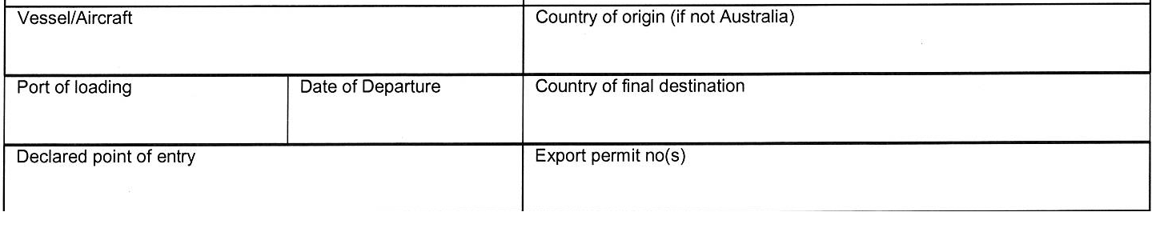
MARLEK / 229

COUNTRY OF ORIGIN (IF NOT AUSTRALIA)

Imported consignment
If the entire consignment was imported into Australia, enter the country of origin.
Examples of completed details:
TURKEY

Imported product and Australian product
If the consignment consists of Australian and imported product, the country of origin is to be entered against the imported product(s) and the ‘Country of origin (if not Australian)’ field ruled through.

If the produce being exported is of Australian origin, the “Country of origin (if not Australian)” field must be ruled through.

PORT OF LOADING
Enter the intended port of loading.

Example of completed field:
BRISBANE

DATE OF DEPARTURE
Enter the expected date of departure. The date must be entered in full.

Example of completed field:
21.1.13

COUNTRY OF FINAL DESTINATION
Enter the country of final destination. This field refers to the internationally accepted name of the country for which the consignment is to be inspected and certified to.
The Certificate as to Condition is to be addressed to the National Plant Protection Organisation (NPPO) of the country of final destination.

Example of completed field:
JAPAN

DECLARED POINT OF ENTRY
Enter the declared point of entry which is the place of importation or place of final clearance. The use of a country name or terms such as port, freeport or similar are not permitted. Some countries have a set list of approved points of entry.
If the declared point of entry is in a landlocked country, enter the transit port eg ‘Kathmandu via Calcutta’.

For bulk grain shipments where the consignment is to be discharged in multiple places in the destination country, the Declared Point of Entry may be populated with the text ALL (NAME OF COUNTRY) PORTS.

There are to be no derivatives of this allowance.

Examples of completed field:
CHITTAGONG

KATHMANDU VIA CALCUTTA

ALL JAPAN PORTS

EXPORT PERMIT NO(S)
This field is not applicable to plant exports and is to be ruled through.
Example of completed field:

DESCRIPTION OF THE CONSIGNMENT
The description of the consignment filed should have sufficient detail and should be provided to allow the consignment to be readily identified. Individuals are liable to prosecution for applying a false trade description – Chapter 8, Part 2, Division 3 of the Export Control Act.

False trade description is deemed to be applied if:
- it is applied to the goods
- it is applied to any covering, label, reel or thing used in connection with the goods
- it is applied to, or stated in, any document relating to the goods or used in any other manner likely to lead to the belief that it describes or designates the goods.

SHIPPING MARKS AND CONTAINER NUMBERS
Enter the shipping marks and container numbers.
Shipping marks are an indicator that identifies a line of product from other lines in the shipment. Distinguishing marks can include lot numbers, grower numbers, pack house numbers or container and seal numbers. This information must be verifiable by the AO at the time of inspection and recorded on the inspection record. Consignee details, excessive details or other irrelevant details (eg: AS ADD) are not permitted in this field.

EXDOC has a specific field for the inclusion of lot numbers.

CONTAINER NUMBERS
Enter the container numbers under the ‘Shipping Marks, Numbers & Container Numbers’ heading. Entering container numbers across the Phytosanitary certificate is not permitted.
If consignment is being loaded into Full Container Loads, enter the container numbers.
If consignments are being loaded into Less than a Container Load, container numbers do not need to be entered.

SEAL NUMBERS
Enter the seal numbers underneath or next to the relevant container number (with separating symbol). Seal numbers must not be entered on the phytosanitary certificate without container numbers (sea and air transport mode). Seal numbers are not verified by AOs unless it is a protocol agreement with the importing NPPO.
Seal numbers may be entered on the certificate underneath or next to (with a separating symbol) the relevant container number and are the responsibility of the exporter. Note: Seals are not validated by Department of Agriculture Plant Exports Authorised Officers, unless they form part of a specific overseas country protocol with Australia.

Entering seal numbers without a container number (sea and air transport mode) is not permitted.

Entering container numbers across the Certificate as to Condition is not permitted.

Example of completed Marks, Container and Seal details:

Marks only:
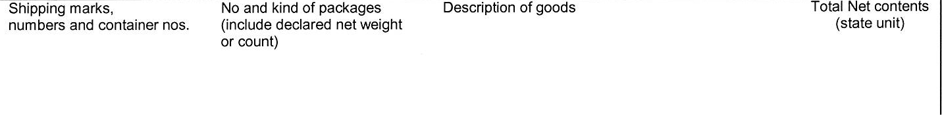
LOT 23A-1588

Marks, container and seal:
LOT 23A-1588
MWCU6845823 / AU123458

Container only:
MWCU6845823
GESU3515961

NO. AND KIND OF PACKAGES (INCLUDE DECLARED NET WEIGHT OR COUNT)

Enter the number and type of packages to be inspected and certified for export. It is important to use the term which is most appropriate to describe the packaging type to the importing NPPO.

This may include the net weight and unit of mass (if applicable) for each line entered on the certificate.

Examples of descriptions are:

BULK – used where product is loaded directly into a ships holds, the tonnage is also stated
BULK – 22000 TNE

CONTAINERS – used where product is bulk loaded directly into containers (FCL only), the number of containers is also stated
9 CONTAINERS

BAGS, CARTONS, BALES, TRAYS, ETC – used where product is packaged.
The number of packages is also stated; e.g: 640 BAGS, 590 CARTONS.
1235 CARTONS

DESCRIPTION OF GOODS

Enter the description of the goods. The description of goods is the primary descriptor of the product and should be a basic commodity name (eg: apple, orange, sorghum). It should have sufficient detail to allow the consignment to be readily identified.

Where a product does not have a common name, enter the botanical name.

Where a product contains a mix or blend of ingredients, enter a broad commodity description such as stockfeed.

EXDOC – will generate the correct description from the data entered into the RFP.

The inclusion of quality descriptors such as milling, hard type, etc can be included as a descriptor, however appropriate supporting evidence must be provided.

The inclusion of organic descriptions is not permitted, as the Plant Exports are not authorised to certify to organic description

Example of completed field:
WHEAT

ADDITIONAL PRODUCT DESCRIPTIONS
Enter the additional product descriptions relating to the consignment.
Additional product descriptors will be verified by the AO. The exporter or packer may have to provide documentation to allow the AO to verify this information and certify it on the phytosanitary certificate.
Documentation can include:
- Statutory Declaration
- Electrophoresis test results from a laboratory
- Certified Seed Certificate
- Botanical identification from an approved seed testing laboratory
If the additional description is a varietal name such as Kensington, Washington Navel etc, this description is to be placed after or underneath the primary descriptor.
Example of completed field:
APPLES - FUJI
Where permitted to be applied to the Certificate as to Condition, varietal names must be true and accurate, eg: ‘Tyson’, not ‘a variety similar to Tyson’.

Quality based descriptions (eg. South Australian Franklin Malting Barley, par-boiled Sunwhite Calrose Rice, Kabuli Chickpeas, Australian, hybrid) is permitted provided appropriate supporting documentation is provided. Quality based descriptions will not be permitted on the Phytosanitary Certificate.

Quality statements are permitted when supported by the appropriate certification including:

- seed analysis certificate (for germination or purity)
- statutory declarations (witnessed as required to comply with the Oaths Act)
- electrophoresis test (option for varietal certification)
- Certified Seed Certificates for varietal names.

TOTAL NET CONTENTS
Enter the total net weight of the consignment or the total net weight for each line stated on the certificate, but not including the weight of any external packaging, e.g: the container unit.

The metric unit of mass eg. GRM, KGM, TNE must also be included. Imperial weight measurements are not permitted.

Examples of completed fields:
450 GRM
21500 KGM
21.5 TNE
When all details have been completed in the above sections, any blank space below these fields must be ruled off prior to authoring (certifying) the certificate. Ruling through or ruling off blank spaces is important to prevent the unauthorised addition of details to the certificate.

ADDITIONAL CERTIFICATION IF APPLICABLE
Enter additional information relating to the product. This information relates to quality statements or commodity conditions such as batch details or packaging dates.

The following statements may be included, subject to approval from the relevant program:
- Radiation levels
- Genetically Modified Organisms (GMOs)
- In-transit treatment
- Plant trash

Statements relating to ‘Fit for Human Consumption’ are not permitted.

Certificates must be issued in accordance with conditions listed in Micor Plants https://micor.agriculture.gov.au/Plants/Pages/default.aspx

A line must be drawn under any details entered into this field. Ruling through or ruling off blank spaces is important to prevent the unauthorised addition of details to the certificate.

Example of completed field:
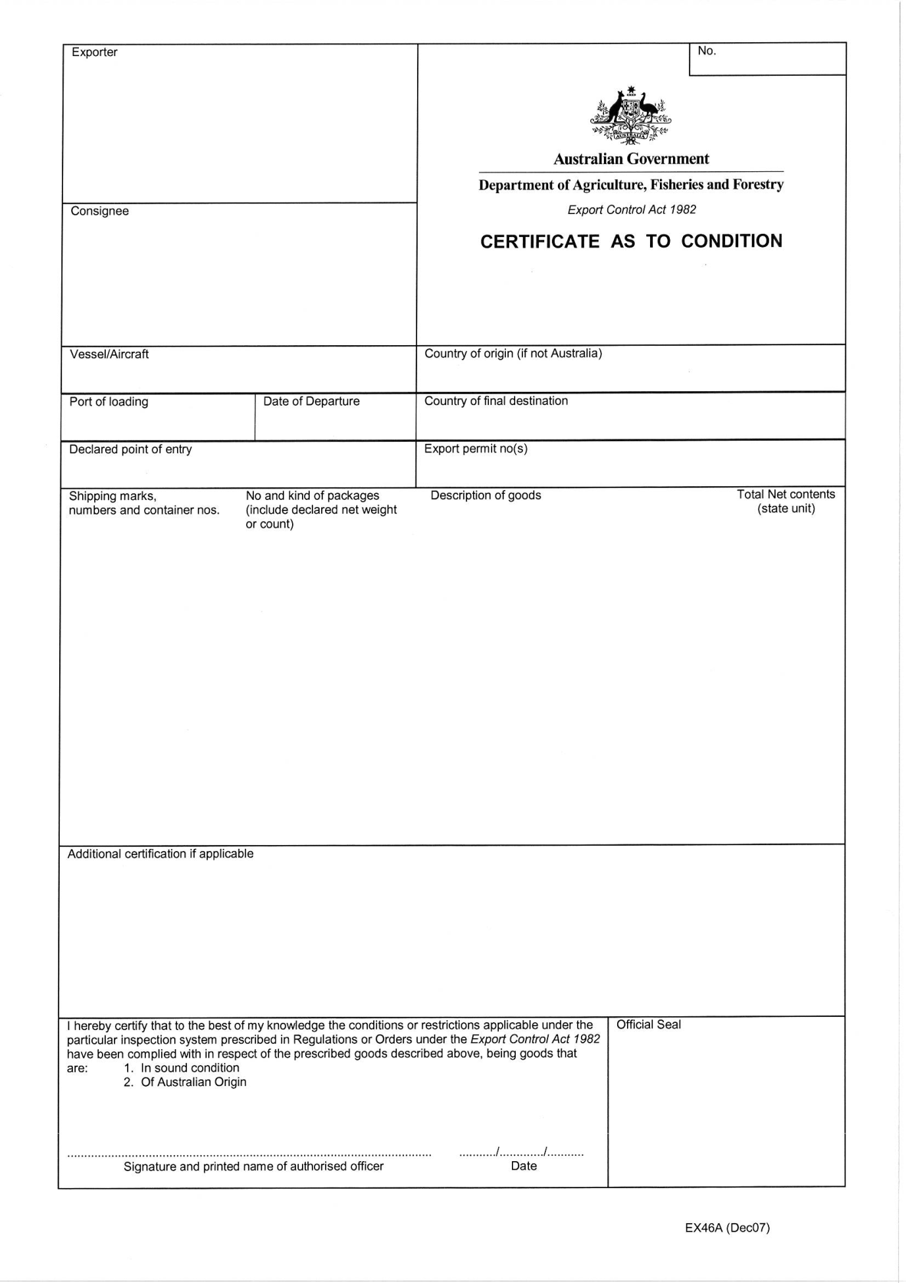
2012-13 SEASON
MALTING BARLEY
If there are no details entered, a line must be drawn through the field before the certificate is signed.

Example of completed field:

SIGNATURE AND NAME OF AUTHORISED OFFICER
The AO issuing the certificate must print their name and record their signature.

DATE
The AO must enter the date the certificate is signed. The date of the Certificate as to Condition may be different to the phytosanitary certificate.

DEPARTMENT OF AGRICULTURE SEAL
All Certificates issued (including any copies) must bear the department’s official stamp/seal.
Without this stamp / seal, the certificate is not valid.

Example of completed fields:
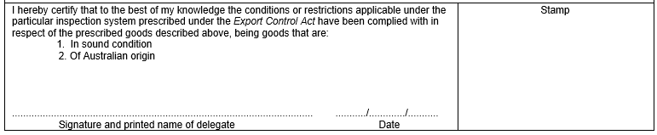
Sarah Smith Sarah Smith 22 5 13

SAMPLE FORM – CERTIFICATE AS TO CONDITION (EX46A)
