How do I submit a new lodgement?

This quick reference guide demonstrates how to submit a new lodgement in the Cargo Online Lodgement System. The new lodgement will include the document/s required to accompany your consignment, for assessment by the department. The **Submit a New Lodgement** process allows you to create a request for assessment of your import documentation.

1. New lodgement
   1. Home page

Go to the Cargo Online Lodgement System home page.

Select **Submit a New Lodgement.**

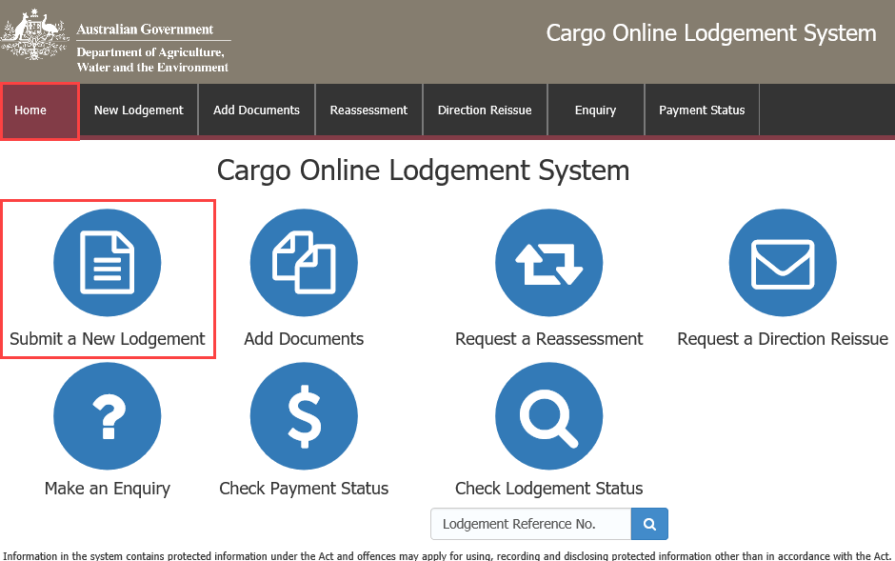

* 1. FID/Entry number

Enter you Full Import Declaration (FID)/ Entry number details along with you Broker/ Importer Branch ID.

Select .

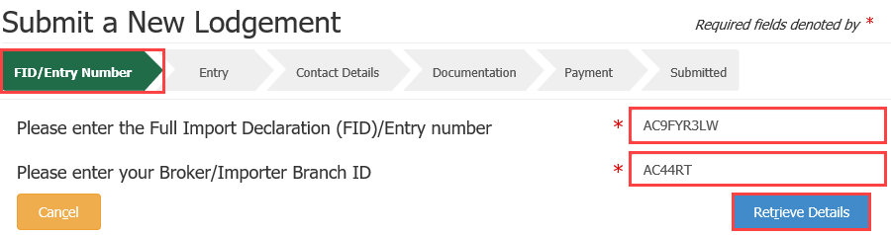

***NOTE:*** denotes a mandatory field. *When you select*  *the consignment details are automatically retrieved from AIMS and only additional information is required to be entered by you.*

***TIP:*** If you already have documents lodged against this entry number and would like to add further documents to an existing lodgement, select **Add Documents** from the home page. For further information, please refer to the quick reference guide: **How do I add additional documents to my lodgement?**

* 1. Entry

Here, you can provide the assessing officer with additional information that may help with the assessment.

Information you may add includes:

* **BICON link**: The URL reference for the BICON import case, relevant to your consignment.
* **Import permit number:** If your consignment requires an import permit, record the number in this field.
* **Delivery and Unpack Location:** The final destination for the consignment. If it is a rural destination you will be required to provide the unpack location details for the consignment.
* **Approved Arrangement Site Location:** The site approved by the department, where the goods will be moved to**.** If you wish to add your Approved Arrangement (AA) site, enter your AA number and select . The system will automatically validate the entered number and will populate the name and address of the site, if validated.
* **Direction Request**: To request a direction to be applied to your entry, select  under **Actions,** then select your request from the drop down menu**.**

**Note:** If you select a direction request other than **Release on documents,** you will be required to enter an **AA number**. Enter “Not applicable” or “NA” in this field, if it is not applicable for the requested direction.

* **Lodgement Date:** (For sea freight only.) This field will only appear if your lodgement is being made less than two business days from the estimated date of arrival. Select one of the following reasons from the drop down menu.

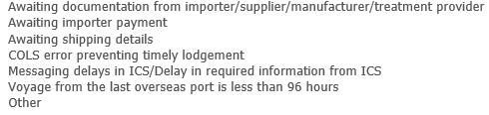

* Some options will require you to provide additional information in a free text field.

Select .

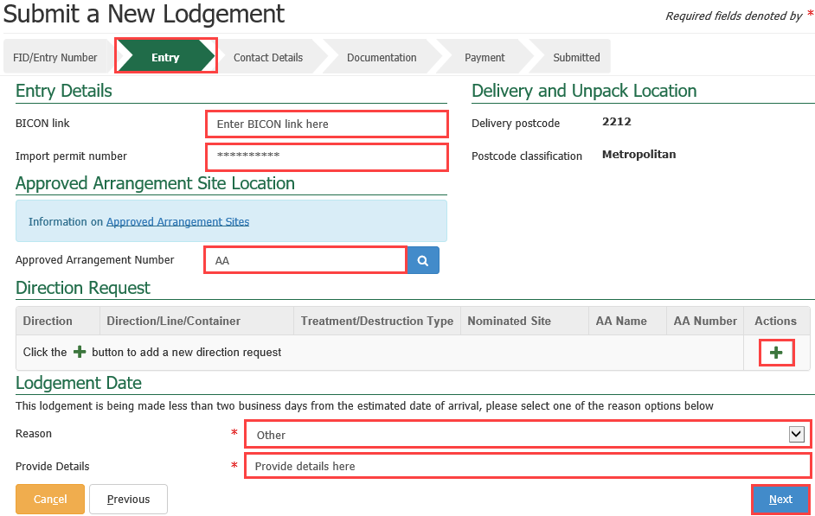

* 1. Contact details

Enter the contact details for the responsible party.

**NOTE:** The department may contact you using the phone number provided here, in the instance the assessment does not align with your expected outcome.

*If you are using the responsible party details for future lodgements, select*  *and the information will be saved to your browser, to load again when making future lodgements.*

If athird partyrequires assessment status notification, select the **Third Party Notification** check box and complete the email field.

Select .

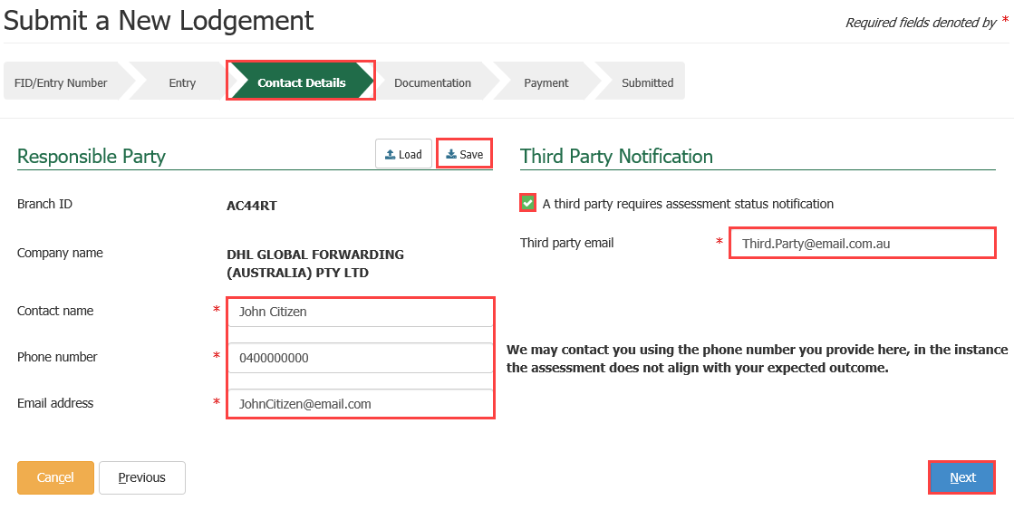

* 1. Documentation

Select  under **Actions** to add documents to your lodgement.

These are the required documents, as mandated by the import conditions in BICON.

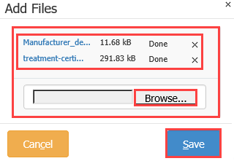This action will open a new window.

Add files

Select **Browse** to locate your file to upload.

Alternatively, select a number of files and drag and drop them into the file box at the top of the window.

Select to upload your document(s).

**NOTE:** Documents may not exceed 20.0MB in total.

Select the required document type(s) from the drop down menu.

Additional comments

Add any additional information that may help the department in assessing the documentation in the ‘**Additional Comments’** field. E.g., If you have multiple import permit numbers relating to the lodgement, add them here.

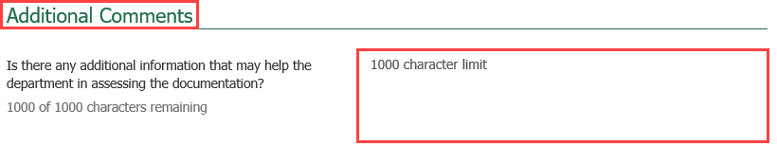

* 1. Declaration

Select the general declaration check box to declare that the information provided in this form is true and correct.

Read the privacy statement.

Select .

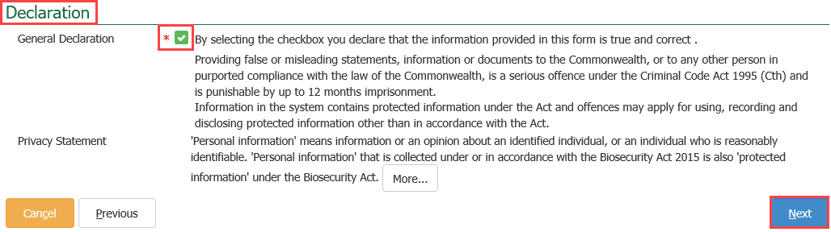

* 1. Account clients

If you are an account client with the department and have credit in your AIMS account, or you have pre-paid against your entry through the Integrated Cargo System (ICS), you will not see the payment screen. Your account will be charged and you will be taken straight to the ‘**Submitted’** screen.

Submitted

Once your payment has been processed, you will receive confirmation that your lodgement has been submitted. Record your **Lodgement Reference Number(LRN)** for future reference.

***TIP:*** *This is your unique number that can be used to identify your consignment when using other parts of the Cargo Online Lodgement System.*

If you would like to complete a new lodgement, select . If you are finished, select .

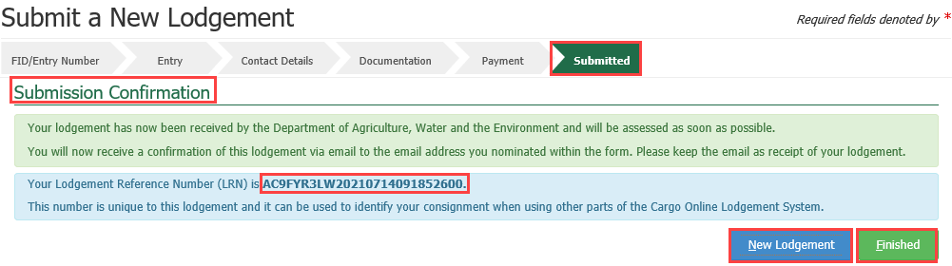

**NOTE:** You will receive an email confirmation from [DoNotReply@agriculture.gov.au](mailto:DoNotReply@agriculture.gov.au). This should be kept as a receipt of your lodgement.

Your documents are now with the department for assessment.

Account clients with insufficient credit

**NOTE:** If you are an account client with the department and you **do not** have enough credit in your AIMS account,, you will be taken to the payment screen.

Payment arrangement

Select , enter your account number, then select .

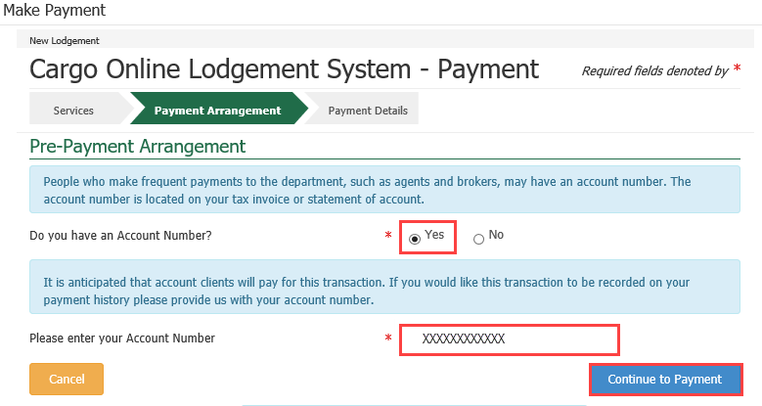

Payment details

You will need to pay for your assessment with your credit card.

Enter the card holder name, card number, expiry date and security code details.

Select .

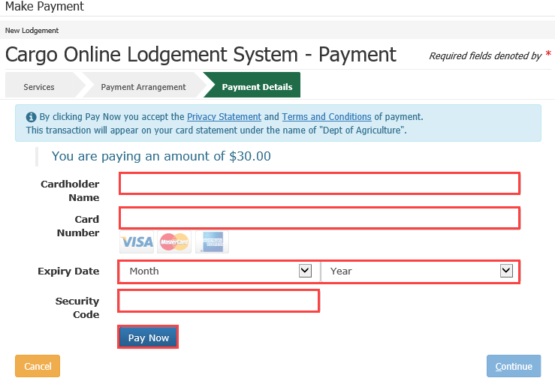

Once you have received your payment confirmation, including your payment reference number, select .

**NOTE:** You must select to finalise this transaction.

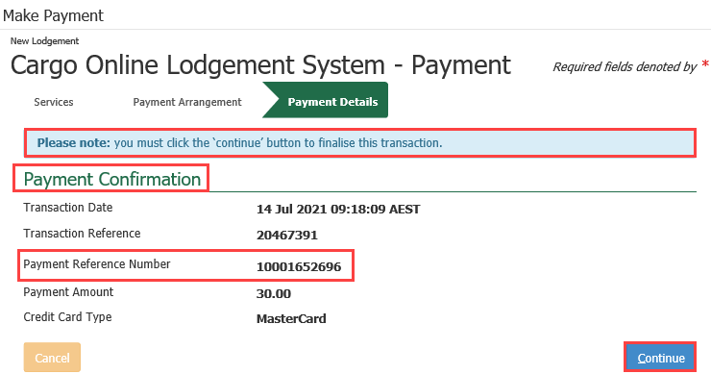

Once your payment has been processed, you will receive confirmation that your lodgement has been submitted. Refer to section **1.8.1** on this quick reference guidefor more details.

* 1. Non-account clients

Payment arrangement

If you are a non-account client, select  then select .

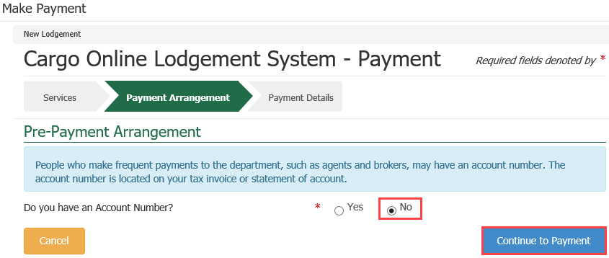

Payment details

You will need to pay for your assessment with your credit card.

Enter the card holder name, card number, expiry date and security code details.

Select .



Once you have received your payment confirmation, including your payment reference number**,** select .

**NOTE:** You must select to finalise this transaction.



Submitted

Once your payment has been processed, you will receive confirmation that your lodgement has been submitted. Record your **Lodgement Reference Number (LRN)** for future reference.

***TIP:*** *This is your unique number that can be used to identify your consignment when using other parts of the Cargo Online Lodgement System.*

If you would like to complete a new lodgement, select . If you are finished, select .



**NOTE:** You will receive an email confirmation from [DoNotReply@agriculture.gov.au](mailto:DoNotReply@agriculture.gov.au). This should be kept as a receipt of your lodgement.

Your documents are now with the department for assessment.